Integrating IOT Sensor Networks with TCP/IP
M. Vijayalakshmi
Dept. of Computer Science
Bhavan’s Vivekananda College,
Secunderabad, Telangana, India,
Vijicbse07@gmail.com

Marram Amitha
Lecturer, Dept. of Computer Science
Bhavan’s Vivekananda College,
Secunderabad, Telangana, India,
maramamitha@gmail.com

Thouti Jyoshna
Dept. of Computer Science
Bhavan’s Vivekananda College,
Secunderabad, Telangana, India,
jyoshna0407thouti@gmail.com

- ABSTRACT

The rapid-fire advancement of technology has steered in a new period of connectivity and robotization, prominently embodied by the Internet of effects (IoT). IoT detector networks have surfaced as a transformative force, seamlessly incorporating the physical and digital worlds by hitching an array of bias and detectors. These networks have the eventuality to revise diligence ranging from healthcare and husbandry to manufacturing and smart metropolises.

At the heart of this connected revolution lies the Transmission Control Protocol/ Internet Protocol (TCP/ IP), a foundational suite of communication protocols that underpins the global internet and enables dependable data exchange. likewise, this disquisition will exfoliate light on the transformative impact of similar integration across different sectors. Whether enhancing perfection husbandry through detector- driven perceptivity or enabling smart metropolises to optimize resource allocation, the possibilities are as extensive as they're groundbreaking. still, alongside these prospects, we will also navigate the challenges posed by this emulsion, similar as the complications of protocol restatement, scalability, and maintaining a secure communication channel.

In the runners that follow, we will claw into the specialized and strategic aspects of integrating IoT detector networks with TCP/ IP. This disquisition aims to equip compendiums with the knowledge and perceptivity needed to navigate the dynamic geography of IoT connectivity. By unravelling the vestments that connect IoT and TCP/ IP, we empower originators, masterminds, and decision- makers to harness the true eventuality of this community and contribute to the ongoing elaboration of the connected world.

- INTRODUCTION

Integrating IoT detector networks with TCP/ IP marks a vital juncture in the elaboration of IoT operations. This integration brings forth a multitude of openings and challenges, demanding a nuanced understanding of both the IoT geography and the complications of TCP/ IP communication. As IoT bias gain across diligence, their capability to communicate seamlessly and securely over TCP/ IP protocols becomes consummate. The community between IoT detector networks and TCP/ IP presents a gateway to employing the full eventuality of the connected world, unleashing new realms of data- driven perceptivity, remote control, and real- time decision- timber.

This disquisition delves into the complications of integrating IoT detector networks with TCP/ IP. We'll embark on a trip through the crucial factors and considerations that bolster this integration. From opting the right detectors and communication protocols to establishing robust network structure and icing data security, each hand of the integration process contributes to the creation of a robust and effective IoT ecosystem. The integration of IoT detector networks with TCP represents a vital confluence of two distinct realms the palpable physical world and the ethereal digital sphere. As IoT ecosystems gain, the flawless integration with TCP empowers these networks to communicate and partake data in a standardized, secure, and effective manner. This symbiotic relationship lays the root for real- time data exchange, remote monitoring, and precise control, with counteraccusations gauging diligence as different as healthcare, manufacturing, transportation, and beyond. This disquisition delves into the intricate interplay between IoT detector networks and TCP, unveiling the mechanics, advantages, and challenges that accompany this union. From the delicate cotillion of data transmission to the unity of communication protocols, each hand of this integration contributes to the creation of a sophisticated and connected geography. likewise, as we cut the geography of IoT- TCP integration, we uncover the eventuality for transformative change across colourful sectors. Whether it's optimizing force chains, enhancing prophetic conservation, or creating smart surroundings, the marriage of IoT and TCP opens doors to unequalled perceptivity and capabilities.

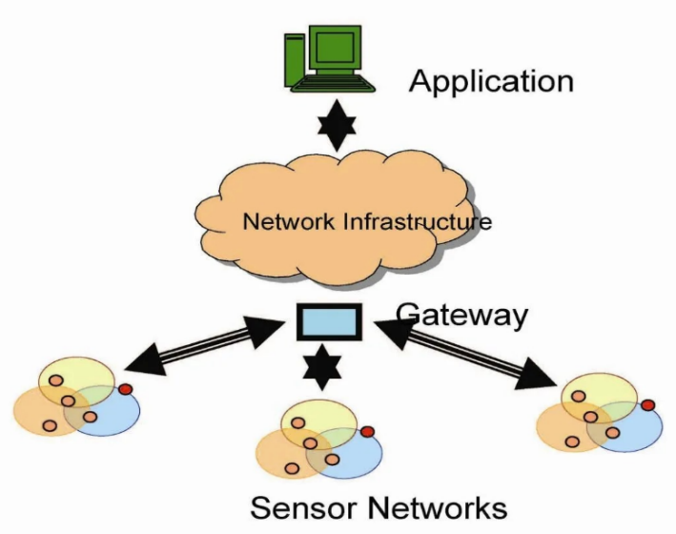

Figure 1: Wireless Sensor Networks

Yet, alongside these prospects, we also navigate the terrain of comity, scalability, and security, admitting that every invention comes with its own set of complications. Within the runners ahead, we embark on a trip through the technological shade that unites IoT detector networks with TCP. By unravelling the mechanisms that bind these two disciplines, we empower visionaries, masterminds, and decision- makers to navigate the complications and harness the immense eventuality of this integration. As we claw into the mechanics and counteraccusations, we embrace the spirit of disquisition that has driven humanity's hunt for knowledge and progress throughout history.

- STEPS INVOLVED IN INTEGRATING SENSOR NETWORK WITH AN TCP/IP NETWORK

Integrating a detector network with an IP (Internet Protocol) network involves a series of way to enable communication between the detectors and the larger network, generally the internet. Then is an overview of the way involved:

- Sensor Selection and Deployment:
Choose the applicable detectors for your operation (temperature, moisture, stir, etc.). Emplace detectors in the asked locales, icing they're duly powered and connected.

- Network structure:
Set up the IP network structure (Wi- Fi, Ethernet, cellular, etc.) where the detectors will be connected. Configure network settings, similar as IP addresses and subnet masks.

- IoT Gateway Setup (Optional):
An IoT gateway to act as a conciliator between detectors and the IP network, if demanded. The gateway may handle protocol restatement, data aggregation, and security.

- Communication Protocol Selection:
Choose a communication protocol suitable for your operation (MQTT, CoAP, HTTP, etc.). ensure the chosen protocol is compatible with both the detectors and the IP network.

- Sensor Data Collection and Transmission:
Program the detectors to collect data from the terrain or bias. Render the collected data according to the chosen communication protocol. Establish connections with the IP network using applicable sockets or libraries.

- Apply IP Network Integration:
Incorporate the IP mound into your detector bias or gateway to enable TCP/ IP communication. Set up socket connections, manage data packets, and handle data routing.

- Data Packaging and Formatting:
Structure the data packets according to the communication protocol's specifications. Include metadata similar as detector ID, timestamps, and other applicable information.

- Security:
Perpetration utensil security measures, similar as encryption and authentication, to insure data sequestration and integrity. Secure communication channels to cover data from unauthorized access.

- Garçon Configuration:
Set up a garçon or pall platform to admit and reuse the detector data. Configure the garçon to handle incoming data packets, excerpt information, and store it in databases.

- Data Processing and Storage:
Reuse the entered detector data as demanded (aggregation, analysis, etc.). Store the reused data in databases, pall storehouse, or other storehouse results.

- Remote Monitoring and Control:
Develop stoner interfaces or operations for remote monitoring and control of detectors. Design dashboards, mobile apps, or web interfaces for real- time visualization and commerce.

- Scalability and conservation:
Ensure the system can gauge as further detectors are added to the network. Regularly update and maintain the system to ensure security, comity, and performance.

- Testing and Troubleshooting:
Completely test the integration to ensure data is transmitted directly and reliably. Troubleshoot any issues that may arise during the integration process.

NOTE: Flash back that the specific way and technologies involved can vary grounded on your chosen detectors, communication protocols, network structure, and operation conditions. Always relate to the attestation handed by your tackle and software factors for detailed instructions.

- ESTABLISHING AN INTERCONNECTION BETWEEN IP (INTERNET PROTOCOL) NETWORKS AND SENSOR NETWORKS

Integrating a detector network with IP network requires careful planning, specialized moxie and a solid understanding of both the detector-specific protocols and IP networking principles. It’s important to choose the right tackle and software factors, apply security measures and completely test the intertwined system to insure its trust ability and effectiveness. Then is a general overview of the crucial tackle and software factors along with hardware factors.

- Hardware Components:

- Detectors:
Detectors These are the bias that capture physical data from the terrain. Choose detectors grounded on the type of data you want to collect (temperature, moisture, stir, etc.).

- Microcontrollers/Microprocessors:
Microcontrollers (e.g., Arduino, Raspberry Pi) or microprocessors (e.g., ESP8266, ESP32) act as the smarts of the detector bumps, recycling data and easing communication.

- IoT Gateway (Optional):
An IoT gateway can be used to aggregate data from multiple detectors and grease communication with the IP network. It may handle protocol restatement and data preprocessing.

- Communication Modules:
Wi- Fi modules (e.g., ESP8266, ESP32), cellular modules (e.g., SIM800, SIM900), or Ethernet interfaces for connecting detectors to the IP network.

- Power Supply:
Ensure a stable and dependable power source for the detectors and microcontrollers.
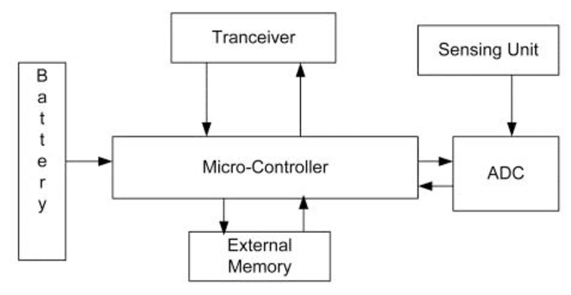

Figure 2: Architecture of a Sensor Node
- Software Components:

- Communication Protocols:
Choose a communication protocol that facilitates data exchange between sensors and the IP network. Common protocols include MQTT, CoAP, HTTP, and WebSocket.

- Detector knot Firmware:
Develop or configure firmware for the detector bumps that enables data collection, formatting, and communication according to the chosen protocol.

- IoT Gateway Software (if applicable):
Develop or configure software to manage data aggregation, protocol restatement, if using an IoT gateway.

- IP Network Stack:
Apply the necessary IP network mound (TCP/ IP) on the detector bumps or gateway to enable communication over the internet.

- Garçon- Side Software:
Set up garçon- side software to admit, process, and store detector data. This can include database systems, pall platforms, and operation fabrics.

- Security Measures:
Utensil encryption, authentication, and other security measures to cover data during transmission and storehouse.
- Remote Monitoring and Control Software:
Develop user interfaces (web, mobile apps) for remote monitoring, control, and visualization of sensor data.

- Data Analytics and Processing (Optional):
Develop stoner interfaces (web, mobile apps) for remote monitoring, control, and visualization of detector data.

- Scalability and Maintenance Tools:
conservation Tools Consider tools for spanning the system as further detectors are added and for ongoing conservation and updates.

Flash back that the specific factors you choose will depend on factors similar as the type of detectors, network structure, communication conditions, and the complexity of your operation. It's important to precisely plan and design your system to insure dependable and effective communication between your detector network and the IP network.

- IMPLEMENTING SECURITY MEASURES:

Security is of consummate significance when establishing a connection between IP (Internet Protocol) networks and detector networks. guarding data integrity, confidentiality, and vacuity is pivotal to help unauthorized access, data breaches, and implicit detriment. Then are crucial security measures to consider:

- Encryption:
Encrypt data transmitted between detectors and the IP network using protocols like TLS (Transport Layer Security) or SSL (Secure Sockets Subcaste). ensure end- to- end encryption to help wiretapping and unauthorized data interception.

- Authentication and Authorization:
Utensil strong authentication mechanisms for both detectors and druggies penetrating the detector data. Use secure authentication protocols similar as OAuth or JWT (JSON Web Commemoratives) for stoner access. Employ access control mechanisms to define who can pierce and control detectors and their data.

- Secure Communication Protocols:
Protocols Choose secure communication protocols, similar as MQTT with TLS, to insure data sequestration during transmission. use secure performances of protocols like HTTPS and secure WebSocket connections.

- Secure Boot and Firmware Updates:
ensure detectors and gateway bias have secure charge processes to help unauthorized firmware variations. Apply secure practices for streamlining firmware to alleviate implicit vulnerabilities.

- Network Segmentation and Firewalls:
Firewalls Member the network to insulate detector networks from critical systems using firewalls and VLANs (Virtual Original Area Networks). Configure firewalls to allow only necessary communication and block unauthorized access.

- Intrusion Detection and Prevention:
Implement intrusion discovery and forestalment systems to cover network business for unusual patterns and block suspicious conditioning.

- Data Integrity Checks:
utensil checksums, hash functions, or digital autographs to corroborate the integrity of transmitted data and help tampering.

- Physical Security:
Physically secure detector bumps and gateway bias to help unauthorized access or tampering. Choose secure locales for device placement, considering factors like environmental conditions and availability.

- Secure Credential Management:
Safely store sensitive credentials (e.g., API keys, watchwords) using secure storehouse mechanisms and avoid hardcoding them in source law.

- Regular Updates and Patch Management:
Keep all software, firmware, and operating systems up to date with the rearmost security patches. Regularly review and update security configurations to address new pitfalls and vulnerabilities.

- Data sequestration Compliance:
Misbehave with applicable data protection regulations (e.g., GDPR, HIPAA) when collecting and transmitting detector data.

- Monitoring and Logging:
Utensil comprehensive monitoring and logging to track and dissect network exertion for implicit security incidents. Maintain inspection logs to identify unauthorized access attempts or unusual gets.

- Penetration Testing and Security Audits:
Conduct regular security assessments, penetration testing, and security checkups to identify vulnerabilities and sins.

By enforcing these security measures, you can significantly enhance the security posture of your connected detector and IP networks, helping to guard sensitive data and maintain the integrity of your IoT ecosystem.

- MQTT PROTOCOL

- INTODUCTION
MQTT (Communication Queuing Telemetry Transport) is a featherlight, effective, and extensively used communication protocol designed for connecting bias and operations in the environment of the Internet of effects (IoT). MQTT follows a publish- subscribe model, making it suitable for scripts where bias need to change dispatches and data in a low- bandwidth, unreliable, or intermittent network terrain. Then is an overview of the MQTT protocol crucial generalities:
Key Concepts:

- Publisher-Subscriber Model:
In MQTT, bias is either publishers or subscribers. Publishers shoot dispatches (also known as" publish" dispatches) to specific motifs, and subscribers admit these dispatches by subscribing to those motifs.

- Quality of Service (QoS) Levels:
MQTT supports different situations of communication delivery assurance.
QoS 0(At most formerly) Communication is delivered formerly without evidence.
QoS 1(At least formerly) Communication is delivered at least formerly, and the philanthropist sends
an acknowledgment
QoS 2(Exactly formerly) Communication is delivered exactly formerly by using a four- step
handshake.

- Protocol Features

- Featherlight:
MQTT is designed to be featherlight, making it suitable for resource- constrained bias and low- bandwidth networks.

- Efficient Communication:
MQTT minimizes the overhead of the protocol, resulting in efficient data transmission.

- Retained dispatches:
Publishers can shoot retained dispatches, which are stored on the MQTT broker and transferred to new subscribers when they connect. This ensures that subscribers admit the rearmost data indeed if they join the network latterly.

- Last Will and Testament (LWT):
A device can specify a" last will" communication that the broker will shoot to a specific content if the device suddenly disconnects.

- Session Persistence:
MQTT brokers can retain customer session state, allowing guests to resubscribe to motifs and admit missed dispatches after a disposition.

- Security:
While MQTT itself doesn't give essential security; it can be used over secure transport layers similar as TLS/ SSL. also, authentication and access control can be enforced at the MQTT broker position.

- ARCHITECTURE:

To understand the MQTT armature, we first look at the factors of the MQTT.
  - Communication
  - Customer
  - Garçon or Broker
  - Content

- Communication
The communication is the data that's carried out by the protocol across the network for the operation. When the communication is transmitted over the network, also the communication contains the following parameters.
- cargo data
- Quality of Service (QoS)
- Collection of parcels
- Content Name

- Customer in MQTT
The subscriber and publisher are the two places of a customer. The guests subscribe to the motifs to publish and admit dispatches. In simple words, we can say that if any program or device uses an MQTT, also that device is appertained to as a customer. A device is a customer if it opens the network connection to the garçon, publishes dispatches that other guests want to see, subscribes to the dispatches that it's interested in entering, unsubscribes to the dispatches that it isn't interested in entering, and closes the network connection to the garçon. In MQTT, the customer performs two operations Publish When the customer sends the data to the garçon, also we call this operation as a publish. Subscribe When the customer receives the data from the garçon, also we call this operation a subscription.

- Garçon
The device or a program that allows the customer to publish the dispatches and subscribe to the dispatches. A garçon accepts the network connection from the customer, accepts the dispatches from the customer, processes the subscribe and unsubscribe requests, on the operation dispatches to the customer, and closes the network connection from the customer.

- Content
The marker handed to the communication is checked against the subscription known by the garçon is known as Content. Now we will look at the armature of MQTT. To understand it more easily, we will look at the illustration. Suppose a device has a temperature detector and wants to shoot the standing to the garçon or the broker. However, also there will be two effects that happed, If the phone or desktop operation wishes to admit this temperature value on the other side. The publisher first defines the content; for illustration, the temperature also publishes the communication, i.e., the temperature's value. After publishing the communication, the phone or the desktop operation on the other side will subscribe to the content, i.e., temperature and also admit the published communication, i.e., the value of the temperature. The garçon or the broker's part is to deliver the published communication to the phone or the desktop operation.

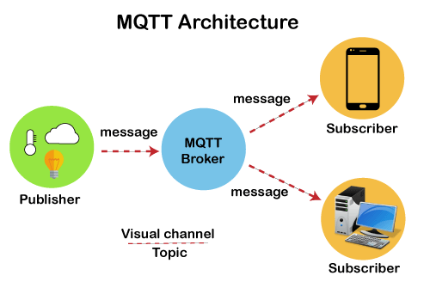

Figure 3: Architecture of MQTT Protocol

- MQTT BROKER:
An MQTT broker is a critical element in the MQTT (Communication Queuing Telemetry Transport) communication protocol. It serves as a conciliator that facilitates communication between MQTT guests (bias or operations) by managing the routing and distribution of dispatches grounded on motifs. The MQTT broker plays a vital part in enabling effective, dependable, and scalable communication in Internet of effects (IoT) and machine- to- machine(M2M) operations. Then it is how an MQTT broker is used:
- Communication Routing:
The primary part of an MQTT broker is to route dispatches between publishers and subscribers. When a publisher sends a communication with a specific content, the broker ensures that the communication is delivered to all subscribers who have expressed interest in that content.

- Content Subscription and operation:
MQTT guests(subscribers) can subscribe to one or further motifs of interest. The broker keeps track of the active subscriptions and forwards published dispatches to the applicable subscribers grounded on their content preferences.

- Content Hierarchy and Wildcard:
The broker supports a hierarchical content structure, allowing guests to use content situations to organize and classify dispatches. guests can subscribe to specific motifs or use wildcard characters to admit dispatches from multiple motifs that match a pattern.

- Quality of Service (QoS):
Handling The broker manages the delivery of dispatches according to the specified QoS position. It ensures that dispatches are delivered at least formerly (QoS 1) or exactly formerly (QoS 2) grounded on the publisher's and subscriber's QoS preferences.

- Retained dispatches:
The broker can store retained dispatches on specific motifs. When a new subscriber connects to a content with retained dispatches, the broker sends the most recent retained communication to the subscriber. This point ensures that subscribers admit the rearmost status indeed if they join the network after a communication has been published.

- Last Will and Testament (LWT):
The broker handles the delivery of" last will" dispatches to specified motifs in case a customer suddenly disconnects. This point can be used to communicate the customer's status or take specific conduct upon disposition.

- customer Connection operation:
The broker manages customer connections, including establishing and maintaining connections, handling dispositions, and maintaining session state for guests that reconnect.

- Security and Access Control:
The broker can apply authentication and access control mechanisms to ensure that only authorized guests can connect and publish subscribe to specific motifs.

- cargo Balancing and Scalability:
In larger deployments, MQTT brokers can be distributed and cargo- balanced to handle a high volume of dispatches and connections. This allows for scalability and fault forbearance.

- Data Storage (Optional):
Some MQTT brokers offer data storehouse capabilities, allowing dispatches to be stored for literal analysis or delayed delivery to subscribers.

- Integration with operations:
MQTT brokers can be integrated with other operations, databases, or pall services to reuse and assay the data changed between MQTT guests.

In summary, an MQTT broker serves as a central mecca for managing the inflow of dispatches between publishers and subscribers in an MQTT network. It ensures effective and dependable communication, enabling bias and operations to change data seamlessly in IoT and M2M surroundings.

- TCP/IP PROTOCOL

TCP/ IP (Transmission Control Protocol/ Internet Protocol) is the abecedarian suite of communication protocols that underpins the operation of the internet and ultramodern computer networks. It provides a standardized frame for bias to communicate and change data across different networks, enabling the flawless inflow of information across the global digital geography.
The TCP/ IP protocol suite encompasses a collection of protocols that work together to grease data transmission, addressing, routing, and other essential networking functions. likewise, we will explore the layers of the TCP/ IP protocol mound, ranging from the physical and data link layers to the network, transport, and operation layers. Each subcaste contributes to the flawless movement of data, from the raw electrical signals that cut network lines to the stoner-friendly operations that empower us to browse the web, shoot dispatches, and unite across the globe.
As we embark on this trip through the realm of TCP/ IP, we will unravel its complications, clarify its inner workings, and showcase its critical significance in the realm of ultramodern communication. By understanding TCP/ IP, we equip ourselves with the foundational knowledge necessary to comprehend the intricate web of connections that bind our digital world together.

- LAYERS
LAYERS The TCP/ IP (Transmission Control Protocol/ Internet Protocol) protocol suite is organized into four layers, each serving a specific part in easing communication and data exchange over computer networks. These layers give a structured frame for data transmission, addressing, routing, and colourful networking functions. The layers of the TCP/ IP model are frequently appertained to as the" Internet protocol mound." Then are the four layers of the TCP/ IP model:

- Application Layer:
The Application Layer is the top subcaste of the TCP/ IP model and is responsible for relations between stoner operations and the network. It provides colourful protocols and services that enable communication and data exchange between software operations running on different bias. exemplifications of protocols at this subcaste include HTTP (Hypertext Transfer Protocol), SMTP (Simple Correspondence Transfer Protocol), FTP (train Transfer Protocol), and DNS (sphere Name System).

- Transport Layer:
This Layer manages end- to- end communication and ensures dependable data delivery between bias. It's responsible for breaking down large dispatches into lower parts, managing inflow control, and furnishing error discovery and correction. Two prominent protocols at this subcaste are:
Transmission Control Protocol (TCP):
Provides dependable, connection- acquainted communication with error recovery, sequencing, and flow control.
User Datagram Protocol (UDP):
Offers connectionless, briskly communication with minimum outflow, suitable for operations where speed is more critical than trust ability.

- Internet Layer:
Internet Layer handles addressing, routing, and forwarding of data packets across different networks. It's responsible for determining the stylish path for data packets to travel from the source to the destination. The central protocol in this subcaste is the Internet Protocol (IP), which provides logical addressing and routing capabilities. IPv4(Internet Protocol interpretation 4) and IPv6(Internet Protocol interpretation 6) are two performances of the IP protocol.

- Link Layer (also known as Network Access Layer):
The Link Layer is the nethermost subcaste of the TCP/ IP model and is responsible for the physical transmission of data over the network medium. It deals with tackle-specific details, similar as addressing bias using MAC (Media Access Control) addresses, framing data into packets, and managing access to the physical transmission medium. The Link Layer encompasses technologies similar as Ethernet, Wi- Fi, and DSL (Digital Subscriber Line).

These four layers work together to enable communication and data exchange between bias connected to a network. As data passes through each subcaste, it's reprised with applicable information at each position, and this encapsulation is reversed as the data reaches the destination. The TCP/ IP model is pivotal for understanding how bias communicate over the internet and other computer networks, and it serves as the foundation for ultramodern networking and communication protocols.

- FUNCTIONS
The TCP/ IP (Transmission Control Protocol/ Internet Protocol) suite serves as the foundation for data communication on the internet and other computer networks. It provides a set of protocols that work together to enable bias to communicate, exchange data, and access coffers across connected networks. The functions of TCP/ IP are essential for icing dependable, effective, and standardized communication in the digital world.
Then are the crucial functions of TCP/ IP:

- Addressing and Routing IP (Internet Protocol):
It is responsible for addressing and routing data packets from source to destination across different networks. It assigns unique IP addresses to bias and determines the stylish path for data to travel to reach its destination.

- Packetization and Framing:
TCP/ IP breaks down data into packets or parts to grease effective transmission. It encapsulates data with heads that contain information similar as source and destination addresses, sequence figures, and checksums.

- Reliable Data Transfer:
TCP (Transmission Control Protocol) ensures dependable data delivery by establishing connections, sequencing data packets, admitting damage, and retransmitting lost or corrupted packets.

- Connection operation:
TCP/ IP protocols establish, maintain, and terminate connections between bias. TCP provides mechanisms for opening, ending, and managing communication sessions.

- Flow Control:
TCP monitors the inflow of data between sender and receiver to help traffic and ensure that data is delivered at a rate the receiver can handle.

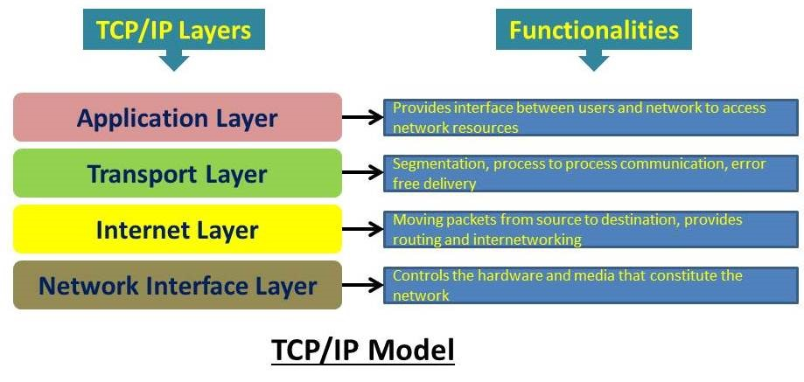

Figure 4: Layers and Functionalities of TCP/IP

- Error Discovery and Correction:
TCP/ IP detects crimes in data transmission through checksums and provides mechanisms for retransmitting or correcting corrupted packets.

- Logical Addressing:
IP addresses give logical addressing, allowing bias to be uniquely linked on a network or the internet. IP addresses are essential for routing data to the correct destination.

- Name Resolution DNS (sphere Name System):
It is a crucial function of TCP/ IP that translates mortal- readable sphere names (e.g., www.example.com) into IP addresses, enabling druggies to pierce coffers using meaningful names.

- Fragmentation and Reassembly:
TCP/ IP handles the fragmentation of data into lower packets for transmission over networks with varying Maximum Transmission Unit (MTU) sizes. It also reassembles fractured packets at the destination.

- Network Services and operations:
The TCP/ IP suite supports a wide range of network services and operations, including web browsing (HTTP), dispatch (SMTP, POP3, IMAP), train transfer (FTP), remote access (SSH, Telnet), and more.

- Security:
While not a primary function, TCP/ IP can be used in confluence with security protocols (e.g., TLS/ SSL) to insure translated and secure communication between bias.

- Interoperability:
TCP/ IP enables bias and networks from different merchandisers to communicate seamlessly, promoting interoperability and allowing the creation of a global network like the internet.

- HOW MQTT IS CONNECTED TO IP

MQTT (Message Queuing Telemetry Transport) is a communication protocol that operates on top of the IP (Internet Protocol) stack. MQTT uses IP as the underlying transport mechanism to establish connections between MQTT clients (devices or applications) and MQTT brokers. This connection enables the exchange of messages and data within an IoT (Internet of Things) or M2M (Machine-to-Machine) network. Here's how MQTT gets connected with IP:
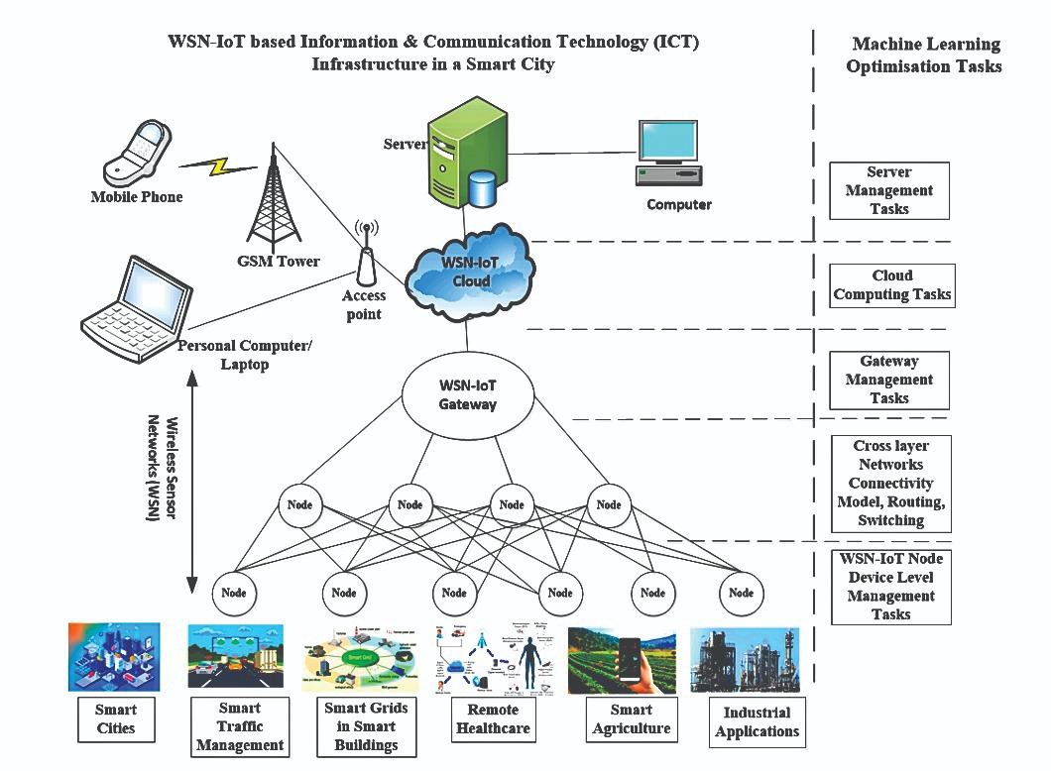

Figure 4: TCP/IP Layers and Functionalities

- MQTT Client Initialization:
An MQTT client, whether it's a publisher or subscriber, initiates a connection to an MQTT broker. The client needs to know the IP address or hostname of the broker it intends to connect to.

- Transport Layer:
The MQTT client uses the TCP (Transmission Control Protocol) as the transport layer protocol to establish a connection with the MQTT broker. TCP provides a reliable, connection-oriented communication channel over IP.

- Establishing a TCP Connection:
The MQTT client initiates a TCP connection to the IP address and port number of the MQTT broker. The broker listens for incoming connections on a designated port, typically port 1883 for non-secure connections and port 8883 for secure connections using TLS/SSL.

- MQTT Protocol Handshake:
Once the TCP connection is established, the MQTT client and broker perform a protocol handshake. This involves exchanging control packets to establish the connection parameters, capabilities, and agreed-upon communication settings.

- Authentication and Authorization (Optional):
If authentication and authorization are enabled, the MQTT client provides credentials (username and password) to the broker to verify its identity and access rights.

- MQTT Communication:
After the handshake is complete and authentication is successful (if required), the MQTT client can publish messages to specific topics or subscribe to topics of interest. The client sends MQTT publish, subscribe, and unsubscribe messages over the established TCP connection.

- Data Exchange:
The MQTT broker routes published messages to subscribers based on the topics they have subscribed to. Subscribers receive the messages over the same TCP connection.

- Disconnecting:
Either the MQTT client or the broker can initiate a graceful disconnection by sending a disconnect message. This ensures that resources are properly released and any necessary cleanup is performed.

- ROLES PLAYED BY MQTT AND TCP/IP IN IOT

MQTT (Message Queuing Telemetry Transport) and TCP/IP (Transmission Control Protocol/Internet Protocol) play essential roles in the Internet of Things (IoT) ecosystem, facilitating communication between devices and enabling the seamless exchange of data. Here are the roles played by MQTT and TCP/IP in IoT:

- MQTT:

MQTT serves as a lightweight messaging protocol designed for efficient data exchange between IoT devices. It enables devices to publish data (messages) and subscribe to topics of interest, creating a decentralized and asynchronous communication model. It follows a publisher-subscriber architecture, allowing devices to publish data to specific topics and subscribe to topics they are interested in. This model enables efficient one-to-many and many-to-many communication among IoT devices.

MQTT is designed to minimize overhead, making it suitable for resource-constrained devices and networks. It uses a compact binary payload format and offers different Quality of Service (QoS) levels to ensure data delivery reliability as per application requirements. MQTT supports different QoS levels (0, 1, and 2) for message delivery. This allows IoT applications to balance data delivery reliability with communication overhead. QoS levels ensure that data is delivered once and only once, if required.

MQTT brokers can store and deliver retained messages, which are useful for conveying important status or configuration information to newly connected devices. This feature enhances system efficiency and helps devices synchronize with the latest information. It provides the LWT (Last Will and Testament) feature, which allows devices to specify a "Last Will" message to be sent by the broker in case the device unexpectedly disconnects. This feature is useful for indicating device status or taking appropriate actions in case of failures.

- TCP/IP:

TCP/IP is the foundational networking protocol suite of the Internet. It provides the essential communication infrastructure that enables devices to connect to the internet and communicate with each other over local and wide-area networks. TCP/IP uses IP addresses to uniquely identify devices on a network. Devices use these addresses to route data packets to their intended destinations. This addressing scheme allows IoT devices to locate and communicate with each other across different networks.

TCP, a component of TCP/IP, ensures reliable and ordered delivery of data packets between devices. It manages acknowledgment and retransmission mechanisms to guarantee data integrity. It includes error detection and correction mechanisms, which are crucial for maintaining data integrity and communication reliability in IoT applications. TCP/IP enables IoT devices to connect to cloud services, servers, and other devices on the internet. This connectivity is essential for remote monitoring, control, and data exchange in IoT ecosystems.

- SUMMARY:

In summary, MQTT and TCP/ IP play reciprocal places in IoT. MQTT focuses on effective and flexible data exchange between bias, while TCP/ IP provides the networking structure and trust ability necessary for bias to communicate over the internet and colourful types of networks. Together, they form an important foundation for erecting scalable and connected IoT systems. Either the MQTT customer or the broker can initiate a graceful disposition by transferring a dissociate communication. This ensures that coffers are duly released and any necessary remittal is performed. It's important to note that MQTT can also be used over secure transport layers similar as TLS/ SSL, which provides encryption and enhanced security for the communication between MQTT guests and brokers. Secure MQTT connections use harbourage 8883 for communication. MQTT uses the TCP/ IP protocol mound to establish connections between MQTT guests and brokers. The IP subcaste handles the addressing and routing of data packets, while the TCP subcaste provides dependable, connection- acquainted communication. MQTT builds on top of this foundation to enable effective and standardized communication within IoT and M2M networks.

BIBLIOGRAPHY
https://krazytech.com/technical-papers/security-requirements-in-wireless-sensor-networks

http://sensors-and-networks.blogspot.com/2011/02/schematic-digaram-of-sensor-node.html

https://www.javatpoint.com/mqtt-protocol

https://mycomputernotes.com/introduction-to-tcp-ip-protocol-suite/

https://www.mpdigest.com/2022/05/26/integrating-wireless-sensor-networks-within-iot/

https://papers.ssrn.com/sol3/papers.cfm?abstract_id=3186315

https://arxiv.org/pdf/1903.11549

https://www.codingninjas.com/studio/library/tcp-features

http://www.ajer.org/papers/v4(10)/N04101020107.pdf

https://www.geeksforgeeks.org/what-is-transmission-control-protocol-tcp/

Learning Internet of Things by Peter Waher
Getting Started With Internet Of Things by Cuno Pfister
Internetworking with TCP/IP Volume One 5th Editon by Comer, Douglas E. Published by Addison-Wesley

