Artificial Intelligence (AI) Application for Youth Mental Health
Aditi Bhosale, Preshita Kudtarkar, Dr. Dhanamma Jagli,
Dept.of MCA, Dept.of MCA, Deputy HOD, Dept.of MCA,
V.E.S.Institute of Technology, V.E.S.Institute of Technology, V.E.S.Institute of Technology,
Chembur ,Mumbai Chembur ,Mumbai Chembur ,Mumbai
aditibhosale2012@gmail.com preshitakudtarkar@gmail.com dhanamma.jagli@ves.ac.in

Abstract—The increasing prevalence of mental health issues among children and adolescents is becoming a significant public health concern, with studies estimating that a significant percentage of school-age children experience mental illness that negatively impacts their education. Early identification and prevention are crucial, and Artificial Intelligence (AI)-assisted applications can play a role in addressing this unmet need for mental health services in schools. These applications can leverage machine learning algorithms, natural language processing techniques, and data analytics to analyze data and provide valuable insights for identifying mental health issues. They can generate alerts, provide personalized recommendations and interventions, offer educational resources, and facilitate data collection for research purposes. However, ethical considerations such as privacy, security, informed consent, and fairness in AI algorithms should be carefully addressed. Despite challenges, AI-assisted applications have the potential to revolutionize the way mental health issues in children and youth are identified and addressed in schools, promoting mental health awareness, early intervention, and prevention efforts, and ultimately improving their overall quality of life.
Keywords— Artificial Intelligence, Youth mental health, Intervention, prevention, awareness

Introduction
The increasing concern for public health lies in the rising prevalence of mental health challenges among children and adolescents. These issues can vary in severity and duration, ranging from mild and temporary symptoms like mild anxiety or depression to more severe and persistent diagnosed conditions such as anxiety disorders or major depression. Several factors, including physical and cognitive health, mental functioning, social environment, family dynamics, and stressful life events, contribute to the development of mental disorders in adolescents. Research suggests that approximately 12-30% of school-age children experience mental illness that adversely affects their education, and half of all mental illnesses emerge before the age of 14, with the majority occurring before the age of 25. Childhood and adolescence are especially vulnerable stages for the onset of mental illness.
However, mental health concerns in children and adolescents frequently go undetected and untreated, leading to a significant number of individuals experiencing ongoing mental health issues in adulthood. Timely identification and prevention can have significant advantages, as many young people initially exhibit mild to moderate symptoms. Consequently, it is essential to establish and enhance mental health initiatives within educational institutions to cater to the unique requirements of students grappling with a range of mental health challenges on a regular basis.
Artificial Intelligence (AI)-supported applications have the potential to contribute to the identification of mental health problems, as well as provide diagnoses and treatment options within school settings. This can effectively address the existing gap in mental health services for children and adolescents, ensuring their needs are met.

Literature Review
Sr. No. | Author | Title | Summary
1. | Please refer:  [References-1] | Effectiveness of school-based mental health programs on mental health among adolescents | The objective of this research was to examine how interventions implemented in schools impact the mental health of adolescents residing in the southeastern region of Iran.
2. | Please refer:  [References-2] | Adolescents accept digital mental health support in schools: A co-design and feasibility study of a school-based app for UK adolescents | This study developed and tested a self-help digital intervention for adolescents with early symptoms of deteriorating mental health, hosted by schools in the UK.
3. | Please refer:  [References-3] | A Scoping Review of the Literature Summarizing the Factors That Affect Implementation | This review found that there are important factors that affect how well school-based mental health services work for kids and teens.
4. | Please refer:  [References-4] | Understanding Mental Health App Use Among Community College Students: Web-Based Survey Study | The objective of this research was to identify factors that promote or hinder the use of mental health apps among students in community colleges.
5. | Please refer:  [References-5] | School culture and student mental health: a qualitative study in UK secondary schools | This study explored school culture's impact on student mental health in three UK secondary schools, emphasizing the importance of involving students in interventions that promote positive school culture.

Problem Definition
Adolescents and young adults face mental health challenges, but accessing timely and effective services can be difficult. Traditional interventions may not be appealing to tech-savvy youth. Artificial Intelligence (AI)-assisted applications for youth mental health are emerging as a potential solution, but they also pose challenges in terms of usability, privacy, and effectiveness. The objective of this study is to investigate and tackle these obstacles, with a focus on ensuring the safety, acceptability, and efficacy of AI-assisted applications in assisting and meeting the mental health requirements of young individuals.

Challenges related to mental health -

Stigma and discrimination: Mental health issues are stigmatized, leading to discrimination and social isolation, preventing people from seeking help.

Lack of awareness: There is a general lack of understanding about mental health, resulting in low mental health literacy and delays in seeking help.

Limited infrastructure: Mental health facilities are inadequate, hindering access to timely and appropriate care, especially for marginalized populations.

Economic and social factors: Economic and social factors, such as poverty and unemployment, contribute to mental health challenges, particularly among vulnerable populations.

Inadequate policy and funding: Mental health policies and funding in India are often inadequate, necessitating robust policies, increased funding, and effective implementation of programs.

Objective

Early Detection and Intervention - Using AI algorithms to identify early warning signs of mental health issues in youth, such as changes in behavior, mood, or sleep patterns, and provide timely interventions to prevent or minimize the impact of mental health problems.

Personalized Support - Utilizing AI to offer personalized mental health support based on individual needs, preferences, and goals. This may include tailored recommendations for coping strategies, self-care activities, or therapy options, taking into account the unique circumstances and characteristics of each user.

Accessible and Convenient Care - Leveraging AI to increase access to mental health care for youth by providing a user-friendly and easily accessible platform that can be used on various devices, such as smartphones or tablets, anytime and anywhere.

Data-Driven Insights - Using AI to analyze and interpret data collected from users to gain insights into patterns, trends, and risk factors associated with youth mental health. These insights can inform the development of effective interventions and strategies for promoting mental well-being in young people.

Education and Awareness - Incorporating AI-powered educational resources and tools to increase mental health literacy among youth, including information about common mental health conditions, coping skills, and self-help strategies.

Collaboration and Integration - Facilitating collaboration and coordination among various stakeholders, such as mental health professionals, educators, parents, and youth themselves, through AI-assisted communication and coordination tools, to ensure a holistic and integrated approach to youth mental health care.

Ethical and Responsible Use - Ensuring that the AI-assisted application for youth mental health is developed and used ethically and responsibly, with appropriate data privacy and security measures, and adherence to relevant regulations and guidelines.

Continuous Improvement - Utilizing AI to continuously learn and adapt based on user feedback, outcome data, and research findings, to improve the effectiveness and efficiency of the application in supporting youth mental health.

Research Deisgn and Methodology
AI-assisted applications can leverage various technologies to analyze data and provide valuable insights for identifying mental health issues in children and youth. By leveraging large datasets, machine learning algorithms can be trained to detect patterns and relationships within various data sets pertaining to student behavior, social interactions, language utilization, and other pertinent factors. Natural language processing techniques can be used to analyze written or spoken language to identify keywords, sentiment, and other linguistic features that may indicate mental health issues. Data analytics can be used to aggregate and analyze data from multiple sources, such as surveys, assessments, and wearable devices, to provide a comprehensive picture of a student's mental health status.

These AI algorithms can analyze data in real-time or on a periodic basis, depending on the design and implementation of the application. They can generate alerts or notifications to relevant stakeholders, such as teachers, counselors, or parents, when potential signs of mental health issues are identified. These alerts can trigger further assessments, interventions, or referrals to mental health professionals for more in-depth evaluation and treatment.

AI-assisted applications can also provide personalized recommendations and interventions based on the identified mental health issues. For example, if a student is identified as experiencing symptoms of anxiety, the application can provide self-care strategies, coping skills, and relaxation techniques to help the student manage their anxiety. These interventions can be tailored to the unique needs and preferences of each student, taking into account factors such as their age, gender, cultural background, and personal preferences.

Furthermore, AI-assisted applications can offer educational resources, information, and support to students, teachers, and parents to promote mental health awareness and reduce stigma. These resources can include psychoeducation materials, interactive tools, and self-assessment tools to help students better understand and manage their mental health. They can also provide resources for teachers and parents to recognize signs of mental health issues in children and youth and provide appropriate support. This can contribute to a more supportive and inclusive school environment that prioritizes mental health and well-being.

Additionally, AI-assisted applications can facilitate data collection and analysis for research purposes, contributing to a better understanding of mental health issues in children and youth. The data collected from these applications can be utilized to identify trends, patterns, and potential risk factors associated with mental health issues. This information can then guide evidence-based interventions and policies aimed at addressing and supporting mental well-being. This can support ongoing research efforts to advance the field of youth mental health and improve the effectiveness of interventions.

Analysis & Findings
The findings suggest that negative experiences during early stages of life can have enduring impacts on mental health. Experiences of early-life adversities such as abuse, neglect, trauma, or challenging family circumstances can increase the probability of developing mental health problems in adulthood.

Based on the gathered data, it was observed that a significant portion of individuals identify signs or indications of mental health issues in children or young people within their surroundings.
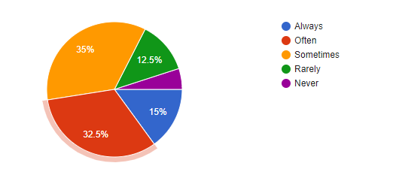

On the other hand, only 23% of individuals express a sense of familiarity or confidence regarding the warning signs and symptoms associated with mental health concerns in children and adolescents.

To address these consequences, early interventions, support systems, and trauma-informed care play a crucial role. Along with this from the survey 90% of the masses felt the need to educate students about mental health and have schools and colleges include mental health programs as part of their curriculum.

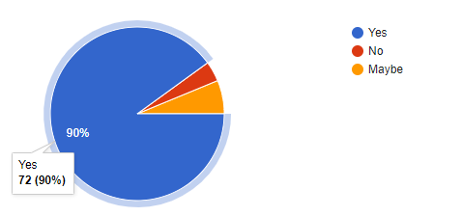

Not only that, people were also in favor of using technology, such as apps or online platforms for this purpose. Similarly, they also feel strongly for incorporating AI with such technologies.

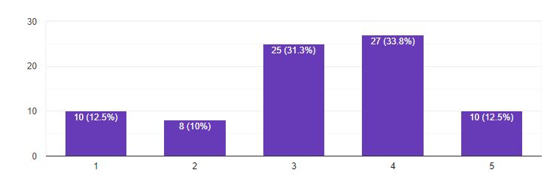

Limitations
However, it is important to note that AI-assisted applications for youth mental health are not a substitute for professional mental health care. They should be seen as complementary tools that can support early identification, prevention, and intervention efforts in schools, but should not replace the expertise and guidance of qualified mental health professionals.

Ethical considerations, such as data privacy, security, and appropriate informed consent should be obtained from students, teachers, and parents. Fairness and bias in AI algorithms should also be carefully monitored and addressed to prevent any potential disparities in the identification and treatment of mental health issues among different populations.

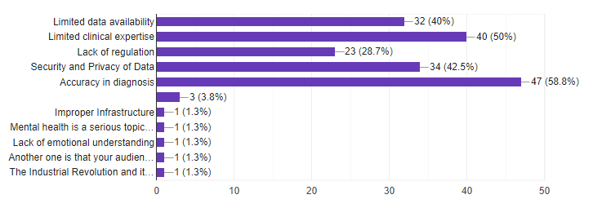

Conclusions
To conclude, the implementation of AI-assisted applications holds significant promise in revolutionizing the identification and management of mental health problems in children and adolescents within educational institutions. These applications can leverage the power of data analysis, machine learning algorithms, and personalized interventions to provide early intervention and prevention efforts. By identifying potential signs of mental health issues at an early stage, AI-assisted applications can facilitate timely intervention, preventing the worsening or chronicity of mental health problems. Moreover, these applications can bridge the gap in mental health services for children and adolescents by providing scalable and accessible support in schools where resources may be limited. This can lead to improved mental health outcomes and well-being for children and youth who may otherwise face barriers in accessing traditional mental health services. Further research, development, and implementation of AI-assisted applications can continue to advance the field of youth mental health, leading to more effective interventions, policies, and practices that promote mental health and well-being in this vulnerable population. Ethical considerations should also be carefully addressed to ensure the safety, confidentiality, and fairness of the services provided, and to protect the rights and well-being of the users. In general, the utilization of AI-assisted applications in the context of youth mental health presents significant opportunities for early intervention, prevention, and advancement of mental health support. Further endeavors in research, development, and implementation can effectively address the unfulfilled requirements of children and adolescents with mental health challenges within educational settings.

References

1) Shahraki-Sanavi F, Ansari-Moghaddam A, Mohammadi M, Bakhshani NM, Salehiniya H: Effectiveness of school-based mental health programs on mental health among adolescents. J Educ Health Promot. 2020 [https://www.ncbi.nlm.nih.gov/pmc/articles/PMC7377131/]

2) Siobhan Hugh-Jones, Kirsty Pert, Sarah Kendal, Simon Eltringham, Chris Skelton, Nahel Yaziji, Robert West: Adolescents accept digital mental health support in schools: A co-design and feasibility study of a school-based app for UK adolescents; 2022
[ https://doi.org/10.1016/j.mhp.2022.200241 ]

3) Richter A, Sjunnestrand M, Romare Strandh M, Hasson H. Implementing School-Based Mental Health Services: A Scoping Review of the Literature Summarizing the Factors That Affect Implementation: International Journal of Environmental Research and Public Health. 2022 [ https://doi.org/10.3390/ijerph19063489 ]

4) Judith Borghouts, Elizabeth V Eikey, Gloria Mark, Cinthia De Leon, Stephen M Schueller, Margaret Schneider, Nicole Stadnick, Kai Zheng, Dana B Mukamel, Dara H Sorkin: Understanding Mental Health App Use Among Community College Students: Web-Based Survey Study: J Med Internet Res 2021;23(9): e27745 [ https://www.jmir.org/2021/9/e27745 ]

5) Patricia Jessiman, Judi Kidger, Liam Spencer, Emma Geijer-Simpson, Greta Kaluzeviciute, Anne–Marie Burn, Naomi Leonard & Mark Limmer : School culture and student mental health: a qualitative study in UK secondary schools : BMC Public Health; 2022[https://bmcpublichealth.biomedcentral.com/articles/10.1186/s12889-022-13034-x ]

