Low-Profile Dual-Band Filtering Patch Antenna and its LTE band and ISM band Applications

Ch. Pavan Kumar V.M.S.N. *¹, H.D. Praveena ², G Ramakrishna Prasad³, S Harichandra Prasad⁴
Assistant Professor^{1,} Dept. of ECE, Bapatla Engineering College, Bapatla, India.
Assistant Professor^{2,} Dept. of ECE, Mohan Babu university, Tirupathi, India.
Associate Professor^{3,} Dept. of ECE, KLEF Deemed to be university, Vijayawada India.
Associate Professor⁴, Dept. of ECE, Adithya Engineering College, Kakinada, India

Abstract: This paper presents a low-profile dual-band filtering patch antenna element and its application to LTE (Long Term Evolution) band (L-band) and ISM band (S-band). The proposed model consists of two separate U-shaped patches in which the smaller patch is embedded in the larger patch. The multi-stub microstrip feed line is used to generate two resonant modes and the modes of the patches and multi-stub feed line can be controlled individually, the two operating bands can be tuned to desired frequencies. Here, a low-profile dual-band antenna element operating at 1.9GHz (LTE band) and 2.4GHz (WLAN) is implemented and it is simulated and verified by using the FEKO Tool. The Design can also be implemented for different frequencies and can be used for different applications.
Keywords: Patch antenna, Feed Scheme, Low-profile, Dual-band, Filtering, and FEKO Tool.
A.INTRODUCTION
Dual-frequency operation of antennas has become a necessity for many applications in recent wireless communication systems, such as GPS, GSM services operating at two different frequency bands. In satellite communication, antennas with low frequency ratio are very much essential. A Dual-frequency patch antenna with an inset feed can produce a dual-frequency response, with both frequencies having the same polarization sense with a low frequency ratio. It is also less sensitive to feed position, which allows the use of an inset planar field.
The two most important passive devices in the RF front end are the microwave filters and antenna. Antennas and microwave filters are mostly individually designed and connected by transmission lines which increase loss and circuit size, Integration of these two passive devices together reduce the impedance mismatch between them , losses will be reduced and size will be compact and hence overall performance of the system will be enhanced. Such a function will be multi-function module performing radiation and filtering simultaneously. Such integration is also made for the purpose of mastering the bandwidth which means the shaping of the frequency response.
In some designs, extra filtering circuits are inserted to the antenna feeding networks, causing extra insertion loss and degrading antenna gains. To solve this problem, filtering antennas without extra filtering circuits are proposed in [3]. However, the reported filtering antennas above are restricted to single-band operation.
Recently, some dual-band filtering antennas were reported [4]-[5]. In [4], a dual-band antenna and filter are designed separately and then cascaded together to form a dual-band antenna-filter module. In [5], two dual-band planar filtering antennas were proposed. The rectangular patch generates two orthogonal polarizations at the two bands in [4]. And the TM10 and TM30 modes of the patch were employed to enable dual-band operation in [5]. However, the operating frequencies of these two antennas cannot be controlled individually. In [6], a U-slot patch antenna is integrated with a dual-mode stub-loaded resonator through electromagnetic coupling. Good performance including harmonic suppression is obtained. However, it employs a 2-layer PCB structure and cannot meet the low-profile requirement.
In this paper, a dual-band filtering patch antenna with a novel feed scheme is proposed. This antenna consists of two separate U-shaped patches and a multi-stub microstrip feed-line. For size minimization, the smaller patch is embedded in the larger one. When the antenna operates at the lower band, the smaller patch is not excited but it functions as impedance matching circuit between the feed structure and the larger patch. It is found that the feed structure can also provide two resonant modes. Thus, the two operating bands can be tuned to desired frequencies by controlling the modes of two patches and feed structure.
B. ANTENNA ELEMENT MECHANISM
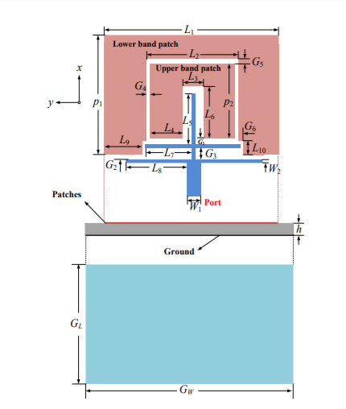
MICROSTRIP ANTENNA DESIGN

Fig1. Geometry of the Dual-Band filtering patch antenna
The layout of the dual-band filtering antenna is shown in Fig 1. The antenna consists of two separate U-shaped patches and a multi-stub feed line. It is fabricated on RT/Duroid 5880 substrate with relative permittivity of 2.2 and height of 1.575 mm. The larger and smaller U-shaped patches operate at the lower and upper frequency bands, respectively. For size reduction, the smaller patch is embedded in the larger one and they are fabricated on the top layer of the substrate, whereas the ground is printed on the bottom layer of the substrate.
Table1. List of dimensions of patch
L1 | 63.4 | L9 | 11.1
L2 | 35.6 | L10 | 2
L3 | 7.6 | G1 | 0.7
L4 | 13.7 | G2 | 0.6
L5 | 28.9 | G3 | 1.2
L6 | 30.2 | G4 | 0.3
L7 | 19.8 | G5 | 2.6
L8 | 27.3 | G6 | 2.8
W1 | 4.7 | W2 | 1
P1 | 49.95 | P2 | 40.03
G_{L} | 80 | G_{W} | 100

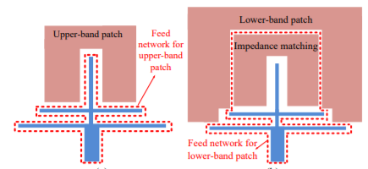
ANTENNA CONFIGURATION:
Fig 2. Feed scheme of the antenna
As shown in Fig. 2, a multi-stub microstrip line consiststing of a main transmission line and two transverse stubs is used to feed the inner U-shaped patch operating at the upper band and outer patch does not radiate but acts as the loading element. For the lower band, the multi-stub feed line and the inner patch are together used to feed the outer patch and the inner patch does not resonate but behaves as impedance matching circuit between the multi-stub feed line and the outer patch. Since the two U-shaped patches and feed structure can be individually designed, the operating bands can be controlled independently. The upper band can be independently controlled by tuning the parameters L7 and P2 whereas the lower band can be adjusted by tuning the parameters L8 and P1 with nearly no impact on the upper band. Such features will greatly facilitate the design of the proposed antenna.
The formulae for calculating width, length of the patches, effective relative permittivity is given from (2.1) – (2.5)
W = $\frac{c}{2*fr}$*$√\frac{2}{εr+1}$ ------------------------(2.1)
L_{eff} = $\frac{C}{2*fr*√εreff}$ -----------------------(2.2)
ε_{reff} = $\frac{εr+1}{2}$+$\frac{εr-1}{2}$(1+12×$\frac{h}{w}$)^{-1/2}-----------(2.3)
∆L=0.412×h×($\frac{ϵreff+0.3}{εreff-0.258}$)×$(\frac{\frac{w}{h}+0.264}{\frac{w}{h}+0.8}$) ----(2.4)
L=L_{eff} – 2*∆L -----------------------(2.5)
Where, w is the width of the patch;
L_{eff} is the effective length of the patch;
ꜫ_{reff} is the effective relative permittivity;

∆𝐿 is the length extension;

L is the actual length of Microstrip patch antenna.

Case (i) deals with the dimensions regarding with lower band patch i.e, the one operating at resonant frequency of 1.8 GHz.
Width of the patch, W1 = 65.88 mm
Length of the patch, p1 = 55.56mm
Case (ii) deals with the dimensions regarding with upper band patch i.e, the patch operating at resonant frequency of 2.4 GHz.
Width of the patch, W2 = 49.41 mm
Length of the patch, p2 = 41.36 mm
DUAL-BAND FILERING ANTENNA ELEMENT DESIGN USING FEKO TOOL
FEKO TOOL:
FEKO is a powerful 3D simulation package intended for the analysis of a wide range of electromagnetic problems. Applications include EMC analysis, antenna design, microstrip antennas and circuits, dielectric media, scattering analysis, cable modelling and many more.
SIMULATED RESULTS OF MICROSTRIP PATCH ANTENNA:
TOTAL GAIN:
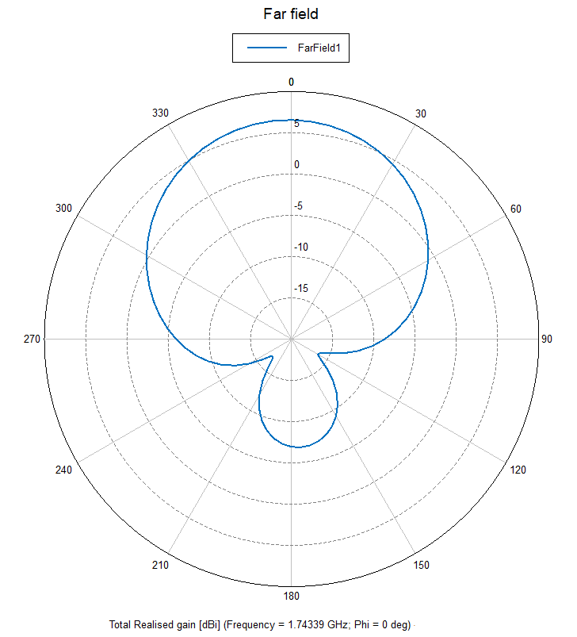
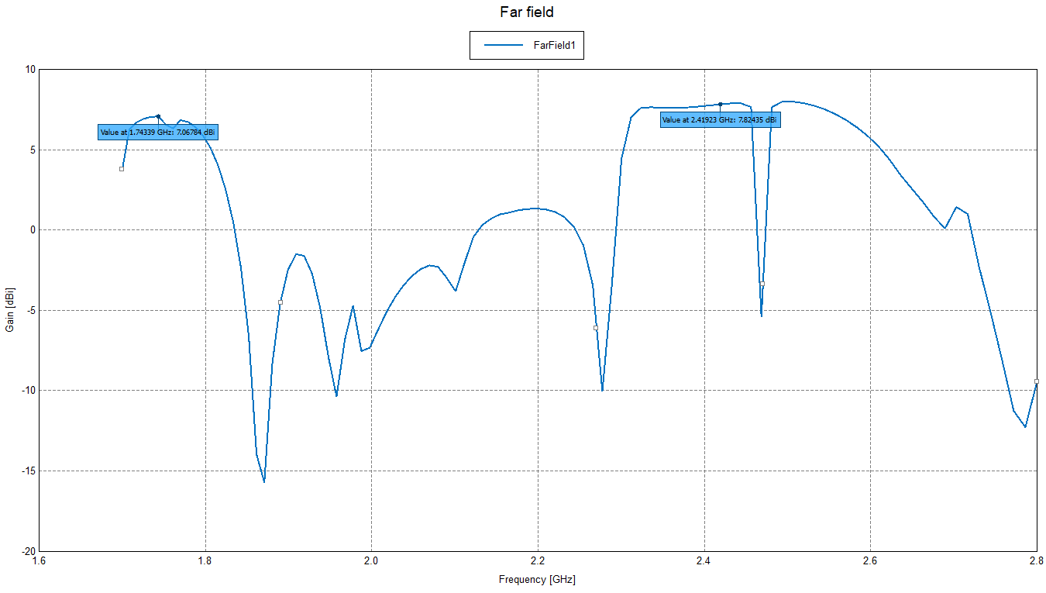
An antenna's power gain or simply gain is a key performance number which combines the antenna's directivity and electrical efficiency. Antenna gain is usually defined as the ratio of the power produced by the antenna from a far-field source on the antenna's beam axis to the power produced by a hypothetical lossless isotropic antenna, which is equally sensitive to signals from all directions.
Fig 3. Total gain of microstrip antenna

Realized gain:
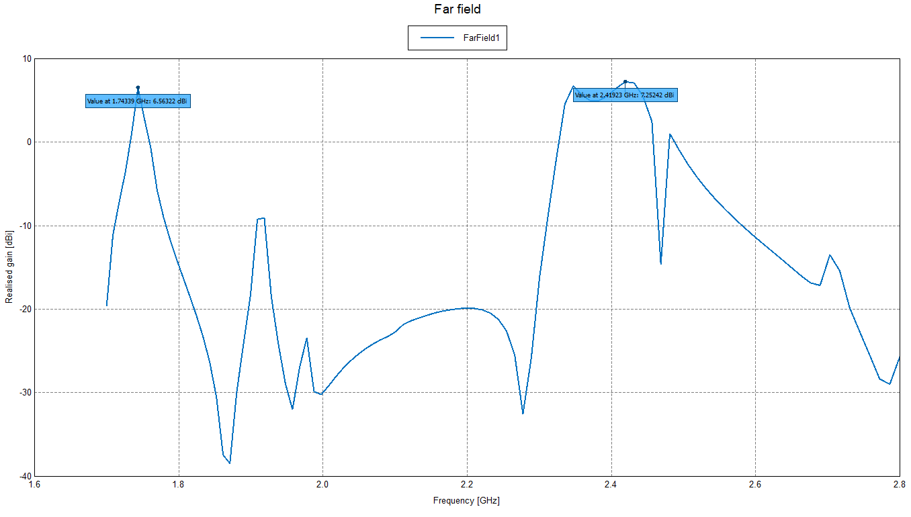
According to IEEE Standard 145-1993, Realized Gain differs from the above definitions of gain in that it is "reduced by the losses due to the mismatch of the antenna input impedance to specified impedance." Realized gain will be always less than Gain as observed in Fig 4.
Fig 4. Realized gain of microstrip antenna
RADIATION PATTERNS:
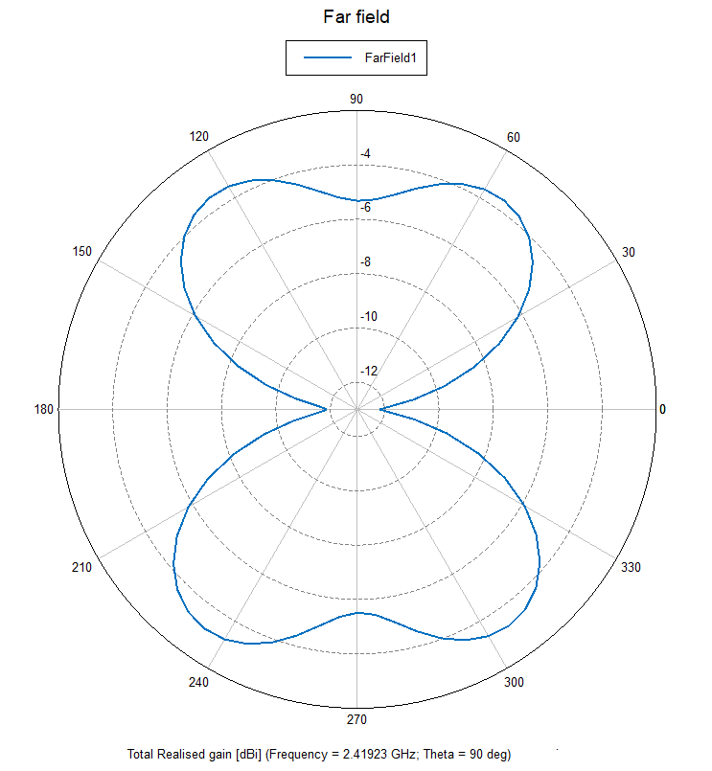
In the field of antenna design the term radiation pattern (or antenna pattern or far-field pattern) refers to the directional (angular) dependence of the strength of the radio waves from the antenna or other source. The far-field pattern of an antenna may be determined experimentally at an antenna range. The far-field radiation pattern can also be calculated from the antenna shape by computer programs such as FEKO as in Fig 5..
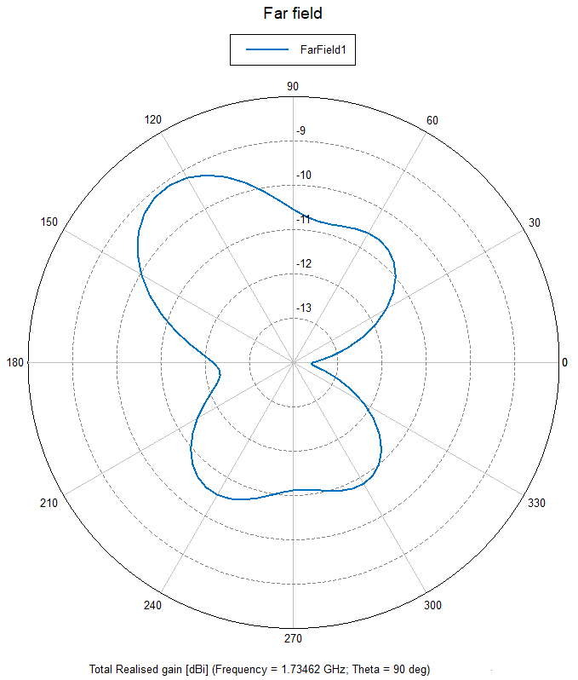
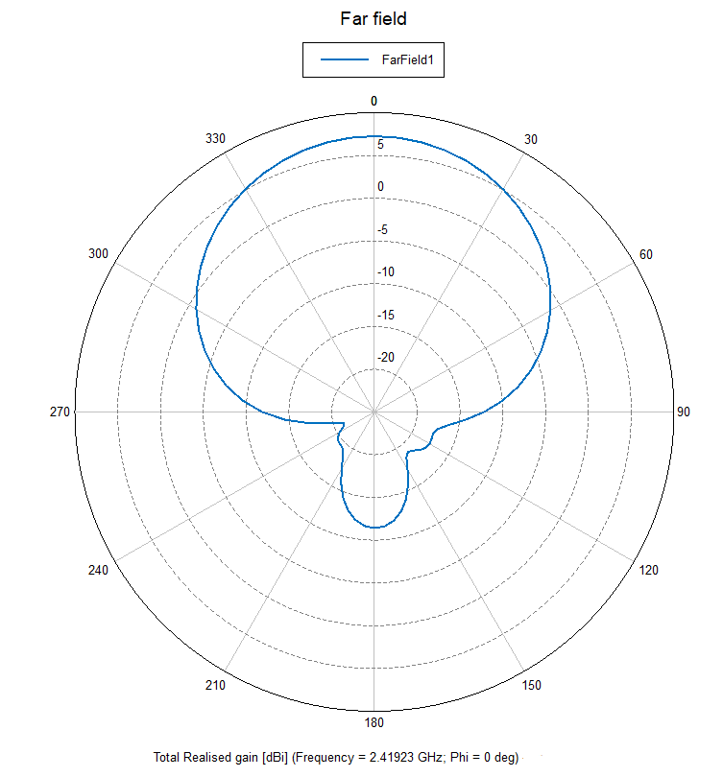
Fig 5. Radiation patterns of microstrip antenna
Current Distribution:
Current flowing in the patches gives an idea about how the electric charges are flowing in the patch and where the maximum current is flowing. In the Fig. 6 and Fig. 7, the current flowing patterns are observed at the resonant frequencies.
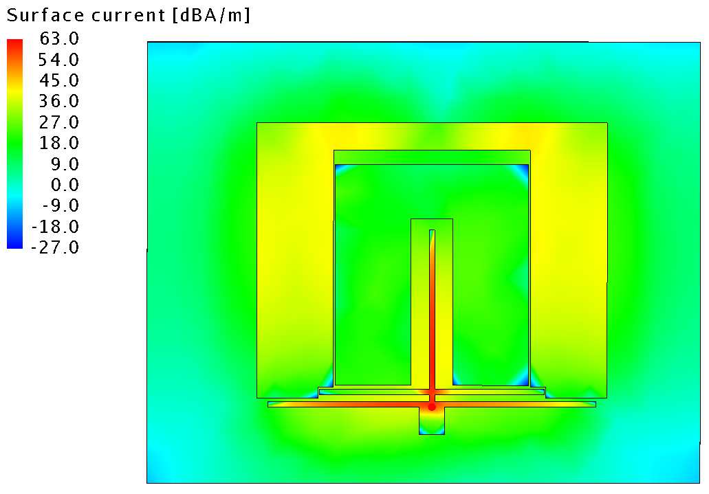
Fig:6 Current distribution at 1.74GHz
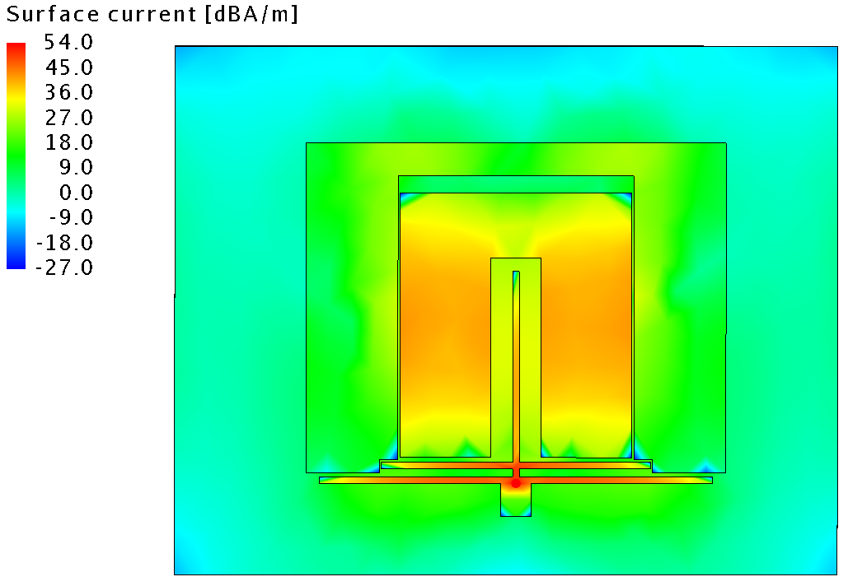
Fig 7: Current distribution at 2.41 GHz
If we observe the current flow in Fig 6 at 1.74 GHz the current flow is more in outer patch when compared to the inner patch. In the same fashion, in Fig 7, the current flow is more in Inner Patch than it is in Outer patch. This explains the filtering property of the designed antenna.
VSWR:
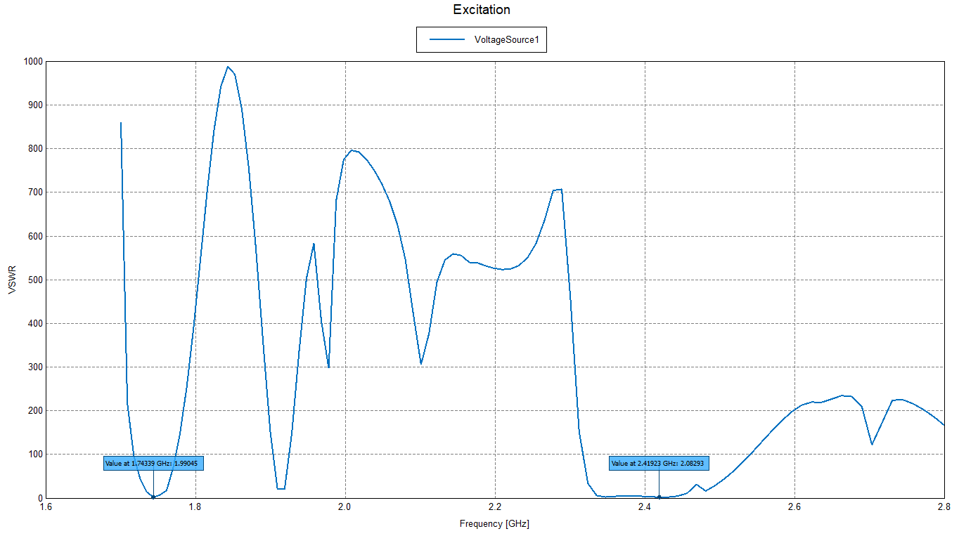
Standing wave ratio (SWR) is a measure of how efficiently RF power is transmitted from the power source, through the transmission line, and into the load.
Fig 8:VSWR of microstrip antenna
The value of VSWR should be less than or around 2. Higher the value of VSWR, more power will be reflected into the transmission line.
CONCLUSION
A low profile Dual-Band antenna is proposed which operats in LTE band (L-Band) and in ISM band (S-band) for WiFi application. The proposed antenna consists of two separate patchs embedded in one another for size reduction and these patches are excited by multi-stub feed line. The feed structure provides two resonant modes and the these resonant frequencies can be altered by varying the feed structure i.e, length of inner patch for upper frequency translation and varying length of outer patch lower frequency can be altered. The main advantage of this design is low profile and insertion loss of the feeding circuit is negligible.
REFERENCES:
- X. Y. Zhang, Y. Zhang, Y. M. Pan and W. Duan,"Low –Profile Dual-Band Filtering Patch antenna and Its Application to LTE MIMO System," in IEEE Transactions on Antennas and Propagation, vol. 65, no. 1, pp. 103-113, Jan. 2017.
- Dipali S. Yeole, Uday Pandit Khot “Reconfigurable Multiband Microstrip Patch Antenna Design for Wireless Communication Applications,” IEEE International Conference On Recent Trends In Electronics Information Communication Technology, May 20-21, 2016, India.
- X.-Y. Zhang, W. Duan, and Y.-M. Pan, “High-gain filtering patch antenna without extra circuit,” IEEE Trans. Antennas Propag., vol. 63, no. 12, pp. 5883-5888, Dec. 2015.
- D. Zayniyev, and D. Budimir, “Dual-band microstrip antenna filter for wireless communications,” in IEEE Int. Symp. Antennas and Propagation Digest, 2010.
- Y.-J. Lee, G.-W. Cao, and S.-J. Chung, “A compact dual-band filtering microstrip antenna with the same polarization planes,” in Proc. Asia-Pacific Microw. Conf., 2012, pp. 1178-1180.
- C.-X. Mao, S. Gao, Y. Wang, B. Sanz-Izquierdo, Z.-P. Wang, F. Qin, Q.-X. Chu, J.-Z. Li, W.-Gao, and J.-D. Xu, “Dual-band patch antenna with filtering performance and harmonic suppression,” IEEE Trans. Antennas Propag., In press.
- Yiping Zang, Sen Yang, Dan Feng, Chuanhan Zhan and Huiqing Zhai, “Varactor-tuned dual band filter-antenna for wireless applications,” 2016 Asia-Pacific International Symposium on Electromagnetic Compatibility (APEMC), Shenzhen, 2016, pp. 794-796.
- N. A. Murad, M. Esa and S. Tukachil, “Microstrip U-shaped dual-band antenna,” 2005 Asia-Pacific Conference on Applied Electromagnetics, pp. 110–113, Dec. 2005.
- B.Tlili, “Design of C-Slot Microstrip Patch Antenna for WiMax Application,” Loughborough Antennas & Propagation Conference, pp. 521-524, Nov.2009.
- Ramesh Garg, "Microstrip Antenna Design Handbook", Prakash Bhartia Publications, 2000 Edition.
- Yassin, R. A. Saeed and R. A. Mokhtar, "Dual-Band Microstrip Patch Antenna Design Using C-Slot for Wi-Fi and WiMax Applications," 2014 International Conference on Computer and Communication Engineering, Kuala Lumpur, 2014, pp. 228-231.

