IoT Enabled Health Monotoring System

Jayashree C Nidagundi
Dept. of Electronics & Communication Engineering
SDM College of Engineering & Technology, Dharwad, India
jayaparjwal@rediffmail.com

ABSTRACT
Health Monitoring system using IoT theme describes the collection and interoperation of patient data collected from the sensors from the hospitals through IoT Technology. The collected sensor data will support the doctor in the emergency situation for the betterment and improvement of patient health. The hardware platform to implement the proposed work consists of a sensors and Raspberry Pi 3 Model B+ equipped in a way to communicate with a doctor through the Cloud. This proposed idea will help doctors to know about the state of patient health and monitor anywhere in the world. In the findings of the proposed work, sensors gather the medical information of the patient that including patient’s heart rate, Body Movement, Pulse rate and Temperature, Humidity and Air quality of the room. This information is sent to the Internet and stored in a medical server. The doctor and patient can monitor the patient data from any place of the world through the provided Internet server anytime. Thus, the patient's health parameters are regularly monitored through the medical server to a doctor will help to make an effective diagnosis and almost accurate care can be given. The data collected through the IoT will help the patient to recover easily and also enhanced medical care can be given to the patients at a low cost.
Keywords—Internet of Things(IoT), Health Monitoring System, Sensors, Clouds etc.

INTRODUCTION

The Internet of Things is a rising topic of social, economic and technical significance. Internet of Thing using sensors, Processors and with accessories used for communication through the internet and becoming the constitutive part of the Internet, it is built with a suitable protocol which helps the interacting and communicating with each other and with the users respectively. This communication through the internet helps to find many applications which are developed based on IoT technology in which every physical object like sensor devices is connected to the internet. Healthcare plays a major role in the Internet of things which reduces the difficulty faced by patients and doctors. The IoT technology is increasing to support the cost and quality of patient life and also ensures the life span of patients with proper medication. In conventional health care undetected health problems can be solved through this IoT Technology thereby ensures healthcare services by maintaining a digital identity for each patient complication can be greatly reduced. The communication between the health sensors device with the computer which has the default ability to communicate with the server which makes the whole system cost reduction and the complexity of the system is also reduced. EASE OF USE. The motivational points need to be considered in an implementation of the proposed work:
- Real-time health monitoring systems using IoT can help doctors prioritize patients, and provide urgent care to those who are in the most danger thereby saving lives.
- More competent patient management can help utilize the resources of the hospital more wisely and save money.
- It is easy to use the system for patients and medical professionals.
- The remote health monitoring system is especially useful to monitor patients with chronic diseases. Most chronic diseases are incurable, so it is necessary to monitor the state of the patient while at home, and quickly respond if health indicators worsen.
- The Human Machine Interface is convenient and portable so it is very convenient for doctors to manage patients from the web server, and it is also very easy for patient’s guardians to monitor their family members health remotely.
Health monitoring using IoT is a technology to enable monitoring of patients outside of conventional clinical settings (e.g., in the home), which may increase access care right to the home. In addition, patients and their family members feel comfort knowing that they are being monitored to care and decrease healthcare delivery costs. This can significantly improve an individual's quality of life. It allows patients to maintain independence, prevent complications, and minimize personal costs. This system facilitates these goals by delivering and will be supported if a problem arises.

BACKGROUND

The health monitoring system consists of several sensors connected to a patient and they communicate the data through the processing unit. In [1], the patient monitoring system consist of Raspberry Pi as a data aggregator as well as a processing device, patient and doctor smart phone/computer are used as a monitoring system. The prototype developed in [2], detects the human motion such as walking, running or position within a closed room. It can classify activities like standing, sleeping, sitting, position. This system also tracks heart rate with the body temperature and humidity to determine the physical condition and abnormality. Md. Milon Islam et al.[3], proposed smart healthcare system to monitor the heart rate, body temperature, and some measures of hospital room’s condition such as room humidity, the level of CO and CO2 gases. This healthcare monitoring system uses Web User Interface for Data Processing. The paper[4], developed a prototype to monitor the health parameters of the patient i.e.; heartbeat and temperature using Raspberry Pi 3. They proposed continuous monitoring of the patient conditions and store the patient's data in the server using the IoT concept. Rameswari.R, Divya.N[5] describes the system which contains various existing and blooming technologies in the healthcare such as ECG, EMG monitoring through android apps, usage different protocols for transferring data such as MQTT, TCP/UDP, OCN authenticated mode, WLAN technologies etc. The paper[6] presents a health care monitoring system. for COVID-19 patients, high blood pressure patients, diabetic patients, etc., To support the health monitoring parameters specially in rural areas, the system will measure a patient’s body temperature, heartbeat, and oxygen saturation (SpO2) levels in the blood and send the data to a mobile application using Bluetooth. The main objective considered here is to increase affordability for regular people. Besides sustainability in the context of finance, patients will have easy access to personal healthcare. The authors presents an IoT-based system that will simplify the utilization of an otherwise complicated medical device at a minimum cost while sitting at home. A 95 percent confidence interval with a 5 percent maximum relative error is applied to all measurements related to determining the patient’s health parameters. The Module[7] implemented using ESP32 processor and two sensors effectively monitors the essential health parameters and information is sent to doctors/ nurses on mobile or computer system. Doctors can see the ECG, EEG waveforms & monitor other parameters of the patient on their computer screen sitting in their room and suggest medicines immediately in emergency. Information also received to cloud through Wi-Fi from the processor. The review paper[8] systematically list out the effectiveness, efficiency, privacy, data protection aspects of various health monitoring schemes. The authors brings out the challenges in the existing systems and provide some suggestions and recommendations for parameters of health monitoring. A smart health monitoring system[9] is developed using IoT technology specially to reach out for rural areas or village people especially in covid-19 situations. This system would help in identifying and early treatment of COVID-19 individual patients. The patient monitoring system[10] is designed using IoT platform, Arduino Mega 2560 and ESP8266 Wi-Fi Module and sensors. The system is able to detect the vital signs of patient using sensors and analyze it as per the patient age and privide alert message through android apps. Doctors will compare the vital information of particular patient with information stored in the cloud for necessary medication. The system[11] is developed to monitor the BP, HB, ECG information on LCD based on finger clip sensor information of the patient. Continuous monitoring is carried using IoT platform if any health parameter variations alert message sent to caretakers. The system[12] is highly used in emergency cases for suggesting medicines for patients using IoT platform. The review in [13] investigated many aspects for healthcare monitoring system including wheelchair monitoring, asthma monitoring, mood monitoring etc using latest technologies. An IoT based wearable health monitoring system[14], which remotely monitors the exact locations and health parameters of individuals of quarantined in real time. The system is built using optoelectronic and electronic components. The study of all the literature leads to formation desired requirements of health monitoring system using latest technologies aiming at:
- Implementing wired communication becomes too difficult, fragile and expensive to be feasible. A wireless sensor network makes the system low cost, have quick installation times, and high system reliability
- In traditional System, Patient must report to the Doctor every three days to check up so Doctor can treat well. But real-time doctor not able to check the patient health status.
- Health monitoring system is Adopted to provide Patient health care data on Internet/Android Mobile, with the help of this data doctor can easily monitor the patient health parameter. It helps Patient in emergency time.
- Evaluating the effectiveness of the Healthcare systems.
- All the sensors can monitor simultaneously and sends the results to the authenticated person. Provide medical assistance according to the data received i.e., heart rate, pulse rate etc.

METHODOLGY
Continuous online patient and patient’s room condition monitoring is the main idea of the proposed system. The block diagram of health care monitoring system is shown in Fig.1, consist of different hardware and software blocks. The explanation of all the required hardware blocks and embedded software is described in subsequent sub sections. The input sensors sense the change and then information is sent to Raspberry board for evaluation. Then results are continuously updated onto the cloud account. Doctor can see the information available with him on his screen and immediately and suggest the treatment to patient. Both doctor and patient are connected to internet.

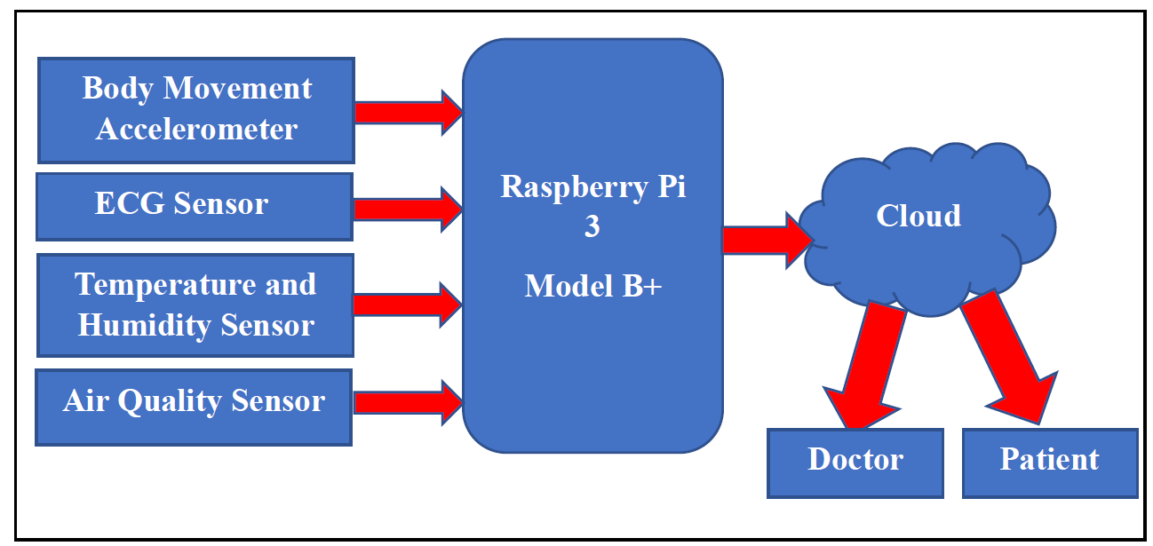

Fig. 1 Block Diagram of IoT Enabled Health Monitoring System

Hardware Reqiurement of Proposed Syatem.
- Raspberry pi 3 Model B+
The Raspberry Pi is a tiny computer about the size of a deck of cards. It uses what's called a system on a chip, which integrates the CPU and GPU in a single integrated circuit, with the RAM, USB ports, and other components soldered onto the board for an all-in-one package. It doesn't have onboard storage, but it has an SD card slot you can use to house your operating system and files. The Raspberry module used is shown in Fig.2.
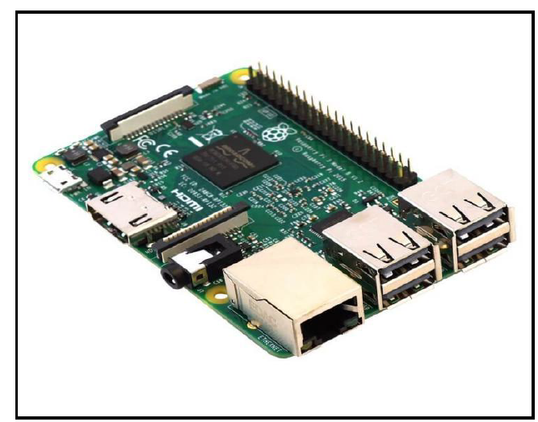

Fig. 2 Raspberry Pi-3B Model

- ECG Sensor:
The ECG sensor as shown in Fig.3, record the electrical activity of the heart over a period of time using electrodes placed on the skin. These electrodes detect the tiny electrical changes on the skin that arise from the heart muscle's electrophysiological pattern of depolarizing and repolarizing during each heartbeat.

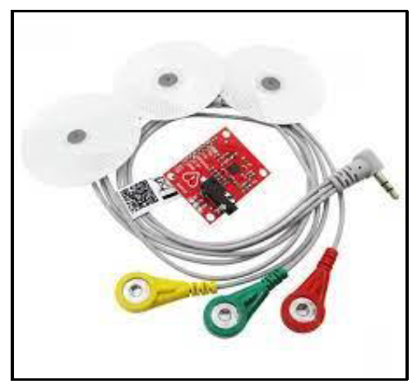
Fig.3 ECG Sensor

- Temperature and humidity-based sensor:
DHT11 module shown in Fig.4 is used for detecting Temperature and respective humidity of the room. It is a low-cost digital sensor. This sensor can be easily interfaced with any micro-controller such as Raspberry Pi to measure humidity and temperature instantaneously. DHT11 humidity and temperature sensor is available as a sensor and as a module. DHT11 is a relative humidity sensor. To measure the surrounding air this sensor uses a thermistor and a capacitive humidity sensor.
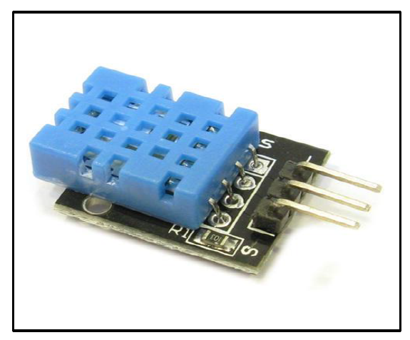
Fig.4 Temperature and Humidity Sensor
- Air Quality Sensor:
The MQ2 Gas Sensor is an electronic sensor used for sensing the concentration of gases in the air such as LPG, propane, methane, hydrogen, alcohol, smoke and carbon monoxide. MQ2 gas sensor is also known as chemi-resistor. It contains a sensing material whose resistance changes when it comes in contact with the gas. Air quality sensors are devices used to detect contaminants in the air. This includes particulates, pollutants and noxious gases that may be harmful to human health. The air quality sensor is shown in Fig.5.

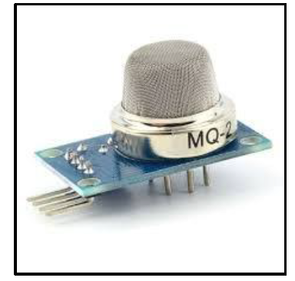
Fig.5 Air Quality Sensor
- Body Movement Accelerometer:
The ADXL 345 module shown in Fig.6 is used for detecting the moving direction. By using this sensor module, human movement can be observed in which direction it moves like Left or Right.
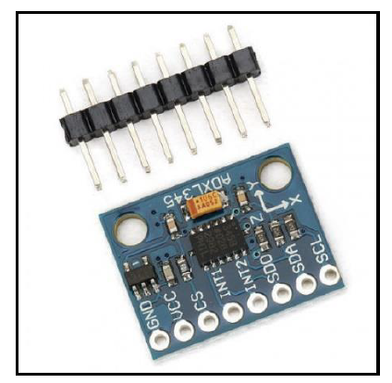
Fig.6 Body Movement Detection Sensor

Software Requirement

ThingSpeak is an open-source cloud storage pictorially shown in Fig.7, allows users to communicate with an Internet enabled devices. It facilitates data access, retrieval and logging of data by providing an API to both the devices and social network websites. It is IoT Cloud platform where you can send sensor data to the cloud. You can also analyze and visualize your data with MATLAB or other software, including making your own applications.
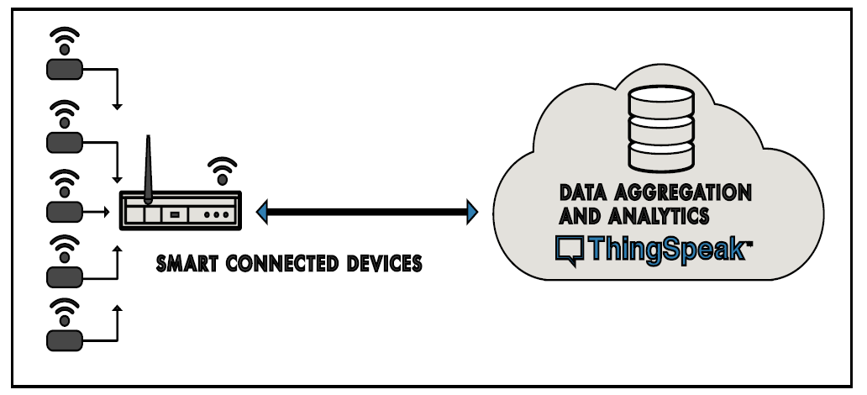
Fig.7 Thing Speak Cloud Connectivity with Smart Devices
The healthcare monitoring system utilizes the three-stage architectural features, namely
Sensor Module , Data Processing and Module Web User Interface .The sensors are wired which are used to collect data from the patient’s body and the environment by gathering physiological signs. The collected data are then processed in raspberry pi 3 B+ module. The collected data is then stored in cloud through ThingSpeak web application. ThingSpeak is used for the graphical interpretation, and display of collected results. The Doctors and patients can access the details of collected data by logging on to the web application. The prototype of the proposed model is described in Fig.8
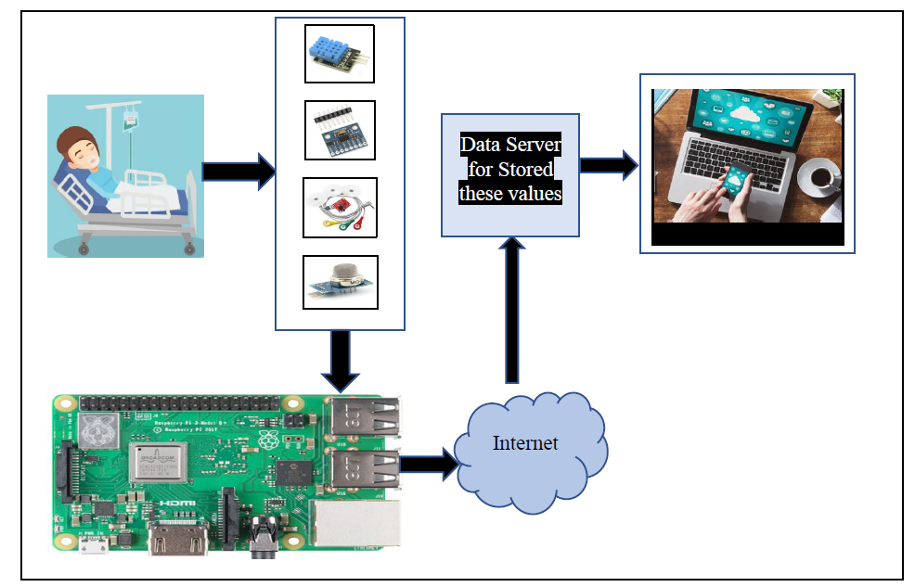
Fig.8 Prototype Model of Proposed work

RESULTS

This system is enhanced to automatically collect the Temperature and Humidity, Body Movement, Air Quality and ECG Sensors. The output of a critical patient and the collected data is then processed in Raspberry pi 3 model B+. The processed data will be sent to cloud via Internet and both the Doctors and Patients relatives are able to access the data by logging on to the web application. The results of Temperature and Humidity monitoring are shown in Fig.9.

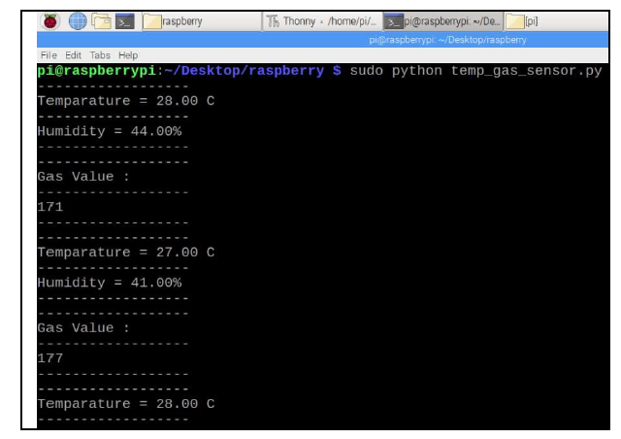
Fig.9 Readings obtained with interfacing Temperature and Gas Sensors

Similarly the monitoring of body movements of bed ridden patients positions are also recorded on the screen as shown in Fig.10.
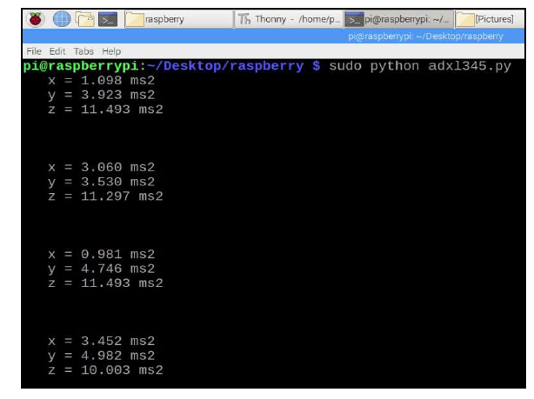
Fig.10 Readings obtained with interfacing Position Sensor

The proposed prototype helps the doctors to arrive at quick decisions if the condition of patient is very critical. The results are also continuously sent to the cloud storage via internet. Monitoring system on the ThingSpeak storage are shown in Fig.11.
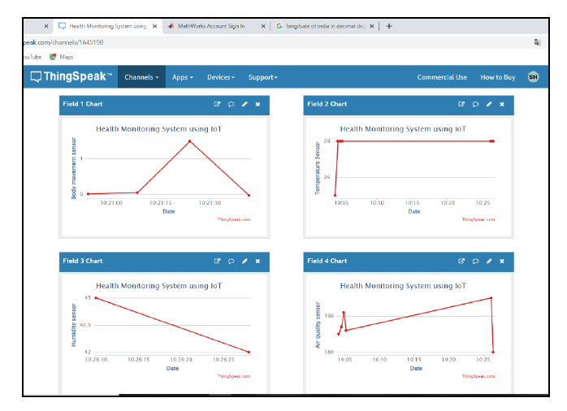
Fig.11 Sample Data Storage on Cloud

Real-time health monitoring systems using IoT can help doctors prioritize patients, and provide urgent care to those who are in the most danger thereby saving lives. More competent patient management can help utilize the resources of the hospital more wisely and save money. It is easy to use the system for patients and medical professionals. The remote health monitoring system is especially useful to monitor patients with chronic diseases. Most chronic diseases are incurable, so it is necessary to monitor the state of the patient while at home, and quickly respond if health indicators worsen. This prototype Human Machine System is convenient and portable so it is very convenient for doctors to manage patients from one app, and it is also very easy for patients to monitor their own health by wearing a lightweight device like a bracelet, watch, ear rings etc.

CONCLUSION & FUTURE WORK
The system introduced smart healthcare to monitor the basic important signs of patients like heart rate, body movements, and some measures of hospital room’s condition such as room temperature, room humidity and the air quality of room. Authentic medical staff can view and track the data in real-time even though the patients are outside of the hospital. The system is very useful in the case of infectious disease like a novel coronavirus (COVID-19) treatment. The developed system will improve the current healthcare system that may protect lots of lives from death. In the future, IoT health monitoring will provide increased independence and mobility for elderly, sick, and physically or mentally disabled patients and reduce stress for family and doctors who can be alerted and react immediately as soon as issues arise. The proposed system can be enhanced to detect and collect several anomalies for monitoring purpose such as brain signal monitoring, tumour detection etc. The system can be designed further to send alert messages in emergency situation. The situation becomes worst when a patient is suffering from dementia. The wearable devices detect the patient’s condition along with sending information to the caretaker too. The information can either be given through text or email while alerting the doctors too. In medical emergencies, people of any age require immediate help from any source of help. Seeing how beneficial these IoT monitoring devices are- in future, the number of homes will have a sensor network. These networks will monitor each and every activity of a patient with the sensor of sending in alerts in an emergency. IoT monitoring device that keeps track of a patient’s prescribed medicine routine. The technology can be proven best for patients with dementia or Alzheimer’s.

REFERENCES

- Dr. E.N. Ganesh, “Health Monitoring System using Raspberry Pi and IOT, ” Oriental Journal of Computer Science and Technology An International research journal of Computer Science and Technology published on 07 Mar 2019
- Prabu K, Ravikumar T, “Arduino and Raspberry Pi Based Efficient Patient Monitoring System, ” International Journal of Engineering Research & Technology (IJERT) ISSN: 2278-0181 Published By, www.Ijert.Org ICETET - 2016 Conference Proceedings
- Md. Milon Islam, Ashikur Rahaman, Md. Rashedul Islam, “Development of Smart Healthcare Monitoring System in IoT Environment,” Springer Nature Singapore Pte Ltd 2020
- Mohd Abdul Muqeet, Mohammed Umair Quadri, “IOT Based Patient Monitoring System Using Raspberry Pi,” IJRECE VOL. 7 Issue 2 (April- June 2019)
- Rameswari.R, Divya.N, “Smart Health Care Monitoring System Using Android Application: A Review,” International Journal of Recent Technology and Engineering (IJRTE) ISSN: 2277-3878, Volume-7 Issue-4S, November 2018
- Mohammad Monirujjaman Khan,¹Turki M. Alanazi,²Amani Abdulrahman Albraikan,³and Faris A. Almalki, " IoT-Based Health Monitoring System Development and Analysis, "International Journal on Security and Communication Networks, Special Issue . 2022
- Sangeethalakshmi K., Preethi Angel S., Preethi U., Pavithra S., Shanmuga Priya V.,"Patient health monitoring system using IoT, " Vol.28, PP. 2228-2231, https://www.sciencedirect.com/science/article 2023
- Suliman Abdulmalek,^{1,2} Abdul Nasir,^{1,*} Waheb A. Jabbar,³ Mukarram A. M. Almuhaya,¹ Anupam Kumar Bairagi, Md. Al-Masrur Khan, and Seong-Hoon Kee, "IoT-Based Healthcare-Monitoring System towards Improving Quality of Life: A Review, " article National Library of Medicine National centre for Biotechnology Information PubMed central , October,2022
- Vaneeta Bhardwaj ¹, Rajat Joshi , Anshu Mli Gaur, " IoT-Based Smart Health Monitoring System for COVID-19 ," National Library of Medicine National centre for Biotechnology Information PubMed central , Jan,2020
- Nor Shahanim Mohamad Hadis, Muhammad Nazri Amirnazarullah, Muhammad Mahdi Jafri and Samihah Abdullah, " IoT Based Patient Monitoring System using Sensors to Detect, Analyse and Monitor Two Primary Vital Signs, " Journal of Physics,2020
- Yedukondalu Udara, Srinivasarao Udara, Harish H M,Hadimani H C, " HEALTH MONITORING SYSTEM USING IOT, " International Journal of Engineering and Manufacturing Science, 2018 , ISSN 2249-3115 Volume 8, Number 1, pp. 177-182,
- C.Senthamilarasi, J.Jansi Rani, B.Vidhya , H.Aritha, " A SMART PATIENT HEALTH MONITORING SYSTEM USING IOT," International Journal of Pure and Applied Mathematics, Vol. 119 No. 16, pp 59-70,2018
- Bikash Pradhan,¹Saugat Bhattacharyya,²and Kunal Pal," IoT-Based Applications in Healthcare Devices," Journal of Healthcare Engineering,2021
- ] Ju-Yu Wu, Yuhling Wang , Congo Tak Shing Ching, ,Hui-Min David Wang , Lun-De Liao,"IoT-based wearable health monitoring device and its validation for potential critical and emergency applications," Front. Public Health, 16 June 2023

