ASSESSMENT OF WATER QUALITY INDEX USING GIS METHOD IN KALUGUMALAI, THOOTHUKUDI
* Abinaya R^{1,2}, Antony Ravindran A¹, P.Mohana³, S.Muthusamy¹, Antony Alosanai Promilton A¹
¹PG and Research Department of Geology, V.O.Chidambaram College, Thoothukudi, Tamilnadu, India.
²(Reg.No: 21212232222013) Research scholar Manonmaniam Sundaranar university, Tirunelveli, Tamilnadu, India
³Centre for Remote Sensing and Geoinformatics, Sathyabama Institute of Science &amp; Technology, Chennai-600119, Tamil Nadu, India
ABSTRACT
The present study aimed to attempt the subsurface groundwater quality contamination and utility for agriculture purposes. The scientific approach to subsurface groundwater quality study was identified with cation-anion parameters and WHO standards. The collected samples were systematically analyzed in the geochemistry lab and obtained over the limit of Cl⁻, So⁻⁴ parameter. The rock-water interaction plays a major role to control water quality. The infiltration of water moves through subsurface soil and rock-dissolved chemical constitutes reflect in the geochemical studies. The GIS techniques are applied to the WQI interpolation map display clearly seen in geochemical distribution and variation. In this study, much more amount of clay is enriched to continuous rainfall and evaporation processes to form the calcrete or kankar rock formation. The calcrete is a much more amount of Cl⁻ enrich reflects in the geochemical data.
Keywords: Geochemistry, WQI, GIS, Groundwater, Kalugumalai.

INTRODUCTION:
The factors influencing water quality, particularly focusing on comparing surface water and groundwater. Groundwater is generally considered to be of superior quality due to the natural purification processes it undergoes while percolating through the soil and rock types column and vadose zone. These processes effectively remove impurities and contaminants from the water, contributing to its higher quality compared to surface water. The final composition of groundwater, however, is not solely determined by the percolation processes (Antony Alosanai Promilton et. al., 2022). It is influenced by two crucial factors: the mineralogical composition of the aquifer framework through which the groundwater flows and the contact time or age of the water within the aquifer. Different aquifers consist of distinct minerals that can introduce specific elements into the groundwater as it interacts with these geological formations. It is called rock water interaction. Additionally, the length of time the water remains in contact with the aquifer materials allows for various chemical reactions to occur, which further shape the chemical constituents of groundwater.
Mathess (1982) extensively studied the processes affecting groundwater quality and identified several key mechanisms that play a significant role. These processes include dissolution, hydrolysis, precipitation, adsorption, ion exchange, oxidation, reduction, and bio-chemical mediated reactions. Each of these reactions contributes to altering the chemical composition of the water, either by adding or removing certain substances. The research also highlights specific responses that control the chemistry of groundwater. Groundwater chemistry primarily depends on the mineral composition and the formation it traverses, resulting from interactions between rocks and water. While evaporation, concentration, and precipitation can also influence groundwater's chemical makeup, the dominant process is rock-water interaction. Solid phases, including inorganic and organic matter, serve as the primary sources and sinks of dissolved constituents in groundwater ( Elango, L., & Kannan, R. 2007 Vinoth Kingston et.al.,2021). The dissolution of minerals like calcite and dolomite, along with the subsequent precipitation of calcite, affects the levels of calcium and magnesium ions in the water. Cation exchange within the aquifer introduces various ions, such as sodium and potassium, altering the overall chemical properties. The oxidation of pyrite and organic matter releases iron and other compounds, while the reduction of oxygen, nitrate, and sulphate produces sulphide, impacting water quality. Moreover, the reductive production of methane, dissolution of minerals like gypsum, anhydrite, and halite, and incongruent dissolution of primary silicates leading to the formation of clays are essential processes that further shape groundwater composition. By delving into these processes and their contributions to groundwater quality, this research aims to provide valuable insights for effective water resource management and environmental conservation. Understanding the complexities of these reactions will enable us to better comprehend groundwater systems and implement measures to preserve and protect this vital natural resource.
Study Area
Kalugumalai is a small town located in the Thoothukudi district of Tamil Nadu, India. The region experiences a tropical climate with hot and humid conditions prevailing throughout most of the year. The average annual temperature ranges from around 25°C to 35°C, and the monsoon season occurs from June to September, with the heaviest rainfall in October and November. The region receives a significant amount of rainfall during the monsoon, which plays a vital role in replenishing water sources and supporting agricultural activities. Due to its proximity to the coast, Kalugumalai experiences high humidity levels, especially during the monsoon. Geologically, the region is characterized by ancient granitic and metamorphic rocks, including granite, gneiss, and charnockite. These hard rock formations have shaped the landscape, contributing to the hilly terrains and limiting the occurrence of alluvial soils. Groundwater availability is influenced by fractures and fissures in the hard rocks, which act as pathways for water storage and movement. The cultural and historical heritage of Kalugumalai is deeply tangled with its geology, as the hills and rock formations have been utilized for various historical monuments and sculptures, making it a significant archaeological site of cultural and religious importance. The fertile soils and access to water from the nearby Tamirabarani river and groundwater sources support agriculture in the region, with crops such as rice, millets, pulses, cotton, and vegetables being cultivated by the local communities.
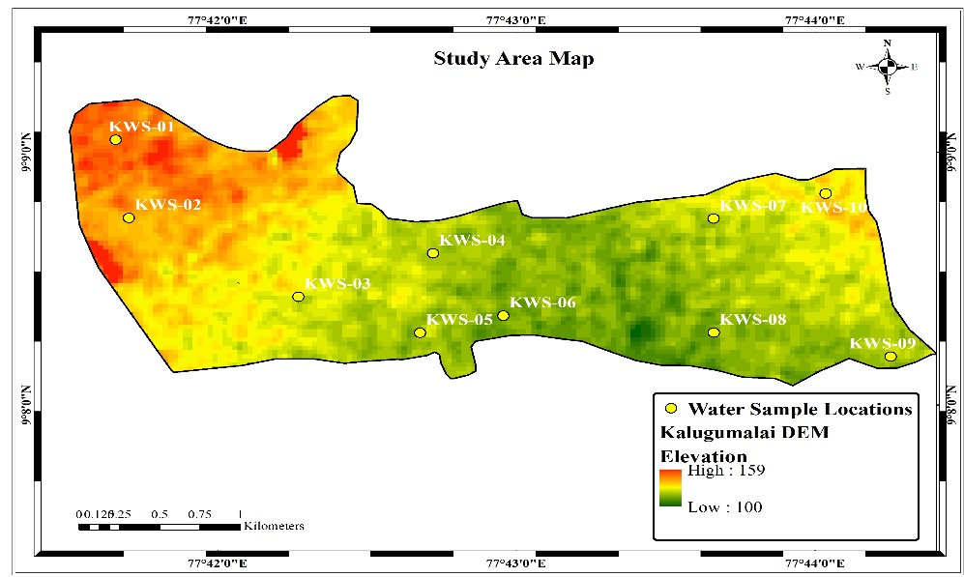
Fig-1 Water sample Locations in the study area

Materials and Methods:
Totally 10 water samples were collected from the Kalugumalai region and systematically analyzed in the geochemistry lab. Cation and anion values were obtained and validated with WHO standards.
WATER QUALITY INDEX (WQI):
The study employed the method of weighted arithmetic Water Quality Index to assess the water quality index (WQI) of the groundwater samples collected from various stations in the Kalugumalai area. Notably, Kalugumalai groundwater serves as a vital water source for the entire Thoothukudi district. However, due to the recent water crisis in the region, there is an urgent need to evaluate the quality of the river's water. To achieve this, 10 samples from different stations (FIG -1) along the Kalugumalai village were analyzed for various physical and chemical parameters, including Ca²⁺, Mg²⁺, Na⁺, K⁺, Cl⁻, SO₂⁻⁴, HCO₃⁻, TDS, pH, and EC. These parameters play a crucial role in determining the overall water quality and its suitability for various purposes. By calculating the WQI, we aim to gain insights into the current state of water quality in the region, which can inform decision-making and guide appropriate measures for sustainable water resource management and conservation efforts.

Parameter | Min | Max | Avg | Std.dev
pH | 6.7 | 8.2 | 31.05 | 0.24
EC (µS/cm) | 342 | 2332 | 1053.75 | 675.53
TDS (mg/l) | 218 | 1478 | 670.55 | 433.48
Ca²⁺ (mg/l) | 69 | 231 | 142.65 | 52.57
Mg²⁺ (mg/l) | 9 | 42 | 23.45 | 9.93
Na⁺ (mg/l) | 45 | 117 | 79.65 | 23.91
K⁺ (mg/l) | 71 | 183 | 129.5 | 34.11
HCO₃⁻ (mg/l) | 229 | 723 | 490.6 | 156.32
Cl⁻ (mg/l) | 212 | 376 | 284.55 | 48.83
So₄²⁻ (mg/l) | 238 | 487 | 352.55 | 87.67

GIS prediction maps using the interpolation method:
The Q-GIS 3.8.2 software is utilized to create water quality index maps for seven parameters. To generate the interpolation maps for each parameter, we employed the inverse distance weighted (IDW) interpolation method. This technique is based on the shape files' maps of the river boundary, reflecting the first law of Waldo Tobler in geography (Hengl 2009). The IDW method relies on accurate local deterministic interpolation, giving more weight to points closer to the prediction location than those farther away (Chang2006; Panhalkar and Jarag 2016). This approach allowed us to produce interpolation maps that represent the variation of low, medium, and high values for each parameter between the selected points or locations in the Thamirabarani River. The resulting maps offer valuable insights into the spatial distribution of water quality, aiding in the assessment of pollution levels and potential environmental impacts. These visual representations can inform decision-makers and stakeholders in implementing targeted measures to preserve and improve the water quality in the Thamirabarani River, contributing to sustainable water resource management and conservation efforts.
RESULT AND DISCUSSION
This study focuses on conducting morphological investigations and geochemical mapping of Kalugumalai groundwater, utilizing the Q-GIS interpolation method to determine the Water Quality Index (WQI). Water pH is a crucial parameter that indicates the acidity or alkalinity of water, making it significant for both drinking and irrigation purposes. It plays a vital role in determining water quality as it impacts the solubility of metals, water alkalinity, and hardness (Osibanjo et al., 2011). In our study, the pH values of the river waters ranged from 6.7 to 8.2, signifying the alkaline properties of the water samples collected from the rivers. These findings provide valuable insights into the overall condition of the water bodies and can aid in making informed decisions regarding water usage and management for various applications.
During the dry period, the electrical conductivity (EC) values ranged from 342 to 2332 μS/cm. The higher EC values observed are directly associated with elevated concentrations of dissolved solids in the water. Moreover, the presence of contaminants can contribute to increased EC levels in surface waters. Understanding these EC variations is essential for assessing water quality and potential environmental impacts, providing valuable information for effective water resource management and conservation strategies.
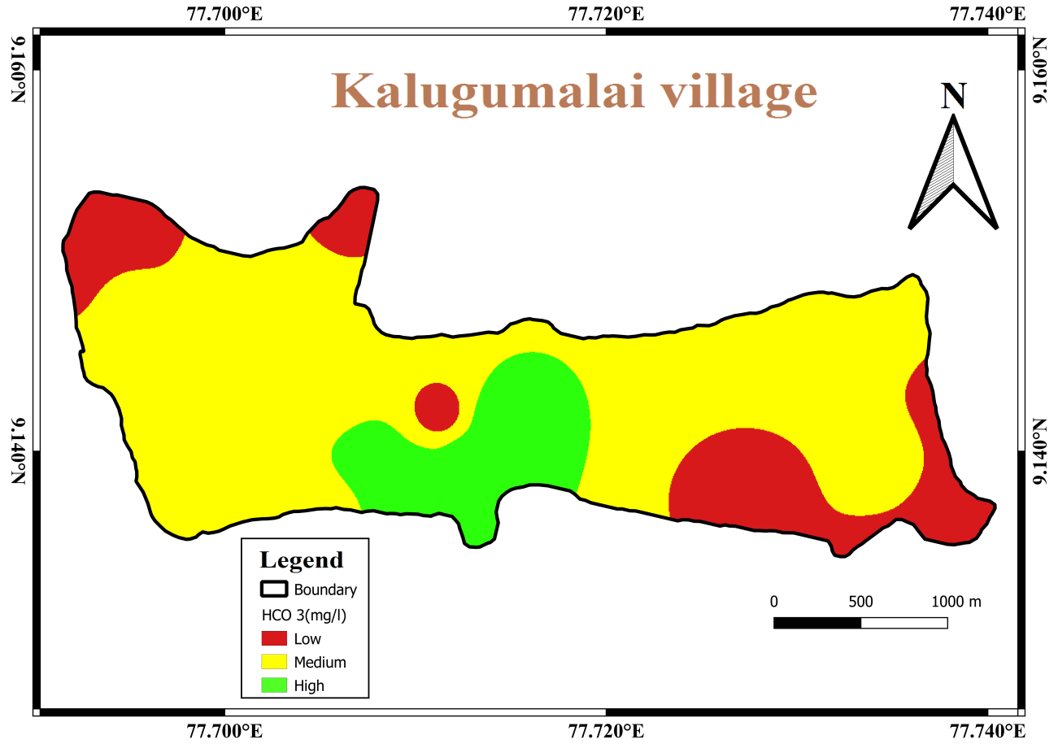
Fig-2 Spatial interpolation of HCO₃⁻
Table 1, displays the variation in bicarbonate (HCO₃⁻) concentrations in water, ranging from 229 to 723 mg/l. Bicarbonate is found in significant quantities, often associated with carbonate ions. The main contributors to carbonate weathering and the release of bicarbonate into the water are carbonate-rich rocks, including crystalline limestone, dolomitic limestone, calc granulite, and kankar (a lime-rich weathered mantle overlying carbonate rocks). These rocks act as major sources of dissolved carbonates, which are then added to the water through processes such as irrigation, rainfall infiltration, and freshwater movement (Subramani et al., 2009). Understanding the bicarbonate content and its sources is crucial for assessing water quality and its suitability for various purposes, especially in areas influenced by these carbonate-rich geological formations.
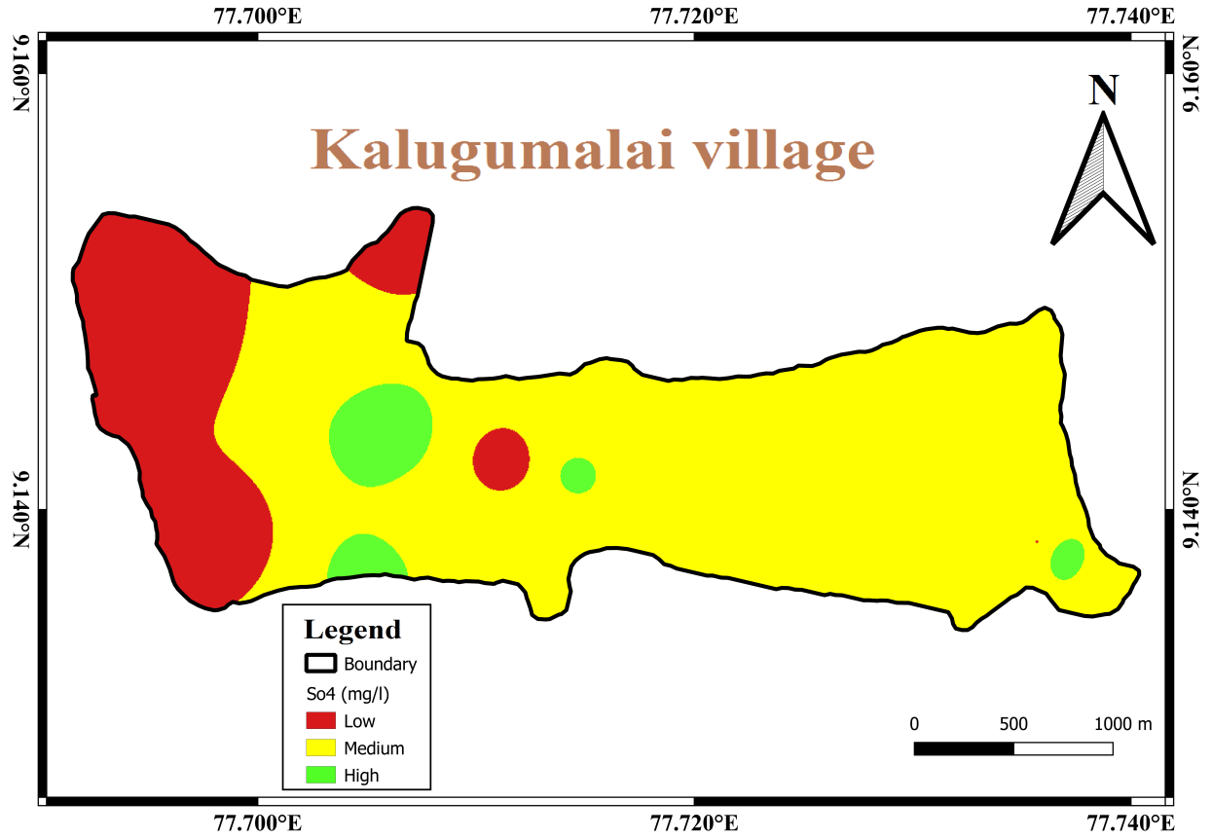
Fig-3 Spatial interpolation of So²⁻₄
The sulfate (SO₂⁻⁴) concentration exhibited a range from 238 to 487 mg/l. The primary sources of sulfate are atmospheric deposition, sulfate-containing fertilizers, and bacterial oxidation of sulfur. Consequently, sulfate may originate from the decomposition of organic matter in weathered soils, leaching of sulfate from fertilizers, and human-related factors, such as sulfuric salts in domestic wastewater (Bahar and Yamamuro, 2008; Varol and Davraz,2015). Understanding the sources and variations in sulfate levels is essential for assessing water quality and identifying potential impacts from both natural and anthropogenic influences. This knowledge can aid in implementing appropriate measures for sustainable water management and protecting water resources from the detrimental effects of sulfate pollution.
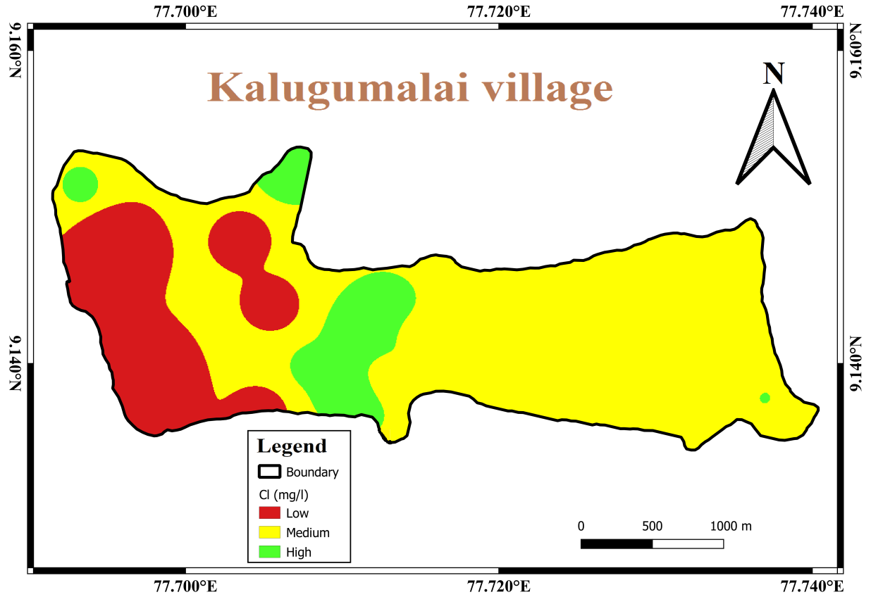
Fig-4 Spatial interpolation of Cl⁻
The fluctuation in chloride (Cl⁻) concentrations in water due to kankar and calcite rock having rich Cl⁻ concentrations from the origin of clay formation, ranging from 212 to 376 mg/l. Elevated levels of chloride ions in water can be attributed to sewage waste pollution and the leaching of saline residues in the soil, along with potential impacts from human activities. The locations with the highest bicarbonate, chloride, and sulfate values were identified, and these increases in anion contents were found to be linked to the discharge of domestic and industrial wastewater (Chatterjee et al.,2010). Identifying and understanding the sources of these anions are crucial for assessing water quality and taking appropriate measures to mitigate pollution and protect water bodies from adverse effects on both natural ecosystems and human health.

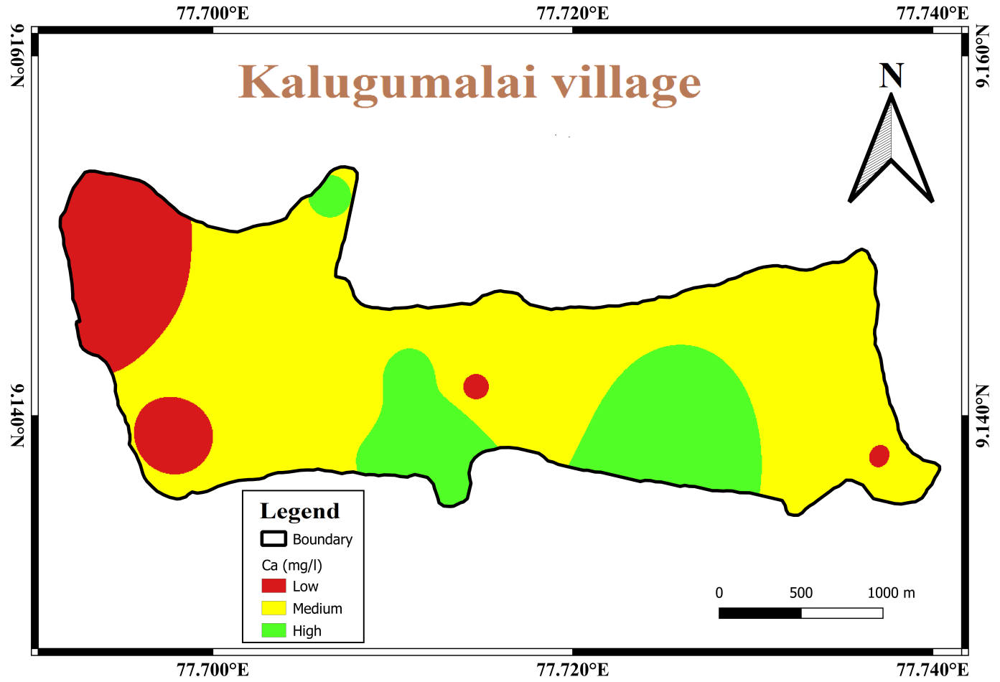
Fig-5 Spatial interpolation of Ca²⁺
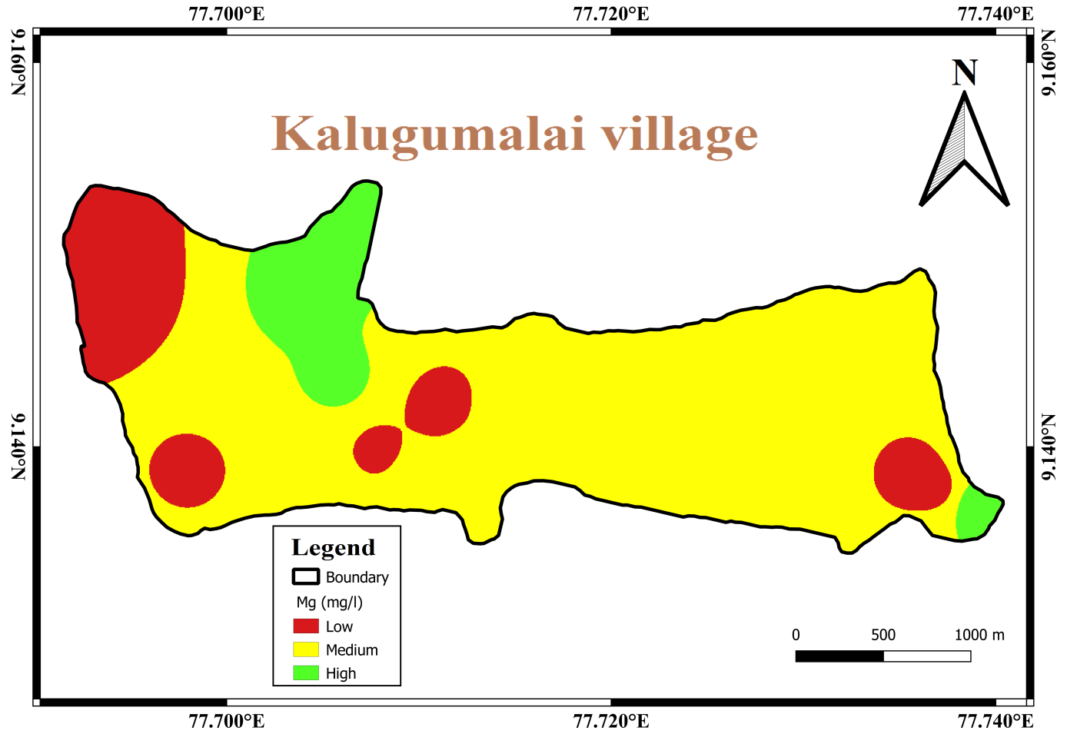
Fig-6 Spatial interpolation of Mg²⁺

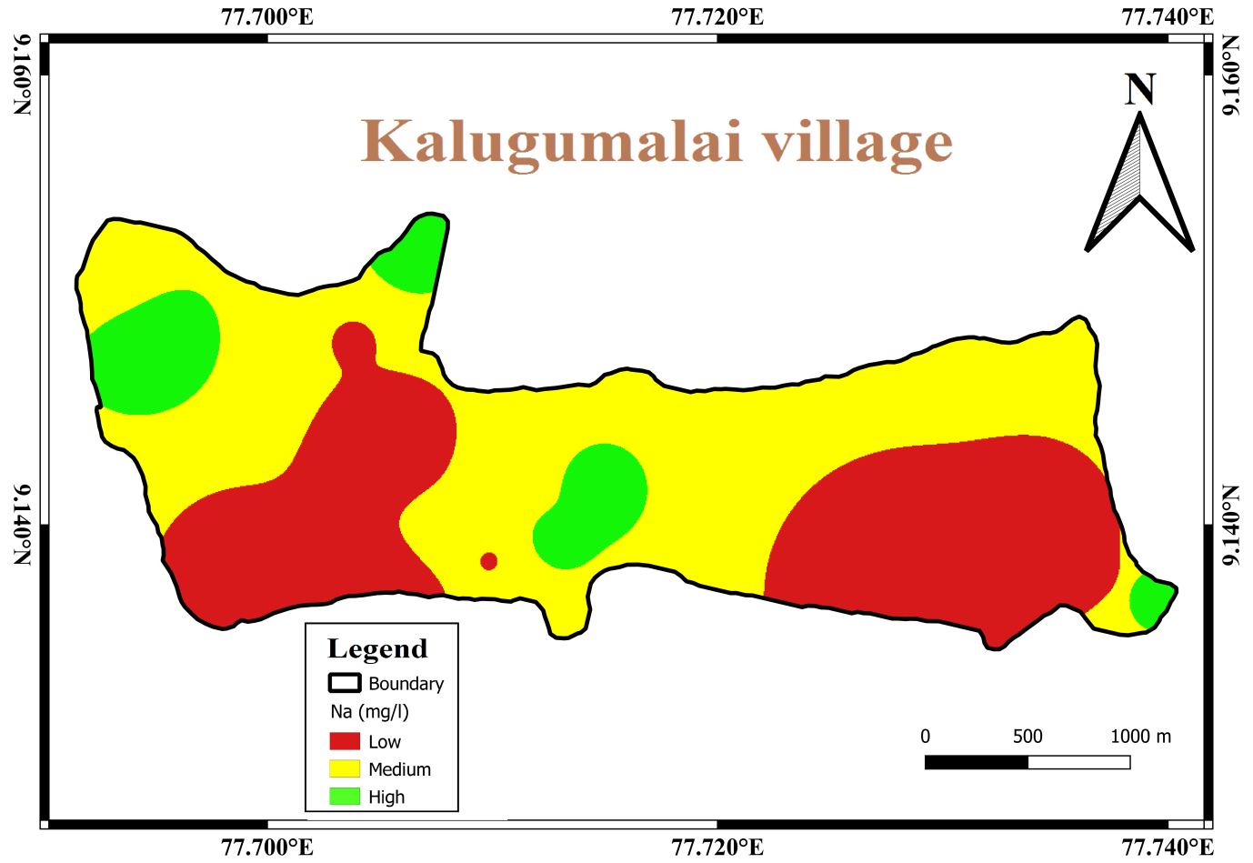
Fig-7 Spatial interpolation of Na⁺
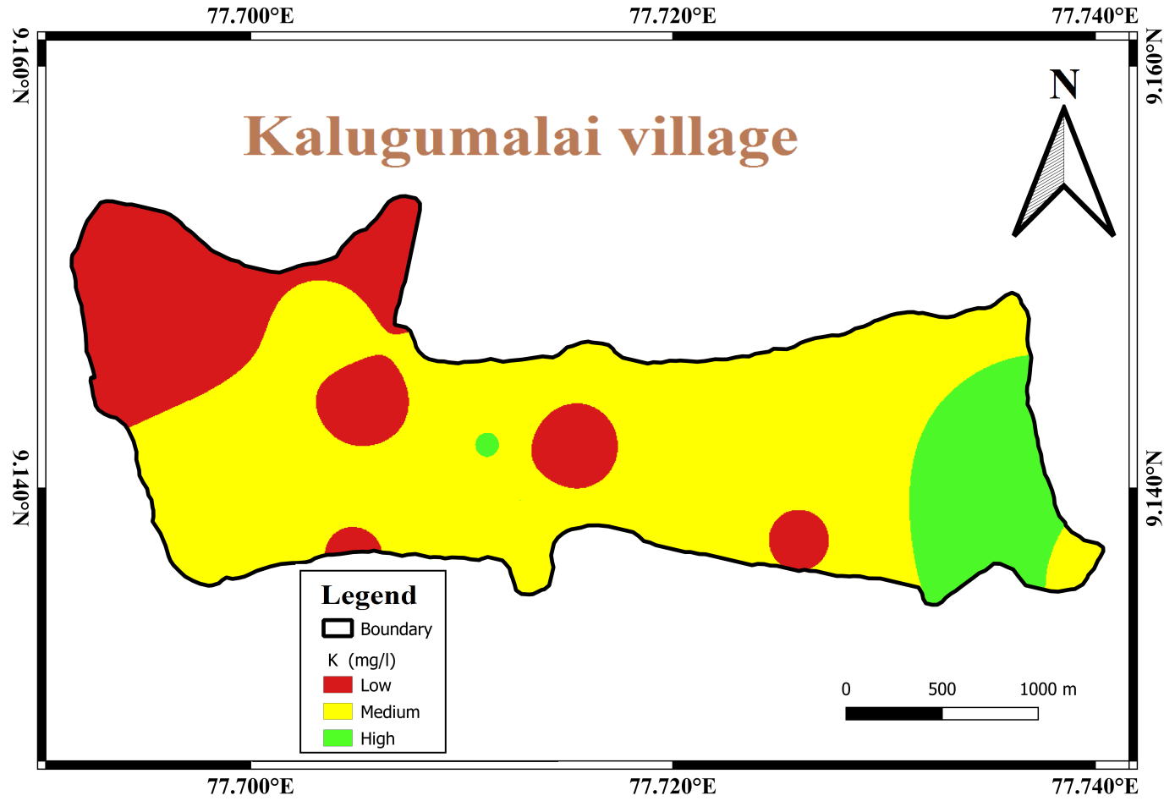
Fig-8 Spatial interpolation of K⁺
The varying concentrations of cations in the water samples, with Ca²⁺ ranging from 69 to 231 mg/l, Mg²⁺ from 9 to 42 mg/l, Na⁺ from 45 to 117 mg/l, and K⁺ from 77 to 183 mg/l. Among these cations, Ca²⁺ and Mg²⁺ are the dominant ones in the river waters. Ca²⁺ is primarily derived from the dissolution of carbonate minerals like calcite, dolomite, and aragonite, as well as carbonate cement within formations. On the other hand, Mg²⁺ in natural water originates mainly from ferromagnesian minerals found in igneous and metamorphic rocks (such as olivine, diopside, biotite, and hornblende) and magnesium carbonate (dolomite) in sedimentary rocks (Singh et al., 2012). Understanding the sources and levels of these cations is crucial for assessing water quality and can provide valuable insights into the geological processes and interactions that influence the chemical composition of the river waters.
Typically, the major ion content varies due to water-rock interaction, but at certain locations, anthropogenic pollutants take precedence.
Conclusion
Geochemical mapping and aquifer assessment play pivotal roles in analyzing water quality. By examining the cation and anion concentrations in water samples from open wells and bore wells, it becomes possible to differentiate between fresh and saline water, thus ensuring its suitability for agricultural and drinking purposes. The primary objective of this water quality study is to ascertain the interaction between rock formations and water, with a specific focus on identifying the presence of Silica-soaked quartzite rock and its implications for the availability of fresh water, as determined through geochemical mapping techniques.
This agricultural development research is geared towards benefiting small-scale farmers by creating additional cultivable land and promoting agriculture in regions with low rainfall. The water quality is influenced by the weathering of silicate, plagioclase, and granitic rocks in the source areas, with the dominant interactions being Mg²⁺-Ca²⁺-Na⁺. Through the investigation of rock-water interactions, the study aims to trace the origin of groundwater from gneiss and quartzite rocks to determine its suitability for both drinking and agricultural purposes. It's worth noting that the tributaries of the Kalugumalai region contribute to the enhancement of broken quartzite veins and granitic zones, further influencing the water quality dynamics.

Acknowledgments
The First author expresses his sincere thanks to Shri. A.P.C.V. Chockalingam, Secretary and our Principal Dr. C. Veerabhahu, V.O.Chidambaram College, Thoothukudi. Dr. P. Siva Subramanian, Professor and Head, PG and Research Department of Geology, V.O.Chidambaram College, Thoothukudi extended the help.

REFERENCE:
Antony Ravindran, A., & Antony Alosanai Promilton, A. (2022). Geophysical and geochemical prospecting for submarine groundwater discharge in a karst leaky aquifer from Valliyur Hills to Uvari Beach. Modeling Earth Systems and Environment, 8(4), 4909–4921. https://doi.org/10.1007/s40808-022-01412-8
Bahar, Md. M., & Yamamuro, M. (2008). Assessing the influence of watershed land use patterns on the major ion chemistry of river waters in the Shimousa Upland, Japan. Chemistry and Ecology, 24(5), 341–355. https://doi.org/10.1080/02757540802342291
Chang, K., 2006. Introduction to Geographic Information System; Tata McGraw-Hill, 2006, pp. 318–346.
Chatterjee, R., Tarafder, G., & Paul, S. (2009). Groundwater quality assessment of Dhanbad district, Jharkhand, India. Bulletin of Engineering Geology and the Environment, 69(1), 137–141. https://doi.org/10.1007/s10064-009-0234-x
Elango, L., & Kannan, R. (2007). Chapter 11 Rock–water interaction and its control on the chemical composition of groundwater. Developments in Environmental Science, 229–243. https://doi.org/10.1016/s1474-8177(07)05011-5
Hengl, T., 2009. A Practical Guide to Geostatistical Mapping, 2nd ed. University of Amsterdam, Amsterdam
Osibanjo, O., Daso, A. P., & Gbadebo, A. M. (2011). The impact of industries on surface water quality of River Ona and River Alaro in Oluyole Industrial Estate, Ibadan, Nigeria. African Journal of Biotechnology, 10(4), 696-702.
Panhalkar, S. S., & Jarag, A. P. (2016). Assessment of spatial interpolation techniques for river bathymetry generation of Panchganga River basin using geoinformatics techniques. Asian Journal of Geoinformatics, 15(3), 10-15.
Singh, A. K., Mahato, M. K., Neogi, B., Tewary, B. K., & Sinha, A. (2011). Environmental geochemistry and quality assessment of mine water of Jharia Coalfield, India. Environmental Earth Sciences, 65(1), 49–65. https://doi.org/10.1007/s12665-011-1064-2
Subramani, T., Rajmohan, N., & Elango, L. (2009). Groundwater geochemistry and identification of hydrogeochemical processes in a hard rock region, Southern India. Environmental Monitoring and Assessment, 162(1–4), 123–137. https://doi.org/10.1007/s10661-009-0781-4
Varol, S., & Davraz, A. (2014). Evaluation of the groundwater quality with WQI (Water Quality Index) and multivariate analysis: a case study of the Tefenni plain (Burdur/Turkey). Environmental Earth Sciences, 73(4), 1725–1744. https://doi.org/10.1007/s12665-014-3531-z
Vinoth Kingston, J., Antony Ravindran, A., Richard Abishek, S., Aswin, S. K., & Antony Alosanai Promilton, A. (2021). Integrated geophysical and geochemical assessment of submarine groundwater discharge in coastal terrace of Tiruchendur, Southern India. Applied Water Science, 12(1). https://doi.org/10.1007/s13201-021-01553-8
Weng, Q. (n.d.)., 2006. An Evaluation of Spatial Interpolation Accuracy of Elevation Data. Progress in Spatial Data Handling, 805–824. https://doi.org/10.1007/3-540-35589-8_50.

