TOPIC: “Influence of protected cultivation structures on vegetable crops”

Author Name: Nuzhat Bint Nazir¹, Adil Majeed¹, Naveed Najam¹
¹Ph.D Soil and Water Conservation Engineering, COAE&T, SKUAST-KASHMIR

ABSTRACT
Faced with constraints of land holdings, rapid urbanization, declining crop production, biodiversity and ever increasing population, demand for food, especially vegetables has increased by folds and thus protected cultivation in a limited area has offered a new dimension to produce more. China ranks first in the world in vegetable production followed by India. Protected cultivation being the most efficient means to overcome climatic diversity, has the potential of fulfilling the requirements of small growers as it can increase the yield of produce by many folds and at the same time improve the quality of the produce significantly as per the demand of the market. Protected cultivation structures create an atmosphere that is favorable for crop growth, resulting in a higher yield and higher-quality produce. Green house, polyhouse, shadow hall shade net house & low tunnels are different types of protected cultivation structures, which are commonly adopted for crop cultivation. During extreme cold in winter season (November to February) vegetables can be grown under greenhouse structure. Further, the vegetables grown under open-field condition does not possess better quality and higher yields than the ones grown under protected cultivation. As compared to open field cultivation, the reduction in irrigation water requirement was 35.6 % for shadow hall, 35.2 % for polyhouse and 25.5 % shade net house cultivation. The plant height, number of leaves and number of branches in polyhouse increased by 114.93 %, 83.24 % and 355 % respectively over open field condition. Shadow hall is most suited for the cultivation of vegetables as depicted by higher growth and yield parameters, followed by polyhouse, shade net house. The growth and yield parameters were the least when vegetables were grown in open field. In comparison to open field conditions (685.49 kg/ha cm and 691.82 kg/ha cm, respectively), polyhouse conditions had a high water use efficiency (1222.36 kg/ha cm and 1135.82 kg/ha cm, respectively) throughout the 2017–18 and 2018–19 academic years. Severity of powdery mildew was found to be the lowest in closed shade net and highest in open field.

Keywords: Protected cultivation, protected structures, polyhouse, shadow net, vegetables, yield.

Introduction
Protected cultivation or controlled environment agriculture (CEA) is a cropping technique where controlled micro-climate influences the growth and development of a plant (Pattnaik and Mohanty., 2021) .The essential factors such as temperature, humidity, light, and others, are regulated as per the requirement of the crop (www.agrifarming.in).Green house, polyhouse, shade net house and low tunnels are the different types of protected cultivation structures commonly adopted by the Indian farmers (Maheshwara et al., 2020). Indian gardeners, particularly those with tiny land holdings, have begun adopting the idea of producing vegetables beneath covered structures (Kumar and Verma, 2009). Opting for protected cultivation, the productivity of vegetable crops can be increased by 3 to 5 times as compared to open environment (Santosh et al., 2017).
Need for protected cultivation (Wani et al., 2017)
India is second largest after China in vegetable production of 113.5 million tons. By the end of 2020, however, it is predicted that the annual demand for vegetables will be at 135 million tons. Low production and productivity of vegetable has been attributed to the extremes of temperatures ranging from 0 to 48 ͦC during the year. Use of water is optimized and there’s reduction in the consumption by 40-50%. Reduces diseases, pests and viruses due to biotic stress during rainy and post rainy season. Increasing demand of high quality vegetables.
Scope of protected cultivation in India (Panda et al., 2008)
- Cultivation in problematic agricultural zones.
- Greenhouses around massive cities.
- Export of farming turn out.
- Plant propagation.
- Biotechnology.
- Economic returns.
Production of vegetables worldwide in 2019
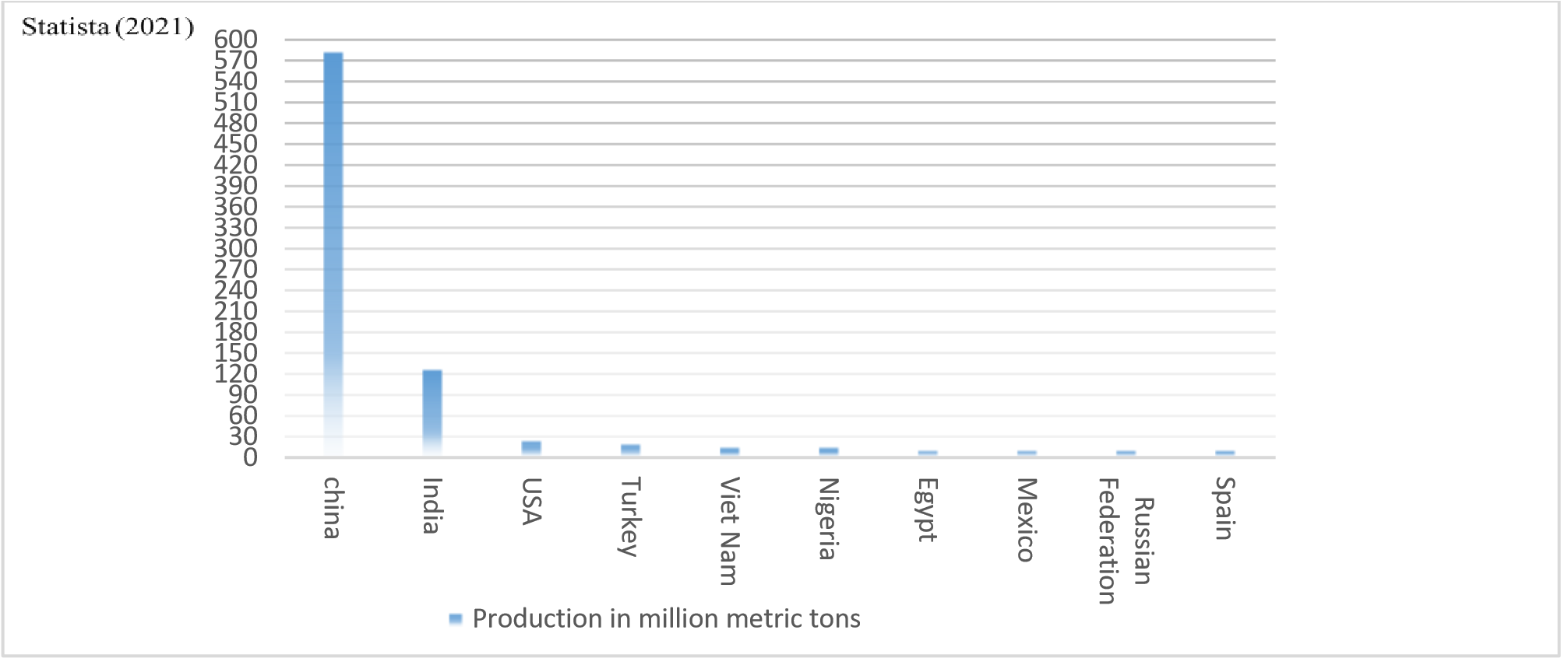
Total area of Kashmir under vegetable cultivation in August 2018 was 48160.92 ha with a production of about 1539.59 MTs (diragrikmr.nic.in, August 2018), which has increased from 48000 ha to 51000 ha, from 1500 MTs to 1638 MTs (Ziraat Times, August 2020).
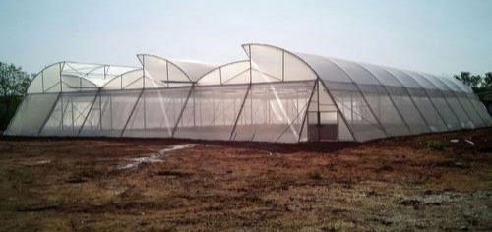
Protected structures Polyhouse:
- Framed structure having 200 micron UV stabilized transparent polyethylene.
- Creates greenhouse effect making microclimate favourable for plant growth and development.

Shade net house:
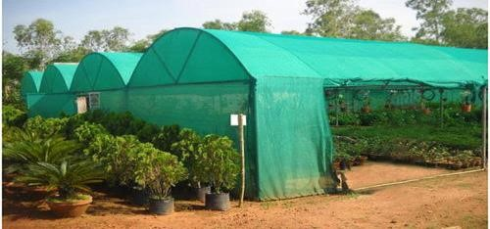
- Framed structure used to protect plants from highly intense solar radiation.
- Materials such as GI pipes, angle iron, wood or bamboo are used.
- Used for hardening of fruit planting material raised under greenhouse.

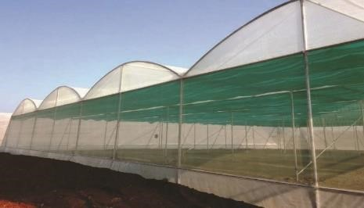
Insect proof net house:
- It is covered with UV stabilized insect proof net of 40-50 mesh.
- Used for effective control of pests and diseases.

Shadow hall:
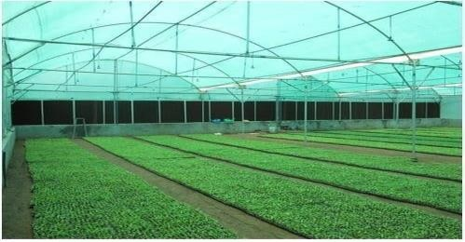
- Framed structure made of GI pipes.
- Covered with nets of different shades.
- This structure protects crop from devastating rains.

Plastic low tunnels:
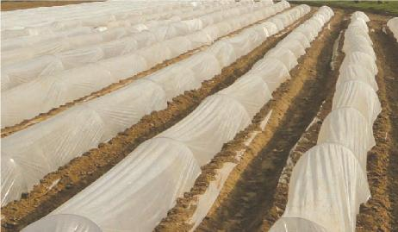
- Generally known as row covers.
- Plastic mulches and drip irrigation may be used in conjunction with low tunnels.
- Crops grown under low tunnel conditions are melons, cucumber, tomato, strawberry.

Area under protected cultivation (Hassan., 2017)
 | World scenario |  | Indian scenario
S.No | Country | Area (ha) | State | Approximate area (ha)
1 | China | 2,760,000 | Maharashtra | 15,000
2 | South Korea | 57,445 | Karnataka | 10,000
3 | Spain | 52,170 | Himachal Pradesh | 5000
4 | India | 50,000 | Punjab | 4000
5 | Japan | 49,059 | Uttarakhand | 3000
6 | Turkey | 33,515 | Tamil Nadu | 2100
7 | Italy | 26,500 | North Eastern | 2000
8 | Mexico | 11,759
9 | Netherland | 10,370
10 | France | 9,620
11 | USA | 8,425

Area achieved under different protected cultivation structures in India (Prakash et al., 2019)
Protected cultivation | Total area(ha) | Percent share
Greenhouse structure | 298.62 | 0.14
Naturally ventilated polyhouse | 4136.81 | 1.92
Shade net house | 4827.5 | 2.24
Plastic tunnel | 4868.35 | 2.26
Walk- in tunnel | 3.84 | 0.00
Plastic mulching | 191472.4 | 88.72
Total | 215809.97 | 100

Crops grown under protected cultivation (Pattnaik and Mohanty., 2021)

Flowers | Chrysanthemum, Carnation, Gerbera, Rose, Lilium, Orchid, Gladiolus, etc.
Vegetables | Tomato, Coloured Capsicum (Yellow and Red Bell Peppers), Cucumber, Broccoli, Red Cabbage, Leafy vegetables, Radish, etc.
Fruits | Strawberry
Seedling and Nurseries | Vegetables, Flowers, Tissue Culture, Clonal for Forestry, Fruit Grafting (like Lemon, Citrus, Mango, Guava, Litchi, etc.)

Case Study 1: Influence of Different Protected Cultivation Structures on Water Requirements of Winter Vegetables (Santosh et al., 2017)
Study area: Experimental farm of Agricultural and food Engineering Department, IIT Kharagpur, India
Objective: To determine crop water requirement of winter vegetable crop under different protected cultivation structures.
Material used: Three types of protected structures (polyhouse, modified shade net house with 75% shade and 200 micron UV stabilizes film and shade net house with 75% shade)
Winter vegetables: Tomato, Capsicum, Cucumber and Cabbage
The minimum and maximum temperature and relative humidity ranges from 9.6 ͦC to 27 ͦC and
27.2 ͦC to 41.8 ͦC and 19 to 78% and 79 to 99 % in Kharagpur
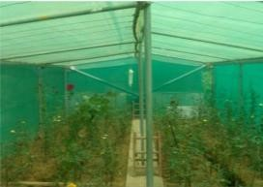
Methodology
The daily irrigation water requirement for the vegetable crops were estimated by using the following relationship
WR = ET₀× Kc ×Wp × A
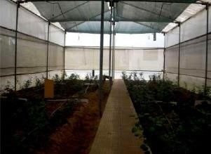
Where,
WR = Crop water requirement (l day⁻¹)
ETO = Reference evapotranspiration (mm day⁻¹)
Kc = Crop Coefficient
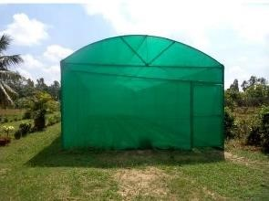
Wp = Wetting fraction (taken as 1 for close growing crops)
A = Plant area, m² (i.e. spacing between rows (m) × spacing between Plants (m))
Daily meteorological data recorded during the year 2014-2015 were used to compute reference evapotranspiration (ETO).
Results:
Crop coefficients (Kc) and plant area (m²) of different vegetables
S.No | Crop | Kc initial | Kc middle | Kc end | Plant Area, m²
1 | Tomato | 0.6 | 1.15 | 0.80 | 0.5 × 0.5 = 0.25
2 | Capsicum | 0.6 | 1.05 | 0.90 | 0.45× 0.5 = 0.23
3 | Brinjal | 0.6 | 1.05 | 0.90 | 0.5 × 0.5 = 0.25
4 | Cucumber | 0.6 | 1.00 | 0.75 | 0.5 × 0.25 = 0.13
5 | Cabbage | 0.7 | 1.05 | 0.95 | 0.6 × 0.45 = 0.27
6 | Broccoli | 0.7 | 1.05 | 0.95 | 0.6 × 0.45 = 0.27
7 | Cauliflower | 0.7 | 1.05 | 1.00 | 0.6 × 0.45 = 0.27

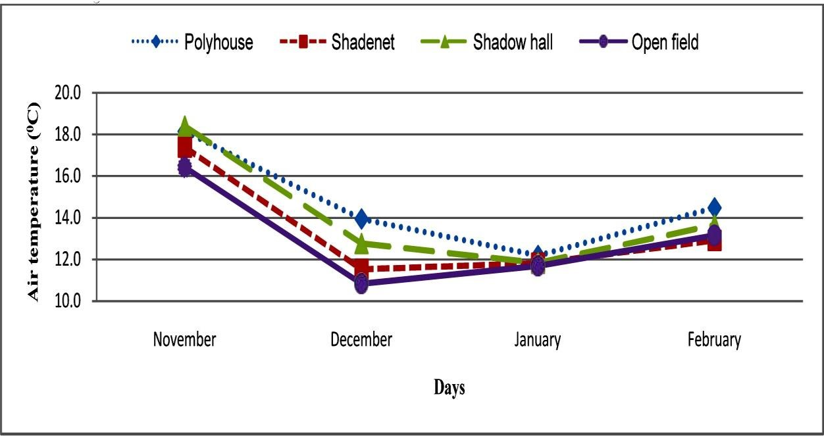
Average monthly minimum temperature recorded in different protected cultivation structures

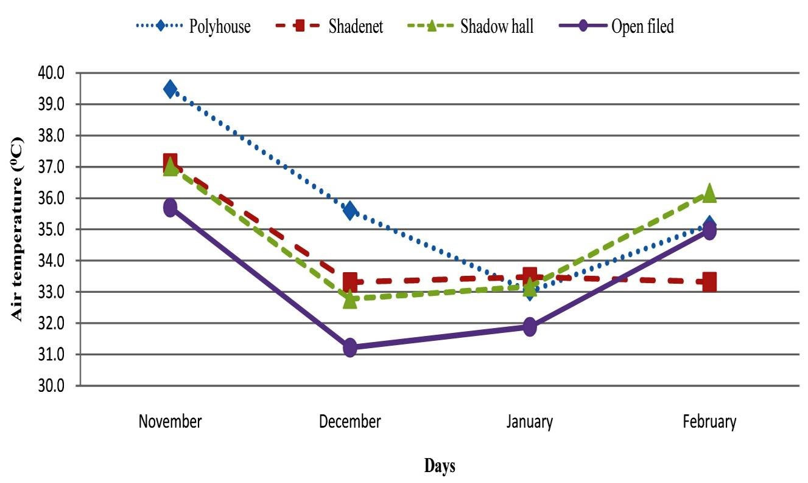
Average monthly maximum temperature recorded in different protected cultivation structures

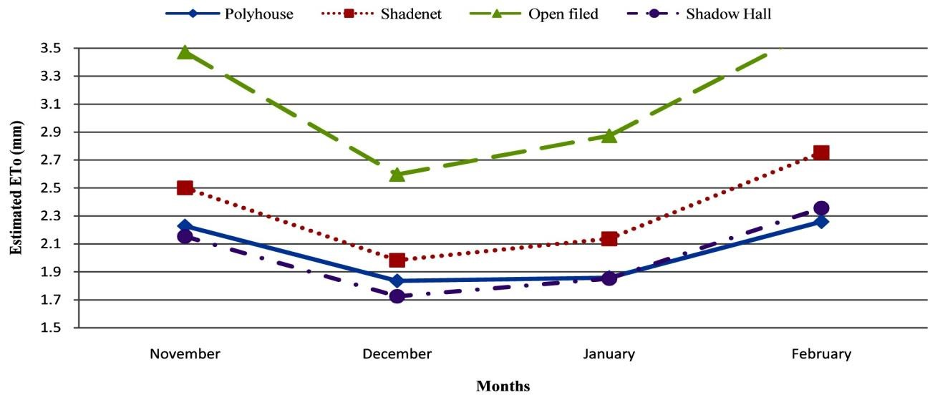Average monthly estimated reference evapotranspiration in different protected cultivation structures
Water requirement of winter vegetables under different protected structures (litres day⁻¹ Plant⁻¹)

- Tomato
Month | Tomato
 | Poly house | Shade net house | Open | Shadow hall
Nov | 0.41 | 0.45 | 0.63 | 0.39
Dec | 0.46 | 0.51 | 0.66 | 0.44
Jan | 0.52 | 0.61 | 0.82 | 0.53
Feb | 0.45 | 0.55 | 0.73 | 0.47
Total | 56.64 | 65.12 | 87.45 | 56.27

- Capsicum
Month | Capsicum
 | Poly house | Shade net house | Open | Shadow hall
Nov | 0.37 | 0.42 | 0.58 | 0.36
Dec | 0.34 | 0.37 | 0.49 | 0.32
Jan | 0.38 | 0.45 | 0.61 | 0.39
Feb | 0.52 | 0.63 | 0.84 | 0.54
Total | 49.20 | 56.64 | 76.45 | 49.11

- Cucumber
Month | Cucumber
 | Poly house | Shade net house | Open | Shadow hall
Nov | 0.19 | 0.21 | 0.29 | 0.18
Dec | 0.18 | 0.20 | 0.26 | 0.17
Jan | 0.21 | 0.25 | 0.33 | 0.22
Feb | 0.25 | 0.30 | 0.40 | 0.26
Total | 25.16 | 29.05 | 38.99 | 25.08

- Cabbage

Month | Cabbage
 | Poly house | Shade net house | Open | Shadow hall
Nov | 0.46 | 0.51 | 0.71 | 0.44
Dec | 0.43 | 0.47 | 0.62 | 0.41
Jan | 0.49 | 0.58 | 0.79 | 0.51
Feb | 0.60 | 0.73 | 0.97 | 0.62
Total | 60.54 | 69.92 | 93.89 | 60.36

Case study 2: Influence of different protected structures on growth, yield and severity of powdery mildew of capsicum (Capsicum annuum L.) in semi-arid region (Maheshwara et al., 2019).
Study area: Experimental field of the Department of Soil and Water Conservation Engineering, College of Agricultural Engineering, University of Agricultural Sciences, Raichur, Karnataka, India.
Objective: To investigate the influence of different protected structures on growth and yield of capsicum cv. Indira.
Material used: Three types of protected structures (closed shade net, polyhouse, and sides opened shade net).
Crop: Seedlings of Capsicum (cv. Indira).
Methodology:
- The experiment consisted of four treatments comprising of closed shade net, polyhouse, sides opened shade net and open field condition.
- Raised beds of 1m width and 18m length were prepared with a gap of 50 cm between two beds in all the structures and in open field
- Seedlings were selected and they were transplanted in the raised beds at a spacing of 60 cm between rows and 45 cm between plants within a row. Yield parameters were recorded during harvest.

Results

Growth parameters of capsicum as influenced by protected structures
Treatment | Plant height (cm) |  | Number of leaves |  | Number of branches
 | 2017-2018 | 2018-2019 | 2017-2018 | 2018-2019 | 2017-  2018 | 2018-  2019
Closed shade net | 50.47 | 70.45 | 61.78 | 68.06 | 8.55 | 9.64
Polyhouse | 65.06 | 78.29 | 74.03 | 77.11 | 12.97 | 14.83
Opened shade net | 32.59 | 62.45 | 50.48 | 54.83 | 4.96 | 5.38
Open field | 30.59 | 54.13 | 40.40 | 43.62 | 2.85 | 3.42

Effect of different protected structures on the yield of capsicum
Treatment | Yield per plant(kg) |  | Yield(tons/ha)
 | 2017-2018 | 2018-2019 | 2017-2018 | 2018-2019
Closed shade net | 1.46 | 2.11 | 56.22 | 74.16
Polyhouse | 2.28 | 3.12 | 81.35 | 89.42
Opened shade net | 1.21 | 1.65 | 48.83 | 61.57
Open field | 0.9 | 1.22 | 39.18 | 47.61

Effect of different protected structures on the severity of powdery mildew
Treatment | Severity of powdery mildew (%)
 | 2017-2019
Closed shade net | 16.00
Polyhouse | 48.40
Opened shade net | 16.40
Open field | 52.60

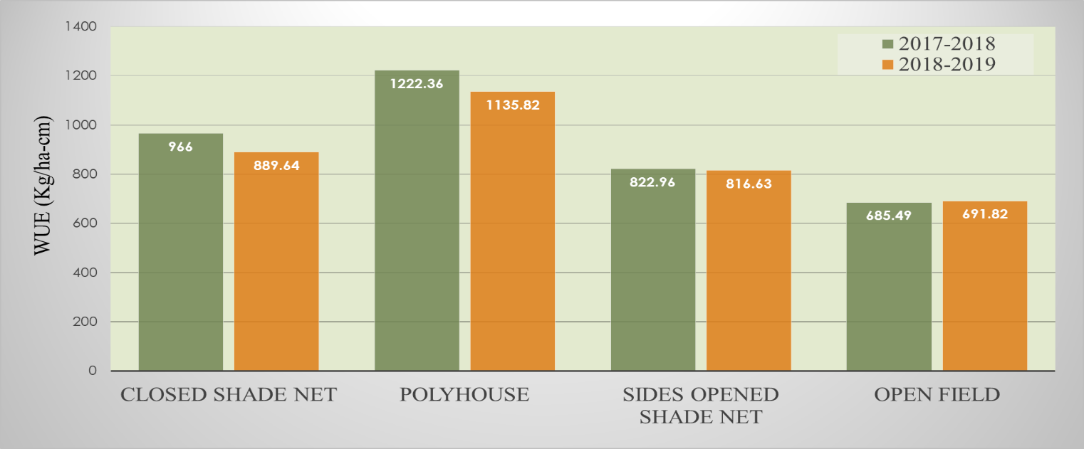
Water Use Efficiency (WUE) of capsicum grown under protected structures
Conclusion:
- ET₀ estimated outside the protective covering structures show lower values than those for ET₀ values estimated inside.
- Due to increased temperature in protected cultivation structures, ET₀ also varies according to temperature and radiation.
- In open field condition winter vegetable requires higher irrigation water requirement for all the crops comparing to other protective covering structures.
- As compared to open field cultivation, the reduction in irrigation water requirement was 35.6 % for shadow hall, 35.2 % for polyhouse and 25.5 % shade net house cultivation.
- During 2017-18 the plant height, number of leaves, number of branches in polyhouse increased by 114.93 %, 83.24 % and 355 % respectively over open field condition.
- During 2018 -19 the plant height, number of leaves, number of branches in polyhouse increased by 44.63 %, 76.78 % and 333 % respectively over open field condition.
- During 2017-18, the yield/plant (kg) and yield/m² (kg/m²) in polyhouse increased by 153.33 % and 107.93 %, respectively, over open field condition.
- During 2018-19, the yield per plant (kg) and yield/m² (kg/m²) in polyhouse increased by 155.74 % and 87.82 % respectively, over open field condition.
- Water use efficiency (1222.36 kg/ha cm and 1135.82 kg/ha cm, respectively) was high during 2017-2018 and 2018-19 in polyhouse over open field condition (685.49 kg/ha cm and 691.82 kg/ha cm respectively).
- Severity of powdery mildew was found to be the lowest in closed shade net and highest in open field.

References:
1. Panda, N.K., Paul, J.C., Panigrahi, B. and Mishra, J.N., 2008. Energy requirement for capsicum cultivation in naturally ventilated greenhouse in coastal Orissa. Agricultural Engineering Today 32(4): 23-27.
2. Kumar, M. and Verma, V. 2009. Bell pepper (Capsicum annuum L.) production in low cost naturally-ventilated polyhouses during winters in the mid hills of India. In: International Symposium on Strategies Towards Sustainability of Protected Cultivation in Mild Winter Climate 807(1): 389-394.
3. Hassan, M. 2017. Protected cultivation and drip fertigation technology for sustainable food production. International Journal of Economic Plants 3(3): 102-106
4. Santosh, D.T., Tiwari, K.N. and Singh, V.K., 2017. Influence of different protected cultivation structures on water requirements of winter vegetables. International Journal of Agriculture, Environment and Biotechnology 10(1): 93-103.
5. Wani, K.P., Ummyiah, H.M., Khan, S.H. and Magray, M.M., 2017. Protected cultivation of vegetable crops under temperate conditions. Journal of Pharmacognosy and Phytochemistry 6(5): 1629-1634.
6. Prakash, P., Kumar, P., Kar, A., Singh, A.K. and Anbukkani, P., 2019. Progress and performance of protected cultivation in Maharashtra. Indian Journal of Economics and Development 15(4): 555-563.
7. Pattnaik, R.K. and Mohanty, S. 2021. Protected cultivation: importance, scope, and status. Food and Scientific Reports 2(3): 19-21. https://www.agrifarming.in/protected-cultivation-of-vegetables-flowers-and-fruits.
8.http://www.diragrikmr.nic.in/assets/files/Scan_20180821.pdfhttp://www.fao.org/fruits-vegetables-2021/en
https://www.statista.com/statistics/264065/global-production-of-vegetables-by-type https://ziraattimes.com/2020/08/kashmirs-vegetable-production

