SMART WEARABLE GADGET FOR WOMEN SAFETY

T M Angelin Monisha Sharean
Department of Information Technology
St. Xavier’s Catholic College of Engineering
Nagercoil, India
monisha@sxcce.edu.in

N Ansgar Mary
Department of Information Technology
St. Xavier’s Catholic College of Engineering
Nagercoil, India
ansgar@sxcce.edu.in

ABSTRACT
Safety for women has always been an issue, particularly in the modern era with all the technological advancements. Women are never safe, and they are particularly exposed when travelling alone through desolate locations and lonely roadways. There are numerous uses for women's protection while they are in perilous circumstances. These applications' limitation on sending alert messages solely to saved contacts is a flaw. Because of outdated systems, women have fewer options for escaping dangerous situations. A GPS monitoring gadget to find the women was also included in earlier designs, although it lacked a specified radius. The current system lacks a component that prevents the warning message from going to neighboring cell phones. On occasion, multiple messages might be needed to ensure that the recipient has received the message. Before it was suspended, text message options were available, but it appears that several customers were upset about the text messages. According to reports from WHO, an NCRB-social-government organization, 35% of women in the world encounter a lot of unethical physical harassment in public places, including railway stations, bus stops, and sidewalks. In the lives of women, there have been numerous regrettable occurrences. This study proposes a device to safeguard women. When the gadget is turned on, it begins sending real-time information to specific contacts or police command centers via the GPS receiver and IOT. Using IOT technology, it simultaneously sends a warning to that person's cell phone. When the system is turned on, a warning piezoelectric signal is immediately generated. SSafety for women has always been an issue, particularly in the modern era with all the technological advancements. Women are never safe, and they are particularly exposed when travelling alone through desolate locations and lonely roadways. There are numerous uses for women's protection while they are in perilous circumstances. These applications' limitation on sending alert messages solely to saved contacts is a flaw. Because of outdated systems, women have fewer options for escaping dangerous situations. A GPS monitoring gadget to find the women was also included in earlier designs, although it lacked a specified radius. The current system lacks a component that prevents the warning message from going to neighbouring cell phones. On occasion, multiple messages might be needed to ensure that the recipient has received the message. Before it was suspended, text message options were available, but it appears that several customers were upset about the text messages. According to reports from WHO, an NCRB-social-government organization, 35% of women in the world encounter a lot of unethical physical harassment in public places, including railway stations, bus stops, and sidewalks. In the lives of women, there have been numerous regrettable occurrences. This study proposes a device to safeguard women. When the gadget is turned on, it begins sending real-time information to specific contacts or police command centers via the GPS receiver and IOT. Using IOT technology, it simultaneously sends a warning to that person's cell phone. When the system is turned on, a warning piezoelectric signal is immediately generated. Safety for women has always been an issue, particularly in the modern era with all the technological advancements. Women are never safe, and they are particularly exposed when travelling alone through desolate locations and lonely roadways. There are numerous uses for women's protection while they are in perilous circumstances. These applications' limitation on sending alert messages solely to saved contacts is a flaw. Because of outdated systems, women have fewer options for escaping dangerous situations. A GPS monitoring gadget to find the women was also included in earlier designs, although it lacked a specified radius. The current system lacks a component that prevents the warning message from going to neighbouring cell phones. On occasion, multiple messages might be needed to ensure that the recipient has received the message. Before it was suspended, text message options were available, but it appears that several customers were upset about the text messages. According to reports from WHO, an NCRB-social-government organization, 35% of women in the world encounter a lot of unethical physical harassment in public places, including railway stations, bus stops, and sidewalks. In the lives of women, there have been numerous regrettable occurrences. This study proposes a device to safeguard women. When the gadget is turned on, it begins sending real-time information to specific contacts or police command centres via the GPS receiver and IOT. Using IOT technology, it simultaneously sends a warning to that person's cell phone. When the system is turned on, a warning piezoelectric signal is immediately generated.
Keywords— IoT, GPS Receiver, Peizo alarm, Arduino UNO R3, ESP8266 nodeMCU.

INTRODUCTION
Every economy does depend on women, who also have a major role in determining the nation's future. She used to stay at home to take care of her domestic duties, but now she manages work and home at the same time, participating in economic development on an equal level with men.
Women can now work night shifts under the Factories Act of 1948, fulfilling a long-standing demand for gender fairness in the workplace. The amendment proposes that night shifts for women should only be permitted if the employer ensures that safety requirements, sufficient safeguards in the factory regarding occupational safety and health, equality of opportunity for women workers, adequate protection of their self-worth and value, and transportation from the factory grounds to the closest point of their residence are met. Night shifts have been around for a while, but in India, they were not legalized for women to work until recently thanks to an amendment to the Factories Act of 1948.
From rural to metropolitan regions, some many women entrepreneurs and individuals contribute to the country's gross domestic product. The textile sector already employs 60% of women, and as this industry grows, the percentage will significantly increase. Until a while ago, the IT sector did not have to follow the aforementioned safety steps when hiring women for late-night hours. There is no denying that women in India have made significant progress in the nearly 70 years since they gained their freedom, but they continue to face a variety of challenges due to the male-dominated culture.
In today's Indian society, there are still many bad and male forces at work that obstruct the advancement of women. Women now work night shifts thanks to the growth of the IT and BT industries. The company is in charge of giving these workers transportation to and from work. Today, even though businesses offer transportation services, the safety of women cannot be fully guaranteed. For example, in one incident in Pune in 2007, two of the company's assigned cab drivers brutally assaulted a girl working in a call center. In addition, we have recently seen numerous other incidents where women's safety was not fully guaranteed by the cab services offered by the company.
One of India's finest sons, Swami Vivekananda, is credited with saying, "There is no chance for the welfare of the world unless the condition of women is improved, a bird can't fly on only one wing." The fact that "Women Empowerment" is included as one of the eight Millennium Development Goals further emphasizes the significance of this reality. India must therefore transform its female labor force into an efficient human resource to become a developed nation, and this is only feasible by empowering women.
Women are abused in about 10% of all crimes perpetrated in the nation. Two-thirds of the estimated 876 million individuals worldwide who are illiterate are female. Female infanticide caused 30 lakh girl newborns to lose their lives between 2001 and 2011. Every 20 minutes, a woman in India is violated. 60 years after being given their freedom, one-third of women in India still lack a basic education. Compared to 80% in China, just 39.5% of women are employed in India. 10.9% of women own land, yet women make up 70% of the 1.3 billion people who live in extreme poverty worldwide. Less than 40% of mothers deliver their babies in a hospital.
Domestic Abuse One in three women who have ever been married say their husband has smacked them. Between 12% and 15% of people report having their arms twisted, being pushed, shaken, kicked, pulled, or beaten up, or having anything thrown at them. 10% of wives say their husbands have physically coerced them into having sex. Domestic abuse affects almost two-thirds of married women in India, where one act of violence costs a woman seven days of employment. Every seventh married woman has experienced bodily harm as a result of marital abuse. The first instance of marital abuse for the majority of women who have ever experienced it happened within the first two years of their marriage. The only solution in this circumstance is to provide women with a portable safety gadget [1] that ensures their safety.
Our project is focused on developing a smart device that helps women flee perilous situations using IoT [2] technology. Even though women are becoming more autonomous and keeping up with contemporary trends, their safety has been a concern because it is so difficult for them to leave the house at night due to physical/sexual abuse and a fear of violence. Women are never safe, and they are especially at risk when traveling alone on deserted highways. Even with the current rapid advancement of technology and the development of new technologies, women and girls still face challenges. Society should respect women and provide them with sufficient protection. However, some places have added security cameras that may record and store the images. They don't do anything till everything has happened. We include IoT devices that detect people's positions, motions, etc. to help avoid such circumstances.

EXISTING SYSTEM

Existing Systems
Recently created solutions for women's protection include wearable technology, intelligent security systems, and smartphone applications [3, 4]. These wearable gadgets typically come in the form of smartphone applications, bands [5], accessories, etc. A security gadget called Suraksha [6] can be turned on in three different ways: by voice command, by pressing a button, or by being violently thrown. When activated, this system uses an integrated GSM module to broadcast the device's location to a list of pre-selected contacts. However, it might not always be easy for the user to hold this item in her hand when she is in a difficult situation. The victim's holding device may also catch the attacker's attention [7]. A one-touch alarm system that resembles a watch is another option for this problem [8]. When a button is pressed, the device's GSM and GPS module transmits the user's location to pre-programmed SOS contacts. The user might find this device unpleasant in terms of aesthetics, and the attacker might too [9].
Women's safety has allegedly become a serious problem as a result of the fact that they are unable to leave their homes at any given moment due to physical/sexual abuse and a fear of violence, according to Dr. C K Gomathy and Ms. S. Geetha [10]. Even in the twenty-first century, where technology is quickly advancing and new devices are being created. Although we are all aware of how crucial women's safety is, we still need to study them using different machine learning algorithms [11] to determine how best to protect them. By employing the Arduino controller to manage the system's entire operation, they have created equipment for notifying the system. GPS location-related SMS are sent over GSM. When someone is in danger, the switch is pressed and the LCD is used to display the situation. In this case, we've added a buzzer laser diode that will turn on when the women flip the switch. By switching gadgets at a distance, a user no longer needs to be present nearby to use the device. This method enables several users to control device operation, and the switch's built-in authentication feature speeds up failure detection.
Other research is conceivable with the introduction of smart technology, where people and items create a network, as indicated in the other study [12], which discussed all of the applications with an original notion for security and protection for women. This will facilitate their technological resolution using portable tools and concepts. For the safety of women, it is helpful to use shrill alarms and to notify the emergency contacts by sending texts with the location. This approach can dispel the anxiety that every woman in the nation has for her safety and security. The strategy for women's security was suggested in another solution [13]. utilizing a wireless system that uses a secure medium to transmit and notify messages delivered to a predetermined number. When the button is pressed, the sensors gather the user's information, which is then transferred along with the call to the predetermined number. By utilizing GPS tracking, this device will help to expedite the monitoring of women's safety. The preprogrammed numbers will receive SMS messages, which will save time and ensure that the victim receives assistance without delay. The project's goal is to provide women with protection by automatically detecting issues and threats.
An alarm system for societal security is presented by Phadtare et al., [14], using ordinary or garden commercially available electronic bias to warn the nearby public and emergency connections by transferring immediate position. The system consists of an Android app with many IOT module features built in that may be used to detect falls, measure race pressure, SpO2, heart rate, body temperature, etc., and send the data to the connections indicated. The most important thing is to make sure that the stoner or fatality gets help right away.
A GSM-based one-touch alarm system for women's protection is described by Premkumar et al. in their paper [15]. Simply push the button on the gadget whenever you detect danger. The gadget has GPS, GSM, and a snap microcontroller. The gadget, which resembles a standard watch, uses the Global Positioning gadget (GPS) to track the woman's whereabouts and the Global System for Mobile Communication (GSM) to send emergency dispatches to connections and the police control center.
Described by Nagamma H [16], as a security system for ladies. Our concept resembles a smart band and has colored detectors built right into the band that can cover women. She can press the actuator on the guard when she wears out the bar or a guard if she encounters any difficulties, or if she believes a valuable item is in danger. When she falls, the Raspberry Pi uses GSM to send colorful information, including position, body posture, palpitation rate, and an SMS alarm, to the predetermined number.
A safe and secure electronic system for women is described by Seelam et al. [17] and includes an Arduino regulator as well as temperature LM35, flex, MEMS accelerometer, palpitation rate, and sound detectors, among other detectors. In this design, a buzzer, TV, GSM, and GPS are utilized. The device is activated and uses the GPS module to track the location of the fatality when the sensor detects that the woman is in danger and crosses the threshold limit. The GSM module transfers the function of the fatality to the registered connection number.
Priyanka et al.'s [18] research put up a fresh, original concept for shielding women from disastrous circumstances. We utilize a microcontroller (ATMEGA8), temperature sensors, accelerometer sensors, GSM, WIFI shield, LCD, buzzer, and RS232 connection. When the victim presses the switch, the temperature sensor and MEMS accelerometer sensors transmit data to the microcontroller (atmega8) including the victim's temperature and movement. The microcontroller compares the data to the controller's predefined threshold values. The buzzer will sound an alarm if it rises above the threshold amount. The victim's location is tracked by GPS, which also transmits the victim's location to the local police station and the victim's family members' phone numbers via an alert message.
A smart device to help women who feel frightened has been developed, according to Viswanath et al. (19). This novel device may be quietly activated and fastened to the user's shoes. Four times tapping the foot that is four steps behind the other triggers the Bluetooth Low Energy alert system to send a message to the victim's phone asking for assistance in locating the attached gadget.
For the protection of women, Magidwar et al. [20] presented this study. This paper describes a device known as a security jacket. This software helps to safeguard ladies by shocking the suspect electrically. This security system makes it possible to respond quickly in the event of harassment and aids in preventing bad things from happening by sending an alarm message to a registered number with the location.
In this study, an intelligent gadget to help women in danger is proposed by Devi et al. [21]. It uses a variety of sensors, including a temperature sensor, force sensor, pulse-rate sensor, and MEMS sensor, to identify danger and automate the emergency warning system. When the victim is in a scenario where texting or vocal communication is complex, the aberrant signals from the sensors are analyzed to convey the location of the lady in danger to the authorities and to the victim's loved ones. The device immediately sends a warning message to the victim's family and the closest police station.
Monisha and others, [22] "FEMME" is a security tool created for women who have been abused and are in distress. It has colorful functionality and is simple, convenient, and easy to carry. Worldwide, the number of smartphone addicts is declining. Our "FEMME" will be one of the countless functions on a smartphone that individuals can use to their advantage. Simply hitting the previously mentioned exigency button will activate the device. When activated, this device uses a GSM module to deliver an immediate position and a torture transmission to the police's pre-set figures. The device sends the torture communication in an instant position and records the audio of the incident when the emergency button is double-clicked.
According to Kale et al., [23] This proposed device combines many hardware gadgets into a wearable "Smart band". that constantly communicates by using a smartphone to access the Internet. The fundamentals of human conduct, such as behavior and responses to events like anger, fear, and anxiety, are already preprogrammed into this system. A signal is produced by this technology and sent to the smartphone. This software or application has access to GPS and is pre-programmed to send aid requests along with position coordinates to the neighborhood police station, family members, and other app users anytime it receives an emergency signal. With the use of this system, the public and police can provide immediate assistance within a small area.

Existing Mobile Apps:
Numerous smartphone apps [24] are available for women's safety. These can be downloaded and put on mobile phones, which are commonly used by women today. When women are being abused, these are used. Here are some of the apps discussed.
The Tamil Nadu Police created the Kavalan [25] (Police in Tamil), an SOS app, as a part of the Tamil Nadu State Police Master Control Room effort. With the help of the app, Tamil Nadu residents can promptly request police aid in cases of physical emergency, eve teasing, kidnapping, and other emergencies such as floods and earthquakes. Please click the SOS button on the main page in case of an emergency. A countdown of five seconds will begin. The app will automatically email the Kavalan team your location and a video from your rear camera after five seconds. The staff will be in touch with you in a moment. Your location will also be transmitted concurrently as an SMS alert to your listed emergency contacts.
With the help of the innovative software Noon Light [26], you can respond to both prospective and actual dangers. You can utilize it when you're not sure whether to call 911 in one of two ways. Second, you can utilize it if you need assistance from the authorities because you are in difficulty. When you are nervous, press and hold the button on your Android phone. Only let go when you are genuinely in trouble. When you are in danger, press the button to alert the neighborhood police to your location. To get assistance, you can also SMS or phone. Users were incensed when the ability to send text messages was suspended. The app's audio and video recording-related functions have received positive reviews from many users, but there have also been complaints that the functionality is broken by a similar number of users.
The bSafe [27] is a personal safety app that builds a ‘social safety network' of people who receive notifications in the event of an emergency or in circumstances where the user feels uncomfortable. It contains a safety alarm that transmits the user's chosen contact to the precise location as well as audio and video of the immediate area. It establishes a timer that will promptly alert pals to turn it off or start a phony call into their phone if they desire an interruption.
The Safety Pin app [28] serves as a roadmap for selecting the safest path. The app sends notifications as you approach a dangerous area, and you can invite friends and relatives to follow along. According to the organization, several factors, including public transportation, visibility, and security, are used to gauge an area's safety.
It is a wearable safety item for ladies that has two side buttons that can be used to send a message or make contact with a guardian. It also starts audio recording by syncing with the user's smartphone. The concerned member who receives the alert can immediately call 100 from within the app in case of an emergency.
It records [29] audio and video of the user's surroundings and alerts the contacts who have been added to their contact list. The program makes the claims that it has a safety confirmation feature, works without GPRS, and has a high level of location accuracy. By hitting the "I am Safe button" after arriving at the destination safely, the user can notify their loved ones. It is offered on iTunes and the Google Play Store.

Drawbacks in Existing Systems
There is no way to track crimes against women under the existing system. However, there are additional locations where CCTV cameras have been installed and where recordings are stored. They are used to reacting after things have happened. They have to text their loved ones on their cell phones to ask for help. The majority of women find it difficult to use their phones at this crucial moment. Even then, it may be difficult to communicate quickly enough to prevent violence. Additionally, it is utterly untrustworthy.
The drawbacks of current methods include
- Not very trustworthy
- Costly manual labor requirement

PROPOSED SOLUTION

The proposed women's safety device assists a woman who might be in an unsafe situation. The device is essentially ready for all the situations that might go against the will of the woman. The IoT module will track the current location of the victim and update the webpage. In addition to location tracking, it also provides some safety and security to women like giving an electric shock to the attacker. When the woman feels attacked or threatened, she can press a button on the device. The IoT SOS call mechanism is then activated. When the button is pressed, the buzzer activates and emits a loud noise to alert anyone nearby who can help her.

Architecture
The architecture of a smart wearable contains numerous parts that are interconnected as indicated in the flow diagram below. The cloud connects the mobile devices in the architecture. To make it easier to wear, the complete architecture might be integrated into the accessory in the form of a band. Even after they have been defined in the abstract, define acronyms and abbreviations the first time they are used in the text. It's not necessary to define acronyms like IEEE, SI, MKS, CGS, SC, DC, and RMS. If at all possible, avoid using abbreviations in the title or headings.
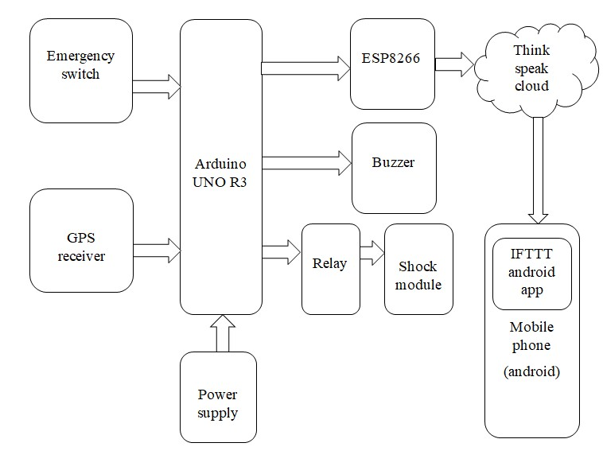
Figure. Architecture of Smart Wearable Device

Module and Component Description:
      - ARDUINO UNO R3
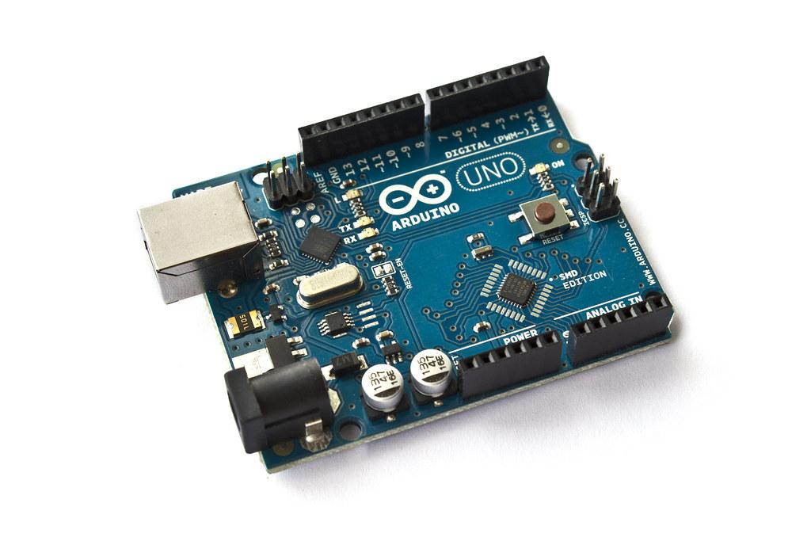
Figure. Arduino Uno R3

The Arduino Uno R3 is a circuit board built around the detachable, dual-inline-package (DIP), ATmega328 AVR microprocessor. It has a USB port, a power jack, an ICSP header, six analog inputs, a 16 MHz ceramic resonator, 14 digital input/output pins, six of which can be used as PWM outputs, and a reset button. The microcontroller is supported by everything you need; all you need to do is connect a USB cable, an AC-to-DC adapter, or a battery to get going. Without being unduly anxious that you will make a mistake, you can experiment with your UNO; in the worst case, you can replace the chip for a few dollars and start over.
      - NEO 6M GPS Receiver
The NEO-6M GPS receiver module is a strong, integrated 25 x 25 x 4mm ceramic antenna GPS receiver with full functionality. You can keep an eye on the module's health thanks to the power and signal indicators. The module can continue to save data even if the primary power supply is accidentally turned off thanks to the data backup battery. Its 3mm mounting holes may ensure easy installation on your aircraft, allowing it to, among other things, fly steadily in a fixed location, automatically return to its home, and fly to waypoints. Alternatively, you might use it to accurately "smart"-bot your smart robot automobile so that it will automatically reverse or travel to a certain area!
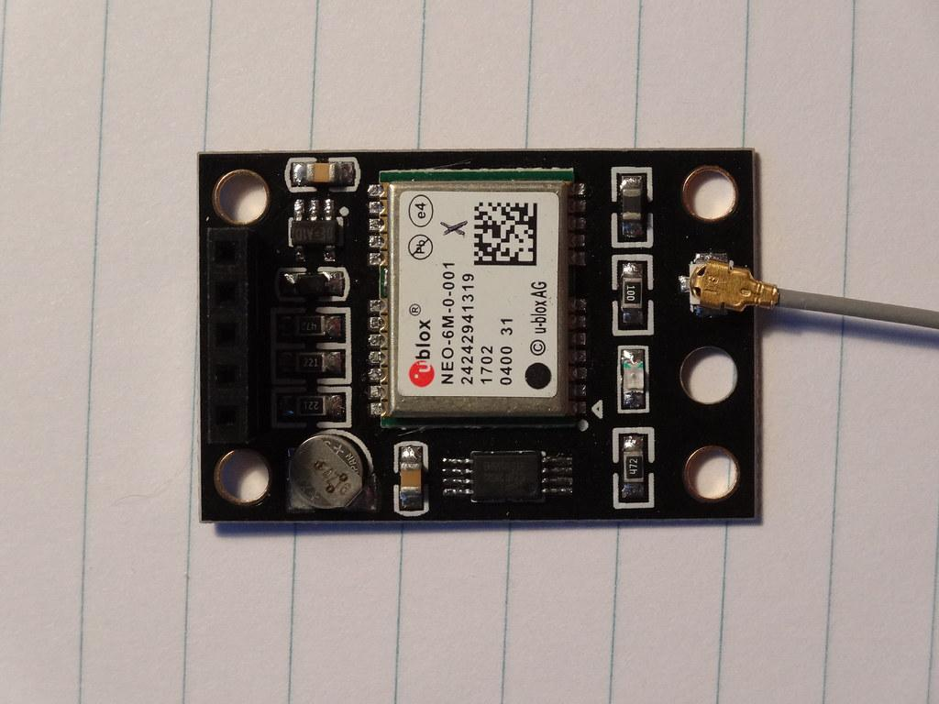
Figure. NEO-6M GPS RECEIVER
- ESP8266 NODEMCU
The ESP8266 is a low-cost System on a Chip (SoC), and the NodeMCU (Node Microcontroller Unit) is an open-source platform for designing hardware and applications based on it.
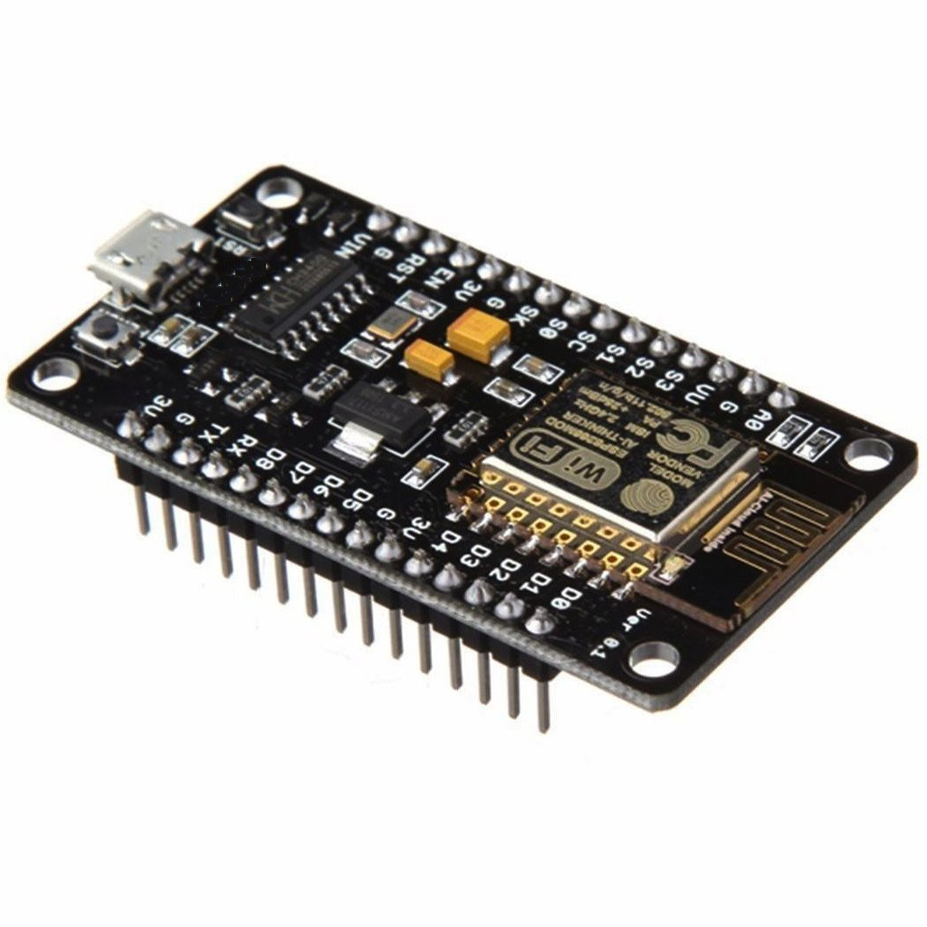
Figure. ESP8266 NODEMCU
The ESP8266, developed and manufactured by Espressif Systems, is equipped with all essential computer parts, such as a CPU, RAM, networking (WiFi), and even a contemporary operating system and SDK. It is an excellent choice for all Internet of Things (IoT) projects as a result of this inclusion.
- Push Button
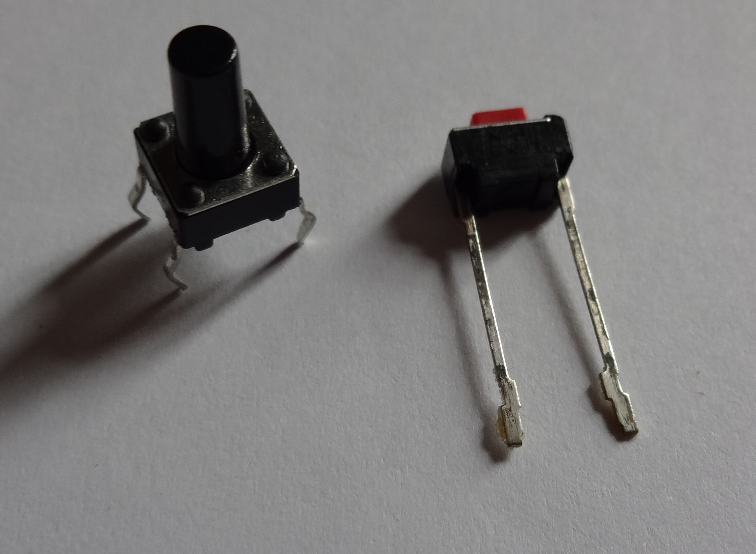
Figure. Push Button

A push button, also referred to as a button, is a simple switch mechanism used to operate a machine or process. Buttons are formed of solid materials and are typically made of metal or plastic.
- Buzzer
A mechanical, electromechanical, or piezoelectric (short for piezoelectric) aural signaling device is referred to as a buzzer or beeper. Alarm clocks, timers, trains, and devices that signal user input, including mouse or keyboard clicks, typically use buzzers and beepers.
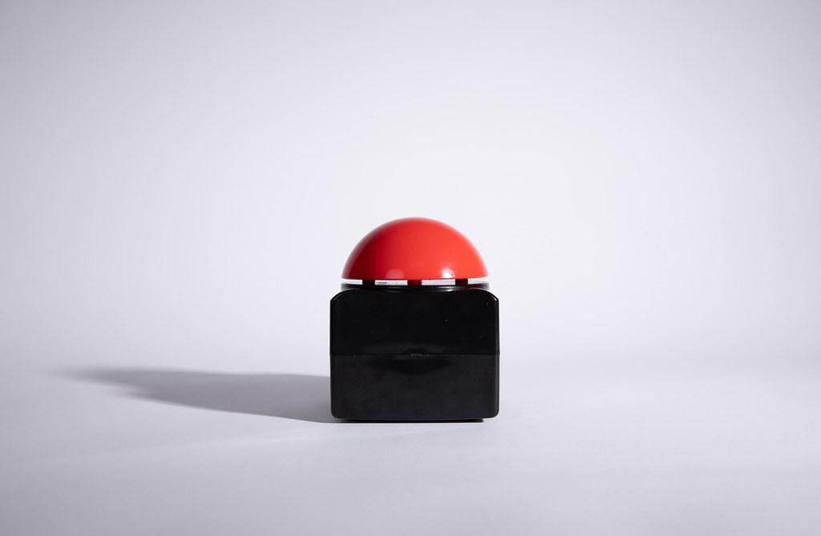
Figure. Buzzer
- Shock Module
When actuated by an external trigger, such as a button or switch, a shock module is an electronic component that can provide an electric shock or discharge. Typically, it consists of a charging circuit, a firing circuit, and a high-voltage capacitor. When the trigger is engaged, the charging circuit initiates a high-voltage charge on the capacitor. A high-voltage shock is then produced as a result of the discharge circuit quickly releasing the stored charge. By changing the characteristics of the charging and discharge circuits, the shock's intensity and duration can be managed. Stun weapons, self-defense tools, and animal deterrents are just a few uses for shock modules. However, using them carefully is crucial because their usage can be contentious and subject to rules and regulations.
A shock module circuit normally consists of many parts that, when activated, produce a high-voltage shock.
- High-voltage capacitor
- Charging circuit
- Discharge circuit
- Safety features
- ARDUINO IDE
The Arduino Integrated Development Environment, often known as the Arduino Software (IDE), includes menus, a communication area, a textbook push, a toolbar with buttons for common or garden locations, and a textbook editor for writing legal texts. To upload and execute programs, it connects to the Arduino board. Allow for the writing and uploading of laws to Arduino boards, using a variety of libraries and a collection of miniature system examples. Operating systems (Windows, Linux, and Mac OS X) that are not identical are compatible with the Arduino software (IDE). The Arduino software is prepared to work with new or enhanced medications. Making interactive prototypes was tested first with electronics programming and robotics.
- ThingSpeak Cloud Server
With the help of the IoT analytics platform indulgence ThingSpeak, you can analyze, fantasize, and analyze real-time data streams right in the box. You can provide data to ThingSpeak based on your bias, generate instant live data visualization, and send warnings. The ability to
- Fluently configured. bias to send data to ThingSpeak by utilizing well-liked IoT protocols is one of the key features of ThingSpeak.
- Real-time visualization of your detector data.
- Practice managing MATLAB to make sense of your IoT data.
- Implement automatic IoT analytics based on recurring events or schedules IFTTT
- IF THIS, THEN THAT (IFTTT)
IFTTT, which stands for "If This Then That" and rhymes with "Gift," was chosen as the name since Applets would only have one detector and one action. If this happens, that also occurs. As an example, "Turn on your Hue radiances when you get home." Previously active Applets can be activated, or a simple ritual can be created.
With over 700 nonidentical apps and services, including Twitter, Dropbox, Evernote, Fitbit, Amazon Alexa, and Google Assistant, you can achieve more thanks to IFTTT's assistance in connecting nonidentical apps and biases. We call these services through IFTTT. Here is a list of every service that supports IFTTT. We link Applets to services, robotization affects your programs and bias is unable to function on its own. For instance, you might use IFTTT to connect your Google calendar with your Amazon Alexa to-do list.

The Circuit Diagram:
Components like the Arduino, GPS receiver, NODEMCU, shock module, and power supply are represented in the pin diagram. The Arduino is linked to the components using the available pins, as shown in the illustration below.
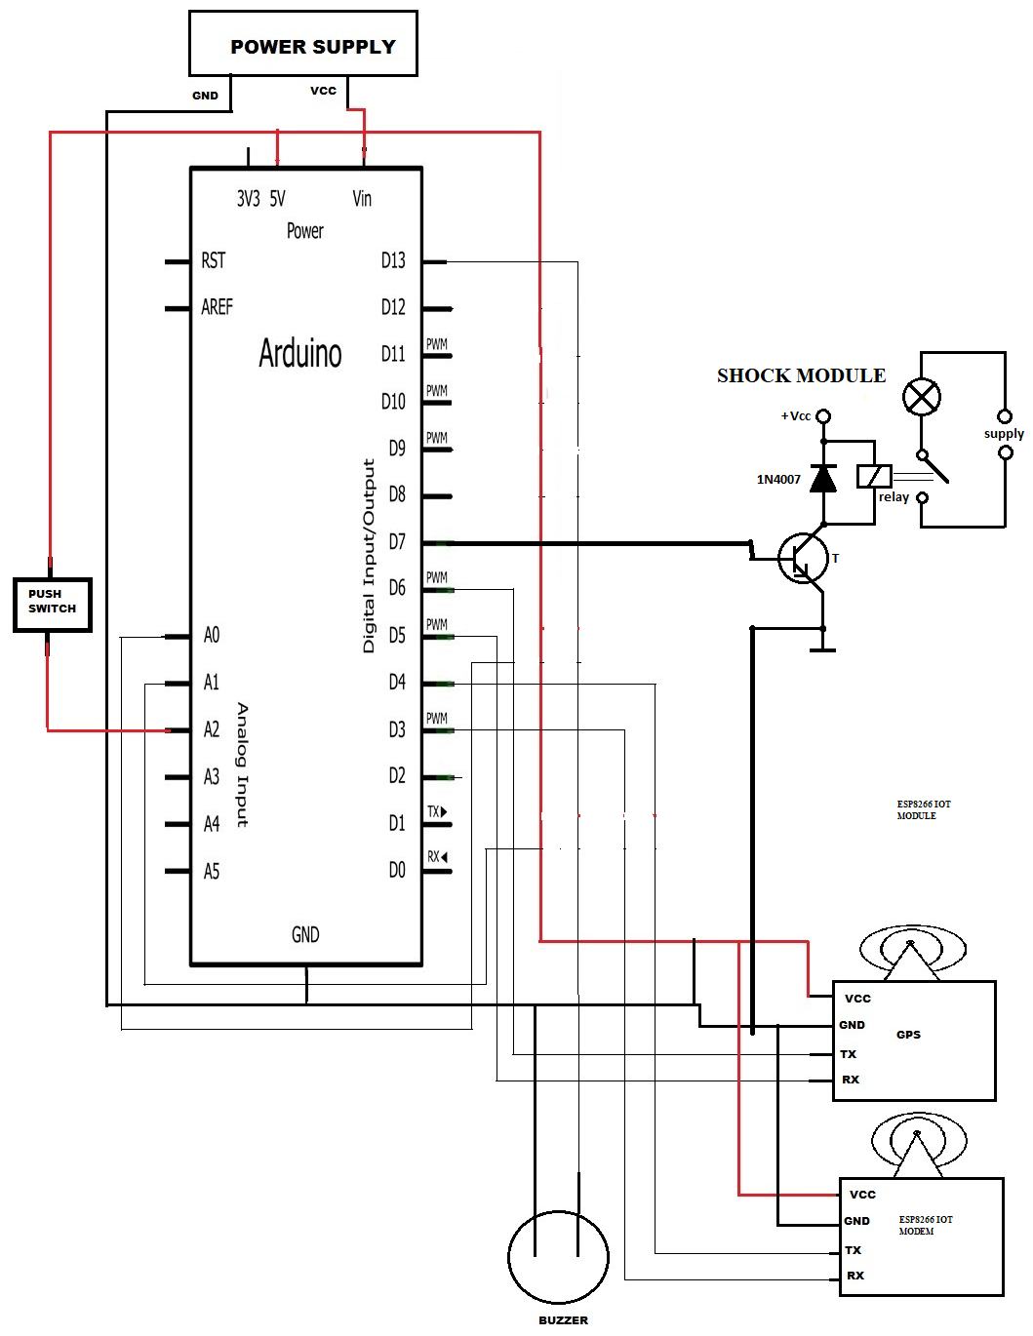
Fig. Circuit Diagram – Smart Wearable Device
IV.RESULT
The result of all creation when the emergency button is pressed is shown in this diagram. It generates an automatic call with a pre-written emergency message to the pre-registered or defined contact.
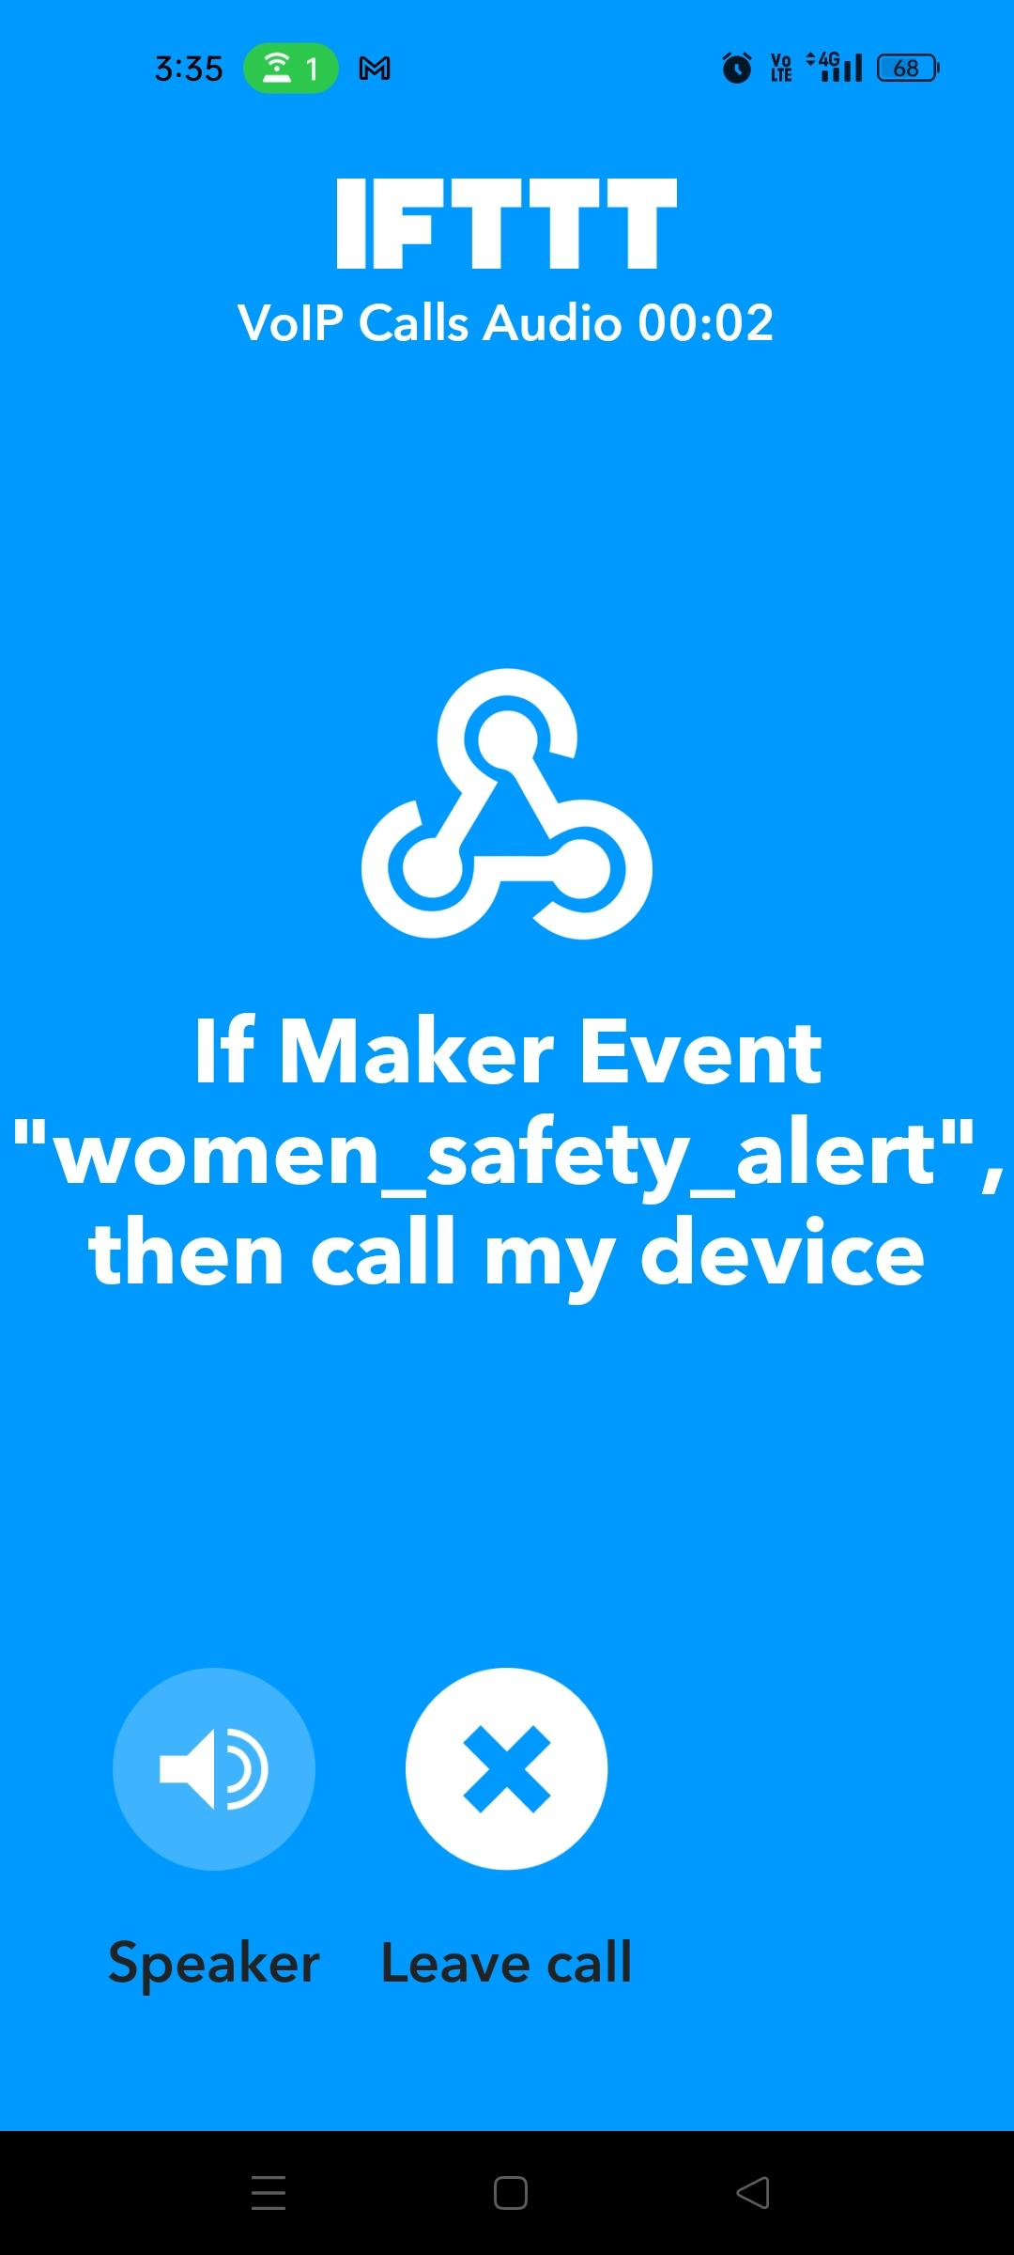
Figure. Receiving a call in the IFTTT module
Visual and audio notifications, as well as a VoIP call to a predetermined phone number, would normally be the output of the women's safety gadget powered by an Arduino ESP8266 and equipped with a shock module. Here is a quick summary of the output:
1. Visual alerts: When the shock module is activated, the gadget may include one or more LEDs that light up. It alerts the user and anybody nearby that the device has been activated and that she is in danger.
2. Audible alerts: When the shock module is triggered, the gadget may have a buzzer or speaker that makes a loud noise. It alerts the user and anybody nearby that the device has been activated and that she is in danger.
3. Shock output: When activated, the shock module will deliver a high-voltage jolt that can temporarily disable or dissuade an assailant.
4. SOS Call alert: When the shock module is activated, the gadget can be set up to make an SOS Call to a specific phone number. This call alert can let people know that the user needs assistance and is in danger, including emergency contacts, law enforcement, and other pertinent authorities. Overall, the output of the device is meant to offer the user many layers of security and assist her in escaping a dangerous situation as fast and safely as possible.
Figure. Smart Wearable Gadget - circuit diagram
V. FUTURE SCOPE
With the use of a smart device, this proposal developed a system for the security of women. When the button is pressed, the sensors gather user data, which is subsequently sent, together with a call and alarm message, to the predetermined number. With this system, there are the best prospects of lowering crime. To prepare for the occurrence, shock avoidance measures are used, and the alarm tone used for notification will support strategies for alerting antagonism.
This gadget might eventually be included in a smartwatch. By adding new features that weren't previously available, the integration of this gadget might improve the capabilities of the smartwatch. This might come with elements like sophisticated biometric tracking.

REFERENCES
Kale, Nishigandha, Komal Hadke, Mayuri Kadam, and Kanchan Nale. “Women Safety Device With Gps, Gsm And Health Monitoring System ”(2021).
Akram, Wasim, Mohit Jain, Sweetlin Hemalath “Design of ASmart Safety Device For Women Using Iot” Procedia Computer Science 165 (2019): 656-662.
Harikiran, G. C., Karthik Menasinkai, And Suhas Shiro “Smart Security Solution For Women Based On The Internet Of Things (IoT)” In 2016 International Conference On Electrical, Electronics, And Optimisation Techniques (Iceeot), Pp. 3551-3554. IEEE, 2016.
Ahir, Shivani, Smit Kapadia, Jigar Chauhan, And Nidhi Sanghavi. "The Personal Stun-A Smart Device For Women's Safety”.In 2018 International Conference On Smart City And Emerging Technology (Icscet), Pp. 1-3. IEEE, 2018.
Daniel, Preethu, Anciya Backer, K. Shini, Sulthana Nazar, And Soumya Joseph “Smart Band For Women Safety” International Journal Of Computer Science Trends And Technology 7, No. 2 (2019): 17-21.
Bhardwaj, Nishant, And Nitish Aggarwal “Design And Development Of “Suraksha”-A Women Safety Device” International Journal Of Information &amp; Computational Technology 4, No. 8 (2014): 787-792.
Devi, Ms, M. Thaarini, A. Vansrani, And M. Sreeja “Smart Security Gadget For Women Using IoT”
Helen, A., M. Fathima Fathila, R. Rijwana, And V. K. G.Kalaiselvi. “A Smart Watch For Women Security Based On The Iot Concept 'Watch Me'" In 2017 2nd International Conference On Computing And Communications Technologies (ICCCT), Pp. 190-194. IEEE, 2017.
Bhilare, Poonam, Akshay Mohite, Dhanashri Kamble, Swapnil Makode, And Rasika Kahane “Women Employee Security System Using GPS And Gsm Based Vehicle Tracking” International Journal For Research In Emerging Science And Technology 2, No. 1 (2015): 65-71.
Ashiq, S. Mohamed, And C. Manivelprabh “Design Of Electric Shock Antenna Watch With Automated SMS Facilities For Women Safety In India Under Government License" International Journal Of Emerging Technology And Advanced Engineering 3, No. 3 (2013): 575-577.
Khandelwal, Teena, Manisha Khandelwal, And Purnendu Shekhar Pandey. “Women Safety Devices Designed Using Iot And Machine Learning”, 2018 IEEE Smartworld, Ubiquitous Intelligence Computing, Advanced, Trusted Computing,Scalable Computing &amp; Communications, Cloud &amp; Big Data Computing, Internet Of People And Smart city innovation (Smartworld/ Scalcom/ Uic/ Atc/ Cbdcom/ Iop/ Sci), Pp. 1204- 1210. IEEE, 2018.
Gomathy, C. K., And Ms S. Geetha “Women Safety Devices Using Iot” International Journal Of Scientific Research In Engineering And Management 5, No. 10 (2021): 1-9.
D. S. Prashanth, G. Patel, and B. Bharathi, “Research And Development Of A Mobile Based Women Safety Application With Real-Time Database And Data-Stream Network”,2017 International Conference On Circuit, Power And ComputingTechnologies (Iccpct), Kollam, India, 2017, Pp. 1-5, Doi:10.1109/Iccpct.2017.8074261.
Phadtare, Shubham, Raj Kudale, Pranav Ladkat, Tejas Balshetwar, And Anita Vikram Shinde. “IoT Based Social Safety Android Application Using Geolocation For Real-Time Tracing.
Premkumar, P R. Cibi Chakkaravarthy, M. Keerthana, R. Ravivarma, And T. Sharmila. “One Touch Alarm System For Women’s Safety Using Gsm.” International Journal Of Science, Technology & Management 4, No. 2394-1537 (2015).
D. S. Prashanth, G. Patel And B. Bharathi, “Research And Development Of A Mobile Based Women Safety Application With Real-Time Database And Data-Stream Network,” 2017 International Conference On Circuit, Power And Computing Technologies (Iccpct), Kollam, India, 2017, Pp. 1-5, Doi: 10.1109/Iccpct.2017.8074261.
Priyanka, K., S. Purushothaman, A. Vaniprabha, And C. Sathiyavel. “Protection For Women Using IoT Smart Devices With Location And Parameters.” International Research Journal Of Engineering And Technology (Irjet) 6, No. 5 (2019).
Helen, A., M. Fathima Fathila, R. Rijwana, And V. K. G. Kalaiselvi. “A Smart Watch For Women's Security Based On The IoT Concept 'Watch Me'." In 2017 2nd International Conference On Computing And Communications Technologies (ICCCT), Pp. 190-194. Ieee, 2017.
Viswanath, Nandita, Naga Vaishnavi Pakyala, And G. Muneeswari. “Smart Foot Device For Women’s Safety.” In 2016 Ieee Region 10 Symposium (Tensymp), Pp. 130-134. Ieee, 2016.
Magidwar, Shubham, Akshay Hargane, Pratik Singh, Mrudula Nade, And Rama Gaikwad. “Implementation Of A Wearable Defense System For Women’s Security Using Wireless Sensor Network.” International Research Journal Of Engineering And Technology (Irjet) 3, No. 11 (2016): 1217-1221.
Devi, Ms, M. Thaarini, A. Vansrani, And M. Sreeja. "Smart Security Gadget For Women Using IoT."
Monisha, D. G., M. Monisha, G. Pavithra, And R. Subhashini. “Women Safety Device And Application-Femme.” Indian Journal Of Science And Technology 9, No. 10 (2016): 1-6.
Kale, Nishigandha, Komal Hadke, Mayuri Kadam, And Kanchan Nale. “Women Safety Device With Gps, Gsm And Health Monitoring System.” (2021).
Chand, Dhruv, Sunil Nayak, Karthik S. Bhat, Shivani Parikh, Yuvraj Singh, And Amita Ajith Kamath “A Mobile Application For Women Safety: Wosapp” In Tencon 2015- 2015 IEEE Region 10 Conference, Pp. 1-5. IEEE, 2015.
https://vikaspedia.in/e-governance/women-and-e-governance/kavalansos-mobile-app
https://en.wikipedia.org/wiki/Noonlight
https://www.getbsafe.com/
https://en.wikipedia.org/wiki/Safetipin
https://lbb.in/mumbai/eyewatch-app/

