Tropospheric ultraviolet (UV) radiation and its effect on agricultural plants: An assessment
Indra Jeet Chaudhary¹ and Bhavna Nigam²
¹Department of Environmental Science, Savitribai Phule Pune University (Maharashtra) India
²School of Environment and Sustainable Development, Central University of Gujarat, Gandhinagar, Gujarat, India
Email: indrajeet.cug@gmail.com
Abstract
Increasing composition of gaseous pollutant derived by anthropogenic activity disturbed natural atmospheric gaseous composition and deplete the stratospheric ozone layer. Major consequences of this depletion are increase incidents of harmful UV-B radiations reaching to terrestrial surface. Plants being permanent tool to removed harmful effect of solar radiation. Plants use sunlight as primary energy sources, therefore the small increase in UV-B radiation is recognized as harmful for plants. Many studies have shown that solar UV-B radiation cause significantly effect on morphological, physiological, biochemical and molecular components the plant. There are several visible and micro morphological effects of enhanced UV-B radiation was also observed including visible injury and stomatal characteristics. In this chapter to identification effect of UV-B radiation on plant growth and yield loss. Despite that study also focused on UV-B tolerance plants species selection for opened to new area of research towards decreasing the UV-B radiation effect on agricultural losses.
Keyword: UV-B radiation; growth & physiological changes, tolerance plants and agricultural losses.
1. Introduction
Solar ultraviolet (UV) radiation at the Earth’s surface passes through the atmosphere where many complicated absorption and scattering processes occur. In general, radiation at progressively shorter UV wavelengths becomes increasingly harmful to most biological species. UV radiation is classified as UV-A (315–400 nm), UV-B (280–315 nm), and UV–C (100–280 nm). Atmospheric gases absorb very little UV-A radiation. Atmospheric oxygen and ozone absorb all UV-C radiation and prevent it from reaching the troposphere and the Earth’s surface. The earth's stratospheric ozone layer plays a critical role in absorbing ultraviolet radiation emitted by the sun. In the last thirty years, it has been discovered that stratospheric ozone is depleting as a result of increasing in various human originated ODSs (ozone depleting substances). Major consequences of this depletion are increase incidents of harmful UV-B radiations reaching to terrestrial surface. Although ultraviolate radiations subdivides into three parts UV-A (315-400nm), UV-B (280-315nm) and UV-C (200-280 nm), UV-C radiation is completely absorbed by the atmosphere and UV-A fully transmitted to the earth's surface cannot be absorbed by the ozone layer and less harmful than the other UV radiation.
However, some astronomical parameters, such as solar zenith angle, as well as physical characteristics of the earth’s surface, like altitude, albedo and meteorological conditions, also affect the transmission of UV‐B (Porfirio et al., 2012), transmission of UV‐B is mainly controlled by ozone (Kakani et al., 2003). Gases such as CFCs (CFC‐11, CFC‐12, and CFC‐113) with a high potential to deplete ozone having a half‐life ranging from 50 to 150 years (Kakani et al., 2003). Plants being immovable are inevitably exposed to sunlight for carrying out major physiological and developmental processes (Agrawal et al., 2007). Several studies have demonstrated that the solar UV-B radiation significantly affects various morphological, biochemical and molecular processes of plants.
Knowledge of the intensity, wavelength dependence, and angular distribution of UV radiation at the Earth’s surface is important for several reasons. The evolution and growth of most terrestrial and aquatic life forms, including human beings, are influenced by many environmental variables, including the intensity of UV irradiance at the Earth’s surface or under water. In human beings, excessive accumulated exposure can cause sunburn, skin cancer, eye cataracts, or suppression of the immune system (UNEP, 2006). Most biological systems respond to UV radiation with effects that generally become more detrimental with decreasing wavelength. The specific sensitivity to UV radiation for a particular life form is quantified by an action spectrum such as that for erythema (skin reddening) in human beings (McKinlay andDiffey, 1987), plant damage (Caldwell et al., 1986), and DNAdamage (Setlow, 1974). For example, the sun burning action spectrum. There is also emerging evidence that UV-B radiation can be beneficial to human health through the production of Vitamin D. A number of studies have linked low solar UV radiation exposure to a higher risk of some internal cancers, such as colorectal and prostate, and autoimmune diseases, such as multiple sclerosis and type 1 diabetes (Young and Walker, 2005; UNEP, 2006). In addition, manufactured materials such as plastics are sensitive to exposure to UV radiation, and significant research is carried out to develop UV-resistant materials intended for outdoor use. UV radiation also drives photochemical reactions in the atmosphere and is therefore important for tropospheric pollution studies.
The environment of UV radiation at the Earth’s surface and under water depends on many complicated absorption and scattering processes that occur in the atmosphere, at the Earth’s surface, and under water. Surface radiation absorbed by a particular atmospheric gas has wavelength-dependent structure with features that are similar to the absorption spectrum of the constituent. The most significant atmospheric absorber at UV-B wavelengths is stratospheric ozone and the wavelength structure is seen in ground-based measurements (Kerr and McElroy, 1993). Absorption by airborne aerosols such as smoke from forest fires (McArthur et al., 1999), biomass burning (Kirchoff et al., 2001), or desert dust (di Sarraet al., 2002) generally has little wavelength-dependent structure and absorption usually increases with decreasing wavelength. Scattering processes in the atmosphere include molecular (Rayleigh) scattering and scattering by larger particles such as cloud constituents and aerosols.
2. UV-B radiation and its effect on plants
It has been established that UV-B radiation harms living things by destroying their DNA, proteins, lipids, and membranes. Plants are at risk since they rely on sunlight for photosynthesis and can't avoid being exposed to increased quantities of UV-B radiation (Azarafshan et al., 2020). Since sunlight is the plants' main energy source, they are undoubtedly exposed to UV-B radiation. Several plant macromolecules like protein, nucleic acid, lipid, and phytochrome rapidly absorb UV-B light, which can have major biological effects (Vanhaelewyn et al., 2020). Many study have shown that solar UV-B radiation cause significantly effect on morphological, physiological, biochemical and molecular components the plant (Aksakal et al., 2017). The effect of UV-B can be direct or by interfering various process of plant (Aksakl et al., 2017). The biomass, physiology and yield characteristic etc. showing in figure 1. According to studies, UV-B radiation affects the photosynthetic process of plants, which directly impacts the yield of plants (Jovanić et al., 2022). Reduction of photosynthetic rate also reduced the biomass accumulation in plants (Honda et al., 2021).
Sensitivity of crop plants to UV-B radiation varies depending on species and cultivars of plants (Caldwell et al., 2007). According to the Hidema (2007), few plant species are tolerant to the ambient UV-B radiation and several are apparently stimulated in their growth. However, most of the species are significantly sensitive to the ambient UV-B radiation. Besides this, plant have defense mechanisms against UV-B stress, such as production of the antioxidant system (Brosché and Strid, 2003) and accumulation of UV-absorbing compounds (Frohnmeyer and Staiger, 2003; .Fedina et al., 2007).
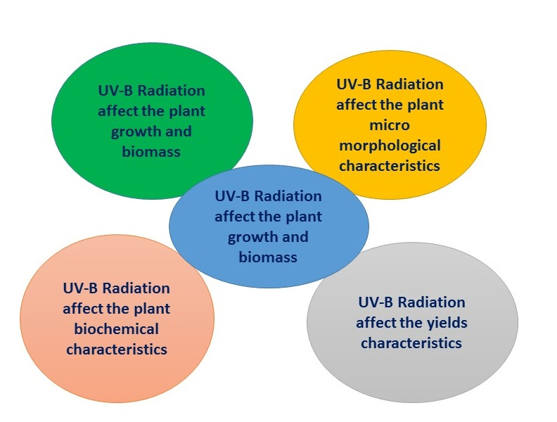
Figure 1. UV-B radiation and its effect on plants
2.1. Effect of UV-B radiation on plant growth and biomass
Increasing UV-B radiation decreases the seedlings and different growth parameters of plants. Throughout growth seasons, there was a substantial reduction in plant height, stem diameter, and leaf area index (LAI) in correlation with increasing UV-B radiation (Kataria et al., 2014). Numerous studies have been conducted to determine the impact of UV-B radiation on plant growth and biomass. Reddy (2013) reported that UV-B stress leads to reduction of plant height and leaf length/area. Plant height decrease may due to UV-B radiation reduces mainstem and branch elongation rates, resulting in more compact and shorter plants (Parihar et al., 2015) and leaf area decreases because of UV-B induce the reduction in cell, change in leaf structure, reduction in cell number and by both cell division and cell expansion (Jansen et al., 2012). UV-B exposure can result in shorter petioles and leaf blades that are shorter, narrower, and/or thicker. The consequent reduction in leaf area has been linked to UV-B inhibitory effects on biomass accumulation (Jansen et al., 2012).
UV-B-induced changes in plant shape may alter light competition (Robson et al. 2015). UV-B radiation's harmful effects result in distorted morphological characteristics. UV-B exposure reduced plant height, leaf area, and plant dry weight while increasing auxiliary branching and leaf curling (Robson et al. 2015, Kumar and Pandey 2017, Palma et al. 2021). According to Zuk-Golaszewska et al. (2003), after a few weeks of UV-B exposure, rice leaf area and plant dry weight were drastically reduced. According to Bernado et al. (2021), higher UV-A reduced leaf area per unit plant biomass (leaf area ratio) while increasing biomass production per unit leaf area (leaf area productivity) and per unit leaf nitrogen (leaf nitrogen productivity). High UV-B levels clearly reduced relative growth rate and nitrogen productivity, as leaf area ratio, leaf area productivity, and leaf nitrogen productivity were all reduced.
2.2 Effect of UV-B radiation on Photosynthetic pigments
One of the most delicate metabolic processes is photosynthesis. Studying photosynthesis' reaction to UV-B exposure is crucial since it is directly related to biomass production and yield. Despite the fact that UV-B has many different targets in plants, one of its primary action targets is the photosynthetic system, and damage to this organ considerably increases the overall harm UV-B causes (Lidon and Ramalho, 2011; Lidon et al. 2012).
Photosynthesis is only known process to converts light energy into chemical energy, and is one of the very important process which helps to supports life system on the earth (Lambers et al., 2023). This is also only potential natural process to produce oxygen and maintain atmospheric O₂/CO₂ ratio. As photosynthesis is light driven process, it is sensitive to the quality of solar radiations. UV-B affects photosynthesis by degradation of photosynthetic pigment or by the inhibition of enzyme involved in the biosynthesis pathway which ultimately hinders the photosynthetic capacity of plants (Piccini et al., 2020). UV-B affects evolutionary conserved protein named RUBISCO (ribulose-1, 5-bisphosphate carboxylase/oxygenase) involved in C₃ cycle (Hazra et al. 2015). The possible mechanism of UV-B-induced inactivation of Rubisco could be modification of the peptide chain, degradation of the protein, and diminished transcription of the gene. Other target of UV-B radiation on photosynthetic process are loss in the integrity of the thylakoid membranes, damage in oxygen evolving complex or on water splitting complex by damaging Mn cluster. UV-B reduces the generation of ATP and synthesis of NADP. This lowering ATP/ADP ratio leads to affect the Rubisco activase enzyme. This is why increasing ultraviolet radiation has become one of the most important issues affecting photosynthesis and the CO₂ assimilation process (Perdomo et al. 2017).
Direct impacts of increased UV-B radiation on photosynthetic variables include thylakoid membrane integrity loss, PS II has suffered more damage than PS I. Reduced carbon dioxide fixation and oxygen evolution Dry weight, starch, and chlorophyll content were reduced; rubisco activity was reduced; and ATP synthase was inactivated (Piccini et al., 2020). While the indirect impacts of increased UV-B radiation on photosynthesis include stomatal closure, changes in leaf thickness and structure modify the light environment within the leaf. Changes in canopy morphology have an indirect effect on whole plant photosynthesis (Kataria et al., 2014).
2.3. Effect of UV-B radiation on plant metabolites
UV-B readily absorbed by the number of macro molecules like protein, amino acid, nucleic acid which result in the destruction of the various molecules. Proteins and lipids are direct targets of UV-B radiation. Since proteins strongly absorb ~280 nm or higher wavelengths, UV-B can affect the aromatic amino acids such as tyrosine, phenylalanine, and tryptophan easily absorb UV-B radiation which can cause the damage and inactivation in various protein and enzyme structure and also inhibit the various metabolic process (Salama et al., 2011) ROS generate due to UV-B stress can cause the instability of the membrane by destructing the lipid bound to the membrane. Oxidative damage measured by the lipid peroxidation activity.
2.4. Effect of UV-B radiation on crop yields loss
Solar UV-B radiation and its possible impact on global agriculture is a major issue for the future. UV-B light has a disproportionately large photobiological effect. Increased UV-B radiation levels can have a negative impact on agricultural photosynthesis and productivity on a large scale (Robson et al., 2015). The majority of our understanding of the effects of UV-B radiation on plants comes from research on economically significant crops. The majority of the plant species tested in the field were found to be UV-B sensitive, although sensitivity varied between cultivars of the same species (Teramura and Sullivan, 1991). Soybean (Glycine max) is one species that has received a lot of attention. Soybean cultivars cultivated under increased UV-B radiation exhibited varied sensitivity. Increased UV-B radiation reduced yields significantly (20-25%) in one cultivar, Essex, but had no effect on another cultivar, Williams (Teramura et al., 1990a; Yuan et al., 2002). Furthermore, intense UV-B radiation reduced wheat grain production by 8%, affecting crop spike counts (Teramura et al., 1990b).
UV-B radiation significantly harmed the plant's photosynthetic system and membrane, affected protein composition and enzyme activity, harmed DNA, and altered leaf chemistry (Zhang et al., 2016; Piccini et al., 2020). Plant stunting, leaf discolouration, or losses in vegetative biomass and grain output can all result from morphological damage (Hasanuzzaman et al., 2013). Many studies have found that UV-B radiation can cause alpine plant developmental phases to be delayed or postponed, as well as the commencement of blooming in other plants (Hasanuzzaman et al., 2013; Zhang et al., 2016; Dotto et al., 2018; Piccini et al., 2020). UV-B radiation may directly alter cell division and several fundamental growth properties, resulting in a delay in plant development, and this general growth delay has been recognised as one of the UV-B radiation protective mechanisms (Valenta et al., 2020). Several studies in soybean, rice, and barley indicate that activating phenolic biosynthesis increases phenolic accumulation in the plant, which could be a protective mechanism against UV-B radiation (Schmitz-Hoerner et al., 2003; Koti et al., 2007; Meyer et al., 2021; Gu et al., 2022). The most significant unfavourable element was flowering delay, which is directly related to yield reduction in crop plants (Kazan & Lyons, 2016). Plant height decline is frequently employed as an index to determine the degree of UV-B radiation sensitivity (Kataria et al., 2014). Kataria & Guruprasad, (2015) found that under greenhouse conditions, UV-B radiation had no consistent effect on wheat height. In contrast, Liu et al. (2013) observed that UV-B radiation significantly dwarfed soybean due to shorter internodes rather than node number. Plant dwarfism can be linked to photo-oxidative damage of the phytohormone indole acetic acid (IAA), which leads to decreased cell wall extensibility (Wang & Komatsu, 2022). Higher UV-B exposure was shown to increase ethylene levels and enhance radial development while decreasing elongation (Garcia-Garcia et al., 2020). UV-B radiation also reduced the number of secondary tillers and grain in rice cultivars (Mohammed & Tarpley, 2009). Furthermore, several studies have found that when exposed to intense UV-B radiation, total biomass accumulation decreases (Liu et al. 2013; Kazan & Lyons, 2016; Delerue et al., 2022). Reducing overall biomass is frequently accompanied by considerable changes in biomass partitioning into plant organs (Delerue et al., 2022). Leaves and stems devoured a large amount of total biomass, but spikes consumed less. These alterations could be related to UV-B radiation adaption. Upper leaf tissue works as an anatomical cover or filter to reduce UV-B transmission into sensitive underlying tissue as a result of leaf thickening (Kataria et al., 2014). Reduced photosynthetic rates due to declines in enzyme activity, photosystem II efficiency, and stomatal conductance may also contribute to a loss in grain production and total biomass (Kataria et al., 2014; Andrew et al., 2019; Katsoulas et al., 2020). Plants respond differentially to UV-B in different environments, such as the variances between greenhouse and outdoor growth conditions (Katsoulas et al., 2020). Aside from genetic differences between cultivars, variability between experiments could be due to differences in growth conditions, length of UV-B radiation, stage of growth, and the ratio of incident to UV-B radiation.
3. Defense strategy of plant in response to UV-B radiation
Plants develop a variety of defence mechanisms that significantly modify the photosynthetic apparatus's susceptibility to UV-B light. Morphological alterations such as increased length of epidermal cells (Haupt and Scheuerlein, 1990), synthesis of a waxy cuticle (Mulroy, 1979), accumulation of UV-B absorption compounds, and formation of different reactive oxygen species (ROS) are examples of these protective mechanisms. Plants can mitigate the effects of UV-B radiation on their photosynthetic systems by creating a complicated collection of repair mechanisms such as photo reactivation, excision, and recombination repair.
Many study reported that exposure of UV-B induce the generation of reactive oxygen species (ROS) which leads to oxidative stress. To cope with oxidative damage plant develop enzymatic and non-enzymatic defence system that scavenger cellular ROS (Shiu and lee et al., 2005). The synthesis and accumulation of secondary metabolites like phenolic compounds, flavonoids, and anthocyanins are the most frequently observed responses in plants exposed to UV-B radiation (Aksakl et al., 2016). This pigment also serves as UV screen which protect the plant from damaging effect of UV radiation (Yadav et al., 2017). In order to avoid or restrict harm, plants have developed "sunscreen" flavonoids that accumulate under UV-B exposure (Chen and Hongtao, 2021). In several plant species, UV-B light boosts net plant photosynthesis when there is a high level of photosynthetically active radiation. Both UV-B and high PAR can increase the production of flavonoids in young and old plant leaves. When plants are exposed to UV-B light, photosynthesis is positively impacted by UV-A radiation (Escobar-Bravo et al., 2017).
Accumulation of secondary metabolites flavonoids and phenol are the most frequently observed responses in plants exposed to UV-B radiation (aksakl et al., 2016). This pigment also serve as UV screen which protect the plant from damaging effect of UV radiation (Yadav et al., 2016). (Wang et al., 2017) suggested that UV-B stimulate the activity of Phenylalanine ammonia lyase (PAL) enzyme which is play an important role in flavonoid biosynthesis. Various study reveals that UV-B increase the flavonoids in buckwheat sprouts (Tsurunaga et al., 2013), fruit of the tomato (Castagna et al., 2013), wheat (Agrawal & Rathore, 2007) and Hypericum (Namli et al., 2014) Phenolic compounds mainly accumulated in the cuticles, vacuoles or in cell wall of the epidermis (aksakl et al., 2016). Role of UV-B radiation to enhance the flavonoids contents in plant leaves is described in Figure (Fig 2).
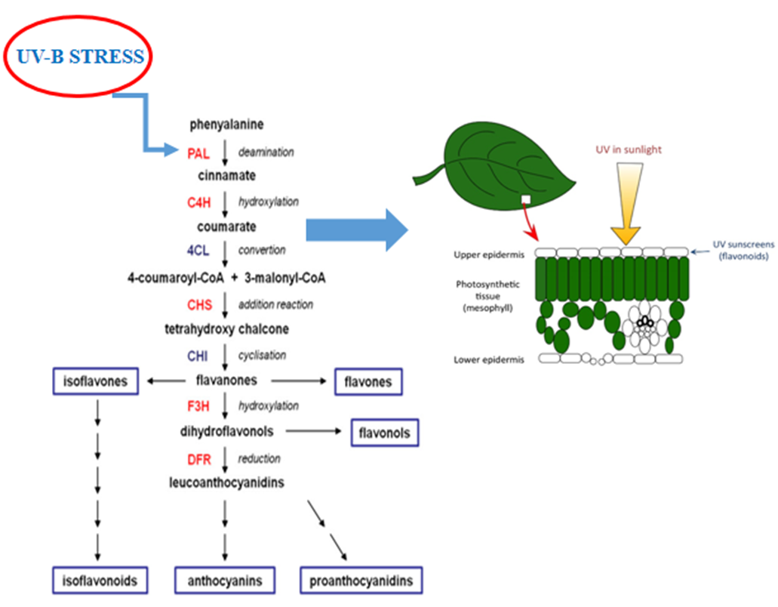
Figure: 2 Describes the synthesis of secondary metabolites under the exposure of UV-B radiation to protect the photosynthesis activity (modified from Peukert et al., 2013).
Earlier studies suggested that that UV-B stress, promotes ROS formation of the plant. Previous study observed that even lower doses of UV-B promotes the generation of reactive oxygen species (ROS) such as peroxide and hydroxyl radicals, either due to metabolic disturbances and impairment of photosynthetic electron transport or as a result of increased activity of membrane localized NADPH-oxidases and peroxidases (Jenkins, 2009; Hideg et al., 2013; Müller-Xinget al., 2014).
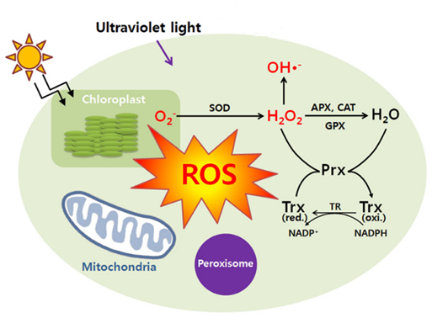
Figure: 3 Enzymatic defence response of plant under the exposure of UV-B radiation (adopted from Ganesh et al., 2013)
Sharma (2017) suggested reviewed that UV-B increase the activity of Superoxide dismutase (SOD), catalase (CAT), ascorbate peroxidases (APX), Malondialdeyde (MDA) and Peroxidase (POD) are involved in the ROS scavenging system, whereas the non-enzymatic scavenging system includes low molecular mass antioxidants such as Ascorbic acid (vitamin C), glutathione (GSH), carotenoids (Car), proline and compounds such as phenols. UV-B irradiation enhances the level of superoxide dismutase (SOD), and glutathione reductase (GR), as reported in cyanobacterium (Prasad and Zeeshan, 2005), wheat (Sharma et al., 1998).Through extensive studies, it was identified that the tolerance of seedlings to UV-B is due to the enhancement of SOD activity and other antioxidative enzymes in Cassia auriculata (Agarwal et al., 2007), potato (Santos et al., 2004). (Agarwal and Pandey, 2003) identified that increase the CAT and peroxidases (POX) activity under Cassia species in UV-B stress. Non-enzymatic antioxidants on UV-B exposure was also observed in pepper plants (Mahdavian et al., 2008), Cassia auriculata (Agarwal, 2007) and Acorus calamus (Kumari et al., 2010).
UV-B increase the activity of Superoxide dismutase (SOD), catalase (CAT), ascorbate peroxidases (APX), Malondialdeyde (MDA) and Peroxidase (POD) are involved in the ROS scavenging system, whereas the non-enzymatic scavenging system includes low molecular mass antioxidants such as ascorbic acid (vitamin C), glutathione (GSH), carotenoids (Car), proline and compounds such as phenols. By decreasing the use of ODSs we can reduce the impact of ODS on stratospheric ozone. Studies on identification of UV-B tolerance plants species and UV exclusion has opened up a new area of research towards increasing the photosynthetic efficiency and enhancing the rapid fixation of atmospheric carbon dioxide in present level to reduce and mitigate the global warming and climate change.
4. Management of UV-B radiation effect on plants
In order to avoid or restrict harm, plants have developed "sunscreen" flavonoids that accumulate under UV-B exposure (Chen and Hongtao, 2021). In several plant species, UV-B light boosts net plant photosynthesis when there is a high level of photosynthetically active radiation. Both UV-B and high PAR can increase the production of flavonoids in young and old plant leaves. When plants are exposed to UV-B light, photosynthesis is positively impacted by UV-A radiation (Escobar-Bravo et al., 2017).
UV exclusion studies can provide the realistic assessments of sensitivity of plant to current level of UV radiation. Most of the previous research dealing with the effects of UV-B radiation on plant metabolism and gene expression has been conducted in greenhouse, growth chamber or laboratory conditions. These types of indoor experiments are important for understanding the physiology of the UV response. However, they frequently produce unrealistic spectral balances between UV-A, UV-B and PAR, and in some cases, plants have been exposed to relatively high short-term doses of UV-B which lack ecological relevance (Krizek et al., 2014). Therefore, outdoor studies, that use visible background irradiance provided by sunlight, are necessary to realistically evaluate the biological effects of solar UV-B radiation. The two most widely used approaches in outdoor studies that use visible background irradiance provided by sunlight, are necessary to realistically evaluate the biological effects of solar UV-B radiation. The two most widely used approaches in outdoor studies are the attenuation approach (UV exclusion studies). Many study reported that the enhancement in growth, biomass accumulation and yield by exclusion of solar UV-B. With respect to photosynthetic components, the amount of Chl was shown to increase in the leaves of Cyamposis, Amaranthus, Sorghum, cotton and wheat by excluding UV radiation and this was accompanied by an increase in the rate of oxygen evolution (Aksakl et al., 2016). Guruprasad et al., (2013) have found the higher amount of O2˙− and ˙OH radicals and the higher radical scavenging activity in the leaves exposed to ambient UV radiation as compared to the leaves of the plants grown under UV exclusion filters. An increase in the concentration and the activity of Rubisco were found in lower plants (Ulva lactuca) and higher plants (cotton, wheat, sorghum and amaranthus) after exclusion of solar UV radiation. Reduction in the ROS production, antioxidant enzyme activity and ascorbic acid content after UV exclusion indicated that ambient UV components exert a significant stress on crop plants. Reduction in the production of UV absorbing substances indicated a changed pattern of metabolism leading to improved primary metabolism after exclusion of solar UV-B. Exclusion of ambient UV significantly increased the efficiency of PS II and activity of Rubisco which ultimately enhances the rate of photosynthesis in plant and channelizes this additional fixation of carbon towards the improvement of crop yield (Kataria et al., 2014)
5. UV-B radiation tolerance plants
Photosynthesis, a process used by plants to produce chemical energy, depends on sunshine. For this, they employ wavelengths between 400 and 700 nm. Due to its lower intensity and the fact that it is not absorbed by the ozone layer, UV-A (315–400 nm) is the least harmful to living things among them. Despite being extremely dangerous, UV-C (100–280 nm) is fortunately absorbed by the atmosphere. All living organisms are adversely affected by UV-B (280-315 nm) at large doses (WHO, 1994). Current UV irradiance projection models predict that UV-B will continue to increase in the next years (Douglass et al., 2011).
Plants can directly sense UV-B photons via the UV RESISTANCE LOCUS 8 (UVR8) photoreceptor (Ulm et al., 2015). Acclimatization to UV-B involves a combination of protective and repair mechanisms, such as the accumulation of UV-B-absorbing 'sunscreen' metabolites in epidermal cell vacuoles, increased antioxidant levels, protection of the photosynthetic apparatus, and increased levels of DNA repair enzymes. As a result, plants appear not to ‘feel' UV-B as a stress that negatively and clearly interferes with cellular activity (also known as distress) as long as they are properly adapted (Hideg et al., 2013). UV-B-stressed plants are those that cannot cope with UV-B levels and the associated cellular damage (González Besteiro et al., 2011).
6. Conclusion
Anthropogenic activity and natural atmospheric gaseous composition deplete the stratospheric ozone layer. Major consequences of this depletion are increase incidents of harmful UV-B radiations reaching to terrestrial surface. Plants being immobile are more prone to solar radiation and ultimately UV-B. Plants use sunlight as primary energy sources, therefore the small increase in UV-B radiation is recognized as harmful for plants. Many studies have shown that solar UV-B radiation cause significantly effect on morphological, physiological, biochemical and molecular components the plant. Increasing ultraviolet radiation has become one of the most important issues affecting terrestrial ecosystem. It’s caused harmful effect to agricultural crop in ways increased the yield loss. Studies on identification of UV-B tolerance plants species and yield loss due to UV-B radiation will be useful tool for area of research towards decreasing the effect of UV-B radiation for sustainable agriculture production.
7. References
Agarwal, S. and Pandey, V., 2003. Stimulation of stress-related antioxidative enzymes in combating oxidative stress in Cassia seedlings. Indian Journal of Plant Physiology, 8(3), pp.264-269.
Agrawal, S., 2007. Increased antioxidant activity in Cassia seedlings under UV-B radiation. Biologia Plantarum, 51(1), pp.157-160.
Aksakal, O., Tabay, D., Esringu, A., Aksakal, F.I. and Esim, N., 2017. Effect of proline on biochemical and molecular mechanisms in lettuce (Lactuca sativa L.) exposed to UV-B radiation. Photochemical & Photobiological Sciences, 16(2), pp.246-254.
Aksakl, O., Tabay, D. and Kara, A.A., 2016. Effects of sodium nitroprusside (SNP) pretreatment on UV-B stress tolerance in lettuce (Lactuca sativa L.) seedlings. Environmental Science and Pollution Research, 23(1), pp.589-597.
Andrew J Simkin and others, Feeding the world: improving photosynthetic efficiency for sustainable crop production, Journal of Experimental Botany, Volume 70, Issue 4, 1 February 2019, Pages 1119–1140, https://doi.org/10.1093/jxb/ery445.
Azarafshan M, Peyvandi M, Abbaspour H, Noormohammadi Z, Majd A. 2020. The effects of UV-B radiation on genetic and biochemical changes of Pelargonium graveolens L'Her. Physiol Mol Biol Plants. 2020 Mar;26(3):605-616. doi: 10.1007/s12298-020-00758-6. Epub 2020 Feb 4. PMID: 32205934; PMCID: PMC7078430.
Bernado WP, Rakocevic M, Santos AR, Ruas KF, Baroni DF, Abraham AC, Pireda S, Oliveira DDS, Cunha MD, Ramalho JC, Campostrini E, Rodrigues WP. Biomass and Leaf Acclimations to Ultraviolet Solar Radiation in Juvenile Plants of Coffea arabica and C. canephora. Plants (Basel). 2021 Mar 28;10(4):640. doi: 10.3390/plants10040640. PMID: 33800618; PMCID: PMC8065693.
Brosché, M. and Strid, Å., 2003. Molecular events following perception of ultraviolet‐B radiation by plants. Physiologia Plantarum, 117(1), pp.1-10.
Caldwell, M.M., Bornman, J.F., Ballaré, C.L., Flint, S.D. and Kulandaivelu, G., 2007. Terrestrial ecosystems, increased solar ultraviolet radiation, and interactions with other climate change factors. Photochemical & Photobiological Sciences, 6(3), pp.252-266.
Chen Shi, Hongtao Liu, 2021. How plants protect themselves from ultraviolet-B radiation stress, Plant Physiology, Volume 187, Issue 3, November 2021, Pages 1096–1103, https://doi.org/10.1093/plphys/kiab245.
Delerue F, Scattolin M, Atteia O, Cohen GJV, Franceschi M, Mench M. Biomass partitioning of plants under soil pollution stress. Commun Biol. 2022 Apr 19;5(1):365. doi: 10.1038/s42003-022-03307-x. PMID: 35440753; PMCID: PMC9018880.
Dotto M, Gómez MS, Soto MS, Casati P. UV-B radiation delays flowering time through changes in the PRC2 complex activity and miR156 levels in Arabidopsis thaliana. Plant Cell Environ. 2018 Jun;41(6):1394-1406. doi: 10.1111/pce.13166. Epub 2018 Apr 20. PMID: 29447428.
Escobar-Bravo, R., Klinkhamer, P.G.L., Leiss, K.A. 2017. Interactive Effects of UV-B Light with Abiotic Factors on Plant Growth and Chemistry, and Their Consequences for Defense against Arthropod Herbivores. Front. Plant Sci. 8:278.doi: 10.3389/fpls.2017.00278.
Fedina, T.Y. and Lewis, S.M., 2007. Effect of Tribolium castaneum (Coleoptera: Tenebrionidae) nutritional environment, sex, and mating status on response to commercial pheromone traps. Journal of Economic Entomology, 100(6), pp.1924-1927.
Frohnmeyer, H. and Staiger, D., 2003. Ultraviolet-B radiation-mediated responses in plants. Balancing damage and protection. Plant Physiology, 133(4), pp.1420-1428.
Garcia-Garcia, D.; Crespo-Amorós, J.E.; Parres, F.; Samper, M.D. Influence of Ultraviolet Radiation Exposure Time on Styrene-Ethylene-Butadiene-Styrene (SEBS) Copolymer. Polymers 2020, 12, 862. https://doi.org/10.3390/polym12040862.
González Besteiro MA, Bartels S, Albert A, Ulm R. Arabidopsis MAP kinasephosphatase 1 and its target MAP kinases 3 and 6 antagonistically determine UV-B stress tolerance, independent of the UVR8 photoreceptor pathway. Plant J. 2011;68:727–37.
Gu M, Yang J, Tian X, Fang W, Xu J, Yin Y. Enhanced total flavonoid accumulation and alleviated growth inhibition of germinating soybeans by GABA under UV-B stress. RSC Adv. 2022 Feb 25;12(11):6619-6630. doi: 10.1039/d2ra00523a. PMID: 35424610; PMCID: PMC8981559.
Hasanuzzaman, M., Nahar, K., & Fujit, M. (2013). Extreme Temperature Responses, Oxidative Stress and Antioxidant Defense in Plants. InTech. doi: 10.5772/54833.
Hazra S, Henderson JN, Liles K, Hilton MT, Wachter RM. Regulation of ribulose-1,5-bisphosphate carboxylase/oxygenase (rubisco) activase: product inhibition, cooperativity, and magnesium activation. J Biol Chem. 2015 Oct 2;290(40):24222-36. doi: 10.1074/jbc.M115.651745. Epub 2015 Aug 17. PMID: 26283786; PMCID: PMC4591810.
Hectors, K., Prinsen, E., De Coen, W., Jansen, M.A. and Guisez, Y., 2007. Arabidopsis thaliana plants acclimated to low dose rates of ultraviolet B radiation show specific changes in morphology and gene expression in the absence of stress symptoms. New Phytologist, 175(2), pp.255-270.
Hideg E, Jansen MA, Strid A. UV-B exposure, ROS, and stress: inseparable companions or loosely linked associates? Trends Plant Sci. 2013;18:107–15.
Hidema, J., Taguchi, T., Ono, T., Teranishi, M., Yamamoto, K. and Kumagai, T., 2007. Increase in CPD photolyase activity functions effectively to prevent growth inhibition caused by UVB radiation. The Plant Journal, 50(1), pp.70-79.
Honda, S., Ohkubo, S., San, N.S. et al. 2021. Maintaining higher leaf photosynthesis after heading stage could promote biomass accumulation in rice. Sci Rep 11, 7579. https://doi.org/10.1038/s41598-021-86983-9.
Jansen MA, Coffey AM, Prinsen E. UV-B induced morphogenesis: four players or a quartet? Plant Signal Behav. 2012 Sep 1;7(9):1185-7. doi: 10.4161/psb.21260. Epub 2012 Aug 17. PMID: 22899069; PMCID: PMC3489657.
Jovanić B.R., Radenković, B., Despotović-Zrakić M., Bogdanović Z. Barać D. 2022. Effect of UV-B radiation on chlorophyll fluorescence, photosynthetic activity and relative chlorophyll content of five different corn hybrids. Journal of Photochemistry and Photobiology, 10, 100115.
K. Zuk-Golaszewska1, M.K. Upadhyaya2, J. Golaszewski1 2003. The effect of UV-B radiation on plant growth and development. PLANT SOIL ENVIRON., 49, 2003 (3): 135–140.
Kakani, V.G., Reddy, K.R., Zhao, D. and Mohammed, A.R., 2003. Effects of ultraviolet‐B radiation on cotton (Gossypium hirsutum L.) morphology and anatomy. Annals of Botany, 91(7), pp.817-826.
Kataria S, Jajoo A, Guruprasad KN. Impact of increasing Ultraviolet-B (UV-B) radiation on photosynthetic processes. J Photochem Photobiol B. 2014 Aug;137:55-66. doi: 10.1016/j.jphotobiol.2014.02.004. Epub 2014 Feb 15. PMID: 24725638.
Kataria S., & Guruprasad K.N. 2015. Exclusion of solar UV radiation improves photosynthetic performance and yield of wheat varieties. Plant Physiology and Biochemistry, 97, 400-411. https://doi.org/10.1016/j.plaphy.2015.10.001.
Kataria, S., Jajoo, A., Guruprasad K.N. 2014. Impact of increasing Ultraviolet-B (UV-B) radiation on photosynthetic processes. Journal of Photochemistry and Photobiology B: Biology, 137, 55-66.
Katsoulas, N.; Bari, A.; Papaioannou, C. Plant Responses to UV Blocking Greenhouse Covering Materials: A Review. Agronomy 2020, 10, 1021. https://doi.org/10.3390/agronomy10071021.
Kazan , K., and Lyons, R., 2016. The link between flowering time and stress tolerance, Journal of Experimental Botany, Volume 67, Issue 1, January 2016, Pages 47–60, https://doi.org/10.1093/jxb/erv441.
Kumar G. and Pandey A. 2017. Effect of UV-B Radiation on Chromosomal Organisation and Biochemical Constituents of Coriandrum sativum L. Jordan Journal of Biological Sciences. 10, 2, 85 – 93.
Lambers, H. and Bassham, James Alan (2023, June 28). photosynthesis. Encyclopedia Britannica. https://www.britannica.com/science/photosynthesis.
Lidon, F.C. and Ramalho, J.C. 2011. Impact of UV-B irradiation on photosynthetic performance and chloroplast membrane components in Oryza sativa L, J. Photochem. Photobiol. B: Biol. 104, 457–466.
Lidon, F.J.C., Reboredo, F.H. Leitão, A.E. Silva, M.M.A. Duarte, M.P. Ramalho, J.C. 2012. Impact of UV-B radiation on photosynthesis – an overview, Emir. J. Food Agric. 24 546–556.
Liu, B., Xiao-bing Liu a, Yan-Sheng Li a, S.J. Herbert 2013. Effects of enhanced UV-B radiation on seed growth characteristics and yield components in soybean. Field Crops Research, 154, 158-163. https://doi.org/10.1016/j.fcr.2013.08.006.
Meyer, P., Van de Poel, B. & De Coninck, B. UV-B light and its application potential to reduce disease and pest incidence in crops. Hortic Res 8, 194 (2021). https://doi.org/10.1038/s41438-021-00629-5.
Mohammed A. R. & Tarpley L. 2009. Effects of Elevated Ultraviolet-B Radiation on Productive Tillers, Spikelet Sterility and Grain Characteristics of Southern US Rice (Oryza sativa L.) Cultivars. J. Agronomy & Crop Science (2009) ISSN 0931-2250. doi:10.1111/j.1439-037X.2009.00377.x.
Palma CFF, Castro-Alves V,Morales LO, Rosenqvist E,Ottosen CO and Strid Å (2021)Spectral Composition of Light AffectsSensitivity to UV-Band Photoinhibition in Cucumber.Front. Plant Sci. 11:610011. doi: 10.3389/fpls.2020.610011.
Parihar P., Singh S, Rachana Singh a, Vijay Pratap Singh b, Sheo Mohan Prasad 2015. Changing scenario in plant UV-B research:UV-B from a generic stressor to a specific regulator. Journal of Photochemistry and Photobiology B: Biology, 153, 334-343. https://doi.org/10.1016/j.jphotobiol.2015.10.004.
Perdomo JA, Capó-Bauçà S,Carmo-Silva E and Galmés J (2017)Rubisco and Rubisco Activase Playan Important Role in the BiochemicalLimitations of Photosynthesis in Rice,Wheat, and Maize under HighTemperature and Water Deficit.Front. Plant Sci. 8:490. doi: 10.3389/fpls.2017.00490.
Piccini C, Cai G, Dias MC, Romi M, Longo R, Cantini C. UV-B Radiation Affects Photosynthesis-Related Processes of Two Italian Olea europaea (L.) Varieties Differently. Plants (Basel). 2020 Dec 4;9(12):1712. doi: 10.3390/plants9121712. PMID: 33291829; PMCID: PMC7762067.
Porfirio, A.C.S., De Souza, J.L., Lyra, G.B. and Lemes, M.A.M., 2012. An assessment of the global UV solar radiation under various sky conditions in Maceió-Northeastern Brazil. Energy, 44(1), pp.584-592.
Reddy, K.R., Singh, S.K., Koti, S., Kakani, V.G., Zhao, D., Gao, W. and Reddy, V.R., 2013. Quantifying corn growth and physiological responses to ultraviolet-B radiation for modeling. Agronomy Journal, 105(5), pp.1367-1377.
Robson TM, Klem K, Urban O, Jansen MA. Re-interpreting plant morphological responses to UV-B radiation. Plant Cell Environ. 2015 May;38(5):856-66. doi: 10.1111/pce.12374. Epub 2014 Jun 24. PMID: 24890713.
Salama, H.M., Al Watban, A.A. and Al-Fughom, A.T., 2011. Effect of ultraviolet radiation on chlorophyll, carotenoid, protein and proline contents of some annual desert plants. Saudi Journal of Biological Sciences, 18(1), pp.79-86.
Shiu, C.T. and Lee, T.M., 2005. Ultraviolet-B-induced oxidative stress and responses of the ascorbate–glutathione cycle in a marine macroalga Ulva fasciata. Journal of Experimental Botany, 56(421), pp.2851-2865.
Ulm, R., Jenkins, G.I. Q&A: How do plants sense and respond to UV-B radiation?. BMC Biol 13, 45 (2015). https://doi.org/10.1186/s12915-015-0156-y.
Valenta, K., Dimac-Stohl, K., Baines, F. et al. Ultraviolet radiation changes plant color. BMC Plant Biol 20, 253 (2020). https://doi.org/10.1186/s12870-020-02471-8.
Vanhaelewyn L,Van Der Straeten D, De Coninck Band Vandenbussche F. 2020. Ultraviolet Radiation From a PlantPerspective: The Plant-MicroorganismContext. Front. Plant Sci. 11:597642.doi: 10.3389/fpls.2020.597642.
Wang X, Komatsu S. 2022.The Role of Phytohormones in Plant Response to Flooding. Int J Mol Sci. Jun 7;23(12):6383. doi: 10.3390/ijms23126383. PMID: 35742828; PMCID: PMC9223812.
Zhang, ZS., Jin, LQ., Li, YT. et al. Ultraviolet-B Radiation (UV-B) Relieves Chilling-Light-Induced PSI Photoinhibition And Accelerates The Recovery Of CO2 Assimilation In Cucumber (Cucumis sativus L.) Leaves. Sci Rep 6, 34455 (2016). https://doi.org/10.1038/srep34455.

