A Critique of the various Challenges of Conventional teaching and Blended teaching for enhancing the learning outcomes of the B.Ed learners.

Dr. Priya Dhingra ( Associate Professor)
Swati Tyagi ( Research Scholar)
Department of Education
Bhagat Phool Singh Mahila Vishwavidhalya, Haryana

Abstract
In today’s digital era, technology has entered every field of human endeavor. During the Covid pandemic, there was a paradigm shift from traditional teaching to on line teaching. Lots of research have been occurs to focus on the amenable aspects of digital technologies in Education. National Education Policy 2020, itself focuses on promoting digital literacy through online or blended mode to the young generation as well as teachers. It has now become an essential competency skill for teachers to be equipped with the usage of digital tools in pedagogy. Due to the present demand, future teachers must be highly compatible in using technology in education. Therefore, this paper focuses on the various challenges of conventional teaching and blended teaching for enhancing the learning outcomes of B.Ed learners. For this realization, around 20 research papers were reviewed to provide qualitative data.
Keywords- Conventional teaching, Blended teaching, Learning outcomes, Virtual divide.

1.0 Introduction
Education is a crucial phenomenon for the advancement of the overall nation. The 2020 National Education Act acknowledges the value of technology for its advantages as well as the hazards and dangers associated with it. However, the advantages of digital education cannot be enjoyed without bridging the digital divide. More importantly, the use of online technology and digital education is necessary to address these ethical concerns. Teachers need appropriate training and development to be effective online teachers. It cannot be assumed that a good teacher in a traditional classroom will be a good teacher in an online classroom. At the same time, existing digital platforms and IT-based education programs continue to be improved and expanded to meet the current and future challenges of providing quality education for all. Using appropriate methods is essential to improving students' learning outcomes because they are embedded in human abilities.

2.0 Operational definition of the keywords
2.1 Conventional teaching-
It's the traditional sort of coaching in which the instructors and students meet within an identical area at an identical time. Operationally, teacher-centered coaching and lecturing is the maximum common teaching method used for B.Ed inexperienced pupils.
2.2 Blended teaching-
Graham (2006) defines mixed gaining knowledge as "an aggregate of coaching from two traditionally separate models of coaching and gaining knowledge of conventional face-to-face learning systems and laptop-mediated learning". Operationally blended learning is defined as a coaching method that blends using technology within the learning environment with the conventional learning putting and tools to maximize gaining knowledge as it transforms the setting from a class that is instructor-focused into one that is student-focused. This helps enhance the fine of a teaching-learning manner by enhancing its outputs, developing new potentials for self-studying in addition to lifelong mastering.
2.3 Learning outcomes-
The knowledge or abilities a student should have acquired by the end of a course, class, or program are referred to as learning outcomes. What students should know, be able to accomplish, or value as a result of taking a course is stated in learning outcomes, which are quantifiable assertions.
2.4 Virtual divide- Consistent with the NEP 2020, the blessings of online/digital schooling can not be leveraged except the virtual divide is removed through concerted efforts, which include the Digital India campaign and the provision of lower-priced computing devices. it is important that the use of era for online and digital training appropriately addresses concerns of fairness. There may be evidence that a digital divide may additionally obstruct the getting-to-know system as students do now not have access to technology sufficiently. Addressing this gap will improve college students' abilities to learn, collaborate, and share information.
3.0 Brief review of related literature
The following review of scholarly articles collected which support the study –
A govt summary posted by means of the United Nations (August 2020) said, 94 percent of students globally were impacted, reaching 99 percent in international locations with negative and lower-middle earnings, according to the UN. according to a UN estimate (PDF) launched last month, the pupil populace is expected to attain 99 percent in low- and decrease-center-profits nations on August 18, 2020.
because of the outbreak of the Covid-19 pandemic, there has been a surprising shift in the teaching and studying paradigm from conventional classroom mastering to online learning. at the same time as students and teachers are nonetheless seeking to cope with this unexpected trade, there are numerous hazards and troubles of online studying techniques. but, online studying additionally has many advantages, it's far reachable to a vast variety of college students, there is flexibility in terms of time and a higher interface, as well as coaching content that improves student performance. moreover, the predominance of traditional teaching and getting-to-know processes for a long time has caused the formation of students' behavior of gaining knowledge of and adapting to the path in a one-of-a-kind manner than online gaining knowledge. A combined learning method is a great opportunity that permits college students to revel in the high quality of each strategy. mixed gaining knowledge is referred to as an academic technique that mixes digital studying substances with traditional face-to-face study room guidance. In a real combined studying situation, the scholar and the instructor must be bodily gifts inside the exact vicinity. As an example, a pupil can take conventional study room publications and complement the curriculum with web multimedia homework. It meets the wishes of various college students who may prefer online getting-to-know or traditional studying as it combines both practices into one.
S. Maria Josephine Arokia Marie (2021) conducted a study on improved Pedagogical Practices to enhance student trainers' overall performance through combined studying. This study aims to discover an innovative approach to teaching and gaining knowledge known as the combined mastering approach. A progressive approach to coaching and learning mixed learning with a rotational version in which college students research inside the presence of a trainer and an internet platform was used to educate an experimental group that include 29 trainer college students, even as a conventional method was used with a control organization along with 24 student instructors. The experiment lasted 8 weeks. The effects of the examination found that there have been large variations in suggested test scores in preference of the experimental organization at the 0.05 degree. The findings also indicated that there had been statistically great differences at zero.05 stage within the level of teaching overall performance of the members earlier than and after the implementation of the blended getting-to-know method in want of the post-application. it's been authorized for the combined gaining knowledge of the program in science training.
Prabhas Ranjan (2020) researched on - is blended learning better than online getting to know for B.Ed college students. This study becomes experimental and unfolds over the years to examine the effectiveness of a combined gaining knowledge of mode and online mastering modes (such as their precise teaching and learning techniques) for an undergraduate curriculum. A randomly selected pattern of students with a comparable degree of intelligence quotient (IQ) was subjected to both controlled (face-to-face) and experimental remedies (online and blended studying). The participants had been college students of the mainly full-time B.Ed route. The researcher located that the common results achieved in the blended learning mode have been higher than in the online getting-to-know mode. teacher-scholar interaction seemed to be a critical element for higher-blended learning overall performance. This research additionally shows that combined studying has led to higher gaining knowledge of effects and motivation. combined learning has the potential to aid student-targeted teaching and mastering. it's far a critical finding for the rising fashion of online schooling in India.
Alsalhi, N. R., Eltahir, M. E., & Al-Qatawneh, S. S. (2019) researched the impact of mixed gaining knowledge of on 9th-grade technology success and attitudes towards its use. It was a quasi-experimental have a look that include 112 college students, experimental-sixty-one and control-fifty-one. The finding found that there were considerable differences among the experimental and manage organizations. Greater research into the software of combined getting to know in higher schooling establishments is recommended with the aid of the examination. key phrases: Attitudes, achievement, blended mastering.
Dhawan, S. (2020) conducted a look at online getting to Know: a panacea inside the Time of the COVID-19 Crisis. This study consists of the significance of online schooling and an evaluation of the strengths, weaknesses, possibilities, and challenges of the getting-to-know regime in instances of disaster. It sheds mild on the increase of EdTech through the pandemic and suggests a way to deal with the challenges of online studying.
Darojat, O . .(2016) studied – Curriculum improvement through mixed pedagogy. The reason for the study is to recognize the problems related to implementing combined pedagogy. A qualitative case examination became utilized in open and distance gaining knowledge of (ODL) universities in Southeast Asia. This look offers sensible advice that internet-primarily based learning is now turning into a strategic desire for ODL in growing nations to amplify get admission to and meet challenges for a better future.

Diverse challenges students faced in every organization during the COVID-19 Parameters (An international perspective: coaching Chemistry and tasty students at some stage in the COVID-19 Pandemic Rodney A. Tigaa* and Swapnil L. Sonawane https://dx.doi.org/10.1021/acs.jchemed.0c00554)

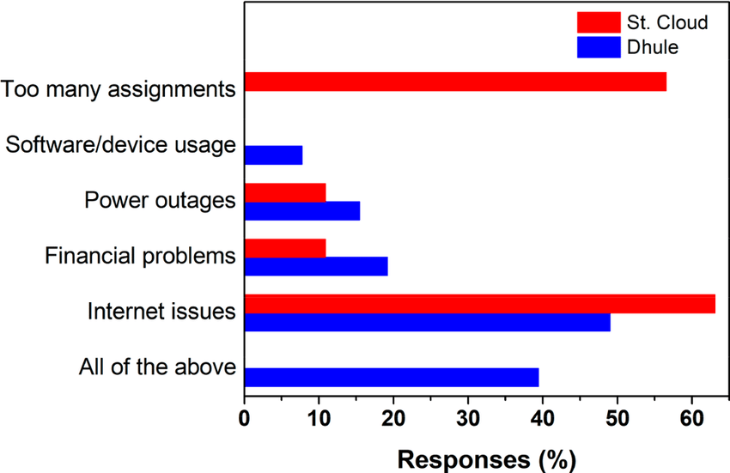

Student self-evaluation of the amount of chemistry found out through trainer-shared materials at some point during the COVID-19 epidemic, and assessment of face-to-face and online studying to envision pupil choice-
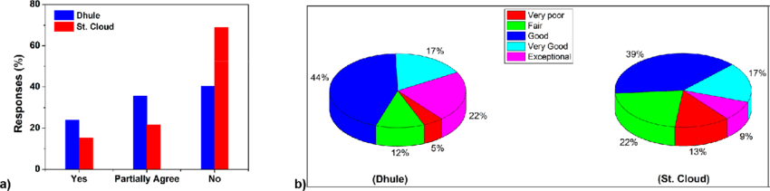

S. Maria Josephine Arokia Marie (2021) conducted a study on Improved Pedagogical Practices Enhance Student Teacher Performance Through Blended Learning. This study aims to explore an innovative approach to teaching and learning called the Blended Learning approach. An innovative approach to teaching and learning Blended Learning with a rotational model where students learn in the presence of a teacher and an internet platform was used to teach an experimental group consisting of 29 teacher students, while a conventional method was used with a control group consisting of 24 student teachers. The experiment lasted eight weeks. The results of the study revealed that there were significant differences in mean test scores in favor of the experimental group at the 0.05 level. The findings also indicated that there were statistically significant differences at the 0.05 level in the level of teaching performance of the participants before and after the implementation of the Blended learning method in favor of the post-application. It has been approved for the Blended Learning Program in Science Education.
Prabhas Ranjan (2020) researched on - Is blended learning better than online learning for B.Ed students? This study was experimental and spread over two years to compare the effectiveness of a blended learning mode and online learning modes (including their specific teaching and learning strategies) for an undergraduate curriculum. A randomly selected sample of students with a comparable level of intelligence quotient (IQ) was subjected to both controlled (face-to-face) and experimental treatment (online and blended learning). The participants were students of the mostly full-time B.Ed course. The researcher found that the average results achieved in the blended learning mode were higher than in the online learning mode. Instructor-student interaction appeared to be a critical factor for better-blended learning performance. This research also suggests that blended learning has led to better learning outcomes and motivation. Blended learning has the potential to support student-centered teaching and learning. It is an important finding for the emerging trend of online education in India.
Alsalhi, N. R., Eltahir, M. E., & Al-Qatawneh, S. S. (2019) researched the effect of blended learning on ninth-grade science achievement and attitudes toward its use. It was a quasi-experimental study consisting of 112 students, experimental-61 and control-51. The finding revealed that there were significant differences between the experimental and control groups. More investigation into the application of blended learning in higher education institutions is advised by the study. Keywords: Attitudes, Success, Blended Learning.
Dhawan, S. (2020) conducted a study on Online learning: a panacea in the time of the COVID-19 crisis. This study includes the importance of online education and an analysis of the strengths, weaknesses, opportunities, and challenges of the e-learning regime in times of crisis. It sheds light on the growth of EdTech during the pandemic and suggests how to deal with the challenges of online learning.
Darojat, O . .(2016) studied – Curriculum improvement through blended pedagogy. The purpose of the study is to understand the issues associated with the implementation of combined pedagogy. A qualitative case study was used in two open and distance learning (ODL) universities in Southeast Asia. This study provides a practical recommendation that Internet-based learning is now becoming a strategic choice for ODL in developing countries to expand access and meet challenges for a better future.

4.0 Blended learning strategies in teacher education programs

Blended learning (C. Graham) tends to address three commonly related aspects of teaching:
- a mix of online and face-to-face teaching,
- a mixture of teaching methods,
- a mixture of teaching methods.
BL is not only a combination of online and offline modes; rather, it refers to a thoughtful combination of worthwhile activities in both modes. The combination requires consideration of several factors, particularly focusing on learning outcomes and the student-centered learning environment. Given the advent of digital technologies and the growing importance of using technology for teaching and learning at all levels from school to higher education, NEP 2020 recommends the use of blended learning models. NEP-2020 states that the importance of face-to-face personal learning is fully recognized in promoting digital learning and education. Accordingly, different effective blended learning models will be identified for appropriate replication for different subjects.

4.11 The importance of blended learning for improving the learning outcomes of undergraduate students

- removes barriers of time and place;
-provides enough opportunities for experiential learning;
-supports a higher level of interaction between the learner and the instructor, between the learner and the learner, between the learner and the content, and between the learner and the course interface;
- supports not only the use of various information and communication technologies but also facilitates the emergence and development of various types of interactions and meetings between participants;
-increases skills for technologically integrated lesson plans;
- offers teaching flexibility (through Face to face (F2F), instructor-led online activities, and self-access web activities) using a practical, up-to-date, and time-efficient complement of lessons;
-provides the opportunity to customize learning using synchronous and asynchronous delivery modes;
- offers the possibility to design and implement research-based learning activities through unrestricted interaction and critical discourse, which encourages more reflective and creative students;
- offers students the opportunity to tailor their learning experience to their needs, pace, styles, skills, demographics, prior learning history using online formats and beliefs;
- offers various interactive platforms to improve teaching, such as google classroom, google meet, GPT chat, etc. Significance of blended learning for enhancing the learning outcomes of the B.Ed learners.

5.0 Contrasting the curriculum components between conventional teaching and blended teaching in a teacher training program

Conventional teaching | Blended teaching
Content delivery
Sitting-on campus;  Fixed time table;  live lectures;  a missed lecture cannot be repeated. | online;  optional on/off-campus seating;  free schedule;  on-demand:  asynchronous and synchronous lectures;  IT support;  Recorded lectures that can be replayed on demand.
Learner’s Activities
School face type;  Passive education;  Active learning;  Social studies;  group work;  Individual projects;  test pen and paper. | online tutors;  web-based visit personal activities;  personal projects;  online activities: e-mail, text chat, forums;  unlimited interactions and keynotes;  computer-mediated  online e-learning;  online modules;  webinars.  computer-based tests
Instructional Materials
oral lecture presentations;  oral lecture text;  Mega teaching lesson plan;  traditional and constructive teaching methodology;  Mostly hardware-based teaching aids used like charts, models, etc;  classroom discussions. | online lecture presentations;  online lecture text;  technologically integrated lesson plans;  technologically based methodologies;  including software-based teaching aids like PowerPoint, websites, excel, chat GTP, etc;  an online forum for group discussions.
Required competencies
the basic level of professional competence;  communicative competence. | Techno-pedagogical skills competence;  -ICT competence;  self-learning competence;  self-management competence.

6.0 Conclusion
A concern of NEP 2020 for the implementation of the Blended learning strategy in the classroom will be highly superfine when initially the training for the same will be provided in the professional courses. So it is highly recommended every educational institute supports future teachers to get well-equipped with the latest digital technologies in pedagogies. According to Sethy, "an effective blended learning TTP should make sure that it: promotes connections and conversations, guides, directs, and tracks learning routes, nurtures a top-tier global workforce, provides consistent and up-to-date messages, utilizes the technologies effectively, fosters independent habits for learning and reference, encourages learning and work, and improves performance and controls costs."
A lot of research concluded that blended teaching is more highly beneficial than conventional teaching in enhancing the learning outcomes of the learners. Therefore, Blended teaching should be viewed as an opportunity to change the way that teacher training curriculum should be developed, scheduled, and transact through a combination of online and offline modes or synchronously and asynchronously.

Bibliography
Alsalhi, N. R., Eltahir, M. E., & Al-Qatawneh, S. S. (2019). The effect of blended learning on the achievement of ninth-grade students in science and their attitudes towards its use. Heliyon, 5(9), e02424.

Anthony, E. (2019). (Blended) Learning: How Traditional Best Teaching Practices Impact Blended Elementary Classrooms. Journal of Online Learning Research, 5(1), 25-48.

Darojat, O. (2016). Improving curriculum through blended learning pedagogy. Turkish online journal of distance education, October, 17(4), 203-218.

Dhawan, S. (2020). Online learning: A panacea in the time of COVID-19 crisis. Journal of Educational Technology Systems, 49(1), 5-22.
Dumford, A. D., & Miller, A. L. (2018). Online learning in higher education: exploring advantages and disadvantages for engagement. Journal of Computing in Higher Education, 30(3), 452-465.

Geng, S., Law, K. M., & Niu, B. (2019). Investigating self-directed learning and technology readiness in blending learning environment. International Journal of Educational Technology in Higher Education, 16(1), 1-22.

Herman, Lusa. (2021). Effect of blended learning on students' learning outcomes: Meta-analysis.Jurnal Pendidikan Progresif, 11 (2), 309-25.
International Perspective: Teaching Chemistry and Engaging Students During the COVID-19 Pandemic Rodney A. Tigaa* and Swapnil L. Sonawane https://dx.doi.org/10.1021/acs.jchemed.0c00554

Ministry of Education (2021), Government of India. Covid Action Plan, https://www.education.gov.in/en/covid-action-plan-mitigating-loss-learning-action-plan-access-retention-continuous-learning-capacity

Ministry of Education, Government of India. (2020). National Education Policy 2020. http://www.education.gov.in/sites/upload_files/mhrd/files/NEP_Final_English_0.pdf

Park, Y. S., Konge, L., & Artino, A. R. (2020). The positivism paradigm of research. Academic Medicine, 95(5), 690-694.

Rahi, S. (2017). Research design and methods: A systematic review of research paradigms, sampling issues, and instruments development. International Journal of Economics & Management Sciences, 6(2), 1-5.
Ranjan, Prabhas. (2020). Is Blended Learning Better than Online Learning for B.Ed Students? Journal of learning for development. Vol. 7, No. 3, pp. 349-366.

S. Maria Josephine Arokia Marie (2021). Improved pedagogical practices strengthen the performance of student teachers through a blended learning approach. https://doi.org/10.1016/j.ssaho.2021.100199 .
University Grant Commission. (2021). Blended mode of teaching and learning: Concept notes. New Delhi. http://www.ugc.ac.in/pdfnews/6100340

Xhaferi, Brikena. (2020). ONLINE LEARNING BENEFITS AND CHALLENGES DURING THE COVID 19 - PANDEMIC- STUDENTS' PERSPECTIVE FROM SEEU. SEEU Review Volume 15 Issue 1: Challenges and Perspectives of Covid – 19, DOI: 10.2478/secure-2020-0006

WESP, United Nations (August 2020). Executive summary. http://www.un.org/development/desa/dpad/wp-content/uploads/sites/45/WESP_2021_Executive-summary_E.pdf

------------------------------------------------------------------------------------------------

