Interpreting Health Trends: Epidemiology's Contributions to Understanding Diseases

Sushant Wankhade¹, Isha Wankhade², Gurukiran P.¹, Gurdeep Rattu³
¹ Department of Biotechnology, Reva University, Rukmini Knowledge Park, Srinivasa Nagar, Bengaluru, Karnataka 560064, India
2 National Horticulture Research and Development Foundation (NHRDF), Nashik-Aurangabad Road, Nashik-422003, Maharashtra, India

Authors email:
wankhadesushant5@gmail.com
isha27700@gmail.com
gurukiranpjadav@gmail.com
gurdeep.r147@gmail.com (Corresponding author)
Editor Id “IIPER1680036292"

Abstract
Epidemiology is the study of how often diseases occur in different groups of people. A key feature of epidemiology is the measurement of disease outcomes in relation to a population at risk. Understanding the prevalence, risk factors, and distribution of these conditions is crucial for informing public health strategies and clinical interventions. Globally, these infections are one of the main causes of illness and mortality. Immunocompromised people, children, and the elderly are particularly at risk. Neurodegenerative conditions like Alzheimer's and Parkinson's disease primarily impact the elderly. The prevalence of Alzheimer's disease has been rising rapidly, and more people throughout the world are becoming affected. Age, genetics, and lifestyle choices all have a significant impact on how it develops. The prevalence of Parkinson's disease, which is marked by motor dysfunction, is also rising. Type 1 and type 2 diabetes create serious problems for the general population's health. Because of variables like obesity, sedentary lifestyles, and genetic susceptibility, the prevalence of diabetes has increased over the past few decades. Osteoporosis, which is characterized by decreased bone density and an elevated risk of fracture, primarily affects the elderly, especially postmenopausal women. Its widespread prevalence around the world raises serious public health issues. This chapter provides an overview of the epidemiological trends and patterns of three distinct but significant diseases: Respiratory tract infections such as common cold, sinus infections, tonsils and laryngitis, Neurological diseases like Alzheimer disease and Parkinson’s disease, and endocrine diseases like Diabetes mellitus and Osteoporosis.

Keywords: Epidemiology, Disease, Pathogenicity, Symptoms, Prevention

- Introduction
The epidemiologic triad (also known as the epidemiologic triangle) is another often used model that looks at the interaction between host, agent, and environment factors in determining the likelihood of disease. The host is either the disease's actual or potential victim or recipient.
The word "epidemiology" originates from the Greek words "epi," which means "upon" or "among," and "demos," which means "people." In essence, epidemiology is the study of how illnesses affect populations and spread, with the ultimate goal of enhancing community health and wellbeing. Epidemiologists study the occurrence of illnesses and other health-related occurrences in an effort to better understand the intricate interactions between a variety of variables, including genetics, environment, behaviour, and socioeconomic determinants. The study of the causes, symptoms, and distribution of health and disease in a given population is known as epidemiology.
When organisms reproduce in host tissue, it is called an infection and it can lead to illness. A person who is having infectious organisms while being asymptomatic is known as a carrier. The spreading of an organism across its surroundings is called dissemination. The Spanish physician Joaqun de Villalba coined the term "epidemiology" in his 1802 book Epidemiologa Espaola to refer to the study of epidemics.
Types: -
- Descriptive epidemiology
- Analytical epidemiology
- Experimental epidemiology
The three main methods used in epidemiology are experimental, analytical, and descriptive. Although all three can be used to look into the spread of disease, descriptive epidemiology is the approach that is most frequently employed, apart from all these three there is one another type called as theoretical epidemiology.
Following a description of a disease's basic epidemiology, specific analytical techniques can be utilized to learn more about the condition, and a particular experimental strategy can be constructed to test a hypothesis.
Diseases: -
- Respiratory Infection
- Neurological Diseases: - Parkinson and Alzheimer's
- Endocrine: Diabetes mellitus, Osteoporosis

- Respiratory tract Infections: -
Infections of the nose, sinuses, trachea (windpipe), bronchi (airways), sinuses, throat, airways, or lungs are referred to as respiratory tract infections (RTIs). Most RTIs resolve on their own, however occasionally you might need to see a GI (gastroenterologist) for a regular checkup. (19)

  - Types of Respiratory tract infections:

Respiratory tract infections are of types:
- Upper respiratory tract infections
- Lower Respiratory tract infections

    - Upper respiratory Tract infections: -
These infections are those which infect the nose, Oesophagus, and airways and may result in various symptoms such as chest pain, nausea, dysphagia, odynophagia, vomiting, fever, and bleeding.
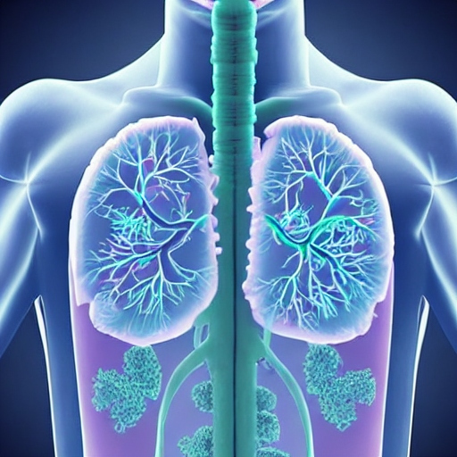
Bowel infections, also known as gastrointestinal infections (gastroenteritis), are brought on by microorganisms (sometimes known as "bugs" or germs") in the gut. You can contract a bowel illness by ingesting tainted food or water or by coming into contact with an infected individual. (19) They may last up to 48 to 72 hours.
Upper respiratory tract infections include the following:
- common colds
- sinus infections
- tonsillitis Fig. 1. Respiratory Tract Disease
- laryngitis

Common cold: - it is a viral infection of the nose and throat and windpipe. Cold spreads easily in homes classrooms and in workplaces. There is no cure for common cold it goes away within 10 days More than 200 viruses can cause cold.(20)
Sinus infections:- These infections cause when fluid builds up in a air filled pocket in the face called sinuses the fluid sinuses allow germs to grow. viruses as well as bacteria cause such sinus infection. The symptoms of sinus infection include runny nose post nasal drainage blocked or stuffy nose swelling and pressure around your eyes cheeks nose or forehead.(20)
Laryngitis:- The Omicron variant is prone to cause severe laryngitis. The vocal cords open and close smoothly, forming sounds through vibration and movement. Laryngitis is a swelling or inflammation of the voice box from overuse, infection or irritation.(20)
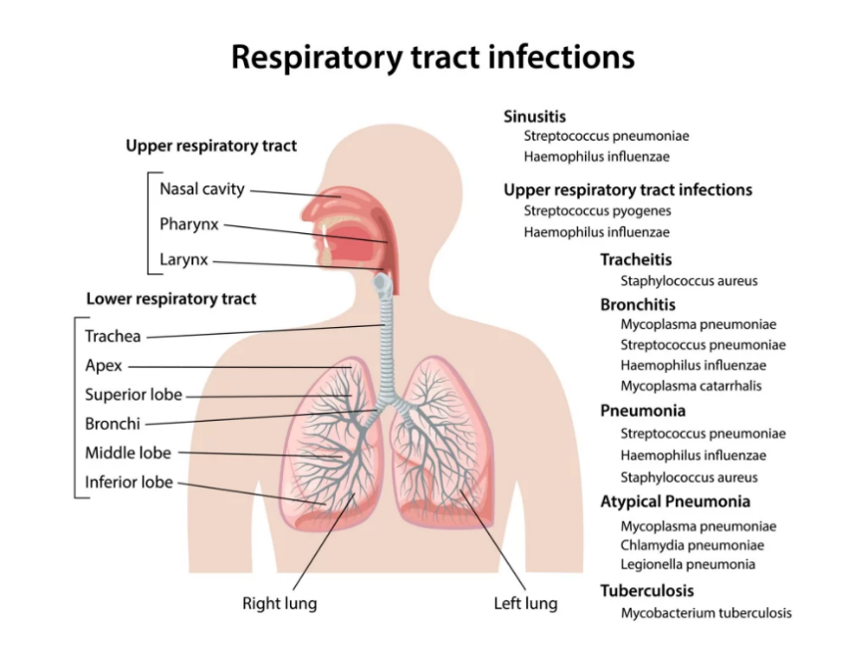

Fig. 2. Upper Respiratory Tract and lower respiratory tract infection (23)

    - Lower respiratory Tract Infections (LRTI): -
LRTI is caused by various types of microorganisms which include bacteria, fungi, and viruses. They may last up to 1 week-2 weeks. Lower respiratory tract infections can cause a variety of different gastro symptoms, depending on how bad the infection is. (21)
Common cold symptoms can also occur in less serious infections, such as:
- a congested or runny nose
- dried-up cough
- minimal fever
- minor throat discomfort
- chronic headache
Symptoms of more serious illnesses can include: fever, difficulty breathing, a blue color to the skin, a strong cough that may produce mucus, and rapid breathing wheezing and chest pain (21)
Lower respiratory tract infections include:
- bronchitis
- pneumonia
- bronchiolitis
- tuberculosis

  - Prevention: -
Keeping hydrated and taking medicines are also recommended for stomach infections. Penicillin, cephalosporin, antifolate/sulfa combos, nitroimidazole, penmen, glycopeptide, and monobactam antibiotics are frequently used to treat gastrointestinal infections.
With soap and water, thoroughly wash your hands.
- Practice food safety, including washing fruits and vegetables and preparing meats, and do not replace hand washing with alcohol-based hand sanitizer.
- When ill, avoid preparing food or cooking for others, clean hard surfaces with bleach, and carefully wash any clothing or linens.
- Before, during, and after preparing meals, wash your hands and your work surfaces.
- separating cooked food from raw meats, fish, poultry, and eggs
- Avoiding undercooked food and heating food until it reaches a safe internal temperature
- Within two hours of cooking, place food in the refrigerator below 40°F (4°C).
- Avoid unpasteurized dairy products, unpasteurized juices, and undercooked or raw animal products (22).

- Neurological Diseases
  - Parkinson's disease

    - Overview:
Parkinson's disease (PD) is a neurological disease that is chronic and progressive. Pathologic examination reveals selective degeneration of dopaminergic neurons in the substantia nigra pars compacta as well as the presence of cytoplasmic inclusions known as Lewy bodies; clinical examination reveals a resting tremor, bradykinesia, and rigidity. It is critical to distinguish PD from the illnesses referred to together as the Parkinson's disease and related syndromes. These are relatively uncommon illnesses that share some of the characteristics of Parkinson's disease, such as rigidity as well as bradykinesia. The Parkinson-plus syndromes, on the other hand, do not react to medical treatment and have no cure Some clinical aspects are also distinctive.
In developed countries, the prevalence of Parkinson's disease is estimated to be 0.3% of the total population and 1% of those over the age of 60. Parkinson's disease is definitely an age-related condition. According to studies, the prevalence of Parkinson's disease rises until the ninth decade (ages 80 to 89). Of life. There is no reliable data on the prevalence of Parkinson's disease after the ninth decade. Several studies have been conducted. Men were shown to have a higher incidence of Parkinson's disease than women despite the fact that additional research have disputed this finding.
Classification: Parkinson's disease is the most frequent type of Parkinsonism, often known as idiopathic Parkinsonism because it has no known aetiology. Other Parkinson-plus syndromes can have comparable movement symptoms but a wide range of other symptoms. Some of them are synucleinopathies as well. Lewy body dementia is characterised by motor symptoms that precede cognitive deterioration and hallucinations. Alternatively, multiple systems atrophy (MSA) has an early onset of autonomic dysfunction (such as orthostasis) and may have autonomic, cerebellar, or Parkinsonian predominance.
Tau, rather than alpha-synuclein, is involved in several Parkinson-plus disorders. Progressive supranuclear palsy (PSP) and corticobasal syndrome (CBS) are two examples. PSP is characterised by rigidity, early falls, bulbar symptoms, and vertical gaze restriction; it has been linked to frontotemporal dementia symptoms. Asymmetric parkinsonism, dystonia, alien limb, and myoclonic jerks are all symptoms of CBS.[35] certain timings of presentation and related symptoms can help distinguish certain movement disorders from idiopathic Parkinson disease.
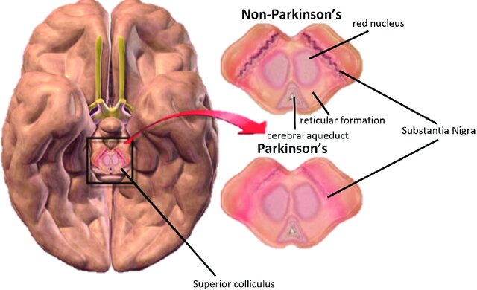

Fig. 3. Parkinson’s Disease [25]

    - Neuropathy and pathophysiology:
The main clinical features of Parkinson's disease are cell death in the basal ganglia of the brain (affecting up to 70% of dopamine-secreting neurons in the substantia nigra pars compacta towards the end of life) [1]. Alpha-synuclein becomes misfolded and clumps together with other alpha-synuclein in Parkinson's disease. Because cells are unable to eliminate these aggregates, alpha-synuclein becomes cytotoxic, causing cell damage [2][3].
There are five major brain routes that connect other brain locations to the basal ganglia. The motor, oculomotor, associative, limbic, and orbitofrontal circuits are among them. The names denote the primary projection region of each circuit.[6] All are impacted by Parkinson's disease, and their disturbance produces movement, attention, and learning-related symptoms.[6] The motor circuit has received the greatest scientific attention [6].
A specific conceptual model of the motor circuit and its modification with PD has had an impact, however some limitations have been identified, leading to changes.[6] According to this paradigm, the basal ganglia ordinarily have a continual inhibitory influence on a variety of motor systems, keeping them from activating at inappropriate periods. When a decision is made to undertake a specific action, inhibition for the relevant motor system is lowered, allowing it to be activated. Because dopamine facilitates the release of inhibition, high levels of dopamine function tend to stimulate motor activity, whereas low levels of dopamine function, as seen in Parkinson's disease, necessitate greater exertions of effort for each given movement.[6] Dopamine deficiency results in hypokinesia, or a general decrease in motor output.[6] Drugs used to treat Parkinson's disease, on the other hand, may cause excessive dopamine activity, allowing motor systems to be triggered at inappropriate periods and resulting in dyskinesias.[6]
Brain cell death: The aberrant buildup of the protein alpha-synuclein linked to ubiquitin in injured cells is one mechanism triggering brain cell death. This insoluble protein forms inclusions known as Lewy bodies inside neurons [7][8]. These brain regions are the primary sources of neuronal degeneration in Parkinson's disease; however, Lewy bodies may protect cells from death (by sequestering or walling off the aberrant protein). Other types of alpha-synuclein (for example, oligomers) that do not aggregate into Lewy bodies and Lewy neurites may be hazardous [9] [8]. The presence of Lewy bodies in cortical areas is typical in dementia patients. Unless a person has dementia, neurofibrillary tangles and senile plaques, which are hallmarks of Alzheimer's disease, are uncommon [10].
    - The neuroimmune connection:
The neuroimmune interaction is strongly involved in the pathogenesis of Parkinson's disease. Parkinson's disease and autoimmune illnesses share genetic variants and biological mechanisms. According to one study, several autoimmune illnesses may raise one's risk of acquiring Parkinson's disease by up to 33%. PD is associated with autoimmune disorders due to protein expression patterns of monocytes and CD4+ T cells. Herpes virus infections can cause autoimmune reactions to alpha-synuclein, possibly through viral protein molecular mimicry. Alpha-synuclein and its aggregate form, Lewy bodies, have the ability to bind to microglia. Microglia can multiply and become too activated as a result of alpha-synuclein binding to MHC receptors on inflammasomes, resulting in the release of proinflammatory cytokines such as IL-1β, IFNγ, and TNFα. Activated microglia impact astrocyte activation, transforming their protecting phenotype into a neurotoxic one. Astrocytes protect neural connections in healthy brains. In Parkinson's disease patients, astrocytes are unable to safeguard dopaminergic synapses in the striatum. Microglia deliver antigens to T cells via MHC-I and MHC-II. This process activates CD4+ T cells, allowing them to breach the blood-brain barrier (BBB) and produce more proinflammatory cytokines such as interferon- (IFN), TNF, and IL-1. Mast cell degranulation and consequent proinflammatory cytokine release has been linked to BBB collapse in Parkinson's disease. Peripheral monocytes, which have been detected in the substantia nigra of Parkinson's disease patients, are another immune cell implicated in the disease.
These monocytes may contribute to further dopaminergic link disruption. Furthermore, monocytes derived from Parkinson's disease patients express larger quantities of the PD-associated protein, LRRK2, as compared to non-PD persons via vasodilation. Furthermore, high levels of pro-inflammatory cytokines, such as IL-6, can cause the liver to produce C-reactive protein, another protein typically identified in Parkinson's disease patients, which can contribute to an increase in peripheral inflammation. Peripheral inflammation can have an impact on the gut-brain axis, which has been linked to Parkinson's disease. Years before motor impairments develop, PD patients have altered gut microbiota and gastrointestinal disorders. Alpha-synuclein is formed in the gut and can travel to the brainstem and subsequently to the substantia nigra via the vagus nerve. Furthermore, the bacteria Proteus mirabilis has been linked to elevated levels of alpha-synuclein and an increase in motor symptoms in Parkinson's disease patients.A medical citation is required To better understand the pathological progression of Parkinson's disease, more research into the function of alpha-synuclein, inflammation, the gut-brain axis, and individual variability in immunological stress responses is needed.

    - SIGNS AND SYMPTOMS: Parkinson's disease is a neurodegenerative disorder that primarily affects movement. It is characterized by a wide range of motor and non-motor symptoms.
Motor Symptoms:
1. Tremors: Typically, a resting tremor, most commonly seen in the hands, fingers, or chin. It usually disappears during purposeful movement.
2. Bradykinesia: Slowness of movement, which can lead to difficulties in initiating and completing movements. This can affect various activities like walking, writing, or buttoning a shirt.
3. Rigidity: Stiffness of muscles, which can result in reduced range of motion and difficulty with movements.
4. Postural Instability: Difficulty maintaining balance and an increased risk of falls due to impaired reflexes and posture control.
5. Gait Disturbances: Shuffling steps, reduced arm swing, and a tendency to take small steps, often leading to a characteristic "festinating" gait.
6. Freezing of Gait: A sudden, temporary inability to move the feet, often while attempting to initiate walking or change direction.
7. Micrographia: Small, cramped handwriting that develops due to difficulties in fine motor control.
Non-Motor Symptoms:
1. Loss of Smell: An early and common symptom of Parkinson's disease is a decreased sense of smell (anosmia).
2. Sleep Disturbances: This can include insomnia, excessive daytime sleepiness, restless leg syndrome, and vivid dreams or nightmares.
3. Depression and Anxiety: Many people with Parkinson's experience mood disorders such as depression and anxiety.
4. Cognitive Changes: These can range from mild cognitive impairment to more severe dementia in later stages of the disease.
5. Speech Changes: Slurred speech, monotone voice, and reduced facial expressions (masked face) are common.
6. Constipation: Gastrointestinal symptoms like constipation are often reported.
7. Urinary Problems: Issues with urinary urgency, frequency, or incontinence can arise.
8. Orthostatic Hypotension: A drop in blood pressure upon standing, leading to dizziness or fainting.
9. Sexual Dysfunction: Parkinson's can lead to decreased libido and other sexual issues.
10. Swallowing Difficulties: Problems with swallowing (dysphagia) can occur, increasing the risk of choking or aspiration pneumonia.
It's important to note that while these symptoms are commonly associated with Parkinson's disease, they can also be present in other conditions. If you or someone you know is experiencing these symptoms, it's advisable to consult a medical professional for proper evaluation and diagnosis. Early diagnosis and appropriate management can help improve the quality of life for individuals with Parkinson's disease.

    - DAIGNOSIS
Diagnosing Parkinson's disease involves a comprehensive assessment that considers both clinical symptoms and medical history. There is no single definitive test for Parkinson's disease; instead, a combination of evaluations is used to reach a diagnosis. The process typically involves:
1. Medical History and Physical Examination: A doctor will review the patient's medical history and conduct a thorough physical examination to assess the presence and progression of motor and non-motor symptoms associated with Parkinson's disease.
2. Neurological Examination: A neurologist will examine the patient's muscle tone, reflexes, coordination, gait, and other motor functions to identify characteristic signs of Parkinson's, such as tremors, bradykinesia, rigidity, and postural instability.
3. Response to Dopaminergic Medication: A positive response to dopaminergic medication (levodopa) can support the diagnosis of Parkinson's disease. Improvement in motor symptoms after taking this medication can help differentiate Parkinson's from other movement disorders.
4. Elimination of Other Causes: The doctor will rule out other conditions that may mimic Parkinson's disease, such as essential tremor, multiple system atrophy, or drug-induced parkinsonism.
5. Imaging Studies: While not necessary for diagnosis, imaging tests like brain MRI or CT scans may be performed to rule out other structural causes of symptoms. DaTscan is a specialized imaging test that can assess dopamine transporter levels in the brain, providing supportive evidence for Parkinson's disease.
6. Clinical Criteria: The diagnosis of Parkinson's disease is often based on specific clinical criteria, such as the UK Brain Bank Criteria or the Movement Disorder Society (MDS) Clinical Diagnostic Criteria. These criteria take into account the presence and progression of various motor and non-motor symptoms.
7. Neurologist Consultation: A neurologist with expertise in movement disorders is usually involved in confirming the diagnosis and differentiating Parkinson's disease from other similar conditions.
8. Follow-up and Monitoring: Parkinson's disease is a progressive condition, and symptoms may evolve over time. Regular follow-up appointments with a neurologist are essential to monitor symptoms, adjust treatment, and manage any complications.
It's important to remember that diagnosing Parkinson's disease can be complex, and the process may take some time. Additionally, early and accurate diagnosis is crucial for starting appropriate treatment and management strategies to improve the quality of life for individuals with Parkinson's. If you suspect you or someone you know may have Parkinson's disease, it's recommended to seek evaluation and guidance from a medical professional, preferably a neurologist with experience in movement disorders.[11]
    - CAUSES: -
The exact cause of Parkinson's disease is not fully understood, but it is believed to result from a combination of genetic, environmental, and possibly other factors. Here are some factors that are thought to contribute to the development of Parkinson's disease:
1. Genetics: While most cases of Parkinson's disease are not directly inherited, there is a genetic component to the disease. Certain gene mutations, such as those in the LRRK2, PARKIN, and PINK1 genes, have been associated with an increased risk of developing Parkinson's disease. However, these mutations are relatively rare and account for only a small percentage of cases.
2. Environmental Factors: Exposure to certain environmental toxins and substances may increase the risk of Parkinson's disease. These include:
• Pesticides and Herbicides: Some studies suggest a link between exposure to certain pesticides and an increased risk of Parkinson's disease.
• Industrial Chemicals: Exposure to industrial chemicals like solvents and heavy metals may also be associated with a higher risk.
• Manganese: Prolonged exposure to high levels of manganese, often seen in certain occupations, has been linked to a Parkinson's-like syndrome.
4. Alpha-Synuclein Aggregation: In Parkinson's disease, there is an accumulation of abnormal protein aggregates, particularly alpha-synuclein, within neurons. These aggregates are a hallmark of the disease and are believed to contribute to neuronal dysfunction and death.
5. Neuroinflammation: Chronic inflammation in the brain, known as neuroinflammation, is thought to play a role in the progression of Parkinson's disease. Immune system responses within the brain can contribute to the degeneration of neurons.
6. Gut-Brain Axis: Emerging research suggests a potential link between the gut and the brain in Parkinson's disease. Changes in the gut microbiome and inflammation in the digestive tract may influence the development and progression of the disease.
7. Age and Genetics: Advancing age is the most significant risk factor for Parkinson's disease. The disease becomes more common as people get older. Additionally, having a family history of Parkinson's disease or related neurodegenerative disorders may increase the risk.
It's important to note that while these factors are believed to contribute to Parkinson's disease, the exact interplay between genetics, environment, and other factors is still an active area of research. Parkinson's disease is a complex conditio
n, and multiple factors likely contribute to its onset and progression.

  - Alzheimer: -
Alzheimer's disease (pronounced "alz-HAI-mirs") is a brain disorder that causes a progressive decrease in memory, thinking, learning, and organisational abilities. It progressively impairs a person's ability to perform fundamental daily tasks. The most prevalent cause of dementia is Alzheimer's disease (AD).

Alzheimer's symptoms worsen over time. According to researchers, the illness process may begin 10 years or more before the first symptoms occur. Alzheimer's disease most usually affects adults over the age of 65.
Stages: Alzheimer's disease organisations and healthcare practitioners use a variety of terminology to define Alzheimer's disease stages based on symptoms. While the names differ, the stages all follow the same pattern: AD symptoms deteriorate over time. However, no two persons suffer AD in the same way. Each person with Alzheimer's disease will move through the stages at their own pace. Not all changes will occur in every individual. Because phases may overlap, it can be difficult for providers to place a person with AD in a certain stage.
Some organizations and providers frame the stages of Alzheimer’s disease in terms of dementia:
• Preclinical Alzheimer’s disease.
• Mild cognitive impairment (MCI) due to Alzheimer’s disease.
• Mild dementia due to Alzheimer’s disease.
• Moderate dementia due to Alzheimer’s disease
• Severe dementia due to Alzheimer’s disease.
Other organizations and providers more broadly explain the stages as:
• Mild.
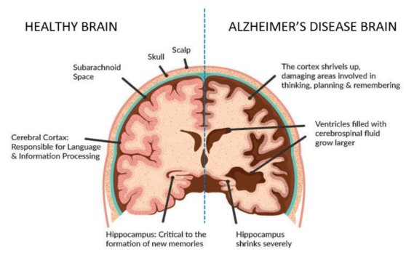
• Moderate.
• Severe.
Or:
• Early.
• Middle.
• Late. Fig.4. Brain Anatomy in Alzheimer Disease [24]
Don’t be afraid to ask your healthcare provider or your loved one’s provider what they mean when they use certain words to describe the stages of Alzheimer’s.

    - Classification:
Alzheimer's disease is a progressive neurodegenerative disorder that primarily affects cognitive functions, particularly memory and thinking skills. There are several ways to classify Alzheimer's disease, including based on its clinical progression, underlying pathology, and stages of severity. One common classification system is based on the stages of the disease:
1. Preclinical Stage: This is the earliest stage of Alzheimer's disease and typically occurs before noticeable symptoms appear. In this stage, changes in the brain are occurring, such as the accumulation of amyloid plaques and tau tangles, but individuals do not yet exhibit cognitive impairments.
2. Mild Cognitive Impairment (MCI) Due to Alzheimer's Disease: Some individuals with preclinical Alzheimer's disease may progress to a stage known as mild cognitive impairment. MCI involves noticeable cognitive deficits that are not severe enough to interfere significantly with daily functioning. Not all cases of MCI will progress to Alzheimer's disease.
3. Early Stage (Mild Alzheimer's Disease): In this stage, individuals start to experience more noticeable cognitive impairments, including memory loss, difficulty finding words, challenges with problem-solving, and mood changes. However, they can still manage many of their daily activities independently.
4. Middle Stage (Moderate Alzheimer's Disease): As Alzheimer's disease progresses, individuals enter the middle stage. Memory and cognitive deficits become more pronounced, leading to increased difficulty with tasks like managing finances, organizing daily activities, and recognizing familiar people. Behavioral and psychological symptoms, such as agitation, anxiety, and wandering, may also emerge.
5. Late Stage (Severe Alzheimer's Disease): In the late stage, individuals experience severe cognitive decline, resulting in an inability to communicate coherently, recognize loved ones, or perform basic self-care activities. Motor function can also be impaired, leading to difficulties with mobility and swallowing. Individuals require full-time assistance and care.
It's important to note that Alzheimer's disease is characterized by a progressive decline in cognitive function, and the specific symptoms and progression can vary from person to person. The underlying pathology of Alzheimer's disease involves the accumulation of abnormal proteins, including amyloid plaques and tau tangles, which lead to neuronal dysfunction and cell death.[12]
Diagnosing Alzheimer's disease is typically done through clinical assessments, cognitive testing, and ruling out other potential causes of cognitive decline. It's important for individuals who suspect they or a loved one may have Alzheimer's disease to seek medical evaluation and guidance from a healthcare professional, ideally a neurologist or geriatric specialist, for accurate diagnosis and appropriate management strategiesTop of Form
    - Pathophysiology:
The pathophysiology of Alzheimer's disease is complex and involves multiple biological processes that lead to the progressive degeneration of neurons in the brain. The disease is characterized by the accumulation of abnormal protein deposits, specifically amyloid plaques and tau tangles, as well as inflammation and synaptic dysfunction. Here's an overview of the key pathophysiological mechanisms involved in Alzheimer's disease:
1. Amyloid Plaques Formation:
• Amyloid Beta (Aβ) Protein: Amyloid plaques are clusters of abnormal protein fragments called beta-amyloid (Aβ). Aβ is derived from a larger protein called amyloid precursor protein (APP) through a series of enzymatic cleavages.
• Abnormal Aggregation: In Alzheimer's disease, Aβ peptides tend to misfold and aggregate, forming insoluble plaques between neurons. These plaques disrupt normal neuronal function and contribute to neuronal damage.
2. Tau Protein and Neurofibrillary Tangles:
• Tau Protein: Tau is a protein that plays a role in stabilizing microtubules within neurons, which are essential for proper cell structure and function.
• Hyperphosphorylation: In Alzheimer's disease, tau proteins become hyperphosphorylated, causing them to detach from microtubules and aggregate into twisted fibers called neurofibrillary tangles.
• Disrupted Transport: Accumulation of neurofibrillary tangles disrupts the transport of nutrients and other essential molecules within neurons, leading to cell dysfunction and death.
3. Neuronal Dysfunction and Death:
• Synaptic Dysfunction: Amyloid plaques and tau tangles contribute to the dysfunction of synapses, the connections between neurons crucial for communication and memory formation.
• Neuronal Inflammation: The presence of abnormal proteins triggers an inflammatory response in the brain, involving immune cells called microglia. However, chronic inflammation can lead to neuronal damage.
• Neuronal Death: Over time, the accumulation of Aβ and tau, along with inflammation and impaired synaptic function, leads to the progressive death of neurons, particularly in regions crucial for memory and cognition.
4. Cholinergic System Impairment:
• Acetylcholine Deficiency: The brain's cholinergic system, responsible for the production and transmission of acetylcholine, is impaired in Alzheimer's disease.
• Cognitive Impairment: Reduced acetylcholine levels contribute to cognitive deficits, including memory loss and impaired thinking.
5. Oxidative Stress and Mitochondrial Dysfunction:
• Oxidative Stress: The abnormal protein aggregates and inflammation generate oxidative stress, which damages cellular components and contributes to neuronal dysfunction.
• Mitochondrial Dysfunction: Mitochondria, the energy-producing structures in cells, are impaired, leading to reduced energy production and increased oxidative stress.
6. Blood-Brain Barrier Dysfunction:
• Leaky Blood-Brain Barrier: The integrity of the blood-brain barrier, which normally protects the brain from harmful substances, is compromised in Alzheimer's disease. This allows toxic molecules and inflammatory factors to enter the brain.
These complex interactions between protein aggregation, inflammation, synaptic dysfunction, and cell death ultimately result in the cognitive impairments and memory loss characteristic of Alzheimer's disease. Understanding these pathophysiological mechanisms is crucial for developing effective treatments that target the underlying causes of the disease and slow its progression.[13]

    - SIGNS AND SYMPTOMS: -
Alzheimer's disease is a progressive neurological disorder that primarily affects cognitive functions, particularly memory, thinking, and behavior. The signs and symptoms of Alzheimer's disease can vary from person to person and may change as the disease progresses. Common early signs and symptoms include:
1. Memory Loss: Difficulty remembering recently learned information,
2. Difficulty with Planning and Problem-Solving: Struggling to develop and follow plans, manage finances, or solve problems that were once manageable.
3. Confusion with Time and Place: Getting disoriented about dates, seasons, or places, and not recognizing familiar locations.
4. Trouble Completing Familiar Tasks: Struggling with tasks that were once routine, such as cooking a meal or managing household chores.
5. Challenges with Language: Experiencing difficulty in finding the right words, following or joining a conversation, or repeating phrases.
6. Misplacing Items: Putting things in unusual places, such as putting a wallet in the refrigerator, and being unable to retrace steps to find them.
7. Decreased or Poor Judgment: Making questionable decisions, showing poor judgment in handling money, or falling for scams.
8. Withdrawal from Work or Social Activities: Losing interest in previously enjoyed hobbies, avoiding social activities, and becoming increasingly isolated.
9. Changes in Mood and Personality: Experiencing mood swings, becoming confused, suspicious, fearful, or anxious, especially in unfamiliar environments.
10. Difficulty Recognizing People: Struggling to recognize family members, friends, or even oneself in the mirror.
11. Loss of Initiative: Becoming less motivated to engage in activities, even those that were once enjoyable.
It's important to note that while memory loss is often associated with Alzheimer's disease, individuals may experience a combination of these symptoms to varying degrees. As the disease progresses, these symptoms worsen, leading to more severe cognitive impairment and an increased need for assistance with daily activities. In the later stages of Alzheimer's disease, individuals may have difficulty communicating, become disoriented, and require round-the-clock care.
If you or someone you know is exhibiting these signs and symptoms, especially if they interfere with daily life and functioning, it's important to seek medical evaluation and diagnosis from a healthcare professional. Early diagnosis and appropriate management strategies can help improve the quality of life for individuals with Alzheimer's disease and their caregivers.

The exact cause of Alzheimer's disease is not fully understood, but it's believed to result from a combination of genetic, environmental, and lifestyle factors. Here are some key factors that are thought to contribute to the development of Alzheimer's disease:
1. Genetics: While most cases of Alzheimer's disease are not directly inherited, there are certain genetic factors that can increase the risk. Mutations in specific genes, such as the APOE gene (especially the APOE ε4 allele), have been associated with a higher risk of developing Alzheimer's disease. However, having these genetic variants does not guarantee that an individual will develop the disease.
2. Age: Age is the most significant risk factor for Alzheimer's disease. The risk of developing the disease increases as people get older, especially after the age of 65.
3. Amyloid Plaques and Tau Tangles: Abnormal protein aggregates, such as amyloid plaques (composed of beta-amyloid protein) and tau tangles (resulting from hyperphosphorylated tau protein), are hallmarks of Alzheimer's disease. These protein deposits disrupt normal cellular function and contribute to neuronal damage and death.
4. Neuroinflammation: Chronic inflammation in the brain is thought to play a role in the development and progression of Alzheimer's disease. Inflammatory processes may contribute to the accumulation of abnormal proteins and damage to neurons.
5. Oxidative Stress: Oxidative stress occurs when there is an imbalance between the production of reactive oxygen species (free radicals) and the body's ability to neutralize them with antioxidants. Oxidative stress can damage cells, including neurons, and is believed to be involved in the development of Alzheimer's disease.
6. Mitochondrial Dysfunction: Mitochondria are responsible for producing energy within cells. Dysfunction in mitochondria can lead to reduced energy production and increased oxidative stress, which may contribute to neuronal damage.
7. Neurotransmitter Imbalance: Neurotransmitters are chemical messengers that transmit signals between nerve cells. In Alzheimer's disease, there is a disruption in neurotransmitter systems, particularly those involving acetylcholine, which is important for memory and cognitive function.
8. Vascular Factors: Cardiovascular risk factors, such as high blood pressure, diabetes, and high cholesterol, have been linked to an increased risk of Alzheimer's disease. These factors can impair blood flow to the brain, contributing to cognitive decline.
9. Environmental Factors: Certain environmental factors may increase the risk of Alzheimer's disease. These include a history of head trauma, exposure to certain toxins, and chronic stress.
10. Lifestyle Factors: Unhealthy lifestyle choices, such as a diet high in saturated fats and sugar, lack of physical activity, smoking, and excessive alcohol consumption, can contribute to the development of Alzheimer's disease.
It's important to note that Alzheimer's disease is likely caused by a combination of these factors, and the interplay between genetic susceptibility, environmental influences, and other mechanisms is still an active area of research. While some risk factors cannot be changed (such as age and genetics), adopting a healthy lifestyle, managing cardiovascular risk factors, and staying mentally and socially engaged may help reduce the risk of developing Alzheimer's disease.

- Endocrine disorder and diseases
The endocrine system, also referred to as the hormonal system, is a network of organs and glands which generate hormones. Sometimes the body produces excessive or insufficient hormones, or it may stop functioning them as required. Therefore, endocrine problems and illnesses may develop.
  - Diabetes mellitus
Diabetes mellitus (DM) is a condition in which blood glucose levels are not properly controlled. India had 315 million people with high blood pressure, 254 million with generalized obesity, and 351 million with abdominal obesity. There were 101 million people with diabetes and 136 million with pre-diabetes.
Blood sugar (glucose) levels that are too high can cause diabetes. It occurs when your body is unable to efficiently metabolise insulin or when your pancreas fails to produce any insulin at all. Every age group is impacted by diabetes.
    - Types: -
There are four types of Diabetes mellitus such as Type 1 diabetes, Type 2 diabetes, Gestational diabetes. Maturity onset diabetes of the young (MODY).
Among all four types, Type 2 diabetes is the most common. If you have a family history of the disorder and risk factors for it, such as being overweight or obese. Type 2 diabetes may affect anyone at any age, even children. [14]
    - Symptoms: -.
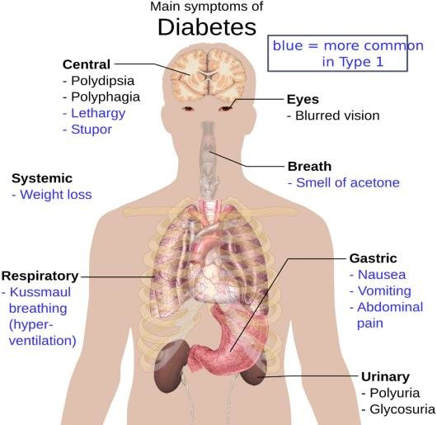
- Increased thirst (polydipsia) and dry mouth.
- Frequent urination.
- Fatigue.
- Blurred vision.
- Unexplained weight loss.
- Numbness or tingling in your hands or feet.
- Slow-healing sores or cuts.
- Frequent skin and/or vaginal yeast infections.[26]

    - Causes: -
obesity, excess weight, and inactivity
Type 1 Diabetes: - Fig. 5. Symptoms of Diabetes [33] Mellitus
In type 1 diabetes, the immune system incorrectly targets and kills the insulin-producing cells in the pancreas. Although the precise source of this autoimmune reaction is not entirely understood, genetic and environmental factors are thought to both contribute. Environmental triggers, certain viral infections, and genetic predisposition have all been mentioned as potential causes.
Type 2: -
The most prevalent type of diabetes, type 2, is distinguished by insulin resistance, in which the body's cells do not respond to insulin as well as they should. High blood sugar levels are the result of this. Type 2 diabetes has a complex aetiology involving both hereditary and environmental factors:
Genetics: Type 2 diabetes risk can be raised by family history and genetic susceptibility. The sensitivity of the body to insulin as well as other aspects of glucose metabolism may be impacted by specific gene variations.
Obesity: Being overweight, especially in the abdominal area, increases the risk of type 2 diabetes. Inflammation and insulin resistance brought on by obesity have an impact on how glucose is regulated.
Physical inactivity: Being inactive on a daily basis makes the body less sensitive to insulin and increases weight gain, which raises the risk of type 2 diabetes.
Unhealthy Diet: Insulin resistance and obesity can be brought on by a diet high in processed foods, sweet drinks, and unhealthy fats.
Age: As people get older, especially after the age of 45, their risk of developing type 2 diabetes rises.
Gestational Diabetes: -
When hormonal changes during pregnancy interfere with insulin function, gestational diabetes develops. Although it normally goes away after giving delivery, women who have experienced gestational diabetes are more likely to later develop type 2 diabetes. Although the precise causes of gestational diabetes are not entirely understood, it is thought that hormonal and genetic factors are involved.[15]

    - Treatment: -
There is currently no treatment for type 2 diabetes, but our researchers are working on a groundbreaking study on weight management to assist people in putting their condition into remission.
Type 1 diabetes is managed with insulin injections or an insulin pump, routine blood sugar monitoring, and carbohydrate tracking. Pancreas transplantation or islet cell transplantation may be options for some persons with type 1 diabetes.
Oral Medication: -
Gliptins are a class of oral diabetes drugs that have been given the Food and Drug Administration's (FDA) approval to treat adults with type 2 diabetes mellitus. FDA-approved DPP-4 inhibitors include alogliptin, linagliptin, saxagliptin, and sitagliptin.
Diabetes type 2 management includes
- A nutritious diet.
- Consistently moving.
- Losing weight.
- Insulin treatment or possibly diabetes medications.
- Monitoring of blood sugar
By taking these actions, it is more probable that blood sugar levels will remain within a healthy range. And they could aid in delaying or avoiding difficulties.[27]
Insulin therapy: -
Certain type 2 diabetics require insulin therapy. Today, insulin therapy may be recommended earlier if blood sugar targets are not achieved by lifestyle changes and other treatments, as opposed to the past when it was only used as a last choice.
The time it takes to start working and how long it takes to have an effect vary between different forms of insulin. For instance, long-acting insulin is made to function all day or overnight to maintain stable blood sugar levels. At mealtimes, short-acting insulin is typically administered.
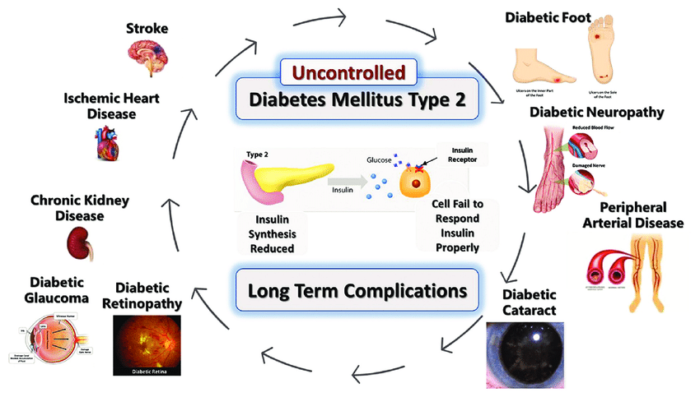
Fig. 6. Complication and risk factors of Type-2 Diabetes Mellitus [34]

    - Diagnosis: -
Fasting Blood Sugar Test: -
A fasting blood sugar level of 99 mg/dL or less is considered normal, a reading of 100 to 125 mg/dL denotes prediabetes, and a reading of 126 mg/dL or above denotes diabetes.
HbA1c Test: -
For the diagnosis of type 2 diabetes, the haemoglobin A1C blood test is incredibly sensitive and precise. In order to assess whether your blood sugar is regularly high, it checks your average blood sugar level over a two- or three-month period.[16]
  - Osteoporosis
Osteoporosis is a bone disease that occurs when bone quality or structure decreases, bone mineral density turns it down, or when bone mass decreases. This may result in a loss of bone density and an elevated risk of breaking bones.
Osteoporosis is referred to as a "silent" illness because it frequently goes unnoticed until a bone is broken, and sometimes even then. Osteoporosis is the main factor in fractures in elderly men and postmenopausal women. Any bone can break; however, hip, spine, and wrist vertebrae are the most frequently broken bones.[17]
    - Symptoms: -
Osteoporosis doesn’t have symptoms the way lots of other health conditions do. That’s why healthcare providers sometimes call it a silent disease.
You won’t feel or notice anything that signals you might have osteoporosis. You won’t have a headache, fever or stomachache that lets you know something in your body is wrong.
The most common “symptom” is suddenly breaking a bone, especially after a small fall or minor accident that usually wouldn’t hurt you.
Although osteoporosis doesn't directly create symptoms, a few changes in your body may indicate that your bones are weakening or becoming less dense. These osteoporosis warning signals can include:
losing at least one inch from your height.
alterations to your normal posture (more bending forward or stooping).
Breathlessness (should your spinal discs be compressed sufficiently to lower your lung capacity).
Lumbar spine discomfort, often known as lower back ache.
It could be difficult to recognise aesthetic changes in oneself.
Someone close to you might be more likely to notice physical changes, particularly in your posture or height. Older people are sometimes made fun of for "shrinking" as they age, but this is actually an indication that you should have a bone density test and see a doctor.[28]
    - Causes: -
Osteoporosis is a condition characterized by weakened and brittle bones, making them more susceptible to fractures and breaks. Several factors can contribute to the development of osteoporosis:
1. Age: As you age, your bones naturally become less dense and more fragile, increasing the risk of osteoporosis.
2. Gender: Women are at a higher risk of developing osteoporosis, especially after menopause, due to the decrease in estrogen levels that plays a protective role for bone density.
3. Hormonal Changes: Hormonal imbalances, such as low levels of estrogen or testosterone, can contribute to bone loss.
4. Lack of Calcium and Vitamin D: A diet deficient in calcium and vitamin D can lead to reduced bone density and increased risk of osteoporosis.
5. Sedentary Lifestyle: Lack of weight-bearing exercise and physical activity can lead to weaker bones.
6. Family History: A family history of osteoporosis or fractures can increase your risk.
7. Certain Medical Conditions: Conditions such as hyperthyroidism, hypogonadism, rheumatoid arthritis, celiac disease, and some autoimmune disorders can increase the risk of osteoporosis.
8. Medications: Long-term use of certain medications, such as glucocorticoids (steroids), anticonvulsants, and some cancer treatments, can negatively affect bone health.
9. Smoking and Excessive Alcohol Consumption: Both smoking and heavy alcohol consumption can weaken bones and increase the risk of osteoporosis.
10. Low Body Weight and BMI: Having a low body weight or low body mass index (BMI) can be associated with lower bone density.
11. Ethnicity: Individuals of Asian or Caucasian descent are at a higher risk of developing osteoporosis.
12. Gender Reassignment: Transgender individuals who undergo gender-affirming hormone therapy may be at risk for bone density changes.
13. Malabsorption Issues: Digestive disorders or surgeries that affect nutrient absorption, such as celiac disease or gastric bypass surgery, can impact bone health.
Preventing osteoporosis involves maintaining a healthy lifestyle that includes a balanced diet rich in calcium and vitamin D, engaging in weight-bearing exercises, avoiding smoking and excessive alcohol consumption, and addressing any underlying medical conditions. If you're concerned about osteoporosis, it's advisable to consult a healthcare professional for assessment and guidance.[29]

4.2.3. Pathophysiology: The pathophysiology of osteoporosis involves an imbalance between bone formation and bone resorption, leading to a decrease in bone density and increased risk of fractures. Bone is a dynamic tissue that undergoes constant remodeling, a process of breaking down old bone tissue and replacing it with new bone. Osteoporosis disrupts this balance, resulting in weaker bones. Here's a simplified overview of the pathophysiological processes involved:
1. Normal Bone Remodeling:
• Bone remodeling involves two main cell types: osteoblasts and osteoclasts.
• Osteoblasts are responsible for building new bone tissue by depositing minerals (like calcium and phosphorus) and collagen.
• Osteoclasts are responsible for breaking down old bone tissue, releasing minerals into the bloodstream.
2. Bone Resorption and Formation Imbalance:
• In osteoporosis, there's an increase in osteoclast activity (bone resorption) and a decrease in osteoblast activity (bone formation).
• Osteoclasts break down bone tissue faster than osteoblasts can build new bone, leading to a net loss of bone mass.
3. Hormonal Factors:
• Estrogen plays a critical role in maintaining bone density by inhibiting osteoclast activity.
• In postmenopausal women, the decline in estrogen levels contributes to increased osteoclast activity and bone loss.
• Similarly, low testosterone levels in men can also contribute to bone loss.
4. Inflammatory Factors:
• Chronic inflammation can stimulate the production of certain molecules that promote osteoclast activity and bone resorption.
5. Parathyroid Hormone (PTH) and Calcium Regulation:
• When blood calcium levels are low, the parathyroid glands release PTH, which stimulates osteoclasts to break down bone to release calcium into the bloodstream.
• Chronic elevation of PTH due to calcium imbalance can contribute to bone loss.
6. Genetic Factors:
• Genetic factors can influence an individual's susceptibility to osteoporosis, including how their bone cells function and respond to hormones.
7. Age-Related Changes:
• With age, the ability of osteoblasts to form new bone decreases, and bone repair becomes less efficient.
8. Microarchitectural Changes:
• Osteoporosis affects the structure of bone tissue at a microscopic level, leading to thinning and weakening of the bone trabeculae (microscopic bone structures).
9. Fracture Risk:
• As bone density decreases, bones become more porous and brittle, increasing the risk of fractures, especially in weight-bearing areas like the spine, hips, and wrists.
Understanding the underlying processes of osteoporosis helps guide preventive and treatment strategies. These may include dietary interventions, calcium and vitamin D supplementation, weight-bearing exercises, hormone replacement therapy (in some cases), medications that target bone turnover, and lifestyle modifications to minimize fracture risk.[30]
    - Sign and symptoms:
Osteoporosis is often referred to as a "silent disease" because it doesn't usually cause noticeable symptoms until a fracture occurs. However, as the condition progresses, some individuals may experience certain signs and symptoms:
1. Loss of Height: Osteoporosis can lead to compression fractures in the spine, causing a gradual loss of height over time.
2. Back Pain: Compression fractures in the spine can cause chronic or acute back pain. The pain may worsen with movement and can be exacerbated by standing or walking for extended periods.
3. Fractures: Osteoporosis significantly increases the risk of fractures, particularly in the hip, spine, and wrist. These fractures can occur due to minor trauma or even with no apparent cause.
4. Stooped Posture: Compression fractures in the spine can result in a stooped or hunched posture, often referred to as a "dowager's hump" or kyphosis.
5. Easy Fracturability: Osteoporotic bones are more fragile, making fractures more likely from minor incidents that might not typically cause fractures in healthy individuals.
6. Loss of Bone Mass: While this cannot be observed directly, advanced bone density scans (like DEXA scans) can reveal decreased bone mass, indicating osteoporosis.
7. Limited Mobility: Pain and fractures can lead to reduced mobility and difficulty performing daily activities.
It's important to note that these symptoms can be subtle and might not be solely indicative of osteoporosis. Additionally, many people with osteoporosis remain asymptomatic until they experience a fracture. Therefore, regular bone health assessments, especially for individuals at higher risk, are crucial for early detection and intervention.
    - Risk factors for osteoporosis include:
• Age (postmenopausal women and older individuals are at higher risk)
• Gender (women are more susceptible)
• Family history of osteoporosis
• Low body weight or BMI
• Smoking
• Excessive alcohol consumption
• Sedentary lifestyle
• Poor nutrition and low calcium intake
• Certain medical conditions (rheumatoid arthritis, hyperthyroidism, etc.)
• Long-term use of certain medications (glucocorticoids, anticonvulsants, etc.)
If you're concerned about osteoporosis or its risk factors, it's advisable to consult a healthcare professional who can evaluate your individual risk and recommend appropriate measures for prevention, early detection, and management.[31]

    - Prevention:
Osteoporosis prevention
Maintain healthy and diverse diet rich in fresh fruits, vegetables, and whole grains.
Consume calcium-rich meals.
Get enough vitamin D.
Smoking should be avoided.
Reduce your alcohol consumption.
Caffeine should be avoided.
carry out regular weight-bearing and strength-training exercises
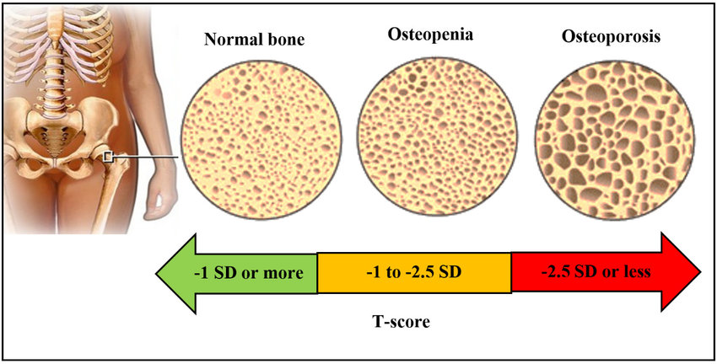
Fig. 7. Difference in normal bone and osteoporosis [35]
    - Treatment:
The treatment of osteoporosis aims to strengthen bones, reduce the risk of fractures, and improve overall bone health. The approach to treatment often involves a combination of lifestyle changes, medications, and other interventions. The specific treatment plan will depend on the severity of osteoporosis, individual risk factors, and the recommendations of a healthcare provider. Here are some common treatment strategies:[32]
1. Lifestyle Modifications:
• Adequate Calcium and Vitamin D Intake: Consuming foods rich in calcium and ensuring sufficient vitamin D intake is crucial for bone health.
• Weight-Bearing Exercises: Engaging in weight-bearing exercises like walking, jogging, dancing, and resistance training can help improve bone density and strength.
• Fall Prevention: Taking measures to prevent falls can reduce the risk of fractures. This includes using assistive devices, improving home safety, and maintaining good balance.
2. Medications:
• Bisphosphonates: These medications inhibit bone resorption and help maintain bone density. Examples include alendronate, risedronate, and ibandronate.
• Selective Estrogen Receptor Modulators (SERMs): Medications like raloxifene mimic the effects of estrogen in some parts of the body, promoting bone density.
• Denosumab: This injectable medication targets a protein involved in bone resorption, slowing down bone loss.
• Teriparatide and Abaloparatide: These are synthetic forms of parathyroid hormone that stimulate bone formation. They are typically used for severe osteoporosis.
• Hormone Replacement Therapy (HRT): Estrogen therapy, often combined with progestin, can be prescribed for postmenopausal women to help maintain bone density. However, the risks and benefits should be carefully considered.
3. Calcitonin: This hormone helps regulate calcium levels and can be administered as a nasal spray to slow down bone resorption.
4. Osteoporosis Management Clinics: Specialized clinics provide comprehensive care, including education, exercise programs, and medical interventions.
5. Nutritional Supplements: In cases of severe deficiency, calcium and vitamin D supplements may be recommended.
6. Fall Risk Assessment and Prevention: Identifying and addressing factors that contribute to falls can significantly reduce the risk of fractures.
7. Surgery: In cases of severe fractures or spinal deformities, surgical interventions such as kyphoplasty or vertebroplasty may be considered.
It's important to note that treatment plans are tailored to individual needs, and the decision to start or change a treatment regimen should be made in consultation with a healthcare provider. Regular monitoring and follow-up appointments are crucial to assess the effectiveness of treatment and make any necessary adjustments. Osteoporosis management also involves ongoing lifestyle modifications to support bone health and minimize fracture risk.[18]

Observational research is used in descriptive epidemiology to examine how diseases are distributed through time, space, and individuals. The study does not consider any additional or causative hypotheses; instead, it describes the distribution of a set of variables.

- Conclusion
The epidemiology of respiratory tract infections, diabetes, Parkinson's disease, Alzheimer's disease, and Parkinson's disease highlights the significance of managing these diseases within the context of global health. The effects of these disorders must be reduced through targeted interventions that take risk factors, genetics, and environmental variables into account. For effective preventive, early diagnosis, and management techniques to be developed, doctors, researchers, and public health authorities must work together continuously. This will ultimately improve the quality of life for those affected by these diseases. Promoting prevention, early diagnosis, and efficient care is crucial as the prevalence of chronic diseases rises, driven by a number of factors including ageing populations, changing lifestyles, and environmental impacts. For the development of comprehensive approaches that include education, risk reduction, and novel therapies, multidisciplinary collaboration across medical research, public health initiatives, and healthcare delivery systems is essential.

Acknowledgments
This book chapter was supported by Reva University, University of Delhi South Campus, and National Horticulture Research and Development Foundation (NHRDF), India.

Conflicts of interest
The authors declare no conflict of interest, financial or otherwise.

Ethical approval
Ethics approval was not required for this work.

References: -
1).[ Davie CA (2008). "A review of Parkinson's disease". British Medical Bulletin. 86 (1): 109–127. doi:10.1093/bmb/ldn013. PMID 18398010]
2).[ Villar-Piqué A, Lopes da Fonseca T, Outeiro TF (October 2016). "Structure, function and toxicity of alpha-synuclein: the Bermuda triangle in synucleinopathies". Journal of Neurochemistry. 139 (Suppl 1): 240–255. doi:10.1111/jnc.13249. PMID 26190401. S2CID 11420411
3)Burré J, Sharma M, Südhof TC (March 2018). "Cell Biology and Pathophysiology of α-Synuclein". Cold Spring Harbor Perspectives in Medicine. 8 (3): a024091. doi:10.1101/cshperspect.a024091. PMC 5519445. PMID 2810853
4)Dickson DV (2007). "Neuropathology of movement disorders". In Tolosa E, Jankovic JJ (eds.). Parkinson's disease and movement disorders. Hagerstown, MD: Lippincott Williams & Wilkins. pp. 271–283. ISBN 978-0-7817-7881-7
5) Armstrong MJ, Okun MS (February 2020). "Diagnosis and Treatment of Parkinson Disease: A Review". JAMA. 323 (6): 548–560. doi:10.1001/jama.2019.22360. PMID 32044947. S2CID 211079287.
6) Obeso JA, Rodríguez-Oroz MC, Benitez-Temino B, Blesa FJ, Guridi J, Marin C, Rodriguez M (2008). "Functional organization of the basal ganglia: therapeutic implications for Parkinson's disease". Movement Disorders. 23 (Suppl 3): S548–S559. doi:10.1002/mds.22062. PMID 18781672. S2CID 13186083.
7)Davie CA (2008). "A review of Parkinson's disease". British Medical Bulletin. 86 (1): 109–127. doi:10.1093/bmb/ldn013. PMID 18398010
8)Schulz-Schaeffer WJ (August 2010). "The synaptic pathology of alpha-synuclein aggregation in dementia with Lewy bodies, Parkinson's disease and Parkinson's disease dementia". Acta Neuropathologica. 120 (2): 131–143. doi:10.1007/s00401-010-0711-0. PMC 2892607. PMID 20563819.
9) Obeso JA, Rodriguez-Oroz MC, Goetz CG, et al. (June 2010). "Missing pieces in the Parkinson's disease puzzle". Nature Medicine. 16 (6): 653–661. doi:10.1038/nm.2165. PMID 20495568. S2CID 3146438.
10) Dickson DV (2007). "Neuropathology of movement disorders". In Tolosa E, Jankovic JJ (eds.). Parkinson's disease and movement disorders. Hagerstown, MD: Lippincott Williams & Wilkins. pp. 271–283. ISBN 978-0-7817-7881-7.
- Jennifer A. Pallone DO, Introduction to Parkinson’s Disease, Elsevier
- Alzheimer's Disease: A General Introduction and Pathomechanism, Finder, Verena H, the journal of clinical investigation.
- Michael A. DeTure & Dennis W. Dickson, The neuropathological diagnosis of Alzheimer’s disease
- Introduction to Diabetes Mellitus, Kirti Kaul, Joanna M. Tarr, Shamim I. Ahmad, Eva M. Kohner & Rakesh Chibber
- Diabetes mellitus: an overview of the types, symptoms, complications and management., Cloete L , Nursing Standard (Royal College of Nursing (Great Britain) : 1987), 28 Oct 2021, 37(1):61-66
- Type 2 Diabetes Mellitus: Update on Diagnosis, Pathophysiology, and Treatment Richard J. Mahler, Michael L. Adler, The Journal of Clinical Endocrinology & Metabolism, Volume 84, Issue 4, 1 April 1999
- Diagnosis and Treatment of Osteoporosis, MARY GAYLE SWEET, MD, JON M. SWEET, MD, MICHAEL P. JEREMIAH, MD, AND SIM S. GALAZKA, MD
- Diagnosis, Screening, Prevention, and Treatment of Osteoporosis, Author links open overlay panelKaren F. Mauck MD, MSc a, Bart L. Clarke MD b, Elsevier
- Introduction: Acute Respiratory Tract Infections: The Forgotten Pandemic
Frank Shann, Ann Woolcock, Robert Black, Allan Cripps, Hjordis Foy, Mark Harris and Rennie D'Souza
- Upper Respiratory Tract Infection Micah Thomas; Paul A. Bomar.
- Lower respiratory tract infections: What to know by Alana Biggers, M.D., MPH — By Jenna Fletcher
- Prevention of paediatric respiratory tract infections: emphasis on the role of OM-85 U. B. Schaad
- Upper Respiratory Tract Infection by Dr. Avni Serasiya December 15, 2022
- Therapeutic and Diagnostic Applications of Nanocomposites in the Treatment Alzheimer's Disease Studies, Siddhartha Dan, Deeksha Sharma, Kartikey Rastogi, Shaloo, Himanshu Ojha, Mallika Pathak, Rahul Singhal, volume 12, Biointerface Research in Applied Chemistry.
- A Non-Invasive Medical Device for Parkinson’s Patients with Episodes of Freezing of Gait, C. Punin, B. Barzallo, Roger Clotet, Llumiguano Carlos, MDPI.
- Dental and oral symptoms of diabetes mellitus,Mária Albrecht, Jolán Bánóczy, Gyula Tamás Jr. ,Volume 16, Community Dentistry and Oral Epidemiology.
- Prevention and Treatment of the Complications of Diabetes Mellitus, Charles M. Clark, Jr., M.D., and D. Anthony Lee, M.D.
- AETIOLOGY AND PRESENTING SYMPTOMS IN MALE OSTEOPOROSIS, P. PERIS, N. GUAÑABENS, A. MONEGAL, X. SURIS, L. ALVAREZ, M. J. MARTINEZ DE OSABA, M. V. HERNANDEZ, J. MUÑOZ-GOMEZ.
- Secondary Causes of Osteoporosis, Lorraine A. Fitzpatrick MD, Elsevier
- A comprehensive overview on osteoporosis and its risk factors, Farkhondeh Pouresmaeili, Behnam Kamalidehghan, Maryam Kamarehei & Yong Meng Goh
- Diagnosis of osteoporosis and assessment of fracture risk, Prof John A Kanis, The Lancet.
- Osteoporosis in elderly: prevention and treatment, Manish Srivastava, MD, Chad Deal, MD, VOLUME 18, ISSUE 3, P529-555, AUGUST 2002
- Incidence of Diabetes Mellitus in Patients with Hepatitis B and C virus Infection, March 2019, International Journal of Scientific and Research Publications 9(3):p8726, 10.29322/IJSRP.9.03.2019.p8726
- Invited Commentary: Smash of Diabetes Mellitus on Smile, June 2021Advances in Human Biology, 10.4103/aihb.aihb_68_21, NC-SA 4.0
- Advances in Sensing Technologies for Monitoring of Bone Health, April 2020, Biosensors 10(4):42, 10.3390/bios10040042

