Environmental Impact Assessment Report
Safeguard Policies for Environment
With
Environmental Checklist, Management and Monitoring Plan
EIA/ IEE for BRO – Kurkuti – Ghamsali – Niti Roads, Uttarakhand State

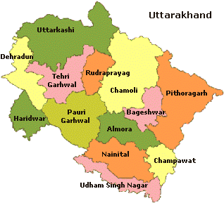
BRO: Border Road Organization,
November – 2019
TABLE OF CONTENTS

Sr. No. | Description of Item | Page Nos.
CHAPTER – 1: ENVIRONMENTAL IMPACT ASSESSMENT AND EMP FOR UTTARAKHANDSTATE
1. | INTRODUCTION AND BACKGROUND OF THE PROJECT | 08
2. | BACKGROUND – Scope and Study | 23
3. | PROJECT DESCRIPTION AND ALIGNMENT | 32
4. | OBJECTIVEOF CONSULTANCY SERVICES | 46
5. | PROPOSED APPROACH AND METHODOLOGY: Eco – Friendly OR Environmental Friendly Road Construction Methods and Materials | 49
6. | ENVIRONMENTAL INDEX OR FEATURES OF THE PROJECT | 51
7. | DEMOGRAPHIC INFRASTRUCTURE INDEX OF THE PROJECT DISTRICT/ STATE | 53
8. | ENVIRONMENTAL CHECKLIST | 76
9. | STATUTORY CLEARANCES REQUIRED | 77
10. | ENVIRONMENTAL IMPACT ASSESSMENT OF THE PROJECT | 85
11. | BASELINE ENVIRONMENTAL INDEX AND STATUS | 85
12. | AIR, WATER AND NOISE LEVEL | 93
13. | INSTITUTIONAL REQUIREMENTS AND ENVIRONMENTAL MONITORING PLANS | 114
14. | Principal Component Analysis (PCA) Indicators | 116
15. | ENVIRONMENTAL MANAGEMENT PLAN (EMP) for Kurkuti – Ghamsali – Niti Road in the State of Uttarakhand | 135
16. | CONCLUSIONS AND BUDGET | 146
17. | CONCLUSIONS AND RECOMONDATIONS | 149

Sr. No. | LIST OF TABLES | Page Nos.
CHAPTER – 1: ENVIRONMENTAL IMPACT ASSESSMENT AND EMP FOR UTTARAKHAND STATE
Table 1: | The Route Plan of Kurkuti – Ghamsali – Niti. | 17
Table 2: | Noteworthy and Remarkable Facts on Uttarakhand State. | 17
Table 3: | Average Temperature for the Year in Uttarakhand. | 30
Table 4: | Extra Widening/ Improvement and Land Acquisition Index. | 32
Table 5: | Ghamsali Village Population and Literacy Rate. | 34
Table 6: | Demographics of Rewal Chak Kurkuti Village with Population and Literacy Rate. | 34
Table 7: | Niti Village Population and Literacy Rate. | 35
Table 8: | Joshimath Tehsil Population Rate. | 36
Table 9: | Divisions and Districts in Uttarakhand (Uttaranchal). | 37
Table 10: | The Inventory of Kurkuti – Ghamsali – Niti Project Road. | 45
Table 11: | Economy of Uttarakhand at a Glance. | 52
Table 12: | Homogeneous Section based on Traffic Volume Tehsil/ District Wise Villages. | 53
Table 13: | Existing – Proposed Chainage Wise Villages. | 53
Table 14: | Uttarakhand Facts and Special Effects. | 54
Table 15: | Yearly Increase in Population Rate of Uttarakhand State, 2014 to 2019. | 56
Table 16: | Conversation/ Speaking Percentage Languages in Uttarakhand State, 2011 (Uttaranchal). | 56
Table 17: | Religious Conviction Percentage in Uttarakhand State, 2011 (Uttaranchal). | 57
Table 18: | List of Villages with Length. | 75
Table 19: | Rapid Environmental Assessment Checklist. | 76
Table 20: | Required Statutory (EIA/ S) Clearances. | 77
Table 21: | Pavement Crust Thickness for Widening and New Construction. | 79
Table 22: | Chainage References of Village Community/ Town (Kurkuti – Ghamsali – Niti Road). | 79
Table 23: | Chainage of References Village/ Township (Kurkuti – Ghamsali – Niti Road). | 79
Table 24: | Details of Existing DESIGN PARAMETERS for Proposed Structures. | 80
Table 25: | Hilly OR Mountainous Terrain All Most Stretch/ Normal/ Rolling Gradient. | 81
Table 26: | Details of Reserved Forest with Existing and Design Chainage. | 83
Table 27 (a): | Crust/ Pavement Composition Kurkuti – Ghamsali – Niti Road. | 83
Table 27 (b): | Soil Classification Kurkuti – Ghamsali – Niti Road. | 83
Table 27 (c): | Bridge and Proposed Culverts. | 84
Table 28: | Classified Different Average Daily Traffic (ADT) Surveys and Dates of Commencement Locations. | 84
Table 29 (a): | Design of Proposed Better Crust Thickness for Ridge Pavement Composition. | 85
Table 29 (b): | Design of Proposed Flush Cause Ways/ Hume Pipe Culvert for Cross Drainage Works. | 85
Table 30: | AAQ Monitoring Result of Project Road. | 93
Table 31: | National Ambient Noise Standards. | 94
Table 32: | Equivalent Noise Level Data. | 94
Table 33: | CPCB Best Use Classification for Surface Water Bodies. | 95
Table 34 (a): | Ground Water and Surface Water Quality along the Project Road. | 95
Table 34 (b): | Ground Water and Surface Water Quality along the Project Road. | 96
Table 35: | Potential Environmental Impacts. | 104
Table 36: | Impacts during Design Phase. | 110
Table 37: | Environmental Management Plan during Construction Period. | 110
Table 38: | Environmental Management during Operation Phase. | 111
Table 39: | Institutional Responsibility of Remedial Measures. | 114
Table 40: | Principal Component Analysis as Significant Indicators of Remedial Measures. | 116
Table 41: | Environmental Management Plan (EMP). | 135
Table 42: | Environmental Mitigation and Monitoring Requirements. | 146
Table 43 (a): | Details of Kurkuti – Ghamsali – Niti Road. | 147
Table 43 (b): | Tentative Cost of Kurkuti – Ghamsali – Niti Road. | 149
Table 44 (a): | Focus Group Discussion Public Consultation. | 150
Table 44 (b): | Positive Impacts. | 150
Table 44 (c): | Negative Impacts. | 151
Table 44 (d): | Public Consultation and Focus Group Discussions in Kurkuti – Ghamsali – Niti Road. | 152

Sr. No. | LIST OF FIGURES | Page Nos.
CHAPTER – 1: ENVIRONMENTAL IMPACT ASSESSMENT AND EMP FOR UTTARAKHAND STATE
Figure 1 (a): | Uttarakhand States’ Birds, Animals and Cumulative Impact Assessment (CIA) Supporting Wealthy and Rich Diversity OR Species. | 12
Figure 1 (b): | Traditional Uttarakhand States’ Food Culture and Cumulative Impact Assessment (CIA) Supporting Wealthy and Rich Assortment OR Collection. | 13
Figure 1 (c): | Mountain Ranges, Meandering Rivers and Miles of Forests Supporting Wealthy and Rich Biodiversity. | 14
Figure 1 (d): | Mountain Ranges, Meandering Rivers and Miles of Forests Supporting Wealthy and Rich Biodiversity. | 15
Figure 1 (e): | Mountain Ranges, Meandering Rivers and Miles of Forests Supporting Wealthy and Rich Biodiversity. | 16
Figure 2: | Detailed Project Description Process (Schematic Diagram OR Flowchart Showing Project Layouts and Concluding Components). | 25
Figure 3: | Index Map Showing Projected Road. | 26
Figure 4: | The Tentative Prototype – Paradigm – Digital Sample/ Example of Digital Terrain Model (DTM)/ DEM Generation of Geo – Tiff – Format of Kurkuti to Ghamsali to Niti Road, Village (17.565 Km) Projected New Road at Kurkuti Latitude of 30.7116° (North) and Longitude of 79.8381° (East); Niti Latitude of 30.7776° (North) and Longitude of 79.8412° (East). Vetting/ Geology and Slope Stability are observed by IIT Delhi/ Roorkee Team Experts. (Package – I) | 29
Figure 5: | Project Alignment of Kurkuti – Ghamsali – Niti Road. | 33
Figure 6: | Demographic Map of Rewal Chak Kurkuti Village. | 35
Figure 7: | Approved Project Alignment of Kurkuti – Ghamsali – Niti Road Projected as per Inception Report by Environmental Team Experts. | 46
Figure 8: | Project Execution Objectives and Decision Making Work – Life Cycle. | 48
Figure 9: | Methodological Perspective Over – View of Road Date Base Construction Photographs. | 50
Figure 10: | Lipukekh Pass – Indo – China Border and Shri Laxmi Narayan Temple in Legship. | 55
Figure 11: | Joshimath Tample is among the most Famous Religious Place for Pilgrims. | 58
Figure 12: | Traditional Tample Festivals of Uttarakhand State. | 60
Figure 13: | Uttarakhand’s Traditional Food – based Dishes like Kafuli/ Kapaa, Phaanu, Baadi, Chainsoo, Rus/ Thhatwani, Dubuk/ Dubke, Jhangore ki Kheer, Sisunaak Saag and Chudkaani. | 72
Figure 14: | Buddha Temple Dehradun, Clement Town Places to Visit… Le monastère de Mindrolling Uttarakhand. | 73
Figure 15: | Technical Universities Campus in Pauri, Dehradun and Uttarakhand. | 74
Figure 16: | Prototype – Paradigm of Land Use Pattern of Existing Road. | 81
Figure 17 (a): | Daily Variations of Traffic Volume at Kurkuti (Chainage 00+000) to Niti (Chainage 18+530) on Projected Road. | 82
Figure 17 (b): | Catalogue for Pavement with Bituminous Surface with CTSB, CTB and SAMI – Effective CBR 10% (Plate – 22). | 83
Figure 18: | Three Columns of Sustainability Development – Environmental, Economic and Social. | 93
Figure 19: | Increase in Levels of Pollutant – Emissions – Impact on Future Generated Aspects/ Prospects from Various Sources. | 100
Figure 20: | Noise Levels Impact Must Not Exceed the Permissible Limits in Sensitive Zones along Road Side. | 101
Figure 21: | Mitigatory Measures Plans Generated; Initialized and Finalized to Avoid Contamination Impact on Water Resources and Quality. | 102
Figure 22: | Plan Mitigatory Measures to Avoid Soil Contamination Impact on Agricultural Land and Other Sensitive Zones in Environmental/ Natural/ Ecological Vicinity/ Area/ Site. | 104
Figure 23 (a): | Mitigation Enhancement as per Alignment Design Phase to Reduce Tree Cutting and Compensatory Plantation Relevance. | 106
Figure 23 (b): | Anticipated Refined Enhancement Measures of Road Design Phase as per Alignment to Reduce Tree Cutting and Compensatory Plantation Relevance for ZERO Pollution Level. | 107
Figure 23 (c): | Recommended Refined Enhancement Measures of Road Design Phase as per Alignment to Reduce Tree Cutting and Compensatory Plantation Relevance for ZERO Pollution Level. | 108
Figure 23 (d): | Road Designing Phase as per Alignment to Reduce Tree Cutting and Compensatory Plantation Relevance for ZERO Pollution Level. | 109
Figure 24: | Process of Pyrolysis in Solid and Waste Water Treatment. | 112
Figure 25: | Solid Waste Handling Pyrolysis Technique. | 113
Figure 26: | Sewage Treatment Process (STP) of Wastewater Layout. | 114
Figure 27 (a): | TCS: TYPICAL CROSS SECTION FOR 2 – LANE CARRIAGEWAY.  TYPICAL CROSS SECTION – I | 119
Figure 27 (b): | TYPICAL CROSS SECTION: FOR 2 – LANE CARRIAGEWAY.  TYPICAL CROSS SECTION – II | 119
Figure 27 (c): | TYPICAL CROSS SECTION: FOR 2 – LANE CARRIAGEWAY.  TYPICAL CROSS SECTION – III | 120
Figure 27 (d): | TYPICAL CROSS SECTION: FOR 2 – LANE CARRIAGEWAY.  TYPICAL CROSS SECTION – IV | 120
Figure 27 (e): | TYPICAL CROSS SECTION: FOR 2 – LANE CARRIAGEWAY.  TYPICAL CROSS SECTION – V | 121
Figure 27 (f): | TYPICAL CROSS SECTION: FOR 2 – LANE CARRIAGEWAY.  TYPICAL CROSS SECTION – VI | 121
Figure 27 (g): | TYPICAL CROSS SECTION: FOR 2 – LANE CARRIAGEWAY.  TYPICAL CROSS SECTION – VII | 122
Figure 27 (h): | TYPICAL CROSS SECTION: FOR 2 – LANE CARRIAGEWAY.  TYPICAL CROSS SECTION – VIII | 122
Figure 27 (i): | TYPICAL CROSS SECTION: FOR 2 – LANE CARRIAGEWAY.  TYPICAL CROSS SECTION – IX | 123
Figure 28: | BOTHER... SAFEGUARD; PROTECT; CONSERVE AND PRESERVE OUR PLANET EARTH’S NATURAL – MOTHER... (ECO – NATURAL – GREEN – ENVIRONMENT)...!!! | 123
Figure 29 (a): | Overview of the Environment and Social Framework. | 131
Figure 29 (b): | Core Principles of the Environmental and Social Framework. | 132
Figure 29 (c): | The Environmental Objectives; Application Scope; Policy Approach of the Environmental and Social Framework. | 133
Figure 29 (d): | The Policy Requirements; Roles and Responsibilities of the Environment and Social Framework. | 134
ABBREVIATIONS AND ACRONYMS

AADT | Annual Average Daily Traffic |  | MOEF | Ministry of Environment and Forests
AC | Asphaltic Concrete |  | MORT & H | Ministry of Road Transport & Highways
ADT | Average Daily Traffic |  | BRO | Border Road Organisation
BBD | Benkelman Beam Deflection |  | MSA | Million Standard Axles
BC | Bituminous Concrete |  | MSL | Mean Sea Level
BM | Bituminous Macadam |  | NH | National Highway
BOQ | Bill of Quantities |  | NMT | Non – Motorized Traffic
BOT | Build Operate Transfer |  | NPV | Net Present Value
BSNL | Bharat Sanchar Nigam Limited |  | NSDP | Net State Domestic Product
BT | Bituminous Track |  | NTPC | National Thermal Power Corporation
CBR | California Bearing Ratio |  | O&M | Operation & Maintenance
CD | Cross Drainage |  | O – D | Origin Destination
CGWB | Central Ground Water Board |  | OFC | Optical Fiber Cable
CMSA | Cumulative Million Standard Axles |  | OMC | Optimum Moisture Content
COI | Corridorof Impact |  | PCC | Plain Cement Concrete
CRRI | Central Road Research Institute (India) |  | PCU | Passenger Car Unit
CVPD | CommercialVehiclePerDay |  | PIU | Project Implementation Unit
DBFOT | Design, Build, Finance, Operate & Transfer |  | PPM | Parts Per Million
DBM | Dense Bituminous Macadam |  | PPP | Public Private Partnership
DLC | Dry Lean Concrete |  | PPR | Preliminary Project Report
DTM | Digital Terrain Model |  | PQ | Pre – Qualification
EA | Environmental Assessment |  | PQC | Pavement Quality Control
EASL | Equivalent Standard Axle Load |  | PWD | Public Works Department
EIA | Environment Impact Assessment |  | QAP | Quality Assurance Plan
EIRR | Economic Internal Rate of Return |  | QC | Quality Control
FFR | Final Feasibility Report |  | R&R | Resettlement and Rehabilitation
FIRR | Financial Internal Rateof Return |  | RAP | Resettlement Action Plans
GAD | General Arrangement Drawing |  | RCC | Reinforced Cement Concrete
GDP | Gross Domestic Product |  | RHS | Right Hand Side
GOI | Government of India |  | RL | Reduced Level
GPS | Global Positioning System |  | ROB/ RUB | Road Over Bridge/ Road Under Bridge
GSB | Granular Sub – Base |  | ROW | Right of Way
GTS | Geodetic Triangulation Survey |  | Rs. | Rupees
Ha | Hectare |  | SH | State Highway
HDM–4 | Highway Design & Maintenance Model (Series – 4) |  | SIA | Social Impact Assessment
HDMQ | Highway Designand Maintenance Model with Congestion Analysis |  | Sq. Km. | SquareKiloMeters
HFL | High Flood Level |  | TBM | Temporary Bench Mark
IRC | Indian Road Congress |  | Temp | Temperature
IRR | Internal Rate of Return |  | TOR | Terms of Reference
Km | Kilometre |  | TRL | Transportation Research Laboratory
KMPH | Kilometre Per Hour |  | UG | Under Ground
LA | Land Acquisition |  | VDF | Vehicles Damage Factor
LT/ HT | Low Tension/ High Tension Electric Lines |  | Veh. | Vehicles
m | Meters |  | VGF | Viability Gap Funding
MDR | Major District Road |  | WB | World Bank
mm | Millimetre |  | WBM | Water Bound Macadam
Dia. | Dia Meters |  | WMM | Wet Mix Macadam
EPC | Engineering, Procurement, and Construction |  | PPE | Personal Protective Equipment
PPR | Peste – des Petits Ruminants |  | GAD | General Administration Department
LMI | Labour Market Information |  | MSE | Mean Squared Error
SARA | Saturates, Aromatics, Resins and Asphaltenes |  | ACZ | Agro – Climatic Zone
PET | Poly – Ethylene Tere – phthalate |  | SEDP | Sustainable Environmental Development Practices
FRC | Fibre Reinforced Concrete |  | PCM | Public Consultation Method
PCM | Public Consultation Meeting |  | FGD | Focus Group Discussion
UTC | Universal Time Coordinated |  | GPS | Global Positioning System
DEM | Digital Elevation Model |  | DTM | Digital Terrain Model
FCW | Flush Cause Way |  | CRRI | Central Road Research Institute
CVPD | Commercial Vehicles Per Day |  | ATTC | Advanced Technical Training Centre
CCCT | Centre for Computers and Communication Technology |  | CRPF | Central Reserve Police Force
NWL | Normal Water Level |  | TAR | Tibet Autonomous Region
CCP | CIVIL CONSTRUCTION PRACTICES |  | NSSDA | National Standard for Spatial Data Accuracy
GSD | Ground Sample Distance |  | DGPS | Differential Global Positioning System
NRSC | National Remote Sensing Centre |  | GIS | Geographical Information System
DEM | Digital Elevation Model |  | RL | Reduced Level

This is a Draft Report on Environmental and Social Management Framework (ESMF) for the proposed Enhancing Land, Air, Water, Noise and Road Construction Resource Efficiency (ELAWNRCRE) Project with financial assistance from the BRO/ ITBP/ CPWD/ PWD/ MPRDC/ MSRDC/ ADB/ NDB OR World Bank etc. This is hereby disclosed with a view to soliciting comments/ suggestions on or before December 2019. In this regard, please send your comments/ suggestions by email to h.g@rediffmail.com or by WhatsApp Number 09329213257 to Dr. Harish Kumar Gupta, Environment Expert, L. N. M. Infra Projects Pvt. Ltd., Bhopal (M.P.).

Chapter – 1: ENVIRONMENTAL IMPACT ASSESSMENT AND EMP FOR UTTARAKHAND STATE

1. INTRODUCTION AND BACKGROUND OF THE PROJECT

Uttarakhand formerly known as Uttaranchal is a state in the Northern part of India. It is often referred to as the “Devabhumi” (literally “Land of the Gods”) due to a large number of Hindu temples and pilgrimage centres found throughout the state. Uttarakhand is known for the natural environment of the Himalayas, the Bhabhar and the Terai. On 9th November 2000, Uttarakhand became the 27th state of the Republic of India, being carved from the Himalayan districts of Uttar Pradesh. It borders Tibet Autonomous Region of China to the North; the Sudurpashchim Pradesh of Nepal to the East; the Indian states of Uttar Pradesh to the South and Himachal Pradesh to the west and North – West. The state is divided into two divisions, Garhwal and Kumaon, with a total of 13 districts. The interim capital of Uttarakhand is Dehradun, the largest city of the state, which is a railhead and the High Court of the state is located in Nainital.

Archaeological evidence supports the existence of humans in the region since prehistoric times. The region formed a part of the Uttara Kuru Kingdom during the Vedic age of Ancient India. Among the first major dynasties of Kumaon were the Kunindas in the 2nd century BCE who practised an early form of Shaivism. Ashokan edicts at Kalsi show the early presence of Buddhism in this region. During the medieval period, the region was consolidated under the Kumaon Kingdom and Garhwal Kingdom. In 1816, most of modern Uttarakhand was ceded to the British as part of the Treaty of Sugauli. Although the erstwhile hill kingdoms of Garhwal and Kumaon were traditional rivals, the proximity of different neighboring ethnic groups and the inseparable and complementary nature of their geography, economy, culture, language, and traditions created strong bonds between the two regions which further strengthened during the Uttarakhand movement for statehood in the 1990s.

The natives of the state are generally called Uttarakhandi, or more specifically either Garhwali or Kumaoni by their region of origin. According to the 2011 Census of India, Uttarakhand has a population of 10,086,292, making it the 20th most populous state in India.

Etymology

Uttarakhand's name is derived from the Sanskrit words uttara (उत्तर) meaning “North”, and khanda (खण्ड) meaning “Land”, altogether simply meaning “Northern Land”. The name finds mention in early Hindu scriptures as the combined region of “Kedarkhand” (present day Garhwal) and “Manaskhand” (present day Kumaon). Uttarakhand was also the ancient “Puranic” (पौराणिक) term for the central stretch of the Indian Himalayas.

However, the region was given the name Uttaranchal by the Bharatiya Janata Party led central government and Uttrakhand state government when they started a new round of state reorganization in 1998. Chosen for its allegedly less separatist connotations, the name change generated enormous controversy among many activists for a separate state who saw it as a political act. The name Uttarakhand remained popular in the region, even while Uttaranchal was promulgated through official usage.

In August 2006, Union Cabinet of India assented to the demands of the Uttaranchal Legislative Assembly and leading members of the Uttarakhand statehood movement to rename Uttaranchal state as Uttarakhand. Legislation to that effect was passed by the Uttaranchal Legislative Assembly in October 2006, and the Union Cabinet brought in the bill in the winter session of Parliament. The bill was passed by Parliament and signed into law by then President A. P. J. Abdul Kalam in December 2006, and since January 1st, 2007 the state has been known as Uttarakhand.

History

History of Uttarakhand and Uttarakhand Movement: Ancient rock paintings, rock shelters, paleolithic stone tools (hundreds of thousands of years old), and megaliths provide evidence that the mountains of the region have been inhabited since prehistoric times. There are also archaeological remains which show the existence of early Vedic (c. 1500 BCE) practices in the area. The Pauravas, Nandas, Mauryans, Kushanas, Kunindas, Guptas, Gurjara – Pratihara, Katyuris, Raikas, Palas, Karkotas, Chands, Parmars or Panwars, and the British have ruled Uttarakhand in turns.
It is believed that the sage Vyasa scripted the Hindu epic Mahabharata in the state. Among the first major dynasties of Garhwal and Kumaon were the Kunindas in the 2nd century BCE who practised an early form of Shaivism and traded salt with Western Tibet. It is evident from the Ashokan edict at Kalsi in Western Garhwal that Buddhism made inroads in this region. Folk Hindu shamanic practices deviating from Hindu orthodoxy also persisted here. However, Garhwal and Kumaon were restored to nominal Vedic Hindu rule due to the travels of Shankaracharya and the arrival of migrants from the plains.

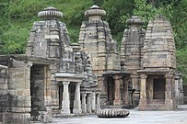

Katarmal Sun Temple constructed by the Katyuri Kings in the 9th century CE.

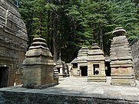

Jageshwar Temples are a group of over 100 Hindu Temples dated between 7th and 12th century.

Between the 4th and 14th centuries, the Katyuri dynasty dominated lands of varying extent from the Katyur Valley (Modern – Day Baijnath) in Kumaon. The historically significant temples at Jageshwar are believed to have been built by the Katyuris and later remodelled by the Chands. Other peoples of the Tibeto –Burman Group known as Kirata are thought to have settled in the Northern highlands as well as in pockets throughout the region, and are believed to be ancestors of the modern day Bhotiya, Raji, Buksa, and Tharu people.

Princely Flag of Kingdom of Garhwal

By the medieval period, the region was consolidated under the “Garhwal Kingdom” in the West and the Kumaon Kingdom in the East. During this period, learning and new forms of Painting (the Pahari School of Art) developed. Modern – day Garhwal was like wise unified under the rule of Parmars who, along with many Brahmins and Rajputs, also arrived from the plains. In 1791, the expanding Gorkha Empire of Nepal overran Almora, the seat of the Kumaon Kingdom. It was annexed to Kingdom of Nepal by Amar Singh Thapa. In 1803, the Garhwal Kingdom also fell to the Gurkhas. After the Anglo – Nepalese War, this region was ceded to the British as part of the Treaty of Sugauli. The Garhwal Kingdom was then re – establishedfrom a smaller region in Tehri.

Uttarakhand as a Part of the United Province, 1903

After India attained independence from the British, the Garhwal Kingdom was merged into the state of Uttar Pradesh, where Uttarakhand composed the Garhwal and Kumaon Divisions. Until 1998, Uttarakhand was the name most commonly used to refer to the region, as various political groups, including the “Uttarakhand Kranti Dal” (Uttarakhand Revolutionary Party), began agitating for separate statehood under its banner. Although the erstwhile hill kingdoms of Garhwal and Kumaon were traditional rivals the inseparable and complementary nature of their geography, economy, culture, language, and traditions created strong bonds between the two regions. These bonds formed the basis of the new political identity of Uttarakhand, which gained significant momentum in 1994, when demand for separate statehood achieved almost unanimous acceptance among both the local populace and national political parties.

The most notable incident during this period was the Rampur Tiraha Firing Case on the night of 1st October 1994, which led to a public uproar. On 24th September 1998, the Uttar Pradesh Legislative Assembly and Uttar Pradesh Legislative Council passed the Uttar Pradesh Reorganisation Bill, which began the process of forming a new state. Two years later the Parliament of Indiapassed the Uttar Pradesh Reorganisation Act, 2000 and thus, on 9th November 2000, Uttarakhand became the 27th state of the Republic of India.

“माटू हमरू, पाणी हमरू, हमरा ही छन यी बौण भी... पितरों न लगाई बौण, हमुनही त बचौण भी।
Soil ours, water ours, ours are these forests. Our forefathers raised them; it's we who must protect them.
— Old Chipko Song (Garhwali Language)”

Uttarakhand is also well known for the mass agitation of the 1970s that led to the formation of the Chipko Environmental Movement and other Social Movements. Though primarily a livelihood movement rather than a forest conservation movement, it went on to become a rallying point for many future environmentalists, environmental protests, and movements the world over and created a precedent for non – violent protest. It stirred up the existing civil society in India, which began to address the issues of tribal and marginalized people. So much so that, a quarter of a century later, India Today mentioned the people behind the “Forest Satyagraha” of the Chipko Movement as amongst “100 People Who Shaped India”. One of Chipko's most salient features was the mass participation of female villagers. Both female and male activists played pivotal roles in the movement. “Gaura Devi was the main activist who started this movement other participants was Chandi Prasad Bhatt, Sunderlal Bahuguna, and Ghanshyam Raturi, the Popular Chipko Poet”.

The consultancy services for carrying out preparation of Initial Environmental Examination (IEE)/ Detailed Project Report (DPR) and bid documents. In order to fulfil the traffic needs and road safety requirement, Border Road Organisation (BRO) has appointed the M/s HIGHWAY ENGINEERING Consultant BHOPAL (MP), for Survey, Investigation and Preparation of Detailed Project Report for improvement of Road and Bridges etc. for construction of High Altitude Hill Roads to Border Road Organization under Phase – I in the state of Uttarakhand using Satellite Imagery and Geographical Information System (GIS). The report brings out the project background, mobilization and staffing, approach and methodology relating to surveys/ investigations and detailed design. A broad conceptualization of the project essentially based on study of available data/ reports and a detailed reconnaissance survey has been provided. “Uttarakhand BRO – 21 BRTF (123 – RCC) Division Suraitota, has been entrusted preparation of Initial Environmental Examination (IEE) of Kurkuti – Ghamsali – Niti from 00.000 Km to 20.000 Km (20.00 Kms) from CL – 9 to NHDL Specification in 21 – BRTF area under PROJECT – Shivalik in Uttarakhand”.Through Consultancy Services As Specified By MORT & H and Provisions of IRC – SP – 19 for Improvement/ Development of Road Kurkuti – Ghamsali – Niti from 00.000 Km to 20.000 Km (20.00 Kms) area under Project Shivalik Uttarakhand State, the assignment for Letter No. 80260/ Consultancy/ KGN/ 48/ E8 Dated July 2018. The report also makes proposals on issues requiring discussions with the Border Road Organisation (BRO) by Ministry of Home Affairs, Department of Border Management, and Government of India and decisions necessary for detailing of the project.

The report covers the following major aspects and prospects are as discussed below one by one:

Project Background;

Mobilization and Progress;

Project Appreciation and Conceptualization;

Proposed Approach and Methodology;

Alignment Deciding Criteria andSignificant Factors

Connectivity to Indo – Tibetan Border Police (ITBP) Posts Authorities of 11th and 13th Battalion, Raised on 24th October 1962, under the Central Reserve Police Force (CRPF) Act;

Stable Side of Hilly Areas;

Avoiding of S – Bends to the Extent Possible;

Gradient Limits;

Availability of Road Construction Materials;

Minimum Number of Cross Drainage Structures;

Connectivity to Intermediate Village, If Any;

Avoiding Acquisition of Private Land;

Keeping the Alignment 25 – 30 m above Normal Water Level (NWL) of River, If Any;

The consultancy services for the same have included design of best possible alignment and pavement composition, culverts and other structures in addition to analysis of costs, determining project feasibility and Initial Environmental Examination (IEE) Report for the Project Kurkuti – Ghamsali – Niti Road Starts from Kurkuti Road and Terminates at Niti Road in the Uttarakhand State.

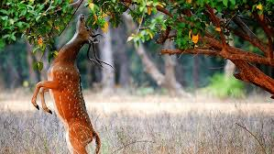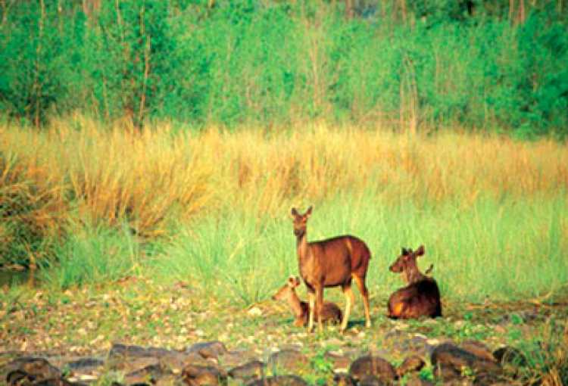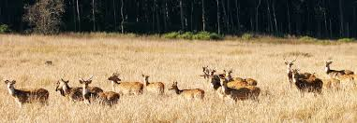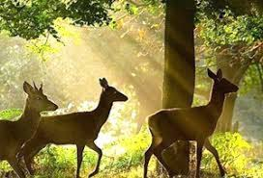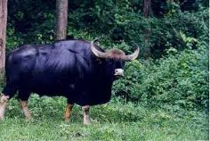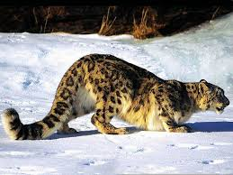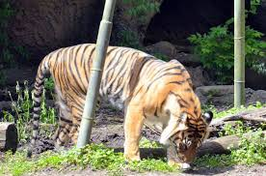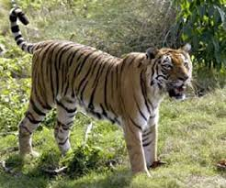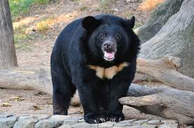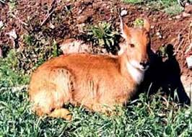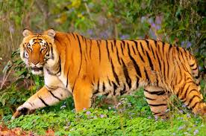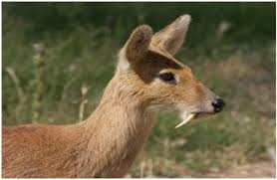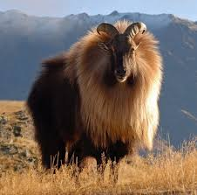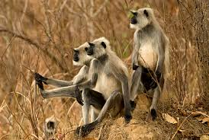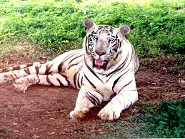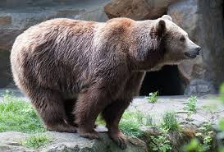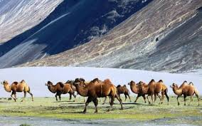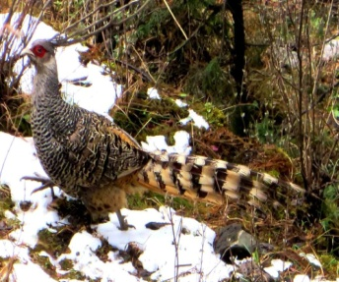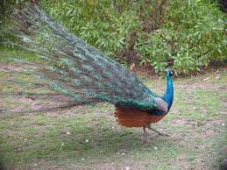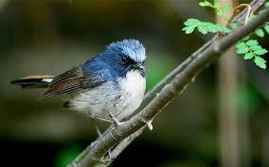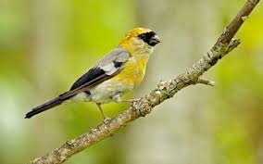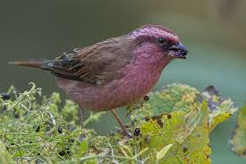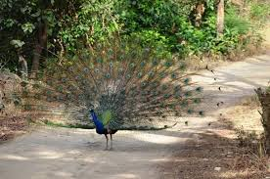

Figure 1 (a): Uttarakhand States’ Birds, Animals and Cumulative Impact Assessment (CIA) Supporting Wealthy and Rich Diversity OR Species.
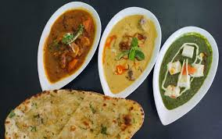

Figure 1 (b): Traditional Uttarakhand States’ Food Culture and Cumulative Impact Assessment (CIA) Supporting Wealthy and Rich Assortment OR Collection.
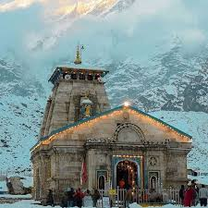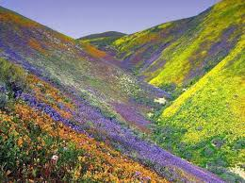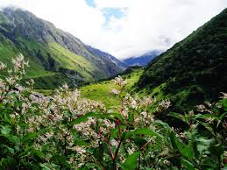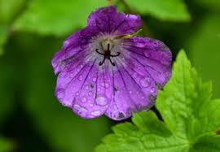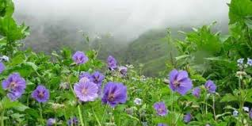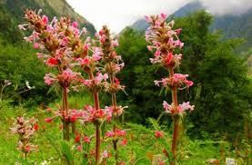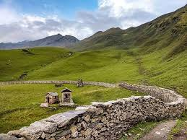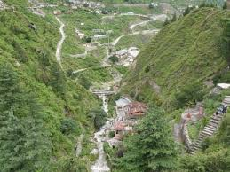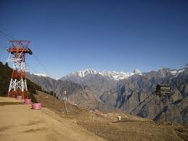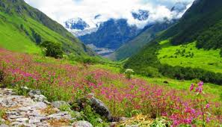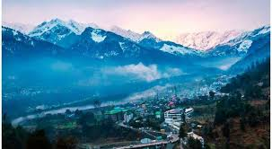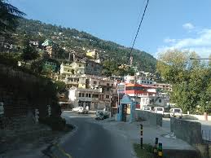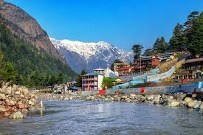

Figure 1 (c): Mountain Ranges, Meandering Rivers and Miles of Forests Supporting Wealthy and Rich Biodiversity.
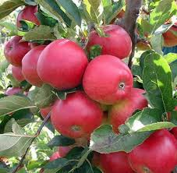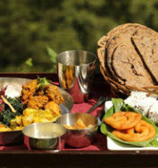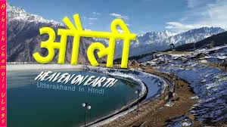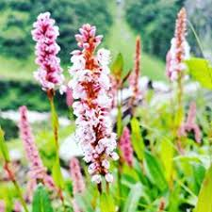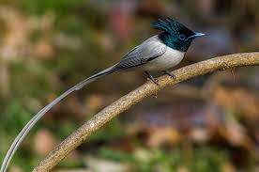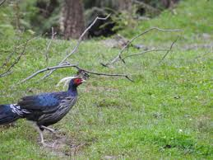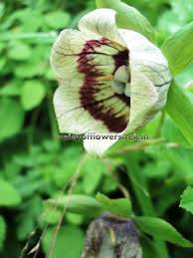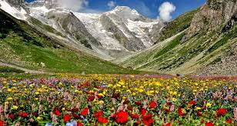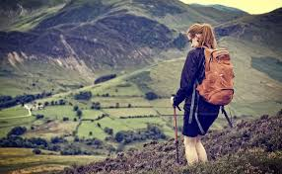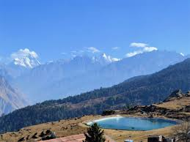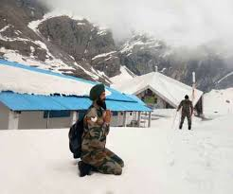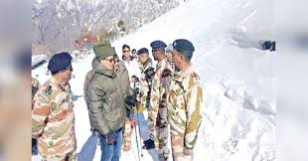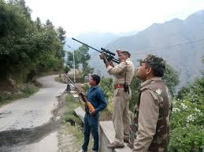

Figure 1 (d): Mountain Ranges, Meandering Rivers and Miles of Forests Supporting Wealthy and Rich Biodiversity.
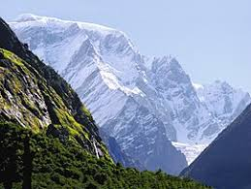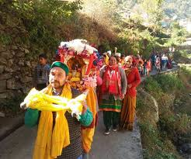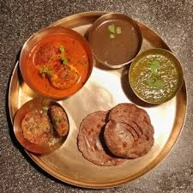
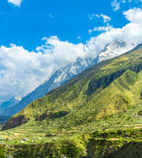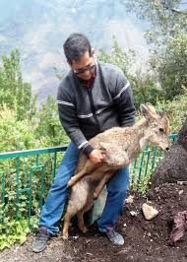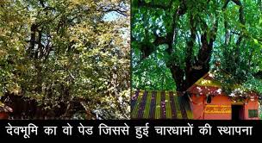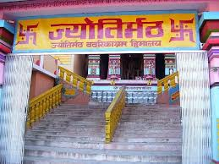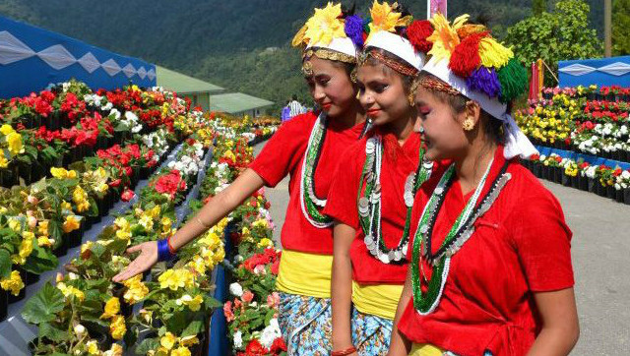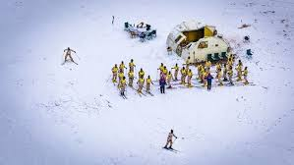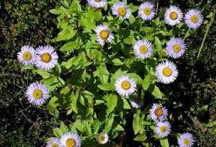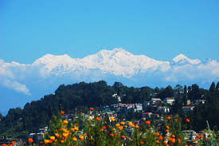
Figure 1 (e): Mountain Ranges, Meandering Rivers and Miles of Forests Supporting Wealthy and Rich Biodiversity.
Most of the areas being hilly, summers in Uttarakhand State are soothing as the temperature hardly crosses 30°C (about 86°F), whereas the summers are exceedingly hot with temperatures crossing the 40°C mark and considerable humidity. Winters can be chilly with temperatures going below 5°C at times. The climate in the Northern part of Uttarakhand is typically Himalayan. This mountain range itself exerts an appreciable extent of influence on monsoon and rainfall patterns. Within the Himalayas, climate differs depending on altitude and position. Climate ranges from subtropical in the southern foothills, averaging summer temperatures of about 30°C (about 86°F) and winter temperatures of about 18°C (about 64°F). Warm temperate conditions prevail in the Middle Himalayan valleys, with summer temperatures usually hovering about the mark of 25°C (about 77°F) and cooler winters. It lies between Latitude 30.0668° N and Longitude 79.0193° E. Located in the North – Eastern part of the country, Uttarakhand is surrounded by West Bengal on its South and shares international borders with Bhutan on its South – East, Nepal on its West and the Tibet Autonomous Region (TAR) of China on its North – East and it is often referred to as the “Smart and Beautiful – Heritage of Himalayas”. The beautiful mountains, the deep valleys and the biodiversity make Uttarakhand a favourite spot for tourists like Mountain Ranges, Meandering Rivers and Miles of Forests Supporting Wealthy and Rich Biodiversity in Uttarakhand State as shown above in Figures 1 (a), (b), (c), (d) and (e). The Initial Environmental Examination (IEE) Report for improvement of “Uttarakhand BRO – 21 BRTF (123 – RCC) Division Suraitota, has been entrusted preparation of Initial Environmental Examination (IEE) of Kurkuti – Ghamsali – Niti Road from 00.000 Km to 20.000 Km (20.00 Kms) from CL – 9 to NHDL Specification in 21 – BRTF area under PROJECT – Shivalik in Uttarakhand”. The Projected Road Kurkuti – Ghamsali – Niti Starts at Kurkuti and Terminates at Niti. The Project Assignment/ Task for Letter No. 80260/ Consultancy/ KGN/ 48/ E8 Dated July 2018. The design length of proposed alignment is 191.00 Km. and the route plan of Kurkuti – Ghamsali – Niti Road is given in Table 1.

Table 1: The Route Plan of Kurkuti – Ghamsali – Niti Road.

Road Direction and Route Plan

Place Name |  | Distance | Approximate Time for Journey | Mode of Vehicle
From | To
Kurkuti | Niti | 17.56 Km. | 04.25 Hrs | By Road with 4 Wheeler Drive
Total |  | 17.56 Km.

Physiographic Index

Uttarakhand is the second – smallest Indian state and is geographically located at Latitude 30.0668° N and Longitude 79.0193° E. Landlocked in the Himalayan range, the state is bordered by Tibet on its North – East, Nepal on its west, Bhutan on its South – East and West Bengal on its South. The residents of Uttarakhand experience two kinds of climate. The Northern part of the state experiences tundra type of climate, whereas, the Southern part observes sub – tropical climatic conditions. Because of the tundra type of climate, the Northern part of the state remains covered with snow for almost 4 months in a year, when the night temperature goes below the level of 0°C. The weather condition of the state is mainly divided into 5 seasons, which are depicted below:

- Spring;
- Summer;
- Autumn;
- Monsoon;
- Winter.

Uttarakhandis subdivided into following units as Noteworthy and Remarkable Facts on Uttarakhand State are shown in the Table 2 with worth mentioning and incredibleIndex of Uttarakhand State.

Table 2: Noteworthy and Remarkable Facts on Uttarakhand State.

Facts on Uttarakhand State
Official Website | https://www.euttaranchal.com and https://uk.gov.in/ andhttps://uktech.ac.in/
Date of Formation | Uttarakhand formerly known as Uttaranchal is a state in the Northern part of India. On 9th November 2000, Uttarakhand became the 27th State of the Republic of India, being carved from the Himalayan Districts of Uttaranchal. The region formed a part of the Uttara Kuru Kingdom during the Vedic age of Ancient India.
Area | 53,483 Km²
Density | The population density of the state is 189 People/ Km² having a 2001 – 2011 decadal growth rate of 18.81%.
Total Population (2012 and 2019) | 1.01 crores OR 10.3932 Million Approximately.
Males Population (2011) | 5,137,773
Females Population (2011) | 4,948,519
Number of District | 13
Capital | Dehradun
Rivers | Alaknanda River, Ganges River, Pindar River, Assan Barrage, Gaula River, Pushpawati River, Bhilangna River, Kosi River and Ramganga River. In some parts of Uttarakhand, rivers like Ganga, Tons, Yamuna, and Kali are famous for offering a wide variety of water sports.
Forests and National Park | Six National Parks in Uttarakhand for Your Next Getaway. Jim Corbett National Park, Rajaji National Park, Valley of Flowers National Park, Nanda Devi National Park, Gangotri National Park, Govind Pashu Vihar National Park and Sanctuary.
Languages | Garhwali or Kumaoni depending on their place of origin.
Neighbours State | Himachal Pradesh, Haryana, Uttar Pradesh.
State Animal | “Alpine Musk Deer” (Official Moschus chrysogaster).  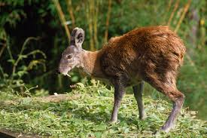
State Bird | “Himalayan Monal Pheasant” (Official Lophophorus impejanus).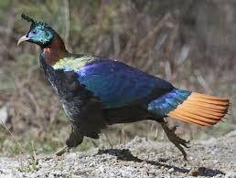
State Tree | “Burans” (Official Rhododendron arboreum).  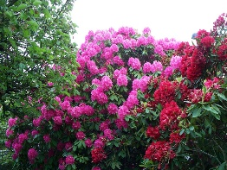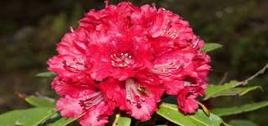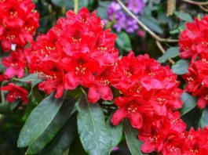
State Flower | “Brahm Kamal” (Official Saussurea obvallata).
State Fish | To Protect the Endangered “Mahaseer” Fish, Uttarakhand.  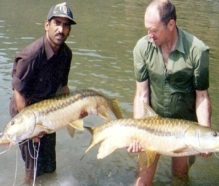
Net State Domestic Product (2011 – 12 To 2015 – 16) | 1,62,168 (Rs. Crore)
Literacy Rate (2011) | 78.82%
Females per 1,000 Males {Sex Ratio Females (Rural)} | 963 {1000}
Assembly Constituency | General Seats 54, SC Seats 14, ST Seats 2. Total Seats 70.
Parliamentary Constituency | The Lok Sabha (meaning “House of the People”) is the lower house of the Parliament of India. Uttarakhand state elects 5 members and they are directly elected by the state electorates of Uttarakhand. Members are elected for five years. The numbers of seats, allocated to the state/ union territory are determined by the population of the state/ union territory.

Waterfalls

Combined with the snow capped peaks of Uttarakhand, and the lush green forests that lead you to amazing trekking memories, Waterfalls in Uttarakhand rejuvenate your mind, body and soul like no other. Whether it is about bathing in the medicinal natural ponds at the edge of these waterfalls, or simply admires their beauty on a day trip, the undeniable serenity of these falls adds more to your ordinary day.
If you’re one of those people for whom only thinking about such places sparks joy, then scroll down to know what awaits you at these falls to plan a perfect outing …!!! Uttarakhandis primarily a land of sky scraping mountains/ hills and the lush green vegetation on the mountain sides presents an Eye – Soothing View and this sight is made more panoramic by the waterfalls in Uttarakhand. Mostly perennial in nature, waterfalls abound in Uttarakhand, especially in the Northern region. The local inhabitants of Uttarakhand consider some of the waterfalls to be sacred place. The waterfalls of Uttarakhand are ideal sites for setting trekking base camps, since they fall from high altitudes and are perennial in nature; these waterfalls are also conducive for setting up hydro power projects. Witness the beauty of Uttarakhand and indulge in spiritual pilgrimages, adventure sports, and treks. Visit Nainital, Rishikesh, Haridwar, Auli, Jim Corbett, and more. The important waterfalls in Uttarakhand are:

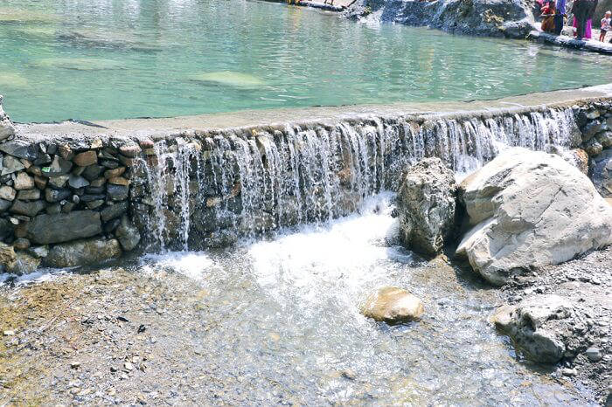

- Kempty Waterfalls: Located a few kilometers off Mussoorie, Kempty falls is a serene waterfall that is a must visit for all the tourists visiting the nearby hill station. Falling from a height of 1,364 Metres above sea level, these falls are an amazing site to admire. Nature’s beautiful creation like this one is a perfect spot for a day trip or a picnic with your loved ones and stay till the evening time to revive your senses with a fresh cool breeze that flows around this region. So, when are you planning to visit one of the Top Waterfalls in Uttarakhand …?

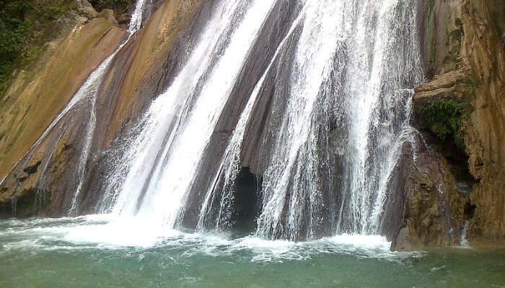

- Bhatta Waterfalls: Earlier a lesser known place, this charming waterfall in Mussoorie has gained popularity in recent years and is surely not to be missed while you’re planning a trip to Mussoorie. You can easily reach this place via bus or a car in the Bhatta village and have a fun outing with your folks ..!!! A rather steep fall, that comes directly from the hills above, hitting the rocks around, people belonging to different age groups visit this place to bath and enjoy the serenity of this place.

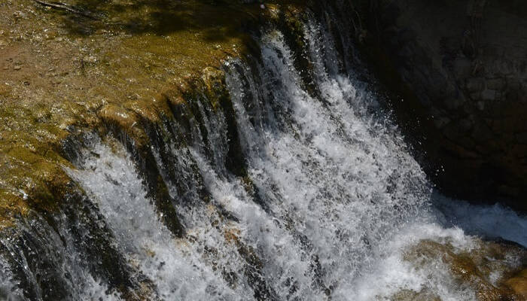

- Corbett Waterfalls: With a mere distance of 25 Kms from Ramnagar, you can easily reach Corbett falls in Uttarakhand for a day trip. The dense teak wood forest adds more to the charm of this place and a melodious chirping of the birds in this region will make you stay for a bit longer. You can either stay overnight and set a camp near these waterfalls or just have a picnic meal with your favourite travel folks. This is surely amongst the most Famous Waterfalls in Uttarakhand that you ought to visit …!!!

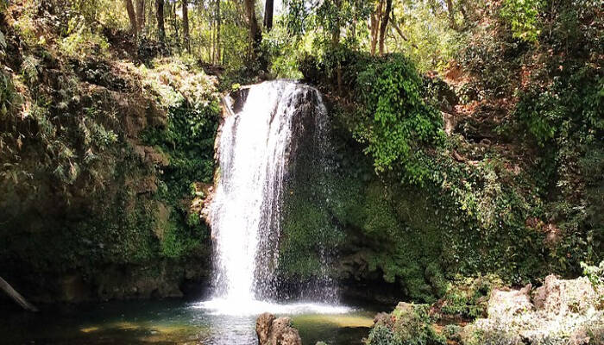

- Vasudhara Waterfalls: With a close proximity to Badrinath, Vasudhara falls make an amazing spot to witness spectacular views around and soak in the tranquility that accompanies this environment. Dropping from a height of 400 Feet and 122 Metres above sea level. Even though it is said that the true beauty of this place can only be admired by those who are guilt free, it is always a good idea to visit waterfalls to revive your senses.

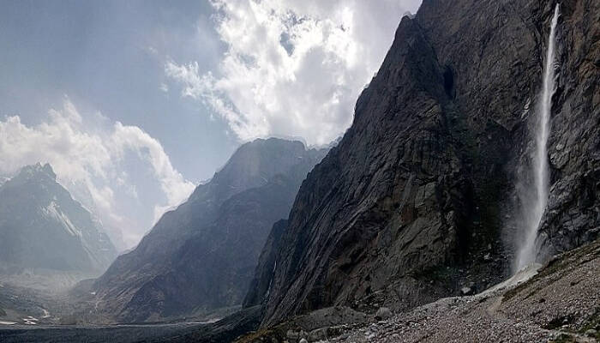

- Neer Garh Waterfalls: You can easily reach Neer Garh waterfall from Rishikesh Railway Station, as it is only at a distance of 9 Km. Amongst the most popular places to visit in Rishikesh, this waterfall is known for having a fun trek abode. If you’re not in the mood to exercise, then surely a dip in the cool waters of this place will be perfect for you. There are also two bridges on this waterfall and the colourful butterflies found here add more beauty to this place.

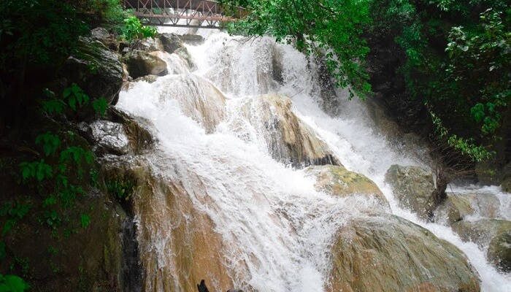

- Birthi Waterfalls: Covering a mere 14 Km distance from Tejam will let you experience the splendid site of Birthi Falls in Pithoragarh district of Uttarakhand. Approximately 400 Feet above sea level, the rolling water splashes on the shore with an unparalleled gorgeous view that is more than enough to make your day. You can even choose to trek to this place and have an exciting outing with your pals (friends) at this site for sure …!!!

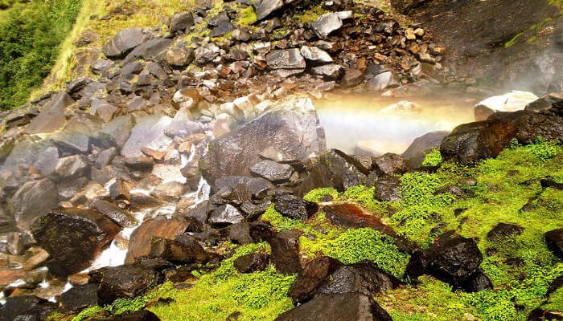

- Tiger Waterfalls: Falling from a height of 50 Metres, the renowned Tiger falls offer a relaxing bath in the pond below. You can easily access this place via a short trek of 1 Km after a drive on Chakrata – Lakhamandal route. An alternative route involving the scenic views of the forests in Chakrata via a 5 Km trek can also lead you to this place. Be careful of the narrow and rough roads that are used to reach this place and they’re only suitable for SUV Cars.

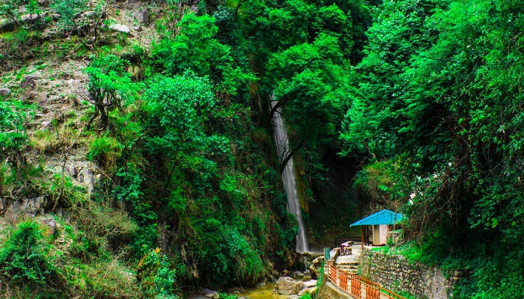

- Sahastradhara Waterfalls: Here as per with numerous caves around, we wouldn’t be surprised if Sahastradhara falls turns out to be your favourite waterfall in Uttarakhand. The sulphur content of this waterfall is said to have medicinal properties, which is why you can see many locals as well as tourists bathing in these falls. The best time to visit this place is the rainy season, when the falls have more water and the relatively greener region in the surrounding add to the charm of this place. You surely cannot miss out on the Best Waterfall in Uttarakhand on your next vacay …!!!

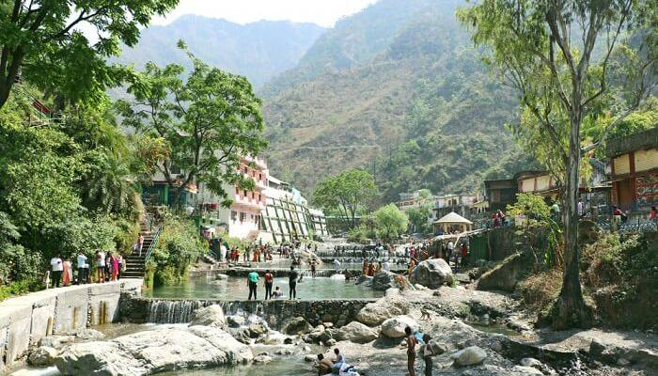

2. BACKGROUND – Scope and Study

The construction of high altitude hilly/ mountainous roads to Indo – China Border road under phase – II in the state of Uttarakhand has been entrusted to Border Road Organisation (BRO) by Ministry of Home Affairs, Department of Border Management, and Government of India. The work is of National importance having strategic in nature from Border security aspect. The consultancy work for Preparation of Detailed Project Report has been awarded to M/s HIGHWAY ENGINEERING Consultant BHOPAL (MP). The Border Road Organisation (BRO) has been entrusted with theassignment of Consultancy Services for preparation of Detailed Project Report of National Highways/ State Roads (approved as National Highway) in many States for up gradation to Two/ Four Lanes with paved shoulder configuration. BRO now invites proposal from Technical Consultants for carrying out detailed project report for proper structuring and implementation of projects on Engineering, Procurement, and Construction (EPC)/ Public Private Partnership (PPP) mode on Kurkuti – Ghamsali – Niti Roadin the North Uttarakhand State. In order to fulfill the traffic needs and road safety requirement, BRO has appointed the M/s HIGHWAY ENGINEERING Consultant BHOPAL (MP) as consultants to Providing Consultancy Services for Preparation of Detailed Project Report of Kurkuti – Ghamsali – Niti Road for Managementand Construction of High Altitude Hill Roads to Indo – China Border Road under Part – 1 in the State of Uttarakhand, Package No.: 00, using Satellite Imagery/ Global Positioning System.

The Ministry of Home Affairs (MHA), Govt. of India has decided to take up the development of High Altitude Hill Roads to Indo – China Border. The Border Road Organisation (BRO) has been entrusted with the construction of High Altitude Hill Roads to Indo – China Border road in the State of Uttarakhand. This project section is from Kurkuti – Ghamsali – Nitiin the State of Uttarakhand and the Total Length of Proposed Road is 17.56 Km. The Coordinates of Project roads at Starting Point, Kurkuti are Latitude of 21.3199° (North) and Longitude of 82.5646° (East). Coordinates at the End Point, Niti are Latitude of 30.7776° (North) and Longitude of 79.8412° (East). Length provide by ITBP for the road is 20.00 Km., whereas the designed length is 17.56 Km.

The project study consists of preparation of the following as shown in Figure 2:

Stage 1 – Inception Report and Quality Assurance Plan;
Stage 2 – Reconnaissance/ Investigation/ Servey Report;
Stage 3 – LA and Clearances I – Report;
Stage 4 – Detailed Project Report (DPR);
Stage 5 – Technical Schedules;
Stage 6 – LA and Clearances II – Report.

.

Figure 2: Detailed Project Description Process (Schematic Diagram OR Flowchart Showing Project Layouts and Concluding Components).

Consultancy Services for preparation of feasibility study and detailed project report of INITIAL ENVIRONMENTAL EXAMINATION (IEE) assessED – controlled… areas like super communication expressway...!!!

Operations and Maintenances

CS/ CC/ Bituminous Road Construction
Clearing Sites/ Places/ Areas
Standards/ Policies/ Essential Environmental Clearances

Road/ Bridge Construction Network/ Activities
Construction of Roads/ Bridges and Pertinent/ Applicable Structures

FINAL PLANS/ DPR
Project Planning’s (Alternative Considerations)
Sanction from BRO and State/ Local/ Regional Government Agencies
Leveling/ Laying Foundation on Coat
Preliminary Engineering Applications
(Preferred Plans/ Locations/ IEE REPORT)
Route Inspection/ Innovations and Inventory
Project Development Concepts/ Baselines

Natural Resources

The state is gifted with abundant natural resources and the resources can be grouped into biotic or a – biotic, both of which can be renewable. Biotic resources include agriculture crops fodder and forests. The entire Himalayan region is endowed with natural flora and fauna, and is a natural paradise for nature lovers, conservationists, botanists, zoologists and environmentalists etc. There are 4,000 species of flowering plants, 300 species of ferns and its allies, 11 species of Oaks, 8 species of tree ferns, and 30 to 40 species of Primulas 20 species of bamboos. In Fauna, the state is also very rich 144 species of mammals and 500 to 600 species of birds, over 400 species of butterflies and moths. Many species of reptiles etc. are available and many medicinal plants/ herbs/ and important shrubs are found in low and high altitude areas. Other resources are water resources, human resources, livestock resources, hydro – electric potential, tourism, agricultural, horticulture etc. In forest, non – wood forest produce has a vast potential like sand, boulders and other materials. Under economic geology the minerals like copper, iron, lime, dolomite/ limestone, coal, quartzite and tale, silicate and graphite are available in the state. Garnet is abundant in the gneiss and mica schist’s at places. Large cardamoms production is very high in the state. The basic information on various natural resources is either not available or if available it is not adequate and up to date. There is a vast potential for hydro – electric power generation and tourism development deserves consideration to add to the economy of the region/ state.

Socio – Economic Profile Index

Uttarakhand was carved out of the State of Uttar Pradesh on 9th November 2000 and was the 27th State of India. It is strategically located at the foothills of the Himalayan Range. Forming the Northern part of the country, it shares its boundary with China, Tibet in the North, Himachal Pradesh in the West and Northwest, Gangetic Plains of Uttar Pradesh in the South and Nepal in the East. The total geographic area 2 of the State is 53,483 Square Kilometers (1.63% of India) with a total population of 1.01 Crore. Dehradun is the capital of the State. The State of Uttarakhand is a rich repository of natural resources with plenty of water resources, glaciers, and dense forests etc. It is endowed with around 175 rare species of aromatic and medicinal plants. Rich in natural resources, the State has almost all major climatic zones, making it suitable for a variety of commercial opportunities in horticulture and floriculture activities. The mainstay of the economy is agriculture as more than 75% of the total population depends on agriculture for their livelihood. Uttarakhand holds immense importance as a religious place and experiences vast inflow of domestic as well as international tourists. “Badrinath, Kedarnath, Gangotri, Yamunotri and Haridwar” attract regular religious tourists, which significantly add to the State economy. The State is divided into two regions i.e., “Garhwal and Kumaon” and comprises 13 Districts out of which four Districts are in the plains and the other nine are in the hills. The Figure 3 Showing Index Map of Projected Road.

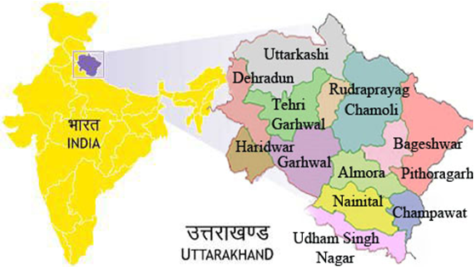

Figure 3: Index Map Showing Projected Road.

Uttarakhand Demographic Index

Uttarakhand is a Multi – Ethnic State and broadly, the population can be divided into tribal and non – tribal groups. The Uttarakhand State is facing the problem of quick translation of rainfall to surface runoff because of slope and faces the problems of landslides. Thus to cope up with these issues, an organized calculation of probability distribution to understand and selection of the best – fit probability distribution on an annual series of rainfall data for a period of 1991 – 2002 of 13 districts of Uttarakhand was made. The choice of best probability distribution could also be used to influence decisions relating to local economics and hydrologic safety systems. Further to this seasonal rainfall distribution, it reveals that the area receives about 82% of the total annual rainfall during the monsoon season, 10% during the post – monsoon season, and 8% during the pre – monsoon season. This preliminary result will help the water resource planner in hydrological modeling and the policy maker to frame general guidelines for the best use of rainfall for Uttarakhand.

Uttarakhand State is mainly known for two different mountainous regions, namely Kumaon and Garhwal. Most of the parts of the state are under forest cover and main rivers like Ganga and Yamuna originate from this state. All 13 districts of the state were selected for this study, which includes Almora, Bageshwar, Chamoli, Champawat, Dehradun, Haridwar, Nainital, Pauri, Pithoragarh, Rudraprayag, Tehri, Udham Singh Nagar and Uttarkashi. They are dominant ethnic group in the state and the people from the plain mostly involved in trade and services represent a marginal group. The Digital Terrain Model (DTM)/ DEM Generation of Geo – Tiff – Format of Projected Road, Vetting/ Geology and Slope Stability by Environmental Team Experts is as shown in the Figure 4. As per the 1991 census of India, the total population of the state is 4, 06,457, whereas in 1981 it was 3, 16,385 only. Decennial growth has come down, as in 1971 to 81 and it was 50.77% whereas for the years 1981 to 91 and it was found 28.47% only. The overall density of population in the Uttarakhand State is 83,743 Km². East district is the most populated where as North's density only 7, is least populated. Sex ratio (females per thousand male) in 1981 was 835, where as it has improved and now is 878. There are only eight urban towns and urban population is 9.10% of total population. Schedule caste and schedule tribe population is 5.93% and 22.36% respectively, North district is a tribal district and it has about 55.38% tribal population. Literacy rate is 56.94% (19th position), higher than the all India average literacy rateare of 52.11%. Figure 4: The Tentative Prototype – Paradigm – Digital Sample/ Example of Terrain Model (DTM)/ DEM Generation of Geo – Tiff – Format of Kurkuti – Ghamsali – Niti (17.56 Km) Projected New Road at Kurkuti Latitude of 29.9831° (North) and Longitude of 78.5278° (East); Niti Latitude of 30.7776° (North) and Longitude of 79.8412° (East). Vetting/ Geology and Slope Stability are observed by Environmental Team Experts. (Part – I)

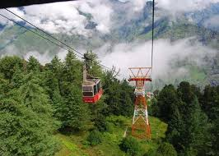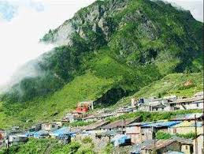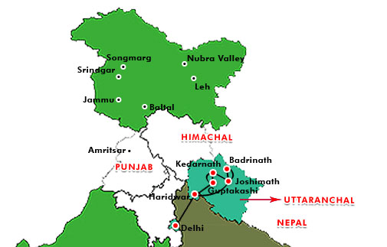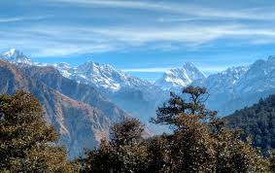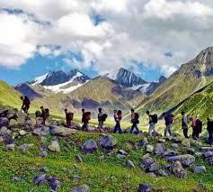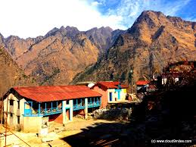
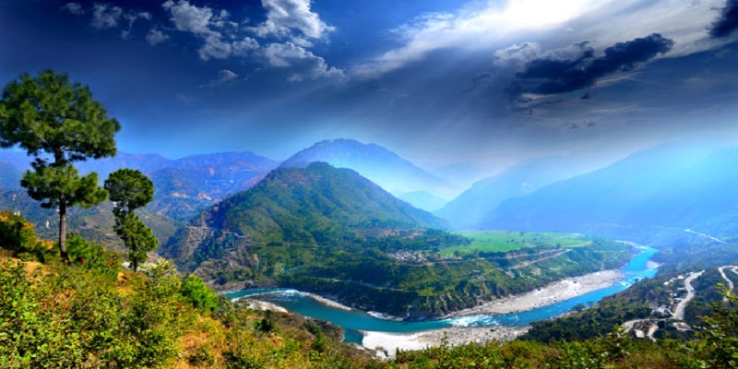
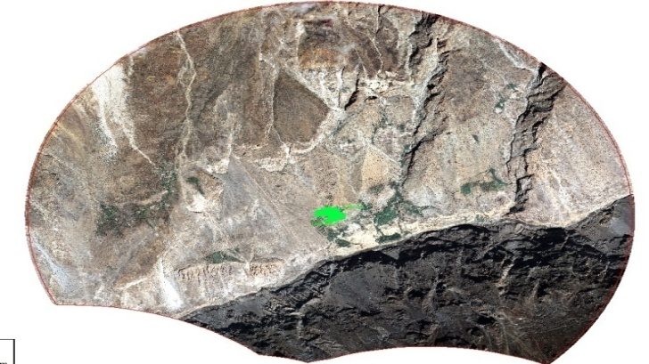 | 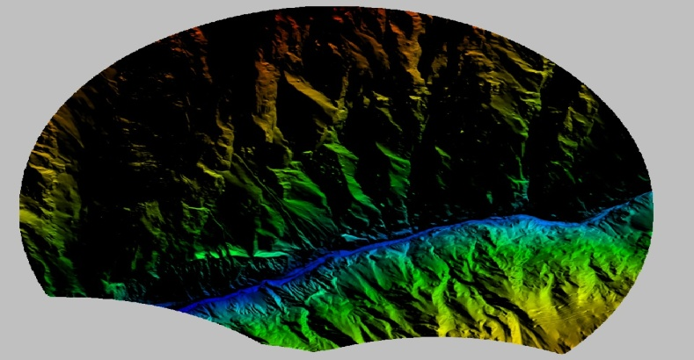
Kurkuti – Ghamsali – Niti Road,  Village (UK) Area – 37.625 Sq. Km. Overview of the 50 cm GSD Ortho – photo. | The 5 m Grid DEM a Relief View (An Overview for the Whole Area of Interest).
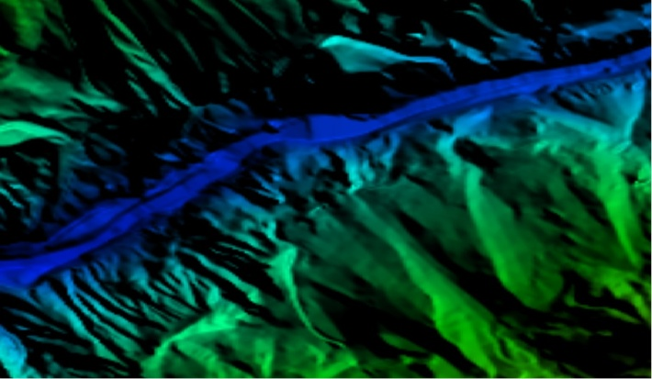 | 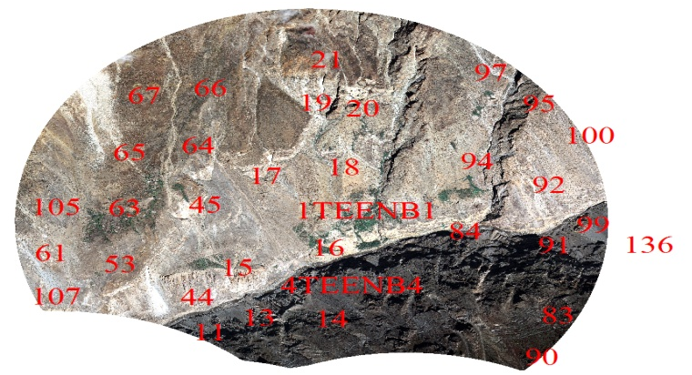
The DEM in Relief View for a Part of a River. | The Plan 3D Features Over the Ortho – photo an Overview.
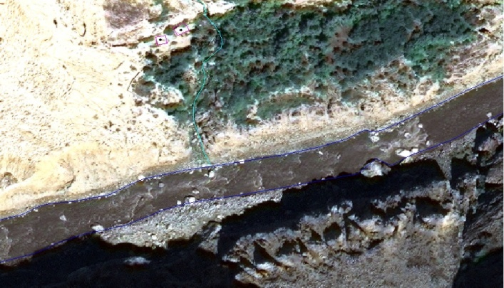 | 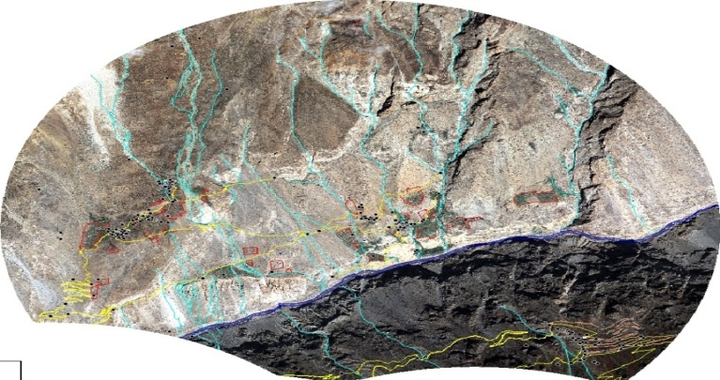
The Plan 3D Features – Part of a River; Roads and Buildings Plan Over the Ortho – photo. | Differences at Ground Scale between Measured and Adjusted Tie Photogrammetric Points.
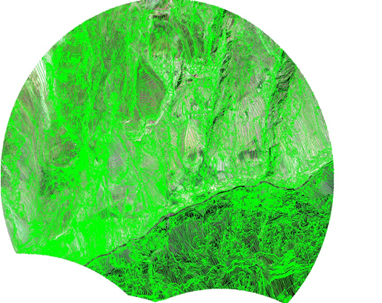
Compilation of Break Lines (A Line Portrays the Sudden Changes in the Elevation) and Mass Points Using Stereo Images.
State:  Name:  Total Length of the Road as per Remote Sensing:  Total Sq. Km. Area as per 5 Km Buffer Boundary: | Uttarakhand State  Kurkuti – Ghamsali – Niti, Road (UK)^{Package– I}  17.565 Km  37.625 Sq. Km.

Figure 4: The Tentative Prototype – Paradigm – Digital Sample/ Example of Digital Terrain Model (DTM)/ DEM Generation of Geo – Tiff – Format of Kurkuti to Ghamsali to Niti Road, Village (17.565 Km) Projected New Road at Kurkuti Latitude of 30.7116° (North) and Longitude of 79.8381° (East); Niti Latitude of 30.7776° (North) and Longitude of 79.8412° (East). Vetting/ Geology and Slope Stability are observed by IIT Delhi/ Roorkee Team Experts. (Package – I)
Climatic Projection Index

The Climate of Uttarakhand is sharply demarcated in case of its two distinct divisions: the predominant hilly terrain and the smaller plain region. The most favorable time to visit Uttarakhand happens to be in the course of the summers when the weather is very clement and mild. Certain areas of the hills even become inaccessible in winter due to extremities of climate causing prolonged snowfall. The plain region seems to be at its best in terms of climate in winter, when the weather is pleasant. The type of climate that is mainly to be found in the plains closely resembles the corresponding state in the Gangetic plain. Summers are exceedingly hot with temperatures crossing the 40°C mark and considerable humidity. Winters can be chilly with temperatures going below 5°C at times. The climate in the Northern part of Uttarakhand is typically Himalayan. This mountain range itself exerts an appreciable extent of influence on monsoon and rainfall patterns. Within the Himalayas, climate differs depending on altitude and position. Climate ranges from subtropical in the Southern foothills, averaging summer temperatures of about 30°C (about 86°F) and winter temperatures of about 18°C (about 64°F). Warm temperate conditions prevail in the Middle Himalayan valleys, with summer temperatures usually hovering about the mark of 25°C (about 77°F) and cooler winters.

Cool temperate conditions dominate the higher areas of the Middle Himalayas, where the summer temperatures are usually around 15°C to 18°C (59°F to 64°F) and winters drop below the freezing point. You will encounter a cold alpine climate at higher reaches where summers are cool and winters are harsh. At altitudes over 4,880 Meters (16,000 Feet), the climate is bitterly cold with temperatures consistently below the freezing point and the area perennially shrouded in snow and ice. The Eastern flanks of the Himalayan ranges are subject to heavy rainfall while the Western section is relatively dry. Uttarakhand is characterized by two types of climate, sharply differentiated in the plains and the mountainous regions. The climate of the Uttarakhand State has been roughly divided into the tropical, temperature and alpine zones. For most of the period in a year, the climate is cold and humid as rainfall occurs in each month. The area experiences a heavy rainfall due to its proximity to the Bay of Bengal. The rainfall in North district is comparatively less than of the other districts. The general trend of decrease in temperature with increase in altitude holds good everywhere. Pre – monsoon rain occurs in April – May and monsoon (South – West) operates normally from the month of May and continues up to early October.

Temperature Profile Index

The mean temperature in the lower altitudinal zone, it varies from 1.5°C to 9.5°C. Temperature varies with altitude and slope. The maximum temperature is recorded usually during July and August and minimum during December and January. Fog is a common feature in the entire state from May to September. Biting cold is experienced at high altitude places in the winter months and snowfall is also not uncommon during this period.

The average temperature for the year in Uttarakhand is 23.5°C or 74.3°F. The warmest month, on average, is June with an average temperature of 31.1°C or 88.0°F. The coolest month on average is January, with an average temperature of 13.3°C or 55.9°F. The average amount of precipitation for the year in Uttarakhand is 1,132.5 milli Metres or 44.59 inches. The month with the most precipitation on average is August with 330.3 milli Metres or 13.00 inches of precipitation. The month with the least precipitation on average is November with an average of 4.8 milli Metres or 0.19 inches. There is an average of 46.8 days of precipitation, with the most precipitation occurring in August with 11.9 days and the least precipitation occurring in November with 0.6 days (Table 3).

Table 3: Average Temperature for the Year in Uttarakhand.

Climate Data for Uttarakhand
Month | Jan | Feb | Mar | Apr | May | Jun | Jul | Aug | Sep | Oct | Nov | Dec | Year
Average High °C (°F) | 11.0  (51.8) | 14.8  (58.6) | 19.7  (67.5) | 25.9  (78.6) | 24.5  (76.1) | 28.0  (82.4) | 25.9  (78.6) | 25.4  (77.7) | 23.2  (73.8) | 19.1  (66.4) | 15.9  (60.6) | 13.5  (56.3) | 20.6  (69.0)
Daily Mean °C (°F) | 13.3  (55.9) | 15.9  (60.6) | 21.1  (70.0) | 27.1  (80.8) | 30.6  (87.1) | 31.1  (88.0) | 28.7  (83.7) | 28.4  (83.1) | 27.5  (81.5) | 24.5  (76.1) | 19.4  (66.9) | 14.7  (58.5) | 16.4  (61.5)
Average Low °C (°F) | 2.6  (36.7) | 4.9  (40.8) | 9.5  (49.1) | 13.3  (55.9) | 17.0  (62.6) | 20.2  (68.4) | 18.7  (65.7) | 16.5  (61.7) | 13.9  (57.0) | 11.9  (53.4) | 7.0  (44.6) | 3.7  (38.7) | 11.6  (52.9)
Average Precipitation mm (inches) | 26.6  (1.05) | 26.1  (1.03) | 21.3  (0.84) | 15.2  (0.60) | 31.9  (1.26) | 140.9  (5.55) | 318.4  (12.54) | 330.3  (13.00) | 172.2  (6.78) | 34.4  (1.35) | 4.6  (0.18) | 10.6  (0.42) | 1,132.5  (44.6)
Average Precipitation Days | 2.1 | 2.0 | 1.9 | 1.3 | 1.9 | 4.9 | 11.3 | 11.9 | 6.2 | 1.8 | 0.6 | 1.0 | 46.8
Average Snowy Days | 6.3 | 3.8 | 0.1 | 0.0 | 0.0 | 0.0 | 0.0 | 0.0 | 0.0 | 0.0 | 0.7 | 4.4 | 15.2
Mean Daily Sunshine Hours | 10.9 | 11.6 | 12.4 | 13.3 | 14.1 | 14.5 | 14.3 | 13.6 | 12.7 | 11.8 | 11.1 | 10.7 | 12.6
Source: India Meteorological Department Weather Base.

Humidity Index

Basic Information: Meteorological Data at 03, 06, 09 and 12 Universal Time Coordinated (UTC) and also upper air data through pilot balloon observation manually at 01/ 02 and 11/ 12 UTC daily. Thermometers namely Maximum, Minimum, Dry Bulb and Wet Bulb thermometers are kept inside a Singles Stevenson Screen (Dry Bulb gives the air temperature at an instant and Relative Humidity and Dew Point Temperature of air is determined from the Hygrometric Table corresponding to the Dry Bulb and Wet Bulb temperatures at the instant). The Self – Recording Instruments Namely Thermograph to record air temperature and Hygrograph to record Relative Humidity of air on daily basis are kept in Double Stevenson Screen. Ordinary Rain Gauge to record daily total rainfall and the Self – Recoding Rain Gauge are installed inside the observatory, besides Open Pan Evapori – Meters to record the evaporation of air. Charts for all the Self – Recording Instruments are changed at 0820 Hrs 1st daily. The Wind Instruments Namely Wind Vane to record the direction of air, Anemometers to record the wind speed and Sunshine Recorder are installed on the Pilot Balloon Observation Tower. From this tower, Upper Air Circulation over Uttarakhand of Kurkuti – Ghamsali – Niti Road is observed manually from instrument known as Optical Theodo – lite. Upper Data are analyzed digitally through Hand Held Data Logger. Both the Kew Pattern (K. P.) Barometers and Self – Recording Barograph installed in the Observatory Office records the Atmospheric Pressure at any instant.

Rainfall Index

Heavy rains lashed many parts of Uttarakhand, especially those in Kumaon region, with Khatima in Udham Singh Nagar district receiving the maximum of 222 mm of showers. Kichcha, another town in Udham Singh Nagar district, received 135 mm of rainfall followed by Kalsi in Dehradun district which received 129 mm and Raiwala which recorded 115 mm of rainfall. Banbasa in Champawat district recorded 79 mm rainfall, the Disaster Management office in Dehradun said. The Kali and Gori rivers in Pithoragarh district were in spate, is flowing just a few metres below the danger level at 888.70 Metres and 604.55 Metres respectively. The Ganga was flowing at 291.20 Metres, around three Metres beneath the danger mark. The Met department has forecast similar weather till July 15th with heavy rain likely in “Nainital, Champawat, Udham Singh Nagar, Pithoragarh, Chamoli, Tehri, Pauri, Dehradun and Haridwar”. The weatherman attributed it to the presence of a trough extending from Punjab to South Assam in lower levels across Haryana, Uttar Pradesh and center of low pressure area over East Uttar Pradesh and strengthening of South Westerly flow from Arabian Sea in lower levels which it said would enhance the moisture incursion over Uttarakhand. The minimum temperature in Dehradun was 24.1 degrees Celsius, the Met department said, adding the maximum was likely to hover around 29°C.

In Haridwār, the average annual temperature is 23.6°C. The average annual rainfall is 1,285 mm. The averages maximum annual rainfall of 2426.77 mm occurred in Champawat, whereas the lowest average annual rainfall 406.70 mm occurred in Haridwar.

Wind Pattern Index

The wind intensity is not high except when accompanied by Pre – monsoon thunderstorms. However, in the afternoon they are comparatively more severe. Their direction is generally South Easterly in the mornings and sometimes changes to North Westerly in the evenings.

Extra Widening/ Improvement Index

- The Project road is proposed as two lanes with shoulder, drain, and extra widening (7.0 m + 2 × 0.9 m + 0.6 m + 0.6 m) as shown in the Table 4.

Table 4: Extra Widening/ Improvement and Land Acquisition Index.

Sr. No. | Feature | Description
1. | Extra Widening/ Land Acquisition  (7.0 m + 2 × 0.9 m + 0.6 m + 0.6 m) | 24 m Wide Strip of Land is Required

The aim of reconnaissance survey was to assess the scope of land acquisition and resettlement study and accordingly the detailed plan of action was prepared for the preparation of land acquisition planning and resettlement plan. The transparent process for land acquisition for industrialization, development of essential infrastructural facilities and urbanization with the least disturbance to the owners of the land and other affected families and provide just fair compensation to the affected families whose land has been acquired or proposed to be acquired or are affected by such acquisition and make adequate provisions for such affected persons for their rehabilitation and resettlement and for ensuring that the cumulative outcome of compulsory acquisition should be that affected persons become partners in development leading to an improvement in their post acquisition social and economic status and for matters connected therewith or incidental thereto.

Methodology for Social Impact Assessment

Project Road if traverses through hilly/ mountainous and steepas well as plain terrain. The proposed alignment improvement design is based on various parameters. The design principles for alignment selection have been evolved based on discussions with the expertise in Highway Engineers, Bridge Design Specialists, Environmentalist, Transport and other key personnel. The selection of the alignment is broadly based on the following criteria:

- Technical soundness and economic viability;
- Least social and environmental adverse impact;
- Least displacements and loss of public property;
- Avoiding adverse impact to water bodies and other environmental features;
- Locations of required causeways;

3. PROJECT DESCRIPTION AND ALIGNMENT

Projected Road Description: The Project Section of Kurkuti – Ghamsali – Niti, Road is located in the district of Chamoli, which in turn is located in the State of Uttarakhand length as per topography survey is 18.53 Km and as per design is 17.56 Km. The alignment of the project road is connecting Kurkuti, Farkiya, Bampa, Kurkuti and Niti. The project road Kurkuti – Ghamsali – Niti having length of 17.56 Km and the project stretch is traversing in hilly terrain from Kurkutiat (21.3199° N Latitude and 82.5646° E Longitudes) and Ends at Niti Village (30.7776° N Latitude and 79.8412° E Longitudes) in the State of Uttarakhand. The RL difference between two locations is 203 m. The Proposed designed alignment/ corridor between these stations comes out to be from 00+000 Km to 18+530 Km.

Start/ End Points, Terrain and Land Form

The roads are Kurkuti – Ghamsali – Niti in the state of Uttarakhand. The starting point of the Project road is Kurkuti and Ends at Niti. The Place Kurkuti is spread in valley which is surrounded by high hills on East and West side. It is situated in District Mehargoan Valley.

Niti: This is the last point of project stretch and is spread on a wide flat ground (plateau) surrounded by high hills. It is 20.0 Km from Niti and since the place is on a high altitude, it is experienced that the oxygen level is low. There is no existing road except foot track from Kurkuti towards Niti for most of the length except some isolated sections where the conditions are badly damaged. The remaining portion of the project stretch is traversing in hilly terrain starting at Niti and Ends at Niti. This stretch is for an approximate length of 17.56 Km and the place Kurkuti is spread in valley which is surrounded by high hills on East and West side. It is situated in District Mehargoan Valley and the project road is passing through in hilly terrain throughout the stretch.

Shoulder and Road Width

The reconnaissance and alignment of project road survey, no boundary stones were found. Further, it was confirmed that land for the proposed alignment is yet to be acquired depending upon the design of the alignment, hence no existing ROW. Kurkuti – Ghamsali – Niti, starts from Kurkuti and terminates at Niti. The actual design length of the proposed alignment is 17.56 Km. On the project road (Kurkuti – Ghamsali – Niti), as it is entirely new alignment and there is only a foot track, there is no traffic plying on this section comprises Single lane (3.75 wide for entire length), with 1.25 m wide shoulders on either side and the terrain is mountainous and has steep gradients. The proposed alignment is a link for Kurkuti – Ghamsali – Niti. The pattern on both side of road is barren land. The details of land use pattern along the project road are (Figure 5):

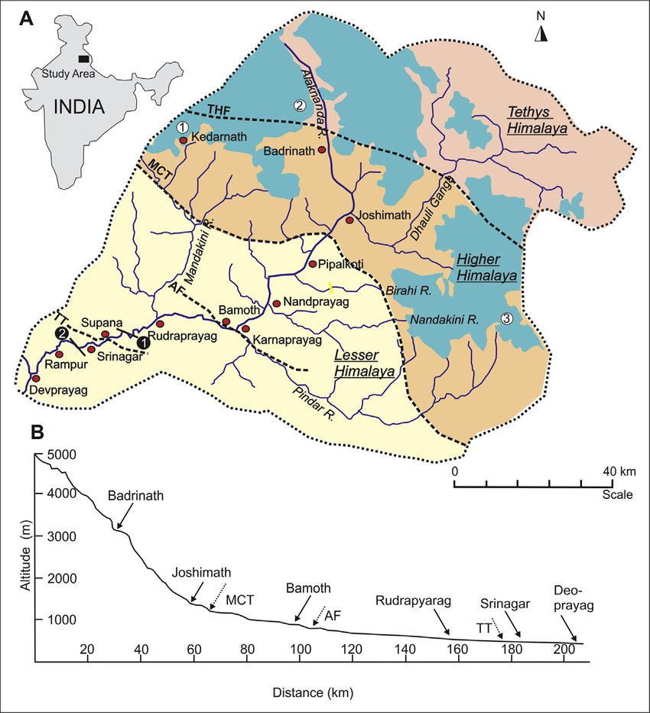

Figure 5: Project Alignment of Kurkuti – Ghamsali – Niti Road.

Traffic Survey Overview: Traffic surveyors comprehend the gratitude of existing traffic and travel distinctiveness is immensely important to boost wide – ranging traffic and transportation plan. With tremendous years of knowledge in survey services viz. Traffic survey, Pedestrian Count, Vehicle Parking, Origin – Destination Survey and Connected Services, Traffic surveyors brings a wealth of acquaintance/ knowledge and practice to any proposed projects. The proposed alignment is a link between Kurkuti – Ghamsali – Niti in the state of Uttarakhand and the total length of the proposed alignment is 17.56 Km. As the entire proposed alignment is a new alignment, there is no traffic survey have been conducted on the same study report.

Road Description: The project road Kurkuti – Ghamsali – Niti is having length of 17.56 Km. The project stretch is traversing in hilly terrain from Kurkuti (3139 m or 10298.56 Feet in Height) and ends at Niti (5,070 m or 16633.86 Feet in Height). The Reduced Level (RL) difference between two locations is 5,632 m (18,478 Feet). The Proposed designed alignment between these station comes out to be 17.56 Km. (As shown above in yellow colour) given in Figure 3. The Projected Corridor Kurkuti – Ghamsali – Niti, Road in North Uttarakhand is a newly declared under Part: 1, connecting link NH/ SH in the Uttarakhand State.

Ghamsali (घमसाली) Overview

It is an ancient village of Uttrakhand State of India, which is famous for its natural pure water which comes from inside of Earth. It is said that one who drink it, all the health problems such as BP, Hypertension, cancer, bone problems etc. are removed just because of its natural source. A forever pure water river is also there which just 30 Meters away from village is and anybody can take free swimming enjoyment over there.

About Ghamsali (घमसाली)

Ghamsali is a small Village/ Hamlet in Dwarikhal Block in Pauri Garhwal District of Uttarakhand State, India. It comes under Ghamsali Panchayath and it is located 70 Km towards South from District head quarters of Pauri. About 135 Km from State capital Dehradun Kurkuti having Pin Code is 246 173 and postal head office is Silogi. Ghamsali is surrounded by Kaljikhal Block towards North, Nainidanda Block towards East, Rikhnikhal Block towards North, and Sult Block towards East. Ramnagar, Jaspur, Kotdwara, Sherkot are the nearby Cities to Ghamsali Village.

Ghamsali 2011 Census Details

Ghamsali Local Language is Hindi and Ghamsali Village Total population is 110 and number of houses are 38. Female Population is 67.3% and Village literacy rate is 66.4% and the Female Literacy rate is 40.0% (Table 5).

Table 5: Ghamsali Village Population and Literacy Rate.

Census Parameters (Particulars) | Census Data
Total Number of Houses | 38
Total Population | 110
Female Population Rate %age | 67.3% (74)
Total Literacy Rate %age | 66.4% (73)
Female Literacy Rate %age | 40.0% (44)
Child (0 – 6)Population by 2011 | 12
Working Population Rate %age | 40.9%
Schedule Caste Population%age | 6.4% (7)
Schedule Tribe Population%age | 0.0% (0)
Girl Child (0 – 6) Population % by 2011 | 58.3% (7)

Kurkuti (कुर्कुटई)

Kurkuti, Uttarakhand is close to Margaon and North of Kosa Reserved Forest and Kurkuti has an elevation of 3,139 Metres. As per Uttaranchal Village Information the area Rewal Chak Kurkuti (रेवाल चक कुर्कुटई) is located in the Joshimath tehsil of Chamoli district (Table 6 and Figure 6).

Table 6: Demographics of Rewal Chak Kurkuti Village with Population and Literacy Rate.

Census Parameters (Particulars) |  | Detail Remarks
Town/ Village Name | : | Rewal Chak Kurkuti
District | : | Chamoli
Tehsil | : | Joshimath
Number of Households | : | 8
Total Population | : | 23
Population – Male | : | 9
Population – Female | : | 14
Sex Ratio | : | 1,556 (Females per 1,000 Males)
Literacy Rate | : | 78.26%
Male Literacy Rate | : | 100%
Female Literacy Rate | : | 64.28%

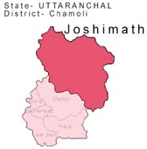

Figure 6: Demographic Map of Rewal Chak Kurkuti Village.

Niti (नीति) Overview

Niti is a Village in Joshimath Block in Chamoli District of Uttarakhand State, India. It is located 30 Km towards East from District head quarters Chamoli Gopeshwar and approximately 173 Km from State capital Dehradun. Niti Pin Code is 246 443 and postal head office is Vishnupuram. Niti is surrounded by Dasholi Block towards West, Gopeshwar Block towards West, Ghat Block towards South, Pokhari Block towards West and Pauri, Almora, Tehri, Chamba are the nearby Cities to Niti.

Niti 2011 Census Details

Niti Local Language is Hindi and Niti Village Total population is 47 and number of houses are 29. Female Population is 53.2% and Village literacy rate is 78.7% and the Female Literacy rate is 34.0% (Table 7).

Table 7: Niti Village Population and Literacy Rate.

Census Parameters (Particulars) | Census Data
Total Number of Houses | 29
Total Population | 47
Female Population Rate %age | 53.2% (25)
Total Literacy Rate %age | 78.7% (37)
Female Literacy Rate %age | 34.0% (16)
Child (0 – 6)Population by 2011 | 01
Working Population Rate %age | 95.7%
Schedule Caste Population%age | 0.0% (0)
Schedule Tribe Population%age | 97.9% (46)
Girl Child (0 – 6) Population % by 2011 | 0.0% (0)

Joshimath (जोशीमठ) Tehsil Population

Joshimath Tehsil in Chamoli District and Uttarakhand State Total population is 48,202. Rural Population is 29,055 and Urban Population is 19,147. Joshimath, also known as Jyotirmath is a city and a municipal board in Chamoli District in the Indian state of Uttarakhand. Located at a height of 6,150 Feet (1,875 m), it is gateway to several Himalayan mountain climbing expeditions, trekking trails and pilgrim centers like Badrinath. Valley of Flowers is a fairy – land situated high in the Himalayas of the Uttaranchal, at an altitude of 3,600 Meters above sea – level, protected by snowy mountains (Table 8).

Table 8: Joshimath Tehsil Population Rate.

Category | Population | Male | Female
Rural | 29,055 | 15,786 | 13,269
Urban | 19,147 | 12,042 | 7,105
Total | 48,202 | 27,828 | 20,374

About Joshimath Tehsil

Located in the Indian state of Uttarakhand, the Jyotirmath – Malari Road is an asphalted high mountain road within the Nanda Devi National Park. The road is 64.6 Km and extremely steep. It links Jyotirmath (also known as Joshimath), a city at an elevation of 1.934 m above the sea level, and Malari, a small village near the Tibet border at 3.033 m above the sea level. Take special care with rare snow leopards and bears. The road includes countless hairpin turns along the Dhauliganga River. This cliff road is swept away by the winter snow and ice or by flooding of the river waters periodically.

Joshimath is a Tehsil in Chamoli District of Uttarakhand State, India and Joshimath Tehsil Head Quarters is Joshimath town. It is located 32 Km towards East from District head quarters Chamoli Gopeshwar. Around 174 Km from State capital Dehradun towards West and Joshimath Tehsil is bounded by by Gopeshwar Tehsil towards West, Ghat Tehsil towards South, Pokhari Tehsil towards West, Ukhimath Tehsil towards West. Pauri City, Tehri City, Almora City, Chamba City are the nearby Cities to Joshimath.
Joshimath (Joshimath), Auli (Bugyal), Govindghat, Hemkund Sahib (Hemkunt Sahib), Badrinath are the nearby important tourist destinations to see.

Geography of Uttarakhand

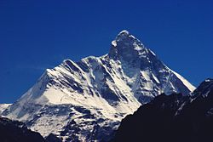

With the elevation of 7,816 Metres (25,643 Feet) above sea level, Nanda Devi is the highest mountain in Uttarakhand and the second – highest mountain in India, following Kangchenjunga in Sikkim.Uttarakhand has a total area of 53,483 Km², of which 86% is mountainous and 65% is covered by forest. Most of the Northern part of the state is covered by high Himalayan peaks and glaciers. In the first half of the nineteenth century, the expanding development of Indian roads, railways and other physical infrastructure was giving rise to concerns over indiscriminate logging, particularly in the Himalaya. Two of the most important rivers in Hinduism originate in the glaciers of Uttarakhand, the Ganges at Gangotri and the Yamuna at Yamunotri. They are fed by myriad lakes, glacial melts and streams. These two along with “Badrinath and Kedarnath” form the “Chota Char Dham”, a “Holy Pilgrimage” for the “Hindus”.

The state hosts the Bengal tiger in Jim Corbett National Park, the oldest national park of the Indian subcontinent. The “Valley of Flowers”, a “UNESCO World Heritage Site” located in the upper expanses of Bhyundar Ganga near Joshimath in Gharwal region, is known for the variety and rarity of its “Flowers and Plants”. One who raised this was Sir Joseph Dalton Hooker, Director of the Royal Botanic Gardens, Kew, who visited the region. As a consequence, Lord Dalhousie issued the Indian Forest Charter in 1855, reversing the previous laissez – faire policy. The following “Indian Forest Act” (IFA) of 1878 put Indian forestry on a solid scientific basis. A direct consequence was the founding of the Imperial Forest School at Dehradun by Dietrich Brandis in 1878. Renamed the “Imperial Forest Research Institute” in 1906, it is now known as the “Forest Research Institute” (FRI). The model “Forest Circles” (FC) around Dehradun, used for training, demonstration and scientific measurements, had a lasting positive influence on the forests and ecology of the region. The Himalayan ecosystem provides habitat for many animals (including bharal, snow leopards, leopards and tigers) plants, and rare herbs.

Uttarakhand lies on the Southern slope of the Himalaya range, and the climate and vegetation vary greatly with elevation, from glaciers at the highest elevations to subtropical forests at the lower elevations. The highest elevations are covered by ice and bare rock. Below them, between 3,000 and 5,000 Metres (9,800 Feet and 16,400 Feet) are the Western Himalayan Alpine Shrub and Meadows. The temperate “Western Himalayan Subalpine Conifer Forests” grow just below the tree line. At 3,000 to 2,600 Metres (9,800 to 8,500 Feet) elevation the transition to the temperate Western Himalayan Broadleaf Forests, which lie in a belt from 2,600 to 1,500 Metres (8,500 to 4,900 Feet) elevation? Below 1,500 Metres (4,900 Feet) elevation laid the Himalayan Subtropical Pine Forests. The “Upper Gangetic Plains Moist Deciduous Forests” and the “Drier Terai – Duar Savanna and Grasslands” cover the lowlands along the Uttar Pradesh border in a belt locally known as “Bhabar”. These lowland forests have mostly been cleared for agriculture, but a few pockets remain. In June 2013 several days of extremely heavy rain caused devastating floods in the region, resulting in more than 5,000 people missing and presumed dead. The flooding was referred to in the Indian media as a “Himalayan Tsunami”.

Subdivisions: Administrative Divisions of Uttarakhand

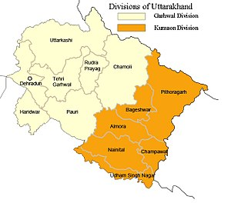

Divisions and Districts of Uttarakhand

There are 13 Districts in Uttarakhand, which are grouped into two divisions, Kumaon and Garhwal. Four new districts named Didihat, Kotdwar Ranikhet, and Yamunotri were declared by then Chief Minister of Uttarakhand, Ramesh Pokhriyal, on 15th August 2011, but yet to be officially formed (Table 9).

Table 9: Divisions and Districts in Uttarakhand (Uttaranchal).

Divisions | Districts/ Regions/ Areas
Kumaon Division | Almora, Bageshwar, Champawat, Nainital, Pithoragarh, and Udham Singh Nagar.
Garhwal Division | Chamoli, Dehradun, Haridwar, Pauri Garhwal (Commonly Known as Pauri), Rudraprayag, Tehri Garhwal (Commonly Known as Tehri), Uttarkashi.

Each district is governed by a district magistrate. The districts are further divided into sub – division, which is governed by sub – divisional magistrates; sub – divisions comprise blocks containing panchayats (village councils) and town municipalities. According to the 2011 census, Haridwar, Dehradun, and Udham Singh Nagar are the most populous districts, each of them having a population of over one million.

Culture Symmbols; Architecture and Crafts (Monuments of National Importance and State Protected Monuments in Uttarakhand)

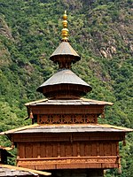

Mahasu Devta Temple at Hanol is notable for its traditional wooden architecture.

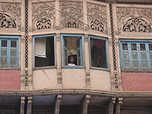

Architectural details of a Dharamshala, Established in 1822, Haridwar.

Abhisarika Nayika, a Painting by Mola Ram.

Among the prominent local crafts is wood carving, which appears most frequently in the ornately decorated temples of Uttarakhand. Intricately carved designs of floral patterns, deities, and geometrical motifs also decorate the doors, windows, ceilings, and walls of village houses. Paintings and murals are used to decorate both homes and temples. Pahari painting is a form of painting that flourished in the region between the 17th and 19th century. Mola Ram started the Garhwal Branch of the Kangra School of painting. Guler State was known as the “Cradle of Kangra Paintings”. Kumaoni art often is geometrical in nature, while Garhwali art is known for its closeness to nature. Other crafts of Uttarakhand include handcrafted gold jewellery, basketry from Garhwal, woollen shawls, scarves, and rugs. The latter are mainly produced by the Bhotiyas of Northern Uttarakhand.

Arts and Literature (Dehradun Literature Festival)

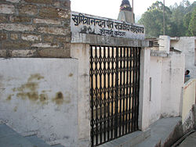

Sumitranandan Pant Museum, Kausani (Uttarakhand).

Uttarakhand's diverse ethnicities have created a rich literary tradition in languages including Hindi, Garhwali, Kumaoni, Jaunsari, and Bhoti. Many of its traditional tales originated in the form of lyrical ballads and chanted by itinerant singers and are now considered classics of Hindi literature. Abodh Bandhu Bahuguna, Badri Datt Pandey, Ganga Prasad Vimal, Harikrishna Raturi, Mohan Upreti, Naima Khan Upreti, Prasoon Joshi, Shailesh Matiyani, Shekhar Joshi, Shivani, Shiv Prasad Dabral “Charan”, Taradutt Gairola, Tom Alter; Lalit Kala Akademi fellow – Ranbir Singh Bisht; Sangeet Natak Akademi Awardees – B. M. Shah, Narendra Singh Negi, Prem Matiyani and Urmil Kumar Thapliyal; Sahitya Akademi Awardees – Leeladhar Jagudi, Manglesh Dabral, Manohar Shyam Joshi, Ramesh Chandra Shah, Ruskin Bond and Viren Dangwal; Jnanpith Awardee and Sahitya Akademi fellow “Sumitranandan Pant” are some major literary, artistic and theatre personalities from the state. “Prominent philosophers, Indian independence activists and environmental activists Gaura Devi, Govind Ballabh Pant, Chandi Prasad Bhatt, Kalu Singh Mahara, Mukandi Lal, Shri Dev Suman, Sunderlal Bahuguna and Vandana Shiva are also from Uttarakhand”.

Flora and Fauna

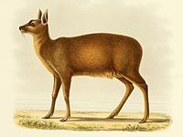

Alpine Musk Deer (Moschus chrysogaster).

Himalayan Monal (Lophophorus impejanus).

West Himalayan Common Peacock (Papilio bianor polyctor).

Uttarakhand has a diversity of flora and fauna. It has a recorded forest area of 34,666 Km² which constitutes 65% of the total area of the state. Uttarakhand is home to rare species of plants and animals, many of which are protected by sanctuaries and reserves. National parks in Uttarakhand include the “Jim Corbett National Park” (the oldest national park of India) in Nainital and Pauri Garhwal District, and “Valley of Flowers National Park” and “Nanda Devi National Park” in Chamoli District, which together are a “UNESCO World Heritage Site”. A number of plant species in the valley are internationally threatened, including several that have not been recorded from elsewhere in Uttarakhand. “Rajaji National Park” in “Haridwar and Dehradun Distric” and “Govind Pashu Vihar National Park” and “Gangotri National Park” in “Uttarkashi District” are some other protected areas in the State.

Leopards are found in areas, which are abundant in hills but may also venture into the low land jungles. Smaller felines include the jungle cat, fishing cat, and leopard cat. Other mammals include four kinds of deer (barking, sambar, hog and chital), sloth, Brown and Himalayan black bears, Indian gray mongooses, otters, yellow – throated martens, bharal, Indian pangolins, and langur and rhesus monkeys. In the summer, elephants can be seen in herds of several hundred. Marsh Crocodiles (Crocodylus palustris), Gharials (Gavialis gangeticus) and other reptiles are also found in the region. Local crocodiles were saved from extinction by captive breeding programs and subsequently re – released into the Ramganga River. Several freshwater terrapins and turtles like the Indian Sawback Turtle (Kachuga tecta), Brahminy River Turtle (Hardella thurgii), and Ganges Softshell Turtle (Trionyx gangeticus) are found in the rivers. Butterflies and birds of the region include Red Helen (Papilio helenus), the Great Eggfly (Hypolimnos bolina), Common Tiger (Danaus genutia), Pale Wanderer (Pareronia avatar), Jungle Babbler, Tawny – Bellied Babbler, Great Slaty Woodpecker, Red – Breasted Parakeet, Orange – Breasted Green Pigeon and Chestnut – Winged Cuckoo. In 2011, a rare migratory bird, the Bean Goose, was also seen in the Jim Corbett National Park. A critically endangered bird, last seen in 1876 is the Himalayan quail endemic to the Western Himalayas of the State.

Evergreen oaks, rhododendrons, and conifers predominate in the hills. Sal (Shorea robusta), Silk Cotton Tree (Bombax ciliata), Dalbergia sissoo, Mallotus philippensis, Acacia catechu, Bauhinia racemosa, and Bauhinia variegata (Camel's Foot Tree) are some other trees of the region. Albizia chinensis, the sweet sticky flowers of which are favoured by sloth bears, are also part of the region's flora. A decade long study by “Professor Chandra Prakash Kala” concluded that the “Valley of Flowers” is endowed with 520 species of Higher Plants (angiosperms, gymnosperms and pteridophytes), of these 498 are “Flowering Plants”. The park has many species of medicinal plants including Dactylorhiza hatagirea, Picrorhiza kurroa, Aconitum violaceum, Polygonatum multiflorum, Fritillaria roylei, and Podophyllumhexandrum. In the summer season of 2016, a large portion of forests in Uttarakhand caught fires and rubbled to ashes during “Uttarakhand Forest Fires” incident, which resulted in the damage of forest resources worth billions of rupees and death of 6 people with hundreds of wild animals died during fires.

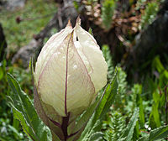

Brahma Kamal (Saussurea obvallata).

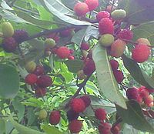

Kaphal (Myrica esculenta).

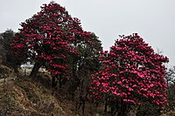

Burans (Rhododendron arboreum).

Transport (Char Dham Highway and Char Dham Railway)

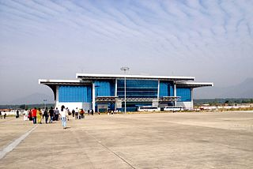

Jolly Grant Airport, Dehradun.
Uttarakhand has 28,508 Km of roads, of which 1,328 Km are national highways and 1,543 Km are State Highways. The “State Road Transport Corporation” (SRTC), which has been reorganised in Uttarakhand as the “Uttarakhand Transport Corporation” (UTC), is a major constituent of the transport system in the state. The Corporation began to work on 31st October 2003 and provides services on interstate and nationalised routes. As of 2012, approximately 1,000 buses are being plied by the UTC on 35 nationalised routes along with many other non – nationalized routes. There are also private transport operators operating approximately 3,000 buses on non – nationalised routes along with a few interstate routes in Uttarakhand and the neighbouring state of U. P. For travelling locally, the state, like most of the country, has “Auto Rickshaws” and “Cycle Rickshaws”. In addition, remote towns and villages in the hills are connected to important road junctions and bus routes by a vast network of crowded share jeeps.

The air transport network in the state is gradually improving “Jolly Grant Airport” in “Dehradun” is the busiest airport in the state with six daily flights to Delhi Airport. Pantnagar Airport, located in Pantnagar of the Kumaon region has 1 daily air service to Delhi and return too. There government is planning to develop Naini Saini Airport in Pithoragarh, Bharkot Airport in Chinyalisaur in Uttarkashi District and Gauchar Airport in Gauchar, Chamoli District. There are plans to launch helipad service in Pantnagar and Jolly Grant Airports and other important tourist destinations like “Ghangaria and Hemkund Sahib”.

As over 86% of Uttarakhand's terrain consists of hills, railway services are very limited in the state and are largely confined to the plains. In 2011, the total length of railway tracks was about 345 Km. Rail, being the cheapest mode of transport, is most popular and the most important railway station in Kumaun Division of Uttarakhand is at Kathgodam, 35 Kilometres away from Nainital. Kathgodam is the last terminus of the broad gauge line of North East Railways that connects Nainital with Delhi, Dehradun, and Howrah. Other notable railway stations are at “Pantnagar, Lalkuan and Haldwani”.

Dehradun railway station is a railhead of the Northern Railways. Haridwar station is situated on the Delhi – Dehradun and Howrah – Dehradun railway lines. One of the main railheads of the Northern Railways, Haridwar Junction Railway Station is connected by broad gauge line. Roorkee comes under Northern Railway region of Indian Railways on the main Punjab – Mughal Sarai trunk route and is connected to major Indian cities. Other railheads are Rishikesh, Kotdwar and Ramnagar linked to Delhi by daily trains.

Tourism in Uttarakhand

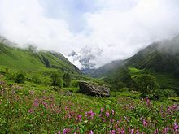

Valley of Flowers National Park.

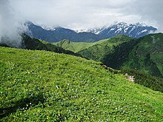

View of a Bugyal (Meadow) in Uttarakhand.
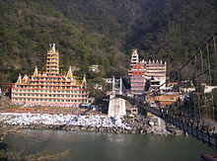

Rishikesh view and 13 stories Shiva Temple across Lakshman Jhula bridge over the Ganges.

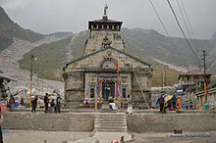

Kedarnath Temple is one of the 12 Jyotirlingas.

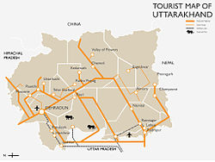

Schematic Tourist Map of Uttarakhand.

Uttarakhand has many tourist spots due to its location in the Himalayas. There are many ancient temples, forest reserves, national parks, hill stations, and mountain peaks that draw large number of tourists. There are 44 nationally protected monuments in the state and “Oak Grove School” in the state is on the tentative list for “World Heritage Sites”. Two of the most holy rivers in Hinduism the Ganges and Yamuna, originate in Uttarakhand.

Uttarakhand has long been called “Land of the Gods” as the state has some of the holiest Hindu shrines, and for more than a thousand years, pilgrims have been visiting the region in the hopes of salvation and purification from sin. Gangotri and Yamunotri, the sources of the Ganges and Yamuna, dedicated to Ganga and Yamuna respectively, fall in the upper reaches of the state and together with Badrinath (dedicated to Vishnu) and Kedarnath (dedicated to Shiva) form the Chota Char Dham, one of Hinduism's most spiritual and auspicious pilgrimage circuits. Haridwar, meaning “Gateway to the God”, is a prime Hindu destination. Haridwar hosts the Haridwar Kumbh Mela every twelve years, in which millions of pilgrims take part from all parts of India and the world. Rishikesh near Haridwar is known as the preeminent “Yoga Centre” of India. The state has an abundance of temples and shrines, many dedicated to local deities or manifestations of “Shiva and Durga”, references too many of which can be found in Hindu scriptures and legends. Uttarakhand is, however, a place of pilgrimage for the adherents of other religions too. Piran Kaliyar Sharif near Roorkee is a pilgrimage site to Muslims, Gurdwara Hemkund Sahib, Gurdwara Nanakmatta Sahib and Gurdwara Reetha Sahib are pilgrimage centers for Sikhs. Tibetan Buddhism has also made its presence with the reconstruction of Mind rolling Monastery and its Buddha Stupa, described as the world's highest at Clement Town, Dehradun.“Auli and Munsiari” are well – known skiing resorts in the state.

The state has 12 National Parks and Wildlife Sanctuaries, which cover 13.8% of the total area of the state. They are located at different altitudes varying from 800 to 5,400 Metres. The oldest national park on the Indian sub – continent, Jim Corbett National Park, is a major tourist attraction. “Vasudhara Falls”, near “Badrinath” is a waterfall with a height of 122 Metres (400 Feet) set in a backdrop of snow – clad mountains. The state has always been a destination for mountaineering, hiking, and rock climbing in India. A recent development in adventure tourism in the region has been white water rafting in “Rishikesh”. Due to its proximity to the Himalaya ranges, the place is full of hills and mountains and is suitable for trekking, climbing, skiing, camping, rock climbing, and paragliding. Roopkund is a trekking site, known for the mysterious skeletons found in a lake, which was featured by “National Geographic Channel” in a documentary and the trek to “Roopkund Passes” through the “Meadows of Bugyal”.

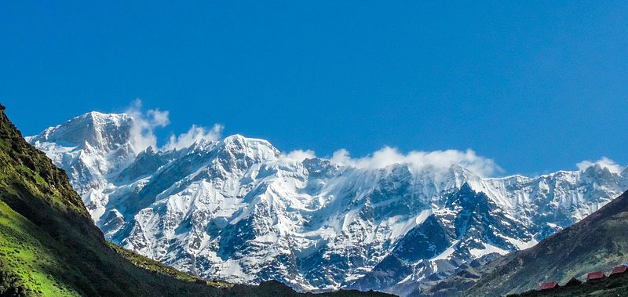

Himalayan Mountains Range in Kedarnath, Uttarakhand.

Institutions of Higher Education in Uttarakhand

On 30th September 2010 there were 15,331 primary schools with 1,040,139 students and 22,118 working teachers. At the 2011 census the literacy rate of the state was 78.81% with 87.4% literacy for males and 70% literacy for females.The language of instruction in the schools is either English or Hindi. There are mainly government – run, private unaided (no government help), and private aided schools in the state. The main school affiliations are CBSE, CISCE or UBSE, the state syllabus defined by the Department of Education of the Government of Uttarakhand. Uttarakhand is also home to a number of universities and degree colleges and Dehradun is known as “School Capital of India”.

Sports

The high mountains and rivers of Uttarakhand attract many tourists and adventure seekers. It is also a favorite destination for adventure sports, such as paragliding, sky diving, rafting and bungee jumping. More recently, golf has also become popular with Ranikhet being a favorite destination. The Uttarakhand Cricket Association is the governing body for cricket activities. The Uttarakhand cricket team represents Uttarakhand in Ranji Trophy, Vijay Hazare Trophy and Syed Mushtaq Ali Trophy. The “Uttarakhand State Football Association” (USFA) is the governing body for association football. The Uttarakhand football team represents Uttarakhand in the Santosh Trophy and other leagues.

How to Reach Joshimath Tehsil

By Rail: There is no railway station near to Joshimath Tehsil in less than 10 Km. However, Rishikesh Railway Station is major railway station 147 Km near to Joshimath. Pin Codes of Joshimath Tehsil 246 472 (Pipalkoti), 246 483 (Tapoban), 246 422 (Badrinath Seasonal), 246 443 (Vishnupuram), 246 424 (Chamoli), 246 423 (Niti).
Banks in Joshimath: Punjab National Bank, Joshimath (IFSC Code: PUNB0024500, Micr Code: NON – MICR); State Bank of India, Joshimath (IFSC Code: SBIN0006170, Micr Code: 246002022); and The Nainital Bank, Joshimath (IFSC Code: NTBL0JOS086, Micr Code: ××××××1234).

- Colleges in Joshimath: Government Inter Collage (G.I.C.),
Address: Karanprayag Road Narayanbagar.

- Govt Inter Collage (G.I.C.) Rohida,
Address: P.O. Rohida District Chamoli, Block Gairsain, Pin – 246 428.

- G.I.C. Bhagawati,
Address: Shri Guru G.I.C. Bhagawati, Chamoli Village – Bhagoti District – Chamoli.

- G.I.C. Lolti,
Address: G.I.C. Ratgaon, Village Ratgaon P.O. Ratgaon.

Itinerary (Route and Schedule)

- Day 01: Arrival at Joshimath (6,696 Feet);
- Day 02: Joshimath to Mana (10,429 Feet) – 50 Km [Drive];
- Day 03: Mana to Laxmiban (12,000 Feet) – 8.5 Km;
- Day 04: Laxmiban to Chakrateerth (13,658 Feet) – 9.5 Km;
- Day 05: Chakrateerth to Satopanth Lake (14,258 Feet) to Chakrateerth – 7.5 Km;
- Day 06: Chakrateerth to Somtoli (11,745 Feet) – 11 Km;
- Day 07: Somtoli to Mana – 6.5 Km. Drive to Joshimath;
- Day 08: Joshimath to Dehradun.

- The Existing Alignment of Kurkuti – Ghamsali – Niti, Road is Newly Declared as NH/ SH; is connecting to Newly Declare Road. The Total Existing Length of the Projected Road is approximately 18.53 Km.
- The Actual Design Length of the Project Road is around 17.56 Km.
- The project road section between Kurkuti – Ghamsali – Niti, Road has been divided into following homogeneous section in the Table 10:

Report Purpose

- To Identify Existing Traffic Data in the Region/ State;
- To Describe New Data Collection Requirements;
- To Presents the Findings of Data Collection Undertaken;
- To Determine if the Data Collection is Fit for Use;

Table 10: The Inventory of Kurkuti – Ghamsali – Niti Project Road.

ROAD INVENTORY
Road Name: Kurkuti – Ghamsali – Niti
Section : From Km 00+000 To 17+56 Km. |  |  |  |  |  |  |  |  |  |  | District: Chamoli Uttarakhand
Chainage |  | Type of Terrain | Land Use Pattern | Name of Village/ Town | Right of Way (m) | Roadway Width (m) | Carriageway |  |  | Shoulders |  |  | Average Height of Embankment or Depth of Cutting (m) | Road Side Drainage |  | Service Road, If Any | Details of Cross Roads |  |  | Remarks
Km | Km |  |  |  |  |  | Type | Width (m) | Condition | Type |  | Width (m) |  | Exists (F/ NF) | Does not Exist |  | Location | Destination | C/W (m)
00+000 | 17+56 | Hilly | Barren and No Use of Forest Land | NIL | NIL | NIL | NIL | NIL | NIL | NIL |  | NIL | NIL | NIL | NIL | NIL | NIL | NIL | NIL | Foot Track

- The Existing road Starts from 00+000 Km Kurkuti Village of Latitude and Longitude (21.3199° N Latitude and 82.5646° E Longitudes) and the road Terminates at 18+530 Km. of Niti Village with Latitude and Longitude (30.7776° N Latitude and 79.8412° E Longitudes). The Project Road Kurkuti – Ghamsali – Niti is situated in Uttarakhand State.
- The consultancy services for the same is to include design of best possible alignment and pavement composition, design of bridges, culverts and other structures in addition to analysis of costs, determining project feasibility, preparation of Land – Acquisition – Plan (LAP), if applicable in any area, and obtaining of all requisite clearances as per need or suitability in the projected areas.

- The index map illustrates the Approved Project Alignment of Kurkuti – Ghamsali – Niti Road Projected are presented in the Figure 7 below:

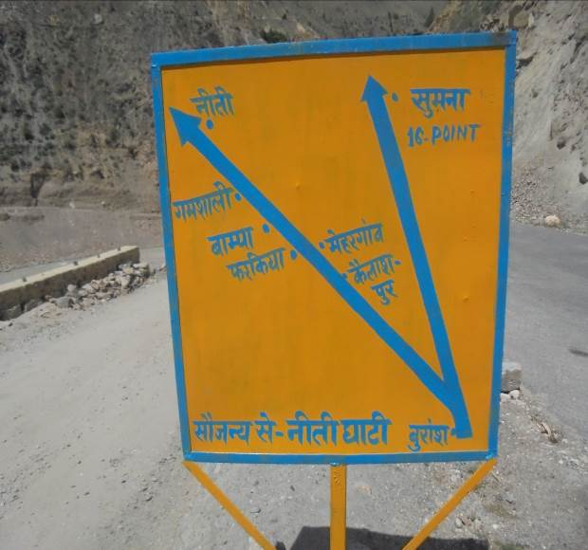 | 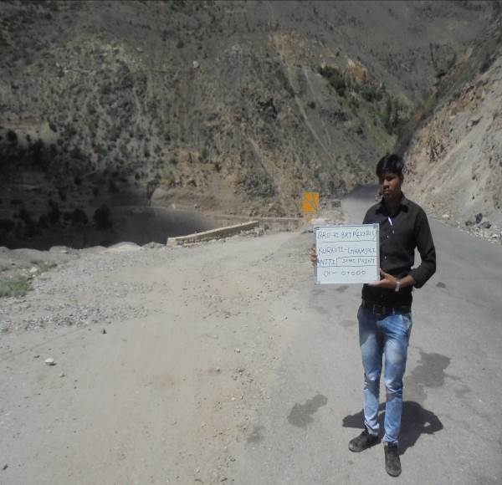

Start Point at Kurkuti Village Chainage = 00+000 Km.
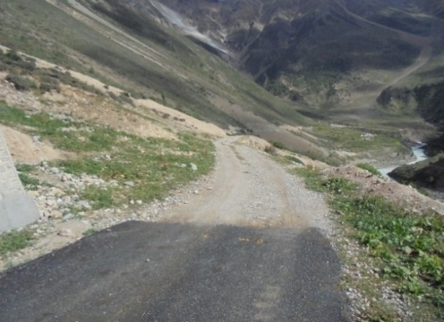 | 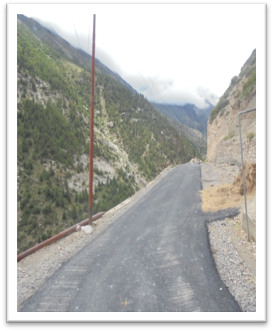

End Point at Niti Village Chainage = 18+530 Km.

Figure 7: Approved Project Alignment of Kurkuti – Ghamsali – Niti Road Projected as per Inception Reportby Environmental Team Experts.

Meticulous/ Particular TOR for Satellite Imagery

The coordinates of the origin and destination points of the proposed roads provided in the TOR were tentative. These have been checked on ground by us in concurrence of ITBP posts at the particular stations by GPS to ensure the accuracy of the coordinates.

4. OBJECTIVE OF CONSULTANCY SERVICES

Objective of Consultancy Services: The main objectives of the consultancy services are to prepare Initial Environmental Examination (IEE)/ DPR Report and bid documents for the length of 17.56 Km. of Kurkuti – Ghamsali – Niti Road and to establish the techno, economical, viability of the project and prepare detailed project reports for design of roads and bridges. An important requirement with regard to improving the Project Road is that the development of work shall be within the Right of Way (ROW) of 24 Meters and avoiding additional land acquisition as far as possible. All these means that the development schemes for the Project Road should be as economical as possible consistent with the functional requirements and that it should amenable for quick implementation without delays.

To serve the environmental aspects and adopt good Road Construction Practices (Sustainable Environmental Development Practices) under this project are being considered. The present research methodology aims to use the waste of some industries like polypropylene, polyester (as waste of backing and carpet industries respectively) in the preparation of a special type of asphalt to be used in the production of Hot Mix Asphalt (HMA) for roads, bridges, structures and dams construction during the civil work. The solid materials in paving mix were low quality aggregates of high absorptive type and waste marble filler with the final objective to provide added value, to reduce the production costs and keep the virgin solid materials especially aggregates for a longer period of time. The produced mixes are of similar or of better performance compared to the conventional asphalt mixtures. And there is an urgent need to address the great challenges of our times: climate change, resource depletion, pollution, and peak oil. These issues are all accelerating rapidly, and all have strong links with the road as well as building industry as shown below in Project Execution Objectives and Decision Making Work – Life Cycle (Figure 8).

- Ground Control Point Survey by using Differential Global Positioning System (DGPS);
- Procurement of 0.5 m Resolution of Satellite Imagery from National Remote Sensing Centre (NRSC), Hyderabad, India;
- Development of Geographical Information System(GIS) Layers and Digital Elevation Model (DEM) of Finalized Alignment of Border Roads;
- Contours Creation at 2.5 m Interval;
- Ortho – photo Generation at 0.5 m Ground Sample Distance (GSD);

Major Tasks and Scope of Consultancy Services

- Engineering Surveys and Investigations

- Topographic Surveys;
- Hydraulic and Hydrological Investigations;
- Traffic Surveys;
- Material Investigations;

- Engineering Designs

- Geometric Designs;
- Pavement and Road Designs;
- Design of Bridge and Structures;
- Drainage Designs;

- Project Cost Estimations

- Detailed Project Report; Initial Environmental Examination and Bid Documents

- General Topographical Features of the Area/ Region/ State

- Proposed Drainage Facilities/ Structures of the Area/ Region/ State

- Establishing the Most Suitable Alignment of the Projected Road;

- Minimal Adverse/ Unfavourable/ Unpleasant Impact on the Surrounding Environment.

HAMARA SANDESH…!!! HARA BHARA “UTTARAKHAND” PRADESH…!!!
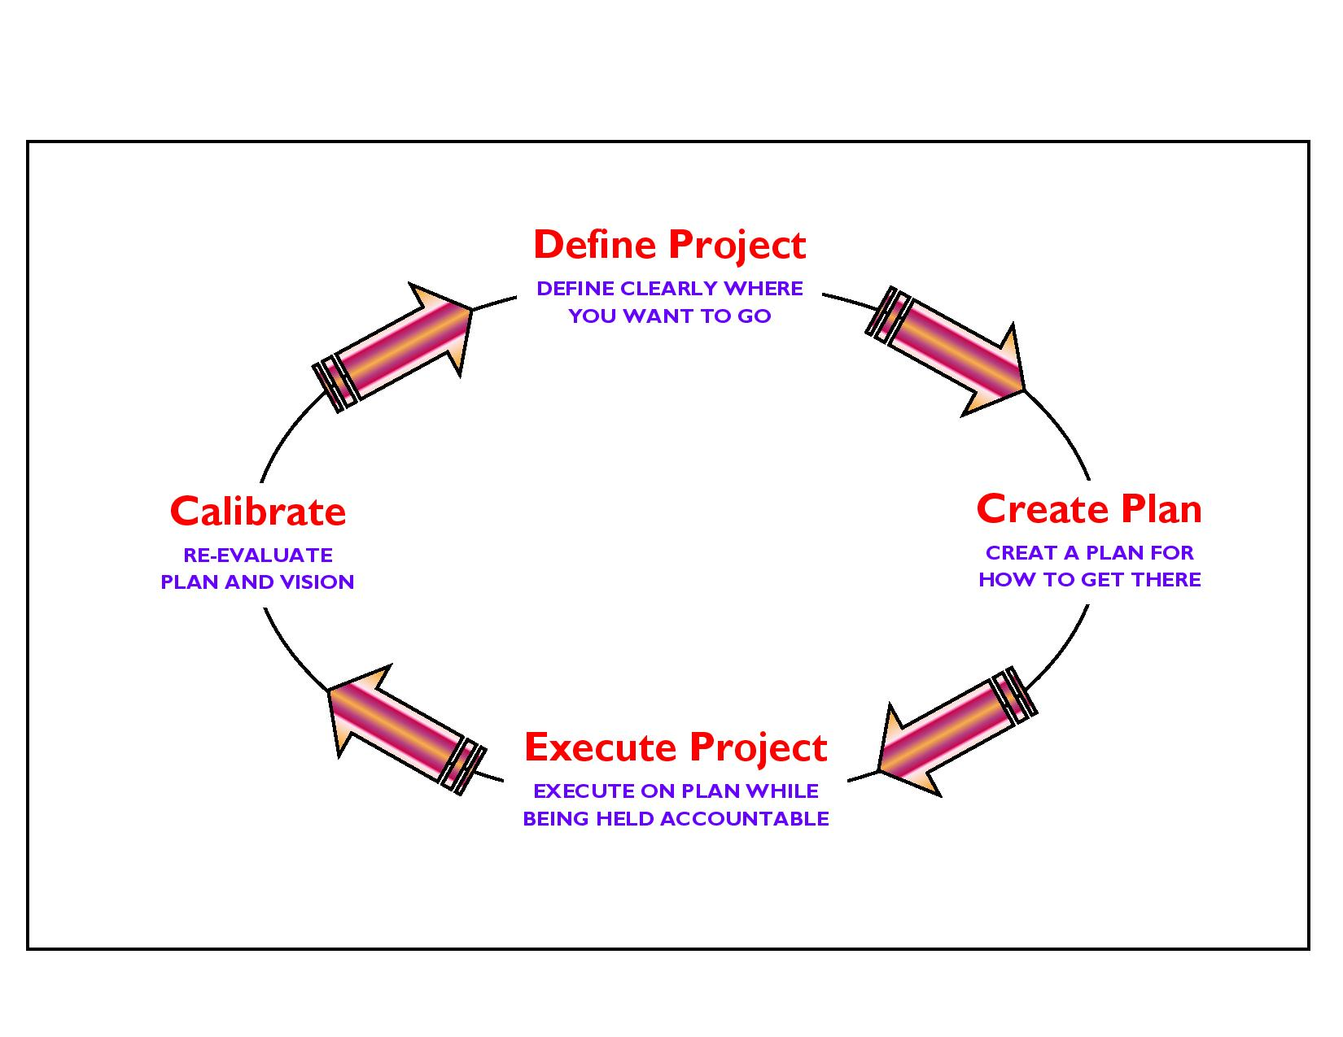

Figure 8: Project Execution Objectives and Decision Making Work – Life Cycle.

There is a growing consensus from scientists and the industry that, we are going to reach peak for construction in the next twenty years, and that we might have reached this point already. Global demand is soaring, whilst global production is declining, and oil is set to become increasingly expensive and scarce. The road and building industry is hugely dependent on cheap resources from the manufacture and transportation of its materials, to the machinery and tools used in demolition and construction. Not only in India, but also in other countries, they use vast quantities of fossil fuels, accounting for over half of total carbon emissions that lead to increase in temperature, global warming and climate change. The built environment is also responsible for significant amounts of air, soil and water pollution, and millions of tones of landfill waste and this is a situation that clearly needs to change. Strategic value of these always occur, because our roads, belongs to some very important and informative objectives, which makes our country strong against another country as whole around the World OR Globe OR Precious Earth Sphere.

5. PROPOSED APPROACH AND METHODOLOGY: Eco – Friendly OR Environmental Friendly Road Construction Methods and Materials

General Approach: The general approach of the Consultants would be to comprehensively address the various issues involved in the project, to carry out all the field and design office activities as set out in the Scope of Services of the Term of Reference (TOR) and finally to develop improvement proposals satisfying the objectives of the project.

Methodology: The project involves a series of inter – related activities, both in the field and in the design office. Methodology for carrying out these activities is described in the following paragraphs.

Topographical Surveys: The topographical surveys by means of Global Positioning System (GPS), for fixing of ground control points for the entire length of the corridor. Further, the survey has been completed with the 0.5 m high resolution satellite imagery.

Soil and Material Investigations: Prospective sources of construction materials have been located by the Consultants to add in list of sources of materials. To estimate the quantities of available suitable materials; the Consultants have prepared quarry/ material source charts including lead distances etc. This shall form an input in Rate Analysis of borrow/ quarry materials, following which recommendations for the use of the materials from different sources can be made. Material investigation done for engineering properties reveals that the material available at site is fit for use in protection, drainage and surfacing works aggregate and no quarry outside the site is required. The material can be used for crust layer execution by processing the available material by stone crusher and rotary screen. Only local transportation is the need for transporting the aggregates for preparation of bituminous mix preparation and laying at respective chainages.

For the completion of this environmental report the data was collected from different sources including government department and our DPR as well as Initial Environmental Examination (IEE) Report, Expert/ Specialist Team. The main aim of this report is to produce a smart; innovative/ informative/ adaptive/ applicable guideline for good construction practices. Eco – friendly design methodologies and technologies can further reduce energy consumption by minimizing energy inputs for heating, cooling and light, and incorporating energy efficient appliances and applications. Saving energy for the occupant also saves money – an issue that will become increasingly important as the cost of fossil fuels and materials for road, bridges, and structure are used inevitably rises in the near future. High absorptive aggregate and waste polymer must play a very important role in road paving to decrease the cost of construction and maintenance. With the inevitability of declining fossil fuels, and the threat of global climate change, reducing our energy consumption is an essential survival strategy. Choosing to Build – Green...!!! And Go – Green...!!! To Save Energy Consumptions and its Valuable Resources to Achieve Significant Prospective Goals in the Projected Area Study. The low embodied energy of green products ensures that very little energy went into their manufacture and production, with a direct reduction in carbon emissions. The best modifier of asphalt must contain high percentages of Iso and Cyclo – Paraffins and lower percentage of asphaltenes similar to asphalt composition itself and the waste polymer from other industries can be used in future work.

The report mainly contains environmental points regarding different stages of the Designing; Construction and Operational Phases like three as depicted below for Kurkuti – Ghamsali – Niti Road, which is situated in the Northern part of Uttarakhand State to achieve projected goals and mainly these are in:

- Designing Phase;
- Construction Phase;
- Operational Phase.

Bitumen, as a residue from crude oil distillation, is the complex mixture of four main families of compounds, referred to as SARA fractions (Saturates, Aromatics, Resins and Asphaltenes). The behaviour of bitumen depended on the relative concentration and the chemical features of asphaltenes and maltenes; thus, variation in its composition strongly affects its mechanical properties. Methodological Perspective Over – View of Road Date Base Construction Photographs is given in Figure 9.

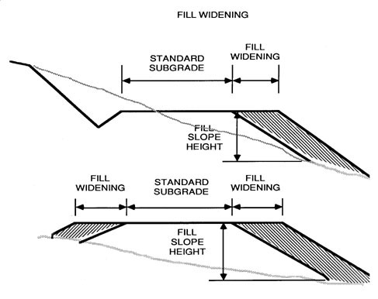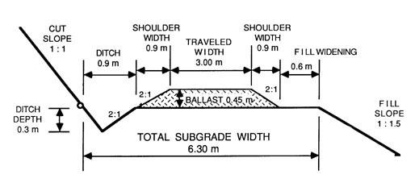
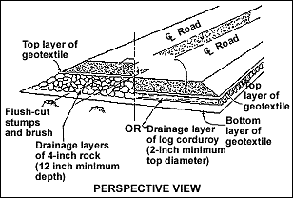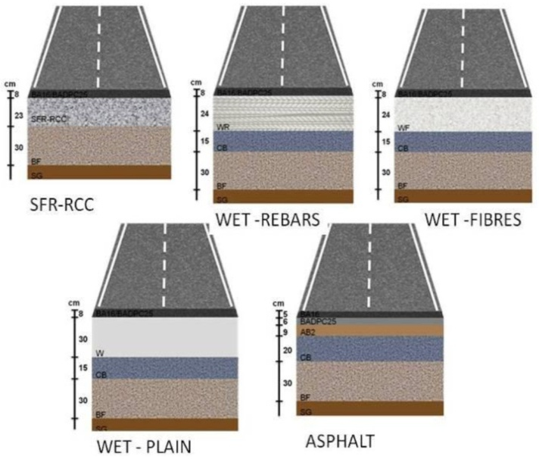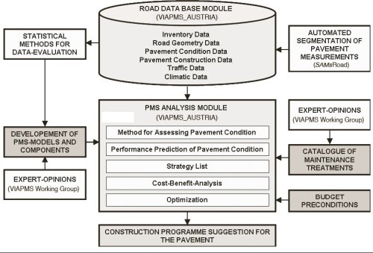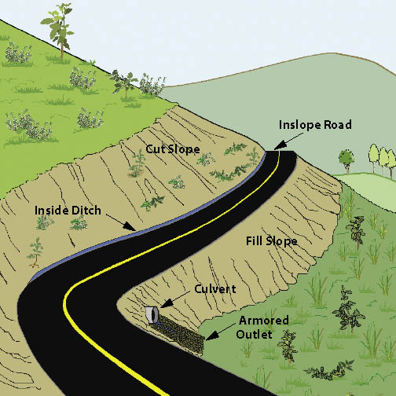

Figure 9: Methodological Perspective Over – View of Road Date Base Construction Photographs.

It presents a large set of interesting potential properties: impermeability, ductility, adhesivity and resistance to the effect of weathering and chemicals, etc. In the last 20 years, a wide spectrum of modifying polymeric materials has been tested with bitumens for their use in road construction. For a polymer to be effective it must blend with bitumen and improve its resistance at high temperatures without making the bitumen too viscous at mixing temperatures or too brittle at low temperatures. It should be capable of being processed by conventional equipment, available, not expensive and physically and chemically stable during storage, application and service. In actual modified bitumens, thermoplastic rubbers, as well as some thermoplastic polymers, were mainly used. The use of secondary (recycled) aggregates, instead of primary (virgin) materials helped in easing landfill pressures, reducing the need for extraction, protecting environment and minimizing the consumption of original resources. Polyester polymer, thermoplastic Poly – Ethylene Tere – phthalate (PET) and mineral fibres are the additives, which are mostly used to produce strong and durable reinforcement bitumen. Also, different industrial wastes such as waste polymers, spent toner, marble quarry waste and fibres ...etc. can be used as asphalt modifiers for civil construction work. Carpet waste fibres were used recently in asphalt mixtures and in Fibre Reinforced Concrete (FRC). Such reinforcement improved effectively the shatter resistance, toughness, and ductility of concrete. One of the major waste generating industries is the construction and marble production, and, it was reported that the potentials to use this type of waste in low to medium traffic urban as well as rural areas roads and as binder courses were very beneficial. There are some literatures that discussed the use of fillers such as limestone powders, rubber silica and carbon black as modifiers for asphalt mixture. In Egypt, the use of waste materials in HMA is not applied yet, in addition to the presence of a large amount of low quality aggregate not suitable for use in paving or other purposes.

Preparation of Hot Mix Asphalt and Properties

Hot mix asphalt samples were prepared using virgin asphalt and modified binders and were evaluated using the Marshall Test Method (ASTM: D – 6927). The mixes were designed according to the standard limits of surface (wearing) course. The job mix was formulated (% Wt.) using coarse and fine aggregates, sand and filler as 33, 30, 32 and 5 Wt. %, respectively. The mixes were tested for maximum load and flow along with density and air voids in mixes and solid materials were determined.

- HMA are hot mixes asphalt consisted of normal absorptive aggregate type, primary (virgin) asphalt samples and limestone filler;
- HMA are hot mixes asphalt consisted of high absorptive aggregate type, virgin (primary) asphalt samples and limestone filler;
- HMA are hot mixes asphalt consisted of high absorptive aggregate type, marble dust, modified asphalt through using 5% of waste polypropylene and waste polyester respectively.

Conclusion and Recommendation

This research aimed to prepare and use special types of HMA consisting of unordinary materials with the final objective of decreasing the cost of paving and maintenance, keeping the premium aggregate for the longest period of time and decreasing the land space needed for land filling of un – degradable pollutants. To achieve this aim, 5 to 15% of each of waste polypropylene and polyester were used in asphalt modifying. High absorptive aggregate and marble fillers were used in mixes preparation instead of ordering materials such as normal absorptive aggregate and limestone filler. The obtained results showed that all the types of waste polymers and solid materials used in the study are suitable in road paving and construction activities. The mixes comply with the standards and have reduced temperature susceptibility. The best modifier was polypropylene waste and the polyester waste was found to be very tough. The mix can be used as base course or other purpose in any type of construction and civil work.

6. ENVIRONMENTAL INDEX OR FEATURES OF THE PROJECT

Environment and Economy Status of Uttarakhand

Climate, Rainfall and Temperature

The climate of Uttarakhand varies with elevation and the low altitude (100 m – 1,500 m) has a Humid subtropical climate. High altitude and very high altitude areas (3,500 m – 5,500 m) have a subtropical highland climate and alpine climate. Uttarakhand receives 2,000 to 5,000 millimetres (79 to 197 in) of rainfall annually, 70% to 80% obtained between May and October, snowfall annually, obtained between November and March.

Most of the inhabited regions of Uttarakhand experience a temperate climate, with temperatures seldom exceeding 28°C (82°F) in summer. The average annual temperature for most of Uttarakhand is around 18°C (64°F). Uttarakhand is one of the few states in India to receive regular snowfall. The average annual temperature for the major part of Uttarakhand is recorded 18°C (64°F) approximately. During the months of March – May, the sun shines at its best in the state of Uttarakhand. The weather remains wintry and humid, since it rains most of the time. Monsoon prevails from late – June to early – September. The state has five seasons: winter, summer, spring, autumn, and a monsoon season between June and September. Uttarakhand's climate ranges from sub – tropical in the South to tundra in the North. Most of the inhabited regions of Uttarakhand experience a temperate climate, with temperatures seldom exceeding 28°C (82°F) in summer. The average annual temperature for most of Uttarakhand is around 18°C (64°F). The climate of Uttarakhand varies with elevation and the low altitude 100 m – 1,500 m have a humid sub – tropical climate. High altitude and very high altitude areas (3,500 m – 5,500 m) have a subtropical highland climate and alpine climate. Uttarakhand receives 2,000 to 5,000 Millimeters (79 to 197 in) of rainfall annually, 70% to 80% obtained between May and October.

Uttarakhand is one of the few states in India to receive regular snowfall. The snow line ranges from 6,100 Meters (20,000 Feet) in the South of the state to 4,900 Meters (16,100 Feet) in the North. The tundra – type region in the North is snowbound for four months every year, and the temperature drops below 0°C (32°F) almost every night. In North – Western Uttarakhand, the peaks are frozen year – round; because of the high altitude, temperatures in the mountains can drop to as low as −40°C (−40°F) in winter. During the monsoon, heavy rains increase the risk of landslides. The record for the longest period of continuous rain in Uttarakhand is 11 days. Fog affects many parts of the state during winter and the monsoons, making transportation perilous.

The Uttarakhand state is the second fastest growing state in India. It's “Gross State Domestic Product” (GSDP) (at constant prices) more than doubled from ₹24,786 Crores in Financial Year 2005 to ₹60,898 Crore in Financial Year 2012. The real GSDP grew at 13.7% (CAGR) during the FY 2005 – FY 2012 period. The contribution of the service sector to the GSDP of Uttarakhand was just over 50% during FY 2012. Per capita income in Uttarakhand is ₹1, 03,000 Crores (Financial Year 2013) which is higher than the national average of ₹74,920 Crores (FY 2013). According to the Reserve Bank of India, the total foreign direct investment in the state from April 2000 to October 2009 amounted to US $46.7 Million.

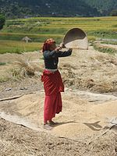

A Woman Winnowing Rice, an Important Food Crop in Uttarakhand.

Like most of India, agriculture is one of the most significant sectors of the economy of Uttarakhand. Basmati rice, wheat, soybeans, groundnuts, coarse cereals, pulses, and oil seeds are the most widely grown crops. Fruits like apples, oranges, pears, peaches, lychees, and plums are widely grown and important to the large food processing industry. Agricultural export zones have been set up in the state for lychees, horticulture, herbs, medicinal plants, and basmati rice (Table 11). During 2010, wheat production was 831 thousand tonnes and rice production was 610 thousand tonnes, while the main cash crop of the state, sugarcane, had a production of 5,058 thousand tonnes. As 86% of the state consists of hills, the yield per hectare is not very high. Approximately 86% of all croplands are in the plains while the remaining is from the hills.

Table 11: Economy of Uttarakhand at a Glance.

Economy of Uttarakhand at a Glance Figures in Crores of Indian Rupees
Sr. No. | Economy at a Glance (Financial Year – 2012) | In Indian Rupees
1. | Almora GSDP (Current) | ₹95,201/-
2. | Per Capita Income | ₹1,03,000/-

Other key industries include tourism and hydropower, and there is prospective development in IT, ITES, biotechnology, pharmaceuticals and automobile industries. The service sector of Uttarakhand mainly includes tourism, information technology, higher education, and banking. During 2005 – 2006, the state successfully developed three “Integrated Industrial Estates” (IIEs) at Haridwar, Pantnagar, and Sitarganj; Pharma City at Selakui; “Information Technology Park at Sahastradhara” (Dehradun); and a growth centre at Sigaddi (Kotdwar). Also in 2006, 20 industrial sectors in public private partnership mode were developed in the state.

Humidity, Weather and Climate Index

Humidity is found to be 45% along with North – Northwest (NNW) wind flow at 00 to 5.7 Km/ H. Uttarakhand States’ current Weather and Temperature on an average is 14°C and Weather Forecast for next 3 days may varies between 25°C to 28°C and temperatures seldom exceeding 28°C (82°F) in summer. Elevation/ Altitude/ Ceiling are found to be 5,425 Meters above the Mean Sea Level (MSL) in the State of Uttarakhand. The temperature in the region reaches and varies maximum to minimum level in – between 15°C to 14°C on an average in Uttarakhand State. Atmospheric Pressure found to be 1,015.60 mb and Ultraviolet Index is found to be 7 and similarly Dew Point is nearly 14°C. Cloud cover in the Uttarakhand state is approximately 70% with Visibility Status 8 Km and around 16 – wind compass rose are formed for the study. The eight half – winds are the points obtained by bisecting the angles between the principal winds. The half – winds are North – Northeast (NNE), East – Northeast (ENE), East – Southeast (ESE), South – Southeast (SSE), South – Southwest (SSW), West – Southwest (WSW), West – Northwest (WNW) and North – Northwest (NNW).

Homogeneous Section

The entire Projected Road is considering as one homogeneous sections based on Traffic Volume and its characteristics in the below {Table 12 on Page No. 52 and Figure 17 (a) on Page No. 81}. And Table 13 shows the Existing – Proposed Chainage Wise Villages.

Table 12: Homogeneous Section based on Traffic Volume Tehsil/ District Wise Villages.

Sr.  No. | Homogenous Section | Design Section Chainage |  | ExistingSection Length  (Km) | Design Length (Km) | Lane Widening
 |  | From  (Km) | To  (Km)
1. | Kurkuti – Ghamsali – Niti Road | 0.00 | 17.56 | 0.00 to 18.53 | 0.00 to 17+56 | Bothways

Table 13: Existing – Proposed Chainage Wise Villages.

Sr.  No. | Homogenous Section | Existing Chainage Section |  | Proposed Chainage Section
 |  | From  (Km) | To  (Km) | From  (Km) | To  (Km)
1. | Kurkuti – Ghamsali – Niti Road | 00+000 | 18+530 | 00+000 | 17+565

7. DEMOGRAPHIC INFRASTRUCTURE INDEX OF THE PROJECT DISTRICT/ STATE

Demographics (Cities in Uttarakhand by Population, Garhwali and Kumaoni People)

The local people of the state are referred to as Uttarakhand and often especially either Garhwali or Kumaoni depending upon their place of origin. As per the census of the year 2011, the state of Uttrakhand had 5,137,773 males and 4,948,519 females. Also, it is ranked 12th in terms of the most populated states. The population density is about is 189 persons per Square Kilometers. As demonstrated by the Census 2011, it has a population of 1 Crore, an expansion from 84.89 Lakhs in the 2001 evaluation. The population growth of the state in the present decade was 18.8% and previously it was about 19%. The population growth rate of the state of Uttarakhand is 18% and the number of inhabitants in the state is extending at a pretty fast pace (Table 14).

FACTS ABOUT UTTARAKHAND:

Table 14: Uttarakhand Facts and Special Effects.

Sr. No. | Factuals Effects
1. | The official Languages over here are Sanskrit and Hindi. Garhwali and Kumaoni are also spoken by a large number of people in the state;
2. | It is particularly connected by roadways, rail, and air. Its biggest air terminal is located in Dehradun and it is called as Jolly Grant Airport;
3. | The major food of the state is vegetables with wheat and also non – vegetarian food is consumed in a large way over here. A particular thing of the state cuisine is the use of tomatoes and milk related things. Coarse Grain with high fiber content is remarkably consistent out here;
4. | One of the notable Hindu journeys in the form of the Haridwar Kumbh Mela happens in Uttarakhand. Haridwar is one of the four spots in the nation where this Mela takes place;
5. | Cultivating is among the most vital areas of the economy of the state. Basmati Rice and Oilseeds are some of the grown items of here are regular things like apples, peaches and plums are grown and a key to the food business of the state of Uttarakhand.

The native people of Uttarakhand are generally called Uttarakhandi and sometimes specifically either Garhwali or Kumaoni depending on their place of origin in either the Garhwal or Kumaon region. According to the 2011 Census of India, Uttarakhand has a population of 10,086,292 comprising 5,137,773 males and 4,948,519 females, with 69.77% of the population living in rural areas. The state is the 20th most populous state of the country having 0.83% of the population on 1.63% of the land. The population density of the state is 189 people per Square Kilometre having a 2001 – 2011 decadal growth rate of 18.81%. The gender ratio is 963 females per 1,000 males. The crude birth rate in the state is 18.6 with the total fertility rate being 2.3. The state has an infant mortality rate of 43, a maternal mortality rate of 188 and a crude death rate of 6.6.

Infrastructure

Uttarakhand is located in Northern India and previously was known as Uttaranchal. It is also called the Land of the Gods in perspective of different Hindu temples and famous pilgrimage sites in the state. It is known for its breath taking wonderfulness of the Himalayas and also the Terai. On 9th November 2000, the state was made using the Himalayan and North Western areas of Uttar Pradesh. The state is divided into two in the form of Garhwal and Kumaon, with a whole of 13 areas. The capital is Dehradun and it is also the largest city over here. Uttarakhand's roads are maintained by the Border Road Organisation (BRO), an offshoot of the Indian Army. Border trade between the two countries through the Lipukekh pass conducted for five months from June to October at Taklakot mart in Western Tibet on the Chinese side. Archaeological confirmations support the presence of people in the area since the old times. The state is also a popular tourist spot and numerous people from all over India and around the globe come over here to spend some time with their family and friends. Additionally, there is a long list of attractions over here.

PITHORAGARH: Business transactions worth over ₹6.55 Crore took place between India and China this year through the border at Lipukekh Pass in Uttarakhand. Total business transacted between the two countries through the border this year was 6.55 Crore. Of which imports by Indian traders stood at 5.59 Crore and exports by them stood at 96.5 Lakh, trade officer P. S. Kutiyal said on phone from Dharchula. A total of 244 Indians, including 70 traders and 174 helpers, went to Taklakot mart this year to do business with their Chinese counterparts, the trade officer said. “Indo – China border trade, aimed at strengthening economy of tribal border villages was resumed in the year 1992. The traditional trade with erstwhile Tibet had been closed after the 1962 border conflict between two countries. According to the trade officer, the Indian traders exported commodities like tea, coffee, jaggery, sugar candy, tobacco products and cosmetics; and imported raw Tibetan wool, readymade garments, shoes and cements bags”. On 8th December 2008, it was announced that Uttarakhand had become the first state in India to achieve 100% sanitation coverage, becoming completely free of public defecation, thus attaining the status of “Nirmal State OR Swachh State”, like Swachh Bharta Abhiyan/ Mission in India. “A clean India would be the best tribute India could pay to Mahatma Gandhi on his 150 birth anniversary in 2019,” said Shri Narendra Modi as he launched the Swachh Bharat Mission at Rajpath in New Delhi. Figure 10 shows Lipukekh Pass – Indo – China Border and Shri Laxmi Narayan Temple in Legship.
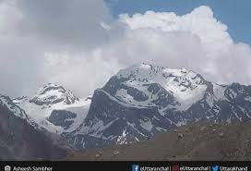 | 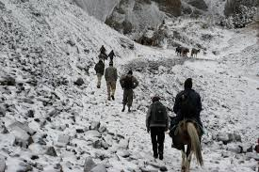
Lipukekh Pass in Uttarakhand – Indo – China Border. | The Lipulekh Pass at Height 16,800 Feet.
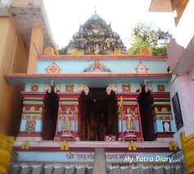 | 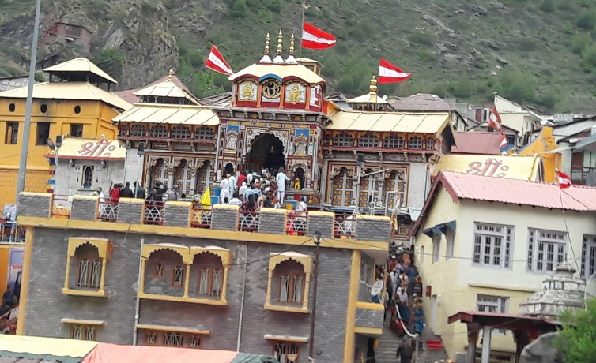
Shri Laxmi Narayan Tample in Legship is Dedicated to Hindu God Narayana. | Famous Tample in Uttarakhand.
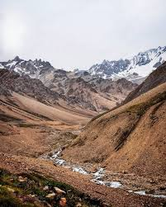 | 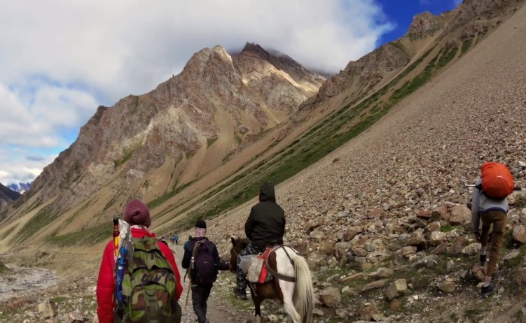
Pithoragarh Pathway. | Lipukekh Pass to Om Parvat.
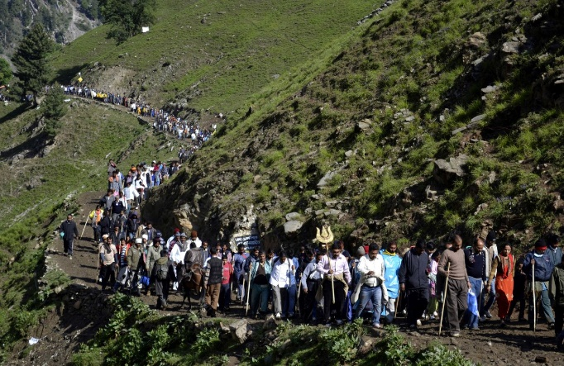 | 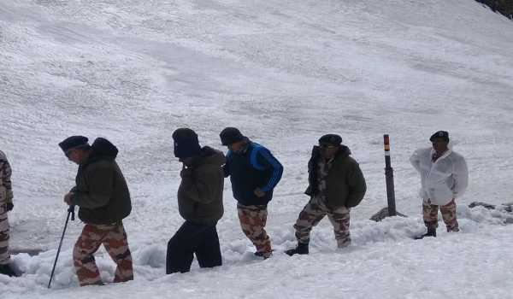
Lipukekh Pathway. | ITBP DG, Visits Lipulekh Pass… to Review Arrangement for Kailash Mansarivar Yatra.
Figure 10: Lipukekh Pass – Indo – China Border and Shri Laxmi Narayan Temple in Legship.
To get to the population of Uttarakhand in 2019, the population of the previous 5 years needs to be seen. They are as follows (Table 15):

Table 15: Yearly Increase in Population Rate of Uttarakhand State, 2014 to 2019.

Sr. No. | Year | Population in Million
1. | 2014 | 10.170
2. | 2015 | 10.220
3. | 2016 | 10.280
4. | 2017 | 10.320
5. | 2018 | 10.356
6. | 2019 | 10.3932 (Estimated)

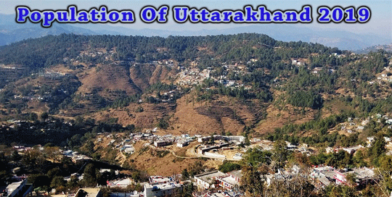

By checking out the population of Uttarakhand from 2014 to 18, it is evident that the population has gone up by 0.186 Million in the previous 5 years. This figure shows that the yearly population increase is of 0.0372 Million. Therefore, the population of Uttarakhand in 2019 is 10.356 Million + 0.0372 Million = 10.3932 Million. To conclude it, the population of Uttarakhand in 2019 as per estimates = 10.3932 Million. Languages of Uttarakhand State are as given below in the Table 16.

Table 16: Conversation/ Speaking Percentage Languages in Uttarakhand State, 2011 (Uttaranchal).

Sr. No. | Languages | Conversation/ Speaking Percentage/ Category/ Class in %age | Remarks
1. | Hindi | 89.15% | Up to Mark
2. | Urdu | 04.22% | Low Level
3. | Bengali | 01.50% | Medium and Low Level
4. | Nepali | 01.05% | Low Level
5. | Maithili (Tharu) | 00.54% | Low Level
6. | Punjabi | 02.61% | Very Low Level
7. | Others | 00.93% | Low Level

Hindi belonging to the Indo – Aryan languages is the official language of Uttarakhand and is spoken by 89.15% of the population (2011 Census of India figures include Garhwali spoken by 23.03%, Kumaoni spoken by 19.94% and Jaunsari spoken by 1.35% of the population as variants of Hindi). Sanskrit is given the status of second official language. Garhwali and Kumaoni are endangered languages listed by UNESCO. Apart from Hindi, Urdu is the second most spoken language with 4.22% speakers followed by Punjabi (02.61%), Bengali (1.50%), Nepali (1.05%) and Maithili (figures include Tharu as a variant of Maithili) by 0.54% speakers. Many Tibeto – Burman languages are also spoken in this region, including Jad, Rongpo, Darmiya, Byangsi, Chaudangsi, Raji and Rawat.

Groups Ethnicity

Uttarakhand has a multiethnic population spread across two geocultural regions: the Garhwal, and the Kumaon. A large portion of the population is Rajput (various clans of erstwhile land owning rulers and their descendants), including members of the native Garhwali, and Kumaoni as well as a number of immigrants. According to a 2007 study by Centre for the Study of Developing Societies, Uttarakhand has the highest percentage of Brahmins of any state in India, with approximately 20% of the population being Brahmin. “Approximately 18.76% of the population belongs to the Scheduled Castes (an official term for the indigenous aboriginal lower castes in the Traditional Caste System in India). Scheduled Tribes such as the Tharu, Jaunsari, Buksa, Bhotiya and Raji constitute 2.89% of the population”. More than four – fifths of Uttarakhand's residents are Hindus, Muslims, Sikhs, Christians, Buddhists, and Jains make up the remaining population with the Muslims being the largest minority.

Religion

Hinduism is the state's major religion and is practiced mainly by ethnic Nepalis; an estimated 57.8% of the total populations are adherents of the religion. There exist many Hindu temples. Kirateshwar Mahadev Temple is very popular, since it consists of the Chardham altogether. Vajrayana Buddhism, which accounts for 27.3% of the population, is Uttarakhand's second – largest, yet most prominent religion. Prior to Uttarakhand's becoming a part of the Indian Union, Vajrayana Buddhism was the state religion under the Chogyal. Uttarakhand has 75 Buddhist monasteries, the oldest dating back to the 1700s the public and visual aesthetics of Uttarakhand are executed in shades of Vajrayana Buddhism and Buddhism plays a significant role in public life, even among Uttarakhand's majority Nepali Hindu population. The Table 17 shows Religious Conviction Percentage in Uttarakhand State.

Table 17: Religious Conviction Percentage in Uttarakhand State, 2011 (Uttaranchal).

Sr. No. | Religion | Religious Conviction Percentage Group/ Cast/ Category in %age | Remarks
1. | Islam | 13.95% | Up to Mark
2. | Hinduism | 82.97% | Low Level
3. | Sikhism | 02.34% | Low Level
4. | Buddhism | 00.15% | Very Low Level
5. | Christianity | 00.37% | Slightly Low Level
6. | Jainism | 00.09% | Low Level
7. | Other or Not Religious | 00.13% | Low Level
8. | Atheist | 0.002% | Very Low Level

 | 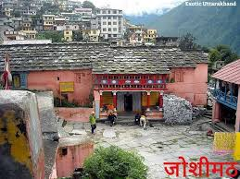
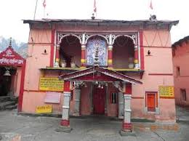 | 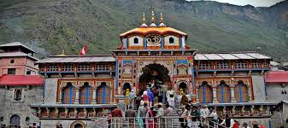
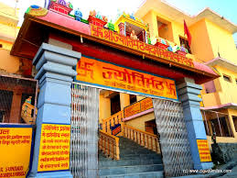 | 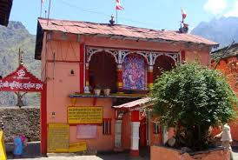
The Joishimath Tample is among the most Famous Religious Places.

Figure 11: Joshimath Tample is among the most Famous Religious Place for Pilgrims.

Hinduism is the state's major religion and is practiced mainly by ethnic Nepalis; an estimated 57.8% of the total populations are adherents of the religion. There exist many Hindu temples. Kirateshwar Mahadev Temple is very popular, since it consists of the chardham altogether.Vajrayana Buddhism, which accounts for 27.3% of the population, is Uttarakhand's second – largest, yet most prominent religion. Prior to Uttarakhand's becoming a part of the Indian Union, Vajrayana Buddhism was the state religion under the Chogyal. Uttarakhand has 75 Buddhist monasteries, the oldest dating back to the 1700s. The public and visual aesthetics of Uttarakhand are executed in shades of Vajrayana Buddhism and Buddhism plays a significant role in public life, even among Uttarakhand's majority Nepali Hindu population. The Figure 11 shows Joshimath Tample is among the most Famous Religious Place for Pilgrims.

Christians in Uttarakhand are mostly descendants of Lepcha people who were converted by British missionaries in the late 19th century, and constitute around 10% of the population. As of 2014, the Evangelical Presbyterian Church of Uttarakhand is the largest Christian denomination in Uttarakhand. Other religious minorities include Muslims of Bihari ethnicity and Jains, who each account for roughly one percent of the population. “The traditional religions of the native Uttarakhandese account for much of the remainder of the population. Although tensions between the Lepchas and the Nepalese escalated during the merger of Uttarakhand with India in the 1970s, there has never been any major degree of communal religious violence, unlike in other Indian states. The traditional religion of the Lepcha people is Mun, an animistpractice which co – exists with Buddhism and Christianity”.

Dances and Music Culturein Uttarakhand

The dances of the region are connected to life and human existence and exhibit myriad human emotions. Langvir Nritya is a dance form for males that resembles gymnastic movements. Barada Nati folk dance is another dance of Jaunsar – Bawar, which is practised during some religious festivals. Other well – known dances include Hurka Baul, Jhora – Chanchri, Chhapeli, Thadya, Jhumaila, Pandav, Chauphula, and Chholiya. Music is an integral part of the Uttarakhandi culture. Popular types of folk songs include Mangal, Basanti, Khuder and Chhopati. These folk songs are played on instruments including dhol, damau, turri, ransingha, dholki, daur, thali, bhankora, mandan and mashakbaja. “Bedu Pako Baro Masa” is a popular folk song of Uttarakhand with international fame and legendary status within the state. It serves as the cultural anthem of Uttarakhandi people worldwide. Music is also used as a medium through which the gods are invoked. Jagar is a form of spirit worship in which the singer, or Jagariya, sings a ballad of the gods, with allusions to great epics, like Mahabharat and Ramayana, which describe the adventures and exploits of the god being invoked. Basanti Devi Bisht, Chander Singh Rahi, Girish Tiwari “Girda”, Gopal Babu Goswami, Heera Singh Rana, Meena Rana, Narendra Singh Negi and Pritam Bharatwan are popular folk singers and musicians from the state, so is country music singer Bobby Cash.

Fairs and Festivals

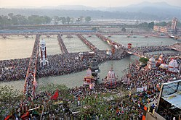

Pilgrims gather for the third Shahi Snan (“Royal Bath”) at Har Ki Pauri in Haridwar, Uttarakhand on 14th April 2010 during Haridwar Kumbh Mela.

One of the major Hindu pilgrimages, Haridwar Kumbh Mela, takes place in Uttarakhand. Haridwar is one of the four places in India where this mela is organised. Haridwar most recently hosted the “Purna Kumbh Mela” from “Makar Sankranti” (14th January, 2010) to Vaishakh “Purnima Snan” (28th April, 2010). Hundreds of foreigners joined Indian pilgrims in the festival, which is considered the largest religious gathering in the world. Kumauni Holi, in forms including Baithki Holi, Khari Holi, and Mahila Holi, all of which start from Vasant Panchami, are festivals and musical affairs that can last almost a month. Ganga Dashahara, Vasant Panchami, Makar Sankranti, Ghee Sankrant, Khatarua, Vat Savitri, and Phul Dei are other major festivals. In addition, various fairs like Kanwar Yatra, Kandali Festival, Ramman, Harela Mela, Kauthig, Nauchandi Mela, Giddi Mela, Uttarayani Mela and “Nanda Devi Raj Jat Mela” take place.

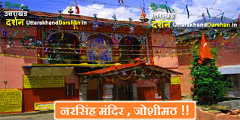 | 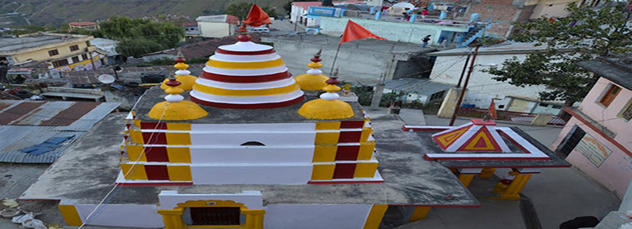
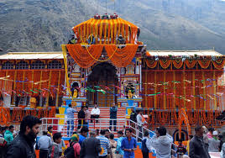 | 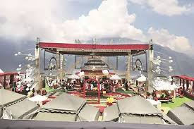
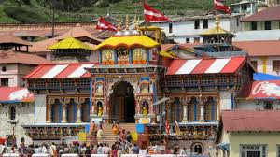 | 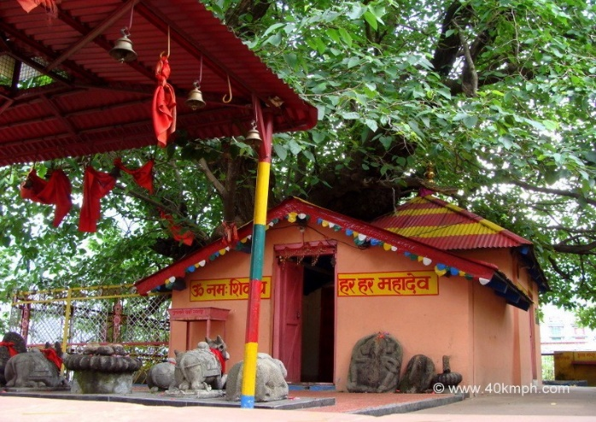
The Traditional Tample Festival of Uttarakhand.

Figure 12: Traditional Tample Festivals of Uttarakhand State.

Uttarakhand's Nepalese majority celebrate all major Hindu festivals, including Diwali and Dussera. Traditional local festivals, such as Maghe Sankranti and Bhimsen Puja, are also popular. The Figure 12 shows Traditional Tample Festivals of Uttarakhand State.

21. Festivals of Uttarakhand – India's Devbhoomi

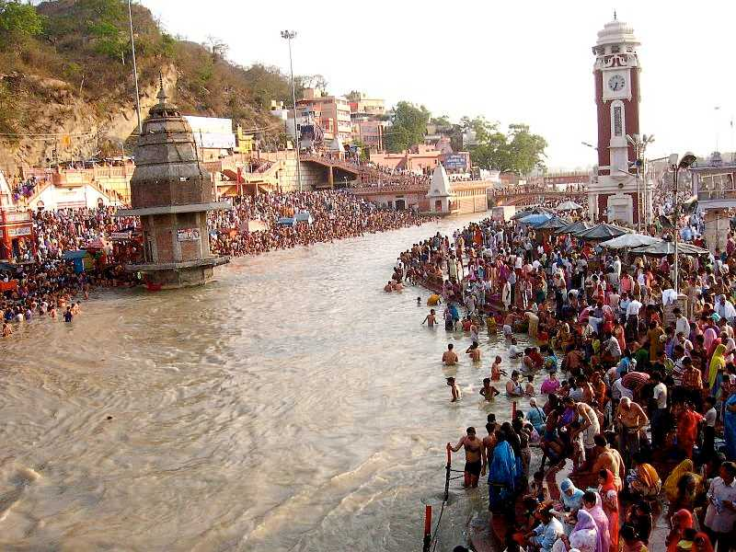
Uttarakhand is popularly known as “Devbhoomi” or the land of “Gods”. It is a very famous pilgrimage site where people come from all parts of India and even the world to immerse in the spiritual and religious environment. From the sacred ghats of Ganga in Haridwar to the snow – capped mountains of Auli, Uttarakhand is viewed as a holy place. It has a varied and vibrant culture as it is home to people of different ethnic groups, tribal communities, and even immigrants. Here, people speak many languages like Hindi, Bhotia, Garhwali, Kumaoni, wear different traditional dresses and also celebrate various festivals. The beliefs and traditions of the Garhwali and Kumaoni people are a significant part of their life and also ascertain their identity. Here is a list of Festivals of Uttarakhand, which are celebrated by the people in full zeal.

1. Kumbh Mela

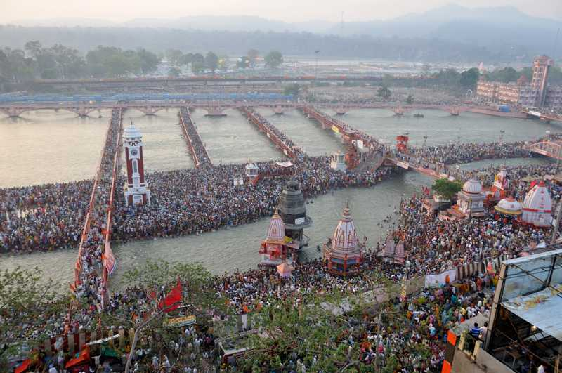

Kumbh Mela is one of the biggest and the most popular festival of Uttarakhand. Although technically it is a mela or fair, it is a significant occasion for the people of this Northern State. It is the largest congregation of pilgrims, which involves taking dips in the river of Ganga to rid oneself of one's sins. Devotees, saints, sadhus, or just onlookers, irrespective of their caste, creed or gender come from across the nation and even from around the world to bathe themselves in the waters of Ganga, hoping to get rid of the cycle of birth and death. This mela is a 3 – monthlong festival and takes place once in every four years rotating between “Allahabad, Haridwar, Ujjain, and Nasik”, i.e., only once in 12 years in any one place. The exact date is picked by Vikrant calendar after elaborate rituals.

It is hard to determine when precisely this festival began although its origins can be found in Hindu mythology. It is believed that “Lord Vishnu” while transporting “Amrit” (Drink of Immortality) to Kumbh, i.e., the sacred pitcher, left drops of it at “Four Places” (The Present Day Holy Places). There is also reference to a battle between devas and asuras for this Amrit in the religious texts, which are cited as the reason for transporting this Amrit to a safe place. The first historical reference to the Kumbh Mela can be found in the writings of the Chinese traveler, Hiuen Tsang who came to India in 600 AD during the reign of “Harshvardhan”. He talked about a gathering on the ghats of Allahabad where people took turns bathing themselves in the river's waters. “Kumbh Mela” of “Haridwar” attracts the most audience and even has a record of hosting the most significant human gathering in the world.

2. Basant Panchami

“Basant Panchami” is the festival, which celebrates the coming of “Basant or Spring” season. It is a significant festival in Uttarakhand. This festival marks the end of winter, a season of death and decay, and is celebrated in the month of Magh or January/ February. The locals dress themselves up in yellow clothing, perform “Chounphula and Jhumelia Dances” and fly kites. They worship “Saraswati”, goddess of knowledge and prosperity and the land. Sweet rice is made in almost every home.

3. Bhitauli and Harela

Among the people of Uttarakhand, every season has some festivals, and each festival is celebrated appropriately. Harela is a festival that marks the beginning of the rainy season or monsoon. The people belonging to the Kumaon community celebrate this festival during the month of “Shravana”, i.e., July – August. Mythologically, this festival commemorates the wedding of “Lord Shiva and Parvati”. People make small idols or dikars of gods like Maheshwar, Ganesh. This festival is followed by another, Bhitauli which is celebrated in the month of Chaitra, i.e., March – April. It revolves around agriculture where women sow seeds in the soil and by the end of the festival they reap the harvest which is called harela. This gives them the opportunity to test the quality of their seeds. During this festival, brothers also provide gifts for their sisters.

4. Holi

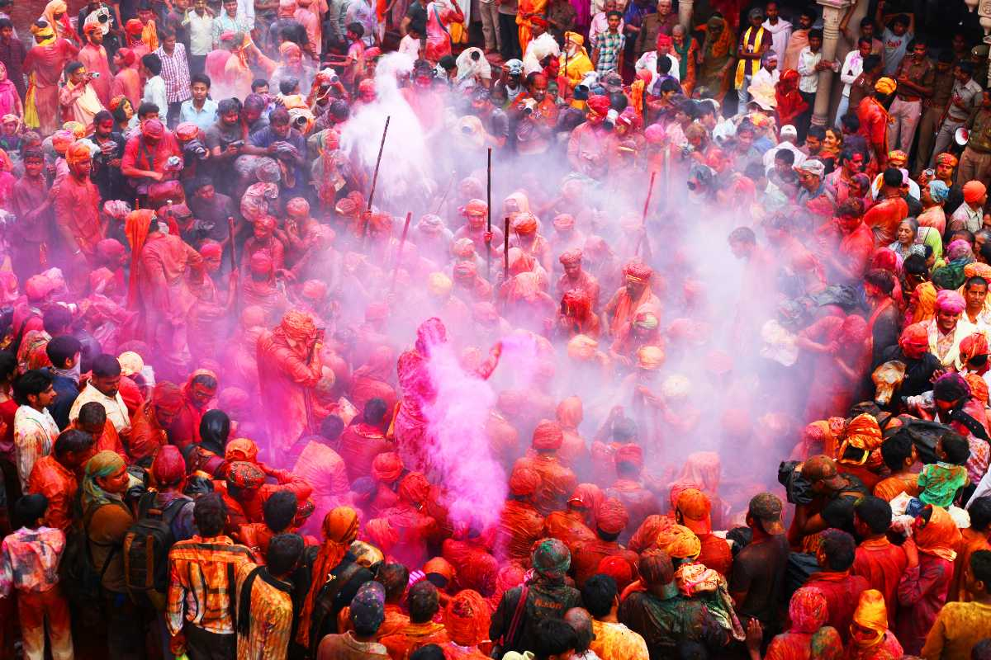

This festival of colours is a big occasion for the people of Uttarakhand. Holi is celebrated with a lot more fervour in the Kumaon region where the celebrations start as early as “Basant Panchami”. As per the mythology, Holi marks the triumph of good over evil. Unlike the plains where “Holika Dahan” (Burning of a Pyre) is an integral part of Holi, in Uttarakhand, as the crop is not harvested yet, ears of grains are not offered to the holy fire. Folk music is another essential part of holi celebrations. “Mahila Holi” involves women singing to their heart’s content; “Khadi Holi” involves the locals donning their traditional clothes, usually observed in rural areas and “Baithiki Holi” requires singing of different classical ragas. “People also make the traditional Gujiya, and Fried Potatoes called Aloo Gutuk, which are served with a Himalayan spice called Jamboo”.

5. Makar Sankranti

Makar Sankranti is a famous festival celebrated in many states of India. For the people of Uttarakhand, this festival marks the change of season. As per the Hindu religious texts, “Makar Sankranti” marks the day of Uttarayani, i.e., the sun has entered the zodiacal sign of “Makar” (Capricorn) from “Kark” (Cancer) and has thus started moving towards the North. On this day, people worship the sun at sunrise and bathe in the river waters. The locals prepare “Khichdi” and til ke laddoo. The popular fair of “Uttarayani” also takes place during this time.

6. Kale Kauva or Ghughutia

During the time of “Makar Sankranti”, the festival of “Ghughutia or Kale Kauva” is also celebrated. The locals prepare sweets made from deep – fried flour in different shapes like knives, swords, etc. By feeding the crows and migratory birds, the locals welcome them and also hope that they come back next year as well. The children also sing songs to attract these migratory birds.

7. Phool Dei

“Phool Dei” is a festival that celebrates the year’s harvest and the coming of the spring season. It takes place on the first day of the Chaitra Season (March – April) as per the Hindu calendar and is also known as the “Harvest Festival”. As the name suggests, it is the time when flowers blossom and this is accompanied by the ceremonial pudding called dei which is made by the locals using jaggery or gud, curd and flour. This dish is an integral part of the festival and young girls are also an integral part of this festival of Uttarakhand. They go from house to house, singing the folk song of “Phool Dei” with offerings of jaggery, rice, and coconut. It is believed that they bless the homes by placing flowers and rice on the doorsteps. In return, the young girls are offered along with sweets and blessings for their act and performance.

8. Ganga Dusshera

“Ganga Dusshera” or “Dasar” is a festival that celebrates the advent of the holy river Ganga from the heaven above. This festival falls on “Dashami” (10th Day: Tenth Day) of the month of Jyeshtha and is a ten – daylong festival. It is observed on the Ghats of Ganga in Haridwar, Rishikesh and Allahabad where devotees take a dip in the river water hoping to rid oneself of their sins for ten consecutive days. This is considered a purification act and “Darshans” are held, and watermelons and kakdi are offered to the deity. Ganga Dusshera is a big festival that attracts a lot of devotees.

9. Kandali

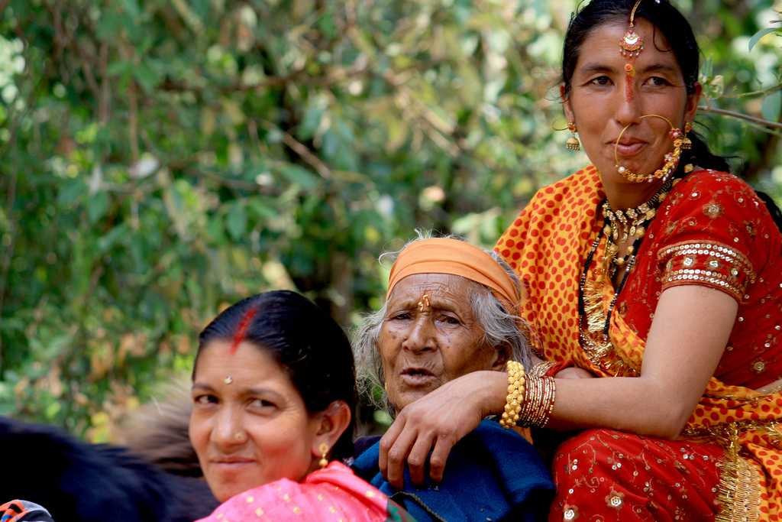

Kandali festival is celebrated by the “Rung Tribe” in the “Chaundans Valley” of “Pithoragarh” district in the Kumaon division. This Uttarakhandi festival marks the flowering of the flower Kandali which blooms only once in 12 years. This festival celebrates the defeat of Zorawar Singh's army, a general of the “Sikh Empire” who tried to invade this region in 1841. As per the local stories, it was the women who defended this region against the soldiers who tried to loot the villages and hid in the Kandali shrub. In this process, the shrub was also destroyed. Another legend states that a young boy died after applying the Kandali plant on his wounds, and subsequently his mother cursed the plant and ordered the women to rip it out of the ground when it reached its full bloom. It is a week – long festival in which the people of the valley worship the idol of “Lord Shiva” made from barley and buck wheat and pray for victories over their enemies. This is followed by puja, a ceremonial feast and then the raising of the flag. Victorious cries are uttered, and the scene of resistance is also recreated. The locals even proceed to attack the shrub of Kandali. Local liquor is also an integral part of this festival. Festivities and celebration take place all night.

10. Bat Savitri

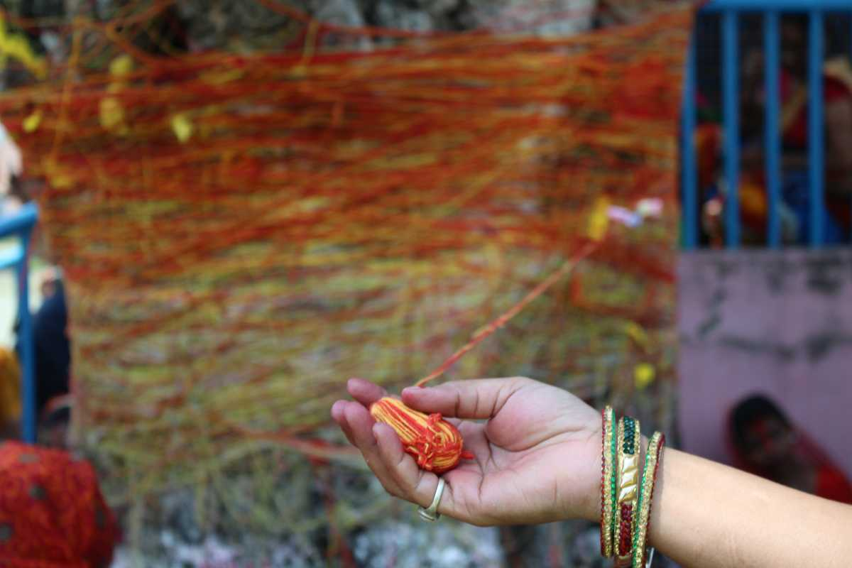
“Bat Savitri” is another famous festival in Uttarakhand. During this, married women fast for an entire day for the welfare and prosperity of their husbands and offer prayers to the deity Savitri and a banyan tree or bat. In the Hindu religion, Banyan tree is considered holy and the origin of this festival can be traced to the Mahabharata in which “Savitri”, whose husband “Satyavan”, died within a year of their marriage, fasts and prays and finally her devotion pays off as her husband returns from the dead. It is under the banyan tree that this act takes place. This festival takes place on “Amavasya” (Day of the Full Moon) in the month of “Jyestha”, i.e., June.

11. Purnagiri Mela

Bearing the name of the temple in which it is held, the “Purnagiri Mela” is a sacred festival that is celebrated to commemorate “Goddess Sati”. At an elevation of over 1,650 m “Above Mean Sea Level” (AMSL), not only do the vibrant colours bring life to the festival, the picturesque views of the Himalayas that are on display are a sight to be hold. In terms of its religious significance, the area in which the Purnagiri Temple is now situated is believed to be the place where the navel of “Sati” and “Savant Prajapati” was cut down by the “Vishnu Chakra” and is also one of the 108 “Siddha Peethas” (Sacred) which is visited by pilgrims throughout the year. This Mela takes place annually during the period of “Chaitra Navratri” and spans for over a period of two months.

12. Syalde Bikhauti Mela

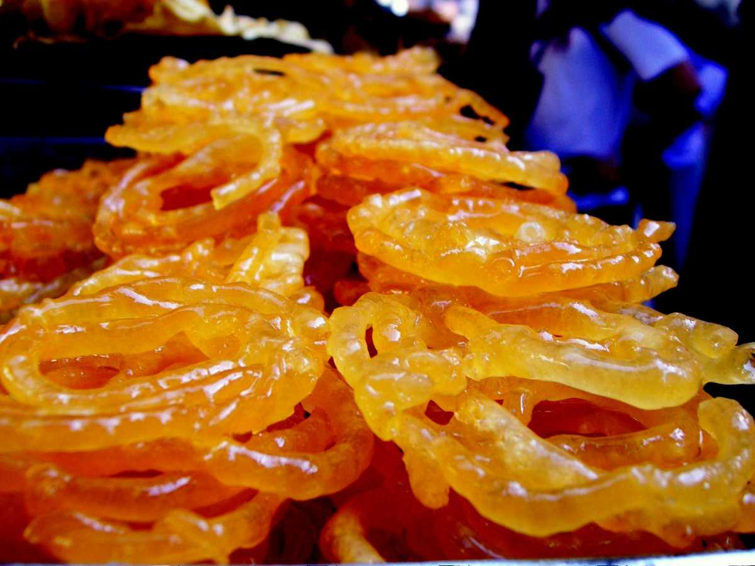

An annual fair that is annually held in the months of April – May in the town of “Dwarahat” (Almora), the Syalde Bikhauti Mela is held in two phases; the first being held in the Vimandeshwar Temple and the other in the Dwarahat market place. During the mela, one can witness folk dances and songs with traditional foliage being adorned by the gathered people. An important ritual, “Oda Bhetna” refers to the striking of the “Stone” (Oda). As per legend, the ancient times saw people worship their deity in a temple nearby and due to some friction between the followers of the two groups, a brawl broke out that lead to bloodshed. The leader of the group that lost the fight was beheaded and a “Stone” (Oda) was placed near it to commemorate the fallen leader. The numerous traditions on display and the lip – smacking Indian delicacy of “Jalebi” being an integral part of the fair, the “Syalde Bikhauti Mela” are one of cultural convergence.

13. International Yoga Festival, Rishikesh

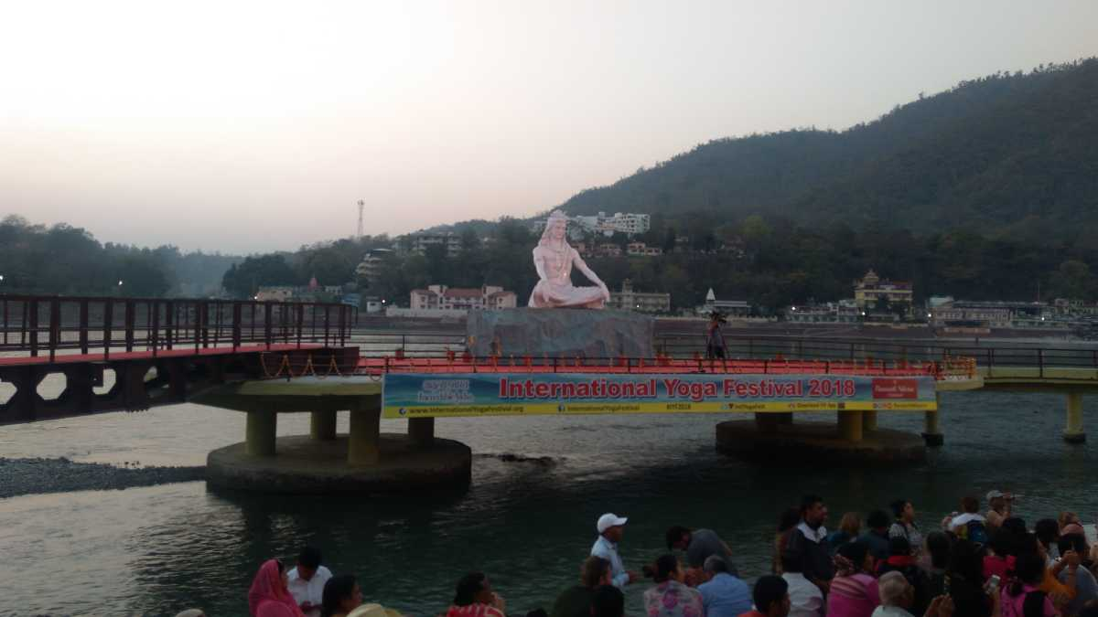

Yoga, the age – old Indian science of mental health and physical well being, sees the gathering of thousands of yoga enthusiasts in Rishikesh to celebrate the techniques devised by sages of yester year. In today's fast – paced life style, Yoga has changed lives via its holistic techniques. The first edition of the “International Yoga Festival” (IYF) was held way back in the year 1999 in the “Parmarth Niketan Ashram”, under the guidance of “Pujya Shri Swami Veda Bharatji” but ever since its inception, it has grown leaps and bounds in terms of its attendees. With the 2019 edition set to be held during 1st – 7th March 2019, one can be assured to celebrating the various aspects of Indian culture via the “Sattvic Food”, “Bhajans” and “Kirtans” and humble abode, features that are sure to arouse your senses. The true religious spirit of Rishikesh is further celebrated as evenings of the week long. The one – week Festival covers over 70 hours of Yoga classes with the general daily program being:

- Classes start at 4: 00 AM.
- One – hour yoga class at 6: 30 AM, followed by a simple breakfast.
- Several two – hour yoga sessions start at 8: 30 AM.
- Inspiring lectures from revered saints and yogacharyas at 11: 00 AM.
- Traditional Indian lunch from 12: 30 PM to 1: 30 PM.
- After a short rest, three Yogasana classes from 3: 30 PM to 5: 00 PM.
- From 6: 00 PM to 7: 00 PM, attend the Aarti, on the banks of the River Ganga.
- Dinner at 7: 00 PM.
- Special evening programs of Satsang, Cultural Song and Dance Performances, Campfires, etc.
- Lights out at 9: 30 PM.

14. Ghee Sankranti

A festival that portrays the gratitude of the locals who earn a living via the occupation of farming by marking the onset of the harvesting season, the Ghee Sankranti also known as the “Olgia” festival, is celebrated on the first day of the month of “August” (Bhado); a time wherein the crops are thriving and the milk – laden cattle are ready to be milked. In terms of how the celebration has gradually evolved from over the years, the ancient tradition saw nephews and sons – in – laws give presents to their maternal uncles and fathers – in – laws respectively. However, today’s context is summarised by the fact that agriculturists and artisans give presents to their land owners. Common presents that are exchanged include axes, ghee, “Datkhocha” (Metallic Toothpick) and firewood. As the name suggests, an important ritual of this festival includes that of eating ghee and chapatis stuffed with urad dal…!!!

15. Hilljatra

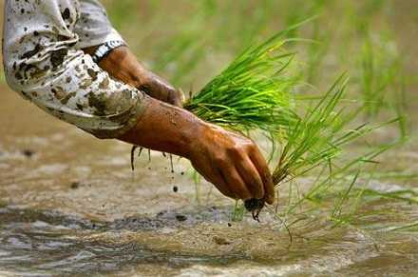
Marked as the festival of pastoralists and agriculturalists, the “Hill Jatra” festival was first observed in India in the Kumaour village. The ceremony is related to the “Ropai” (The Plantation of Paddy), for which one must sacrifice a buffalo to please the Gods who will ensure a good yield for the ongoing farming season. In regards to the actual ceremony, it can be broadly classified under three categories: worship and ritualistic services forming the first set of activities followed by numerous pastoral activities. To conclude the ceremony, songs are recited and people are seen to be wearing marks that express the rich cultural heritage of Uttarakhand. “Traditional Dances” like that of the “Chanchari” are performed, thereby making the entire festival a whole some and immersive experience.

16. Kandali

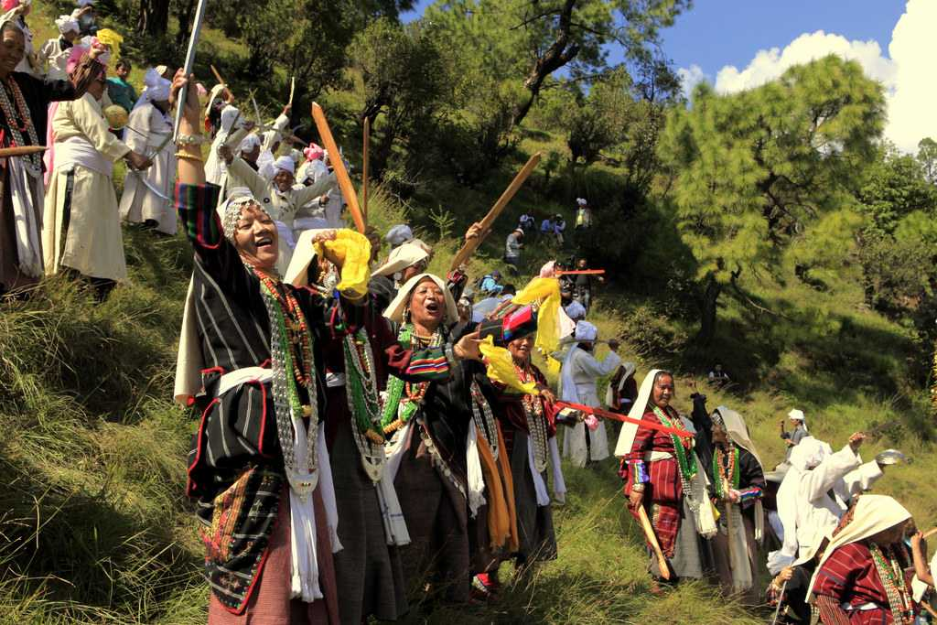

Held in the “Pithoragarh District” of Uttarakhand, the Kandali festival is one that has been known for its cultural appeal and charm over its travelers. Coinciding in the months of August – October, the origin and history behind this festival yet remains unclear; variations include the defeat of Zorawar Singh’s armed forces which had been claimed to have assaulted Pithoragarh in the late nineteenth century.

17. Kanwar Yatra

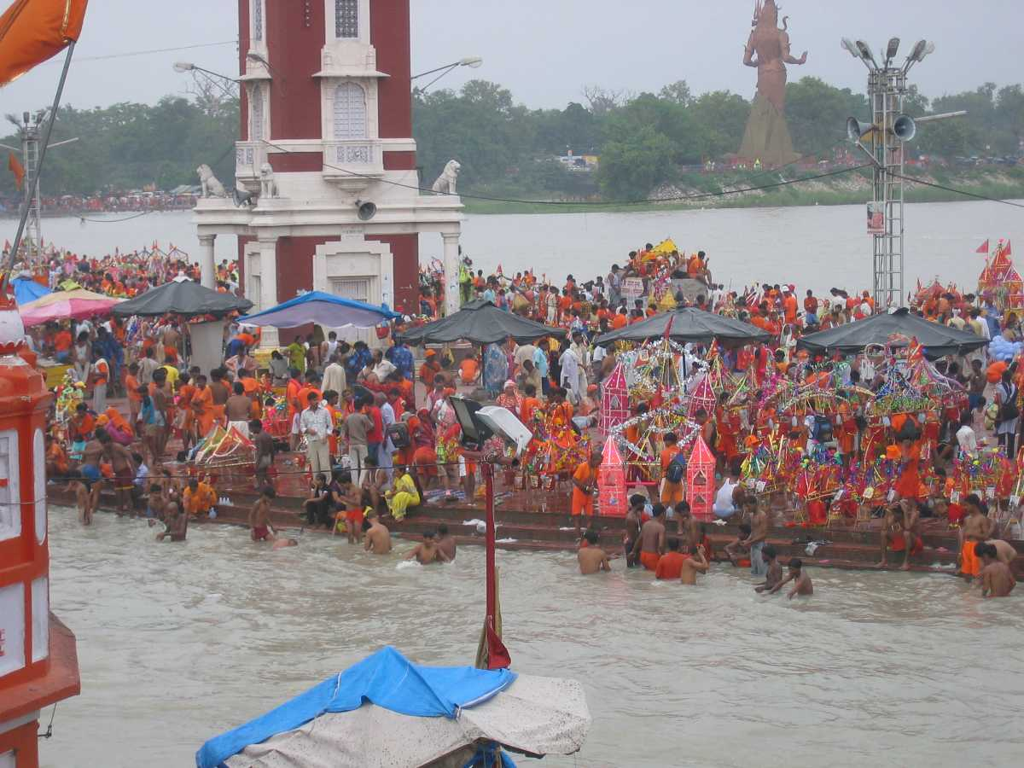

The onset of the Hindu month of “Shravan” (July) marks the commencement of the sacred pilgrimage journey of the “Kanwar Yatra”. During the month – long yatra, millions of devotees of Lord Shiva from all over the country make a journey to the banks of the “River Ganga” (Cities like Haridwar, Gangotri, Gaumukh, etc.) and carry back sacred water from the river to a Shiva temple. The dedication of the devotees is such that they even carry their deity on a “Kanwar” and travel to the holy river bare/ naked Feet. Large camps and gatherings can be seen in Haridwar and Gangotri during the yatra with numerous make shift accommodations that are constructed across the journey for the Kanwarias to rest. The magnanimity of the event can be fathomed when considered that the gathering on the ghats of the River Ganga in Haridwar has been recorded as one the biggest human gatherings in India.

18. Bissu Mela

Organized in the “Chakrata Block of Dehradun”, the “Bissu Mela” is an expansive fair that is celebrated by the “Jaunsari Tribe”, whose origins can be traced back to that of the “Pandavas”. Celebrated for over the period of a week in virtue of a good harvest season in Uttarakhand, a major attraction of the fair sees villagers from all over gather together to shower their love and affection to “Santoora Devi”, an incarnation of “Goddess Durga”. One can indulge in the cultural diversity by grooving to the folk music wherein men and women sport vivid and flam boyant traditional clothes while bringing to life lost traditions for the younger generations to feast upon.

19. Nanda Devi Raj Jat Yatra

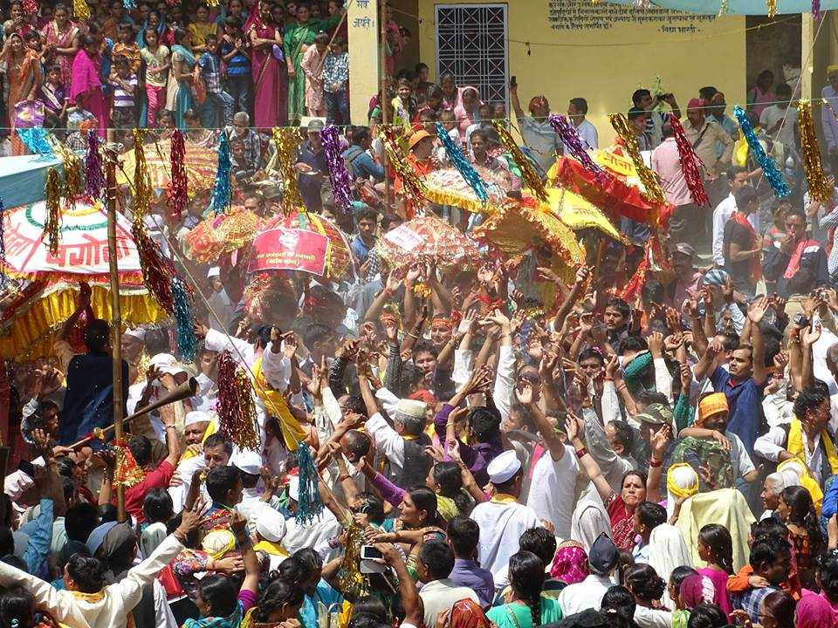
Also known as the “Himalayan Mahakumbh”, this festival marks a commemoration to Goddess Nanda Devi wherein devotees from both the Garhwal and Kumaon regions of Uttarakhand come together to be a part of the sacred yatra. Held for duration of three weeks and being organized once in every twelve years, the “Nanda Devi Raj Jat Yatra” which spans over 280 Km takes almost 22 days to complete. During this yatra, all sections of the society take part – dalits play drums, thakurs blow bhankauras, and Brahmins take care of ceremonial parasols.

20. Magh Mela

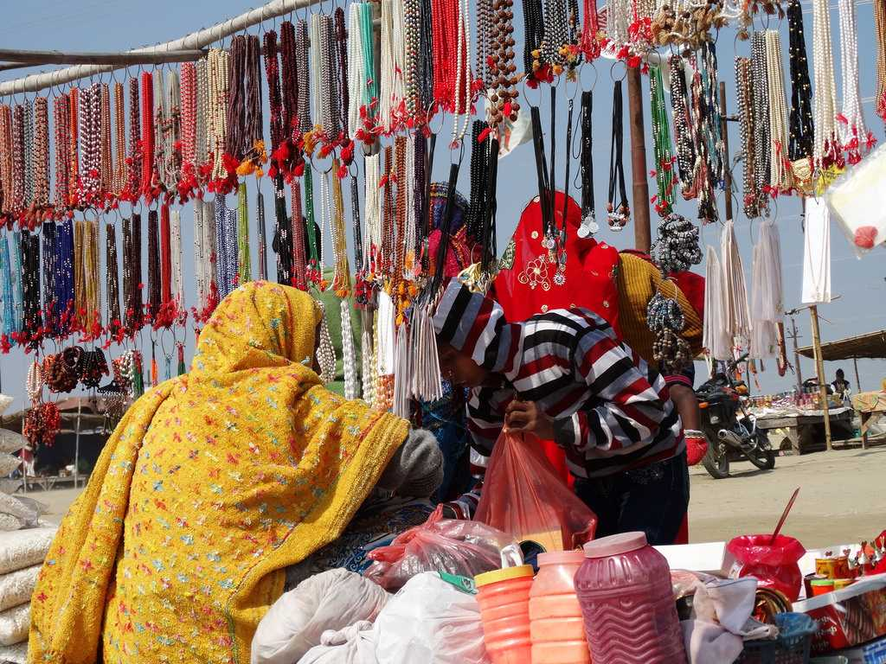

Known to be one of the most popular fairs in the “Uttarkashi District” in Uttarakhand, the “Magh Mela” is a religious fair that has gradually become an important source of income via tourism. Held during the month of January, (14th – 21st January) dolis or palanquins carrying the deity, are seen flocking to the “Ramlila Ground” where devotees immerse themselves in the river Ganga. A fair which exhibits local produce and handicrafts of local artisans from all over Uttarakhand, in the modern time is not restricted to Uttarkashi district – a skiing ground being prepared in “Dayara Bugyal”, a premier meadow in India.

21. Uttarayani Mela

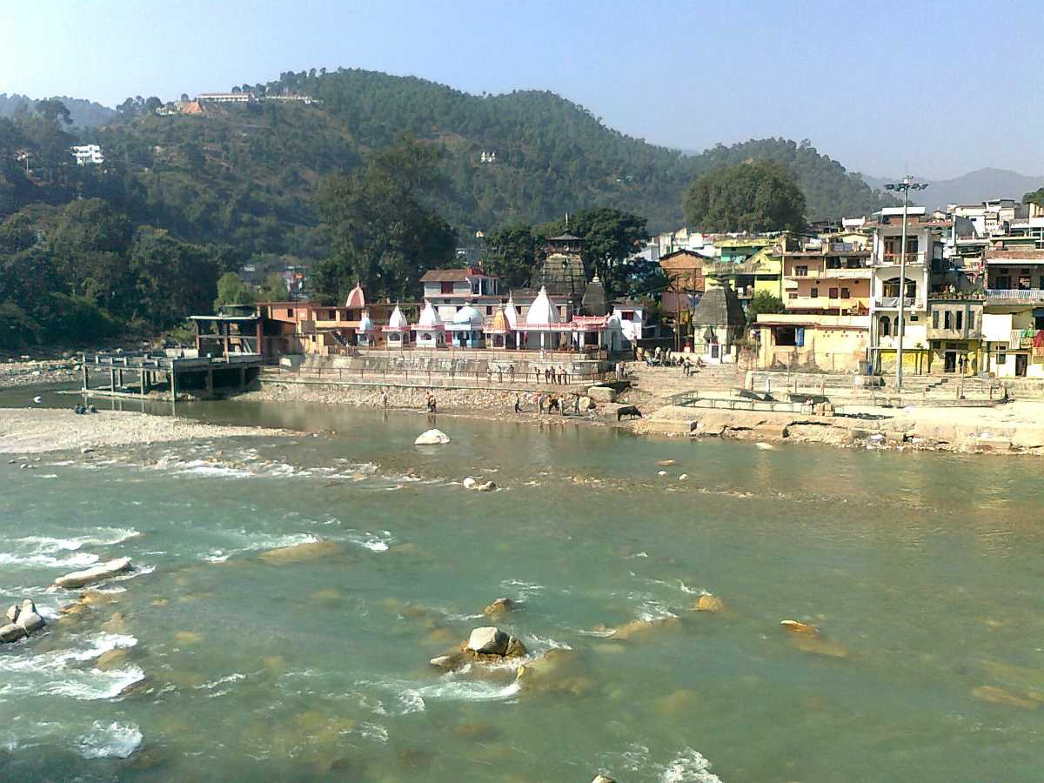
The second week of January, the auspicious day of “Makar Sankranti” marks the onset of the “Uttarayani Mela” which is held in the Kumaon region of “Uttarakhand” (Bageshwar, Ranibagh, Hanseswari and so forth). The Bagnath Temple in Bageshwar serves as the ground for the fair which usually spans for a week. Festivities and cultural heritage of the area is illustrated by a plethora of local artists singing “Jhoras, Chancharis and Bairas” (Folklore). Local produce such as iron and copper vessels, baskets, casks, mattresses and many more items can be purchased while at the fair. According to the local people of the area, when the sun moves from the Southern Hemisphere to the Northern Hemisphere, a dip in the water of the river is reckoned to be auspicious and claims to cleanse the spirit. Uttarakhand is home to people of varied culture, but many of their festivals revolve around harvest and agriculture, which is an integral source of their livelihood.

Cuisine (Kumaoni)

Bal Mithai, a Popular Sweet from Uttarakhand.

The primary food of Uttarakhand is vegetables with wheat being a staple, although non – vegetarian food is also served. A distinctive characteristic of Uttarakhand cuisine is the sparing use of tomatoes, milk, and milk – based products. Coarse grain with high fibre content is very common in Uttarakhand due to the harsh terrain. Crops most commonly associated with Uttarakhand are Buck wheat (locally called Kotu or Kuttu) and the regional crops, Maduwa and Jhangora, particularly in the interior regions of Kumaon and Garhwal. Generally, either Desi Ghee or Mustard Oil is used for the purpose of cooking food. Simple recipes are made interesting with the use of hash seeds Jakhiya as spice. Bal Mithai is popular fudge – like sweet. Other popular dishes include Dubuk, Chains, Kap, Bhatiya, Phana, Paliyo, Chutkani and Sei. In Sweets; Swal, Ghughut/ Khajur, Arsa, Mishri, Gatta and Gulgulas are popular. A regional variation of Kadhi called Jhoi or Jholi is also popular. The Figure 13 shows Uttarakhand’s Traditional Food – based Dishes like Kafuli/ Kapaa, Phaanu, Baadi, Chainsoo, Rus/ Thhatwani, Dubuk/ Dubke, Jhangore ki Kheer, Sisunaak Saag and Chudkaani.

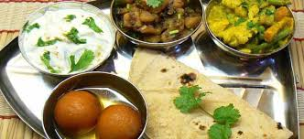
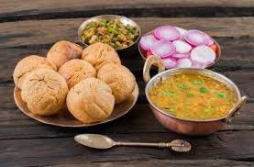
Aaloo ke Gutke. One of the Basic and Most Popular Dishes in Uttarakhand, Aaloo (Potatoes) ke Gutke is a Simple Preparation where dry Spices are Roasted and Used.

Figure 13: Uttarakhand’s Traditional Food – based Dishes like Kafuli/ Kapaa, Phaanu, Baadi, Chainsoo, Rus/ Thhatwani, Dubuk/ Dubke, Jhangore ki Kheer, Sisunaak Saag and Chudkaani.

Media

Every state advocates a number of newspaper houses and Uttarakhand is no exception to it. Uttarakhand boasts of 31 daily publications. Many papers come from the cities of Uttarakhand, but some of them are also published from the hilly sub urban areas. The more one state or country grows in literacy rate the more the people of that place feel the urge to read newspapers. Uttarakhand newspapers can be called to be the mirror of Uttarakhand. The application of news is expected to be unbiased as this is the major weapon in reflecting and transforming the society. The major houses of newspapers in Uttarakhand are mainly located in Haridwar, Tehri, Pauri Garhwal, Nainital, Udhamsinghnagar and Dehradun. Most of the Uttarakhand newspapers give stress on local news to draw the attention of the locals. But the quality of the papers and the news as well are not up to the mark for most of the papers. The houses of newspapers at Uttarakhand are not economically conscious that could be guessed from the less number of ads in their newspapers though the pink paper Doon Classified stands as an exception. Among the Uttarakhand newspapers “The Hawk” comes out both in English and Hindi from Dehradun and Haridwar which enjoys huge popularity from both its native places. Valley Mail is another paper in Hindi with an English name which contains four pages. The “Himachal Times” is one of the prominent newspapers of Uttarakhand. It is a newspaper which has achieved a remarkable recognition in its style of news presentation. Online media covering Uttarakhand’s Figure 14 shows Buddha Temple Dehradun, Clement Town Places to Visit… Le monastère de Mindrolling Uttarakhand.
To name some other newspapers of Uttarakhand are:

- Kavita Express;
- Apne Log;
- Khabar Laye Hai;
- Daily Shikhar Sandesh;
- Uttarakhand Ki Ore;
- Seemant Varta;
- Garhwal Post etc.

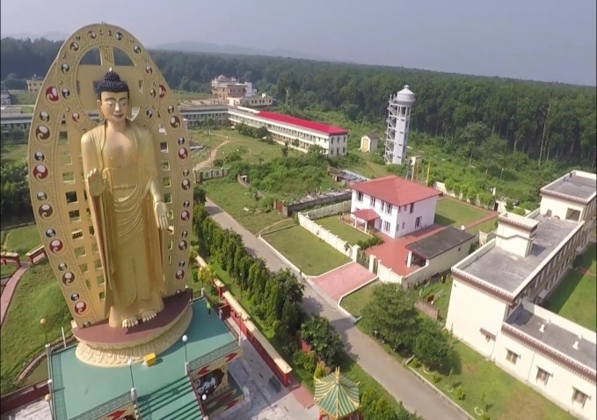 | 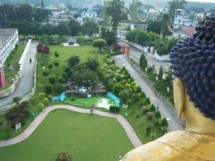
Buddha Temple Dehradun Clement Town Places to Visit in Uttarakhand. | Famous Lover's Point in Dehradun – The Place to Spend Time Together.
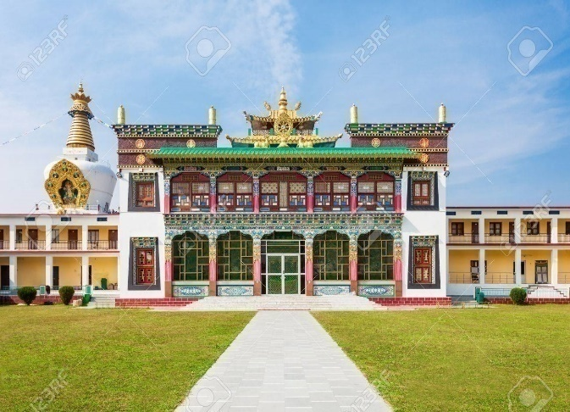 | 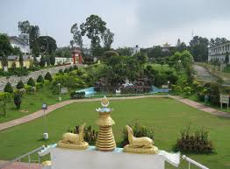
Le monastère de Mindrolling est un monastère tibétain situé près de la ville de Clement, à Dehradun, dans l'état d'Uttarakhand, en. | Buddha Temple – Dehradun Uttarakhand, India.

Figure 14: Buddha Temple Dehradun, Clement Town Places to Visit… Le monastère de Mindrolling Uttarakhand.

Education in Uttarakhand

“Uttarakhand Technical University” is one of the own Technical University of Uttarakhand was established in 2004. The University is situated in Dehradun the capital city of Uttarakhand, earlier all the Technical Colleges in Uttarakhand were affiliated to UP Technical University situated in Uttar Pradesh. Then after the formation of Uttarakhand the government finds the need for separate technical university for technical colleges in Uttarkhand so for this purpose new technical university was formed by the name “Uttarakhand Technical University” in 2004. The Admission to various courses offered by the colleges affiliated to Uttarakhand Technical University is done on the basis of a State Entrance Examination usually conducted in the month of June. The admission notice for the same is published in all the major state dailies. Entrance Exam Forms are usually available in 2nd week of April. The Figure 15 shows Technical Universities Campus in Pauri, Dehradun and Uttarakhand. The Uttarakhand Technical University, Dehradun was established on 27th January 2005 by Govt. of Uttarakhand through the Uttarakhand Technical University Act 2005. The Uttarakhand Technical University campus is situated at NH – 72 Suddhowala, Dehradun. Dehradun is the State capital of Uttarakhand well connected through Rail, Road and Air Transport.

The University has been established in an area of 8.372 hectare and it is the only affiliating University of the state for technical institutions. There are 8 Constituent and 132 affiliated colleges with 33,000 students in various courses. The University imparts education in Graduate, Post Graduate and Doctorate programmes in various disciplines like Management, Engineering, Hotel Management, Computer Application, and Pharmacy etc. The University is serving the technical education through its progress monitored each semester, part time Ph. D. programme especially designed for the teachers and scientists by giving them opportunity to explore the untouched area of the research. The University is in its own campus running M. Tech. and M. Pharma Programme in various disciplines. Apart from this University is having 8 Constituent Colleges. “Spreading Technical Education” (STE) is in the remote under privileged area of Uttarakhand hills.

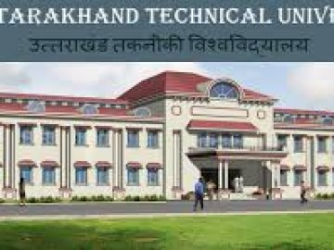 | 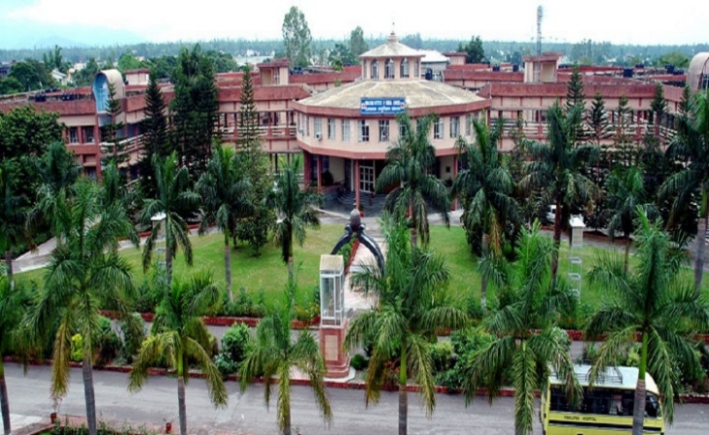
Uttarakhand Technical University. | Uttarakhand University of Horticulture and Forestry – [UUHF], Pauri, Uttarakhand.
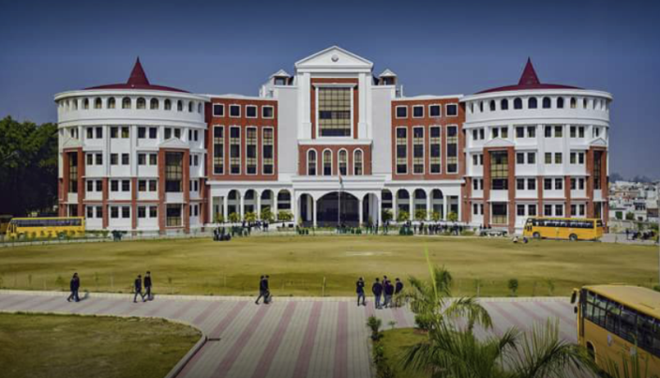 | 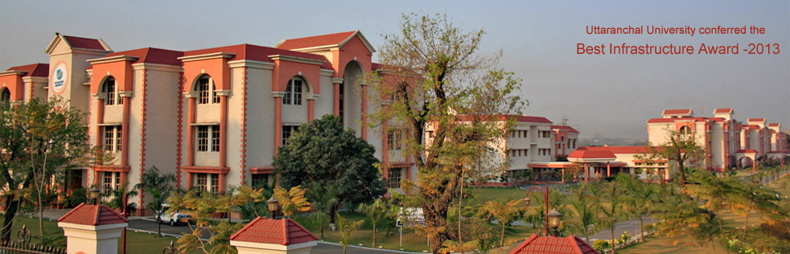
Graphic Era Hill University Dehradun Campus (GEHU), Dehradun. | Uttaranchal University.
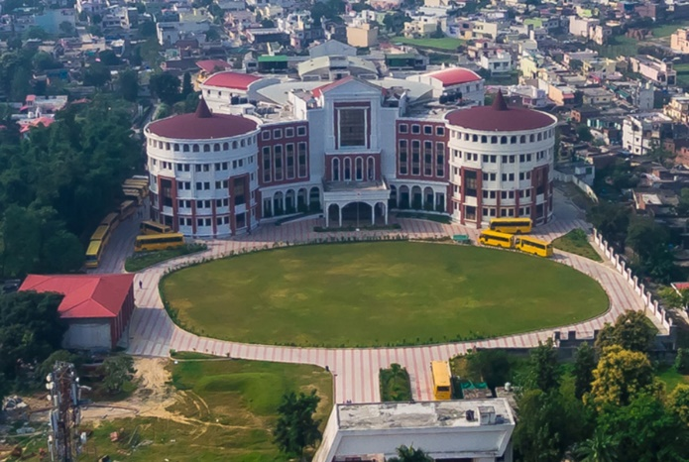 | 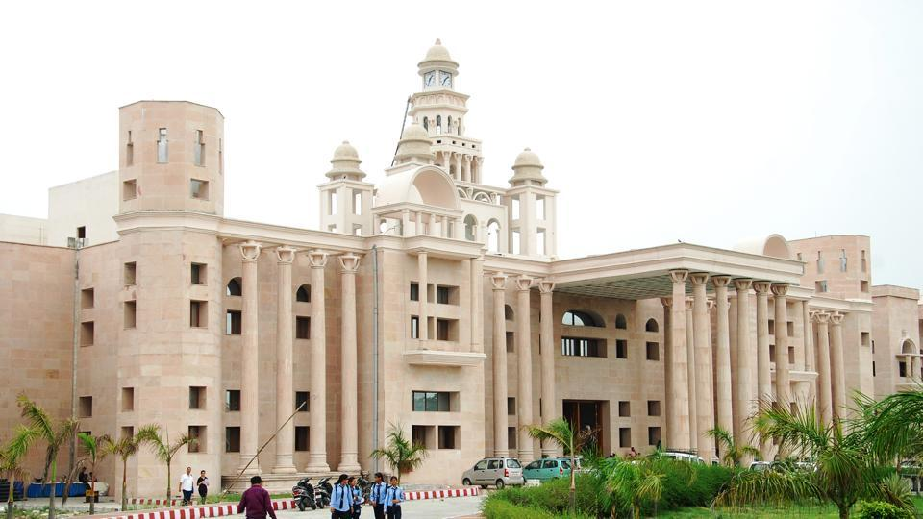
Graphic Era Hill University, Dehradun. | Uttarakhand Technical University.

Figure 15: Technical Universities Campus in Pauri, Dehradun and Uttarakhand.
Pavement Condition

The existing road has CL – 9 specifications from 00+000 Km to 18+530 Km with bituminous surface, Carriageway width is 3.50 m to 3.75 m and condition of the pavement is varying from Poor to Very Poor along the road and condition of shoulders is also very poor. The existing alignment passing through the mountainous steep terrain and the existing hill slope vary from 10° to 85°. The existing road has an intermediate lane configuration from 00.000 Km to 17.560 Km. total length of the road as per remote sensing and the total Sq. Km. Area as per 5 Km. buffer boundary is 53,483 Km² and carriageway width 5.5 m bituminous surfaces and cement concrete surfaces and condition of the pavement is varying from poor to fair and having shoulder width of 1.0 m to 1.5 m on either side along the road and condition of shoulders is also poor and covered with vegetation. The entire project road traverses between hilly and mountainous terrains (Table 18). Char Dham Expressway National Highway (चार धाम महामार्ग), is a proposed two – lane (in each direction) Express National Highway with a minimum width of 10 Metres in the state of Uttarakhand. The total cost of INR ₹12,000 crores and the foundation stone of the project was laid by Route Alignment Autorities/ Experts. Distance between New Delhi to Dehradun is 248 Km by Road and journey takes approximately 05 Hours and 50 minutes (248.00 Km) via Expressway National Highway (चार धाम महामार्ग) and 305 Km by Rails and Aerial distance is 202 Km only. The driving distance between Dehradun and Nainital is 270 Km, while the aerial distance from Dehradun to Nainital is 170 Km. There is/ are nearly 1 direct bus (es) playing between Dehradun to Nainital. These buses (es) is/ are State Transport Bus etc. The minimum time a bus takes to reach Nainital from Dehradun is 06 hours 27 minutes. The fastest way to reach Nainital from Dehradun takes around 05 hours 15 minutes, which is to take a taxi from Dehradun to Nainital. The cheapest way to reach Nainital from Dehradun takes you 12 hours 02 minutes, which is to take Ddn Kgm Express from Dehradun to Kathgodam then take State Transport Bus from Kathgodam to Nainital. There is/ are 9 direct train (s) from New Delhi to Dehradun. These train (s) is/ are Ddn Janshtbdi (12055), Dehradun Shtbdi (12017), Nanda Devi Express (12205), Dehradun Express (12687), Ind Ddn Express (14317) etc. The minimum time a train takes to reach Dehradun from New Delhi is 05 hours 50 minutes. The cheapest way to reach Dehradun from New Delhi takes around 05 hours 50 minutes, which is to take Ddn Janshtbdi from New Delhi to Dehradun. The fastest way to reach Dehradun from New Delhi takes approximately 00 hours 55 minutes, which is to take from New Delhi to Dehradun. “Uttarakhand is located between 28°43' N to 31°27' N latitude and 77°34' E to 81°02' E longitude and has an area of 53,483 Km² (20,650 Sq. Mi.) and the highest elevations are covered by ice and bare rock. Mount Nanda Devi is the Highest Peak of Uttarakhand with the altitude of 7,816 m above sea level”.

Table 18: List of Villages with Length.

Sr. No. | Location | Location | Length (m) | Name of Village/ Town
 | From | From
A | B | C | D | E
1. | 9+650 | 9+650 | 250 | Farkiya
2. | 12+300 | 12+300 | 700 | Bampa
3. | 14+500 | 14+500 | 250 | Ghamsali

Geometrics

The horizontal alignment of the Project traverses through Hilly terrain in its entire length. It is essential to improve substandard geometrics at various locations on project road. Geometric improvements shall be made as per standard and specifications. In order to upgrade the road to the geometric requirements commensurate with the design speed, improvement has been proposed for the Project Road. The alignment passes through several villages and habitation areas of which some have built – up sections. The improvement works, consist of the existing intermediate lane carriageway to 2 lane with paved shoulder Carriageway (10.0 m Width) of Rigid pavement with hard shoulder of 2.0 m on either side of rural section and intermediate lane to 2 lane with paved shoulder of 2.50 m Carriageway (12.0 m Width) of Rigid pavement on either side on built up section. The surface and subsurface drainage system shall be planned as per IRC SP: 42 – 1994. A camber of 2.5% shall be provided in main carriageway and minimum longitudinal gradient of 0.05% in rural areas and 0.2% in urban shall be provided for smooth surface runoff. Longitudinal lined/ unlined drain shall be provided near ROW in scattered built up section with outlets to cross drainage structures.

8. ENVIRONMENTAL CHECKLIST

RAPID ENVIRONMENTAL ASSESSMENT CHECKLIST
ROADS AND HIGHWAYS

INSTRUCTIONS

(i) The project team as “Environmental Expert/ Specialist” completes this checklist to support the environmental classification of a project. It is to be attached to the environmental categorization form and submitted to the Ministry of Environment and Forest and Climate Change (MoEF & CC) for concern nodal/ zones/ regional officer or expert/ specialist.

(ii) Answer the questions assuming the “Without Mitigation” case. The purpose is to identify potential impacts on its environment and surrounding areas. Use the “Remarks” section to discuss any anticipated mitigation measures and Rapid Environmental Assessment Checklist/ Initial Environmental Examination (IEE) Report is shown in Table 19.

Table 19: Rapid Environmental Assessment Checklist.

Country/ Project Title | India: Uttarakhand State  Sub – Project: Initial Environmental Examination Report for: Kurkuti – Ghamsali – Niti, Road
Sector Division/ Section | Road and Transport Government of India (GOI)
Screening Questions | Yes | No | Remarks
A. Project Site
Is the project area adjacent to or within any of the following environmentally sensitive zones/ sites/ areas? |  | X | No environmentally sensitive zone/ site is located within the projected road;
Cultural Heritage Site; |  | X | No archaeologically protected monument or cultural heritage site/ zones is located within the road;
Protected Area; |  | X | No protected areas are located/ placed close to roads and nearby zones/ areas;
Wetland Area; |  | X | No protected or classified wet land is located close to roads and nearby surrounding areas;
Mangrove Cover/ Area; |  | X | Project road is not located in Coastal Areas;
Estuarine Locality/ Area; |  | X | No Estuarine is located in the Project Area;
Buffer Zone of Protected Area; |  | X | No such area is located in the Project Vicinity;
Special Area for Protecting Biodiversity; |  | X | No such area is located in the Project Vicinity;
B. Potential Environmental Impacts
Encroachment on historical/ cultural areas; disfiguration of landscape by road embankments, cuts, fills, and quarries? |  | X | The area is no mountainous throughout the proposed alignment and there is no human settelment nor any historical/ cultural places. So there no human encroachment;
Encroachment of precious ecology (e.g., Sensitive or protected areas)? |  | X | Attempts have been made to minimizing the cutting of trees while finalizing the road widening options, but we didn't found any sensitive or procted area in the projected area;
Alteration of surface water hydrology of waterways crossed by roads, resultingin increased sediment in streams affected by increased soil erosion at construction site? |  | X | The proposed alignment is crossing only small natural drains. All drainage courses will be maintained to avoid alteration in surface water hydrology so that water courses are not affected. The temporary soil stockpiles will be designed so that runoff will not induce sedimentation of waterways. Silt fencing during construction will be provided. To mitigate this problem the environmental management plan is already in corporated with their mitigation method;
Deterioration of surface water quality due to silt runoff and sanitary wastes from worker – based camps and chemicals used in construction? |  | X | Adequate sanitary facilities including “Soak Pits Treatment (SPT)”, facilities will be provided at construction camps, which will be set – up away from habitat and water bodies. No harmful ingredients are likely to be used in the construction activities. Surface water quality is not impacted due to construction. Measures like embankment slope stabilization, “Reinforced Cement Concrete (RCC)”, retaining walls are proposed to prevent siltation of ponds located next to the road due to surface runoff;
Increased local/ regional areas air pollution due to rock crushing, cutting and filling works and chemicals from asphalt processing? |  |  | Regional/ local/ on site“Air Pollution Level (APL)”, will be high during construction period due to structure/ road construction work; vehicle movementsand asphalt processings etc. The Asphalt Mixing Plant (AMP) OR Hot Mix Plant (HMP) will be located away from habitat areas adequetly high stack for effective dispersion of likely Dust Emissions. Separation measures like spraying of water on unpaved vehicle movement areas are proposed to minimize the dust generation. To mitigate this problem the Environmental Management Plans (EMPs)are already in corporated with their mitigation methods and measures;
Risks and vulnerabilities related to occupational health and safety due to physical, chemical, biological and radiological hazards during project construction and operation? |  |  | Workers may get exposed to dust and noise during construction activities. However, the exposure levels are likely to be short and insignificant. Workers will be provided requisite Personal Protective Equipments (PPEs) to minimize such exposure and associated harmful occupational health effects. To mitigate this problem the Environmental Management Plan is already in corporated with their mitigation methods;
Noise and vibration activities due to blasting and other civil works on site construction of roads/ bridges and valuable residential and commercial structures establishments? |  | X | No blasting is involved. No significant noise generation is expected during construction activities except normal construction equipment operational noise. These noise levels will be impulsive in nature and its impact will be confined within few Meters of either side of the road. All stationary noise making sources equipment like DG set, compressors will be installed with acoustic enclosures/ mufflers/ silencers to reduce noise level on site if specified for the region or state.

9. STATUTORY CLEARANCES REQUIRED

The Environmental Impact Assessment/ Statement (EIA/ S) process adopted will follow regulations of Government of India (GOI) and Uttarakhand Government. As per current policy since the project is more not more than 100 Km in length so the MOEF notification will not apply and need no Environmental Impact Assessment/ Statement (EIA/ S) Clearances. Table 20 presents clearances required under the proposed project for roads network area.

Table 20: Required Statutory (EIA/ S) Clearances.

Sr. No. | Act / Rules | Purpose | Applicable Yes/ No | Authority
1. | Environment Protection Act (EPA) – 1986. | To protect and improve overall environment. | No | MOEF; GOI; DOE; SPCB
2. | Environmental Impact Assessment Notification (EIAN) 14th September, 2006. | To provide environmental clearance to new development activities following environmental impact assessment. | No | MOEF; (EIAN)
3. | Notification for use of Fly Ash (NFA). | Reuse large quantity of fly ash discharged from thermal power plant to minimize land use for disposal. | Yes | NFA
4. | Coastal Regulation Zone (CRZ) Notification 1991 (2002). | Protection of fragile coastal belt. | No | CRZN
5. | National Environment Appellate Authority Act, (NEAA) 1997. | Address grievances regarding the process of Statutory Environmental Clearance (SEC). | No | NEAA; SEC
6. | The Land Acquisition Act (LAA) – NH – 1956. | Set out rule for acquisition of land by government. | Yes | Revenue Department; LAA
7. | MOEF Circular on Marginal Land Acquisition and Bypasses 1999. | Defining “Marginal Land”  Acquisition relating to the 1997 Notification (MLAN). | No | MOEF; MLAN
8. | The Forest (Conservation) Act – 1927; The Forest (Conservation) Act – 1980; Forest (Conversion) Rules –1981. | To check deforestation by restricting conversion of forested areas into non – forested areas. | Yes | Forest Department; Government of Haryana (GOH)
9. | Wild Life Protection Act – 1972. | To protect wildlife through certain of National Parks and Sanctuaries. | No | CCF; Department of Forest; (GOH)
10. | Air (Prevention and Control of Pollution) Act – 1981. | To control air pollution by and Transport Controlling Emission of Air Department (TCEPA). Pollutants as per the prescribed standards. | Yes | GO UP; SPCB; TCEPA
11. | Water Prevention and Control of Pollution) Act – 1974. | To control water pollution by controlling discharge of pollutants as per the prescribed standards. | Yes | (GOH); SPCB
12. | Noise Pollution (Regulation and Control Act) 1990. | The standards for noise for day and night have been promulgated by the MOEF for various land uses. | Yes | MOEF; (GOH); SPCB
13. | Ancient Monuments and Archaeological Sites and Remains Act – 1958. | Conservation of cultural and historical remains found in India. | No | ASI; GOI
14. | Public Liability and  Insurance Act (PLIA) – 1991. | Protection form hazardous materials and accidents. | Yes | PLIA
15. | Explosive Act – 1984. | Safe transportation, storage and use of explosive material. | Yes | Chief Controller of Explosives
16. | Minor Mineral and concession Rules (MMCR). | For opening new quarry. | Yes | District Collector; MMCR
17. | Central Motor Vehicle Act –1988 and Central Motor Vehicle Rules (CMVR) – 1989. | To check vehicular air and noise pollution. | Yes | Motor Vehicle Department; CMVR
18. | National Forest Policy 1952; National Forest Policy (Revised) 1988 (NFP). | To maintain ecological stability through preservation and restoration of biological diversity. | Yes | Forest Department; GOI; and (GOH); NFP
19. | The Mining Act (MA) – 1989. | The mining act has been notified for safe and sound mining activity. | Yes | Department of Mining (DOM); MA

Widening Proposal

The proposed widening has been carried out through considering social and environmental aspects of the project. Concentric widening has been proposed in built – up portion to save acquisition of road side established or installed residential and commercial structures. Likewise eccentric widening (LHS or RHS) has been proposed in open areas to save tree from the other side. In other words, only one side tree requires to be felled. Out of total Existing Length 17.56 Km. length concentric widening is Proposed for about 17.56 Km. mainly in built – up locations shown in Tables 21, 22, 23 (a) and (b).

Table 21: Pavement Crust Thickness for Widening and New Construction.

Description | Proposed
Pavement Crust Thickness for Widening and New Construction | Rigid Pavement: PQC – 300 mm (M40); DLC – 150 mm (M15); Drainage + GSB – 225 (150+75) mm; Sub – Grade – 500 mm | Overlay: BC – 40 mm; DBM – 50 mm

Table 22: Chainage References of Village Community/ Town (Kurkuti – Ghamsali – Niti Road).

Sr. No. | Existing Chainage (Km) Starting Point | Existing Chainage (Km) Ending Point | REMARKS  Name of Village/ Town/ Bypass/ Area
 | From | To
A | B | C | D
1. | Kurkuti Chainage: 00+000 Km  E – 82.5646°  N – 21.3199°  Z – 3139 or 10298.56 Feet | Niti Chainage: 18+530 Km  E – 79.8412°  N – 30.7776°  Z – 5,070 m or 16633.86 Feet | Kurkuti – Ghamsali – Niti Road

Table 23 (a): Chainage of References Village (Kurkuti – Ghamsali – Niti Road).

Sr. No. | Existing Chainage |  | Length (m) | Land Use (Built – Up/ Agriculture/ Forest/ Industrial/ Barren) | Name of Village/ Town
 | Start | End
A | B | C | D | E | F
1. | 9+650 | 9+900 | 7.40 | Built – Up | Farkiya
2. | 12+300 | 13+000 | 7.40 | Scattered Built – Up | Bampa
3. | 14+500 | 14+750 | 7.00 | Scattered Built – Up | Ghamsali

Table 23 (b): Chainage of References Junction (Kurkuti – Ghamsali – Niti Road).

Sr. No. | Existing Chainage | Destination of Cross Road or Railway | Road Side | Type of Junction
A | B | C | D | E
1. | 0+000 | Sumna | RHS | Y
2. | 1+080 | Kailashpur | RHS | Y
3. | 3+050 | Mehargoan | RHS | Y
4. | 5+650 | Gurguti | LHS | Y
5. | 7+125 | Army Training Camp | LHS | Y
6. | 9+590 | Farkiya Village | LHS | T
7. | 12+310 | Bampa | RHS | Y
8. | 12+500 | Panchanag Temple | LHS | T
9. | 12+980 | Bampa | RHS | Y
10. | 14+580 | Ghamsali | LHS | T
11. | 14+650 | Check Post | RHS | T
12. | 17+430 | Temple | LHS | T
13. | 18+530 | Geldung | RHS | Y

Major Bridge/ Minor Bridge and Cross Drainage Structures (Culverts)

There are 00 Nos. of Major Bridge, 08 Nos. Of Flush Cause Ways (FCW), 00 Nos. of Hume Pipe Culvert (HPC), 00 Nos. of (Arch) Minor Bridges, and 05 Nos. of Minor Bridges along the Existing Road. During inventory and condition survey, the details of Bridge and 33 Nos. of Culverts Wise Improvement Proposal containing Rehabilitation, Widening or Reconstruction with culverts retained generally require clearing of vent way and existing DESIGN PARAMETERS for Proposed Structures are shown in the Table 24 respectively. The flowing design standards have been assumed adopted and approved as per Indian Roads Congress (IRC) Guidelines, contained in IRC: 73, IRC: 86, IRC: 38 and IRC: SP: 23.

Table 24: Details of Existing DESIGN PARAMETERS for Proposed Structures.

Sr. No. | Item | Plain/ Rolling Terrain
1. | Design Speed (Km/ Hr) | 20 Km/ Hr – 30 Km/ Hr, As per IRC: SP: 48 – 1998, Sub Clause: 6.3.1
2. | Right of Way | 24:00 m
3. | Land Width (m) Open/ Built – up Area | In Open Areas – 25 m and in Built – up Areas 3.75 m
4. | Width of Carriageway (m) | 3.75 m
5. | Paved Shoulders | Nil
6. | Unpaved Shoulders | 2 × 1.25 m
7. | Camber/ Cross Fall | -------
(i) | Carriageway and Paved Shoulders | 2.5%
(ii) | Earthen Shoulders | 3.0%
8. | Maximum Super Elevation | 7.0%
9. | Minimum Radii of Horizontal Curves (m) | 30 m Ruling/ 20 m Absolute Minimum
10. | Minimum Length of Vertical Curves (m) | 15 m for every Deflection Angle of 5°
11. | Drains | As per Design
12. | Sight Distance | As per IRC: 73, IRC: 86, IRC: 38 and IRC: SP: 23
13. | Gradient | -------
(i) | Ruling Gradient | 5.0%
(ii) | Limiting Gradient | 6.0%
(iii) | Exceptional Gradient | 7.0%
14. | Vertical Clearance for Power/ Telecommunication Lines  Low Voltage up to 110 V  Electric Power Line up to 650 V  Electric Power Line more than 650 V | 5.5 m  6.0 m  6.5 m

RIGHT OF WAY AND LAND PATTERN

The available RIGHT OF WAY (ROW) is 24 m and finished road width 8.8 m as per provision in IRC 48 – 1998 and in Built up Area and 3.75 m in Open Area along the projected corridor. Design has been done within available ROW and the existing alignment is a link between Kurkuti – Ghamsali – Niti Road. The land use pattern on both side of road is agricultural and built – up area and the details of land use pattern along the project road areas shown in the Figure 16-:

1. | Built – up Area Land Pattern | : | 15.00%
2. | Agricultural Area Land Pattern | : | 79.00%
3. | Barren Area Land Pattern | : | 00.00%
4. | Forest Area Land Pattern | : | 06.00%
5. | Private Area Land Pattern | : | 00.00%

Figure 16: Prototype – Paradigm of Land Use Pattern of Existing Road.

TERRAIN

The terrain is hilly and mountainous region at most of the stretch and has normal gradient throughout the Hilly/ Mountainous region but also has rolling terrain in 17.56 Km. and the details of which are given in the Table 25 below:

Table 25: Hilly OR Mountainous Terrain All Most Stretch/ Normal/ Rolling Gradient.

Sr. No. | Existing Chainage |  | Design Chainage |  | Length (Km) | Land Use Pattern and Type of Terrain
 | Km | Km | Km | Km
1. | 00+000 | 18+530 | 00+000 | 17+565 | 17.56 | Rolling Terrain

RESERVED FOREST

There is forest land area exists in about 17.56 Km. length of the road passes through forest. The forest along the project corridor is reserved forest. Chainage – wise details of forest are given below on the projected corridor as results evaluated from the study area. In the regions Kurkuti – Ghamsali – Niti Road has found forest land exists on the project corridor (Table 18). In Uttarakhand, 81% of the total geographical land is taken care and under control of the Forest Department of Uttarakhand. Consequently, it has been a land of conservationists, environmentalists, botanists and obviously, nature lovers. With 17 species of Tree Ferns, 27 species of Oaks, 35 species of Bamboos, 28 species of Primulas, 268 species of Ferns and 329 species of Flowering Plants, Forests in Uttarakhand definitely set example of “God’s Plenty”.

Uttarakhand covers a geographical area of 8,157 Sq. Km., out of which 4,289 Sq. Km. is allotted to Reserved Forests of Uttarakhand, 216 Sq. Km. to Protected forests in Khasmal and 137 Sq. Km. in Gorucharan. A very dense forest of Uttarakhand covers about 225 Sq. Km., moderately dense forests about 826 Sq. Km. and 789 Sq. Km. is occupied by open forests. Between 670 to 4,520 Feet the vegetation includes Laurels, Bamboos, Sal and Fig Trees. Alder, Birch, Chestnut, Oak, Maple are found in the Temperate forests of Uttarakhand between 4,520 to 14,570 Feet. And above this region, Cypresses, Juniper and Rhododendrons grow till 17,590 Feet.

The main objectives of Forest Department of Uttarakhand are as below:

- Protection of Trees;
- Prevent Illegal Poaching of Trees;
- Carry A – forestation Campaigns;
- To Monitor Pollution, and Carry out Researches on Forestry;
- To Protect Soil Erosion.

Few years back, a forestation was done through 746.8 Hectares in Forestry Hector of Uttarakhand and 531.90 Hectares in Soil Conservation Sector. There are four schemes sponsored by Central Government to assist the Forest Department. These are as below:

- Integrated Wasteland Development Project;
- Integrated A – forestation and Eco – Development Project;
- Area Oriented Fuel Wood and Fodder Project;
- Non – Timber Forest Produce.

No trees were allowed to be cut from the reserved forests. During the first decade of the present century Kurkuti – Ghamsali – Niti Road were the only towns of commercial importance in the erstwhile/ former/ previous State as shown in the Table 18.

TRAFFIC: Projected Traffic

The daily traffic volume count has been carried out at 2 locations considering the traffic intensity and merging and diverging traffic on the project road corridor. To convert the mixed traffic into common unit, passenger car unit factor is used as given in Indian Road Congress (IRC) 102: 1988; Report Data. Adopted equivalent passenger car unitsand Details of Reserved Forest with Existing and Design Chainage for the study have been presented in Table 26. A summary of traffic data in terms of Annual Average Daily Traffic (ADT) and Passenger Car Unit (PCU) has been presented in Figures 17 (a) to (b) to have better appreciation. The report is concerned about Kurkuti – Ghamsali – Niti Road and the Traffic Survey Locations and Schedules are given below:

Figure 17 (a): Daily Variations of Traffic Volume at Kurkuti (Chainage 00+000) to Niti (Chainage 18+530) on Projected Road.

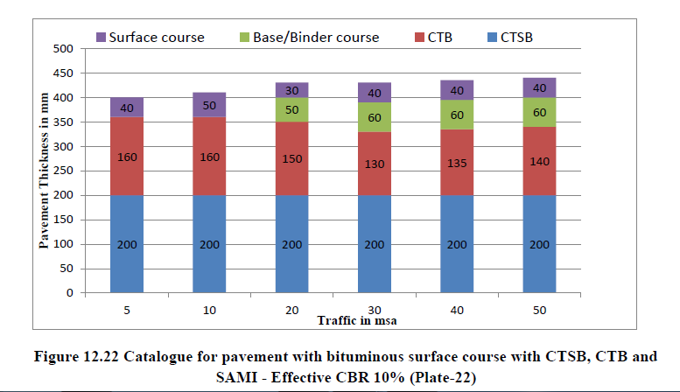

Figure 17 (b): Catalogue for Pavement with Bituminous Surface with CTSB, CTB and SAMI – Effective CBR 10% (Plate – 22).

Table 26: Details of Reserved Forest with Existing and Design Chainage.

Sr.No. | Existing Chainage |  | Design Chainage |  | Length  (Km) | Type of Forest
 | Km | Km | Km | Km
1. | 2+680 | 5+500 | 2+300 | 5+100 | 2.80 | Reserved Forest
2. | 6+360 | 7+000 | 5+800 | 6+470 | 0.67 | Reserved Forest

ROAD JUNCTIONS/ INTERSECTIONS

Major Bridge/ Minor Bridge/ Submergence and Cross Drainage Work Structures

There is 00 Nos. Vented Cause Way (VCW), 00 Nos. of Hume Pipe Culvert (HPC), 00 Nos. of (Arch) Minor Bridges, and 05 Nos. of Minor Bridges along the Existing Road. During inventory and condition survey, the details of culverts wise Improvement Proposal containing Rehabilitation, Widening or Reconstruction. Crust design has been done based on the field CBR evaluated from the samples collected from site during field survey at every 1.0 Km interval and critical CBR has been adopted for crust design in accordance with IRC – 37: 2012, using 10% CBR for sub grade and from the curves as mentioned in IRC: 37 – 2012 pavement thickness were computed for the relevant million standard axles and pavement thickness required for the above designed MSA and as per IRC guidelines is shown in following Tables 27 (a) to (c).

Table 27 (a): Crust/ Pavement Composition Kurkuti – Ghamsali – Niti Road.

Sr. No. | Section | Adopted (MSA) | CBR  (%) | Crust/ Pavement Composition (mm)
 |  |  |  | BC | DBM | WMM | GSB
A | B | C | D | E | F | G | H
1. | Kurkuti – Ghamsali – Niti Road | 05 | 08% | 40 | 60 | 200 | 200

Table 27 (b): Soil Classification Kurkuti – Ghamsali – Niti Road.

Chainage |  | Type of Soil
From | To
0000 | 1450 | Ordinary Rock
1450 | 2150 | All Kind of Soil
2150 | 3170 | Hard Rock
3170 | 4560 | All Kind of Soil
4560 | 5750 | Ordinary Rock
5750 | 7760 | Hard Rock
7760 | 8950 | Ordinary Rock
8950 | 9980 | All Kind of Soil
9980 | 11250 | Hard Rock
11250 | 13560 | Ordinary Rock
13560 | 14630 | All Kind of Soil
13560 | 16645 | Hard Rock

The Place Sumna is spread in valley which is surrounded by high hills on East and West side. Army Training Camp is the last point of project stretch and is spread on a wide flat ground (plateau) surrounded by high hills and it is more or less 20.00 Km. from Niti. The remaining portion of the project stretch is traversing in hilly terrain Kurkuti (10298.56 Feet in Height) and ends at Niti (Approximately 16633.86 Feet in Height).

Table 27 (c): Bridge and Proposed Culverts.

Type of Structure  (TS) | Major Bridges (MB) | Minor Bridges (MB) | Slab/ Arch/ Box Culvert  (S/ A/ BC) | Vented Cause Way  (VCW) | Hume Pipe Culvert (HPC) | Flush Cause Way (FCW)
A | B | C | D | E | F | G
Existing Structure 46 Nos. | 00 | 05 | 33 | 00 | 00 | 08

TRAFFIC: Projected Traffic

In this chapter, the report is concerned about Kurkuti – Ghamsali – Niti Road. Traffic Survey Locations and Schedules were, as given below (Table 28):

Table 28: Classified Different Average Daily Traffic (ADT) Surveys and Dates of Commencement Locations.

Location/ Chainage (Km) | Date of Traffic Survey |  |  | Duration
 | From | To
Kurkuti – Ghamsali – Niti
Classified Traffic Volume Count
Near Kurkuti/ 14+700 | 05/ 10/ 2018 |  | 11/ 10/ 2018 | 7 Days/ 24 Hours
Location | Average Daily Traffic |  | Average daily PCUs
Near Kurkuti | 57 |  | 87 | -------

Survey was carried out in “Ghamsali Village” (14+700) and “Average Daily Trafic” (ADT) recorded at this station is 57 Nos. and 87 Nos. “Passenger Car Unit” (PCU). Fast moving vehicles were recorded as 63.21% of the total traffic (in PCU). Peak hour traffic flow of 15 Nos. formed around 26.85% of the total traffic and peak hour is identified during 7.00 to 8.00 AM.

Traffic Growth: The growth rates estimates were subjected to scenario analysis and the most likely case was adopted for the purpose of the present study. The traffic growth estimates scenario is based on the likely growth of the Indian economy and its relationship to the growth in the state economy. Information presented in the study area reveals that traffic growth is more than 7% in initial years of the project.
PAVEMENT COMPOSITIONS

The flexible pavement is adopted for proposed carriageway reconstruction and Flexible Pavement design period of 15 year. That has been designed as per IRC 37: 2018.

The proposed pavement design standard is presented in Table 29 given below:

Hence the Design of Proposed Better Crust Thickness for Flexible Pavement Composition as is shown in the Table 29.

Table 29: Design of Proposed Better Crust Thickness for Flexible Pavement Composition.

Sr.  No. | Section | CVPD |  |  |  | CBR | Pavement Composition (mm)
 |  | Present Year 2017 | Base Year 2020 | 15 Year | 30 Year | (%) | BC | DBM | CRM | GSB
1. | Kurkuti – Ghamsali – Niti Road | 453 | 514 | 1,068 | 2,220 | 10% | 40 | 60 | 200 | 200

10. ENVIRONMENTAL IMPACT ASSESSMENT OF THE PROJECT

The environmental impact assessment has been carried out and which is based on status of the environment, and impact of proposed four lanning roads/ bridges based on these findings of the Environmental Management Plans (EMPs) have been prepared for the implementation in the project. Following section discusses status of the environment, and its complementary impact assessment work plan assigned to Environmental Management Plans (EMPs) required for the project development/ implementation system and process.

11. BASELINE ENVIRONMENTAL INDEX AND STATUS

Demographic and Climatic Conditions

Uttarakhand has been rated top in the “Planning Commission's Green Ranking” based on quality of air and water, waste management, forest cover and climate change. Environment performance will account for 2% of a state's overall performance. “The Measure is Meant to be both an Incentive and Compensation to States for “Green Initiatives”. For allocating funds tied to environmental performance, the government has two options. The first is to devolve 2% of the gross budgetary support on the basis of the performance index. The second is to allocate funds by giving an additional weightage of 2% to the performance criteria of the “Gadgil Formula”. “The Himalayas is divided into five regions i.e., Punjab Himalayas, Kumaon Himalayas, Nepal Himalayas and Assam Himalayas. Himalayas are home to various snow capped peaks, here is the list of some of the highest peaks of Uttarakhand”.

1. Nanda Devi (7,816 Meters, 25,636 Feet)

Nanda Devi is the highest peak wholly in India lies in Kumaon Himalayas in Uttarakhand. Nanda Devi is a two peak massif forming a 2 Kms long East West ridge. Nanda Devi main is higher and together these peaks are referred as twin peaks of goddess Nanda. Nanda Devi is known for its steep rise from the local terrain, it rises over 3,300 m from its base on the “South Nanda Devi Glaciers”. Renowned mountaineer Mr. Kushang Sherpa of Himalayan Mountaineering Institute describes it as the toughest peak to climb in the world.

2. Chaukhamba (7,138 Meters, 23,412 Feet)

Chaukhamba meaning four pillars is the highest mountain massif in the Gangotri group of Himalayas of the Western Garhwal. The four peaks have heights of respectively 7,138 7,088 6,995 and 6,854 m. On the Western slopes lies the head the “Gangotri Glacier”. The Gangotri glacier gives rise to the “Bhagirathi”, one of the two main sources of the holy river Ganga.

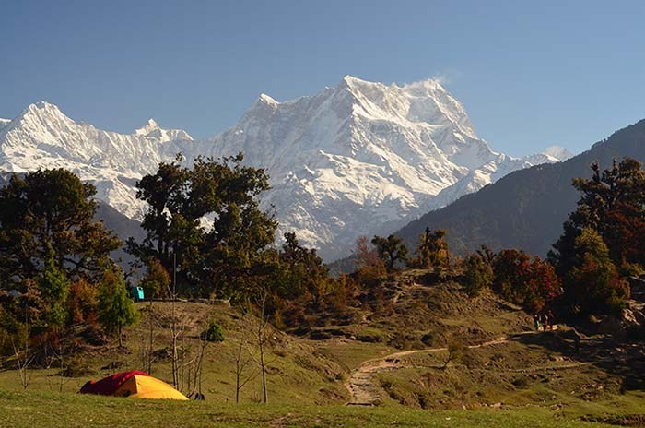

3. Trishul (7,120 Meters, 23,353 Feet)

Trishul massif is a group of three Himalayan mountain peaks, which takes the shape of a trident. Trishul Mountain lies in Northern Kumaon region of Uttarakhand in Bageshwar district and is best viewed from Kausani or during the “Roopkund Trek” from “Bedini Bugyal”.

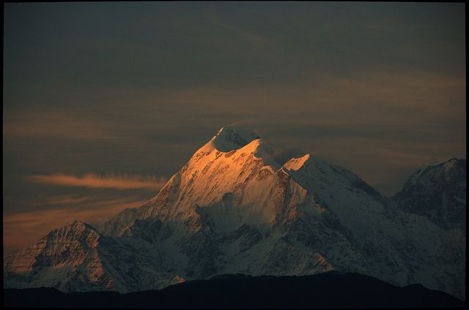

4. Satopanth (7,075 Meters, 23,206 Feet)

“Satopanth” is formed from two “Sat” means “Truth” and “Panth” means “Path”, so Satopanth means “Path of Truth”. Mt. Satopanth situated in Garwhal Himalaya and second highest peak in the Gangotri Group of Garwhal Himalaya range separating the “Gangotri” and “Chaturangi Glaciers”. Mt. Satopanth is quite famous among those who want to move to next level of Mountaineering as their first climbing peak.

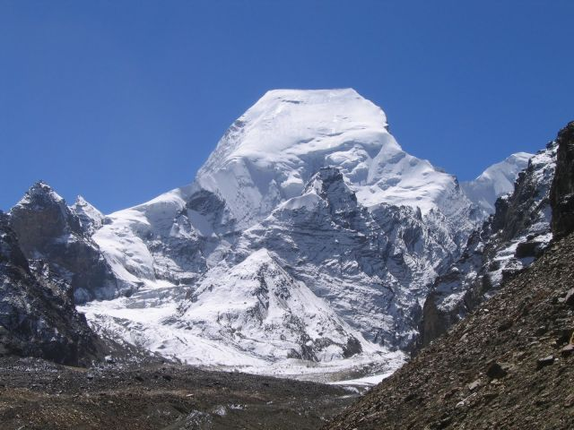

5. Kedarnath (6,962 Meters, 22,835 Feet)

Mount Kedarnath is a part of Gangotri Group of peaks in the Western Garhwal Himalaya in Uttarakhand. Mount Kedarnath has a sub peak called “Kedarnath Dome” and they both were first climbed together, in 1947, by a Swiss team led by André Roch.

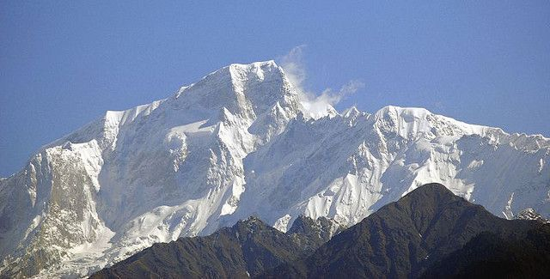

6. Panchachuli Peaks (6,905 Meters, 22,649 Feet)

Panchachuli lies in Eastern Kumaon Himalayas in Pithoragarh district of Uttarakhand. It is believed that this is the place “Five Chulis” (Cooking Hearths) where the Pandavas cooked their last meal on the way to heaven. They are majestic and form a famous barrier between Darma and Gauri Valleys. Panchachuli base camp trekking route is one of the exciting base camp trekking.

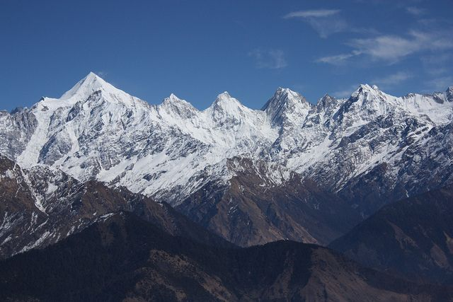

7. Thalaysagar (6,904 Meters, 22,645 Feet)

Mountain Thalay Sagar is located just “North of Gangotri” in “Western Garhwal Himalayas”. It is one of the most difficult mountains in the Garhwal with no easy ascent route and to be considered as the test piece of contemporary mountaineering. In 2008 the first successful Indian ascent was accomplished by Mr. Basanta Singha Roy the famous mountaineer (He is a banker works with Panjab National Bank) from West Bengal.
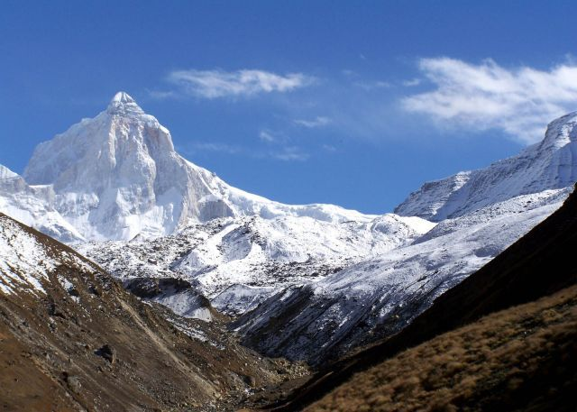

8. Changabang (6,866 Meters, 22,520 Feet)

Changabang peak is part of the Garhwal Himalaya of Uttarakhand and it is part of a group of peaks that form the Northeast wall of the “Nanda Devi Sanctuary”. Changbang is particularly is a rocky and steep peak in Garhwal Himalayas and considered as tougher climbs though having a lower altitude than other peaks in the vicinity.

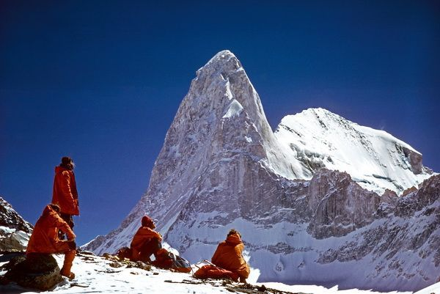

9. Nanda Kot (6,861 Meters, 22,504 Feet)

Nanda Kot peak lies in Kumaon Himalayas of Uttarakhand just outside of the ring of peaks enclosing the “Nanda Devi Sanctuary”. The name Nanda Kot literally means “Nanda’s Fortress” and refers to the abode of one of the sacred forms of the “Hindu Goddess Parvati”.

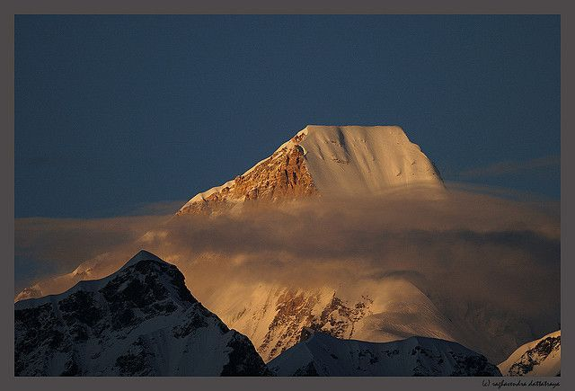

10. Bhagirathi (6,856 Meters, 22,487 Feet)

The highest peak of the “Bhagirathi Group” forms a complex and topographically complicated massif. “Mount Bhagirathi” has three major peaks. It stands at and dominates the end of the valley leading up to Gaumukh, which are the end of the “Gangotri Glacier” and the source of the “River Ganga”. The upper part of the river Ganga is also called Bhagirathi, and both the mountain and the river are named after “King Bhagirath”.

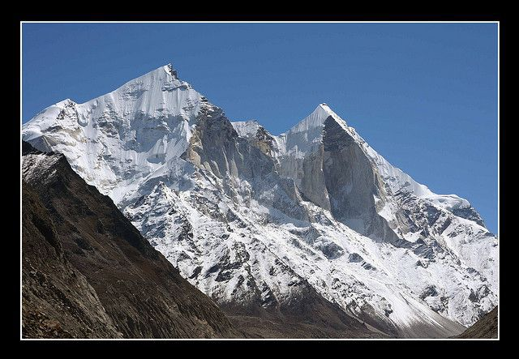

The people of Uttarakhand are warm, simple and friendly with a natural gaiety. The custom and rituals of Uttarakhandese are as diverse as the ethnic groups that inhabit the land. They have an impressive repertoire of folk songs and dances. People of Uttarakhand love to celebrated with a gay abandon and their way of life is inextricably bound up with nature along deep ravines and their valleys allowing monsoon to penetrate in the Northern most parts, which nourishes this “Garden of the Himalayas”. At higher altitudes, monsoon mist cling to huge tracts of lichen covered forest, where every conceivable species of Rhododendron and giant magnolia trees, conifers and beautiful flowering plants as Primulas, Gentians, Blue Poppies, Wild Strawberry, Raspberry. All over Uttarakhand forest and wilderness areas are inhabited by the Snow — Leopard, Thar, Yaks, Wild Ass in the Tibetan Pleatue, Bharal or Blue Sheep, Shapi and the symbol of Uttarakhand — the endangered Red Panda etc. Amidst the grandeur of the mountain peaks lush valleys, fast flowing rivers, Uttarakhand offers her visitors a rare and singular experience. Within a matter of an hour one can move from its sub – tropical heat of the lower valleys to the cold of the rugged mountain slopes that reach up to the areas of perpetual snow. An ideal time to visit the Uttarakhand place is from March to June and October to mid December. Flowers take a breath taking landscape in April – May. October comes again with a new cycle of flowers. The sky is clear in November as one of the best times to enjoy the scenic splendour of Uttarakhand State. It is quite cold in March and December and the monsoon stays from end June to early September.

Climate

The climate of the state has been roughly divided into the tropical, temperature and alpine zones. For most of the period in a year, the climate is cold and humid as rainfall occurs in each month. The area experiences a heavy rainfall due to its proximity to the Bay of Bengal. The rainfall in North district is comparatively less than of the other districts. The general trend of decrease in temperature with increase in altitude holds good everywhere. Pre — monsoon rain occurs in April – May and monsoon (South — West) operates normally from the month of May and continues up to early October. The climate of project areas is on the whole dry, hot in summer and cold in winter. The year may be divided into five seasons in every state/ region of concern. Weather and Climate Index has a great influence on human activities and it affects on the life style of the population and reduces efficiency of work. Man has made great progress in the field of “Artificial Intelligence” as well as in the field of irrigation, but the food production is still controlled by the climatic condition of any region as a whole around the world. The cold season from March to December is followed by hot season, which lasts till the onset of the North – Westmonsoon. The monsoon withdraws by 15th September and is followed by the Post — Monsoon or the Transition Period (TP). Thunderstorms, in association with Pre — Monsoon and Monsoon rains occur mostly during June to September. During the winter also, a few thunderstorms occur in association with the Western Disturbances. A few thunderstorms may be accompanied by hail and hail storms. Occasional dust storm occurs during the hot season and contributes in increasing the level of Suspended Particulate Matter (SPM) in the upper atmospheric region, which causes increases of CO₂ level and Global Warming and Green House Effect (GHE).

Kurkuti (कुर्कुटई)

The block name is Dwarikhal and Pauri Garhwal is the District in the Uttarakhand State. Humidity is found to be 69% along with West wind flow at 6.59 Meters/ Sec towards SE. Uttarakhand’s current Weather and Temperature on an average is 26.9°C to 34.8°C and there is found to be overcast clouds, few clouds, clear sky, scattered clouds, broken clouds, along with moderate rain and light rain. Kurkuti Live Weather Temperature has been found to be 30.8°C and Weather Forecast for next 3 days may varies between 25.2°C to 26.8°C with heavy intensity rain. The temperature in the region reaches and varies minimum to maximum level in – between for next 3 days may varies between 25.2°C to 34.8°C and temperatures seldom exceeding 28°C (82°F) in summer. Pressure level is observed to be 1019.40 mb and Ultra – Violet Index is near about 1 with Cloud Cover 72%. Ceiling point is 9,144 m and dew point is found to be 7°C with visibility 16 Km. Uttarakhand is home to several Himalayan glaciers. With an average Elevation/ Altitude are found to be 1,938 Meters (6358.26 Feet) above the Mean Sea Level (MSL), the Nanda Devi is 7,816 Meters (25,636 Feet) long making it the longest Himalayan glacier. The climate of Uttarakhand varies greatly owing to its rugged topography. Uttarakhand is located at 30.0668° N and 79.0193° E. It has an average elevation of 1,500 Metres (4,900 Feet). Uttarakhand lies at uneven ridges of low heights at the Bhagirathi 6,856 Meters (22,487 Feet) Hills. It is approximately 236 Km (147 Miles) from the national capital, New Delhi. Highest elevation‎: ‎7,816 Meters (25,636 Feet); Area Rank‎: ‎19th; Lowest Elevation‎:‎ 6,856 Meters (22,487 Feet); Official Languages‎: Hindi and Garhwali. Telephone Code or STD Code is 01386 and Station Name is “Kalagarh” in Uttarakhand.

Niti (नीति)

The block name is Joshimath and Chamoli is the District in the Uttarakhand State. Humidity is found to be 88% along with West wind flow at 2.11 Meters/ Sec towards North. Uttarakhand’s current Weather and Temperature on an average is 13.8°C to 20.1°C and there is found to be overcast clouds, few clouds, clear sky, scattered clouds, broken clouds, along with moderate rain and light rain. Niti Live Weather Temperature has been found to be 14.2°C and Weather Forecast for next 3 days may varies between 25.2°C to 26.8°C with heavy intensity rain. The temperature in the region reaches and varies minimum to maximum level in – between for next 3 days may varies between 25.2°C to 34.8°C and temperatures seldom exceeding 28°C (82°F) in summer. Pressure level is observed to be 1019.40 mb and Ultra – Violet Index is near about 1 with Cloud Cover 72%. Ceiling point is 9,144 m and dew point is found to be 7°C with visibility 16 Km. Uttarakhand is home to several Himalayan glaciers. With an average Elevation/ Altitude are found to be 1,938 Meters (6358.26 Feet) above the Mean Sea Level (MSL), the Nanda Devi is 7,816 Meters (25,636 Feet) long making it the longest Himalayan glacier. The climate of Uttarakhand varies greatly owing to its rugged topography. Uttarakhand is located at 30.0668° N and 79.0193° E. It has an average elevation of 1,500 Metres (4,900 Feet). Uttarakhand lies at uneven ridges of low heights at the Bhagirathi 6,856 Meters (22,487 Feet) Hills. It is approximately 236 Km (147 Miles) from the national capital, New Delhi. Highest elevation‎: ‎7,816 Meters (25,636 Feet); Area Rank‎: ‎19th; Lowest Elevation‎:‎ 6,856 Meters (22,487 Feet); Official Languages‎: Hindi and Garhwali. Telephone Code or STD Code is 01386 and Station Name is “Kalagarh” in Uttarakhand.

Economic Profile

Uttarakhand's gross state domestic product for 2004 is estimated at $ 6 Billion in current prices. Born out of partition of Uttar Pradesh, the new state of Uttarakhand produces about 8% of the output of the old Uttar Pradesh state. The Uttarakhand state is the second fastest growing state in India. It's “Gross State Domestic Product” (GSDP) (at constant prices) more than doubled from ₹ 24,786 Crores in FY 2005 to ₹ 60,898 Crore in Financial Year 2012. The real GSDP grew at 13.7% (CAGR) during the FY 2005 – FY 2012 period. The contribution of the service sector to the GSDP of Uttarakhand was just over 50% during FY 2012. Per capita income in Uttarakhand is ₹ 1, 03,000 Crore (FY 2013) which is higher than the national average of ₹ 74,920 Crore (FY 2013). According to the Reserve Bank of India, the total foreign direct investment in the state from April 2000 to October 2009 amounted to US $ 46.7 Million. Like most of India; agriculture is one of the most significant sectors of the economy of Uttarakhand. Basmati rice, wheat, soybeans, groundnuts, coarse cereals, pulses, and oil seeds are the most widely grown crops. Fruits like apples, oranges, pears, peaches, litchis, and plums are widely grown and important to the large food processing industry. Agricultural export zones have been set up in the state for leechi, horticulture, herbs, medicinal plants, and basmati rice. During 2010, wheat production was 831 thousand tonnes and rice production was 610 thousand tonnes, while the main cash crop of the state, sugarcane, had a production of 5,058 thousand tonnes. As 86% of the state consists of hills, the yield per hectare is not very high and 86% of all crop lands are in the plains while the remaining is from the hills.

Other key industries include tourism and hydropower, and there is prospective development in IT, ITES, biotechnology, pharmaceuticals and automobile industries. The service sector of Uttarakhand mainly includes tourism, information technology, higher education, and banking. During 2005 – 2006, the state successfully developed three “Integrated Industrial Estates” (IIEs) at Haridwar, Pantnagar, and Sitarganj; Pharma City at Selaqui; Information Technology Park at Sahastradhara (Dehradun); and a growth centre at Siggadi (Kotdwar). Also in 2006, 20 industrial sectors in public private partnership mode were developed in the state.

Sustainable Design and Life Cycle Management: More than any other human endeavour the built environment has direct, complex, and long lasting impact on the EARTH and its BIOSPHERE. Around one – tenth of global economy is devoted to CIVIL — CONSTRUCTION and about one half of world’s major resources are consumed by CONSTRUCTION and related industries. The Three Columns of Sustainability Development — Environmental, Economic and Social Parameters are shown in Figure 18.

Figure 18: Three Columns of Sustainability Development – Environmental, Economic and Social.

While the situation is not so acute in India at present, increasing urbanization may push us in that direction. These statistics underline the importance of changing the CIVIL CONSTRUCTION PRACTICES (CCP). To address these challenges, there is a need to develop effective approaches for life cycle design and management of CONSTRUCTIONS that will ensure their sustainability in terms of improved physical performance, cost effectiveness, and environmental compatibility. These optimized designs and management systems should provide the owners with the solutions that achieve an optimal balance between three relevant and competing criteria, namely, (i) Engineering Performance (e.g., Safety, Serviceability and Durability), (ii) Economic Performance (Minimum Life Cycle Costs and Minimum User Costs) and (iii) Environmental Performance (Minimum Greenhouse Gas Emissions, Reduced Materials Consumption, Energy Efficiency, etc.).

12. AIR, WATER AND NOISE LEVEL

Air Quality

The results analysis of air samplesis presented in general for all monitoring stations the PM₁₀ values were monitored in the range 110 — 112 µg/ m³. While comparing with the National Ambient Air Quality (NAAQ) Standard of 100 µg/ m³ by the Central Pollution Control Board (CPCB) all the monitored PM₁₀ values were found to be near the limit (Slightly Higher). This is because of high vehicular location and dryness of the areas. PM_{2.5} values were ranging from 35 — 38 µg/ m³. While comparing with the NAAQ Standard of 60 µg/ m³ and the monitored PM_{2.5} values were found to be well within the limit. Similarly monitored values for SO_{X}, NO₂ and CO are also found within the limits are as shown in the Table 30.

Table 30: AAQ Monitoring Result of Project Road.

Sr.  No. | Parameters | Unit | KURKUTI  Chainage  00+000 | NITI  Chainage  17+560 | Prescribed  Limits (µg/m³) | Protocol
Date of AAQ Monitoring |  |  | 18.07.2019 | 19.07.2019
A – 01 | PM₁₀ |  | 98 | 91 | 100 | IS: 5182 (Part – 23), 2006.
A – 02 | PM_{2.5} |  | 35 | 38 | 60 | CPCB  Guidelines.
A – 03 | SO₂ |  | 17 | 17 | 80 | IS: 5182 (Part – II), 2001.
A – 04 | NO_{X} |  | 19 | 25 | 80 | IS: 5182 (Part – VI), 2007.
A – 05 | CO |  | 840 | 1,200 | 2,000 | IS: 5182 (Part – 10).

The maximum SO₂ and NO_{X} levels monitored were 23.41 µg/ m³ and 35.15 µg/ m³ respectively. While comparing with the NAAQ Standard (80 µg/ m³), the monitoring results were found to be well within the limits. The maximum CO concentration monitored was 1.8 µg/ m³ and most of the CO levels were monitored below the detectable limit of 2 µg/ m³. While comparing the NAAQ Standard, the monitored CO levels were found to be well within the limit. All Hydro — Carbon (HC) values were found to be below the detectable limit of 65 µg/ m³. All Particulate Lead values were found to be below the detectable limit of 0.01 µg/ m³ and within the NAAQ Standard of 1.0 µg/ m³ (24 — Hourly).

Noise Levels

Ambient Noise Standards

Ambient noise standards were established as per the CPCB/ MOEF Gazette Notification dated 26th December, 1989. It is based on the “A” weighted equivalent noise level, Leq are given in the Table 31.

Table 31: National Ambient Noise Standards.

Area Code | Category of Zones | Day* Limits of  Leq {dB(A)} | Night* Limits of  Leq {dB (A)}
A | Industrial | 75 | 70
B | Commercial | 65 | 55
C | Residential | 55 | 45
D | Silence Zone** | 50 | 40
Sources**: GOI; CPCB, 1989.

Monitoring Locations and Results

The noise measurement work has been carried out continuously for a period of 24 Hours. At each site 2, 880 data were recorded, each taken at an interval of 30 seconds of which 1, 800 data recorded at day time (07: 00 AM to 10: 00 PM) and 1, 080 at night time (10: 00 PM – 07: 00 AM) as shown in the Table 32.

Table 32: Equivalent Noise Level Data.

Sr. No. | Name of  Locations | Date of  Monitoring | Category of  the Area | Leq dB (A),  Day | Leq dB (A),  Night
1. | KURKUTI  Chainage  00+000 | 26.07.2019 | Educational Area on Site | 54.2 | 28.4
2. | NITI  Chainage  17+560 | 27.07.2019 | Religious Area on Site | 40.6 | 49.5
The monitored noise levels were ranging from 65.2 dB (A) to 54.2 dB (A) While comparing the MOEF Ambient Noise Norms for different categories, Leq noise levels at all locations during day time and during night time, were found to be exceeding their respective limits. This is because of regular movement of diverse vehicles. It may be noted that as the noise survey was carried out at sensitive receptors i.e., School Zones; Domestic Zones; Sensitive Zones; Old People Living Zones; Children Parks; Zoo Parks and Hospital Zones respectively, noise standards is found above the limits at almost all the location.

Water Quality

Water Quality Standard

The rivers, canal, lakes and ponds located along the proposed project road are a source of water for the local, regional inhabitants, for domestic as well as agricultural uses. An analysis of their present status and the quality of the water has been done through and with the help of state/ local/ regional agencies. They have been classified as per the CPCB standard classification norms for best optimum use of data and report used as shown in the Table 33.

Table 33: CPCB Best Use Classification for Surface Water Bodies.

Sr. No. | Parameters | Class – A | Class – B | Class – C | Class – D | Class – E
1. | pH | 6.5 – 8.5 | 6.5 – 8.5 | 6.0 – 9.0 | 6.5 – 8.5 | 6.5 – 8.5
2. | Dissolved Oxygen (as O₂),  Mg/ l, Minimum. | 6 | 5 | 4 | 4 | -------
3. | BOD, 5 Days at 20°C,  Maximum. | 2 | 3 | 3 | ------- | -------
4. | Total Coli – form Organism,  MPN/ 100 ML, Maximum. | 50 | 500 | 5,000 | ------- | -------
5. | Free Ammonia (as N),  Mg/ l, Maximum. | ------- | ------- | ------- | 1.2 | -------
6. | Electrical Conductivity,  Mhos/ Cm, Maximum. | ------- | ------- | ------- | ------- | 2,250
7. | Sodium Absorption  Ratio, Maximum. | ------- | ------- | ------- | ------- | 26
8. | Boron (as B),  Mg/ l, Maximum. | ------- | ------- | ------- | ------- | 2

Class A | : Drinking Water Source without Conventional Treatment but after Disinfection;
Class B | : Outdoor Bathing (Organized);
Class C | : Drinking Water Source after Conventional Treatment and after Disinfections;
Class D | : Propagation of Wild – Life and Fisheries;
Class E | : Irrigation, Industrial Cooling, and Controlled Waste Disposal;
Below E: Not Meeting A, B, C, D and E Criteria.

Water Quality Variation along the Projected Road

Surface Water Quality: The pH of surface water was found to be in the range 7.10 to 7.91 along the Corridors. Total hardness is found 337 – 234 ppm (parts per million). Lead contents were found to be below the detection limit. In general, surface water quality along the Corridors is good and complies with CPCB Surface Water Quality Norms. Details of water quality features are mentioned in Table 34 (a) and (b) below.

Table 34 (a): Ground Water and Surface Water Quality along the Projected Road.

Sr. No. | Parameters | Units of Measurement | Surface Water Quality Monitoring  Result along the Project Road |  |  | Protocol
 |  |  | KURKUTI | NITI | Desirable  Limit
Date of Sampling |  |  | 21.06.2019 | 22.06.2019 | < OR ≥ OR Nil
1. | Colour | Hazen  Units | <5 | <5 | 5 | IS: 3025
2. | Turbidity | NTU | 34 | 7 | <5 | IS: 3025
3. | pH | ------- | 7.91 | 7.09 | 6.5– 8.5 | IS: 3025
4. | Temperature (T) | °C | 14 | 14 | 14 | IS: 3025
5. | Dissolved Oxygen (DO) | mg/l | 3.8 | 4.2 | 4.4 | IS: 3025
6. | Conductivity | µmhos/cm | 1,250 | 674 | 976 | IS: 3025
7. | Total Suspended Solids (TSS) | mg/l | 30 | <4 | <4 | -------
8. | Total Dissolved Solids (TDS) | mg/l | 812 | 316 | 634 | IS: 3025
9. | Alkalinity as CaCO₃ | mg/l | 410 | 291 | 370 | IS: 3025
10. | Total Hardness as CaCO₃ | mg/l | 234 | 289 | 337 | 300
11. | Calcium as CaCO₃ | mg/l | 123 | 198 | 174 | IS: 3025
12. | Magnesium as CaCO₃ | mg/l | 111 | 91 | 163 | IS: 3025
13. | Sodium as Na | mg/l | 92 | 41 | 51 | APHA
14. | Potassium as K | mg/l | 86 | 13 | 10 | APHA
15. | Chloride as Cl | mg/l | 98 | 24 | 24 | IS: 3025
16. | Phosphate as PO₄ | mg/l | 0.43 | 0.03 | 0.03 | -------
17. | Sulphate as SO₄ | mg/l | 29 | 45 | 51 | IS: 3025
18. | Nitrate as NO₃ | mg/l | 0.12 | 0.06 | 0.08 | IS: 3025
19. | Oil and Grease (OG) | mg/l | Nil | Nil | Nil | IS: 3025
20. | Phenolic Compounds (PC) | mg/l | <00.0001 | <00.0001 | <00.0001 | IS: 3025
21. | Chemical Oxygen Demand (COD) | mg/l | 97 | <4 | <4 | -------
22. | Biological Oxygen Demand (BOD) | mg/l | 52 | <2 | <2 | IS: 3025

Table 34 (b): Ground Water and Surface Water Quality along the Projected Road.

Sr. No. | Parameters | Units of Measurement | Surface Water Quality Monitoring  Result along the Project Road |  |  | Protocol
 |  |  | KURKUTI | NITI | Desirable  Limit
Date of Sampling |  |  | 24.07.2018 | 25.07.2019 | < OR ≥ OR Nil
23. | Arsenic as As | mg/l | <0.01 | <0.01 | 0.01 | IS: 3025
24. | Mercury as Hg | mg/l | <00.0001 | <00.0001 | 00.0001 | IS: 3025
25. | Lead as Pb | mg/l | <0.01 | <0.01 | 0.01 | IS: 3025
26. | Cadmium as Cd | mg/l | <0.01 | <0.01 | 00.0003 | IS: 3025
27. | Chromium as Cr⁺⁶ | mg/l | <0.05 | <0.05 | 0.05 | IS: 3025
28. | Copper as Cu | mg/l | <0.01 | <0.01 | 0.05 | IS: 3025
29. | Zinc as Zn | mg/l | <0.01 | <0.01 | 5 | IS: 3025
30. | Selenium as Se | mg/l | <00.0005 | <00.0005 | 0.01 | IS: 3025
31. | Iron as Fe | mg/l | 0.15 | 0.01 | 0.3 | IS: 3025
32. | Total Coli – form | MPN/ 100 ml | 50 | 28 | ------- | IS: 5401 – (Part – II)
33. | Faecal Coli – form | MPN/ 100 ml | 20 | 13 | ------- | IS: 5401– (Part – II)

ECOLOGYCAL AND ENVIRONMENTAL TEXTURE

Flora

Uttarakhand is endowed with a unique and diverse range of biodiversity. From the snow bound peaks of the Himalayas to the moist Alpine scrub, sub Alpine forests, dry – temperate and moist – temperate forests to moist deciduous forests, the state possesses a wide biodiversity that in return nurtures a large multiplicity of floral and faunal forms. The state is home to nearly 4,048 species of Angiosperms and Gymnosperms belonging to 1,198 genera under 192 families. Of these nearly 116 species are specific to Uttarakhand i.e., their geographical distribution is limited to the boundaries of the state. Around 161 species of flora found in Uttarakhand are recognized as rare or threatened under the categorization of the “International Union for Conservation of Nature” (IUCN). Out of the 223 species of Orchids reported from the North Western Himalayas, over 150 have been reported from the State.

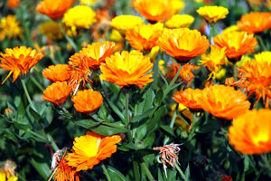

The Uttarakhand flora includes a variety of species of plants. The abundance of flora in the state can be understood from the fact that the forests cover as much as 36% of the total area of Uttarakhand. There are about 4,000 different types of plants in Uttarakhand. The rhododendrons form a significant part of the Uttarakhand flora. They are abundant in the alpine and temperate regions of Uttarakhand. Near about 35 different varieties of rhododendrons grow in these regions. The flowering time of these plants stretches between May and August. The flowers of these plants decorate the entire region. The rhododendrons are the brightest and most colorful members of the flora at Uttarakhand. The orchids that grow in the state of Uttarakhand exhibit a lot of variety. More than 600 different kinds of orchids are found here. These orchids are an important part of the flora of Uttarakhand. The terrestrial orchids are found in the temperate areas, while the epiphytic orchids are found in the tropical regions.

The ecological studies have been carried out to understand the present status of terrestrial and aquatic ecosystem within 10 Km distance, on either side from the Right of Way (ROW) of proposed project. The information provided is based on physical surveys and secondary sources such as information collected from forest department. There is Reserved Forest (RF) in this road but no eco — sensitive areas near the project route. The prominent species include teak mixed with Bamboo, Palm, Kadamb and Banyan Trees. Other Trees include Neem, Peepal and Mango etc. There are no endangered species of flora in the area.

Fauna

This great floral diversity supports a wide variety of faunal forms too. It includes about 102 species of mammals, 623 species of birds, 124 species of fish, 69 species of reptiles and 19 species of amphibians. Highly endangered species like the Snow Leopard, Musk Deer, Tiger, Asian Elephant, Bharal, Himalayan Monal, Cheer Pheasant, and King Cobra etc. find suitable habitat in the forests of Uttarakhand. This precious natural wealth is our common heritage. In order to conserve this heritage, the state has declared twelve areas as “Protected” including 6 National Parks and six Wildlife Sanctuaries. Nearly 65% of the geographical area of the State is under forest cover, of which over 12% comes under the “Protected Area Network” (PAN). This exceeds the national average by a fair margin and is a reflection of the state’s commitment to conservation. The Corbett National Park, established in 1936 is the first National Park of the Asian mainland. The “Nandadevi Biosphere Reserve”, established under the “Man and Biosphere” programme of UNESCO has the honour of being Uttarakhand’s only and the country’s second “Biosphere Reserve”. This biodiversity wealth is the pride of Uttarakhand.
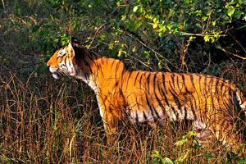

The natural vegetation of forests may be divided into:

- Trans – Himalayan Zone;
- Sub – Alpineand Alpine Zone;
- Montane or Temperate Region;
- Sub – Mountain and Sub – Tropical Region;
- Tropical Wet Evergreen and Semi Evergreen Region;

The original fauna of Uttarakhand in its Southern low lands of height of 800 Feet to 5,000 Feet include Laurel, Fig, Bamboo and Sal tree. These plantations have been greatly reduced for providing farming land. At a height of 5,000 Feet to 13,000 Feet, one can find temperate trees like chestnut, oak, birch, maple, magnolia, silver fir and alder. The alpine region of height more than 13,000 Feet is covered with cypress, juniper and rhododendron. Therefore, the flora in Uttarakhand varies with the height of a place. The world of Uttarakhand fauna exhibits a great deal of variety. There are as many as 550 types of birds in the state. Some of the well known birds include Eagles, Giant Lammergeier Vultures, Minivet, Whistling Thursh, Pheasant and Bulbul. Some of the birds of Uttarakhand belong to the endangered species. Some important members of the fauna of Uttarakhand are the birds of the place. The zoologists have discovered that the forests of this state of India are crowded with more than 400 different species of butterflies. The Uttarakhand Rivers house a variety of fish like salmon, trout and carp. Among the animals, the Red Panda dwells at a height of 6,000 to 12,000 Feet on treetops. Yak is very closely associated with this mountainous state of India. These animals are quite economically viable for the people of the region.

Blue sheep found here is a kind of squirrel that can fly. Tahr, Binturong and Marmot are found in the greeneries of the state, mainly in the Kangchendzonga National Park. The wild animals, which are found in this area/ site / region, include the Nilgai (Boselaphus Tragocamelus), Antelok (Anelok Cervicapra), Pig (Sus Scrofa), Wolf (Canis Lupus), Jackal (Conis Aureus), Fox (Vulpes Bengalensis), Hare (Lupus Ruficandatus), Monkey (Macaca Mulatta), Wild Cat (Felis Bengalensis) and the Porcupine (Hystric Leucura). The game – birds of the area include the usual varieties found throughout the plains as well as hilly areas. Among them mention may be made of the Peafowl (Pavo Cristatus), the Black Partridge (Frencolinus Francolinus) and the Gray Partridge (Francalinus Pondicervanus). The area is famous for the number and variety of water fowls, which visit it during the winter season. The Goose (Anser Anser), Common Teal (Anas Crecca), red – crested Pochard Duck (Netta Rufina), White – Eyed Pochard (Aythya Rufa) and Widgeon (Mareca Penelope) visit the area/ site/ region only in Winter Season and inhabit the fringes of Rivers, Lakes, Ponds, Stream Channels and Swamps etc.

Aquatic Life

Snakes are common in the area especially in the rural areas or sites, the chief being the Cobra (Naja Naja), Karait (Bungarus Caeruleus), and Rat – Snake (Ptyas Mucosus). Indian Crocodile or Naka (Crocodilus Pulustris), and the Ghariyal (Gavialis Gangeticus) are also found in the rivers or lakes. Fish of almost all the varieties that occur elsewhere in the state are found in the rivers, lakes and ponds of this area, the common species being Rohu (Lebeo Rohita), Bhakur (Catla Catla), Nain (Cirrhina Mrigala), Parhin (Wallagonia Attu), Krunch (Lebeo Calbasu), Tengan (Mystus Seenghla) etc.

Archaeological and Historical Sites

There is no archeologically protected monument or historical sites along the project route or roadways network of construction site.

Environmental Impacts

Impact on Topography

During the construction of the proposed project, the topography will change due to excavation of borrow areas, fills for project road, especially construction of project related cross drainage structures and intersections etc. Provision of construction camp/ yard for material handling will also alter the existing topography. There will be change in topography at re – alignments as these re – alignments have been proposed through agriculture farming fields. The change in topography will also be due to the probable induced developments of the project. With adequate planning, all topographical impacts or signature could be made to enhance the local aesthetics. Similarly, it will invite benefits in the form of land leveling and tree plantations in the vicinity/ region/ area/ site of the projected road.

Impact on Climate

The widening and strengthening of project is not going to have impact on micro as well and macro – climate of the region on the site or area/ region.

Impact on Air Quality

There will be rise in “Suspended Particulate Matter” (SPM) levels due to the construction activities, because the project runs entirely in plain areas. Since the emission will be fugitive in nature and it is difficult to quantify the SPM standards even expected to be violated, as the background values are not alarming rate at many places. “Affected Persons” (APs) should be completely well – versed even; if it is exceeded then it will be for very short time period. There will be some increase in levels of gaseous pollutant also, which are highly harmful to all or whole ecosystem surviving/ sustaining on this “Precious Planet Earth”. The impact on ambient air quality has been assessed using AERMOD – Lakes Environmental Software and CALINE4 – A Dispersion Model for Predicting Air Pollution Concentrations near Roadways or Road network. The air quality predictions have been done for the horizon years 2010, 2020 and 2030. The results of various or numerous types of mathematical modelling applications shows that CO, SO₂, NO_{X}, HC, “Respirable Particulate Matter” (RPM) stuff concentration will remain within the limits of CPCB tills the end of project life. The SPM levels are well within limit at present also. But significant contribution of SPM is expected from vehicular emissions; transportation; industrial as well as domestic activities in future as given in Figure 19.

“Affected Persons” (APs) should be fully informed of their rights and responsibilities from the very beginning of the process to achieve transparency and understanding between the APs and the project implementers.

Primary stakeholders include the APs, the beneficiaries of the project, the host population, the “Project Partner Agencies” (PPAs) such as “Urban Development Authority” (UDA), and more importantly the project proponent and the “Ministry of Defence and Urban Development” (MOD and UD), Ministry of Finance and Ministry of Land and Land Development. The secondary stakeholders are those who have an interest in the project such as the National Government, the political authority, policy – makers, advocacy groups, NGOs and other private and public sectors which have indirect involvements with the project.

Therefore, PPA need to be assisted more closely in explaining and guiding them in resolving the issues in a more productive manner more favourable to the APs, as per involuntary resettlement principles and guidelines. This nature of consultation with the project APs and their profiling are mandatory as per the requirements of preparing the “Resettlement Action Plans” (RAP), which needs to be carried out as socio – economic and census surveys as an integral part of detailed designing.

Implementation Stage | Involve APs in decision – making committees;
 | Involve APs in monitoring and evaluation;
 | Establish Grievance Redress Committee (GRC) procedures, representatives of APs;
 | Arrange APs inputs to entitlements, income restoration and resettlement options;
 | Consultations with APs on alternatives;
 | Involve APs in assessing project impacts.

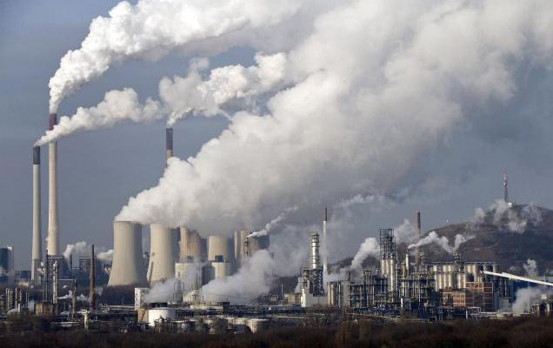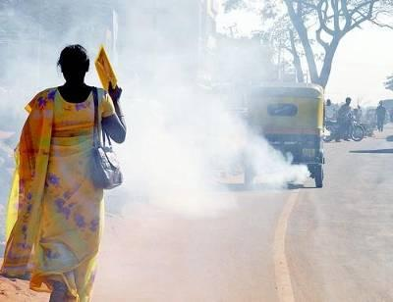
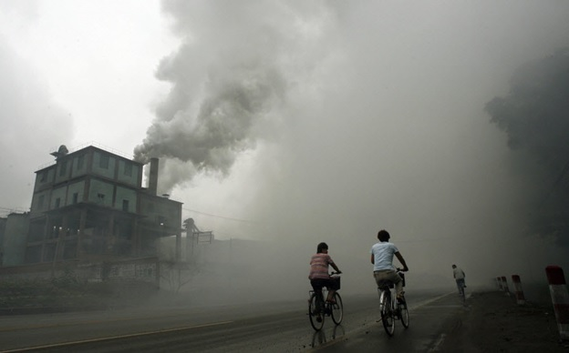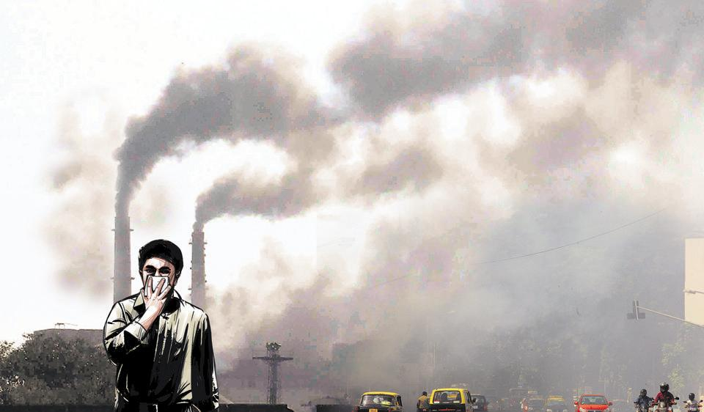
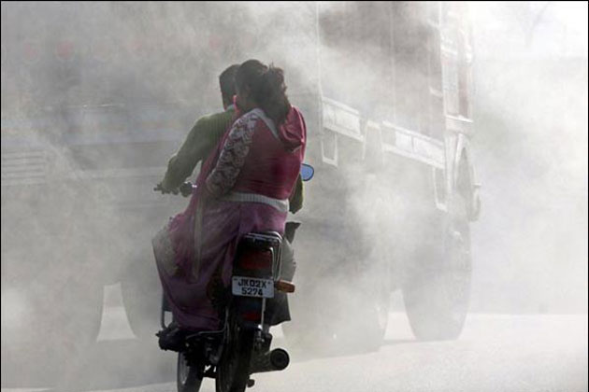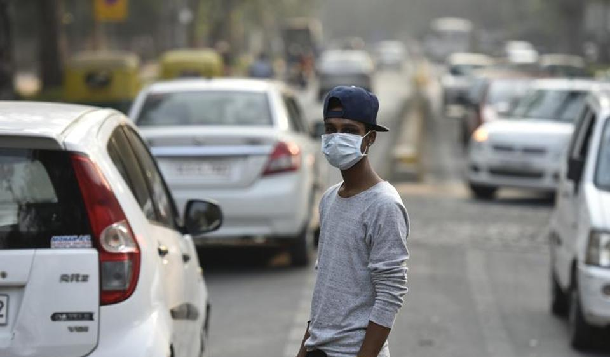
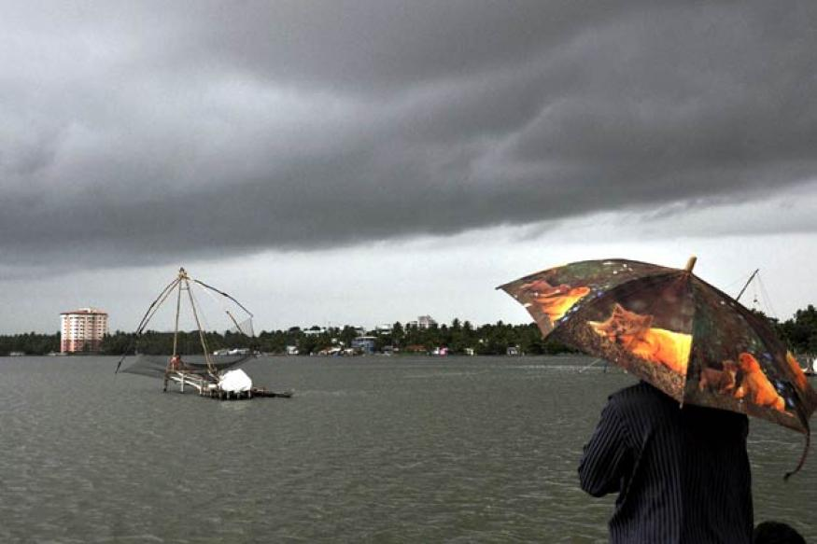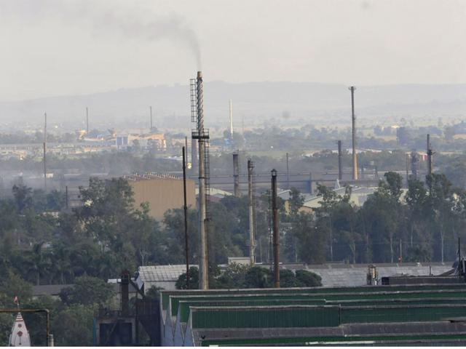

Figure 19: Increase in Levels of Pollutant – Emissions – Impact on Future Generated Aspects/ Prospects from Various Sources.

Impact on Noise Levels

The impact of noise levels from the proposed project on the neighbouring communities is addressed by carrying out Noise Modelling using FHWA Model developed by Federal High Way Administration (FHWA). It has been concluded after Mathematical Modelling that both day time and night time equivalent noise levels are within the permissible limits as right from start of project life. Noise sensitive receptors have been identified along the projected road site/ area. The noise sensitive receptors include school, hospitals, colleges; old orphan people’s sensitive house zones (Ashrams) and other nearby housing transportation activities along the road side etc. The predicted levels indicate that the noise levels in future years will not exceed permissible limits right from start of project life as given in Figure 20. Hence there is no need to protect these noise sensitive receptors.

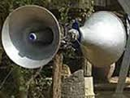
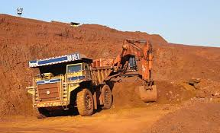
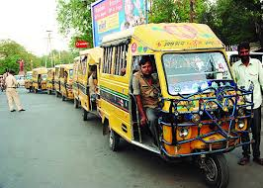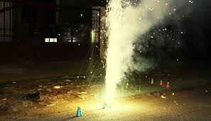
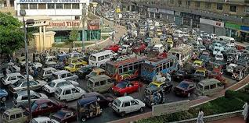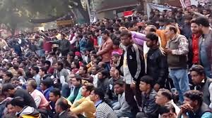

Figure 20: Noise Levels Impact Must Not Exceed the Permissible Limits in Sensitive Zones along Road Side.

Impact on Water Resources and Quality

The construction and operation of the proposed project roads will not have any major impacts on the surface water and the ground water quality in the area projected site/ region. Contamination to water bodies may results due to spilling of construction materials, oil, grease, fuel and paint in the equipment yards and Asphalt Crusher Plants (ACP) or Hot Mixing Plants (HMP). This will be more prominent in case of locations where the project road crosses water streams; major canals distributaries, minor/ major ponds and minor/ major small lakes etc. Mitigatory measures have been planned; generated; initialized and finalized to avoid contamination of these water bodies are given in Figure 21.

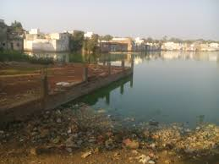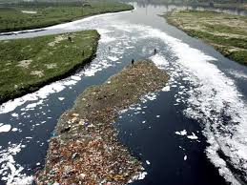
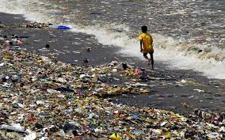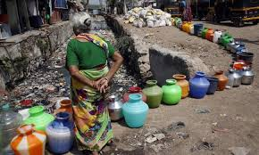
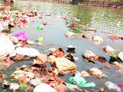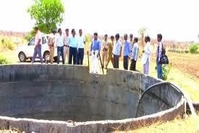
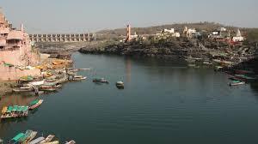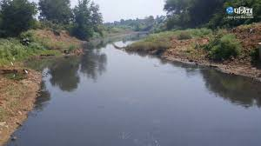

Figure 21: Mitigatory Measures Plans Generated; Initialized and Finalized to Avoid Contamination Impact on Water Resources and Quality.

Impact on Ecological Resources and Soil Quality

There is no wildlife sanctuary in the close vicinity of the project road. The study area passes primarily through agricultural land in plain areas. There will be temporary impact on terrestrial ecology, as trees will be cut. But after construction no impact is anticipated as compensatory a forestation is planned. There are no endangered species or rare species of flora and fauna in the projected area. There is no major loss of vegetation; hence adverse impact in terms of availability of nesting sites for the bird doesn’t arise in the region. Furthermore, there is no sensitive Environmental/ Natural/ Ecological area near the existing projected roads, so the impact will be insignificant or inconsequential. Brief potential impacts are shown in Figure 22 and are presented in matrix below in the Table 35.

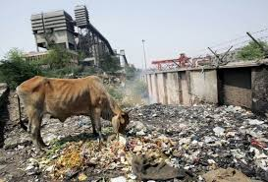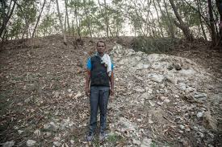
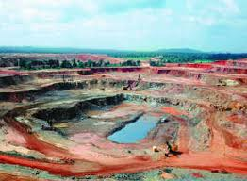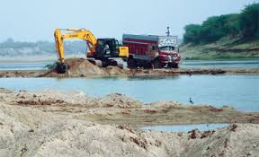
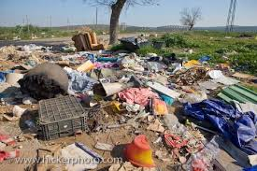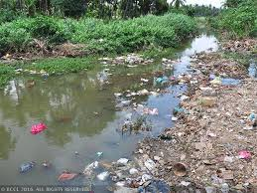
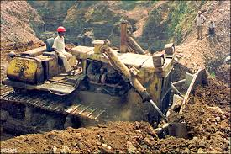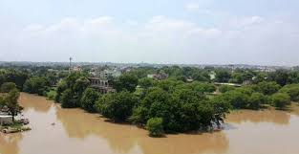

Figure 22: Plan Mitigatory Measures to Avoid Soil Contamination Impact on Agricultural Land and Other Sensitive Zones in Environmental/ Natural/ Ecological Vicinity/ Area/ Site.

Table 35: Potential Environmental Impacts.

Project Activity | Pre –Construction | Construction Phase |  |  |  |  |  | Operation Phase
Component Affected | Land Acquisition | Site Clearance | Earth Moving (Borrow Pits) | Contractor Camps | Quarries Areas | Construction of Highway | Asphalt Crusher Plants | Operation
Soil | Loss of productive agricultural land | Loss of crops, and increase in soil erosion | Loss of top soil and erosion | ------- | Increase in erosion, siltation and slope instability | Soil pollution | Pollution due to spills | Soil contamination due to surface runoff
Ground  Water | ------- | ------- | ------- | Water  Extraction for drinking | ------- | Exploitation of water for construction | ------- | Maintenance of trees/ shrubs
Surface Water | ------- | Change in water quality and siltation | Water logging and mosquito breeding | Water pollution from sanitary and other wastes | Water logging problems | Change in water quality | Water pollution due to spill into water bodies | Degradation due tospill-oversand roadrun off
Drainage | ------- | Change in natural drainage pattern | Change in drainage pattern | ------- | Modification in natural drainage | Interference with natural drainage, water logging | ------- | Cleaning and maintenance
Air Quality | ------- | Increase in air pollution | Particulate matter pollution | Atmospheric pollutiondue to fuelburning | Dust pollution | Dust pollution | SPM, SO₂ | Increase in SPM, NO_{X}, CO
Noise Quality | ------- | Reduced buffering of noise | Increase in  noise levels due to machinery | ------- | Vibration from blasting operations | Vibrators, concrete batching plants noise etc. | Increase in noise | Increase in noise levels due to increased traffic
Forest | ------- | Habitat loss, and vegetation | Loss of forest | Encroachment into forest areas | Loss of habitat/ cover | Loss of forest | ------- | -------
Trees | Tree cutting clearance | Loss of trees | Loss of trees | Cutting of  trees | Tree cutting | Loss of trees | ------- | -------
Temples/ Mosques | Clearance | Removal/ rehabilitation | ------- | ------- | ------- | ------- | ------- | -------

Impact on Drainage Pattern

The proposed widening and strengthening will not alter drainage pattern of the area as adequate cross drainage structures have been planned along the new alignments and existing culverts along the project road are planned for Rehabilitation and Resettlement (R and R). Construction of bridges across water streams may result in siltation of water body, which can affect aquatic life and fauna in the region/ area or proposed site. Proper mitigatory measures have been recommended in Environmental Management Plans (EMPs).

Impact on Human Use Values

Impact on human use values are including “Precious Planet Earth’s”, common property resources such as temples, mosques, wells, hand pumps, stream channels, stream fountains and tube well etc. Impact on these has been minimized through proper planning of the alignments along roadside/ location site. The environmental impacts have been summarized as in Figures 23 (a) to (d) and Table 36 given below.

Mitigation Avoidance and Enhancement Measures

The mitigation measures have been planned for identified adverse environmental impacts alignment enhancement design phase is being applied along roadside to reduce tree cuttings as compensatory plantation process or relevance. These mitigation measures have been identified as Environmental Management Plans (EMPs) during Planning, Construction and Operation Phase.

Design Phase

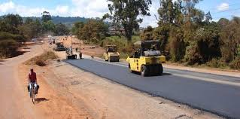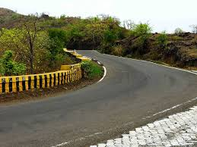
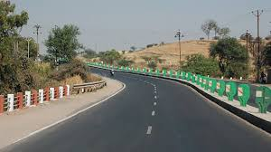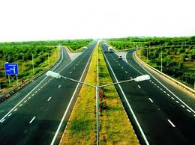
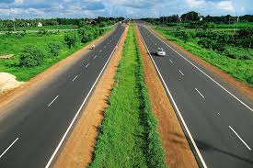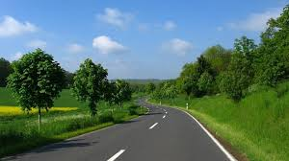

Figure 23 (a): Mitigation Enhancement as per Alignment Design Phase to Reduce Tree Cutting and Compensatory Plantation Relevance.

Anticipated; Recommended and Refined Enhancement Measures of Road Design Phase for ZERO Pollution Level

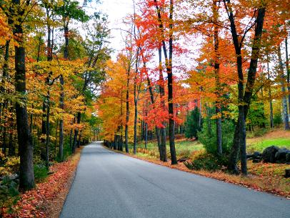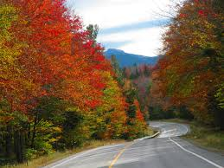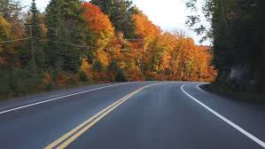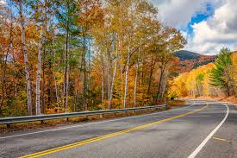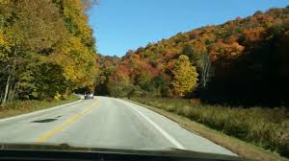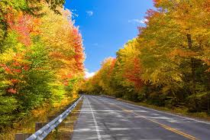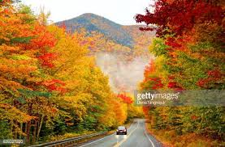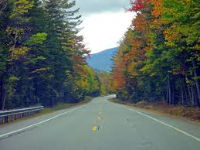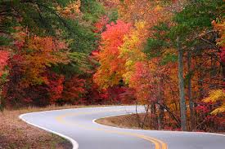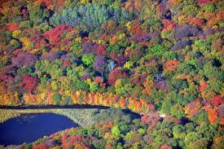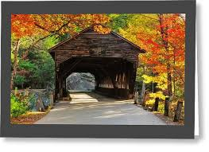
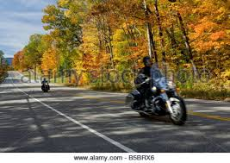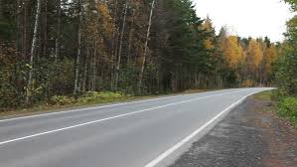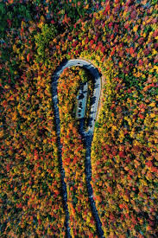

Figure 23 (b): Anticipated Refined Enhancement Measures of Road Design Phase as per Alignment to Reduce Tree Cutting and Compensatory Plantation Relevance for ZERO Pollution Level.
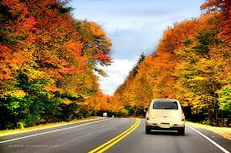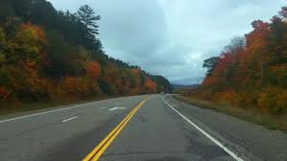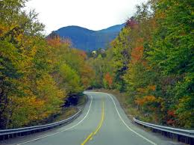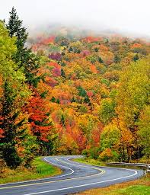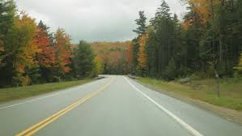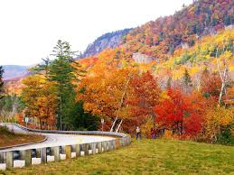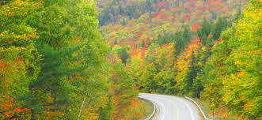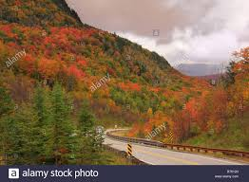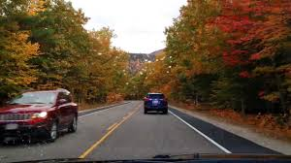
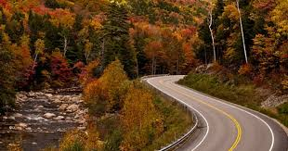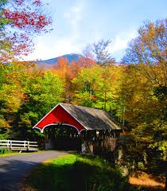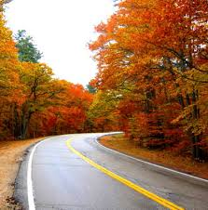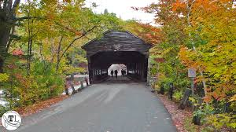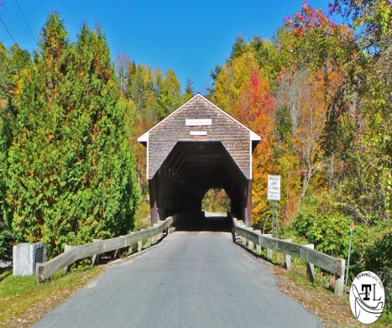

Figure 23 (c): Recommended Refined Enhancement Measures of Road Design Phase as per Alignment to Reduce Tree Cutting and Compensatory Plantation Relevance for ZERO Pollution Level.

Road Designing Phase for ZERO Pollution Level

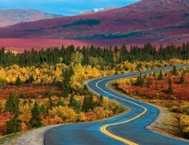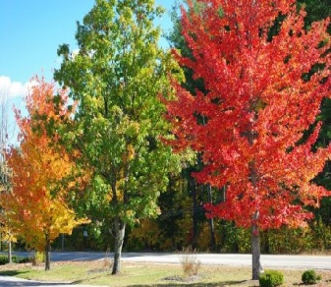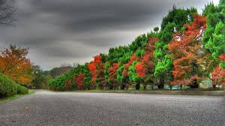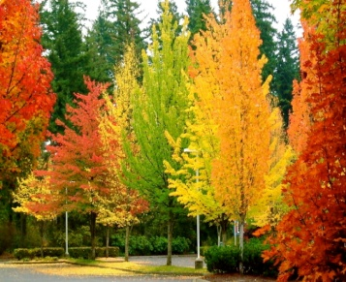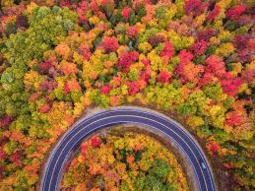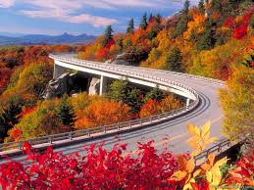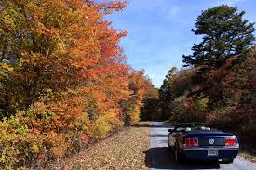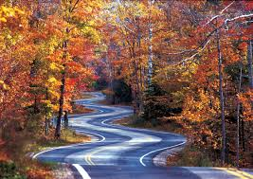
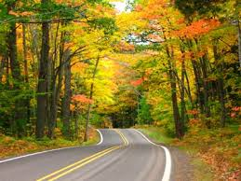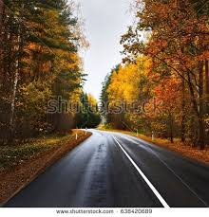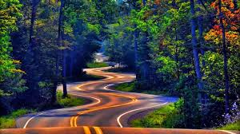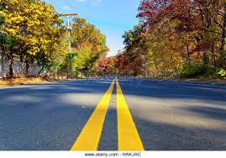
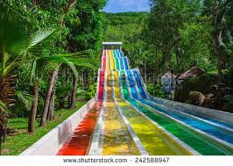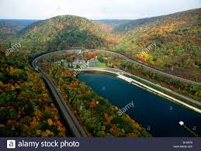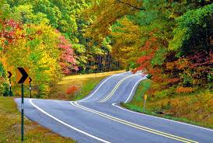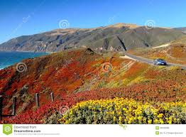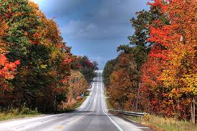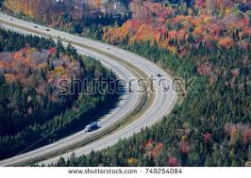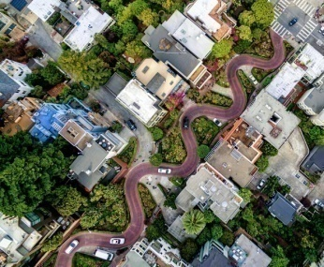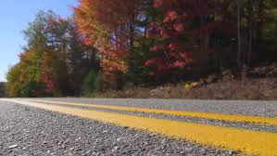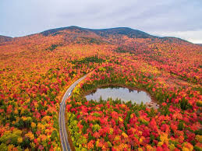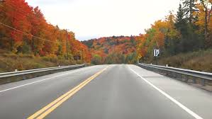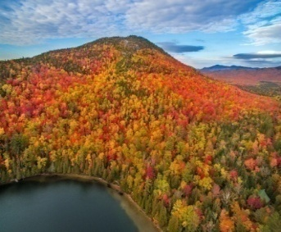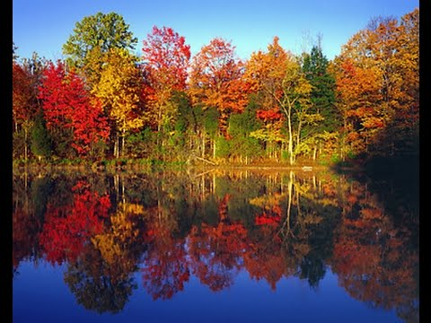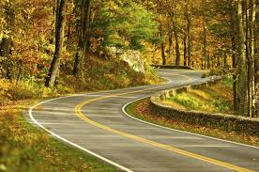
Figure 23 (d): Road Designing Phase as per Alignment to Reduce Tree Cutting and Compensatory Plantation Relevance for ZERO Pollution Level.
Impacts during design phase is limited to removal of trees, acquisition of land and structures, relocation of water ways, water parks, water bodies, water locations, water streams or channels identification and management of borrow pits are as mentioned in Table 36.

Table 36: Impacts during Design Phase.

Impacts | Mitigation Measures
Land Acquisition | Alignment design to minimize the land acquisition whenever applicable;
Major Displacement | Bypasses and detours to be considered preciously;
Removal of Trees | Alignment design to reduce the number, widening on the side of the road where less trees are required to be cut. Compensatory plantation to be planned;
Impact on Public Utilities e.g., Community Wells etc. | Alignment design to be considered. In case of removal alternate arrangement to be done before;
Impact on Cultural Sites | Alignment design to be considered. Public consultation may be needed if impact cannot be avoided;
Relocation of Waterways | Hydrology to be considered. Public consultation will be needed, wherever applicable;
Access Restriction | Required alternatives, underpasses, proper signposts for people should be included in design all types of roads constructions;
Congestion in Settlement Areas | Service road to be provided everywhere all over the road network;
Borrow Pits | Locations to be selected considering minimum loss of productive land and redevelopment and resettlement;
Environmental Specifications for Contractors | Environmental qualifications specification should be included in pre – qualification packages for the contractors and structure designers.

Construction Phase

Environmental management during construction phase is more crucial, because major impacts during construction like earthworks road network, movement of heavy machineries etc. causes lot of disturbances and management becomes essential at this stage during construction work. The construction workers camp will be located at least 500 Meters away from habitations. The construction yard, Hot Mix Plants (HMPs) and crushers like Asphalt Crusher Plants (ACP) etc. will be located at 500 Meters away from habitations and in downwind directions. The minimum distance of these will be kept 3.0 Km. from reserve forest areas. Adequate cross drainage structures have been planned to maintain proper cross drainage. In order to compensate negative impacts on floral species due to cutting of trees the project plans compensatory plantation in the ratio of 1: 3 i.e., for everyone has to be applied… if one tree is cut…!!! Then three or more trees will be planted. The acquisition of forest area will be minimal and will be compensated through compensatory afforestation. The noise barriers have been planned closed to educational institute so that post project noise levels are within the specified limits. The project will take an opportunity to provide Environmental Enhancement Measures (EEM) to improve aesthetic activities in the projected area. The planned Environmental Enhancement Measures include ponds enhancement, plantation in median and in available clear space in Right of Way (ROW), seating arrangements around trees must be installed or placed in the specific region. The pond Enhancement Measures (EM) will include such as stepped access, washing platforms and seating arrangements ought to be applied etc. Some of ditches will be filled up due to embankment construction in the Right of Way (ROW). In order to avoid contamination of water bodies during construction sedimentation chambers, oils and grease separators, oil interceptors at storage areas and at construction yard have been planned. The bill of quantities for mitigation and enhancement measures has been given in respective Environmental Management Plans (EMPs) of construction packages. Table 37 below summarizes impacts and its Environmental Management Plan during Construction Period.

Table 37: Environmental Management Plan during Construction Period.

Impacts | Mitigation Measures
Soil Erosion | Proper planning for slope stabilization, topsoil storage, plantation and turf on slopes;
Loss of Topsoil | Arable lands will be avoided for earth borrowing network. If needed, topsoil will be separated and refilled after excavation on operational site/ region/ area;
Borrowing of Fill Materials | Excavation from pre – selected locations. After excavation the borrow pits will be dressed to match with the surroundings. In specificcases borrow pits can be excavated in consultation with localpeople to use those pits as water harvesting point locations in particular areas/ sites;
Disposal of Construction Waste | No haphazard dumping of construction waste. Only pre – selected location maintaining local environmental regulations activities/ performance will be used for operational site;
Disposal of Human Waste by Construction Workers | Specific landfill sites should be identified to manage solid waste generated from habitation of construction workers on operational site/ area/ specified region;
Generation of Dust | Water will be sprayed during construction phase, in earth handling sites, asphalt mixing or crushing sites and other excavation areas for suppression of dust on operational site;  In case fly ash is used, dust emission during its unloading, storage at open place and handling for road construction should be suppressed by water sprinkling at regular interval and operation with space and time;  Dust emission from piles of excavated material should also be controlled by spraying water on the piles located areas/ sites/ regions;  Special care should be taken when working near schools and medical facilities and other sensitive zones.

Environmental issues change during operation phase and its mitigation plans are also related with vehicular movement, road safety and management of ecological as well as natural/ environmental/ ordinary issues. Environmental aspects are thus more or less related to vehicular emission; domestic; industrial or anthropogenic activities in the surrounding areas. The mitigation measures for different environmental aspects are discussed in Table 38 below.

Table 38: Environmental Management during Operation Phase.

Impacts | Mitigation Measures
Dust | Bad road maintenance of road gives high rise to dust pollution. Road Surface will be maintained properly and constantly;
Gaseous Pollution | All vehicles should be checked for “Pollution Under Control (PUC)”, certificates and occasional spot testing of emission from vehicles will be carried out in specified regions;
Noise | Noise level for different automobiles has been prescribed in Environment (Protection) Rules, 1986. Signs will be posted to restrict blowing of horns with high tons in front of highly sensitive locations or zones;
Surface Runoff | Surface runoff from the road will not be disposed directly in the water – bodies or surfaces used by people for bathing and washings purposes etc. It should also not be disposed directly in to any watercourse with good water quality;
Wild Life | There should be speed restrictions through specific forest area in the night and day time to prevent accident with wild animals. There will be proper signs and indications for the drivers to inform about these activities happening in the region/ area or site;
Flora | Tree plantations will be monitored continuously on regularly basis;
Safety | Safety signs and signals should be kept always clean and updated on regular basis;
Public Amenities | Bus stops, underpasses etc. should be kept in order for specified zones on the site/ region or area.

Waste Water and Solid Treatment Process

Current treatment strategies are directed towards reducing the amount of solid waste that needs to be land filled, as well as recovering and utilizing the materials present in the discarded wastes as a resource to the largest possible extent. Different methods are used for treatment of solid as well as waste water and the choice of proper method depends upon refuse characteristics, land area available and Disposal of Human Waste by Construction Workers with disposal cost as they are given below in pyrolysis process as shown in the Figure 24:

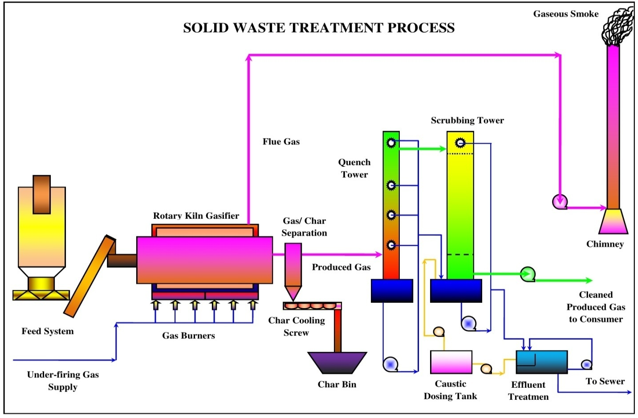

Figure 24: Process of Pyrolysis in Solid and Waste Water Treatment.

Pyrolysis: Pyrolysis is defined as thermal degradation of waste in terms of may be water or solid in the absence of air to produce char, pyrolysis oil and syngas, e.g., the conversion of wood to charcoal also it is defined as destructive distillation of waste in the absence of oxygen. External source of heat is employed in this process. Because most organic substances are thermally unstable they can upon heating in an oxygen – free atmosphere be split through a combination of thermal cracking and condensation reactions into gaseous, liquid and solid fraction.

- Incineration process;
- Compaction process;
- Pyrolysis process;
- Gasification process;
- Composting process.

Solid Waste Handling Practice

Proper method should be adopted for management of solid waste disposal in a soil. Industrial wastes can be treated physically, chemically and biologically until they are less hazardous. Acidic and alkaline wastes should be first neutralized; the insoluble material, if biodegradable should be allowed to degrade under controlled conditions before being disposed off into the soil. As a last resort, new areas for storage of hazardous waste should be investigated such as deep well injection and more secure landfills. Burying the waste in locations situated away from residential areas is the simplest and most widely used technique of solid waste management.

Environmental and aesthetic considerations must be taken into consideration before selecting the dumping site’s soil condition and quality. Incineration of other wastes is expensive and leaves a huge residue and adds to air, water and soil as major pollutant in terms of residue as well. “Pyrolysis Practice or Technique” is a process of combustion in absence of oxygen or the material burnt under controlled atmosphere of oxygen as Solid Waste Handling Pyrolysis Technique shown Figure 25. It is an alternative to incineration. The gas and liquid thus obtained can be used as fuels. Pyrolysis of carbonaceous wastes like firewood, coconut, palm waste, corn combs, wheat pod, cashew shell, rice husk, paddy straw, barley pod, maize husk and saw dust, yields charcoal along with products like tar, methyl alcohol, acetic acid, and acetone and fuel gases.

Figure 25: Solid Waste Handling Pyrolysis Technique.

Environment Baseline: Environmental, ecological and societal profile of the study region/ vicinity of project location are based on secondary data of Physiographic, Topology, Climate, Water Quality, Biological outline of town. The study has to be incorporated regarding Sewage Treatment Plant (STP) both in terms of theoretically and technically applicability for the specific region. The working model of Sewage Treatment Plant or principal subject matter has to be applied in the town so that it must play significant role for the people and its cultural civilization of the society as shown in the Figure 26. The flora and fauna recognized in the study spot are commonly found and not precise to the province due to the deficiency of forest in the study zone.

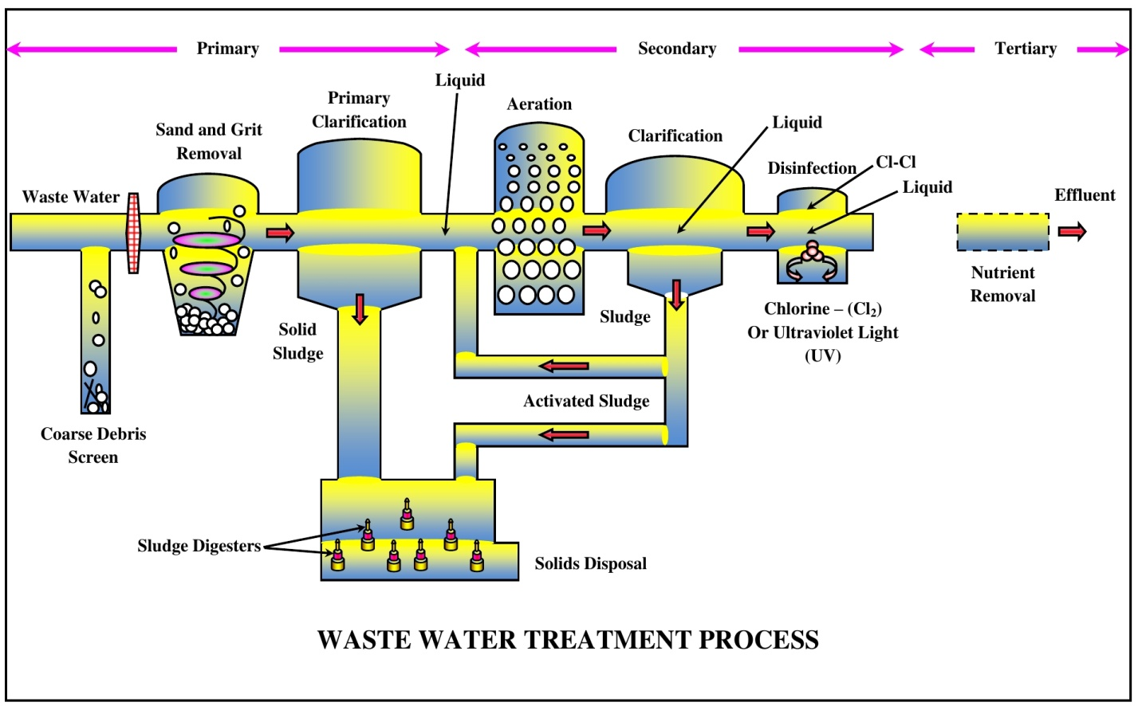

Figure 26: Sewage Treatment Process (STP) of Wastewater Layout.

13. INSTITUTIONAL REQUIREMENTS AND ENVIRONMENTAL MONITORING PLANS

National Highway Authority of India (NHAI) has a well established Environmental Management Unit (EMU), Head by a Senior Officer Indian Forest Services (IFS) from Ministry of Environment and Forest, who is supported by an officer of Dy. G. M. rank from State Pollution Control Board (SPCB). Main responsibility of EMU will be established to monitor the progress regarding Environmental Management Plan (EMP). Environmental Management Plan will be the responsibility of contractors and will be closely coordinated by the Engineer (Supervision Consultant). Table 39 as given below discusses about the remedial measures components, locations/ regions/ areas, time frame work and institutional responsibility with applicable criteria.

Table 39: Institutional Responsibility of Remedial Measures.

Environmental  Components | Remedial Measures  Components | Locations/ Regions/ Areas | Time Frame Work | Applicable Responsibility Criteria
Design – Phase
Major Resources (Alignment, Public Amenities and Public Utilities)
Alignment | Avoid impacting school, health facilities, water bodies and residential quarters. | Throughout the Project Corridor. | During Design | Design Consultant
Public Amenities | Provision of service roads, underpasses, safety signs, bus stops, lay bees, parking spaces etc. | Throughout the Project Corridor as Mentioned in  EIA Report. | During Design | Design Consultant
Closure of Public Utilities e.g., Tube – Wells, Wells, Bus Stops etc. | Alternative arrangement. | Throughout the  Project Corridor as Mentioned in  Social Impact Assessment (SIA). | At the Beginning of Construction Activities. | Contractor, Supervising Engineer
Construction – Phase
Water Resources and Pollution (Water Bodies, Rivers, Drinking and Wastewater Water)
Water Bodies | Construction of embankments, de – siltation and environmental enhancement as mentioned in EIA report. | Water Bodies  As Mentioned in EIA Report. | Throughout Construction Phase | Contractor, Supervising Engineer
Rivers/ Nallahs | Prevention of pollution of water. | Rivers/ Nallahs Mentioned in EIA Report. | Throughout Construction  Phase | Consultant,  Contractor,  Supervising  Engineer
Water Requirement for Construction | Arrange water without affecting local requirement. Do not use local water bodies. Drill boreholes with required permission. No water collection within forest area. | Throughout the Project Corridor. | Throughout Construction Phase. | Contractor, Supervising Engineer
Drinking Water Requirement | Arrange water without affecting local requirement. | Workers’ Camps Working Site. | Throughout Construction Phase. | Contractor, Supervising Engineer
Wastewater from Workers’ Camp | Ensure proper sanitation and drainage. No direct wastewater discharge in water bodies or the rivers/ Nallahs. | Workers’ Camps | Throughout Construction Phase | Contractor, Supervising Engineer
Air and Noise
Dust Generation | Spraying of water, proper handling of fly ash. | Throughout the Project Corridor. | Throughout Construction Phase. | Contractor, Supervising Engineer
Dust Generation near Sensitive Locations | Spraying of water, work during scheduled period only. | Schools, PHCs as Mentioned in EIA Report. | During Construction Near the Vulnerable Sites. | Contractor, Supervising Engineer
Asphalt Plant | Location away from sensitive areas. | Throughout the Project Corridor. | Throughout Construction Phase. | Contractor, Supervising Engineer
Stone Crushers | Implementing proper air pollution control measure as per law. | Stone Crushers. | Throughout Construction Phase. | Contractor, Supervising Engineer
Gaseous Emission from Construction Work Vehicles | Ensure checking of vehicular emission and obtaining Pollution Under Control (PUC) certificate. | Throughout the Project Corridor. | Throughout Construction Phase. | Contractor, Supervising Engineer
Noise from Machineries and Construction | Ensure machineries meeting noise level standards. Blasting to be done with required caution. | Throughout Projected Locality/ Region | Throughout Construction Phase | Contractor, Supervising Engineer
Noise at Sensitive Locations | Work only at scheduled period. Construct noise barrier if suggested. No work during night in forest areas. | At Schools, PHCs as Mentioned in EIA Report. In Forest Areas. | During Construction Near the Vulnerable Sites. | Contractor, Supervising Engineer
Land and Soil
Storage of Construction Materials, Debris. Fly Ash, etc. | Prevent siltation from washing of construction materials. | Throughout the Project Corridor. | During Rainy Seasons. | Contractor,  Supervising Engineer
Soil Erosion | Proper planning for slope stabilization, topsoil storage, plantation and turf on slopes. | Throughout the Project Corridor. | Throughout Construction Phase. | Contractor, Supervising Engineer
Borrow Pits and Queries | Excavation from pre – selected locations. After excavation the borrow pits will be dressed to match with the surroundings. | Selected Borrow Pits and Quarries as given in EIA Report. | Throughout Construction Phase. | Contractor, Supervising Engineer
Solid Waste from Construction Work | Ensure dumping outside city area with permission from local authority or used as landfill material. | Throughout Project Area/ Site/ Region | Throughout Construction Phase. | Contractor, Supervising Engineer
Flora (Plants’ Life)
Tree Felling | Ensure plantation of trees on both sides of road and around in consultation with forest department. | Throughout the Project Corridor and Beyond. | Throughout Construction Phase. | Design Consultant, Contractor, Supervising Engineer
Fauna (Plants’ Life)
Forest Area | No work after evening. No use of water bodies, safety regulations, no workers’ camp. | In the Forest Area. | Throughout Construction Phase | Contractor, Supervising Engineer
Others (Public, Religious and Aesthetics)
Workers’ Camp | Ensure providing camp of proper dimension and environmental quality as given in EIA report. | Workers’ Camps. | Throughout Construction Phase. | Contractor, Supervising Engineer
Public Facilities | Ensure access to all important locations. | Throughout the Project Corridor. | Throughout Construction Phase. | Contractor, Supervising Engineer
Religious Places | Ensure minimum disturbance during festival time. | Throughout the Project Corridor. | Religious Festivals. | Contractor, Supervising Engineer
Aesthetics | Planting flowering creepers on medians, slope vegetations, suitable design of restaurants etc. | Throughout the Project Corridor. | Throughout Construction Phase. | Contractor, Supervising Engineer
Operation – Phase
Sources (Dust, Gaseous Pollution, Forest, Safety and Public Amenities)
Dust | Road maintenance. | Throughout the Project Corridor. | Throughout Operation Phase. | Contractor, Supervising Engineer
Gaseous Pollution | Check the vehicles for pollution control. | Throughout the Project Corridor. | Throughout Operation Phase. | Contractor, Supervising Engineer, Traffic Department
Forest | Speed restriction safety signs underpass maintenance. | In Forest Areas. | Throughout Operation Phase. | Contractor, Supervising Engineer, Traffic Department
Safety | Maintain all safety provisions. | Throughout the Project Corridor. | Throughout Operation Phase. | Contractor, Supervising Engineer, Traffic Department
Public Amenities | Bus stop and other amenities to be properly kept. | Throughout the Project Corridor. | Throughout Operation Phase. | Contractor, Supervising Engineer, Traffic Department

14. Principal Component Analysis (PCA) Indicators

Significant Indicators as Principal Component Analysis (PCA) performed also indicates that indicators, which play significant role in explaining vulnerability among the districts states. Amongst all the indicators considered in particular sector indicators with weights greater than the average weight of all indicators are considered as important in explaining vulnerability study applications. Table 40 gives the list of significant indicators in order of their importance for each sector. These indicators can play important role in decision making process/ system/ methodology in a goal to reduce vulnerability.

Table 40: Principal Component Analysis as Significant Indicators of Remedial Measures.

Sr. No. | Principal Indicators Analysis/ Aspects | Conceptual Basis
(A) | Social Aspects/ Analysis
1. | Population Served Per Health Centre (Community, Primary and Sub Health Centers); | Adaptive Capacity
2. | Percentage of Households With Access To Sanitation Facilities; | Adaptive Capacity
3. | Level of Urbanization; | Adaptive Capacity
4. | Percentage of Households With Access to Safe Drinking Water; | Adaptive Capacity
5. | Density of Population; | Sensitivity
6. | Number of Slum Dwellers Per Slum; | Sensitivity
7. | Percentage of Households Owning Radio, Transistor, Television and Telephones; | Adaptive Capacity
8. | Proportion of Elderly Population Aged 65 and Above; | Sensitivity
9. | Proportion of Child Population in The Age Group 0 – 6; | Sensitivity
10. | Literacy Rate and Growth; | Adaptive Capacity
(B) | Economic Aspects/ Analysis
11. | Agricultural Credit Societies Per Lakhs of Population; | Adaptive Capacity
12. | Loan Disbursed by Agricultural Credit Societies Per Cultivator; | Adaptive Capacity
13. | Scheduled Commercial Banks Per Lakhs of Population; | Adaptive Capacity
(C) | Agricultural Aspects/ Analysis
14. | Percentage of Land Holdings Below 1 Hectare; | Sensitivity
15. | Fertilizer Consumption and Utilization; | Adaptive Capacity
16. | Percentage of Net Irrigated Area to Geographical/ Physical/ Environmental Area By Surface Water; | Adaptive Capacity
17. | Percentage of Bio – Farming Villages in Total Villages; | Adaptive Capacity
18. | Percentage Share and Contribution of Agricultural And Cultivators Main Workers; | Sensitivity
19. | Yield and Capitulate of All Crops; | Adaptive Capacity
(D) | Water Aspects/ Analysis
20. | Crop Water Stress, Strain and Sprain (Evapo – transpiration/ Potential Evapo – transpiration); | Sensitivity
21. | Surface Water Availability and Accessibility; | Adaptive Capacity
(E) | Climate Aspects/ Analysis
22. | Warm Nights – Days, When Minimum Temperature > 90th Percentile; | Exposure
23. | Warm Days – Cool Nights – Days, When Maximum Temperature > 90th Percentile; | Exposure
24. | Warm Spell Duration Indicator (Annual count of days with at least 6 consecutive days when maximum temperature > 90th percentile); | Exposure
25. | Cool Days – Cool Nights – Days, When Maximum Temperature < 10th Percentile; | Exposure
26. | Cool Nights – Days, When Minimum Temperature < 10th Percentile; | Exposure
27. | Flood Discharge; | Exposure
28. | Extremely Wet Days – Annual Total Rainfall, When Rainfall > 99th Percentile; | Exposure
(F) | Health Aspects/ Analysis
29. | Percentage of People Having Diarrhea and Other Dieses; | Sensitivity
30. | Index, Directory, Catalog, Guide, Manifestation or Indicator of Malaria; | Sensitivity
(G) | Pollution Aspects/ Analysis
31. | Pollution of Rivers/ Wetlands, Degradation of Forests and Biodiversity Loss is Being Observed; | Exposure
32. | Effective Industrial Waste Management and Pollution Control; | Exposure
33. | With Increasing Pollution Increase in Respiratory Diseases and Allergies is Also Predicted to Increase on the Site; | Exposure
34. | Water Pollution is another Big Concern for the State. Depletion of Water Resources and Deterioration of Water Quality is Big Concern for the State; | Exposure
35. | Use of More Efficient Technology to Reduce Pollution. Effective Industrial Waste Management and Pollution Control; | Exposure
36. | Climate Change (CC) could Increase Air Pollution Levels by Accelerating the Atmospheric Chemical Reactions that Produce Photochemical Oxidants due to a Rise in Temperature; | Exposure
37. | Long Term Targets – By achieving renewable sources of environmental factors/ paraMeters through agriculture – ecosystem management, implementation of main schemes as soil carbon storage and Metersing, enhancing soil health, reducing ground water pollution specially harmful chemicals and enhancing biodiversity modifications; | Exposure
38. | The other serious issues of groundwater quality are high concentration of fluorides (mainly in granitic terrain), agricultural, municipal and industrial or anthropogenic pollutions; | Exposure
(H) | Forest Aspects/ Analysis
39. | Percentage of High Density Forest Area to Geographical Area; | Adaptive Capacity
40. | Non – Timber Forest Products (NTFPs) Diversity (Number of Varieties); | Adaptive Capacity
41. | Number of Joint Forest Management (JFM) Communities, Neighbourhood – Area – District – Groups of People; | Adaptive Capacity
(I) | Soil Aspects/ Analysis
42. | Dependence on natural resources is the way of life but unsustainable practices of harvesting, irrigation, elimination of crop residue, forest degradation, deteriorating soil and water quality are augmenting the problems besides other impacts of Climate Change (CC) occur in the state; | Adaptive Capacity
43. | Mono – cropping reduces the crop diversity and adversely affects the soil health in the state or region; | Sensitivity
44. | Soil and water conservation innovative ideas must be applied through demonstration of best engineering practices; | Sensitivity
45. | Set up a knowledge management network to avail information on land – use pattern, soil types, weather or climatic conditions, genotypes of crops, water availability, pasture, off – season crops and agro – forestry practices etc. | Adaptive Capacity
46. | Develop capacity to run agriculture related climate models, decipher their projections, to understand the impact on crops, soils and water like precious and important factors etc. in the region/ area or state; | Adaptive Capacity
47. | Soil testing – practice and packages must be applied during civil construction work (soil kit to the farmers); | Exposure
48. | Undertake and revise soil resource mapping at village/ local/ regional or state level; | Exposure
49. | Promote use of water and soil conservation techniques, namely dry land farming, drip irrigation, intermittent flooding, drying sowing use of high yielding drought resistant cultivars as appropriate etc. in different areas or states; | Adaptive Capacity
50. | Promote agro – forestry and agro – climatic or weather conditions to increase forest biomass and hence soil moisture; | Exposure
51. | Identify critical unspecified areas within forests for soil and water conservation; | Exposure
52. | This effort would not only provide fodder to the animals, but also would curb or reduce further land degradation and soil erosion; | Exposure
53. | Soil moisture stress to the crops leading to their stunted growth in the region or state; | Exposure
54. | Soil and water conservation technologies will need to be strongly adopted after observing or seeing the rising temperatures and decreasing water conditions in the state; | Adaptive Capacity
55. | Soil and water conservation through demonstration of best practices: Application of mulching techniques, drip irrigation, and micro/ macro irrigation practices, techniques and methodologies etc. should be encouraged; | Adaptive Capacity
56. | Soil conditions may pose threat problems with an expected increase in acidity, alkalinity and salinity; | Sensitivity
57. | Soil temperature may increase in spring hence the planting time may also vary accord to space and time; | Sensitivity
58. | Further, it would be worthwhile to build and strengthen capacity in the state to run climate models, interpret their projections, and use the same to run the various bio physical models to understand the impact of Climate Change (CC) on crops, soils, water etc. and then to design appropriate adaptation strategies during construction of civil work or human made or designed, but not natural process; | Adaptive Capacity
59. | In some regions mono – cropping of soybean wheat is rendering the soil infertile, sterile, unproductive, barren, unfruitful, arid, uncultivable and may lead to over use of artificial fertilizer which may be detrimental in the long run; | Sensitivity
60. | Promoting and managing agro – forestry, agro – climatic specific crops farming practices and management including that of water, soil, pests, crops, cropping cycle and practices for harnessing the full productivity potential of the different zones should be done on high priority basis for regional areas or site locations; | Adaptive Capacity
61. | This would mean promoting measures for soil moisture conservation through development of watersheds and small catchments that would also increase biomass production and increase the fertility of the “Precious Soil” as well on “Precious Planet Earth”; | Adaptive Capacity
62. | Also as the evapo – transpiration rate increases with increase in temperature, it will lead to depletion in moisture retention capacity of the different soil types and can pose a threat to agricultural activities; | Sensitivity
63. | Expansion of area of cultivation under mono – cropping of profitable crops without nutrition management is leading to rapid decline in soil fertility of these farms and agricultural fields; | Adaptive Capacity
64. | Simple soil and water conservation techniques, methodologies, applications, processes and overall watershed development including the rejuvenation of tanks is proposed to be the focus; | Adaptive Capacity
65. | Low capacity of natural water recharge and resources system in the sub – soil in most of the areas of Uttarakhand State is also a major concern; | Sensitivity
66. | Water logging in canal command areas leads to soil salinity and needs immediate attention towards conjunctive use of surface streams, channels and ground water; | Sensitivity
67. | The state is characterized by a great diversity of parent rocks and minerals, which have weathered under different climatic conditions, vegetative covers and topographic situations to form soils with different characteristics in different zones; | Exposure
68. | Shifting of rainfall pattern affects cropping and farming patterns. Mono – cropping reduces the crop diversity and adversely affects the precious and significant soil health conditions. | Sensitivity

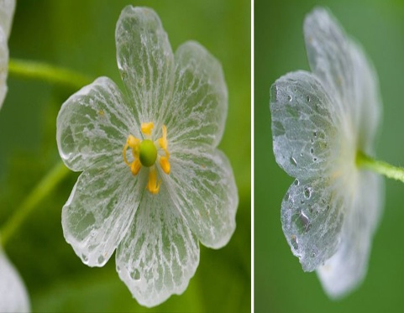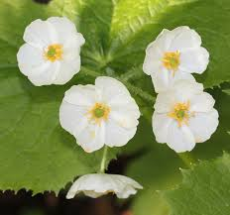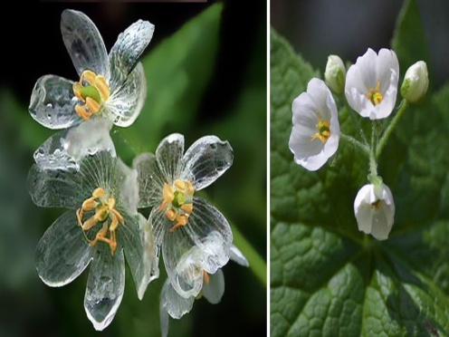

Aspects of Transparent Skeleton – Flowers in Rainy Season, Diphylleia Grayi Rare – Plants.

Figure 27 (a): TCS: TYPICAL CROSS SECTION FOR 2 – LANE CARRIAGEWAY.
TYPICAL CROSS SECTION – I

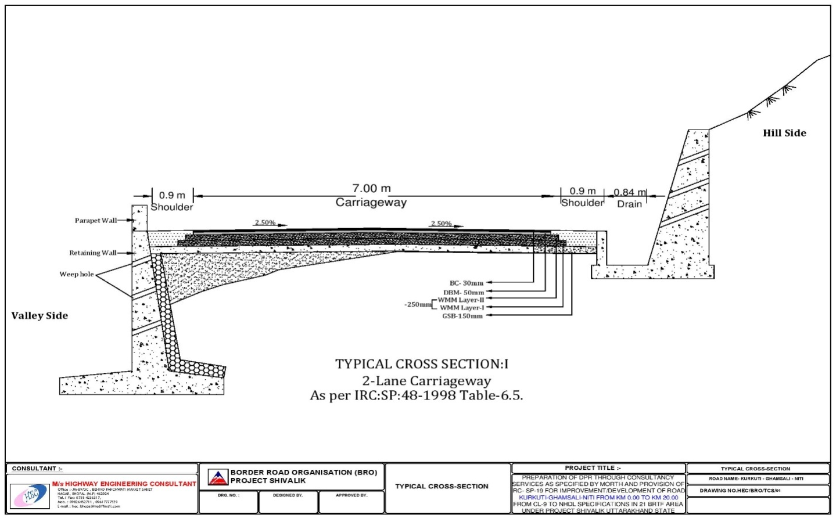

Figure 27 (b): TYPICAL CROSS SECTION: FOR 2 – LANE CARRIAGEWAY.
TYPICAL CROSS SECTION – II

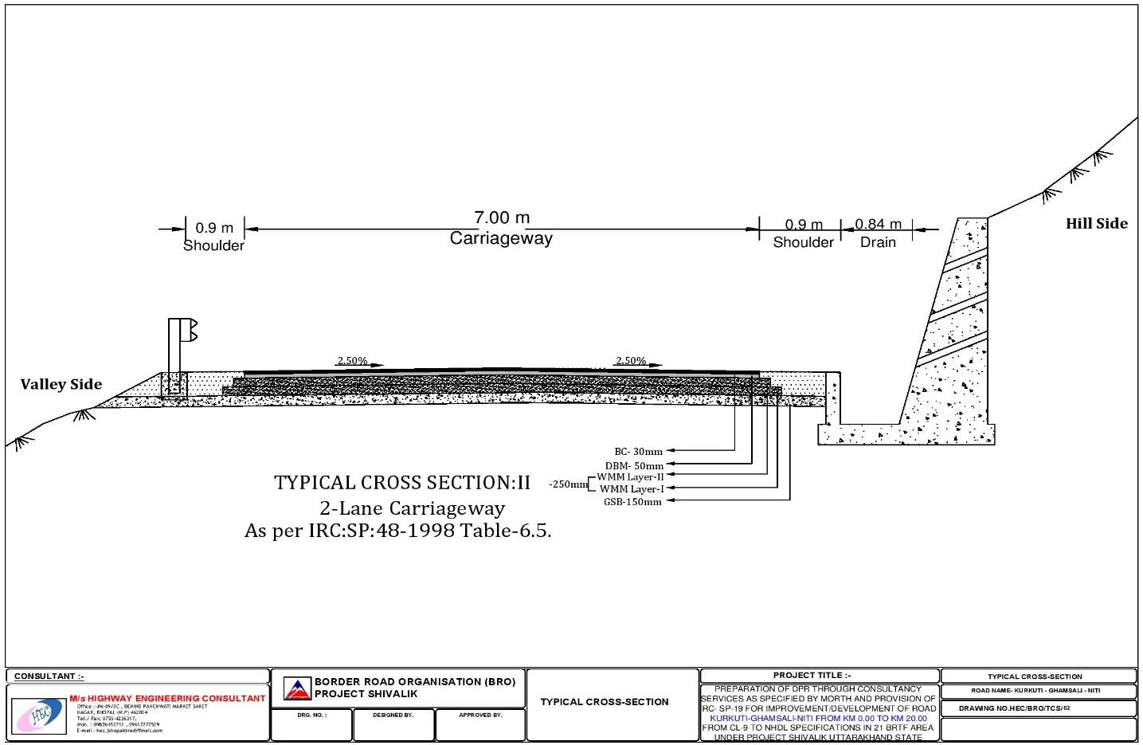
Figure 27 (c): TYPICAL CROSS SECTION: FOR 2 – LANE CARRIAGEWAY.
TYPICAL CROSS SECTION – III

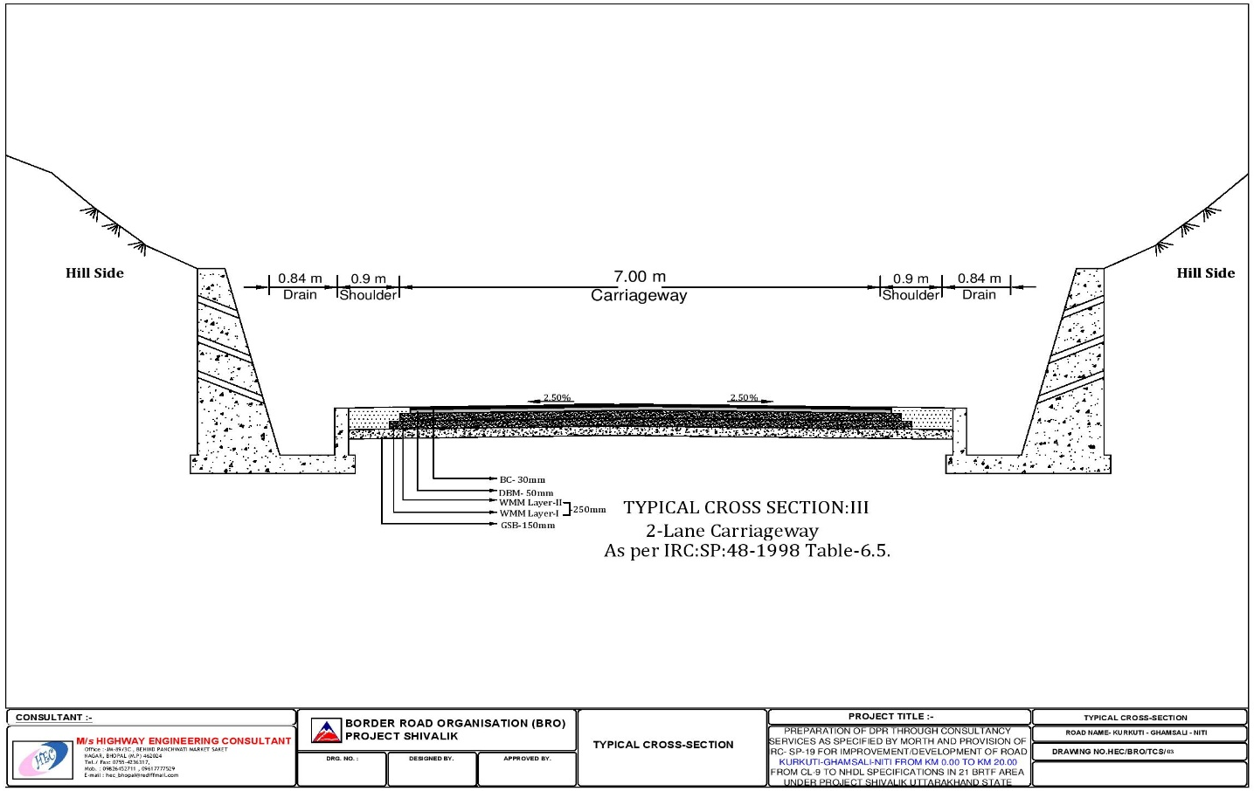

Figure 27 (d): TYPICAL CROSS SECTION: FOR 2 – LANE CARRIAGEWAY.
TYPICAL CROSS SECTION – IV

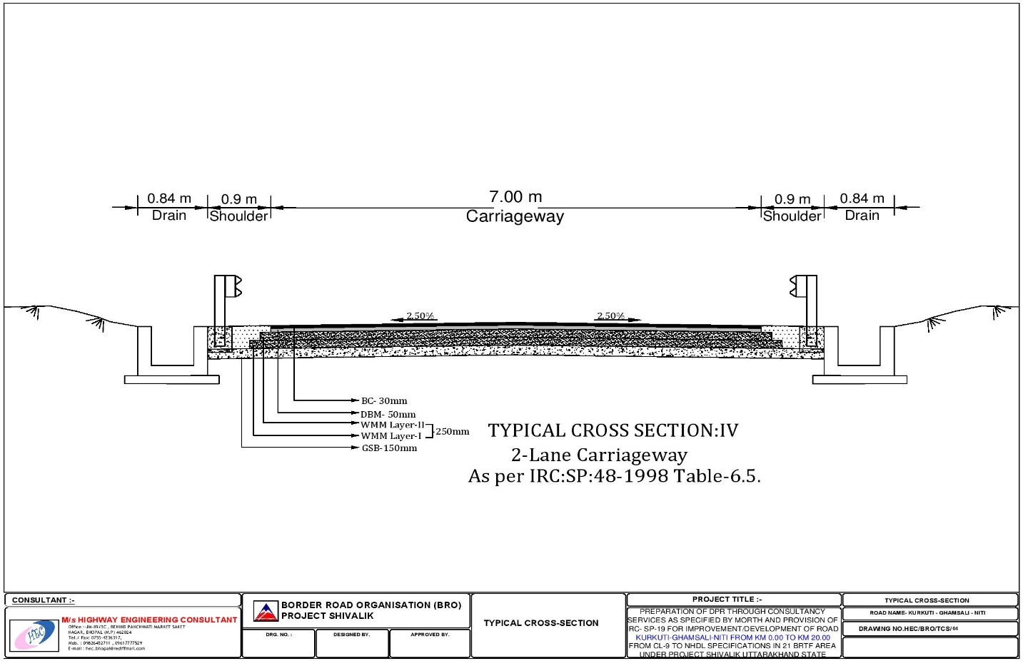
Figure 27 (e): TYPICAL CROSS SECTION: FOR 2 – LANE CARRIAGEWAY.
TYPICAL CROSS SECTION – V

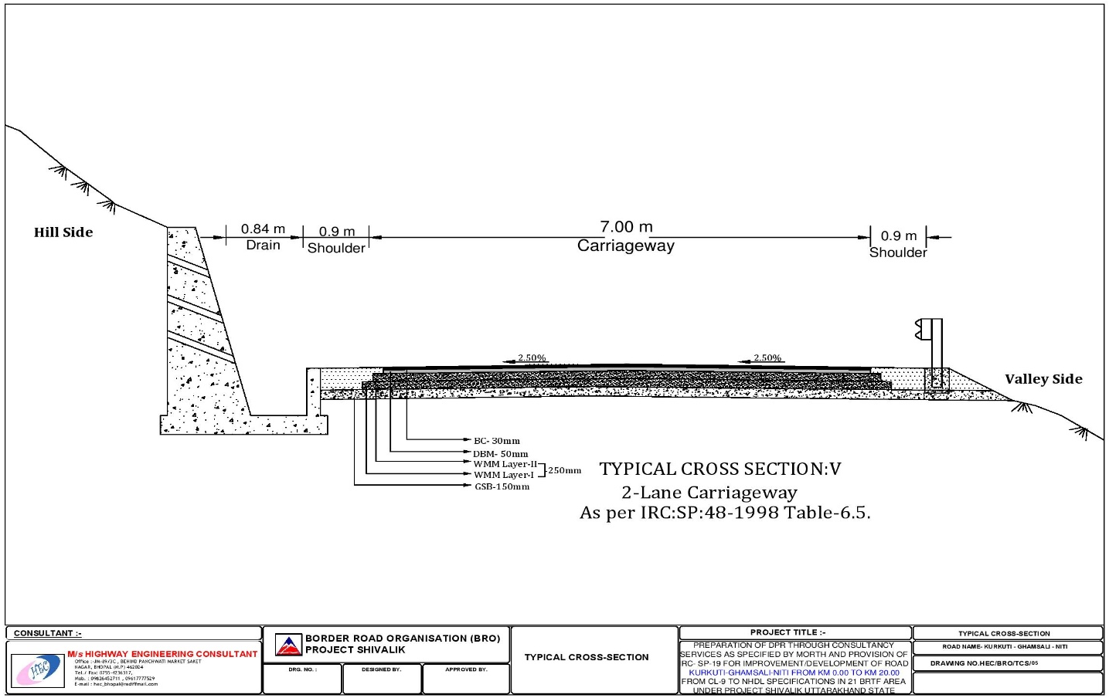

Figure 27 (f): TYPICAL CROSS SECTION: FOR 2 – LANE CARRIAGEWAY.
TYPICAL CROSS SECTION – VI

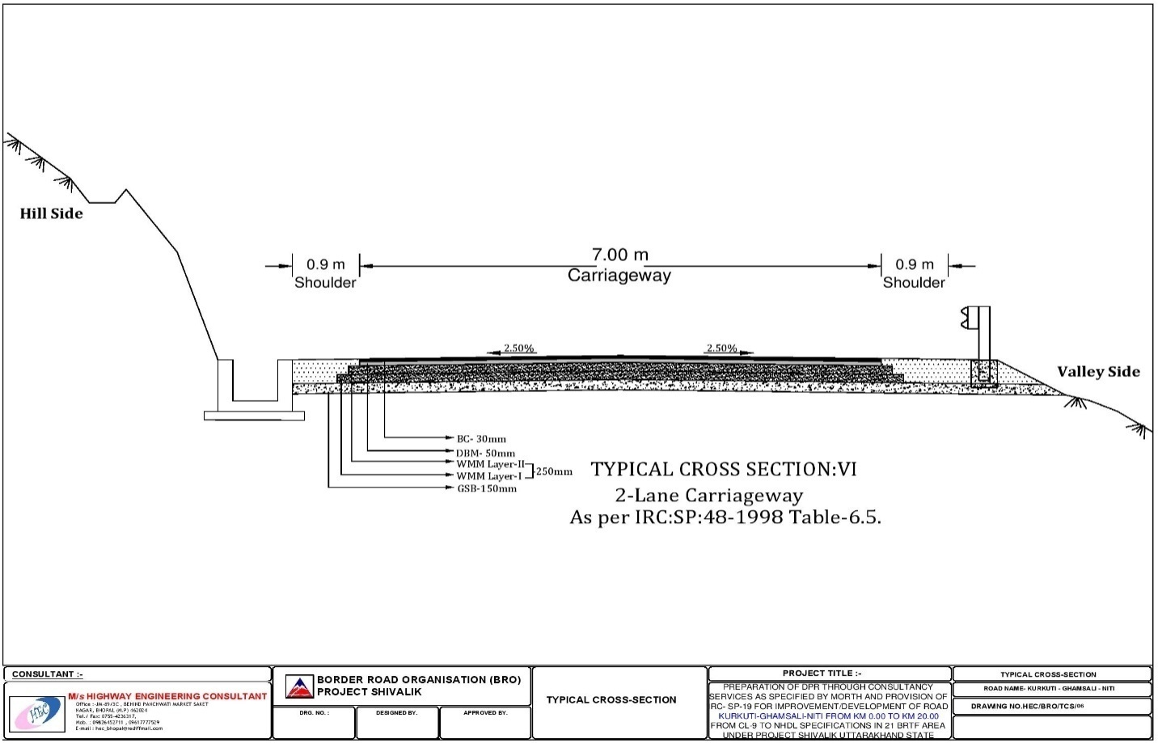
Figure 27 (g): TYPICAL CROSS SECTION: FOR 2 – LANE CARRIAGEWAY.
TYPICAL CROSS SECTION – VII

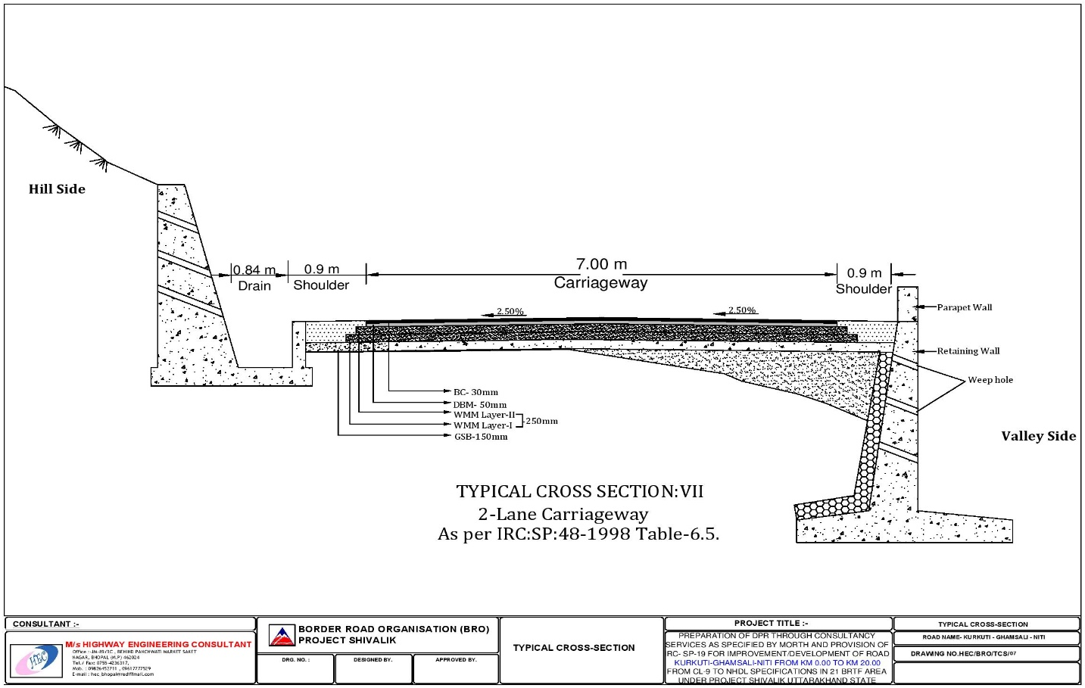

Figure 27 (h): TYPICAL CROSS SECTION: FOR 2 – LANE CARRIAGEWAY.
TYPICAL CROSS SECTION – VIII

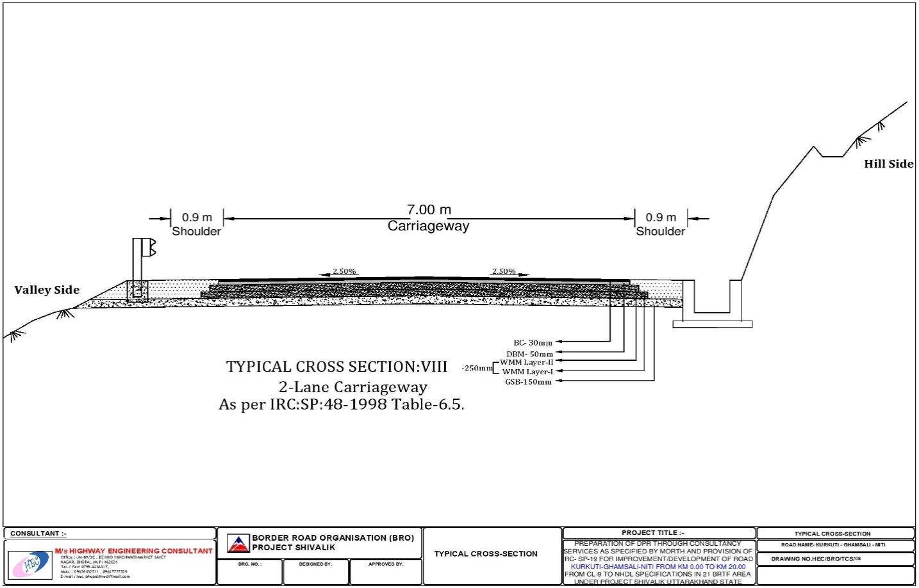
Figure 27 (i): TYPICAL CROSS SECTION: FOR 2 – LANE CARRIAGEWAY.
TYPICAL CROSS SECTION – IX

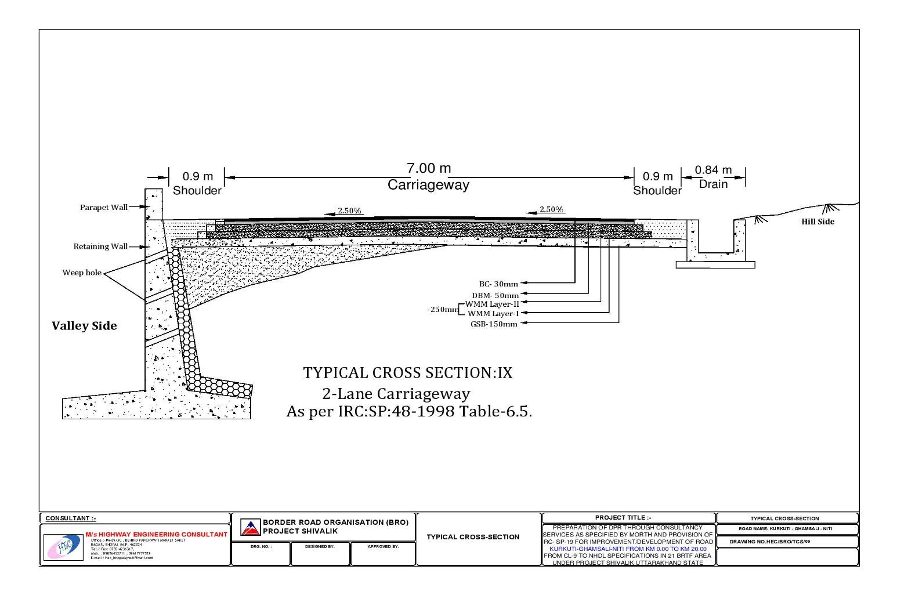

Figure 28: BOTHER... SAFEGUARD; PROTECT; CONSERVE AND PRESERVE OUR PLANET EARTH’S NATURAL – MOTHER... (ECO – NATURAL – GREEN – ENVIRONMENT)...!!!

***************************
*********************
Chapter – 2: ENVIRONMENT SCREENING REPORT

2.1 GENERAL DESCRIPTION

The Initial Environmental Examination (IEE) is carried out to assess the potential environmental impacts likely to be triggered by the project road. The project road will be reconstructed without any land acquisition and displacement of people. The project road belongs to Category C projects as per BRO's recent Environmental Assessment Guidelines and requires an IEE to be carried out. IEE report will be prepared based on the IEE format of Advanced Data or Design Systems (ADS) with due consideration to environmental legislation e.g., Environmental (Protection) Rules, 1986 of Government of India (GOI). The Project Road for Kurkuti – Ghamsali – Niti Road is situated in Uttarakhand State. The alignment of the project road connects Kurkuti – Ghamsali – Niti Road respectively.

The objectives of IEE are as following:

- To provide information about the general environmental settings around the sub project area as baseline data;

- To provideinformation on potentialimpacts of the project and characteristic of impacts, magnitude, distribution and their duration;

- To provide information on potential mitigation measures to minimize the impact;

- To provide information on the basis of Environmental Management Plans (EMPs);

- The field visits were madeto collect the requisite information from various government departments and from other secondary sources (including limited public consultation in the form of focused group discussions).

In the IEE Activities Proposed to be undertaken as part of this project will be considered and the potential impacts will be analyzed.

2.2 DESCRIPTION OF THE PROJECT

The Project Road for Kurkuti – Ghamsali – Niti Road is situated in Uttarakhand State. The proposed project road at present has single lane carriageway. The road will be widened for intermediate lane. It is planned to reconstruct the existing road with provisions for side drains, bridges, culverts etc. The project road will be implemented within the existing Right of Way (ROW) without any land acquisition. The terrain is flat with very minor changes in elevation, and the landscape is open and devoid of forest cover. The only noticeable changes from the flat terrain occur in the few places, where the road briefly descends through ravines carved out by streams and then climbs back to the level plain. Settlements are sparse; the road runs largely through open fields/ barren lands. Many hand pumps are placed alongside the roadways or roadside for obtaining drinking water.

2.3 BRO REQUIREMENTS

The BRO classifies projects such as Scientific Research and Experimental Development (SRED) into one of three categories based on a screening of their expected environmental impacts:

- Category A. Category A projects are defined by the BRO as "Projects expected to have significant adverse environmental impacts. An Environmental Impact Statement/ Assessment (EIS/ A) (as defined by the BRO regulations) is required to address significant impacts."

- Category B. Category B projects are defined as "Projects judged to have some adverse environmental impacts, but of a lesser degree and/ or significance than those for Category A projects. An Initial Environmental Examination (IEE) is required to determine whether or not significant environmental impacts warranting an EIA are likely. If an EIA is not needed, the IEE is regarded as the Final Environmental Assessment Report (FEAR)."

- Category C.Category C projects are defined as "Projects unlikely to have adverse environmental impacts. No EIA or IEE is required, although environmental implications are still reviewed."

2.4 GOVERNMENT OF INDIA REQUIREMENTS

The following is provided for informational purposes. The IEE OR FEAR in hand has not been prepared to meet the specific criteria/ strategies/ goals/ objectives in actual on priority basis, and does not support to meet Government of India (GOI) requirements that may ultimately be determined to be applicable to certain Scientific Research and Experimental Development (SRED) activities. As of this writing, it is not anticipated that any GOI’s process/ system concerning EIAs will be required. Careful planning of those activities that of necessity occur outside the existing Right of Way (for example: placement of labour camps, extraction of fill from borrows areas, placement of temporary approaches to river crossings during bridge replacement), combined with proper contracting and procurement measures should keep all SRED activities below the thresh – hold limit that would trigger or activate the mechanism, which is in actual practice the need for an EIA OR EIS.

2.4.1 Central Government Requirements

- Primary responsibility for administration and implementation of the GOI policy with respect to conservation, ecologically or environmentally sustainable development and pollution control rests with the Ministry of Environment and Forest (MOEF) and the regulations established pursuant to the National Conservation Strategy; National Forest Policy; the Policy for Abatement or Mitigation Strategies of Pollution (1992); and the Indian Environmental Protection Act – 1986 (29th of 1986), revised in the year 1997.

- Guidance for the preparation of Environmental Impact Assessments/ Statements (EIA/ S) within this overall framework for environmental clearance of new development proposals is provided and suggested by the GOI's Handbook of Environmental Procedures and Guidelines (1994).

- Additional guidelines for road projects are provided by the Ministry of Road Transport and Highways (MORTH) in its publication entitled Environmental Guidelines for Rail/ Road and Highway Projects. The Guidelines include the summary questionnaire to be submitted to MOEF for the preparation and planning of EIAs for domestic road projects requiring EIA as noted above in the paragraphs.

- MOEF Circular No. 21012/ 26 – 99 – la – 111 dated 22nd August, 2013 exempts linear projects with ROWs of less than 40 metros (including the existing Right of Way (ROW) and land acquisition as may be required by the project) from most review processes. Projects entirely contained within the existing Right of Way (ROW) are considered as maintenance, which is generally not subject to MOEF review.

- Thus, road projects limited to actions as per instructions such as those are proposed and implemented by Scientific Research and Experimental Development (SRED) are generally exempted from GOI/ EIA requirements. The Project will not include construction of any new high level bridges and thus will not require significant changes and variations to the existing roadsides/ ways alignment or grade level quality construction of civil work.

2.4.2 State Forest Department Requirements

Removal of Trees along the Right of Way (ROW): Trees will have to be removed within the existing Right of Way (ROW) in some places to allow for widening of the carriageway, construction of shoulders, or to meet and follow current road safety standards. It should be noted that trees within the Right of Way are considered to be within the purview of the State Forest Department (SFD). Therefore, an application will be required pursuant to MOEF Letter Ref. No. 4 – 1/97' – FC, dated 18th February, 1998, which provides revised guidelines for applicability of the Forest Conservation Act (1980) to linear infrastructure projects such as rail and road projects. Clearance by the State Forest Department is assumed to have been granted/ decided/ approved/ fixed and established unless there is an indication to the contrary within 30 days.

Impacts to Reserved Forests: In the event of potential impacts to Reserved Forests, a Notice of Compliance (NOC) is required from the State Forest Department (SFD). In the event that a submission to MOEF is required, the NOC must be obtained prior to action by MOEF as an esteemed organisation.

2.4.3 State Pollution Control Board Requirements (SPCB)

- Certain actions to be included in SRED (e.g., the locations and operations of asphalt crushing or mixing plants) will require submission of an application to the SPCB pursuant to the water (Prevention and Control of Pollution) Act of 1974, Cass Act of 1977, and Air (Prevention and Control of Pollution) Act of 1981.

- The SPCB generally establishes a review panel or board/ section/ group/ jury members and circulates the application for public review and comment in each affected district. At least one public hearing is held in each affected district following not less than 30 days notice in local and regional newspapers/ media network/ news channels etc.

- A state – level hearing is also required, taking all comments received from the districts into account and assuming acceptability of the SPCB issues as per NOC status and standard maintained for civil construction road network.

- The SPCB's NOC, as well as the Forest Department's NOC is required before MOEF action on any required EIA can be considered complete or whole comprehensive and inclusive report work.

2.5 DESCRIPTION OF THE ENVIRONMENT

Data and information required for preparation of the Initial Environmental Examination (IEE) report have been collected from various government departments or agencies/ well established organizations, secondary sources and through actual field visits/ tours/ on site/ area/ location fieldworks etc. Environmental conditions for applicability index of the area are discussed below one by one in detail:
- Physical Resources

- Weather and Climate Index

Kurkuti (कुर्कुटई)

    - The block name is Dwarikhal and Pauri Garhwal is the District in the Uttarakhand State. Humidity is found to be 69% along with West wind flow at 6.59 Meters/ Sec towards SE. Uttarakhand’s current Weather and Temperature on an average is 26.9°C to 34.8°C and there is found to be overcast clouds, few clouds, clear sky, scattered clouds, broken clouds, along with moderate rain and light rain. Kurkuti Live Weather Temperature has been found to be 30.8°C and Weather Forecast for next 3 days may varies between 25.2°C to 26.8°C with heavy intensity rain. The temperature in the region reaches and varies minimum to maximum level in – between for next 3 days may varies between 25.2°C to 34.8°C and temperatures seldom exceeding 28°C (82°F) in summer. Pressure level is observed to be 1019.40 mb and Ultra – Violet Index is near about 1 with Cloud Cover 72%. Ceiling point is 9,144 m and dew point is found to be 7°C with visibility 16 Km. Uttarakhand is home to several Himalayan glaciers. With an average Elevation/ Altitude are found to be 1,938 Meters (6358.26 Feet) above the Mean Sea Level (MSL), the Nanda Devi is 7,816 Meters (25,636 Feet) long making it the longest Himalayan glacier. The climate of Uttarakhand varies greatly owing to its rugged topography. Uttarakhand is located at 30.0668° N and 79.0193° E. It has an average elevation of 1,500 Metres (4,900 Feet). Uttarakhand lies at uneven ridges of low heights at the Bhagirathi 6,856 Meters (22,487 Feet) Hills. It is approximately 236 Km (147 Miles) from the national capital, New Delhi. Highest elevation‎: ‎7,816 Meters (25,636 Feet); Area Rank‎: ‎19th; Lowest Elevation‎:‎ 6,856 Meters (22,487 Feet); Official Languages‎: Hindi and Garhwali. Telephone Code or STD Code is 01386 and Station Name is “Kalagarh” in Uttarakhand.

Niti (नीति)

    - The block name is Joshimath and Chamoli is the District in the Uttarakhand State. Humidity is found to be 88% along with West wind flow at 2.11 Meters/ Sec towards North. Uttarakhand’s current Weather and Temperature on an average is 13.8°C to 20.1°C and there is found to be overcast clouds, few clouds, clear sky, scattered clouds, broken clouds, along with moderate rain and light rain. Niti Live Weather Temperature has been found to be 14.2°C and Weather Forecast for next 3 days may varies between 25.2°C to 26.8°C with heavy intensity rain. The temperature in the region reaches and varies minimum to maximum level in – between for next 3 days may varies between 25.2°C to 34.8°C and temperatures seldom exceeding 28°C (82°F) in summer. Pressure level is observed to be 1019.40 mb and Ultra – Violet Index is near about 1 with Cloud Cover 72%. Ceiling point is 9,144 m and dew point is found to be 7°C with visibility 16 Km. Uttarakhand is home to several Himalayan glaciers. With an average Elevation/ Altitude are found to be 1,938 Meters (6358.26 Feet) above the Mean Sea Level (MSL), the Nanda Devi is 7,816 Meters (25,636 Feet) long making it the longest Himalayan glacier. The climate of Uttarakhand varies greatly owing to its rugged topography. Uttarakhand is located at 30.0668° N and 79.0193° E. It has an average elevation of 1,500 Metres (4,900 Feet). Uttarakhand lies at uneven ridges of low heights at the Bhagirathi 6,856 Meters (22,487 Feet) Hills. It is approximately 236 Km (147 Miles) from the national capital, New Delhi. Highest elevation‎: ‎7,816 Meters (25,636 Feet); Area Rank‎: ‎19th; Lowest Elevation‎:‎ 6,856 Meters (22,487 Feet); Official Languages‎: Hindi and Garhwali. Telephone Code or STD Code is 01386 and Station Name is “Kalagarh” in Uttarakhand.

- Climate and Temperature Index

    - There is no meteorological observatory in the district and on the basis of records of the observatories in the districts where similar climatic conditions prevail. It is very cold in summer also. North District summer highest day temperature is in between 12°C to 21°C. Average temperatures of January is 5°C, February is 7°C, March is 11°C, April is 14°C, May is 15°C for specific regions. The mean temperature in the lower altitudinal zone, it varies from 1.5°C to 9.5°C. Temperature varies with altitude and slope of mountainous/ hilly region and the maximum temperature is recorded usually during July and August and minimum during December and January. Fog is a common feature in the entire Uttarakhand State from May to September. Biting cold is experienced at high altitude places in the winter months and snowfall is also not uncommon during this period. Humidity varies from 80 to 90% and wind flows at 16 KPH from West to East on an average. Transmission Windows (TWs) for malaria i.e., the appropriate conditions of temperature and humidity in which a vector thrives, is projected to increase (temperature ranges between 14 – 40°C, and RH > 50%) with Climate Change (CC).

- Rainfall and Temperature Index

    - PHYSICAL ASPECTS: With an annual average rainfall of 2,068 mm, it is one of the highest rainfall receiving regions on the planet, which makes it an important site from a meteorological perspective. Analysis of rainfall data plays an important role for any water resource planning as well as for hydrological modeling. The mean monthly rainfall data for all districts of Uttarakhand for 102 years (1901 – 2002) were used for the present study displays the annual rainfall behavior recorded for whole Uttarakhand for the duration 1901 – 2002. The average annual rainfall recorded is 1069 mm for the whole duration. During this period, the highest amount of rainfall was about 1982.15 mm in 1936, whereas the lowest amount of rainfall recorded was about 559.98 mm during 1987. The dark line in the figure represents the annual average rainfall. If the annual rainfall in a year departs from the average annual rainfall by greater than or equal to 25%, then it is declared as a drought (meteorological drought) year. On the basis of 25% departure from the average annual rainfall, 30.4% times there were dry years. There was sufficient rainfall from July to September to meet evapotranspiration demand and vice versa from the October to June.

      - (i) Moderate rainfall (more than 800 mm) receiving region in the Northern and South – Eastern parts of the district/ region/ locality;

      - (ii) Low rainfall (700 mm to 800 mm) in the extensive Eastern and Southern parts of the district/ region/ locality;

      - (iii) Very low rainfall (less than 700 mm) in the Western part of the district/ region/ locality.

    - Climate projections for 2030s (2021 – 2050) and 2080s (2071 – 2098) have been derived from PRECIS (Providing Regional Climate for Impact Studies), which is a desktop version of the HadRM³ model with a grid resolution of 0.44°×0.44° Angles. PRECIS simulation dataset is provided by the Indian Institute of Tropical Meteorology, Pune. The Climate Change Scenarios are driven by the Green House Gases (GHG) Emission Scenario, which assumes a future world of very rapid economic growth, a global population that peaks in midcentury and declines thereafter and assumes rapid introduction of new and more efficient technologies/ innovations in this scenario or field. Change in precipitation and temperature in 2030s and end of the century 2080s have been derived with respect to 1970s (1961 – 1990).

- Humidity Index

    - Humidity is found to be 69% along with West wind flow at 6.59 Meters/ Sec towards SE. Uttarakhand’s current Weather and Temperature on an average is 26.9°C to 34.8°C and there is found to be overcast clouds, few clouds, clear sky, scattered clouds, broken clouds, along with moderate rain and light rain. Kurkuti Live Weather Temperature has been found to be 30.8°C and Weather Forecast for next 3 days may varies between 25.2°C to 26.8°C with heavy intensity rain.

    - Humidity is found to be 88% along with West wind flow at 2.11 Meters/ Sec towards North. Uttarakhand’s current Weather and Temperature on an average is 13.8°C to 20.1°C and there is found to be overcast clouds, few clouds, clear sky, scattered clouds, broken clouds, along with moderate rain and light rain. Niti Live Weather Temperature has been found to be 14.2°C and Weather Forecast for next 3 days may varies between 25.2°C to 26.8°C with heavy intensity rain. It became renowned for the quality of the tea grown on the hills around the town, and today tea and tourism are still the main income earners for the area in Uttarakhand State.

    - Since the study region lies far away from the sea coast area/ region, it experiences continental type of climate zone. It has the Tropical monsoon climate with five distinct/ dissimilar/ divergent seasons namely…!!!

      - i. Monsoon season extending from June to September month;

      - ii. Retreating monsoon season extending from October to November month;

      - iii. Winter season – December to February month;

      - iv. Summer season – March to May month.

      - v. The temperature during spring season ranges between 6°C at night to 17°C during day in the month of December the sky generally remains clear in Uttarakhand State.

      - vi. Autumn season falls on the months of September and October in Uttarakhand State

    - Other minor effects are increased incidences of skin disorders, such as prickly heat and fungal skin disorders such as ringworm and athlete's foot as a result of increased temperature and humidity. Some of the viral diseases like Peste des Petits Ruminants (PPR) are an acute or sub – acute viral disease of goats and sheep characterized by fever, necrotic stomatitis, gastroenteritis, pneumonia etc. may also re – appear affecting small ruminant population as well. Temperature Humidity Index (THI), representing the combined stress of temperature and humidity, affects the productivity of livestock. In addition to these inherent problems increasing temperature and humidity are also affecting the quality of these produce. For value addition, processing units and marketing of products need to be developed for rural clusters in different Agro – Climatic Zones (ACZ). This would also help in reducing the wastage of the produce. Beside the vector borne diseases that could expand its occurrences, other infections that are related to varying temperature and humidity indices are also imminent threats to human health and its well beings.

- Ambient Air Quality Index

    - The air quality along the roadsides/ ways is good as there is less flow of traffic. No major source of emission of exhaust gases exist along the roadways or roadsides except some commercial and residential establishments concerns, enterprises, shopsetc., which burn wood as a fuel for commercial and domestic purposes/ reasons or functions.

    - As existing road is in narrow condition, dust due to wind – blown and movement of vehicles on earthen shoulder portion is observed experimentally, physically and practically along the roadside. However, such dust particles are settled or mend or resolved within short distances from the road.

- Noise Levels Index

    - In the area along the projected road, noise levels are moderate as there is less traffic flow. Therefore, the contribution of traffic, an increase of ambient noise levels can be considered insignificant or unimportant and immaterial.

- Seismological Index

    - As per seismic zonalmap of India, the sub project area is locatedin seismic zone – II. The bridges, culverts and other structures, therefore, need to be designed accordingly as per specific record of civil construction work.

(ii) Ecological Resources Index

- Terrestrial Ecology

    - Impacts to flora will be minimal throughout most of the projected areas. Most of the length of the Right of Way (ROW) lies in rural areas as well as some parts of urban areas also. Insofar as can be determined, no threatened or endangered plant species are located within or adjacent to the affected ROWS and no adverse impacts to special status of species/ varieties/ groups are likely to occur due to these activities. Virtually all rehabilitation and resettlement applicable processes or activities will be confined to the existing ROWS, and both direct and indirect impacts to threatened or endangered plant species are unlikely. Plant species present within the Right of Way (ROW) are either introduced species or ubiquitous native species, which are highly tolerant of grazing, compaction, and other physical disturbances. Construction activities will have direct impact only in a narrow band of vegetation adjacent to the existing roadways. Potential impacts to flora, in both the forested and non – forested land areas will be avoided by ensuring that roadside activities such as asphalt crushing and hot mixing plants, construction camps and other ancillary features are properly sited. Right of Way, both inside and outside of forested areas is lined by mature trees overarching the roadways/ roadside. In some portion trees will have to be cut to permit rehabilitation and resettlement of the roads to current/ recent applicable safety measure standards.

- Wildlife

    - The road does pass through any wildlife area in the projected region. And wildlife zone occurs in the region/ area or state.

- Fisheries

    - No fishing activity is observed in the drains of sub – projected area. And no fisheries zone occurs in the region/ area or state.

(iii) Economic Development

- Industries

    - No major/ minor industrial activity is observed along the projected roadside. Therefore no industrial zone occurs in the region/ area or state.

- Commercial Activities

    - Commercial activities observed mostly near the inhabitation portion, along the projected road. These commercial activities are in the form of shops/ malls or complexes in the region/ area or site.

- Infrastructure Facilities

    - Infrastructure facilities are adequate/ sufficient and satisfactory in the area along the projected roadside.

- Agricultural Development

    - The climate of the area is more suitable for growing agricultural i.e., wheat, soya bean, Zwaar (Heavy), Bazra or Pearl Millet (Pennisetum Glaucum) is the most widely grown type of millet as a part of plants and vegetables. There exists huge potential as far as the agriculture development is concerned. Soils are Medium to Deep – Black with relatively high clay content. The major agricultural crops are wheat, gram soybeans and cotton seeds for cotton generation/ production etc.

2.6 Social Impact Assessment (SIA): GENERAL DESCRIPTION

As part of the project, to ascertain the Resettlement and Social Development and Improvement Component (SDIC) of the project, the scope of the present study as defined by the Terms of References (TORs) are involved with several elements, paraMeters and factors, which are in order as below:

- To examine and assess the overall social and poverty profile of the project area on the basis of the primary and secondary data sources such as statistical handbooks, poverty data, land use patterns and prototype models and sample areas/ site visits/ field visits are key stakeholder’s interviews and preparation of a socio – economic profile of the state of Uttarakhand and the project districts.

- Preparation of social and poverty or scarcity and deficiency index analysis, taking into account socio – economic and poverty status of the projected area of influence, including the nature, extent and determinants of poverty in the project area including assessment of the risk of human trafficking and HIV/ AIDS due to the project. In addition, estimation/ judgment/ inference/ evaluation/ assessment of the likely socio – economic and poverty or deficiency index reduction impacts of the project also constituted an important as well as significant aspect of the study.

- Consultations with relevant officials from the governments, NGOs and other relevant officials, including consultation with Affected Persons (APs) and affected communities to assess responses to the project and ascertain the nature and scope of local participation in project planning and implementation stage.

- To identify, analyze and where appropriate, quantify the potential resettlement impacts of the proposed project on the area and the population.

- To suggest measures to enhance benefits and mitigate adverse impact on socio – economic profile in the region.

The report is based on the findings of the socio – economic surveys, field visits or site/ area visits and small group meetings/ discussions with the project populations in the projected area.

2.7 METHODOLOGY

The study will be conducted with a participatory approach that aimed at putting the community at the center with a collective process of reflection, discussion and consultation with all major stakeholders in the Project. The primary stakeholders, such as farmers, shopkeepers, daily wage labourers, Panchayat members, women and other socio – economically deprived groups like Scheduled Caste (SC), Scheduled Tribes (ST), Other Backward Classes (OBC), health workers, school teachers, General Category (GC) people and Non – Government Organizations (NGOs) will be consulted individually, in homogenous sub – groups and mixed groups to understand the local needs and responses to the proposed sub – projects and also to ascertain the impact or contact of the proposed project on the communities, the area and the overall regional state.

Site or field visits will be made by the team to the respective projects and all the villages getting affected by the proposed project intervention, in order to ascertain the socio – economic profile of the area, Participatory Rural Appraisal (PRA) Methodologies and Techniques like social mapping, resource mapping, transect walk and mobility maps etc. will be used during the course of the field investigation work.

Community meetings shall be initiated to obtain, acquire and achieve the views, responses and possible solutions from the local people.

Focus Group Discussions (FGD's) will be organized at the village level with different potential affected groups of people, more importantly, women, indigenous/ native/ local/ original and other socio – economically deprived people to ascertain the impact of the project on them.

Meetings with village Panchayats, Non – Government Organizations, health workers, and school teachers, social workers will also be held during the course of field/ site and area visits with emphasis on project impact, poverty, road safety and related issues.

A Socio – Economic Survey (SES) covering 20% of the total households/ businesses along the alignments of each of the sub – projects shall be conducted and carried out and accomplished by means of a detailed questionnaire as opinion poll.

A detailed analysis of secondary data sources shall be carried out and accomplished to understand the social, economic and demographic situation in the projected area and will be submitted along with Initial Environmental Examination (IEE) OR Final Environmental Assessment Report (FEAR)as shown in the columns with the Flow Diagrams 29 (a, b, c and d respectively).

2.8 SOCIO – ECONOMIC CHARACTERISTICS

On the basis of socio – economic data collected from the District – Handbooks and other departmental publications and brochures relevant to the project roads, as stated earlier, a Project Road Influence Area Profile (PRIA) has been prepared. The profile consists of demographic features, land utilization, occupation structure, agriculture production, acreage intensity irrigation facilities, and concentration of infrastructure facilities, such as, availability of banks, hospital beds, primary schools, electrified villages, drinking water facilities, status of accessibility (paved/ unpaved road), number of hat/ bazaar, primary health centers, government public distribution shops, post offices and family planning center etc. The compiled data have been used in the present project for several analyses during the study. A summary with salient features are presented in and Flow Diagrams 29 (a, b, c and d respectively) as given below.

Since the time series data are not available for the above socio – economic paraMeters, it is difficult to establish any trend analysis report work. However, the data available reveal the salient features of the Project Road Influence Area Profile (PRIA) as well as the concentration of different activities occurs in the projected area/ region. The status of a Project Road Influence Area (PRIA), thus identified, in a specific activity would be useful to appreciate the relative importance of that particular projected road. The information collected and compiled for all the projected roads has been utilized for establishing, launching, ascertaining the relative potential, possible, probable, prospective for future development and growth and in turn an increase in traffic of the state or region.

2.9 IMPACT ON THE INDIGENOUS PEOPLE

The indigenous/ local/ native/ original people who are presently confined to local area only shall look – after the development of road and thus transportation infrastructure will get more exposure to education, health, markets and other informative and innovative activities etc. The area is not vulnerable to migration settlements from external people. Since the major occupation of people in local area is agricultural based and there are no proper warehousing facilities for storage of agricultural product in the area the indigenous people will be benefited by road development projects. The Column 15 of Table 41: ENVIRONMENTAL MANAGEMENT PLAN (EMP) for Kurkuti – Ghamsali – Niti Road in the State of Uttarakhand.

Figure 29 (a): Overview of the Environment and Social Framework.

BRO’s core principles which governs operations on environment and social management; Environmental and Social Standards (ESS) w.r.to Environment, Involuntary Resettlement and Indigenous or Originated People (EIRIOP);
“Purposes” of the Articles of Agreement of the Border Road Organization (BRO);
Introduction
Objectives
Core Principles
ENVIRONMENTAL OVERVIEWS AND SOCIAL FRAMEWORKS

Figure 29 (b): Core Principles of the Environmental and Social Framework.
Aim of this Environment and Social Framework is to: Manage environmental; social risks; impacts in projects; manage operational; reputational risks of BRO and its stakeholders;
- Mainstream environmental and social considerations into decision – making processes of all parties;
- Encourage international – good – environmental and social practices; operations; strengthen country systems;
- Policy seeks to ensure environmental social soundness and sustainability of projects;
- Enable clients to identify, manage environmental and social risks and impacts in BRO’s projects;
- Improve development effectiveness and impact to increase results on the ground, and facilitate cooperation on environmental and social matters with development partners;
- Its operations, BRO seeks to balance economic, social, and environmental interests while fostering ownership and accountability of member countries.

h) Co-operative Functioning and Knowledge Dissemination Regarding Policies and Responsibilities
g) Precautionary Measures/ Approaches/ Applications/ Evaluations in Precious Environmental Goals
e) Conservation of Natural Resources in Environmental Field

d) Climatic Changes/ Conditions/ Observations

f) Gender Equality and Overall Impact on Environment

b) Environmental Study and Country Systems

a) Inclusive and Environmental Sustainable Development

c) Environmental and Social Aspects/ Interests/ Achievements
ENVIRONMENTAL Core Principles

A. Environment Objective;
B. Application Scope;
C. Policy Approach;
D. Environmental Policy Requirements;
E. Roles and Responsibilities;

Figure 29 (c): The Environmental Objectives; Application Scope; Policy Approach of the Environmental and Social Framework.

A. Environmental Objectives;
B. Application Scope;
C. Policy Approach;
- Environmental involuntary resettlement; indigenous or native peoples standards; preparation and implementation of BRO projects;
- BRO addresses gaps, if any, engaging client or customer to take adequate actions to ensure full success of Environmental Objectives of Framework (EOF).
C. Policy Approach:
Under Framework, BRO requires clients to meet key requirements for environmental and social assessment;
- Further, if BRO determines relevant requirements of the country in which the project is located are more stringent than the requirements of its Environmental Policies and Goals (EPG);
- BRO may require the customer to comply environment with more stringent requirements.
- Including investment projects on environment and their components regardless of financing sources;
- BRO agree to apply additional needs relating to the environmental or social affairs with the Articles of Agreement and its Policies Applicability (AAPA).
BRO believes:
- Environmental;
- Social sustainability are crucial while addressing infrastructure gaps;
- Environmental Sustainable Development (ESD) needs consistent with national laws; regulations, and its mandatory policies.
B. Application Scope:
Policy applies to all BRO financed; BRO administered projects with or without sovereign guarantee;
A. Environmental Objective:
To combine the achievement of this it is very important with project decision making process of the client and BRO and the overall operations of BRO;
- BRO will apply on project by project basis, an appropriate risk – based framework grounded on BRO experience with BRICS and other International Good Engineering Practices (IGEP) in the Environment;
- The implementation of the Environmental Policies (EP) are the responsibility of the client or costumer, including way of assessments, consultations, plans, implementation, complaint redressal, dispute resolution, disclosure and monitoring. However, BRO seeks to play a proactive role by (i) Ensuring stricter compliance with applicable national standards (ii) Working with client to strengthen country capacity and systems (iii) Facts sharing with clients on International/ Global Good Practices (I/ GGP). BRO provide support to clients during project processing, monitoring supervision where and whenever essential in the field of Environmental Goals (EG).

Figure 29 (d): The Policy Requirements; Roles and Responsibilities of the Environment and Social Framework.

D. Environmental Policy Requirements;
E. Roles and Responsibilities;

- (d) Monitoring and supervising the Client’s compliance with its environmental and social obligations under the legal agreement between BRO and the Client;
- (e) Establish and maintain a fair and effective grievance redress mechanism for Environmental and Social Safeguards (ESS).
E. Roles and Responsibilities:
- (a) Screening each project to assign a category to it;
- (b) Undertaking due diligence review of the Client’s or Customer’s Environmental and Social Assessment Reports (CESAR);
- (c) Determining the feasibility or practicability of BRO financing for the project.
D. Environmental Policy Requirements:
- The screening covers three types of concerns of ESS, i.e., environmental, involuntary resettlement and indigenous or originated or native people;
- Environmental and Social Management Framework (ESMF).

15. ENVIRONMENTAL MANAGEMENT PLAN (EMP) for Kurkuti – Ghamsali – Niti Road in the State of Uttarakhand

Table 41: Environmental Management Plan (EMP).

Environmental Issues/ Components | Remedial Measure Statements | Reference to Laws/ Guidelines | Locations/ Areas | Monitoring Indicators | Monitoring Methods | Mitigation Coast | Institutional Responsibility and Requirement
 |  |  |  |  |  |  | Implementation | Supervision
- Pre – Construction and Design Stage
1. Alignment
1.1: Pavement Damage and Inadequate Drainage Provisions in Habitat Areas. | - Construction of concrete pavement in habitat areas considering alignment level and drainage.  - Raise road level above the nearby areas with provision of adequate side drains to evacuate the rain water and domestic discharges (drained by habitats occasionally) to prevent damage to road and rain water entry to habitats’ houses.  - Provision of adequate no. of cross drainage structures based on drainage pattern around the alignment. | Design Requirement. | All habitat areas throughout the alignment. | Design of both cross and side drains no. 57 of slab/ box culverts, Hume pipes. | Review of detail design documents and drawings. | Included in construction cost. | Design Consultant. | BRO/ (CSC)
1.2: Loss of Tree and Vegetation. | - Restricting tree cutting within construction limit.  - Avoid tree cutting at ancillary site.  - Martian compensatory tree plantation of 8,480 trees @ 1: 10. | Design Requirement. | Throughout the alignment. | 848 No. of tree will be cut. | Observation | Included in construction cost | Design Consultant. | BRO/ (CSC)
1.3: Protection of Sensitive Receptors. | - Careful selection of alignment to the sensitive receptor.  - Timely schedule ling of construction activity  - Provision of noise suitable barriers. | Project Requirement. | Location of sensitive receptors (Refer Table). | Design and alignment plan | Review of design | Included in construction cost | Contractor. | BRO/ (CSC)
1.4: Safety along the Proposed Alignment. | - Make provisions of crash barriers at accident prone areas as identified in the road safety studies.  - Provision of rumble strips in habitat areas to regulate speed.  - Provision of retro – reflective warning sign boards nears school, hospital, and religious places and forests areas.  - Provision of proper sidewalks/ pedestrian zone along the road near habitat areas, school, hospital, religious places and forests.  - Compliance with norms specified in IRC codes for state highway for curvature and grading.  - Provision of safety curve at all bridges.  - The design should attempt to equalize cut and fill.  - Minimize the cutting in hill areas. Incorporate slope stabilization measures to prevent any land slide situation.  - Incorporate slope stabilization measures to prevent any land slide situation. | Design Requirement. | Places where height of embankment is more than 3.0 m. | No. of accident and vehicle collision. | Field observation, interview of locals. | Included in construction cost. | Design Consultant. | BRO/ (CSC)
2. Natural Hazards
2.1: Protection for Damage from Earthquake. | - Design considering relevant seismic standard in the clause under IRC 6 – 2014 for earthquakes in bridges. |  | Throughout the stretch. | Incorporation of IRC 6 – 2014 guidelines for earthquake in bridge design. | Review of bridge design. | Project preparation cost. | Design Consultant. | BRO
2.2: Protection of Road Embankment in Flood Prone Areas. | - Raise embankment height above the HFL levels in the flood prone areas.  - Provision of adequate balancing culverts.  - Improvement in existing culverts/ bridges to increase their carrying capacity. | IRC: 34 Recommendations for road construction in waterlogged area and IRC: 75 and MORT and H guidelines for Design of High Embankments (DHE). | All the existing culverts/ bridges. | Design of both cross and side drains, no. of slab/ box culverts, no. and size of Hume pipes. | ------- | Included in construction cost. | Design Consultant. | BRO
3. Shifting of Utility Structures
3.1: Disruption of Utility Services to Local Community. | - All telephone and electrical poles/ wires and underground cables should be shifted before start of construction.  - Necessary permission and payments should be made to relevant utility service agencies to allow quick shifting and restoration of utility services.  - Local people must be informed through appropriate means about the time of shifting of utility structures and potential disruption of services if any. | Project Requirement. | Throughout the corridor. | Utility shifting plan.  Complaints from local people.  Status of local utility services. | Interaction with concerned utility authorities and local public. | Included in construction cost. | Contractor. | BRO/ CSC
- Construction Stage
1. Air Quality
1.1: Dust Generation due to Construction Activities and Transport, Storage and Handling of Construction Materials. | - Transport, loading and unloading of loose and fine materials through covered vehicles.  - Paved approach roads.  - Storage areas to be located downwind of the habitation area.  - Water spraying on earthworks, unpaved haulage roads and other dust prone areas. | MORT and H Specifications for Road and Bridge Works Air (P and CP) Act – 1981 and Central Motor and Vehicle Act – 1988. | Throughout Project corridor. | PM₁₀ level measurements dust pollution or complain of locals. | Standards CPCB methods observations public consultation. | Included in project cost. | Contractor. | BRO/ CSC
1.2: Emission of Air Pollutants (HC, SO₂, NO_{X}, CO etc.) from Vehicles due to Traffic Congestion and use of Equipment and Machinery. | - Regular maintenance of machinery and equipment.  - Batching, asphalt mixing plants and crushers at downwind (1 Km) direction from the nearest settlement.  - Only crushers licensed by the PCB shall be used.  - DG sets with stacks of adequate height and use of low sulphur diesel as fuel.  - Ambient air quality monitoring.  - Follow traffic management plan as given in Section – 8. | The Air (Prevention and Control of Pollution) Act, 1981 (Amended 1987) and Rules1982. | Asphalt mixing plants, crushers, DG sets locations. | Monitoring of ambient air quality and checking PUC certificates. | Standards CPCB methods. | Included in project cost. | Contractor. | BRO/ CSC
2. Noise
2.1: Noise from Construction Vehicle, Equipment and Machinery. | - All equipment to be timely serviced and properly maintained.  - Bottlenecks to be removed.  - Construction equipment and machinery to be fitted with silencers and maintained properly.  - Only IS approved equipment shall be used for construction activities.  - The regulation near residential, built up and forest area construction shall be restricted to daylight hours.  - Timing of noisy construction activities shall be done during night time and weekends near schools and selected suitable times near temples when there are no visitors, concurrent noisy operations may be separated to reduce the total noise generated, and if possible re – route traffic during construction to avoid the accumulation of noise beyond standards. Else provision of temporary noise barrier at sensitive locations or near sources. | Legal requirement noise Pollution (Regulation and Control) Rules, 2000 and amendments there of + Clause No. 501.8.6. MORT and Highway Specifications for Road and Bridge Works. | Throughout project section especially at construction sites, residential and identified sensitive locations. | Noise levels measurements.  Complaints from local people. | As per noise rule, 2000.  Consultation with local people. | Included in Project Cost Plantation Cost is Separate. | Contractor. | BRO/ CSC
3. Land and Soil
3.1: Land use Change and Loss of Productive/ Top Soil. | - Non – agricultural areas to be used as borrow areas to the extent possible.  - If using agricultural land, top soil to be preserved and laid over either on the embankment slope for growing vegetation to protect soil erosion. | Project Requirement. | Throughout the project section and borrow areas. | Borrow pit locations.  Top soil storage area. | Review borrow area plan, site visits. | Included in Construction Cost. | Contractor. | BRO/ CSC
3.2: Slope Failure and Soil Erosion due to Construction Activities, Earthwork, and Cut and Fill, Stockpiles etc. | - Bio – turfing of embankments to protect slopes.  - Slope protection by providing frames, dry stone pitching, masonry retaining walls, planting of grass and trees.  - The side slopes of all cut and fill areas will be graded and covered with stone pitching, grass and shrub as per design specifications. Care should be taken that the slope gradient shall not be greater than 2:1.  - The earth stockpiles to be provided with gentle slopes to prevent soil erosion. | IRC: 56 – 1974 recommended practice for treatment of embankment slopes for erosion control Clause No. 306 and 305.2.2 MORT and Highway Specifications for Road and Bridge Works Guidelines IX for Soil Erosion. | Throughout the entire project road  Especially along hilly areas. | Occurrence of slope failure or erosion issues. | Review of design documents and site observation. | Included in Construction Cost. | Design Consultant and Contractor. | BRO/ CSC
3.3: Borrow Area Management. | - Non – productive, barren lands, upland shall be used for borrowing earth with the necessary permissions/ consents.  - Depths of borrow pits to be regulated and sides not steeper than 25%.  - Topsoil to be stockpiled and protected for use at the rehabilitation stage.  - Transportation of earth materials through covered vehicles.  - IRC recommended practice for borrow pits (IRC – 10: 1961).  - Borrow areas not to be dug continuously.  - To the extent borrow areas shall be sited away from habituated areas. Borrow areas shall be levelled with salvaged material or other filling materials which do not pose contamination of soil. Else, it shall be converted into fishpond in consultation with fishery department and land owner/ community.  - Rehabilitation of the borrow areas as per guidelines for redevelopment of borrow areas. | IRC Guidelines on borrow areas and for quarries (Environmental Protection Act And Rules – 1986; Water Act, Air Act) + Clause No. 305.2.2 MORT and Highway Specifications for Road and Bridge Works Guidelines V for Borrow Areas Management. | Borrow sites location. | Existence of borrow areas in inappropriate unauthorized locations.  Poor borrow area management practices.  Incidents of accidents.  Complaints from local people. | Review of design documents and site observation. | Included in Construction Cost. | Design Consultant and Contractor. | BRO/ CSC
3.4: Quarry Operations. | - Aggregates will be sourced from existing licensed quarries.  - Copies of consent/ approval/ rehabilitation plan for a new quarry or use of existing source will be submitted to Environmental Officer (EO), BRO.  - The contractor will develop a Quarry redevelopment plan, as per the mining rules of the state and submit a copy of approval to Executing Agency (EA). | Clause No. 111.3 MORT and Highway Specifications for Road and Bridge Work Guidelines VI for Quarry Areas Management. | Quarry area locations. | Existence of licenses for all quarry areas from which materials are being sourced existence of a quarry redevelopment plan. | Review of design documents, contractor documents and site observation. | Included in Construction Cost. | Contractor. | BRO/ CSC
3.5: Compaction of Soil and Impact on Quarry Haul Roads due to Movement of Vehicles and Equipment. | - Construction vehicles, machinery, and equipment to be stationed in the designated Right of Way (ROW) to avoid compaction.  - Approach roads/ haulage roads shall be designed along the barren and hard soil area to reduce the compaction.  - Transportation of quarry material to the dumping site through heavy vehicles shall be done through existing major roads to the extent possible to restrict wear and tear to the village/ minor roads.  - Load of haulage trucks will be monitored to ensure they do not exceed the standard limits to avoid safety issues and excessive damage on the roads.  - Land taken for construction camp and other temporary facility shall be restored to its original conditions. | Design Requirement. | Parking areas, haulage roads and construction yards. | Location of approach and haulage roads presence of destroyed/ compact ted agricultural land or land which has not be restored to its original condition. | Site observation. | Included in Construction Cost. | Contractor. | BRO/ CSC
3.6: Contamination of Soil due to Leakage/ Spillage of Oil, Bituminous and Non–Bituminous Debris Generated from Demolition and Road Construction. | - Construction vehicles and equipment will be maintained and refuelled in such a fashion that oil/ diesel spillage does not contaminate the soil.  - Fuel storage and refuelling sites to be kept away from drainage channels.  - Unusable debris shall be dumped in ditches and low lying areas.  - To avoid soil contamination Oil – Interceptors shall be provided at wash down and refuelling areas.  - Waste oil and oil soaked cotton/ cloth shall be stored in containers labelled “Waste Oil” and “Hazardous” sold off to MoEF/ SPCB authorized vendors.  - Non–bituminous wastes to be dumped in approved borrow pits with the concurrence of landowner and covered with a layer of topsoil conserved from opening the pit.  - Bituminous wastes will be disposed off in an identified dumping site approved, appropriately designed, compliant waste management facilities (land–fills). | Design Requirement. | Fuelling station, construction sites, and construction camps and disposal location. | Quality of soil near storage area.  Presence of spilled oil or bitumen in project area. | Site observation. | Included in Construction Cost. | Contractor. | BRO/ CSC
4. Water Resources
4.1: Sourcing of Water during Construction. | - Requisite permission shall be obtained for abstraction of groundwater from Central Groundwater Authority (CGA).  - Arrangements shall be made by contractor that the water availability and supply to nearby communities remain unaffected. | ------- | Throughout the project section. | Approval from competent  Authority.  Complaints from local people on water availability. | Checking of documentation on.  Talk to local people. | Included in Construction Cost. | Contractor. | BRO/ CSC
4.2: Disposal of Water during Construction. | - Provisions shall be made to connect road side drains with exiting nearby ponds otherwise make provision of water harvesting pits intermittently. | Clause No. 1010 EP Act – 1986 MORT and Highway Specifications for Road and Bridge Works. | Throughout the project section. | Design of road side drains existence of proper drainage system for disposal of waste water. | Standards methods site observation and review of documents. | Included in Construction Cost. | Contractor. | BRO/ CSC
4.3: Alteration in Surface Water Hydrology due to Embankment. | - Existing drainage system to be maintained and further enhanced.  - Provision shall be made for adequate size and number of cross drainage structures especially in the areas where land is sloping towards road alignment.  - Road level shall be raised above High Flood Level (HFL); level wherever road level is lesser than HFL. | Design Requirement, Clause No. 501.8.6. MORT and Highway Specifications. | Near all drainage  channels, river crossings etc. | Design of road side drains. | Review of design documents.  Site observation. | Included in  Construction Cost. | Contractor. | BRO/ CSC
4.4: Siltation in Water Bodies due to Construction Activities/ Earthwork. | - Embankment slopes to be modified suitably to restrict the soil debris entering water bodies.  - Provision of silt fencing shall be made at water bodies.  - Silt/ sediment should be collected and stockpiled for possible reuse as surfacing of slopes where they have to be re – vegetated.  - Earthworks and stone works to be prevented from impeding natural flow of rivers, streams and water canals or existing drainage system. | Design Requirement, Clause No. 501.8.6. MORT and Highway Specifications for Road and Bridge Works (CP and CP) and Worldwide Best Practices. | Near all water bodies, river embankment slopes. | Siltation of rivers, streams, ponds and other water bodies in project area. | Field observation. | Included in Construction Cost. | Contractor. | BRO/ CSC
4.5: Deterioration in Surface Water Quality due to Leakage from Vehicles and Equipments and Waste from Construction Camps. | - No vehicles or equipment should be parked or refuelled near water – bodies, so as to avoid contamination from fuel and lubricants.  - Oil and grease traps and fuelling platforms to be provided at re – fuelling locations.  - All chemicals and oil shall be stored away from water and concreted platform with catchment pit for spills collection.  - All equipment operators, drivers, and warehouse personnel will be trained in immediate response for spill containment and eventual clean – up. Readily available, simple to understand and preferably written in the local language emergency response procedure, including reporting, will be provided by the contractors.  - Construction camp to be sited away from water bodies.  - Solid wastes shall be collected, strong and taken to the approved, appropriately designed, compliant waste management facility (landfills) only.  - Water quality shall be monitored periodically.  - All equipments operators, divers, and ware house personal will be trained in immediate response for spill containment and eventual cleanup. Readily available, simple to understand and preferably retain in the local language emergency response procedure, including reporting, will be provided by the contractor. | The Water (Prevention and Control of Pollution) Act – 1974 and Amendments Thereof. | Water bodies, refueling stations, construction camps. | Water quality of ponds, streams, rivers and other water bodies in project.  Presence of oil floating in water bodies in project area. | Conduction of water quality tests as per the monitoring plan.  Field observation. | Included in Construction Cost. | Contractor. | BRO/ CSC
5. Flora and Fauna
5.1: Vegetation Loss due to Site Preparation and Construction Activities and Structure Development. | - Minimize tree cutting to the extent possible.  - Roadside 848 trees to be removed with prior approval of competent authority.  - Compensatory plantation at 1: 10 basis and additional plantation as per the IRC: guidelines in consultation with Forest Department (FD).  - Regular maintenance of all trees planted.  - Provision of LPG in construction camp as fuel source to avoid tree cutting, wherever possible.  - Plantation of trees on both sides of the road. Integrate Vegetation Management (IVM) with the carriage way completely clear of vegetation. From the edge of the road to the boundary of Right of Way (ROW), vegetation structured with smaller plants near the line and larger trees further away to avoid costly and provide habitats for a wide variety of plants and animals. Additional plantation near river banks to check erosion as part of compensatory plantation.  - In the event of design changes during the construction stages additional assessments including the possibility to save trees shall be made by the Executing Agency (EA).  - Road side Plantation Strategy as per IRC specifications including manuring. | Forest Conservation Act – 1980 and IRC: SP: 21 and IRC: SP: 66. | Throughout project corridor. | Right of Way (ROW) width 848 number of trees for felling.  Compensatory plantation plan 8,480 number of trees replanted. | Review of relevant documents – tree cutting permit, compensatory plantation plan.  Field observations. | Road side Plantation Cost is Included in Project Costs. | Relevant agency specialized in a forestation. | BRO/ CSC
6. Construction Camps
6.1: Impact Associated with Location. | - All camps should maintain minimum distance from following:  - 500 m from habitation;  - 500 m from forest areas where possible;  - 500 m from water bodies where possible;  - 500 m from through traffic route where possible;  - The average distance between two camps should be 50 Km. | Design Requirement. | All construction camps. | Location of campsites and distance from habitation, forest areas, water bodies, through traffic route and other construction camps. | On site observation.  Interaction with workers and local community. | Included in Construction Costs. | Contractor and Environmental Officer (EO). | BRO/ CSC
6.2: Worker’s Health in Construction Camp. | - The location, layout and basic facility provision of each labour camp will be submitted to SQC prior to their construction. The construction shall commence only after approval of SQC.  - The contractor will maintain necessary living accommodation and ancillary facilities in functional and hygienic manner as approved by the Executing Agency (EA).  - Adequate water and sanitary latrines with septic tanks attached to soak pits shall be provided.  - Preventive medical care to be provided to workers including a First – Aid – Kit (FAK) that must be available in the camp.  - Waste disposal facilities such as dust bins must be provided in the camps and regular disposal of waste must be carried out.  - The contractor will take all precautions to protect the workers from insect and pest to reduce the risk to health. This includes the use of insecticides, which should comply with local regulations.  - No alcoholic liquor or prohibited drugs will be imported to, sell, give, and barter to the workers of host community.  - Awareness rising, to immigrant workers/ local community on communicable and sexually transmitted diseases. | The Building and Other Construction Workers (Regulation of Employment and Conditions of Service) Act – 1996 and The Water (Prevention and Control of Pollution) Act – 1974 and Amendments Thereof. | All construction camps. | Camp health records.  Existence of proper First – Aid – Kit (FAK) in camp site.  Complaints from local people. | Camp records.  Site observation.  Consultation with local people living nearby. | Part of the Contractors Cost. | Contractor. | BRO/ CSC
7. Management of Construction Waste/ Debris
7.1: Selection of Dumping Sites. | - Unproductive/wastelands shall be selected for dumping sites.  - Away from residential areas and water bodies.  - Dumping sites have adequate capacity equal to the amount of debris generated.  - Public perception and consent from the village Panchayats has to be obtained before finalizing the location. | Design Requirement and MORT and Highway Guidelines. | At all dumping sites. | Location of dumping sites.  Public complaints. | Field survey and interaction with local people. | Included in Construction Costs. | Contractor. | BRO/ CSC
7.2: Reuse and Disposal of Construction and Dismantled Waste. | - The existing bitumen surface shall be utilized for paving of cross roads, access roads, and paving works in construction sites and camps, temporary traffic diversions, and haulage routes.  - Unusable and non – bituminous debris materials should be suitably disposed off at pre – designated disposal locations, with approval of the concerned authority. The bituminous wastes shall be disposed in secure landfill sites only in environmentally accepted manner. For removal of debris, wastes and its disposal MORT and Highway guidelines should be followed.  - Unusable and surplus materials, as determined by the Project Engineer (PE), will be removed and disposed off – site.  - All excavated materials from roadway, shoulders, verges, drains, cross drainage will be used for backfilling embankments, filling pits, and landscaping. | MORT and Highway Guidelines. | Throughout the project corridor. | Percentage of reuse of existing surface material.  Method and location of disposal site of construction debris. | Contractor records.  Field observation.  Interaction with local people. | Included in Construction Costs. | Contractor. | BRO/ CSC
8. Traffic Management and Safety
8.1: Management of Existing Traffic and Safety. | - Temporary traffic diversion shall be planned by the contractor and approved by the “Engineer”.  - The traffic control plans shall contain details of diversions; traffic safety arrangements during construction; safety measures for night time traffic and precautions for transportation of hazardous materials. Traffic control plans shall be prepared in line with requirements of “IRC’s: SP: 55 – Document”.  - The Contractor will ensure that the diversion/ detour are always maintained in running condition, particularly during the monsoon to avoid disruption to traffic flow.  - On stretches where it is not possible to pass the traffic on the part width of existing carriageway, temporary paved diversions will be constructed.  - Restriction of construction activity to only one side of the existing road.  - The contractor shall inform local community of changes to traffic routes, and pedestrian access arrangements with assistance from “Engineer”. | Design Requirement and IRC: SP: 55. | Throughout the project corridor especially at intersections. | Traffic management plan.  Safety signs on site.  Number of traffic accidents. | Review traffic management plan field observation of traffic management and safety system.  Interaction with people in vehicles using the road. | Included in Construction Cost. | Contractor. | BRO/ CSC
8.2: Pedestrians, Animal Movement. | - Temporary access and diversion, with proper drainage facilities.  - Access to the schools, temples and other public places must be maintained when construction takes place near them.  - Fencing wherever cattle movement is expected.  - To avoid the need for cattle underpasses, some of the proposed culverts `near habitations may be widened to facilitate cattle movement. | Design requirement And IRC: SP: 27 – 1984; IRC: SP: 32-1988; Road Safety for Children (5 – 12 Years Old) IRC: SP: 44 – 1994 Highway Safety Code IRC: SP: 55 – 2001; Guidelines for The Building and other Construction Workers Act – 1996 and Cess Act of 1996 Factories Act – 1948. | Near habitation on both sides of schools, temples, hospitals, graveyards, construction sites, haulage roads, diversion sites. | Road signage and drainage as per IRC – guideline.  Complaints from local people. | Field observation interaction with local people. | Included in Construction Cost. | Contractor. | BRO/ CSC
8.3: Safety of Workers and Accident Risk from Construction Activities. | - Contractors to adopt and maintain safe working practices.  - Usage of fluorescent and retro – flectory signage, in local language at the construction sites.  - Training to workers on safety procedures and precautions.  - Mandatory appointment of safety officer.  - All regulations regarding safe scaffolding, ladders, working platforms, gangway, stairwells, excavations, trenches and safe means of entry and egress shall be complied with.  - Provision of PPEs to workers.  - Provision of a readily available first aid unit including an adequate supply of dressing materials.  - The contractor will not employ any person below the age of 18 years for any work.  - Use of hazardous material should be minimized and/ or restricted.  - Emergency plan (to be approved by engineer) shall be prepared to respond to any accidents or emergencies.  - Accident Prevention Officer (APO) must be appointed by the contractor. | ------- | Construction sites. | Availability of safety gears to workers.  Safety signage training records on safety.  Number of safety related accidents. | Site observation.  Review records on safety training and accidents.  Interact with construction workers. | Included in Construction Cost. | Obligation of Contractor. | BRO/ CSC
8.4: Accident Risk to Local Community. | - Restrict access to construction sites to authorized personnel.  - Physical separation must be provided for movement of vehicular and human traffic.  - Adequate signage must be provided for safe traffic movement. | ------- | Construction sites. | Safety signs and their location.  Incidents of accidents.  Complaints from local people. | Site Inspection.  Consultation with local people. | Included in Construction Cost. | Contractor. | BRO/ CSC
9. Site Restoration and Rehabilitation
9.1: Clean–up Operations, Restoration and Rehabilitation. | - Contractor will prepare site restoration plans, which will be approved by the “Engineer”.  - The clean – up and restoration operations are to be implemented by the contractor prior to demobilization.  - All construction zones including river-beds, culverts, road – side areas, camps, hot mix plant sites, crushers, batching plant sites and any other area used/ affected by the project will be left clean and tidy, at the contractor's expense, to the satisfaction of the Environmental Officer (EO).  - All the opened borrow areas will be rehabilitated and “Engineer” will certify in this regard. | Project Requirement. | Throughout the project corridor, construction; camp sites and borrow areas. | Clean and restored camp sites.  Presence/ absence of construction material/ debris after completion of construction works on construction site. | Site observation.  Interaction with locals.  Issue completion certificate after restoration of all sites are found satisfactory. | Included in Construction Cost. | Contractor. | BRO/ CSC
- Operation Stage
1. Air quality
1.1: Air Pollution due to Vehicular Movement or Vehicles Playing on the Road. | - Roadside tree plantations shall be maintained.  - Regular maintenance of the road will be done to ensure good surface condition.  - Vehicular air pollution will be managed and monitored.  - Ambient air quality monitoring. If monitored paraMeters are above the prescribed limit, suitable control measures must be taken.  - Technological and behavioural changes.  - Road signs shall be provided reminding the motorist toproperly maintains their vehicles to economize on fuel consumption and unprotect the environment. | Environmental Protection Act – 1986; The Air (Prevention and Control of Pollution) Act – 1981. | Throughout the corridor. | Ambient air quality (PM₁₀, CO, NO_{X}) survival rate of trees planted. | As per CPCB requirements site inspection. | Included in Operation/ Maintenance Cost. | Contractor. | BRO/ CSC
2. Noise
2.1: Noise Pollution due to Movement of Traffic. | - Effective traffic management and good riding conditions shall be maintained to reduce the noise level throughout the stretch and speed limitation and honking restrictions may be enforced near sensitive locations.  - The effectiveness of the multilayered plantation should be monitored and if needed solid noise barrier shall be placed.  - Create awareness amongst the residents about likely noise levels from road operation at different distances, the safe ambient noise limits and easy to implement noise reduction measures while constructing a building close to the road. | Noise Pollution (Regulation and Control) Rules, 2000 and amendments thereof. | Sensitive receptors. | Noise levels. | Noise monitoring as per noise rules, 2000.  Discussion with people in sensitive receptor sites. | Included in Operation/ Maintenance Cost. | Contractor. | BRO/ CSC
3. Land and Soil
3.1: Soil Erosion at Embankment during Heavy Rainfall. | - Periodic checking to be carried to assess the effectiveness of the stabilization measures viz. turfing, stone pitching, river training structures etc.  - Necessary measures to be followed wherever there are failures. | Project Requirement. | At bridge locations and embankment slopes and other probable soil erosion areas. | Existence of soil erosion sites.  Number of soil erosion sites. | On site observation. | Included in Construction Cost. | Contractor. | BRO/ CSC
4. Water Resources/ Flooding and Inundation
4.1: Siltation. | - Regular checks shall be made for soil erosion and turfing conditions of river training structures for its effective maintenance. | Project Requirement. | Near surface water bodies. | Water quality. | Site observation. | Included in Operation/ Maintenance Cost. | Contractor. | BRO/ CSC
4.2: Water Logging due to Blockage of Drains, Culverts or Streams. | - Regular visual checks and cleaning of drains shall be done along the alignment to ensure that flow of water is maintained through cross drains and other channels/ streams.  - Monitoring of water borne diseases due to stagnant water bodies. | Project Requirement. | Near surface water bodies. | Presence of flooded areas or areas with water stagnation. | Site observation. | Included in Operation/ Maintenance Cost. | Contractor. | BRO/ CSC
4.3: Road Inundation due to Choking of Drainage Channels. | - BRO will ensure that all drains (side drains and all cross drainages) are periodically cleared especially before monsoon season to facilitate the quick passage of rainwater and avoid flooding. | Project Requirement. | Flood prone sections. | Incidents of flooding and road inundation with details on change. | Field observation  Interaction with local community. | Included in Operation/ Maintenance Cost. | Contractor. | BRO/ CSC
5. Flora
5.1: Vegetation. | - Planted trees, shrubs, and grasses to be properly maintained.  - The tree survivalist audit to be conducted at least once in a year to assess the effectiveness. | Forest Conservation Act – 1980. | Project tree plantation sites. | Minimum of 70% of tree survival. | Records and fields observations. | Operation and Maintenance Cost. | Contractor. | BRO/ CSC
6. Maintenance of Right of Way and Safety
6.1: Accident Risk due to Uncontrolled Growth of Vegetation. | - Efforts shall be made to make shoulder completely clear of vegetation.  - Regular maintenance of plantation along the road side.  - Invasive plant not to be planted near the road. | Project Requirement. | Throughout the project route. | Presence of and extent of vegetation growth on either side of road.  Accident data. | Visual inspection.  Accident records. | Included in Operation/ Maintenance Cost. | Contractor. | BRO/ CSC
6.2: Accident Risks Associated with Traffic Movement. | - Traffic control measures, including speed limits, will be enforced strictly.  - Further encroachment of squatters within the Right of Way (ROW) will be prevented.  - No school or hospital will be allowed to be established beyond the stipulated planning line as per relevant local law.  - Monitor/ ensure that all safety provisions included in design and construction phase are properly maintained.  - Highway patrol unit(s) for round the clock patrolling. Phone booths for accidental reporting and ambulance services with minimum response time for rescue of any accident victims, if possible.  - Tow – away facility for the break down vehicles if possible. | IRC: SP: 55 | Throughout the project route. | Police records on accident.  Condition and existence of safety signs, rumble strips etc. on the road.  Presence/absence of sensitive receptor structures inside the stipulated planning line as per relevant local law. | Review accident records.  Site observation. | Included in Operation/ Maintenance Cost. | Contractor. | BRO/ CSC
6.3: Transport of Dangerous Goods. | - Existence of spill prevention and control and emergency responsive system.  - Emergency plan for vehicles carrying hazardous material. | ------- | Throughout the project stretch. | Status of emergency system – whether operational or not. | Review of spill prevention and emergency response system. | Included in Operation/ Maintenance Cost. | Contractor. | BRO/ CSC

Note: EA: Executing Agency, BRO: Border Road Organisation, EO: Environmental Officer, IRC: Indian Road Congress.

- The “Project Engineer” or “The Engineer” is the team of Construction Supervision Consultants (CSC) responsible for approving the plans, engineering drawing, release of payments to contractor etc. on behalf of the employer (BRO). It is usually the team leader of the CSC that takes the responsibility of signing approval documents on behalf of the “CSC – Team Members/ Jury Members”.

- The “Environmental Officer” is the “Environmental Specialist or Expert” under the CSC who is responsible for providing recommendations to the “CSC – Team Leader” for approving activities specific to “Environment Safeguards” on behalf of “The Engineer” or “Project Engineer”.

Uttarakhand 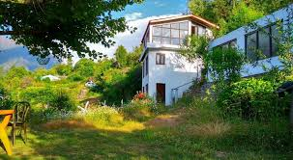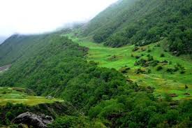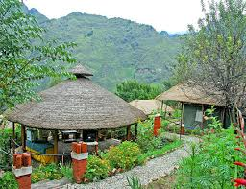 State
EA: Executing Agency, BRO: Border Road Organisation (BRO); Government of India (GOI), EO: Environmental Officer, IRC: Indian RoadC ongress, CSC: Construction Supervision Consultant, JFM: Joint Forest Management Committee, CPCB: Central Pollution Control Board.

The “Project Engineer” or “The Engineer” is the team of Construction Supervision Consultants (CSC) responsible for approving the plans, engineering drawing, release of payments to contractor etc. on behalf of the employer (BRO). It is usually the team leader of the CSC that takes the responsibility of signing approval documents on behalf of the CSC team. The “Environmental Officer” is the “Environmental Specialist or Expert” under the CSC who is responsible for providing recommendations to the “CSC – Team Leader” for approving activities specific to “Environment Safeguards” on behalf of “The Engineer” or “Project Engineer”.

Joint Forest Management (JFM) Committee’s exist at the village level. Each Joint Forest Management committee has 15 members of which 3 to 5 members are mandated to be women. The member secretary of each committee is the local Forester or Beat Officer, who oversees the accounts and activities of the Joint Forest Management committee. Respective Joint Forest Management committee’s will be identified and confirmed by the contractor under the guidance of the “Environmental Specialist or Expert” of the CSC during construction Kurkuti – Ghamsali – Niti Road in the State of Uttarakhand.

16. CONCLUSIONS AND BUDGET

ENVIRONMENTAL MONITORING PLAN AND COST (EMPC): {Kurkuti – Ghamsali – Niti Road in the State of Uttarakhand}

Based on the field survey and data available from secondary sources, it can be concluded that the project will not have significant negative environmental impacts. The issues of concern in the project are construction of bypasses, re – alignments, and bridges and acquisition of private land and forest land etc. Proper Environmental Management Plans (EMPs) compliance needs to be ensured. The issues related to land acquisition and re – settlement has been evaluated and adequate compensation has been suggested in Resource Allocation Program (RAP) document. The Environmental Mitigation and Monitoring Requirements are given in the Table 42.

Table 42: Environmental Mitigation and Monitoring Requirements.

Particulars | Estimated Rate | Total Cost (in Lakhs)
Environmental Monitoring during Construction and Implementation Phase | Lump Sum | 5.0
Environmental Training Programs | Lump Sum | 2.0
Plantation of 12,150 Trees Including Maintenance Cost for 3 Years | Rs. 1,000 per Tree Including Maintenance | 260
Water Sprinkling for Dust Emission Suppression | 80,000 per Km. | 54.4
Solid Noise Barrier Installation by Trees in Places | Lump Sum | -------
Enhancement of Water Bodies Sources and Resources | Rs.1 Lakh Each | -------
Safety Signs and Provisions at Different Locations/ Sites/ Areas | ------- | Provided in Civil Works Contract
Cost to be Included in Engineering | ------- | -------
All Underpasses OR Bypasses/ Roads/ Ways | Included in Civil Works | -------
Dust Emission Suppression by Watering | Incidental to Work with in Contractor | -------
Environmental Measures at Workers’ Camps during Site Visit | Incidental to Work with in Contractor | -------
Vegetation Turf at Slopes along Roadsides/ Roadways | Civil Works | -------
Operation Phase
Environmental Monitoring and Evaluation Plans | ------- | 1.0 per Annum
Tree Maintenance and Monitoring Plans | Included Above | -------
Training for Segregation; Mitigation and Monitoring etc. | ------- | 2.0 per Annum
Road Maintenance Cost not Considered as Per Specific Targets OR Proposed Work | ------- | -------
Sub Total | For Contract Period = (3.0×3) | 9 for 3 Years
Total | Twenty Seven Lakhs | 27.00 Lakhs
Grand Total | ------- | 425.4 Lakhs

Based on the environmental assessment and surveys or visits conducted for the project, associated potential or prospective adverse environmental impacts can be mitigated to an acceptable/ satisfactory level by adequate implementation of the measures/ methods/ ways/ processes as stated in the Environmental Impact Assessment (EIA) Report. Adequate provisions have been made to cover the environmental mitigation and monitoring requirements (including a forestation cost), which is approximately Rs. 4.25 Crores or Rs. 425.4 Lakhs.

Cost Estimate

Cost estimate for the projected road is finalized based on the improvement proposals are summarized/ recapitalized/ reviewed/ abridged/ précised respectively. The existing Right of Way (ROW) along the project road varies from 8 m to 10 m. Therefore, land acquisition is required for widening of the project road, Improving and black spots. Hence the project will have social impact in terms of loss of livelihood or shelter, which will have to be studied and a suitable mitigation/ alleviation/ easing/ improvement plans has to be prepared.

Construction of project is proposed in Two Phases. Phase – I include intermediate lane/ two lanes of existing road from Existing Length = 18.53 Km. and Proposed Length = 17.56 Km. Cost estimate for the project Road is finalized/ finished/ concluding/ ending with ultimate approach based on the improvement proposals in Table 43 (a) and (b).

Table 43 (a): Details of Kurkuti – Ghamsali – Niti Road.

Description |  | Existing | Proposed
Terrain | : | Hilly Mountainous and has Steep Gradients | Hilly Mountainous and has Steep Gradients
Designed Length | : | Existing Length = 18.53 Km. | Proposed Length = 17.56 Km.
Alignment | : | The Existing Alignment is almost Poor Except at few Locations. | The New Alignment with Geometric Improvements.
Design Speed | : | Average = 20 – 30 Km/ Hr. | 20 Km/ Hr to 30 Km/ Hr, As per IRC: SP: 48 – 1998, Sub Clause: 6.3.1
Cross – Section | : | C/ W Width – Varying = b/ w 7 m  Shoulder = 0.9 m | Flexible Pavement  Two – Lane (Class – 9: Road)  0.6 m Drain + 0.9 m Shoulder + 7 m C/W + 0.9 m Shoulder + 0.6 m Extra Widening  Sr. No. From To Length (Km)  1. 00.000 17.56 17.56  Total 17.56
CBR Considered | : | ------- | 10%
Traffic (2017) | : | Nil | On Basis of Projected Traffic* From Km. 00.000 to Km. 17.56.
Pavement Design Life | : | Nil | 15 Years, As per IRC: SP: 48 – 1998, Clause: 10.6, Sub Clause: 10.6.1
Design MSA | : | ------- | MSA – 5
Pavement Crust Thickness for Widening and New Construction | : | Existing Structure = 46 Nos. | Flexible Pavement  Sr. No. Type of Structure Length (mm)  1. Bituminous Concrete 40 mm  2. Dense Bituminous Concrete 60 mm  3. Crusher Run Macadam 200 mm  4. Granular Sub Base 200 mm  Total 500 mm
Bridges | : | Major Bridge = 00 Nos. | 00 Major Bridge is at Kurkuti – Ghamsali – Niti Road Bypasses and Newly Proposed Parallel To Existing Bridge.
 |  | Minor Bridges = 05 Nos. on Project Road | Widening = 00 Nos.  Reconstruction = 00 Nos.  Retained = 05 Nos.  New Proposed = 07 Nos.
Culverts | : | Total Culvert = 41 Nos.  HPC = 00 Nos.  Slab Culvert = 6 Nos.  Box Culvert = 27 Nos.  FCW = 8 Nos. | Retained = 05 Nos.  Widening = 00 Nos.  Reconstruction = 31 Nos.  New Proposed = 33 Nos.  See Proposals in Table 43 (b)
Forest Reserves | : | Approximately 17.56 Km (100%) Forest Area Existing in the Kurkuti – Ghamsali – Niti Road Regions | Not Applicable
Right of Way (ROW) | : | ------- | Proposed ROW in open area – 24.0 m  Proposed ROW in Builtup area – 15.0 m
Land to be Acquired | : | ------- | 07.49 Hectare Private & 15.54 Hectare Goverment
Tentative Total Civil Cost (₹) Project: |  |  | ₹379,645,8/-
Tentative Total Cost Including Land Acquisition: |  |  | ₹4,987.254
Tentative Total Civil Construction Cost: |  |  | ₹12.69 Crores Per Km
Table 43 (b): Tentative Cost of Kurkuti – Ghamsali – Niti Road.

Section | Proposed Length (km) | Base Cost Per KM (₹) | Base Cost Per KM (Crore)
Kurkuti – Ghamsali – Niti Road | 17.56 | ₹ 222.8364 | 12.69

17. CONCLUSIONS AND RECOMONDATIONS

The Remote Sensing Technology (Stereo Photogrammetric) OR Geographical Information System (GIS) has been proven a fastest method of carrying out the topographical survey within the hilly terrain areas, thus considering the same advantages the RS technology has been used in BRO Road DPR projects. Even though the areas are of very complex geography and terrain, the RS technology was able to provide fast and reliable DEM – Digital Elevation Model, Topographical features and base data to prepare such complex geography road DPR projects. In the project, 50 cm Very High Resolution Multispectral Satellite Imagery (World View – 2) from Digital Globe – USA has been used. This imagery was procured through National Remote Sensing Agency – INDIA. The processing of the above imagery was undertaken in software’s such as SOCETSET, ERDAS, and Global Mapped. After satellite image processing the products delivered are DTM/ DEM, 3D – Topographical Features, Ortho – photo, which has further been used in finalization of road alignment as per IRC guidelines.The products from RS has also been played a very critical role in identifying the water bodies crossing the alignments in order to provide cross drainage works to cater for the runoff. Details of the structures for the same are mentioned above in Project details. As per contract agreement the current stage of corridor comprises preparation of Final Feasibility Report (FFR) for re – habilitation and upgrading of existing road to 2 – lane with paved shoulder. We have conducted Classified Traffic Volume counts at 2 No. locations for analyzing the capacity. As per analysis of the traffic surveys total number of PCUs at all two locations has crossed the threshold limit (15,000 PCU) of design service volume for 2 lane roads with paved shoulder configuration as per the IRC in year 2041. The project road is not only an important transport link for en – route habitations within Uttarakhand State/ Region, but it is also an important inter – state link. The existing road has stretches whose geometrics do not conform to Indian Road Congress (IRC) standards will need to be improved by means of re – alignments and by re – construction. The road passes through ribbon development at 5 Nos. locations, where travel speed does not meet National Highway (NH) Standards, hence bypasses have been proposed for them. The soil conditions along the projected road are generally good and the construction materials like soil and aggregates are available nearby area/ region of the state.

The existing Right of Way (ROW) along the projected road varies from 8 m to 10 m and also we proposed Kurkuti – Ghamsali – Niti Road. Therefore, land acquisition is required for widening of the project road, improving and black spot points. Hence the project will have social impact in terms of loss of livelihood or shelter, which will have to be studied and a suitable mitigation plan must be prepared thoroughlyfor Survey, Investigation and Preparation of Detailed Project Report for improvement of Road and Bridges etc. for construction of High Altitude Hill Roads to Indo – China Border under Phase – II in the state of Uttarakhand using satellite imagery of Existing Length = 18.53 Km. and Proposed Length = 17.56 Km. It is recommended that the project to be undertaken with paved in the immediate future. The project can be constructed within 24 months’ period with strategic planning and through two construction packages.

One ROB is Proposed at Kurkuti – Ghamsali – Niti Road, where track project road is to be designed for 20 Km/ Hr to 30 Km/ Hr speed in project road length, but two locations (Km 00.000 to Km. 17.56) designed for 30 Km/ Hr. It is recommended that the project be undertaken for Foot Track/ Two Laning with Paved in the immediate future. The estimated total capital cost of Projected Road is 222.8364 OR 12.69 Crores per Km for Kurkuti – Ghamsali – Niti Road in the State of Uttarakhand.

Public Consultation Meeting (PCM)

Appendix – 1

Public Consultation and Focus Group Discussions in Kurkuti – Ghamsali – Niti Road

Kurkuti Start from East Kailashpur Tehsil of West Gurguti district/ village the grade junction of new and old Road. This is recommended by Public Consultation Meeting (PCM) and Uttarakhand State Government. Hence, it is proposed to other like Kurkuti – Ghamsali – Niti town to avoid acquisition of the land and disturbance to the local people. The details of the options studied and recommended are given below:

Project Beneficiaries and Benefits

Focus Group Discussion of Public Consultation were arranged in the three villages. From the Public Consultation, an understanding on the positive as well as negative impacts of the improvement of the road was gathered. Following Tables 44 (a) to (d) gives the details of Public Consultation Method (PCM) conducted:

Table 44 (a): Focus Group Discussion Public Consultation.

Village Name | Place of PC/ Meeting | Number of Participants
Kailashpur; Mehargoan | Projected Road | 067
Gurguti; Farkiya | Projected Road | 098
Bampa; Geldung | Projected Road | 105
Grand Total |  | 270
Source: Socio – Economic Survey, August 2019 by L. N. Malviya Infra Projects Pvt. Ltd.;

IMPACTS

During the Mixed FGD, information from the respondents was elicited on the pros and cons of the road construction. Summarized below are positive and negative impacts, as per the respondents:

Table 44 (b): Positive Impacts.

Beneficiary | Benefits Anticipated
Road Service Providers | - Increase in sale expected;  - Trade improvement.
Road Passengers | - Due to better roads lesser journey time, thus time saving; and  - Smooth and safe riding on the road.
Drivers | - Convenience in vehicle driving;  - More number of trips.
Residents along the Road | - There will be lesser dust;  - Lesser noise.
Transport Operators, Owners, and Managers | - Improved business in terms of reduced maintenance and operational cost; Fuel saving;  - Longer Vehicle life; and  - More number of trips and routes to ply along.
Agro – IndustrialProducers/  Farmers | - Agricultural marketing will be easy; as more buyer sellers will be available;  - Arrangements of seeds, fertilizers and other agricultural input items and services will be easy to approach; and  - Better values for the agricultural crops.
Women | - Comfort in travel, due to better road conditions.
Migration | - Due to construction of road, reduction in seasonal migration is expected, as people will get employment opportunities, in the lean seasons (non – farm period).
Vulnerable Groups like Pensioners, Unemployed, Disabled | - Smooth travelling, due to pucca road;  - Comfort in travel; and  - Better connectivity to banks / post offices / government offices.
Health Services Providers | - Easy to reach patients, thus faster delivery of health services;  - Similarly patients will be able to reach health service providers in time thereby saving medical attention time.
School Children/ Teachers | - Convenience and easy approach to School and Collages.
Source: Socio – Economic Survey, August 2019 by L. N. Malviya Infra Projects Pvt. Ltd.;

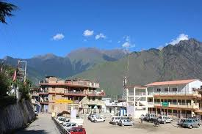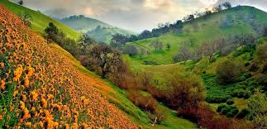

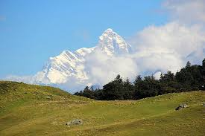

Table 44 (c): Negative Impacts.

Issues | Nature of Problems Anticipated
Pollution (Especially during Construction) | - More noise and dust;  - Water logging, due to flow of excessive water.
Diseases | Temporary effect due to;  - Dust; and  - Possible water borne (due to water logging, if, it is there).
Road Safety | - It may lead to more accidents, (as the speed of vehicles on the pucca road will be higher) if proper safety measures are not adopted. However, it could be minimized by constructing speed breakers near populous places;  - Installing warning boards and safety signs;  - Construction of railing at desired places.
Migration/ Displacement | - Road widening, if takes place, shall lead to displacement of people, living along the road.
Agriculture | - Barring a temporary effect of dust accumulation on the grown crop, no major negative impact on the agriculture and allied sector is anticipated;  - Road widening, if takes place, shall require possession of agricultural land, which will negatively impact the livelihood of the farmer.
Source: Socio – Economic Survey, August 2019 by L. N. Malviya Infra Projects Pvt. Ltd.;

Table 44 (d): Public Consultation and Focus Group Discussions in Kurkuti – Ghamsali – Niti Road.

Village: Kailashpur; Mehargoan
Place/ Road Name: Projected Road
Date/ Month/ Year: 17/ 05/ 2019
Time: 1: 45 PM
Focus Group Discussions (FGD) Number: 01
Sr. No. | Name | Village
1. | Mr. Ram Pal Sharma | 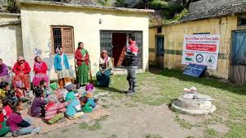  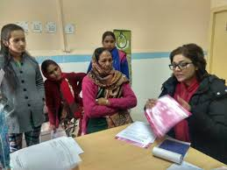
2. | Mr. Punnu Chhazta
3. | Mr. Sita Ram Thapa
4. | Mr. Sukhdev Jha
5. | Mr. Prabhudev Kuthyal
6. | Mr. Prakash Singh Badal
7. | Mrs. Shveta Dangi
8. | Miss Chulbul Rani
9. | Miss Priya Agarwal
10. | Miss Shushma Swaraj
11. | Mrs. Lajwanti Notyal
Place Name: Projected Road

Village: Kailashpur; Mehargoan

Village: Gurguti; Farkiya
Place/ Road Name: Projected Road
Date/ Month/ Year: 18/ 05/ 2019
Time: 2: 45 PM
Focus Group Discussions (FGD) Number: 02
Sr. No. | Name | Village
1. | Mr. Deepak Malhotra | 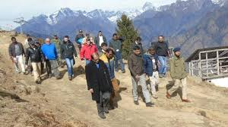  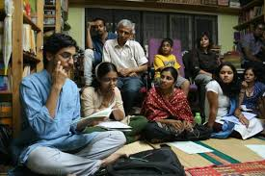  Place Name: Projected Road  Village: Gurguti; Farkiya
2. | Mr. Kuldeep Raina
3. | Mr. Hiranand Verma
4. | Mr. Kulbhushan Rajak
5. | Mr. Gyan Prakash Gupta
6. | Mr. Hari Naryan Handa
7. | Mr. Praful Kumar Mishra
8. | Miss Sakshi Chauhan
9. | Miss Kangna Rainawat
10. | Miss Pritty Zinta
11. | Mrs. Ram Payari
12. | Mrs. Prabha Davi
13. | Miss Kanchan Kumari
14. | Miss Sheetal Matwali
15. | Miss Sonakshi Sinha

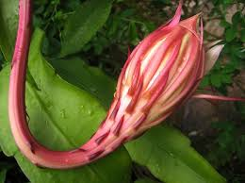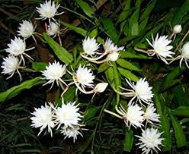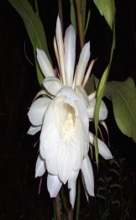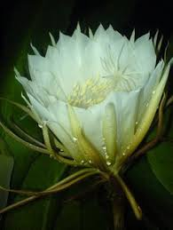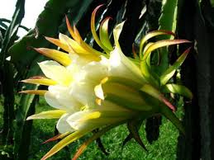

Village: Bampa; Geldung
Place/ Road Name: Projected Road
Date/ Month/ Year: 19/ 05/ 2019
Time: 3: 45 PM
Focus Group Discussions (FGD) Number: 03
Sr. No. | Name | Village
1. | Mr. Sudhanshu Kumar | 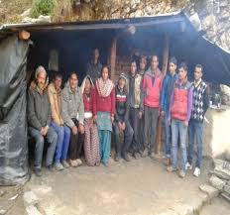  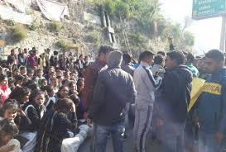  Place Name: Projected Road  Village: Bampa; Geldung
2. | Mr. Shyam Lal Gupta
3. | Mr. Manish Gupta
4. | Mr. Vinod Bundela
5. | Mr. Karan Ojha
6. | Mr. Vishal Agarwal
7. | Mr. Shubham Sharma
8. | Miss Kavita Saxena
9. | Miss Surbhi Singh
10. | Miss Rosey Punjabi
11. | Miss Kanya Kumari
12. | Mrs. Lilawati Devi
13. | Mrs. Kalawati Shukla
14. | Miss Sweety Agarwal
15. | Miss Preeti Das Mohan

***************************
*********************

