Impact of Noise customization in Differential Privacy for Cyber Physical Systems
¹Manas Kumar Yogi, ²Dr.A.S.N.Chakravarthy
¹Assistant Professor, CSE Department, Pragati Engineering College (A), Surampalem
²Professor, CSE Department, JNTUK, Kakinada, A.P., India

Abstract
The integration of Cyber Physical Systems (CPS) poses significant privacy challenges due to the amalgamation of computational and physical processes. Differential Privacy (DP) emerges as a crucial framework to safeguard individual privacy while extracting meaningful insights from CPS data. This study delves into the nuanced impact of noise customization within the DP paradigm in the realm of CPS. Noise customization involves the strategic addition of calibrated noise to data, influencing the delicate balance between privacy preservation and data utility. We explore the diverse types of noise, such as Laplace, Gaussian, and adaptive scaling, evaluating their impact on privacy, data accuracy, and system robustness. The suitability of noise customization is analyzed in varying data distributions, addressing the dynamic nature of CPS environments. Benefits encompass tailored privacy protection, adaptability to changing conditions, and optimized communication overhead. However, challenges arise in striking the right balance between privacy and utility, particularly in fine-grained analyses. This research underscores the importance of customized noise in fortifying the privacy fabric of CPS, providing insights into the trade-offs inherent in privacy-preserving data analytics within this complex and dynamic cyber-physical landscape.
Keywords-Noise, Cyber-Physical Systems, Privacy, Security, Gaussian
1. Introduction
Differential Privacy (DP) is a privacy-preserving framework that aims to protect individuals' sensitive information when analyzing data. It is particularly relevant in the context of Cyber Physical Systems (CPS), where the integration of computational elements with physical processes can introduce privacy concerns. Noise customization in DP involves the addition of carefully calibrated noise to the query responses or data before releasing or analyzing it. This noise helps in preventing the disclosure of individual-level information while still allowing for meaningful aggregate analysis. The impact of noise customization in DP within the context of CPS can be significant and multifaceted [1]:
1. Privacy Protection:
Individual Privacy: Differential Privacy ensures that the presence or absence of any single individual's data does not significantly affect the output of the analysis. Customizing the noise helps in fine-tuning the level of privacy protection based on the specific requirements of the CPS.
2. Data Accuracy and Utility:
Trade-off: There is often a trade-off between privacy and data accuracy/utility. Increasing the amount of noise for better privacy protection might reduce the accuracy of the analysis. Customizing the noise allows for balancing this trade-off according to the specific needs and constraints of the CPS.
3. Robustness:
Adaptation to Context: Noise customization allows for adapting the privacy mechanisms to the specific characteristics of the CPS. This adaptability enhances the robustness of the system against different types of attacks or changes in the data distribution.
4. Dynamic Environments:
Flexibility: CPS often operate in dynamic environments where the data distribution may change over time. Customizing the noise enables the system to be more flexible in handling such dynamic conditions while maintaining privacy guarantees.
5. Communication Overhead:
Optimization: Customizing the noise levels can help optimize the communication overhead in CPS. By carefully adjusting the noise, it is possible to achieve the desired privacy guarantees with minimal impact on the communication between the cyber and physical components.
6. Security Against Inference Attacks:
Mitigation: Differential Privacy aims to protect against inference attacks where an adversary tries to infer sensitive information about individuals based on the released data. Customizing the noise can enhance the system's resistance against various inference strategies.
7. Regulatory Compliance:
Tailoring to Requirements: Different applications within CPS might have varying privacy requirements due to regulatory or ethical considerations. Customizing the noise allows for tailoring the privacy mechanisms to meet these specific requirements.
8. Collaborative CPS:
Interoperability: In scenarios where multiple CPS components or entities collaborate, noise customization can facilitate interoperability by allowing each component to adapt its privacy mechanisms according to its own constraints and requirements.
It can be observed that the impact of noise customization in Differential Privacy in Cyber Physical Systems is substantial, influencing the trade-off between privacy and utility, adaptability to dynamic environments, and the overall robustness and efficiency of the system. The customization allows for tailoring privacy mechanisms to the specific needs and constraints of the CPS, making it a valuable tool in achieving a balance between privacy preservation and data analysis.
2. Related Work
In below Table 1 , we present a summary of types of noise used in Differential Privacy, their impact, suitability of data distribution, benefits, and limitations:
It's important to note that the suitability of a specific type of noise depends on the characteristics of the data and the requirements of the application. The choice of noise type involves a trade-off between privacy protection and data utility, and it may require careful tuning based on the specific use case within the framework of Differential Privacy.
Table 1.Types of Noise and their impact[2-5]
Sl.No. | Type of Noise | Impact | Suitability of Data Distribution | Benefits | Limitations
1 | Laplace Noise | - Additive noise with heavy tails | - Well-suited for distributions with long tails or outliers | - Robust privacy guarantees | - May introduce significant noise for small queries or fine-grained analysis
2 | Gaussian Noise | - Additive noise with a normal distribution | - Well-suited for Gaussian or near-Gaussian data | - Smoother, less disruptive to data analysis | - May not be optimal for non-Gaussian data distributions
3 | Exponential Noise | - Additive noise with an exponential distribution | - Suitable for certain types of positively skewed data | - Simplicity and ease of implementation | - May not be the best fit for all types of data distributions
4 | Geometric Noise | - Additive noise with a geometric distribution | - Suitable for count or occurrence data | - Effective for privacy-preserving counting queries | - Limited to discrete and non-negative data types
5 | Poisson Noise | - Additive noise with a Poisson distribution | - Appropriate for count data and rare events | - Well-suited for scenarios with discrete data | - May not perform well with continuous data distributions
6 | Subsampled Noise | - Randomly dropping a fraction of data points | - Useful for scenarios with large datasets | - Reduction of information leakage through sampling | - Loss of information due to subsampling
7 | Adaptive Noise Scaling | - Adjusting noise levels based on data characteristics | - Adaptable to different data distributions | - Improved utility for various types of queries | - Complexity in dynamically scaling noise levels

3. Impact of Noise customization
Noise customization in differential privacy involves adding varying amounts of noise to data based on the sensitivity of the query and the privacy preferences of individuals. This process helps protect the privacy of sensitive attributes while still allowing meaningful analysis. Let's use a simple example to illustrate noise customization in differential privacy [6-8]:
Example: Salary Analysis
Imagine an HR department wants to analyse the average salary of its employees without revealing individual salaries. The organization wants to implement differential privacy to protect employee privacy while still obtaining useful insights.
Steps:
1. Sensitivity Calculation: The sensitivity of the query (average salary) is determined by how much the query result changes when a single employee's salary is added or removed. Let's assume that the maximum change in the average salary due to a single employee's salary is $10,000.
2. Privacy Budget Allocation: The organization decides on a privacy budget (ε) that quantifies the amount of privacy protection. A lower ε provides stronger privacy but might introduce more noise.
3. Noise Customization:
- For employees who are comfortable with their salaries being somewhat exposed, less noise is added. For example, ε = 0.5.
- For employees who value higher privacy, more noise is added. For example, ε = 1.0.
4. Query Execution: The organization calculates the average salary while adding noise to the query result. The noise level depends on ε and the sensitivity of the query. The noise value is sampled from a Laplace or Gaussian distribution, ensuring that individual salaries remain private.
Results:
- Employee A (ε = 0.5): If the actual average salary is $60,000, after noise addition, the reported average might be $61,000. The noise is minimal, as Employee A is more open to privacy trade-offs.
- Employee B (ε = 1.0): If the actual average salary is $60,000, after noise addition, the reported average might be $70,000. The noise is higher, as Employee B values higher privacy.
Benefits:
Noise customization offers a balance between privacy and data utility:
- Employees who are more privacy-conscious receive stronger protection.
- Employees who are less concerned about privacy experience minimal distortion in the query result.
- The organization gains insights into average salary trends without revealing sensitive individual salaries.
Challenges:
- Balancing noise levels to protect privacy without overly distorting query results.
- Ensuring proper communication with employees about privacy trade-offs.
4. Results
From kaggle, we have obtained the Home Medical Visits - EDA dataset [9] for carrying out the experiment of effect of different type of noise additions in the differential privacy technique used in the study. The dataset has 40079 rows with 15 attributes. Different type of analysis like average waiting time of the patients, age groups and locations with highest number of visits can be performed on the given dataset. For implementing the algorithms we have used python 3.4 language and Jupyter notebook as the IDE.

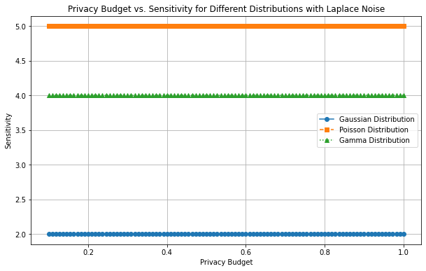
Fig.1.Privacy budget Vs. Sensitivity for various data distributions with Laplace noise

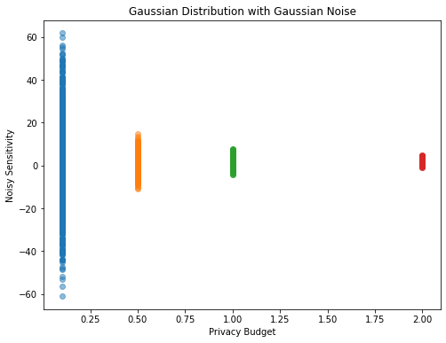
Fig.2.Privacy budget Vs. Noise Sensitivity with Gaussian noise

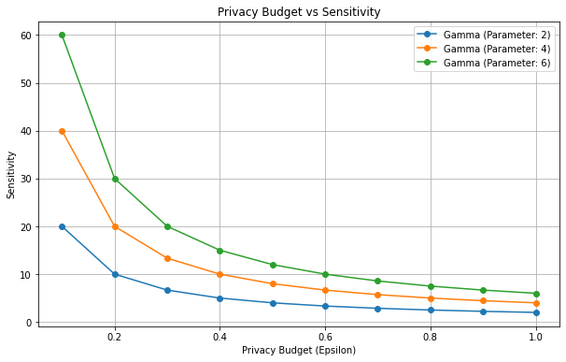
Fig.3. Privacy budget Vs. Sensitivity with Gamma distribution parameters

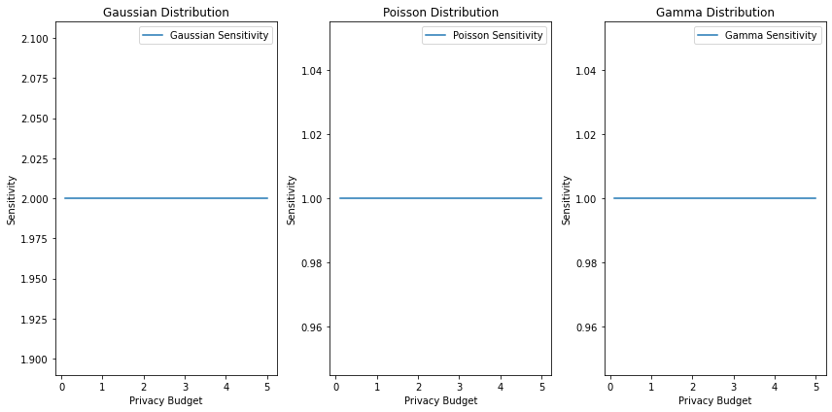
Fig.4. Privacy budget Vs. Sensitivity with Gaussian, Poisson and Gamma dataset distribution
5. Future Directions
The impact of noise customization in Differential Privacy (DP) within the context of Cyber Physical Systems (CPS) is a dynamic area of research. As technology and privacy concerns evolve, several future directions can be envisioned to further enhance the understanding and application of noise customization in DP for CPS [10-11]:
1. Adaptive Noise Mechanisms:
- Explore and develop adaptive noise mechanisms that can dynamically adjust the level of noise based on the changing characteristics of the CPS environment. This could involve real-time monitoring of data distributions, query patterns, and contextual factors.
2. Machine Learning Integration:
- Investigate the integration of machine learning techniques to optimize noise customization in DP. This could involve training models to predict optimal noise levels for different types of queries or data distributions, thereby automating the customization process.
3. Privacy-Accuracy Trade-off Quantification:
- Develop methodologies to quantify and explicitly model the trade-off between privacy and accuracy in CPS. This could involve creating frameworks to measure the impact of noise customization on utility and providing guidelines for choosing appropriate noise levels.
4. Differential Privacy in Edge Computing:
- Extend the study of noise customization to the edge computing paradigm within CPS. Investigate how noise customization can be effectively implemented in edge devices to provide privacy guarantees without compromising the efficiency of data analysis.
5. Privacy-Preserving Machine Learning Models:
- Explore the development of privacy-preserving machine learning models that inherently incorporate DP principles. This could include the creation of algorithms that generate model updates with privacy guarantees, reducing the need for post-processing noise addition.
6. Federated Differential Privacy:
- Investigate how federated learning and federated differential privacy can be combined to provide privacy guarantees in a distributed CPS environment. This includes exploring ways to customize noise in a federated setting and ensuring coordinated privacy protection across multiple entities.
7. Robustness Against Advanced Attacks:
- Research methods to enhance the robustness of noise customization mechanisms against advanced privacy attacks. This includes studying the impact of model inversion, membership inference, and other sophisticated attacks on customized noise and developing countermeasures.
8. Standardization and Best Practices:
- Work towards standardization of noise customization practices in DP for CPS. Develop best practices, guidelines, and benchmarks for implementing and evaluating customized noise mechanisms, fostering a more consistent and secure approach across different CPS applications.
9. Privacy Metrics for CPS:
- Define and refine privacy metrics specifically tailored to CPS. Develop comprehensive evaluation criteria that consider the unique characteristics of cyber-physical systems, ensuring that privacy mechanisms are effectively addressing the challenges posed by the integration of computation and physical processes.
10. Cross-disciplinary Collaboration:
- Encourage collaboration between researchers in differential privacy, CPS, and related fields. Cross-disciplinary efforts can lead to a more holistic understanding of the challenges and opportunities in customizing noise for privacy in CPS.
11. Real-world Deployment Studies:
- Conduct more real-world deployment studies to assess the practicality and effectiveness of noise customization in various CPS applications. This involves collaborating with industry partners to implement and evaluate customized noise mechanisms in operational settings.
These future directions aim to push the boundaries of knowledge in the intersection of noise customization, differential privacy, and cyber-physical systems, fostering advancements that are not only theoretically sound but also practically applicable in addressing the evolving landscape of privacy challenges in CPS.
6. Conclusion
In conclusion, the impact of noise customization in Differential Privacy within the realm of Cyber Physical Systems (CPS) is paramount, ushering in a new era of privacy-preserving data analysis amid the intricate interplay of computational and physical elements. As CPS continue to proliferate across diverse domains, ranging from smart cities to industrial automation, the nuanced application of customized noise proves to be a linchpin in striking the delicate balance between safeguarding individual privacy and extracting meaningful insights from sensitive data. The tailored application of noise in Differential Privacy offers a multifaceted set of advantages. Privacy protection, a foundational tenet, is enhanced by the judicious customization of noise levels, ensuring that individual contributions do not unduly influence aggregate analysis. This is particularly crucial in CPS scenarios where the fusion of real-time physical data and computational processing demands heightened privacy measures. The dynamic nature of CPS environments, characterized by evolving data distributions and fluctuating conditions, finds a robust ally in customized noise. The flexibility to adapt privacy mechanisms to the specific characteristics of CPS fosters resilience against various potential threats and changes in the operational landscape.
Furthermore, the customization of noise allows for a nuanced trade-off between data accuracy/utility and privacy, a crucial consideration in applications where precise analysis is imperative. This adaptability is essential in addressing the unique challenges posed by CPS, where the seamless integration of cyber and physical components necessitates a privacy framework that aligns with the dynamic nature of the system.
Despite these benefits, challenges persist. Striking the optimal balance between privacy and utility requires meticulous calibration, and the introduction of noise, while preserving privacy, may impact the accuracy of certain analyses. Moreover, the computational overhead associated with implementing customized noise mechanisms should be carefully managed to ensure the efficiency of CPS operations.
In essence, the impact of noise customization in Differential Privacy in CPS is transformative, ushering in a paradigm where privacy is not a mere addendum but an integral design consideration. As CPS continues to evolve, the judicious application of customized noise becomes an indispensable tool, navigating the intricate terrain of privacy preservation in the digital-physical convergence era.
References
1. Qu, Youyang, et al. "Customizable reliable privacy-preserving data sharing in cyber-physical social networks." IEEE Transactions on Network Science and Engineering 8.1 (2020): 269-281.
2. Sangogboye, Fisayo Caleb, et al. "A framework for privacy-preserving data publishing with enhanced utility for cyber-physical systems." ACM Transactions on Sensor Networks (TOSN) 14.3-4 (2018): 1-22.
3. Lu, Yunlong, et al. "Federated learning for data privacy preservation in vehicular cyber-physical systems." IEEE Network 34.3 (2020): 50-56.
4. Geng, Quan, and Pramod Viswanath. "The optimal noise-adding mechanism in differential privacy." IEEE Transactions on Information Theory 62.2 (2015): 925-951.
5. Sun, Lichao, and Lingjuan Lyu. "Federated model distillation with noise-free differential privacy." arXiv preprint arXiv:2009.05537 (2020).
6. Sarathy, Rathindra, and Krishnamurty Muralidhar. "Evaluating Laplace noise addition to satisfy differential privacy for numeric data." Trans. Data Priv. 4.1 (2011): 1-17.
7. Soria-Comas, Jordi, and Josep Domingo-Ferrer. "Optimal data-independent noise for differential privacy." Information Sciences 250 (2013): 200-214.
8. Gong, Maoguo, et al. "Preserving differential privacy in deep neural networks with relevance-based adaptive noise imposition." Neural Networks 125 (2020): 131-141.
9. Dagan, Yuval, and Gil Kur. "A bounded-noise mechanism for differential privacy." Conference on Learning Theory. PMLR, 2022.
10. Xiao, Xiaokui, et al. "iReduct: Differential privacy with reduced relative errors." Proceedings of the 2011 ACM SIGMOD International Conference on Management of data. 2011.
11. Zhang, Zijian, et al. "Cost-friendly differential privacy for smart meters: Exploiting the dual roles of the noise." IEEE Transactions on Smart Grid 8.2 (2016): 619-626.

