Novel Method of Covid-19 Detection Using Deep Neural Networks

Prof. Veena Dhavalagi Assistant Professor, Dept of ISE
Sapthagiri College of Engineering,
VTU Bengaluru, India

Prof. Priyanka M R
Assistant Professor,
Dept of ISE
Sapthagiri College of Engineering, VTU Bengaluru, India

Abstract: The novel coronavirus 2019 (COVID- 2019), first emerged in Wuhan city of China in December 2019, which spread rapidly to the entire world and became a pandemic. It has caused a disastrous effect on daily lives, public health, and the global economy. It is very difficult or critical to detect the positive cases as early as possible in order to prevent the rapid spreading of this epidemic and to quickly treat affected patients.
As there are no accurate automated toolkits, there is a need for the auxiliary diagnostic tools is increased. Recent findings using radiology imaging techniques when obtained suggests that the images contained salient information about the COVID-19 virus.

Application of advanced artificial intelligence (AI) methodologies coupled with radiological imaging might be helpful for the accurate detection of this disease, and also be backing to overcome the problem which is the paucity of specialized physicians in remote villages.
In this study, a new prototype for automatic COVID-19 detection was detected which made use of the raw chest X-ray images. The proposed model is developed in order to provide the accurate diagnostics for binary classification (COVID vs. No- Findings) and the concept of multi-class classification (COVID vs. No-Findings vs. Pneumonia). The model produced a classification accuracy of 98.08% for binary classes and the accuracy of 87.02% for multiclass cases. The DarkNet was the model used in our study as a classifier for the YOLO (you only look once) real time object detection system. 17 convolutional layers were implemented and there was a introduction of different filtering on each layer. Our model used would assist radiologists for the validation of the initial screening, and cloud usage was made to immediately screen patients.

Introduction
COVID-19 pandemic is caused by SARS-COV2 virus and is most widely spread pandemic in the 21st century. The COVID-19 spreads between people mainly through air droplet or direct contact. Currently, there are 179 million infected people with more than 3 million deaths worldwide. There is a increase in number day by day.
The common symptoms of COVID-19 are fever, weakness, cough and diarrhea. More than half of patient report shortness of breathes and also faces the acute respiratory distress syndrome. The estimation of the mortality rate around 3.4%, however, the number could vary based on the countries or areas. The COVID-19 pandemic is not only concerned with health deterioration but also shows its affect on societies and economy at their core.
The pandemic has vital impact in many aspects of human life such as in the field of education, tourism, energy (especially oil and gas), transportation, manufacture, healthcare, politics also economics. Many efforts have been made in order to deal with the pandemic in a direction to reduce the spread of the diseases, improvising the disease detection methods, as well quicken the availability of COVID-19 vaccine. There is increased requirement for testing, diagnosis, and treatment as there is many massive cases of COVID-19. The definitive test for COVID-19 diagnosis is reverse transcription polymerase chain reaction (RT-PCR). Using the technique, the large test samples are being processed in the lab one by one waiting for their turn for processing. The results are obtained in several days. Due to the low RT-PCR sensitivity of 60%–70%, even if the results are negative, symptoms can be detected by examining radiological images of patients. It is stated that CT is a very sensitive method to detect COVID-19, and can be regarded as a screening tool with RT-PRC. CT

findings are observed over a long period of interval after the symptoms are seen, and patients usually have a normal CT in the first 0–2 days. In a study on CT scan of lungs of patients who survived COVID-19 pneumonia, the most important lung disease is observed ten days once after the symptoms are seen. An alternative test for the diagnosis of COVID-19 is using chest X-ray radiography. It is one of the fast, effective, and affordable test that is used for the identification of the COVID-19-related pneumonia and states that there are differences in the X-ray and CT scan result pre and post COVID-19 symptoms. So the results of CT scans and X-rays can be used to judge whether a person infected by SARS-COV2 virus or not. In response to the pandemic outbreak, many researchers from various backgrounds actively participate in finding effective diagnostic mechanism and vaccination for its treatment. The researchers’ domain is not confined to the medical and biotechnology fields but also includes the researcher from the fields like data science, machine learning and deep learning. An example of deep learning approach to detect COVID-19 is based on the X-ray or CT scan images. The use of X-ray images is ground on the fact that as the corona virus enters into the respiratory tract; it will affect the lungs of the human and causes pneumonia. In this case, the lungs are filled with fluid, get inflamed also developing patches called "Ground-Glass Opacity" (GGO). Therefore, it is likely to detect COVID-19 on the basis of chest X-ray of infected human. X-ray machine is meant for scanning various human organs. Recurrently, the interpretation of X-ray images is done by expert radiologists. The advanced development of deep learning, specially Convolutional Neural Network (CNN), accredit the interpretation of X- ray images presided automatically by system. A good system is the one that can be relied on also having high accuracy to reduce the misdiagnosis. It is also important to take into account the common disorders so that they do not lead to misdiagnoses.

Related Works:
As per paper [1], The proposed model is based on 14 layers of convolutional neural network and a modified spatial pyramid pooling module. The multiscale ability of the proposed network identifies the COVID- 19 disease for various chronic levels. According to the performance results, the proposed SPP-COVID-Net attain the best mean accuracy of 0.946 also the lowest standard deviation among the training folds accuracy. It encompasses around 862,331 total number of parameters, which makes use of less than 4 Megabytes memory storage. The model is apt for the implementation for speedy screening purposes so that better-destined diagnoses can be performed to optimize the test time and cost.
In reference 2, the deep learning-based technology is typically advised for analyzing X-ray images to identify COVID-19-infected patients. Using deep features, the help vector device distinguishes corona-affected X-ray images from others. The method aids clinical professionals in the early identification of COVID-19-infected patients. The multi-level thresholding with SVM technique that was suggested showed excellent classification accuracy for infected lungs. Each image had a 512 by 512 pixel resolution and was the same size. According to the results of the suggested model, the lung categorization had an average sensitivity, specificity, and accuracy of 95.76%, 99.7%, and 97.48%, respectively.
In reference 3,For the purpose of identifying patients who have coronavirus pneumonia using chest X-ray radiographs, a DCNN-based model called Inception V3 with transfer learning has been developed in reference 3. Its classification accuracy is over 98% (training accuracy is 97%, and validation accuracy is 93%). The outcomes reveal that transfer learning for COVID-19 detection was a technique that worked well, performed consistently, and was simple to implement.
In another attempt, the authors of [5] approached the same problem in a different method. The model in this study was trained on 120 X-ray images (60 COVID-19 and 60 normal) and 339 CT scan images (192 COVID-19 and 147 normal) [5]. The dataset is divided into two categories: 50% for training the CNN and 50% for validating the model three times every epoch [5]. The model was tested on a total of 67 photos, including X-ray and CT scan images. The suggested model here comprises of a CNN with one convolution layer, a Batch Norm layer, and ReLU activation [5].Following the completely linked layer is a SoftMax layer that outputs '0' or '1'. Transfer learning ideas were also applied here, as well as the pretrained model Alex Net, which was trained on over a few million photos on ImageNet and in the region of 1000 classes [5]. To get binary results, the last layer of the Alex Net has been replaced [5]. The comparisons in the data reveal that the proposed CNN outperforms the Alex Net in CT scans, with an accuracy of 94.1% versus 82% for the Alex Net.

Methodology
The invention of the CNN in 1994 by Yann LeCun is what propelled the field of Artificial Intelligence and Deep learning to its former glory. The first neural network named LeNet5 had a very less validation accuracy of 42% since then we have come a long way in this field. Nowadays almost all giant technology firms rely on CNN for more efficient performance. The data
training in our CNN model has to satisfy following
constraints:

- There should be no missing values in our dataset.

The dataset must distinctly be divided into training and testing sets, either the training or the testing set shouldn’t contain any irrelevant data out of our model domain in case of an image dataset all the images must be of the same size, one uneven distribution of image size in our dataset can decrease the efficiency of our neural network.

The photos should be transformed to black and white before being fed into the convolution layer because reading images in RGB would need a 3-D NumPy matrix, which would significantly reduce the execution time of our model

4) Any faulty or fuzzy photographs in the database should also be removed before putting them into the neural network. Now that we've mastered the data pre-processing principles, let's look at how the convolutional neural network works.
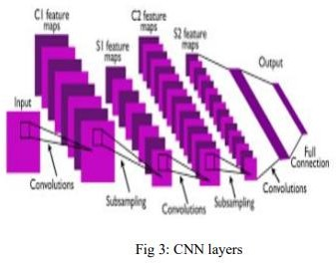

The Algorithms\Layer Used in our model are:

Convolution layer:

This layer involves scanning the whole image for patterns and formulating it in the form of a 3x3 matrix. This convolved feature matrix of the image is known as Kernel. Each value in the kernel is known as weight vector

Pooling layer:
After the convolution comes to the pooling here the image matrix is broken down into the sets of 4 rectangular segments which are non-overlapping. There are two types of pooling, Max pooling and average pooling. Max pooling gives the maximum value in the relative matrix region which is taken. Average pooling gives the average value in the relative matrix region. The main advantage of the pooling layer is that it increases computer performance and decreases over-fitting chances.
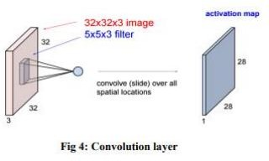

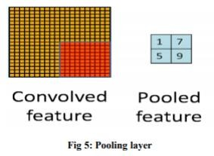

Activation layer:

- It is the section of Convolutional Neural Networks where the values are Normalized, or fits inside a specified range. The convolutional function employed is ReLU, which admits only positive values and excludes negative ones. It is due to the cheap computational cost.

Fully connected layer:

- The features are compared to the features of the test image, and similar traits are associated with the provided label. Labels are typically encoded as numbers for computational ease; they are afterwards translated into their appropriate strings.
- 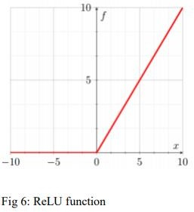

Proposed Model
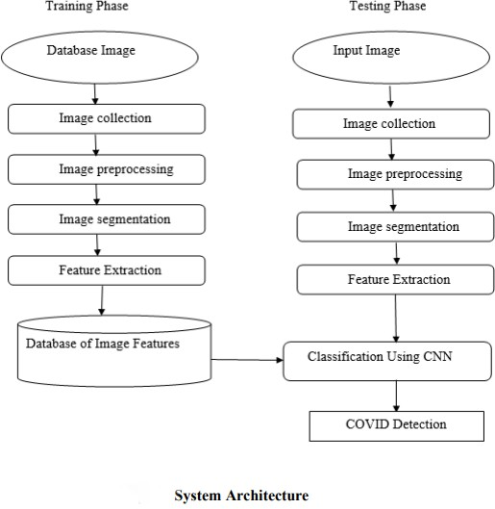
The system design mainly consists of:
- Image Collection
- Image Pre-processing
- Image Segmentation
- Feature Extraction
- Training
- Classification

Image Collection:
The Classification of X-Ray Scan images is the input to proposed system also the images of CT Scan are taken and the magnifier used to take pictures of CT Images.

Image Pre-processing:

The goal of pre-processing is to improve image data by reducing undesirable distortions and improving some image attributes that are crucial for subsequent image processing. Three major steps are involved in image pre-processing.
- Grayscale conversion b) Noise elimination b) Image improvement.

Grayscale conversion

A grayscale image solely contains brightness information. In a grayscale image, each pixel value represents an amount or quantity of light. In a grayscale image, the brightness gradient may be distinguished. A grayscale image just measures the intensity of light. The brightness of an 8 bit image will range from 0 to 255, where '0' represents black and '255' represents white. Grayscale conversion converts a color image to a grayscale image. Grayscale photos are easier and faster to process than color images. On grayscale images, all image processing techniques are used. The X Ray image is transformed to grayscale in our proposed approach.
.

Noise Removal:

The goal of noise reduction is to detect and eliminate undesirable noise from digital images. The challenge is determining which elements of an image are real and which are the result of noise. Noise is defined as random fluctuations in pixel values. To reduce unnecessary noise, we use a median filter in our suggested system. The median filter is a nonlinear filter that preserves edges. A sliding window of odd length is used to implement the median filter. Each sample value is ordered by magnitude, and the most central value, which is the median of the samples within the window, is a filter output.

Image Enhancement:

The objective of image enhancement is to process an image to increase visibility of feature of interest.here contrast enhancement is used to get a better quality result

Image Segmentation:
Following picture pre-processing, the Lung area was segmented from the surrounding X-Ray images. To improve segmentation, a black-and-white image with altered contrast was created..

Feature Extraction:
- Feature extraction is critical in retrieving information from a given image. In this case, we're analyzing texture images with GLCM. The spatial relationship between image pixels is captured using GLCM. The Gray level image matrix is used by GLCM to record the most frequent features such as contrast, entropy, energy, homogeneity, correlation, ASM, and cluster-shade. Contrast

∑𝑖 ∑𝑗 (𝑖 − 𝑗) 2 𝐶(𝑖,𝑗) Energy ∑𝑖 ∑𝑗𝐶 2 (𝑖,𝑗) Homogeneity
∑𝑖 ∑𝑗 𝐶(𝑖,𝑗) 1+|𝑖−𝑗| The purpose of feature extraction (glcm) is to curbs the original image data set by measuring some values and features that helps to classify different images from the another.

Training:
Create training dataset from images of known Cancer types. Train classifiers on the created training dataset. Create testing dataset in temporary folder. Predict results from the test cases. Plot classifiers graphs. Add feature- sets to test case file, to make image Processing models accurately.

Classification:
Convolution Neural Network is a binary classifier that uses the hyper-plane, which is also known as the decision boundary between two classes. Some pattern recognition issues, such as texture classification, make use of CNN. In CNN, mapping nonlinear input data to linear data enables good classification in high dimensional space. CNN maximizes the minimal distance between various classes. To split the classes, different Kernels are needed. SVM is a binary classifier that determines the hyperplane when splitting two classes.The border between the hyperplane and two classes is maximized. Support vectors are the samples closest to the margin that will be chosen to determine the hyperplane.The border between the hyperplane and two classes is maximized. Support vectors are the samples closest to the margin that will be chosen to determine the hyperplane.

Experimental Results
First, the overall 3-class classification accuracy levels are 93.9% (796/848), 94.7% (803/848), and 94.9% (805/848), based on three confusion matrices, respectively. The difference is only about 1%. The precision, recall rate, F1-score, and prediction accuracy of the new transfer learning VGG16-based CNN model are then computed based on the confusion matrix of the combined data, as shown in Table 3. 2404 of the 2544 testing cases are accurately detected and divided into three kinds. Overall, the accuracy is 94.5% (2404/2544) with a 95% confidence interval of [0.93, 0.96]. Furthermore, the computed Cohen's kappa coefficient is 0.89, confirming the dependability of the proposed method for training this novel deep transfer learning model to perform this classification job.

Table 3Classification report of the proposed method.

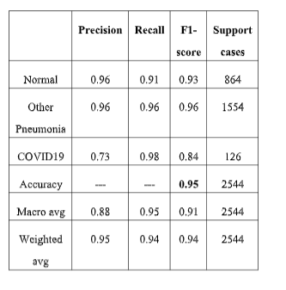
To further assess our model's effectiveness in detecting COVID19 infected cases using chest X-ray pictures, we classify normal and community-acquired pneumonia images as negative, and COVID-19 infected pneumonia cases as positive. When the values in the confusion matrix are combined, as shown in, the model has a detection sensitivity of 98.4% (124/126) and a specificity of 98.0% (2371/2418). The overall precision is 98.1%.

Table 4 then displays and contrasts confusion matrices generated by four models trained and tested with different input images, three data subsets generated from the data partition, overall classification accuracy, and 95% confidence intervals. The results show that if the data augmentation strategy is not used, the model accuracy on the testing subset data reduces to 82.3% with a kappa value of 0.71. Classification accuracy is 88.0% with a Cohen's kappa score of 0.75 when no image pre-processing is used and the original chest X-ray pictures are fed straight into the VGG16-based CNN model ("simple model"). The "filter-based model" achieves 91.2% accuracy and a Cohen's kappa score of 0.83 by using picture filtering and pseudo color images without eliminating the majority of diaphragm regions.
Confusion matrix of four CNN models on X-ray images. The accuracy's 95% confidence interval (CI) is shown in the final column.

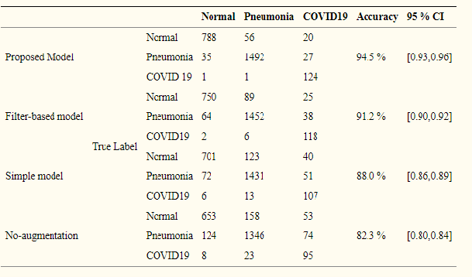
Study results exhibit that this transfer learning approach can lead to higher performance with the whole accuracy of 94.5 % (2404/2544) in the classification of three classes and 98.1 % (2495/2544) wrt classification cases with pre and post COVID-19 infection, also the high robustness with a Cohen’s kappa score of 0.89.

CONCLUSION
In this study, A new approach is proposed and investigated to develop a transfer deep learning CNN model in order to detect and classify COVID-19 cases making use of chest X-ray images. Study results demonstrate the added value of performing image preprocessing to generate better input image data to build deep learning models.
We are almost convinced that it is possible for the proposed CNN model shows the analogous of the highest score for the accuracy of a preferred chest radiologist, subjected to a very effective examination tool for the quick diagnosis of many infectious diseases like Covid-19 epidemic that do not require the introduction of a radiologist or physical examinations. The aim here with respect to work is to evaluate the propensity of the proposed CNN algorithm to distinguish between healthy and covid. As a conclusion the system gave very encouraging results. the used texture and color features enhanced the performance of our system and lead to a high recognition accuracy. This accuracy proves the usefulness of texture features as recognition features for diagnosis of covid.
The system is being used for the detection of Pneumonia diseases by choosing the proper training sets.
In future studies, we recommend addressing other topics such as outbreak escalates, as well as trying to explore different approaches to Convolutional Neural Networks, including deep learning models and improved interpretation of CNN models.
REFERENCES

[1]. A Lightweight Deep Learning Model for COVID- 19 Detection, Siti Raihanah Abdani ; Mohd Asyraf Zulkifley ; Nuraisyah Hani Zulkifley

[2]. Automatic X-ray COVID-19 Lung Image Classification System based on Multi- Level Thresholding and Support Vector Machine, Aboul Ella Hassanien, Hassan Aboul-Ella.

[3]. Classification of COVID-19 from Chest X-ray images using Deep Convolutional Neural Networks,
Sohaib Asif, Yi Wenhui*, Hou Jin, Yi Tao, Si Jinhai

[4]. A Deep Neural Network to Distinguish COVID-19 from other Chest Diseases Using X-ray Images,
Saleh Albahli

[5]. Halgurd S. Maghdid, Aras T. Asaad, Kayhan Zrar Ghafoor, Ali Safaa Sadiq, Muhammad Khurram Khan, “Diagnosing COVID-19 Pneumonia from X- ray and CT images using deep learning and transfer learning algorithms, ” arXiv:2004.00038.

[6]. Kong W., Agarwal P.P. Chest imaging appearance of COVID-19 infection. Radiology: Cardiothoracic Imaging. 2020;2(1)

[7]. Singhal T. A review of coronavirus disease-2019 (COVID-19) Indian J. Pediatr. 2020;87:281–286.

[8]. Zu Z.Y., Jiang M.D., Xu P.P., Chen W., Ni Q.Q., Lu
G.M., Zhang L.J. Coronavirus disease 2019 (COVID-19): a perspective from China. Radiology. 2020 doi: 10.1148/radiol.2020200490.

[9]. Kanne J.P., Little B.P., Chung J.H., Elicker B.M., Ketai L.H. Essentials for radiologists on COVID- 19: an update—radiology scientific expert panel. Radiology. 2020 doi: 10.1148/radiol.2020200527.

