Drivers and Directions of Learning Styles among PG Student’s in a State Agricultural University (SAU) – An Explorative Study

Dr. K. Venkataranga Naika, Pooja, Dr. Shankara M.H, Shailesh and Dr. Murthy
University of Agricultural Sciences, Bengaluru

I. Introduction
Learning is the Process by which experience is transformed in to knowledge and knowledge is transformed in to action. It is a dynamic process of adoption and action in which we repeatedly interact with our social, biological and physical environment. People have their own styles of learning-they also have unique ways of looking at the world. While these techniques are based partly on a person preferred learning styles but also depends on values, beliefs, morals and tastes, cultural traditions, past experience language, attitude and personality type.
An individual's learning style is apparent not just during the completion of a Learning Style Inventory (LSI) questionnaire but also in practical situations when they seek information and take action. Studies suggest a connection between career choices and one's position on the LSI's prehension and transformation dimensions. These dimensions interact to form four primary learning styles: Divergent, Convergent, Accommodators, and Assimilators. Divergent learners explore various perspectives, Convergent learners focus on singular solutions, Accommodators thrive in hands-on experiences, and Assimilators excel in organizing information systematically. This framework aims to tailor educational strategies to individuals' unique learning preferences, though ongoing debates in educational research question the practicality of such customization based on specific learning styles.
Students vary in motivation, attitudes, and backgrounds. Teachers, as the driving force in education, increase their chances of meeting diverse learning needs with a comprehensive understanding of these differences. Students learn through diverse methods—seeing, hearing, reflecting, acting, and using logical and intuitive reasoning. Learning also involves activities like memorizing, recalling, reciting, and drawing analogies. Recognizing and addressing these diverse learning styles contributes to a more effective educational experience.
No two students are alike they have different background, strengths and weakness, taste, preference and approach of studying.
Similarly, no teachers are alike in their teaching style/approach. Methods used to the tastes of students calls for learning styles inventory (LSI) which means a way or approach a student learns. But, the basic issues are (1) what kind of students are coming out of Agricultural Universities? who are accountable for triplicate functions of teaching, research and extension. (2) What are their qualities (3) What methods / Approaches they prefer or follow are the issues addressed in this paper.
Specifically, the objectives of this investigation are to explore the (l) Learning styles of Post Graduate Students Boys and Girls and to elicit their properties.

II. Brief Sketch of the concept of learning style
The notion of "learning style" dates back to 334 BC when Aristotle acknowledged that each child possesses specific talents and skills (Reiff, 1992). Since then, the concept has evolved, with various researchers developing their ideas. In essence, a learning style pertains to the individualized way in which a student learns, retains, and applies information, reflecting their preferential approach to the learning process.

The Concept
Learning styles encompass cognitive, affective, and psychological behaviors that function as relatively consistent indicators, reflecting how learners perceive, engage with, and react to their learning environment.(Keefe, 1979).
Debellow (1990) provided a definition of learning style as the manner in which individuals absorb, process, and retain information.
Stewart and Felicity (1992) articulated learning style as the "educational conditions under which a student is most likely to learn."
Sarasin (1998) further elaborated on learning style, describing it as the "preference or predispositions of an individual to perceive and process information in a particular way or combination of ways."

learning styles : types and measurement
Ravi babu (2014) has given two descriptions about the learning styles. The details are as follows:
Reproducing Learning Style: In this learning style, individuals favor imitation and practice. They thrive on memorizing content and reproducing information by reading aloud, writing, silently rehearsing, or listening to others. Visualizing numerous figures related to the content and mentally constructing these figures for recalling necessary information is a preference. They prioritize hands-on experience with the subject matter, valuing practical engagement over mere acquisition of knowledge. Repetition, especially through discussions or self-explanation, serves as a key method for retaining information in this learning style.
Instructive learning style: Individuals with this learning style achieve the deepest and most effective comprehension when they are afforded the liberty to reflect and build upon the information and guidance they receive. They excel in connecting the subject matter with other subjects, concepts, or ideas that they are already familiar with or confident in.

As per Justin Ferriman's classification in 2013, there exist seven distinct learning styles:
Visual (Spatial): Inclined towards using pictures and images.
Aural (Auditory-musical): Favorable to utilizing sound and music.
Verbal (Linguistic): Inclined towards using words in both speech and writing.
Physical (Kinesthetic): Prefer using their body, hands, and sense of touch.
Logical (Mathematical): Inclined towards using logic, reasoning, and systematic approaches.
Social (Interpersonal): Prefer learning in groups or alongside others.
Solitary (Intrapersonal): Inclined towards working alone and engaging in self-study.

Models/Inventories of learning style
There are numerous models/inventories available on learning styles. However, few of the models/inventories are; David Kolb’s model, Henry and Mumford’s model, Barbe, Swassing and Milone VAK learning Model, Fleming's VARK modalities, the Myers-Briggs model and Anthony Gregerc's model. Numerous models aim to elucidate how individuals process information, delineating the stages of input, memory, and expression. One thought focuses on matching various approaches to reading instructions with a student's preferred ways of learning. While another attends to presentation preferences such as projects, discussion, games, independent study, lecture and so forth. Some models/approaches to style are comprehensive and include a wide range of factors that influence learning. Some are more influential than others and few are generally agreed facts, but no model/measurements of learning styles are universally accepted.
Coffield et al., (2004) were chronologically (1909-2000) documented 78 learning style modes, inventories, questionnaires and theories including 12 revised ones. Out of which, three learning style inventories are employed for assessing learning styles in the field of agricultural education. Kolb (1985) LSI is very popular and is presented below.

Kolb's Learning Styles Inventory (Kolb LSI)
Kolb (1985) characterizes the learning style process as a four-stage journey involving the exploration of adaptive learning nodes.
Concrete Experience (CE): This stage involves feeling, where individuals learn from new and specific experiences. They tend to be empathetic and prefer to approach each situation as a unique case.
Reflective Observation (RO) : learners place a strong emphasis on meticulous observation when forming judgments, and they approach issues from various perspectives. They gravitate towards learning environments like lectures, where they can assume the role of impartial and objective observers. They value the teacher's expertise in offering interpretations of the subject matter.
Abstract Conceptualization (AC): It involves more of thinking. They analyse the ideas logically and act on in understanding of a situation.These individuals typically exhibit a preference for dealing with things and symbols rather than focusing on interpersonal interactions.
Active Experimentation (AE): These individuals excel through hands-on learning experiences. Their optimal learning conditions involve active participation in projects, homework, assignments, or group discussions. In the four-stage learning process, they initially immerse themselves in a tangible learning encounter and subsequently contemplate it from various angles. Through this reflection, they construct abstract concepts, crafting generalizations or principles. Subsequently, these learners evaluate these overarching principles in novel situations through active experimentation. This approach leads to the identification of four fundamental learning styles, each formed by combining two specific abilities.Below are the key characteristics of the four learning styles
- Converging Style (AC+AE): Demonstrating proficiency in both thinking and action, individuals with this style excel in problem-solving, decision-making, and the practical application of ideas. Their preference lies in addressing technical challenges rather than interpersonal issues.
- Diverging Style (CE+RO): Individuals with the Diverging Style exhibit a proficiency in both feeling and observing. They excel in innovative and imaginative abilities, showcasing strength in generating ideas and approaching situations from various perspectives. Their optimal performance is often achieved by observing and attentively listening to others' opinions. This learning style is characterized by a strong interest in people and tends to be feeling-oriented.
- Assimilating style (AC+RO): They have ability to watch and think. They are able to assimilate observations and thought into an integrated whole. They prefer concise and logical frame approach of instruction. They are concerned with ideas and abstract concepts rather than people
- Accommodating style (CE+AC): They have ability to act and feel. They like doing things, carrying out plans and getting involved in new experiences. They are more of risk takers, uses trial and error rather than thought and reflection. They solve the problems well when required to react immediate circumstances. Prefer to work in team to complete the tasks.

III. Methodology

This section provides insights into the research methodology and procedures employed for the investigation.

- Study Location

The research was conducted in February 2019 at the University of Agricultural Sciences (UAS) in Bangalore, Karnataka. The University of Agricultural Sciences Bangalore encompasses five campuses: Agriculture College, GKVK Campus, Bangalore; Agriculture College Mandya; Agriculture College, Hassan; Sericulture College, Chinthamani (Chikkaballapura district); and Agriculture College, Chamarajanagara.

Post-Graduate (PG) programs are offered at two campuses, namely Agricultural College, GKVK Campus, Bangalore, and Agricultural College Mandya. Agricultural College Bangalore was deliberately chosen for the study due to several reasons:

- It offers M.Sc(Agri) degrees in more than 15 disciplines.
- A larger number of students are available on a single campus.
- It is convenient for the researcher.
- The campus is easily accessible.
- The student population is heterogeneous, with foreigners excluded.

2. Sampling and Data Collection
Data were collected through distributed questionnaire from students of jr. M.sc (Agri) who were admitted to the GKVK campus of UAS Bangalore, during the Academic year 2019-20. A questionnaire was devised for the purpose. The questionnaire was pre-tested on a few students and then revised. The revised questionnaire was distributed to the entire cohort of 255 Post-Graduate students at the GKVK campus. Completed questionnaires could be obtained from only 124 students in spite of persistent follow up out of 124 students, 84 were girls and 40 were boys. Totally 124 students constitute the sample. Which accounts for 48.62%. The sampling method used was complete enumeration technique. Table-1 gives details of this fact.
Kolb's (1984) learning style inventory was given. It included 12 statements for each of the four learning styles viz., Accommodators, Assimilators, Converges and Diverges. Each student was asked to rank the learning styles from 1 to 4 for each statement. For each student, the ranks were added over the 12 statements for each learning style. Then the differences (AE-RO) and (AC-CE) were computed from the total ranks for each student. They were plotted in a two-dimensional graph. The scatterplot is given in the Fig.1-3
The Collected data was analyzed using simple percentages and Kolb's (1985) procedure was used to quantity the learning style inventory.

Table-1 number of M.Sc students admitted during 2019-20

Sl.No | Department | No of Students | Male | Female
1 | Agricultural Economics | 15 | 5 | 10
2 | Agricultural Entomology | 17 | 9 | 8
3 | Agricultural Extension | 15 | 5 | 10
4 | Marketing & Cooperation | 12 | 4 | 8
5 | Microbiology | 14 | 4 | 10
6 | Agricultural Statistics | 14 | 7 | 7
7 | Agronomy | 18 | 10 | 8
8 | Apiculture | 4 | 3 | 1
9 | Crop Physiology | 13 | 6 | 7
10 | Environmental Sciences | 10 | 8 | 2
11 | Food and Nutrition | 8 | 4 | 4
12 | Genetics and Plant breeding | 18 | 9 | 9
13 | Horticulture | 13 | 6 | 7
14 | Bio-Chemistry | 3 | 2 | 1
15 | Bio-Technology | 22 | 9 | 13
16 | Plant Pathology | 17 | 4 | 13
17 | Seed technology | 13 | 8 | 5
18 | Sericulture | 12 | 3 | 9
19 | Soil Science | 17 | 5 | 12
 | Total | 255 | 111 | 144
 | Percentage Total (%) | 100% | (43.53%) | (56.47%)

Source: Register Office, UAS, Bangalore

A cursory look at the data in table-1 high light the fact that, the number of students admitted to master's degree programme at University of Agricultural Sciences, Bangalore during 2019-20. It is interesting to note that girls students are more than boys (43.53%) meaning, girls number is in the increasing trend than boys. In the yester years, because agricultural courses were field oriented the trend used to be reverse. However, changing times, increasing trend can be noticed. Further, social sciences (Economics, Extension, Statistics and Marketing) accounted for 23.00% over, crop production and crop protection courses, Nevertheless, plant sciences attracting more number compared to other disciplines. Table-1 gives more details of this fact discipline wise.

IV. Results and discussion
Table-2 Distribution of PG Students according to learning Style
(n-124)
Category of Learning style | Girls |  | Boys |  | Total
 | Number | Percentage (%) | Number | Percentage (%) | Number | Percentage (%)
Assimilator | 21 | 25.00 | 13 | 32.50 | 34 | 27.41
Divergent | 28 | 33.34 | 11 | 27.50 | 39 | 31.46
Convergent | 10 | 11.90 | 11 | 27.50 | 21 | 16.94
Accommodator | 25 | 29.76 | 5 | 12.50 | 30 | 24.19
Total | 84 | 100.00 | 40 | 100.00 | 124 | 100.00

It is evident from the results of table-2 that boys and girls differ in their learning style. However, among girls one third of them belong to divergent and more than one forth of them belongs to Accommodators followed by Assimilators (25.00%) and convergers. Fig (1)

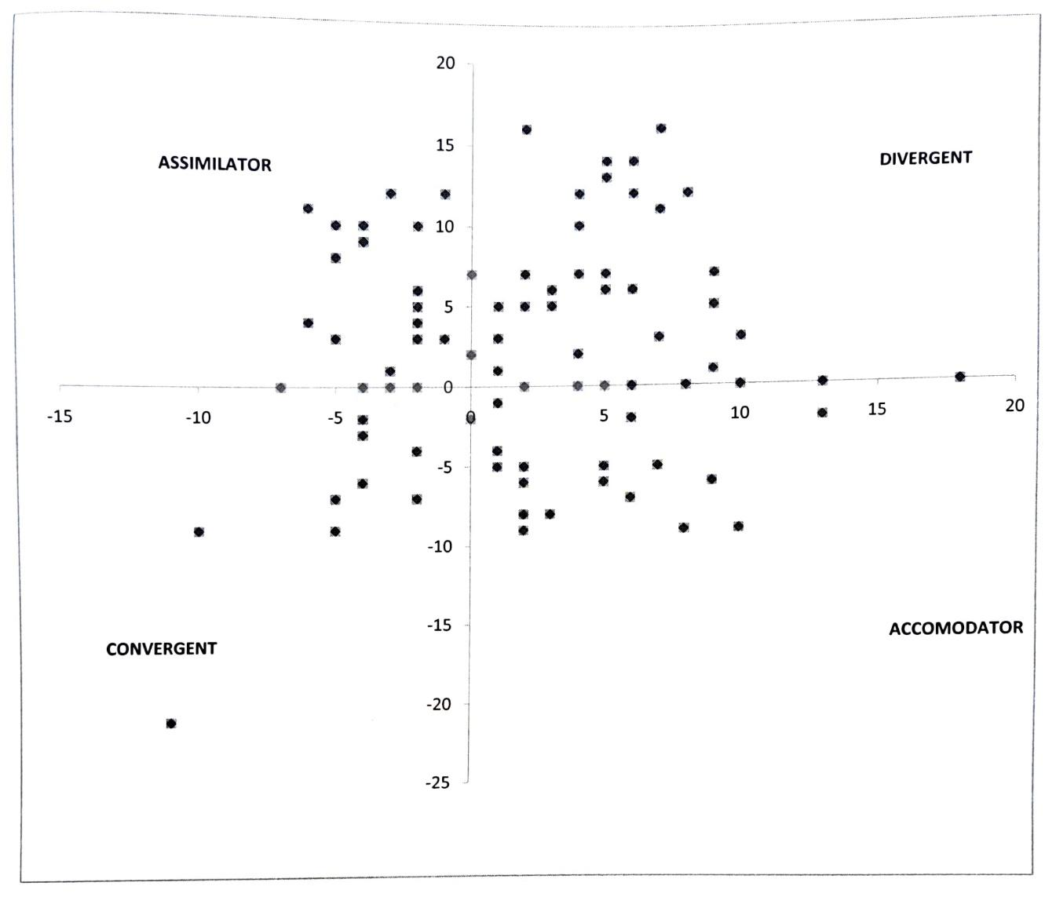
Figure-1: Learning Styles of Post Graduate Students (Girls)

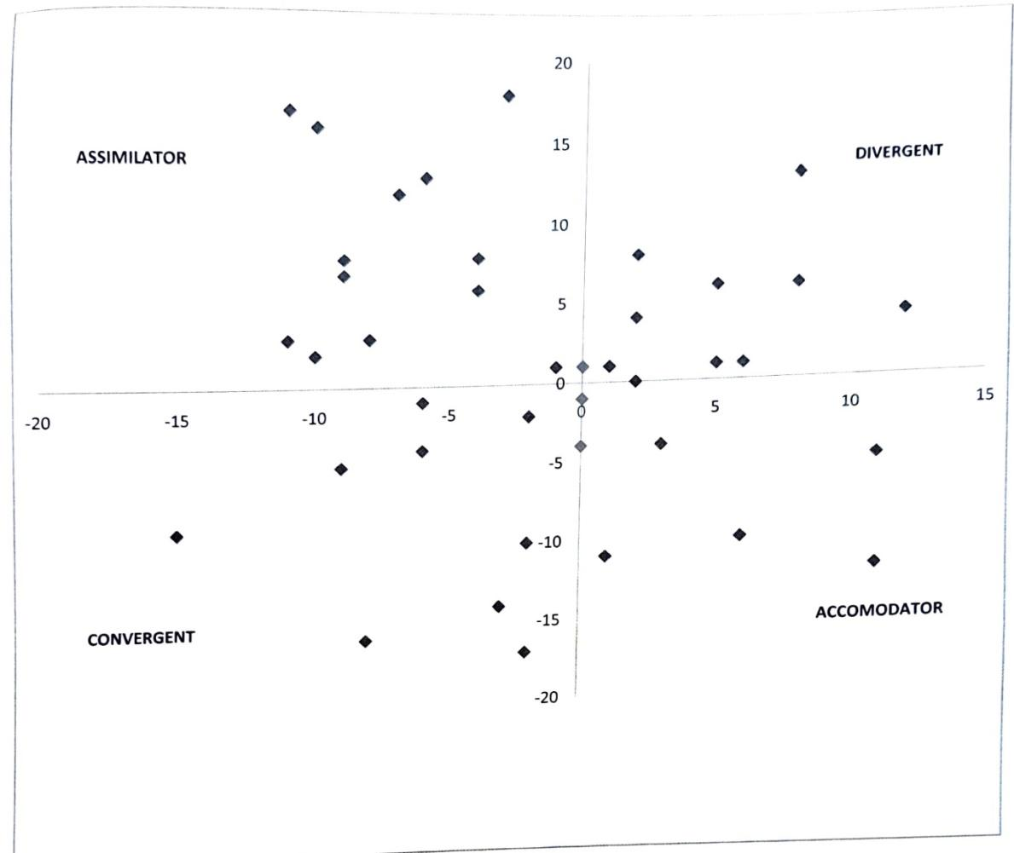
Figure-2: Learning Styles of Post Graduate Students (Boys)

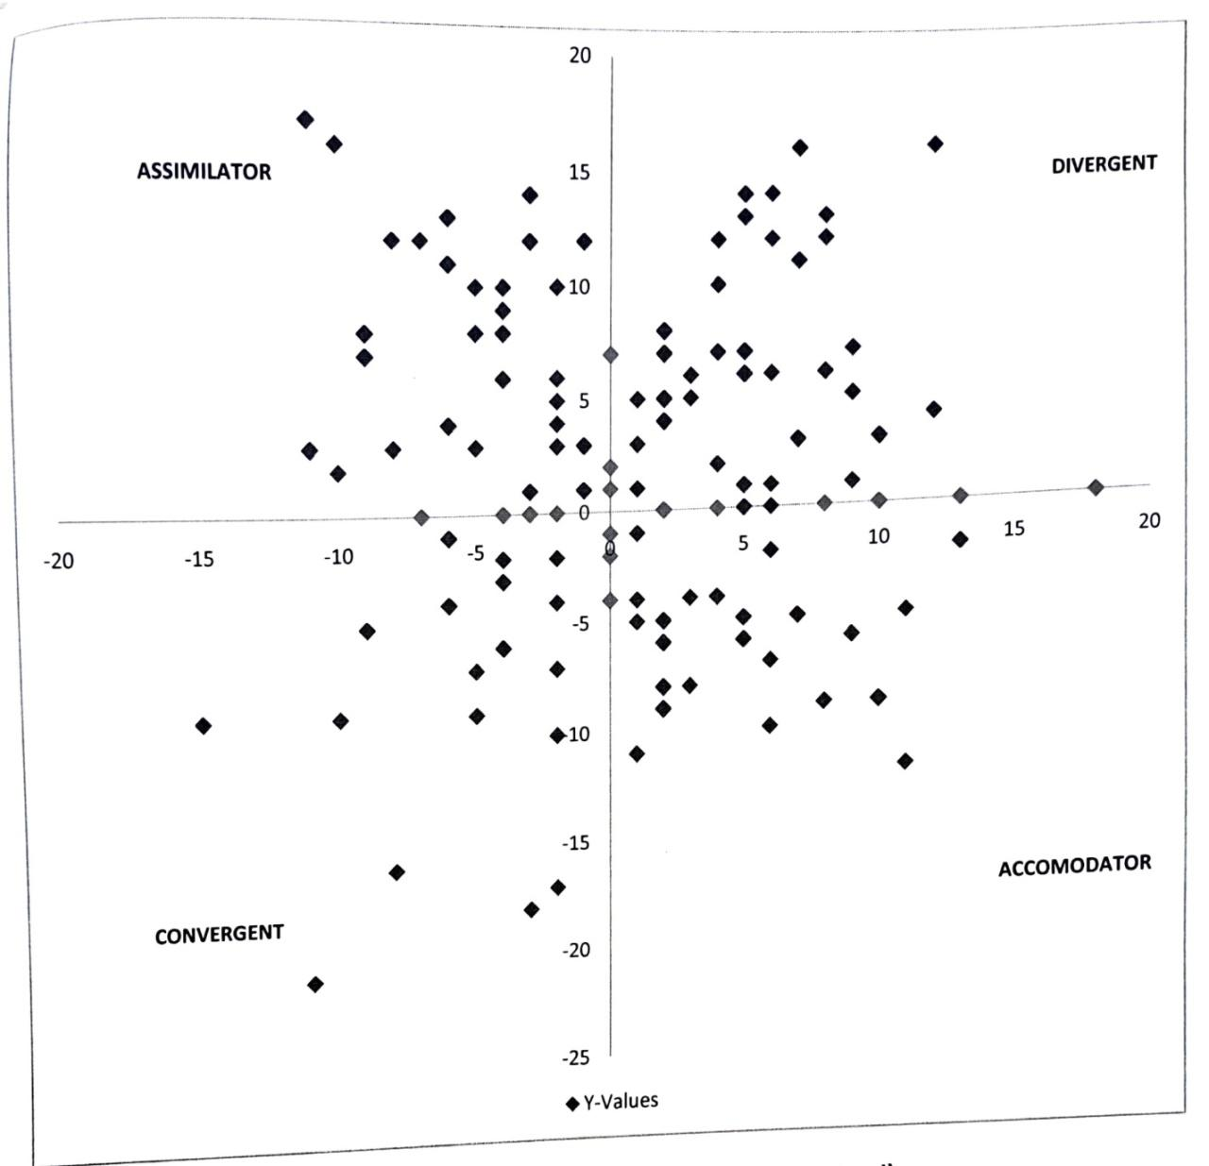

Figure-3: Learning Styles of Post Graduate Students (boys and girls combined)

With respect to boys, majority were belong to Assimilators (32.50%) and equal number of them (27.50) were belong to convergers and Divergent followed by accommodators Fig(2). Put together both boys and girls, it is interesting to note that majority were divergent (31.46) little more than one forth of them were assimilators followed by accommodators and convergers. This finding is in line with that of Raghavendra Muragad (2007) who citied in his study on learning styles of PD Students in the same university that majority were Divergents followed by convergents, Assimilators and accommodators contrary to this finding Madhuprasad (2016) have investigated the under graduate students learning style among sc/st students. He comes to different conclusion that majority of UG students belong to Convergents (33.05%) followed by accommodators (27.90%) assimilators (27.04%) and divergents (12.02%). He is of the opinion that teachers should emphasis problem solving approach to facilitate learning. Jaykumar et al (2016) have measured the learning styles of under graduate, Students of Agriculture, Horticulture and Engineering Degree programmes in vellur District of Tamil Nadu another state in South India. Using VAR Learning style model developed by Barbeetal (1975). He concluded that the majority of students are visual learners (52.69%), followed by auditory learners (32.14%), and kinesthetic learners (8.05%). When considering the distribution across different streams, the highest percentage of visual learners was observed in the Engineering stream (66.66%), followed by Horticulture (62.509%) and Agriculture (61.11%) streams, respectively. Furthermore, it was noted that a significant number of students in the agriculture stream were unimodal learners. As highlighted, given that students in agriculture and horticulture streams are predominantly auditory learners, it becomes crucial for teachers to incorporate discussions and brainstorming in their teaching methods to enhance effectiveness.
With respect to learning styles of PG students UAS, Bangalore. Being divergent (Table-2) and Fig(1), (2) & (3) they are strong in imaginative ability, good in generating ideas and seeing things in different perspective, interested in people and broad, cultural. Therefore, teachers should understand the methods that suits to teach these students, colour they like, pictures they wish to see in teaching. In order to make teaching interesting to the students in the class rooms. Kolb (1985) categories of learning style gives more details of this fact.
V. Conclusion
It is axiom to note that, the learning styles of PG students is varied among boys and girls. But, majority of Boys and Girls were divergent: added to these boys were assimilators where as girls are accommodators. Which means boys like inductive reasoning vis-à-vis girls who like hands on experience in learning. This trend calls for drivers (Teachers) to (1) identify the type of learning style of students and include appropriate method(s) of teaching (2) Motivate the students for better learning and (3) Make use of colour, pictures based on learning styles of students in teaching. So that, quality of teaching can be improved in the coming years to take this university to a greater height.
Vi. References
BARBE, WALTER BURKE, SWASSING, RAYMOND, H. AND MILONE MICHAEL,
N. 1979, Teaching through modality strengths concepts and practices. Columbus, Ohio: Zaner-Bloser.

COFFIELD, F. MOSELEY, D., HALL, E., & ECCLESTONE, K., 2004. Should we be
using learning styles?: What research has to say to practice. London, England: Learning & Skills Research Centre.

DEBELLOW, T. C., 1990, Comparison of eleven major learning style models: Variables,
appropriate populations, validity of instrumentation and the research behind them, Internatl. J. Reading, Writing and Learning disabilities, 6:203-222.

FLEMING, N., 2011, Teaching and Learning Styles. VARK Strategies. Christchurch: N.
D. Fleming. Pp.128.

GRASHA, A. F. AND REICHMANN, S. W., 1974, The Grasha-Reichmann student learning
style scales. In Handbook for faculty development, pp. 55-58.

JAYAKUMAR, N. ANU SURESH. SUNDARAMARL M. AND PUTHIRA PRATHAP, D., 2016, Understanding Learning style variations among Undergraduate students. J. Extn. Edu., 28(4): 5727-5734.

KADAM, P. B. LAMBE, S. P. AND WAKLE. P. K.. 2015, Learning style of Agricultural
technology school students. Asian j. Extn. Edu., 33, pp.12-14.

KEEFE, J. W., 1979, Learning Styles: An overview. In J. W. Keefe (ed.), Student Learning
Styles: Diagnosing and prescribing Programs: National Association of Secondary School Principals. Reston, VA. Pp. 30-33.

KATHLEEN WILSON AND GEORGE MARREN., 1990, Systems approach
for improvement in agriculture and resource management. Macmillan publisher New York P:25-30.

KOLB, D. A., 1985, Experiential learning: Experience as the source of learning
and development. J. Mangt. Competencies, Englewood Cliffs, NJ: Prentice-Hall. 5(3): 13 24.

MADHU PRASAD, V. L, VENKATARANGA NAIKA, K., MANJUNATH, V. AND
USHA RAVINDRA, 2016, Learning Styles of Undergraduate SC/ST students at University of Agricultural Sciences, Bengaluru. Project Report, Directorate of Extension, Hebbal, UAS, Bangalore.

MADHU PRASAD, V. L., VENKATARANGA NAIKA, K., CHANDRASHEKARA,
S., AND USHA RAVINDRA, 2017, Learning Styles of Undergraduate SC/ST students at University of Agricultural Sciences, Bengaluru. Project Report, Directorate of Extension, Hebbal, UAS, Bangalore.

RAGHAVENDRA MURGOD, 2007, A study on learning styles of post graduate students
at University of Agricultural Science, Bangalore, M.Sc. Thesis, Univ. Agric. Sci., Bangalore.

RAVI BABU, M., 2014, A study on reproducing and constructive learning styles among
secondary School students. Internatl. J. Dev. Res. 4(12): 2798-2801.

REIFF, J. C., 1992. Learning styles. What research says to the Teacher series,
National Education Association, Washington, DC.

SARASIN, L. C., 1998, Learning style perspectives: impact in the classroom. Madison,
WI: Atwood. Pp. 4-5.

STEWART, K. L. AND FELICETTI, L. A., 1992, Learning styles of marketing majors. Educational Research Quarterly, 15 (2):15-23. -15

