A novel hybrid neuro-fuzzy machine learning based prediction model for bearing capacity of shallow foundation

Akash Sankar Chowdhury Shashwath E P
3rd year B. Tech CSE 3rd year B. Tech. CSE – AI&ML
SRMIST Tiruchirappalli SRMIST Tiruchirappalli
Tiruchirappalli, TN, India Tiruchirappalli, TN, India
Akashchowdhury1611@gmail.com shashwath.ep@gmail.com

- Abstract:
In the design of structures, the carrying capability of shallow foundations is crucial. Particularly when the soil is complex or varied, traditional methods for calculating bearing capacity can be unreliable. In this study, a hybrid Adaptive Neuro-Fuzzy Inference System (ANFIS) and Particle Swarm Optimization (PSO) model is used to determine bearing capacity. Fuzzy logic and neural networks are combined in the ANFIS-PSO model to learn intricate correlations between input and output variables. The model parameters are optimized using PSO, leading to a more precise and trustworthy forecast of bearing capacity. Using a dataset of experimental data from shallow foundations, the ANFIS-PSO model was assessed. With an R² value of 0.90274 and an RMSE score of 0.0552, the model successfully predicted bearing capacity. These findings show that the ANFIS-PSO model is useful for calculating bearing capacity. The ANFIS-PSO model has a number of benefits over conventional techniques for calculating bearing capacity. First, the model can accommodate language explanations of uncertainty and soil mechanics data. Additionally, the model may identify non-linear connections between various soil metrics. Third, the model can refine its parameters to increase precision. The bearing capacity assessment process may undergo a revolution thanks to the ANFIS-PSO model. The model can be used to build safer and more cost-effective structures since it is more precise and reliable than conventional techniques. The model is useful for a variety of soil conditions and can be used by architects and civil engineers.
Keywords: shallow foundation, ANFIS, PSO, bearing capacity
- Introduction:
The foundation of any building is critical to its stability and lifespan because it acts as the vital connection between the superstructure and the subsurface soil layers [1]. Shallow foundations, among other foundation types, are distinguished by their broad base and thin thickness, with a depth that is equal to or less than their breadth. In shallow foundations, the base area plays a significant role in load distribution, and failure occurs at a shallow depth that reaches the surface. An important component of soil mechanics and foundation engineering is comprehending the bearing capacity of soil, which is also known as the soil's load-carrying capacity. The maximum load per unit area at which shear failure takes place is referred to as the ultimate bearing capacity.
Soft computing methods based on machine learning have been used by researchers to increase the accuracy of predictions regarding the bearing capacity of shallow foundations [2]–[11]. The Adaptive Neuro-Fuzzy Inference System (ANFIS) is one such model that has demonstrated significant potential in a number of applications. ANFIS combines the benefits of fuzzy logic and neural networks, making it possible to find complex relationships between input and output variables [12]. As a result of its capacity to manage complicated data and make precise predictions, ANFIS has attracted a lot of interest. Furthermore, when combined with ANFIS, Particle Swarm Optimization (PSO) has proven to be a successful optimization strategy [13]. PSO is a population-based optimization technique that continuously modifies the placements of potential solutions in the search space in order to identify the best one. It was inspired by social behaviour. The performance and dependability of the model have been significantly improved by merging PSO with ANFIS, according to researchers [13]–[16].
The implementation of the ANFIS-PSO approach for determining the bearing capacity of shallow foundations is the main emphasis of this study. This method provides a reliable and effective way to determine the load-carrying capability of shallow foundations by combining fuzzy logic with optimization. The findings of this study are anticipated to have a substantial impact on construction methods, assuring the stability and safety of structures. Insights from this research will also have a significant impact on soil mechanics and foundation engineering. Accurate forecasts of bearing capacity become increasingly important as the need for stronger, more resilient structures grows. While still somewhat accurate, conventional methods for determining bearing capacity frequently have trouble dealing with the complexity of soil behaviour. An innovative and complex strategy that could transform the field of foundation engineering is presented by the merging of ANFIS and PSO. The ANFIS-PSO method's attractiveness rests in its capacity to draw lessons from the past and modify its rules to produce precise forecasts [13]. The model can manage uncertainty and linguistic descriptions found in soil mechanics data by using fuzzy logic. ANFIS uses neural networks to detect non-linear correlations between different soil metrics, which enables the model to detect complex patterns that would be overlooked by traditional approaches[12]. Furthermore, PSO's theory of swarm intelligence fits with how particles behave naturally in a search space [17], [18]. The discovery of optimal solutions is made easier and more computationally effective because to PSO's exploration and exploitation capabilities. The hybrid ANFIS-PSO method can therefore successfully handle the challenging optimization problem of determining bearing capacity.
This study's potential uses go well beyond just theoretical ones. The ANFIS-PSO method can be used by civil engineers and architects to optimize foundation designs for a variety of structures, from small residential buildings to massive infrastructure projects. A more precise bearing capacity estimate enables better load distribution planning, which results in safer and more economical buildings. Furthermore, the ANFIS-PSO method's capability to precisely determine bearing capacity becomes even more significant in areas vulnerable to earthquakes or other geotechnical hazards. Engineers can create structures that survive these difficulties by being aware of the soil's load-bearing limits, thereby saving lives and reducing property damage in the event of natural calamities.
- Dataset used for the study:
The dataset for the study is taken from published studies [19], [20]. The histogram of the dataset is presented in figure 1. Input parameters taken are the width of the foundation (B), depth of the foundation (D), length to width ratio (L/B), density (y), and angle of friction (φ), whereas the final output parameter is considered to be the bearing capacity of the foundation (q_{u}). To analyse the distribution of the input and output parameters and study the influence of the input parameters on the output parameters, correlation matrix has been plotted in figure 2. The correlation matrix comprises the box plot, confidence ellipse and the values of Pearson’s r. It can be inferred from the figure 2 that parameter D is having most influence on the output followed by B. The least influence on the output parameter is for the parameter f.
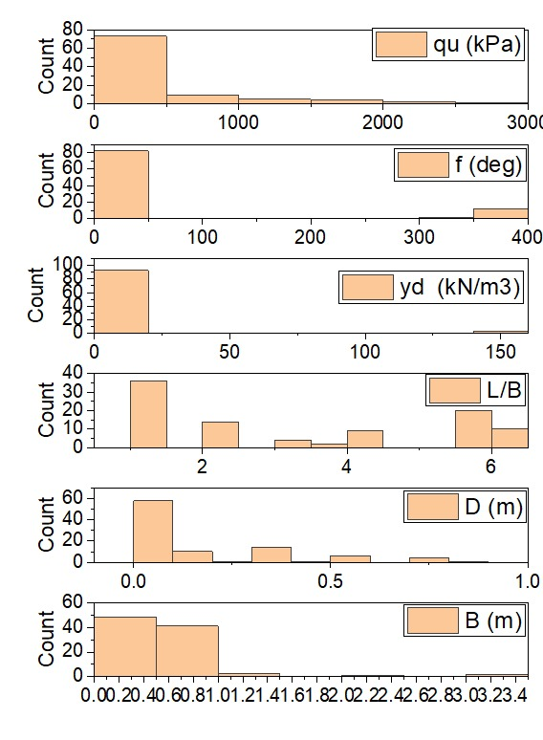
Figure 1: Dataset for the study

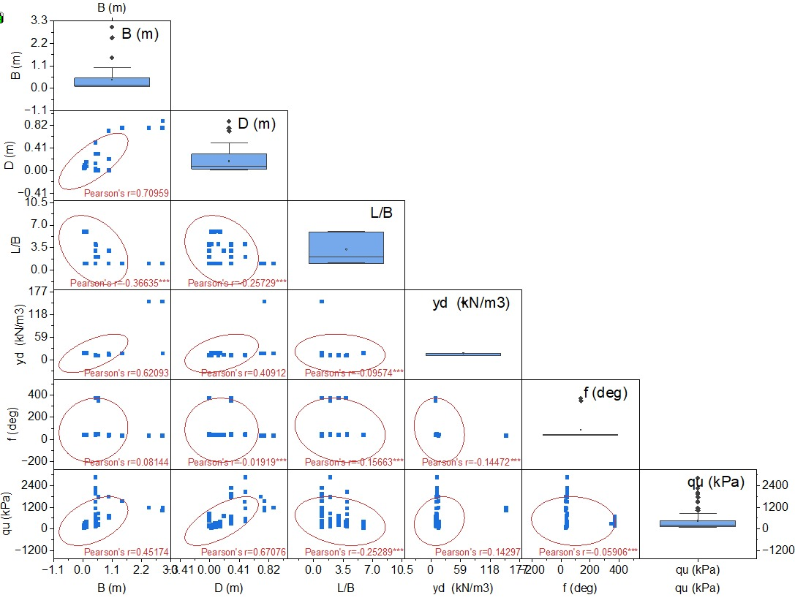
Figure 2: Correlation Matrix of the dataset used for the study

- Observations and Discussion:
The ANFIS-PSO model for the study has been developed in MATLAB. The performance of the model is presented in the form of regression curve, distribution of MSE and error mean in figure 3 and 4 for training and testing datasets respectively. The distribution of the predicted outcome to the actual is shown in scatter plot in figure 5. The predicted datapoints are plotted around the actual = predicted line. The coefficient of determination (R²) and root mean square error (RMSE), weighted mean absolute percentage error (WMAPE), variance accounted for (VAF), four important measures, offer important insights into the precision and dependability of the model's predictions.
$$R^{2}=\frac{\sum_{i=1}^{n}{(d_{i}-d_{mean})^{2}-\sum_{i=1}^{n}{(d_{i}-y_{i})^{2}}}}{\sum_{i=1}^{n}{(d_{i}-d_{mean})^{2}}}$$
(1)
$$WMAPE=\frac{\sum_{i=1}^{n}{\left|\frac{d_{i}-y_{i}}{d_{i}}\right|}×d_{i}}{\sum_{i=1}^{n}{d_{i}}}$$
(2)
$$RMSE=\sqrt{\frac{1}{N}\sum_{i=1}^{n}{(d_{i}-y_{i})^{2}}}$$
(3)
$$VAF=(1-\frac{\operatorname{var}{(}d_{i}-y_{i})}{\operatorname{var}{(}d_{i})})×100$$
(4)
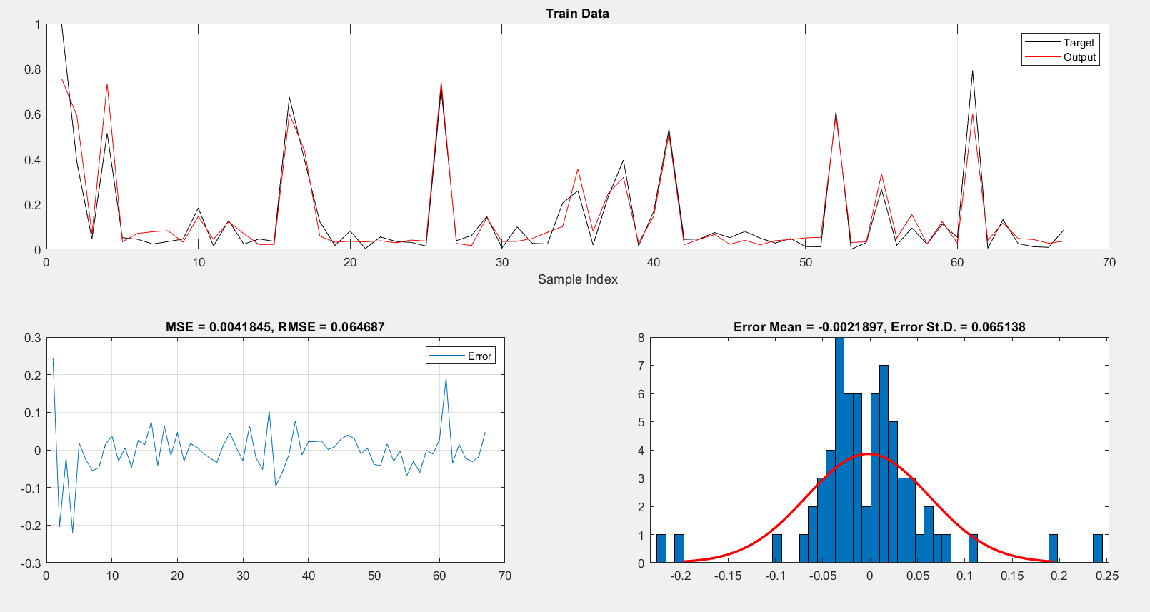
It is to be taken into consideration that d_{i} is referred to as the observed i^{th} value, y_{i} is referred to as the predicted i^{th} value, and N refers to the number of data samples. Based on this the equations are derived and the final values are noted.

Figure 3: Regression Plot with Error Matrix for training dataset of ANFIS – PSO model

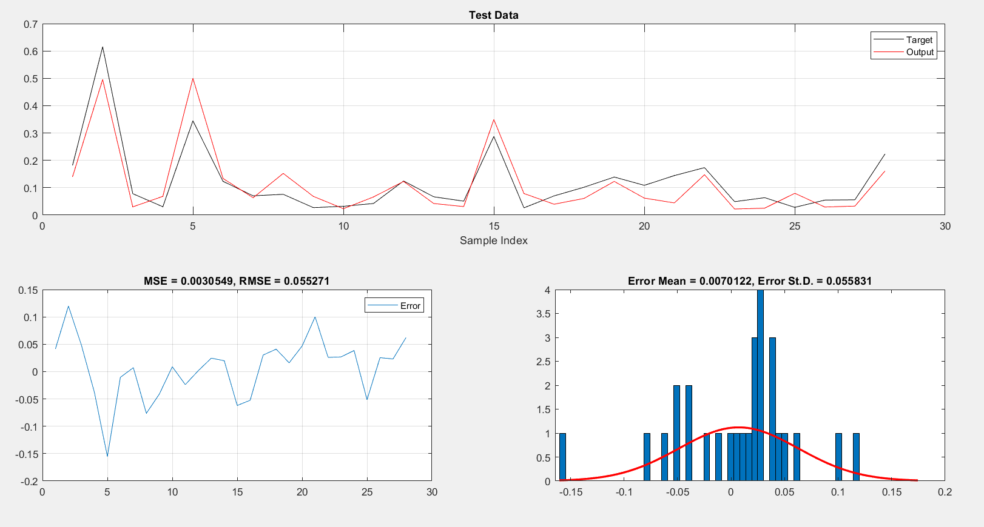

Figure 4: Regression Plot with Error Matrix for testing dataset of ANFIS – PSO model
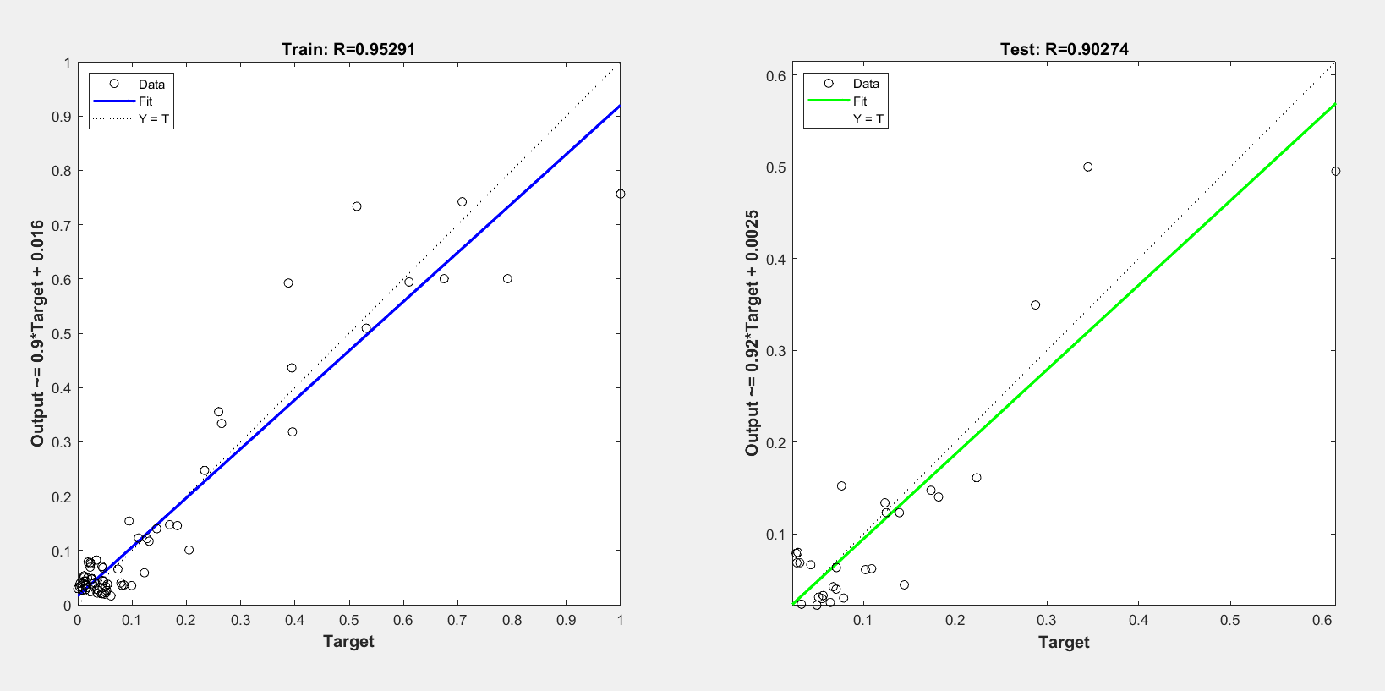

Figure 5: Scatter Plot for both training and testing data

The values of the performance parameters are noted in Table 1. The ANFIS-PSO model attained a remarkable R² value of 0.953 during the training phase. The model was able to explain almost 95.29 percent of the variability seen in the training data, as seen by the strong R² score. In other words, the model was able to give reliable predictions of bearing capacity by accurately capturing complicated relationships between input and output factors. In foundation engineering, where accurate estimations are essential for assuring the structural integrity and safety of structures and infrastructure, a strong R² result is necessary. The low RMSE of 0.065 that was attained during the training phase further contributes to the model's dependability. The average difference between the values in the training data that were predicted and the actual values is measured by RMSE. The low RMSE number shows that the model's predictions were generally accurate, with few errors, and near to the actual values. This shows how the ANFIS-PSO model may be used to accurately predict the bearing capacity of shallow foundations during the training process.
The ANFIS-PSO model maintained its outstanding performance during the testing phase, reaching an R² value of 0.815. The model can explain about 81.5 percent of the variability in the testing data, according to this R² statistic. It is also important that the model's performance generalizes effectively to unknown input and goes beyond the training data. It demonstrates that the ANFIS-PSO model has learnt underlying patterns that can be applied to new, unforeseen data instead than overfitting to the training data, making it a robust and trustworthy tool for real-world applications. The ANFIS-PSO model's correctness and generalizability are further demonstrated by the testing model's low RMSE score of 0.0552. The model's ability to generate accurate estimates of bearing capacity for shallow foundations is further demonstrated by the model's tiny RMSE value, which shows that the predictions closely match the actual values in the testing dataset. The study's findings show the ANFIS-PSO model's excellent performance in determining the bearing capacity of shallow foundations.
The study's findings highlight the ANFIS-PSO model's exceptional performance in determining the carrying capacity of shallow foundations. The model's success in capturing intricate correlations between input and output variables is demonstrated by its capacity to explain a sizable portion of the variability in the data, both during training and testing. Additionally, the low RMSE values show that the model frequently makes predictions that are near to the actual values, ensuring that estimation mistakes are kept to a minimum. Given these astounding results, the ANFIS-PSO model has a lot of promise to be a useful resource for foundation engineers and soil mechanics specialists. The model can be extremely helpful in ensuring the stability, safety, and long-term performance of shallow foundations in a variety of building projects by offering accurate and trustworthy projections of bearing capacity. The ANFIS-PSO model provides a cutting-edge method for optimizing foundation designs and enhancing the resilience of constructions against geotechnical challenges, such as earthquakes and other natural hazards, whether they are for residential buildings, commercial buildings, or large infrastructural developments. Overall, this research advances the field of foundation engineering and sets the path for future safer and more effective building methods.

Parameters | IDEAL VALUES | TR VALUES | TS VALUES
R² | 1 | 0.9080 | 0.8149
WMAPE | 0 | 0.2918 | 0.3598
VAF | 100 | 90.8018 | 80.1005
RMSE | 0 | 0.0647 | 0.0553

Table 1: Ideal values with all the obtained results of the model

- Conclusion:
The study's findings will serve as a helpful tool for the construction industry, ensuring that buildings are built with both literal and symbolically strong foundations. By creating new standards for sustainability, efficiency, and safety, the ANFIS-PSO methodology has the potential to revolutionize building practices. Adaptive Neuro-Fuzzy Inference System (ANFIS) and Particle Swarm Optimization (PSO) together offer a state-of-the-art method for estimating the bearing capacity of shallow foundations. By utilizing machine learning and optimization, this method offers more accurate forecasts and a deeper understanding of soil mechanics and foundation engineering. The research's many potential applications could change the construction industry by improving the robustness, stability, and safety of buildings everywhere. The ANFIS-PSO technique sets the door for a new age of innovative and sustainable construction practices as we delve further into the complexities of soil behaviour and foundation design.
- References
[1] V. Murthy, “Soil mechanics and foundation engineering.” CBS Publishers and distributers pvt. Ltd., 2010.
[2] M. Kumar, R. Biswas, D. R. Kumar, T. Pradeep, and P. Samui, “Metaheuristic models for the prediction of bearing capacity of pile foundation,” Geomechanics and Engineering, vol. 31, no. 2, pp. 129–147, Oct. 2022, doi: 10.12989/GAE.2022.31.2.129.
[3] R. Ray, D. Kumar, P. Samui, L. B. Roy, A. T. C. Goh, and W. Zhang, “Application of soft computing techniques for shallow foundation reliability in geotechnical engineering,” Geoscience Frontiers, vol. 12, no. 1, pp. 375–383, Jan. 2021, doi: 10.1016/J.GSF.2020.05.003.
[4] R. Ray, D. Kumar, P. Samui, L. B. Roy, A. T. C. Goh, and W. Zhang, “Application of soft computing techniques for shallow foundation reliability in geotechnical engineering,” Geoscience Frontiers, vol. 12, no. 1, pp. 375–383, Jan. 2021, doi: 10.1016/j.gsf.2020.05.003.
[5] G. L. Sivakumar Babu and A. Srivastava, “Reliability analysis of allowable pressure on shallow foundation using response surface method,” Comput Geotech, vol. 34, no. 3, pp. 187–194, May 2007, doi: 10.1016/J.COMPGEO.2006.11.002.
[6] R. Ray, D. Kumar, P. Samui, L. B. Roy, A. T. C. Goh, and W. Zhang, “Application of soft computing techniques for shallow foundation reliability in geotechnical engineering,” Geoscience Frontiers, vol. 12, no. 1, pp. 375–383, Jan. 2021, doi: 10.1016/j.gsf.2020.05.003.
[7] R. Ray, D. Kumar, P. Samui, L. B. Roy, A. T. C. Goh, and W. Zhang, “Application of soft computing techniques for shallow foundation reliability in geotechnical engineering,” Geoscience Frontiers, vol. 12, no. 1, pp. 375–383, May 2021, doi: 10.1016/j.gsf.2020.05.003.
[8] P. Samui, “Support vector machine applied to settlement of shallow foundations on cohesionless soils,” Comput Geotech, vol. 35, no. 3, pp. 419–427, May 2008, doi: 10.1016/j.compgeo.2007.06.014.
[9] G. L. Sivakumar Babu and A. Srivastava, “Reliability analysis of allowable pressure on shallow foundation using response surface method,” Comput Geotech, vol. 34, no. 3, pp. 187–194, May 2007, doi: 10.1016/j.compgeo.2006.11.002.
[10] S. Debnath and P. Sultana, “Prediction of Settlement of Shallow Foundation on Cohesionless Soil Using Artificial Neural Network,” pp. 477–486, 2022, doi: 10.1007/978-981-16-6456-4_49.
[11] R. N. Behera, C. Patra, B. M. Das, and N. Sivakugan, “Ultimate bearing capacity of shallow strip foundation under eccentrically inclined load—a critical assessment,” https://doi.org/10.1080/19386362.2018.1549693, vol. 15, no. 7, pp. 897–905, 2018, doi: 10.1080/19386362.2018.1549693.
[12] J. S. R. Jang, “ANFIS: Adaptive-Network-Based Fuzzy Inference System,” IEEE Trans Syst Man Cybern, 1993, doi: 10.1109/21.256541.
[13] H. Moayedi, M. Raftari, A. Sharifi, W. A. W. Jusoh, and A. S. A. Rashid, “Optimization of ANFIS with GA and PSO estimating α ratio in driven piles,” Eng Comput, vol. 36, no. 1, pp. 227–238, Jan. 2020, doi: 10.1007/S00366-018-00694-W/FIGURES/11.
[14] H. Harandizadeh, · Danial, J. Armaghani, and · Mahdy Khari, “A new development of ANFIS-GMDH optimized by PSO to predict pile bearing capacity based on experimental datasets,” Eng Comput, vol. 1, p. 3, doi: 10.1007/s00366-019-00849-3.
[15] N. Kardani, A. Bardhan, D. Kim, P. Samui, and A. Zhou, “Modelling the energy performance of residential buildings using advanced computational frameworks based on RVM, GMDH, ANFIS-BBO and ANFIS-IPSO,” Journal of Building Engineering, vol. 35, p. 102105, Mar. 2021, doi: 10.1016/j.jobe.2020.102105.
[16] H. Moayedi and A. Rezaei, “The feasibility of PSO–ANFIS in estimating bearing capacity of strip foundations rested on cohesionless slope,” Neural Comput Appl, vol. 33, no. 9, pp. 4165–4177, May 2021, doi: 10.1007/s00521-020-05231-9.
[17] L. T. Le, H. Nguyen, J. Dou, and J. Zhou, “A comparative study of PSO-ANN, GA-ANN, ICA-ANN, and ABC-ANN in estimating the heating load of buildings’ energy efficiency for smart city planning,” Applied Sciences (Switzerland), 2019, doi: 10.3390/app9132630.
[18] M. Kumar, V. Kumar, B. G. Rajagopal, P. Samui, and A. Burman, “State of art soft computing based simulation models for bearing capacity of pile foundation: a comparative study of hybrid ANNs and conventional models,” Model Earth Syst Environ, 2022, doi: 10.1007/S40808-022-01637-7.
[19] M. Kumar et al., “Hybrid ELM and MARS-Based Prediction Model for Bearing Capacity of Shallow Foundation,” Processes 2022, Vol. 10, Page 1013, vol. 10, no. 5, p. 1013, May 2022, doi: 10.3390/PR10051013.
[20] M. Bagińska and P. E. Srokosz, “The Optimal ANN Model for Predicting Bearing Capacity of Shallow Foundations trained on Scarce Data,” KSCE Journal of Civil Engineering 2019 23:1, vol. 23, no. 1, pp. 130–137, Dec. 2018, doi: 10.1007/S12205-018-2636-4.

