Detection of Crop Flow Path In Axial Flow Paddy Thresher By Using Magnetometer

Chethan C R  Scientist,  ICAR - Directorate of Weed Research,  Jabalpur, India – 482004 | Baldev Dogra  Principal Scientist,  Department of Farm machinery and Power Engineering,  College of Agricultural Engineering &Technology,  Punjab Agricultural University,  Ludhiana, India – 141004.  Email: baldevdogra@pau.edu
Ritu Dogra  Professor,  Department of Renewable Energy Engineering, College of Agricultural Engineering &Technology,  Punjab Agricultural University,  Ludhiana, India – 141004.  Email: ritudogra@pau.edu | Derminder Singh  Professor, Department of Electrical Engineering and Information Technology,  College of Agricultural Engineering &Technology,  Punjab Agricultural University,  Ludhiana, India – 141004.  Email: dermindersingh@pau.edu
Rashmi Arora
Assistant Professor, Department of Mechanical Engineering,
College of Agricultural Engineering &Technology,
Punjab Agricultural University,
Ludhiana, India – 141004.
Email: rashmiarora@pau.edu

ABSTRACT
Threshing is a significant operation in paddy cultivation, which affects quantitative and qualitative losses of grains. The axial flow paddy thresher ensures higher threshing quality by allowing crop to thresh in multiple passes. However, the retention time, over threshing and crop back feeding aresome of the major issues in axial flow threshers and are mainly dependent on louvers spacing and inclination angle. Analysis of actual crop flow within the threshing unit will provide an opportunity to suggest improvementin existing axial flow paddy threshers. A magnetometer sensor (Make: Honeywell, Model: HMR 2300) based instrumentation system has been developed to analyse the crop flow path within axial flow threshing unit. A crop movement monitoring software was specially developed for instrumented system to record incident magnetic field. The developed system records incident magnetic field accurately and thus the actual crop flow path within threshing unit was easily detected. The observations revealed that the crop reappearedfor more than 2 – 4 times at the feed entrance after completion of one drum revolution, which leads to over threshing.

Keywords- Axial flow, Back feeding, Honeywell HMR 2300, Magnetic field, Torque transducer.

I. INTRODUCTION

Rice (Oryza Sativa) is the world’s second most important food crop and main staple food of Asian countries. Threshing is a significant farm operation in paddy cultivation which affects qualitative and quantitative losses of grains.Threshing of the paddy in developing countries is performed both manually and mechanically.Mechanical threshersinclude cross flow, axial flow and tangential axial flow threshing mechanism; they are having an advantage of reduced human drudgery and higher threshing capacity. However, the axial flow paddy thresher’s performance is better than the cross-flow threshers (Sinha et al., 2014). In axial flow threshers crop moves spirally between the threshing drum and the concave for several complete turns. Thus, the crop is threshed for longer duration by repeated impact of threshing pegs (Sessiz and Ulger, 2003; Ardeh and Gilandeh, 2008; Sinha et al., 2014). This mechanism ensures increased feed-in capacity,threshing efficiency and cleaning efficiency by allowing the crop to thresh and grain to separate at multiple stages (Harrison, 1992). Further, some of researcher reported that the grain losses and breakage losses in axial flow threshers are limited to 1.53 to 2.71 % and 2.21 to 2.51 % respectively at standard drum speed (Majumdar, 1985; Ahuja et al., 1986). However, the retention time, over threshing and back feeding of the crop is a major problem in axial flow threshers,which are mainly dependent on louvers spacing and inclination angle (Chuan-udom and Chinsuwan, 2009). Also performance of thresher is affected by parameters such as moisture content of crop (Alizadeh and Khodabhaksipour, 2010), feed rate (Chinsuwanet al., 2003a), clearance between concave rod (Chinsuwanet al., 2003b), concave clearance (Andrews et al., 1993), and louver inclination (Gummertet al., 1992; SangwijitandChinsuwan, 2010).Thus, to improve the performance characteristics of an axial flow thresher,analysis of crop flow path within threshing unit is necessitated.
In the present work, a magnetic field-based sensing system was developed. A magnetic material whose density is near to the rice crop was introduced along with the crop during threshing process.Kutzbachand Wacker (1980) developed an inductive crop movement measuring system and it was successfully used in paddy thresher to monitor the crop movement, the path travelled by material inside the threshing unit and studied the effect of louver adjustment on retention time, time per revolution and clearing time. Similar type of experiment was carried out by Gummertet al., (1992);he showed that the crop-flow data helped to improve the crop movement and reduced the backfeeding through feed opening by modifying louver adjustment.Therefore, in order to improve the axial flow concept of threshing,a path travelled by the crop material inside the threshing unit has to be determined precisely. In this studyamagnetic sensor-basedmeasurement setup and crop movement monitoring system software has been developed to determine the crop flow movement in axial flow paddy thresher by using Honeywell HMR 2300 magnetometer sensors and detected the crop travelling path.

II. MATERIALS AND METHODS

2.1 Smart digital magnetometer - Honeywell HMR 2300

Honeywell HMR2300 is a three-axis smart digital magnetometer to detect strength and direction of an incident magnetic field.It consists of orthogonally oriented three magneto-resistive sensors, which measureslocal magnetic field with threedirectional vector component of incident magnetic field (Figure 1). Outputs of these sensors are converted to 16-bit digital values by using an internal A/D converter(delta-sigma) and digital data is transferred through RS-232 serial port at configurable data rates. The specification of the magnetometer is detailed in Table1.

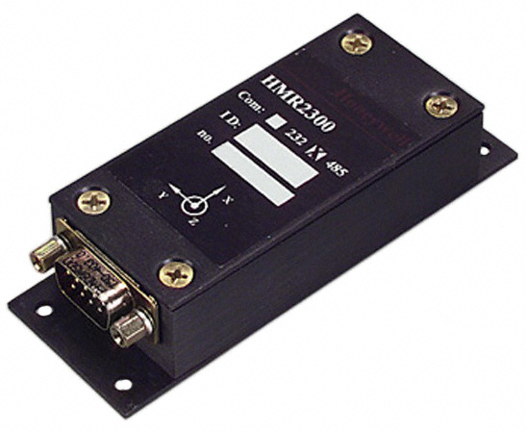

Figure 1: Smart digital magnetometer- Honeywell HMR 2300 (Source: www.digikey.com

Table1: Specification of Smart digital magnetometer – Honeywell HMR 2300

Features | Range | Values | Units
Full scale | -2 to +2 |  | Gauss
Resolution | -2 to +2 | <70 | micro-Gauss
Accuracy | ±1 at 25°C | 0.5% | Gauss
Accuracy | ±2 at 25°C | 2% | Gauss
Accuracy | RSS | 0.1% | Gauss
Sampling | 10 – 154 Hz | Selectable
Output | 3 - axis | BCD ASCII or Binary
Interface | Serial 9600-19200 | RS-232 or RS-485 | bauds
Power supply | +6 to +15 |  | Volts
(Source: Kuga and Carrara, 2013)

Cylindrical Neodymium industrial magnets of size 5 x 8 mm areused in study to provide magnetic field. The magnetshave a density of5.3 gcm⁻³ and volume of 0.29 cm³, which is less than the density and volume of crop required for threshing process.For the purpose of experiment, two magnets attached each other were placed within the heat sinkable rubber tube and placed in between the inter node of rice straw (Figure 2), additionally they are enclosed by the scotch tape to ensure easy movementwithin the crop.

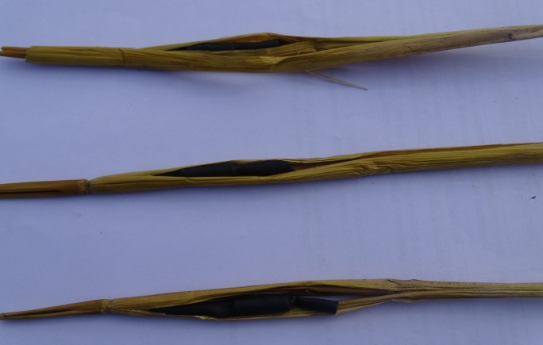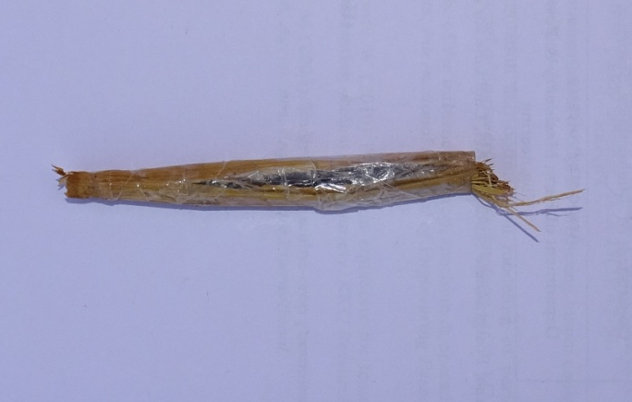
a. Heat sunk rubber-magnet within the inter node of crop b. Taped magnet recovered after threshing
Figure 2: Neodymium magnets inserted within heat sinkable rubber tube along with crop

2.2 Crop movement monitoring system software

A crop movement monitoring system software has been procured from AIMIL Ltd by Punjab Agriculture University to detect the crop flow path inhidden surface. It comprised of software of National instruments, “Power DNA” software for 16 channel data loggers (Figure 3), gives the data in both digital and graphical format; further the data can be saved either in SD card or in PC. Options has been provided in the software to change the sampling data rate from 10 to 154 Hz and data output format in BCD, ASCII or in Binary. Different colour code for different sensors and different line pattern for different vector componentshave been assigned within the software (Table2) for graphical representation of the measured quantities.

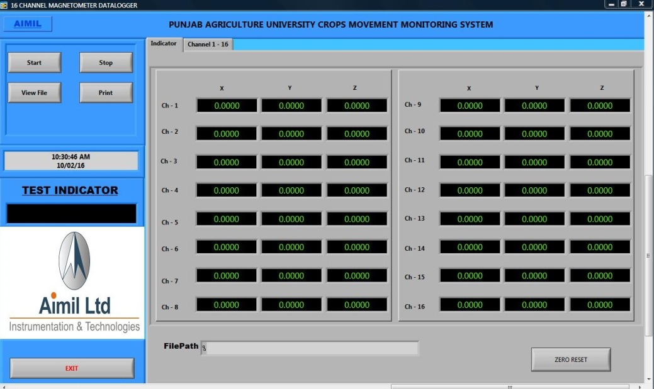
Figure 3: Crop movement monitoring system software developed for PAU

Table2: Colour code and line pattern used for graphical representation of measured incident magnetic field

Sensor name | Colour code with line pattern
 | X | Y | Z
1* | -------------- | --- --- --- --- | - - - - - - - -
2 | -------------- | --- --- --- --- | - - - - - - - -
3** | -------------- | --- --- --- --- | - - - - - - - -
4 | -------------- | --- --- --- --- | - - - - - - - -
5 | -------------- | --- --- --- --- | - - - - - - - -
6 | -------------- | --- --- --- --- | - - - - - - - -
7 | -------------- | --- --- --- --- | - - - - - - - -
8 | -------------- | --- --- --- --- | - - - - - - - -
9 | -------------- | --- --- --- --- | - - - - - - - -
10 | -------------- | --- --- --- --- | - - - - - - - -
11 | -------------- | --- --- --- --- | - - - - - - - -
12 | -------------- | --- --- --- --- | - - - - - - - -
13 | -------------- | --- --- --- --- | - - - - - - - -
14 | -------------- | --- --- --- --- | - - - - - - - -
15 | -------------- | --- --- --- --- | - - - - - - - -
16 | -------------- | --- --- --- --- | - - - - - - - -
(* - white colour code for line; ** - light grey colour code for line)

2.3 Development of magnetometer instrumentation setup

The instrumentationsection consists of magnetometer sensors, signal conditioners, 12VDC/2A power supply, terminal cards, data logger and personnel computer. The magnetometer sensors detect the incident magnetic field and transform the signal to data logger through signal conditioning circuit and terminal cards. The processed data from data logger are retrieved to personnel computer through RS232.
The magnetic field has to be incident as near as to the magnetometer sensors, otherwise the sensing range decreases as the distance between them increases. To achieve this, an arc shaped frame with a length and diameter same as threshing drum has been fabricated to hold the magnetometer sensors and mounted just above the thresher top cover. The magnetometer also detects ferrous material near to them and the field strength increases with increase in thickness of material,this might havelead to accuracy error in detected readings. Hence, to avoid the detection errors, a strip of top cover near to the sensors for entire length has been removed and replaced the gap by transparent 4 mm polycarbonate cover. The entire setup has been developed to suit the axial flow paddy thresher. The schematic view of the magnetometer instrumentedaxial flow paddy thresher has been shown in Figure 4. To measure the amount of power required to thresh the crop, a telemetry-based torque transducer developed for tractor P.T.O attachment has been used(BinsfieldTorquetrak 10 k). Based on the torque transducer output readings the power required during threshing was calculated.

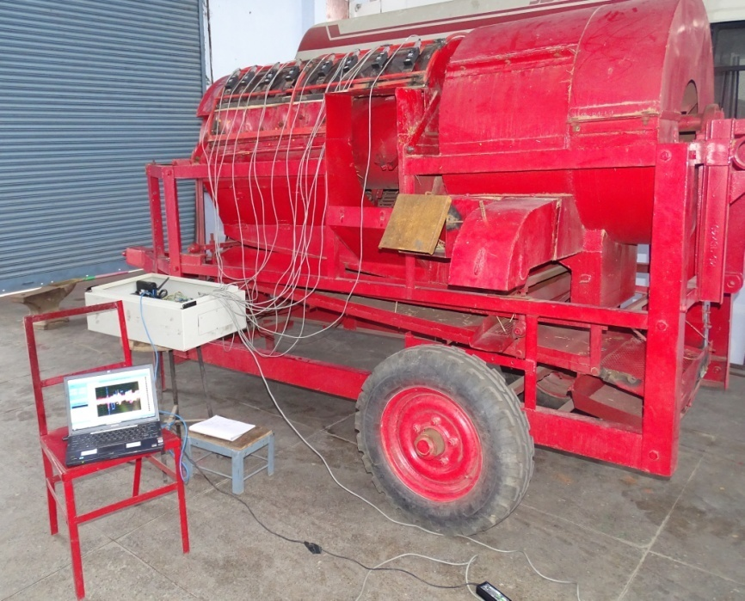
Figure 4: Magnetometer instrumented axial flow paddy thresher

a. Axial flow paddy thresher
b. Magnetometer sensor
c. Box consists of signal conditioner, Terminal cards and data logger
d. Personnel computer

a
b

c

d

2.4 Experimental procedure

The feed-in capacity of selected axial flow paddy thresher was 4.2T/hr at straw-grain ratio of1.13 to 1.25. To carry out the experimental trials,freshly harvested paddy crop weighing 3 kg with a moisture content of around 17 - 22 % (Wet basis) werebundled and taped Neodymium magnets were placed within the bundles. Seven numbers of louvers placed at 120 mm spacing apart on instrumented axial flow paddy thresher has beenfixed at 15⁰ angles (Figure 5).

a. Polycarbonate transparent cover
b. Louver for movement
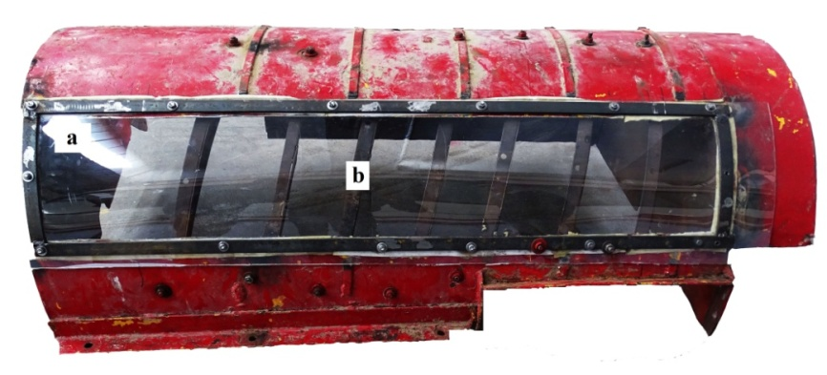
Figure 5: Transparent top cover for magnetometer sensors with louvers

The breakage losses of paddy on these settings were minimum 0.11 to 2.48 % (Waman, 2012). The axial flow paddy thresher was operated at recommended 600rpm throughout the experiment using tractor P.T.O.The optimized value of louver angles and thresher drum speed was selected to detect the crop flow path based on the previous study(Waman, 2012).Each bundle of paddy crop with taped Neodymium magnets were introduced in to the thresher one at a time during experiment. The flow chart for the experiment is detailed in the Figure 6.

Start

Signal
No signal
Yes
No
Yes
No

PC display – PAU Crop Movement Monitoring System software

Thresher operation at idle condition

Honeywell HMR 2300 (Magnetometer)

If
Magnetic field detected

Figure 6: Flow chart for operational process of the system

Crop feed in to thresher along with magnets
Axial Movement of the crop within the thresher
If
Magnetic field detected
Stop

Total retention time of crop (inside the thresher during experiment) andthe incident magnetic field data hasbeen observed and stored in the personnel computer.

III. RESULTS AND DISCUSSION

The magnetometer sensors were tested and calibrated prior to the experiment under laboratory conditions to check the sensitivity range. The results revealed that, the sensors were very sensitive and accurate for measuring the magnetic field. It was also observed that local magnetic field and ferrous metal portion of the thresher near to the sensors was restricting the magnetic field effect on sensors. To overcome this problem a strip of metal portion was removed and replaced by a polycarbonate transparent sheet. Also,the software was restored tozero before starting to record the data. The sixteen numbers of sensors were fixed on top cover frame in series and mounted on the thresher. Further, the thresher was operated at idle condition prior to the actual experiment. It was seen that, when the thresher drum spikes move near to the sensors, the sensors detect the incident magnetic field and gives the signal to the signal conditioner. The clear picture of difference between movement and no-movement of the spikes indicated by crop movement monitoring system software graph is shown in Figure 7.
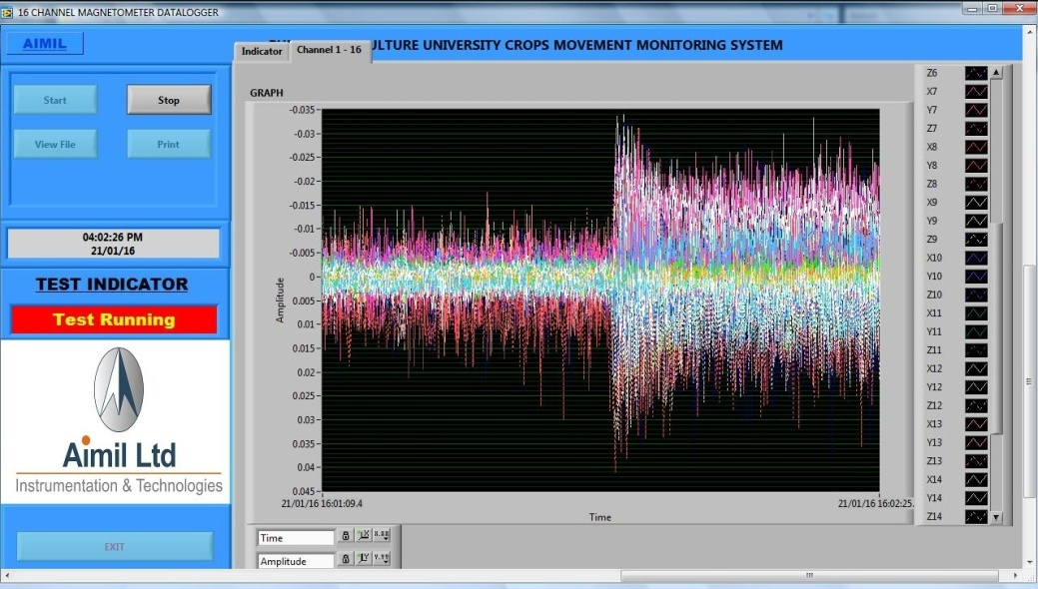
Figure 7: Magnetometer sensor output during thresher idle running

The actual testing of instrumented axial flow paddy thresher was conductedin field conditions (Figure 8).The prepared sample crop bundles with magnets were fedinto the thresher one at a time and respective readings of feed-in, retention time, grain output, grain losses from all outlets, torque required to thresh the crop and the incident magnetic field strength were recorded.

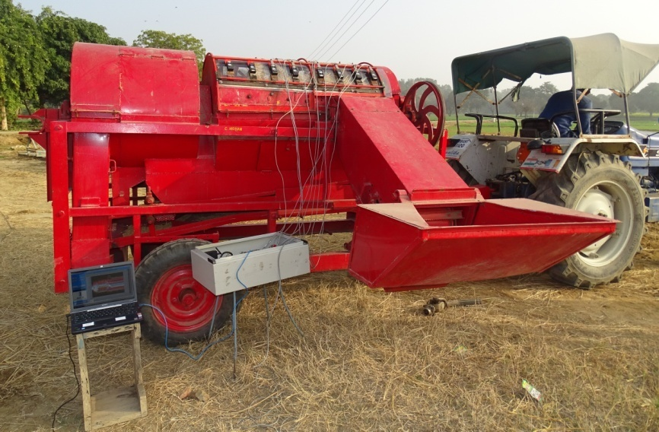
Figure 8 Field testing of instrumented axial flow paddy thresher

The focus of present study was to check whether magnetic sensor can help to detect magnets introduced along with the crop. As the trajectory travelled by the magnets indicates crop flow path during threshing so that more attention can be focused to crop flow path detection within thresher. The performance of the thresher during experimentation is depicted in Table 3 and the measured incident magnetic field is shown in Figure 9.

Table3: Thresher performance during experiment

S. No. | Particulars | Remarks
1 | Grains collected at main outlet, kg | 1.36
2 | Total grain loss from all outlets, % | 1.8 – 2.0
3 | Threshing efficiency, % | > 99
4 | Cleaning efficiency, % | 97 - 98
5 | Breakage loss, % | Up to 0.8
6 | Average torque required to thresh the crop, Nm | 245
7 | Average power required to thresh the crop, kW | 15
8 | Average retention period of crop during threshing, S | 6 - 8

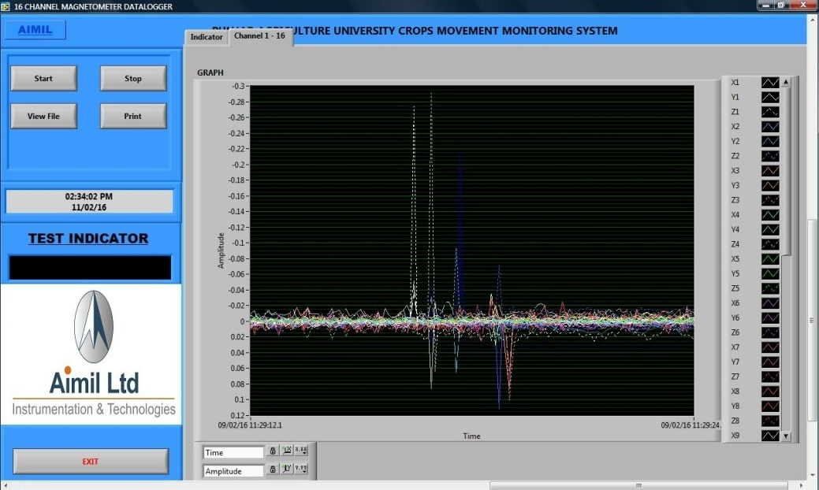
Figure 9: Graphical representation of the measured incident magnetic field during experiment

The experimental result reveal that the incident magnetic field ranged from -0.3 to 0.2 gauss. Experimental observations reveal that even after resetting the system value to zero, the magnetometer sensordetects the local magnetic field and the spikes movement.But the magnitude of measured values was in lower range compared to earlier readings.In threshing process, when the magnet along with crop reaches the sensor detection range,the incident magnetic field values were raised from initial low range to high range and drop again to low range as the magnet passes away. This is clearly illustrated ingraphical representationthrough plotted data lines.The route followed by the crop can be easily identified by differentiating the peak points.Based on the results of the experiments, the crop trajectory within the thresher is represented in Figure 10 and crop flow path was indicated by red dotted line.

Straw out
Crop feed in
15
14
11
10
07
06
03
02
16
13
12
09
08
05
04
01

*01 – 16: Honeywell HMR 2300 sensors
Figure 10: Crop flow path during threshing process
Results indicate that the crop was reappearing at the entrance of the feed opening after one revolution of the drum. But the crop was moved faster at middle and at end portion of the thresher. The results of replicated experiments lead to doubt about reappearing of the crop near the sensor number 9. However, most of the observationsindicate the reappearance of crop at feed opening (also observed by Gummert et al., 1992). The reappearance of crop leads to increased back feeding, over threshing of the crop and reduced the intake capacity. The reason for reappearing of crop may be due to the angle and spacing of louvers, even though thresher performance may be good, but it was over threshing till now. This study providesopportunity to the researcher and designer to modify the existing axial flow paddy thresher for increasing quality and quantity of thresher.

IV. CONCLUSION

The major invisible problem in an axial flow paddy thresher affects the qualitative and quantitativelosses of grains. However, higher percentage of invisible grain damage not only deteriorates the quality of threshing but also lead to major grain loss. This may be due to improper design of the thresher which increases back feeding and over threshing of the crop. The crop flow path detection study will enhance the opportunity to reduce the beck feeding and over threshing by modifying the conventional thresher. The magnetometer sensor based instrumented system measures the incident magnetic field accurately, so that the actual crop flow path within the threshing unit can be easily detected. This study revealedthatthe crop was reappearing at the feed entrance after completion of one drum revolution, which leads to over threshing. The results obtained also showed a big potential to improve the existing axial flow paddy thresher.
REFERENCES

Ahuja, S. S., Dhaliwal, I. S. and Sharma, V. K., Performance evaluation of IRRI-PAK axial flow thresher on wheat and paddy. Journal of Agricultural Engineering,1986, 23(1), 8 – 23.

Alizadeh, M. and Khodabhaksipour, M.,Effect of threshing drum speed and crop moisture content on the paddy grain damage in axial-flow thresher. CercetăriAgronomiceîn Moldova, 2010,63(4), 144.

Andrews, S. B., Siebenmorgen, T. J., Vories, E. D., Loewer, D. H. and Mauromoustakos, A., Effects of combine operating parameters on harvest loss and quality in rice.Transactions of the ASA, 1993, 36(6), 1599-1607.

Ardeh, E. A. A. and Gilandeh, Y. A., Investigation of the effective factors on threshing loss, damaged grains percent and material other than grain to grain ratio on an auto feed threshing unit. American journal of agricultural and biological sciences, 2008, 3(4), 699 – 705.

Chinsuwan, W., Pongjan, N., Chuan-udom, S. and Phayom, W., Effects of feed rate and threshing speed on performance of axial flow rice thresher.TSAE Journal, 2003a, 10(1), 9 – 14.

Chinsuwan, W., Pongjan, N., Chuan-udom, S. and Phayom, W., Effects of threshing bar inclination and clearance between concave rod on performance of axial flow rice thresher. TSAE Journal, 2003b,10(1), 15 – 20.

Chuan-udom, S. and Chinsuwan, W., Effects of louver inclination on threshing unit losses of an axial flow rice combine harvester. KKU Research Journal, 2009, 14(3), 322 – 330.

Gummert, M., Kutzbach, H. D., Muhlbauer, W., Wacker, P. and Quick, G. R., Performance Evaluation of An IRRI Axial flow Paddy Thresher. AMA,1992, 23(3), 47 – 58.

Harrison, H. P., Grain separation and damage of an axial flow combine. Canadian agricultural engineering, 1992, 34(1), 49 – 53.

Kuga, H. K. and Carrara, V., Attitude determination with magnetometers and accelerometers to use in satellite simulator. In Proceedings – 15th International Symposium on Dynamic Problems of Mechanics. Brazil, 2013

Kutzbach, H.D. and Wacker, P., Determination of the movement of material in axial-flow threshing drums. Grundlagen der Landtechnik, 1980, 30(4), 101 – 104.

Majumdar, K. L., Design, development and evaluation of CIAE multi crop thresher. In Proceedings - Silver jubilee convention of ISAE, Bhopal, 1985.

Sangwijit, P. and Chinsuwan, W., Prediction equations for losses of axial flow rice combine harvester when harvesting chainat 1 rice variety. KKU Research Journal, 2010, 15(6), 497 – 504.

Sessiz, A. and Ulgar, P., Determination of threshing losses with a raspbar type axial flow threshing unit. Journal of agricultural engineering,2003, 44(4), 1 – 8.

Sinha, J. P., Manes, G. S., Dixit, A., Singh, A., Singh, M. and Singh, B. P.,Performance evaluation of axial flow and tangential axial flow threshing system for basmati rice (Oryza Sativa). International Journal of Research in Agriculture and Forestry, 2014, 1(2), 44 – 49.

Waman, D. K., Studies on the performance of modified axial flow paddy thresher at different louver angles. Unpublished M. Tech thesis. Punjab Agricultural University. Ludhiana, 2012

