BIODEGRADATION OF RICE STRAW USING THERMOPHILIC CONSORTIUM FOR METHANE PRODUCTION BY BIOCHEMICAL DIGESTION
Shashikala K J ¹, Srinidhi R Kulkarni ² and Dr. C. M Kalleshappa ³.
- Assistant Professor, Department of Chemical Engineering, BIET, Davangere-04.
- Assistant Professor, Department of Chemical Engineering, BIET, Davangere-04.
- Professor, Department of Chemical Engineering, BIET, Davangere-04.

ABSTRACT
From the debris of agricultural stubble is a paddy, wheat or grains fields. From biochemical digestion phenomenon is having prospective to form biogas production. The aim of this work was to investigate the possibilities of thermophilic strain on rice-straw digestion was conducted wise batch reactor by maintaining pH from 7to 8, temperature is 55ºC kept for 24 days. The bio-gas digester feedstock equipped by maintaining carbon: nitrogen ratio is 20:1 with 8% solid and dry bio-mass with 66.2% of volatile solids. The chapter divided into two parts, contains elemental and proximate appraisal of paddy straw conducted by adopting CHNS method. It is indicated that C:N ratio is 60:1 in paddy straw, further hydrogen: carbon ratio is 1:7 in cellulose feed stock. Proximate appraisal reveals that the volatile solid is 66.20% by wt. In the second part of the chapter the production of bio-gas was discussed. The analytical result showed that the composition of methane and carbon-dioxide is average in bio-gas is 53.35% and 46.58%, correspondingly. The yield of Bio-gas is 0.484 m3/kg of volatile solid.
Outline
Preamble of the chapter
Aim of the Chapter
Methodology adopted in the chapter
Chapter Analytical results
Production of Bio-gas

Conclusion of the Chapter

Preamble
Rice straw is produced as a by-product of rice production at harvest [1]. Rice straw is removed with the rice grains during harvest and it ends up being piled or spread out in the field depending if it is harvested manually or using machines [2]. With developments in the technologies for its collection and utilization, rice straw is increasingly removed from the fields to be used for better purposes such as for mushroom and energy production and for cattle feed [4]. Collecting rice straw is still a major challenge in the rice straw supply chain. Upon being gathered from the field, bundles of rice straw need to be compressed into bales to make them compact to reduce the transportation cost. With the introduction of combine harvesters that tend to leave the rice straw in the field, collecting rice straw has become even harder and costlier [7].
Because of harder and costlier hence the people start’s seasonal burning of crop residues called “stubble burning” especially paddy straw, by farmers of Punjab and Haryana contribute significantly to the national capital’s air pollution woes, with severe consequences for public health. In the wake of air pollution crisis in Delhi NCR, both central and state governments have come up with a number of awareness activities and subsidies to encourage farmers to stop stubble burning and adopt alternative straw management strategies. [11] Understanding that the farmers, devoid of cost-effective alternatives, end up burning the straw hence, we have developing a processing technology to convert agro- like paddy straw into biogas – thus generating revenues to incentivize farmers to not burn the straw.
Aim of the chapter
- To generate Biogas from Rice Straw.
- To Study composition of Rice straw (CHNS Analysis).
- To Study optimization of parameters for anaerobic digester.
- To Study the characteristics and compositions of Biogas.
Methodology adopted in the chapter
Biomass of paddy straw was choosing to prepare biogas from local region of Davanagere. The feedstock like paddy straw is made into small sections of length 1 cm for the better production of biogas. Small pieces were grinded (1 mm size) in order to attain and enhance the surface area the biomass since accessibility of fermentative microbes inside the digester. The bio-gas digester feedstock organized using C:N ratio is 20:1 with 8% solid content. The dry bio-mass was taken about 40 g by weighing with the results of 66.2% Volatile solids (VS) [10]. The biomass of paddy straw is adopted in ground form (<0.25 to 5.5 mm) and kept inside water for 24 hours with the ratio of 1:10 ratio. The thermophilic consortium is separated from soil, which is collected at dump yard and refrigerated at 4ºC [15].
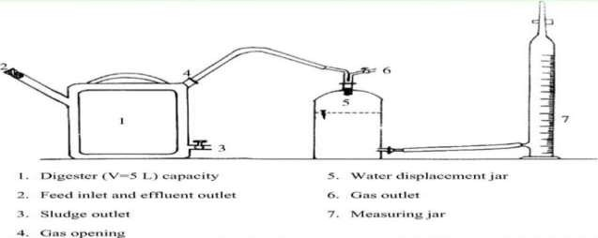
The exact temperature was maintained from 50 to 55ºC. It is composition of hydro-lytic, acido-genic, aceto-genic and methano-genic bacteria’s to conduct experiment under anaerobic condition to attain efficiently. [12]. CHNS determined by adopting elemental method based on composition of carbon, hydrogen, nitrogen and sulphur content in raw rice straw. Total Solids (TS) and total VS for the rice straw were estimated using standard method [13]. The day to day production of methane by anaerobic digester was noted adopting the water displacement technique [18] and volume of methane with the respect to cumulative is estimated. Methane is appraised by adopting a gas chromatograph technique [19] with nitrogen as carrier gas. Selected feedstock was soaked for 24 h, before the plant setup, since this defines as a pre-treatment process (Fig 3.1).

Fig: 3.1 LABORATORY SETUP
Anaerobic process, plants release situations that enhance the natural break-down of organic matter using bacteria without air [16]. The phenomenon of three main products is Biogas - a mixture of carbon dioxide (CO₂) and methane (CH₄), which is adopted to produce heat and electricity. Fibre - can be adopted to enrich the soil by nutrient conditioner, and Liquor - can be adopted as liquid fertiliser. The phenomenon inside digester is composed with a warm and sealed without air containers. The digestion tank is processed with warm and mixed continuously to generate the optimum conditions for conversion into biogas [16].
In an anaerobic digestion plant, there are two types of process:

Mesophilic digestion – It is generally adopted in phenomenon during anaerobic digestion, especially in sludge treatment. Disintegration of the volatile suspended solids (VSS) is about 40% of attainment time between 15 and 40 days and temperature from 30 to 40ºC, which requires bigger digestion containers. It is generally more robust compare to thermophilic phenomenon, but the production of bio-gas is to be less along with sanitization is usually continued [17].

Thermophlic digestion – It is common and not as mature methodology when compared to mesophilic digestion. The digester temperature was maintained at 55ºC and kept for a period from 12 to 15 days. Thermophilic digestion Technique (TDT) gives maximum biogas production and an enhanced pathogen and virus, this technology is ‘kill’, more expensive, extra energy is required also it is essential to get more sophisticated with controled & instrumentation. Anaerobic digestion is divided in to four phases: Hydrolysis, acidogenesis (acid- producing), acetogenesis (acetic acid – producing), and metahnogenesis (methane – producing) [17].
Water Displacement technique (WDT) is day to day production of methane in each anaerobic digester is noted by adopting the WDT. The volume of water replaced inside the container is equal to that of the total volume of the gas. One side gassing gadget is connected to the biogas system and other side connected to invert measuring cylinder with water. The quantity of gas is calculated is equal to the mL of the water replaced. The bio-gas is allowed to collect in the inverted measuring cylinder by replacing water [18].
Gas chromatography is technique is used to appraise the Methane. This technique is equipped with a thermal conductivity detector (TCD). The TCD senses which is changes in the thermal conductivity of the column effluent and compares with the reference flow of carrier gas, here nitrogen is used as carrier [19].
Elemental analysis is a process where a sample of some material (e.g., soil or drinking water, bodily fluids, (minerals and chemical compound’s) is analysed for its elemental and sometimes isotopic composition Elemental analysis can be qualitative (determining what elements are present), and it can be quantitative (determining how much of each are present) [20]. Elemental analysis falls within the ambit of analytic chemistry. CHNS analysis provides a rapid determination of carbon, hydrogen, nitrogen and sulphur in organic matter (rice straw) and other types of materials. They are capable of handling a wide variety of sample types along with solids, liquids, volatile and viscous samples, in the areas of pharmaceuticals, polymers, chemicals, ecosystem, food and energy [20].

Proximate analysis is a standard test method of analysis (ASTM E1756-08, and E872-82) were used to analyze the proximate estimation is used to measure the Moisture content (MC), Total Solids (TS), Volatile Solids (VS), and Ash content in each bio-mass [21].

Results and Discussion of the chapter
Elemental analysis is depend on carbon, hydrogen, nitrogen and Sulphur composition was conducted in rice straw on daily basis. The average analytical values of the collected sample of the rice straw are represented in Table.2
Table 1 CHNS estimated value of rice straw (wt % basis)
Sample of rice straw (250gm) | Carbon (%) | Nitrogen (%) | Hydrogen (%) | Sulphur (%)
Sample 1 | 34.9 | 0.49 | 4.8 | 0.035
Sample 2 | 35.4 | 0.53 | 4.9 | 0.035
Sample 3 | 35.4 | 0.52 | 4.9 | 0.04
Average | 35.26 | 0.51 | 4.9 | 0.04
Proximate analysis, collected biomasses were estimated using proximate estimation to calculate the contents like volatile solids and organic matter, which are utilize during anaerobic digestion phenomenon for production of bio-gas. Standard (ASTM) methods were adopted for proximate estimation to compute the MC, TS, VS and Ash content in each sample of biomass as presented in the Table.
Table 2 Proximate estimation of various samples collected for biogas production in %
Sample Paddy straw (250 gm) | Moisture content % | Fixed carbon% | Volatile solids% | Ash content %
Sample 1 | 6.69 | 13.29 | 66.20 | 13.8
Sample 2 | 6.68 | 13.28 | 66.20 | 13.7
Sample 3 | 6.70 | 13.30 | 66.23 | 13.6
Average | 6.69 | 13.29 | 66.21 | 13.70

Production of biogas gives the details taken time to produce biogas. The study reveals that to generate biogas about four weeks was completed. It is clearly showed that biogas production was more in pioneer stage and initial period of incubation.
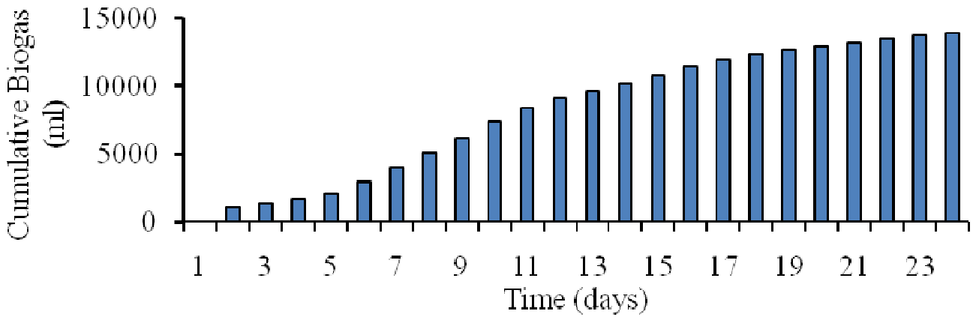
Fig. 1 Cumulative time to generate biogas production using paddy straw
From the first to the second week of incubation, the pioneer stage displayed a similar pictorial depiction and gradually increased. However, the rate of biogas generation that was notably at its highest ranged from 0 to 10775 ml during a set period of time. The output of biogas increased steadily over the first and second weeks of the experiment study, reaching a peak between 10,150 and 10,775 ml at the end of the time period. With the exception of a little decline in week 3, biogas production reached its peak in the final and fourth weeks, peaking at about 14,000 ml. The amount of biogas produced each day has climbed steadily over the last three to four days, totaling 600 ml by day's end. The organic substances
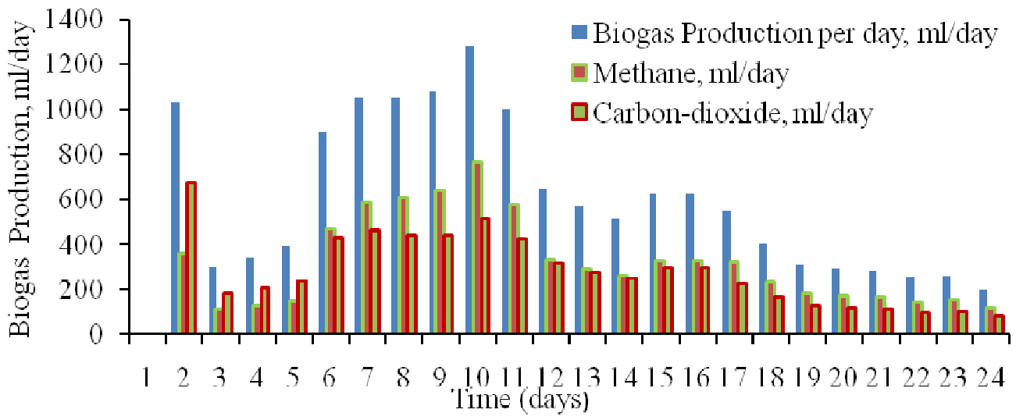

Fig. 2 Production of biogas, methane and carbon dioxide during anaerobic condition using rice straw

In the pioneer phase of digestion process, production of CO2 is greater than CH4 in terms of quantity. Cumulative CO2 contents enhanced sharply and attained a production peak value of 1301.92 ml, means about 58% more than CH4 in the same study period. During this phase the thermophilic consortium occurs in lag phase due to lesser temperature in bio-chemical reaction, but as reaction continued the desirable components concentration was dominates in the digestion phenomenon. The optimum quantity of methane production represents on 8th and 9th day of digestion process. The percentage of CH4 and CO2 content in biogas varied along with the temperature, composition of raw material and bio-chemical reaction controlled by microbes.

Conclusion of the Chapter
CHNS analysis concludes that paddy straw indicates high content of carbon an average 35.26% and virtue of maximum MC, may direct to shoot up volatile matter content. In pioneer stage of incubation the lag phase starts and governed up to five days. During lag phase regime total production of biogas was 2,060 ml/day and production ratio of CH4 to CO2 is 1:2. From 6th day on wards of incubation upto 11th day exponential studies reported the production of biogas, CH4 and CO2, but in this area the CH4 production take over CO2. From 12th to 16th day of incubation represents the behaviour of stationary growth, then reached to death phase due decreases in biomass.
The maximum biogas production takes place on the 10th day of incubation, methane production is on same day was 766.72 ml/day. In anaerobic digestion of paddy straw adopted thermophilic strain, the total displacement 13,940 ml was noticed. Out of that, yield of CH4 is 7436.86 ml and CO2 is 6493.74 ml. The ratio between composition of methane and carbon dioxide is noticed in biogas was 1.149:1 correspondingly. Further temperature range between 50ºC and 54ºC to attain the tolerance and performance with respect to production of biogas in thermophilic consortia. The yield of biogas yield attained is 0.484 m3/kg of volatile solid.

Reference
- Jameson Filer, Hujhuang H. Ding and Sheng Chang,School of Engineering, University of Guelph, Published: 1 May 2019.
- A Haryanto, B P Sugara, M Telaumbanua and A R B Rosadi, IOP Conf Series; Earth and Environmental science, The university of Lampung, IOP Publishing doi:10.1088/1755-1315/147/1/012032.
- H Zhang P Zhang, j-Ye, y. Wu,W.Fang, X.Gou and G.Zeng, Int.Biodeterioe,2016,113,9.
- A.A. Adamu and E. O. Aluyour, Global journal of Engineering researcher VOL 12,2013:63-68., Published; 16/july/2013.
- Keanoi, napon, Hussaro, kanokom and teekasap sombat, American journal of environmental science, Published:2013,9(6) 529.
- Tahseen Sayara and Antoni Sanchez, department of environment and sustainability Agriculture Faculty of Agricultural Sciences and Technology, Palestine Technical University-Kadoorie, Tulkarm, Palestine, Published 2019, nov 1.
- Mariana Ferdes, , Mirela Nicoleta Dincă , Georgiana Moiceanu , Bianca S, tefania Zăbavă and Gigel Paraschiv ; Department of Biotechnical Systems, Politehnica University of Bucharest, 060042 Bucharest, Romania; Department Management and Entrepreneurship, Politehnica University of Bucharest,060042 Bucharest, Romania;
- C. J. Creevey, W. J. Kelly, G. Henderson and S. Leahy, Microbial. Biotechnology, Published:2014, 467.
- E. Rouches, I. Herpoël-Gimbert, J. P. Steyer and H. Carrere,Renew. Sustain. Energy Rev, Published: 2016, 59, 179.
- Shiwei Wang, Fang Ma ,Weiwei Ma, Ping Wang, Guang Zhao and Xiaofei Lu State Key Laboratory of Urban Water Resource and Environment, Harbin Institute of Technology, Harbin 150090, China; Published:12/jan/2019.
- Darwin, J. Cheng , Z. M. Liu, J. Gontupil and O. S. Kwon, Int. J. Agric. Biol. Eng., 2014, 7(6), 7
- Phutela Urmila Gupta and Sahni Nidhi, African Journal of Microbiology Research, 2013, 7(21), 2689.
- E. Rouches, I. Herpoël-Gimbert, J. P. Steyer and H. Carrere, Energy Rev., 2016,
- S. Achinas, V. Achinas and G. J. Euverink, Engineering, Published 2017.
- Gomez C D C 2013 Biogas as an energy option: an overview The Biogas Handbook: Science, Production and Applications, ed A Wellinger et al. (Cambridge: Woodhead Publishing Limited) pp 1–16.
- Koyama, Tadashiro (1963). "Gaseous metabolism in lake sediments and paddy soils and the production of atmospheric methane and hydrogen". Journal of Geophysical Research. 68 (13): 3971–3973. Bibcode:1963JGR....68.3971K. doi:10.1029/JZ068i013p03971
- Yue, Zhengbo; Teater, Charles; Liu, Yan; MacLellan, James; Liao, Wei (2010). "A sustainable pathway of cellulosic ethanol production integrating anaerobic digestion with biorefining". Biotechnology and Bioengineering. 105 (6): 1031–9. doi:10.1002/bit.22627. PMID 19998279. S2CID 25085927
- Ubong Williams Robert, Sunday Edet Etuk and Agbasi Okechukwu Ebuka. (2019). Modified water displacement method and its use for determination of bulk density of porous materials, Journal Renewable Energy & Mechanics (REM), Vol.01 No.01 2019: 1-16. DOI: 10.25299/rem.2019.vol1(01).2292
- Santos, F., and Galceran, M. (2002). The application of gas chromatography to environmental analysis. TrAC Trends in Analytical Chemistry, 21(9-10), 672–685. doi:10.1016/s0165-9936(02)00813-0
- ABM Helaluddin1, Reem Saadi Khalid1, Mohamed Alaama and Syed Atif Abbas. (2016). Main Analytical Techniques Used for Elemental Analysis in Various Matrices Tropical Journal of Pharmaceutical Research February 2016; 15 (2): 427-434.
- Betz, J. M.; Nikelly, J. G. (1987). Determination of Ethanol In Alcoholic Beverages by Liquid Chromatography Using the UV Detector. Journal of Chromatographic Science, 25(9), 391–394. doi:10.1093/chromsci/25.9.391

