Tackling Aggravated Climatic Civil and Meteorological Aviation Weather Challenges Through Technology Transmission (TACMWCT³) FORMULA

Dr. Harish Kumar Gupta Department of Civil and Road Highways Construction Engineering, L. N. Malviya Infra Projects Pvt. Ltd., Head Office, Bhopal (Madhya Pradesh State) Rajiv Gandhi Proudyogiki Vishwavidyalaya (University), Bhopal, India h.g@rediffmail.com |  | Professor Kiran Gupta Department of Engineering Chemistry, Oriental College of Technology (OCT), Bhopal (Madhya Pradesh State) Rajiv Gandhi Proudyogiki Vishwavidyalaya (University), Bhopal, India gpt.kiran15@gmail.com

Abstract

The paper will be discussed with the forthcoming natural and manmade catastrophic events. One day which may affect our Natural Eco – System and its existing Air – Environments’ Climatic Weather Aviation Meteorological Challenges Changing Conditions/ Occurrences, which are abruptly degrading air quality index (AQI) day by day, due to the generation of the Contaminated/ Polluted Constituents/ Black Carbon Soot Particles Emission in the form of solid, liquid and gaseous substances Whole Around the GLOBE at Local, Regional and Worldwide Scale. Detailed project Kurkuti – Ghamsali – Niti Road explored for civil engineering highway construction may influence on various types of meteorological weather parameters/ proceedings during construction highways road network. The promotion of cleaner, climate – friendly technologies and improved environmental management practices for enhanced livelihood sustainability and fostering resilience requires resources, which are accelerating rapidly, and all have strong interlinks/ connections with the highway roads network in civil engineering/ buildings/ industries producing anthropogenic substance in natural eco – system and its environment as depicted in Figure 1: Project Execution Objectives and Decision Making Work – Life Cycle…!!! Through Technology Transmission (T³ Formula…!!!). The road, building, the industry are hugely dependent on cheap resources from the manufacture and transportation of its materials to the machinery and tools used in demolition and civil construction work. Not only in India but also in other developing countries, they use vast quantities of fossil fuels, accounting for over half of total Carbon Emissions {e.g., in the form of Black Carbon Soot Particles OR Black Carbon OR volatile organic compounds (VOC) from various kinds of source points} that leads to an increase in temperature, global warming, and climate change. With the inevitability of declining fossil fuels, and the threat of global climate change, reducing our energy consumption is an indispensable survival strategies and goals.

The farther a product travels, the more fuel is consumed, and a greater level of greenhouse gas emissions is produced everywhere whole around at global scale. These emissions contribute to pollution, climate or weather events like Meteorological parameter changes, and ocean acidification around the world and have been shown to more significant impact on environment as well as eco – system biodiversity measures. The main byproduct of these energy sources comes from emissions, which significantly contribute to Global Warming and Climate Change spectacles. Increased emissions, ocean acidification, deforestation, climate change, and the introduction of invasive species all work to reduce natural biodiversity whole around the sphere or globe. Climate Change Could Increase Air Pollution Levels by accelerating the Atmospheric Chemical Reactions that Produce Photochemical Oxidants Due to Variations and Rise in Temperature.

Climate change is already happening and even must take immediate – drastic steps to reduce emissions, significant changes are going on not only in India but also in developing countries, which occur throughout the world. Green House Gas emissions from transport represent 13% of total India’s domestic emissions, decarbonizing transport must be part of the solution in terms of Cleaner/ Greener Environmental Technologies. This will be a major change, but moving to a low – carbon economy and transport system also present huge opportunities; not just for climate change but for our prosperity, health, preservation, conservation program and the wider natural Air – Environment Eco – System. However around 17.56 Km of Kurkuti – Ghamsali – Niti Road is an especial case study in terms of civil engineering highways road network construction is being considered for research and innovations on various applications/ tools used in road construction work. Characterized by heavy reliance on cars, and trucks for both passenger and freight movement, transportation is major consumer of fossil fuels and Major Big contributors to Climate Change are Meteorological Weather Events/ Climatic Conditions OR Aviation/ Weather Challenges/ Events OR Disrupt Environmental Sustainability Enhancements.

Keywords – cleaner/ greener environmental and civil engineering technologies, operational design models, climate – friendly technologies, meteorological climatic aviation conditions OR aviation/ weather meteorological challenges/ events, environmental sustainability enhancements, environmental management practices, civil road highways construction engineering and work – life cycle

- INTRODUCTION

Objective of Civil Engineering Consultancy Services: The main objectives of the consultancy services are to prepare initial environmental examination (IEE)/ in terms of chapters and bid documents for an especial case study of the length of 17.56 Km of Kurkuti – Ghamsali – Niti Road and to establish the techno, economical, viability of the project and prepare detailed project explored for design of roads and bridges [1]. An important requirement with regard to improving the Project Road is that the development of work shall be within the right of way (ROW) of 24 Meters and avoiding additional land acquisition as far as possible. All these means that the development schemes for the Projected Road should be as economical as possible consistent with the functional requirements and that it should amenable for quick implementation without delays. To serve the environmental aspects and adopt good Road Construction Practices (Sustainable Environmental Development Practices) under this project are being considered. The present research methodology aims to use the waste of some industries like polypropylene, polyester (as waste of backing and carpet industries respectively) in the preparation of a special type of asphalt to be used in the production of hot mix asphalt (HMA) for roads, bridges, structures and dams construction during the civil engineering construction work [2]. The solid materials in paving mix were low quality aggregates of high absorptive type and waste marble filler with the final objective to provide added value, to reduce the production costs and keep the virgin solid materials especially aggregates for a longer period of time. The produced mixes are of similar better performance as compared to the conventional asphalt mixtures. And there is an urgent need to address the great challenges of our times: climate change, resource depletion, deforestation, air quality index (AQI), water quality index (WQI), noise level index, status of ground water, surface water, pollution load, and peak oil etc. [3]. These all issues are accelerating rapidly, and have strongest point interlinks or inter – related with the road as well as the building industry as shown below in Project Execution Objectives and Decision Making Work – Life Cycle as shown in Figure 1.

- Ground Control Point Survey by using differential global positioning system (DGPS);
- Procurement of 0.5 m Resolution of Satellite Imagery from national remote sensing centre (NRSC), Hyderabad, India;
- Development of geographical information system (GIS) Layers and digital elevation model (DEM) of Finalized Alignment of Border Roads;
- Contours Creation at 2.5 m Interval;
- Ortho – photo Generation at 0.5 m ground sample distance (GSD).

Major/ Minor Tasks and Scope of Civil Engineering Consultancy Services

- Civil Engineering Surveys and Investigations

- Topographic Surveys;
- Hydraulic and Hydrological Investigations;
- Traffic Surveys;
- Material Investigations.

- Civil Engineering Designs

- Geometric Designs;
- Pavement and Road Designs;
- Design of Bridge and Structures;
- Drainage Designs.

- Civil Project Cost Estimations

- Civil Detailed Project Report; Initial Environmental Examination and Bid Documents

- Civil General Topographical Features of the Area/ Region/ State

- Civil Proposed Drainage Facilities/ Structures of the Area/ Region/ State

- Civil Engineering Establishing the Most Suitable Alignment of the Projected Road.

- Civil Engineering Minimal Adverse/ Unfavourable/ Unpleasant Impact on the Surrounding Environment.

HAMARA SANDESH…!!! HARA BHARA RAHE HAMARA “BHARAT” DESH…!!!

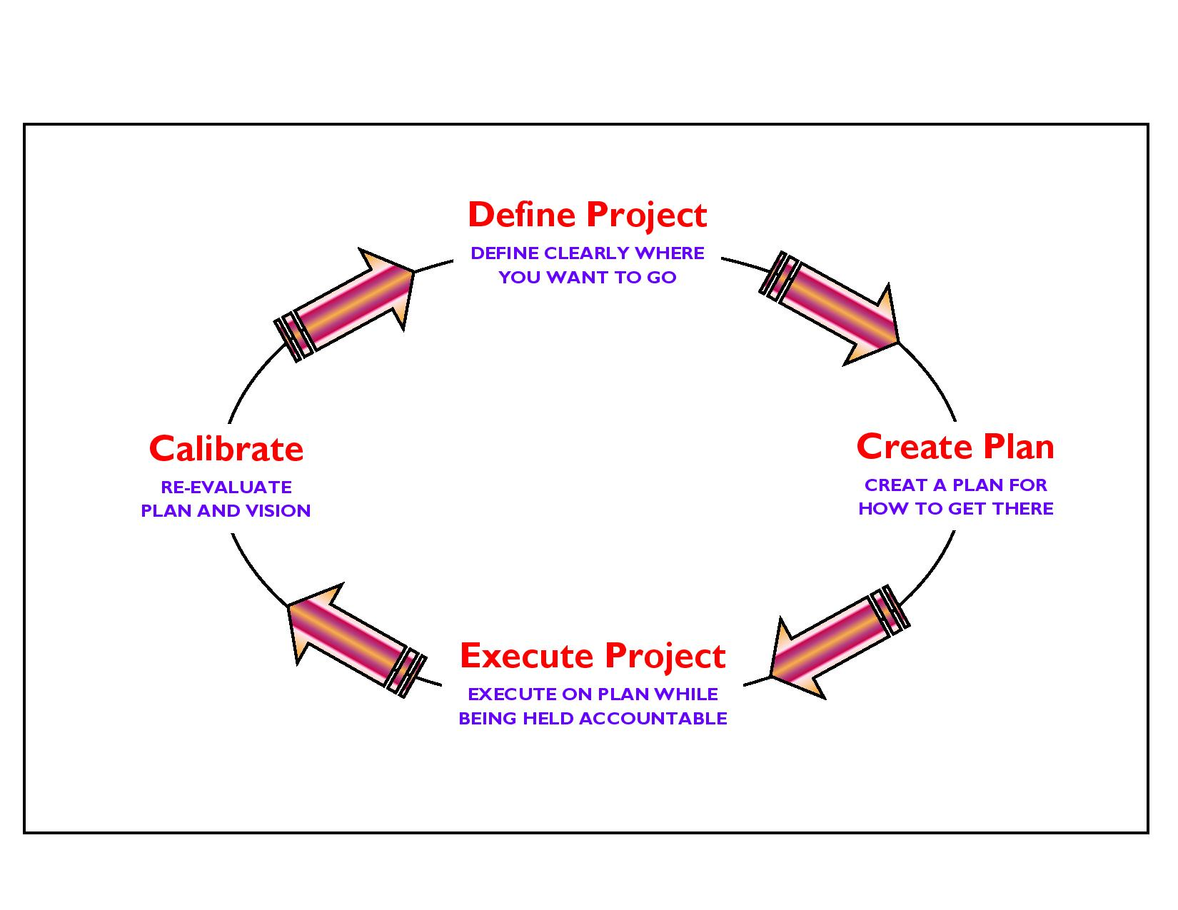

Figure 1: Project Execution Objectives and Decision Making Work – Life Cycle.
- MATERIALS AND METHODS

PROPOSED APPROACH AND METHODOLOGY: Eco – Friendly OR Environmental Friendly Road Construction Methods and Materials in Civil Engineering

General Approach Features: The general approach of the consultants would be to comprehensively address the various issues involved in the project, to carry out all the field and design office activities as set out in the Scope of Services of the term of reference (TOR) and finally to develop improvement proposals satisfying the objectives of the projected areas [4].

Methodology Used: The project involves a series of inter – related activities, both in the field and in the design office. The methodology for carrying out these activities is described in the following paragraphs. Extremely/ extensible high – resolution satellite imagery global positioning system (GPS), along with aviation meteorology may be used for precise measurements like civil engineering highways road construction network and observations may be calculated on demand [5].

Topographical Surveys Analysis: The topographical surveys by means of a global positioning system (GPS) with, climatic weather/ meteorological observations, for fixing of ground control points for the entire length of the corridor. Further, the survey has been completed with the 0.5 m high – resolution satellite imagery, along with aviation meteorology may be used for precise measurements, analysis and observations [6].

Soil and Material Investigations Features: Prospective sources of construction materials have been located by the consultants to add in list of sources of materials. To estimate the quantities of available suitable materials; the consultants have prepared quarry/ material source charts including lead distances etc. This shall form an input in rate analysis of borrow/ quarry materials, following which recommendations for the use of the materials from different sources can be made. Material investigation done for engineering properties reveals that the material available at site is fit for use in protection, drainage system and surfacing works aggregate and no quarry outside the site is mandatory. The material can be used for crust layer execution by processing the available material by a stone crusher and rotary screen [13]. Only local transportation is the need for transporting the aggregates for preparation of bituminous mix preparation and laying at respective chainages under the projected areas/ places/ regions [7].

For the completion of this environmental data was collected from different sources including government department with initial environmental examination (IEE) report in terms of chapters, by Expert/ Specialist Team has been organized for civil engineering highways road construction network. The main purpose/ aim of this statement is to produce a smart; innovative/ informative/ adaptive/ applicable guideline for good construction practices. Eco – friendly design methodologies and technologies can further reduce energy consumption by minimizing energy inputs for heating, cooling and light, and incorporating energy efficient appliances and applications. Saving energy for the occupant also saves money – an issue that will become increasingly important as the cost of fossil fuels and materials for road, bridges, and structure are used inevitably rises in the near future programs. High absorptive aggregate and waste polymer must play a very significant as well as imperative role in road paving to decrease the cost of construction and maintenance. With the inevitability of declining fossil fuels, and the threat of global climate change, reducing our energy consumption are an essential survival strategy. Choosing to Build – Green...!!! And Go – Green...!!! To Save Energy Consumptions and its Valuable Resources to Achieve Significant Prospective Goals in the Projected Area Study region. The low embodied energy of green products ensures that very little energy went into their manufacture and production, with a direct reduction in carbon emissions. The best modifier of asphalt must contain high percentages of Iso and Cyclo – Paraffins and lower percentage of asphaltenes similar to asphalt composition itself and the waste polymer from other industries can be used in future work programs in advance priority basis [8]. The report mainly contains environmental points regarding different stages of the Designing; Construction and Operational Three Phases such as depicted below for Kurkuti – Ghamsali – Niti Road, which is situated in the Northern part of Uttarakhand State to achieve projected goals and mainly these are under:

- Designing Phase;
- Construction Phase;
- Operational Phase.

Bitumen, as a residue from crude oil distillation, is the complex mixture of four main families of compounds, referred to as SARA fractions (Saturates, Aromatics, Resins and Asphaltenes). The behaviour of bitumen depends on the relative concentration and the chemical features of asphaltenes and maltenes; thus, variation in its composition strongly affects its mechanical properties [9]. Methodological Perspectives and Over – View of Road Date Base Construction Photographs is given in Figure 2.

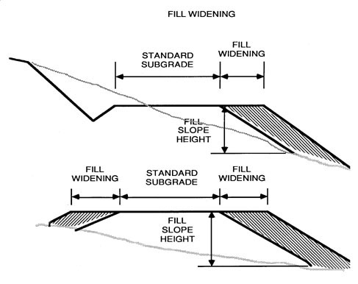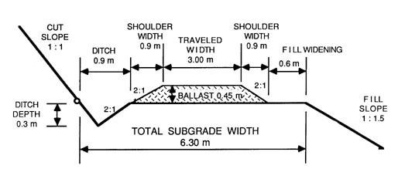
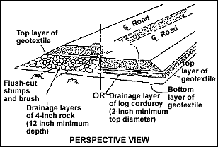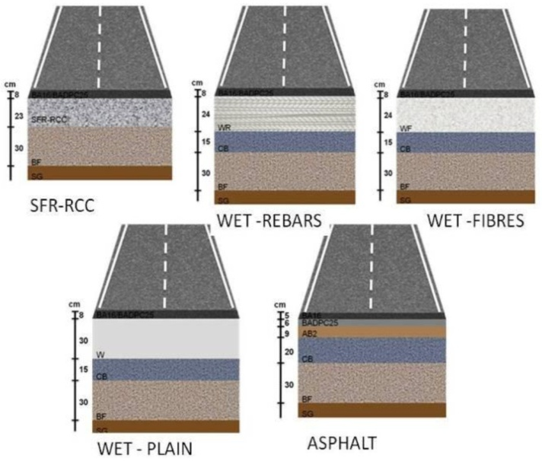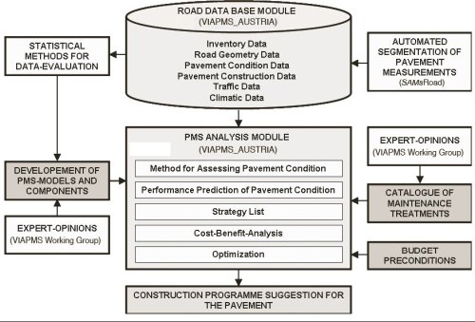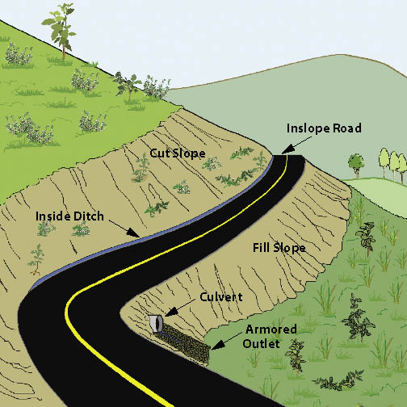

Figure 2: Methodological Perspective Over – View of Road Date Base Construction Photographs.

It presents a large set of interesting potential properties: Impermeability, ductility, adhesivity and resistance to the effect of weathering and chemicals, etc. In the last 20 years, a wide spectrum of modifying polymeric materials has been tested with bitumens for their use in road construction network. For a polymer to be effective it must be blend with bitumen and improve its resistance at high temperatures without making the bitumen too viscous at mixing temperatures or too brittle at low temperatures [10]. It should be capable of being processed by conventional equipment, available, not expensive and physically and chemically stable during storage, application, analysis, measurements and actual/ factual services. In actual modified bitumens, thermoplastic rubbers, as well as some thermoplastic polymers, were mainly used. The use of secondary (recycled) aggregates, instead of primary (virgin) materials helped in easing landfill pressures, reducing the need for extraction, protecting environment and minimizing the consumption of original resources [11]. Polyester polymer, thermoplastic poly – ethylene tere – phthalate (PET) and mineral fibres are the additives, which are mostly used to produce strong and durable reinforcement bitumen. Also, different industrial wastes such as waste polymers, spent toner, marble quarry waste and fibres etc. can be used as asphalt modifiers for civil engineering highways’ road construction network. Carpet waste fibres were used recently in asphalt mixtures and in fibre reinforced concrete (FRC). Such reinforcement improved effectively shatter resistance, toughness, and ductility of concrete structure materials. One of the major waste generating industries is the construction and marble production, as it was reported that the potentials to use this type of waste in low to medium urban traffic as well as rural traffic areas of roads and as binder courses were very beneficial. There are some literatures that has already been discussed the use of fillers such as limestone powders, rubber silica and carbon black as modifiers for asphalt mixture. In Egypt, the use of waste materials in hot mix asphalt (HMA) is not applied yet, in addition to the presence of a large amount of low quality aggregate not appropriate for use in paving construction work in civil engineering or for other purposes [12].

Preparation of Hot Mix Asphalt and Properties: Hot mix asphalt samples were arranged using virgin asphalt and modified binders and were estimated using the Marshall Test Method (ASTM: D – 6927). The mixes were designed according to the standard limits of surface (wearing) course. The job mix was formulated (% Wt.) using coarse and fine aggregates, sand and filler as 33, 30, 32 and 5 Wt. by %age, respectively. The mixes were tested for maximum load and flow along with density and air voids in mixes and solid materials were determined [13].

- HMA are hot mixes asphalt consisted of normal absorptive aggregate type, primary (virgin) asphalt samples and limestone filler for construction work;
- HMA are hot mixes asphalt consisted of high absorptive aggregate type, virgin (primary) asphalt samples and limestone filler in construction;
- HMA are hot mixes asphalt consisted of high absorptive aggregate type, marble dust, modified asphalt through using 5% of waste polypropylene and waste material as polyester respectively.

- ENVIRONMENTAL INDEX WITH Economic Status of Uttarakhand OR TREND FEATURES OF THE PROJECT

Climate, Rainfall and Temperature Variations: The climate of Uttarakhand varies with elevation and the low altitude (100 m – 1,500 m) has a humid subtropical climate. High altitude and very high altitude areas (3,500 m – 5,500 m) have a subtropical highland climate and alpine climate. Uttarakhand receives 2,000 to 5,000 millimeters (79 to 197 in) of rainfall annually, 70% to 80% obtained between May and October, snowfall annually, obtained between November and March. Most of the inhabited regions of Uttarakhand experiences a temperate climate variations, with temperatures seldom exceeding 28°C (82°F) in summer days. The average annual temperature for most of Uttarakhand is found to be around 18°C (64°F). Uttarakhand is one of the few states in India which receives regular snowfall at many places. The average annual temperature for the major part of Uttarakhand is recorded to be of around 18°C (64°F) approximately during the months of March – May, the sun shines at its best in the state of Uttarakhand State. The weather remains wintry and humid, since it rains most of the time. Monsoon prevails from late – June to early – September respectively. The state has five seasons: like winter, summer, spring, autumn, and a monsoon season occur between June and September. Uttarakhand climate ranges from sub – tropical region in the South to tundra in the Northern part of the origin. Most of the inhabited regions of Uttarakhand experience a temperate climate, with temperatures seldom exceeding 28°C (82°F) in summer days only. The average annual temperature for most of Uttarakhand is found to be around 18°C (64°F). The climate of Uttarakhand varies with elevation and the low altitude 100 m – 1,500 m have a humid sub – tropical climate along with very High altitude and very high altitude areas (3,500 m – 5,500 m) have a subtropical highland climate and alpine climate.

Uttarakhand receives 2,000 to 5,000 Millimeters (79 in to 197 in) of rainfall annually, 70% to 80% obtained in between May and October. Uttarakhand is one of the few states in India to receive regular snowfall at most part of the region or state. The snow line ranges from 6,100 Meters (20,000 Feet) in the South of the state to 4,900 Meters (16,100 Feet) in the Northern part/ area. The tundra – type region in the North is snowbound for four months every year, and the temperature drops down as below 0°C (32°F) at almost every night. In North – Western Uttarakhand, the peaks are found to be frozen year – round; because of the high altitude, temperatures in the mountains can drop to as low as −40°C (−40°F) in winter. During the monsoon, heavy rains increase the risk of landslides. The record for the longest period of continuous rain fall in Uttarakhand is 11 days and more number of days due to climatic conditions and variations in the locality or region. Fog affects many parts of the state during winter and monsoons, making transportation perilous and more dangerous during these days while travelling. The Uttarakhand state is the second fastest growing state in India and its gross state domestic product (GSDP) {at constant prices} more than doubled from ₹ 24,786 Crores in the Financial Year 2005 to ₹ 60,898 Crore in the Financial Year 2012. The real GSDP grew at 13.7% (CAGR) during the Financial Year 2005 – Financial Year 2012 period. The contribution of the service sector to the GSDP of Uttarakhand was just over 50% during the Financial Year 2012. Per capita income in Uttarakhand is ₹ 1, 03,000 Crores (Financial Year 2013) which is higher than the national average of ₹ 74,920 Crores (FY 2013). According to the Reserve Bank of India, the total foreign direct investment in the state from April month 2000 to October month of the year 2009 amounted to US $ 46.7 Million consequently.

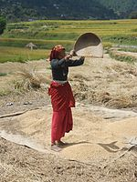

A Woman Winnowing Rice, an Important Food Crop in Uttarakhand.

Similarly in most of Indian context, agriculture is one of the most noteworthy sectors of the economy of Uttarakhand State. Basmati rice, wheat, soybeans, groundnuts, coarse cereals, pulses, maize, barley and oil seeds are the most widely grown crops of the locality. Fruits like apples, oranges, pears, peaches, lychees, mangoes and plums are widely grown and important to the larger food processing industry. Agricultural export zones have been set up in the Uttarakhand state for lychees, horticulture, herbs, medicinal plants, and basmati rice as shown in Table 1. During the year 2010, wheat production was 831 thousand tonnes and rice production was found to be 610 thousand tonnes, while the main cash crop of the state, sugarcane, had a production of 5,058 thousand tonnes respectively. As 86% of the state consists of hills, the yield per hectare is not very high. Approximately 86% of all croplands are in the plains while the remaining is from the hills stations/ areas.

Table 1: Economy of Uttarakhand at a Glance.

Economy of Uttarakhand at a Glance Figures in Crores of Indian Rupees
Sr. No. | Economy at a Glance (Financial Year – 2012) | In Indian Rupees
1. | Almora GSDP (Current) | ₹ 95,201/-
2. | Per Capita Income | ₹ 1,03,000/-

Supplementary types of key industries include tourism and hydropower production energy demand, and there is prospective development in IT, ITES, biotechnology, pharmaceuticals and automobile industries frequently. The service sector of Uttarakhand State mainly includes tourism sector, information technology demand, higher education system, and banking sectors etc. During the years 2005 – 2006, the state successfully developed three integrated industrial estates (IIEs) at Haridwar, Pantnagar, and Sitarganj; Pharma City at Selakui location; information technology park positioned at Sahastradhara (Dehradun); and a growth centre situated at Sigaddi (Kotdwar). Also in the year 2006, 20 industrial sectors in public private partnership mode were developed in the Uttarakhand State.

Humidity, Weather and Climate Index Parameters: Humidity is found to be 45% along with North – North West (NNW) wind flows at 00 to 5.7 Km/ H. Uttarakhand States’ current Weather and Temperature on an average is 14°C and Weather Forecast for next 3 days may varies between 25°C to 28°C and temperatures seldom exceeding 28°C (82°F) in summer days. Elevation/ Altitude/ Ceiling are found to be 5,425 Meters above mean sea level (MSL) in the State of Uttarakhand. The temperature in the region reaches and varies maximum to minimum level in – between 15°C to 14°C on an average in Uttarakhand State. Atmospheric Pressure found to be 1,015.60 mb and Ultraviolet Index is found to be 7 and similarly Dew Point is nearly 14°C. Cloud cover in the Uttarakhand state is approximately 70% with Visibility Status 8 Km and around 16 – wind compass rose are formed for the study. The eight half – winds are the points obtained by bisecting the angles between the principal winds. The half – winds are North – North East (NNE), East – North East (ENE), East – South East (ESE), South – South East (SSE), South – South West (SSW), West – South West (WSW), West – North West (WNW) and North – Northwest (NNW) respectively.

Homogeneous Section of Traffic: The entire Projected Road is considering as one homogeneous sections based on Traffic Volume and its characteristics are stated in Table 2 and Figure 7. And Table 3 shows the Existing – Proposed Chainage Wise Villages.

Table 2: Homogeneous Section based on Traffic Volume Tehsil/ District Wise Villages.

Sr.  No. | Homogenous Section | Design Section Chainage |  | Existing Section Length  (Km) | Design Length (Km) | Lane Widening
 |  | From (Km) | To (Km)
1. | Kurkuti – Ghamsali – Niti Road | 0.00 | 17.56 | 0.00 to 18.53 | 0.00 to 17 + 56 | Bothways

Table 3: Existing – Proposed Chainage Wise Villages.

Sr. No. | Homogenous Section | Existing Chainage Section |  | Proposed Chainage Section
 |  | From (Km) | To (Km) | From (Km) | To (Km)
1. | Kurkuti – Ghamsali – Niti Road | 00 + 000 | 18 + 530 | 00 + 000 | 17 + 565

- DEMOGRAPHIC INFRASTRUCTURE CATALOGUE OF THE PROJECT DISTRICT/ STATE

Demographics (Cities in Uttarakhand State by Population, Garhwali and Kumaoni People): The local people of the State are referred to as Uttarakhand and often especially either Garhwali or Kumaoni depending upon their place of existing origin. As per the census data of the year 2011, the state of Uttrakhand had 5,137,773 males and 4,948,519 females respectively. Also, it is ranked 12th in terms of the most populated states and the population density is about is 189 persons per Square Kilometers. As demonstrated by the Census data analysis year 2011, it has a population of 1 Crore, an expansion from 84.89 Lakhs in the year 2001 evaluation and assessment. The population growth of the state in the present decade was 18.8% and previously it was about 19% only. The population growth rate of the state of Uttarakhand is round about 18% and the number of inhabitants in the state is extending their ways of work and living style of daily life at a pretty fast pace as shown in Table 4.

Table 4: Uttarakhand Facts and Special Effects.

Sr. No. | Factual and Special Effects
1. | The official Languages over here are Sanskrit and Hindi. Garhwali and Kumaoni are also spoken by a large number of inhabited people in the Uttrakhand State;
2. | It is particularly connected by roadways, rail, and air. Its biggest air terminal is located in Dehradun and it is called as Jolly Grant Airport in the regional state;
3. | The major food of the state is vegetables with wheat and also non – vegetarian food is consumed in a large way over here by the local people. A particular thing of the state cuisine is the use of tomatoes and milk related things in different preparation manners and conducts. Coarse Grain with high fiber content are found to be remarkably consistent out over here;
4. | One of the notable Hindu journeys in the form of the Haridwar Kumbh Mela happens in Uttarakhand State. Haridwar is one of the four spots in the nation where this Mela takes place in the Uttrakhand State;
5. | Cultivating is among the most vital constituent as areas wise of the economy of the state. Basmati Rice and Oilseeds are some of the grown items found here are regular things like apples, peaches and plums are grown and a key to the food business growth rate increasing of the Uttarakhand State.

The native residing people of Uttarakhand State are generally called Uttarakhandi and sometimes specifically used for Garhwali or Kumaoni depending on their place of origin in either the Garhwal or Kumaon region. According to the year 2011 Census data of India, Uttarakhand has a population of 10,086,292 comprising 5,137,773 males and 4,948,519 females, with 69.77% of the population living in rural areas. The state is the 20th most populous state of the country having 0.83% of the population on 1.63% of the land – dwelling area. The population density of the state is 189 people per Square Kilometre having a year 2001 – 2011 decadal growth rate of 18.81%. The gender ratio is 963 females per 1,000 males. The crude birth rate in the state is 18.6 with the total fertility growth rate being 2.3. The state has an infant mortality rate of 43, a maternal mortality rate of 188 and a crude death rate found to be around 6.6.

Infrastructure: Uttarakhand is located in Northern India and previously was known as Uttaranchal. It is also called the Land of the Gods in perspective of different Hindu temples and famous pilgrimage sites in the Uttarakhand State. It is known for its breath taking wonderfulness of the Himalayas and also the Terai. On 9th November, 2000, the state was made using the Himalayan and North Western areas of Uttar Pradesh. The state is divided into two in the form of Garhwal and Kumaon regions, with a whole of 13 areas/ places/ regions. The capital is Dehradun and it is also the largest city over here. Uttarakhand’s roads are maintained by the border road organisation (BRO), an offshoot of the Indian Army. Border trade between the two countries through the Lipukekh pass conducted for five months from June to October at Taklakot mart in Western Tibet on the Chinese site location. Archaeological confirmations support the presence of people in the area since the actual old times. The state is also a popular tourist spot and numerous people from all over India and around the globe come over here to spend some time with their family members and close friends. Additionally, there is an identical long list of attractions over here.

PITHORAGARH: Business transactions worth over ₹ 6.55 Crore took place between India and China this year through the border at Lipukekh Pass in Uttarakhand State. Total business transacted between the two countries through the border this year was ₹ 6.55 Crore of which imports by Indian traders stood at ₹ 5.59 Crore and exports by them stood at ₹ 96.5 Lakh, trade officer Mr. P. S. Kutiyal said on phone call from Dharchula. A total of 244 Indians, including 70 traders and 174 helpers, went to Taklakot mart this year to do business with their Chinese counterparts and competent, the trade officer stated. Indo – China border trade, aimed at strengthening economy of tribal border villages was resumed in the year 1992. The traditional trade with erstwhile Tibet had been closed after the 1962 border conflict between two countries. According to the trade officer, the Indian traders exported commodities like tea, coffee, jaggery, sugar candy, tobacco products and cosmetics; and imported raw Tibetan wool, readymade garments, shoes and cements bags etc. On 8th December, 2008 it was announced that Uttarakhand had become the first state in India to achieve 100% sanitation coverage, becoming completely free of public defecation, thus attaining the status of Nirmal State OR Swachh State, like Swachh Bharta Abhiyan/ Mission in India. A clean India would be the best tribute India could pay to Mahatma Gandhi on his 150 birth anniversary in 2019, said Shri Narendra Modi as he launched the Swachh Bharat Mission at Rajpath in New Delhi. Figure 4 shows Lipukekh Pass – Indo – China Border and Shri Laxmi Narayan Temple in Legship.

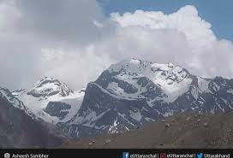 | 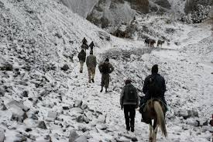
Lipukekh Pass in the State of Uttarakhand – Indo – China Border Line of Control. | The Lipulekh Pass at the Height of Approximately 16,800 Feet.
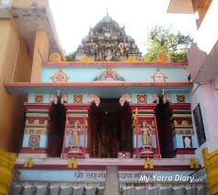 | 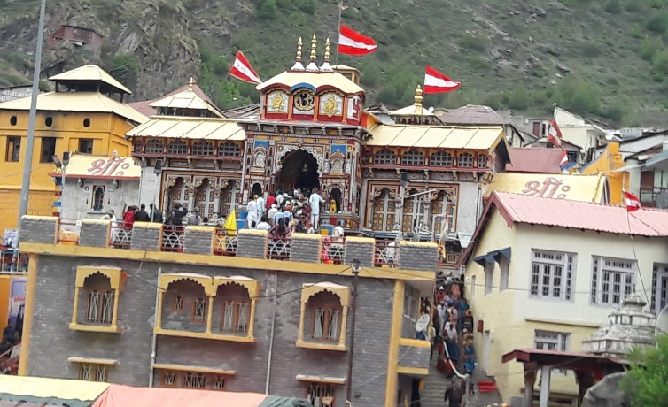
Shri Laxmi Narayan Temple in Legship is Mostly Dedicated to Hindu God Narayana. | Famous Temple in Uttarakhand State.
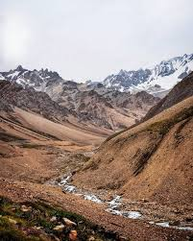
Pithoragarh Pathway. | Lipukekh Pass to Om Parvat.
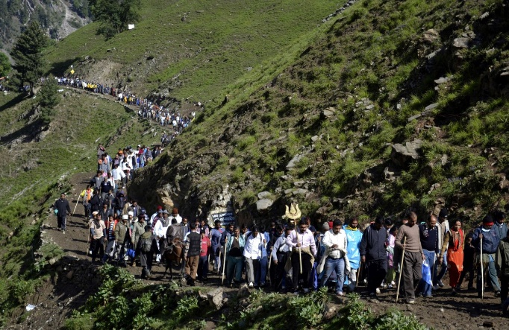 | 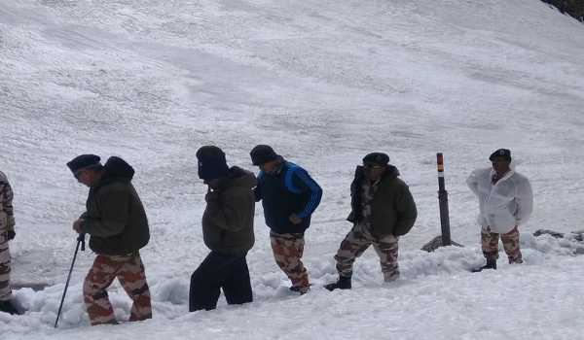
Lipukekh Pathway. | ITBP DG, Visits Lipulekh Pass… to Review Arrangement for Kailash Mansarivar Yatra.

Figure 4: Lipukekh Pass – Indo – China Border and Shri Laxmi Narayan Temple in Legship.

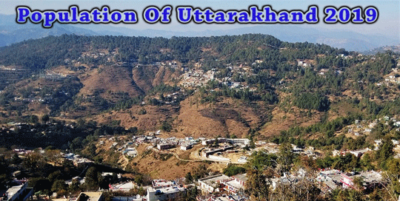

To get to the population of Uttarakhand in 2019, the population of the previous 5 years needs to be seen and they are stated in Table 5:

Table 5: Yearly Increase in Population Rate of Uttarakhand State, from years 2014 to 2019.

Sr. No. | Year | Population in Million
1. | 2014 | 10.170
2. | 2015 | 10.220
3. | 2016 | 10.280
4. | 2017 | 10.320
5. | 2018 | 10.356
6. | 2019 | 10.3932 (Estimated)

By checking out the population of Uttarakhand State from the years 2014 to 2018, it is evident that the population rate has gone up by 0.186 Million in the previous 5 years back. This figure shows that the yearly population increase is of approximately 0.0372 Million. Therefore, the population of Uttarakhand State in the year 2019 is 10.356 Million + 0.0372 Million = 10.3932 Million. To conclude it, the population of Uttarakhand State in the year 2019 as per estimates = 10.3932 Million. Languages of Uttarakhand State are depicted below in Table 6.

Table 6: Conversation/ Speaking Percentage Languages in Uttarakhand State, Year 2011 (Uttaranchal).

Sr. No. | Languages | Conversation/ Speaking Percentage/ Category/ Class in %age | Remarks
1. | Hindi | 89.15% | Up to Mark
2. | Urdu | 04.22% | Low Level
3. | Bengali | 01.50% | Medium and Low Level
4. | Nepali | 01.05% | Low Level
5. | Maithili (Tharu) | 00.54% | Low Level
6. | Punjabi | 02.61% | Very Low Level
7. | Others | 00.93% | Low Level

Hindi belonging to the Indo – Aryan languages is the official language of Uttarakhand State and is spoken by 89.15% of the population (2011 Census data of India figures include Garhwali spoken by 23.03%, Kumaoni spoken by 19.94% and Jaunsari spoken by 1.35% of the population as variants of Hindi). Sanskrit is given the status of second official language in the regional state. Garhwali and Kumaoni are endangered languages listed by UNESCO Heritage. Apart from Hindi, Urdu is the second most spoken language with 4.22% speakers followed by Punjabi (02.61%), Bengali (1.50%), Nepali (1.05%) and Maithili (figures include Tharu as a variant of Maithili) by 0.54% speakers. Many Tibeto – Burman languages are also spoken in this region by the local people residing the this area/ place/ origin, including Jad, Rongpo, Darmiya, Byangsi, Chaudangsi, Raji and Rawat etc.

Groups Ethnicity in the Region: Uttarakhand has a multiethnic population spread across two geocultural regions like Garhwal, and the Kumaon regions. A large portion of the population is Rajput (various clans of erstwhile land owning rulers and their descendants), including members of the native Garhwali, and Kumaoni as well as a number of immigrants are also resides in the locality. According to a year 2007 study by Centre for the Study of Developing Societies, Uttarakhand has been found the highest percentage of Brahmins of any state in India, with approximately 20% of the population being Brahmin (Pundits/ Pujaris). Approximately 18.76% of the population belongs to the Scheduled Castes (an official term for the indigenous aboriginal lower castes in the Traditional Caste System in India). Scheduled Tribes such as the Tharu, Jaunsari, Buksa, Bhotiya and Raji constitute around 2.89% of the population are residing in the same locality. More than four – fifths of Uttarakhand’s residents are Hindus, Muslims, Sikhs, Christians, Buddhists, and Jains make up the remaining population with the Muslims being the largest minority in the region of the Uttarakhand State.

Religion of the Uttarakhand State: Hinduism is the state’s major religion and is practiced mainly by ethnic Nepalis; an estimated 57.8% of the total populations are adherents of the religion. There exist many Hindu temples and one of them most famous like Kirateshwar Mahadev Temple is very popular, since it consists of the Chardham altogether as one of the most spectacular area of habitation as religion wise. Vajrayana Buddhism, which accounts for 27.3% of the population, is Uttarakhand’s State is second – largest, yet found to be most prominent conviction. Prior to Uttarakhand’s becoming a part of the Indian Union, Vajrayana Buddhism was the state religion comes under the Chogyal categories. Uttarakhand has 75% Buddhist monasteries, the oldest dating back to the 1700s centuries as the public and visual aesthetics of Uttarakhand are executed in shades of Vajrayana Buddhism and Buddhism plays a most momentous role in public life, even among Uttarakhand’s majority Nepali Hindu population is found more in the locality/ origin. Table 7 shows the Religious Conviction Percentage in Uttarakhand State.

Table 7: Religious Conviction Percentage in Uttarakhand State, Year 2011 (Uttaranchal).

Sr. No. | Religion | Religious Conviction Percentage Group/ Cast/ Category in %age | Remarks
1. | Islam | 13.95% | Up to the Mark
2. | Hinduism | 82.97% | Low Level
3. | Sikhism | 02.34% | Low Level
4. | Buddhism | 00.15% | Very Low Level
5. | Christianity | 00.37% | Slightly Low Level
6. | Jainism | 00.09% | Low Level
7. | Other or Not Religious | 00.13% | Low Level
8. | Atheist | 0.002% | Very Low Level

 | 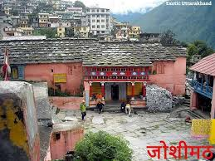
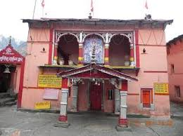 | 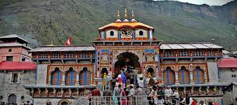
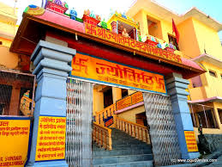 | 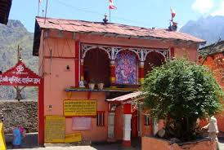
The Joishimath Temple is among the most Famous Religious Places in the Locality OR Origin.

Figure 5: Joshimath Temple is among the most Famous Religious Place for Pilgrims.

Hinduism is the state's major religion and is practiced mainly by ethnic Nepalis; an estimated 57.8% of the total populations are adherents of the religion. There exist many Hindu temples as one of them is Kirateshwar Mahadev Temple is very popular, since it consists of the chardham operating mission to complete by religious people altogether. Vajrayana, which accounts for 27.3% of the population, is Uttarakhand’s second – largest, yet most prominent religion. Prior to Uttarakhand’s becoming a part of the Indian Union, Vajrayana Buddhism was the state religion under the Chogyal group of people. Uttarakhand has 75 Buddhist monasteries, the oldest dating back to the 1700s. The public and visual aesthetics of Uttarakhand are executed in shades of Vajrayana Buddhism and Buddhism plays a substantial role in public life, even among Uttarakhand’s majority Nepali Hindu population has been found more since so many years. The Figure 5 shows Joshimath Temple is among the most Famous Religious Place for Pilgrims. Christians in Uttarakhand are mostly descendants of Lepcha people, who were converted by British missionaries in the late 19th century, and constitute around 10% of the inhabited population. As of the year 2014, the Evangelical Presbyterian Church of Uttarakhand is the largest Christian denomination in Uttarakhand. Other religious minorities include Muslims of Bihari ethnicity and Jains, by witch each account for roughly one percent of the population. The traditional religions of the native Uttarakhandese account for much of the remainder of the population. Although tensions between the Lepchas and the Nepalese escalated during the merger of Uttarakhand with India in the 1970s, there has never been any major degree of communal religious violence, unlike in other Indian states. The traditional religion of the Lepcha people is Mun, an animist practice which co – exists with Buddhism and Christianity.

Dances and Music Culture in Uttarakhand State: The dances of the region are connected to life and human existence and exhibit myriad human emotions. Langvir Nritya is a dance form for males that resembles gymnastic movements as one of the most famous activities. Barada Nati folk dance is another dance of Jaunsar – Bawar, which is practised during some religious festivals. Other well – known dances include Hurka Baul, Jhora – Chanchri, Chhapeli, Thadya, Jhumaila, Pandav, Chauphula, and Chholiya. Music is an integral part of the Uttarakhandi culture. Popular types of folk songs include Mangal, Basanti, Khuder and Chhopati. These folk songs are played on instruments including dhol, damau, turri, ransingha, dholki, daur, thali, bhankora, mandan and mashakbaja. Bedu Pako Baro Masa is a popular folk song of Uttarakhand with international fame and legendary status within the state. It serves as the cultural anthem of Uttarakhandi people at worldwide level. Music is also used as a medium through which the gods are invoked. Jagar is a form of spirit worship in which the singer, or Jagariya, sings a ballad of the gods, with references to great epics, like Mahabharat and Ramayana, which describe the adventures and exploits of the god being invoked. Basanti Devi Bisht, Chander Singh Rahi, Girish Tiwari Girda, Gopal Babu Goswami, Heera Singh Rana, Meena Rana, Narendra Singh Negi and Pritam Bharatwan are popular folk singers and musicians from the state, so is country music singer Bobby Cash.

Fairs and Festivals

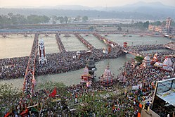

Pilgrims gather for the third Shahi Snan (“Royal Bath”) at Har Ki Pauri in Haridwar, Uttarakhand on 14th April, 2010 during Haridwar Kumbh Mela.

One of the major Hindu pilgrimages, Haridwar Kumbh Mela, takes place in Uttarakhand State. Haridwar is one of the four places in India where this mela is organised. Haridwar most recently hosted the Purna Kumbh Mela from Makar Sankranti (14th January, 2010) to Vaishakh Purnima Snan (28th April, 2010). Hundreds of foreigners joined Indian pilgrims in the festival, which is considered the largest religious gathering in whole around the world. Kumauni Holi, in forms including Baithki Holi, Khari Holi, and Mahila Holi, all of which start from Vasant Panchami, are festivals and musical affairs that can last almost a month. Ganga Dashahara, Vasant Panchami, Makar Sankranti, Ghee Sankrant, Khatarua, Vat Savitri, and Phul Dei are other major festivals. In addition, there are various fairs like Kanwar Yatra, Kandali Festival, Ramman, Harela Mela, Kauthig, Nauchandi Mela, Giddi Mela, Uttarayani Mela and Nanda Devi Raj Jat Mela takes place. Uttarakhand’s Nepalese majority celebrate all major Hindu festivals, including Diwali and Dussera. Traditional local festivals, such as Maghe Sankranti and Bhimsen Puja, are also one of them popular rituals. Figure 6 shows Traditional Temple Festivals of Uttarakhand State.

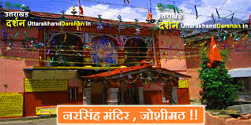 | 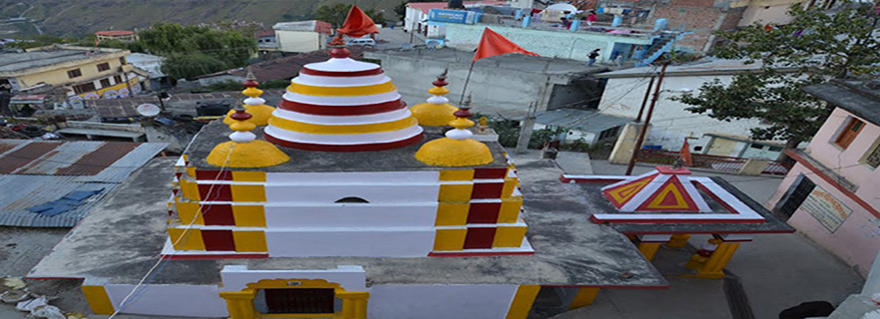
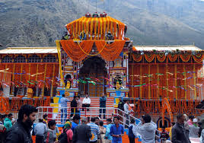 | 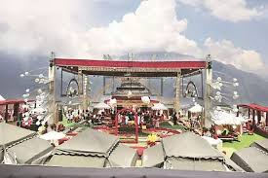
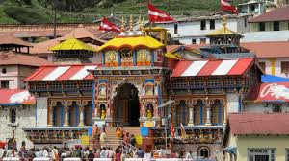 | 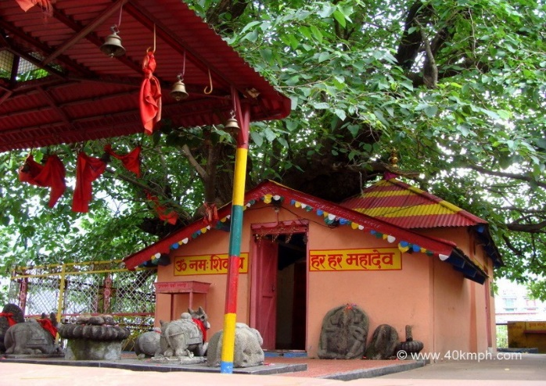
The Traditional Temple Festivals of Uttarakhand State.

Figure 6: Traditional Temple Festivals of Uttarakhand State.

- RAPID ENVIRONMENTAL ASSESSMENT CHECKLIST OF ROADS AND HIGHWAYS

INSTRUCTIONS

(i) The project team as “Environmental Expert/ Specialist” completes this checklist to support the environmental classification of a project. It is to be attached to the environmental categorization form and submitted to the Ministry of Environment and Forest and Climate Change (MoEF & CC) for concern nodal/ zones/ regional officer or expert/ specialist [14].

(ii) Answer the questions assuming the “Without Mitigation” case. The purpose is to identify potential impacts on its environment and surrounding areas. Use the “Remarks” section to discuss any anticipated mitigation measures and Rapid Environmental Assessment Checklist/ Initial Environmental Examination (IEE) Report in terms of chapters is shown in Table 8.

Table 8: Rapid Environmental Assessment Checklist.

Country/ Project Title | India: Uttarakhand State  Sub – Project: Initial Environmental Examination Report for: Kurkuti – Ghamsali – Niti, Road
Sector Division/ Section | Road and Transport Government of India (GOI)
Screening Questions | Yes | No | Remarks
A. Project Site
Is the project area adjacent to or within any of the following environmentally sensitive zones/ sites/ areas? |  | X | No environmentally sensitive zone/ site is located within the projected road;
Cultural Heritage Site; |  | X | No archaeologically protected monument or cultural heritage site/ zones is located within the road;
Protected Area; |  | X | No protected areas are located/ placed close to roads and nearby zones/ areas;
Wetland Area; |  | X | No protected or classified wet land is located close to roads and nearby surrounding areas;
Mangrove Cover/ Area; |  | X | Projected road is not located in Coastal Areas;
Estuarine Locality/ Area; |  | X | No Estuarine is located in the Projected Area;
Buffer Zone of Protected Area; |  | X | No such area is located in the Projected Vicinity;
Special Area for Protecting Biodiversity; |  | X | No such area is located in the Projected Vicinity;
B. Potential Environmental Impacts
Encroachment on historical/ cultural areas; disfiguration of landscape by road embankments, cuts, fills, and quarries? |  | X | The area is no mountainous throughout the proposed alignment and there is no human settelment nor any historical/ cultural places. So there are no human encroachment;
Encroachment of precious ecology (e.g., Sensitive or protected areas)? |  | X | Attempts have been made to minimizing the cutting of trees while finalizing the road widening options, but we didn’t found any sensitive or procted area in the projected area;
Alteration of surface water hydrology of waterways crossed by roads, resulting in increased sediment in streams affected by increased soil erosion at construction site? |  | X | The proposed alignment is crossing only small natural drains. All drainage courses will be maintained to avoid alteration in surface water hydrology so that water courses are not affected. The temporary soil stockpiles will be designed so that runoff will not induce sedimentation of waterways. Silt fencing during construction will be provided. To mitigate this problem the environmental management plan is already incorporated with their mitigation method;
Deterioration of surface water quality due to silt runoff and sanitary wastes from worker – based camps and chemicals used in construction? |  | X | Adequate sanitary facilities including “Soak Pits Treatment (SPT)”, facilities will be provided at construction camps, which will be set – up away from habitat and water bodies. No harmful ingredients are likely to be used in the construction activities. Surface water quality is not impacted due to construction. Measures like embankment slope stabilization, “Reinforced Cement Concrete (RCC)”, retaining walls are proposed to prevent siltation of ponds located next to the road due to surface runoff;
Increased local/ regional areas air pollution due to rock crushing, cutting and filling works and chemicals from asphalt processing? |  |  | Regional/ local/ on site“Air Pollution Level (APL)”, will be high during construction period due to structure/ road construction work; vehicle movementsand asphalt processings etc. The Asphalt Mixing Plant (AMP) OR Hot Mix Plant (HMP) will be located away from habitat areas adequetly high stack for effective dispersion of likely Dust Emissions. Separation measures like spraying of water on unpaved vehicle movement areas are proposed to minimize the dust generation. To mitigate this problem the Environmental Management Plans (EMPs) are already incorporated with their mitigation methods and measures;
Risks and vulnerabilities related to occupational health and safety due to physical, chemical, biological and radiological hazards during project construction and operation? |  |  | Workers may get exposed to dust and noise during construction activities. However, the exposure levels are likely to be short and insignificant. Workers will be provided requisite Personal Protective Equipments (PPEs) to minimize such exposure and associated harmful occupational health effects. To mitigate this problem the Environmental Management Plan is already incorporated with their mitigation methods;
Noise and vibration activities due to blasting and other civil works on site construction of roads/ bridges and valuable residential and commercial structures establishments? |  | X | No blasting is involved. No significant noise generation is expected during construction activities except normal construction equipment operational noise. These noise levels will be impulsive in nature and its impact will be confined within few Meters of either side of the road. All stationary noise making sources equipment like DG set, compressors will be installed with acoustic enclosures/ mufflers/ silencers to reduce noise level on site if specified for the region or state.

- STATUTORY CLEARANCES REQUIRED

The environmental impact assessment/ statement (EIA/ S) process adopted will follow regulations of government of India (GOI) and Uttarakhand Government. As per current policy since the project is not more than 100 Km in length so the MOEF notification will not apply and need no environmental impact assessment/ statement (EIA/ S) Clearances. Table 9 represents clearances required under the proposed project for civil engineering highways roads construction network area with specific guidelines/ rules/ regulations for an implementation work [15].

Table 9: Required Statutory (EIA/ S) Clearances.

Sr. No. | Act / Rules | Purpose | Applicable Yes/ No | Authority
1. | Environment Protection Act (EPA) – 1986. | To protect and improve overall environment. | No | MOEF; GOI; DOE; SPCB
2. | Environmental Impact Assessment Notification (EIAN) 14th September, 2006. | To provide environmental clearance to new development activities following environmental impact assessment. | No | MOEF; (EIAN)
3. | Notification for use of Fly Ash (NFA). | Reuse large quantity of fly ash discharged from thermal power plant to minimize land use for disposal. | Yes | NFA
4. | Coastal Regulation Zone (CRZ) Notification 1991 (2002). | Protection of fragile coastal belt. | No | CRZN
5. | National Environment Appellate Authority Act, (NEAA) 1997. | Address grievances regarding the process of Statutory Environmental Clearance (SEC). | No | NEAA; SEC
6. | The Land Acquisition Act (LAA) – NH – 1956. | Set out rule for acquisition of land by government. | Yes | Revenue Department; LAA
7. | MOEF Circular on Marginal Land Acquisition and Bypasses 1999. | Defining “Marginal Land”  Acquisition relating to the 1997 Notification (MLAN). | No | MOEF; MLAN
8. | The Forest (Conservation) Act – 1927; The Forest (Conservation) Act – 1980; Forest (Conversion) Rules –1981. | To check deforestation by restricting conversion of forested areas into non – forested areas. | Yes | Forest Department; Government of Haryana (GOH)
9. | Wild Life Protection Act – 1972. | To protect wildlife through certain of National Parks and Sanctuaries. | No | CCF; Department of Forest; (GOH)
10. | Air (Prevention and Control of Pollution) Act – 1981. | To control air pollution by and Transport Controlling Emission of Air Department (TCEPA). Pollutants as per the prescribed standards. | Yes | GO UP; SPCB; TCEPA
11. | Water Prevention and Control of Pollution) Act – 1974. | To control water pollution by controlling discharge of pollutants as per the prescribed standards. | Yes | (GOH); SPCB
12. | Noise Pollution (Regulation and Control Act) 1990. | The standards for noise for day and night have been promulgated by the MOEF for various land uses. | Yes | MOEF; (GOH); SPCB
13. | Ancient Monuments and Archaeological Sites and Remains Act – 1958. | Conservation of cultural and historical remains found in India. | No | ASI; GOI
14. | Public Liability and  Insurance Act (PLIA) – 1991. | Protection form hazardous materials and accidents. | Yes | PLIA
15. | Explosive Act – 1984. | Safe transportation, storage and use of explosive material. | Yes | Chief Controller of Explosives
16. | Minor Mineral and Concession Rules (MMCR). | For opening new quarry. | Yes | District Collector; MMCR
17. | Central Motor Vehicle Act –1988 and Central Motor Vehicle Rules (CMVR) – 1989. | To check vehicular air and noise pollution. | Yes | Motor Vehicle Department; CMVR
18. | National Forest Policy 1952; National Forest Policy (Revised) 1988 (NFP). | To maintain ecological stability through preservation and restoration of biological diversity. | Yes | Forest Department; GOI; and (GOH); NFP
19. | The Mining Act (MA) – 1989. | The mining act has been notified for safe and sound mining activity. | Yes | Department of Mining (DOM); MA

Mandatory Pavement Conditions: The existing road has CL – 9 specifications from 00 + 000 Km to 18 + 530 Km with bituminous surface, Carriageway width is 3.50 m to 3.75 m and condition of the pavement is varying from Poor to Very Poor along the road and condition of shoulders is also very poor. The existing alignment passing through the mountainous steep terrain and the existing hill slope vary from 10° to 85°. The existing road has an intermediate lane configuration from 00.000 Km to 17.560 Km. total length of the road as per remote sensing and the total Sq. Km. Area as per 5 Km. buffer boundary is 53,483 Km² and carriageway width 5.5 m bituminous surfaces and cement concrete surfaces and condition of the pavement is varying from poor to fair and having shoulder width of 1.0 m to 1.5 m on either side along the road and condition of shoulders is also poor and covered with vegetation. The entire projected road traverses between hilly and mountainous terrains as shown in Table 10. Char Dham Expressway National Highway (चार धाम महामार्ग), is a proposed two – lane (in each direction) Express National Highway with a minimum width of 10 Metres in the State of Uttarakhand. The total cost of INR ₹ 12,000/- crores and the foundation stone of the project was laid by Route Alignment Authorities/ Experts. Distance between New Delhi to Dehradun is 248 Km by Road and journey takes approximately 05 Hours and 50 minutes (248.00 Km) via Expressway National Highway (चार धाम महामार्ग) and 305 Km by Rails and Aerial distance is 202 Km only. The driving distance between Dehradun and Nainital is 270 Km, while the aerial distance from Dehradun to Nainital is 170 Km. There is nearly 1 direct bus (es) playing between Dehradun to Nainital. These buses (es) is/ are State Transport Bus etc. The minimum time a bus takes to reach Nainital from Dehradun is 06 hours 27 minutes. The fastest way to reach Nainital from Dehradun takes around 05 hours 15 minutes, which is to take a taxi from Dehradun to Nainital. The cheapest way to reach Nainital from Dehradun takes you 12 hours 02 minutes, which is to take Ddn Kgm Express from Dehradun to Kathgodam then take State Transport Bus from Kathgodam to Nainital. There are 9 direct train (s) from New Delhi to Dehradun. These train (s) are Ddn Janshtabdi (12055), Dehradun Shtabdi (12017), Nanda Devi Express (12205), Dehradun Express (12687), Ind Ddn Express (14317) etc. The fastest way to reach Dehradun from New Delhi takes approximately 00 hours 55 minutes, which is to take from New Delhi to Dehradun. “Uttarakhand is located between 28°4’' N to 31°27’ N latitude and 77°34’ E to 81°02’ E longitude and has an area of 53,483 Km² (20,650 Sq. Mi.) and the highest elevations are covered by ice and bare rock. Mount Nanda Devi is the Highest Peak of Uttarakhand with the altitude of 7,816 m from the above mean sea level (MSL)”.

Table 10: List of Projected Villages with Length.

Sr. No. | Location | Location | Length (m) | Name of Village/ Town
 | From | From
A | B | C | D | E
1. | 09 + 650 | 09 + 650 | 250 | Farkiya
2. | 12 + 300 | 12 + 300 | 700 | Bampa
3. | 14 + 500 | 14 + 500 | 250 | Ghamsali

Project Geometrics: The horizontal alignment of the Project traverses through Hilly terrain in its entire length. It is essential to improve substandard geometrics at various locations on projected road. Geometric improvements shall be made as per standard and specifications. In order to upgrade the road to the geometric requirements commensurate with the design speed, improvement has been proposed for the Project Road. The alignment passes through several villages and habitation areas of which some have built – up sections. The improvement works, consist of the existing intermediate lane carriageway to 2 lane with paved shoulder carriageway (10.0 m Width) of rigid pavement with hard shoulder of 2.0 m on either side of rural section and intermediate lane to 2 lane with paved shoulder of 2.50 m Carriageway (12.0 m Width) of rigid pavement on either side on built up section. The surface and subsurface drainage system shall be planned as per IRC SP: 42 – 1994. A camber of 2.5% shall be provided in main carriageway and minimum longitudinal gradient of 0.05% in rural areas and 0.2% in urban shall be provided for smooth surface runoff. Longitudinal lined/ unlined drain shall be provided near ROW in scattered built up section with outlets to cross drainage structures.

Projected Traffic Volume: The daily traffic volume count has been carried out at 2 locations considering the traffic intensity and merging and diverging traffic on the project road corridor. To convert the mixed traffic into common unit, passenger car unit (PCU) factor is used as given in Indian road congress (IRC) 102: 1988; Report Data. Adopted equivalent passenger car units (PCUs) and Details of Reserved Forest with Existing and Design Chainage for the study have also been presented. A summary of traffic data in terms of annual average daily traffic (ADT) and passenger car unit (PCU) has been presented in Figure 7 to have better appreciation. The chapter is concerned about Kurkuti – Ghamsali – Niti Road and the Traffic Survey Locations and Schedules are depicted below in Figure 7:

Figure 7: Daily Variations of Traffic Volume at Kurkuti (Chainage 00 + 000) to Niti (Chainage 18 + 530) on Projected Road.
Other key industries include tourism management and hydropower sectors, and there is prospective development in IT, ITES, biotechnology, pharmaceuticals and automobile industries etc. The service sector of Uttarakhand State mainly includes tourism, information technology, higher education, and banking sectors. During the years 2005 – 2006, the state successfully developed three integrated industrial estates (IIEs) at Haridwar, Pantnagar, and Sitarganj; Pharma City at Selaqui; Information Technology Park at Sahastradhara (Dehradun); and a growth centre at Siggadi (Kotdwar). Also in the year 2006, 20 industrial sectors in public private partnership mode were developed in the state.

Sustainable Design and Life Cycle Management: More than any other human endeavour the built environment has direct, complex, and long lasting impact on the EARTH, BIOSPHERE, ECOLOGY as well as its’ ECO – SYSTEM NATURAL ENVIRONMENT. Around one – tenth of global economy is devoted to CIVIL — CONSTRUCTION and about one half of world’s major resources are consumed by CONSTRUCTION and related buildings as well as industries. The Three Columns of Sustainability Development — Environmental, Economic and Social Parameters are shown below in Figure 8.

Figure 8: Three Columns of Sustainability Development – Environmental, Economic and Social.

While the situation is not so acute in India at present, increasing urbanization may always push us in that direction. These statistics underline the importance of changing the civil construction practices (CCP) aims and goals. To address these challenges, there is a need to develop effective approaches for life cycle design and management of construction that will ensure their sustainability in terms of improved physical performance, cost effectiveness, and environmental compatibility. These optimized designs and management systems should provide the owners with the solutions that achieve an optimal balance between three relevant and competing criteria, namely, (i) Engineering Performance (e.g., Safety, Serviceability and Durability), (ii) Economic Performance (Minimum Life Cycle Costs and Minimum User Costs) and (iii) Environmental Performance (Minimise Carbon Soot Particles Emissions and its Application, Minimise Greenhouse Gas Emissions, Reduced Materials Consumption, Energy Efficiency, etc.). Impacts during design phase is limited to removal of trees, acquisition of land and structures, relocation of water ways or water bodies, water parks, water locations, water streams or channels identification and management of borrow pits areas are as mentioned in Table 11.

Table 11: Impacts during Design Phase.

Impacts | Mitigation Measures
Land Acquisition | Alignment design to minimize the land acquisition to resolve problems of inhabited people whenever applicable;
Major Displacement | Bypasses and detours places/ zones/ regions are to be considered preciously;
Removal of Trees | Alignment design to reduce the number, widening on the side of the road where less trees are required to be cut. Compensatory plantation has to be planned according to the need of residing people in the locality;
Impact on Public Utilities e.g., Community Wells etc. | Alignment design to be considered. In case of removal alternate arrangement to be done before hand on priority basis;
Impact on Cultural Sites | Alignment design to be considered preciously. Public consultation may be needed if impact cannot be avoided at projected areas and places;
Relocation of Waterways | Hydrology has to be considered for the public of locality. Public consultation will be needed, wherever applicable on priority basis;
Access Restriction | Required alternatives, underpasses, proper signposts for people should be included in design all types of civil highway roads’ constructions network;
Congestion in Settlement Areas | Service road has to be provided everywhere all over the projected road network;
Borrow Pits | Locations has to be selected considering minimum loss of productive land and redevelopment and resettlement plans;
Environmental Specifications for Contractors | Environmental qualifications specification ought to be included in pre – qualification packages for the contractors and structure designers in civil engineering fields.

Construction Phase Management and Plan: Environmental management during construction phase is more crucial, because major impacts during construction like earthworks road network, movement of heavy machineries etc. causes lot of disturbances and management becomes essential at this stage during construction network. The construction workers camp will be located at least 500 Meters away from habitations areas. The construction yard, hot mix plants (HMPs) and crushers like asphalt crusher plants (ACP) etc. will be located at 500 Meters away from habitations and in downwind directions. The minimum distance of these will be kept 3.0 Km. from reserve forest areas. Adequate cross drainage structures has to be planned to maintain proper cross drainage. In order to compensate negative impacts on floral species due to cutting of trees in the project plans as compensatory plantation in the ratio of 1: 3 i.e., for everyone has to be applied… if one tree is cut…!!! Then three or more trees will be planted. The acquisition of forest area will be minimal and will be compensated through compensatory afforestation. The noise barriers has to be planned closed to educational institute so that post project noise levels are within the specified limits [16]. The project will take an opportunity to provide environmental enhancement measures (EEM) to improve aesthetic activities in the projected areas. The planned Environmental Enhancement Measures include ponds enhancement, plantation in median and in available clear space in right of way (ROW), seating arrangements around trees must be installed or placed in the specific region/ places. The pond enhancement measures (EM) will include such as stepped access, washing platforms and seating arrangements ought to be applied etc. Some of ditches will be filled up due to embankment construction in the right of way (ROW). In order to avoid contamination of water bodies during construction sedimentation chambers, oils and grease separators, oil interceptors at storage areas and at construction yard has to be planned. The bill of quantities for mitigation and enhancement measures has been given in respective environmental management plans (EMPs) of construction packages [17]. Table 12 below summarizes impacts and its environmental management plan during Construction Period.

Table 12: Environmental Management Plan during Civil Engineering Construction Period.

Impacts | Mitigation Measures
Soil Erosion | Proper planning for slope stabilization, topsoil storage, plantation and turf on slopes will be considered;
Loss of Topsoil | Arable lands will be avoided for earth borrowing network. If needed, topsoil will be separated and refilled after excavation on operational site/ region/ area;
Borrowing of Fill Materials | Excavation from pre – selected locations. After excavation the borrow pits will be dressed to match with the surroundings. In specific cases borrow pits can be excavated in consultation with local people to use those pits as water harvesting point locations in particular areas/ sites;
Disposal of Construction Waste | No haphazard dumping of construction waste. Only pre – selected location maintaining local environmental regulations activities/ performance will be used for operational site;
Disposal of Human Waste by Construction Workers | Specific landfill sites should be identified to manage solid waste generated from habitation of construction workers on operational site/ area/ specified region;
Generation of Dust | Water will be sprayed during construction phase, in earth handling sites, asphalt mixing or crushing sites and other excavation areas for suppression of dust on operational site;  In case fly ash is used, dust emission during its unloading, storage at open place and handling for road construction should be suppressed by water sprinkling at regular interval and operation with space and time;  Dust emission from piles of excavated material should also be controlled by spraying water on the piles located areas/ sites/ regions;  Special care should be taken when working near schools and medical facilities and other sensitive zones like old people staying ASHRAMS etc.

Environmental issues change during operation phase and its mitigation plans are also related with vehicular movement, road safety and management of ecological as well as natural/ environmental/ ordinary issues. Environmental aspects are thus more or less related to vehicular emission; domestic; industrial or anthropogenic activities like carbon soot particles in the surrounding areas/ places. The mitigation measures for different environmental aspects are discussed in Table 13 stated below.
Table 13: Environmental Management during Operation Phase.

Impacts | Mitigation Measures
Dust | Bad road maintenance of road gives high rise to dust pollution emissions. Road Surface will be maintained properly and constantly;
Gaseous Pollution | All vehicles should be checked for pollution under control (PUC), certificates and occasional spot testing of emission from vehicles will be carried out in specified regions/ places/ locality;
Noise | Noise level for different automobiles has been prescribed in Environment (Protection) Rules, 1986. Signs will be posted to restrict blowing of horns with high tons in front of highly sensitive locations or zones or areas;
Surface Runoff | Surface runoff from the road will not be disposed directly in the water – bodies or surfaces used by people for bathing and washings clothes purposes etc. It should also not be disposed directly in to any watercourse, stream channels, water bodies with good water quality;
Wild Life | There should be speed restrictions through specific forest area in the night and day time to prevent accident with wild animal’s locality. There will be proper signs and indications for the drivers to inform about these activities happening in the region/ area or projected site;
Flora | Tree plantations will be monitored continuously on regularly on priority basis;
Safety | Safety signs and signals would be kept always clean and updated on regular and priority basis;
Public Amenities | Bus stops, underpasses etc. should be kept in order for specified zones on the site/ region or projected area.

Waste Water and Solid Waste Treatment Process: Current treatment strategies are directed towards reducing the amount of solid waste that needs to be land filled, as well as recovering and utilizing the materials present in the discarded or unusual or disposed off wastes as a resource to the largest possible extent. Different methods are used for treatment of solid as well as waste water and the choice of proper method depends upon refuse characteristics, land area available and Disposal of Human Waste by Construction Workers with disposal cost as they are given below in pyrolysis process shown in Figure 9.

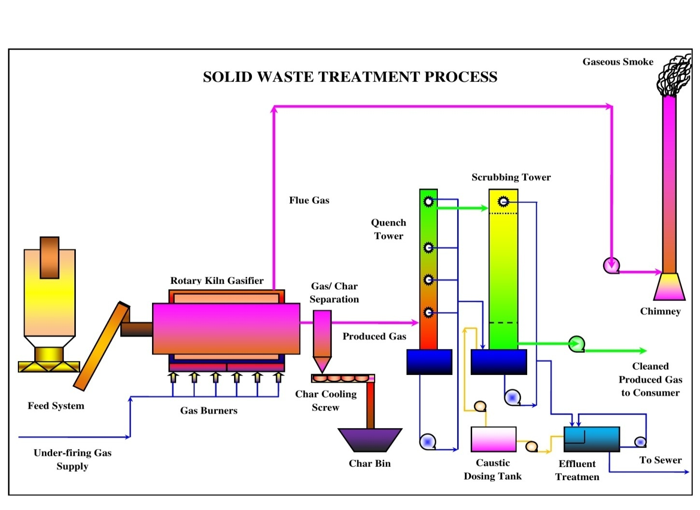

Figure 9: Process of Pyrolysis in Solid and Waste Water Treatment Performance.

Pyrolysis Process Technique: Pyrolysis is defined as thermal degradation of waste in terms of it may be water or solid in the absence of air to produce char, pyrolysis oil and syngas, e.g., the conversion of wood to charcoal also it is defined as destructive distillation of waste in the absence of oxygen [18]. External source of heat is employed in this process. Because most organic substances are thermally unstable they can upon heating in an oxygen – free atmosphere be split through a combination of thermal cracking and condensation reactions into gaseous, liquid and solid fraction state.

- Incineration process system;
- Compaction process system;
- Pyrolysis process system;
- Gasification process system;
- Composting process system.
Proper Solid Waste Handling Practices: Proper method should be adopted for management of solid waste disposal in a soil. Industrial wastes can be treated physically, chemically and biologically until they are less hazardous. Acidic and alkaline wastes should be first neutralized; the insoluble material, if biodegradable should be allowed to degrade under controlled conditions before being disposed off into the soil. As a last resort, new areas for storage of hazardous waste should be investigated such as deep well injection and more secure landfills. Burying the waste in locations situated away from residential areas is the simplest and most widely used technique of solid waste management. Environmental and aesthetic considerations must be taken into consideration before selecting the dumping site’s soil condition and quality. Incineration of other wastes is expensive and leaves a huge residue and adds to air, water and soil as major pollutant {including carbon soot particles of materials} in terms of residue as well. Pyrolysis Practice or Technique is a process of combustion in absence of oxygen or the material burnt under controlled atmosphere of oxygen as Solid Waste Handling Pyrolysis Technique shown in Figure 10. It is an alternative to incineration [19]. The gas and liquid thus obtained can be used as fuels. Pyrolysis of carbonaceous wastes like firewood, coconut, palm waste, corn combs, wheat pod, cashew shell, rice husk, paddy straw, barley pod, maize husk and saw dust, yields charcoal along with products like tar, methyl alcohol, acetic acid, and acetone and fuel gases etc.

Figure 10: Solid Waste Handling Pyrolysis Technique OR Scheme.

Environment Baseline: Environmental, ecological, biological and societal profile of the study region/ vicinity of project location are based on secondary data analysis of Physiographic, Topology, Climate, Water Quality, Biological outline of town or region. The study has to be incorporated regarding sewage treatment plant (STP) both in terms of theoretically and technically applicability for the specific regions/ localities for waste materials handling process under the construction work site or camp. The working model of Sewage Treatment Plant or principal subject matter has to be applied in many towns/ regions/ locality so that it must play substantial role on large scale for the people and its cultural sophistication of the society is shown in Figure 11. The flora and fauna recognized in the study spot are commonly found and not precise to the province due to the deficiency of forest in the specific study area zone.

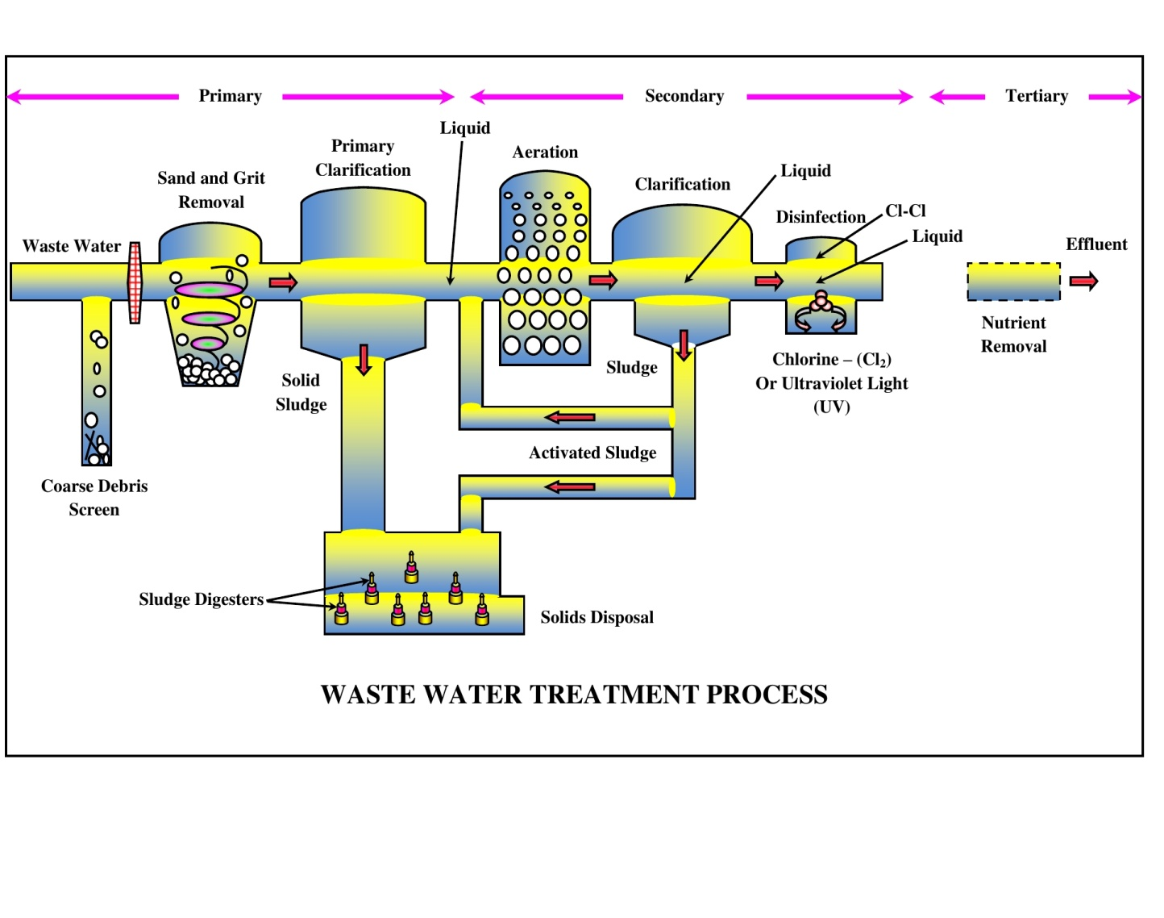

Figure 11: Sewage Treatment Process (STP) of Wastewater Layout Practices.

ENVIRONMENTAL MONITORING PLAN AND COST – {Kurkuti – Ghamsali – Niti Road in the State of Uttarakhand}: Based on the field survey and data available from secondary analysis sources, and it can be concluded that the project will not have significant negative environmental impacts. The issues of concern in the project are during the time of construction of bypasses, re – alignments, and bridges and acquisition of private land and forest land etc. Proper environmental management plans (EMPs) compliance needs to be ensured [20]. The issues related to land acquisition and re – settlement has been evaluated and adequate compensation has been suggested in resource allocation program (RAP) document bureaucracies. The Environmental Mitigation and Monitoring Requirements are specified in Table 14.

Table 14: Environmental Mitigation and Monitoring Requirements.

Particulars | Estimated Rate (₹) | Total Cost (in Lakhs)
Environmental Monitoring during Construction and Implementation Phase | Lump Sum | 5.0
Environmental Training Programs | Lump Sum | 2.0
Plantation of 12,150 Trees Including Maintenance Cost for 3 Years | ₹ 1,000 per Tree Including Maintenance | 260
Water Sprinkling for Dust Emission Suppression | 80,000 per Km | 54.4
Solid Noise Barrier Installation by Trees in Places | Lump Sum | -------
Enhancement of Water Bodies Sources and Resources | ₹ 1 Lakh Each | -------
Safety Signs and Provisions at Different Locations/ Sites/ Areas | ------- | Provided in Civil Works Contract
Cost to be Included in Engineering | ------- | -------
All Underpasses OR Bypasses/ Roads/ Ways | Included in Civil Works | -------
Dust Emission Suppression by Watering | Incidental to Work with in Contractor | -------
Environmental Measures at Workers’ Camps during Site Visit | Incidental to Work with in Contractor | -------
Vegetation Turf at Slopes along Roadsides/ Roadways | Civil Works | -------
Operation Phase
Environmental Monitoring and Evaluation Plans | ------- | 1.0 per Annum
Tree Maintenance and Monitoring Plans | Included Above | -------
Training for Segregation; Mitigation and Monitoring etc. | ------- | 2.0 per Annum
Road Maintenance Cost not Considered as Per Specific Targets OR Proposed Work | ------- | -------
Sub Total | For Contract Period = (3.0 × 3) | 9 for 3 Years
Total | Twenty Seven Lakhs | 27.00 Lakhs
Grand Total | ------- | 425.4 Lakhs
Based on the environmental assessment and surveys or visits conducted for the project, associated potential or prospective adverse environmental impacts can be mitigated to an acceptable/ satisfactory level by adequate implementation of the measures/ methods/ ways/ processes as stated in the environmental impact assessment (EIA) Report with Chapters [21]. Adequate provisions have been made to cover the environmental mitigation and monitoring requirements (including a forestation cost), which is estimated to be approximately ₹ 4.25 Crores or ₹ 425.4 Lakhs.

- RESULTS AND DISCUSSIONS

Result analysis from numerous study areas as per research initiatives taken place to confirms the benefits of confined aggregate within the civil construction engineering system verses unconfined aggregate for Kurkuti – Ghamsali – Niti Roads’ network. Reduces thickness and weight of structural support element by 50% or more allows subgrade material to withstand more than 10 time the number of cyclic – load applications before accumulating the same amount of everlasting refraction. Provides over 30% stress reduction when supporting aggregate under the pavement have been studied under civil engineering road construction work comes across the challenges that has to be faced for implementing the system. The advantages and disadvantages of the civil engineering in road construction there are two major challenges were pavement drainage and subgrade strength system, strata proposed along with supported pavement section, which shows that the civil engineering materials can be used as reinforcement, pavement, which can unquestionably improve by providing civil engineering network at one – third to the base of the pavement. Civil engineering also helps in the less permanent displacement in the subgrade layer by distributing the traffic load over a large capacity of the subgrade. Approximately half of the base reduction from civil engineering reinforcement by interlocking is being actually taken place. Design result of 20% to 40% thickness reduction is possible by civil engineering network in pavement design, grater thickness reduction stronger subgrade material.

Cleaner/ greener environmental and civil engineering technologies will be fruitful in operational design models and methodologies. The climate – friendly technologies, meteorological climatic aviation conditions not only will be helpful for civil engineering construction road network. Aviation/ weather meteorological challenges/ events may be used to study geographical information system (GIS) and remote sensing (RS) technology (Stereo Photogrammetric) not only in plan terrains, but also for hill terrains too for civil engineering construction work. The environmental sustainability enhancements, environmental management practices, civil road highways construction engineering and work – life cycle are the standard parameters for more significant and valuable studies in civil engineering road highways construction network program etc. In case of any civil engineering construction work done for Kurkuti – Ghamsali – Niti Roads’ network there are two basic criteria’s which are to be followed, firstly the structure should be safe against any type of failure and second is that structure should be economical as far as possible. Whenever the structure is constructed over loose or weak soil then it is very difficult to follow these basic criteria’s and poor soil condition usually is the reason behind the lack of strength, and associated deformability. Unpaved road stabilization and reinforcement using 3d - techniques confinement systems stabilizes the material of road subgrade, acting like a semi – rigid slab, loads are distributed latterly reducing subgrade contact pressures and minimizing deformations and settlement. Soil stabilization with in civil engineering road, highway construction, improves load distribution characteristics on paved and unpaved surfaces. The experimental use of geographical information system (GIS) and remote sensing (RS) technology (Stereo Photogrammetric) in road construction work is to be carried out at by non – government Organisation at Kurkuti – Ghamsali – Niti Roads. The model has prepared for road pavement construction using civil engineering applications and approaches on weak soil filled with concrete. The results are compared with road pavement without it with reference to cost, material required etc. The result shows the use of civil engineering methodologies as discussed above with applications in road pavement is for Research and Innovation program, which seems to be very economical as compared to concrete constructed and water bound macadam (WBM) roads’ network in civil construction of highway roads in engineering network.

- CONCLUSIONS

Remote Sensing (RS) Technology (Stereo Photogrammetric) OR Geographical Information System (GIS): Has been proved to be the extremely fastest method of carrying out the topographical survey within the hilly terrain areas, thus considering the same advantages the RS technology has been used in major road highways network projects’ practices:

- This research aimed to prepare and use special types of unordinary materials with the final objective of decreasing the cost of paving and maintenance, keeping the premium aggregate for the longest period of time and decreasing the land space needed for land filling of un – degradable pollutants emissions [22]. To achieve this aim, 5% to 15% of each of waste polypropylene and polyester were used in asphalt modifying. High absorptive aggregate and marble fillers were used in mixes preparation instead of ordering materials such as normal absorptive aggregate and limestone filler.
- The obtained results showed that all the types of waste polymers and solid materials used in the study areas are suitable in road paving and construction activities. The mixes comply with the standards and have reduced temperature susceptibility. The best modifier was polypropylene waste and the polyester waste was found to be very tough. The mix can be used as base course or other purpose in any type of construction and civil engineering work [23]. Even though the areas are of very complex geography and terrain, the RS technology was able to provide highly fastest and reliable DEM – Digital Elevation Model, Topographical features and base data to prepare such complex geography of road projects.
- In the project, 50 cm Very High Resolution Multispectral Satellite Imagery (World View – 2) from Digital Globe – USA has been used. This imagery was procured through National Remote Sensing Agency – INDIA. The processing of the above imagery was undertaken in software’s such as SOCETSET, ERDAS, and Global Mapped respectively. After satellite image processing the products delivered are DTM/ DEM, 3D – Topographical Features, Ortho – photo, which has further been used in finalization of road alignment as per IRC: standard guidelines [24].
- The products from RS has also been played a very critical role in identifying the water bodies crossing the alignments in order to provide cross drainage works to cater for the runoff [25]. Details of the structures for the same are mentioned above in project details. As per analysis of the traffic surveys total number of PCUs at all two locations has crossed the threshold limit (15,000 PCU) of design service volume for 2 lane roads with paved shoulder configuration as per the IRC: standard guidelines in the year 2041 [26].
- The projected road is not only an important transport link for en – route habitations within Uttarakhand State, but it is also an important inter – state link. The existing road has stretches whose geometrics do not conform to Indian road congress (IRC) standards will need to be improved by means of re – alignments and by re – construction [27]. The road passes through ribbon development at locations, where travel speed does not meet national highway standards, hence bypasses have been proposed for them. The soil conditions along the projected road are generally good and the construction materials like soil and aggregates are available nearby area of the state.

REFERENCES

[1] | Anthes, R. A. & Ray, P. S. (1986). The general question of predictability. Mesoscale Meteorology and Forecasting, Ed., Amer. Meteor. Soc., 636-656.
[2] | Christopher, B., & Holtz, R. (2017). Geotextile Engineering Manual US Federal Highway. Administration, Washington, D.C., Report No. FHWA-TS-86/ 2031985,
[3] | Collins, W. D., & Coauthors, (2006). The formulation and atmospheric simulation of the Community Atmosphere Model Version 3 (CAM3). J. Climate, 19, 2144-2161.
[4] | Crozier, J. M. (1997). The climate – landslide couple: a southern hemisphere perspective, Rapid mass movement as a source of climatic evidence for the Holocene, Gustav Fischer Verlag, 333-354.
[5] | Dahal, R. K., & Hasegwa, S. (2008). Reprehensive Rainfall thresholds for landslide in Nepal Himalaya, Geomorphology, 100 (3-4), 429-433.
[6] | Elachi, C., & Van Zyl, J. (2006). Introduction to the Physics and Techniques of Remote Sensing. 2nd edn. Hoboken, New Jersey: Wiley-Interscience.
[7] | Farr, T. G., Rosen, P. A., & Caro, E., et al. (2007). The Shuttle Radar Topography Mission. Reviews of Geophysics 45, RG2004.
[8] | Feynman, R. P., Leighton, R. B., & Sands, M. (2005). The Feynman Lectures on Physics. 2nd edn. 3 Vols.
[9] | Hausman, J., & Zlotnicki, V. (2010). Sea state bias in radar altimetry revisited. Marine Geodesy 33, 336-347.
[10] | Hirschberg, P. (1988). The saline flow into the Atlantic. M.S. thesis, Dept. of Oceanographic Studies, The Pennsylvania State University, 207.
[11] | Jol, H. M. (2009). Ground Penetrating Radar: Theory and Applications. Amsterdam: Elsevier.
[12] | Kanamitsu, M., Ebisuzaki, W., Woollen, J., Yang, S. K., Hnilo, J., Fiorino, J. M., & Potter, G. L. (2002). NCEP-DOE AMIP-II Reanalysis (R-2). Bull. Amer. Meteor. Soc., 83, 1631-1643.
[13] | Knutti, R. (2014). IPCC Working Group I AR5 snapshot: The rcp85 experiment. DKRZ World Data Center for Climate, accessed on 14th October 2014.
[14] | Kumar Gunjan, Sahoo, G. & Tiwari, R. K. (2012). Identity Management in Cloud Computing-A Review, International Journal of Engineering Research & Technology, Vol. 1 (4).
[15] | Longair, M. S. (2003). Theoretical Concepts in Physics. 2nd edn. Cambridge: in Cambridge University Press.
[16] | Murad Al Qurishee (2017). Application of Geoweb in pavement Design. IRJET (VOL4) 7 July 2017.
[17] | Pavlis, N. K., Holmes, S. A., Kenyon, S. C., & Factor, J. K. (2008). An Earth gravitational model to degree 2160: EGM2008. EGU General Assembly, Vienna.
[18] | Pokhare Sanat K. (2016). Experimental evaluation of geoweb reinforced base under repeated loading methods, IJPRT, 9 September 2016, 1409-1416.
[19] | Rajesh Kumar Tiwari & Sahoo, G. (2011). A Novel Steganographic Methodology for High Capacity Data Hiding in Executable Files, International Journal of Internet Technology and Secured Transactions, 3 (2) 210-222.
[20] | Rayner, N. A., Parker, D. E., Horton, B., Folland, C. K., Alexander, L. V., Rowell, D. P., Kent, E. C., & Kaplan, A. (2003). Global analyses of sea surface temperature, sea ice, and night marine air temperature since the late nineteenth century. J. Geophys. Res., 108, 4407.
[21] | Skamarock, W. C., & Coauthors, (2008). A description of the Advanced Research WRF Version 3. NCAR Tech. Note NCAR/TN-475+STR, 113.
[22] | Tiwari Rajesh Kumar & Sahoo, G. (2012). Data Hiding in Microsoft Word File, International Journal of Information and Computer Security, Volume 4 Issue 3.
[23] | Wallace, J. M., & Hobbs, P. V. (1977). Atmospheric Science: An Introductory Survey. Academic Press, 350.
[24] | White, I. D., Mottershead, D. N. & Harrison, J. J. (1996). Environmental Systems, London: Chapman and Hall.
[25] | Wieczorek, F. G. (1996). Landslide triggering mechanisms, National Research Council, 247 (76-79).
[26] | Zeljko, A. & Sanja, D. J. (2010). Landslide risk increasing caused by highway construction, Taiei: International Research Society INTERPRAEVENT, 333-343.
[27] | Zhang, Y. (2011). Mean global and regional distributions of MOPITT carbon monoxide during 2000-2009 and during ENSO. Atmospheric Environment 45 (6), 1347-1358.

