FISHING GEAR TECHNOLOGY IN RELATION TO ENERGY EFFICIENCY FOR FISH HARVESTING MANAGEMENT

JAYA NAIK and THAMIZHMANI R

Department of Fisheries Engineering & Technology
College of Fisheries, KVAFSU, Mangaluru

ENERGY EFFICIENCY IN FISHING TECHNOLOGY
Energy Efficiency: Fishing vessels are implementing various measures to reduce fuel consumption and overall energy use. Some of these measures include:
- Adopting more efficient engine technologies.
- Optimizing vessel design to reduce drag and improve fuel economy.
- Implementing weather forecasting and route planning to minimize fuel usage.
- Using alternative energy sources, such as solar power, where feasible.

Adopting more efficient engine technologies: Upgrading to newer, more fuel-efficient engines can lead to substantial reductions in fuel consumption. Modern engine designs often incorporate advanced technologies like electronic fuel injection, turbocharging, and improved combustion processes. These enhancements can increase the engine's power output while minimizing fuel consumption and emissions.
Optimizing vessel design to reduce drag and improve fuel economy: By designing vessels with hydrodynamics in mind, shipbuilders can reduce resistance and drag as the vessel moves through the water. This can be achieved through streamlined hull shapes, reduced protrusions, and improvements in the underwater section of the hull. A more hydrodynamic design allows the vessel to move more efficiently, thereby reducing the amount of fuel needed to maintain a given speed.
Implementing weather forecasting and route planning to minimize fuel usage: Weather conditions can significantly impact a vessel's fuel consumption. By using advanced weather forecasting systems, fishing vessels can choose more favorable routes with optimal weather conditions. Avoiding rough seas and strong headwinds, or taking advantage of favorable currents, can save fuel and reduce overall energy use during voyages.
Using alternative energy sources, such as solar power, where feasible: Solar power can be an excellent renewable energy source for fishing vessels, especially for certain onboard electrical systems. Solar panels can be installed on the vessel's deck or other suitable locations to harness sunlight and convert it into electrical energy. This can help power lighting, electronic equipment, and other low-power systems, reducing the need for conventional fuel-powered generators and batteries.
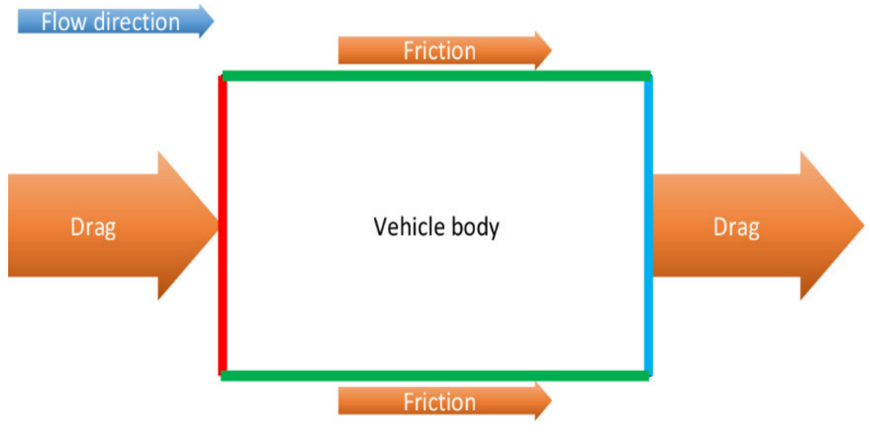
Fig 1: Optimizing vessel design to reduce drag
Courtesy: https://www.mdpi.com/2076-3417/10/12/4313

ENERGY ANALYSIS OF SELECTED FISH HARVESTING SYSTEMS
Energy analysis of fish harvesting systems involves assessing the energy inputs and outputs associated with various methods of catching fish. This analysis helps to understand the energy efficiency and environmental impact of different fishing techniques. Here, I'll provide an overview of some common fish harvesting systems and their energy analysis:
Traditional Net Fishing:
Traditional net fishing involves the use of nets, which can be set or hauled by hand. The energy analysis of this method would consider the energy used in setting and hauling the nets, as well as the energy required to repair and maintain them. Factors such as the type of net material, boat propulsion, and the number of crew members involved will affect the overall energy efficiency.
Trawl Fishing:
Trawling involves dragging a large net (trawl) through the water to catch fish. The energy analysis here would include the fuel consumption of the trawler vessel, the energy needed to haul the net, and the energy required for fish processing on board. Trawl fishing can have a significant energy footprint due to the fuel consumption of larger vessels.
Long line Fishing:
Longline fishing uses a long mainline with multiple baited hooks to catch fish. The energy analysis will assess the energy used to set and retrieve the longline, fuel consumption for vessel propulsion, and energy for fish processing and storage on board.
Purse Seine Fishing:
Purse seine fishing involves encircling a school of fish with a large net and then pulling the bottom of the net to close it (like pulling the strings of a purse). Energy analysis will include the fuel consumption of the vessel, energy used in deploying and retrieving the net, and the energy required for processing and storage.
Gillnet Fishing:
Gillnets are vertical panels of netting that allow fish to get caught by their gills. The energy analysis will consider the energy used to set and retrieve the Gillnets, as well as the energy required for maintenance and repair.
Fish Traps/ Pots:
Fish traps or pots are containers designed to lure fish inside and prevent them from escaping. The energy analysis would involve the energy used to deploy and retrieve the traps, and the energy needed for maintenance and repair.
Handline Fishing:
Handline fishing is a simple method where a single fishing line with a baited hook is used. The energy analysis would mainly focus on the physical energy exerted by the fishermen during the fishing process. When conducting an energy analysis, it's essential to consider the direct energy inputs (fuel, physical labor) and indirect energy inputs (e.g., energy embodied in fishing gear and vessel construction). Additionally, the impact on the marine ecosystem, bycatch, and the carbon footprint of the fishing method should also be considered to get a comprehensive understanding of its sustainability. Efforts are being made in the fishing industry to improve energy efficiency, reduce bycatch, and promote more sustainable fishing practices.
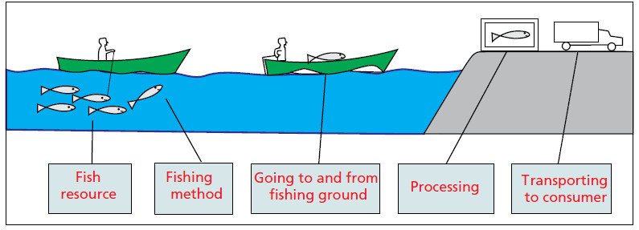
Fig 2: Energy required catching Fish and bringing them to consumer
Courtesy: https://www.aquafind.com/Energy_Use_In Fisheries.php

Energy-Efficient Fishing Gear: Using more efficient fishing gear and practices can reduce the energy required for fishing operations and minimize bycatch.
Using more energy-efficient fishing gear and adopting sustainable fishing practices are essential steps towards reducing the environmental impact of fishing operations. Here are some ways in which energy-efficient fishing gear and practices can be employed to achieve these goals:
Selective fishing gear: Using fishing gear that is designed to target specific fish species can significantly reduce bycatch, which refers to the unintentional catching of non-target species. By reducing bycatch, fishermen can avoid wasting energy on catching species that are not desired or commercially valuable.
Improved fishing nets: Innovations in fishing net designs can help in reducing drag and resistance in the water, which means less energy is required to tow and retrieve the nets. Lightweight and stronger materials can be utilized to achieve this goal.
Fishing gear modifications: Making adjustments to fishing gear, such as using larger mesh sizes or escape panels, can allow smaller, juvenile fish to escape, giving them a chance to mature and reproduce, contributing to sustainable fish populations.
Fish aggregating devices (FADs): FADs are floating objects deployed in the water to attract fish. Using biodegradable or non-entangling FADs can minimize their impact on marine life and prevent ghost fishing, where abandoned FADs continue to trap and kill fish.
Alternative fishing methods: Implementing alternative fishing methods, such as pole-and-line fishing, handline fishing, or trap fishing, can be more selective and less energy-intensive compared to certain industrial fishing practices.
Fuel-efficient vessels: Upgrading fishing vessels with more fuel-efficient engines and hull designs can reduce fuel consumption and, in turn, decrease greenhouse gas emissions and the overall carbon footprint of fishing operations.
Fishing gear recycling and waste management: Properly managing fishing gear waste and encouraging recycling of old or damaged gear can help minimize its impact on marine ecosystems and reduce the need for manufacturing new gear, which has its own energy and resource requirements.
Seasonal fishing restrictions: Implementing fishing moratoriums during specific breeding seasons can allow fish populations to recover and maintain their reproductive capacity, ensuring sustainable fishing in the long term.
Stakeholder collaboration: Encouraging collaboration between fishing communities, scientists, governments, and environmental organizations can lead to the development and adoption of energy-efficient fishing gear and practices that take into account local ecological conditions and social considerations.
By incorporating these energy-efficient fishing gear and practices, fishing operations can become more sustainable, preserving marine biodiversity and supporting the livelihoods of fishing communities in the long run.
******************************************************************

Education and training: Proper training for crew members on energy-saving practices can raise awareness and lead to a more energy-conscious culture on board.
Education and training for fishing crew members are crucial to promote sustainable and energy-efficient practices in the fishing industry. By providing proper training on energy-saving practices, fishing vessels can reduce their environmental impact and operating costs while maintaining long-term viability. Here are some key areas that crew members should be trained on:
Awareness of Environmental Impact: Educating crew members about the environmental impact of fishing practices can help them understand the importance of energy conservation. They will be more likely to adopt energy-saving practices when they realize how their actions can affect marine ecosystems and fish populations.
Weather and oceanographic knowledge: Crew members should be educated on weather patterns and oceanographic conditions. Understanding wind, current, and tide patterns can help plan fishing trips more efficiently, reducing fuel consumption and maximizing catch rates.
Proper Equipment Handling: Training crew members on how to handle and maintain fishing gear and equipment properly can lead to increased efficiency and reduced energy waste. Well-maintained equipment is more efficient and requires less energy to operate.
Responsible fishing practices: Training crew members in sustainable fishing techniques, such as using selective fishing gear and avoiding sensitive habitats, can help preserve fish stocks and maintain healthy marine ecosystems in the long run.
Navigation and route planning: Teach crew members about efficient navigation and route planning to reduce unnecessary travel time and fuel consumption.
Energy-saving awareness: Raise awareness among crew members about the importance of energy conservation and the impact of their actions on the environment. Encourage a culture of energy consciousness on board, where everyone actively participates in reducing the vessel's energy footprint.
Emergency preparedness: Training crew members in emergency response procedures helps prevent accidents and potential oil spills, protecting both the crew and the marine environment.
Impact of By-catch/Miscellaneous catch in energy analysis
1. Understanding Bycatch: Start by explaining what bycatch is and its impact on the environment and fisheries. Bycatch refers to the unintended catch of non-target species while fishing for a specific target species. It can include fish, birds, marine mammals, and other marine organisms. Bycatch is a significant problem as it often results in the unnecessary waste of resources and can harm vulnerable or endangered species.
2. Benefits of Bycatch Reduction: Emphasize the importance of reducing bycatch in fishing operations. Bycatch reduction has several benefits, including:
• Conservation of marine resources and biodiversity.
• Preservation of non-target species, some of which may be threatened or endangered.
• Improved fishery sustainability and long-term profitability.
• Reduced energy and labor costs associated with handling and processing unwanted catch.
• Enhanced reputation and market access for fisheries committed to sustainable practices.
3. Use of Selective Fishing Gear: Explain that using selective fishing gear can help minimize bycatch by targeting only the intended species while allowing non-target species to escape unharmed. Some examples of selective fishing gear include:
• Fisheries with Mesh Size Regulations: Using nets with appropriate mesh sizes can allow smaller, immature fish to escape, reducing the capture of undersized fish.
• Escape Gaps or Excluder Devices: Installing escape gaps or excluder devices in fishing gear can allow larger, non-target species to escape while retaining the desired catch.
• Circle Hooks: These hooks are more likely to catch fish in the mouth, reducing injury and making it easier to release non-target species.
• Turtle Excluder Devices (TEDs): These devices are designed to allow sea turtles to escape from shrimp trawls, reducing turtle bycatch.
• Bird Deterrents: Various methods can be employed to deter seabirds from getting caught in fishing gear, such as using bird-scaring lines or underwater bait setting.
4. Proper Gear Handling and Training: Ensure that crew members are trained in the proper use and handling of selective fishing gear. Proper training will reduce accidental bycatch caused by operator error and improve the effectiveness of selective gear.
5. Incentives for Bycatch Reduction: Highlight any existing incentives or programs that reward fisheries for implementing effective bycatch reduction strategies. Governments or seafood certification programs may provide support for sustainable fishing practices.
6. Promote Sustainable Seafood Consumption: Educate crew members about the importance of promoting sustainable seafood consumption among consumers. When consumers demand sustainably caught fish, it creates an additional incentive for fisheries to adopt bycatch reduction practices.
Bycatch reduction requires a collective effort and ongoing commitment from all stakeholders involved in the fishing industry. By implementing these methods and using selective fishing gear, crews can help conserve resources, protect marine ecosystems, and promote the long-term viability of fisheries.
Devices are used to reduce by catch
1. Turtle Exclusion Devices (TEDs): TEDs are primarily used in shrimp trawl nets, which are large nets dragged along the ocean floor to catch shrimp and other bottom-dwelling species. Sea turtles are particularly vulnerable to being caught in these nets as they need to surface for air regularly. TEDs are fitted into the trawl net's opening to create an escape route for sea turtles. They consist of a grid of bars or other barriers that guide turtles towards an opening at the top of the net, where they can surface and breathe, allowing them to escape safely.
2. Bycatch Reduction Devices (BRDs): BRDs, as the name suggests, are devices implemented in various fishing gears, such as longlines, gillnets, and trawl nets, to reduce the incidental capture of non-target species. BRDs are diverse in design and function depending on the fishing gear type and the specific species being targeted. Their primary goal is to allow smaller or unwanted species to exit the gear before they become entangled or trapped.
Bycatch is a significant issue in commercial fishing, leading to the unintended capture of various marine species, including juvenile fish, sharks, sea turtles, marine mammals, and seabirds.
This bycatch can have severe consequences for these species and the overall marine ecosystem. Implementing TEDs and BRDs has proven successful in reducing the impact of fishing on non-target species and promoting more sustainable fishing practices.
Several countries and international organizations have adopted regulations mandating the use of TEDs and BRDs in specific fisheries to protect vulnerable species and minimize the impact of fishing activities on the marine environment. Research and continuous improvement in the design and implementation of these devices play a crucial role in ensuring their effectiveness in bycatch reduction.
Central Institute of fisheries Technology
Development of CIFT-TED an Indigenous design of TED was developed at CIFT with a focus on reducing by catch loss. THE CIFT-TED is a simple single grid hard TED with a top opening. The device can be fabricated and installed with minimum training using locally available infrastructure and net making skills at a cost of approximately Rs. 2500. The design, construction, installation and operation of CIFT-Ted have been elaborated by Dawson & Boopendranath (2002).
Field trials and demonstration with CIFT-TED along the East coast of India
Field trials with CIFT-TED along the east coast of India so far have shown a mean catch loss in the range of 0.52-0.97% for shrimp and 2.44-3.27% for non-shrimp resources, which is considerably less than the loss incurred during the operations with imported TED designs.
Source:
Design and operation of Turtle Excluder Devices (TED), Raghu Prakash R. Central Institute of Fisheries Technology, Visakhapatnam Research Centre. drraghuprakash@hotmail.com

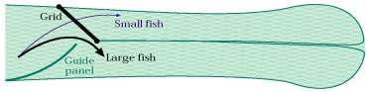
Fig 3: Separator panel BRDs
Courtesy: ICAR-Central Institute of Fisheries Technology
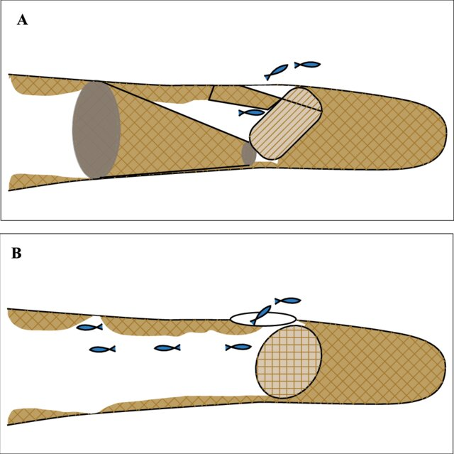

Fig 4: (A) Large mesh panel and (B) By-catch Reduction Devices.

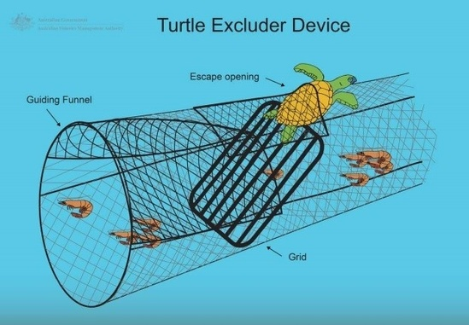

Fig 5: Turtle Excluder Device

{Courtesy : www.fisheries.noaa.gov/bulletin/noaa-issues-final-rule-require-turtle-excluder-device-use-all-skimmer-trawl-vessels-40}
***************************************************************
Energy use optimization in Fishing
Trawling: Trawling is one of the most energy intensive fishing methods. It consumed nearly 5 times more fuel compared to longlining and gillnetting (passive fishing methods) and over 11 times to purse seining for every kilogram of fish produced. For large trawlers, 90% fuel consumption accounts during active trawling operation. Percentage of fuel cost in the operational expenditure of trawlers may vary between 45% and 75%, depending on engine power and duration of voyage.
Gillnetting/ longlining: Gillnetting and long lining are the passive type of fishing where the gross energy requirement is comparatively lower than trawling. These passive gears are either fixed or drifting in water column which do not require energy for operation process except hauling where it is done by mechanical means.
Purse seining: Purse seining is one of the most aggressive and efficient commercial fishing methods for capture of shoaling pelagic species (Ben-Yami. 1989; Ben-Yami and Anderson, 1985). It is a fishing technique which targets pelagic shoaling fishes. Before actual operation the shoal detection needs more fuel for fish scout, once shoal gets detected the encircling, capture and hauling process is follow-up. Purse seine operations are relatively energy efficient and Green House Gas (GHG) emissions for small scale mechanised purse seine operations is low compared to trawling, gillnetting and lining operations.
Traps and pots: Traps or pots are gears in which fish are retained or enter voluntarily and will be hampered from escaping. They are designed in such a way that the entrance itself became a non- return device, allowing the fish to enter the trap but making it impossible to leave the catching chamber. It can be baited or non-baited. Generally passive fishing gears like gillnets and trammel nets, tangle nets, longlines, trap nets and pots, and other lift nets consuming very little power in fishing and in some cases no mechanical energy. Although travelling, setting and retrieval of gear may use some energy, target stocks are attracted by bait or are carried to the gear or encounter it by chance and are trapped.

ANALYZING THE ENERGY EFFICIENCY OF FISHING GEARS
1. GILLNET
Analyzing the energy efficiency of fishing gear, such as gillnets, is an essential aspect of sustainable fisheries management. The energy analysis typically involves evaluating the energy inputs and outputs associated with the fishing system.
1. Fishing Vessel Energy Consumption: The energy analysis starts with assessing the energy consumption of the fishing vessel used to deploy, retrieve, and maintain the Gillnets. This includes fuel consumption, electricity usage, and other energy inputs related to vessel operations.
2. Gillnet Material Production: The production of gillnets involves the use of various materials, such as netting, floats, and weights. Assessing the energy inputs required to manufacture these materials is essential for a comprehensive analysis.
3. Deployment and Retrieval: The energy required to deploy and retrieve gillnets, which includes activities like setting the nets, hauling them back, and removing catch, is a significant component of the overall energy consumption.
- Setting the nets: Deploying gillnets involves the process of placing the nets in the water to catch fish. This may require the use of boats or other vessels, which consume fuel and, in turn, contribute to energy consumption and greenhouse gas emissions. The size and weight of the nets can also influence the effort needed for deployment.
- Hauling the nets back: After a certain period, the nets need to be hauled back to the fishing vessel to retrieve the catch. This process can be physically demanding and require mechanical assistance, such as winches or pulley systems, to lift the heavy nets. These mechanisms can consume energy as well.
4. Fishing Duration and Distance Traveled: The time the Gillnets spend in the water and the distance traveled by the fishing vessel to set and retrieve the nets also impact the energy efficiency of the system.
5. Catch Composition and Quantity: The energy analysis should consider the type and quantity of fish caught using gillnets. Different species may require varying levels of energy to catch and process.
6. Bycatch and Discards: Bycatch, which refers to non-target species caught unintentionally, and discards, which are unwanted catch that is thrown back into the sea, contribute to the overall energy inefficiency of the system.
7. Post-Harvest Processing: After the catch is brought onboard, there are energy inputs associated with processing, storage, and transportation of the fish to markets or processing facilities.
8. Maintenance and Repairs: Regular maintenance and occasional repairs of the Gillnets and fishing vessel also require energy inputs.
9. Fishing Practices and Technology: The fishing practices employed and the technology used in the gillnet fishery can significantly influence energy efficiency.
10. Fuel Types and Energy Sources: The type of fuel used in the fishing vessel and the energy sources utilized in other aspects of the fishing operation play a crucial role in the overall energy analysis.
It's important to note that energy analysis is just one component of a comprehensive sustainability assessment that also considers ecological, economic, and social factors.
Ways to Reduce Energy Consumption:
Improving gear design: Research and development of more efficient gillnet designs can help reduce the physical effort needed for deployment and retrieval. Lighter materials or modifications to the net configuration may lead to energy savings.
Mechanization: Introducing mechanical aids, such as powered winches or net haulers, can significantly reduce the energy expenditure during deployment and retrieval. However, this may come with initial costs and potential maintenance requirements.
Optimizing fishing practices: Careful planning of fishing locations and timing can help minimize the distance traveled and time spent during deployment and retrieval, thus reducing overall energy consumption.
Training and skill development: Providing proper training to fishing crews can improve their efficiency in deploying and retrieving gillnets, potentially reducing the time and energy required for these activities.
Regulations and enforcement: Implementing and enforcing regulations regarding fishing gear and practices can promote the adoption of more energy-efficient methods and equipment.
Technology advancements: Advancements in fishing technology and energy-efficient equipment can lead to more sustainable and less energy-intensive fishing practices.

2. TRAWL NET
Energy analysis of Trawl net fishing involves assessing the energy inputs and outputs associated with the fishing method. It aims to understand the energy efficiency and environmental impact of Trawl net fishing operations. Here are some key aspects of the energy analysis:
1. Energy Inputs:
a. Fuel Consumption: The primary energy input in trawl net fishing is the fuel used by the fishing vessel. This includes the fuel consumed by the main engine, auxiliary engines, and generators.
b. Vessel Construction and Maintenance: Energy used in the construction and maintenance of the fishing vessel, including materials, welding, painting, and repairs.
c. Gear Deployment and Retrieval: Energy expended during the deployment and retrieval of the trawl net gear.
d. Crew and Operations: Energy required for crew operations, onboard equipment, and other operational activities.
Deployment and Retrieval: The energy required to deploy and retrieve Trawl net, which includes activities like setting the nets, hauling them back, and removing catch, is a significant component of the overall energy consumption.
Boat Power: The primary source of energy for deploying and retrieving trawl nets comes from the boat's engines. The power output of the engines and the duration of their operation directly impact the energy consumption.
Setting the Nets: Deploying the trawl nets involves releasing them into the water and allowing them to sink to the desired depth. This activity may require energy for winches or other mechanisms to handle the heavy nets and position them correctly.
Trawling Operations: While the trawl nets are being towed through the water to catch fish, fuel consumption by the boat's engines is ongoing. The distance and duration of trawling operations influence the overall energy expenditure.
Hauling Back Nets: Retrieving the trawl nets involves pulling them back onto the boat. This activity can be energy-intensive, especially if the nets are heavily laden with catch or if they encounter resistance due to water currents.
Sorting and Removing Catch: After hauling back the nets, the catch needs to be sorted, and non-targeted species (bycatch) are typically returned to the sea. This process may involve additional energy for handling equipment and refrigeration systems to store the harvested fish.
2. Energy Outputs:
a. Catch: The fish catch is the primary energy output of trawl net fishing. The energy content of the catch can vary depending on the species and their sizes.
b. Bycatch and Discards: Trawl nets can unintentionally catch non-target species (bycatch), which are often discarded at sea. Bycatch and discards represent an energy loss.
3. Energy Efficiency Measures:
a. Trawl Design: Different trawl designs can impact fuel efficiency and bycatch reduction. Optimizing the trawl shape and size can improve fishing performance.
b. Engine Efficiency: Using more fuel-efficient engines or optimizing engine performance can reduce energy consumption.
c. Onboard Practices: Implementing best practices for fishing operations can minimize fuel wastage and maximize catch efficiency.
4. Environmental Impact:
a. Greenhouse Gas Emissions: Fuel consumption in trawlnet fishing contributes to greenhouse gas emissions, mainly carbon dioxide (CO2) and methane (CH4).
b. Bycatch and Discards: The capture and discarding of non-target species can disrupt marine ecosystems and lead to biodiversity loss.
5. Comparative Analysis: Comparing the energy efficiency of trawlnet fishing with other fishing methods can provide valuable insights into its sustainability and environmental impact. For example, comparing it with longline fishing or purse seine fishing.
Energy analysis of fishing methods helps fishery managers, policymakers, and industry stakeholders to make informed decisions on sustainable fishing practices and conservation efforts.
It's important to note that the specifics of the energy analysis may vary depending on the region, fishing practices, and the type of trawl net used. Detailed data on fuel consumption, catch composition, and fishing operations are required to conduct a comprehensive energy analysis.
Reducing the energy consumption during deployment and retrieval of trawl nets can be crucial for sustainable fishing practices. Using more fuel-efficient vessels, optimizing trawling routes, adopting selective fishing gear to minimize bycatch, and investing in alternative, less energy-intensive fishing methods are some of the measures that can help reduce the environmental impact of these activities.
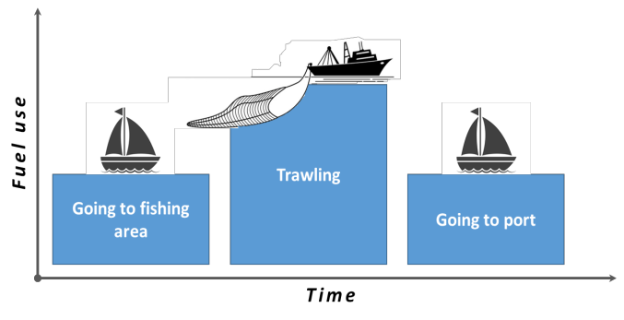
Fig 6: Time and Fuel consumption For Trawling

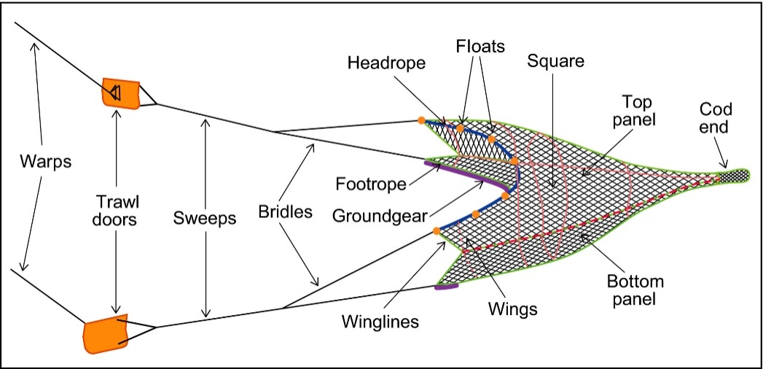
Fig 7: Parts of Trawl net

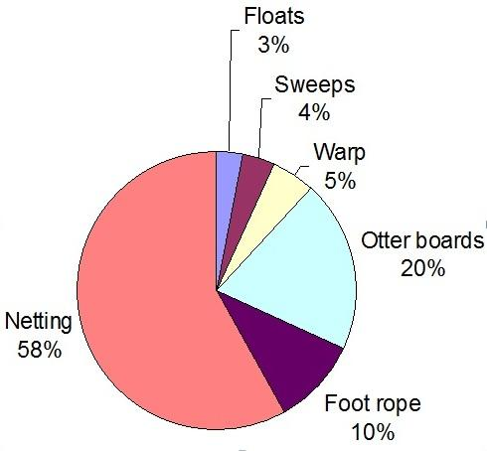
Fig 8: Drag of Trawl Net
{Courtesy : Profiling Growth And Fuel Consumption Of Mechanized Trawlers Of Kerala And Investigations On Efficiency Of Low Drag Trawl}

3. PURSE SEINE
Purse seine fishing is a popular fishing method used to catch large quantities of fish, particularly species that school close to the surface. This method involves encircling a school of fish with a large net called a purse seine net, which is then drawn closed at the bottom to trap the fish inside. The catch is then hauled on board the fishing vessel.
1. Energy Inputs:
a. Fuel consumption: Purse seine fishing vessels typically use marine diesel engines to power their operations. The energy input would be the amount of fuel consumed during fishing activities, including traveling to the fishing grounds, setting the net, and hauling in the catch.
b. Vessel construction: The energy required to manufacture the fishing vessel and its equipment, such as the purse seine net and winches, should also be taken into account.
c.Fishing location: The distance traveled to reach fishing grounds can affect energy consumption, with longer distances leading to higher fuel use.
d. Gear handling: Energy is expended in deploying and retrieving the purse seine net, which involves the use of winches and other machinery.
e. Fishing duration: The time spent at sea and the number of fishing trips per year can influence energy consumption.
f. Crew labor: The physical labor of the crew members in operating the vessel, handling the gear, and processing the catch adds to the overall energy input.
2. Energy Outputs:
a. Catch composition: The type and quantity of fish caught per trip influence the energy output. Different species have varying energy values in terms of their weight and nutritional content.
b. Bycatch: Purse seine fishing can result in bycatch, which refers to non-target species or juvenile fish caught unintentionally. The energy value of bycatch should be considered in the analysis.
c. Processing: The energy required to process the catch (e.g., cleaning, freezing, or canning) before it reaches the market should be included in the energy output.
d. Waste: The energy used to dispose of any waste generated during the fishing and processing operations should also be accounted for.
3. Environmental Impact:
a. Greenhouse gas emissions: The burning of fossil fuels in fishing vessel engines contributes to carbon dioxide (CO2) emissions, which are a significant factor in the environmental impact of purse seine fishing.
b. Bycatch and ecosystem impact: The unintentional capture of non-target species can have ecological consequences, affecting the overall energy flow and balance within marine ecosystems.
4. Technological Improvements: Efforts to reduce energy consumption and minimize the environmental impact of purse seine fishing may involve the adoption of more fuel-efficient engines, optimizing fishing practices to reduce bycatch, and implementing better waste management strategies.
Please note that the specific energy analysis for purse seine fishing may vary depending on factors such as the fishing location, target species, vessel size, and technology used. Additionally, the data used for the analysis may vary in accuracy and availability, as fishing practices and technologies are continually evolving.
Reduce the energy consumption of Purse seine fishing
Improved Fishing Gear Design: Develop and implement more efficient purse seine nets that reduce drag in the water, allowing for easier and faster retrieval of the catch. Using lightweight and durable materials can also help to decrease energy requirements during fishing operations.
Selective Fishing: Encourage the adoption of selective fishing practices, such as using fish aggregation devices (FADs) equipped with technology that attracts only the target species. This can reduce the need for extensive searching and chasing schools of fish, thereby lowering fuel consumption.
Data and Technology Integration: Utilize advanced technology like GPS, sonar, and fish finders to locate fish more accurately. This helps fishermen target specific areas with higher fish concentrations, minimizing the time and energy spent searching for fish.
Optimized Fishing Routes: Plan fishing routes more efficiently to reduce fuel consumption and greenhouse gas emissions. This involves considering factors such as weather conditions, current patterns, and fish migration routes.
Alternative Propulsion Systems: Explore and adopt alternative propulsion systems, such as hybrid or electric engines, which can be more fuel-efficient and produce fewer emissions compared to traditional diesel engines.
Improved Vessel Maintenance: Regular maintenance of fishing vessels ensures that engines and equipment operate optimally, reducing energy waste and increasing fuel efficiency.
Education and Training: Provide education and training to fishermen on energy-efficient fishing practices. Raising awareness of the benefits of reducing energy consumption and the long-term impacts on the environment can motivate behavior change.
Regulatory Measures: Governments and international bodies can implement regulations and incentives to promote energy-efficient fishing practices. For instance, providing subsidies or tax breaks for vessels that adopt energy-saving technologies.
Fisheries Management: Implement sustainable fisheries management practices that aim to maintain fish stocks at healthy levels. This will help prevent overfishing and reduce the need for extensive fishing efforts.
Reduced Overcapacity: Address overcapacity in the fishing industry to avoid unnecessary competition and pressure on fish stocks, which can lead to increased energy consumption.
Combining these strategies can contribute to reducing the energy consumption of purse seine fishing while also promoting sustainable fishing practices and protecting marine ecosystems.
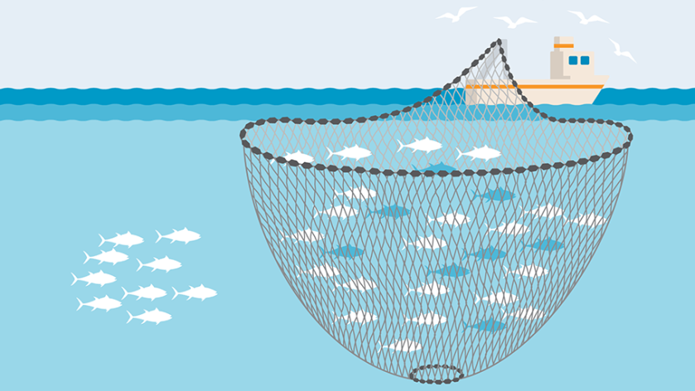
Fig: 9. Purse seine fishing

4. Long line
Longline fishing is a commercial fishing method that uses a long mainline with baited hooks spaced along its length to catch fish. The energy analysis of longline fishing involves examining the energy inputs, processes, and outputs associated with the entire fishing operation. Here are some key aspects to consider in the energy analysis of selected longline fishing:
Fishing Vessel Energy Consumption: The fishing vessel is a crucial component of longline fishing. Its energy consumption includes fuel for propulsion, electrical power for onboard equipment, refrigeration for preserving catch, and other auxiliary systems. The type of fuel used, vessel size, and distance traveled to fishing grounds, and fishing duration all affect the overall energy consumption.
Fishing Gear Production: Longline fishing requires the production and maintenance of fishing gear, including the mainline, hooks, buoys, and weights. The energy analysis should consider the raw material extraction, manufacturing processes, transportation, and disposal of fishing gear.
Bait Production and Storage: Energy is expended in the production and storage of bait used to attract fish to the hooks. This may involve sourcing, processing, refrigeration, and transportation of bait to the fishing vessel.
Fishing Operations: Deploying and retrieving longlines is a labor-intensive process that requires energy inputs. Winches, hydraulic systems, and other machinery are used during these operations.
Bycatch and Discards: Longline fishing may result in bycatch, catching unintended species or undersized fish that must be discarded. Energy is indirectly involved in the handling and disposal of bycatch.
Fish Processing: After the catch is brought on board, there is further energy consumption involved in processing and preserving the fish, including cleaning, gutting, and freezing.
Packaging and Transportation: Energy is expended in packaging the catch for transportation to processing plants or markets.
Post-Harvest and Distribution: Energy is used in the post-harvest phase, including cold storage and transportation to market or processing facilities.
To analyze the overall energy consumption in Longline fishing, data on the following parameters is essential:
Fishing vessel characteristics: Fuel consumption rate, engine efficiency, and distance traveled during deployment and retrieval.
Longline gear specifications: Weight, length, and other relevant dimensions that can influence the energy requirements for deployment and retrieval.
Catch characteristics: Weight and volume of the catch obtained during each fishing trip.
Onboard equipment: Energy consumption of winches, hydraulics, processing machinery, and refrigeration systems.
These analysis should aim to identify energy-intensive stages and potential areas for efficiency improvements or alternative, more sustainable practices.
It's important to note that the environmental impact of longline fishing goes beyond energy consumption and includes considerations of overfishing, habitat damage, and effects on non-target species. Sustainable fishing practices and management strategies are crucial to mitigate these impacts and ensure the long-term health of marine ecosystems.
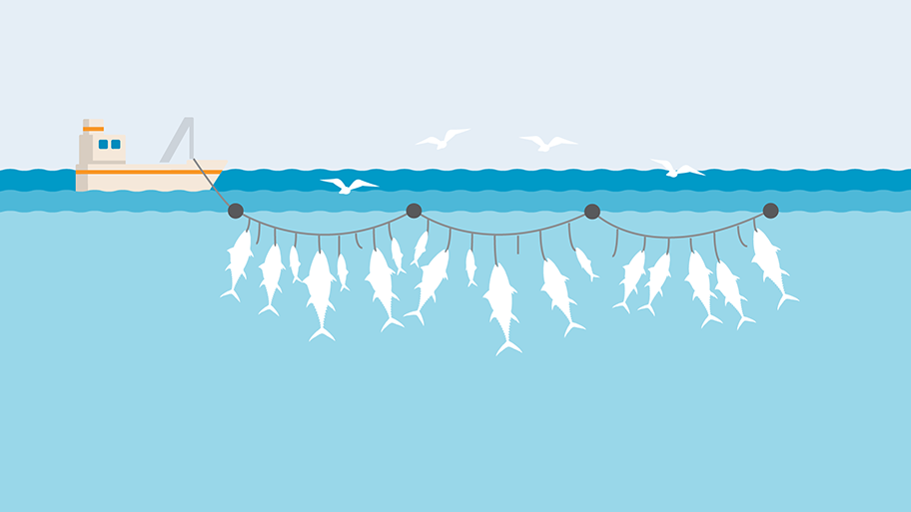
Fig 10: Long line
{Courtesy: https://www.msc.org/what-we-are-doing/our-approach/fishing-methods-and-gear-types/longlines}

5. HAND LINE
Energy analysis of handline fishing involves evaluating the energy inputs and outputs associated with this traditional fishing method. Handline fishing is a simple and ancient technique that involves using a single fishing line with bait and a hook, typically operated by one person. Here are some key aspects of the energy analysis:
Energy Inputs:
a. Human Energy: Handline fishing heavily relies on human labor to operate. The energy input comes from the fisherman who casts the line, reels it in, and handles the catch. The amount of energy expended depends on factors such as the duration of fishing, physical strength, and fishing experience of the person.
- Duration of Fishing: The longer the fishing session, the more energy the fisherman needs to exert. Extended periods of fishing can be physically demanding, especially when the fisherman has to repeatedly cast and reel in the line.

- Physical Strength: The physical strength of the fisherman plays a crucial role in determining how much energy they can exert during fishing. Stronger individuals may find it easier to handle the repetitive motions involved in casting and reeling.
- Fishing Experience: Experienced fishermen tend to develop better techniques and efficiency, which can reduce the amount of energy expended per catch. They might also have a better understanding of when and where to fish, optimizing their efforts.

- Fish Species and Size: The type and size of the fish being caught also influence the amount of energy required. Larger and more resistant fish may require more effort to reel in.

- Fishing Equipment: While handline fishing is relatively simple and requires minimal gear, the type of line and hook used can still affect the ease of fishing and energy required.
b. Bait Energy: Bait is used to attract fish to the hook. The energy embedded in the bait can be considered an input to the fishing process. The origin of the bait (e.g., live bait or artificial lures) would determine the energy required for its production or acquisition.
c. Equipment Energy: Though minimal, there is some energy input associated with the production and maintenance of fishing equipment such as fishing lines, hooks, and reels.
Energy Conversion:
The primary conversion of energy in handline fishing occurs when the fish is caught and hauled in by the fisherman. The mechanical work done by the fisherman's hand and arm is converted into potential energy stored in the captured fish.
Energy Outputs:
The main energy output of handline fishing is the harvested fish. This represents the useful energy obtained from the fishing activity. The energy content of the fish can be estimated based on its mass and the average caloric value per unit mass for that species.

Waste and Bycatch:
Handline fishing generally has lower bycatch rates compared to other fishing methods, such as trawling or longlining. Bycatch refers to the unintended capture of non-target species. However, some energy losses may occur due to discarded or unwanted fish, which may not be suitable for consumption or sale.
Environmental Impact: Handline fishing is generally considered a more sustainable fishing method compared to large-scale industrial fishing techniques. It has less impact on marine habitats and ecosystems. However, the overall sustainability and environmental impact of handline fishing depend on factors such as the species being targeted, fishing practices, and the level of fishing pressure on the particular fishery.
It's important to note that energy analysis is just one aspect of assessing the sustainability and environmental impact of a fishing method. Other factors, such as the size and health of fish populations, fishing regulations, and social considerations, also play significant roles in determining the overall sustainability of hand line fishing practices.
Reducing the energy consumption of handline fishing
Selective fishing gear: Use selective fishing gear to minimize bycatch (unwanted species caught unintentionally). This helps preserve marine biodiversity and reduces unnecessary energy expended in handling and discarding non-target species.
Fishing area and season management: Implementing fishing area and season restrictions can help protect vulnerable marine species during their breeding and spawning periods. This allows fish populations to recover and maintain their natural balance.
Gear material and design: Optimize the materials and design of handlines to reduce drag and friction in the water, making them more energy-efficient to operate.
Fishing techniques: Train fishermen in efficient fishing techniques to reduce the need for excessive hauling or reeling in of lines. Proper techniques can minimize energy wastage and fatigue during fishing operations.
Reduce waste and post-harvest loss: Implement practices that reduce waste and post-harvest losses, such as proper handling, storage, and transportation of caught fish. Reducing spoilage means more efficient utilization of the energy expended during the fishing process.
By implementing these strategies, handline fishing can become even more environmentally friendly, helping to conserve marine resources and reducing its overall energy footprint.
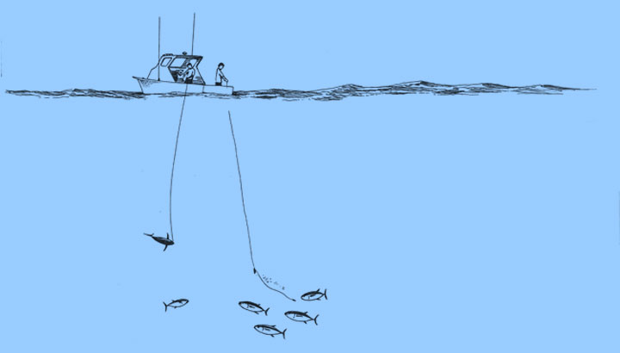
Fig 11: Hand line
{Courtesy: https://www.hawaii-seafood.org/}
6. FISH TRAPS (or) POTS FISHING
Energy analysis of fish traps or pots fishing involves assessing the energy inputs and outputs associated with the fishing method. It aims to understand the environmental impact and energy efficiency of this particular fishing technique. Several factors contribute to the energy analysis of fish traps/pots fishing:
Manufacturing and Maintenance: Energy is required to manufacture the fish traps or pots, including the materials used in their construction. Additionally, regular maintenance and repairs also consume energy resources.
Deployment and Retrieval: Energy is expended in the process of deploying the fish traps/pots into the water and retrieving them after a certain duration of fishing.

Deployment:
- During the deployment phase, energy is expended in various ways, depending on the fishing method used. For traditional or small-scale fishing, fishermen may manually lower the traps/pots into the water from a boat or the shore. This process requires physical effort and may consume a moderate amount of energy from the fishermen.
- In modern and commercial fishing operations, specialized equipment like hydraulic systems, winches, or cranes might be used to deploy larger and heavier traps/pots. These systems require mechanical or electrical energy to operate.
The energy expended during deployment is influenced by factors such as the number and size of traps/pots being deployed, the fishing location, and the fishing method employed.
Retrieval:
- The retrieval phase involves pulling the traps/pots back up from the water to access the catch. Similar to the deployment process, manual labor or machinery can be used for retrieval, impacting the amount of energy expended.
- In manual retrieval, fishermen use physical effort to lift the traps/pots, which can be tiring, especially if they are heavy or numerous.
- Commercial fishing operations may employ mechanized systems to retrieve traps/pots, which can save labor but may consume significant amounts of mechanical or electrical energy.
The energy expended in retrieval is also influenced by factors such as the duration the traps/pots spend in the water, the depth and distance from the shore, and the fishing resources targeted.
Transportation: The energy used to transport the fish traps/pots to and from the fishing location, either by boats or other means, is an important aspect to consider.
Bait: Often, bait is used in fish traps/pots to attract the target species. The energy required to procure, store, and use bait needs to be accounted for in the analysis.
Lost Gear and Bycatch: Fish traps/pots can get lost, damaged, or abandoned at sea, leading to energy losses. Additionally, there is a possibility of bycatch (catching unintended species), which can lead to energy waste and environmental concerns.
Fish Processing and Storage: After retrieval, the caught fish may require processing and refrigeration for storage. The energy consumption during these processes is also relevant to the analysis.
Fishing Vessel Operation: If fishing vessels are used to deploy, retrieve, and service the fish traps/pots, the energy consumption of these vessels should be included in the analysis.
End-of-life Disposal: When fish traps/pots reach the end of their lifespan, their disposal may require energy resources or lead to environmental impacts.
Reducing the energy consumption of fishing traps or pots involves implementing various strategies and innovations to make the fishing process more efficient and environmentally friendly.
- Material selection: Design traps using lightweight, durable, and environmentally friendly materials. This reduces the energy required to deploy, retrieve, and maintain the traps.
- Optimize trap design: Work on trap designs that maximize catch efficiency while minimizing energy input. Reducing the size and weight of traps can make them easier to handle and deploy, saving energy during the fishing process.
- Implement biodegradable materials: Use biodegradable escape panels and biodegradable twine to allow non-target species to escape when the trap is lost or discarded. This reduces the negative impact on marine ecosystems and helps prevent ghost fishing.
- Trap placement and monitoring: Optimize trap placement using data and technology to locate areas with the highest potential for catching target species. This way, fishermen can reduce the number of empty traps and save energy in retrieving them.
By combining these strategies, the energy consumption of fishing traps can be significantly reduced, promoting sustainable fishing practices and contributing to the conservation of marine ecosystems.
Fish traps/pots fishing is often considered a more selective and environmentally friendly fishing method compared to certain other fishing practices like trawling, which can cause significant habitat damage and result in higher bycatch rates. However, the specific energy efficiency of fish traps/pots fishing would depend on various factors, including the type and size of fish traps used, the target species, and local fishing practices.
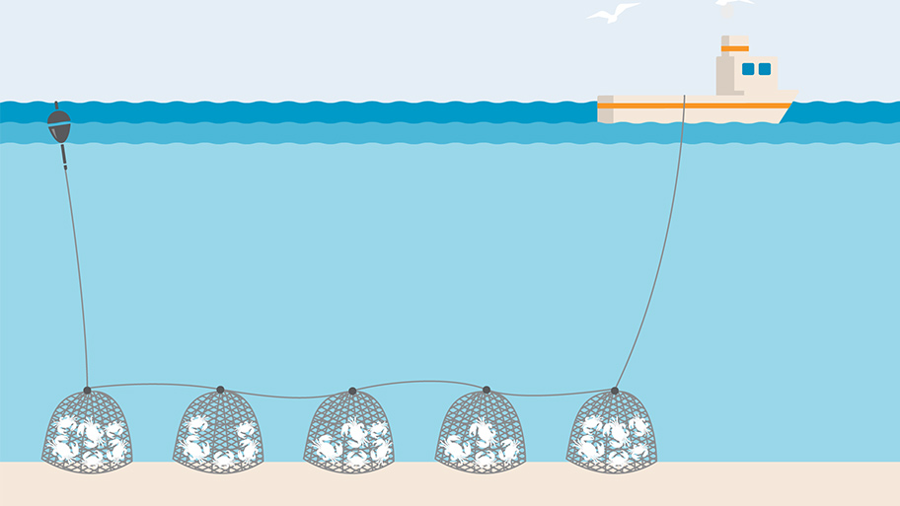
Fig 12: Fishing pots and Traps
{Courtesy: https://www.msc.org/what-we-are-doing/our-approach/fishing-methods-and-gear-types/pots-and-traps}

