Chapter

Earthworms And Sustainable Agriculture:
A Review
Kajal, Ramandeep, Pooja Sharma and Komal Duhan
Department of Zoology, Baba Mastnath University, Rohtak
*Corresponding author: Pooja Sharma; e-mail: poojamarichi3726@gmail.com

Abstract
Utilizing natural resources without endangering the ability of future generations to meet their own needs is the idea of sustainability. Pesticides are known for their higher cost and adverse effects on agriculture. Chemical fertilizers should not be used excessively because they degrade soil. Organic fertilizers are cost effective and easily available. Sustainable agriculture or organic agriculture eliminate the harmful effects of synthetic fertilizers. In general, earthworm feeding and burrowing have many beneficial benefits on soil quality for crop yield. The activity of earthworms in their burrows increases the porosity of the soil, which increases the quantity of air and water that may enter the soil. One of the most significant animals in the soil, earthworms have the ability to maintain soil fertility. By producing aggregates, earthworms also strengthen the structure of the soil. Earthworms are essential to the initial breakdown, continued decomposition, and recycling of nutrients found in organic waste. Application of vermicompost increases the release of plant hormones, which results in beneficial adjustments to plant growth parameters. Casts from earthworms, which include nitrogen, phosphorous, potassium, and magnesium, improve soil fertility.
Key words: Sustainable agriculture, earthworms, vermicompost, nutrients
INTRODUCTION

Sustainable agriculture is defined by the Food and Agriculture Organization as "production that satisfies food security, environmental protection, social, and economic needs in rural areas." (FAO 2016). The development of agricultural output has already reduced the unsustainability of soils, according to Kopittke et al. (2019), who evaluated the significance of the ecosystem services given by soils and raised awareness. Agriculture is an important sector in economy as it accounts for one-seventh of GDP and provides subsistence to nearly two-third of our population (Ministry of Chemicals and Fertilizers, Department of Fertilizers, Gov. of India, 2016-2017). Focusing on historical data on fertilizer use and agricultural production, a rise in fertilizer use is demonstrating that imbalanced and excessive use of chemical fertilizers are ineffective for increasing agricultural yields (Tilman et al., 2002). The degradation of the soil is caused by the damage that chemical fertilizers do to the soil's micro and macroflora and fauna (Eliazer Nelson et al., 2019).

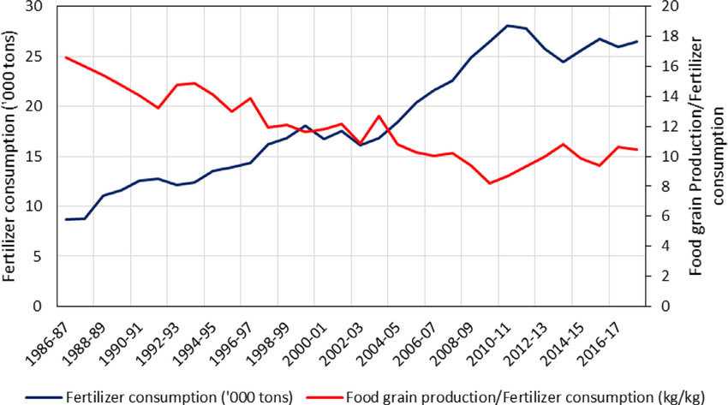 Historical trends of India's consumption of chemical fertilizers and the amount of food grain produced per unit of chemical fertilizer consumption (source: RBI 2021).
Numerous research have shown that using inorganic fertilizers excessively results in both soil degradation (Singh, 2000; Eliazer Nelson et al., 2019) and the release of greenhouse gases that harm the ecosystem (Sutton et al., 2013). In the modern era, a new agricultural method known as organic agriculture, sustainable agriculture, or ecological agriculture has been introduced to reduce and eliminate the negative impacts of synthetic fertilizers on human health and the environment (Keeney et al., 1991). To boost crop output, it is important to use various organic resources, including cow dung, poultry droppings, and farmyard manure (Asadu and Unagwu, 2012). Therefore, fertilizers are required and applied to replenish the nutrients removed from the soil by crop harvest in order to boost crop output (Olatunji and Ayuba, 2012). Inorganic fertilizers are notorious for being expensive and having negative ecological effects when improperly used (Gupta Mahajan et al., 2008). However, compared to inorganic fertilizers, organic fertilizers are typically more affordable and readily available from local suppliers (Aksou U.,2001). The production of high-quality food using natural systems, maintaining long-term soil fertility, boosting biological cycles within the farming system, advancing healthy use with proper care of water resources, and reducing pollution are all essential contributions made by organic farming (Willer et al.,2008).
Typically, three basic ecological categories stand out: epigeic which only conducts activities a few centimetres below the soil-litter interface and mostly feeds on litter at the soil surface; endogeics that construct temporary burrows without preference direction and mostly feed on soil organic materials; and anecics that dwell permanently underground in vertical burrows and primarily consume soil litter (Bouche, 1972; Lee,1985). However, the variation in earthworm burrowing activities is highly correlated with soil characteristics (such as soil texture, soil type, organic matter), soil temperature, and is particularly sensitive to soil moisture (Lee, 1985). Earthworm activity and the development of burrows improve aeration and water infiltration, hence reducing surface runoff (Lee, K.E., et al.,1995)

Three main ecological categories
(guilds) are usually distinguished: epigeics that mainly feed on litter at the soil
surface with activities limited to a few centimeters below the soil-litter inter-
face; endogeics that mainly feed on SOM and form non-permanent burrows
without preferential orientation; and anecics that mainly feed on litter at the
soil surface and live in permanent vertical burrows (Bouche, 1972;Lee,
1985).
Three main ecological categories
(guilds) are usually distinguished: epigeics that mainly feed on litter at the soil
surface with activities limited to a few centimeters below the soil-litter inter-
face; endogeics that mainly feed on SOM and form non-permanent burrows
without preferential orientation; and anecics that mainly feed on litter at the
soil surface and live in permanent vertical burrows (Bouche, 1972;Lee,
198
Earthworm

Anecics
“Deep to the surface”
Epigeic
“Close to the surface”
Endogeic
“Within the earth”

gggggff

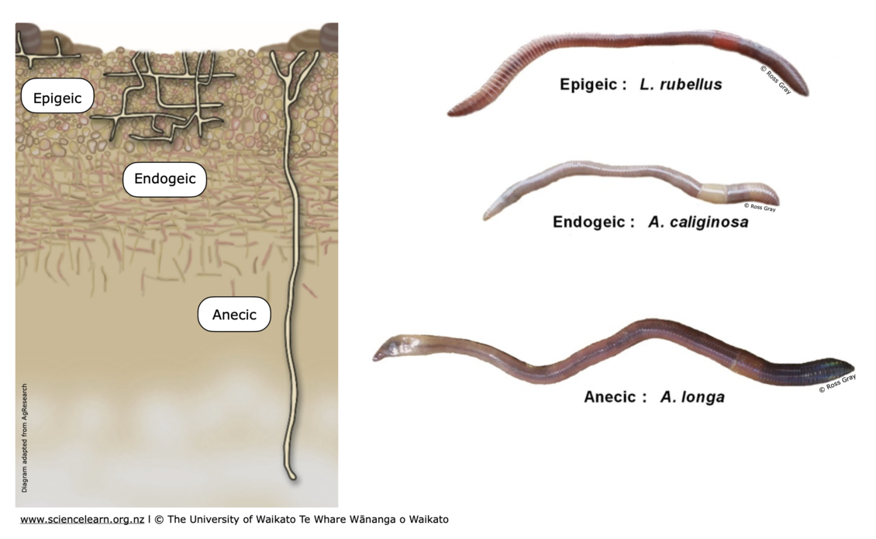

The months of March–April and September–October saw the most burrowing and reproduction, respectively. The earthworms descend from the surface on dry, hot days. The nightcrawler (Lumbricus Terrestris) can migrate up to 20 m (Brown GG, et al., 2003).
A. Benefits of earthworms to soil health:
Earthworms are known as "ecosystem engineers" because they significantly affect the physical, chemical, and biological characteristics of soil (Pelosi et al., 2014). Earthworms aid in the decomposition of organic materials and the transformation of major and minor mineral nutrients (Edward CA et al.,19).

(a) In soil fertility:
One of the most significant soil creatures is the earthworm, which has the ability to maintain soil fertility and hence play a key part in the sustainability of agriculture (Brown et al., 2004). Earthworms are essential for increasing soil fertility because they can retrieve the physical, chemical, and biological properties of the soil [3,5,14] through borrowing activity. However, the variability in earthworm burrowing activities is highly correlated with soil characteristics, soil temperature, and is particularly sensitive to soil moisture (Lee K E., 1985). Organic matter is added to the soil and soil layers are combined by earthworms. Earthworms boost the amount of plant nutrients that are readily available while also enhancing soil structure, assimilation, and tilling. The activity of earthworms also enhances water potential and soil drainage. Through the formation of aggregates, earthworms also enhance soil structure. The soil structure is not permanently improved by human agricultural activities like cultivation, but the earthworm has considerably longer-term beneficial benefits in preserving soil tilth. Earthworms may devour more organic material from the soil's surface than all other soil organisms combined. Earthworms enhance physical structure of soil and encourage the growth of deep root system by creating channels through which roots of plant easily penetrate (Ramsay JA, 1978). Earthworms alter the soil's chemistry, biology, and structure by eating, altering, and combining organic wastes (Lavelle P, et al., 2004).
(b) In nutrient availability to soil:
Through the tissues in their bodies and their activity as borrowers, earthworms have an impact on the supply of nutrients (Lal. R and Hawksworth D.L, 1999). Depending on the time and space scales taken into account, earthworms have varying effects on the dynamics of organic matter (Mora P et al.,2005). Earthworms are essential to the initial breakdown, continued decomposition, and recycling of nutrients found in organic waste. They dispose of this material as cast, which is rich in nutrients. Earthworms improve the mineralization of organic matter and raise the soil's nitrogen content. The earthworm's gut contains nitrogen-fixing microorganisms that boost nitrogenase enzyme activity (Edward CA, et al., 1996). The second most important ingredient for plant growth is phosphorus, following nitrogen (Vance CP et al., 2000). The increase in phosphatase activity also increases the amount of phosphorus in earthworm cast (Kuczak CN et al., 2006). This allows plants to easily absorb the substantial amounts of nitrogen, phosphorus, and other nutrients found in the cast of earthworms, such as P, Ca, and K.
(c) Vermicomposting for recycling wastes:
Vermicompost

- Promotes plant growth
- Increases porosity in soil
- Increases microbial activity in soil
- Improve water retention
- Enhance soil structure and drainage

Vermicompost is a type of organic fertilizer that is created when biodegradable waste is digested by earthworms. It is regarded as a safe method of waste management as well as an environmentally friendly method of agricultural production (Przemieniecki, SW, et al.,2021). Direct application of organic wastes to agricultural fields may result in soil environmental issues, such as phytotoxicity (Hsu JH, et al.,1999). The organic and mineral components of the food that earthworms consume are amplified, resulting in castings that are more nutrient-dense than the soil surrounding them. This process is accompanied by an enrichment in unstable chemicals and a subsequent rise in microbial activity (Coq et al., 2007; Abail et al., 2017).
Vermicomposting is a non-thermophilic (mesophilic) technique that uses the digestive system of earthworms to turn organic waste into a humus-like product that serves as a high-value nutrient fertilizer and soil amendment [28,31,44].
Composting is a method for handling manures, green garbage, and municipal solid waste (Goyal S, et al., 2005). Despite this, vermicomposting produces a superior final product than composting because of the interaction between enzymatic and microbiological activities that take place during the process (Bajsa O, et al., 2003). Vermicompost-treated soil was found to have significantly improved physicochemical characteristics including pH, moisture content, water holding capacity, and chemical characteristics such as nitrogen, phosphorous, potassium, calcium, and magnesium, whereas the corresponding physicochemical values in control soil were insignificant in rice crop (Tharmaraj K, et al.,2011). Application of vermicompost can enhance the biological characteristics of soil. According to recent studies, adding vermicompost to soil significantly improves its biological features, including soil organic carbon, soil microbial biomass, enzymatic activity, population of various beneficial microorganisms, hormones, etc (Manivannan S, et al., 2009). Hence, vermicompost increases soil fertility by enhancing the physical, chemical, and biological characteristics of the soil.
(d) Role of earthworm in plant growth:
Earthworms alter the structure of the soil to affect plant growth. By creating burrows and organomineral casts at various locations throughout the soil profile, they help to increase soil porosity and the strength of organomineral aggregates (Lavelle P, et al., 2006 and Kretzschmar., 2004). This outcome is intended to promote plant development in a variety of circumstances (Brown GG, et al., 2004).
Application of vermicompost boosts plant hormone release, which results in beneficial adjustments to plant growth parameters (Adhikary S.,2012). Auxins and cytokinins, which are released by earthworms and are beneficial to plant growth (Krishnamoorthy and Vajranabhaiah, 1986). The presence of gibberellic acid (GA) in vermicompost regulates the intake of calcium and potassium and improves the growth of shoot elongation (Moghadam, A.R.L et al.,2012). The ground is magnificently prepared for plant growth by earthworms. (Darwin, 1881).
Some studies showed that the application of vermicompost boosted the overall concentrations of carbs, fibres, and vitamin C in cabbage heads as well as the amount of essential oils in the leaves of mint plants (Thymus vulgaris) (Verma R. et al., 2014). Vermicomposting improves fruit quality characteristics as hardness, colour, and the number of marketable fruits produced (Arancon, N.Q. et al.,2003).
Ancient wisdom regarding the contribution of earthworms to improving soil fertility has now been greatly clarified by scientific findings from many studies. This is a crucial area of research where the findings are closely related to social welfare (Kale RD, 2007 and Edwards CA et al.,2009).

References:

- Annual report 2016-2017. Government of India, Ministry of Chemical and Fertilizers, Department of Fertilizers.
- Abail, Z., Sampedro, L., Whalen, J.K. (2017). Short-term carbon mineralization from endogeic earthworm casts as influenced by properties of the ingested soil material. Applied Soil Ecology, 116, 79-86. DOI: 10.1016/j.apsoil.2017.02.022.
- Abdul Rida AM, Bouché MB (1997). Earthworm toxicology: from acute to chronic tests. Soil Biol. Biochem., 29: 699- 703.
- Adhikary, S. Vermicompost, the story of organic gold: A review. Agric. Sci. 2012, 3, 905–917.
- Aina PQ (1984). Contribution of earthworms to porosity and water infiltration in a tropical soil under forest and long-term cultivation. Pedobiol., 26: 131- 136.
- Aksoy U. Ecological Farming. II. Ecological Farming Symposium in Turkey. 14-16 December. Antalya, 2001.
- Asadu CLA and Unagwu BO (2012). Effect of combined Poultry Manure and inorganic fertilizer on maize performance in an ultisol of south-ea NigeriNigeria Journal of Soil Science. 22(1): pp 79 – 87.
- Arancon, N.Q.; Edwards, C.A.; Bierman, P.; Metzger, J.D.; Lee, S.; Welch, C. Effects of vermicomposts on growth and marketable fruits of field-grown tomatoes, peppers and strawberries. Pedobiologia 2003, 47, 731–735.
- Bajsa O, Nair J, Mathew K, Ho GE. Vermiculture as a tool for domestic wastewater management. Water Science and Technology. 2003;48:125-132. DOI: 10.2166/wst.2004.0821
- Bouche, M.B., 1972. Lombriciens de France. In: Ecologie et systematique, INRA Editions. Vol. 72, No. HS. 671-p.
- Brown GG, Benito NP, Pasini A, et al (2004). No-tillage greatly increases earthworm populations in Parana State, Brazil. Pedobiol., 47: 764-771.
- COQ, S., Barthes, B. G., Oliver, R., Rabary, B., Blanchart, E. (2007). Earthworm activity affects soil aggregation and organic matter dynamics according to the quality and localization of crop residues-an experimental study (Madagascar). Soil Biology and Biochemistry, 39, 2119–2128. Doi: 10.1016/j.soilbio.2007.03.019
- Darwin, C., 1881. The formation of vegetable mould through the action of worms, with observations on their habitats. Murray, London. 326 pp.
- Edwards CA, Bohlen PJ (1996). Biology and Ecology of Earthworms. 3rd Edition. Chapman and Hall, London.
- Eliazer Nelson, A.R.L., Ravichandran, K., Antony, U., 2019. The impact of the Green Revolution on indigenous crops of India. J. Ethn. Foods 6, 8. doi:10.1186/s42779-019-0011-9.
- FAO 2016. Sustainability assessment of food and agriculture systems (SAFA) [online]. [Access 07.11.2016]. Rome. Food and Agriculture Organization of the United Nations. Available at: http://www.fao.org/nr/sustainability/sustainability-assessments-safa/en.

- Goyal S, Dhull SK, Kapoor KK. Chemical and biological changes during composting of different organic wastes and assessment of compost maturity. Bioresource Technology. 2005; 96:1584-1591. DOI: 10.1016/j. biortech.2004.12.012

- Hsu JH, Lo SL. Chemical and spectroscopic analysis of organic matter transformations during composting of pig manure. Environmental Pollution. 1999; 104:189-196. DOI: 10.1016/ S0269-7491(98)00193-6.
- Kale R D, “The need for an interdisciplinary approach in understanding the importance of earthworms in India,” in Proceedings of Indo US Workshop on Vermitechnology in Human Welfare (Indo—US Science and Technology Forum), June 2007, C. A. Edwards, R. Jeyaraaj, and I. Jayaraaj, Eds., p. 164, Coimbatoor, Tamil Nadu, India, 2009
- Keeney DR, Follett RF. Managing nitrogen for ground water quality and farm profitability: Overview and introduction. In Managing Nitrogen for Ground Water Quality and Farm Profitability (R.F. Follet et al., Eds.), 1991, 1-7.
- Koppitke, P.M, Menzies, N.W., Wang, P., Mckenna, B.A., Lombi, E. (2019). Soil and the intensification of agriculture for global food security. Environment International, 132, 1-8. November 2019, doi.org/10.1016/j.envint.2019.105078.
- Kretzschmar A, “Effects of earthworms on soil organization,” in Earthworm Ecology, C. A. Edwards, Ed., vol. 1, pp. 201–210, 2nd edition, 2004.
- Krishnamoorthy, R. V. and Vajranabhaiah, S. N. 1986. Biological activity of earthworm casts: An assessment of plant growth promoter levels in the casts. Proc. Indian Acad. Sci. (Anim. Sci.)., 95: 341-351.
- Kuczak CN, Fernandes EC, Lehmann J, Rondon MA, Luizao FJ. Inorganic and organic phosphorus pools in earthworm casts (Glossoscolecidae) and a Brazilian rainforest Oxisol. Soil Biology and Biochemistry. 2006;38(3):553-60.
- Lal R, “Soil conservation and biodiversity,” in The Biodiversity of Microorganisms and Invertebrates: Its Role in Sustainable Agriculture, D. L. Hawksworth, Ed., pp. 89–103, CAB International, Wallingford, UK, 1999.
- Lavelle P, Charpentier F, Villenave C, Rossi JP, Derouard L, Pashanasi B, André J, Ponge JF, Bernier N. Effects of earthworms on soil organic matter and nutrient dynamics at a landscape scale over decades. Earthworm ecology. 2004; 2:145-60.
- Lavelle P, Decaens T, Aubert M, et al., “Soil invertebrates and ¨ ecosystem services,” European Journal of Soil Biology, vol. 42, supplement 1, pp. S3–S15, 2006.
- [29] Lazcano, C.; Revilla, P.; Malvar, R.A.; Domínguez, J. Yield and fruit quality of four sweet corn hybrids (Zea mays) under conventional and integrated fertilization with vermicompost. J. Sci. Food. Agric. 2011, 91, 1244–1253.
- Lee, K.E., 1985. Earthworms: Their Ecology and Relationships with Soils and Land Use. Academic Press Inc.
- Lee, K.E. Earthworms and sustainable land use. In Earthworm Ecology and Biogeography in North America; Hendrix, P.F., Ed.; CRS Press: Boca Raton, FL, USA, 1995; pp. 215–234.
- [30] Lim, S.L.; Yeong, W.T.; Lim, P.; Shak, K.P.Y. The use of vermicompost in organic farming: Overview, effects on soil and economics. J. Sci. Food Agric. 2015, 95, 1143–115
- Mahajan Gupta RD, Sharma R. Bio-fertilizers-A way to sustainable agriculture. Agrobios Newsletter. 2008; 6:36-37
- Manivannan S, Balamurugan M, Parthasarathi K, Gunasekaran G, Ranganathan LS. Effect of vermicompost on soil fertility and crop productivity beans (Phaseolus vulgaris). Journal of Environmental Biology. 2009;30(2):275-281
- Moghadam, A.R.L.; Ardebill, Z.O.; Saidi, F. Vermicompost induced changes in growth and development of Lilium Asiatic hybrid var. Navona. Afr. J. Agric.Res. 2012, 7, 2609-2621.
- Mora P, Miambi E, Jiménez JJ, Decaëns T, Rouland CJ. Functional complement of biogenic structures produced by earthworms, termites and ants in the neotropical savannas. Soil Biology and Biochemistry. 2005;37(6):1043-8.
- Olatunji O and Ayuba, SA (2012). Effect of combined applications of poultry manure and NPK 20-10-10 fertilizer on soil chemical properties and yield of maize (Zea mays L.). Proceedings of the 35th Annual Conference of the Soil Science Society of Nigeria (SSSN). 7th –11th March, 2011, Fe University of Technology Minna.
- Pelosi C, Barot S, Capowiez Y, Hedde M, Vandenbulcke F. (2014). Pesticides and earthworms. A review. Agron. Sustain. Dev 34: 199–228
- Przemieniecki, S.W.; Skwiercz, A.; Damszel, M.; Telesiński, A.; Zapałowska, A.; Sierota, Z.; Gorczyca, A. Ecology, biology and enzymatic activity of the rhizosphere planted with Larix decidua seedlings after addition of vermicompost. Appl. Soil Ecol. 2021, 168, 104101.
- Ramsay JA and Hill S (1978). Earthworms: The agriculturist’s friends. Macdonald J., 39(10): 1.
- RBI, 2021. Handbook of statistics on Indian States. Reserve bank of India. Published by Reserve bank of India. https://www.rbi.org.in/Scripts/Publications View.aspx?id=20070.
- Singh, R.B., 2000. Environmental consequences of agricultural development: a case study from the Green Revolution state of Haryana, India. Agric. Ecosyst. Environ. 82, 97– 103. doi:10.1016/S0167-8809(00)00219-X
- Sutton M.A., Bleeker A., Howard C.M., Bekunda M., Grizzetti B., de Vries W., van Grinsven H.J.M., Abrol Y.P., Adhya T.K., Billen G., Davidson E.A, Datta A., Diaz R., Erisman J.W., Liu X.J., Oenema O., Palm C., Raghuram N., Reis S., Scholz R.W., Sims T., Westhoek H. & Zhang F.S., with contributions from Ayyappan S., Bouwman A.F., Bustamante M., Fowler D., Galloway J.N., Gavito M.E., Garnier J., Greenwood S., Hellums D.T., Holland M., Hoysall C., Jaramillo V.J., Klimont Z., Ometto J.P., Pathak H., Plocq Fichelet V., Powlson D., Ramakrishna K., Roy A., Sanders K., Sharma C., Singh B., Singh U., Yan X.Y., Zhang Y., 2013. Our nutrient world: the challenge to produce more food and energy with less pollution. Global overview of nutrient management. Centre for ecology and hydrology, Edinburgh on behalf of the Global Partnership on Nutrient Management and the International Nitrogen Initiative. URI: https://wedocs.unep.org/20.500.11822/10747
- Tharmaraj K, Ganesh P, Kolanjinathan K, Suresh KR, Anandan A. Influence of vermicompost and vermiwash on physico chemical properties of rice cultivated soil. Current Botany. 2011;2(3):18-21
- [28] Theunissen, J.; Ndakidemi, P.A.; Laubscher, C.P. Potential of vermicompost produced from plant waste on the growth and nutrient status in vegetable production. Int. J. Phys. Sci. 2010, 5, 1964–1973.
- Tilman, D., Cassman, K.G., Matson, P.A., Naylor, R., Polasky, S., 2002. Agricultural sustainability and intensive production practices. Nature 418, 671–677. doi:10.1038/nature01014
- Vance CP, Graham PH, Allan DL. Biological nitrogen fixation: phosphorus-a critical future need. In Nitrogen fixation: From molecules to crop productivity 2000:509- 514.
- Verma, R.; Maurya, B.R.; Meena, V.S. Integrated effect of bio-organics with chemical fertilizer on growth and yield and quality of cabbage (Brassica oleracea var capitata). Indian J. Agri. Sci. 2014, 84, 914–919.
- Willer, H., Yussefi-Menzler, M., Sorensen, N. (2008): The world of organic agriculture-statistics and emerging trends 2008. http://orgprints.org/13123/4/world-of-organic-agriculture2008.pdf

