Empowering the Future via Energy Storage: Sustainable Roadmap of Renewable Energy Mission
Gyaneshwar Sharma*
Physics Department, Tilak Dhari P G College Jaunpur – 222002 India
* Corresponding Author: gyaneshwar.jnu@gmail.com

Introduction:
As a result of several international issues, driven by recent emergence of political conflicts, global community recently faced steep upsurge in shortage of fossil fuels and significant rise in their price. The price of natural gas, oil and electricity has threatened with its riotous records. This imbalance nature of energy distribution has leads energy crisis all around the globe. However, from sustainability point of view, natural fossil resources may not be considered promising for their availability in limited amount. Our imprudent dependency on nonrenewable energy resources certainly would lead energy crisis in coming years, if reliable and efficient alternatives of non-renewable energy would not be devised on urgent basis. It is very hard to envisage the life and to perform the routine duties without energy. In essence, it acquired prime position in our daily routine and plays essential role in everyday life. Currently, the fossil fuel are more reliable resource of energy. Which is responsible for emission of greenhouse active gases that are harming our climate and causes recurrence in extreme weather events around the world, from wildfires in USA and painful summer heatwaves in India, to typhoons in Asia and record-breaking rainfall in the UK and flood/droughts and sea levels are rising. The occurrence of extreme weather events have become more frequent since the recent decades. Form the evidences, it is interpreted that humankind is playing principal role in climate change.
The affordable, reliable, ecologically safe and human-rights valued energy can be accessed (https://www.forumforthefuture.org ):
- Working with patrons across a spectrum of markets and sectors (including developers, financiers, and civil society) in more sustainable manner.
- Revisiting the sustainability and future-fit of conventional energy systems.
- Enabling energy players to shape transition pathways. Which technologies, models, behaviors will really drive the transformation of our energy system?
- With destructive wars being fought over our planet’s limited resources, switching to renewable energy is becoming ever more relevant.
Phase-out of Fossil Fuels: A major goal was to gradually phase out the use of fossil fuels such as coal, oil, and natural gas in favor of zero corban emission and establishment of renewable energy sources. Many countries are agreed to reduce their dependence on these non-renewable resources.
Solar Energy Expansion: Solar power was rapidly growing as a major renewable e`nergy source. Advancements in solar panel technology, increased efficiency, and reduced costs were making it more accessible and more popular.
Wind Energy Development: Wind energy was also on the rise, with more efficient turbines and larger-scale wind farms being developed. Offshore wind projects were gaining popularity due to their potential for generating substantial amounts of clean energy.
Hydropower Optimization: Many countries were looking to maximize the potential of hydropower, including the modernization of existing hydropower plants and exploring new locations for dams.
Bioenergy Utilization: Biomass and biofuels were being explored as viable renewable energy sources. Research focused on sustainable ways to utilize organic materials for energy production.
Geothermal Energy Expansion: Geothermal power was gaining attention for its reliability and low-carbon footprint. Investment in geothermal technologies and exploration of new geothermal resources were being pursued.
Investment in Energy Storage: Developing efficient and cost-effective energy storage solutions, such as batteries, pumped hydro storage, and other grid-scale storage technologies, was a critical aspect of the roadmap to ensure stable and reliable renewable energy integration.
Smart Grid Implementation: Smart grid technologies were being adopted to optimize the integration of renewable energy sources into the existing power grid, making it more resilient and efficient.
Electrification of Transportation: The roadmap for renewable energy also included efforts to transition the transportation sector from fossil fuel-powered vehicles to electric vehicles (EVs) and promoting EV infrastructure.
Public Awareness and Policy Support: Governments and organizations were working to raise awareness about the benefits of renewable energy and implementing supportive policies, incentives, and subsidies to accelerate the transition.
International Collaboration: The roadmap involved fostering international cooperation and partnerships to address global climate change challenges and promote the adoption of renewable energy technologies worldwide.

Renewable energy in Indian perspective Current scenario
As a developing nation, previously India has relied certainly on coal to meet its energy demands. However, India has always been concerned about the consequences of non-renewable energy and committed to strengthening of alternative energy sources for sustainable growth. Today, India is managing power generation systems and pursuing their goals towards immediate shifting of energy generation with a more significant share of renewable energy. Presently, India is capable to fulfill 40% of its demand of energy from renewable energy resources (48.55 GW from solar, 40.03 GW from Wind, 4.83 GW from small hydro, 46.5 GW from large hydro, 10.62 GW from Biopower, 6.78 GW from Nuclear) (https://pib.gov.in ). Due to their renowned economic opportunity and natural resources, India is progressively emphasizing as prime destination for investment in renewable energy resources. India is presently promoting energy storage projects with the aim to meet India’s ambitious target of expanding its renewable energy capacity to 500 gigawatts (GW) by 2030 (https://www.india-briefing.com/news). With the implementation of energy storage, the energy storage will be more economic from the current rate of INR 5.5-6.5 per unit. It will also foster the development of large-scale battery energy storage systems by encouraging competitive bidding to drive down costs. The government anticipates the storage scheme will generate private investments worth INR 56 billion (approx. US$680.47 million) through this initiative. The government will provide support in form of funding and certain incentives to cover risks of developers of critical projects that are economically unviable - in the form of grants for the period of three years (https://economictimes.indiatimes.com). India has 37 MWh of battery storage capacity. While, it requires 236 GWh of battery energy storage in addition to 27 GW pump storage projects by 2031-32.

Role of energy storage in green energy
Energy storage is becoming more and more crucial role in green energy systems. The green energy mission can be strengthened by simplifying the intermittent mechanism of renewable energy generation and educating the overall reliability and efficiency of green energy deployment. The performance of electricity generation from solar and wind technology is severely limited by weather condition and availability of wind and daylight. Energy storage technologies enable the capture and retention of excess energy produced during favorable conditions, which can then be released during times of high demand or when renewable energy sources are not generating power.
Some key roles of energy storage in green energy:
Storing Excess Energy: Solar panels and wind turbines often produce more electricity than is needed at certain times. Energy storage systems (such as batteries) allow the excess energy to be stored and used later, ensuring that renewable energy is not wasted.
Load Balancing: Energy demand fluctuates throughout the day, and traditional power plants have to adjust their output accordingly. With energy storage, renewable energy can be stored when demand is low and released when demand peaks, helping to balance the load on the grid.
Grid Stability and Reliability: Energy storage provides grid operators with the ability to smooth out fluctuations in renewable energy generation, making the grid more stable and reliable.
Backup Power: Energy storage systems can serve as backup power sources during emergencies or grid outages. This capability enhances the resilience of the grid and improves energy security.
Enabling Off-Grid Solutions: In remote areas or during disasters, energy storage can be used with renewable energy sources to create off-grid systems, bringing electricity to places where traditional power infrastructure is lacking.
Integration of Renewables: Energy storage can help integrate a higher share of renewable energy into the grid. As renewable energy sources become more prevalent, energy storage becomes increasingly important to manage the variability and intermittency of these sources.
Reducing Peak Demand: Energy storage can be used to shave off peak demand periods, reducing the need for expensive and polluting peaker plants that are often used to meet short-term high electricity demands.
Time Shifting: Energy storage allows utilities and consumers to buy electricity when it is cheaper (during low-demand periods) and use it during high-demand periods, reducing electricity costs and promoting efficiency.
Environmental Benefits: By facilitating the efficient use of renewable energy, energy storage reduces the need for fossil fuel-based power plants, leading to lower greenhouse gas emissions and a cleaner environment.
Incentivizing Investment in Renewable Energy: Energy storage makes renewable energy projects more attractive to investors by mitigating risks associated with intermittent energy generation.
While energy storage technologies have made significant progress, further advancements, and cost reductions are needed to fully unlock the potential of green energy and create a more sustainable and resilient energy future. Research and development efforts are ongoing to improve energy storage technologies and enhance their integration into existing energy systems.

Importance of Energy Storage:
Due to imbalanced power supply during the odd situation and sustainability point of view, the energy storage seems to be more relevant and convenient to address the scarcity of energy. In addition, energy storage may be potential adds-on towards efficient energy harvesting from renewable energy resources from wind, solar and hydro, to nuclear and fossil fuels, to demand side resources and system efficiency assets (storage n.d.). Energy storage may provide reliable solution to generation, transmission, or distribution of energy – sometimes in a single asset. There is an open opportunity towards the development of efficient energy storage system. Which would be more economic due to reduction in cost of transportation of generated/harvested energy. Energy storage can save functioning charges and maintenance charges of grid and provide certain benefits to consumers who would be well-equipped with energy storage in their residence and businesses. Energy Storage provides greater flexibility to ensure the availability of supply of power to consumers, whenever and wherever they need it without any interruption. The Energy storage have ability to smoothen the demand and supply by storing excess energy when the wind is blowing and the sun is shining, and delivering energy in absence of intermittent resources such as wind and solar. Thus Energy storage is add-on technology. When the sun isn’t shining or the wind isn’t blowing, the stored energy will be there to fulfill the energy gap.
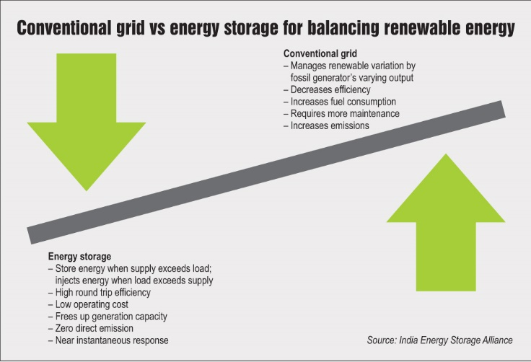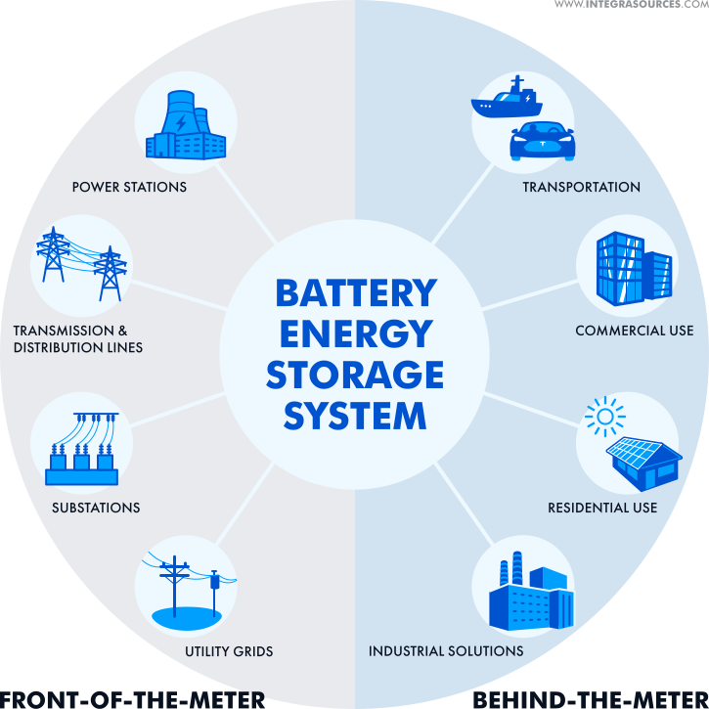
Figure 1. The futuristic role of energy storage when this is integrated with renewable energy resources to ascertain the demand, production and efficient and uninterrupted delivery (storage n.d.). https://renewablewatch.in/2018/07/20/enabling-ecosystem/ https://www.integrasources.com/blog/energy-management-and-energy-saving-bess/

Ferroelectrics: Energy harvesting materials
Since the discovery of ferroelectricity, the ferroelectric materials are playing significant role for the technology and continuously propelling the area of power electronics, capacitors, memory storage, energy harvesting, energy storage, imaging and actuation etc. due its inherent ability of demonstrating spontaneous polar functionality. For electrical energy storage technology, a dielectric with special characteristics are desirable. Battery may supply energy with a certain rate for a longer time. From the application point of view, Battery are considered as suitable source of energy where low power as required to drive the device. Capacitors instantaneously flows all amount of stored energy with enormous rate.
Table
Source | Energy density  (W.h/kg) | Power Density (W/kg)
Battery | 10-300 | 500
Capacitor | $$<30$$ | $${10}^{8}$$
Supercapacitor | $$<30$$ | $${10}^{1}-{10}^{6}$$

As, super-capacitor possesses high-energy storage density. However, its low power density does not make it suitable for certain application where high power density are desired e.g. high power electronics, electron guns, active armor and directed energy weapons etc. To fulfill the requirement of high power electronics, capacitor based efficient energy storage devices are in urgent demand. With the unprecedented development in the area of power electronics, dielectric materials with high energy-storage density, low loss, and good temperature stability are highly desirable candidate in power electronics for potentially high discharge mechanism (Hao, A review on the dielectric materials for high energy-storage application 2013). The dielectric system with high energy storage capacity is less explored. However, there are physical approaches may be employed to enhance the energy storage performances. Here, we will discuss the mechanism of enhancement of energy storage. Based on their response towards the externally applied electric field, the dielectric materials may classified in to linear dielectrics, piezoelectric, pyroelectric, ferroelectric and relaxor.

Linear Dielectric Material:
Dielectrics are insulator material in nature, i.e. ideally, no current will flow through the dielectric system when electrical voltage is applied to its two terminals. However, at microscopic level, charge re-distribution yields significantly important phenomena- specially when its capacitive feature is taken in to consideration. When electric field is applied across the dielectric specimen, it transformed into electrically polarized system due to separation positively charged nucleus and negatively charged electrons of electrically neutral atoms. Whole system become polarized due to shifting of electrons clouds towards the positive voltage. The dielectric materials which exhibits linear variation of polarization with the external field and follows same polarizing path on the reversal of field and polarization become zero when field on removal of field. All dielectric materials are insulators, but a good dielectric is one, which get easily polarized.

Piezo-electric Material:
The piezoelectric effect was first discovered by Jacques and Pierre Curie in 1880. Piezoelectrics materials are the technologically important class of materials. Which exhibits linear electromechanical responses when they are subjected to external electrical or mechanical stimuli. Piezoelectrics exhibits coupling between mechanical and electrical energy. Under the application of mechanical stress, the specimen produces electrical voltage on the application of mechanical stress and mechanical effect when electrical voltage is applied. Piezoelectrics plays significant role in electronics devices and gadgets such as energy harvesting, generation and storage, sensor, accelarators, ultrasonic transducers, biomedical, structural, and environmental applications, filters and resonators and micro-electromechanical systems.

Pyroelectric Materials:
Pyroelectric materials exhibits generation of electrical signal when the specimen is subjected to thermal variation due to having non-zero value of polarization in the absence of an electric field. This phenomena is known as pyroelectric effect. The spontaneously polarized bulk material may be equivalently transformed in to capacitor form of having bound surface charges of opposite nature. When thermal variation causes reduction in degree of polarization as well as drop in bound charge density of opposite surfaces. Under open-circuit condition, electrical voltage are generated across the surface and in short-circuit condition current flows through the external circuit. Experimentally, pyroelectric current ($I_{pyro}$) is determined as:
$$I_{pyro}=\frac{dq}{dt}=p⋅A⋅\frac{dT}{dt}$$
Where $p=\frac{dP}{dT}$ is the pyroelectric coefficient, A is geometrical area of conducting electrode, and dT/dt is the rate of change of temperature of specimen.
Ferroelectric Material:
Ferroelectrics are the materials that exhibit spontaneous electric polarization due to having naturally parallel alignment of constituent dipole moments. When induced polarization is linearly proportional to the applied external electric field, this class of materials are called dielectrics. There are certain materials which exhibit non-linear dependence of polarization and electric field. Such materials are termed as ferroelectrics. In addition, ferroelectrics demonstrate the peculiar polarization curve, which is characterized by a hysteresis loop. The ferroelectric state of the specimen are quite sensitive to the history. When externally applied field is removed, the polarization of ferroelectric system remain non-zero and the orientation of polarization can be switched via reversing the direction of field.

Principle of energy storage
Electrical energy storage is designed to play key roles towards—lowering the electricity costs by storing energy, improved reliable supply of energy with greater flexibility and security during the failures caused by disasters, and green and sustainable in manner. More importantly, energy storage may provide support the solar and wind energy renewable scheme via favoring the decarbonisation and decentralization of loads on electric grid. Since renewable energy generation can be intermittent and variable, energy storage systems can store excess energy when generation is high and deliver it when generation is low, enabling a more reliable and consistent power supply from renewable sources.

The key principles of energy storage include:
Conservation of Energy: The fundamental principle of energy storage is to identify the appropriate route to convert the ambient energy into a more suitable form of energy. Energy storage systems aims this principle by capturing and storing energy in a form that can be easily retrieved and converted back into its original form.
Conversion Efficiency: Energy storage systems aim to maximize the efficiency of the energy conversion process. Most of energy conversion process suffers from weak energy conversion efficiency and are considered as in-efficient for application point of view. Higher efficiency ensures that minimal energy is lost during the storage and conversion process, maximizing the usefulness of the stored energy.
Energy Density: Energy density is an important principle in energy storage, equivalent to the amount of energy per unit volume that can be stored. Higher energy density enables more energy to be stored in a compact and lightweight manner, which is particularly important for portable and mobile applications such as electric vehicles.
Charge and Discharge Rates: Energy storage systems should be capable of both charging (storing energy) and discharging (retrieving energy) at desirable rates. The charge and discharge rates determine how quickly energy can be stored or released, and they can vary depending on the specific technology or system used for energy storage.
Environmental Impact: Energy storage systems should be capable to reduce their footprint on environmental impact. This includes considerations such as the use of environmentally friendly materials, efficient manufacturing processes, and responsible end-of-life disposal or recycling methods for energy storage devices.
Theory of energy storage of ferroelectrics:
Ferroelectric materials are known for their ability to exhibit spontaneous electric polarization that can be reversed by the application of an external electric field. This property allows them to store and release electrical energy, making them suitable for energy storage applications. The theory of energy storage in ferroelectric materials involves the interaction between the electric field, polarization, and the energy stored in the material. When a ferroelectric material is subjected to an electric field, the electric dipoles within the material align in response to the applied field, resulting in the development of a net polarization. This alignment process is known as polarization switching or domain reorientation. The energy required to switch the polarization depends on the characteristics of the ferroelectric material and the strength of the applied electric field. The energy stored in a ferroelectric material arises from two main contributions:
Electric Field Energy: The energy associated with the electric field is proportional to the square of the applied electric field strength. When the polarization of the ferroelectric material is switched, the electric field energy is stored in the material. This energy can be released when the polarization is reversed by an opposite electric field, allowing the material to act as an energy storage device.
Domain Wall Energy: Ferroelectric materials consist of multiple domains, each with a distinct polarization direction. Domain walls separate these domains. The movement of domain walls during polarization switching involves the reorientation of the material's polarization and incurs energy due to the creation and annihilation of domain walls. The energy associated with domain wall motion contributes to the overall energy storage capability of the ferroelectric material.
To enhance the energy storage performance of ferroelectric materials, various factors can be considered, such as material composition, crystal structure, domain engineering techniques, and temperature control. Optimizing these factors can help achieve higher energy density, improved charge-discharge efficiency, and better cycling stability in ferroelectric energy storage devices.
It's worth noting that the theory of energy storage in ferroelectric materials is a complex and active area of research, and different theoretical models and experimental techniques are employed to understand and predict the behavior of these materials in energy storage applications.
Energy storage performances:
Energy storage characteristics refer to the properties and parameters that describe the performance of an energy storage system. These characteristics provide valuable information about the storage capacity, efficiency and other important aspects of the system. Some key energy storage characteristics include:
Energy storage Density: Energy density represents the amount of energy that can be stored in a given volume or mass of the storage medium. It is a crucial characteristic as it determines the storage capacity of the system. Recoverable energy density, also known as usable energy density or practical energy density, refers to the amount of energy that can be effectively stored and retrieved from an energy storage system within a given volume or mass. It represents the energy that is available for use without considering losses or limitations that may occur during the storage and retrieval processes.
Recoverable Energy storage:
Recoverable energy density is the estimation of actual usable amount energy of a storage system. It provides a more realistic measure of the energy storage capacity of a system. Recoverable energy density is an important parameter during the evaluation of storage characteristics for a specific application. It provides a more accurate assessment of the usable energy capacity, allowing for a better understanding of the actual energy available for use and the practical performance of the storage system. Loss energy density refers to the energy that is dissipated or lost during the operation of an energy storage system. It represents the energy that is not recoverable or usable for the intended purpose due to loss. The efficiency of an energy storage system represents the ratio of the useful energy output to the energy input. It accounts for losses that occur during charging, discharging, and any other energy conversion processes within the system.

The recoverable energy W_{rec}, energy loss W_{loss} and efficiency $η$ is determined graphically from the isothermal ferroelectric hysteresis loop using mathematical relation:
$W_{rec }= \int_{P_{r}}^{P_{max}}{E⋅dP}$ 1
$W_{loss }= \int_{0}^{P_{max}}{E⋅dP}-\int_{P_{r}}^{P_{max}}{E⋅dP}$ 2
$η=\frac{W_{rec}}{W_{rec}+W_{loss}}\%$ 3
It's important to note that loss energy density represents the energy that is dissipated or lost within the storage system itself. It does not account for losses that may occur during energy transmission or other external factors. Losses should be minimized in energy storage systems to maximize the usable energy and overall system efficiency.
Power Density: Power density refers to the rate at which energy can be delivered or extracted from the storage system. It indicates how quickly the energy can be accessed when needed. Higher power density allows for rapid charging and discharging, making it suitable for applications with high power requirements.
Cycle Life: Cycle life refers to the number of charge and discharge cycles that a storage system can undergo while maintaining a certain level of performance. It indicates the system's durability and longevity. Longer cycle life is desirable to ensure a reliable and long-lasting energy storage solution.

Dielectric materials for energy storage:
Dielectric materials play a significant role in energy storage application, particularly in capacitors and dielectric energy storage devices. These materials are chosen for their ability to store electrical energy in an electric field, thanks to their unique dielectric properties. According to the empirical consideration, there are four class of dielectric materials, namely dielectric-glass-ceramics, relaxor ferroelectric, antiferroelectrics and polymer-based ferroelectrics are thought to be more proven candidates for next-generation application. Here, we provide systematics analysis and state-of-the-art advances in electric energy-storage performance in these materials.

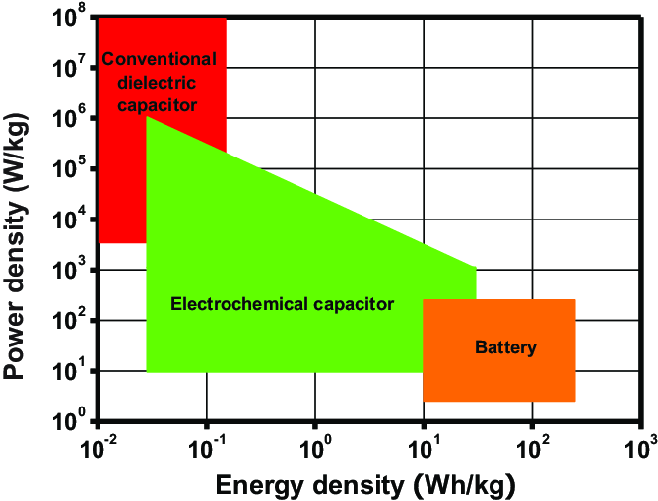
Figure 2 Diagram of power density as a function of energy density in different energy-stored devices. (Hao, A review on the dielectric materials for high energy-storage application 2013)

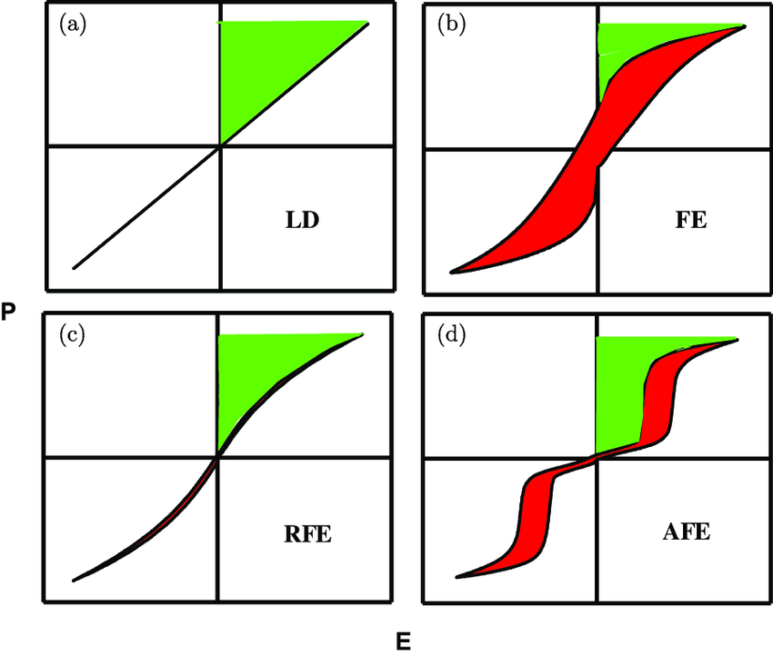
Figure 3 Diagram of hysteresis and energy storage density for (a) linear dielectrics, (b) ferroelectrics, (c) relaxor ferroelectrics, and (d) antiferroelectrics. The green area in the first quadrant is the recoverable energy density J reco , and the red area is the energy loss J loss . (Hao, A review on the dielectric materials for high energy-storage application 2013)
Based on physical prerequisites, the materials exhibit high value of saturation-polarization, low remnant polarization, and high electrical breakdown field, are required to demonstrate efficient energy storage activity. There are various class of dielectric materials e.g. anti-ferroelectrics, dielectric-glass-ceramics, relaxor ferroelectric and polymer-based ferroelectrics that seem to be more favorable than the conventional ferroelectric system due to high value of remnant polarization (Hao, A review on the dielectric materials for high energy-storage application 2013).

Ferroelectric polymers exhibit certain additional advantageous properties e.g. flexibility, process ability, and lightweight nature of polymers. These materials can be synthesized and easily tuned to possess high dielectric constants and excellent charge storage capabilities, making them suitable for energy storage applications. Here are some key aspects of polymer ferroelectric materials for energy storage:
High Energy Density: Polymer based ferroelectrics have the potential to store a large amount of electrical energy due to their high dielectric constants. By incorporating the ferroelectric polymers into capacitors, higher energy densities can be achieved compared to traditional dielectric materials.
Reversible Polarization: One of the key advantages of ferroelectric polymers is their ability to exhibit reversible polarization. When an external electric field is applied, the dipoles in the material aligns, resulting in the storage of electrical energy. This energy can be released when the electric field is removed or reversed. The reversible nature of the polarization makes polymer ferroelectric materials suitable for repeated charge and discharge cycles.
Flexibility and Formability: Polymer ferroelectric materials offer flexibility and formability, allowing them to be shaped and integrated into various device configurations. They can be processed using techniques such as spin coating, solution casting, or inkjet printing, enabling the fabrication of thin films, coatings, or complex device structures.
Low Cost and Scalability: Polymers are generally less expensive compared to inorganic ferroelectric materials, such as ceramics. Additionally, the manufacturing processes for polymer ferroelectric materials are often less complex and more scalable, making them attractive for large-scale production.
Multifunctionality: Polymer ferroelectric materials can exhibit other desirable properties such as high breakdown strength, good thermal stability, and mechanical flexibility. These additional functionalities make them suitable for diverse applications beyond energy storage, such as sensors, actuators, memory devices, and optoelectronic devices.
While polymer ferroelectric materials hold great potential for energy storage, there are still challenges to overcome. Some of these include stability over long-term cycling, polarization fatigue, and the need for higher operating temperatures compared to traditional dielectric materials. Ongoing research efforts are focused on addressing these challenges and further optimizing the performance of polymer ferroelectric materials for practical energy storage applications.
Dielectric Strength: The dielectric strength of a polymer ferroelectric refers to the maximum electric field or voltage that the material can withstand before experiencing electrical breakdown. This property is significant in applications where high electric fields are present, such as in capacitors, actuators, and memory devices. The dielectric strength of a polymer ferroelectric can vary depending on the specific polymer used, its composition, processing conditions, and any additives or fillers incorporated into the material. Some commonly used polymer ferroelectrics include poly(vinylidene fluoride) (PVDF) and its copolymers, such as poly(vinylidene fluoride-trifluoroethylene) (PVDF-TrFE) and poly(vinylidene fluoride-chlorotrifluoroethylene) (PVDF-CTFE). PVDF, for instance, is known for its high dielectric strength, typically in the range of 200-300 MV/m (megavolts per meter). PVDF-based copolymers like PVDF-TrFE and PVDF-CTFE also exhibit good dielectric strength, often similar to or slightly lower than PVDF. It's important to note that the dielectric strength of a polymer ferroelectric can be influenced by factors such as sample thickness, temperature, frequency of the applied electric field, and the presence of defects or impurities within the material. Additionally, the orientation and crystalline structure of the polymer can also impact its dielectric strength.
PVDF
PVDF are found to be crystallized in various form, based on the linking of functional group with the structural back bone. PVDF exhibits the repeating of (-CH₂-CF₂-)n. The overall properties of PVDF material can be tuned significantly in variety of ways. The length and linking of carbon chain provides huge fertile ground towards the realization of broad physical properties. As more number of monomers are included the length of chain increases, the designed materials attained soft waxy phase. When the length of the chain is maintained above 1000, a flexible solid structure is obtained. It is typically a semi-crystalline material with 50% amorphous nature. It has highly regular structure. In which the monomer vinyl difluoride units are connected in head-to-tail fashion. There is very low probability of occurrence of head-to-head arrangement. On the basis of linking the functional –H and –F groups to polymer chain (–C –C –), the PVDF materials are found to be crystallize in different phases i.e. $α$, $β$, $γ$, $δ$ and $ε CITATION Kos12 \backslash l 1033 (Koseki 2012)$. However, the underlying physical characteristics are very sensitive to the crystalline structure i.e. symmetry of –H and –F group attachment.
Among these, $α$ and $β$ conformations are the most general and important class of polymorphs of PVDF (J. Y. Lim 2015). The $α$ are synthesized under normal crystallization conditions. β is formed by crystallization under pressure or by mechanical distortion of polymer films. The $α$ is the thermodynamically stable structure. β- phase can be obtained via driving crystal phase transition from the α -phase. The most common technique for obtaining polar β -PVDF involves mechanical extension and electrical poling. Mechanical extension contributes to the transition of the original spherulitic structure into a crystal array, in which the molecules are forced into their most extended conformation (polar β-phase), with all of the dipole moments aligned in the same direction.
For comparison of relevant parameters of leading piezoelectrics and β-phase PVDF is given in Table [1]. The comparative study suggests that β-phase PVDF is having outstanding mechanical flexibility as well as high piezoelectric response. This excellent property of β-phase PVDF is devoted to its small Young’s modulus and very low acoustic impedance. Low acoustic impedance parameter, in comparison to inorganic counterpart, makes highly suitable for acoustic sensor for underwater operation and biological tissue application. Its high effective coupling coefficient enables PVDF materials for wide bandwidth applications. Due to its excellent thermal and mechanical stability and simple fabrication process empowers a smooth and low cost production of PVDF at large scale.
Table 1 Comparison of material parameters of PZT and β-PVDF
Material | PZT | β-PVDF
Density (g/cm³) | 7.55 | 1.78
Acoustic velocity (m/s) | 3603 | 2200
Young's Modulus (GPa) | 1200 | 3
Acoustic Imp (10⁶ kg/m²s) | 27.2 | 2.7
Efficient Coupling Coefficient k²_{eff} (%) | 20.25 | 14
Piezoelectric Coefficient d33 (pC/N) | 289–380 | −24 to 34
Coefficient of thermal Expansion (10⁻⁶) | 1.75 | 42–75

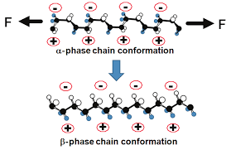
Figure 4 Conversion of $α$-PVDF into $β$-PVDF conformation (J. Y. Lim 2015).
Ferroelectric polymers are being actively explored as dielectric materials for electrical energy storage applications. However, their high dielectric constants and outstanding energy densities are accompanied by large dielectric loss due to ferroelectric hysteresis and electrical conduction, resulting in poor charge–discharge efficiencies under high electric fields. To address this long-standing problem, here we report the ferroelectric polymer networks exhibiting significantly reduced dielectric loss, superior polarization and greatly improved breakdown strength and reliability, while maintaining their fast discharge capability at a rate of microseconds. These concurrent improvements lead to unprecedented charge–discharge efficiencies and large values of the discharged energy density and also enable the operation of the ferroelectric polymers at elevated temperatures, which clearly outperforms the melt-extruded ferroelectric polymer films that represents the state of the art in dielectric polymers. The simplicity and scalability of the described method further suggest their potential for high energy density capacitors.

Methodology for the optimization of energy storage property:
The low energy storage density of common ferroelectric materials has significantly hindered their energy storage application area. For efficient energy storage performance, the materials should possess high energy storage density and good dielectric strength, also must be nonhazardous and cost effective(Yang et al., 2023). The energy storage characteristics of ferroelectric materials can be influenced and modified over various methods and techniques. Here are some approaches to change the energy storage characteristics of ferroelectrics:
Material Composition: The energy storage characteristics of ferroelectric materials can be altered by adjusting their chemical composition. Modifying the elemental composition or doping the material with impurities can affect properties such as dielectric constant, polarization, coercive field, and energy density. Different compositions can be explored to optimize specific energy storage characteristics.
Crystal Structure and Phase Transitions: Ferroelectric materials exhibit different crystal structures and may undergo phase transitions at specific temperatures. By controlling the crystal structure or inducing phase transitions, the energy storage properties can be modified. For example, changes in the Curie temperature or the presence of multiple phases can influence the energy storage behavior.
Domain Engineering: Ferroelectric materials consist of domains, each with a distinct polarization direction. Domain engineering techniques, such as domain wall manipulation or domain switching, can be employed to modify the energy storage characteristics. Creating and controlling domain structures can enhance the energy storage performance by optimizing domain wall motion and polarization switching behavior.
Electric Field and Temperature Control: The energy storage characteristics of ferroelectrics can be influenced by the applied electric field and temperature. Varying the strength and duration of the applied electric field during polarization switching can affect the energy storage capacity. Similarly, temperature control can modify the phase transition behavior and alter the energy storage properties.
Thin Film Deposition and Interface Engineering: Ferroelectric thin films offer additional opportunities for tailoring energy storage characteristics. Techniques such as pulsed laser deposition, chemical vapor deposition, or physical vapor deposition can be used to deposit thin films with controlled thickness and interfaces. Interface engineering at the film-substrate or film-electrode interfaces can optimize energy storage performance by enhancing charge transfer and reducing losses.
Composite and Hybrid Structures: Combining ferroelectric materials with other materials or integrating them into composite or hybrid structures can provide additional flexibility in modifying energy storage characteristics. Hybrid structures can offer improved energy density, enhanced charge transport, reduced losses, or tailored dielectric properties.
External Fields and Stimuli: Applying external fields or stimuli, such as mechanical stress, strain, or magnetic fields, to ferroelectric materials can influence their energy storage properties. These external factors can induce changes in polarization and alter the energy storage characteristics.

Challenges and Difficulties in Adoption of Renewable energy as primary resource
Some of the primary difficulties in renewable energy include:
Intermittency: Most renewable energy sources, such as solar and wind, are intermittent. They depend on weather conditions and time of day, which can make them unreliable as primary energy sources without effective energy storage solutions.
Grid Integration: Integrating renewable energy into existing electrical grids can be challenging. The grid needs to be upgraded to handle variable sources of power, and this can be expensive and time-consuming.
Resource Availability: The availability of renewable energy resources varies by location. For example, areas with little sunlight or wind are less suitable for solar or wind power generation. This can limit the widespread adoption of these technologies.
Land and Space Requirements: Large-scale renewable energy installations, such as solar and wind farms, require a significant amount of land or space. This can lead to conflicts over land use, especially in densely populated areas.
Environmental Impact: While renewable energy sources are generally cleaner than fossil fuels, they are not entirely without environmental impact. For instance, the production and disposal of solar panels and wind turbine blades can generate waste.
Cost: While the cost of renewable energy technologies has been decreasing over time, the initial investment can still be high. Governments and industries should need to explore certain alternative to make these technologies more accessible to a broader range of consumers.
Technological Challenges: Developing and scaling up new renewable energy technologies can be technically challenging and time-consuming. To make renewable energy technology user-friendly, Research and development are ongoing to improve efficiency and reduce costs.
- Public interest and support for sustainable development
- Incentives for ESS investment and development
- Safety and flexibility in operations
- Cost of energy deliverability should further reduce
- Parallel dependence of ESS on power electronics based integrating systems.
- Development of international standards for ESS selection and implementation
- Weak grid and poor formed markets
- Availability of land and space
- Ease in operation and continuous space for technological growth
- To ensure sustainability and access to component materials.
- Installation infrastructure and maintenance requirements.
Despite these difficulties, there is a growing recognition of the need to address climate change and reduce our dependence on fossil fuels. As a result, governments, researchers, and industries are actively working to overcome these challenges and accelerate the transition to a more sustainable energy future.

Conclusion:
The future global economic growth is closely related with rapidly developing global market. Wind, solar, biomass, and geothermal energy harvesting are quite desirable today for their cost-effective characteristics, and are emphasizing considerable contribution towards broader commercialization. Due to inconsistency in availability renewable energy resources, a broad spectrum of renewable energy with efficient energy harvesting technology should be integrated to avoid the condition of energy insecurity. Current communication and information technology is highly relied on internet of things. To meet the demand of uninterrupted power supply to components, local energy generation and storage system must be installed along with the devices. Ferroelectric system provides reliable solution towards the autonomy in generation and storage of electrical energy. Ferroelectric energy devices are capable to generate hundreds of kilovolt and supply power up to megawatt. Ferroelectric energy storage is not available for commercial low power application. A proper implementation of ferroelectric energy application will provide sustainable solution to the renewable energy technology.

Reference:
2023. "2021–2023 global energy crisis." Wikipedia.
2023. Global market insights . https://www.gminsights.com/industry-analysis/energy-storage-systems-market.
Hao, Xihong. 2013. "A review on the dielectric materials for high energy-storage application." Journal of Advanced Dielectrics 03: 1330001. doi:https://www.worldscientific.com/doi/abs/10.1142/S2010135X13300016.
J Y Lim, Jihun Kim, Sehyun Kim, Soonjong Kwak, Youngchul Lee, Yongsok Seo,. 2015. "Nonisothermal crystallization behaviors of nanocomposites of poly(vinylidene fluoride) and multiwalled carbon nanotubes,." 62: 11-18. doi:https://doi.org/10.1016/j.polymer.2015.02.012.
J. Y. Lim, S. Kim and Y. Seo. 2015. "Enhancement of E-phase in PVDF by Electrospinning." Proceedings of PPS-30. American Institute of Physics. 070006-6. doi:10.1063/1.4918441.
Koseki, Y., Aimi, K. Ando, S. 2012. "Crystalline structure and molecular mobility of PVDF chains in PVDF/PMMA blend films analyzed by solid-state 19F MAS NMR spectroscopy." Polymer Journal 44: 757–763. doi:https://doi.org/10.1038/pj.2012.76.
Omnexus. n.d. "https://omnexus.specialchem.com."
storage, energy. n.d. "https://energystorage.org." why-energy-storage/benefits/.
Wu, Ting, Hao Jin, Shurong Dong, Weipeng Xuan, Hongsheng Xu, Leihe Lu, Zijing Fang, Shuyi Huang, Xiang Tao, Lin Shi, Shuting Liu, and Jikui Luo. 2022. "A Flexible Film Bulk Acoustic Resonator Based on β-Phase Polyvinylidene Fluoride Polymer." Sensors 20: 1346. doi:https://doi.org/10.3390/s20051346.

