CHAPTER – 4

POLYMER CAPPED SILVER NANOPARTICLES FROM ZIZIPHUS NUMMULARIA LEAVES EXTRACT: POTENT ANTIBACTERIAL AND ANTIOXIDANT ACTIVITY

Abstract:
Generally, synthesis and encapsulation process improve therapeutic value of nano encapsulated drugs. The biodegradable monodisperse silver nanoparticles (AgNPs) biosynthesized from Ziziphus nummularia leaves and encapsulated with polyvinyl pyrrolidone( PVP) polymer as antibacterial agents, due to its high bioavailability, better encapsulation and less toxic properties. The nanoparticles (AgNPs) biosynthesized from Ziziphus nummularia leaves and capped with polyvinyl pyrrolidone (PVP) polymer, The acquired AgNPs and polymeric functionalized AgNPs were fully characterised by the UV- Visible spectroscopy , Transmission electron microscopy (TEM), X-Ray diffraction pattern (XRD) and Fourier transform infrared spectroscopy (FTIR).The crystalline Ag NPs and Polymer Functionalized AgNPs have a face-centered cubic structure with an average size of 9.20 nm, according to X-ray Diffraction spectroscopy. Fourier Transform Infrared spectroscopy revealed that biomolecules such as proteins are responsible for metal ion reduction and the formation of an encapsulating layer in terms of metal ions. High-Resolution transmission electron microscopy revealed that Polymer functionalized AgNPs ranged in size of 10 nm. . AgNPs and Polymer functionalized AgNPs showed effective antimicrobial and antioxidant activity. The biosynthesized mono disperse silver nanoparticles and encapsulated silver nanoparticles demonstrated better antimicrobial and antioxidant activity which can be used in various biomedical applications.

Keywords:
Antibacterial and antioxidant; Characterization; Green synthesis; Polyvinyl pyrrolidone (PVP); Ziziphus nummularia.

1. Introduction
Silver nanoparticles are among one of the most extensively studied nanomaterials. Which metal ions have been used for the treatment of various diseases and biomedical applications [1]. Silver and Gold were used in the form of "Bhasma (Swarna and Rajat) for asthma, anemia, chronic fever, cough, sleeplessness, muscle weakness, and weak digestion [2,3]. The eco-friendly method in chemistry and chemical technology was developed out of concern for environmental problems [4]. Silver nanoparticles are highly commercialized materials [5]. Hence, an ideal route for silver nanoparticles synthesis is required that provides a simple, cost-effective, co-friendly is a biological method [6]. Recent advancement in chemistry approaches for silver nanoparticles, synthesis has proven its potential in all biomedical application. The synthesis of silver nanoparticles using biosources has always been an exciting task for researchers due to their versatile applications. Some of the scientists have been used different biological sources for the synthesis of silver nanoparticles including plant sources (extract of leaves, root, flowers, seeds, stems, and fruits) and microbial sources (like bacteria, fungi, and their culture media)[7].Several medicinally important biomolecules from biological sources including alkaloids, proteins, phenols, saponins, tannins, enzymes, and terpenoids involved in the reduction and stabilization of nanoparticles[8]. Metal nanoparticles can act as diagnostic and therapeutic agents of various disease models including cancer, microbial infections, cardiovascular disease, and neurodegenerative disease [9]. Owing to their excellent biocompatibility and medicinal value, Phyto nanoparticles are recommended for several applications such as antimicrobial, anticancer, image contrast agents, fluorescent probes and drug delivery systems [10]. Phytosynthesized silver nanoparticles are the development of sensors for the recognition of various analytes related to agriculture, diagnostics, and environmental sector [11].Importantly, an extract of Ziziphus nummularia has been shown to possess DPPH radical The utilization of plants for the synthesis of AgNPs relies on the fact that the process is faster, easier, eco-friendly, cost-effectiveness and reliable and forms, more stable synthesized particles than other, classical methods. The formation of silver nanoparticles and also functionalized the obtained silver nanoparticles with polymers to further enhance their biocompatibility for the desired application. Recently many plants have been employed for the synthesis of AgNPs such as Crateva Religiosa [12], Bauhinia Variegata [13], Cleistanthus collinus [14], Morinda citrifolia [15], Iris germanica [16], Ceropegia thwaitesii [17], Sauropus androgynous[18], Rhizophora stylosa[19], Ganoderma lucidum [20] etc. There are so many medicinal plants used to synthesize metal nanoparticles [21-24]. Ziziphus nummularia possesses various pharmacological activities like antioxidant, analgesic and anti-inflammatory, antinociceptive, antipyretic activity. The leaves are used for the treatment of cough, cold, typhoid, and for healing of cuts and cutaneous disease [25]. Importantly, an extract of ziziphus nummularia has been shown to possess DPPH radical scavenging activity [26]. By reference of this evidence, we have examined the green synthesis of polymer functionalized AgNPs from Ziziphus nummularia leaves water extract and investigated its antibacterial and antioxidant activity.
2. Material and Method
2.1. Material
Salt of AgNO₃ was received from Sigma Aldrich, fresh leaf of Ziziphus nummularia was collected from farm of North Gujarat region. Bacterial culture was purchased from MTCC Chandigarh DPPH was purchased from ACS, sigma Aldrich product of polyvinyl pyrrolidone (PVP mw 40,000) in its purity was procured commercially and used without further purification.
2.2. Preparation of plant extract
Fresh leaves of Ziziphus nummularia were washed twice with double-distilled water. Washed leaves were kept for drying to remove water content at room temperature and then cut into fine pieces. 10 gm of plant materials (fine pieces) was taken and boiled with 100 ml of double-distilled water at 40-50⁰C for 10 minutes and cooled. The obtained extract was filtered by Whatman filter paper no.1 and stored at 4⁰C in a freezer for further use for the synthesis.
2.3. Green synthesis of silver nanoparticles
90 ml of 1mM AgNO₃ solution was added to 10 ml leaf extract and this reaction mixture was placed on a hot plate at 60⁰C with constant stirring with a magnetic stirrer for 2 hours. At the starting point of the reaction we observed colour change from yellowish to dark brown, colour change revealed the preliminary confirmation of the formation of the silver nanoparticles. The reduction of Ag⁺ to Ag⁰ in the reaction mixture was due to the biomolecules present in the plant which acts as a reducing agent. Final confirmation for the formation of the silver nanoparticles was studied by UV visible analysis. Use Centrifugation to isolate AgNPs from the reaction mixture. The reaction mixture was centrifuged at 10,000 rpm for 20 minutes. Nanoparticles were observed at the bottom of the centrifuge tube as purified twice by double distilled water, then collected and dried at 70-75⁰C in an oven for 2 hrs. Dry crystalline powder of AgNPs was kept in an airtight bottle for biological activity and characterization (FT-IR, XRD, and HR-TEM).
2.4. Preparation of PVP formulated silver nanoparticles
0.2 gm PVP were dissolved in 100 ml of distilled water and stirred for 1 hr at 80⁰C. The solution was then slowly added to the homogeneous solution of AgNPs formed from leaf extract. Final confirmation of formation of PVP functionalized silver nanoparticles was studied by UV visible Analysis. Centrifugation was used to isolate PVP-capped silver nanoparticles. The reaction mixture was centrifuged at 6000 rpm for 15 minutes. Nanoparticles were observed purified twice by double distilled water then collected and dried at 80 -85 ⁰C.
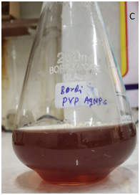
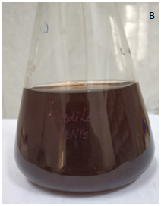
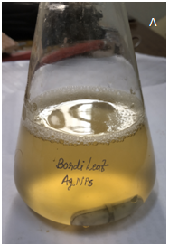

Figure: 1 Colour change from yellowish to dark brown [A] Initial Time, [B] After 2 hr and [C] After adding PVP Ag NPs

2.5 Characterization of Green synthesis Silver nanoparticles
The absorption spectra of synthesized AgNPs were measured in the range of 200 nm to 800 nm by a UV-visible spectrophotometer (Shimadzu UV-1800 UV-visible spectrophotometer). The shape and size of synthesized AgNPs were determined by High-resolution transmission electron microscopy (HR-TEM). The surface chemistry of the nanoparticles was studied using Fourier transform Infrared spectroscopy (FTIR), X-Ray diffraction (XRD) study was carried out to purify crystalline structure with an average particles size using Rigaku D/max 40 kV diffractometer equipped with the graphite chromator.
2.6 Antibacterial activity of silver nanoparticles
Antibacterial activity of synthesized AgNPs and polymer functionalized AgNPs was carried out by Harsh Mistry et.al.(2020) with some modifications[27]. All the test bacterial strains were grown in nutrient broth at 37⁰C overnight and adjusted to 0.5 as per McFarland standards. Under sterile conditions, 100 μL of gram-positive (Staphylococcus aureus) and gram-negative strains (Escherichia coli) were spread on each nutrient agar plate. A diameter well of 10 nm was punched on the agar plate using a cork borer and the synthesized AgNPs, polymer functionalized AgNPs and AgNO₃ were inoculated in each well. Plates were incubated at 37⁰C for 24 hours and the bacterial activity was evaluated by measuring the diameter of the inhibition zone using zone scale (HiMedia).
2.7Antioxidant activity by 2,2-diphenyl -1-picrylhydrazyl (DPPH) method
Antioxidant capacity of synthesized AgNPs and polymer capped AgNPs was performed according to Harsh et.al. [27] with slight modification. The radical scavenging activity of AgNPs, polymer functionalized AgNPs, and vitamin C was determined using the DPPH. Various concentration (10,50,80,100 μg/ml) of 1 mL AgNPs were mixed with 1 ml of 1 mM freshly prepared DPPH solution followed by vortex. Then, the solution was kept for 30 minutes in dark at room temperature. The absorbance was recorded at 517 nm DPPH with all reagents except sample was used as a control and methanol was used as a blank. The free radical scavenging activity was represented as the percentage of inhibition which was calculated by using the following formula.
% of scavenging = [(Pc-Ps)/Pc] × 100
Where Pc is the absorbance of the control and Ps is the absorption of AgNPs/polymer capped AgNPs/vitamin C.
3. Result and Discussion
3.1 UV-visible spectroscopic analysis.
The aqueous reduction reaction mixture was subjected to a UV-visible spectrophotometer to confirm the formation of AgNPs reduction of Ag⁺¹to Ag⁰ observed by a colour change from light brownish to dark brownish was due to excitation surface Plasmon resonance (SPR) [28] of AgNPs which finally confirmed the production of AgNPs. Observed results are highly in accordance with a recent report [29]. The successful formation of AgNPs and polymer functionalized AgNPs absorbance peak at 431 and 443 nm show in figure 2 [30]. This result is congenial with previous findings [31-33]. Studies show that the SPR of most metallic compounds is size and shape dependant [34-36].

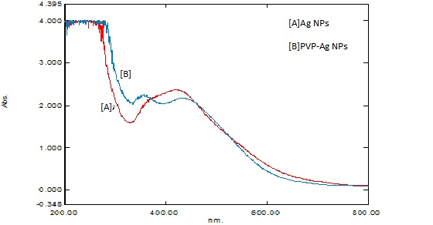

Figure: 2 UV-Visible absorption spectra of [A] Ag NPs [B] PVP Ag NPs
A
B

3.2 Fourier transform infrared spectroscopy (FTIR) analysis:
The FTIR spectrum of synthesized AgNPs is shown in figure 3. Which manifests absorption peaks located between the region about 4000 cm-1 and 500 cm-1. FTIR spectrum of plant extract and AgNPs displays peak at 3300, 3050, 2890, 1597, 1350, 1050 cm⁻¹ for silver nanoparticles. The obtain results are congenial with the previous report [29]. The AgNPs show several peak at 3200,613, 532cm⁻¹ region. The peak at 1421 cm⁻¹is common to both the extract and AgNPs and is characteristic of the C-H bending vibration. Vibration stretching at 3300 cm⁻¹ peak correspond to O-H stretching of water and phenolic compounds. The peak at 1350 and 1050 cm⁻¹ is evidence of the C-H stretching for respective amines. The existence of a peak at 420 cm⁻¹ shows metal oxide bonding. The peak at 1640 cm⁻¹ corresponds to metal carbonyl stretching polymer mediated samples have prominent peaks where the stretching vibration associated with O-H and C-H/ CH2 groups are located at 3350 cm⁻¹ and 2930 cm⁻¹ is associated with the aliphatic hydrocarbons group in polysaccharide, proteins or polyphenols of water molecule bounds in Ag surface respectively [37-40].The observed vibration bands below 600 cm⁻¹ birth AgO surface [41,42]. The obtain results are congenial with previous reports demonstrating the applications of ziziphus nummularia as a reducing agent in the formation of AgNPs and polymer functionalized AgNPs [43,44].
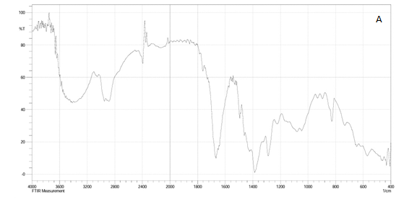

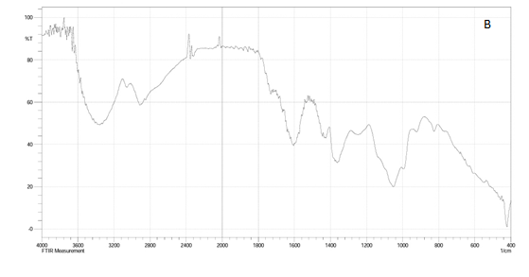

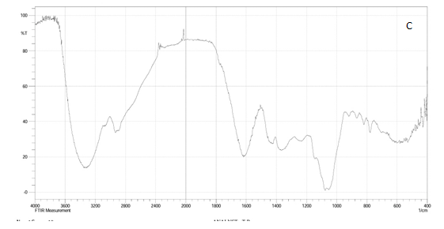

Figure : 3 FT IR Spectrum of [A] Ziziphus nummularia leaf extract [B] Ag NPs [C] PVP functionalized Ag NPs

3.3 X-RAY diffraction analysis:
The XRD pattern of polymer functionalized AgNPs(as seen in Fig.4 ) showed a well-crystallized sample with the major diffraction peaks at 2 theta values of 27.12°, 32.39°,46.33° and77.4° which corresponds to the plane(100), (111), (200), (311) respectively. The alteration of the phase change by PVP may be adduced to the bioconjugate between the polymers component and the formulated polymer capped AgNPs. The mean particle size of PVP AgNPs was calculated using the Debye-Scherer formula given as D = 0.9k/b cos Ɵ, where D is the crystalline size (nm), k is the wavelength of X-ray (0.1541 nm), b represent the angular line full width at half maximum (FWHM) of the peak (in radians) and his the Braggs angle (in radians)[45]. By calculation, the PVP AgNPs were found with a 9.20 nm average particles size which is in fair agreement with the HR-TEM average particle size of ~10 nm.
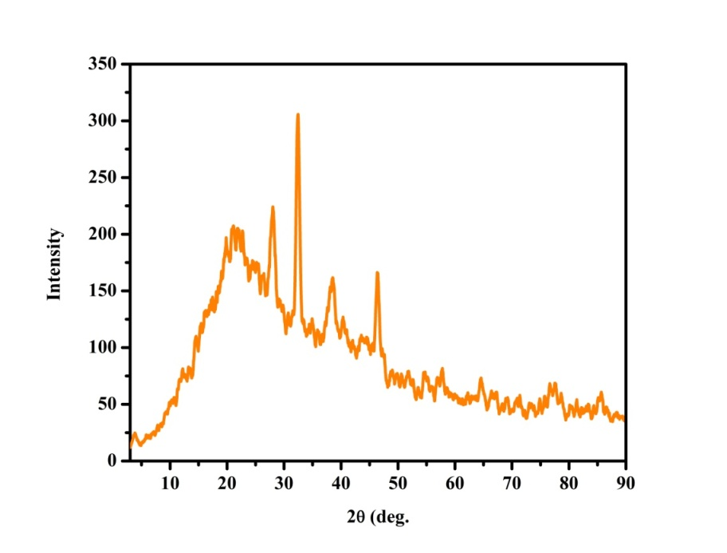

Figure: 4 XRD pattern of PVP functionalized Ag NPs
3.4 HR TEM analysis:
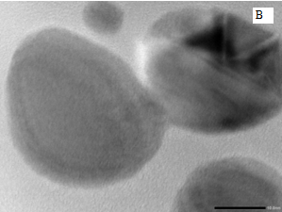
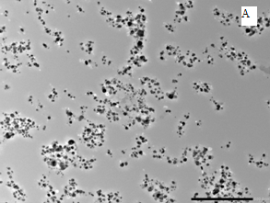
High-resolution transmission electron microscopy HR-TEM was performed using the H-7500 model. Size and shape morphology were studied by HR-TEM shown in figure 5. The polymer functionalized AgNPs has taken up a spherical morphology uniform size with the average particle size of 10 nm shown in figure 6.Using the Selected area electron diffraction(SAED) pattern with bright circular spots, the crystallinity of the biosynthesized polymer functionalized AgNPs was evidenced.

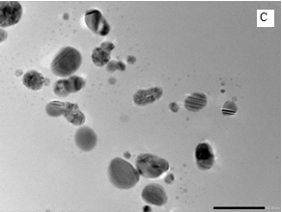
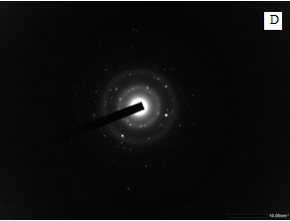

Figure: 5 HR-TEM image [A],[B],[C] and SAED image [D] of PVP functionalized Ag NPs
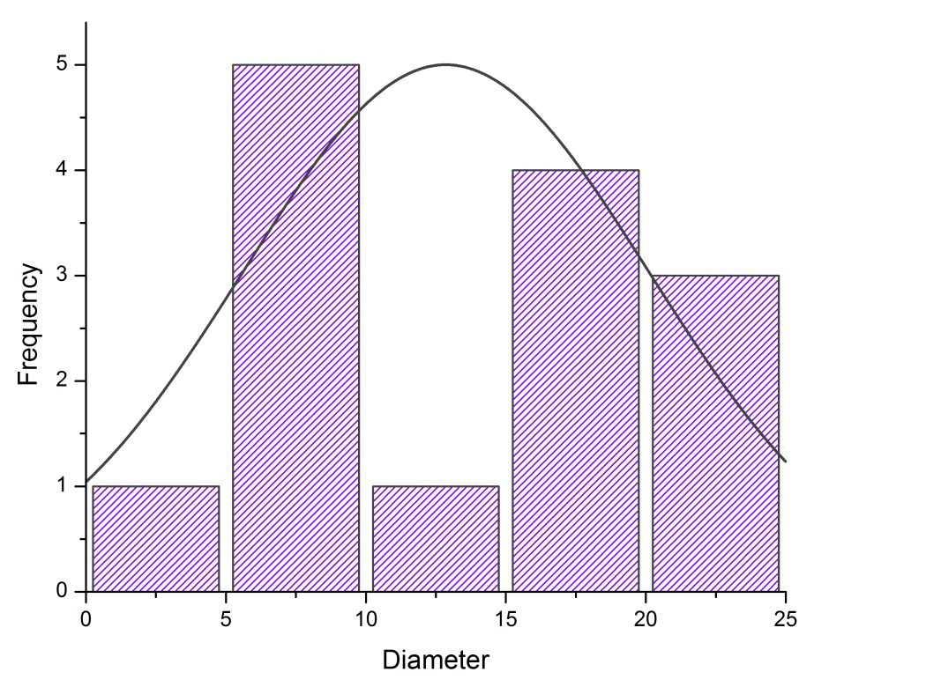

Figure: 6 The size distribution curve from the TEM analysis and SAED pattern of PVP functionalized AgNPs

3.5 Antibacterial activity of AgNPs and Polymer functionalized AgNPs:
The antibacterial potential of AgNPs was assessed by measuring the Inhibition zone of plant extract, silver nanoparticles and polymer functionalized nanoparticles was summarized in table 1.The PVP AgNPs inhibit the growth of Escherichia coli, Staphylococcus aureus , shown in figure 7 It also shows good activities then the all the organisms in comparison with standard drug[27]. PVP AgNPs stand a better chance as a potential substitute for the conventional antibacterial drugs sequel to its activities at a lower concentration.
SR.NO. | Organism | Zone of Inhibition (In mm)
 |  | AgNO₃  (10 mM) | AgNPS | PVP AgNPS | Ampicillin  (1 mg/ml)
1 | Escherichia coli | 15 | 19 | 20 | 15
2 | Staphylococcus Aureus | 15 | 18 | 19 | 17

Table: 1 Antibacterial activity of Ag NPs and PVP Ag NPs

Figure: 7 Antibacterial zones of inhibition of AgNPs and PVP AgNPs in comparison with
Standard Ampicillin.
3.6 Antioxidant activity of AgNPs and Polymer capped AgNPs
DPPH is a steady compound that can be reduced by accepting hydrogen or electrons and has been widely applied to determine antioxidant activity. AgNPs showed effective antioxidant potential as their radical scavenging ability was increasing with the increment concentration. The figure 8 shows the antioxidant activity of the AgNPs what about 48.53%. PVP AgNPs was about 51.15%.Results confirmed that the polymer capped AgNPs have more antioxidant activity than AgNPs. The antioxidant property of the AgNPs is due to the absorption of plant constituents on the silver nanoparticles [46].

Figure: 8 Antioxidant activity (%) of synthesized silver nanoparticle and polymer functionalized Ag NPs in comparison with standard ascorbic acid.

4. Conclusion
Silver nanoparticles were successfully synthesized using an extract of ziziphus nummularia leaves using AgNO₃ salt solution. The formed AgNPs were further functionalized with PVP to enhance its biocompatibility without any hazardous or toxic material further. At the preliminary level, the formation of AgNPs and polymer AgNPs was confirmed by the colour change of solution various characterization techniques were used to confirm the comparison of Ag NPs and polymer capped AgNPs. The UV visible confirmed the formation of AgNPs trolls through visible colour change to dark brown after 2 hours peak at 431 nm. The FTIR spectra gave information of the different functional groups in the Ziziphus nummularia extract responsible for the biogenic formation of AgNPs and polymer-formed AgNPs. Crystalline nature and an average particle size of 9.20 nm AgNPs and polymer capped AgNPs were confirmed by XRD analysis.HR-TEM imaging microscopy which showed a spherical shape with a particle size of 2 to 25 nm. Good Antibacterial Activity of AgNPs and polymer capped AgNPs was performed against gram-positive and gram-negative bacteria which considerable zone of inhibition. Also, the good antioxidant activity of synthesized silver nanoparticles and polymer capped silver nanoparticles. This investigation described the eco-friendly and cost-effective biological method to synthesized polymer capped nanoparticles for antibacterial and antioxidant activity.

7. Reference:
- Jeyaraj M, Sathishkumar G, Sivanandhan G, MubarakAli D, Rajesh M, Arun R, Kapildev G, Manickavasagam M, Thajuddin N, Premkumar K, Ganapathi A. Biogenic silver nanoparticles for cancer treatment: an experimental report. Colloids and surfaces B: Biointerfaces. 2013 Jun 1;106:86-92.
- Pal D, Sahu CK, Haldar A. Bhasma: the ancient Indian nanomedicine. Journal of advanced pharmaceutical technology & research. 2014 Jan;5(1):4.
- Sarkar PK, Das S, Prajapati PK. Ancient concept of metal pharmacology based on Ayurvedic literature. Ancient Science of Life. 2010 Apr;29(4):1.
- Thuesombat P, Hannongbua S, Akasit S, Chadchawan S. Effect of silver nanoparticles on rice (Oryza sativa L. cv. KDML 105) seed germination and seedling growth. Ecotoxicology and environmental safety. 2014 Jun 1;104:302-9.
- Larue C, Castillo-Michel H, Sobanska S, Cécillon L, Bureau S, Barthès V, Ouerdane L, Carrière M, Sarret G. Foliar exposure of the crop Lactuca sativa to silver nanoparticles: evidence for internalization and changes in Ag speciation. Journal of hazardous materials. 2014 Jan 15;264:98-106.
- Bindhu MR, Umadevi M. Antibacterial and catalytic activities of green synthesized silver nanoparticles. Spectrochimica acta part A: molecular and biomolecular spectroscopy. 2015 Jan 25;135:373-8.
- Kotcherlakota R, Das S, Patra CR. Therapeutic applications of green-synthesized silver nanoparticles. InGreen synthesis, characterization and applications of nanoparticles 2019 Jan 1 (pp. 389-428). Elsevier.
- Kulkarni N, Muddapur U. Biosynthesis of metal nanoparticles: a review. Journal of Nanotechnology. 2014 Jan 1;2014.
- Ventola CL. The nanomedicine revolution: part 2: current and future clinical applications. Pharmacy and Therapeutics. 2012 Oct;37(10):582.
- Mukherjee S, Chowdhury D, Kotcherlakota R, Patra S. Potential theranostics application of bio-synthesized silver nanoparticles (4-in-1 system). Theranostics. 2014;4(3):316.
- Ahmad F, Ashraf N, Ashraf T, Zhou RB, Yin DC. Biological synthesis of metallic nanoparticles (MNPs) by plants and microbes: their cellular uptake, biocompatibility, and biomedical applications. Applied microbiology and biotechnology. 2019 Apr;103(7):2913-35.
- Jadhav J, Shah R. Synthesis of Biogenic Silver Nanoparticles From Medicinal Plant And It's Antibacterial Activity.
- Vaghela H, Shah R, Parmar K. Biogenic synthesis of silver nanoparticles using Bauhinia variegata bark extract and its antibacterial efficacy. International Journal of Nanomaterials and Chemistry. 2017;3(2):45-9.
- Kanipandian N, Kannan S, Ramesh R, Subramanian P, Thirumurugan R. Characterization, antioxidant and cytotoxicity evaluation of green synthesized silver nanoparticles using Cleistanthus collinus extract as surface modifier. Materials Research Bulletin. 2014 Jan 1;49:494-502.
- Jeyaraj M, Rajesh M, Arun R, MubarakAli D, Sathishkumar G, Sivanandhan G, Dev GK, Manickavasagam M, Premkumar K, Thajuddin N, Ganapathi A. An investigation on the cytotoxicity and caspase-mediated apoptotic effect of biologically synthesized silver nanoparticles using Podophyllum hexandrum on human cervical carcinoma cells. Colloids and Surfaces B: Biointerfaces. 2013 Feb 1;102:708-17.
- Hiral V, Rahul S, Shailesh V, Amanullakhan P. Biosynthesized Silver Nanoparticles Using an Aqueous Root Extract of Iris germanica as a Reducing Agent and Its Antibacterial Efficacy. European Journal of Medicinal Plants. 2020 Apr 21:1-0.
- Bhakya S, Muthukrishnan S, Sukumaran M, Grijalva M, Cumbal L, Benjamin JF, Kumar TS, Rao MV. Antimicrobial, antioxidant and anticancer activity of biogenic silver nanoparticles-an experimental report. RSC advances. 2016;6(84):81436-46.
- Abhimannue AP, Menon A. GREEN SYNTHESIS OF SILVER NANOPARTICLES USING SAUROPUS ANDROGYNOUS LEAF EXTRACT WITH POTENTIAL BIOLOGICAL PROPERTIES.
- Willian N, Syukri S, Zulhadjri Z, Arief S. Marine plant mediated green synthesis of silver nanoparticles using mangrove Rhizophora stylosa: Effect of variable process and their antibacterial activity. F1000Research. 2021 Aug 6;10(768):768.
- Nguyen VP, Le Trung H, Nguyen TH, Hoang D, Tran TH. Synthesis of Biogenic Silver Nanoparticles with Eco-Friendly Processes Using Ganoderma lucidum Extract and Evaluation of Their Theranostic Applications. Journal of Nanomaterials. 2021 Aug 4;2021.
- Vaghela H, Shah R, Parmar KA. Plant mixture mediated biogenic copper nanoparticles: Antibacterial assay. Current Nanomaterials. 2018 Aug 1;3(2):86-94.
- Vaghela H, Shah R, Pathan A. Palladium nanoparticles mediated through bauhinia variegata: Potent in vitro anticancer activity against mcf-7 cell lines and antimicrobial assay. Current Nanomaterials. 2018 Dec 1;3(3):168-77.
- Shah R, Pathan A, Vaghela H, Ameta SC, Parmar K. Green synthesis and characterization of copper nanoparticles using mixture (Zingiber officinale, Piper nigrum and Piper longum) extract and its antimicrobial activity. Chemical Science. 2019;8(1):63-9.
- Vaghela HM, Pathan AA, Shah RH. The biogenic synthesis of Au, Pd and Pt nanoparticles and its medicinal applications: A review.
- Padalia H, Chanda S. Characterization, antifungal and cytotoxic evaluation of green synthesized zinc oxide nanoparticles using Ziziphus nummularia leaf extract. Artificial cells, nanomedicine, and biotechnology. 2017 Nov 17;45(8):1751-61.
- Dureja AG, Dhiman K. Free radical scavenging potential and total phenolic and flavonoid content of Ziziphus mauritiana and Ziziphus nummularia fruit extracts. International Journal of Green Pharmacy (IJGP). 2012;6(3).
- Mistry H, Thakor R, Patil C, Trivedi J, Bariya H. Biogenically proficient synthesis and characterization of silver nanoparticles employing marine procured fungi Aspergillus brunneoviolaceus along with their antibacterial and antioxidative potency. Biotechnology Letters. 2021 Jan;43(1):307-16.
- Wang Y, Ou JZ, Chrimes AF, Carey BJ, Daeneke T, Alsaif MM, Mortazavi M, Zhuiykov S, Medhekar N, Bhaskaran M, Friend JR. Plasmon resonances of highly doped two-dimensional MoS2. Nano letters. 2015 Feb 11;15(2):883-90.
- Khatoon N, Mishra A, Alam H, Manzoor N, Sardar M. Biosynthesis, characterization, and antifungal activity of the silver nanoparticles against pathogenic Candida species. BioNanoScience. 2015 Jun 1;5(2):65-74.
- Wu T, Lu F, Wen Q, Yu K, Lu B, Rong B, Dai F, Lan G. Novel strategy for obtaining uniformly dispersed silver nanoparticles on soluble cotton wound dressing through carboxymethylation and in-situ reduction: antimicrobial activity and histological assessment in animal model. Cellulose. 2018 Sep;25(9):5361-76.
- Behravan M, Panahi AH, Naghizadeh A, Ziaee M, Mahdavi R, Mirzapour A. Facile green synthesis of silver nanoparticles using Berberis vulgaris leaf and root aqueous extract and its antibacterial activity. International journal of biological macromolecules. 2019 Mar 1;124:148-54.
- Jacob SJ, Finub JS, Narayanan A. Synthesis of silver nanoparticles using Piper longum leaf extracts and its cytotoxic activity against Hep-2 cell line. Colloids and Surfaces B: Biointerfaces. 2012 Mar 1;91:212-4.
- Singh PK, Bhardwaj K, Dubey P, Prabhune A. UV-assisted size sampling and antibacterial screening of Lantana camara leaf extract synthesized silver nanoparticles. RSC advances. 2015;5(31):24513-20.
- Oberdörster G, Oberdörster E, Oberdörster J. Nanotoxicology: an emerging discipline evolving from studies of ultrafine particles. Environmental health perspectives. 2005 Jul;113(7):823-39.
- Soylu EM, Soylu S, Kurt S. Antimicrobial activities of the essential oils of various plants against tomato late blight disease agent Phytophthora infestans. Mycopathologia. 2006 Feb 1;161(2):119-28.
- Li Q, Zhang Z, Haque SS, Zhang M, Xia L. Localized surface plasmon resonance effects by naturally occurring Chinese yam particles. Journal of Applied Physics. 2010 Dec 15;108(12):123502.
- Rivera-Rangel RD, González-Muñoz MP, Avila-Rodriguez M, Razo-Lazcano TA, Solans C. Green synthesis of silver nanoparticles in oil-in-water microemulsion and nano-emulsion using geranium leaf aqueous extract as a reducing agent. Colloids and Surfaces A: Physicochemical and Engineering Aspects. 2018 Jan 5;536:60-7.
- de Oliveira Silva BS, Seabra AB. Characterization of iron nanoparticles produced with green tea extract: a promising material for nitric oxide delivery. Biointerface Research in Applied Chemistry. 2016 May 1;6(3).
- Ahluwalia V, Elumalai S, Kumar V, Kumar S, Sangwan RS. Nano silver particle synthesis using Swertia paniculata herbal extract and its antimicrobial activity. Microbial pathogenesis. 2018 Jan 1;114:402-8.
- Song JY, Jang HK, Kim BS. Biological synthesis of gold nanoparticles using Magnolia kobus and Diopyros kaki leaf extracts. Process Biochemistry. 2009 Oct 1;44(10):1133-8.
- Kombaiah K, Vijaya JJ, Kennedy LJ, Bououdina M, Ramalingam RJ, Al-Lohedan HA. Okra extract-assisted green synthesis of CoFe2O4 nanoparticles and their optical, magnetic, and antimicrobial properties. Materials Chemistry and Physics. 2018 Jan 15;204:410-9.
- Ladole CA. Preparation and characterization of spinel zinc ferrite ZnFe2O4. Int J Chem Sci. 2012;10(3):1230-4.
- Rolim WR, Pelegrino MT, de Araújo Lima B, Ferraz LS, Costa FN, Bernardes JS, Rodigues T, Brocchi M, Seabra AB. Green tea extract mediated biogenic synthesis of silver nanoparticles: Characterization, cytotoxicity evaluation and antibacterial activity. Applied Surface Science. 2019 Jan 1;463:66-74.
- Kumar D, Kumar G, Agrawal V. Green synthesis of silver nanoparticles using Holarrhena antidysenterica (L.) Wall. bark extract and their larvicidal activity against dengue and filariasis vectors. Parasitology research. 2018 Feb;117(2):377-89.
- Guo R. Analysis of cation-treated clay microstructure using zeta potential and x-ray diffraction (Doctoral dissertation, University of Alaska Fairbanks).
- Keshari AK, Srivastava A, Chowdhury S, Srivastava R. Green synthesis of silver nanoparticles using Catharanthus roseus: Its antioxidant and antibacterial properties. Nanomedicine Research Journal. 2021 Jan 1;6(1):17-27.

