The overdenture is a logical method for the dentist to use in preventive prosthodontics. As Muller Devan (1953) stated that the prevention of what that is remaining is important than meticulously replacing what has been lost. One of the numerous advantages of an overdenture, being preservation of alveolar bone, preservation of discrete tooth proprioception, denture base support, stability and retention. The mechanical stabilization of the overdenture can further be improved by incorporating the use of various types of attachments and retentive devices. The overdentures are also a valuable indication in cases of rehabilitation for congenital and acquired defects.

GPT defines Overdentures as:

“Any removable dental pros thesis that covers (or) rests on one or more remaining natural teeth, roots of natural teeth (or) dental implants”.

“Dental prosthesis that covers and is partiall y supported by natural teeth, root or dental implant.” (GPT 8)

Harlod. W. Preiskel ² defined overdentures as “a removable prosthesis that covers the entire occlusal surface of a root (or) implant. ”

Synonyms of overdentures:

Overdentures (English)

- Hybrid prosthesen (German)

- Overlay dentures.

- Telescopes dentures.

- Biologic dentures.

- Overlay prosthesis.

- Superimposed prosthesis.

The overdenture, a complete or partial denture prosthesis constructed over existing teeth or root structure, is not a new concept in a technical approach to a prosthodontic problem. Today, with the stress on preventive measures in prosthodontics,the use of overdentures has increased to the point where it is now a feasible alternative to most treatment plan outlines in the construction of a prosthesis for patients with some remaining teeth. In the past, when patients presented themselves as candidates for a denture with teeth that were badly broken down, with periodontal involvement, or with not being able to financially support an extensive restorative treatment, perhaps teeth were extracted that could have been retained under more favorable circumstances. This, of course, led to a complete denture with all of its pitfalls. The first denture was satisfactory but with each passing year and with each subsequent denture, patients became more intolerant of their prostheses. The resorption of bone began a vicious cycle of an ill-fitting denture, causing inflammation, which in turn increased the resorptive process, creating an even more unstable base, repeating the entire process once again. The resorption of the basal bone coupled with a decline in the patient's neuromuscular function, due to a decrease in the proprioceptive response resulting from the loss of teeth, eventually led to failure of the denture. Time and expense are certainly factors that must be considered. Also, implants, although retentive and stable, do not restore neuromuscular pathways that the patient's own teeth had. It is still our task and responsibility to prevent tooth loss whenever possible, and the answers are known to us in the scope of preventive dentistry. GOALS

The overdenture should accomplish three rather obvious, but tremendously important, goals. First, it maintains teeth as part of the residual ridge. This gives the patient a denture that has far more support

than any conventional appliance. Instead of soft, movable mucous membrane, the denture literally sits on teeth pilings," enabling the denture to withstand a much greater occlusal load without movement. Retentive devices may be incorporated into the denture-tooth contact, resulting in improved retention as well as support.

The second goal achieved by the overdenture is a decrease in the rate of resorption. Alveolar bone exists as a support for teeth. If the teeth are removed, then the alveolar process begins a rate of resorption consistent with the length of time the teeth have been missing. Add to this the insult of a complete denture, and the resorption process quickens at an alarming rate. A study by Crum and Rooney5 compares bone loss between patients with conventional dentures and patients with overlay dentures. By retaining the mandibular canines in the use of an overdenture, the resorption of the alveolar bone surrounding these teeth was reduced by eight times. In addition, the alveolar bone between the canines and the alveolar bone posterior to the canines were also preserved in both height and width. This type of study clearly shows that the use of the overdenture preserves alveolarbone.

The third goal achieved by the overdenture is an increase in the patient's manipulative skills in handling the denture. With the preservation of the teeth for an overdenture, there is also the preservation of the periodontal membrane that surrounds these teeth. This preserves the proprioceptive impulses supplied by the periodontal membrane; thus a very important part of the myofacial nervous complex is retained when teeth are maintained.

- A removable partial denture or complete denture that covers and rests on one or more remaining natural teeth, the roots of natural teeth, and or dental implants.

- A prosthesis that covers and is partially supported by natural teeth, natural tooth roots and or dental implants - called also overlay denture, overlay prosthesis, superimposed prosthesis.

- An overdenture may be defined as a removable prosthesis that covers the entire occlusal surface of a root or implant.

- An overdenture is a denture that may be supported by soft tissue, bone, the root of a tooth, or a modified tooth.

OTHER TERMINOLOGIES

IMMEDIATE OVERDENTURE:

Immediate overdenture or transitional overdcnture are partial or complete denture units constructed for insertion following the removal of natural teeth where one or more residual clinical crowns or root elements remain for support.

REMOTE OVERDENTURE:

Remote overdentures are overdentures other than immediate overdentures constructed for insertion at some time "remote" from the removal of hopeless natural teeth and may or may not carry a metal base. The metal base of the remote overdenture reinforces the overdenture,

makes it resist dimensional changes and improves the health of the critical gingival areas immediately adjacent to the supporting abutments.

OVERLAY DENTURE:

Is a term used to describe a removable partial denture that has a metal casting or acrylic resin extension on or over the occlusal or incisal surfaces of natural teeth.

TOOTH SUPPORTED COMPLETE DENTURES:

Is a dental prosthesis that replaces the lost or missing natural dentition and associated structure of the maxillae and or mandible and receives partial support and stability from one or more modified natural teeth.

- The idea of leaving roots of natural teeth to support an overdenture is far from new. In 1856, Ledger had described prosthesis

resembling an overdenture. His restorations were referred to as

plates covering flanges.

- In 1861 there appeared to be an increasing awareness of the value such roots might play in supporting a covering denture.

- By 1888 Evans had described a method of using roots actually to retain restorations.

- In 1896 Essing had prescribed a telescopic like coping.

- Peeso was also making what appeared to be removable telescopic prosthesis at around the same time.

- It was, of course, necessary to devitalize most of the roots employed 'and a great blow was delivered by William hunter with his so-called focal sepsis theory (1909).

- According to the focal sepsis theory the restorative techniques used then was a veritable mausoleum of gold over a mass of sepsis to which there was no parallel in the whole realm of medicine and surgery.

- Many years later, Rothman (1976) stated that Hunter's comments gave dentistry a black eye!

- Continental Europe did not share the enthusiasm of Hunter and his disciplines, so overdentures and similar constructions continued to be made.

- The reasons for retaining the roots were not always specified but it is likely that denture retention and stability must have been uppermost in clinician minds.

- Gilmore was looking for both denture retention and stability whereas Peeso was interested primarily in denture support.

- Most of the retention systems that were developed between the wars, and after the Second Work! War, provided support, stability and retention.

INDICATIONS:

Consideration should be given to using the overdenture for a patient when the result would be equal or superior to that provided by another method of treatment.

- The presence of few remaining teeth is one of the major indications for the overdenture, as many abutments as possible are retained in the arch.

- Overdentures are indicated especially for patients with a poor prognosis for complete dentures when the palatal vault is high and the ridges slope, it may be difficult to make a stable retentive maxillary denture. When the mandible has a poorly defined sublingual fold space, the floor of the mouth drapes and the tongue falls back, positive retention and stability can be hard to attain.

- When teeth are of questionable value, as conventional abutments because of an unfavorable crown root ratio, they can be treated endodontically, and the clinical crown can be reduced almost to the ridge. This procedure improves the crown root ratio tremendously and these teeth serve as overdenture abutments for years.

- Use of an endosseous endodontic implant is considered when bone loss around the teeth to be retained is extensive.

Teeth with little bony support have been used for fabricating a removable partial denture is some instances.

If they become mobile, they can be reduced, and the prosthesis can be altered to cover them. This procedure increases stability and delays residual ridge resorption.

- A unilateral overdenture can be used to provide good function and esthetics when a large amount of bone and soft tissue have been lost on one side of the arch.

CONTRA INDICATIONS

- The overdenture is contra indicated when another method promises to give superior results unless the patient cannot afford the alternative treatment.

- Psychologically some patients cannot accept any type of removable denture. They have only three or four teeth left in an arch, but they insist on having "anything but a complete denture".

- When a patient cannot maintain abutment teeth and periodontal tissue supporting them, he will inevitably loose the teeth. Therefore it is impractical to undertake the additional work and expense required to make the overdenture unless the patient is fully aware of his responsibilities.

ADVANTAGES

1. Equally effective or superior method of treatment:

• In many situations the overdenture gives better service than alternative methods of treatment.

  - It is particularly useful for patients with congenital defects, such as oligodontia, microdontia, cleft palate and cleidocranial dysostosis; and for class III patients, that is, patients with a prognathic jaw not amenable to surgical or orthodontic treatment.

  - It is possible to restore occlusion and improve esthetics tremendously by proper positioning of teeth and support of soft tissues.

  - Frequent overdentures are superior to fixed prosthesis or conventional removable partial denture when a patient has few remaining teeth, none of which is adequately supported by bone.

- Simplicity of construction:

  - The procedures used in creating overdentures arc the same as those for conventional complete dentures.

  - Additionally, the retained teeth or roots or both provide stability to the basis during registration of maxillo mandibular records.

  - Theyalsoaidindeterminingthecorrectvertical

dimension of occlusion and in proper tooth placement.

3. Ease of maintenance:
 |  | • Repairs, alterations, |  | or | refilling | of the | overdenture | can
 |  | be accomplished |  | readily | in the | same | manner as | with

conventional complete dentures.

- Stability:

  - Stability is comparable to that obtained with fixed or removable partial dentures.

  - The retention of four abutments, such as two canines and two molars in each arch, contributes greatly to the stability.

- Retention:

• Generally retention is excellent because of better stability of overdentures.

  - However, relief of the dentures in some areas may be necessitated by pronounced tissue or bony protuberance adjacent to the retained teeth (usually canines).

  - Although the seal is broken, use of one of the available attachments is of a soft-liner such as Molloplast-b overcomes this problem.

- Esthetic Excellence:

  - The extensive selection of, artificial denture teeth and the many possible arrangements for them aid in creating an esthetic effect.

  - The possibility of restoring bony defects and altering the matrix enables the dentist to produce better result with the overdenture than with more conventional prosthesis.

- Open palate possible:

• The maxillary overdenture of many | patients can be "roofless'⁷
if necessary, especially when both | anterior and posterior teeth
are saved.

- Reasonable cost:

  - Fees are based on treatment provided rather than overdenture procedures accomplished.

  - The time required for creating an overdenture is less and thus the cost can be less than for alternative procedures such as FPD.

- Familiar procedures:

  - The procedures are similar to those used for conventional complete dentures.

  - Adequately oriented dentists and technicians with no special training can accomplish them with ease.

- Ease in making measurements.

  - When teeth are retained for immediate insertion of an overdenture, the vertical dimension of occlusion can be maintained with a high degree of accuracy.

  - These teeth also contribute to the stabilization of the recording basis.

  - As with any immediate denture, restoring the existing composition or improving on it is simplified.

  - Even the retention of one or two roots for a remote overdenture aid considerably in proper placement of teeth.

- Ideal occlusion:

  - The dentist is better able to provide not only an adequate occlusion, but also one that is acceptable esthetically.

  - It is possible to have a pronounced vertical overlap of the anterior teeth and still avoid displacing the dentures in function.

  - Therefore, a special effort is made to save a few maxillary anterior teeth. When the pt has either a completely dentulous mandible or

one in which the anterior teeth are intact, and the posterior teeth are replaced by a distal extension partial denture.

  - The organic type of occlusion that many patients have natural teeth can be incorporated into the overdenture.

- Excellent patient acceptance:

  - Probably the major factor that contributes to patient acceptance is the knowledge that he still has his own teeth.

  - Loss of all teeth at an advanced age seems to much more traumatic than at a younger age.

  - Frequently young patient’s requisite that all of their teeth be removed and that complete dentures be substituted; whereas older patients, and rightly so, have a horror of losing all, of their teeth.

- Less trauma to supporting tissues:

  - One of the leading advantages of retaining teeth is that a hard tooth surface supports the denture.

  - This situation inhibits resorption of the residual ridge that occurs when all teeth are removed, and complete dentures are provided.

  - In addition, the soft tissues experience less trauma.

- Stabilization of existing structures:

  - Although the tissues under a long span without tooth support many resorb, little change occurs at the site of the retained teeth.

  - Therefore, the verticals dimension and the lip and face are maintained, and settling is minimized.

- Minimal adjustments:

  - Little adjustment is required because of the stability and support provided to the overdenture by the retained teeth.

- Possibility of using attachments or soft liners:

  - When soft tissue or bony protuberances necessitate considerable relief of the denture, it is difficult to maintain a "seal". However, attachments or soft-liners can be incorporated into the existing overdenture.

  - These procedures may be accomplished after initial insertion, since the need for additional retention may not become apparent until the patient has worn the overdenture.

- Transitional or training denture:

  - Even though the patient may loose the retained teeth or roots or both in a relatively short time, the overdenture is not only stable and retentive for the period of use, but It is also excellent for transitional or transitional or training purposes in preparation for receiving a complete denture.

- Conversion to complete denture:

  - In as much as the tissue coverage and border extensions are usually the same for overdentures as for complete dentures, it is easy to compensate for the loss of one or all of the retained teeth.

  - Either the spaces can be filled in or the denture can be relined or rebased.

- Reversibility:

  - When making overdentures over a complete natural dentition, it is seldom necessary to alter the existing teeth. Therefore the procedure is completely reversible; removal of the denture puts the patients* teeth back to their original status.

- Ease in cleaning:

  - All surfaces of isolated abutments arc readily assessable for cleaning, and the denture, being removable, is easier to clean than is a fixed prosthesis.

DISADVANTAGES

- Overdenture treatment is more expensive than conventional denture treatment because of the endodontic therapy usually require and the subsequent restoration of the teeth with alloys or gold copings. Frequently the teeth to be retained also need periodontal therapy.

- The overdenture is bulkier than fixed or removable partial dentures. Many patients do not like anything that is removable and therefore prefer fixed partial dentures. Generally the overdenture patient is not a suitable candidate for fixed partial dentures.

- If the patient does not keep the retained roots or teeth and the overdenture clean, caries and periodontal disease may still progress.

TEETH FOR OVERDENTURES

The rationale for the retention for of teeth for overdentures is from functional and biological stand point.

The different types of receptors can be classified into th groups (Ramfjord and Ash)

- Exteroreceptors

- Interoreceptors

- Proprioceptors

Most of the sensory inputs from the receptors in the periodontal ligament are proprioceptors signals (Bhaskar, 1980), since tl provide information about the movements and position of mandible.

All of the pressure-sensitive receptors in the periodontal ligament proprioceptors, and all of their inputs are classed as propriocepitorsignals.

The majority of the reflex proprioceptive signals from the periodontal ligament are of the subconscious reflex type.

The periodontal receptors are largely responsible for the ability of mandible to close directly into intercuspal position with interferences.

The use of overdenture is based on the premise that an attention should be made to retain every possible sensory input. Retention of a root means considerably more than mere physiological preservation. In essence, this action preserves an integral component of the sensory feedback system that programs the masticatory system through out the patient's life.

It appears that there are specific sensory nerve endings for various kinds offered, that is, a lingual force or a buccal force.

Directional sensitivity is the most important elements in the interaction of the masticatory systems. It means that the periodontal receptors have a functional individuality and that the relationship of the tooth to its periodontal ligament is highly important from a sensory standpoint. Therefore teeth should be retained for use with an overdenture to preserve the directional sensitivity.

Muscles changes after natural tooth contact:

It has been suggested by Jerge (1965) and Kawamura (1964, 1967) that the periodontal receptors are actively involved in cyclic jaw movements during mastication.

Several investigators (Schaerer and associates, 1967; Beaudreau and associates, 1969) have found that the periodontal receptors are related to the activity of the masticatory muscles.

Proprioception and salivary secretion

Kapur and Collister (1970) studied that the food texture discrimination and concluded that the periodontal receptors played an important role indirect role in the masticatory salivary reflex by regulating

the range and type of masticatory stroke. '

The muscle activity determined by the masticatory stroke controlled the parotid gland during secretion during mastication.

They stated that the absence of periodontal ligament in denture wearers appeared to result in impairment mechanisms regulating parotid gland stimulation during mastication.

According to William.A.Kay⁷⁹ (1976), the sensory perception in periodontally diseased teeth, still provide sufficient support for

the transmission of masticatory pressures and sufficient periodontal ligament receptors to initiate a jaw opening reflex.

Perception of non vital teeth

The majority of the natural teeth used to support overdentures are devitalized and treated endodontically. Perceptual studies showed that vital and devitalized teeth had equal sensory capabilities (Stewart, 1927; Adler, 1947).

Perception of teeth with reduced alveolar bone

Studies showed that the tooth still had a proprioceptive input capability even though much of the bone support was lost.

Decrease of perception in older individuals

Perceptive ability appears to decrease with age. Use of overdentures is an attempt to retain every possible sensory element at the patient may experience a generalized decrease in sensory capacity.

TOOTH MOBILITY IN REDUCED TEETH

Dolder and Sharer (1971) reported that when a tooth was reduced in height to the gingival margin, the mobility was reduced from 100% to 60%.

MASTICATORY PERFORMANCE

Rissin and associates (1978) compared masticatory performance in-patients with natural dentition, complete dentures and overdentures. They found that the overdentures have a chewing efficiency one -third higher than the complete denture patients.

OCCLUSAL FORCES IN OVERDENTURES AND

CONVENTIONAL DENTURES

Conventional denture wearers had lower discriminatory thresholds (just noticeable differences) at the 100, 200 and 500gms force levels; whereas the overdenture wearers discriminated occlusal force better at the 2000gm level. Pacer postulated that during light occlusal forces, the overdenture base probably made light contact or none with retainer teeth because of the resilient effect of the edentulous saddle.

ALVEOLAR BONE PRESERVATION IN DENTURE WEARERS

Crum and Rooney (1975) in a five-year study, found that the retention of mandibular canines for the overdentures led to preservation of alveolar bone. Using comparative cephalometric radiographs and study casts, they

found an average of 0.6mm vertical loss of alveolar bone in the vertical part of the mandible in the overdenture patients. The vertical bone loss in the anterior part of the mandible in-patients with conventional dentures was an average of 5.2mm, that is, eight times as much bone in-patients with overdentures.

Several studies revealed that the alveolar process was resorbed much faster in the anterior part of the mandible than in the anterior part of the maxilla.

Tallgren (1967, 1969) found that the mean resorption of the anterior height of the mandibular process during the first six months of denture use was approximately twice the mean maxillary resorption. Tallgren (1972) stated that the bone loss patterns seemed to indicate that the mandibular ridge was more likely to respond to various functional forces transmitted through the dentures than the maxillary ridge. It was reasoned that this difference in response occurred because of smaller area and the less advantageous shape of the lower basal seat.

Thorough examination accurate diagnosis and rational treatment planning are prerequisites for success with overdenture treatment.

I. HISTORY AND RECORDS

This would include:

    - Medical history

    - Dental history

    - Pretreatment records

- MEDICAL HISTORY:

  - A medical history should be obtained by each patient being considered for overdenture because of the importance of his general health.

  - Debilitating medical or psychiatric disorders, which rule out essential clinical procedures or easily compromise the

patient's ability to maintain an adequate level of oral hygiene, are contraindicated for overdentures.

- The dental practitioner must be concerned with the general well being of his patient, although Prosthodontics therapy can be carried out even upon moderately sick patients should the need arise.

- The conditions to be concerned include:

- Heart disease

- Hepatitis

- AIDS

The state of the remaining dentition, including the number, distribution, angulation and relations of the remaining abutments.

The contours of the edentulous ridges and the denture bearing areas

The vertical and the buccolingual space available for denture construction.

DIGITAL EXAMINATION

This important check includes:

- Palpation of any swollen areas, together with all the edentulous and denture bearing areas.

- Probing depth should be measured and the mobility of the teeth charted.

- Individual teeth should be checked for caries, and the margins of the existing restorations assessed

- While the TMJ should be palpated during opening, closing and lateral movements.

If there is an anomaly, a transitional prosthesis may be required until normal ranges of jaw movements have been resulted.

DENTAL EXAMINATION

  - Carious lesions and defective restorations should be charted and Vitality tests made when indicated.

  - Missing teeth and conditions of replacements should be noted.

  - The occlusion should be evaluated in relation to the findings from the diagnostic casts.

  - It is important to determine the presence of adequate denture space.

  - Indications of clenching or bruxing and of abnormal tongue and lip habits should be observed.

- PRETREATMENT RECORDS:

- Accurate diagnostic casts mounted in a suitable articulator supply information pertinent to the patient and selection of abutments. The occlusion should be analyzed to determine the presence of deflective occlusal contacts. Information disclosed by the diagnostic casts include tooth positions, jaw relations, tuberosity impingements, tori, available denture space, tissue undercuts and size as well as arrangement of teeth.

- Color transparencies or photographs of the teeth and adjacent structures, including frontal, side and occlusal views, can supplement the diagnostic casts as a part of the pretreatment record. Profile registrations (Turner 1969) moulages and cephalometric radiographs may be required for unusual treatment situations.

- EXAMINATION:

This includes:

- Visual examination

- Digital examination

- Dental examination

- Periodontal examination

- Radiographic examination

VISUAL EXAMINATION:

Apart from the history, many would argue that the visual examination is the most important part of the investigation. Among the items to note are

- General appearance

- Facial asymmetry

- Lip support

- Swelling or change in color of the soft tissue

- The size and color of the tongue

- The state of the periodontal structure

- The state of the remaining dentition, including the number, distribution, angulation and relations of the remaining abutments.

- The contours of the edentulous ridges and the denture bearing areas

- The vertical and the buccolingual space available for denture construction.

DIGITAL EXAMINATION

This important check includes:

- Palpation of any swollen areas, together with all the edentulous and denture bearing areas.

- Probing depths should be measured and the mobility of the teeth charted.

- Individual teeth should be checked for caries, and the margins of the existing restorations assessed

- While the TMJ should be palpated during opening, closing and lateral movements.

If there is an anomaly, a transitional prosthesis may be required until normal ranges of jaw movements have been resulted.

DENTAL EXAMINATION

- Carious lesions and defective restorations should be charted and Vitality tests made when indicated.

- Missing teeth and conditions of replacements should be noted.

- The occlusion should be evaluated in relation to the findings from the diagnostic casts.

- It is important to determine the presence of adequate denture space.

- Indications of clenching or bruxing and of abnormal tongue and lip habits should be observed.

- The oral hygiene status and if pertinent, the patient's denture cleaning method should be studied by using disclosing tablets or solution.

- Poor oral hygiene and unhygienic removable prosthesis with attendant inflammation of the denture supporting tissues indicate a poor prognosis for an overdenture unless corrective procedures are effective.

PERIODONTAL EXAMINATION:

Although the majority of the patients who are candidates of overdenture have signs and symptoms of chronic periodontal disease some have deformations that are congenital or that result from traumatic incidents.

- Generalized bone loss, increased periodontal pockets depths and hyper mobility are characteristic of periodontal disease.

- Crevicular and pocket depths as well as furcation should be probed and the findings recorded.

- The magnitude and direction of mobility patterns should be recorded and correlated with the functional demands of the individual tooth.

- Some increase in mobility is not in itself contra indicative of selection of overdenture abutments, but teeth with horizontal and vertical displacements are poor choices.

- Teeth retainable after periodontal therapy and those with a hopeless prognosis should be identified and charted.

- It is essential to evaluate the patient's oral efforts in relation to periodontal status and to assess both motivation and interest in preserving the remaining teeth.

- Establishing and maintaining an adequate oral hygiene regimen are singularly important in achieving a reasonable service life for an overdenture.

RADIOGRAPHIC EXAMINATION

Findings from a complete periapical

radiographic

survey

are

usually the basis for abutment selection.

1. 1. If

films

only

a few natural teeth remain, individual periapical supplemented by a panoramic radiograph are adequate.

- It is of prime importance to ascertain what bone support is available for the prospective abutment.

- Attention should be paid to retained roots, impacted teeth, crown root ratios, carious lesions, apical pathology, radiolucent and radio opaque lesions of the jaws, the status of the periodontium.

- Appropriate decisions about treatment should be made on the basis of this information.

- DIAGNOSIS

It is defined as the determination of the nature of the disease.

- The information obtained will form the basis for diagnosis.

- Rampant caries is almost a disease of the past, although root decay in elderly patients continues to cause problems.

- Chronic periodontitis will be the most common cause for tooth loss today.

- In addition, there may be congenital problems, occlusal complications or even accidents that require overdenture therapy. It is however, important to make a diagnosis - obvious, as it may appear to be.

- Overdentures may be considered if four or fewer retainable sound teeth are present in one arch.

- Complete denture would be preferable for disinterested and unco-operative patients.

- Younger patients particularly, benefit from overdenture construction.

IV. TREATMENT PLANNING

- The patients who have only retainable natural teeth may present difficult questions for the dentist;

- All the questions should be discussed candidly with the patient.

- Johnston and associates (1965) offer the following advice " A bridge is indicated whenever there are properly distributed and healthy teeth to serve as the abutments, provided that these teeth have suitable crown root ratios and that after radiographic, diagnostic casts, and or oral examinations seem capable of sustaining the additional load."

- The use of overdentures is considered if four or fewer retainable teeth are present in an arch, and we consider removable partial dentures or other fixed or removable combinations if more than four retainable teeth are present.

- However, the number four is not immutable, and a rational treatment approach requires flexibility as to the number and position of abutments for overdentures.

The few situations in which

complete

denture is preferable to

an

overdenture:

1. 1. For uncooperative, disinterested patients, the prognosis for overdenture is guarded; when no retainable teeth are present, a complete denture may be indicated. However majority of the

patients benefit from the preservation of teeth to serve as abutments for overdentures.

- Younger patients deserve every treatment consideration to prevent the removable of natural teeth and the associated bone changes.

- For the patients with few retainable teeth, an overdenture usually is indicated. It should be considered when also an inadequate number

of retainable teeth are present to support a conventional type of restoration or to meet specific treatment requisites.

- Other types of patients suitable for overdentures are those destined to loose teeth in one arch.

- While the other arch remains dentulous and those with malrelated ridges, unfavorable tongue positions or muscle attachments, or any situation in which stability or retention would be a serious problem with complete dentures.

ABUTMENT SELECTION:

- The loss of natural teeth by a patient usually follows a characteristic pattern.

- Maxillary teeth are lost before the mandibular teeth.

- The chronology of tooth loss and the method of replacement vary considerably, but the overall patient is characteristic.

- If the patient is seen early in the chronology of tooth loss, abutments will be selected for a maxillary overdenture opposed by a natural |mandibular dentition.

- At later stage abutments will be selected for a maxillary overdenture opposed by an already edentulous maxillary arch.

Donald R. Nelson²¹ (1994) recommended the use of maxillary lateral incisors as overdenture abutments as it offers vertical support to the prosthesis, favorable stress distribution, improved esthetics and preservation of the pre-maxilla.

During the examination all potential abutment teeth should be evaluated carefully from the view points of :

- Periodontal status

- Caries activity

- Potential for endodontic treatment

- Positional considerations

PERIODONTAL STATUS

Since overdentures rely on abutment teeth for support and stability, it is axiomatic that these teeth must be in an acceptable state of periodontal health prior to completion of overdentures.

The most important factors are:

- Conical shape of the abutment

- Masticatory stimulation

- Oral hygiene of isolated,teeth.

- Loss of normal protective contours of the natural tooth from theconical shaping may contribute to an unfavorable gingival response

- After the overdenture is inserted, the factional force of mastication and of the tongue are not applied to the gingival tissues.

- The reduction in the functional stimulation can cause a decrease in keratinization and thereby, can make these tissues more susceptible to injury.

•

Clinical experience has shown that patients find it to maintain acceptable oral hygiene around isolated tooth.

difficult

•

Routine use of toothbrush alone

is

inadequate

for

achieving

the desired level of oral hygiene.

- Prospective abutments should have minimal mobility, have adequate bone support, and be amenable to any indicated periodontal treatment.

- Although mobility patterns are important in selecting abutments, the

improvement of clinical crown - root ratios (with the aid of

successful endodontic treatment) can reduce apparent clinical mobility significantly.

CARIES ACTIVITY:

• Ideally, teeth with minimal or no caries involvement should be selected for abutments.

• Although carious tooth can be used after successful restorative procedures, it must be emphasized that caries activity in a prospective overdenture patient is undesirable for reasons other than the technical problems of restorations.

• An active caries process can lead to a recurrence of caries in unprotected abutment teeth or gingival to coping margins, and this can lead to failure of the overdenture.

POTENTIAL FOR ENDODONTIC TREATMENT:

- Successful endodontic treatment contributes to the esthetic result by allowing sufficient reduction of the abutment tooth and replacement with one of the similar size and shape.

- Crown - root ratios are improved by reducing the crown after endodontic treatment.

- This treatment permits the use of tilted or malposed teeth and hemi

sectioned or root amputated molar teeth as abutments for overdentures.

- Clinical observations indicates that post insertion losses of abutment teeth related to endodontic therapy are rare.

POSITIONAL CONSIDERATIONS:

- Overdentures should be considered for a patient with four or fewer retainable teeth.

- Depending on distribution, four abutments in one arch can represent an ideal stress distribution, such as two canines and two-second premolar abutments.

- This distribution provides maximal stability and support for the overdentures, which is truly tooth supported.

- A better distribution pattern for three abutments consists of two canines and a central incisor, which provide a tripod of support in the anterior jaw.

- This distribution is partially effective for a maxillary overdenture opposed by mandibular natural teeth.

- In the most frequent distribution pattern two abutment teeth are present; usually they are canines, but they can be premolars.

- Canines are selected more often than any other teeth, since they generally are amenable to endodontic treatment, have an adequate periodontal attachment area, and are in strategic position in the arch.

- If only two abutment teeth are available, they should be situated bilaterally for optimum support.

- A canine and a premolar on the same side used for unilateral support are less desirable.

- Even overdenture supported by only one abutment function satisfactorily; in this instance it is best to use a canine, although others may be used.

- If a complete denture opposes an overdenture or an RPD with a large number of artificial teeth, the functional forces on the

overdenture is opposed by an intact natural dentition with perhaps a heavy masticatory musculature.

- Therefore abutments for overdentures opposed by a natural dentition should be selected to reflect the increased need for support and stability.

PREREQUISITE TREATMENT:

- The sequence of treatment procedure varies according to the needs of the patient and the type of overdenture.

- An immediate overdenture is the usual introductory prosthesis.

- Posterior hopeless teeth are removed first to allow for longer healing and better access for periodontic and endodontic procedures on the retained teeth.

• | The periodontal | therapy indicated should |  |  | be completed |  | for
 | all abutment teeth and then the endodontic therapy should be done.
• | Impressions of the arches are |  |  | made | with | nlginate
 | irreversible hydrocolloid and art immediate overdenture is
 | constructed.
• | Directly prior to | the | insertion of the | immediate overdenture,
 | the abutment teeth are |  | reduced and the | remaining hopeless |  |  | teeth
 | are removed.

- Then the immediate overdenture is inserted; 6 to 8 weeks later it usually requires relining.

- The number and distribution of teeth to be removed as well as the physical condition of the patient influence the type of immediate overdenture to be used.

- A patient can wear the immediate overdenture for several months to several years.

- After a year of satisfactory experience, a more definitive overdenture is made.

- In this manner, the immediate overdenture becomes a valid prognostic aid for a more definitive prosthesis.

PROGNOSIS:

- A thorough examination and accurate diagnosis are foundations for determining the prognosis for an overdenture.

- The information collected aids in selection of patients and abutment teeth.

- Perhaps the most important factor for a favorable prognosis is an adequate oral hygiene level maintained by an interested and motivated patient.

- The skillful execution of clinical and laboratory procedures, although important, cannot compensate for poor health care.

- The prognosis for overdenture is also related to post insertion service and maintenance.

• In instances, when the oral hygiene efforts of the patient are inadequate or the required service and maintenance are not given, the prognosis for an overdenture is guarded.

- Effective oral hygiene procedures and regular follow up care, make the prognosis favorable and invariably lead to a longer service life for the overdenture.

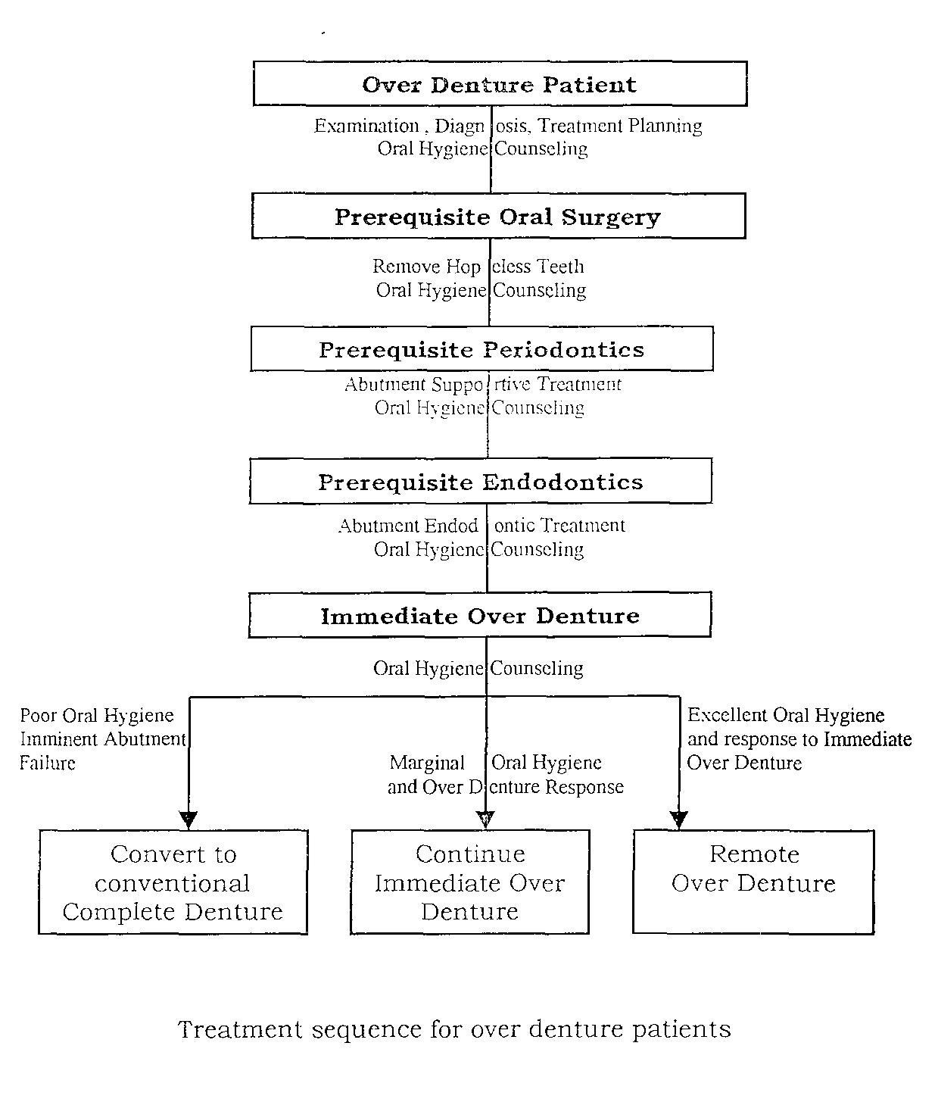

According to James.W.Robbins⁴³ (1981) a periodontal diagnosis was based on an analysis of gingival tissue tone and pocket depth; width of attached gingiva; tooth mobility and status of furcations.

Depending on the examination and treatment planning the different types of periodontal therapy done for the patient are:

- First, the periodontal pockets can be eliminated, for if they remain, the prognosis for an abutment is guarded.

- The surgical procedures that increase the zone of attached gingiva, increase the depth of the vestibule and, in general eliminate the inflammation that surround the teeth to be used as abutments.

- Soft tissue defects that do not involve the underlying supporting bone can be eliminated by a gingivectomy (resection) technique in which superfluous tissue is removed.

- When the presence of osseous defects is observed, flap surgery must be initiated to correct the underlying defect.

• Many methods of osseous defect therapy are as 'osteoplasty, osteotomy, different types

available,

of osseous

such

graft

procedures, and new attachment procedures.

- The most important element in periodontal therapy is the diagnosis.

- The abnormal may be caused by a hyperplasia of the gingival tissues or by the actual destruction of the periodontal attachment apparatus.

• | Problems involving pockets depths that |  | pass | apically |  | to
 | the mucogingival junction still present other complications that
 | make the treatment plan slightly more complex.
• | The | various forms of therapy needed to | eliminate |  | pockets
 | and | establish a healthy oral environment depend on |  | the | type | of

tissue, pocket depth, relation of the base to the pocket to the mucogingival junction, and the extent of involvement of the supporting bone.

MAINTENANCE

- A soft multitufted toothbrush placed on approximately 45 degree angle into the sulcus and used in a vibrating action appears to clean the abutments and allows the tips of the bristle to enter into the crevice to aid in cleaning.

- Some patients have used roller bandages or gauze effectively; whereas other patients have become adept at using a soft 4 - ply nylon knitted yarn or a tooth pick mounted on a handle to perform the necessary hygiene.

According to Gary.D.Derkson²⁷ (1982) A gel of 0.4% of stannous fluoride was an effective agent in reducing the progress of gingivitis around overdenture abutments.

COMPLICATIONS

The success of the overdenture depends on the success with which the patient maintains the abutment teeth and the soft tissues.

Therefore the periodontal considerations must be considered and their treatment must be accomplished, or the overdenture will fail.

1. Irritation from the denture base:

It is important to see that the denture base is relieved adequately to avoid impinging on the gingival cuff that surrounds the abutment; pressure atrophy of this collar of tissue can result in subsequent loss of the attached gingival tissue. After loss of this keratinized band, inflammation can rapidly move apically with resultant loss of attachment and, possibly eventual loss of the abutment.

2. Poor oral hygiene:

If bacterial plaque accumulates on and around the neck of the abutment, a destructive inflammatory condition results. The bacterial plaque, with its release of toxic products, can destroy the fibrous attachment and creative a destructive periodontal condition with eventual loss of the abutment.

3.Periodontal abscess:

This condition must be treated as soon as possible, for it is a cite process that can cause irreversible damage to the supporting tissues in an exceedingly short time. Periodontal abscess often occurs as a result of the embedding of a foreign body within the gingival tissue after scaling and planning procedures in which a fragment of calculus or tooth becomes lodged within the pocket wall. It can be treated adequately by thorough curettage through the sulcus. However if the periodontal pocket or defect involving the underlying bony structures or the pocket is tortuous in nature, a flap procedure is necessary.

Depending on the diagnosis and treatment planning, the different types of endodontic therapy are:

- One visit endodontic procedures:

  - Usually teeth selected for overdenture abutments are vital but has some degree of periodontal disease. The vitality of these potential abutments makes it possible to treat many of them endodontically at one setting.

  - Extensive studies have shown that if the pulp is severed in the area

of . the apical foramen, blood is discharged into the root canal, and the reparative process is aided by this blood coagulum. Additionally root canal therapy can be completed up to the point of suspected

pulp severance during one appointment |  | (Ostby and | Hjortdal,
1971). | If periapical infection can be | expected, | immediate
filing | is contra indicated, and conventional therapy should be

instituted.

- Endodontic treatment variations:

  - More than one potential abutment can be treated at a sitting if time and unilateral anesthesia permit.

  - Second premolars and canines in the same quadrant are the pairs of teeth treated most frequently during the same visit. Maxillary and mandibular canines on the same side can also be treated during the same appointment.

ENDODONTIC IMPLANTS:

Endodontic implants can be used to stabilize teeth with extremely short roots or excessive bone loss. They provide the necessary support to a weakened tooth that may serve as an overdenture abutment. Extending the implant from five to ten mm beyond the apex and reducing the length of the clinical crown can alter the crown root ratio. An endodontic implant is a complete implant, for it is entirely within the bone and root canal; it has no direct communication with the oral cavity.

CONTRAINDICATIONS:

Endodontic implants cannot be used on all teeth. Some contraindications for this procedure follow.

- When a periodontal pocket extents to the apex of the involved tooth.

- When less than 2mm of bone support remain around the root.

- When anatomic structures, such as the maxillary sinus, nares, mandibular canal, and mental foramen cannot be avoided by the implant.

- When the tooth is inclined in such a manner that the implant would penetrate the cortical plate of bone and extent into the soft tissues.

SPECIAL INSTRUMENTS

In addition to the standardized sizes of vitallium implants, special instruments are essential for endodontic implant procedures; they are

40mm intra osseous bone drills (engine reamers) and 40 mm hand reamers. Threaded vitallium implants are reported to be more resistant to removal than smooth implants (Judy and co - workers, 1972). In addition one study indicated that vitallium endodontic implants are completely resistant to corrosion (Seltzer and associates, 1973).

TRANSITIONAL OVERDENTURES

A transitional overdenture, also known as interim overdenture, is made from an existing removable partial denture, the patients' own teeth, or both. Stock teeth can also be used for this purpose.

The objective of this type of treatment is to do the most for the patient with the least trauma to all the concerned: patient, dentist, and technician.

ADVANTAGES:

- Converting an existing prosthesis into an overdenture is less costly than constructing a conventional overdenture.

2. In addition the patient's previous experience with the partial denture usually permits a smooth transition to overdenture status. and minimal interference with function and appearance.

DISADVANTAGES:

- Border extension, esthetics, occlusion, support and stability of the removable partial denture often are inadequate, particularly after use for many years, and make satisfactory conversion difficult.

- Use of autopolymer resin frequently results in an overdenture that is weaker and more apt to break than one that has been processed.

- Therefore the converted prosthesis is considered as temporary or an interim overdenture, to be placed after a suitable transition period.

CONVERSION USING DENTURE TEETH

In this instance, resin denture teeth are added to the partial denture before the hopeless teeth are removed and after the abutment teeth are prepared. The partial denture functions as an immediate prosthesis that can be converted into a transitional overdenture teeth after adequate healing and endodontic treatment of abutments.

TRANSITIONAL OVERDENTURE USING PATIENT'S OWN TEETH

This method is more economical than one requiring a conventional immediate denture.

Procedure:

- An impression is made in a stock tray using irreversible hydrocolloid, and a cast is poured in stone.

- An occlusion rim is constructed over a resin sprinkle base.

- The registration of the maxillomandibular relativity is made and transferred to the articulator of choice with the opposing cast or denture.

- The missing teeth are arranged and the teeth to be retained prepared on the cast.

- Resin teeth are hollow ground to cover these preparations.

- Extraction of the hopeless teeth followed by the tooth preparation of the retained teeth is done.

- An impression of this area is made in reversible hydrocolloid with the temporary denture in place, and then the area is cast in stone.

- The roots of the extracted teeth are cut off, and the diatories are cut into the pulp chamber.

- These teeth are related to the denture through the matrix attached with autopolymer resin using sprinkle technique.

- The transitional overdenture is finished and polished.

POST INSERTION CARE:

1. Oral hygiene instructions are provided, and a series of post insertion visits is scheduled for regular maintenance and service through out the transitional overdenture period.

- Usually the transitional overdenture prosthesis is replaced by a more definitive overdenture by 8 months to a year.

IMMEDIATE OVERDENTURE

An immediate overdenture is an overdenture constructed for insertion immediately after the removal of natural teeth. It may be used as an interim prosthesis.

ADVANTAGES:

- Increased support and stability afforded by natural teeth retained as abutments

- Preserves residual ridge by retention of natural teeth.

- Receives favorable response from patients.

4. Minimal discomfort and interference

with

function

usually characterize the postoperative course.

- The construction technique is relatively simple.

- Modifications to permit relining or other adjustments is comparatively easy.

- When used as an interim prosthesis it allows the dentist ample opportunity to evaluate the response of the abutments and supporting tissues to an overdenture and to observe the effect of correct oral hygiene procedures.

DISADVANTAGES:

- Immediate overdentures being made of conventional denture base resins, are not as strong as those reinforced with metal castings and are more prone to breakage.

CLINICAL PROCEDURES:

Impressions for the immediate overdentures can be made by several methods. In the first method, a preliminary algmate irreversible hydrocolioid impression is made in a stock tray, and a cast is poured in artificial stone. Then a custom impression tray is made.

In the second method, a custom tray is fabricated over the edentulous portion of the cast. After the border is molded with compound, an impression of the edentulous area is made in zinc oxide eugenol impression paste or rubber base impression material and an alginate irreversible hydrocolioid impression is made in a stock tray placed over the first impression and the remaining teeth.

A third and simpler procedure eliminates the need for a custom tray (Rudd and associates, 1969). A stock rim lock impression tray is used and it is customized by adding impression compound to the edentulous portion. After an impression is made of the edentulous portion of the arches, it is removed and trimmed to provide a clearance of one fourth inch (0.64 cm) for the teeth and one eight to one fourth inch (0.32 to 0.64 cm) for the soft tissue. Alginate irreversible hydrocolioid is used to make the final impression. An adhesive or cotton fibers embedded in warm surface of impression compound prevents the separation of alginate impression material from the impression compound.

POURING THE CAST:

A two - stage procedure is used in pouring the impression. The first pour includes the anatomic portion of the impression. The impression with the stone is placed in a tray holder, allowed to set, then immersed in clear slurry water for a few minutes. Then a second mix of the artificial stone is poured for the base. The impression is separated from the cast within an hour.

JAW RELATION RECORDS:

Interocclusal records can be made with wax, zinc oxide impression paste, or slurry activated artificial stone. The casts are mounted in an articulator using slurry activated artificial stone. A face bow transfer facilitates the mounting of the maxillary cast in the articulator.

CONSTRUCTING THE OVERDENTURE:

Selecting and positioning of teeth:

- The technique for constructing the immediate overdenture is a modification of the methods described by Lord and Teel (1969), Brewer and Fenton (1973), Morrow and co - workers (1973) and Morrow (1978).

- Denture teeth of appropriate mold and shade are selected and positioned by removing one tooth on the cast and substituting the corresponding replacement for comparison.

- All the teeth except those serving as abutments arc replaced by denture teeth.

- Reduction of the abutment on the cast should be less than anticipated from natural tooth, which is prepared at the time of insertion.

- The posterior palatal seal is placed on the cast prior to completion of the set up.

Waxing and flasking is done, followed by packing the overdenture with conventional heat - curing denture base resin; however, newer "high impact" resins, such as Hircoe or Lucitone 199, with their improved physical properties can result in stronger, breakage resistant dentures. Then finishing and polishing of the overdentures is done.

PLACING THE OVERDENTURES:

Abutment teeth are prepared immediately after before removal of the last hopeless teeth and placement of the immediate overdenture.

Abutment preparation:

- The abutments are reduced in a manner similar to that used on the cast, but they are made smaller to allow the placement of the overdenture without interference.

- The abutments should be 2 - 3 mm high, and the axial surfaces should be tapered.

- The abutment surfaces are smoothed, and amalgam restorations are placed in the occlusal or incisal surfaces to seal the root canal.

Surgical procedures:

The sequence of tooth removal and, where indicated, undercut corrections, tuberosity reduction, and frenectomy should be done if it is formulated in the treatment plan.

Inserting the overdenture:

- Anterior teeth are removed when the overdenture are ready for insertion.

- If gingival tissues are inflamed and there is noticeable bone loss, a tissue flap is raised. Care is taken to prevent tearing or lacerating the tissue.

- The teeth are removed as atraumatically as possible, and bone irregularities are removed with a bone file. The labial and lingual alveolar ridges arc compressed gently with finger pressure. Excess tissue is trimmed from the margins with tissue scissors, and the tissues are approximated. Sutures are placed between the sockets.

- The overdenture is inserted, and occlusion is checked.

- The patient is instructed not to remove the overdenture until the first postoperative visit, which is scheduled for the next day. At that time the overdenture is removed and cleaned, and indicated corrections are made.

- The immediate overdenture serves as a surgical stent through out the healing period.

POST INSERTION CARE:

The postoperative course of the immediate overdenture patient is usually uneventful, and the patient has minimal discomfort and uninterrupted function.

Adapting overdenture to abutments:

- Abutment overdenture teeth should be polished before adapting the overdenture.

- Abutments are smoothed with a fine grit sandpaper disk and polished with a rubber cup and flour of pumice.

- Amalgloss can be used to place a high gloss on the amalgam restoration and the abutment surfaces.

- The overdenture is adapted to the abutment teeth by adding tooth colored auto-polymerizing resin to the abutment indentation of the denture.

Oral hygiene instructions:

- Each patient is instructed how to clean the abutment teeth and the denture.

- Soft - bristle toothbrushes, disclosing tablets, dental floss, and bubble gum therapy are used to maintain gingival health.

• When used properly bubble gum therapy is effective for conditioning tissues, and the patients can be placed on bubble gum massage after a week.

Overdenture hygiene:

- The patient is instructed to keep the overdenture clean by removing it after each meal and brushing with a soft bristle toothbrush and ordinary hand soap.

- At the end of the first postoperative week, the patient is instructed to remove the overdenture on retiring for the night.

- The interim overdenture is ready made fluoride gel carrier, and the two one minute applications of acidulated phosphate fluoride gel followed by two one minute applications of 0.4% stannous fluoride gel are repeated through out the post insertion period.

- Oral hygiene measures are stressed through out the healing period; otherwise, the service life of the overdenture can be affected adversely by the patient's relapse into the previous habits of oral neglect.

Relining the immediate denture:

- As healing progresses, relining of the interim overdenture usually becomes necessary to maintain adequate tissue adaptation. This relining is accomplished in the conventional manner using auto polymerizing relining resin.

Follow up care:

- The patient usually wearers the immediate overdenture several months, when used as an interim prosthesis, but several years when used as a more definitive prosthesis.

- Throughout the period the patient's response to overdenture treatment and oral hygiene efforts should be monitored periodically.

- Excellent tissue color and tone, minimal crevicular depths, absence of plaque on abutments and on the overdenture, and minimal mobility are the favorable signs related to good oral hygiene.

REMOTE OVERDENTURES

A remote over denture is an overclenture other than transitional or immediate. It is usually constructed for insertion at some time "remote" from the removal of hopeless natural teeth. Although, remote overdenture can be constructed entirely of resin, metal bases are frequently used.

METAL BASE OVERDENTURES

The metal base overdenture is a complete denture with a cast metal base that is supported and stabilized by selected natural teeth with contours that are modified for the purpose by the preparation and placement of copings.

ADVANTAGES:

1. 1. The reinforced denture being inherently stronger, is less subject to breakage, which is a problem sometimes with those made of conventional base resins (Rantanen and associates, 1971).

- 2. Metal denture base overdenture, which are more rigid, resist the dimensional changes associated with polymerization of denture base resins and the functional forces of mastication.

- 3. Denture supporting tissue seem to respond more favorably to metal bases (McCracken, 1953). Clinical observations have shown that critical gingival areas immediately adjacent to abutments frequently improve in color and tone after replacement of a resin overdenture with a metal base overdenture.

- Greater ease in maintaining cleanliness of the metal base and to effective transmission of thermal changes through the metal base (Applegate, 1955).

- The metal base is excellent for jaw relation recording procedures. Stabilized and effectively supported by abutments, the metal base

- permits accurate denture base records and subsequent greater success of the denture.

7. 6. Reinforcement of the overdenture by a rigid cast metal base significantly postpones the need for relining.

DISADVANTAGES:

- Primarily economic, but for the additional clinical and laboratory procedures require both increase in time and cost of treatment.

- Relining presents more technical problems with a metal denture base than with one constructed of resin, but it is feasible.

- Adequate healing of residual ridges before construction of the metal base significantly postpones the need for relining.

- Since the metal bases occupy space, excessively thick casting that interfere with positioning of denture teeth and give poor esthetic effects are a disadvantage.

INDICATIONS:

- Metal base overdentures, being more definitive prosthesis, are indicated for patients who respond favorably to an interim overdenture for a minimum of 8 to 12 months.

- Metal base overdenture are constructed for patients who have the motivation and oral hygiene levels necessary for success and patients who break resin interim overdenture repeatedly.

CONTRA INDICATIONS:

- Poor oral hygiene.

- Lack of motivation.

ABUTMENT COPINGS:

Whether or not to use copings on overdenture abutments is an important consideration for the dentist. Preparation of the teeth to serve as overdenture abutments usually results in the exposure of considerable dentin surface to the oral environment. Protection 01 dentin surface of abutment teeth with gold copings have several advantages.

Advantages of copings:

- Provide some caries protection for the abutment tooth.

- Effectively reinforce the endodontically treated abutment and make it possible to restore broken down teeth otherwise unacceptable as abutments.

- Copings can also preserve abutment contours.

Disadvantages of copings:

- An increase in the time and cost of the treatment.

- Coping margins can also irritate the gingival tissues, and marginal caries can occur, particularly in instances of poor oral hygiene.

PREPARATION OF ABUTMENT TEETH:

In general preparation of copings should conform to the basic principles of full crown preparation and include considerations of the:

1. Occluso gingival reduction of the clinical crown to provide the most favorable mechanical advantage to the existing root and periodontal support.

- Reduction of the axial surface to provide sufficient space for esthetic placement of denture teeth of proper size and contour.

Proximal surfaces are tapered and reduced to the level of the gingival margin with a tapered fissure carbide bur or a Densco no. 1 D-T fine grit diamond.

A long gingival bevel can be placed in the gingival crevice with a Densco no. one eight a fine grit flame shaped diamond, and care should be taken to avoid traumatizing gingival tissues.

A short bevel dowel (5 to 7 mm) in the root canal used to achieve the desired retention, for the completed overdenture exerts only minimal dislodgment forces on the cemented copings.

A parallel tapered groove can be placed in the buccal or lingual surface of the canal preparation to counter rotational forces and to aid in identifying buccal and lingual surfaces of the coping during cementation.

The entrance to the canal preparation is beveled with a Densco no. 2 D-T fine grit diamond instrument to eliminate sharp edges and subsequent fitting problems. In some instances pin can be used for retention instead of a post.

MAKING THE ABUTMENT IMPRESSION:

- A full arch impression of the prepared abutment teeth is made by reversible hydrocolloid or rubber base impression technique.

- The impression material is injected carefully into the post preparation and over the prepared teeth.

- When used for retention, plastic pins of appropriate size are placed in the corresponding holes of the preparation before injection of the impression material.

- The impression is adapted for removable dies by placing thin metal strips mesially and distally to each abutment impression.

- This procedure allows separation and removal of individual dies, which is a convenience during waxing.

- The cast is made by a two stage pouring technique.

- After separation of the cast, a thin bladed saw is used to saw on each side of the abutment teeth to the level of the metal strips in the impression.

- As soon as the ends of the die strips are found in the base of the cast, the dies are removed by tapping on the pins.

- Dies should be ditched with a round bur or a disk to show clearly the margins of the preparation.

- Trimmed dies are coated with separating medium, and the wax patterns are carved.

WAX PATTERNS:

- The contours of the wax pattern is best described as hemispheric, with the convex upwards and smoothly rounded axial surfaces that have no undercut areas.

- The wax in the incisal or occlusal area should be approximately only 1 mm thick; thinner copings may wear through eventually.

- A small bead placed on the buccal surface of the pattern serves as a purchase point during the fitting of the coping to the abutment.

- All abutment copings in the arch should be approximately 2 - 4mm above the gingival margin.

- When completed, the patterns are sprued, invested, burned out, cast in type three gold, finished, and polished.

FITTING CASTINGS:

- Each casting is fitted to the abutment tooth with Kerr disclosing wax to indicate small bubbles or perforation that interferes with seating the casting.

- Imperfections are removed with a S.S.White no. 170L carbide fissure bur.

- Accurate adaptation to the casting is indicated by an exceedingly thin, uniform layer of wax.

CEMENTATION:

• | Abutment teeth are isolated, dried, and treated with a two |  |  |  | 1 -
 | minute applications of APF gel, followed | by two | 1 | - minute
 | sequential treatments with 0.4% stannous fluoride |  |  | and then
 | cemented.
• | An alginate irreversible impression is | made | of | the | arch
 | with cemented copings.

- The cast from this impression is used to make an impression tray for the metal base overdenture.

ADAPTING THE INTERIM OVERPENTURE:

- The interim overdenture is adapted to the newly cemented copings by first removing resin from the coping indentation with a no. 8 round bur.

- Around each abutment indentation a definite margin is created with a bur to serve as finish line.

- A small hole is made in the depth of the indentations to allow extrusion of the auto polymerizing resin when denture is seated in the mouth.

- Auto polymerizing acrylic resin (Lang's Jet Acrylic) of the proper shade is sifted into the abutment indentations and saturated with monomer.

- With the interim overdenture seated in the mouth, the occlusion is verified and the denture is allowed to remain in position for 2 minutes.

- Then it removed and placed in a warm water bath for 15 minutes to accelerate polymerization of the resin.

- The interim, overdenture, adapted to the contours of the abutment copings, can be used by the patient until the new denture is completed.

MAKING THE IMPRESSION:

- An accurate border molded impression is made of the residual ridges and the restored teeth with a rubber - base impression material in an acrylic resin tray.

- This impression is used to make the master cast on which the metal base and the overdenture are to be constructed.

- The borders of the tray should be short enough to permit molding with compound.

- A single layer of base plate wax is adapted to the cast and trimmed to the indicated border extensions.

- Tin foil substitute is painted on the wax before adding the resin tray to facilitate removal of the wax from the impression tray.

- The relief wax remains in the tray through out the border molding and is removed immediately before the corrective wash.

- A strip of relief wax approximately 2 mm wide is removed from the entire circumference of the border of the tray and replaced with impression compound.

- On completion of border molding, the remaining wax is removed from the impression tray, and the compound border is relieved slightly with a sharp knife.

• The indentations in the impression tray corresponding to the abutment teeth should be perforated with a no. 8 bur to allow flow of the rubber base impression material through the tray, increasing retention of the rubber base and minimizing voids.

- Regular body rubber base impression material is proportioned, mixed, and loaded into the impression tray.

- A small amount of rubber base impression material is placed on a finger and wiped over each abutment tooth to minimize voids.

- Then the impression tray is seated, and border-molding movements are reaccomplished.

- After setting, the impression is removed and the master cast is poured.

RESIN RETENTION:

- Small beads or crystals are used to retain the denture base resin. Larger beads should be avoided, for they can interfere with the positioning of the denture teeth.

FINISHING AND POLISHING:

• The metal base is highly polished in the areas immediately adjacent to the gingival tissue around each abutment.

- A high polish in these critical areas seems to facilitate cleanliness and thereby improve tissue response,

• The exterior surface of the metal base should be polished to minimize metal display through relatively translucent denture base resins.

MAXILLARY METAL BASE DESIGN CONSIDERATIONS:

- An open palate design is used most frequently for the metal base of a maxillary overdenture.

- A posterior palatal strap crosses the palate anterior to the posterior palatal seal area.

- The enclosed design provides excellent rigidity with minimal weight.

- As in the mandibular framework, the castings should be thin.

DESIGN MODIFICATION:

Metal base designs can be modified to meet existing requirements. The metal base can be reduced in size so that most of the denture supporting tissue contact is made through the denture base resin and not through the metal. Generally metal base supporting tissue contact seems to be preferable to denture resin supporting tissue contact.

PROCEDURES FOR DESIGNING

DIAGNOSTIC CAST:

The design of the metal base is placed to the diagnostic cast in the systematic manner.

- 1. Place the diagnostic cast on the surveyor, locate the tissue undercuts, and select the tilt. Drawing the survey line on the cast and abutment teeth will indicate the undercuts.

- Tripod the cast so that the dental laboratory can re-establish the tilt used in completing the design.

- Draw the extent of the metal base with a brown pencil. Do not extend the metal base into the tissue undercuts. Indicate any areas of open mesh.

- Indicate the desired mesh around the abutment teeth with a red pencil.

- Indicate the type of retention, such as beads or crystals, for the denture base resin.

- Draw handles in the molar areas and show that they are to be raised above the cast.

- Indicate areas of special reinforcement, such as the lingual border of the anterior segment of the mandibular base.

- The metal base is then fabricated.

METAL BASE TRY - IN:
• | In almost | every | instances the | accuracy of the | adaptation
 | is improved by fitting the base to the abutment teeth with Kerr
 | disclosing wax.
• | Afterthe | wax | is warmed | andplaced | intoeach

abutment indentations, the metal base is seated in the mouth.

- On removal, the base is examined carefully for any minute bubbles or irregularities that interfere with seating of the base.

- These irregularities are removed with a carbide bur in an air driven hand piece.

- Areas roughened should then be smoothed.

JAW RELATION RECORDING PROCEDURES:

Jaw relation recording procedures vary according to whether the arch opposing the overdenture is

- A conventional complete denture

- Another overdenture

- A natural or restored dentition

OVERDENTURE OPPOSED BY COMPLETE DENTURE:

- In this combination, an impression of the edentulous arch is obtained by an accepted method and poured in artificial stone.

- A conventional auto polymerizing resin base with a wax occlusion rim is made on the opposing maxillary cast, and a wax rim is applied to the mandibular metal base.

- Arbitrary axis points are selected for face bow orientation and identified by a mark made with an eyebrow pencil.

ESTABLISHING THE OCCLUSAL PLANE:

- To facilitate establishment of the occlusal plane, a line is drawn with an eyebrow pencil from the tragus of the ear to the ala of the nose.

- A fox occlusal plane guide is convenient for determining the relative parallelism of the occlusal plane of the wax rims and the lines drawn on the face.

FACE BOW TRANSFER:

- Then the face bow transfer is done.

- Although a face bow transfer is not required for monoplane occlusions, its use is convenient for mounting the maxillary cast.

- Then the face bow fork is removed from the maxillary wax rim, and the base plate and the wax rim are replaced in the mouth.

VERTICAL DIMENSION OF OCCLUSION:

- The mandibular metal base with occlusion rim is placed in the mouth, and the mandibular rim is adjusted to the desired vertical dimension of occlusion.

- Recording the resting face height by using index marks on the nose and chin with the patient in an. erect position is one method of determining a tentative vertical dimension of occlusion.

CENTRIC JAW RELATION RECORDS:

- A suitable recording medium such as zinc oxide impression paste or slurry stone is used to make an inter occlusal record of the retruded jaw position.

- If the record is acceptable the base plates are placed on the casts, and the mandibular cast is luted to the maxillary cast and mounted in the articulator.

VERIFYING CENTRIC RECORD:

- After the mandibular cast is mounted, such methods as the articulator acceptance of duplicate records or the centric check point technique should be used to conform the accuracy of the mounted relation (Brewer, 1963).

- Centric checkpoints are especially suitable in verifying jaw relation

records for overdenture because of the inherent vertical and horizontal stability of overdenture bases.

- Denture teeth of the appropriate mold and shade are then selected for positioning on the bases.

OVERDENTURES OPPOSED BY OVERDENTURES:

The procedures for recording jaw relationships when an overdenture is to oppose by an overdenture is similar to that used when an overdenture is to be opposed by a conventional complete denture. However, the procedure is simpler, because abutment teeth support and stabilize both bases instead of one.

OVERDENTURE OPPOSED BY NATURAL OR RESTORED DENTITION:

Jaw relation procedures opposed by natural or reconstructed dentitions can be accomplished by the conventional approaches or by the functionally generated path method described by Meyer (1934).

CONVENTIONAL PROCEDURE:

- In a conventional approach the maxillary cast is mounted on an articulator by means of a face bow transfer.

- A wax occlusal rim on a maxillary occlusal base is countered appropriately and adjusted to the desired vertical dimension of occlusion.

- The centric jaw relationship is recorded in a suitable medium, and the mandibular cast mounted in the articulator.

- Protrusive and lateral eccentric positions can be recorded as needed to make the articulation adjustments.

- Centric, protrusive, and the lateral interocclusal records and related remounts can be made after completion of the denture to harmonize further the occlusion and the mandibular movements of the patient.

- If the opposing occlusion is restored with cast restorations, metal occlusal surfaces are recommended.

FUNCTIONALLY GENERATED PATH TECHNIQUE:

- Maxillary overdentures opposed by natural or reconstructed natural dentition are especially suitable for the functionally generated path technique s described by Meyer (1951,1959).

- In these cases the opposing arch is restored first.

- If teeth are missing in the opposing dentulous arch, fixed or removable dentures are used to restore the functional integrity of the arch.

- Maxillary natural dentitions opposing edentulous mandibular arches are rare; therefore the technique described pertains largely to the construction of a maxillary overdenture opposed by a mandibular dentition.

MAKING THE COMPOUND RIM:

- Black impression compound, heated in water bath, is used to form an occlusal rim on the resin baseplate.

- The compound rim is sealed to the resin base plate to prevent separation during the "chew - in" procedure.

- The occlusal surface of the modeling plastic rim is softened by flaming, and the articulator is closed.

- The lubricated stone teeth should form distinct indentations on the occlusal surfaces of the maxillary compound rim.

- The impression compound rim is cooled and modified by removing the compound on each side of the ridge formed by the central fossa of the mandibular posterior teeth.

- Compound is also removed on the anterior portion of the occlusion rim to clear all the anterior teeth by 1 or 2mm.

RECORDING CUSPAL PATH:

- After cuspal path wax is added to the compound rim, it is inserted in the mouth, and the patient is instructed to execute centric closures, as well as protrusive, right, and left lateral movements.

- Usually a smooth cuspal path is obtained only after several excursions.

- A completed path exhibits smooth wax contours without tears or separation of wax from the compound rim.

POURING THE PATH:

- On removal from the mouth, the base plate and the path are rinsed thoroughly in cool water, placed on the cast, sealed with wax, and remounted in the articulator.

- Then the cuspal path is boxed, poured in vacuum spatulated minimal expansion stone, and mounted to the lower bow of the articulator.

- After the stone has set, the wax is removed from the with clean boiling water.

ADAPTING DENTURE TEETH TO THE CORE:

- The waxed denture teeth is replaced on the cast and adapted to the core by using non toxic water soluble artist's pigment or thin articulating strips as an indicator.

- Cast metal occlusal, which are ideal for functionally generated path techniques, can be constructed if desired.

- The waxed denture is flasked, boiled out, and processed.

- Overdentures constructed by functionally generated path techniques demonstrate excellent functional harmony with mandibular movements.

• This procedure is recommended for overdentures opposed by natural or reconstructed dentitions.

TOOTH SELECTION AND POSITIONING:

- Denture teeth of the appropriate mold and shade are selected for positioning on the bases for try in.

POSITIONING ANTERIOR TEETH:

- The presence of abutments assists in the proper placement of denture teeth and, when supplemented with pretreatment casts, removes much of the doubt regarding selection and arrangement of teeth.

- Porcelain teeth can be used except over abutments, where resin teeth are required.

POSITIONING ABUTMENT TEETH:

- Resin teeth for abutments are selected, hollowed with a bur, and positioned over the abutments on the metal base.

OCCLUSAL SCHEME:

- Posterior teeth can be porcelain or resin, anatomic or non-anatomic.

- When the posterior teeth oppose natural or reconstructed dentitions, metal occlusal surfaces are preferred.

- Then flasking and wax up is done.

OPAQUING THE METAL BASE:

- The metal base is opaqued to prevent undesirable "show through" under relatively translucent denture base resins.

- Pink opaquing material is painted over part of the base to be covered by denture base resin, and tooth colored opaquing material is applied over the abutments.

- Then the opaqued metal base is cemented to the cast with a thin mix of zinc oxyphosphalc cement.

- Tooth colored resin of the appropriate shade is sifted into each abutment indentations in the upper part of the flask and saturated with heat curing monomer.

PACKING THE OVERDENTURE:

- The overdenture base can be tinted at this time if desired.

- A denture resin amenable to the single closure packing technique is mixed and placed in the flask; plastic gloves are worn to prevent contamination of the resin.

- After curing the dentures are retrieved and remounted in the articulator.

- Occlusal discrepancies resulting from processing are corrected before the overdentures are removed from the cast.

PLACING THE OVERDENTURE:

- The overdenture should be examined under a good light, preferably under magnification, to locate any nodules or projections on the tissue surface that need to be removed.

VERIFYING ADAPTATION:

- Pressure indicating paste is brushed on the tissue surface of the overdenture, and pressure areas are identified and adjusted.

POST INSERTION INSTRUCTIONS:

- An adequate level of oral hygiene is the most important factor in achieving a reasonable service life from an overdenture.

  - Overdenture hygiene

  - Bubble gum massage

  - Oral hygiene

  - Recall appointments

  - 5. Maintenance - a significant advantageof the

metal base overdenture is strength. Breakage in service,

with the exception of the occasional fracture of an individual

denture tooth, is rare, Chipped or broken denture teeth are repaired easily in a conventional manner.

- Failure - failure of an overdenture usually is related to loss of the supporting abutment teeth. Abutment teeth can be lost through caries activity, failure of endodontic treatment, periodontal disease, or trauma.

IMPLANT SYSTEMS AND TECHNIQUES

IMPLANT ABUTMENT SITES:

While the operator may have little choice in the selection of natural abutments, there is far greater versatility when implants are to be employed.

Regina Mericske-Stern⁶⁵ (1994) did a comparative study on overdentures with roots and implants for elderly patients and , demonstrated a higher tendency for success when over dentures are supported by implants rather than by roots, particularly true for mandibular over dentures.

Two implants in the mandible and four implants in the maxilla are the normal minimal requirements. Implant sites, angulation and facio lingual positioning are important decisions to be made. Maxillary implant placement and the associated abutments are more difficult where lower natural teeth are present, due to the limited intermaxillary space that may exist and the problems that will occur if the long axis of the implant impinges against the incisal edge of a lower tooth.

PART A: The Branemark system:

The Branemark system has been used to support and retain overdentures for about 15 years. Nowadays, an impressive array of implants is available with diameters of 3mm, 3.75mm, 4mm or 5mm. Implant lengths vary from 7mm to 20mm, according to the diameter selected., but the 7mm length is not recommended for maxillary overdentures.

The internal aspect of the implant is protected by a cover screw that remains in place during the phase of integration. It is removed at the second stage when a healing abutment is inserted. These are the components that are placed at the second surgical stage and the 'issues allowed healing for about two weeks before abutment connection. The transmucosal abutment is now placed and the height selected according to the contour of the soft tissue.

The component attached directly to the implant is known as the :ransmucosal abutment. It is screwed down onto the head of the implant by means of a substantial abutment screw that engages an internal thread within the implant. The design of the implant corporates a hexagonal projection around the screw hole and this projection is engaged by a matched hexagonal shaped depression in the transmucosal abutment. The engagement of these hexagonal shaped components is critical, and failure to precisely locate the two components is one of the more common causes of complications.

The transmucosal abutments are available in a variety of heights ranging from 3mm to 10mm, depending on the depth of the soft tissue as these abutments need to project some 2mm above the mucosa. The height of the transmucosal abutment can be judged by the healing abutment that has to be employed.

If the transmucosal abutment is to be left exposed without a superstructure, it should be protected with a titanium and plastic-healing cap as the edges of the abutments are easily burnished or damaged.

The matched impression coping and the abutment replica are other important components of the system. The impression coping mirrors the

occlusal surface of the transmucosal abutment. It fits precisely over the edges but does not engage the facets of the abutment screw head.

The impression coping is therefore free to rotate. It is secured onto the transmucosal abutment by a guide pin that passes through the coping and engages the internal thread within the abutment screw. Guide pins are available in a variety of lengths up to 20mm. Two designs of impression copings are available. The square variety that is removed in the impression is normally the method of choice.

Using a tapered coping that remains in the mouth when the impression is withdrawn may result in potential inaccuracies when the coping is subsequently repositioned in the impression.

The other important part of the impression system is the stainless steel abutment replicas. This abutment replica reproduces the occlusal section of the transmucosal abutment although the facets of the abutment screw head or represented by a cylindrical reproduction.

For most patients the operator will be making an impression over the transmucosal abutments. The first time essential step is to ensure that these abutments are correctly located on their respective implants, and radiographic conformation is essential.

A primary impression using alginate in a stock tray is made. A complication here is the adaptation of the stock tray, as the healing abutments will prevent complete seating of the stock tray. Where the projection above the mucosa is larger the operator will be obligated to use a tray design for the dentate mouth. A modification of the technique is to place tapered impression copings on the abutments before the alginate impression is made. This provides with precise details for the window in the lab-produced tray.

In constructing the lab produced tray, the operator has to provide a window sufficiently large to accommodate the transmucosal abutment and the impression coping. Where implants have been closely opposed, one window is normally made and the location between the transfer copings assured with Duralay applied in small increments. Where widely spaced implants have been placed, the tray is made with two holes through which the transfer copings project.

Fast setting impression plaster is normally the most convenient, although Duralay can be employed, bearing in mind that the setting time is likely to be greatly increased if placed over a zinc oxide - eugenol type

impression paste. So additional material over the copings have to be applied to ensure that they are family united. The relationship of

the copings to one another is critical and leaves no room for error. Since the impression procedure is time consuming, the use of diagnostic impression in the custom tray before the placement of transfer copings is strongly recommended. The diagnostic impression should be made, the tray adapted, and then cleaned before the transfer copings are placed in the mouth.

Once the impression has been removed from the mouth an analogue representing the transmucosal abutment is carefully placed over the transfer coping. Each of the abutment replicas is carefully positioned in this manner before the impression is cast. It is normally wise practice for the operator to carry out this procedure in case one of the transfer copings is not adequately secured within the impression. This will be discovered as the screw that unites the copings and the analogues is tightened, and the impression can be remade at the same appointment. Impression copings can be used to produce stabilized wax rims for jaw relation records.

The base of the superstructure is the gold coping that seats on the transmucosal abutment. It is secured with the gold screw 1.1mm in diameter. Two screw head designs are produced, incorporating either a slot or an internal hexagon. The gold screw should be tightened to a torque of about 10 Ncm. Other important components to the system include matched screwdrivers and an electronically controlled torque driver. The stud type retainer is now produced that replaces the

Iransmucosal abutment. The base of the stud is the abutment screw that engages the center of the implant. The female component is incorporated in the denture in the conventional manner. Angled abutments are normally best avoided.

They complicate plaque control and construction of the prosthesis, and may possibly lead to stress concentrations.

Angled abutments require special conical shaped healing caps and impression copings.

C.M.Ten Bruggenkate¹⁴ (1991) recommended the placement of angled abutments because of the anatomy of the maxilla.

PART B: THE ASTRA TECH DENTAL IMPLANT SYSTEM

Since 1985, the Astra Tech Dental Implant System has been used in prospective studies at three different university clinics. The results to data are promising with regard to scientific, clinical and radiographic parameters. No marked bone resorption has been observed during the first year compared to the second subsequent years.

IMPLANT COMPONENTS:

The Astra Tech Implant is two-stage titanium consisting of a fixture and an abutment. The fixture is a self-tapping screw with parallel sides, which simplifies installation and minimizes surgical stress to the bone. The fixture is available in two diameters 3.5 and 4.0mm, and in seven lengths, from 8 to 19mm. The cover screws placed during the healing period are also available in two diameters. The abutments, which are self-locating and self-securing, are designed with a 20 or 45 degree tapered top and are available in six lengths, ranging from minimal height to 7.5mm,

has measured along the parallel sided neck. The interface between the abutment in the fixture is mediated via a conical seal design that imparts strength and stability to the system and allows self-guiding connection of the abutment to the fixture.

IMPLANTATION PROCEDURE:

The surgical procedure is conducted in two stages. Fixture placement is carried out with the patient under local anesthesia in an aseptic environment. After anesthesia, an alveolar crest incision is made with buccal and lingual mucoperiosteal flap elevation and tissue dissection to identify the bone and the nerve structures. The relative position of the fixture sites is established using a guide drill to perforate the cortical bone. This also allows evaluation of the quality of cortical and cancellous bone. During this procedure pre-operative clinical and radiographic evaluation play an important role.

The implant sites are then repaired in a step by step procedure using drills of different diameters with indicators giving a direct reading of the correct depth. All preparation of the bone tissue is carried out under copious irrigation with saline at room temperature and with intermittent drilling to prevent heating of bone. Before the fixture is selected, the depth of the implant bed is checked with a depth gauge. The fixture is handled and installed by means of the fixture adapter. The adapter with its mounted

fixture can be primarily installed |  |  | manually | or | attached | to | the
handpiece | connector | and handled directly with |  |  | contra-angled. The
installation is carried out low speed, |  |  | 20rpm, | under | profuse | irrigation
with saline | at room temperature. Final leveling of the fixture is done
with ratchet wrench.

It is preferable to position the fixture at a slightly below the marginal bone level. Before reposition of the mucoperiosteal flaps with interrupted mattress sutures, the cover screws are inserted into the fixtures.

In the upper jaw it is advisable to allow the patient to^use the removable upper denture, after some adjustment immediately after the surgery to limit the haematoma formation and swelling. In the lower jaw the old denture is relieved from any compression over the fixture areas, relined and delivered to the patient after one week.

The healing period for osseointegration follows generally accepted principles: a minimum of 3 months in the mandible and at least 6months in the maxilla is advocated. The patient is checked regularly during the healing phase.

The abutment connection is carried out after infiltration or topical application of local anesthesia. A small incision to confirm the position of the cover screws or a punch instrument is used to remove the overlying mucosa.

Three choices of abutment are available: healing abutment, regular uni-abutment or angled abutment. Suitable abutments are selected, mounted on the abutment adapter and installed. Immediately thereafter, the old dentures can be corrected and given a new soft relining. Based on the angle abutments, the retention of the dentures is usually excellent.

PROSTHETIC ALTERNATIVES:

The choice of prosthetic alternatives is very dependent on the degree of resorption. For an edentulous jaw, the treatment alternatives available, a

fixed detachable bridge is often preferable. If there is only limited bone available, the ridge can be augmented successfully in different ways, to provide the desires fixture support and also to improve the phonetic and esthetic outcome. A less dramatic, yet still beneficial alternative is to provide the patient with an overdenture. This prosthesis has soft tissue support and does not rely solely on the fixtures for stability.

OVERDENTURES:

There are four ways of retaining an overdenture; to unite the fixtures via an overdenture bar, or by the use of separate fixtures with special balls or magnets:

- Milled bar

- Cast bar

- Ball

- Magnet

It should be noted that a minimum of two implants at least 10mm long is required to support the overdenture. Treatment planning is based on the clinical and radiographical analyses which provide information on optimal bone support at the same time as functional, esthetic and hygienic requirements are considered.

Plaster or a high viscosity impression material is recommended for the prosthodontic impression procedures together when using squared impression copings. The overdenture cases demand an elastic material and a rigid tray. An individual tray is often made from cold-cure acrylic. Separate holes are made in the tray for the penetration of the squared

impression copings placed onto the abutments and tightened with the guide pins. When the elastic impression material has set, the impression copings can be further fixed to the tray by using a pattern resin. The tray is separated from the jaw and the impression inspected. Abutment replicas are placed in the impression copings and tightened with the guide pins. For occlusal registration wax trims are used and it is advisable to use a removable rim on a fixed acrylic base. With this procedure, it is easy to check and compare the positions of the abutment replicas on the working cast and the abutments in the jaw.

Well accepted principles of function, esthetics and patient comfort are the basis for deciding vertical dimension, free way space, occlusal plane, centric relation and arch form. If the old denture has been optimized before the implantation treatment, it is very easy to duplicate the old denture and use this duplication as an impression tray.

MILLED BAR:

Lothigius et al (1991) has therefore designed a method involving an individually milled or hand carved bar, suitable for two stage implant systems.

The bar is preferably cast in a type III dental gold alloy and primarily splints the implants. The bar cross section should be occlusally converging with an approximately 10°slope to act as a guiding surface. The bar thereby guides the removable structure into place. Distal to the terminal abutments, extensions are made for added lateral stability and support. Three elevated areas on the bar are prepared to give actual support for overdenture.

The detachable section is a horseshoe shaped overdenture reinforced by a u shaped cobalt chromium framework fitting the milled bar and extending over the tuberosities, reinforced and retaining the polymer based material. It is recommended that the detachable part of the construction fully cover the tuberosity to gain maximal support.

The retention between the bar and the overdenture is derived from Ceka Revax attachments. Four attachments are recommended. All female keepers should be parallel to one another and to the path of insertion. The removable spring pin, the male part of the attachment, can be placed in the metal framework by either the spacer technique, the soldering technique or the acrylic resin fixation technique.
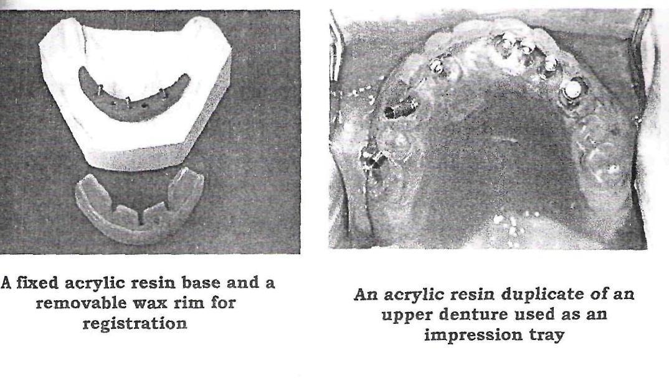

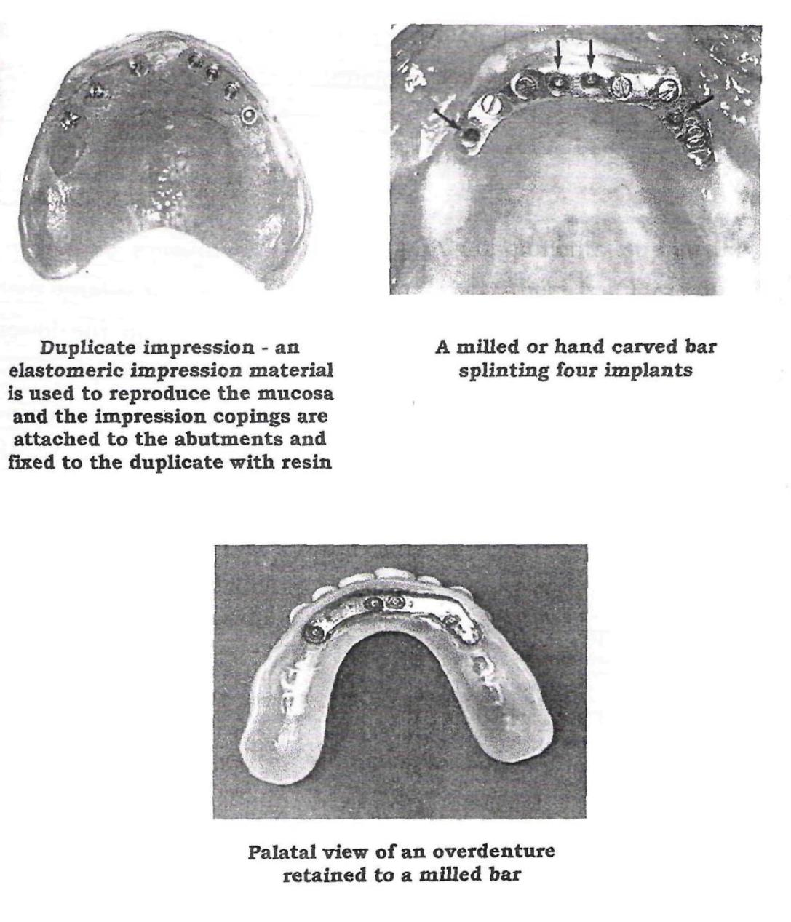

CAST BAR

The implants are connected to a prefabricated / cast alveolar bar and an overdenture is retained with clips. The distance between the supporting implants should not be too great because the rigidity of the bar may be inadequate.

This is much less expensive procedure for an overdenture than the milled bar. The objective is to position the bar in such a way that retention and stability are achieved with a minimum of torque forces against the

fixtures. Gotfredson et al (1993) and reported promising clinical and radiographic results for such bar attachment systems attached to Astra Dental implants for retention of mandibular overdentures.

BALL ATTACHMENTS:

Individual standing copings with attachments supporting an overdenture are essential in situations where there is a large distance between the fixtures. It should preferably be used in the lower jaw where each fixture has good cortical retention. Even though good bone support is essential in these situations, torque movements and transverse forces against the fixtures must be minimized. With the Astra Ball Attachment, some rotation and vertical resilience is permitted, thereby relieving the fixtures from unfavorable forces. Gotfredson et al (1993) has presented promising preliminary results for ball attachments used as retainers for mandibular overdentures.

MAGNET ATTACHMENT:

Basically, the same indications apply for both magnet and ball attachments. A "stress breaking" situation with the magnet attachment reduces the forces against the implant. The magnet attachment denture allows some freedom in regard to the path of insertion, even with a rather advanced, non-parallel orientation between implants.

The magnet keeper, located on the 45°uni-abutment; is made from a titanium coated iron-neodymium-boron magnet. It works with the magnet in a "split-pole" way. Walmsley et al (1993) has used this technique for retention of overdentures in 20 patients.

Overdentures on implants are usually the treatment of choice when only two or three implant fixtures are installed due to lack of bone or for financial reasons. It is of importance to make as much space as possible for the teeth, base material and the retainers of an overdenture.

In the maxilla, overdentures facilitate the restoration of esthetics and phonetics and ensure optimal conditions for oral hygiene. Therefore, overdenture therapy in the upper jaw might also be the treatment of choice even when four or more fixtures can be installed.

Maxillary fixed prosthesis may also create a problem with phonetics because of an unavoidable space between the residual ridge and tissue side of the restoration. Furthermore, phonetics can be impaired because of a short dental arch, and as implants are sometimes located quite palatally, the irregular bulge of the metal around the abutment can obstruct proper phonetics.
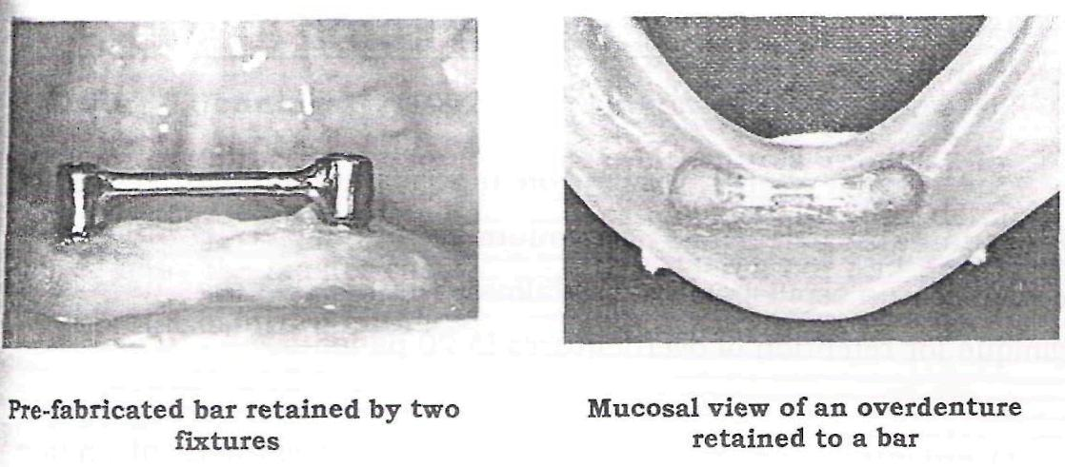

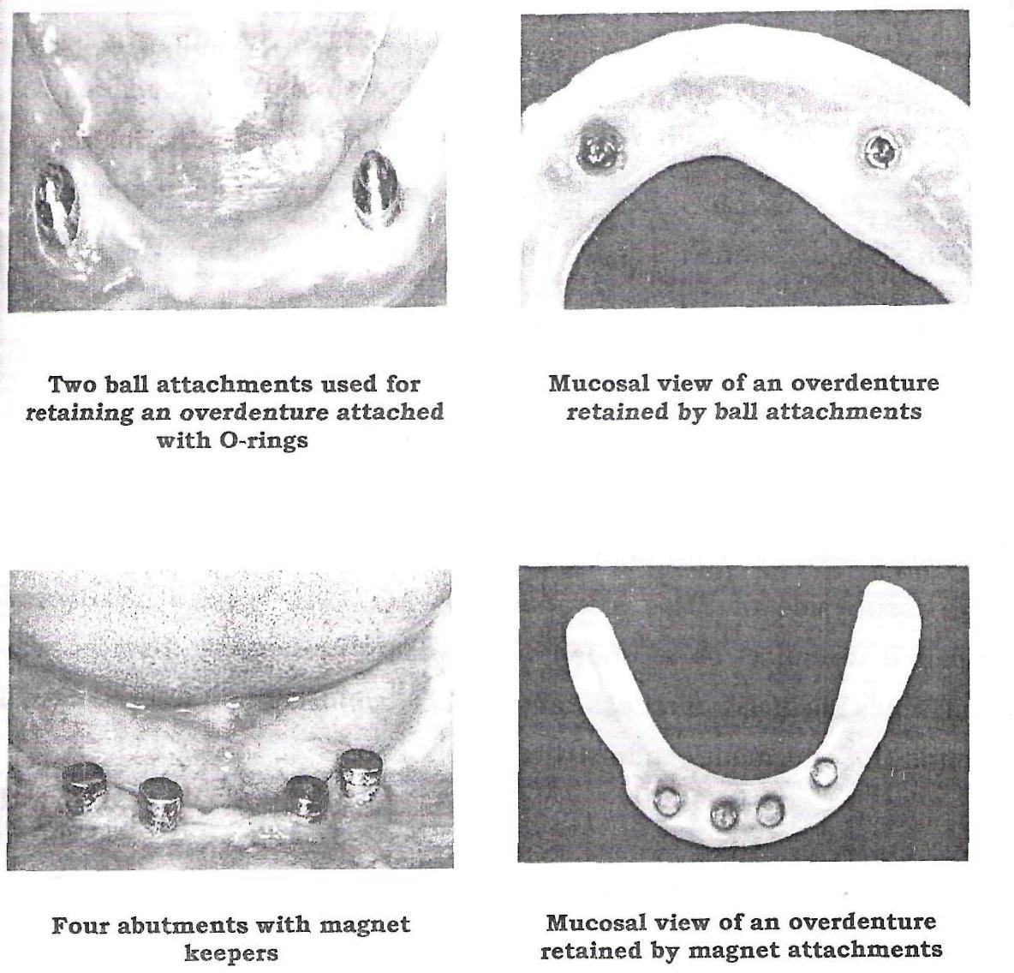

PART C: THE BQNEFIT ITI SYSTEM:

Kevin J.Jennings⁴⁸ (1992) studied on the principles of the laboratory procedures for making overdentures retained by bar attachments on ITI implant fixtures, along with the details of producing the master casts, making a soldered bar and processing a prosthesis incorporating a cobalt - chromium alloy strengthener.

Material:

The implants are made of commercially pure titanium. The intraosseous part of all Bonefit ITI implants is coated with plasma flame

sprayed layer, whereas the transmucosal neck portion is smooth and polished. The microscopic structure of the coating is designed to provide for enlargement of the surface and to enhance bone opposition onto the

implants. .

Design:

The Bonefit ITI implant currently used for overdenture retention is a two-part implant with an open, transmucosal design. Therefore, a one stage surgical approach is required. The two-part implant type appeared to be more advantageous during the healing phase. Three types of two part Bonefit ITI implants are used: hollow cylinder, hollow screws and solid screws. The screws are not self-tapping. The three lengths are 8, 10 and 12mm. The solid screws are available with two diameters: 3.4 and 4.1mm.

Implant delivery and storage:

The implants are delivered in single small glass containers with a screw top. Sterilization of the glass containers is necessary prior to surgery. This delivery system provides for safe removal of the implant from the glass package during the surgical procedure and for initial insertion into the prepared implant bed. This screw - top is then replaced with a screwdriver and the implant is finally threaded into the bone, using a ratchet. Any contact or contamination of the implants with gloves or other materials is avoided. The color of the screw top corresponds with the three different lengths of the implants: brown is 8mm, green is 10mm, and black is 12mm.

Drilling system step by step:

Round burs with three diameters: to penetrate and open the cortical

bone. Twist drills: to cut the bone and to prepare the implant bed to the

desired depth. The diameter is 3.4mm. The trephine (one diameter); is used to cut the implant bed for implants of a diameter of 4.1mm.

Direction indicators (two diameters): they arc used for parallel alignment of the implant and to identify the penetration depth. Screw tap (two diameter): for manual use only, to cut the threads. The screw taps are used with a ratchet. The colored marks of the direction indicators and the screw taps correspond with the implant length. During the healing phase, cover screws with different designs are selected according to the local, individual situation of the soft tissue.

ATTACHMENTS USED WITH BONEFIT ITI IMPLANTS FOR QVERDENTURE SUPPORT:

Nowadays, two types of attachments are available in combination with two-part ITI implant:

- Spherical single attachments (Dalla Bona) are mounted directly on the implant.

- Implant abutments with a conical cylindrical or octagonal design Prefabricated or individually cast gold bars are soldered to prefabricated gold copings that fit exactly to the abutments. The completed bars are connected to the abutments by screws.

ORAL DIAGNOSIS AND TREATMENT PLANNING:

The purpose of the presurgical oral diagnosis and treatment planning is:

- To determine the number and the optimum location of the implant.

- To provide for a favorable distribution of the implant over the arch.

- To avoid discrepancies between the design of the dentures, implant location and retentive devices, such as bar connectors or single attachments.

The treatment planning protocol includes:

- Clinical oral diagnosis

- Radiographs

- Examination of old dentures

- Number of implants to be placed.

The clinical oral examination:

This examination - visual and by palpation - is the first step in order to obtain information about shape, width and height of the residual ridges and about the soft tissue conditions. Horizontal and vertical relationship of the residual ridges are examined, and space required for the prospective implants and retention devices is evaluated. The fact is that most patients with advanced and severe reduction of the residual ridge are treated with implants. Inadequate space available for placing implants and mounting a bar underneath the denture is seldom encountered.

Placement of implants within attached keratinized mucosa does not seem to be a prerequisite for the health of the soft tissue, surrounding the implants. Bone mapping of the maxillary ridge may be useful because of the thickness of the palatal mucosa that disguises the shape of the ridge. It is unnecessary for the mandible. The height of the floor of the mouth in most patients would not allow Identification of the shape of the lingual mandibular bone.

Number of implants to be placed:

For support of maxillary overdentures, the placement of three to four implants should be planned. The implants will be connected by bar.

- Divergent implant axes, the shape of the ridge and loose trabecular bone are contraindications for the placement of only two maxillary

  - implants.

- Due to the curvature of the maxillary ridge, short bar segments of 8-12mm, connecting multiple implants, are suggested. They are more likely to follow the ridge without reducing the palatal space. The space for the tongue will remain free.

For mandibular overdentures, two implants will provide sufficient support for the majority of the patients.

    - Straight ridges in the front: the bar connects the two implants in the shortest way - in a straight line. The prospective distance between the central axes of the two implants should be more than 12mm.

    - Light curvature of the ridge: round bars following the curvature of the ridge may be mounted. The distance between the two implants should allow for the mounting of two female parts. Space required for mounting one female part is approximately 7mm.

    - Pronounced curvature of the ridge: the placement of three or four implants is suggested. Shorter segments of the bars will not interfere with the profile of the ridge.

SURGICAL PROCEDURES, POST - SURGICAL MAINTENANCE AND HEALING PHASES:

Premeditation:

Sedation is usually unnecessary unless the patients are very inxious and the have low stresses level. Antibiotics are given only with diabetes, anticoagulation, irradiated bone, endocarditis or by the recommendation of the physician.

Anesthesia:

Blocks of the mental nerve are unnecessary. Local terminal Alteration with the Ultracaine containing epinephrine provides for sufficient anesthesia to complete the entire surgical procedure.

Aseptic measures:

They must be respected carefully to avoid ant contamination of non infected healthy bone sites.

Surgery:

Surgery should be carried out as quickly and atraumatically as possible, to reduce strain on the patient and on the tissues and to enhance better wound healing. If more than two implants are to be placed - and this is always advised for the maxilla - the implants should be evenly distributed over the segment of the arch, with a minimum separation of 10mm. This distance provides for a favorable length of the segments of the bar.

After raising the mucoperiosteal flap, the prospective bone sites are checked regarding their width and shape. Then the bone cutting procedures

are completed. All bone-cutting procedures are carried out by cooling with refrigerated saline. Before repositioning of the flap with tight sutures, cover screws are mounted on the implants.

Post surgical recommendations:

The patient is given effective analgesics for use at home, if needed, although severe post surgical pains arc seldom reported. Intermittent cooling with ice - water is recommended and the patients informed about the diet. Hygiene instructions are given.

Healing period:

After 7-10 days, depending on the process of wound healing, the sutures are removed. The dentures are provisionally adapted and given to the patient 2 -3 weeks after surgery. The denture base has to be relieved above the implants. Soft-liners are used for better adaptation of the denture base to the denture bearing tissue. The implant should also be protected from the contact with the retained denture base. Wearing of temporary dentures during the healing phase may fulfill social and cosmetic demands, but not those of chewing.

Cleaning instructions:

During the entire healing period of 3 (mandible) to 6(maxilla) months, the implant shoulder, surrounded by soft tissue has to be cleaned with small multi-tufted brushes. Additional products containing chlorhexidine may be used to facilitate removal of plaque. Maxillary and mandibular dentures have to be removed before sleeping to avoid any parafunctional habits. The soft-liners have to be changed regularly.

Prosthodontic procedures:

The connection of complete dentures to osseointegrated implants resembles overdentures retained by natural roots or copings. It seems that the masticatory stability of overdentures when supported by implants is of greater importance for oral function than the presence of a periodontal ligament itself. However, there is scientific evidence that the tactile oral sensibility with implant supported overdentures is different from overdentures supported by roots.

COMPLETE DENTURE APPROACH:

The denture design:

A complete denture is provided with a well fitting denture base and properly extended flanges. In the case of implant retained overdentures, the denture base should be slightly reduced as soreness of the soft tissue may be caused by the denture flanges due to the relative immobility of the overdentures. Retention of the denture by peripheral seal is not required for overdentures. The replication of lost tissue and the support of the facial morphology are provided by the denture base.

Occlusion:

Tooth arrangement and selective tooth set up contribute to retention and stability of the dentures. The occlusal scheme is a tolerant cusp to fossa intercuspidation and bilateral balance guidance. The arrangement of front teeth allows an anterior horizontal overlap of lmm without contact. Stability of occlusion is likely to be a contributing factor to protect the implants from overloading.

Aesthetics:

Individual wishes of the patients can be fulfilled, but should not interfere with the fundamental principles of complete denture construction. The set up of the anterior teeth should not interfere with the activity of the perioral muscles.

Clinical and laboratory procedures:

Overdentures supported by implants, like their root supported counter parts, require correct load distribution between residual ridge and abutments. The key rets with the impression techniques. The preliminary impression is made with metal stock trays and alginate. individual a_crylic resin trays are fabricated with openings for mounting the transfer abutments on the implants. The final impression is made following the altered cast technique. The impression of the denture foundation area is made with zinc oxide -eugenol impression paste. Hard polyether material is administered by a syringe to retain the transfer abutments. During the hardening of the material, the fixation screws of the transfer abutments have to be uncovered and cleaned from all impression materials. After removing the impression from the mouth, the implant analogues are mounted and connected to the transfer copings by means of the fixation screws, and the master cast is poured. Then the step by step procedures of complete denture construction follows. Occlusion wax rims on the shellac bases are used to determine the vertical dimension and the level of the occlusal plane, and to record the maxollimandibular relation. The transfer of the intraoral registration to the articulator is always done by using the face bow, indicating the arbitrary hinge axis. After completion of the tooth set up, the trial denture in wax are checked with the patients and the corrections are made. Following this, the finishing

touches to the dentures are processed in the laboratory. For casting the bar, an orientation index of the tooth position is used, that has been taken from before the wax is boiled out.

Requirements for the placement of the bar:

- To follow the shape of the ridge

- To respect the position of the artificial teeth.

- Not to reduce the space of the tongue.

- To provide for accessibility for oral hygiene.
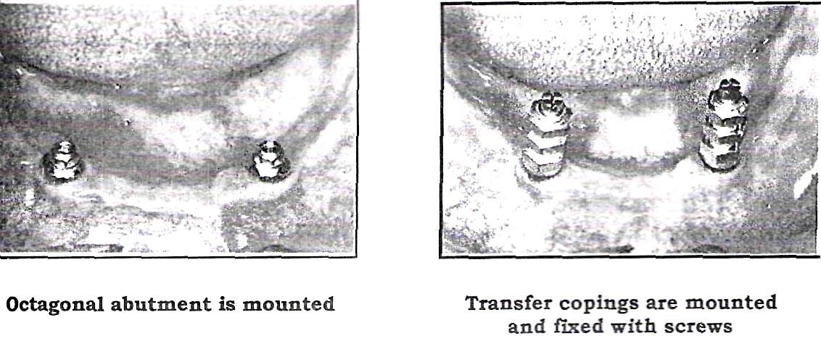

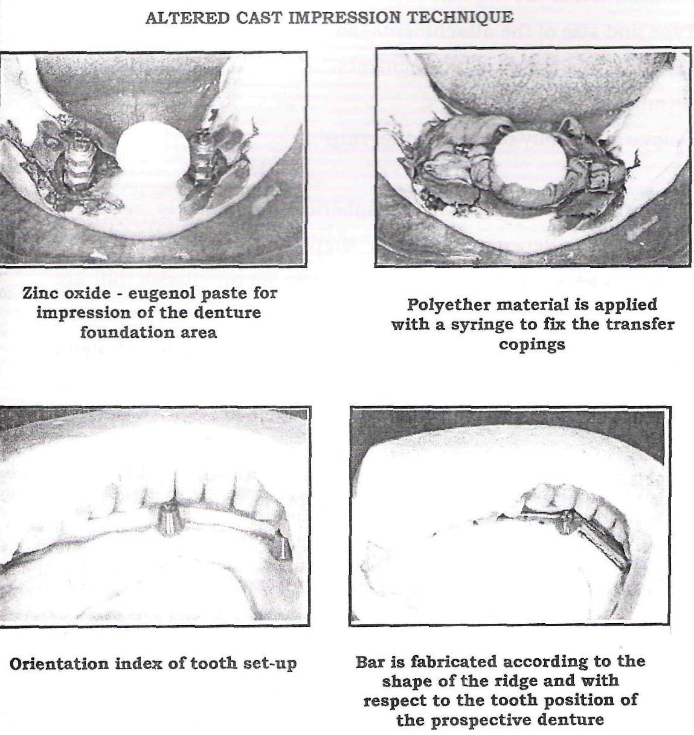

The female parts are usually fixed in the denture base during the laboratory procedures, but they can also be mounted directly in the mouth of the patient. The are fixed to the acrylic resin denture base and not soldered to the cast metal framework.

Support, retention mechanisms and retention devices:

The sum of the retentive strength and support results from various contributing factors:

- Number of supporting implants.

- Distribution of the implant over the segment of the ridge

- Type and size of the attachments/bars.

- Length of the bar or of bar segments.

- Number of female retainers.

- Degree of atrophy of the residual ridge.

The retention mechanism of spherical anchors is resilient, whereas with bars, depending on their shape and design, resilient or rigid support is provided. For support of removable prosthesis that are connected to natural teeth or roots, rigid retention mechanisms are usually preferred. For anchorage of overdentures to implants, resilient retention mechanisms are widely recommended, assuming that implants will be protected from overload.

Indications for placement of two single attachments are:

- Mandible with favorable shape of the ridge, providing for denture support.

- Distance between two implants that do not allow favorable design of the bar.

- A resilient anchorage is preferred

- In combination with highly reduced dentition.

- Easy and most economical anchorage, where new dentures need not be made after placement of implants.

- For temporary use alter the healing phase and prior to the insertion of technically time consuming prosthetic reconstruction.

Contraindications are:

- Maxilla and highly resorbed mandibular ridges.

Indications of bar connectors:

- Maxillary overdentures

- Atrophic residual ridges in the mandible

3. | Mandible with three or four implants due to pronounced
 | curvature of the ridge.

- After partial resection of the soft tissue and / or bone.

Requirements for bar connectors:

- To follow the shape and curvature of the ridge.

- Not to interfere with the denture base and to reduce space of the intraoral cavity.

- Minimal separation of implants: 10mm

- Distal extension: < 10mm, not exceeding the area of the first premolars.

Maintenance:

The objective of regular recalls for overdenture patients is to maintain the health of the peri - implant tissues and to check the denture with regards to fit of the base, stability and occlusion.

Overdentures may enhance plaque accumulation and inflammatory soft tissue reactions. However, compared with fixed prosthesis, the ability to remove the denture facilitates the cleaning of both implants and removable prosthesis.

The check up and adjustments of dentures include:

- Fit of the base, need for relining.

- Sore spots caused by dentures.

- Occlusion, need for remounting and occlusal adjustments

- Female parts of attachments: loose, broken or lost or need to be activated.

- Wear of the gold copings by the denture base.
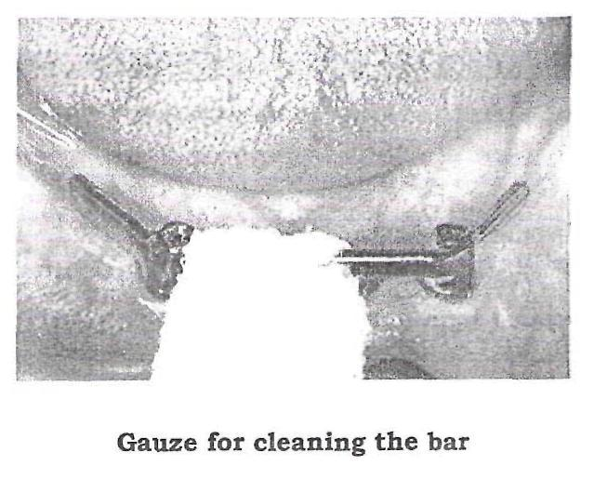

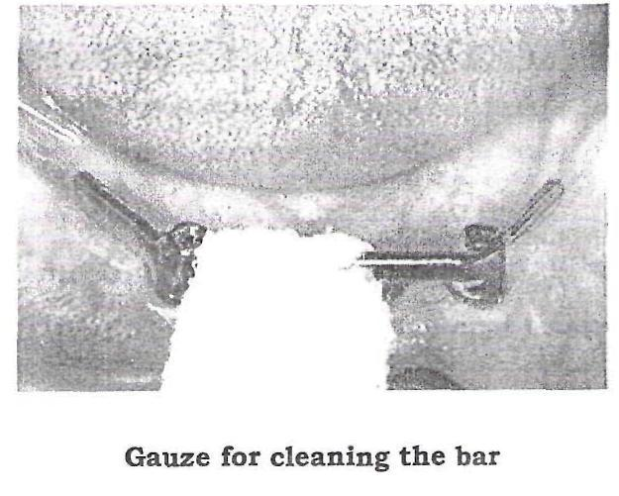

IMPRESSION PROCEDURES

Impressions on overdentures on roots or for implants have three distinct requirements:

- An impression of the entire denture bearing area.

- An impression of the root preparations. For implant procedures, an impression coping representing the head of the implant or of the implant abutment will be employed.

- A correct relation between the first two requirements.

In relating implant components to one and other, inaccuracies of less than thirty microns are normally required. This applies to distortions both in the vertical plane and the lateral areas. It is apparent that the health the health of the oral tissues must be sound before impression procedures are undertaken.

IMPRESSIONS OF THE DENTURE BEARING AREAS

Most complete overdentures are supported by roots or implants, but a large measure of support is derived from the mucosa. Where mucogingival surgery has been undertaken, sufficient time must be allowed for healing before impression procedures are carried out. An average period of 6 weeks should be allowed to elapse. For implants, about 2 weeks after abutment connection should suffice.

An adequate extended final impression is a prerequisite for any satisfactory prosthesis. To resist vertical loads, coverage of the buccal shelf area of the mandible is essential, whilst palatal coverage of the maxilla plays a similar role. If the impression features some mucosal displacement, the impression surface of the denture will be contoured to the shape that the mucosa will assume under load. While slight displacement of the denture bearing mucosa is a necessary part of the impression procedure, no displacement of the gingival margins should take place.

K.C.White⁴⁵ (1989) proposed a two stage impression technique to eliminate the need for finished denture based modification. A first stage impression was made of the resting form of the soft tissue and a second impression was developed under occlusal pressure with modeling compound applied to the boarder and the surfaces of the metal base overlying the abutments.

SELECTING THE TRAY:

So often overlooked is the influence of the tray upon the contour of the impression. The distance an impression material can flow beyond the tray is limited, while the direction in which it flows is influenced by the tray as well as by the mucosa.

Common faults:

1. One of the common faults of a lower stock tray is a short, straight

lingual | flange, which directs | the | impression | material
vertically downwards and does |  | not | guide it | posteriorly
into | the retromylohyoid fossa. Quite frequently, this results in

displacement of the mylohyoid muscle and distortion of the border structure.

- Another common mistake is to employ a stock tray that distorts the sulcus, particularly the labial sulcus.

Technique:

A simple technique has been well described by Neill and Nairn (1990). The initial compound impression is made with the mylohyoid muscles contracted, and the patient's tongue firmly pressed forward against the anterior section of the palate. The impression is then removed, chilled, and the bulk reduced with a sharp knife. At least 2mm of compound is removed from the surface overlying the mylohyoid muscles and from the surface over the buccal aspects of the roots. The extension is then checked in the mouth and, when satisfactory, the surface is painted with the adhesive and an alginate wash impression made. The cast from this impression provides details of the denture bearing area and shows the position of the root preparations.

A closely adapted acrylic resin tray can be made on this cast. If transfer copings are to be employed, holes are cut over the roots slightly larger than the roots and their gingival margins. The lingual flange should be about 4mm thick in the molar region so that there is room available to relieve the impression surface from the mylohyoid muscles. Posteriorly,

the lingual flange may be thinned slightly and turned laterally into the retromylohyoid space. Three stub handles arc useful; the anterior one for positioning the tray in the mouth, the posterior ones for holding the tray in place when the impression is being made.

The rear stub handles should be placed slightly buccal to the midline of the ridge, so that the impression load is taken by the buccal shelf area - one of the primary stress bearing regions of the edentulous mouth. The anterior stud handle is employed for positioning the tray in the mouth.

All the surfaces of the impression surface should duplicate those of the completed denture. It is not just the extension of the borders that matters, it is the thickness of the border and the contour of the buccal and lingual surfaces. Impressions of the edentulous maxilla are rather more straightforward. As with the mandible, it is important to record details of the entire denture bearing area. Common trouble spots include the tuberosities, where a poorly adapted tray will not provide adequate extension. Conversely, a border that is too thick in this region will be displaced by the coronoid process of the mandible during lateral jaw movements.

The tray will require to be adequate!}⁷ contoured to provide details of the entire tuberosity regions and sulci. There remains the question of the relatively hard midline area of the palate, which may require some relief.

IMPRESSIONS OF ROOTS AND IMPLANTS:

Although considered separately, these impressions normally form part of the overall locating impression to relate these structures to the denture bearing areas.

Locating procedures:

Unlike the complete denture the overdenture gains support from the underlying roots or implants. This produces an additional complication, as the impression of the edentulous area must be related to the impressions of the roots or implants together with any restorations that may be placed on them. The various locating procedures commonly employed have been divided into two groups and their relative merits considered.

LOCATING PROCEDURES BEFORE DENTURE

CONSTRUCTION

- "All - in - one" impression.

- Completing the metal framework of the root preparations and luting them in place before making an overall impression.

- Completing metal work for abutment preparations and placing them with a luting agent. These restorations are removed or subsequently placed in an overall locating impression.

- Transfer coping techniques. These are particularly relevant for osseointegration procedures.

LOCATING PROCEDURES FOLLOWING DENTURE

CONSTRUCTION:

- Laboratory processing.

- Intra - oral processing

The main application of this procedure rest with the use of attachment retained overdentures.

Locating procedures before denture construction:

1. "All - in - one" impression:

An impression of root preparations and of the entire edentulous area

is remarkably difficult to obtain. It is done with elastomeric impression

material.

- Completing metal frame work of the root preparations and luting them before an overall impression of the edentulous area is made:

This approach is particularly useful when individual precious metal root copings or other castings are to be constructed. Two impressions are required, one of the abutment preparations and a subsequent impression of the completed abutment preparations for the overdenture. It is important to ensure that the initial impression of the abutment preparation must cover the entire edentulous area, so as to allow the path of overdenture to be determined and the wax - up of the copings completed in alignment with this path.

- Completing metal work of the abutment preparations and placing them unluted before an overall impression of the edentulous area is made:

This valuable and popular technique works well with most stud and bar retainers and root copings. The metal work is made on an initial impression that covers the entire denture bearing area and this allows the path of insertion of the overdenture to be planned.

Once the copings or attachments have been completed, another custom tray is constructed, spaced over the metal work, but close fitting elsewhere. An overall impression is made in this tray and the unluted metal

castings picked up in the impression material. These metal castings are incorporated in the master cast on which the denture is subsequently constructed. The metal castings are not removed from this cast until the denture has been completed, so that location between castings and denture base is assured.

It is important to assess the amount of vertical and bucco lingual space available before using attachments or any space-occupying retainer. Failure to carry out this important step may result in the metal showing through the occlusal surface of the denture, thereby spoiling the appearance and rendering it liable to fracture.

Transfer coping techniques:

Transfer copings are used extensively where osseointegrated fixtures are concerned. Impression compound or an elastomeric material placed in a copper band is usually employed for the impression, with a stainless steel or resin dowel to provide an accurate impression of the root canal preparation.

Nowadays, one generally employs a hard resin transfer copings made of a substance such as Duralay, but this must be used great care to ensure correct seating without the applications of excessive loads. Transfer copings are placed on each of the preparations and when the operator is satisfied that they seat with accuracy.

A closely adapted custom made tray will have been produced on the primary impression and this tray can now be inserted using Kelly's Paste, or another suitable zinc oxide eugenol material. The transfer copings are

now placed over their respective roots, the impression tray loaded impression paste, and inserted over the transfer copings which protect

through the holes in the tray. The impression material itself is too weak to connect copings and tray, arid once the material has hardened, a layer of self - polymerising resin can be placed over the impression material, linking the coping directly with the tray. Impression plaster placed between the coping and tray is suitable alternative and has a faster setting time.

Once the copings are united with the impression tray, the entire assembly can be removed from the mouth. The dies are then carefully located on their respective copings and the impression poured. On this master cast the occlusal rims are made and the denture finally processed. This method can be used with stud or bar attachments are to be employed.

As a rule of thumb, these unluted restorations should stay in place when the denture is removed, thereby demonstrating that the chances of accidental displacement when these restorations have been luted are minimal.

Osseointegration procedures:

For most patients the operator will be making an impression over the transmucosal abutments. The first and essential step is to ensure that these abutments are correctly located on their respective implants, and radiographic confirmation is essential.

A primary impression using alginate in a stock tray is made. In constructing the lab produced tray, the operator has to provide a window sufficiently large to accommodate the transmucosal abutment and transfer coping. Additional space should be provided, as the transfer copings may be located to one another with a material such as Duralay, which may interfere with seating the impression tray unless provision has been made for it.

The location between the two copings is assured after the overall impression has been made. Fast setting impression plaster is normally the most convenient, although Duralay can be employed, bearing in mind that the setting time is likely to be greatly increased if placed over a zinc oxide eugenol type impression paste. Apply additional material over the copings to ensure that they are firmly united.

Since the impression procedure is relatively time consuming, the use of this diagnostic impression in the custom tray before the placement of the transfer copings is strongly recommended. The diagnostic impression should be made, the tray adapted and then cleaned before the transfer copings are placed in the mouth. Two contours of impression copings are available, squared and tapered. The squared type of coping is designed to be removed in the impression tray and it is this method that is normally preferred for all overdenture construction. The tapered coping remains in place while the impression is removed and then repositioned outside the mouth.

At least three lengths of screw are available to secure impression copings on to the transmucosal abutments. The longer the screw, the further it will protect through the impression tray and the easier it is to loosen after the impression material has been set. The drawback is that the impression tray has to be manipulated over the screw before it can be seated in place, and so the screw length is selected according to the amount of space available.

The shortest screws may well be required in the case of maxillary overdentures opposing natural teeth, and in these instances, one should take every precaution to ensure that the heads of the screws are easily found and not buried under a mass of impression

material, as it is impossible to remove the impression tray until all the screws have been completely loosened. Always ensure that the screw is undone. This can be achieved by pulling on the screw head with tweezers to make certain that movement is possible.

Once the impression has been removed from the mouth, an analogue representing the transmucosal abutment is carefully placed over the transfer coping. Each of the root analogues is carefully positioned in this manner before the impression is cast.

When the impression has been cast, the operator then has a replica of the patient's jaw incorporating the head of the implant. Jaw relation records and trial insertion procedures are undertaken with this cast so that the ideal tooth position can be established.

A silicone mass is prepared so that the position of the tooth is recorded and then abutments can then be placed on the implant analogues in the best possible relationship.

Restricted vertical space:

Vertical space limitations are best assessed at the treatment planning stage. An impression technique providing the operator with the maximum versatility is therefore required. Rather than inserting the abutments and then making an impression over these components, more control over the end result can be obtained if an impression is made of the actual heads if the implants. This allows both the selection of the abutments and the planning of the superstructure to be carried out on the master cast with the aid of the trial insertion. Seeing the position of the artificial teeth and their relationship to the heads of the implants allows one to determine with precision a space available.

The first step is a diagnostic impression made with the healing abutments in place. This helps the operator to make correction to the tray. The diagnostic impression is used only to perfect the impression tray and once the tray contours the impression material is removed from it.

The healing abutments can now be removed and single tooth impression copings placed over each of the implants. The impression copings should be rigidly and accurately located to each other impression plaster is a convenient material.

The impression tray is now taken and carefully placed over the connected copings, ensuring that it does not engage any copings or connecting material. The tray can then be removed, loaded with impression paste, and seated carefully over the coping assembly. Each of the coping screws must be undone before the impression is removed and the healing abutments replaced.

Implant analogues are now attached to the copings and incorporated in the master cast. If healing abutments, corresponding with those in the mouth, are screwed into the master cast, the wax bases can be adapted to them.

Once the trial has been established the position of the artificial teeth, the most appropriate abutments can be selected and the design of the superstructure and of the overdenture can be undertaken.

