Novel Method of Covid-19 Detection Using Deep Neural Networks

Prof. Veena Dhavalgi Assistant Professor, Dept of ISE
Sapthagiri College of Engineering,
VTU Bengaluru, India

Prof. Priyanka M R
Assistant Professor,
Dept of ISE
Sapthagiri College of Engineering, VTU Bengaluru, India

Abstract: The novel coronavirus 2019 (COVID-2019) emerged in December 2019 in Wuhan, China, and soon spread throughout the world, becoming a pandemic. It has had a devastating effect on people's everyday lives, public health, and the global economy. It is extremely difficult or crucial to find positive cases as soon as feasible in order to avoid the spread of this epidemic and to treat afflicted individuals as soon as possible. Because there are no accurate automated toolkits, the demand for supplemental diagnostic tools has skyrocketed. When obtained, recent studies using radiology imaging techniques suggest that the photos carried important information regarding the COVID-19 virus.
The use of advanced artificial intelligence (AI) approaches in conjunction with radiological imaging may aid in the accurate detection of this disease while also helping to alleviate the problem of a scarcity of expert physicians in rural areas.
In this study, a new prototype for automatic COVID-19 identification was discovered using raw chest X-ray pictures. The proposed model was developed to deliver reliable diagnostics for binary classification (COVID vs. No-Findings) as well as the concept of multi-class classification (COVID vs. No-Findings vs. Pneumonia). The model had a binary classification accuracy of 98.08% and a multiclass classification accuracy of 87.02%. The DarkNet model was employed as a classifier in our study for the YOLO (you only look once) real-time object identification system. There were 17 convolutional layers constructed, with variable filtering on each layer. Our methodology would let radiologists validate the initial screening, and it would be cloud-based.
Introduction
COVID-19 pandemic is caused by SARS-COV2 virus and is most widely spread pandemic in the 21st century. The COVID-19 spreads between people mainly through air droplet or direct contact. Currently, there are 179 million infected people with more than 3 million deaths worldwide. There is a increase in number day by day.
The common symptoms of COVID-19 are fever, weakness, cough and diarrhea. More than half of patient report shortness of breathes and also faces the acute respiratory distress syndrome. The estimation of the mortality rate around 3.4%, however, the number could vary based on the countries or areas. The COVID-19 pandemic is not only concerned with health deterioration but also shows its affect on societies and economy at their core.
The pandemic has vital impact in many aspects of human life such as in the field of education, tourism, energy (especially oil and gas), transportation, manufacture, healthcare, politics also economics. Many efforts have been made in order to deal with the pandemic in a direction to reduce the spread of the diseases, improvising the disease detection methods, as well quicken the availability of COVID-19 vaccine. There is increased requirement for testing, diagnosis, and treatment as there is many massive cases of COVID-19. The definitive test for COVID-19 diagnosis is reverse transcription polymerase chain reaction (RT-PCR). Using the technique, the large test samples are being processed in the lab one by one waiting for their turn for processing. The results are obtained in several days. Due to the low RT-PCR sensitivity of 60%–70%, even if the results are negative, symptoms can be detected by examining radiological images of patients. It is stated that CT is a very sensitive method to detect COVID-19, and can be regarded as a screening tool with RT-PRC.
CT findings are observed over a long period of time after the symptoms appear, and patients typically have a normal CT in the first 0-2 days. In a study of CT scans of the lungs of patients who survived COVID-19 pneumonia, the most significant lung damage is detected ten days after the symptoms appear. Chest X-ray radiography is an alternate test for COVID-19 diagnosis.
It is one of the fast, effective, and inexpensive tests used to identify COVID-19-related pneumonia and indicates that there are differences in the X-ray and CT scan results pre and post COVID-19 symptoms. As a result, CT scans and X-rays can be utilized to determine if a person is infected with the SARS-COV2 virus or not. In response to the pandemic outbreak, numerous researchers from many backgrounds are actively involved in developing better diagnostic mechanisms and vaccines for its treatment.
The domain of the researchers is not limited to the medical and biotechnology disciplines, but also includes researchers from subjects such as data science, machine learning, and deep learning. An example of a deep learning strategy to detecting COVID-19 is based on X-ray or CT scan pictures. The use of X-ray imaging is based on the fact that when the Corona virus reaches the respiratory tract, it affects the human lungs and causes pneumonia. In this condition, the lungs become inflamed and form patches known as "Ground-Glass Opacity" (GGO). As a result, an infected human's chest X-ray is likely to detect COVID-19. The X-ray machine is used to scan various human organs. The interpretation of X-rays occurs frequently. The enhanced development of deep learning, particularly Convolutional Neural Network (CNN), accredits the interpretation of X-ray images presided over automatically by the system. A good system is one that can be relied on and has high accuracy to reduce misdiagnosis. It is also critical to consider common illnesses to avoid misdiagnoses.

Related Works
As per paper [1], The model proposed is based on 14 layers of convolutional neural network and an modified spatial pyramid pooling module. The multiscale ability with the proposed network identifies the COVID- 19 disease for various chronic levels. As per the performance results, the proposed SPP-COVID-Net attain the best mean accuracy of 0.946 also the lowest standard deviation among the training folds accuracy. It encompasses around 862,331 total number of parameters, which makes use of less than 4 Megabytes memory storage. The model is apt for the implementation for speedy screening purposes so that better-destined diagnoses can be performed to optimize the test time and cost.
In reference 2, the deep learning-based technology is typically advised for analyzing X-ray images to identify COVID-19-infected patients. Using deep features, the help vector device distinguishes corona-affected X-ray images from others. The method aids clinical professionals in the early identification of COVID-19-infected patients. The multi-level thresholding with SVM technique that was suggested showed excellent classification accuracy for infected lungs. Each image had a 512 by 512 pixel resolution and was the same size. According to the results of the suggested model, the lung categorization had an average sensitivity, specificity, and accuracy of 95.76%, 99.7%, and 97.48%, respectively.
In reference 3,For the purpose of identifying patients who have coronavirus pneumonia using chest X-ray radiographs, a DCNN-based model called Inception V3 with transfer learning has been developed in reference 3. Its classification accuracy is over 98% (training accuracy is 97%, and validation accuracy is 93%). The outcomes reveal that transfer learning for COVID-19 detection was a technique that worked well, performed consistently, and was simple to implement.
In another attempt, the authors of [5] approached the same problem in a different method. The model in this study was trained on 120 X-ray images (60 COVID-19 and 60 normal) and 339 CT scan images (192 COVID-19 and 147 normal) [5]. The dataset is divided into two categories: 50% for training the CNN and 50% for validating the model three times every epoch [5]. The model was tested on a total of 67 photos, including X-ray and CT scan images. The suggested model here comprises of a CNN with one convolution layer, a Batch Norm layer, and ReLU activation [5].Following the completely linked layer is a SoftMax layer that outputs '0' or '1'. Transfer learning ideas were also applied here, as well as the pretrained model Alex Net, which was trained on over a few million photos on ImageNet and in the region of 1000 classes [5]. To get binary results, the last layer of the Alex Net has been replaced [5]. The comparisons in the data reveal that the proposed CNN outperforms the Alex Net in CT scans, with an accuracy of 94.1% versus 82% for the Alex Net.

Methodology

The CNN, invented by Yann LeCun in 1994, catapulted the field of Deep Learning and Artificial Intelligence back to prominence. Since then, we have traversed a long way in this industry. LeNet5, the first neural network, achieved a accuracy of 42%. CNN is now used to increase efficiency by nearly the world's leading technological companies. The data is been trained our CNN model must meet the following requirements:

There should not be any missing values in the dataset. All of the features in an image dataset must be of the same size; an uneven distribution of image size in the dataset can impair the performance of our neural network. Because reading photographs in RGB would necessitate a 3-D NumPy matrix, which significantly reduces the execution time of our mode, the photos should be transformed into black and white before that is fed into the convolution layer.

4) Any faulty or fuzzy photographs in the database should also be popped before putting these into the neural network. Now that we've expertised the data pre-processing principles, let's look at how the convolutional neural network works.
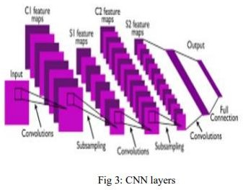

The Algorithms\Layer Used in our model are:

Convolution layer:

This layer scans the whole image for patterns and converts them into a 3x3 matrix. The convolved feature matrix of an image is known as the kernel. The weight vector is a name given to every single value in the kernel..

Pooling layer:
The picture matrix is split down into sets of four non-overlapping rectangular segments after convolution. Maximum pooling and average pooling are the pooling types. Max pooling returns the maximum value in the selected relative matrix region. The average value wrt appropriate matrix region is returned by average pooling. The primary advantage of the pooling layer's is that it enhances computer performance. while reducing the possibility of over-fitting.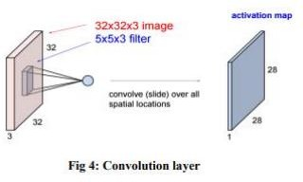

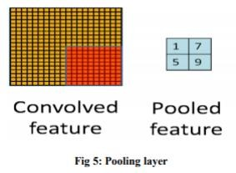

Activation layer:

- this is the section of Convolutional Neural Networks where the values are Normalized, or fits inside a specified range. The convolutional function employed is ReLU, which excludes negative values and considers the positive ones because of cheap computational cost.

Fully connected layer:

- The features are compared to the test image's attributes, and same characteristics are employed with the specified label. Labels are often encoded as numbers for computational convenience and then translated into their corresponding strings.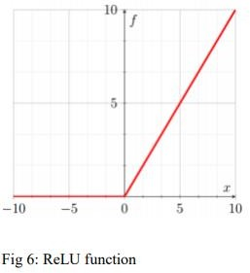

Proposed Model
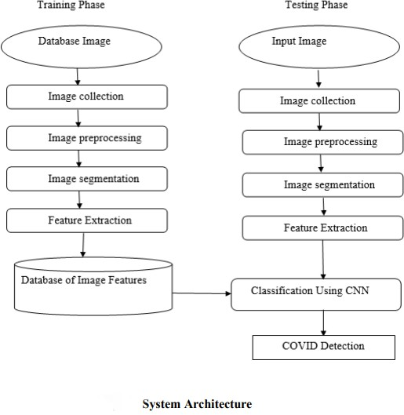
The system design mainly consists of:
- Image Collection
- Image Pre-processing
- Image Segmentation
- Feature Extraction
- Training
- Classification

Image Collection:
The Classification of X-Ray Scan images is the input to proposed system also the images of CT Scan are taken and the magnifier used to take pictures of CT Images.

Image Pre-processing:

The goal of pre-processing is to improve image data by reducing undesirable distortions and improving some image attributes that are crucial for subsequent image processing. Three major steps are involved in image pre-processing.
- Grayscale conversion b) Noise elimination b) Image improvement.

Grayscale conversion

A grayscale image provides just brightness information. A grayscale image's pixel values are being represented by the amount or quantity of light. A grayscale image can show the brightness gradient.. A grayscale image only measures light intensity. The 8 bit image's brightness is in the range from 0 to 255, where '0' represents black and '255' represents white. Grayscale conversion is the process of converting a color image to a grayscale image. Grayscale photographs are simpler and faster to process than color photographs. All image processing techniques are on grayscale images. The X-Ray image is transformed to grayscale using our proposed approach..

Noise Removal:

The main aim of noise reduction is to detect and then remove unnecessary noise from digital photographs. The difficulty is discerning which aspects of an image are real and which are the consequence of noise. Noise is referred as Random fluctuations in pixel values . we make use of an median filter which is a nonlinear filter that keeps edges intact to reduce unnecessary noise. A sliding window of odd length is used to implement the median filter where every sample value is ordered by magnitude, and scrutinize the output is the most central value, which is the median of the samples within the window.

Image Enhancement:

The aim of image enhancement is to alter an image to increase the feature visibility of interest.here contrast enhancement is used to achieve a better quality result

Image Segmentation:

The Lung area was segregated from the surrounding X-Ray images after image pre-processing. A black-and-white image with a different contrast was created to help with segmentation.

Feature Extraction:

Feature extraction is crucial in extracting information referring the image. In this scenario, we're analyzing texture photos with GLCM. The spatial coorelation between image pixels is captured by GLCM. GLCM uses the Gray level image matrix to record the most usual properties such as entropy, contrast, correlation, energy, homogeneity, cluster-shade and ASM. Contrast
∑𝑖 ∑𝑗 (𝑖 − 𝑗) 2 𝐶(𝑖,𝑗) Energy ∑𝑖 ∑𝑗𝐶 2 (𝑖,𝑗) Homogeneity
∑𝑖 ∑𝑗 𝐶(𝑖,𝑗) 1+|𝑖−𝑗| The aim of feature extraction (glcm) is to curbs the original image data set by measurement of some values and features that helps to classify various images from the other.

Training:

Make a training dataset out of photos of recognized cancer kinds. Train classifiers on the newly created training dataset. Make a testing dataset in a temporary folder. Predict the outcomes based on the test situations. Graph classifiers. Add feature sets to the test case file to accurately create image processing models.

Classification:
Convolution Neural Network is a binary classifier that uses the hyper-plane, which is also known as the decision boundary between two classes. Some pattern recognition issues, such as texture classification, make use of CNN. In CNN, mapping nonlinear input data to linear data enables good classification in high dimensional space. CNN maximizes the minimal distance between various classes. To split the classes, different Kernels are needed. SVM is a binary classifier that determines the hyperplane when splitting two classes.The border between the hyperplane and two classes is maximized. Support vectors are the samples closest to the margin that will be chosen to determine the hyperplane.The border between the hyperplane and two classes is maximized. Support vectors are the samples closest to the margin that will be chosen to determine the hyperplane.

Experimental Results
First, the overall 3-class classification accuracy levels are 93.9% (796/848), 94.7% (803/848), and 94.9% (805/848), based on three confusion matrices, respectively. The difference is only about 1%. The precision, recall rate, F1-score, and prediction accuracy of the new transfer learning VGG16-based CNN model are then computed based on the confusion matrix of the combined data, as shown in Table 3. 2404 of the 2544 testing cases are accurately detected and divided into three kinds. Overall, the accuracy is 94.5% (2404/2544) with a 95% confidence interval of [0.93, 0.96]. Furthermore, the computed Cohen's kappa coefficient is 0.89, confirming the dependability of the proposed method for training this novel deep transfer learning model to perform this classification job.

Table 3Classification report of the proposed method.

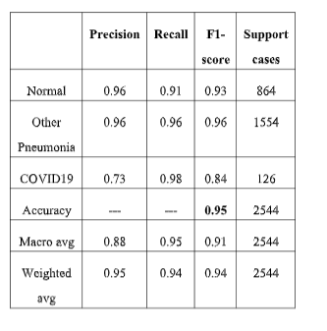
To further assess our model's effectiveness in detecting COVID19 infected cases using chest X-ray pictures, we classify normal and community-acquired pneumonia images as negative, and COVID-19 infected pneumonia cases as positive. When the values in the confusion matrix are combined, as shown in, the model has a detection sensitivity of 98.4% (124/126) and a specificity of 98.0% (2371/2418). The overall precision is 98.1%.

Table 4 then displays and contrasts confusion matrices generated by four models trained and tested with different input images, three data subsets generated from the data partition, overall classification accuracy, and 95% confidence intervals. The results show that if the data augmentation strategy is not used, the model accuracy on the testing subset data reduces to 82.3% with a kappa value of 0.71. Classification accuracy is 88.0% with a Cohen's kappa score of 0.75 when no image pre-processing is used and the original chest X-ray pictures are fed straight into the VGG16-based CNN model ("simple model"). The "filter-based model" achieves 91.2% accuracy and a Cohen's kappa score of 0.83 by using picture filtering and pseudo color images without eliminating the majority of diaphragm regions.
Confusion matrix of four CNN models on X-ray images. The accuracy's 95% confidence interval (CI) is shown in the final column.

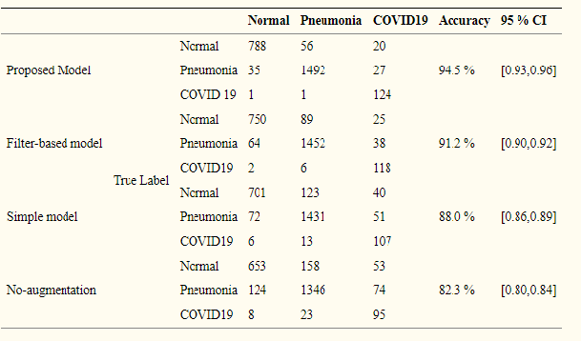
Study results tells that this transfer learning approach might lead to high performance factors with the total accuracy of 94.5 % (2404/2544) wrt classification of three classes and 98.1 % (2495/2544) wrt classification scenarios with pre and post COVID-19 infection, also the high robustness with a Cohen’s kappa score of 0.89.

CONCLUSION
This study describes and tests a novel method for developing a deep learning CNN model for detection and classification of the COVID-19 patients using images of chest X-Ray. The findings after the study indicate that image preprocessing can be used to produce superior image data as a input for deep learning models.
We are almost convinced that it is possible for the proposed CNN model shows the analogous of the highest score for the accuracy of a preferred chest radiologist, subjected to a very effective examination tool for the quick diagnosis of many infectious diseases like Covid-19 epidemic that do not require the introduction of a radiologist or physical examinations. The aim here with respect to work is to evaluate the propensity of the proposed CNN algorithm to distinguish between healthy and covid. As a conclusion the system gave very encouraging results. the used texture and color features enhanced the performance of our system and lead to a high recognition accuracy. This accuracy proves the usefulness of texture features as recognition features for diagnosis of covid.
The system is being used for the detection of Pneumonia diseases by choosing the proper training sets.
In future studies, we recommend addressing other topics such as outbreak escalates, as well as trying to explore different approaches to Convolutional Neural Networks, including deep learning models and improved interpretation of CNN models.
REFERENCES

