Application of Agada Principles in The Management of Skin Disorders
Dr. Mahesh P Savalagimath Dr. B Sreenivas Prasad Dr. Santosh F Patil
Abstract
The Ayurvedic concept of Dooshivisha holds good for the present-day food and lifestyle where exposure to chemicals and toxins is unavoidable and even the food chain is entangled with pesticides, fertilizers and various processing agents.
These low potent poisons produce systemic and metabolic diseases when they get precipitating factors, among which skin diseases are most common. The beauty of Agadatantra lies in its unique way of approaching the diseases, focusing mainly on the Nidaanaas while treating. These may be any of the factors that the person is getting exposed since the Garbhavastha. The etiological diagnosis also rules out the skin manifestations due to Aabharana visha, Jangama visha and Sthaavara visha which helps in treating the disease effectively saving time and unnecessary intake of excess medicines. So the rationality lies in the selection of agadaas and shamanoushadhis in the management of these diseases.Few of such cases along with their causes, diagnosis and management are discussed here to understand the concepts of Agada and their application in managing skin disorders.
Keywords: Dooshivisha, Garavisha, Agada, Skin diseases

Chemicals and toxins in present day food and lifestyle including environment is undeniable fact which causes assault to body. Food chain is entangled with these residual or altered pesticides and fertilizers may it be vegetables, grains, fruits to meat (broilers) which is dosed with several drugs and cattle with hormones for high yield of milk. Food is made attractive with additives, artificial colors and preservatives in the name of permissible limit but goes as unidentifiable etiology for skin, immune and many other disorders. To add on, an irrational use of medicaments and environment painted with different toxins has undesirable effect on health. This scenario has been mentioned in Ayurveda, where in low potent poisons of artificial origin called as Garavisha gain entry to body and act as Dushivisha.
Dushivisha is state where any low potent poison (vegetable, mineral and animal origin) can stay in the body for several years and cause diseases on getting precipitating factors. Dushivisha accumulated in Amashaya causes kapha & vaata disorders and in pakwaashaya causes vaata & pitta disorders which may then lead to organ specificity, for example by affecting shukra causes beeja dosha, by affecting Rakta causes Kushta and so on. It can be inferred that Dushivisha patients may suffer from liver disorders, GI disorders, urinary disorders or reproductive disorders etc depending on the nature and type of poison. It may also manifest as an allergic condition mostly of skin or respiratory system. Most of the occupational disorders seen in persons working in places where chances of exposure to chemicals, heavy metals etc. suffer from several disorders which can be considered and treated effectively as dushivishaja vikaaras. Prolonged and injudicious medication may also develop as dushivisha¹.
ASSESSMENT OF EXPOSURE TO ETIOLOGY:
In the diagnosis of any disease usually three kinds of diagnosis are made.
- Clinical diagnosis
- Morphological diagnosis
- Etiological diagnosis
Clinical diagnosis refers to the assessment of clinical presentation and analysis of dosha involvement and dominance.
Morphological diagnosis refers to understanding the extent of the disease, where one can assess the part affected and the duration etc.
Etiological diagnosis is the search for causative factors of the disease and it should be done very carefully, as the selection of treatment largely depends on this and there by the success of the treatment.
In any skin condition, we can make etiological diagnosis under two headings.
- Exposure before birth
- Exposure after birth
    - Local exposure
    - Systemic exposure
- Exposure before birth:
These factors can be treated as Garbhopaghatakara bhavas, where it is said that
If mother gets exposed to disease specific etiologies before conception or during fertilization or in early post fertilization period, the offspring will suffer from those specific diseases or will get Kha vaigunya (susceptibility) suitable for specific diseases. Here not only mother, but father is also responsible by contributing (like) dushta shukra².
Both parents play important role in the causation of diseases to their children. To establish, we will discuss two cases.
Case 01:
A 12-year-old male child approached with the complaints of multiple skin lesions like bullae, vesicles and erythema all over the body, gradually in episodic fashion since one and a half month after birth. History dissection said child’s elder siblings are apparently healthy, no specific Antenatal history by mother that was specific to contribute for the etiology. But a formal history from paternal side gave an edge to existing condition of child. Father was diagnosed as epileptic 6-8 months prior to conception of this child and underwent anti-epileptic and anti-anxiolytic therapy. So, it may be derived that the patient’s condition can be caused by the shukra dusti due to the drug.

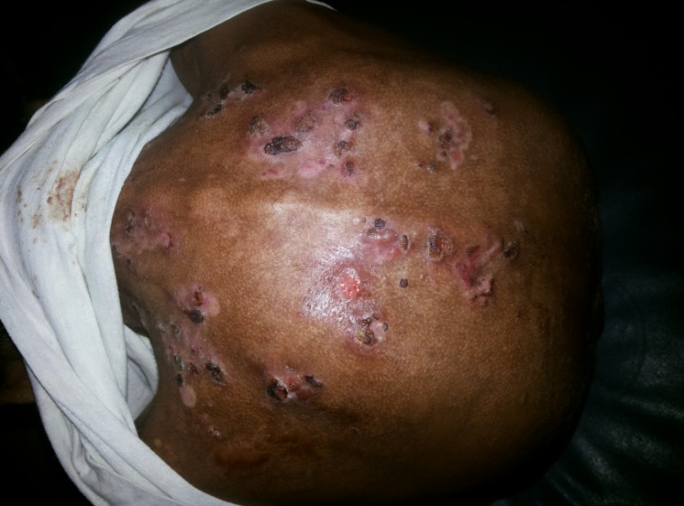
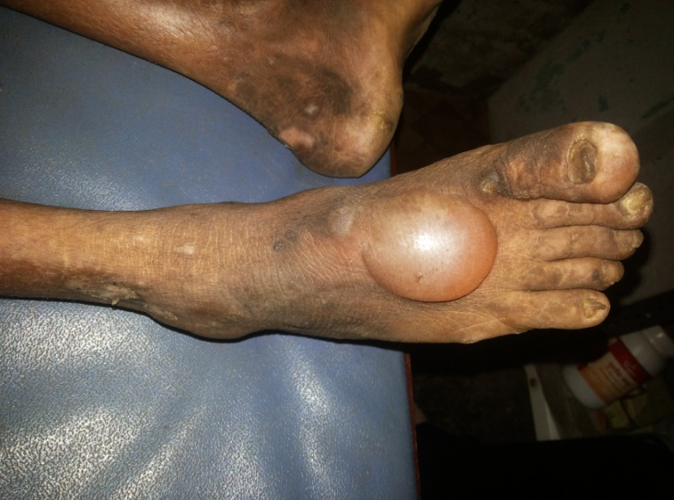

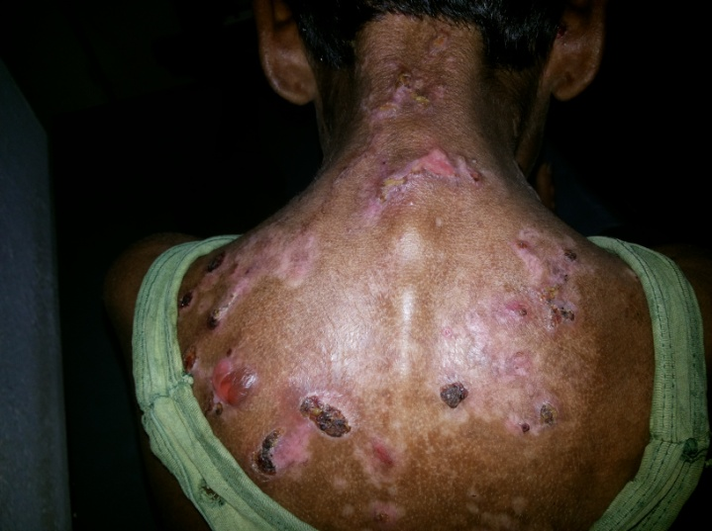
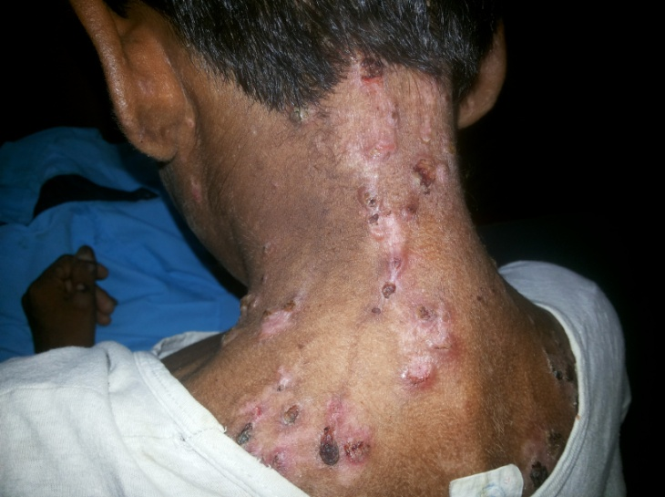

Case 02: A 3-year-old female child was brought with complaints of vesicles and pustules associated with oozing, itching and general weakness. It was told that the baby started developing pustular lesions over abdomen and back, between 15th to 20th days of birth. Gradually, severity increased and parents availed contemporary treatment regularly, but the complaints recurred very often. History revealed that there was no specific family element of skin diseases in both mother and father, even the elder child of the couple was healthy. Antenatal history of mother lauded that during her 3rd month, she met with an accident and had a fracture of the right tibia. She underwent surgical repair and treatment with analgesics and antibiotics for more than two and a half months. So, it may be considered that the exposure of garbha to drugs led to the present pathology.
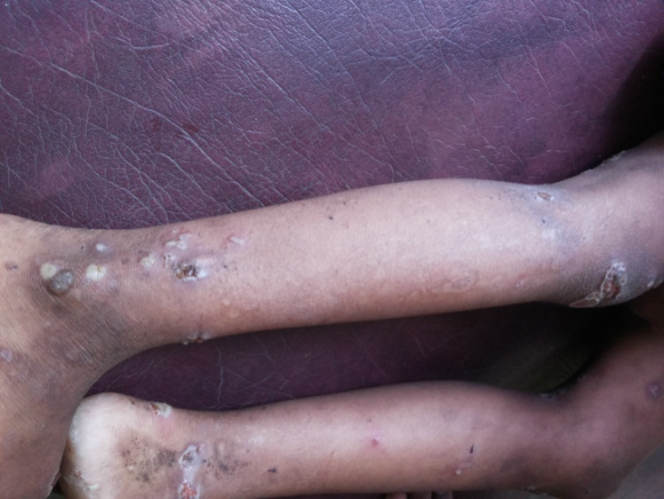
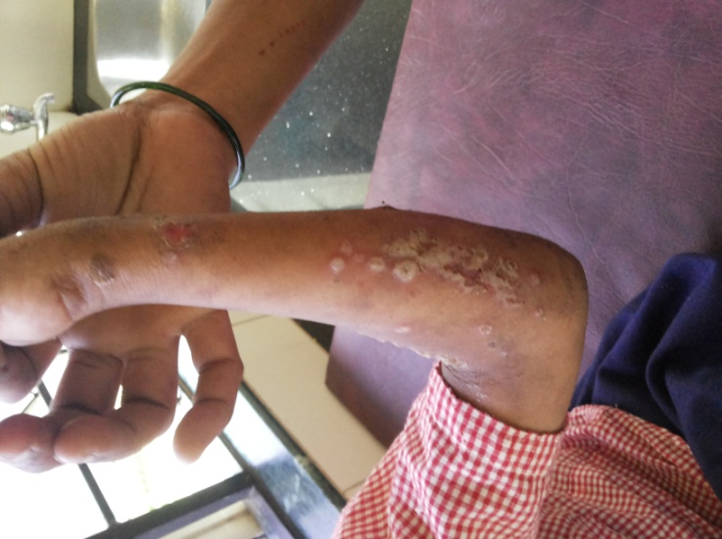

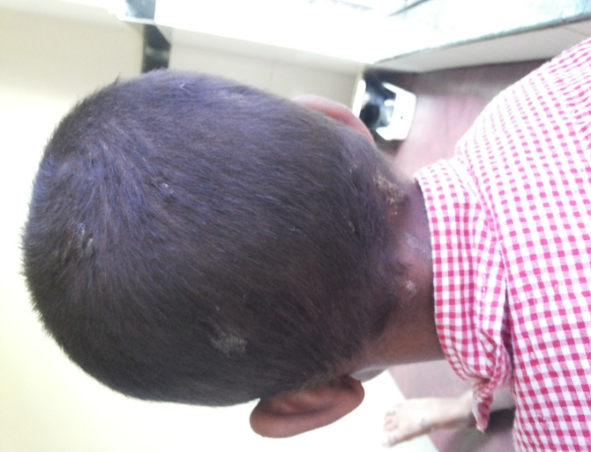
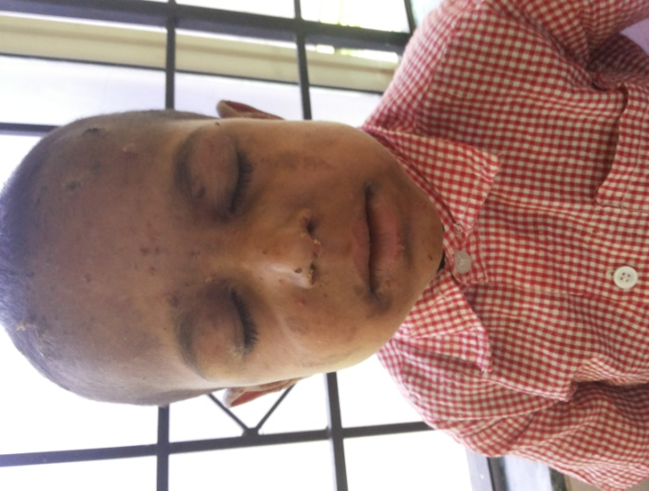

Exposure after birth:
When a patient comes with particular skin manifestations, the dermatologist should always search for the type of exposure so that one can plan the treatment as well as dos and don’ts.
Local exposure: Very often, it is believed in the practice that some chemicals or substances produce skin diseases as a result of allergy and the patient is treated symptomatically. Hence, asked to avoid the substances/chemicals to which he/she is allergic. Scientifically, this should not happen as we understand the allergy caused by chemicals/substances is not exactly by itself, rather it is because of the environment in one’s own body, which is brought about by various etiological factors. When we see the indications of Bhallataka, it is suitable for Vaata-Kapha dominant diseases and people. While same is contraindicated in Pitta dominant disease and Pitta prakruti people, because it acts adversely or like visha to them. This is not because of Bhallataka; it is the body’s composition or environment that is not suitable for Bhallataka. Hence, people develop complications, but at the end, Bhallataka is regarded as a drug causing adverse effects.
Systemic: As discussed earlier, the present-day etiologies, namely Dushivisha and garavisha, that are gaining entry into body through toxicated food, water and air etc. affect the body’s ability to prevent disease manifestation, which is brought about by Oja, which is the prime target of any type of Visha. Individual’s ability to adapt for changes in food, climate etc. is altered/affected and lands into condition of Vikaravighata abhava, this makes even the minimal etiologies to cause disorders and in this context skin diseases. This systemic exposure itself determines the effect of local exposure and hence, the severity of the skin manifestations.
Etiological diagnosis can also be made by understanding morphological findings of Skin manifestations as mentioned in the context of Paduka visha, Abharanavisha etc
Even accessories like footwears or jewellery, if contaminated with chemical or poison can develop skin manifestation over the contact area like dorsum of feet or wrist etc. This goes on to say that wherever the offending agent comes in contact with skin, there it will cause skin manifestations³.
If low potent toxins either natural or artificial origin vitiates blood, then these will cause skin manifestations presenting as Kitibha, Khota etc⁴.
These poisons have specificity in causation of various diseases like some cause Psychological/Psychiatric disorders, few cause speech disorders, others cause GI disorders, Reproductive disorders etc. This gives clear picture about their organ specificity. It is said that if they affect Shukra, then they will cause diseases in offspring; if they affect Rakta, then they will cause Kusta. (skin manifestations)⁵.
These clinical manifestations explained in the context of Dushivisha or Garavisha cannot be seen in all types of toxin/poison exposures, but depends on specific toxin and its affinity to tissue. Many scientific studies have shown that, exposure to pesticides in low doses is common and this can cause neurological and reproductive disorders.⁶
Similarly, another study says that Daughters whose mothers took DES (Diethylstilbestrol is a synthetic estrogen) (about 1 million or more between 1960 and 1970) suffer reproductive organ dysfunction, abnormal pregnancies, a reduction in fertility, immune system disorders, and periods of depression.⁷
As it is very clear here that some low potent poisons affect shukra then garbha developed by that shukra will develop diseases either in the intrauterine life or after birth. Similarly, skin manifestations can occur by affecting rakta dhatu. Another study of environmental factors like pollution exposure in preconceptional, prenatal and postnatal period showed that chemicals can cause allergic disorders like eczema in offsprings.⁸
Skin manifestations are not only caused by Sthavara visha (poisons of vegetable and mineral origin) but even several venoms (poisons of animal origin) also cause skin manifestations, as most of insect bites and stings mainly present with skin manifestations. To highlight this, one can consider Lootha visha clinical presentations, as it is explained that Lootha visha presents with wheels, rashes, pustules, vesicles, discolorations, oozing, itching, fever, etc. It is also explained that the discharge from these skin manifestations produces new lesions on the healthy parts of the body when it comes into contact with them⁹.
TREATMENT:
Etiological diagnosis is important in successful management of any skin manifestation caused by poison, because selection of etiologic-specific Agadas or medicaments depends on it. Once the etiological diagnosis is established, clinical diagnosis will help to assess the dominance of dosha and treatment protocol.
Protocol framed then will be falling like Agada or Vishahara oushadhi for etiology and Shamana for dosha modulation which includes kashaya, churna and external modalities like pariseka and taila application.
But the principle of protocol should be carefully framed with medicines having vishahara property or indicated in visha conditions (ex: patolokaturohinyadi kashaya), or at least they should not be contraindicated in visha conditions.
In general, the following Dushivisha chikitsa is adapted when skin manifestations are caused by the exposure to Low potent poisons or toxins.
Dushivisha patients should be administered Swedana followed by Vamana or virechana or both¹⁰. As such, there is no mention of Snehapaana for Dushivisha, but depending on the clinical presentations one has to decide whether snehapana is to be done or not.
If the patient presents with Vaata dominant lakshanas, then snehapaana is to be done, if the patient presents with increased Kleda (kapha utklesha) and have uttama bala (strength), then one can do abhyanga and swedana followed by suitable shodhana i.e. vamana. Same is followed for Pitta utklesha conditions and virechana is done. Also, in this context, only Vamana and Virechana are mentioned, but by considering the general treatment principles of Kushta one can opt for Raktamokshana¹¹.
If the patient presents with Vaata dominant chronic skin manifestation with reduced bodily strength, then one should choose to do Snehapaana by selecting appropriate ghrita (internally taila is contraindicated in visha condition as it potentiates visha), then abyanaga and swedana followed by appropriate shodhana. Vamana is adopted in Kapha dominant and Virechana in Pitta or Vaata dominance. Commonest used ghritas are Kalyanaka ghrita, Tiktaka ghrita and Mahatiktaka ghrita, but guggulu containing ghritas are usually avoided as the teekshna properties of guggulu may aggravate the condition by potentiating low potent visha.
Acute skin manifestations as a result of exposure to Visha are very often cured or managed by shamana therapy alone and/or along with Sadhyah shodhana like Vamana, Virechana, Raktamokshana, whichever is suitable for the presenting condition. In acute manifestations, Snehapana is not done, in such condition sadhyah shodana is done as the doshas will be in Utklishta avastha and they can be easily eliminated by appropriate shodhana. In such conditions, if one plans for Snehapana which takes 3 to 7 days, during that period itself the disease may get aggravated and the management becomes difficult.
LET US DISCUSS FEW CASES:
Case number 01:
18-year-old male approached with complaints of pustules, discharge, local odema, discoloration and severe itching over dorsum of both foot over a month. History revealed that, it started after wearing new footwear and diagnosed as paduka visha (footwear dermatitis). This was considered as vishaja and complaints showed sannipataja lakshana with pitta-kaphaja dominance (pustules, discharge, local odema and itching). Internally, Bilwadi agada and Patolakaturohinyadi kashaya were used, while externally, parisheka with Lodrasevyadi kashaya followed by Nalpamaradi taila application was done for 15 days. Later to this treatment, nearly all complaints subsided except vaata lakshana (dryness & hyperpigmentation), hence for this Kalyanaka ghruta was advised at shamana dose of 10 ml on empty stomach, Dushivishari agada twice daily after food with honey, and Eladi taila for external application for 15 days. One month of vishahara chikitsa relieved all complaints.
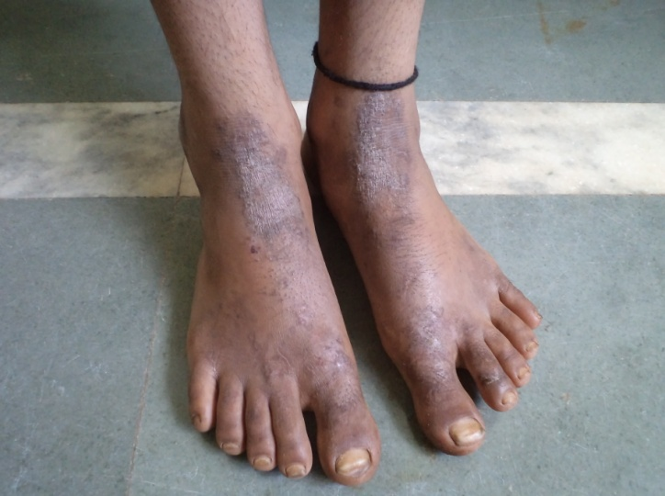
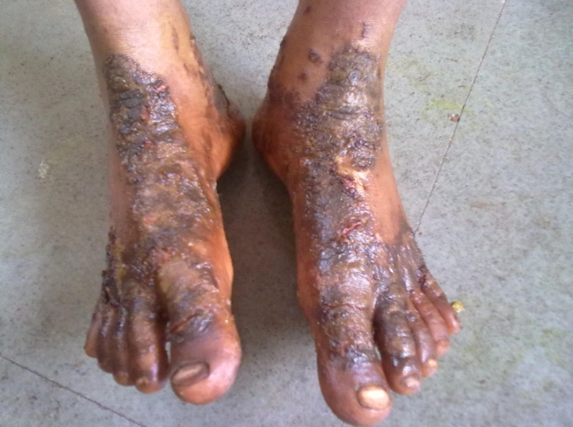

Before treatment After treatment
Case Number 02:
A female aged 21 years approached with the complaints of recurrent skin peeling in very thin layers over face, trunk and extremities, associated with itching and discoloration since the age of nine. She experienced such peels not less than 10 episodes per year. Detailed history gave an incident of infection at age of eight and treated with injection penicillin for which she developed instant allergic urticarial rashes all over the body and was managed immediately by conventional medication, but she started to develop peeling of skin on most parts of the body, which gradually increased. For this, she underwent conventional treatments but was futile. She also revealed that it gets aggravated in rainy season, on exposure to cold climate, eating cold things, food having additives (artificial food colours, taste enhancers, flavours etc.) and by taking antipyretics and analgesics. Based on the history, etiologically it was diagnosed as vaata pitta dominant (skin peeling and discoloration) skin manifestation caused by Dooshivisha (aggravates on exposure to visha vardhaka bhava as explained above). In contemporary medicine the condition was entitled as Erythema Annulare Centrifugum. This patient was treated successfully on the basis of Dushivisha and for the last 07 years, the patient is completely free from the said complaints, even after exposing to above detailed aggravating factors.
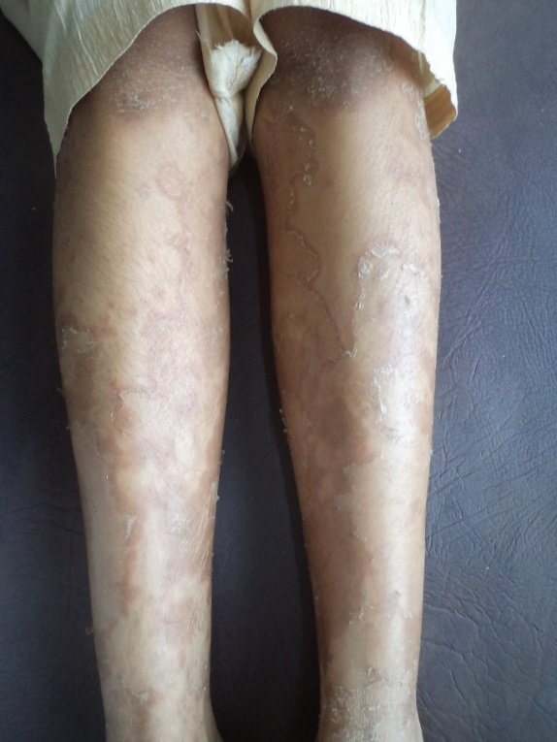
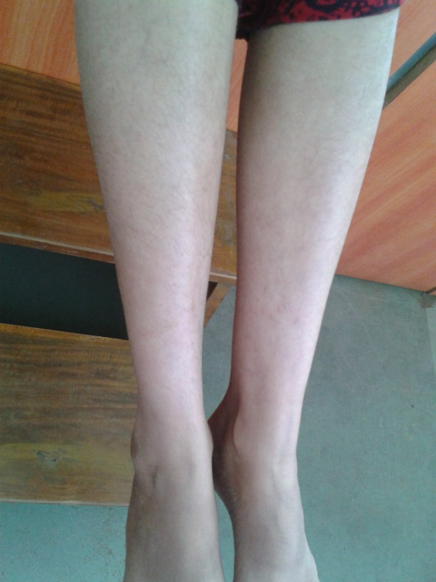
The patient was undertaken for virechana with Tiktaka ghrita snehapana, Eladi taila abhyanaga followed by swedana. Later she was kept on Dushivishari agada with honey and Haridrakhanda thrice a day for a period of six months with 20 days medication and 10 days gap during entire 6 months.

Before Treatment After treatment

Case Number 03:
A male patient aged 42yrs, farmer by occupation came with the complaints of vesicles over dorsum of left foot around the ankle extending up-to midleg with serous discharge, pain, itching and swelling over left lower limb. This was associated with loss of sensation over left foot and first three toes for 8 months. Similar lesions over medial aspect of right leg with mild itching and oozing since one week. Notable incidence was expressed by the patient saying that within a day, a new lesion would appear wherever the discharge of vesicles came in contact with fresh skin and hence always tried to keep the lesions dry. Etiology of unknown bite and morphological presentation diagnosis was made as Loota visha (wherever the discharge from these skin manifestations comes in contact produces new lesions-A.Hru.U.37/58) while conventional diagnosis was Erythema Nodosum leprosum and treated priorly with Dapsone, Rifampicin and clofazimine for more than 3months and there was no relief from the complaints, instead they increased.
Dashanga agada indicated in keeta visha and Patolakaturohinyadi Kashaya (15 ml) was given 4 times a day along with Triphala kashaya pariseka followed with Parantyadi taila application externally twice daily for 08 days. Later to this, when Pitta-kaphaja lakshana came down (reduced discharge, itching and swelling) Dashanga agada was replaced by Bilwadi agada keeping other medications same for next week. Patient started to experience pain over the region of foot where loss of sensation was complained in first visit. After 2 visits, Pitta-kaphaja lakshana came down completely and treatment was continued with Kalyanaka Ghrita 10 ml on empty stomach, Bilwadi agada thrice daily after food internally and Eladi taila for (indicated for twak prasadana and kanduhara) external application for next 15 days. Post to this Loota visha chikitsa, normalcy of sensation over foot was restored and as was relief of other complaints.

Before treatment Before Treatment
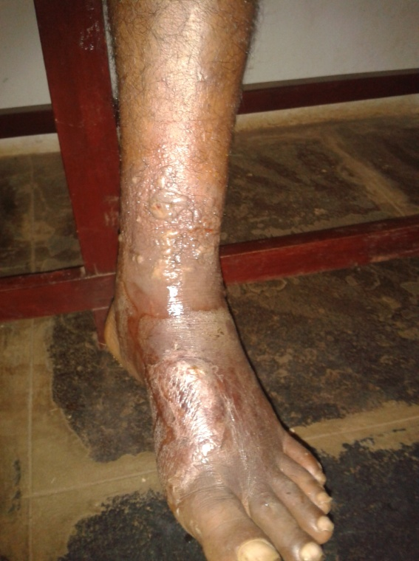
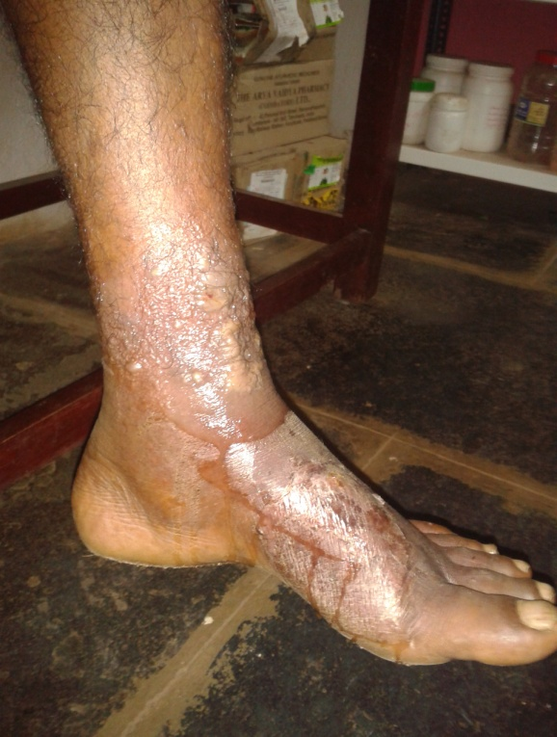

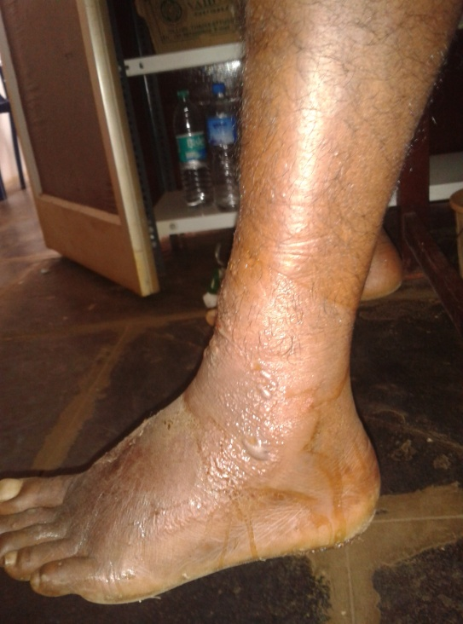
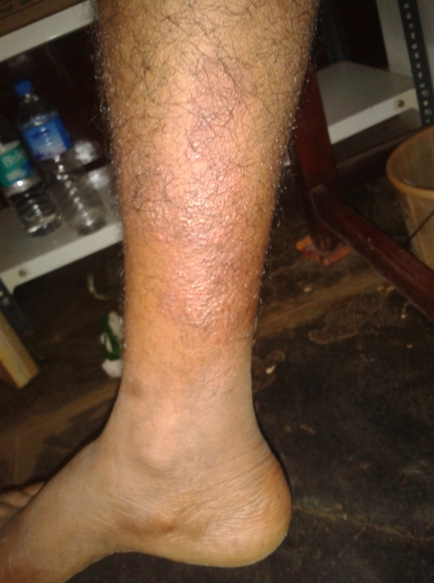

Before treatment Before Treatment
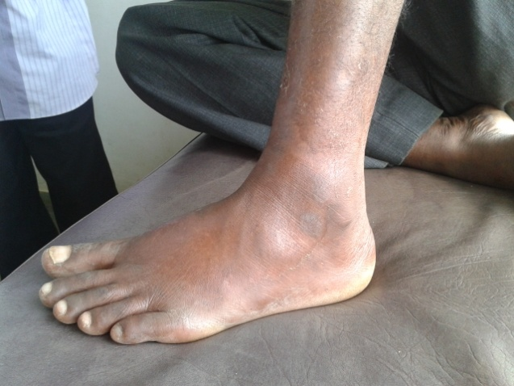
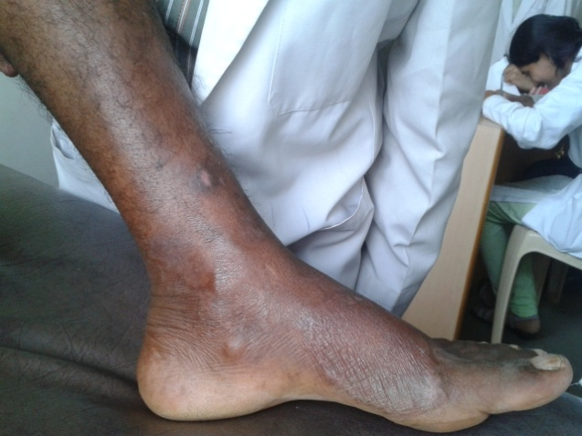

After treatment After Treatment

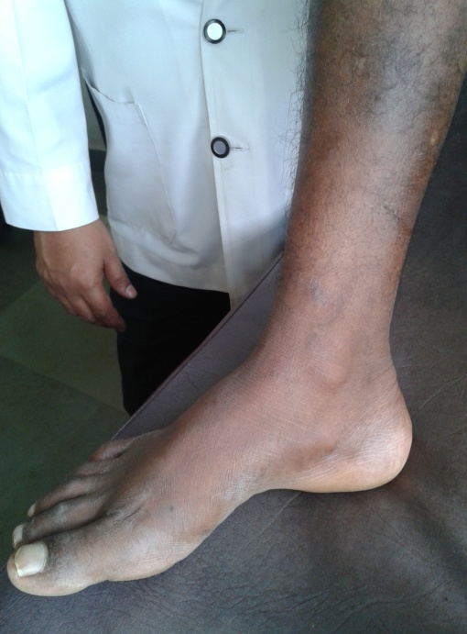

After treatment
Case Number 04:
A male patient aged 39 working as tourist driver approached with sudden onset of redness, small reddish papules over both upper and lower extremities spreading up to lower abdomen, severe burning sensation, mild persistent fever and odema over both lower extremities since 4-5 days. The condition was associated with headache, thirst and generalized weakness. On local examination, there were few necrotic circular lesions of size less than 0.5 cm suggesting of some insect bites. History directed towards an insect bite while touring the clients in Dandeli forest safari and by the same evening he developed above complaints which flared in 2-3 days. He consulted conventional physician but no relief was found and went on to be diagnosed as Leukocytoclastic vasculitis. As per Agadatantra, the morphological and etiological diagnosis was Keeta visha and treated successively and successfully. As the lesions were Sannipataja with Pittakapha pradhanata (burning sensation, skin peeling and odema) , Patolakaturohinydai kashaya 10ml five times a day along with Dashanga agada four times a day internally and Erythaila (indicated in sarpa visha chikitsa in kerala tradition) was given as external application for first two days. By day 3 of admission, the complaints subsided (redness, odema and fever came down) and patient was taken for sadyovirechana with Avipatti churna, where patient had 7 vegas and once blood stained stool. Next morning complaints of redness, burning sensation, swelling and fever were disappeared except the vata dosha lakshana like multiple joints pain and kosta rukshata (indicted by blood-stained stool). For the vata lakshana, we adopted Tiktaka ghruta 10ml once in the morning on empty stomach with hot water and Bilwadi agada thrice a day after food for next 03days along with Nalpamaradi taila for external application. After this course of medication, patient became completely free form the complaints.

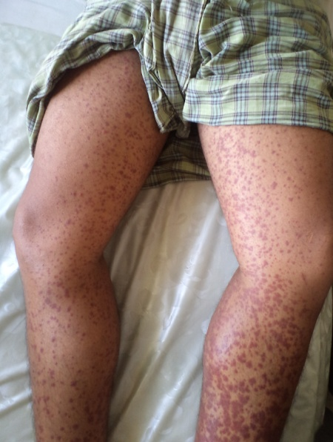
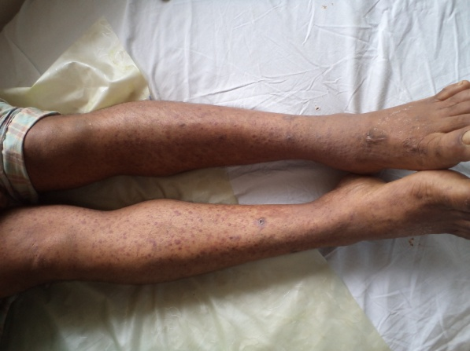
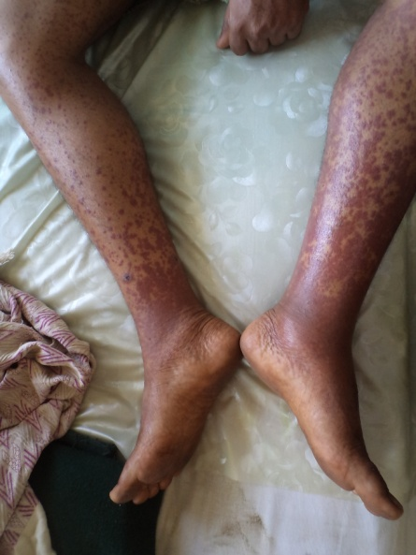
Before Treatment Before Treatment After Treatment
Case number 05:
A farmer by occupation aged 50 years complained of raised erythematic circular lesions all over body including oral and anal mucosa, itching, burning sensation, scaling with mixed presentation of dry and pus formation, multiple joint pain and generalized weakness since 3 years. Associated with constipation and loss of appetite. Patient’s previous medical history was strong indication for development of existing condition. He had taken over the counter medication (self-mediation) for his previous complaints of pustular acne lesions over face and back which actually again aggravated the condition. For this, he consulted local physician and received few oral and intravenous medications which after 4 days developed severe skin reactions/allergy as mentioned above. He neglected these for a month and then experienced skin lesions all over the body. Consultation at peripheral center diagnosed condition as Erythema Multiforme, a condition caused due to hyper sensitivity reaction. According to Ayurveda the condition was diagnosed as Dooshivisha janya Pitta-Kaphaja Kusta (itching, burning sensation and erythematic circular lesions) and Dooshivisha chikitsa was adopted. The patient was first treated with Patolakaturohinyadi kashaya 15ml four times along Dushivishari agada 1gm four times a day internally and Triphala kashaya seka and Nalpamaradi taila as external modalities for 5 days. After developing good appetite, patient was taken for Virechana with Tiktaka ghrita snehapana for 5days followed by abhyanga with Nalpamaradi taila and Triphala kashaya seka (as Sweda) for three days and virechana was done by giving Trivrut leha. After shodhana, the patient was put on Nimbadi kashaya and Bilwadi agada internally (for pitta-kapha shaman and rakta prasadana) and Nalpamaradi taila for external application for 15 days. By the end of follow up medication, more than 60% relief was seen. Once again virechana was done with same protocol and same medicines were continued with addition of Tiktaka ghritha (For vata shaman and oja vardhan) 10ml on empty stomach with hot water for next 20days. Since then, patient is completely free from all the complaints and has not developed any further allergy to conventional medicines that he took for common illnesses thereafter till date.
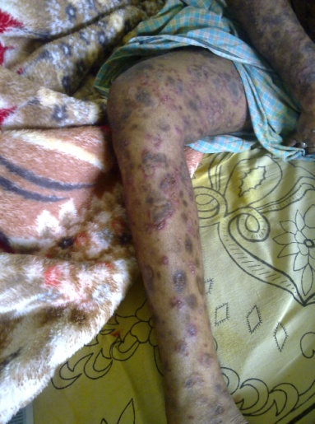
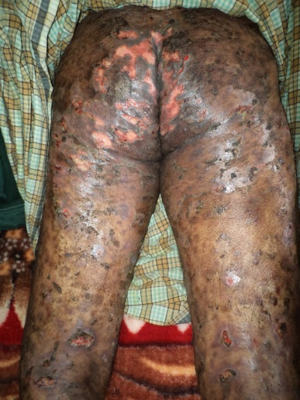
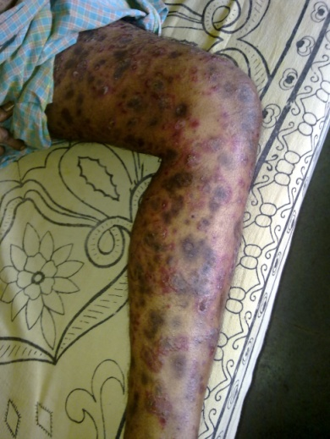

Before Treatment Before Treatment Before Treatment

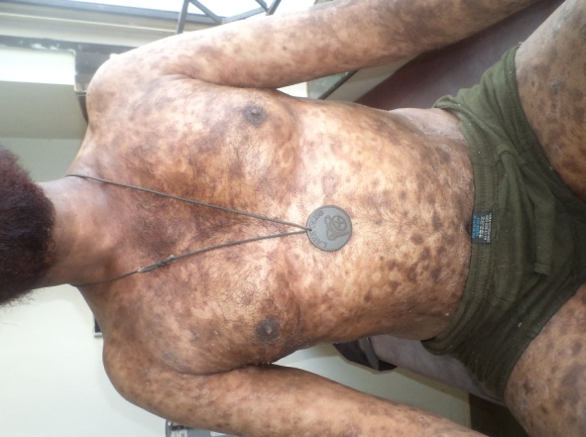
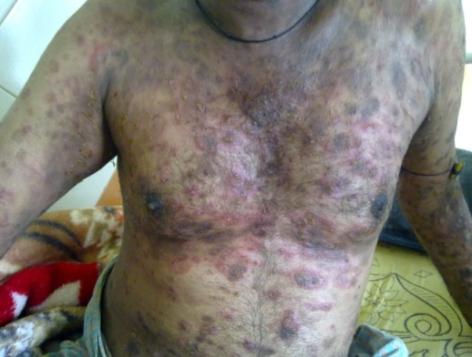

Before Treatment After Treatment
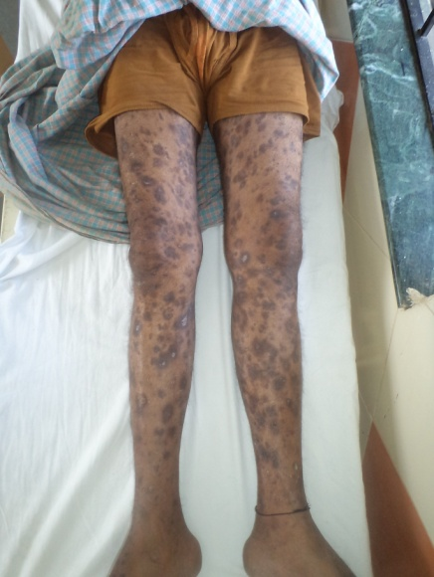
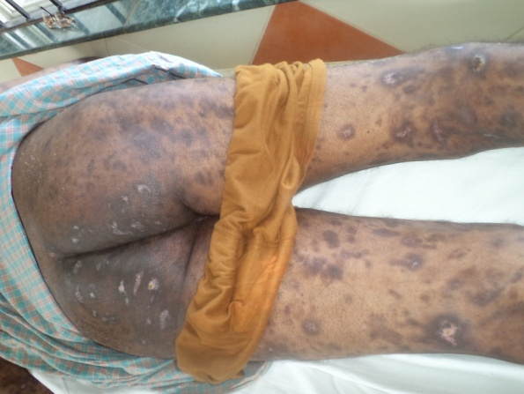

After Treatment After Treatment

RATIONALITY OF SELECTION OF AGADAS & SHAMANA FORMULATIONS:
Management of any disease having poisons or toxins as the causative factors irrespective of high potency or low potency, one should give importance to Oja or Bala, as poisons are told to act adversely over it. Hence, the treatment not only includes correcting the disease but to nurture oja. As a reason, one has to include all dosage forms and drugs having vishahara property which can protect oja and increase bala.
In skin diseases, commonly prescribed Agadas are Dooshivishari agada, Bilwadi Agada and Dashanga Agada. Considering the ingredients of these mentioned agadas, it can be said that Dooshivishari agada is Soumya yoga, Bilwadi agada is moderately teekshna yoga and Dashanga agada is most Teekshna among the three agadas mentioned here.
Generally, it is thought that, when skin conditions are severe in nature then soumya yogas are prescribed or chosen, but on contrary, in skin manifestations caused due to poison or toxin exposure, which are acute and severe in nature one should give teekshna yogas. For example, Lootha visha which is Pitta dominant tridoshaja condition presenting with pitta pradhana lakshanas like srava and daha etc, agada used is Dashanga agada. This is teekshna among mentioned three agadas, though independently the ingredients of this formulation are said to be Pitta vardhaka, here by virtue of its Prabhava it reduces the clinical manifestations of visha. Whereas for modulating the dosha, kashayas are given along with any agada.
Kashayas can be chosen as explained here- when there is increased Kleda and Srava, we can choose Patolakaturohinyadi kashaya along with the agada; if the burning sensation is more intense, then Chandana Parpatakadi kashaya is opted for; if jwara is associated, then Amritottara kashaya is to be given; if Kleda and Kandu are dominating, then Aragwadadi Kashaya is to be given; in the same way, if Shotha is dominating, one can opt for Punarnavadi kashaya. In this way, along with agada, suitable shamana yogas can be selected; even more than one kashaya or shamana yoga can also be given. Clinically Dooshivishari agada has been found effective in chronic skin manifestations with less pitta and kapha dominance, like in Urticaria, Chronic eczema, dermatitis, and other allergic skin manifestations.
Bilwadi agada is found to be effective in pitta dominant conditions even with discharge, itching, fever and swelling. It can be effectively used in vesiculo-bullous presentations like Herpes, Acute dermatitis, Eczema, bites and stings induced skin manifestations etc. Bilwadi agada and Dashanga agada have also been found effective in preventing secondary infections in skin diseases like cellulites etc.
Among externally used yogas, Lodrasevyadi yoga, explained in the context of Lootha visha is also used for external application as Lepa or kashaya Seka other than internal administration. It is seen that, it prevents further spread of the lesions, reduces burning sensation, oozing, itching and helps for faster healing of the skin lesions. Panchavalkadi Kashaya which is also considered to have vishahara property has been used as seka in conditions having more Pitta dominance along with Kapha, this helps in reducing excessive srava, Daha, kandu and enhances the faster healing of skin manifestations. Triphala kashaya is the next most commonly used formulation. It is used as Seka in skin conditions presenting with mild kleda and srava.
After seka, tailas are used for external application, and the commonest is Nalpamaradi taila. Because of its kashaya pradhanata, it is used in conditions associated with itching and mild oozing. Panchavalakaladi taila is used when there is more discharge and a burning sensation. When severe Pitta dominance presentations are seen, Paranthyadi taila, which is explained in the context of Mandali sarpa damsha chikitsa of Prayoga samucchaya, is found to be very effective. In the same way, Erythaila, an oil preparation used by Traditional Visha vaidyas of Kerala, is used in skin manifestations that are severe in nature and also caused by potent bites and stings. For Vaata or Vaata kapha skin manifestations like dryness, discoloration, and itching, Eladi taila is to be used. Pitta-Kapha dominant skin manifestations after treatment come down as Vaata-kaphja or vaatja, and hence, at the end, Eladi taila can also be used for external application.
Usually at the end of the treatment, when one feels that all the skin manifestations have completely reduced, the patient should be administered with ghrita yogas like Kalyanaka ghrita, Tikata ghrita and Mahatiktaka ghrita. This ghrita administration can be done for a period of 15 days or 30 days or as per the yukti of Vaidya, duration can be decided. The selection of the ghrita is to made by considering the dosha dominance and the nature of the disease and also the rasayana properties of the ghrita. Kalyanaka ghrita is best used when there is vaata and rakta dushti is seen, it helps to restore the bodily strength, cures Visha of all origins and also nourishes Oja. It helps for correction of discoloration and also helps to overcome the mental stress that patient will be having. Tiktaka ghrita and Mahatiktaka ghrita are best utilized in the Pitta dominant conditions, both help to subside the Pitta which might not have been eliminated completely during shodhana. Even if the condition is managed by only agada and shamana therapy, these ghritas are also effective in countering Pitta and Vaata vitiation. These ghritas also prevent further vitiation of Pitta and Vaata, improve pigmentation, prevent further infections, and simultaneously help to improve Bala and Oja.
One more important issue is the time of administration of medicines. Classically, repeated administration of medicines is advised for visha conditions and the same is followed in all skin manifestations caused due to exposure to Visha. During such administrations, patient should be carefully observed periodically as clinical manifestations change faster, and hence one should note those changes and shamana yogas can be revised or entire treatment protocol is to be revised. For example, when Aragwadadi kashaya is given with some agada in kleda and kandu pradhana condition, after 10 to 15 doses of medication the presentation usually changes to Vaata-Pitta dominance and hence Guducchyadi kashaya or any other Vaata-Pitta hara shaman yoga is to be administered. In the same way if Teekshna agada is given in the beginning, after 10 to 15 doses that can also be changed to milder ones as explained above.
Conclusion:
The etiological diagnosis plays important role in the management of any disease. Present day life style, food style and environment clearly define that each and every disease has one or other toxic (Visha) etiology. Based on the type of visha and its nature, one has to assess clinical presentation, nature of disease (acute, chronic etc.) and dosha presentation one has to select agadas along with suitable shamana yogas.
References:
- Vaidya Yadavji Trikamji Acharya, Sushruta Samhita of Maharshi Sushruta with Nibandhasangraha commentary. Varanasi, Chaukhamba Sanskrit Prakashana, Reprint 2012, Kalpasthana, Chapter No: 02, verse 25 to 26
- Vaidya Yadavji Trikamji Acharya, Caraka Samhita of Agnivesha with Ayurveda Dipika Sanskrit Commentry. Varanasi, Chaukhambha Prakashana. Reprint 2009, Shareera sthana, Chapter No: 08, verse 21
- Vaidya Yadavji Trikamji Acharya, Sushruta Samhita of Maharshi Sushruta with Nibandhasangraha commentary. Varanasi, Chaukhamba Sanskrit Prakashana, Reprint 2012, Kalpasthana, chapter:01, verse 72 to 74
- Vaidya Yadavji Trikamji Acharya, Caraka Samhita of Agnivesha with Ayurveda Dipika Sanskrit Commentry. Varanasi, Chaukhambha Prakashana. Reprint 2009, Chikitsasthana, chapter:23, verse 31
- Vaidya Yadavji Trikamji Acharya, Sushruta Samhita of Maharshi Sushruta with Nibandhasangraha commentary. Varanasi, Chaukhamba Sanskrit Prakashana, Reprint 2012, Kalpasthana, Chapter 02, verse 32.
- Mathew P, Jose A, Alex RG, Mohan VR. Chronic pesticide exposure: Health effects among pesticide sprayers in Southern India. Indian Journal of Occupational and Environmental Medicine. 2015;19(2):95-101. doi:10.4103/0019-5278.165334
- Takasugi N, Bern HA. Introduction: abnormal genital tract development in mammals following early exposure to sex hormones. In: Toxicity of hormones in perinatal life (Mori T, Nagasawa H, eds). Boca Raton, FL:CRC Press, 1988;1-7.
- Qihong Deng, ChanLu, CuiyunOu, LvChen, HongYuan. Preconceptional, prenatal and postnatal exposure to outdoor and indoor environmental factors on allergic diseases/symptoms in preschool children, Chemosphere, Volume 152, June 2016, Pages 459-467
- Pt. Bhisagacharya Harishastri Paradkar Vaidya, Ashtanga hridaya of Vagbhat with Sarvanasundara Sanskrit commentary, Varanasi, Krishnadas Academy, Reprint 2000, Uttarasthana, chapter 37, verse 55 to 58.
- Pt. Bhisagacharya Harishastri Paradkar Vaidya, Ashtanga hridaya of Vagbhat with Sarvanasundara Sanskrit commentary, Varanasi, Krishnadas Academy, Reprint 2000, Uttarasthana, chapter 35, verse 38.
- Vaidya Yadavji Trikamji Acharya, Caraka Samhita of Agnivesha with Ayurveda Dipika Sanskrit Commentry. Varanasi, Chaukhambha Prakashana. Reprint 2009, Chikitsasthana, chapter 07, verse 39.

Professor, Department of Agadatantra, KAHER’s Sri. B.M Kankanawadi Ayurveda Mahavidyalaya, PG Studies & Research Center, Belagavi, vaidyamaheshps@gmail.com, Mobile: 9845430626
The President of Board of Ayurveda, New Delhi,
Asst. Prof. Department of Agadatantra, KAHER’s Sri. B.M Kankanawadi Ayurveda Mahavidyalaya, PG Studies & Research Center, Belagavi

