A Survey on Various Recommendations
Techniques

Somen Roy Jyothi Pillai, Ani Thomas
Research Scholar Dept. of Computer Science & Engineering Dept. of Information Technology
CSVTU, Bhilai BIT, Durg (C.G) BIT, Durg (C.G)
somenroy2018@gmail.com jyothi.pillai@bitdurg.ac.in ani.thomas@bitdurg.ac.in

Abstract:

Commonly referred to as a recommender system, a recommender system is a powerful way to filter online information. It has become increasingly popular as a result of changing computer user behavior, personalization trends, and new ways of accessing the Internet. The new recommender system works well in providing accurate recommendations, but it still faces various limitations and challenges, such as scalability issues, cold start issues, and Sparsity issues. Due to the wide range of techniques, the selection of technique when constructing an application makes the recommender system focus on complex tasks. Each technique has its own characteristics, strengths, and weaknesses, and raises more questions than answers. The purpose of this research paper is to systematically review several recent contributions in recommender systems. First, we analyze the different applications of recommender systems and then we perform algorithmic analysis of different recommender systems. Finally, authors create a taxonomy that takes into account the various components that are needed to create a successful recommender system. .In conclusion, this paper provides a much needed overview of the state of research in recommender systems and highlights gaps and challenges that can be overcome to help future generations develop effective recommendation systems.

Keywords: Recommender system, classification, clustering Content-based filtering, Collaborative filtering,
Hybrid filtering,

1. Introduction:

A recommender framework (RS) could be a sort of data channel which points to proposing significant pieces of Data (budgetary news, item, motion picture, destination, etc.) Rating expression of users' intrigue may be a sort of explicit feedback which is the dynamic activity of the client, while certain criticism may be a detached activity of behaviour for audits of the page of item and so on. The exponential development of the information era by online stages is made a gigantic effect or change for genuine world individuals and related clients, this change appears that each individual's intrigued and choices are assorted on social organizing destinations expanding the alluring sessions with all kinds of space. So a framework that makes a difference in the clients selects reasonable alternatives for consideration and these frameworks are known as recommender frameworks.

RS frameworks are having a few sifting methods like content-based sifting, Collaborating sifting, and Knowledge-based. In RS, side data, Adaptable misfortune work, sequence-based representation and optimization issue with positioning misfortune, Arrange for that decipher a course framework factorization show into a neural arrangement shapes involvement with a few positioning misfortunes, switch out the factorization introduction for a sequence-based on Nearly all the recommender framework has been outlined for dealers item or service provider and all are like Amazon, Netflix, flip cart, etc. planned to draw in clients.

Presently, suggestion framework isn't restricted to business purpose, but they will have a more noteworthy impact on our way of life and this framework will become a basic device in every sphere of our life. It'll be an individual advisor who can help in each segment of living by giving vital proposals and direction the perfect recommender framework will be a necessary portion of the include look motor which can be able to offer personalized looks it is exceptionally difficult for the clients to figure out the method of reasoning and rationale behind the suggestion.

Content-based sifting – this procedure is based on chronicled information for the client and pertinent occasions where the user's past information is (content, sound, Video) but for the proposal and based on frameworks create a positioning list for expectation but strategies having cold begin issues where unused things and clients come to this interaction and their past data information is lost this may debase the execution of the framework H.Li,(2012)

Collaborating filtering – collaborating strategies are based on the similitude between clients and Things and for that, able to discover a few comparable strategies for clients and occasions be that as it may these strategies create the exceptionally common issue like Scanty, adaptability, and long-tail sense because of the need of criticism or evaluations by the client this procedure is based on network factorization and the issue can be taken care of by SVD but for the expansive and complex environment got to overcome the merge issue for superior ratting Dutta, R. & Mukhopadhyay, D(2008)

Hybrid filtering – A cross-breed method is a conglomeration of two or more procedures utilized together for tending to the confinements of a person's recommender strategies. The joining of distinctive procedures can be performed in different ways. A half-breed calculation may consolidate the comes about accomplished from partitioned procedures, or it can utilize content-based sifting in a collaborative strategy or utilize a collaborative sifting strategy in a content-based strategy. This half-breed consolidation of diverse strategies by and large comes about in expanded execution and expanded exactness in numerous recommender applications. A few of the hybridization approaches are meta-level, feature-augmentation, highlight combination, blended hybridization, cascade hybridization, exchanging hybridization and weighted hybridization McAuley, J.(2016).
Traditional machine learning approach for recommendation system lies on classification and regression techniques based on dataset information, machine learning techniques are very efficient for generalization and interpretation of the RS model it is proved by recent research nowadays deep learning is very popular and more efficient than existing techniques, deep learning provides a new state of the art which can extract some information from pretend model and useful to automatic feature extraction with very handy for large datasets, the advantage of deep learning is very prominent for recent and future research in RS.

In the latter decade, a recommender framework has performed well in fathoming the issue of data over-burden and has become the more suitable apparatus for different ranges such as brain research, science, computer science, etc. any use case, and different domain recommender frameworks confront an assortment of challenges which are

I.1 Issues and Challenges in Recommendation Systems:

The data Sparsity problem is a common issue with the CF technique, which is caused by the fact that most users do not rate most items. This results in a sparse rating matrix, making it difficult to locate a group of users with similar ratings. This is the most evident disadvantage of the technique however; it can be alleviated by the use of additional domain information. Another common issue is the cold-start problem, which is related to the introduction of new items and users to the RS system. For example, a new item cannot be recommended initially in the CF system, as Movie Lens cannot recommend it until it has received some ratings. This is a difficult problem to resolve, as it is difficult to find a similar group of users or to create a CB profile that does not include a user's previous preferences.

Scalability Problem: One of the biggest problems with RS today is how well they can handle algorithms with big real-world data sets. It's getting harder and harder to handle huge, dynamic data sets made up of things like user preferences, ratings, and reviews. It's possible that when you use some recommendation algorithms on a small set of data, they'll give you good results, but if you use them on a lot of data, they might not give you the best results. That's why RSs need to use advanced, big-scale assessment methods to figure out how to use the data in the best way possible.
Privacy: RSs need to collect as much data as possible and make the most of it. But if they do this too much, it can leave users feeling like their privacy is being taken advantage of. That's why it's important to design techniques that can use the data sensibly, and carefully, and not give away too much.

Robustness: Another major issue with RS is its resilience to attacks. A robustness score is a measure of how resilient a system is to attacks. For example, an attacker can create fake user profiles according to some attack models (Push/Nuke attacks, etc.) to make certain target items more or less popular. These attacks are also known as shilling attacks, profile injection attacks, etc.

Generally, a user will select an item from a recommended list if there is some diversity in the recommended items. A smooth recommendation for a specific product type will not be valuable if the user has a limited set of preferences. In the early stages of using an RS as discovery tool, users might want to explore various and different options. So far, there has been little research on this topic. Our goal in this article is to propose solutions that can achieve diversity of items as well as accuracy of recommendation.

Authors proposed various recommender calculations on novel rising measurements that focus on tending to the current limitations of the recommender frameworks. A good recommender framework must increase the suggestion quality according to client inclinations. However, a specific recommender calculation is not always guaranteed to perform similarly across diverse applications. This increases the likelihood of using distinct recommender calculations for distinct applications, which comes with a lot of challenges.

Overview of Recommendation Models:

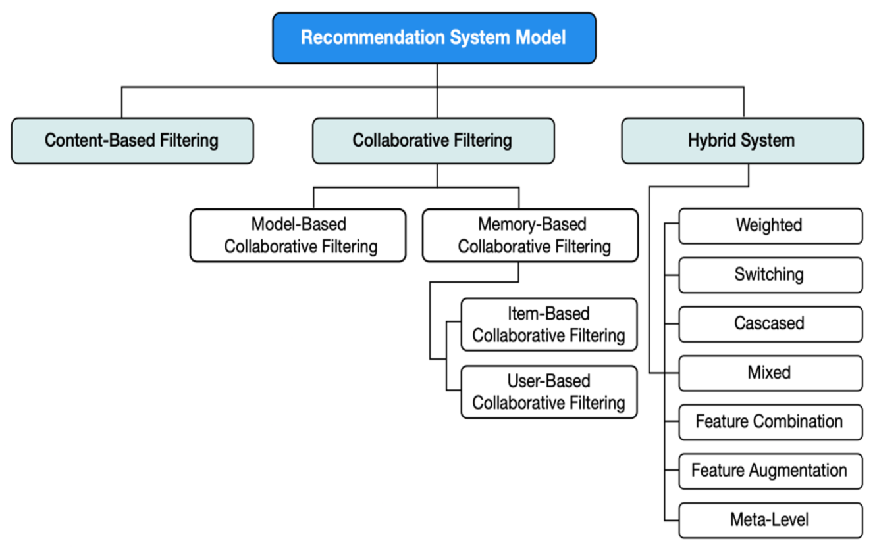

Figure 1 General architecture of the Recommendation model

There is a requirement for more investigation to reduce these challenges. Moreover, there's a huge scope of research in recommender applications that consolidate data from diverse intelligently online destinations like Face book, Twitter, shopping locales, News domain etc. A few other regions for rising research may be within the areas of knowledge-based recommender frameworks, strategies for consistently handling understood client information and taking care of real-time client input to prescribe things in an energetic environment. It will help more about RS models with techniques by depicting figure2.

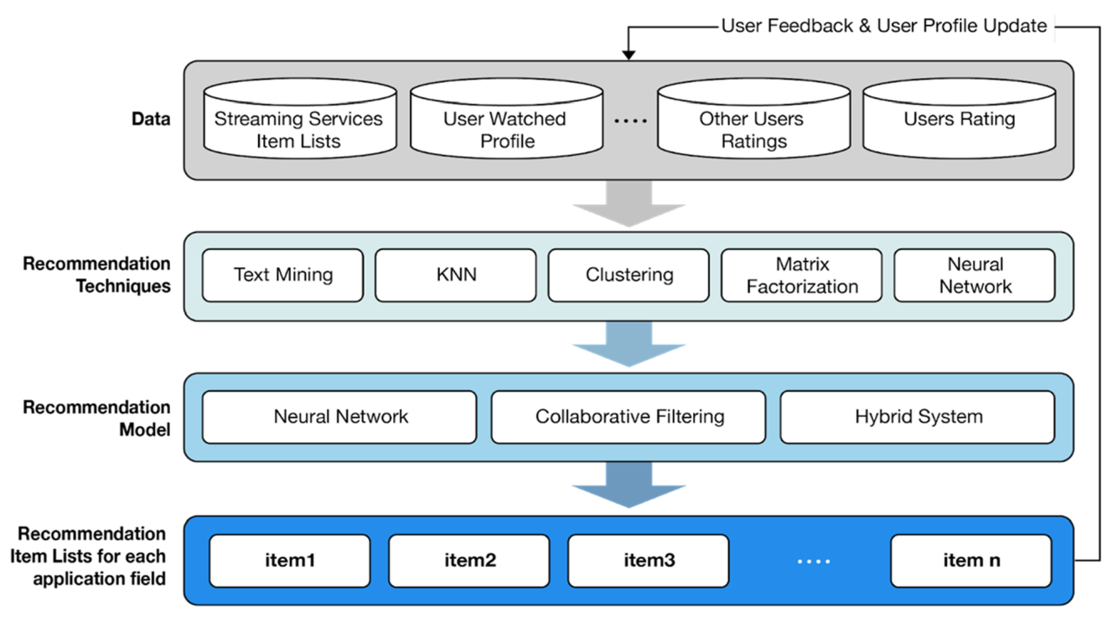

Figure 2. The overall flow of recommendation models and recommendation technique

II. Literature Review:

This work proposes the utilization of valuable textual information for the purpose of making recommendations. Furthermore, the textual information can be used to obtain ratings for products that are not rated by a sufficient number of consumers. This helps to address the issue of cold-start which is a common issue with collaborative filtering techniques. The system is designed to address both cold-start and data. Xiang Liu's [2] study compares the results of a scientific experiment and a professional assessment to determine the degree of fashion of consumers. The authors of the study suggest that feature priority should be taken into account, and that customers' fashion level may be accurately determined by factors such as make-up, accessory, and hair color.

H. Li F. Cai Z. Liao [3] As a rule of thumb, recommendation algorithms are designed and built to provide recommendations based on well liked things. However, recommendation algorithms should not be restricted to just that. Since the same and well known commodities may bore customers, it should also offer variety .Single, A. Srivastava, J et al [6]. Dietary recommendation system for e-commerce based on disorder, health condition and other characteristics of patients. Proposed design has undergone training, tested and cross validated. Training, testing and cross validated shows that the proposed solution is more accurate and more precise than the solutions in the upcoming recommender systems.
Singhal, A and KASTURI (7) outline the research challenges related to the various applications of e-commerce recommender systems. These applications include food ordering, online shopping, secure product delivery, customer tracking, and more. Future experiments may be conducted to anticipate and experiment with the outcome of the upcoming solutions.
Catcov Denis and Jari Veijalainen [16] found that the accuracy and diversity of a recommender system are not independent of one another. The growth of diversity can either reduce accuracy or increase it, depending on the magnitude of the increase in diversity. In the future, we plan to further explore the topic of randomness by designing algorithms that focus on randomness and testing them with real-world users. With a larger data set on randomness, insights into randomness may be gained. Deep learning appears to be a viable avenue for designing algorithms that prioritize randomness.

Recommendation algorithms, such as those developed by Kim J., Choi I et al., [18] are usually designed and developed for the purpose of recommending popular products. However, they should not be restricted to that. They should also offer diversity, since the same and known products can bore the customers. For instance, more accuracy can be used for the identification of books and fashion styles, while diversity is more accurate for the detection of books or fashion styles. Currently, most of the recommender systems used in the E-commerce platforms are based on traditional algorithms, such as Item KNN or SVD, which are used to recommend products that meet the preferences of the customers. However, the accuracy of the recommendations can increase the satisfaction of the customers.

Deep learning-based recommendation systems, such as the NCF algorithms, offer to pursue diversity in order to increase sales volume. This is because pursuing diversity increases customer satisfaction while also maintaining accuracy. Singh, P. K., and Dutta, Pramanik [19] This paper aims to track the trends in RS research. Here are some interesting findings: For example, most research in RS focuses on CF and a knowledge-based approach. China is the top contributing country to RS. The majority of papers in RS are published in IEEE. RS research peaked between 2013 and 2014. Most research in RS focus on CF with the DLL approach.

Hidasi,B, Karatzogloul, A et.al [11] introduced new loss functions. In combination with an improved sampling strategy, the new loss functions provided RNNs with high k gains for session based recommendations. These techniques may offer similar advantages in the domain of Natural Language Processing, which shares many similarities with the domain of recommendation related to machine learning (e.g., ranking, retrieval, data structure, etc.).Improved sampling strategies have yielded remarkable results. While recommendation algorithms are usually designed and developed to recommend the most popular items, they should not be restricted to that. Instead, they should provide diversity. For example, a customer might be bored by the same or well-known items, so a recommendation algorithm should provide a diversity of items to detect books or fashion styling.

Sahoo, A.K., Pradhan et al [20] compare various privacy-protective collaborative filtering techniques as well as various deep learning methods. RBM-CNN shows that health recommender systems are more accurate than others. This paper suggests a new approach using collaborative filtering with deep neural networks, which may be useful for further research. Content-based filtering is one of the most commonly used techniques next to CF. However, content-based filtering also faces the same issue as CF. As a result, the hybrid approach, which combines the other two techniques, seems to yield a better result and is becoming the most widely adopted technique in RS.
Alamdari, P. M, Navimipour et. al [26] Furthermore, all selected mechanisms are compared based on some crucial metrics such as security, response time, scalability, accuracy, operation cost, Diversity, novelty, serendipity, implicit, explicit data source, and independence. The author focused in this work on customer satisfaction more than accuracy. Y. K. Tan and X. Xu et al. [28] propose to improve recurrent model performance for session-based recommender systems by applying appropriate data augmentation techniques to account for temporal changes in user behaviour. Future work should explore the tradeoffs of embedding-based models for better results. Manoharan (Samuel) [14] The model is rapidly trained using the Gated Recurrent Network (GNN). The design is then trained, tested, and cross validated. The results of training, testing, and cross validations show that the proposed model has better accuracy and precision than ML and DL approaches such as MLP (Model-Linear Programming), RNN (Logistic Regression), and Navies (Bayes) Bayes.

McAuley He R. [10] In this paper, we propose a new approach called “Fossil”. This approach predicts personalized sequential behaviour using similarity based models and Markov Chains. We tested this approach on several large-scale real-world data sets and found that it outperforms the current approaches. The authors provide some hybrid methods to achieve better results. Murad, D, Heryadi, Y, et.al [21] It is clear from the overview of RS that research in this area is expanding exponentially. The most often used method for recommendation systems is collaborative filtering. The main disadvantage of this method is that it cannot address the cold start problem, but it may significantly improve in sparse data. Jie Lu et al., Qian Zhang, et al [24]. This article demonstrates how recommender systems may be improved using AI approaches and serve as a reference for recommender system researchers and practitioners. Utilizing a variety of ML and deep learning approaches in addition to other techniques.

SHOUJIN WANG and LONGBING CAO [38] The most noteworthy efforts on session-based recommender systems (SBRSs) to date have been reviewed in-depth and methodically in this study. To remove some uncertainty and inconsistencies in the field, the study proposed a uniform framework to divide the existing works in this field into three sub-areas and offered a unified problem statement for SBRS. It also examined the features of session data and the accompanying difficulties.

Noemi Mauro, Malte Ludewig and et.al[29] In this regard, it is a common problem that simpler methods and older non-neural methods are often disregarded in empirical evaluations and neural methods are used as the baselines, even though neural methods may be ambiguous in their competitiveness. Deqing yang, Wenjing Meng, et.al [31] MKM-SR, unique session-based recommendations (SR) model, takes into consideration user micro-behavior and item knowledge, depending on many intuitions about the item and operation sequences that are present throughout a session. Boi Faltings and fei mi [32] In this study, a real incremental session-based recommendations scenario is used to propose neural approaches. This paper shows how current neural models can be used in this situation with slight modifications and suggests a general technique called memory augmented neural recommender (MAN), which can be used to improve a number of existing neural models.

Zhang G., Zuo H., and Lu J [36] This research paper presented a novel Res TL framework, which is capable of learning the target model for a conditional shift scenario. Res TL is able to retain the distribution features of the source data, while simultaneously learning the residual between two domains. Additionally, Res TL can be used to create the target model by reusing the pre-defined parameters from the source fuzzy system.

Quoc V Le and Tomas Mikolov [34] The potential of distributed representations for machine translation was shown in this article. We effectively learn meaningful translations for single words and short sentences from massive monolingual data sets and a modest beginning lexicon.

Eric Appiah and Longhua Zhou [39] this work suggest a safe deep learning-based recommender system that predicts and gives simple nutrition and treatment suggestions to patients with unique requirements without disclosing their private medical information. Based on their fundamental demographics, dietary habits, medical history, and other pertinent information, the system automatically generates precise suggestions for ill patients.
Sharma, S and V. Rana [40] The influence of related video recommendation systems on video views and likes is discussed in this study along with a personal recommendation system. Measuring ultimately necessitates taking this into account and analysing the intended consequence since recommend estimates and problems fundamental treatment and diet contributions are often employed for numerous extra purposes like user happiness or enhanced transactions.

Overall, our research shows that the ILS measure may serve as a reliable substitute for views of human diversity. However, the specifics of how the measure is implemented might be important; therefore a particular metric has to be validated in a particular domain. Its application, for instance, before the use of algorithmic diversification approaches. With Our work closes a significant research gap in the literature as a result of these findings. Researchers frequently presume implicitly and without verification that the ILS metric they are using which is probably only developed via intuition would be an accurate substitute for human views on diversity.

The purpose of this paper is to provide an overview of the various machine learning algorithms employed by recommender systems, with the aim of identifying the various ML algorithms being employed and aiding new researchers in conducting appropriate research. The results of this review indicate that only a small amount of research has been conducted on hybrid approaches;

However, there is ample scope for research in the areas of semi-supervision and reinforcement learning, while neural network and K-means algorithms are insufficiently researched for the development of RSs. For example, in [23], Geetha et al. proposed a recommender system for films that successfully solved cold-start issues. This system is primarily based on the collaborative filtering approach, content based filtering, demographics based filtering, and hybrid approaches; the aim of this system is to overcome the shortcomings of each approach and it is applicable for any kind of domain in recommender system as further research very helpful to adopt techniques in various method.

III. Popular Research Domain and techniques in RS:

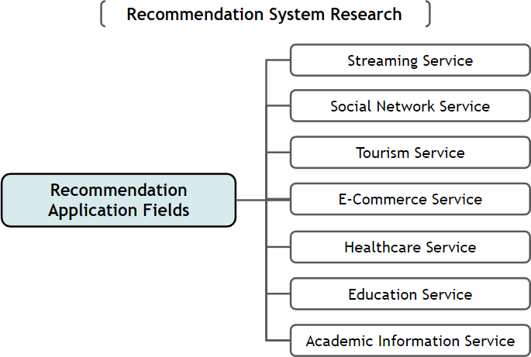

Summary of Research Trends:

Figure 3 shows the ratio of total papers collected on the seven service fields of this study between 2010 and 2022. The figure shows the trend in the ratio of number of papers per year. From these figures, we can see that a lot of research was done on recommendation systems in the following order from 2010 to 2022:
1. Social network services
2. Tourism
3. Healthcare
4. E-commerce
5. Education
From the Figure, we can see that tourism, healthcare and education have recently become a big part of the study and research is growing. From the data, the interest in this field reflects the rapid growth in the interest in specific lifestyles and the field of education offers effective alternatives to Offline education. Today's customer of various domains heavily depends on recommender systems, and these systems are becoming increasingly popular as intelligent agents for all kinds of customers as shown by the distribution below chart.

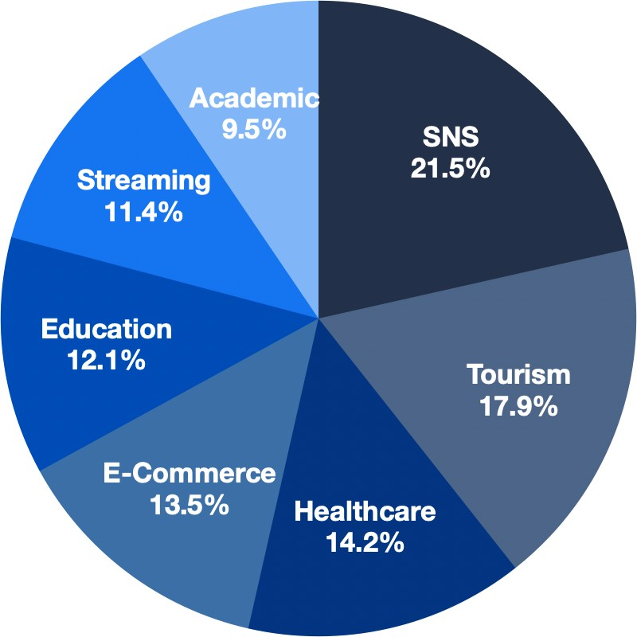

Figure 3 Distribution of seven recommendation system fields from 2010 to 2022

Processing Steps for RS Techniques:

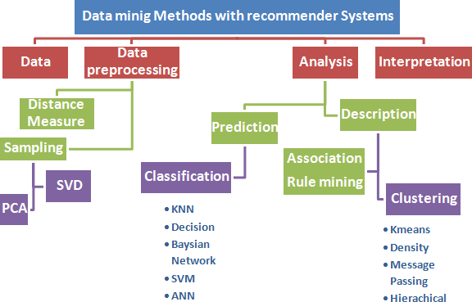

Figure 4 Technology mainly used in Recommender System

Table 1- Comparison of recommender systems techniques:

No | Techniques | Advantage | Disadvantage
1 | Content-Based recommendation Filtering | - The system didn’t use the user's data to recommend items.  - The system can recommend new items to the users based on the similarity between item specifications. | - We need to analyse and detect all item features to create a recommendation list  - The system didn't depend on the user's rate for this item so the evaluation of the product quality was not included.
2 | Collaborative recommendation Filtering | - The system didn’t use demographic information to recommend item | - The quality of the system depends on the highest rating item list.
 |  | - The system matches similar items between users.  3. The system can recommend to the user items outside their preferences and may like this item. | 2. There's a problem with how to recommend items to the new user (cold start  Problem).
3 | Demographic recommendation filtering | 1. It is not based on user-item ratings, it recommends before the user rated any item. | - 1. The gathering of demographic data leads to privacy issues.  - 2. Stability vs. plasticity problem.
4 | Hybrid Approaches | - 1. It combines all advantages of content-based and collaborative filtering.  - 2. It's based on Content Description and user evaluation.  - 3, Solve Overspecialization  - 4. Increase customer satisfaction rate. | - 1. Suffer from the cold start problem.  - 2. Early Rater problem for products.  - 3. Sparsity problem.

IV. Conclusion:

Analysts and academics have been drawn into the analysis of recommender frameworks. This paper provides a comprehensive overview of the research conducted on recommender frameworks, which were distributed from 2011 to 2022. The survey has identified various points of interest, such as the variety of application areas, methods, recreation tools, applications centered, execution metrics, datasets, and framework highlights, as well as the challenges of distinct recommender frameworks. Additionally, holes and challenges have been identified to address long-term questions about point of view for recommender frameworks. In conclusion, this paper provides an in-depth understanding of the nature of recommender system-related research and provides analysts with knowledge and direction for recommender frameworks in the future. The results of this ponder include a few common and significant recommendations.

This survey will give a rule for future investigations within the space of recommender frameworks. In any case, this inquiry has a few confinements. Furthermore, we have looked into it as it was an English paper. Finally, Recommendation systems for News, E-Commerce, Movie Prescribe, Music Suggest, Personalized Recommend and Hybrid Prescribe various research papers on different domains that did not incorporate these catchphrases were not considered. Future inquiries can incorporate including a few extra descriptors and expanding the research motivation to cover more differing articles and news on recommender frameworks by applying deep learning techniques will be helpful in future research of RS.

V. References

[1]. Hu, X., Zhu, W., & Li, Q. (2014). HCRS: A hybrid clothes recommender system based on user ratings and product features. arXiv
preprint arXiv:1411.6754.
[2]. Xiang Liu, 2017. Fashion Evaluation Method for Clothing Recommendation Based on Weak Appearance Feature.

[3]. H.Li, F.Cai, and Z.Liao, “Content Based-Filtering Recommendation Algorithm Using”, in Proceedings of the HMM, pp. 275-277, 2012 View at Google Scholar

[4]. Driskill, R. & Riedl, J., 1999. Recommender Systems for E-Commerce: Challenges and Opportunities. American Association for

Artificial Intelligence, pp.73–76. Available at: http://aaaipress.org/Papers/Workshops/1999/WS-99-01/WS99-01-012.pdf.

[5]. Dutta, R. & Mukhopadhyay, D., 2008. Offering a Recommendation System in E-commerce. IEEE.
[6]. A. Singhal and J. Srivastava, “Research dataset discovery from research publications using web context,” Web Intell., vol. 15, no. 2,
pp. 81–99, 2017.
[7]. A. Singhal, R. Kasturi, and J. Srivastava, “DataGopher: Context-based search for research datasets,” in Proceedings of the 2014 IEEE
15th International Conference on Information Reuse and Integration, IEEE IRI 2014, 2014, pp. 749–756.
[8]. A. Singhal, “Leveraging open source web resources to improve retrieval of low text content items,” ProQuest Diss. Theses, p. 161,
2014.
[9]. S. Lakshmi and T. Lakshmi, “Recommendation Systems: Issues and Challenges,” Int. J. Comput. Sci. Inf. Technol., vol. 5, no. 4, pp
. 5771–5772, 2014.
[10]. He, R., McAuley, J.: Fusing similarity models with Markov chains for a sparse sequential recommendation. CoRR, abs/1609.09152
(2016)
[11]. Hidasi, B., Karatzoglou, A.: Recurrent neural networks with top-k gains for session-based recommendations. In: Proceedings of the
27th ACM International Conference on Information and Knowledge Management, CIKM ’18, pp. 843–852 (2018)
[12]. Hidasi, B., Karatzoglou, A., Baltrunas, L., Tikk, D.: Session-based recommendations with a recurrent neural network. In: Proceedings
International Conference on Learning Representations ICLR ’16 (2016)

[13]. Aciar, S. et al., 2007. Recommender System Based on Consumer Product Reviews.pdf.
[14]. Manoharan, Samuel. "Patient Diet Recommendation System Using K Clique and Deep Learning Classifiers."
Journal of Artificial Intelligence 2, no. 02 (2020): 121-130.
[15]. Venkatesan R and Sabari A 2020 Issues in various RS in E-commerce 2020 - A survey 2020 Journal of Critical Reviews 7(7) 604-
608
[16]. Cotcov, D, jari veijalainen “How does serendipity affect diversity in recommender system? A serendipity greedy algorithm”
computing (2020) 102:393- 411 published online 5 December 2018
[17] Sharma, J, Sharma, k, Kaustubh Garg: “Product Recommendation System a Comprehensive Review” ICCRDA 2020 IOP Conf.
Series: Materials Science and Engineering 1022 (2021) 012021
[18]. Kim, J.; Choi, I.; Li, Q. Customer Satisfaction of Recommender System: Examining Accuracy and Diversity in Several Types of
Recommendation Approaches. Sustainability 2021, 13, 6165. https://doi.org/10.3390/ su13116165
[19]. Singh, P. K, Dutta, P. K, Pramanik, A K D and Choudhury 2020 P RSS: An Overview, Research Trends, and Future Directions,
International Journal of Business and Systems Research · January 2021
[20]. Sahoo, A. K, Pradhan, C, Barik, R. K and Dubey H 2019 DeepReco: deep learning-based health RS using collaborative filtering.
Computation 7(2) 25
[21]. Murad, D. F, Heryadi, Y, Wijanarko, B. D, Isa, S. M and Budiharto 2018 Recommendation system for smart LMS using machine
learning: a literature review Proc. Int. Conf. on Computing, Engineering, and Design (ICCED) IEEE 113-118
[22]. I. Portugal, P. Alencar and D. Cowan, “The use of machine learning algorithms in recommender systems: A systematic review,”
Expert Systems with Applications, vol. 97, pp. 205-227, 2018.
[23]. G. G., S. M., F. C. and S. D., “A hybrid approach using collaborative filtering and content-based filtering for recommender system,”
Journal of Physics: Conference Series, vol. 1000, no. 1, p. 012101, 2018.
[24]. Qian Zhang, Jie Lu, Yaochu Jin: “Artiﬁcial intelligence in recommender systems” Complex & Intelligent Systems(2021)7:439–457
[25]. Leila Esmaeili and Shahla Mardani et al 2020 A novel tourism RS in the context of social commerce Expert Systems with
Applications Volume 149 ISSN 0957- 4174
[26]. Alamdari, P. M, Navimipour, N. J, Hosseinzadeh, M, Safaei, A and Darwesh A 2020 A Systematic Study on the RSS in the E-
Commerce IEEE Acces 8 115694-115716
[27]. P. Wang, J. Guo, Y. Lan, J. Xu, S. Wan, and X. Cheng, “Learning hierarchical representation model for next basket
recommendation,” in SIGIR, 2015, pp. 403–412.
[28]. Y. K. Tan, X. Xu, and Y. Liu, “Improved recurrent neural networks for session-based recommendations,” in DLRS, 2016, pp. 17–22.
[29]. Malte Ludewig, Noemi Mauro, and et al. 2019. Performance comparison of neural and non-neural approaches to the session-based
recommendation. In RecSys. 462–466.
[30]. Malte Ludewig, Noemi Mauro, Sara Latifi, and Dietmar Jannach. 2021. Empirical analysis of session-based recommendation
algorithms. UMUAI 31, 1 (2021), 149–181.
[31]. Wenjing Meng, Deqing Yang, and Yanghua Xiao. 2020. Incorporating user micro-behaviors and item knowledge into multi-task
learning for a session-based recommendation. In SIGIR.1–10.
[32]. Fei Mi and Boi Faltings. 2020. A memory-augmented neural model for an incremental session-based recommendation. In IJCAI. 1–7.
[33]. Fei Mi, Xiaoyu Lin, and Boi Faltings. 2020. Ader: Adaptively distilled exemplar replay towards continual learning for a session-based
recommendation. In RecSys. 408–413.
[34]. Tomas Mikolov, Quoc V Le, and Ilya Sutskever. 2013. Exploiting similarities among languages for machine translation.
[35]. Zhou J et al (2018) Graph neural networks: a review of methods and applications. arXiv Prepr.arXiv1812.08434 40
[36]. Lu J, Zuo H, Zhang G (2019) Fuzzy multiple-source transfer learning. IEEE Trans. Fuzzy Syst.
[37]. Zhitao Wang, Chengyao Chen, and et al. 2018. Variation recurrent model for a session-based recommendation. In CIKM. 1839–
1842.
[38]. SHOUJIN WANG, LONGBING CAO, “ A Survey on Session-based Recommender Systems” in ACM Computing Surveys · May
2021
[39]. Eric Appiah, Longhua Zhou(2021) Secured Recommender System for Special Need Patients Using Deep Learning Public Health,
20 September 2021 https://doi.org/10.3389/fpubh.2021.737269

[40]. Sharma, S, Rana, V (2021) Deep learning-based semantic personalized recommendation System International Journal of

Information management data insights, Volume 1
[41] Kumar, Vikas, et al. "Collaborative filtering using multiple binary maximum margin matrix factorizations." Information
Sciences 380 (2017): 1-11.
[42] Sharma, m and Mittal. Raman ’A Survey and Classification on Recommendation Systems’ January 2022 2nd International
Conference on Big Data, Machine Learning and Applications (BigDML 2021) 19-20, December 2021
[43] Jesse, M, Bauer, C, and Jannach, D.(2022), Intra list similarity and human diversity perceptions of recommendations the details
Matter. User model, user adapted interact: doi, 10.1007/s11257- 022-09351-w
[44] Panda, D.K, and Ray, S.(2022), Approaches and algorithms to mitigate cold start problems in recommender systems, a systematic
literature review. J. Intell. Inf. Syst. 59, 341-366. Doi 10.1007/s10844- 022- 00698-5

