ROBOTICS IN SURGERY AND HEALTH CARE
Dr Fatima Khatoon^{1*}, Summaiya Banu¹, Dr Syed Mohammed Kazim², Dr M A Aleem², Dr Nabeela Fatima²
¹Department of Pharmacy, Nizam Institute of Pharmacy, Deshmukhi, Telangana, India-508284
²Department of Pharmacy Practice, Nizam Institute of Pharmacy, Deshmukhi, Telangana, India-508284
Corresponding Author:
Dr Fatima Khatoon
Department of Pharmacy Practice,
Nizam Institute of Pharmacy, Deshmukhi.
Email: fak89867@gmail.com
Phone: +91-9505547994

ABSTRACT:
The use of robots in surgery and healthcare has brought about a paradigm change that is revolutionizing how patients are treated and medical operations are carried out. Simple tele manipulators gave way to complex, autonomous platforms as robotic technologies in surgery advanced. They provide unmatched dexterity, precision, and the capacity to carry out minimally invasive treatments with improved visualization. Now, difficult surgeries may be carried out by surgeons with fewer incisions, less blood loss, and quicker patient recoveries. Robotic surgery is used in a variety of surgical specialties, including general surgery, urology, gynecology, and orthopedics. Robots are being used in the healthcare industry for patient care, rehabilitation, and medical logistics in addition to surgery. Robots used in telemedicine make it possible to monitor and consult on patients from a distance, enhancing access to healthcare services, particularly in underdeveloped regions. Robotic exoskeletons and other assistive technology improve the quality of life for those with mobility limitations by helping with physical therapy and rehabilitation. Autonomous delivery robots also streamline the supply chain, guaranteeing prompt distribution of medical goods and lightening the load on medical staff. Robotics use in healthcare is not without difficulties, though. Regulation barriers, high start-up costs, and worries about employment displacement must all be addressed. Additionally, it is important to carefully address the ethical implications of robots in healthcare, including responsibility and data privacy. In conclusion, the use of robots in healthcare and surgery is a revolutionary development. Although there are still issues, the advantages in terms of better patient outcomes, increased effectiveness, and more access to healthcare services are indisputable. Robotics integration is positioned to become more and more important in determining the future of patient care and healthcare delivery as technology develops.
Keywords: Robotics, Robotic Surgery, Patient recovery, Rehabilitation, Healthcare.
- INTRODUCTION:
Robotic surgery is one of the latest and most cutting-edge methods of minimally invasive surgery. Even though surgical robotics has been using robotic technology for around 20 years, robotics and automation have been around since 400 BC. We owe it to these thinkers and scientists that we are able to provide the advantage of minimal invasion in surgery. A few of the early pioneers include Archytas of Arentum, Leonardo da Vinci, Gianello Toriano, and Pierre Jaquet-Droz. A cutting-edge field that combines cutting-edge technology and medical know-how to revolutionize patient care is robotics in surgery and healthcare. In this cutting-edge method, robotic systems are used to support surgeons and medical staff in carrying out difficult operations, making diagnoses, and providing patient care.
Robotic arms are frequently used in surgery under the supervision of competent surgeons to increase dexterity and precision. This minimally invasive method frequently leads to smaller incisions, less pain, quicker recoveries, and better patient outcomes.
Robotics not only revolutionizes surgery but also telemedicine, rehabilitation, and diagnostics in the healthcare industry. While robotic exoskeletons support physical therapy and rehabilitation, telemedicine robots allow clinicians to consult with patients from a distance. The gathering of specimens is one duty that diagnostic robots may help with.
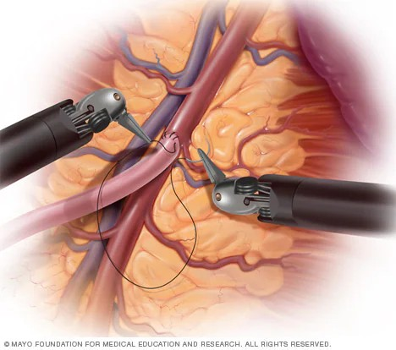
Fig-1: Use of robots in surgeries [Adapted from Mayo Clinic]

- CLASSIFICATION OF ROBOTIC SYSTEM:
Surgical robots vary in quality. Robotic surgery systems come in three varieties: shared-control systems, tele surgical systems, and supervisory-controlled systems. How involved a human physician needs be when executing a surgical procedure is the primary distinction between each system. On one end of the scale, surgical robots perform procedures without the direct intervention of a surgeon. On the other hand, surgeons do surgery with the help of a robot, but the doctor does the majority of the job.
SUPERVISORY CONTROLLED ROBOTIC SYSTEM:
When using a supervisory controlled robotic surgery system, the surgeon still has full control over the surgical procedure, but the robot helps and improves their abilities. Surgical systems are the most automatic of the three types of robotic surgery are supervisory-controlled systems. But that does not imply that these machines can operate without human supervision. In fact, before the robot can operate, surgeons must perform considerable preparation with surgery patients. That's because when doing surgery, supervisory-controlled systems adhere to a set of rules. The robot has to receive data from the human surgeon, which it then starts a series of regulated movements, then finishes the operation. There is no space for error because these robots cannot correct errors in real time. The robot's activities must be closely monitored, and surgeons must be prepared to step in if things doesn't go according to plan. The rationale for which surgeons may employ such a system.
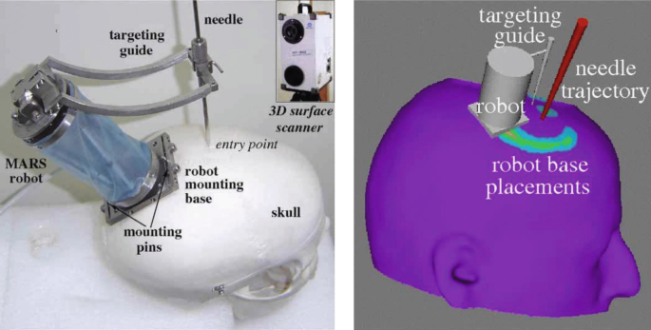
Fig-2: Supervisory Control Robots
  - TELESURGICAL SYSTEM:
A tele-surgical system, sometimes referred to as tele-operated or remote robotic surgery, is a kind of robotic surgery system that enables a surgeon to use robotic technology to perform surgical procedures on a patient from a distance. When a highly experienced surgeon is required but not nearby or when being physically close to the patient is not possible, this technology is especially helpful. Tele surgery, often known as remote surgery, unites patients and surgeons who are apart by distance through the use of robotic technology and wireless networking. The term "tele surgery," which derives from the Greek words "tele," "cheir," and "ergein," means "remote," "hand," and "to work," is used to describe a type of network-mediated robotic control. The fundamental advantage of telesurgery is its ability to overcome some of the disadvantages of traditional surgery, such as the geographical impossibility of timely and high-quality surgical care, a shortage of surgeons, and logistical challenges with surgeon scheduling, expense, and long-distance travel. This technology benefits both patients and surgeons by increasing operation safety and providing technical correctness.
SHARED CONTROL ROBOTIC SURGERY SYSTEM:
A type of robotic surgical technology called a shared control robotic surgery system combines the skill of a surgeon with the accuracy and stability of a robotic device. In this system, the surgeon and the robot collaborate to improve the overall quality and safety of the surgical procedure while sharing control and decision-making duties. During surgery, shared-control robotic devices assist the surgeon, but they are not a replacement for them. The surgeons must control the surgical instruments themselves, unlike other robotic systems. Through active constraint, the robotic system offers stability and support while monitoring the surgeon's performance. The idea of active constraint is based on classifying patient regions as either safe, close, boundary, or banned. Safe areas are referred to be a surgery's primary focus by surgeons. In orthopedic surgery, for instance, the safe area can be a certain location on the patient's hip. Soft tissues do not border safe areas. A near area in orthopedic surgery is one that borders soft tissue. The surgeon's working area is limited by the robot because orthopedic surgical equipment can cause severe damage to soft tissue. It does this by producing responses or force feedback.
- ROBOTIC SYSTEMS USED:
  - ARTEMIS:
The Advanced Robotics and TElemanipulator System for Minimally Invasive Surgery, or ARTEMIS, is designed to be a comprehensive teleoperation and virtual presence system for planning, training, and performing numerous surgical operations that are minimally invasive. The actual design was developed as a test bed for researching and assessing the necessary technologies, as well as their efficacy and quality for use in surgery. The main components are the endoscope guiding system and the two master-slave units guiding the surgical equipment. Each slave-master device consists of a slave or work unit and a master or control unit that are linked by a computer-based control system.
  - AESOP:
Robotic surgery has undergone a revolution thanks to the invention and application of robotic technology in medicine, which has several advantages and improves patient outcomes. AESOP (Automatic Endoscopic System for Optimal Positioning), a robotic arm, was one of the first and most important breakthroughs in this field. This innovative technology, created in the 1990s, allowed surgeons to direct the direction of a conventional laparoscope using a voice command at first and a foot pedal subsequently. AESOP Systems became the first voice-controlled robot to get FDA certification, marking a significant advancement in medical robotics. The development and use of robotic technology in medicine has revolutionized robotic surgery. This technology has several benefits and enhances patient outcomes. One of the first and most significant developments in this area was the robotic arm known as AESOP (Automatic Endoscopic System for Optimal Positioning). This ground-breaking invention from the 1990s allowed surgeons to initially control a standard laparoscope using voice commands and then with a foot pedal. AESOP Systems received FDA clearance as the first voice-controlled robot, a significant development in the field of medical robotics.
  - DA VINCI:
The physician has access to a comprehensive set of instruments when performing robotic-assisted, minimally invasive surgery with the da Vinci surgical system. The term "robotic" frequently misleads people. Robots do not do surgery. Your surgeon performs surgery with da Vinci using equipment guided by a console. The da Vinci technology analyses your surgeon's hand movements at the console in real time while performing the surgery, bending and twisting the tools. The little wristed gadgets can move more freely than a human hand. The da Vinci vision system also gives expanded 3D high-definition images of the surgical zone. Because of the device's modest size, surgeons may be able to perform treatments with only one or a few minor incisions.
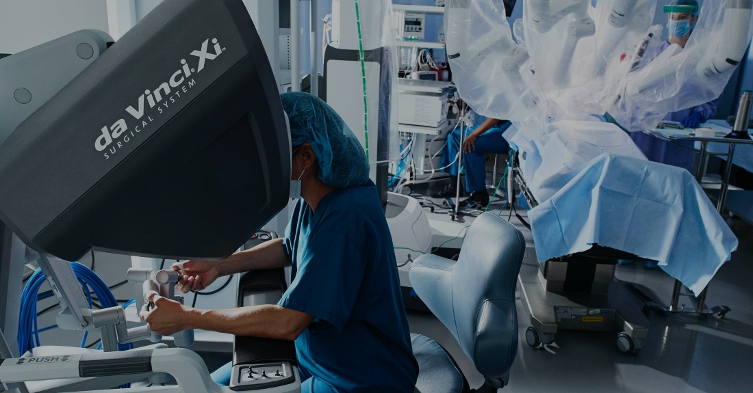
Fig-3: Da Vinci Robot [Adapted from Da Vinci Robotic-Assessted Surgery]
  - ZEUS:
Four years after launching the AESOP robotic system, Computer Motion unveiled the ZEUS robotic system. A second-generation robotic surgical device called ZEUS was created to provide even more control and accuracy during operation. Three robotic arms were added into the ZEUS system, increasing operational agility and range of motion. The laparoscope was operated with one arm, while the other two arms were used to perform various surgical procedures such as cutting and suturing. Computer Motion debuted the ZEUS robotic system four years after introducing the AESOP robotic system. For even greater control and accuracy during surgery, ZEUS, a second-generation robotic surgical tool, was developed. The ZEUS system's operating flexibility and range of motion were increased with the addition of three robotic arms. One arm was used to operate the laparoscope, while the other two arms were employed for various surgical tasks including cutting and suturing.
- ADVANTAGES AND DISADVANTAGES:
  - Advantages: Robotics in medicine and surgery have a number of benefits, including:
- Precision and Accuracy: Because robotic devices can make extremely exact movements, the chance of human mistake during surgical operations is reduced.
- Minimum Invasion: Smaller incisions are needed for many robotic operations, which are less invasive. As a result, patients frequently experience less discomfort, quicker recuperation times, and less scars.
- Enhanced Visualization: Surgeons who employ robotic systems frequently have access to high-definition, three-dimensional visualization of the operating region, which gives them a sharper picture of the anatomy.
- Steady Hands: Robots don't get hand tremors or become tired, so they may move steadily and consistently during lengthy operations.
- Remote Surgery: Tele operated robotic platforms let surgeons carry out operations from a distance. When a professional is not physically there, this is very helpful.
- Reduced Blood Loss: Robotic surgery can result in reduced blood loss due to its precise cutting and cauterization.
  - Disadvantages: Despite the benefits of robotic surgery and healthcare, there are a number of drawbacks and difficulties to take into account:
- Cost: The high expense of purchasing and maintaining robotic devices can increase healthcare expenditures. Some healthcare institutions and patients may find this expense to be a barrier to access.
- Training Requirements: To use robotic systems efficiently, surgeons and medical personnel need specialized training. This training may take a lot of time and money.
- Lack of Haptic Feedback: Human surgeons have a tactile sense (haptic feedback), which robotic systems lack. The evaluation of tissue texture, which is important in several operations, may be difficult as a result.
- Technical Issues: Just like any other piece of technology, robotic surgical equipment is susceptible to glitches or faults that might delay or complicate the procedure.
- Limited Accessibility: Only a select group of patients may use robotic surgical systems since not all hospitals or healthcare institutions have access to them.
- Procedure Suitability: Not all procedures are appropriate for robotic surgery. Due to the intricacy of the condition, some procedures may necessitate an open approach.
- ROBOTICS IN CARDIOTHORACIC SURGERY:
  - CARDIAC REVASCULARIZATION:
Your chest receives three little incisions from the surgeon, each measuring less than a third of an inch. As a result, it is no longer necessary to cut through the breastbone to reach the heart. The left internal mammary artery (LIMA) is detachable from the chest wall thanks to a cutting-edge imaging robot used by the surgeon. Robotic harvesting of the LIMA enables utmost accuracy. The LIMA graft is then sewn to the front side of the heart via the left anterior descending (LAD) artery by the surgeon using direct view of the heart. Because the bypass is done while the patient's heart is still beating, there is a reduced chance of problems. The surgeon makes three tiny incisions on your chest, each less than a third of an inch long. As a consequence, accessing the heart no longer requires cutting through the breastbone. Thanks to a state-of-the-art imaging robot employed by the surgeon, the left internal mammary artery (LIMA) is capable of being separated from the chest wall. The LIMA may be harvested robotically for maximum precision. The surgeon next uses direct vision of the heart to stitch the LIMA graft to the front side of the heart via the left anterior descending (LAD) artery. There is a lower risk of complications since the bypass is performed while the patient's heart is still beating.
  - MITRAL VALVE REPAIR:
Surgical methods are used to treat or replace a heart's leaky or rigid mitral valve, including mitral valve replacement and repair. The mitral valve in the heart serves as the barrier that differentiates the left atrium from the left ventricle.
Both minimally invasive and open heart surgery can be utilized to repair and replace the mitral valve. A catheter-based procedure may occasionally be utilized to treat a mitral valve problem. The particular technique used depends on the degree of your mitral valve disease and whether it is getting worse or not.

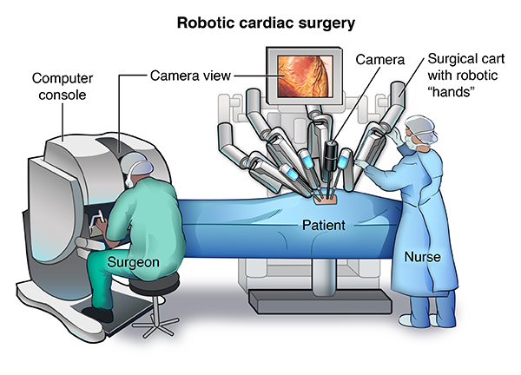
Fig-4: Robotics in Cardiac surgery. [Adapted from Stanford Medicine Children Health]
  - THYMECTOMY:
The most common surgical procedure involving the mediastinum is a thymectomy, which is used to treat thymic tumours as well as to treat myasthenia gravis (MG) in a multidisciplinary manner. Various surgical techniques, including minimally invasive and standard open techniques, have been reported. The development of minimally invasive surgery has advanced with the introduction of robotic thymectomy. The existing data imply that robotic thymectomy may be considered a safe and feasible surgery, with good long-term outcomes in myasthenic patients and promising results in patients with early stage thymoma, both in relation to operational and oncological outcomes. We describe the robotic thymectomy surgical approach that we use for patients with early-stage thymoma with myasthenia gravis.
  - LOBECTOMY:
Lobectomy continues to be the lung cancer treatment method of choice. The extraordinary advancement of robotic surgery has allowed for the demonstration that robotic lobectomy is a procedure that is both safe and quick to conduct, comparable to video-assisted thoracoscopic surgery (VATS). Furthermore, research shows that robotic lobectomy's long-term oncologic outcomes are on par with those of VATS and open lobectomy. The same criteria are used to choose patients as for VATS. Surgery can benefit subjectively from improved vision, more dexterous equipment, and better ergonomics.
- ROBOTICS IN GENERAL SURGERY:
  - ROUX-EN-Y GASTRIC BYPASS:
The most common weight-loss procedure in the United States is known as a Roux-en-Y Gastric Bypass, or RYGB (pronounced "roo-en-why"). It has been used for over 30 years and provides a fantastic combination of weight loss and manageable side effects. The technique can be carried out laparoscopically (via tiny abdominal incisions) or robotically (with the assistance of computers during surgery). Weight Loss Is Encouraged By RYGB In Two Ways Restriction: The surgeon separates the upper and lower portions of the abdomen. The "pouch" or upper section is then attached to the "Rouxlimb," a tiny intestinal limb. Due to the new stomach pouch, which makes you feel full after only a small amount of food, you might eat less. Mal-Absorption: After creating the smaller pouch, the surgeon reroutes your digestive system to avoid the larger area of your stomach and some of your small intestine. The bypass causes you to absorb less energy and nutrients from your diet (mal-absorption).
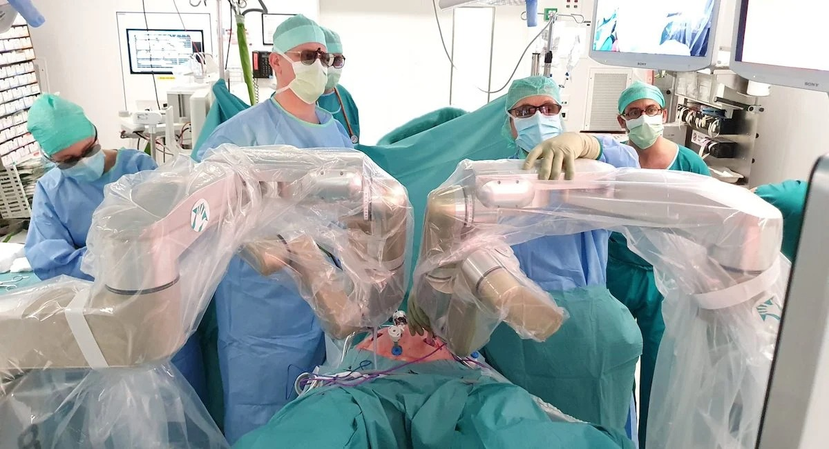
Fig-5: Robotics in General Surgery [Adapted from Robotics in Genaral Surgery]
  - THYROIDECTOMY:
Doctors in South Korea invented the robotic thyroidectomy, a minimally invasive procedure to remove all or part of the thyroid. Robot-assisted endoscopic surgery or robot-assisted thyroid surgery are other names for it. Eren Berber, M.D., an endocrine surgeon at the Cleveland Clinic and one of the first doctors in America to employ this method, thinks that it makes logical that robotic thyroidectomy would be the next step in thyroid surgery, especially for individuals who don't want a neck scar. Prior to its creation, endoscopic surgery or traditional open surgery were the two primary alternatives for thyroid surgery. Traditional open surgery leaves a scar on the neck; endoscopic procedures may or may not leave a scar on the neck.
  - MEDIAN ARCUATE LIGAMENT:
The median arcuate ligament of the diaphragmatic crura compresses the proximal celiac artery (CA) and celiac ganglion, causing medial arcuate ligament syndrome. The symptoms of median arcuate ligament syndrome (MALS) include postprandial epigastric discomfort, nausea, vomiting, and weight loss. Due to its rarity, MALS is often identified by ruling out other, more prevalent illnesses. To confirm the diagnosis, many imaging techniques including stomach tonometry, mesenteric arteriography, computed tomography angiography, magnetic resonance angiography, and mesenteric duplex ultrasonography might be employed. For the release of the median arcuate ligament (MALR), a number of procedures have been suggested, including open surgery, laparoscopic surgery, vascular repair, and endovascular angioplasty. Although many patients have reported improved symptoms after using most of these approaches, the long-term results have indicated varying degrees of symptom recurrence.
- ROBITICS IN NECK AND HEAD SURGERY:
Robotic head and neck surgery uses minimally invasive techniques on distinct anatomical structures and built-in access points. Surgical robotics have revolutionized head and neck surgery, building on the history of minimally invasive endoscopic otolaryngology techniques. Anatomical restrictions limit surgical techniques and make it difficult for surgeons to see what they are doing. The development of trans oral robotic surgery (TORS) during the past ten years has shown positive oncologic and functional results, transforming the way head and neck surgeons handle both malignant and benign disorders. Access will keep becoming better and push the limits of least invasive methods as new robotic platforms are developed.
  - TRANSORAL ROBOTIC SURGERY:
Robotic trans oral surgery, with the use of the cutting-edge da Vinci® Surgical System and trans oral robotic surgery (TORS), head and neck surgeons at Penn can enter throat regions that are challenging to access with conventional surgery. A minimally invasive surgical technique called TORS can be used to remove both cancerous and benign tumors. With better access to the throat, patients recover more quickly and easily, experience fewer swallowing adverse effects, and have better cancer outcomes. TORS treats several disorders with a minimally invasive surgical technique:
- Carcinoma at the tongue base
- Throat and head cancer
- Carcinoma of the hypopharynx
- Throat cancer
- Benign tumors of the larynx
- Carcinoid tumors in the larynx
- Squamous cell cancer of the larynx
- Obstructive snoring
- Tumors oropharynx cancer
- Muco epidermoid carcinoma of the oropharynx
- Squamous cell carcinoma of the oropharynx
- Tumors in the para pharyngeal cavity.
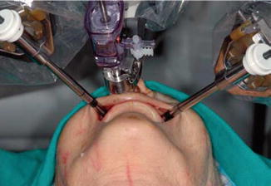
Fig-6: Robotics in Head and Neck Surgery [Adapted from Robotics in Neck and Head Surgery]
  - TONSILLECTOMY:
Tonsillectomy is the medical term for the surgical removal of your tonsils (pronounce it "tahn-suh-LEK-tuh-me"). The fleshy, rounded masses in the back of your throat are your tonsils. You have two, one on each side, unless you have had them removed.
The majority of the time, during this treatment, the surgeons will remove your entire tonsils. However, some patients may just require a partial tonsillectomy.
There are two main reasons why doctors recommend tonsillectomy to cure sleep disorders associated with breathing, such as sleep apnea, and to reduce the risk of infection in people who regularly or chronically suffer from tonsillitis. Although tonsillectomies are typically performed on youngsters, they can also be beneficial for adults. Nowadays, tonsillectomies are less frequent than they were a few decades ago. However, more than 500,000 tonsillectomies are routinely performed by surgeons each year. your tonsil has been released by your surgeon, this device will be wrapped around it to clamp it off. Bleeding is lessened as a result. Scalpel harmonics: This technique makes use of ultrasonic vibrations. Your tonsils can be removed while stopping the bleeding using a vibrato. Other procedures include the use of carbon dioxide lasers, radiofrequency ablation techniques, and/or micro debriders (which combine suction and cutting).
Stages of post-tonsillectomy recovery;
Here is a basic timeline of what to anticipate during tonsillectomy recovery, though everyone's healing will appear a little different:
- 1-2 days following tonsillectomy.
- Sore throat.
- Low-grade fever.
- Fatigue.
- Poor breathe.
- Hoarseness or difficulty speaking.
- Feeling of swelling in your throat, which makes it feel full.
Following a tonsillectomy, three to five days
- Persistent sore throat, which can get worse after three to four days.
- Fatigue.
- 5–10 days following tonsillectomy
- Scabbing.
- When the scabs gradually come off, there is some minor bleeding.
The surgery is done by surgeons to treat chronic tonsillitis or breathing-related sleep disturbances. Tonsillectomies are still performed by surgeons in the US every year, despite the fact that they are somewhat less frequent now.
  - TRANSORAL LASER MICROSURGERY:
Laser Microsurgery Trans oral Larynx, pharynx, and oropharynx are only a few of the anatomic sub sites in the head and neck that have undergone considerable evaluation with trans oral laser microsurgery. TLM has been investigated at various sites for the management of advanced T3/T4 BOT malignancy and has been demonstrated to be a successful surgical technique with outstanding oncologic and functional results in selected patients. Patients who have T4 lesions perform poorly when swallowing, and these lesions are associated with a higher conversion to open approach. From a functional perspective, T3 lesions treated with TLM do reasonably well. Furthermore, as is the case with the majority of surgical procedures, multimodality therapy is required for more advanced tumors, which makes case selection for primary surgery in the setting of T3/T4 base of tongue critical. The principles are the same despite the variances in technique because at our institution we have greater experience with TORS and don't frequently use TLM for advanced BOT cancer. TORS has various advantages over TLM, chief among them the avoidance of line-of-sight problems and wristed instrumentation, although TLM surgery has some advantages in terms of imaging of tumors with more inferior position as compared with current robotic technology. Some surgeons undertake endoscopic partial laryngectomy for the treatment of locally advanced glottic and supra glottic tumors, even though trans oral laser microsurgery (TLM) is typically utilised for early-stage laryngeal malignancies. After the treatment, the patient usually gets spared the need for a tracheotomy, and the swallowing recovery process is preferably quicker than with comparable open procedures. Large tumors must be removed in stages, albeit this does not appear to have an impact on the percentage of loco regional control. Hinni and colleagues conducted a retrospective analysis of TLM for advanced laryngeal cancer, which comprised 117 patients with stage III or IV SCC of the glottic or supra glottic larynx who received TLM at various hospitals.16 Laryngeal preservation, overall survival, disease-free survival, loco regional control, and distant metastases were all studied by the researchers. Two years following therapy, 92% of patients still had an intact larynx. Local control was 74%, local and regional control was 68%, disease-free survival was 58%, overall survival was 55%, and distant metastases were 14% according to the 5-year Kaplan-Meier estimates. Hinni and colleagues came to their conclusion that TLM gives adequate rates of organ preservation and loco regional control with low morbidity in the correct patients. Although TLM for advanced BOT cancer is not frequently used at our institution because we have greater expertise with TORS, the fundamentals are the same. TORS provides various advantages over TLM, chief among them the avoidance of line-of-sight problems and wristed instrumentation. TLM surgery has certain advantages over current robotic technology in terms of imaging of tumors with more inferior position. Although endoscopic partial laryngectomy is sometimes used to treat locally progressed glottis and supra glottic tumors, trans oral laser microsurgery (TLM) is most frequently utilized to treat early-stage laryngeal malignancies. With the aid of a CO2 laser and a microscope, this kind of surgery preserves the cartilaginous support structure while removing a piece of the endo larynx.
- ROBITICS IN UROLOGY AND GYNAECOLOGY:
  - Robotic urology surgery:
Robotic surgery is a type of minimally invasive surgery that makes use of tiny surgical devices and advanced robots. It is a highly sophisticated method that enables the surgeon to carry out surgical procedures with extreme precision. Typically, general anesthesia is used for this kind of operation. Due to the smaller, more precise incisions used during robotic surgery as opposed to open surgery, patients recover more quickly and experience less discomfort. Furthermore, because robotic surgery is more precise than traditional surgical methods, it is less likely to affect erectile and urine continence. Due to the benefits it offers for the patient, robotic surgery is being used for an increasing number of surgical procedures. In urology, robotic surgery is used to treat several pathologies, including prostate cancer (prostatectomy), kidney cancer (nephrectomy), bladder cancer, genital prolapse, and urethral stenosis.
Robotic surgery necessitates a significant investment in both equipment and specific training for doctors. For these reasons, it is not offered at all medical facilities. Urological surgical operations can be conducted using traditional open surgery or, ideally, minimally invasive techniques such as endoscopy or urological laparoscopy.
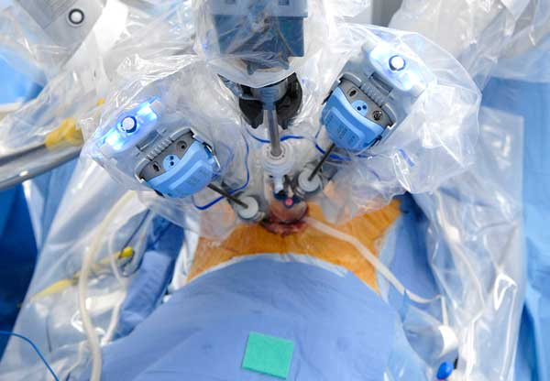
Fig-7: Robotics in Urology [Adapted from Robotics in Urology]
  - Gynecological robotic surgery:
In July 2021, the first gynecologic treatments using the Hugo robotic-assisted surgery (RAS) system were conducted in Panama, offering patients a new minimally invasive treatment. Medtronic plc's modular, multi quadrant platform is intended for a wide range of soft tissue surgeries, including hysterectomies and myomectomies. "As an ob-gyn [obstetrician-gynecologist], I am especially passionate about the positive impact that the Hugo system can have on women's health," Carla Peron, MD, Medtronic's chief medical officer of surgical robotics, stated. The technology is also distinctive and carefully crafted, based on input from surgeons and hospital leaders to significantly address the largest barriers to robotic adoption and utilization the patient and the clinician. Robotic surgery is used in urology to treat prostate cancer, kidney cancer, bladder cancer, genital prolapse, urethral stenosis, and other disorders. Costly equipment and specialized training for surgeons are required for robotic surgery. Due of these factors, not all medical facilities offer it. Alternative methods for doing urological surgical treatments include traditional open surgery or, ideally, minimally invasive methods like endoscopy or urological laparoscopy. Hugo robotic-assisted surgery (RAS) was used for the first time for gynecologic surgeries in Panama in July 2021, offering patients a novel, minimally invasive approach.1 The Medtronic Plc's modular, multiquadrant platform is intended for a variety of soft tissue treatments, includingboth myomectomies and hysterectomies. Carla Peron, MD, chief medical officer of surgical robotics at Medtronic, stated: "As an ob-gyn [obstetrician-gynecologist], I am very excited about the great influence that the Hugo system may have on women's health. The technology is also special and well-thought-out, based on input from surgeons and hospital leaders to truly address the biggest obstacles to robotic acceptance and use.
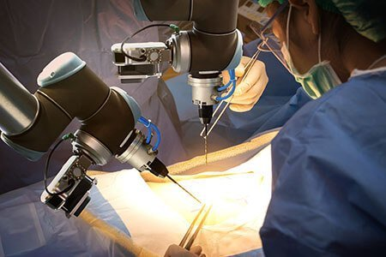
Fig-8: Robotics in Gynecology [Adapted from Robotics in Gynecology]
  - Robotics in nephrotomy:
For locally contained kidney cancer (cancer that has not spread), surgery is typically the first line of treatment. Larger open incisions or minimally invasive techniques like laparoscopic or robotic surgery can both be used to remove kidney tumors. These minimally invasive techniques provide comparable cancer control to open surgery and provide a quicker recovery. At BIDMC, almost all kidney cancer surgeries can be carried out laparoscopically or robotically because to our significant training and experience in these procedures. In 2014, we performed more robotic partial nephrectomies than the majority of other institutions—more than 95% of them. Additionally, in 2014, more than 95% of our radical nephrectomies were carried out using laparoscopy, saving our patients from a more unpleasant procedure. Rib-length incision and possible weeks or months of healing. Part of the kidney is removed during a partial nephrectomy in order to protect the remaining kidney from harm or removal, usually due to a tumor. If the patient has only one kidney or the renal tumor is smaller than 7 cm, it is routinely performed. The patient's rib must be removed in order to conduct this technique traditionally, which calls for an 8–12 inch incision in the flank. Robotic partial nephrectomy is a minimally invasive approach that requires the surgeon to not put his or her hand inside the belly and is carried out using thin, specialized devices inserted through small incisions. This yields a cancer cure rate comparable to open surgery. Similar to surgery, but with significantly less discomfort and a faster recovery.
  - Robotic assisted prostatectomy:
Robotic prostatectomy, also known as robotic prostatic surgery, is a cutting-edge surgical technique that allows the surgeon to accurately remove the prostate and surrounding tissues by inserting miniature robotic instruments through a series of tiny keyhole incisions in the patient's abdomen. This treatment is substantially less invasive than a standard radical retro pubic prostatectomy, which needs an abdominal incision from the belly button to the pubic bone. In order to provide a magnified view of the delicate structures surrounding the prostate gland (such as nerves, blood arteries, and muscles), a three-dimensional endoscope and image processing tools are used during robotic-assisted radical prostatectomy. This enables the best preservation of these significant structures. One of the keyhole incisions is subsequently used to remove the prostate. The physician does the majority of the procedure while sat at a computer panel, manipulating tools that fit around the wrist and have a much wider range of motion than a human wrist. The doctor doesn't touch the patient's internal organs while doing the treatment.
8.5 Hysterectomy:
A hysterectomy is the surgical removal of the uterus and, most likely, the cervix. Depending on the goal of the procedure, a hysterectomy may involve the removal of surrounding organs and tissues, such as the ovaries and fallopian tubes. In the uterus, a foetus grows during pregnancy. Its lining is made of the blood that is shed during your menstrual cycle. The women won't be able to get pregnant or start their menstruation after a hysterectomy. There are various hysterectomies. Depending on circumstances, healthcare professional will talk about the sort of hysterectomy that is required. Depending on the outcome of this, fallopian tubes and/or ovaries may need to be removed. The uterus and cervix are removed during a total hysterectomy, while the ovaries are left in place. A supracervical hysterectomy solely entails the removal of the uterus' top part. A total hysterectomy with bilateral salpingo-oophorectomy involves the removal of the uterus, cervix, fallopian tubes, and ovaries. If a person has never experienced menopause, having their ovaries removed will result in symptoms. The lymph nodes, cervix, ovaries, fallopian tubes, upper vaginal region, and some surrounding tissue are removed. Radical salpingo-oophorectomy on both sides of the uterus. This form of hysterectomy is carried out when cancer is present.
- Vasectomy hysterectomy: An incision is made at the top of vagina to remove uterus. There is no outward incision.
- Dissolvable sutures are placed in the vagina.
- The most common uses are for uterine prolapse and other benign (or noncancerous) disorders.
- Fastest recovery (up to four weeks) and least number of issues make this method the best choice.
- A lot of times, people return home the same day as surgery.
- The procedure is laparoscopic.
A laparoscope (a thin tube with a video camera on the end) is inserted into the lower abdomen through a minor incision in the belly button. The placement of surgical instruments requires several additional very small incisions. One can remove and dissect the uterus. either through the abdominal incisions or the vagina. Some patients check out of the hospital that day or the next morning. In comparison to an abdominal hysterectomy, full healing occurs more quickly and with less discomfort.
Body-part hysterectomy: An abdominal incision between six and eight inches long is used to remove your uterus. Your pubic bone or your belly button is where the incision is done.To close the wound, the surgeon will use stitches or staples. Most frequently applied in cases of malignancy, uterine enlargement, or disease spreading to other pelvic regions. Typically, it necessitates a lengthier hospital stay (two or three days) as well as a longer recuperation period.

- ROBOTICS IN ORTHOPEDICS:
At Mayo Clinic locations in Arizona, Florida, and Rochester, Minnesota, Mako robotic-arm assisted orthopaedic surgery is used for partial and total knee replacements as well as total hip replacements. Robotics applied to orthopaedics has grown in interest from both a surgical and an engineering perspective. During joint replacement procedures, a doctor replaces damaged bone and cartilage with artificial components made of metal alloys, high-quality plastics, and polymers. In a total knee replacement, the whole knee joint is replaced. However, if only a little portion of the knee is injured, surgeons can only replace the damaged section of the knee joint. This is a whole hip replacement as opposed to a partial knee replacement. The hip is a ball-and-socket joint, and both of the joint's components are removed and replaced during a total hip replacement.
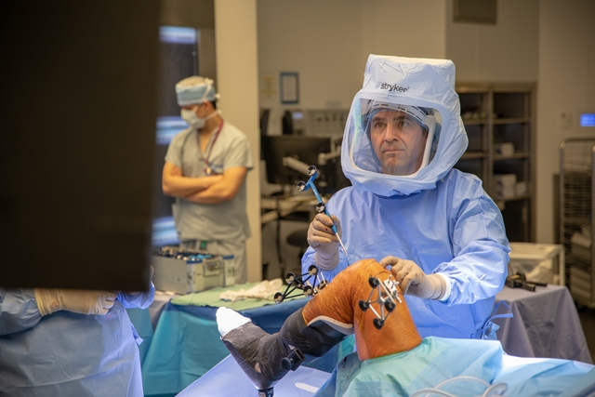
Fig-9: Robotic is Orthopedics [Adapted from Robotics in Orthopedics]
  - TOTAL KNEE ARTHROPLASTY:
Total knee arthroplasty (TKA) or total knee replacement (TKR), a common orthopedic treatment, involves replacing the femoral condyles and tibial plateau with smooth metal and highly cross-linked polyethylene plastic. TKA has been shown to boost patients' participation in physical activity and athletics. Its objective is to enhance the quality of life for those with advanced osteoarthritis by reducing pain and enhancing function. The frequency of TKA operations has increased in wealthy countries as younger patients have undergone the procedure.
After surgery:
As a shock absorber, at least one piece of polyethylene is positioned between the tibia and the femur. The prostheses are often strengthened with cement, although in cases where bone development is relied upon for reinforcement, they may not be. It is possible to replace or resurface the patella. The extensor mechanism is intended to be restored by patella repair. It is possible to use a quadriceps-splitting or quadriceps-sparing technique. The cruciate ligaments can be removed or left in place.
- CONCLUSION:
In conclusion, robotics has had a transformative impact on surgery and healthcare. It has enabled greater precision, minimally invasive procedures, and improved patient outcomes. Robotics in surgery has reduced human error, enhanced the capabilities of surgeons, and expanded access to specialized care. However, challenges remain in terms of cost, training, and ensuring ethical and safe use of these technologies. As technology continues to advance, the future of robotics in healthcare holds promise for further innovation and improved patient care.
REFERENCES:
- Satava RM. Surgical robotics: the early chronicles: a personal historical perspective. Surgical Laparoscopy Endoscopy & Percutaneous Techniques. 2002 Feb 1;12(1):6-16.
- Felger JE, Nifong LW, Chitwood Jr WR. The evolution of and early experience with robot-assisted mitral valve surgery. Surgical Laparoscopy Endoscopy & Percutaneous Techniques. 2002 Feb 1;12(1):58-63.
- Marescaux J, Rubino F. Transcontinental robot-assisted remote telesurgery, feasibility and potential applications. Teleophthalmology. 2006:261-5.
- Cheah WK, Lee B, Lenzi JE, Goh PM. Telesurgical laparoscopic cholecystectomy between two countries. Surgical endoscopy. 2000 Aug 9;14(11):1085-.
- Das S, Vyas S. The Utilization of AR/VR in Robotic Surgery: A Study. InProceedings of the 4th International Conference on Information Management & Machine Intelligence 2022 Dec 23 (pp. 1-8).
- Kim VB, Chapman Iii WH, Albrecht RJ, Bailey BM, Young JA, Nifong LW, Chitwood Jr WR. Early experience with telemanipulative robot-assisted laparoscopic cholecystectomy using da Vinci. Surgical Laparoscopy Endoscopy & Percutaneous Techniques. 2002 Feb 1;12(1):33-40.
- Fuchs KH. Minimally invasive surgery. Endoscopy. 2002 Mar;34(02):154-9.
- Allendorf JD, Bessler M, Whelan RL, Trokel M, Laird DA, Terry MB, Treat MR. Postoperative immune function varies inversely with the degree of surgical trauma in a murine model. Surgical endoscopy. 1997 May;11:427-30.
- Al-Rubaey RF. Robotic surgery and tele-surgery: A review article. Medical Journal of Babylon. 2014;11(3):XVI-XIV.
- Prasad SM, Ducko CT, Stephenson ER, Chambers CE, Damiano Jr RJ. Prospective clinical trial of robotically assisted endoscopic coronary grafting with 1-year follow-up. Annals of surgery. 2001 Jun;233(6):725.
- Kwoh YS, Hou J, Jonckheere EA, Hayati S. A robot with improved absolute positioning accuracy for CT guided stereotactic brain surgery. IEEE transactions on biomedical engineering. 1988 Feb;35(2):153-60.
- Davies B. A review of robotics in surgery. Proceedings of the Institution of Mechanical Engineers, Part H: Journal of Engineering in Medicine. 2000 Jan 1;214(1):129-40.
- Schurr MO, Buess G, Neisius B, Voges U. Robotics and telemanipulation technologies for endoscopic surgery: a review of the ARTEMIS project. Surgical endoscopy. 2000 Apr;14:375-81.
- Dario P, Carrozza MC, Pietrabissa A. Development and in vitro testing of a miniature robotic system for computer-assisted colonoscopy. Computer Aided Surgery. 1999 Jan 1;4(1):1-4.
- Tholey G, Chanthasopeephan T, Hu T, Desai JP, Lau A. Measuring grasping and cutting forces for reality-based haptic modeling. InInternational Congress Series 2003 Jun 1 (Vol. 1256, pp. 794-800). Elsevier.
- Hu T, Castellanos AE, Tholey G, Desai JP. Real-time haptic feedback in laparoscopic tools for use in gastro-intestinal surgery. InInternational Conference on Medical Image Computing and Computer-Assisted Intervention 2002 Sep 25 (pp. 66-74). Berlin, Heidelberg: Springer Berlin Heidelberg.
- Kennedy CW, Hu T, Desai JP, Wechsler AS, Kresh JY. A novel approach to robotic cardiac surgery using haptics and vision. Cardiovascular Engineering: An International Journal. 2002 Mar;2:15-22.
- Kennedy CW, Hu T, Desai JP. Combining haptic and visual servoing for cardiothoracic surgery. InProceedings 2002 IEEE International Conference on Robotics and Automation (Cat. No. 02CH37292) 2002 May 11 (Vol. 2, pp. 2106-2111). IEEE.
- Kennedy CW, Desai JP. Force feedback using vision. InThe 11th International Conference on Advanced Robotics 2003 Jun 30 (pp. 2106-2111).
- Cadière, MD, Ph. D GB, Himpens, MD J, Germay O, Izizaw R, Degueldre, MD M, Vandromme, MD J, Capelluto, MD E, Bruyns, MD J. Feasibility of robotic laparoscopic surgery: 146 cases. World journal of surgery. 2001 Nov;25:1467-77.
- Falcone T, Goldberg JM, Margossian H, Stevens L. Robotic-assisted laparoscopic microsurgical tubal anastomosis: a human pilot study. Fertility and sterility. 2000 May 1;73(5):1040-2.
- Margossian H, Falcone T. Robotically assisted laparoscopic hysterectomy and adnexal surgery. Journal of Laparoendoscopic & Advanced Surgical Techniques. 2001 Jun 1;11(3):161-5.
- Marescaux J, Smith MK, Fölscher D, Jamali F, Malassagne B, Leroy J. Telerobotic laparoscopic cholecystectomy: initial clinical experience with 25 patients. Annals of surgery. 2001 Jul;234(1):1.
- Abbou CC, Hoznek A, Salomon L, Olsson LE, Lobontiu A, Saint F, Cicco A, Antiphon P, Chopin D. Laparoscopic radical prostatectomy with a remote controlled robot. The Journal of urology. 2001 Jun;165(6 Part 1):1964-6.
- Damiano Jr RJ, Tabaie HA, Mack MJ, Edgerton JR, Mullangi C, Graper WP, Prasad SM. Initial prospective multicenter clinical trial of robotically-assisted coronary artery bypass grafting. The Annals of thoracic surgery. 2001 Oct 1;72(4):1263-9.
- Mohr FW, Falk V, Diegeler A, Walther T, Gummert JF, Bucerius J, Jacobs S, Autschbach R. EVOLVING TECHNOLOGY. J Thorac Cardiovasc Surg. 2001;121:842-53.
- Kappert U, Cichon R, Schneider J, Gulielmos V, Ahmadzade T, Nicolai J, Tugtekin SM, Schueler S. Technique of closed chest coronary artery surgery on the beating heart. European journal of cardio-thoracic surgery. 2001 Oct 1;20(4):765-9.
- Boehm DH, Reichenspurner H, Gulbins H, Detter C, Meiser B, Brenner P, Habazettl H, Reichart B. Early experience with robotic technology for coronary artery surgery. The Annals of thoracic surgery. 1999 Oct 1;68(4):1542-6.
- Cisowski M, Drzewiecki J, Drzewiecka-Gerber A, Jaklik A, Kruczak W, Szczeklik M, Bochenek A. Primary stenting versus MIDCAB: preliminary report–comparision of two methods of revascularization in single left anterior descending coronary artery stenosis. The Annals of thoracic surgery. 2002 Oct 1;74(4):1334-9.
- Hollands CM, Dixey LN, Torma MJ. Technical assessment of porcine enteroenterostomy performed with ZEUS™ robotic technology. Journal of pediatric surgery. 2001 Aug 1;36(8):1231-3.
- Hollands CM, Dixey LN. Robotic-assisted esophagoesophagostomy. Journal of pediatric surgery. 2002 Jul 1;37(7):983-5.
- Morimoto AK, Foral RD, Kuhlman JL, Zucker KA, Curet MJ, Bocklage T, MacFarlane TI, Kory L. Force sensor for laparoscopic Babcock. InMedicine Meets Virtual Reality 1997 (pp. 354-361). IOS Press.

