Comprehensive note on applications of solid lipid nanoparticles for sustained ocular drug delivery
Himanshi khatri¹*, Dhanashree Umesh Jirole², Umesh Jirole², Vipul Sansare³
¹Faculty of Pharmaceutical Science and Nursing, Vivekananda Global University,
Jaipur-303012
²Ashokrao Mane Institute of Pharmaceutical Sciences and Research, Save. Maharashtra- 416213
³Department of pharmaceutics, Dnyandeep College of Pharmacy, Boraj, Khed, Maharashtra-415709.
Address for correspondence: himanshikhatri11@gmail.com

ABSTRACT
The delivery of drug in ocular cavity is most essential way for treating diseases associated with eyes. However this route suffers with many hurdles like poor corneal permeability of drugs due to corneal barrier, poor precorneal residential time and eventually less bioavailability. The enhancement of precorneal residence time, increase in velocity of formulation and development of novel drug delivery systems are major approached to improve ocular bioavailability of drugs. The nanotechnology domain has solved drawbacks associated with conventional ocular drug delivery systems. Nanotechnology involved formulation and development of nano sized particles. Various nanocarriers like liposomes, nanoparticles and niosomes are investigated for ocular delivery of drugs. The lipid nanoparticles showed improved drug permeation across cornea and precorneal residence time which can possible enhance ocular bioavailability of drug. Thus lipid nanoparticles could be promising alternative for ocular drug delivery. Thus present book chapter highlights recent advances lipid nanoparticles mediated ocular drug delivery.
KEYWORDS: Lipid nanoparticles, Nanostructured lipid carriers, Ocular drug delivery
INTRODUCTION
Topical administration of drugs in ocular cavity is associated with the need to treat ophthalmic diseases. Ocular administration involves administration of drug close to the tissue around ocular cavity. This route is limited for treatment of local disease conditions associated with eyes. Systemic drug delivery using eye a site of adsorption is avoided in order to prevent risk of eye damage due to high blood concentration of drug [1].
Major classes of drugs administered in ocular cavity are miotics, mydriatics, anti-inflammatory, diagnostic agents and anti-infectious agents. Various types of dosage forms can be used for administration of drugs. The most common dosage form is eye drop. Eye drop is easy to instill but suffers from major drawbacks like poor precorneal residence of drug, loss of drug due to nasolacrimal drainage and dilution in tear fluid. In addition to this, frequent administration of eye drop is necessary to maintain sustained level of drug. Suspension type eye drop also marketed for ophthalmic delivery of various API. Steroidal drugs like hydrocortisone acetate, prednisolone acetate are examples of marketed ophthalmic suspensions. However rate of drug release from suspension is depend on rate of dissolution of drug in tear fluid, which changes constantly as composition of fluid changes.
The ophthalmic scientists have suggested that, the therapeutic efficacy of ophthalmic drugs can be improved by prolonging precorneal residence of drugs. Various attempts were investigated to improve precorneal residence time of drugs which were, addition of viscosity enhancing agents, preparation of semisolid dosage forms and development of novel drug delivery systems. Various novel drug delivery systems including ophthalmic inserts, contact lenses, in-situ gels were investigated for effective ocular drug delivery. Some systems are currently in clinical trials and some are successfully introduced in market by various manufacturers. This chapter highlights different ocular barriers and various novel drug delivery systems investigated for ocular drug delivery.
Transcorneal absorption of drugs
The aim of ocular drug delivery is maximize absorption of drugs in intraocular tissues with minimum loss. The topical administration of drugs in eyes is most common method of ophthalmic drug delivery for the treatment of ophthalmic ailments. The absorption of drugs across the eye is takes place by two pathways; corneal and noncorneal pathways. The corneal pathway involves permeation of drug across the cornea, which is major pathway of drug absorption from ocular drug delivery. The noncorneal absorption involves permeation of drugs across the sclera and conjunctiva into intraocular tissues. This pathway is nonproductive as it restrains the entry of drugs into aqueous humor. However ophthalmic absorption of topically administered drugs is estimated to be less than 5%. Thus adequate bioavailability of topically administered drug is challenging due to the barrier functions of cornea and precorneal loss of drugs from ocular cavity. The understanding of these barriers is necessary for effective development of ophthalmic drug delivery system that can provide therapeutic drug concentration in ocular tissues.
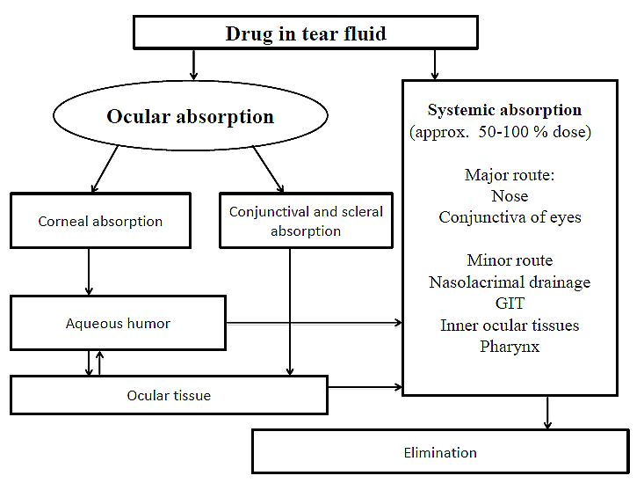
Figure 1 Schematic representation of biopharmaceutics of ophthalmic drugs
Barrier properties of cornea
The cornea comprises of 5% of total ocular surface. Anatomically cornea consist of three major layers; epithelium, stroma and endothelium. The corneal epithelium is major barrier for absorption of topically administered drugs. Compared to tissue epithelium (nasal, GIT, tracheal, bronchial) corneal epithelium is relatively impermeable due to presence of unique tight junctions between epithelial cells, but it is more permeable to drugs as compare to stratum corneum of skin. The corneal epithelium acts as protective barrier for entry of foreign molecules, ions and drugs. The epithelium is comprises of basal columnar epithelial cells, two or three layers of wing cells and layer of squamous cells as highlighted in 10.3. The tight junctions between squamous cells prevent paracellular transport of drugs across the cornea.

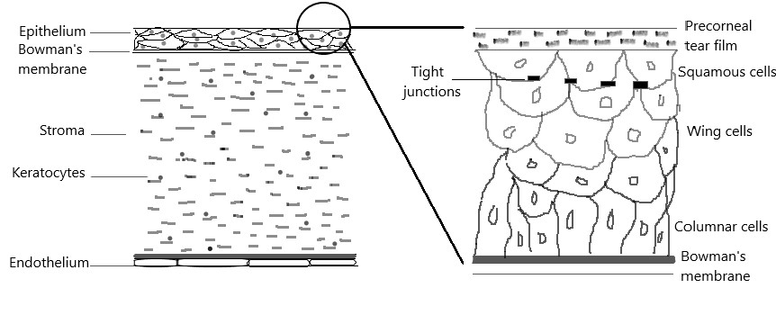
Figure 2 Anatomy of cornea and corneal epithelium
However few intercellular spaces between wing cells and columnar cells allow paracellular transport of drugs through these layers only. It was estimated that, the small molecules like glycerol, PEG 200 and PEG 400 are able to penetrate through intercellular spaces of corneal epithelium, but macromolecules like inulin (MW 5000) are not able to diffuse across the epithelium by paracellular transport. The drugs with molecular dimensions up to 20 nm can able to diffuse through normal epithelium. Corneal stroma is relatively open structure with high hydrophilicity. Because of hydrophilic nature of cornea, it serves as rate limiting barrier for permeation of lipophilic drug. The corneal endothelium lipophilic layer of cornea acts as rate limiting barrier for permeation of polar drugs. Endothelium is responsible for maintaining hydration of cornea. .
Barrier function of conjunctiva and sclera
Apart from corneal absorption of drugs, the conjunctival and scleral absorption are non-corneal pathways of drug absorption. This pathway involves permeation of drug across conjunctiva and sclera. Hydrophilic macromolecules, which have poor corneal permeability, can absorb in ocular tissues by diffusion across conjunctiva and sclera. The conjunctiva comprises of conjunctival epithelium, the superficial cells of epithelium have tight junctions as shown in figure 10.4. The barrier properties of conjunctiva are less effective than that of cornea, thus conjunctival permeability of hydrophilic drugs is higher than that of corneal permeability. Polar drugs with molecular size up of 20,000-40,000 Daltons can pass through conjunctiva. For example, mannitol has 55 times higher conjunctival permeability as compared to corneal permeability. The carrier mediated transport mechanism plays key role in diffusion of drugs across the conjunctiva. Besides the corneal epithelium, the metabolizing enzymes secreted by conjunctiva are another hurdle for ocular bioavailability of drugs. Thus ocular bioavailability of peptides is limited due to its degradation by enzymes secreted by conjunctiva.
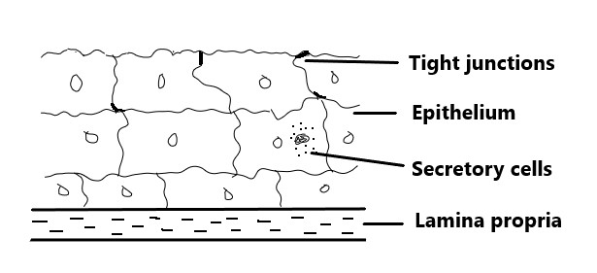
Figure 3 Representation of conjunctival epithelium
Sclera consists of collagen fibers and proteoglycans embedded in an extracellular matrix. Ophthamically applied drugs can penetrate across sclera through spaces within collagen fibers or through aqueous environment of mucopolysaccharides. The sclera is more permeable to drugs than cornea. The charge on the drug molecules affects its scleral permeability. It was estimated that positive charge drugs are poorly permeable across sclera due to their binding to the negatively charge proteoglycan matrix. For example negative charge ciprofloxacin have more scleral permeability than positive charge form. Some β-blocker, sucrose and inulin are more permeable across the sclera than cornea.
Drug elimination from tears
The liquid ophthalmic dosage forms showed poor ocular bioavailability due to precorneal loss of drug by tear fluid. Precorneal loss of drug is elimination of drug from tears before corneal permeation of drug. The instilled volume of ophthalmic dosage forms like solution, suspension are drained from conjunctiva into naso lacrimal duct or cleared from precorneal area resulting in poor ocular bioavailability. Precorneal loss of drugs from eyes is takes place by precorneal drainage, lacrimation and nonproductive conjunctival absorption. These factors limit the permeation of topically applied drugs into the eyes. The precorneal hurdles include,
- Spillage of drug by over flow
The tear fluid is essential for a healthy ocular surface; however, for the permeation of topically applied drugs across cornea, tear film is a significant barrier. The tear film is composed of three layers: the outermost lipid layer (0.1 µm), the middle aqueous layer (8 µm) and innermost mucus layer (0.8 µm). The lipid layer prevents evaporation of tears, the aqueous layer allows spread of tears over the ocular surface and mucin layer adheres the tear film to ocular surface. The normal tear volume is 7 ml and human eye can accommodate 30 ml of fluid without spillage in unblinking condition. In an unstimulated human eye at a normal blink rate of 15–20 blinks/min, and volume of fluid retain in eyes after blinking is approximately 10 ml. Thus more than 70% of administered drug is expel from eyes before absorption.
- Nasolacrimal drainage of drug
Tears are drained through the nasolacrimal duct into the nose. Thus topically administered solution and suspension also drained into nasal cavity along with tears. The most of the administered dose of drug drained into the nose by nasolacrimal drainage. The drainage of drug into nose results in systemic absorption of drugs by permeation across nasal mucosa, which reduces ocular bioavailability. The systemic absorption of drugs may create serious risk. For example timolol and mixed β1 and β2 antagonists are used in glaucoma therapy, which creates serious problems on systemic absorption. Blinking facilitates flow of tears into the nasolacrimal duct. Nasolacrimal drainage of the drug along with tears is the main factor contributing to drug loss from precorneal tear film.
- Enzymatic metabolism
Besides the barrier properties of cornea and conjunctiva, presence of drug metabolizing enzyme in corneal and conjunctival epithelium as well as in lacrimal fluid is also a limiting factor. Various esterases, peptidases and proteases classes of enzymes in corneal and conjunctival epithelium are responsible for degradation and deactivation of drugs.
Approaches to improve ocular bioavailability of drugs
Ocular bioavailability of drugs is limited due to barrier functions of cornea and conjunctiva as well as precorneal loss of drugs. The nasolacrimal drainage and loss of drugs by tear fluid also creates ocular bioavailability problems. Due to poor ocular bioavailability, the frequent administration of medicament is necessary to produce desired pharmacological effect. Frequent local administration of various drugs like antiglaucoma agent, antibiotics and antiviral precipitates dose related side effects. Thus to reduce frequency of drug administration and dose related side effects, the use of controlled drug delivery system is advisable.
Requisites for controlled drug delivery
- To overcome the side effects of drugs due to frequent dosing and high concentration produce by conventional drug delivery system.
- To increase the ocular bioavailability of drugs by improving precorneal residence time and sustained drug delivery.
- To minimize to efficacy of protective barriers like nasolacrimal drainage and precorneal loss of drugs.
- To improve patient comfort and compliance.
Two major approaches are being investigated to improve ocular drug deliveries which are:
- Approaches to improve precorneal residence time of drugs.
- Approaches to enhance corneal permeability either by structural alteration of corneal epithelium barrier or by modification of structure of drug molecules.
Solid Lipid Nanoparticles (SLNs)
SLNs are nanosphere composed of a solid lipid core with average diameter between 50 and 1000 nm. These lipid nanoparticles made from purified triglycerides, complex glyceride mixtures, or waxes that are solid at both room temperature and human body temperature and are stabilized by suitable surfactant [2]. In SLNs, the drug is mainly dispersed in molecular form throughout lipid matrix and located in between the fatty acid chains of the glycerides. It is an alternative carrier system to traditional system such as emulsions, microemulsion, nanoemulsion and are interesting lipid-based drug-delivery. However this system suffers with several limitations like low loading efficiency, drug leakage after polymorphic transition of lipids during storage. The low drug loading capacity of SLNs is due to densely packed arrangement of lipid crystals in SLNs matrix, which allows little space for incorporation of drugs. To overcome these drawbacks, the next generation of SLNs i.e. nanostructured lipid carrier was developed. The NLCs is composed of mixture of liquid lipid and solid, which makes more imperfection in the matrix to incorporate more drug molecules than SLNs (Figure 4). Due to structural difference in solid and liquid lipids they cannot fit together which creates a lot of imperfections in matrix leading to an accommodation of more drugs [3]. Examples of solid lipids and surfactants used for fabrication of SLNs are highlighted in Table 1.
Table 1 Commonly used solid lipids and surfactants for fabrication of SLNs
Class | Examples
Solid lipids | Stearic acid, Tristearin, Tripalmitin, Palmitic acid, Precirol ATO 5, Glycerol monostearate, Compritol 888 ATO, Cetyl palmitate, Glyceryl palmitostearate
Surfactants | Poloxamer 188, Polysorbate 20, Polysorbate 80, Polyvinyl alcohol, Soya lecithin, Sorbitan trioleate, Soya phosphatidylcholine, Sodium cholate, Sodium glycocholate

Figure 4 Diagrammatic representation of SLNs and NLCs

Lipid nanoparticles for ocular drug delivery
Seyfoddin et al. [4] attempted to improve the ocular bioavailability of acyclovir by its loading in SLNs and NLCs carrier. The formulation variables of the SLNs and NLCs were optimized using design of experiment concept. Both SLNs and NLCs showed acceptable physicochemical properties and suitability for ocular administration of acyclovir. NLCs revealed enhanced permeation across bovine cornea compared to free acyclovir. SLNs showed reduced the permeation rate of drug significantly. Thus SLNs and NLCs could be viable carriers for delivery of antiviral drug in ocular cavity.
E. Basaran et al. [5] formulated Cyclosporine A loaded SLNs for ocular drug delivery. Dynasan 116 was used as lipid for fabrication of lipid nanoparticles. Sheep model was used to assess in vivo permeation behavior of drug loaded nanoparticles. The SLNs dispersion applied on the sheep eye and samples were collected at specified time intervals and were analyzed. The drug was detected in aqueous and vitreous humour for more than 48 hours, reflecting sustained permeation of drug across ocular tissues.
Attama et al. [6] encapsulated diclofenac sodium in SLNs matrix. The lipid matrix of SLNs was formulated using goat fat and phospholipid. The bio-engineered human cornea, prepared using human corneal endothelial cells was used to evaluate permeation characteristics of drug loaded SLNs. The drug encapsulated SLNs showed high permeation across the bio-engineered cornea The phospholipid modified lipid nanoparticles could be viable alternative for ocular drug delivery.
Kalam et al. [7] formulated gatifloxacin loaded lipid nanoparticles for ocular drug delivery. Two different types lipid nanoparticles formulations were formulated using different lipids like stearic acid as well as stearic acid and Compritol. Both formulations were evaluated with respect to physicochemical properties and in vitro corneal permeation study. The lipid nanoparticles formulated using stearic acid was found to be effective in terms corneal permeation and hydration.
Kesarla et al. [8] loaded tobramycin in nanosized lipid matrix for ocular drug delivery. The precorneal residence of formulated SLNs was assessed using rabbit model. The SLNs showed improved precorneal residence in rabbit eyes compared to drug solution. In addition to this, the SLNs exhibited better ocular bioavailability of tobramycin compared to commercially available eye drop. Thus, SLNs is promising and viable alternative to improve ocular bioavailability of drug compared to conventionally available products.
Table 2 Overview of lipid nanoparticles based ocular drug delivery
Drug | Lipids used | Major outcomes | Reference
Acyclovir | Stearic acid | Controlled permeation of drug across bovine cornea | [4]
Cyclosporine A | Glyceryl dibehenate | Sustained permeation of drug across cornea. | [5]
Diclofenac sodium | Goat fat and phospholipid | Better encapsulation of drug in lipid matrix and controlled permeation across bio-engineered cornea | [6]
Gatifloxacin | Stearic acid and  Compritol | Controlled permeation of drug across goat cornea and prolonged hydration | [7]
Tobramycin | Stearic acid | Enhanced bioavailability of drug in intraocular tissues | [8]

CONCLUSION
The delivery of drug in ocular cavity is challenging drug delivery to formulation scientist due to many hurdles like barrier properties of cornea, poor precorneal residential time and loss of drug. Many formulation experts have attempted to enhance ocular bioavailability of drug by utilizing numerous approaches. The nanosized particles are promising carriers for encapsulation of drugs for ocular drug delivery. The various nanoparticles like polymeric nanoparticles and lipid nanoparticles have been investigated for delivery of drug in ocular cavity. The lipid nanoparticles showed improved drug permeation across cornea and precorneal residence time which can possible enhance ocular bioavailability of drug. Thus lipid nanoparticles like SLNs could be promising alternative carrier for ocular drug delivery.
REFERENCES
[1] Araújo J, Gonzalez E, Egea MA, Garcia ML, Souto EB. Nanomedicines for ocular NSAIDs : safety on drug delivery. Nanomedicine Nanotechnology, Biol Med 2009;5:394–401. https://doi.org/10.1016/j.nano.2009.02.003.
[2] Seyfoddin A, Shaw J, Al-kassas R, Seyfoddin A, Shaw J, Al-kassas R. Solid lipid nanoparticles for ocular drug delivery Solid lipid nanoparticles for ocular drug delivery. Drug Deliv 2017;17:467–89. https://doi.org/10.3109/10717544.2010.483257.
[3] Souto EB, Doktorovova S, Gonzalez-mira E, Egea MA, Garcia ML. Feasibility of Lipid Nanoparticles for Ocular Delivery of Anti-Inflammatory Drugs. Curr Eye Res 2010;35:537–52. https://doi.org/10.3109/02713681003760168.
[4] Seyfoddin A, Al-kassas R. Development of solid lipid nanoparticles and nanostructured lipid carriers for improving ocular delivery of acyclovir. Drug Dev Ind Pharm 2013;39:508–19. https://doi.org/10.3109/03639045.2012.665460.
[5] Başaran E, Demirel M, Sırmagül B, Yazan Y. Cyclosporine-A incorporated cationic solid lipid nanoparticles for ocular delivery Cyclosporine-A incorporated cationic solid lipid nanoparticles for ocular delivery. J OfMicroencapsulation 2017;27:37–47. https://doi.org/10.3109/02652040902846883.
[6] Attama AA, Reichl S, Christel CM. Diclofenac sodium delivery to the eye : In vitro evaluation of novel solid lipid nanoparticle formulation using human cornea construct. Int J Pharm 2008;355:307–13. https://doi.org/10.1016/j.ijpharm.2007.12.007.
[7] Kalam MA, Sultana Y, Ali A, Aqil M, Mishra AK, Chuttani K. Preparation , characterization , and evaluation of gatifloxacin loaded solid lipid nanoparticles as colloidal ocular drug delivery system. J Drug Target 2010;18:191–204. https://doi.org/10.3109/10611860903338462.
[8] Kesarla R, Tank T, Vora PA, Shah T, Omri A, Kesarla R, et al. Preparation and evaluation of nanoparticles loaded ophthalmic in situ gel Preparation and evaluation of nanoparticles loaded ophthalmic in situ gel. Drug Deliv 2016;23:2363–70. https://doi.org/10.3109/10717544.2014.987333.

