Effect of Granulated Coal Ash as a partial replacement of fine aggregate in concrete

Sanjeeb Kumar Chaudhury
Department of Civil Engineering
Balasore College of Engineering and Technology
Balasore, Odisha,India
sanjeebkumarchaudhury@gmail.com

Sagar Sarangi
Department of Civil & Environmental Engineering
Sarala Birla University
Ranchi, Jharkhand, India
sagarsarangicit@gmail.com

ABSTRACT
In rural area wood is used as a major source of fuel. However granulated coal ash produced from burnt or half burnt is a domestic waste material enrich in various chemical properties. Due to scarcity of good quality fine aggregate in forest region most of the time uneconomic for backward family to use in construction activity. As a result in his experimental fine aggregate is partially replaced with granulated coal ash to investigate the mechanical properties of the concrete. Here, in a varying range from 0% to 25% in weight fraction of fine aggregate has been replaced with granulated coal ash to produce M25 grade of concrete. From the investigation found that 15% partially replacement of fine aggregate with granulated coal ash suitable for producing light weight concrete and beyond that due to finer surface of granulated coal ash not only reduced workability but also reduced the mechanical properties of the concrete specimen.

Keywords—Granulated Coal; partial replacement; workability; compressive strength; flexural strength

INTRODUCTION

Concrete is one of the major consumed building materials in construction industries which is a heterogeneous mixture of cement, fine aggregate, coarse aggregate and water. Due to use of crushed granite stone and river sand as aggregate it’s density lies in a range from 2200kg/m³ to 2600kg/m³ viz. enhanced dead load (self-weight) of the components. Therefore, the use of light weight concrete reduces the cross section of the elements, also reduces the load on the form work. The light weight concrete can be obtained by the use of ash, cenosphere. Granulated Coal(GC) in the concrete as the fine aggregate. Granulated Coal is generally obtained from the burnt and unborn wood. The particles size of the GC is vary (75 micron to 300 mm), accordingly they are graded. These materials give effective result for the low strength concrete works. The addition of this reduces the malodorous components of the concrete. Granulated Coal Ash (GCA) is produced by burning wood in naturally Environment, and by collecting the pieces of burning wood, after grinding these pieces small amount of water and cement are added later on.
Improved quality of GCA commercially utilized as sewage sludge stabilization, pavement base materials, light weight aggregate and other miscellaneous purposes. Due to its specific gravity lies from 0.4g/cm³ to 0.8g/cm³ provide an extraordinary lightness. To resolve the issues on industrial waste disposal now-a-days those waste were partially or fully replaced with aggregate produced special type of building materials [1]. From the literature observed that natural river sand replaced by copper slag, imperial smelting furnace slag, class F fly ash improved concrete mechanical and durability properties. It had been also noted that replacement of copper slag enhanced workability while reduced on replacement of class F fly ash. On this regards GCA is an alternative material which is not only reduced self weith but also enhanced workability of the concrete.
While concrete made with bottom ash reduced compressive strength compared to control specimen; however addition of lower dose of admixture able to enhanced compressive strength observed by researchers [2]–[4]. However, by pulverised again bottom ash enhanced it’s pozzolanic properties as a results 20% partial replacement with cement enhanced compressive strength observed by Jaturapitakkul & Cheerarot (2003)[5]. By addition of pulverised fly ash as secondary cementing material not only improved workability and density but also increased compressive strength of the concrete [6]. Aramraks, (2006) observed an enhancement of compressive strength by replacement of bottom ash with natural fine aggregate in the concrete[7]. The strength properties of light weight concrete using cinder aggregate was studied by Desai & Sathyam, (2014) and found that quantity of cinder in concrete inversely proportionate with compressive strength[8]. However, 75% replacement of natural aggregate with cinder aggregate enhances compressive strength of the concrete.

MATERIAL

To investigate the mechanical properties of concrete ACC Ordinary Portland cement of 43 grade conforming to BIS 1489(P-1) used as binder material [9] and the physiochemical properties shown in Table 1. Natural river sand conforming to BIS 383 [10] and crush granite stone MSA 20mm used as fine aggregate and coarse aggregate respectively. Details procedure of Granular coal ash (GCA) similar to fine aggregate for partial replacement of natural sand discussed in separate section. Potable drinking water supplied to concrete laboratory used for mixing and curing of the specimen

Sampling of CGA
Wood burnt coal commonly known as charcoal has been collected from household and food corner near by the institute region. After crushed through miller fine particle has been collected as row material for GCA. To make it similar to fine aggregate a ternary blended pallets have been prepared by adding 2% of cement and 3% of fine aggregate in weight fraction as additive along with sprinkling water on it to provide a granular shape. After dried in room temperature stored in a gunny bagged for further use in concrete, Properties of the GCA has been shown in Table 2 and Figure 1.

Table 1: Physio-Chemical properties of Cement
Characteristics | Observed value
Chemical Properties
Silicon dioxide (SiO₂) | 44%
Aluminum oxide (Al₂O₃) | 13%
Calcium oxide (CaO) | 21%
Carbon (C) | 9%
Others chemicals | 13%
Physical Properties
Standard consistency | 32.0 %
Initial Setting Time (Minutes) | 55
Final Setting Time (Minutes) | 290
Specific Gravity | 3.15
Fineness | 8.12 %
Soundness(Le-Chatelier method) | 1.4
Compressive Strength
3days | 20.33 N/mm²
7days | 34.00 N/mm²
28days | 39.66 N/mm²

Table 2: Physio-Chemical properties of Cement

Tests | FA values | CA Value
Fineness Modulus | 2.63
Water Absorption | 1.33% | 0.50%
Specific Gravity | 2.63 | 2.80
Impact | - | 15%
Bulk Density | 1540 kg/cum | 1605kg/m³
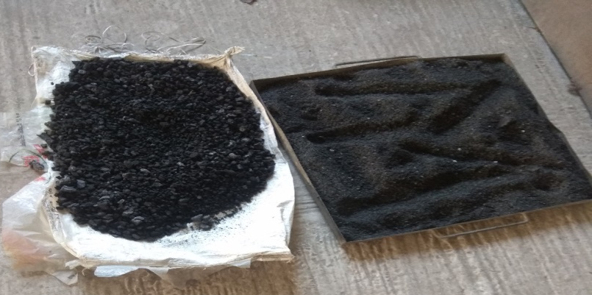
Figure 1 Raw GCA sample

Table 3: Physio-Chemical properties of Cement
Mix Proportion | Cement (Kg.) | Fine Aggregate(Kg.) | GCA (Kg.) | Coarse Aggregate(Kg.) | Water (Ltr.)
Control | 396.00 | 682.00 | 0 | 1215.00 | 186.12
FA95GCA5 | 396.00 | 647.90 | 34.10 | 1215.00 | 186.12
FA90GCA10 | 396.00 | 613.80 | 68.20 | 1215.00 | 186.12
FA85GCA15 | 396.00 | 579.70 | 102.30 | 1215.00 | 186.12
FA80GCA20 | 396.00 | 545.60 | 136.40 | 1215.00 | 186.12
FA75GCA25 | 396.00 | 511.50 | 170.50 | 1215.00 | 186.12

METHODS

Keeping in view of Indian construction industry M25 grade of concrete (1:1.72:3.045), w/c=0.47 for Zone-II has been designed as per BIS 10262 [11]. All the ingredients in dry form as per Table 3 have been poured in a rotating laboratory type mixture of rpm 62 for 5 minutes to form a uniform dry mix. Later on required water has been added in to the drum and allowed to rotate another 5 minutes to obtain a uniform concrete mixture. Freshly prepared concrete undergo workability test as per BIS 516 [12] and cast in 150mm cubical, 150mmX300mm cylindrical and 100mmX100mmX500mm prism specimen for furthered investigation. After removing from mould allow for submersed curing till the test date. Compressive strength and flexural strength of the specimen has been carryout as per ASTM C109 [13] whereas for split tensile strength of harden concrete done as per BIS 5816[14] codal specification. Experimental setup shown in Figure 2 Average of three results taken as final results of the specimen and details has been results section.

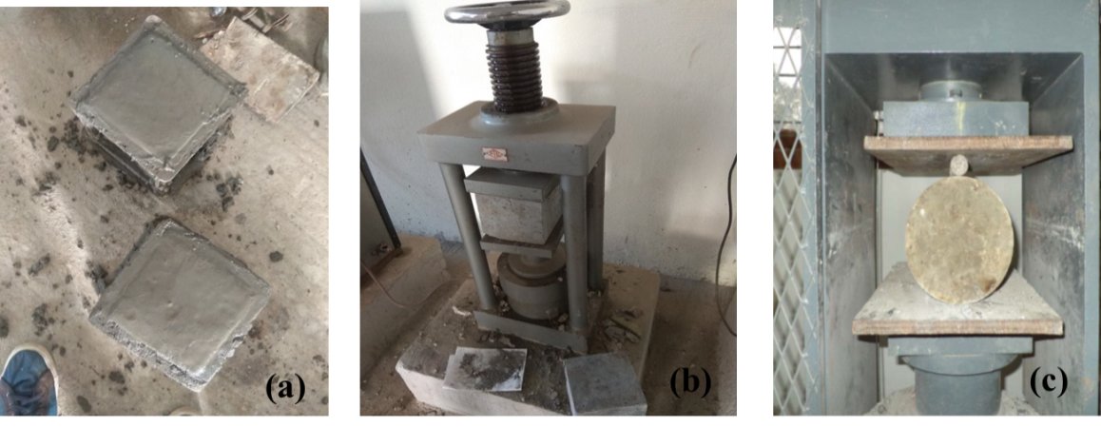
Figure 2: Experimental Setup (a. Casting b. Compressive Strength Setup c. Split Tensile Strength Setup)

RESULTS AND DISCUSSIONS

Workability
From the workability analysis through slump test observed that replacement of granulated coal ash with natural river sand reduced fresh concrete workability properties due to granular size of coal ash. However, partial replacement with river sand based concrete suitable for mass concrete purpose and the detailed test results shown in Table 4.

Compressive Strength
From the harden properties of the concrete obtained from compressive strength analysis. From Table 5 and Figure 3 observed that upto 15% of partial replacement of granulated coal ash with natural river sand able to provide target strength of the concrete mixture i.e. 31.60 N/mm2 while reducing its density at the maturity of 28days.

Tensile Strength
From Figure 4-5 and Table 7-8 observed that partial replacement of granulated coal ash reduced its tensile strength both in split tensile strength and flexural strength. However, experimental data of 28days flexural strength compared with empirical equation [15] found similar in Figure 5.

Table 4: Slump value
Replacement of FA With GCA | Slump Value (mm)
0% | 63mm
5% | 58mm
10% | 56mm
15% | 53mm
20% | 55mm
25% | 51mm

Table 5: Compressive Strength

Replacement of FA With GCA | 7days Compressive strength | Weight (kg) | 28days Compressive strength
0% | 21.773 | 8.295 | 32.88
5% | 23.33 | 8.316 | 32.59
10% | 22.22 | 8.398 | 31.92
15% | 21.48 | 8.112 | 31.70
20% | 18.14 | 7.516 | 28.74
25% | 16.89 | 7.103 | 27.56

Table 5: Split Tensile Strength
Replacement of FA With GCA | 7days Split Tensile Strength | 28days Split Tensile Strength
0% | 1.27 | 4.88
5% | 1.22 | 3.95
10% | 1.20 | 3.58
15% | 1.13 | 2.80
20% | 0.98 | 2.15
25% | 0.82 | 1.49

CONCLUSION

From this experimental investigation concluded that partial replacement of natural river sand with granulated coal ash able to provide target compressive strength while compromising the tensile properties. Hence, it is an alternative sustainable construction material for rural region due to not only minimizes the cost of natural river sand (fine aggregate) but also reducing the self-weight of the material.

Table 5: Flexural Strength

Replacement of FA With GCA | 7days Flexural strength | 28days Flexural strength | Modulus of Elasticity [15]
0% | 3.19 | 4.44 | 4.01
5% | 3.05 | 4.03 | 4.00
10% | 2.90 | 3.97 | 3.95
15% | 2.84 | 3.94 | 3.94
20% | 2.695 | 3.705 | 3.75
25% | 2.575 | 3.549 | 3.67

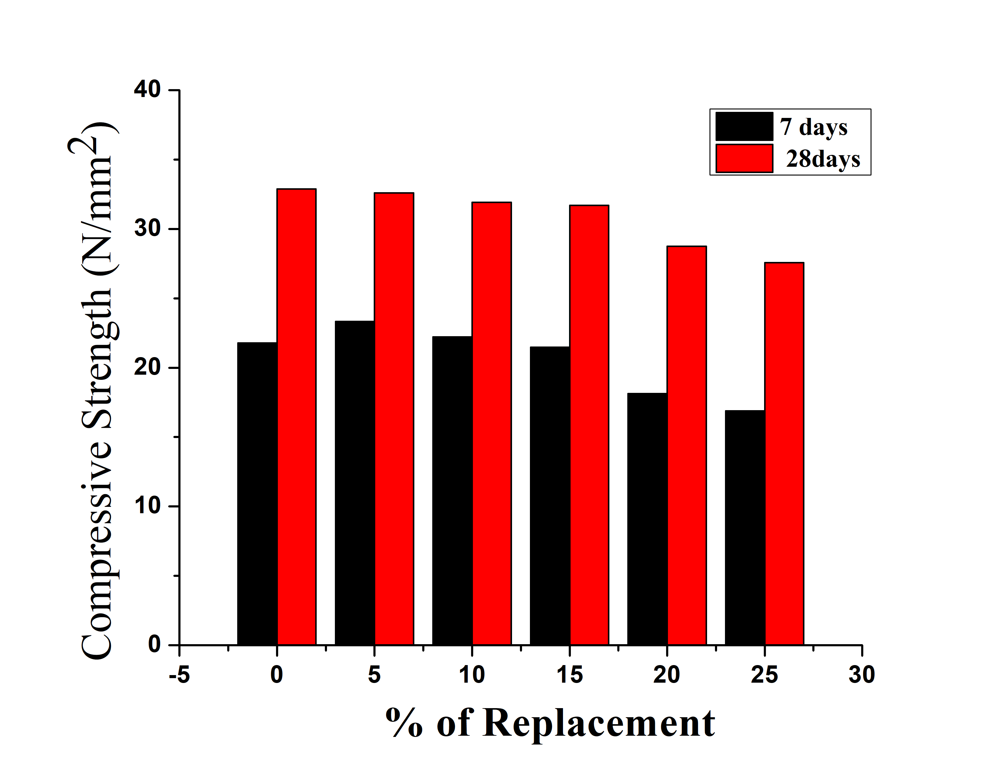

Figure 3: GCA Replacement Vs Compressive Strength

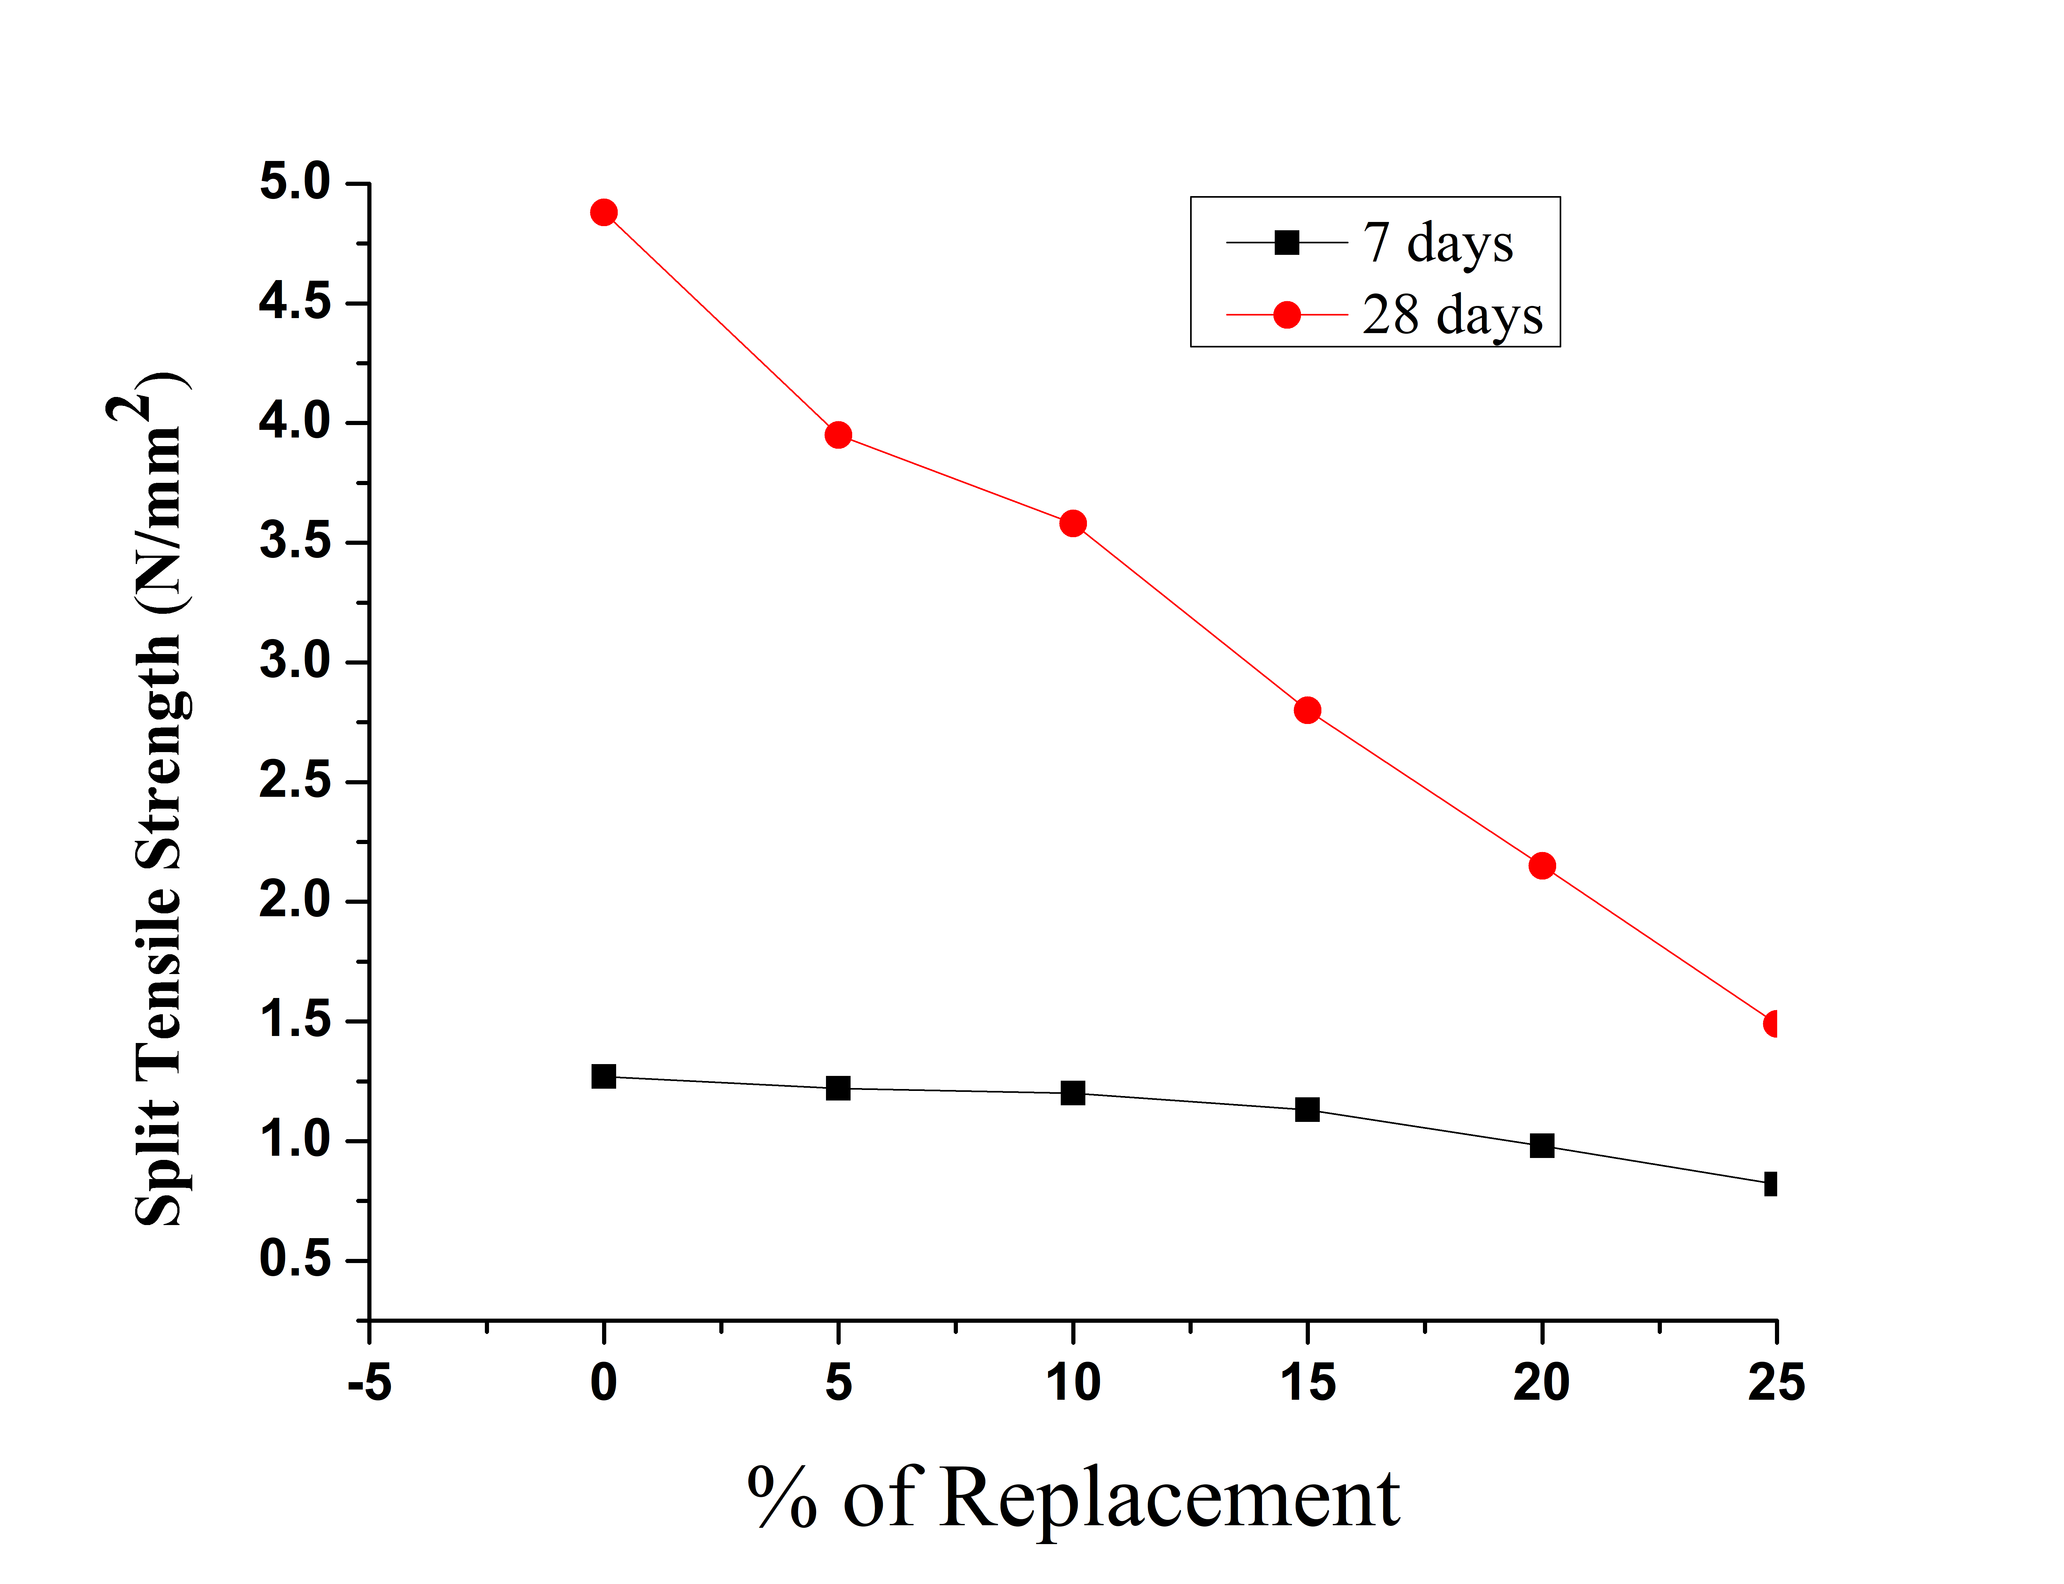

Figure 4: GCA Replacement Vs Split Tensile Strength

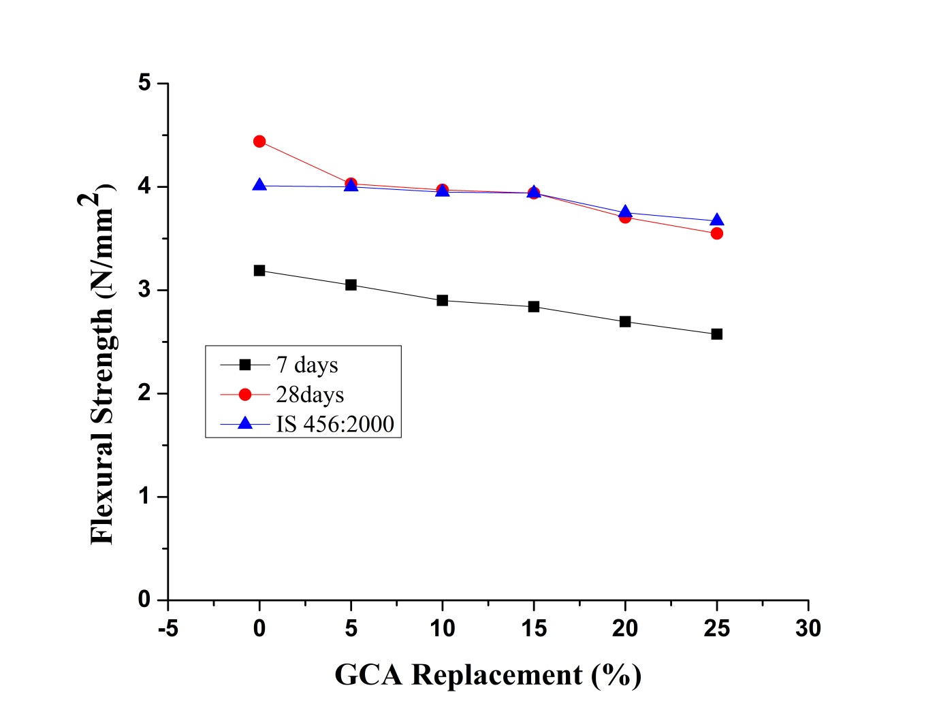
Figure 5: GCA Replacement Vs Flexural Strength

REFERENCES

[1] İ. Yüksel, R. Siddique, and Ö. Özkan, ‘Influence of high temperature on the properties of concretes made with industrial by-products as fine aggregate replacement’, Construction and Building Materials, vol. 25, no. 2, pp. 967–972, Feb. 2011, doi: 10.1016/j.conbuildmat.2010.06.085.
[2] P. Aggarwal, Y. Aggarwal, and S. M. Gupta, ‘Effect of bottom ash as replacement of bottom ash as replacement of fine aggregates in concrete’, Asian Journal of Civil Engineering, vol. 8, no. 1, pp. 49–56, 2007.
[3] N. Ghafoori and J. Bucholc, ‘Investigation of Lignite-Based Bottom Ash for Structural Concrete’, Journal of Materials in Civil Engineering, vol. 8, no. 3, pp. 128–137, Aug. 1996, doi: 10.1061/(ASCE)0899-1561(1996)8:3(128).
[4] K. Soman and D. Sas, ‘Strength properties of concrete with partial replacement of sand by bottom ash’, International Journal of Innovative Research in Technology, vol. 1, no. 7, 2014.
[5] C. Jaturapitakkul and R. Cheerarot, ‘Development of Bottom Ash AsPozzolanic Material’, Material, Journal of Materials In Civil Engineering, pp. 48–53, 2003, doi: https://doi.org/10.1061/(ASCE)0899-1561(2003)15:1(4.
[6] T. Y. Lo, H. Z. Cui, and Z. G. Li, ‘Influence of aggregate pre-wetting and fly ash on mechanical properties of lightweight concrete’, Waste Management, vol. 24, no. 4, pp. 333–338, Jan. 2004, doi: 10.1016/j.wasman.2003.06.003.
[7] T. Aramraks, ‘Experimental study of concrete mix with bottom ash as fine aggregate’, in Symposium on infrastructure development and the environment, 2006, pp. 1–5.
[8] V. B. Desai and A. Sathyam, ‘Some Studies on Strength Properties of Light Weight Cinder Aggregate Concrete’, International Journal of Scientific and Research Publications, vol. 4, no. 2, 2014.
[9] Bureau of Indian Standards, ‘IS 8112(1989) Indian Standard Specification 43 Grade ordinary Portland cement’, New Delhi, 1989.
[10] Bureau of Indian Standards, ‘IS 383-1970 Indian Standard Specification for Coarse and Fine Aggregates from Natural Sources for Concrete’, New Delhi, 1970.
[11] Bureau of Indian Standards, ‘IS 10262 Indian Standard Guidelines for concrete mix design proportioning’, New Delhi, 2009.
[12] Bureau of Indian Standards, ‘IS 516-1959, Indian Standard Specification for Methods of Tests for Strength of Concrete’, New Delhi, 1959.
[13] ASTM, ‘ASTM C109 / C109M-16a,Standard Test Method for Compressive Strength of Hydraulic Cement Mortars (Using 2-in. or [50-mm] Cube Specimens)’, West Conshohocken, PA, 2016. doi: 10.1520/C0109_C0109M-16A.
[14] BIS:5816-1999, ‘Splitting tensile strength of concrete’, Bureau of Indian Standards,New Dehli, 2004.
[15] Bureau of Indian Standards, ‘IS 456 (2000) Indian code for recommended guidelines for Plane and Reinforced Concrete’, New Delhi, 2000.

