Improving geotechnical properties of soil using glass powder and fly ash
Nigitha. D
Assistant Professor, Department of Civil Engineering, SR University-Warangal
Abstract:
The presence of highly expansive clay minerals in soil exhibits the behaviour of swelling and shrinkage when there is a variation in the moisture content. Due to these volume changes, different problems will develop in the structure that is resting on this type of soil. The most common method to improve the properties of problematic soil is stabilization. In this study, the geotechnical properties of problematic soil were improved by adding the different proportions of glass powder and fly ash. The optimum dosage of glass powder and fly ash was determined. For raw soil, the maximum dry density value is 7.43kg/cc and the optimum moisture content is 18%. The Maximum Dry Density (MDD) of the glass powder percentages of 1.89mg/m³ was obtained at 8% of glass powder with an optimum moisture content of 10%. When we added the fly ash (10%,20%,30%,40%) we got maximum dry density values at 1.93 kg/cc at 30% of fly ash. At the unconfined test, the stress is increased to 270 KPA at a strain of 5.1% (8%glass powder+30%flyash) at 7 days.
Introduction:
The soil-related issues pose formidable barriers to the construction purpose. The weak soil is unable to support the superstructure and also it causes erosion complications when it rains especially in urban areas where the land scarcity is greater. To overcome these challenges, geotechnical engineers recommend soil stabilization, which is a technique for improving the index and engineering properties of soil. The stabilization methods vary from mechanical to chemical modification and also electrical process which is chosen based on the soil characteristics and the nature of the planned project. Considering the environmental benefits, nowadays various waste products are added to the soil as admixture. In this approach, soil strength is increased as well as the effective usage of disposal waste. In this investigation, the waste glass powder (GP) and fly ash (FA) were utilized as an admixture to increase the strength of the soil. Chemical stabilization particularly with glass waste emerges as practical which is a hard material. It has a more chemical composition of silicate and alkaline. And it won't harm the environment but it is non-biodegradable so it should be reused in some other way in the form of disposal. The crushed glass powder has some physical properties of high permeability, high resistance and small strain stiffness which enhance the load-carrying capacity and durability of soil (Ikara et al, 2015). Fly ash originates as a by-product of coal combustion from the power plants. Furthermore, it is from the several industries where they are burning the waste materials that exhibit the composition or properties of fly ash. As a result, the generation of waste and coal combustion becomes extremely problematic to dispose of in a safe manner, particularly in India, where the waste generated from the thermal plan is 130 MT per year (Rajput & Yadav, 2015). Incorporating glass powder, and extending to include fly ash, offers a systematic approach, fortifying weak soil for enduring infrastructure stability in construction ventures.
Background Study:
Several studies have focused on improving the stability of black cotton soil by using materials such as glass waste powder (Canakci et al., 2016) (Ibrahim et al., 2021) (Zamin et al., 2021) and fly ash (Bharambe, 2013) (Brooks et al., 2011) (Rajput & Yadav, 2015). However, there has been limited research on the effectiveness of using a combination of these two materials (GP and FA) (Singh & Gahir, 2020). Glass waste is difficult to dispose of in the environment as it takes almost 450 years to biodegrade. Only 40% of glass waste is recovered for recycling, with the rest being dumped in landfills. Despite this, it can be used for soil stabilization due to its favourable physical properties (Javed & Chakraborty, 2020). Various index and engineering characteristics were tested to determine the efficiency of glass powder in black cotton soil. The addition of gradually increasing percentages of glass powder reduces the consistency limit and plasticity index of soil (Zamin et al., 2021) (Siyab Khan et al., 2018) (Javed & Chakraborty, 2020). Different proportions of glass powder were used in the compaction tests, and it was found that the maximum dry density increased as the percentage of glass powder increased (Canakci et al., 2016) (Javed & Chakraborty, 2020). Eventually, the density reached a constant level (Siyab Khan et al., 2018). Meanwhile, the observed optimum moisture content getting decreased due to the low absorption characteristics of glass powder (Canakci et al., 2016) (Ibrahim et al., 2021). The compressive strength of soil was examined following the addition of GP, and the results revealed that the strength increased with the addition of GP up to an optimum value, after which the strength diminished. (Javed & Chakraborty, 2020) (Ibrahim et al., 2021). The use of GP improved the soil's penetration value, as evidenced by the results of the CBR test conducted in both soaked and unsoaked conditions. The observed CBR value was increased with increasing the admixtures (Javed & Chakraborty, 2020). The 1D swelling test was performed, and it was found that the swelling tendency of soil was decreased as the amount of glass powder increased, likely due to its inert characteristics (Ibrahim et al., 2021). Then the efficiency of fly ash was studied by conducting various laboratory test such as consistency limit, Compaction test, Compression test and penetration test. The consistency limit, swelling nature decreased with increasing percentage of glass powder (Cokca, 2001) (Rajput & Yadav, 2015) . The dry unit weight and the compression strength of soil after mixing with fly ash was increased at optimum percentage (Phani Kumar & Sharma, 2004). Finally, the combination of GP and FA on soil was investigated and found that the strength increment was higher (Singh & Gahir, 2020).
Past studies on the GP and FA shows the efficiency to use for the stabilization process. Based on the soil properties, both plays an important role in their possibilities. But very limited study was conducted on the combination of glass powder and fly ash. So, still investigation is needed to understand the efficiency of this combination. In this study, the experimental studies were carried out to understand the efficiency of the combination of GP and FA on the index and engineering properties of the soil.
Materials:
In this study, there are three different types of materials were used such as Soil, glass powder and fly ash. The present investigation used Black cotton soil, which is capable of attracting higher water content. The soil has a volume changing characteristic, such as swelling when wet and shrinking when dry. These actions will result in an issue with the superstructure. The soil sample was collected from Hasanparthy Village in Warangal at a depth of 2m below the surface of the land. As an admixture to stabilize the soil, there are two additives were used such as Glass Powder (GP) and Fly Ash (FA). The glass powder has a more silica content while fly ash has good cementitious properties. The broken glasses were collected and pulverized into a powder in the laboratory using a crushing machine. Then, the broken glasses were then collected and sieved in a 425µ sieve, with the passing powder were used as an admixture in this investigation. The fly ash, which is a commonly available fine powder, was then used as an activator in this investigation.
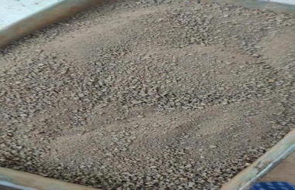 | 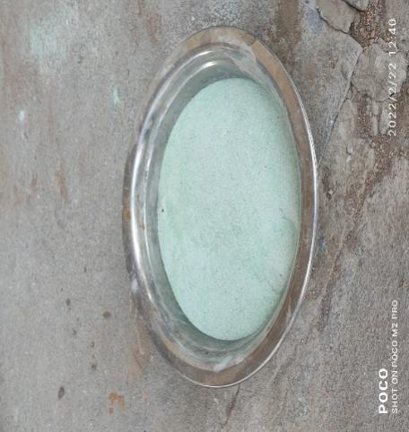 | 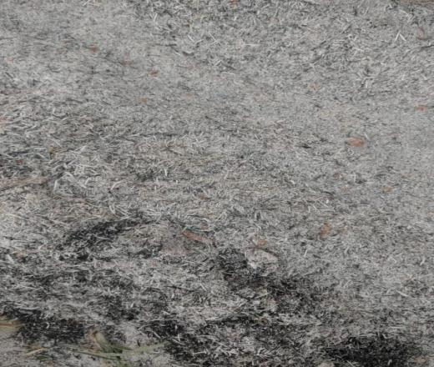
Soil | Glass Powder | Fly Ash
Figure: Collected materials for this study
Research Methodology:
The laboratory tests were conducted to determine the geotechnical properties of soil with and without mixing admixtures. The soil sample was combined with varying proportions of glass powder and fly ash. The glass powder proportion was 2%, 4%, 6% and 8% and the fly ash proportion were 10%, 20%, 30% and 40%. For the different proportion of glass powder with soil, the different tests were carried out to understand the improvement in the soil properties. The analysis of mix percentage for glass powder and fly ash was determined using the standard proctor test. This experiment yielded the appropriate amount of glass powder and fly ash. With this optimum percentage, the compression strength of soil was determined for the different curing days.
Methodology Chart:
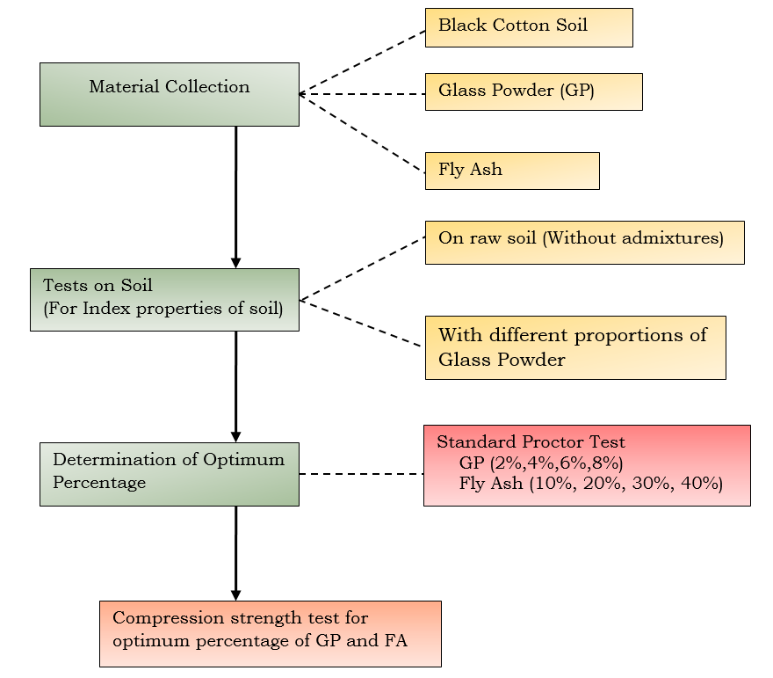
Figure: Details of Experimental program
Results and Discussions:
Properties of Black Cotton soil:
The primary tests were conducted to determine the basic properties of soil without the addition of any admixtures to understand the basic behavior of soil. The properties of Black cotton soil are listed in the Table 1. From the free swell test, the observed swelling percentage is 50% and it shows that the soil will exhibits high expansive behavior. The liquid limit value of soil is 45% and the plastic limit value is 28.5%. From this, it is observed that the soil behaves almost high plasticity. Then, from the A-line chart, its lies above A-line, hence the soil is classified as the Intermediate compressible clay. From the standard proctor test, the maximum dry density and optimum moisture content were determined as 1.73 g/cc and 18%.
Table: Properties of collected soil
S.No | Properties | Values
 | Free Swell Index | 50%
1 | Specific Gravity | 2.62
2 | Liquid Limit | 45%
3 | Plastic Limit | 28.5%
4 | Plasticity Index | 16.5%
5 | Optimum Moisture Content | 18%
6 | Maximum Dry Density | 1.73 kg/cc
The optimum moisture content and the dry density of soil were determined by conducting the standard compaction test. The Figure shows the relationship between maximum dry density and optimum moisture content of the tested soil.

Figure: Proctor Test for Raw Soil
Effect of glass powder on Free Swell Test:
The free swell index tests were conducted for varying percentage of glass powder to understand the effectiveness of admixture on black cotton soil. The outcome of the test is depicted in the graph. The graph demonstrates that as the percentage of glass powder increases, the expansive character of the soil decreases. With the maximum amount of glass powder set at 8%, the free swell potential was lowered from 50% to nearly 20%. The expansive soil will have the more montmorillonite minerals which causes high swell behavior. When some of the soil is replaced with glass powder, the presence of montmorillonite minerals decreases and is replaced by silica minerals because glass powder contains more silica. These are the reason, the expansion capacity of soil got reduced by adding glass powders.

Figure: Variation in swelling behavior with varied percentages of glass powder
Effect of glass powder on consistency limit:
One of the important properties of fine grained soil is the value of Atterberg limits which give the consistency of the soil under varying moisture content. If the soil has higher liquid limit, the swelling potential of soil will be higher. In this study, the soil comes under the high expansive nature so undergone the stabilization process using the admixtures of glass powder. From figure, it is observed that the consistency level of soil is varying from soft to hard, that is the LL and PL value getting decreased with addition of glass powder. So, it shows that the stability of the soil getting increases with the addition of increasing percentage of glass powder. This behavior of soil revels that the glass powder which contains high silica content having high effect on the consistency limits of the soil. The change in value of consistency limit with varying percentage of glass powder is listed in the Table.

Table. Effects of Glass Powder on Liquid Limit and Plastic Limit
Glass Powder (%) | Liquid Limit(Ll) | Plastic Limit (Pl) | Plasticity Index(Pi)
0% | 45% | 30% | 15%
2% | 40% | 27% | 13%
4% | 37% | 24% | 13%
6% | 35% | 23% | 12%
8% | 33% | 20% | 13%

Proctor Compaction test:
The standard compaction test is conducted to determine the soil dry density with respect to the optimum moisture content of the soil. Then, the individual test was conducted for different percentage of glass powder as well as the fly ash. From the optimum percentage of both the admixtures were determined and it taken as the reference value to prepare the sample for UCS test. From the UCS test, the compression strength of the soil will be determined. The figures show the Maximum dry density and the optimum moisture content for various percentage of glass powder and fly ash. The dry density of soil increases with increasing water content until it reaches the optimum moisture content, at which point it begins to decrease due to the increased water content. Because the lubricant between the solid particles increases, particle replication increases, resulting in a reduction in soil density. At that time, the peak point of each curve represents the OMC and MDD for the untreated and treated soil samples. The figure shows that the dry density of soil increases as the percentage of glass powder increases. This is because silica materials are present. Furthermore, the figure shows that the dry density increases with increasing percentages of fly ash up to 30%. After, the addition of 40% of fly ash, the density of soil decreases due to the more replacement of soil by fly ash.

Figure: Maximum dry density Vs Optimum moisture content for different percentage of GP

Figure: Maximum dry density Vs Optimum moisture content for different percentage of FA
Effect of glass powder on Maximum Dry Density
The maximum dry density of soil increases with increasing percentage of glass powder. The increment is due to the specific gravity of glass powder is more, due to that soil density also increased when the replacement of soil will be more by glass powder. The figure shows the increase in the dry density of soil with increasing percentage of powder.

Figure: Dry Density Vs Glass Powder

Optimum Moisture Content Vs Glass Powder:
The observed optimum water content for different percentage of glass powder was decreased. With the increase of glass powder, the replacement of soil will be more, due to that the absorption of water will be reduced. This indicated the better performance of soil with glass powder. Also, the Glass powder increases the surface area of the soil particles by the formation of calcium silicate which increases the strength of the soil and decrease the absorption of water (Ikara et al., 2015).

Figure: Optimum moisture content Vs Glass Powder
Proctor Compaction Test for Glass Powder and Fly ash:
To define the optimum moisture content for Unconfined Compression test, first, Soil compaction test was carried out for combination of admixtures (Fly Ash and Glass Powder. From the tests, it is observed that 8% of glass powder and 30% of fly ash given the good improvement. The results of optimum moisture content were established from the graph and plotted curve are shown in Figure.

Figure: Maximum dry density Vs water content for GP +FA
Unconfined compression strength
The UCS tests were performed for the untreated and treated expansive soil with combination percentages of 8%GP + 30%FA at OMC and MDD, as shown in Fig 4.6.4. The peak compressive strength values of the samples increase from 178kPa to 213kPa as the addition of admixture. It may be due to the addition of GP that works as cohesionless material, which contains high silica (SiO₂ = 71.21 %). The soil is reactive with glass powder and fly ash, the strength increased with addition of admixtures up to an optimum content which revealed by UCS test. For the maximum value, the corresponding strain was recorded as 5.1%. The improvement in the UCS tests, may be due to reduction in plasticity when adding glass powder and Fly ash till a specific limit. And also, due to reduction in cohesive by addition of glass powder.

Figure: Stress-strain behavior of soil with 8%GP +30%FA
The unconfined compressive strength tests were carried out for sample under curing period. Three different curing times was used for the mechanical UCS tests. All samples were cured in the air at 3 and 5 days also 7 days curing was applied for the 8%GP+30%FA addition. As it is clearly seen from Fig., for the 3-days curing time, the values of UCS increased compared with the untreated clay soil. The largest load increases of UCS value was 281kPa when the sample was cured for 7days. The test results also showed that curing time has a positive effect in compressive strength. Through a comparison between the curing times and UCS values at 8%GP+30%FA %, it was found that the UCS values increases 261 kPa at 3 days, 273 kPa at 5 days and 281kP at 7 days.

Figure: Stress-strain behavior of soil with 8%GP +30%FA for different curing days
Conclusion:
The glass which is belongs to the non-biodegradable group are significant quantizes globally and use fly ash that improve the stability of the soil. Black cotton soil (BCS), as BCS are generally known to have weak engineering properties and the need for stabilization often arises before BCS can be used. In this paper, an experimental study has been carried out to assess the effect of glass powder on BCS with respect to its engineering properties. We have classified the soil properties by doing free swell test, specific gravity test, liquid limit and plastic limit test and for stabilization we done proctor compaction test and unconfined compression test. Different percentage of glass powder 0%, 2%, 4%, 6% and 8% were used to BCS with powdered glass. For raw soil the maximum dry density value is 7.43kg/cc and optimum moisture content is 18%. The Maximum Dry Density (MDD) of the glass powder percentages of 1.89mg/m 3 was obtain at 8% of glass powder of optimum moisture content 10%. When we added the fly ash (10%,20%,30%,40%) we got maximum dry density values at 1.93 kg/cc at 30%of fly ash. At the unconfined test the stress is increased to 270 KPA at strain of 5.1% (8%glass powder+30%flyash) at 7days.
References
- Bharambe, R. (2013). A Study on Stabilzation of Black Cotton Soil Using Ferric Chloride. IOSR Journal of Mechanical and Civil Engineering, 10(1), 26–30. https://doi.org/10.9790/1684-1012630
- Brooks, R., Udoeyo, F. F., & Takkalapelli, K. V. (2011). Geotechnical Properties of Problem Soils Stabilized with Fly Ash and Limestone Dust in Philadelphia. Journal of Materials in Civil Engineering, 23(5), 711–716. https://doi.org/10.1061/(asce)mt.1943-5533.0000214
- Canakci, H., Al-Kaki, A., & Celik, F. (2016). Stabilization of Clay with Waste Soda Lime Glass Powder. Procedia Engineering, 161, 600–605. https://doi.org/10.1016/j.proeng.2016.08.705
- Cokca, E. (2001). Use of Class C Fly ashes for the Stabilization of an Expansive Soil. Journal of Geotechnical and Geoenvironmental Engineering, 127(7)(July), 568–573.
- Ibrahim, H. H., Mawlood, Y. I., & Alshkane, Y. M. (2021). Using waste glass powder for stabilizing high-plasticity clay in Erbil city-Iraq. International Journal of Geotechnical Engineering, 15(4), 496–503. https://doi.org/10.1080/19386362.2019.1647644
- Javed, S., & Chakraborty, S. (2020). Effects of Waste Glass Powder on Subgrade Soil Improvement. World Scientific News, An International Scientific Journal, 144(March), 30–42. www.worldscientificnews.com
- Phani Kumar, B. R., & Sharma, R. S. (2004). Effect of Fly Ash on Engineering Properties of Expansive Soils. Journal of Geotechnical and Geoenvironmental Engineering, 130(7), 764–767. https://doi.org/10.1061/(asce)1090-0241(2004)130:7(764)
- Rajput, satyendra singh, & Yadav, R. K. (2015). Effect of Fly-Ash on Geotechnical Characteristics of Black Cotton Soil. 2(03), 9–13.
- Singh, G., & Gahir, J. S. (2020). Soil stabilization with fly-ash and glass powder. Journal of Green Engineering, 10(9), 6029–6038.
- Siyab Khan, M., Tufail, M., & Mateeullah, M. (2018). Effects of Waste Glass Powder on the Geotechnical Properties of Loose Subsoils. Civil Engineering Journal, 4(9), 2044. https://doi.org/10.28991/cej-03091137
- Zamin, B., Nasir, H., Khan, B. J., & Farooq, A. (2021). Effect of Waste Glass Powder on the Swelling and Strength Characteristic of District Karak Expansive Clay. Sir Syed University Research Journal of Engineering & Technology, 11(2), 1–8. https://doi.org/10.33317/ssurj.362.
- Gurmeet Singh ,Jagdeep Singh Gahir(2020). ‘Soil Stabilization with Fly-Ash and Glass Powder’,Journal of Green Engineering(JGE)’,10(9),pp.6029-6038
- Gandhi N.S.V.V.S.J, Kumar B.R, Kumar J.V.P, “Some engineering characteristics of fly ash-treated expansive soils”, Proceedings of IGC2001, pp. 157-161,2001.
- Pandian N.S, Krishna K.C, Bb. Leelavatamma, “Effect of fly ash on the C.B.R. behavior of soils”, Proceedings of IGC-2002, pp. 183-186,2002.
- Pandian N.S, Sridharan A, SRINIVAS S, “Use of fly ash to improve the C.B.R. of soils”, Proceedings of IGC-98, pp. 261-264,1998.
- Ramakrishnan A.K, Natarajan K, Chandran R. K, “Stabilization of Annamalai Nagar clay with lime-fly ash”, Proceedings of IGC-2001, pp.251-254, 2001.
- [6]Sikdar P.K, Guruvittal U.K, “Economics of using fly ash in road construction”, journal of Indian High ways, pp. 37-45, 2004.
- Ikara, I.A., Kundiri, A.M. and Mohammed, A (2015)” Effects of Waste Glass (WG) on the Strength Characteristics ofCement Stabilized Expansive Soil” American Journal of Engineering Research (AJER)Vol. 4, Issue-11, pp. 33-41.

