A review on the study of physicochemical properties and Application of surfactants
Benvikram Barmanª and Manoj Kumar Banjare^{b}
MATS School of Sciences, MATS University, Pagaria Complex, Pandri, Raipur (C.G.), 492004, India
------------------------------------------------------------------------------------------------
Abstract
This review article discusses the physical characteristics of surfactants and how crucial they are to contemporary science and technology. Surfactants are surface active agents, commonly referred to as "active at the surface." Surfactants are materials with an adsorption capacity at surfaces and interfaces. A distinct class of chemical substances is comprised of surfactants. Chemical surfactants come in a variety of forms and are typically categorised according to the charge of the surface-active molecules, which can be anionic, non-ionic, cationic, or amphoteric. Due to their superior physicochemical features and capacities for effective adsorption, solubilization, dispersion, suspension, and transportation, among other things, surfactants have been the subject of a lot of interest. By mixing the correct additives, such as salts, co-solvents, polymers, ionic liquids, and other additives, the characteristics of the surfactant self-assembled nanostructures can be successfully modified for desired applications. They have a polar head group and a non-polar hydrophobic tail as part of their structure. These nanostructures have shown a wide range of potential applications, including synthesis, catalysis, nanoscience, pharmaceutics, separation and extraction, etc. The primary capability of surfactant molecules is the formation of self-aggregating micelles, which give rise to the ability to use surfactants. The study of surfactants opens up a variety of fields for employment, including food, health and personal care goods, biological systems, nanotechnology, and mineral and petroleum processing.
Keywords: Surfactants, micelle, CMC, self-aggregate, surfactants in biological system.
1.Introduction
Surfactants are surface active agents, commonly referred to as "active at the surface." Surfactants are materials with an adsorption capacity at surfaces and interfaces, when any two immiscible phases are connected by an interface and any one phase, such as air, is a gas, the interface is referred to as the surface [1-2]. Some examples of surfaces and interfaces are as follows: Liquid - Vapour (surface), Liquid - liquid (interface), Solid - liquid (interface), and Solid - solid (interface). The surface tension between two liquids or between a liquid and a solid can be reduced by molecules called surfactants. These could act as wetting agents, dispersants, and emulsifiers. Surfactants are made up of a polar head group and a non-polar hydrophobic tail group. In liquids, the surfactant monomers can combine to form micelles, which are colloidal-sized clusters (CSCs) varying in size from 1 to 100 nm. The range of surfactant concentrations known as the critical micelle concentration (CMC) is where micelle creation takes place [3-4]. Below this concentration, the surfactant monomers disperse in the solution. Due to their wide range of possible applications in numerous scientific and technological domains, surfactant self-assembled nanostructures—such as conventional micelles, reverse micelles, and micro-emulsions—have significant significance. Surfactants and other amphiphilic molecules act as surface active agents and have the ability to lower the surface tension of water. Surface-active substances are frequently utilised as antiseptics, foaming agents, emulsifiers, dispersants, and corrosion inhibitors [5]. By mixing appropriate additives, such as salts, co-solvents, polymers, ionic liquids, and other additives, the characteristics of these surfactant self-assembled nanostructures can be successfully tailored for desired applications.
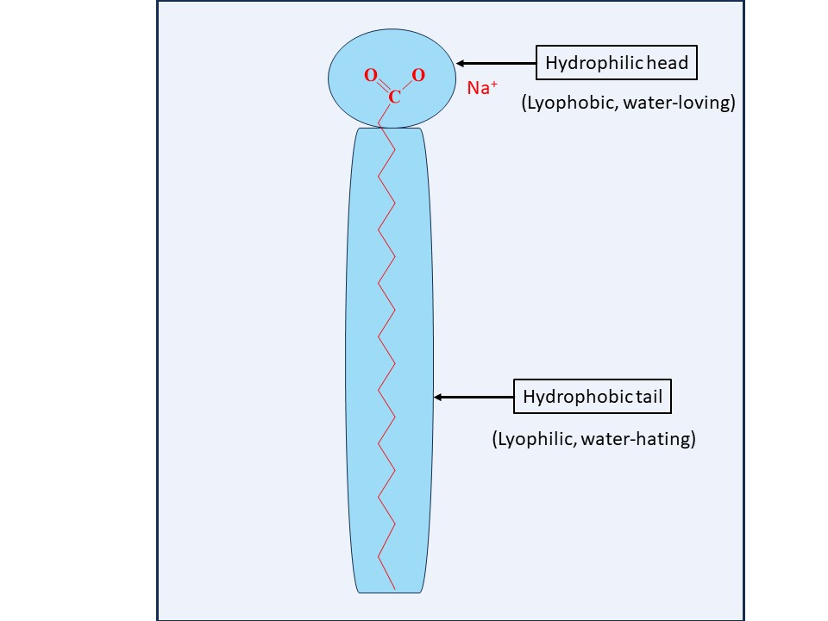

Fig- structure of surfactant molecule

2.Classified of surfactants
Surfactants are available in many forms, and are generally classified based on charge of the surface-active molecules such as anionic, non-ionic, cationic and amphoteric.
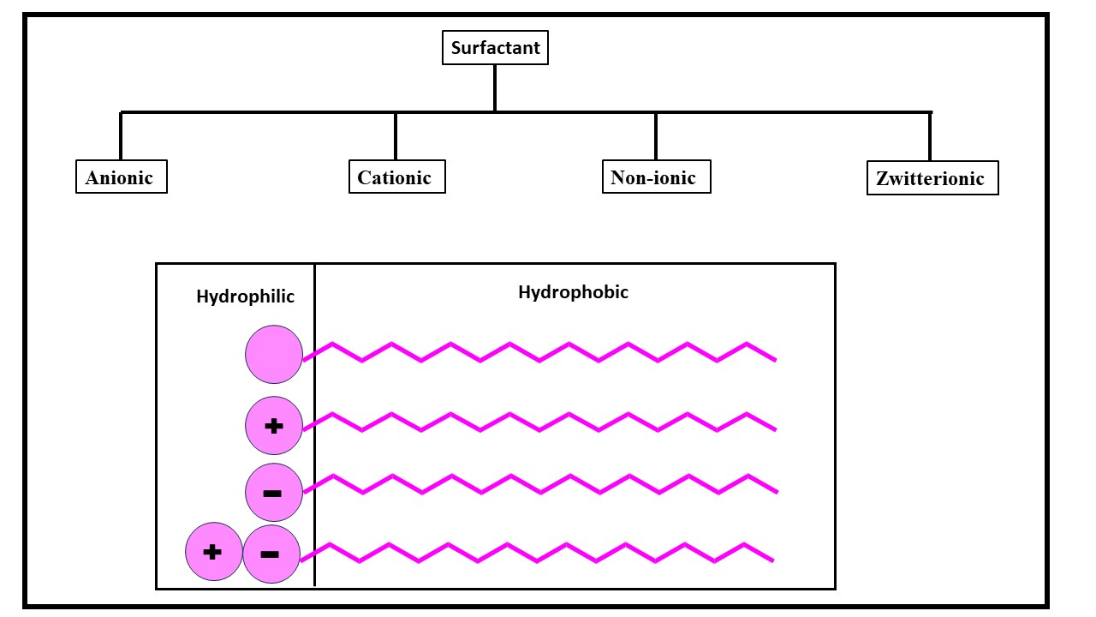
Fig types of surfactants and their structure
2.1 Anionic surfactants
Anionic functional groups, such as sulphate, sulfonate, phosphate, and carboxylate, make up anionic surfactants. We utilise anionic surfactants more frequently than any other type of surfactant, and they are present in the majority of detergent compositions. Alkyl and alkyl-aryl chains with a C12–C18 length give the best detergency [6-7]. The most common type of surfactant, soaps are anionic surfactants made by saponifying natural oils and fats. The term "soap" refers to the metal salt of an alkali carboxylic acid that was originally derived from vegetable or animal fats. The majority of the time, tallow and coconut fatty acid combinations are the foundation of soap bars.
2.2 Cationic surfactants
The hydrophilic component in this category is positively charged. Although this group doesn't have any wash action, it adheres to surfaces and may have softening, antistatic, soil-repelling, antimicrobial, or corrosion-inhibiting effects. They are used as softeners (fabric softeners) and antistatic in a variety of common applications. A halide or methyl sulphate is typically the counter ion of cationic surfactants [8]. The primary, secondary, or tertiary amines depend on the pH.
2.3 Non-ionic surfactants
Non-ionic surfactants contain hydrophilic parts that are not charged. These compounds are effective for cleaning and have no effect by the hardness of the water. They comprise classes like fatty alcohol polyglycosides and alcohol ethoxylates, and they are widely used in cleaning detergents. Long chain alcohols have some surfactant characteristics [9]. Fatty alcohols, cetyl alcohol, stearyl alcohol, cetostearyl alcohol (composed mainly of cetyl and stearyl alcohols), and oleyl alcohol are the most prevalent types of these.
2.4 Zwitterionic surfactants
A zwitterionic surfactant is made up of two groups with opposing charges (anionic and cationic). Zwitterions are frequently referred to be "amphoteric," but these concepts are distinct. An amphoteric surfactant is one that changes from a low to a high pH and converts from a net cation via Zwitterion to a net anion. The molecule is only Zwitterionic across a finite pH range because neither the acid nor the base sites are permanently charged. The physicochemical behaviour at the isoelectric point frequently parallels that of non-ionic surfactants [10]. There is a steady shift towards the cation and anion character, respectively, below and above the isoelectric point. Zwitterion is a subgroup known for its superior dermatological abilities. They somewhat irritate the skin and eyes. Therefore, these are suitable for use in shampoo and various personal care (cosmetic) products. Zwitterionic (amphoteric) surfactants consists of both cation and anion centres attached with the same molecule. The cation part depends on primary, secondary, or tertiary amines or quaternary ammonium cations.
Types of surfactants | Example | Uses
Anionic | Alkyl sulfates, soap, calsoft, texapon | 50% of overall industrial production, laundry detergent, dishwashing liquid, shampoos.
Cationic | Quaternary ammonium salts | Used together with nonionic surfactant but not with anionic, softness in textiles, anti-static additives.
Nonionic | Ethoxylated aliphatic alcohol, polyoxyethylene surfactants, triton x-100, span, tergitol. | 45% of overall industrial production, a wetting agent in coatings, food ingredients.
Zwitterionic | Betaines, amphoacetates. | Expensive, special use e.g. cosmetic.

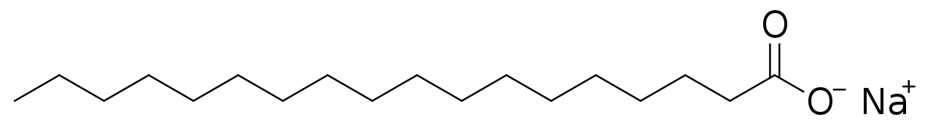

Sodium stearate
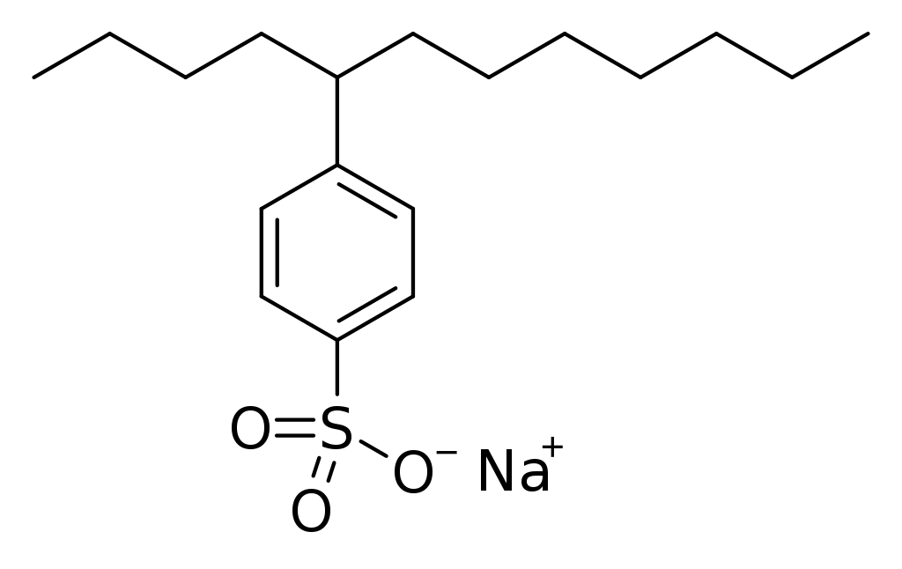
4-(5-Dodecyl) benzenesulfonate

Fig: Molecular structure of surfactants
3. Physicochemical properties of surfactants
surfactant have received wide attention because of their superior physicochemical properties and capabilities in efficient adsorption, solubilization, dispersion, suspension, and transportation etc.
3.1 Hydrophilicity and Hydrophobicity of Surfactant Molecules
Surfactant molecules' hydrophilic functional group has a significant preference for interacting with polar substances including water, metals, and other ions. Surfactants often adhere to metal surfaces, restrict active spots like those exposed to corrosive fluids, and so lessen corrosion assault [11]. According to current thinking, the structure of heterocyclic surfactant molecules dominates the surfactant adsorption process. The surface aggregation concentration is the surfactant concentration at which a monolayer of surfactant molecules adheres to and covers a metal surface. Surface bilayers or multilayers are prone to form when surfactant concentration rises. At solubility saturation, surfactant molecules can also cluster in the aqueous phase, where they typically direct their hydrophilic head groups towards water or hydrophilic surfaces and their hydrophobic tails towards those of nearby surfactant molecules.
3.2 Surface Tension
When molecules have cohesive energy, surface tension results. In aqueous media, water molecules interact with one another via hydrogen bonds and van der Waals forces. The hydrogen bonding is incomplete above the air–water barrier, though. The absence of interacting molecules in the air phase further weakens van der Waals interactions at the contact [12]. As a result, compared to molecules in the bulk phase, those present at the air–water interface has more energy available and fewer chances for bonding. Surface tension is caused by this extra energy. In line with this, the word "surfactant" comes from "surface-active agent," which reduces surface tension. It is hypothesised that substances with higher cohesive energies between water molecules at the air-water interface will have higher surface tension.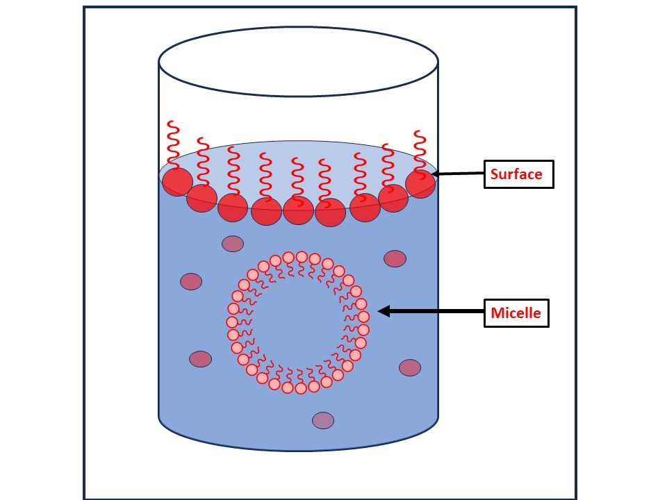
Fig- Solution of surfactant

3.3 Krafft point
Lower than the Krafft point, surfactant molecules do not dissolve significantly in aqueous solutions. Surfactants can form micelles above the Krafft point or temperature, which considerably enhances total surfactant solubility [13].
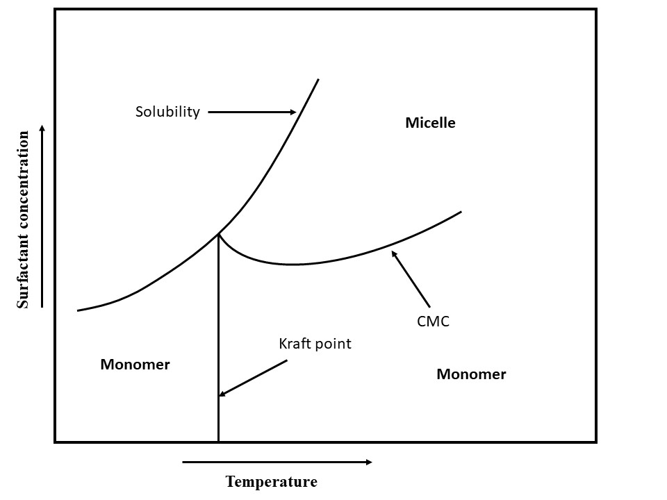
Fig: Temperature, total surfactant concentration, and their interactions with surfactant states are all compared. adjacent to the axes, arrows Point at the direction of the increase.
3.4 Surfactant States
Surfactants can arrange themselves into several stages or states. Surfactant phase or condition and concentration are typically tightly connected. Monomeric surfactants assemble into micelle-like structures when surfactant concentration rises over the cmc. the quantitative correlations between micelle concentration, related cmc, monomer concentration, and total surfactant concentration [14]. At the gel temperature, surfactants can also create micelles and gels. Liquid crystals can also be produced by surfactants. Between the liquid crystal phase and the solid state is the gel state. Some surfactants have limited solubility at high temperatures. This drop is the result of less hydrogen bonding with water due to higher energy levels and conformational changes in the structure of the surfactant [15].
3.5 Microemulsions
Microemulsions resemble micelle-containing fluids. They essentially consist of inflated micelles with a 5- to 100-nm liquid droplet inside each one. They can exist in a water continuous phase with oil droplets inside, or they can exist in an oil continuous phase with nanoscale water droplets inside of a surfactant shell. Microemulsions are mixtures of water, oil, and alcohol with an ionic surfactant that have a wide range of applications [16]. The thermodynamically stable emulsion kind is called a microemulsion.
3.6 Adsorption at Surface/Interface
3.6.1 Adsorption Basics
Surfactant adsorption is a prerequisite to surfactant-based surface coverage. A common interpretation of the adsorption of ionic surfactant on oppositely charged substrates.
3.6.2 Adsorption Isotherms
The Stern Adsorption model, the van der WaalsStern model, the Temkin model, the Freundlich model, the Frumkin model, the Flory-Huggins model, the Dhar-Flory-Huggins model, the Bockris-Swinkels model, and the Bockris-Devanathan Muller model are the most used adsorption models [17]. Regardless of whether nearby sites are occupied, the Langmuir adsorption isotherm makes the assumption that all surface adsorption sites are comparable.
3.6.3 Adsorption Kinetics
Due to desorption, the surfactant concentration in aqueous solution diminishes with time. In order to optimise the frequency of surfactant injections and ensure efficient surfactant adsorption and surface coverage, it is essential to understand the adsorption and desorption kinetics of surfactants [18]. Both the concentration of the surfactant and the concentration of competing ions have an impact on the extent and rate of adsorption of many surfactants. 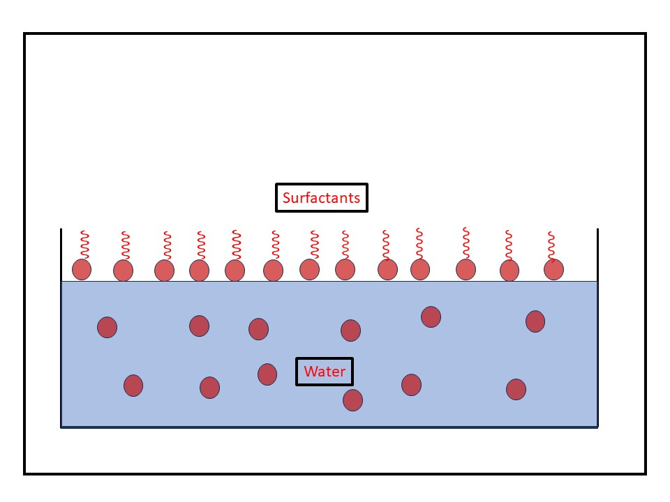
Fig- Adsorption of surfactant at the surface of water.

3.7 Surfactant Partitioning Between Water and Oil
In water, oil, and their mixes, different types of surfactant molecules form. Surfactant molecules can be discovered to be in equilibrium in a variety of forms in an oil and water solution under specific circumstances. A surfactant can adsorb on solid surfaces, form dimers and micelles, react with metal ions or hydrogen ions to produce metal salts and hydrogenated compounds, and form a variety of other compounds. It can also partition to the oil and aqueous phases [19]. Surfactant monomers may prefer partitioning into organic liquid when an aqueous surfactant solution comes into contact with an immiscible organic liquid, such as oil, until equilibrium between the two liquids is attained.
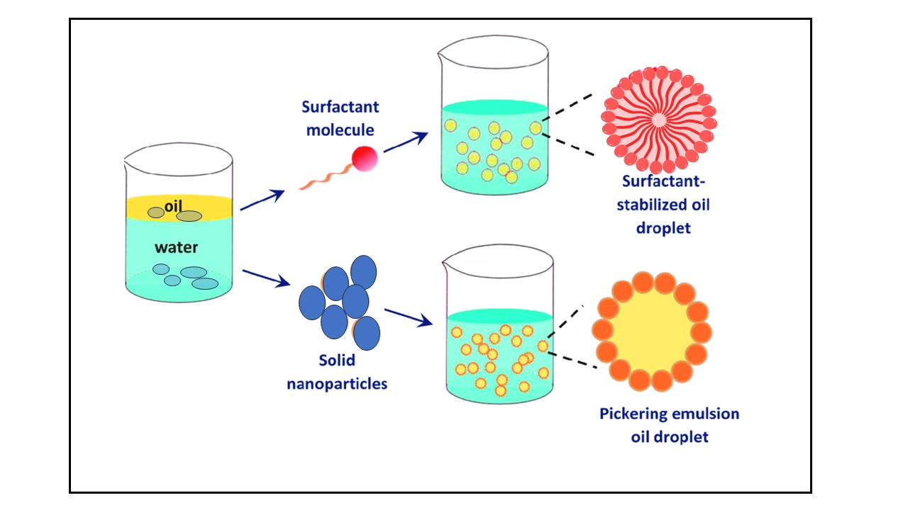
Fig: Surfactant as stabilizer oil/water.
3.8 Surfactant Precipitate and Colloid Formation
In solutions, ionic surfactants typically interact with other ions. Surfactants can react to produce precipitates when they come into contact with reactive counter ions. It is common for oil droplets to develop when certain surfactants, including carboxylates, combine with hydrogen ions to generate carboxylic acid. Additionally, carboxylates can interact with other species that are positively charged, such as calcium or magnesium ions, to produce colloidal, solid particles that are hydrophobic and behave like miniature wax particles. Water solubility is significantly decreased during the precipitation process that produces neutral molecules. However, nonpolar solvents like oils frequently make the hydrophobic colloidal precipitate particles liquid. Precipitation thus substantially favours the lipophilic or oil phase and has a very noticeable effect on phase partition [20]. Ionic surfactants interact with hydrogen ion, hydroxide ion, and other ions.
3.9 Salt/Ion Effects on Surfactant Behaviour
The aqueous phase in oil fields typically contains mixtures of different inorganic salts, which affect surfactant-related processes like aggregation, adsorption, partitioning, surfactant ion pair, hydration, and thus affect corrosion inhibition. These processes not only promote the corrosion of metal in certain ways [21]. This should be considered in any modelling and experimental evaluation work.
3.10 Micelle
Above the cmc, surfactant molecules are compelled to group together to form micelle-like structures. Typically, tens to hundreds of surfactant molecules make up a micelle. The aggregation number refers to the quantity of surfactant monomers contained within a micelle. Simply multiplying the aggregation number by the molecular weight of the surfactant monomer yields the molecular weight of a micelle. Ionic strength, head group characteristics, hydrophobic chain lengths, and temperature all have an impact on the amount of surfactants that aggregate. By weakening the attraction between ionic head groups and strengthening the attraction of the hydrophobic tail to the aqueous medium, increasing ionic strength enhances the propensity for aggregation. Micelles, on the other hand, develop and separate in milliseconds [22]. But as the surfactant concentration and the surfactant's size and properties change, these time scales drastically alter. Micelle aggregates can take the forms of vesicles, rod-like or cylindrical micelles, spherical micelles, hemimicelles, plate-like micelles, and more. The arrangement of the surfactant's hydrocarbon chain in a micelle is what determines its shape.
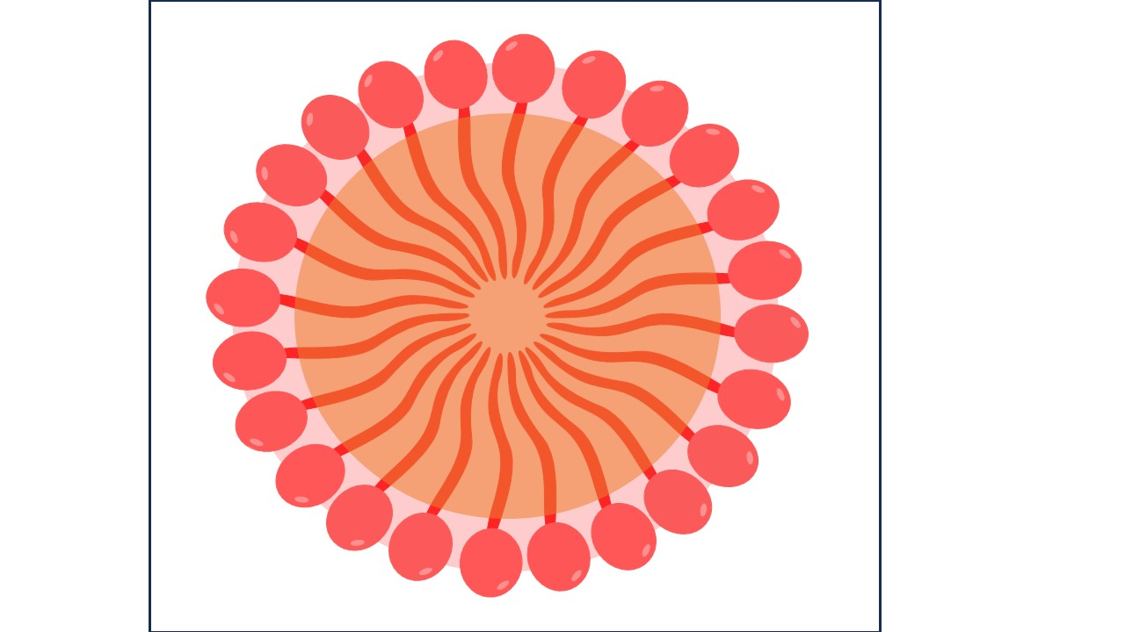
Fig: Micelle
3.11 Critical Micelle Concentration (CMC):
The concentration of surfactants (amphiphilic molecules) over which micelles form is known as the critical micelle concentration (CMC). Micelle nanoparticles are 5 to 100 nm in size. An essential quality of a surfactant is its CMC. These molecules begin to form the micellar structure at this concentration thanks to the reduction in free energy driving assembly. Temperature, pressure, and (in some cases strongly) the presence and concentration of additional surface-active compounds and electrolytes all affect the CMC value for a specific dispersant in a given medium [23]. Only at temperatures over the crucial micelle or Kraft temperature do micelles develop. Micelles cannot form below the Kraft temperature.

4. Applications of Surfactants
The surfactant plays an important role in cleaning, wetting, dispersing, emulsifying, foaming and anti-foaming agents with many practical applications and products, that including a wide variety which are given below:
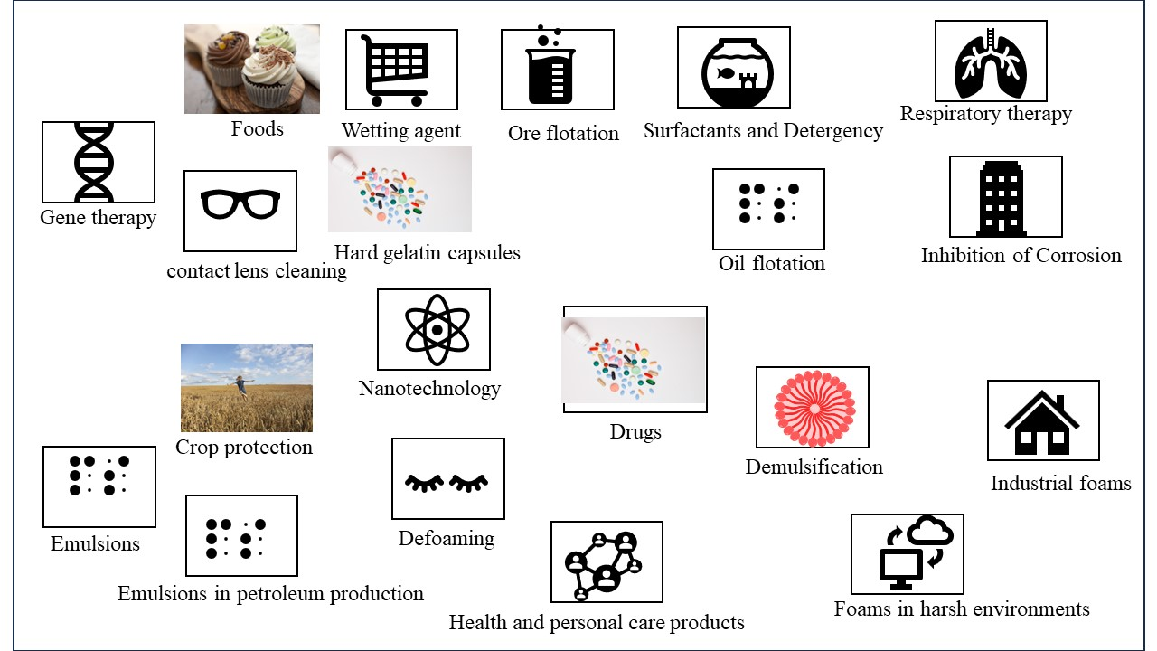
Fig: Application of surfactants
4.1 Surfactants in crop protection
4.2 Surfactants in foods
4.3 Surfactant and wetting
4.4 Ore flotation
4.5 Surfactants and detergency
4.6 Surfactants in respiratory distress therapy
4.7 Surfactants for contact lens cleaning
4.8 Surfactants in hard gelatin capsules
4.9 Solubilization of Drugs
4.10 Inhibition of Corrosion
4.11 Gene therapy
4.12 Surfactant in Nanotechnology
4.13 Surfactants in health and personal care products
4.14 demulsification.
4.15 Industrial foams.
4.16 Oil flotation.
4.17 Foams in harsh environments
4.18 Defoaming.
4.19 Emulsions
4.20 emulsions in petroleum production

4.1 Surfactants in crop protection
Pesticides, herbicides, fungicides, and insecticides are categorised as crop protection products. The stability and effectiveness of pesticides are significantly influenced by their formulation. Crop protection products are now being developed to be stronger, safer for users, less harmful to the environment, easier to use, and more effective when applied. Colloid and interface science has an impact on every area of application for sprayed items. Spray droplets first hit the surface of the leaf, forming a foliar deposit from which the pesticide enters the leaf or comes into touch with the insect [24]. The applicator nozzle, the physical characteristics of the spray fluid, and the motion of the sprayer vehicle all have an impact on the spray pattern. The formulation affects the droplets' effect and retention, the duration of the deposit, and the readiness of the active ingredient to enter the plant. Effectiveness is also influenced by environmental variables as temperature, humidity, wind, sunlight, and rainfall.
4.2 Surfactants in foods
The extraction of cholesterol, the solubilization of oils, the liquor emulsification, the prevention of component separation, and the solubilization of key nutrients are all processes that are aided by surfactants, which are also used in the preparation of many common food items. Ice cream, a partially frozen foam that contains 40–50% air (by volume), is one well-known example. Making an emulsion is the first stage in the ice cream formulation process. Under moderate pressure (about 15 to 19 MPa), the homogenization process pushes hot substances (milk fats, milk solids-no fat, sweeteners, corn-syrup solids, stabilizers/emulsifiers, and other dry solids) through tiny orifices. The uniformity of droplet sizes results in greater stability of fat droplets during ageing, a better whipping ability, and a smoother, more uniform final product [25]. The fat droplet diameters decrease to 0.4 to 2.0 micrometer, allowing a large surface area for protein adsorption (which in turn stabilises the emulsion to coalescence).
4.3 Surfactant and wetting
If a liquid drop has just a weak affinity for the surface, that is, if its surface tension is higher than the surface's critical surface tension (c), a bead will form on the surface. On the other hand, if it has a significant affinity for the surface, that is, if its surface tension is lower than c, it will spread and create a film. Teflon's essential surface tension is 18 mN m-1, while nylon's is around 46 mN m-1. In commercial settings, surfactants are frequently utilised as wetting agents, especially when applying the wetting liquid to a waxy or "wax-like" surface. In this context, anionic surfactants are most frequently utilised [26].
4.4 Ore flotation
The contact angle, which can be altered by the use of surfactants, affects how well solid particles float on a liquid medium. Making a needle float on the surface of water by covering it in wax is a common fundamental chemistry experiment. The needle sinks when a household detergent is added later. The concepts are the same as those used in the flotation method used to treat raw mineral ores, which involves adding a small amount of collector oil during the grinding and slurring stage. The collector oil, an anionic, cationic, or nonionic surfactant, affects the ore particles' capacity to stay wet [27]. Long-chain fatty acids are frequently utilised for oxide and carbonate ores, while organic xanthates and thiophosphates are frequently employed for sulphide ores. For the ore particles to adhere to the air bubbles when air is blasted through the suspension, a foaming agent is typically also included in practise. The ore fragments then float to the top, when skimming is used to retrieve them. This kind of flotation is also employed in the purification of effluents and sludge.
4.5 Surfactants and detergency
"The action of surfactants that causes aids in the removal of foreign material from solid surfaces by adsorbing at interfaces and reducing the energy needed to effect the removal" is the definition of detergent action. The most efficient wetting agents often rapidly diffuse and adsorb at the right interfaces. Long used as a detergent, soap is a surface-active fatty acid salt with at least eight carbon atoms. Glycerol is produced as a by-product when glyceride oils and fats are saponified with NaOH or KOH in the past to make soap. Although soaps are great deodorizers, they are sensitive to acidic pHs and the hardness of the water (Ca2+ and Mg2+ ions), which results in soap scum. Although the usage of detergent builders will make up for this shortcoming, synthetic detergents have mostly taken the place of soaps [28]. The majority of the production of surfactants is used to create the components that go into commercial detergent formulations.
4.6 Surfactants in respiratory distress therapy
Neonatal respiratory distress syndrome, commonly known as hyaline membrane disease, affects premature newborns, and is treated with surfactant formulations as a replacement therapy. 20% of the 250,000 preterm babies born in the US each year have this lung disease, which results in 5000 deaths each year. The main cause of the pathophysiology of respiratory distress syndrome is a significant deficiency in endogenous lung surfactant [29]. In order to enhance gas exchange for the preventative or rescue treatment of neonatal respiratory distress syndrome, lung surfactant preparations are utilised in conjunction with additional oxygen and mechanical ventilation. Exogenous surfactants are either created synthetically or from animal sources.
4.7 Surfactants for contact lens cleaning
Surfactants function as cleaners, emulsifying built-up lipids, oils, and inorganic substances on contact lenses. Surfactant agents are used in mechanical washing devices, by applying a few drops of solution to the surface of the lens and gently rubbing it back and forth with the thumb and forefinger, or by holding the lens in the palm of the hand and gently rubbing with a fingertip (20 to 30 seconds). These cleaners often have a non-ionic detergent, wetting agent, buffers, and preservatives among their constituents.
4.8 Surfactants in hard gelatine capsules
Poorly soluble benzoic acid was provided as a loose powder by Pennings et al.24, and the same powder was put into size 00 and size 1 capsules. The size 1 capsule with the tightest powder packing had the slowest rate of disintegration. By including 0.5% of polyol surfactant in the formulation, they are able to solve this issue. This resulted in a significant improvement in the dissolving rate, which they demonstrated was caused by a rise in the material's rate of disaggregation [30]. Wetting agents, or surfactants, can be added at levels of 0.1-0.5% if hydrophobic chemicals must be included in formulations due to filling machine requirements in order to avoid their detrimental effects on drug release.
4.9 Solubilization of Drugs
Surfactants play a significant part in modern pharmaceutical biotechnology since they are widely used in many therapeutic dosage forms to regulate qualities including wetting, stability, and bioavailability, among others. Regarding their capacity to solubilize hydrophobic medicines and their use in medication delivery, surfactants are crucial. Solubilization is the reversible interaction of a substance with the micelles of a surfactant in water to produce a thermodynamically stable isotropic solution with a decreased thermodynamic activity of the solubilized substance. The ability of surfactants to dissolve pharmaceuticals is influenced by a variety of variables, including temperature, pH, ionic strength, surfactant and drug chemical structures, and many others [31]. Cremophor EL, a non-ionic surfactant that has been utilised to solubilize a wide range of hydrophobic medications including anaesthetics, photo sensitizers, sedatives, immunosuppressive medicines, and anticancer treatments, merits special attention.
4.10 Inhibition of Corrosion
Surfactants' promising prospective use as corrosion inhibitors has been thoroughly researched during the past few years. It is common knowledge that surfactants have a propensity to collect together at interfaces and in solutions. The basic role of the surfactant functional group is to be adsorbed on the metal surface, which is essential for the suppression of corrosion. The capacity of the surfactant to aggregate to form micelles is generally directly tied to the adsorption of the surfactant molecules onto the metal surface, which was discovered to be responsible for the metal's corrosion inhibition [32]. According to the polarisation technique examination, SDS is an effective anodic inhibitor at low anodic overvoltages, and the inhibitor's adsorption followed the Langmuir isotherm.
4.11 Gene therapy
The idea behind gene therapy is to transfect cells with healthy DNA to replace damaged or missing genes. This process is known as transfection. To allow negatively-charged DNA to travel across hydrophobic membranes, many vectors contain a positive charge. It has proven challenging to foresee a vector's efficiency, nevertheless. To allow negatively-charged DNA to travel across hydrophobic membranes, many vectors contain a positive charge [33].
4.12 Surfactant in Nanotechnology
Surfactant molecules can self-assemble into a variety of nanostructures, including spherical/rod-shaped micelles and lamellar sheets, thanks to their amphiphilic nature. It is conceivable to design a surfactant package using surfactant nanotechnology that can solubilize significant amounts of oil while vigorously wetting the casing. Surfactant mixes can be used to create in-situ oil-in-water microemulsions, enabling the wetting of surfaces [34]. This might make it possible to get rid of dangerous chemicals.
4.13 Surfactants in health and personal care products
In addition to their usage as fabric softeners in detergents, cationic surfactants with strong germicidal activity include quaternary ammonium surfactants (quats). Ditallow dimethyl ammonium chloride (DTDMAC) is the most used fabric softener and antistatic product. Germicides, such as benzalkonium chloride, often have a N-alkyldimethylbenzylammonium chloride structure, whereas emulsifiers frequently have a N-alkyltrimethylammonium chloride or N-alkylimidazoline chloride configuration. The notion of greater purity, safety, and efficacy is what has led to the popularity of "natural" cosmetics. Despite having the label "natural" or "herbal," many goods just include herbal extracts that have been added for marketing purposes [35-36]. The following requirements are typically satisfied while formulating a shampoo: mild detergency, good foaming, decent conditioning, suitably maintained, and aesthetically pleasing. There are no requirements for "natural" shampoo, but it may include the following ingredients: no toxic chemicals, use of plant or plant-based surfactants, and only natural additives (such as xanthan gum as a viscosity builder) and preservatives (such as alkylpolyglucosides as an antimicrobial). The term "natural surfactant" may also be interpreted to include a surfactant that was produced chemically from a natural source as well as one that was obtained directly from a natural source [37-38]. New emulsion formulation processes are essential for cosmetic formulations, especially for their preservation capabilities. The tiny droplet sizes and great stability of the phase inversion temperature (PIT) emulsion and microemulsion are their distinguishing features. Microemulsions are helpful for producing a transparent formulation of O/W and also seem to provide a less unpleasant product.
4.14 Demulsification.
When they do exist, some emulsions are undesirable. Chemical demulsification is frequently used in process industries to separate water from oil to create a fluid fit for further processing. Even within the same business, the precise kind of emulsion treatment needed can vary greatly. Characterising the emulsion in terms of its nature (O/W, W/O, or multiple emulsion), the number and kind of immiscible phases, the presence of a protective interfacial coating around the droplets, and the sensitivity of the emulsifiers is the first stage in systematic emulsion breaking. Surfactants are typically categorised as demulsifiers based on their chemical makeup [39]. Soaps, glyceryl esters, fatty acid esters, fatty alcohols, alkylphenol ethoxylates, alkyl sulfonates, alkyl aryl sulfonates, and other detergents are examples of demulsifier surfactants.
4.15 Firefighting foam
Refineries and offshore production platforms are just two examples of the numerous industrial operations that involve the transportation, processing, or handling of flammable petroleum liquids. Firefighting foams were first introduced in the early 1900s and have since developed into specialised and widely used systems. Smothering the fire, preventing air from interacting with flammable vapours, separating flames from the fuel surface, and cooling the fuel and its surface are all ways that firefighting foams work to put out a fire. The foams used to extinguish fires typically have a 75–97% air content and are referred to as "low expansion" foams [40]. Classical characteristics including static half-lives, salt tolerance, toxicity, and stability to decomposition, as well as characteristics like expansion and fire extinguishing performance, are used to pick foam.
4.16 Oil flotation.
Oil and bitumen flotation, which produces an oleic foam, relies more on attachment and filmmaking than mineral ore flotation, which depends on wettability alteration and bubble attachment [41]. Surfactants play important roles in separating bitumen from mineral particles and then floating the former in the hot water flotation method used commercially in Canada to recover bitumen from oil sands.
4.17 Foams in harsh environments.
Foams can be injected into a petroleum reservoir to regulate the mobility of injected fluids or to block specific zones or channels, causing injected fluids to be diverted into different areas of the reservoir as a result. For injection, suitable foams can be created using a variety of gases, including air/nitrogen, hydrocarbons, carbon dioxide, or steam [42].
4.18 Defoaming.
Foam breakers or defoamers are substances that function to lessen a system's foam stability, whereas foam preventatives or foam inhibitors work to stop foam from forming in the first place. Such compounds are many; Kerner 331 lists over a hundred different foam inhibitor and foam breaker compositions. Even if these substances aren't often surfactants in and of themselves, they are nonetheless relevant since in each and every instance the reason for the decreased foam stability can be linked to numerous modifications made to the characteristics of the surfactant-stabilized interface [43].
4.19 Emulsions
A mixture of oil and water is called an emulsion when one of the phases, the dispersed phase, is present as a dispersion of droplets inside the continuous phase. The droplet diameters can range from a few nanometers to hundreds of micrometres, but they are commonly in the range of 0.1 to 100 m. The two most popular emulsion types, O/W and W/O, are easily distinguishable.
4.20 Emulsions in petroleum production.
Following the main and secondary cycles of oil recovery, chemicals may be injected into oilfields as part of an enhanced oil recovery process. This process may involve forming in situ emulsions in the reservoir in order to force out extra oil [44]. The distribution of pore diameters in the rock determines the relative oil and water saturations in a petroleum reservoir.

5. Conclusion
Surfactants hold certain beneficial properties; their use in everyday life becomes nearly indispensable. The wide applications of surfactants such as Surfactants are among the most essential ingredients encountered in laundry detergents, dishwashing detergents, liquid soaps, cleaning products, cosmetic hair care and personal care products etc. these are the main applications of the surfactants.
Acknowledgments
The authors gratefully acknowledge the department of chemistry mats university Raipur (C.G.).
AUTHORS CONTRIBUTION
The manuscript was written through the contributions of all authors. All authors have approved the final version of the manuscript.
NOTES
All authors declare no competing financial interest.
CONFLICTS OF INTEREST
There are no conflicts to declare.
References
1. Attwood D, Florence AT. (1983). Surfactant systems; Their Chemistry, Pharmacy and Biology. London: Chapman & Hall, 1140-1141.
2. R. Azarmi and A. Ashjaran,( 2015). Type and application of some common surfactants, Journal of Chemical and Pharmaceutical Research,7 (2): 632-640.
3. Rosen M. j., kunjappu J. T., (2012), Surfactants and Interfacial Phenomena. 4th ed. John wiley and sun. inc.

4. I. Cattaneo, M.C. Astuto, (2023). Surfactants, anionic and non-ionic, J. Reference Module in Biomedical Sciences.
5. Colby L. Presley, Michelle Militello, Cara Barber, Ryan Ladd, Melissa Laughter, Heather Ferguson, Jesse Dewey, Kayd J. Pulsipher, Chandler W. Rundle, Cory A. Dunnick, The History of Surfactants and Review of Their Allergic and Irritant Properties, Dermatitis, , 32, 5, (289-297), (2021).
6. Juan Wu, Ping Mei, Wu Chen, Zhong‐Bao Li, Qing Tian, Qi‐Xiang Mei, (2019)., Surface Properties and Solubility Enhancement of Anionic/Nonionic Surfactant Mixtures Based on Sulfonate Gemini Surfactants, Journal of Surfactants and Detergents, 22, 6, (1331-1342),
7. Shenyuan. Yang. And khaledi m.g., (1995), Chemical Selectivity in Micellar Electrokinetic Chromatography: Characterization of Solute-Micelle Interactions for Classification of Surfactants,J. analytical chemistry, 67, 3, 499–510
8. Rui A. Gonçalves, Krister Holmberg, Björn Lindman, (2023), Cationic surfactants: A review, j. molliq. 375, (121335).
9. Gary E. Petrowski, John R. Vanatta, (1973), Gas chromatographic determination of hydrophile‐lipophile balance of nonionic emulsifiers, Journal of the American Oil Chemists' Society, , 50, 8, (284-289),.
10. Zhou, M., Li, S., Zhang, Z. et al. Progress in the Synthesis of Zwitterionic Gemini Surfactants. J Surfact Deterg 20, 1243–1254 (2017).
11. Chandrabhan Verma ª, M.A. Quraishi ª, K.Y. Rhee , (2022), Hydrophilicity and hydrophobicity consideration of organic surfactant compounds: Effect of alkyl chain length on corrosion protection, j. advance and colloidal sci. interface, 306,102723
12. Hanae Kawamura, Naoto Yoshino, Kazuyuki Murakami, Hideki Kawamura, Ikumi Sugiyama, Yutaka Sasaki, Takashi Odagiri, Yasuyuki Sadzuka, Yasushi Muraki, (2023), The relationship between the chemical structure, physicochemical properties, and mucosal adjuvanticity of sugar-based surfactants, European Journal of Pharmaceutics and Biopharmaceutics, j.ejpb, 182, (1-11),
13. Tiren Gu, Johan Sjöblom, (1992), Surfactant structure and its relation to the Krafft point, cloud point and micellization: Some empirical relationships, J. Colloids and Surfaces, Volume 64, Issue 1, , Pages 39-46,
14. Daniel Otzen, (2011), Protein–surfactant interactions: A tale of many states, J. Biochimica et Biophysica Acta (BBA) - Proteins and Proteomics,Volume 1814, Issue 5, Pages 562-591,
15. Kurepa, D., Perveen, S., Lipener, Y. et al. The use of less invasive surfactant administration (LISA) in the United States with review of the literature. J Perinatol 39, 426–432 (2019).
16. Wanguo Hou, Jie Xu, (2016,) Surfactant-free microemulsions, J. Current Opinion in Colloid & Interface Science, Volume 25, Pages 67-74,
17. Rosen, M. J. (2004). Surfactants and Interfacial Phenomena. Germany: Wiley, 500.

18. R. Miller, G. Kretzschmar, (1991), Adsorption kinetics of surfactants at fluid interfaces, J. Advances in Colloid and Interface Science, Volume 37, Issues 1–2, Pages 97-121,
19. K. Shinoda, T. Nakagawa, B-I. Tamamushi and T. Isemura,( 1963). Colloidal Surfactants, Some Physicochemical Properties, Academic Press, New York.
20. S. Ross and I. D. Morrison,( 1988). Colloidal Systems and Interfaces, Wiley, New York, NY.
21. Håkan Wennerström, Björn Lindman, (1979), Micelles. Physical chemistry of surfactant association, J. Physics Reports, Volume 52, Issue 1, Pages 1-86,
22. [22] K. Shinoda, T. Nakagawa, B-I. Tamamushi and T. Isemura,( 1963). Colloidal Surfactants, Some Physicochemical Properties, Academic Press, New York.
23. R. J. Williams, J. N. Phillips and K. J. Mysels (1955), The critical micelle concentration of sodium lauryl sulphate at 25° C, J. Trans. Faraday Soc., ,51, 728-737
24. Tatiana Cardoso Damato ª, Letícia D.M. Carrasco ^{b}, Ana Maria Carmona-Ribeiro ^{b}, Ricardo Vagner Luiz ^{c}, Roberta Godoy ^{c}, Denise F.S. Petri ª (2017), The interactions between surfactants and the epicuticular wax on soybean or weed leaves: Maximal crop protection with minimal wax solubilization, J. Crop protection., 91, 57-65.
25. Taiki Miyazawa, Mayuko Itaya, Gregor C Burdeos, Kiyotaka Nakagawa, Teruo Miyazawa, A Critical Review of the Use of Surfactant-Coated Nanoparticles in Nanomedicine and Food Nanotechnology, J. International Journal of Nanomedicine, Volume 16, (3937-3999), (2021).
26. Lilla Landeck, Lynn A. Baden, Swen Malte John, (2019)., Detergents, Kanerva’s Occupational Dermatology, (1131-1143),
27. Somasundaran, P., Wang, D. (2006). Solution Chemistry: Minerals and Reagents. Netherlands: Elsevier Science.
28. Haruhiko Arai, Study of detergency. I. Effect of the concentration and the kind of detergent in hard water, Journal of the American Oil Chemists' Society, 43, 5, (312-314), (1966).
29. M Griese (1999), Pulmonary surfactant in health and human lung diseases: state of the art., J. European Respiratory Journal Jun, 13 (6) 1455-1476;
30. F. H. Pennings, B. L. S. Kwee & H. Vromans (2006) Influence of Enzymes and Surfactants on the Disintegration Behavior of Cross-Linked Hard Gelatin Capsules During Dissolution, J. Drug Development and Industrial Pharmacy, 32:1, 33-37,
31. Amélia M. Silva, Carlos Martins-Gomes, Tiago E. Coutinho, Joana F. Fangueiro, Elena Sanchez-Lopez, Tatiana N. Pashirova, Tatiana Andreani, Eliana B. Souto, Soft Cationic Nanoparticles for Drug Delivery: Production and Cytotoxicity of Solid Lipid Nanoparticles (SLNs), J. Applied Sciences, 9, 20, (4438), (2019)
32. Industrial Applications of Surfactants IV. (2014). United Kingdom: Elsevier Science.
33. Taksim Ahmed, Amany O Kamel & Shawn D Wettig (2016), REVIEW, Interactions between DNA and Gemini surfactant: impact on gene therapy: part I, J. Future medicine, NANOMEDICINE VOL. 11,
34. Marcia Nitschke & Crisiane Aparecida Marangon (2022) Microbial surfactants in nanotechnology: recent trends and applications, J. Critical Reviews in Biotechnology, 42:2, 294-310,
35. [35] JW Mc Bain, ECV Cornish, Bowden RC (1912) Studies of the constitution of soap in solution: sodium myristate and sodium laurate. J. Chem. Soc., Trans., 101: 2042–2056.
36. Xuejiao Wang, Yuting Liu, Tongyue Wu, Biaofeng Gu, Hao Sun, Huanling He, Haiqin Gong, Hu Zhu, (2023)., A win-win scenario for antibacterial activity and skin mildness of cationic surfactants based on the modulation of host-guest supramolecular conformation, Bioorganic Chemistry,134, (106448),
37. L. L. Schramm, E. N. Stasiuk, D. Gerrard Marangoni, (2003). Surfactants: and their applications. Annu. Rep. Prog. Chem., Sect. C, 99, 3.
38. Kenia Barrantes, Mary Fuentes, Luz Chacón, Rosario Achí, Jorge Granados-Zuñiga, María José Alvarado, Luis Somarribas, José Vázquez-Tato, M. Pilar Vázquez-Tato, Julio A. Seijas, Víctor Soto Tellini, (2019), Synthesis and Evaluation of Aromatic Surfactants as Potential Antibacterial and Cytotoxic Agents, J. Letters in Organic Chemistry, 16, 6, (478-484),
39. Surfactants in Personal Care Products and Decorative Cosmetics. (2006). United Kingdom: CRC Press.
40. Sheng, Y., Jiang, N., Lu, S. et al. (2020) , Study of Environmental-Friendly Firefighting Foam Based on the Mixture of Hydrocarbon and Silicone Surfactants. Fire Technol 56, 1059–1075
41. [41] J. P. Tatum, (1988). in Chemicals in the Oil Industry, ed. P. H. Ogden, Royal Society of Chemistry, London, p. 31.
42. Sun L. , Bai B. , Wei B. , Pu w. , Wei P. , Li D. , Zhang C. (2019), Recent advances of surfactant-stabilized N₂/CO₂ foams in enhanced oil recovery, j.fuel, 241, 83-93.
43. Pugh R.J., (1996), Foaming, foam films, antifoaming and defoaming, advances in colloid and interface science, 64,67-142.
44. Bobby Haney, Dong Chen, Li-Heng Cai, David Weitz, Subramanian Ramakrishnan, (2019). Millimeter-Size Pickering Emulsions Stabilized with Janus Microparticles, Langmuir, 35, 13, (4693-4701),

