GAS SENSING PROPERTY OF Fe2O3 THIN FILMS USING E-BEAM EVAPARATION METHOD

THEORY

Fe2O3

Iron(III) oxide or ferric oxide is the [inorganic compound](http://en.wikipedia.org/wiki/Inorganic_compound) with the formula Fe2O3. It is one of the three main [oxides](http://en.wikipedia.org/wiki/Oxide) of [iron](http://en.wikipedia.org/wiki/Iron), the other two being [iron(II) oxide](http://en.wikipedia.org/wiki/Iron(II)_oxide) (FeO), which is rare, and iron(II,III) oxide (Fe3O4), which also occurs naturally as the mineral [magnetite](http://en.wikipedia.org/wiki/Magnetite). As the mineral known as [hematite](http://en.wikipedia.org/wiki/Hematite), Fe2O3 is the main source of the iron for the steel industry. Fe2O3 is [ferromagnetic](http://en.wikipedia.org/wiki/Ferromagnetism), dark red, and readily attacked by acids. Iron(III) oxide is often called [rust](http://en.wikipedia.org/wiki/Rust), and to some extent this label is useful, because rust shares several properties and has a similar composition. To a chemist, rust is considered an ill-defined material, described as hydrated ferric oxide.

Many different types of lohas (metals) are quoted in ancient literature for their medicinal values through many metals. Out of these reduced iron/oxide show important aspect in auyrvedic medicine. Iron (III) oxide (Fe2O3) or ferric oxide is also chemically known as hematite (alpha form) or magnetite (gamma form) in its mineral form. But in ancient medicine it is known as loha bhasm

Structure:

Fe2O3 can be obtained in various [polymorphs](http://en.wikipedia.org/wiki/Polymorphism_(materials_science)). In the main ones, α and γ, iron adopts octahedral coordination geometry. That is, each Fe center is bound to six oxygen [ligands](http://en.wikipedia.org/wiki/Ligand).

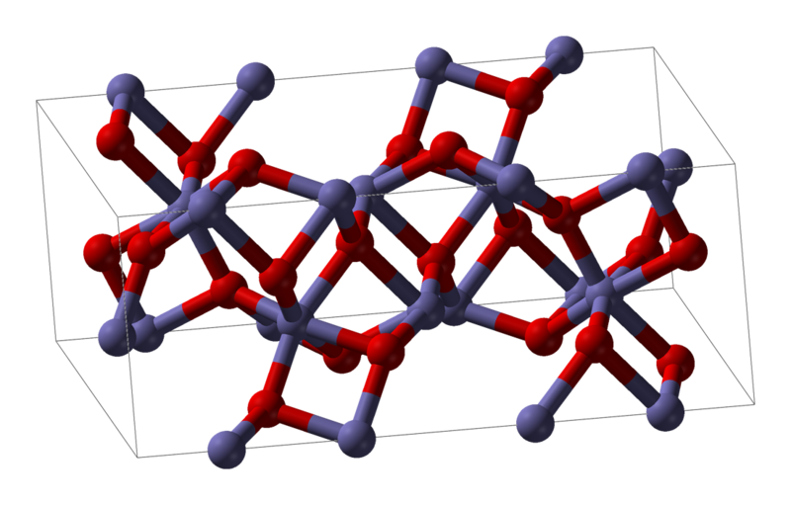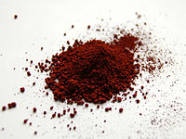

Composition of ore  (Fe2O3):

Iron= 70%,, Oxygen= 30% , Crystallin Silica= 0.5% max.

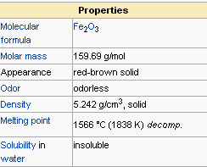

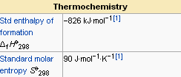

Ferric Oxide, Crystalline (Fe2O3) Nominal Physical Constants:

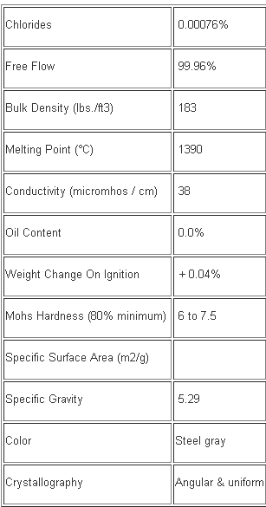

USES OF Fe2O3

* Now a days in purified, rouge is used as a coating in magnetic audio and computer media.
* In a dry or alkaline environment, it can cause passivation and inhibit rust, yet it is also a major component of rust and dried blood.
* Iron (III) oxide is also used as a pigment, under names Pigment Brown 6, Pigment Brown 7, and Pigment Red 101. Some of them, e.g. Pigment Red 101 and Pigment Brown 6, are Food and Drug Administration (FDA)-approved for use in cosmetics
* The latest developments in functionalized magnetic nano-particles show considerable promise for both enhanced and novel application such as

(1)catalyst,

(2)pigment,

(3)sintering,

(4)photonic,

(5)drug, and

(6)biomedical products

2.2Silicon propertiers and application:

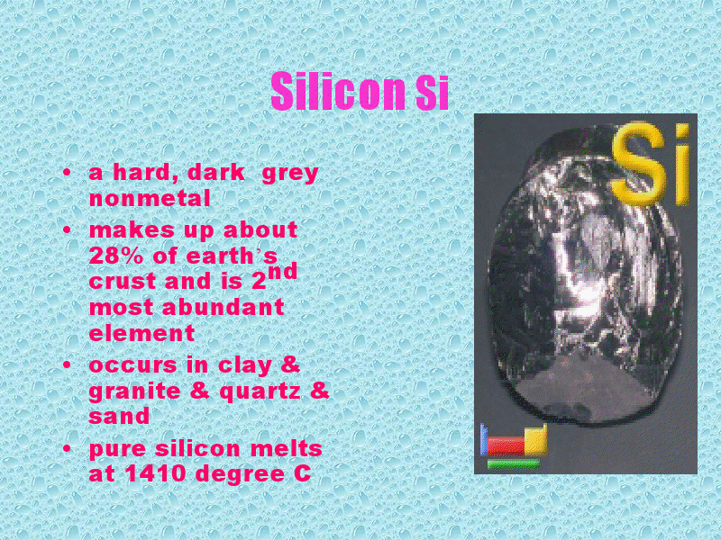

: 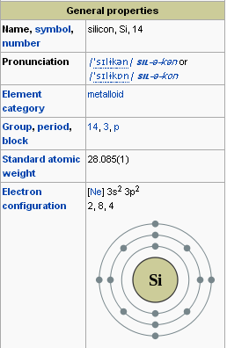

Uses of Silicon:

* The elemental silicon is used in silicone preparation production of metallic alloys with iron, aluminum, copper and manganese or as deoxidizing agent in steel production.
* Silica occurs in living organisms it plays a role in the origin of life on the earth earth.
* Human tissues often contain from 6 to 90 mg of silica per 100 grams of dry tissues
* Si is used as substrate materials as MEMS ,Si has young modulus as steel and it is light as aluminum .
* Melting point is 1400 c is twice higher than aluminum(635 c) it makes silicon dimensionally stable even at elevated temperature.

2.3 syntesys of Fe2O3 nanoparticles

Fe2O3 nanoparticles can be prepared by various methods as follow.

* Co-precipitation :

Co-precipitation is a atomic mixing of different constituent chemicals with low temperature treatment. The chemical co-precipitation being by dissolving the starting materials in an acid solution or salts in aqueous medium .this solution is then mixed with a solution of dissolved precipitation agent such as Oxalic acid, Ammonium hydroxide.

* Thermolysis:

Thermolysis is a chemical process in which chemical precursors decomposed under suitable thermal treatment into one solid compound and unwanted waste evaporates away.

* Combustion:

In combustion synthesis the energy released from the exothermic reaction between nitrites and fuels. which is ignited at a high temperature more than 5000C.

* Sol-gel process:

It’s a technique used to generate the nanoparticles from liquid phase based on tranaformation of chemical solutions.

Sol-gel process involves :

|  |
| --- |
| Mixing |

|  |
| --- |
| Gelling |

|  |
| --- |
| Shape forming |

|  |
| --- |
| Drying |

|  |
| --- |
| Densification |

Advantages of sol gel method:

* Low temperature procxess
* Versatilities and flexible rheology allowing easy shaping

And embedding.

* They offer unique opportunities for acess to organic and inorganic materials.
* Most commonly used precursors of oxides are alkoxides.

2.4 DEPOSITION TECHNIQUES

2.4.1 Spin coating:

Spin coating is a procedure used to apply uniform [thin films](http://en.wikipedia.org/wiki/Thin_film) to flat [substrates](http://en.wikipedia.org/wiki/Substrate_(printing)). An excess amount of a [solution](http://en.wikipedia.org/wiki/Solution) is placed on the substrate, which is then rotated at high speed in order to spread the fluid by [centrifugal force](http://en.wikipedia.org/wiki/Centrifugal_force). A machine used for spin coating is called a spin coater, or simply spinner.

Spin Coating Process Theory:

Spin coating has been used for several decades for the application

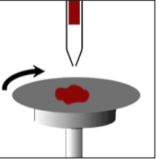

of thin fillms. A typical process involves depositing a small puddle

of a fluid resin onto the center of a substrate and then spinning the

substrate at high speed (typically around 3000 rpm). Centripetal

acceleration will cause the resin to spread to, and eventually off,

the edge of the substrate leaving a thin film of resin on the surface.

.

Final film thickness and other properties

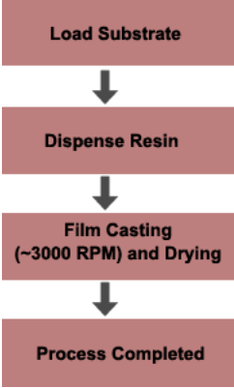

will depend on the nature of the resin

(viscosity, drying rate, percent solids, surface tension, etc.)

and the parameters chosen for the spin process.

Factors such asfinal rotational speed, acceleration,

and fume exhaust contribute to how the properties

of coated fillms are defined.

* + 1. Spray pyrolysis:

Spray pyrolysis is a process in which a thin film is deposited by spraying a solution on a heated surface, where the constituent reacts to form a chemical compound. The chemical reactants are selected such that products other than the desired compound are volatile at the temperature of deposition. The process is particularly useful for the deposition of oxides and has long been a production method for a long period for applying a transparent electrical conductor of Tin oxide or Stannic oxide to glass.

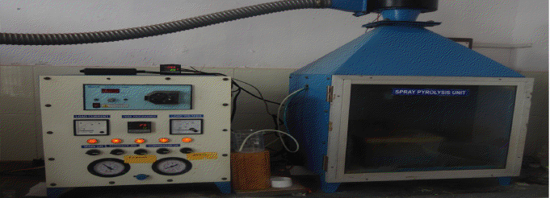

**Factors affecting bonding and subsequent build up of the coating:**

► Cleanliness  
► Surface

► Temperature   
► Time   
► Velocity   
► Physical & chemical reactions

Advantages

(1)required for drying time is short, so each a multicomponent fine droplets in the reaction process to segregation, which can obtain uniform composition nanoparticles;  
(2) as the raw material is in the [Solution](http://www.hewiki.com/view/57905.htm) Under the condition of uniform mixing, so it can accurately control the synthesized compounds;  
(3) can be different [Technology](http://www.hewiki.com/view/77063.htm) Conditions to prepare ultrafine particles with different morphology and properties of the prepared nanoparticles, apparent density, large specific surface area, good performance of powder sintering.

2.4.3Dip Coating:

Dip coating is a popular way of creating [thin films](http://en.wikipedia.org/wiki/Thin_film) for [research](http://en.wikipedia.org/wiki/Research) purposes. Uniform films can be applied onto flat or cylindrical [substrates](http://en.wikipedia.org/wiki/Substrate_(materials_science)). For [industrial processes](http://en.wikipedia.org/wiki/Industrial_process), [spin coating](http://en.wikipedia.org/wiki/Spin_coating) is used more often.

**The dip coating process can be separated into five stages:**

* Immersion: The substrate is immersed in the [solution](http://en.wikipedia.org/wiki/Solution) of the coating material at a constant speed (preferably jitter-free).
* Start-up: The substrate has remained inside the solution for a while and is starting to be pulled up.
* Deposition: The thin layer deposits itself on the substrate while it is pulled up. The withdrawing is carried out at a constant speed to avoid any jitters. The speed determines the thickness of the coating (faster withdrawal gives thicker coating material).
* Drainage: Excess liquid will drain from the surface.
* Evaporation: The solvent [evaporates](http://en.wikipedia.org/wiki/Evaporation) from the liquid, forming the thin layer. For [volatile](http://en.wikipedia.org/wiki/Volatility_(chemistry)) [solvents](http://en.wikipedia.org/wiki/Solvent), such as [alcohols](http://en.wikipedia.org/wiki/Alcohol), evaporation starts already during the deposition & drainage steps.

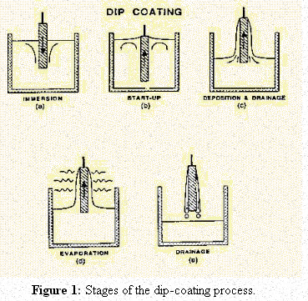

In the continuous process, the steps are carried out directly after each other.

2.4.4Chemical Vapour Deposion(CVD):

Gaseous compounds react to form a dense layer on a heated substrate. The most widely deposited wear-resistant coatings are TiC, TiN, chromium carbide and alumina. Deposition temperatures are generally in the range 800-1000°C which restricts the range of materials which can be coated and can lead to component distortion. Thicknesses are limited to about 10mm due to the thermal expansion mismatch stresses which develop on cooling which also restrict the coating of sharp edged components.

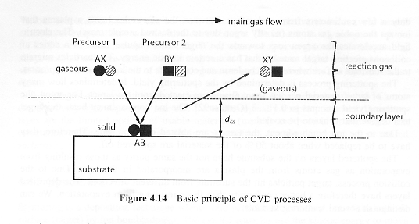

The key steps of this technique are :

* Evaporation and transport of reagents in the bulk gas flow region into the reactor
* Gas phase reactions of precursors in the reaction zone to produce reactive intermediates and gasious by-products.
* Mass transport of reactions to the substrate surface.
* Adsorption of the reactions on the surface.
* Surface diffusion to growth sites ,nucleation and surface chemical reactions leading to film formation.

Characteristics of an “ideal” CVD are:

* High chemical purity.
* Adequate volatility to achieve accetable growth rates at moderate evaporation temperature.
* Long shelf life with indefinite stability under ambient conditions , i.e . unaffected air or moisture.
* Readily manufactured in high yeild at low cost.

Advantages :

* High coating hardness
* Good adhesion (if the coating is not too thick)
* Good throwing power (i.e. uniformity of coating)

 Disadvantages :

* High temperature process (distortion)
* Sharp edge coating is difficult (thermal expansion mismatch stresses)
* Limited range of materials can be coated
* Environmental concerns about process gases

2.4.5 Physical Vapour Deposition:

* Sputtering :

In both cases the source material is a solid (metal or ceramic). A reactive gas may be used in the deposition chamber to deposit compound coatings from an elemental source or maintain the stoichiometry of coatings from compound sources. Typical coating thicknesses range from 1-10mm for wear-resistant coatings, though thinner layers are used in microelectronics and thicker layers are used for high temperature corrosion protection of gas turbine components.

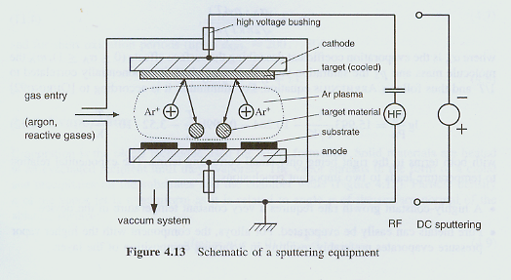

* When energetic ions strike a surface, material is ejected by the transfer of momentum from the ion to the target atoms (akin to billiard ball collisions at the atomic scale). This can be conveniently achieved in a low pressure glow discharge of an inert gas such as argon.
* In such a process the target material is made the cathode and is raised to a potential of several hundred volts. Electrons leaving the cathode stream out into the gas phase where they can impact with argon atoms, ionising them. The positively charged argon is then accelerated to the cathode where it impacts and sputters away material.
* The sputtering yields of different elements for given impact conditions do not vary very much so target alloy compositions can be maintained in the coating except in cases where there are large differences in the atomic weights of alloy constituents.
* **e-Beam evaporation:**

**Principle:**

This Technique is based on the heat produced by high energy e-Beam bombardment on the material to be deposited. The electron beam is generated by e-gun. which uses thermionic emission of electrons produced by in condense filament (cathode) . Emitted electrons are accelerated towards an anode by a high difference of potential (kw).

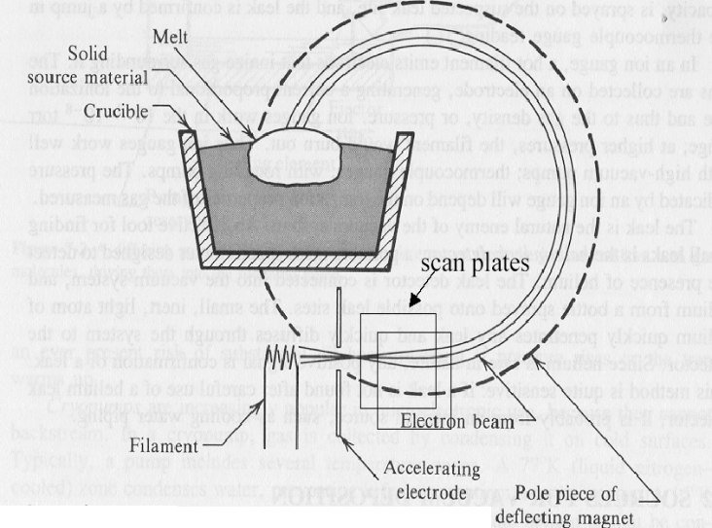

**ADVANTAGES:**

* the deposition rate in this process can be as low as 1 nm per minute to as high as few micrometers per minute.
* The material utilization efficiency is high relative to other methods
* the process offers structural and morphological control of films.
* This process has potential industrial application for hard coatings for cutting and tool industries, and electronic and semiconductor industries.

**DISADVANTAGES:**

* It cannot be used for non-metals
* It should be highly focused.
* E-gun results in non uniform evaporation rate
* Overcome by indirect heating of e-beam

**2.5Characterization techniques**

**2.5.1 Surface characterizations**

**Atomic Force Microscopy(AFM**)

The Atomic Force Microscope was developed to overcome a basic drawback with STM - that it can only image conducting or semiconducting surfaces. The AFM, however, has the advantage of imaging almost any type of surface, including polymers, ceramics, composites, glass, and biological samples.

Binnig, Quate, and Gerber invented the Atomic Force Microscope in 1985. Their original AFM consisted of a diamond shard attached to a strip of gold foil. The diamond tip contacted the surface directly, with the interatomic van der Waals forces providing the interaction mechanism. Detection of the cantilever’s vertical movement was done with a second tip - an STM placed above the cantilever.

**PRINCIPLE**

The AFM consists of a [cantilever](http://en.wikipedia.org/wiki/Cantilever) with a sharp tip (probe) at its end that is used to scan the specimen surface. The cantilever is typically [silicon](http://en.wikipedia.org/wiki/Silicon) or [silicon nitride](http://en.wikipedia.org/wiki/Silicon_nitride) with a tip [radius of curvature](http://en.wikipedia.org/wiki/Radius_of_curvature_(applications)) on the order of nanometers. When the tip is brought into proximity of a sample surface, [forces](http://en.wikipedia.org/wiki/Force) between the tip and the sample lead to a deflection of the cantilever according to [Hooke's law](http://en.wikipedia.org/wiki/Hooke%27s_law).[[2]](http://en.wikipedia.org/wiki/Atomic_force_microscopy#cite_note-2) Depending on the situation, forces that are measured in AFM include mechanical contact force, [van der Waals forces](http://en.wikipedia.org/wiki/Van_der_Waals_force), [capillary forces](http://en.wikipedia.org/wiki/Capillarity), [chemical bonding](http://en.wikipedia.org/wiki/Chemical_bond), [electrostatic forces](http://en.wikipedia.org/wiki/Coulomb%27s_law), magnetic forces (see [magnetic force microscope](http://en.wikipedia.org/wiki/Magnetic_force_microscope), MFM),[Casimir forces](http://en.wikipedia.org/wiki/Casimir_effect), [solvation forces](http://en.wikipedia.org/wiki/Solvation), etc. Along with force, additional quantities may simultaneously be measured through the use of specialized types of probes (see [scanning thermal microscopy](http://en.wikipedia.org/wiki/Scanning_thermal_microscopy), [scanning joule expansion microscopy](http://en.wikipedia.org/wiki/Scanning_joule_expansion_microscopy),  etc.). Typically, the deflection is measured using a [laser](http://en.wikipedia.org/wiki/Laser) spot reflected from the top surface of the cantilever into an array of [photodiodes](http://en.wikipedia.org/wiki/Photodiodes). Other methods that are used include optical interferometry, [capacitive sensing](http://en.wikipedia.org/wiki/Capacitive_sensing) or piezoresistive AFM cantilevers. These cantilevers are fabricated with piezoresistive elements that act as a [strain gauge](http://en.wikipedia.org/wiki/Strain_gauge).

#### AFM probe deflection

Today, most AFMs use a laser beam deflection system, introduced by Meyer and Amer, where a laser is reflected from the back of the reflective AFM lever and onto a position-sensitive detector. AFM tips and cantilevers are microfabricated from Si or Si3N4. Typical tip radius is from a few to 10s of nm.

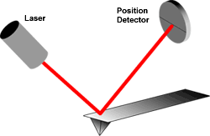

**Beam deflection system, using a laser and photodector to measure the beam position**

Because the atomic force microscope relies on the forces between the tip and sample, knowing these forces is important for proper imaging. The force is not measured directly, but calculated by measuring the deflection of the lever, and knowing the stiffness of the cantilever. Hook’s law gives F = -kz, where F is the force, k is the stiffness of the lever, and z is the distance the lever is bent.

Modes of AFM:

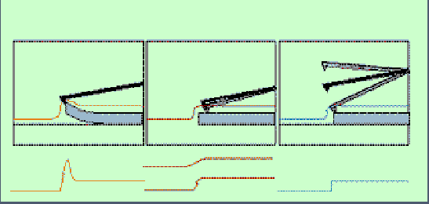

Contact Mode, Non-Contact Mode, Tapping (Intermittent-contact) Mode

**Contact Mode**

* Measures repulsion between tip and sample
* Force of tips against samples remains constant
* Feedback regulation keeps cantilever deflection constant
* Voltage required indicates height of sample
* Problem excessive tracking forces applied by probe to sample.

**Non-Contact Mode**

* Measures attractive force between tip and sample
* Tip does not touch the sample.
* Van der wall forces between tip and sample detected.
* Problems : can’t use with samples in fluids
* Used to analyze semiconductor
* Does not degrade or interfere with sample- better for soft samples

**Tapping (Intermittent-Contact) mode**

* Tip vertically oscillates between contacting sample surface and lifting of at of 500,000 cycles/sec.
* Oscillation amplitude reduced as probe contacts surface due to loss of energy caused by tip contacting surface.
* Advantages :overcomes problems associated with friction, adhesion , electrostatic forces
* More effective for larger scan size

**Advantages and Disadvantages of AFM:**

|  |  |
| --- | --- |
| **ADVANTAGES** | **DISADVANTAGES** |
| Easy sample preparation | Limited veaticle range |
| Accurate height information | Limited magnification range |
| Works in vacuum , air and liquid | Data not independent of tip |
| Living systems can be studied | Tip or sample can be damaged |

**X-ray Diffraction**

The atomic planes of a crystal cause an incident beam of X-rays to interfere with one another as they leave the crystal. The phenomenon is called X-ray diffraction.

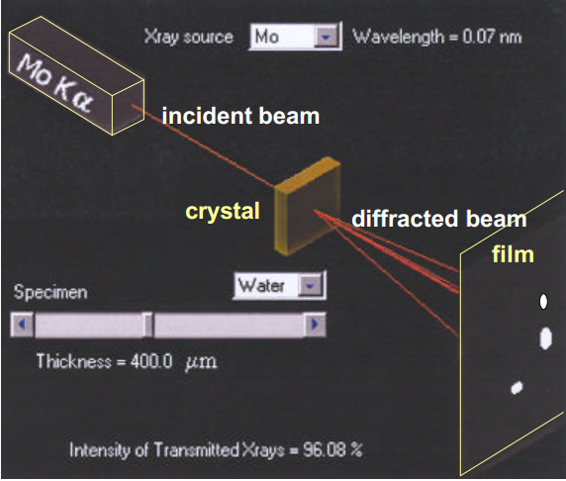

**Effect of sample**

**thickness on the**

**absorption of X-rays**

**Why XRD?**

• Measure the average spacings between layers or rows of atoms

• Determine the orientation of a single crystal or grain

• Find the crystal structure of an unknown material

• Measure the size, shape and internal stress of small crystalline regions

**X-ray Generation & Properties**

X-rays are electromagnetic radiation with typical photon energies in the range of 100 eV - 100 keV. For diffraction applications, only short wavelength x-rays (hard x-rays) in the range of a few angstroms to 0.1 angstrom (1 keV - 120 keV) are used. Because the wavelength of x-rays is comparable to the size of atoms, they are ideally suited for probing the structural arrangement of atoms and molecules in a wide range of materials. The energetic x-rays can penetrate deep into the materials and provide information about the bulk structure.

X-rays are produced generally by either x-ray tubes or synchrotron radiation. In a x-ray tube, which is the primary x-ray source used in laboratory x-ray instruments, x-rays are generated when a focused electron beam accelerated across a high voltage field bombards a stationary or rotating solid target. As electrons collide with atoms in the target and slow down, a continuous spectrum of x-rays are emitted, which are termed Bremsstrahlung radiation. The high energy electrons also eject inner shell electrons in atoms through the ionization process. When a free electron fills the shell, a x-ray photon with energy characteristic of the target material is emitted.

Common targets used in x-ray tubes include Cu and Mo, which emit 8 keV and 14 keV x-rays with corresponding wavelengths of 1.54 Å and 0.8 Å, respectively. (The energy E of a x-ray photon and it's wavelength is related by the equation E = hc/, where h is Planck's constant and c the speed of light) .

## Diffraction and Bragg's Law

Diffraction occurs as waves interact with a regular structure whose repeat distance is about the same as the wavelength. The phenomenon is common in the natural world, and occurs across a broad range of scales. For example, light can be diffracted by a grating having scribed lines spaced on the order of a few thousand angstroms, about the wavelength of light.

It happens that X-rays have wavelengths on the order of a few angstroms, the same as typical interatomic distances in crystalline solids. That means X-rays can be diffracted from minerals which, by definition, are crystalline and have regularly repeating atomic structures.

When certain geometric requirements are met, X-rays scattered from a crystalline solid can constructively interfere, producing a diffracted beam. In 1912, W. L. Bragg recognized a predicatable relationship among several factors.

1. The distance between similar atomic planes in a mineral (the interatomic spacing) which we call the d-spacing and measure in angstroms.

2. The angle of diffraction which we call the theta angle and measure in degrees. For practical reasons the diffractometer measures an angle twice that of the theta angle. Not surprisingly, we call the measured angle '2-theta'.

3. The wavelength of the incident X-radiation, symbolized by the Greek letter lambda and, in our case, equal to 1.54 angstroms.

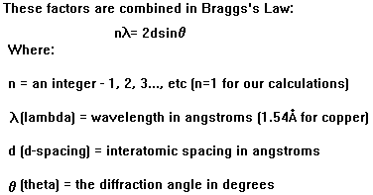

**Thin Film Diffraction**

Generally speaking thin film diffraction refers not to a specific technique but rather a collection of XRD techniques used to characterize thin film samples grown on substrates. These materials have important technological applications in microelectronic and optoelectronic devices, where high quality epitaxial films are critical for device performance. Thin film diffraction methods are used as important process development and control tools, as hard x-rays can penetrate through the epitaxial layers and measure the properties of both the film and the substrate.

There are several special considerations for using XRD to characterize thin film samples. First, reflection geometry is used for these measurements as the substrates are generally too thick for transmission. Second, high angular resolution is required because the peaks from semiconductor materials are sharp due to very low defect densities in the material. Consequently, multiple bounce crystal monochromators are used to provide a highly collimated x-ray beam for these measurements. For example, in the Philips MRD used in the x-ray facility, a 4-crystal monochromator made from Ge is used to produce an incident beam with less than 5 arc seconds of angular divergence.

**Basic XRD measurements made on thin film samples include:**

* Precise lattice constants measurements derived from 2 -  scans, which provide information about lattice mismatch between the film and the substrate and therefore is indicative of strain & stress
* Rocking curve measurements made by doing a  scan at a fixed 2 angle, the width of which is inversely proportionally to the dislocation density in the film and is therefore used as a gauge of the quality of the film.
* Superlattice measurements in multilayered heteroepitaxial structures, which manifest as satellite peaks surrounding the main diffraction peak from the film. Film thickness and quality can be deduced from the data.
* Glancing incidence x-ray reflectivity measurements, which can determine the thickness, roughness, and density of the film. This technique does not require crystalline film and works even with amorphous materials.
* Texture measurements--will be discussed separately

**2.5.2 Optical Characterization – UV visible Spectrophotometer**

Introduction to UV spectroscopy

UV spectroscopy is type of absorption spectroscopy in which light of ultra-violet region (200-400 nm.) is absorbed by the molecule. Absorption of the ultra-violet radiations results in the excitation of the electrons from the ground state to higher energy state. The energy of the ultra-violet radiation that are absorbed is equal to the energy difference between the ground state and higher energy states (deltaE = hf).

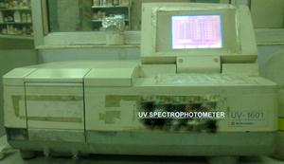

**Principle of UV spectroscopy**

UV spectroscopy obeys the Beer-Lambert law, which states that: *when a beam of monochromatic light is passed through a solution of an absorbing substance, the rate of decrease of intensity of radiation with thickness of the absorbing solution is proportional to the incident radiation as well as the concentration of the solution.*  
The expression of Beer-Lambert law is-  
**A = log (I0/I) = Ecl**  
Where, A = absorbance  
I0 = intensity of light incident upon sample cell  
I = intensity of light leaving sample cell  
C = molar concentration of solute  
L = length of sample cell (cm.)  
E = molar absorptivity  
  
From the Beer-Lambert law it is clear that greater the number of molecules capable of absorbing light of a given wavelength, the greater the extent of light absorption. This is the basic principle of UV spectroscopy.

**Instrumentation and working of UV spectroscopy**

Instrumentation and working of the UV spectrometers can be studied simultaneously. Most of the modern UV spectrometers consist of the following parts-

**Light Source**- Tungsten filament lamps and Hydrogen-Deuterium lamps are most widely used and suitable light source as they cover the whole UV region. Tungsten filament lamps are rich in red radiations; more specifically they emit the radiations of 375 nm, while the intensity of Hydrogen-Deuterium lamps falls below 375 nm.  
  
**Monochromator-** Monochromators generally composed of prisms and slits. The most of the spectrophotometers are double beam spectrophotometers. The radiation emitted from the primary source is dispersed with the help of rotating prisms. The various wavelengths of the light source which are separated by the prism are then selected by the slits such the rotation of the prism results in a series of continuously increasing wavelength to pass through the slits for recording purpose. The beam selected by the slit is monochromatic and further divided into two beams with the help of another prism.  
  
**Sample and reference cells**- One of the two divided beams is passed through the sample solution and second beam is passé through the reference solution. Both sample and reference solution are contained in the cells. These cells are made of either silica or quartz. Glass can't be used for the cells as it also absorbs light in the UV region.  
 **Detector**- Generally two photocells serve the purpose of detector in UV spectroscopy. One of the photocell receives the beam from sample cell and second detector receives the beam from the reference. The intensity of the radiation from the reference cell is stronger than the beam of sample cell. This results in the generation of pulsating or alternating currents in the photocells.  
 **Amplifier**- The alternating current generated in the photocells is transferred to the amplifier. The amplifier is coupled to a small servometer. Generally current generated in the photocells is of very low intensity, the main purpose of amplifier is to amplify the signals many times so we can get clear and recordable signals.  
  
**Recording devices**- Most of the time amplifier is coupled to a pen recorder which is connected to the computer. Computer stores all the data generated and produces the spectrum of the desired compound.

**Applications of UV spectroscopy**

**1. Detection of functional groups**- UV spectroscopy is used to detect the presence or absence of chromophore in the compound. This is technique is not useful for the detection of chromophore in complex compounds. The absence of a band at a particular band can be seen as an evidence for the absence of a particular group. If the spectrum of a compound comes out to be transparent above 200 nm than it confirms the absence of –  
a) Conjugation b) A carbonyl group c) Benzene or aromatic compound d) Bromo or iodo atoms.  
 **2. Detection of extent of conjugation**- The extent of conjugation in the polyenes can be detected with the help of UV spectroscopy. With the increase in double bonds the absorption shifts towards the longer wavelength. If the double bond is increased by 8 in the polyenes then that polyene appears visible to the human eye as the absorption comes in the visible region.  
 **3. Identification of an unknown compound**- An unknown compound can be identified with the help of UV spectroscopy. The spectrum of unknown compound is compared with the spectrum of a reference compound and if both the spectrums coincide then it confirms the identification of the unknown substance.  
 **4. Determination of configurations of geometrical isomers**- It is observed that cis-alkenes absorb at different wavelength than the trans-alkenes. The two isomers can be distinguished with each other when one of the isomers has non-coplanar structure due to steric hindrances. The cis-isomer suffers distortion and absorbs at lower wavelength as compared to trans-isomer.  
 **5. Determination of the purity of a substance**- Purity of a substance can also be determined with the help of UV spectroscopy. The absorption of the sample solution is compared with the absorption of the reference solution. The intensity of the absorption can be used for the relative calculation of the purity of the sample substance