Nanotechnology based approaches for enhancing bioavailability of poorly soluble drugs

Smriti Dewangan  MATS School of Pharmacy  MATS University  Raipur, Chhattisgarh, India  smritidewangan88@gmail.com | Moonmun Dhara  School of Pharmaceutical Sciences  SOA Deemed to be University Bhubaneswar, Odisha, India  moonmundhara@soa.ac.in | Varsha Rawat  MATS School of Pharmacy  MATS University  Raipur, Chhattisgarh, India  rwtvarsha8@gmail.com

ABSTRACT

Nanotechnology has emerged as a transformative field in pharmaceutical research, offering innovative solutions to tackle the long-standing challenge of poor solubility of various drugs. In this chapter, we explore the latest advancements and applications of nanotechnology-based solubility enhancement techniques. The poor aqueous solubility of drugs often leads to compromised bioavailability and therapeutic efficacy, limiting their clinical success. Nanotechnology-based approaches, such as nanosuspensions, solid lipid nanoparticles, nanoemulsions, and cyclodextrin complexes, have shown great promise in enhancing drug solubility and dissolution rates. By manipulating materials at the nanoscale, these techniques provide unique opportunities to encapsulate drug compounds, enhancing their stability and facilitating targeted delivery to specific biological sites. Moreover, the use of nanoscale carriers enables controlled and sustained drug release, leading to improved therapeutic outcomes and reduced side effects. This review highlights the versatility of nanotechnology in enhancing the solubility of hydrophobic and hydrophilic drugs alike, broadening its potential application across a wide range of pharmaceutical compounds. Additionally, the biocompatibility and biodegradability of nanomaterials play a pivotal role in ensuring their safety and clinical relevance. Despite these promising advancements, certain challenges remain, including the need for comprehensive toxicity assessments, scalability of manufacturing processes, and regulatory considerations. Nonetheless, nanotechnology-based solubility enhancement techniques hold significant promise for revolutionizing drug development and personalized medicine. In conclusion, this review underscores the transformative potential of nanotechnology-based solubility enhancement techniques in overcoming drug solubility challenges. As the field continues to evolve, further research and collaboration among academia, industry, and regulatory bodies will be essential to unlock the full therapeutic potential of nanotechnology in pharmaceutical applications.
Keywords- bioavailability; pharmacokinetic; therapeutic; nanotechnology

I. SOLUBILITY

The property of solid, liquid, and gaseous material to dissolve in solvents, particularly liquid solvents, to produce a homogenous solution is termed as solubility. Aqueous solubility of a drug is an important factor in drug absorption following oral administration. Solubility, dissolution, and GI (gastrointestinal) permeability are the key factors that define the rate and extent of drug absorption; thereby affecting the bioavailability in an orally administered drug (Jagtap et al., 2018). Solubility also affects the capacity of a drug to be taken parenterally. The information regarding the solubility of a drug can be used to adjust and assess drug features during the drug design and development process. In addition to the aqueous solubility, the other parameters like drug permeability, dissolution rate, first-pass metabolism, and sensitivity to outflow mechanisms also influence the oral bioavailability of a drug (Savjani et al., 2012).

A. Poorly water-soluble drugs
Biopharmaceutical Classification System (BCS) developed by Amidon and his colleagues in 1995 is a logical outline that classifies a drug substance based on its water solubility and GI permeability. The classification system is clearly mentioned in Figure 1. A drug with poor solubility belongs to either Class II or IV of Biopharmaceutics Classification System (ICH M9 guideline., 2020).

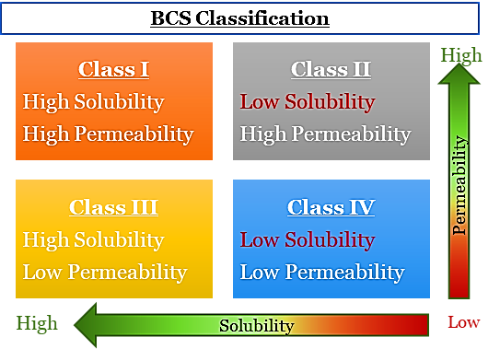
Figure 1: BCS Classification exhibiting the Classes of low solubility

The United States Food and Drug Administration (USFDA) and Committee for Medicinal Products for Human Use (CHMP) of European Medicines Agency's (EMA) considers a drug to have high solubility if the highest single therapeutic dose of the chemical entity (drug) gets soluble in 250 ml or less than 250 ml of aqueous media over the pH range of 1.2 to 6.8 at a temperature of 37±1ºC. Any drug that shows dose/solubility volume more than 250 ml would be considered as drug with low solubility. Some of the examples of low solubility drug is provided in Table 1. Though problematic, these poorly-water soluble drugs are very important as they hold a variety of therapeutically active compounds needed for the treatment of various diseases (USFDA., 1997).

Table 1: Some of the examples of low solubility drugs (Ghadi et al., 2017)
BCS Class II |  | BCS Class IV
Aceclofenac  Atorvastatin calcium  Budesonide  Clonazepam  Diclofenac sodium  Etoricoxib  Ibuprofen  Ketoprofen  Lansoprazole  Mebendazole  Montelukast sodium | Naproxen  Nicardipine  Nitrofurantoin  Oxcarbazepine  Omeprazole  Phenytoin sodium  Rifampicin  Rosuvastatin  Sulfamethoxazole  Telmisartan  Valsartan | Acetazolamide  Albendazole  Amphotericin B  Ciprofloxacin hydrochloride  Cisplatin  Chlorthiazide  Digoxin  Docetaxel  Erythromycin succinate  Furosemide  Haloperidol | Hydrochlorothiazide  Mesalamine  Paclitaxel  Ponesimod  Ritonavir  Sulfasalazine  Taxol  Tivozanib  Verapamil HCl

B. Problems with poor solubility
- BCS Class II: Drugs with low solubility and high permeability
Drugs of this class have variable absorption pattern. Dissolution is considered as the rate limiting step in absorption of the drugs belonging to this class. These drugs have high lipophilicity. Lipophilic compounds have high degree of permeation. Despite their high permeability, these poor soluble lipophilic drugs pose enduring problems in the pharmaceutical drug development, design and optimization. Too much lipophilicity may also favor lipid-rich environment to an extent at which the permeation across the lipid bilayer also become limited (Cook et al., 2008).
- BCS Class IV: Drugs with low solubility and low permeability
Drugs belonging to this class demonstrate several unfavorable characteristics that makes the formulation of pharmaceutical products for oral drug delivery pretty challenging. The drugs of this group exhibit:
- Poor and unpredictable absorption profile
- High Inter-subject variability and Intra-subject variability
- Significantly positive food effect leading to low and variable bioavailability
Therefore, Pharmaceutical industries are determined to develop carefully planned approaches that could elevate the dissolution rate and apparent solubility of these drugs so that they turn into orally bioavailable and thereby therapeutically effective drugs which can eventually benefit ailing patients in clinical settings.

In addition to the BCS Classification, Wu and Benet in 2005 introduced a new system of classification called Biopharmaceutics Drug Disposition Classification System (BDDCS) which again classified the drug molecules on the basis of solubility and extent of metabolism/permeability rate. The BDDCS classification system is clearly mentioned in Figure 2. It can be clearly seen in Figure 2 that Class II and Class IV again comprise of drugs with low solubility.
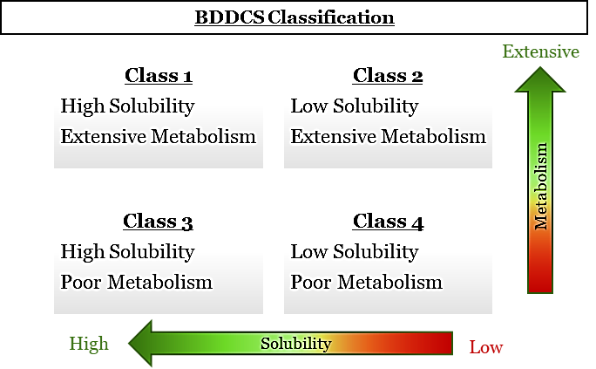
Figure 2: BDDCS Classification exhibiting the Classes of low solubility

C. Bioavailability
Bioavailability is an important aspect in getting the desired pharmacological and therapeutic effects. The drug's oral bioavailability, on the other hand, is primarily determined by its capacity to get soluble in water; its rate of dissolution; GI permeability, vulnerability to outflow mechanisms, and the first-pass metabolism (Khan et al., 2016). In recent years, number of insoluble chemical entities have increased in drug discovery, with about 70% of novel drug candidates exhibiting low aqueous solubility (Beg et al., 2011). Poor water solubility and dissolution in GI fluids limit in vivo oral bioavailability. Thus, the drugs with poor solubility are expected to demonstrate low oral bioavailability increasing the challenge of formulating an oral drug delivery system (Bhalani et al., 2022).
As a result, in vitro dissolution has been acknowledged as an important component and also a major challenge to pharmaceutical scientists, in drug development, and increasing the rate of dissolution and overall bioavailability of low soluble drugs (Khadka et al., 2014).

II. DIFFERENT APPROACHES FOR SOLUBILITY ENHANCEMENT

A significant percentage of newly discovered drug candidates face solubility challenges, with estimates suggesting that approximately 40% of new chemical entities fall into the category of poorly soluble drugs. Many of these compounds are potential candidates for treating diseases such as cancer, cardiovascular disorders, and central nervous system disorders. The limited solubility often leads to suboptimal bioavailability, the need for higher doses, and an increased risk of adverse effects, making their development and clinical translation challenging. It has come to the notice that various important existing drugs and around 70% of pipeline drugs (New Chemical Entities) fall in the category of poor aqueous soluble drugs. As mentioned earlier, such an increase in the addition of the Class II and IV drugs have forced the formulation researchers around the world to focus on the development of various strategies that could be useful to improve the absorption of the drugs with low solubility when administered orally. Various approaches that could elevate the solubility of these drugs are summarized in Figure 3. Details mentioned in Table 2 provide classification of the solubility enhancement techniques; some advantages and disadvantages of these techniques.

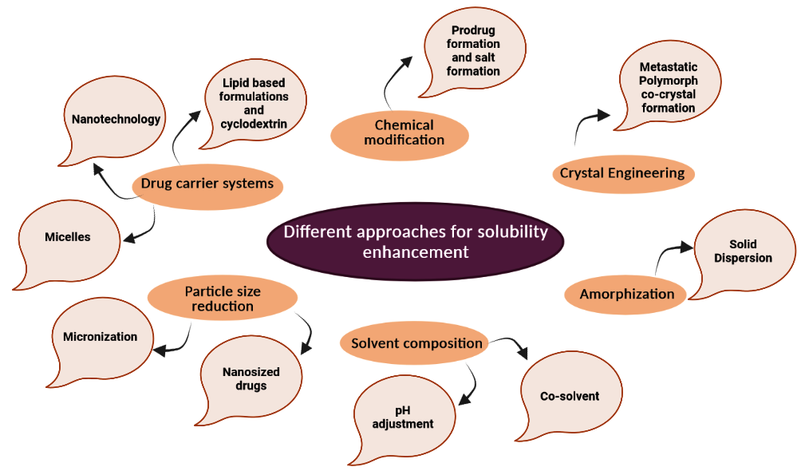
Figure 3: Different approaches for the enhancement of solubility

Table 2: Different techniques for the enhancement of solubility; their advantages and disadvantages
Techniques |  | Advantages | Disadvantages | Reference
 | Crystal Engineering
 | Co-crystal formation | - Stabilization of the product requires less amount of polymer  - Drug loading is high  - Energy systems high | - Drug/polymer/excipient miscibility and compatibility with drug is a challenging task.  - Upon storage, the product exhibits physical instability | (Blagden et al., 2007)
 | Chemical Modification
 | Formation of prodrug | - Drug solubility, lipophilicity and thus, absorption gets improved  - Probability of attain site-specific delivery increases | - Process is burdened with problems in producing, screening and development.  - The drug undergoes degradation, leading to by-product formation and chemical instability.  - Disturbance in solid-state crystalline structure and polymorphism. | (Ratnatilaka et al., 2017)
 | Salt Formation | - Synthesis is easy and require raw material of low cost. | - The method is merely limited to weakly acidic or basic drugs  - The method requires screening and selection of salt forms. | (Thorat et al., 2011)
 | Particle size reduction
 | Micronization and nanosized drugs | - This method is easy to go for industrial scale- up and is considered to be time efficient.  - The drug product experiences reduced degradation  - The method is feasible to formulate a drug with diverse pharmaceutical dosage forms. | - The method faces stability issues related to physicochemical properties like aggregation.  - The drug product may experience change in their bioavailability, and pharmacological activity.  - Drug products require special and careful handling measure during storage and transport. | (Loh et al., 2015)
 | Amorphization
 | Solid dispersion | - This methos offers an additional stability and shield to the drug throughout the process of formulation.  - The method provides improved solubility and rate of dissoloution to the drug product in comparison to other methods.  - The method reduces agglomeration or crystallization of drug molecules. | - The high-energy amorphous drug tends to recrystallize.  - Miscibility problem  - Limited stability. | (Loh et al., 2015)
 | Solvent composition
 | pH adjustment | - Highly used for ionizable drugs.  - Applicable for salt of drugs or the subsequent free basic or acidic drugs. | - It is not possible to attain long-term drug stability  - Upon dilution, the drug product exhibit precipitation tendencies and incompatibility | (Kale et al., 2020)
 | Co- solvent addition | - The method delivers ideal solubility for nonpolar drugs.  - It offers added solubilization for drug solutions | - Very few solvents can be used as co-solvent.  - There remains risk of precipitation upon dilution.  - Co-solvents can modify pH and strength of buffers that are utilized for the formulation of the drug. | (Kale et al., 2020)
 | Drug carrier systems
 | Nanotechnology | - This method offers enhanced solubility of lipophilic drugs.  - Nano-formulated drugs have greater stability  - Drugs formulated by this technology exhibit  - Sustained drug delivery  - Prolonged retention in GI tract.  - Improved muco-adhesive property  - Targeted drug delivery  - This carrier system shields drug from enzymatic activity.  - These offer strategy to overcome multidrug resistance | - The method often is challenged with the biocompatibility issues.  - The concern also remains on the safety of the polymeric drug carriers.  - Non-biodegradable NPs get accumulated in tissues.  - Difficulties in optimization and scaling techniques. | (Hussein W., 2020)
 | Cyclodextrins | - Safe excipient  - The method is suitable for supersaturated drug solutions.  - The method successfully augments the physicochemical stability of drugs results in increases their shelf-life. | - Large amount is required for solubilisation of drug.  - Complexes get dissociated upon dilution in the gastrointestinal tract  - Drug/cyclodextrin complexes are not permeable to lipophilic membranes. | (Khan et al., 2022)
 | Micelles | - The hydrophobic core of micelles acts as a reservoir for the lipophilic drugs.  - Micelles are responsive to stimuli. | - Poor loading capacity  - Poor physical stability in vivo | (Tay et al., 2022)
 | Lipid-based Formulations | - Biocompatible and non-immunogenic in nature  - Manufacturing and industrial scale-up is easy | - The formulation is always challenged with poor stability and short shelf-life issues. | (Khan et al., 2022)

The solubility, hence bioavailability enhancement approaches can also be classified as per the modifications in the physical and chemical forms of drugs (Figure 4). Physical methods involves in reducing the drug size resulting in increasing the surface area whereas the chemical method includes the formation of any new drug components which helps in solubilizing the drug in GI fluids.

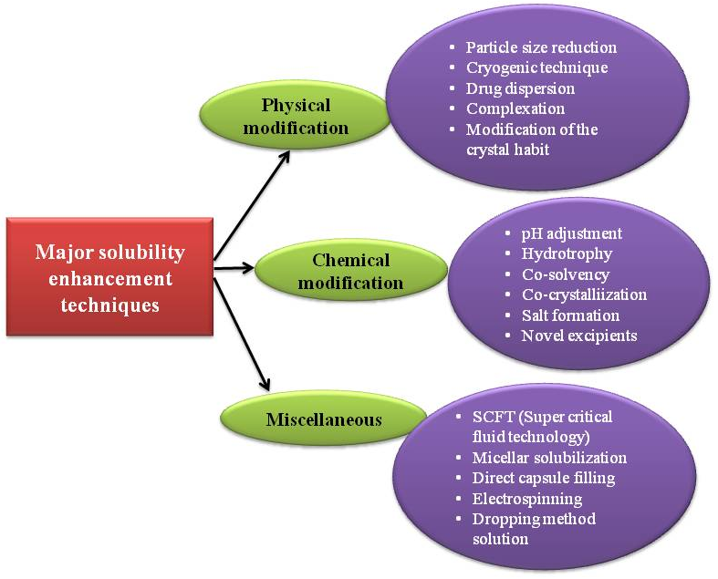
Figure 4: Important solubility enhancement technique

A. Physical modification
- Particle size reduction: It is the common technique used to augment the solubility of any drug by increasing the surface area. Particles of large size provide low surface area resulting in poor soluility and bioavailability. The main attribute is the less interaction of the drug particles with the solvent. To minimize this problem, there are different methods by which the particle size can be reduced and solubility and bioavailability can be modified
- Micronization: Micronization refers to the act of reducing the size of the drug particle or crystalline compound. The process is usually achieved by the use of either jar or fluid energy mills. The process of micronization has been reported to be applied in case of griseofulvin, spironolactone and diosmin. These drugs after micronization have been shown to have improved bioavailability and clinical efficacy (Leleux et al., 2014; Rasenack et al., 2004).
- Nanosuspension: The process of creating a colloidal dispersion of sub-micron drug particles is secured through the implementation of a surfactant. Nanosuspensions are produced using wet milling and homogenization techniques. Poorly water-soluble drugs like Fenofibrate, midazolam, and glimepiride have shown a two-fold increase in bioavailability when formulated as nanosuspensions (Khan et al., 2022). Nanosuspensions offer numerous benefits, as outlined by Liversidge et al.,1995.
  - High drug loading
  - Increased physical and chemical stability of drug
  - Passive drug targeting
  - Dosage reduction
  - Appropriate for hydrophobic drugs

- Drug Dispersion in Carriers: In this method one or more than one active pharmaceutical ingredient is dispersed in a carrier that is inert. Different methods are discussed below:
- Eutectic Mixtures: Combining two or more compounds typically results in limited phase compatibility to form a new entity, occurring only at certain fractions. This inhibits the crystallization process which in turn causes lower melting point of the system in comparison to either of the original components (Bhusnure et al., 2014). As shown in one study, ascorbic acid eutectic mixtures displayed a more favourable solubility profile compared to other drugs (Haneef and Chadha, 2018). Similar rationale is demonstrated by the eutectic mixtures of felodipine with nicotinamide and malonic acid. Additionally, eutectic mixtures of curcumin and nicotinamide exhibited higher intrinsic dissolution rate and bioavailability than those of curcumin and tartaric acid, even though tartaric acid possesses greater water solubility than nicotinamide (Chadha et al., 2017).
- Solid Dispersion: It is a generally employed technique in order to develop the solubility of poorly water-soluble drugs. It typically comprises two components: a hydrophilic matrix (crystalline or amorphous) and a hydrophobic drug. The fundamental idea behind solid dispersion is to disperse a poorly water-soluble drug within an inert, highly water-soluble carrier in the solid state. Upon coming in contact with water, carrier in the solid dispersion dissolves releasing fine colloidal particles. This process leads to an increase in the surface area and bioavailability of the drug with low solubility profile (Sareen et al., 2012; Kumar et al., 2013; Nutan et al., 2020). Various popular methods for preparing solid dispersions are discussed below:
- Solvent evaporation technique: This method involves evaporation of the organic solvent after complete dissolution of carrier and the active pharmaceutical ingredient (API). One of the examples of such method is furosemide and eudragit as carrier.
- Hot Melt extrusion method: The hot-melt extrusion technique involves preparing carriers and active pharmaceutical ingredients through hot-stage extrusion using a co-rotating twin-screw extruder, such as for the production of sustained-release pellets.
- Kneading method: In the kneading technique, drug carriers are transformed into a paste-like consistency with the aid of water, akin to kneading dough for making bread. The drug is then mixed into the paste and compressed for a specific duration. The resulting mixture is passed through a sieve and left to dry. This method is frequently used to enhance the properties of the drug Valdecoxib.
- Co-precipitation method: In this method, definite amount of drug is transferred to carrier solution with constant and continuous stirring in magnetic stirrer. Precaution of keeping the solution away from sunlight must be maintained in this method. The precipitate thus formed must be filtered and kept at room temperature for drying. This prevents loss of water due to the inclusion of complex structures (Moyano et al., 1997). Sichen et al., 2021 formulated Sorafenib tablets with enhanced oral bioavailability using co-precipitated amorphous solid dispersion method.
- Melting method: The melting method utilizes a mortar and pestle to combine drugs and their carriers. To achieve a homogeneous dispersion, the resulting blend is heated to melting point temperature of all the ingredients in the mixture. Subsequently, the system is cooled to form a solid mass. The solid mass is crushed and then sieved to obtain uniform particles. For example, Albendazole and Urea were processed using this technique (Kalaiselvan et al., 2006).
- Co-grinding method: In the co-grinding method, the carrier and drug are blended or grounded together in a blender for a fixed duration and at a constant speed. Formed blend is then transferred to vibration ball mill. After pulverization, the sample is removed and stored at room temperature. An instance of this method is observed with Chlordiazepoxide and Mannitol (Nokhodchi et al., 2007).
- Gel entrapment technique: This technique produces a clear and transparent gel. It involves dissolving cellulose-like hydroxypropyl methylcellulose (HPMC) in an organic solvent resulting in formation of gel. Furthermore the drug is incorporated into the gel and sonicated for a specific duration. Organic solvents are subsequently removed using vacuum. The solid dispersions obtained are further reduced in size using a mortar and pestle (Bhise et al., 2014).
- Spray-drying technique: The spray-drying technique entails dissolving a precise amount of drug in a suitable solvent, while separately dissolving the carrier in an aqueous medium. Sonication, either alone or combined with other suitable methods, is used to create a clear solution. This solution is then subjected to spray-drying in a spray dryer (Bakatselou et al., 2020).
- Lyophilization technique: Lyophilization, considered an alternative to the solvent evaporation technique, involves solubilizing drug carriers in a universal solvent. The resulting mixture is then kept in freeze and sublimed to acquire a lyophilized molecular dispersion (Betageri et al., 1995).
- Melt agglomeration process: The melt agglomeration process utilizes a binder as a drug carrier to formulate solid dispersions. The method involves mixing of all the excipients with drug and binder by heating above the melting point of binder in a high shear mixer (Tsinontides et al., 2004; Vilhelmsen et al., 2005).

- Complexation: Assembly of two or more drug molecules arising to the formation of an entity is called complexation. The complex formed basically contains weak forces, i.e., hydrogen bonds, hydrophobic interactions, and London forces (Loftsson et al., 1996). There are two major types of complexation process.
- Stanching complexation
- Inclusion complexation
There are different methods to achieve the complexation process:
- Lyophilization/freeze-drying technique
- Kneading technique
- Microwave irradiation technique
- Co-precipitation technique
- Spray-drying technique

- Cryogenic Techniques: This technique is usually employed to enhance the dissolution rate of a drug by formulating a nano-sized amorphous drug with high degree of porosity. This method employs very low temperature which is followed by variety of drying process (vacuum, spray, and lyophilization) (Mumenthaler et al., 1991; Leuenberger 2002; Williams et al., 2005).

- Modification of the Crystal Habit:
- Crystal engineering is the use of non-covalent interactions between ionic or molecular components to rationally build solid-state structures with intriguing optical, magnetic, and electrical properties (Fonseca et al., 2018).
- Solvates are molecular adducts that have molecules of solvent integrated into their crystal lattice. When the solvent is water, a hydrate is formed (Ritika et al., 2012).
- Polymorphs refer to a phenomenon in which a compound, having a similar chemical composition, manifests itself in a distinct crystal structure, resulting in diverse physicochemical properties. This common occurrence allows numerous drugs to crystallize into various polymorphic structures, ultimately enhancing their solubility.

B. Chemical Modifications
    - pH Adjustment: Change in pH can affect the solubility of drugs in water. Changing the pH of a solution can modify the charge of drug molecules. When the solution reaches the isoelectric point (neutral net charge), the solute usually has very low solubility and tends to precipitate from the solution (McMorland et al., 1986).
    - Hydrotrophy: In this process, an additional amount of a second solute is introduced to improve the water solubility of drugs. The term "hydrotrophy" refers to substances that are not capable of forming micelles but can enhance the solubility of insoluble substances. These substances may be solids or liquids, and they can be of either organic or inorganic origin (Rasool et al., 1991).
    - Co-Crystallization: These are complexes of non-ionic supramolecular materials that focuses on the low drug solubility, low bioavailability, and instability problems without disrupting the chemical structure of APIs if the formulation process is adjusted. APIs can be crystallized in this process regardless of whether they are acidic, basic, or ionizable. Because of their nonionizable functional groups, substances with poor pharmacological profiles benefit greatly from this technique (Patole et al., 2014).
    - Co-Solvency: With an increase in a new chemical entity's structural complexity, a drug's water solubility dramatically drops. A mixture of solvents is used to increase a compound's solubility if it is less solubilized than the compound's therapeutic dose. Through the provision of several nonpolar groups, co-solvents improve the drug's solubility and hence raise its water solubility. Co-solvents enhances solubility of drug, providing multiple nonpolar groups, thus increasing its aqueous solubility (Millard et al., 2002).
    - Salt Formation: This is a widely used method that increases the rate of dissolution of a drug. This method enhances the solubility of weakly acidic and basic drugs. Usually, hydrochloride, acetate, mesylate, hydrobromide and fumarate is used as counter ions in case of basic drugs; while sodium, calcium and potassium are used for weakly acidic drugs. However, additional of salt to a neutral compound is not possible. E.g. Benexate (anti-ulcer agent) has been reported to have poor solubility. Novel approach of formation of benexate saccharinate monohydrate and benexate cyclamate increased drug’s solubility and rate of dissolution (Gupta et al., 2013).
    - Novel materials: Novel materials are utilized to promote the solubility of drugs. Nanotechnology involves the materials upto 100 nm size (Paroha et al., 2018). Micronization is not enough to improve the solubility and oral bioavailability of various new chemical entities. This is because the micronized materials have a habit of agglomeration, which results in the deterioration of effective surface area for dissolution.

C. Miscellaneous Methods
- Supercritical Fluid (SCF) Technology:
Early in the 1980s, the pharmaceutical industry used this technique for the first time to manufacture medicinal compounds by crystallization and precipitation. The technique is economical, environmentally friendly, and safe. Because of its modest operating conditions (pressure and temperature), this method is appealing for pharmaceutical research (Lenhardt et al., 2008; Lipinski et al., 2002).
- Micellar Solubilization:
In order to enhance the solubility of pharmaceuticals with low water solubility profiles, a component is added to or placed on top of the micelles (the component that is solubilized). According to Rosen (1989), solubilization is the natural dissolution of a chemical by the reversible interaction with micelles of a surfactant in water to create a thermodynamically stable isotropic solution with decreased thermodynamic activity of the solubilized material. For certain of the poorly water-soluble substances, such as glimepiride, glipizide, pioglitazone, glyburide, repaglinide, and rosiglitazone, this method has been applied (Liu et al., 2004).
- Cyclodextrins:
Cyclodextrins are cyclic oligosaccharides with a somewhat hydrophobic interior chamber and a hydrophilic outside surface. The cyclodextrins produce aqueous-soluble inclusion complexes by using numerous hydrophobic medicines with poor water solubility (Loftssan et al., 1996; Ajewski et al., 1996; Loftssan et al., 2002). In-depth research on cyclodextrins and their complexes over the last two to three decades has produced a wealth of information on the physical requirements for complex creation and the forces involved (Bodor et al., 2002). In aqueous media, hydrophobic medicines containing cyclodextrin-drug complexes are known to assemble. In addition to surface-active preservatives, water-soluble polymers are well-known excipients that increase any drug's solubility in an aqueous media (Loftsson et al., 2002; Loftssan et al., 2004). Physical mixing, spray drying, freeze-drying, co-evaporation, melting, and kneading are all methods for achieving complexation.
- Other methods: There are some other methods like direct capsule filling, electrospinning and drop method solution which are also in trend for solubility enhancement techniques.

III. NANOTECHNOLOGY BASED DRUG DELIVERY SYSTEM

Nanotechnology based delivery system of natural and synthetic drug with low water solubility is an attempt to sustain the drug deliver and action at a predetermined rate and to minimize the undesirable adverse effects caused by the drug. Vesicular systems are exceedingly systematic assemblies of one or numerous concentric lipid bi-layers formed, when few amphiphilic building blocks are confronted with water (Jadhav et al 2012).
Poor solubility will be overcome with different vesicular system base drug delivery system such as microspheres, hydrogel, liposomes, hydrogel, solid lipid nanoparticle, carbon nanotube, ethosomes, phytosome, mesoporus and metallic nanoparticle (Figure 5). These help in improving the therapeutic index of both present and new drug entity by encapsulating the active pharmaceutical ingredient inside vesicular structure in one such systems (Witika et al 2021)/( Richard et al 2020). These systems help prolonging the presence of drug in systemic circulation, eventually reducing the toxicity. Such systems are extensively used in tumor targeting, and gene delivery. They also play a major part in oral formulations and increase in stability and permeability of drugs with problems. The current nanotechnology base as a carrier system has become major choice in drug delivery. Lipid vesicles were found to be of value in immunology, membrane biology and diagnostic techniques and have been an aid in the treatment of different diseases (Tiwari et al 2012).

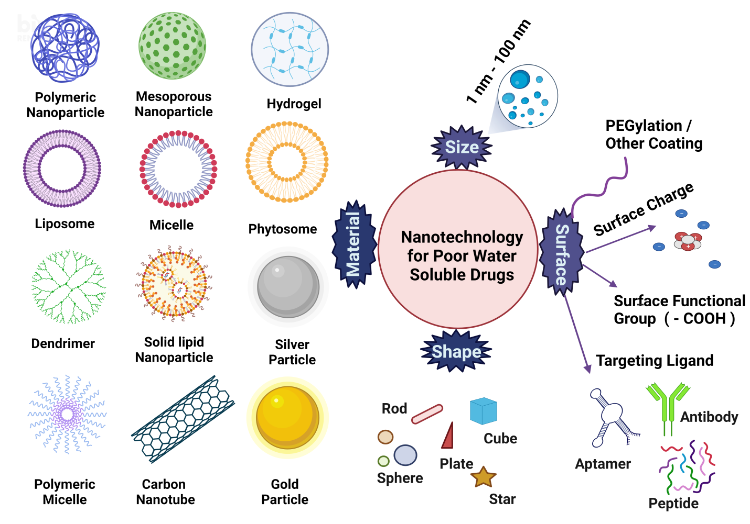
Figure 5: Nanotechnology based approach for poorly water-soluble drug

      - Various Nanotechnology based drug delivery systems
- Liposomes
A liposome is a microscopic particle or colloidal carrier whose diameter is commonly 100-5.0μm. It is a concentric bilayered membrane surrounded by a water-insoluble lipid bilayer primarily made of natural or synthetic phospholipids. Liposomes are classified according to their number, surface charge and size of bilayers. It has a variety of benefits in such as its amphiphilic nature, biocompatibility, and easy of surface modification, resulting in a feasible drug delivery system (Figure 6) (Nsairat et al., 2022).

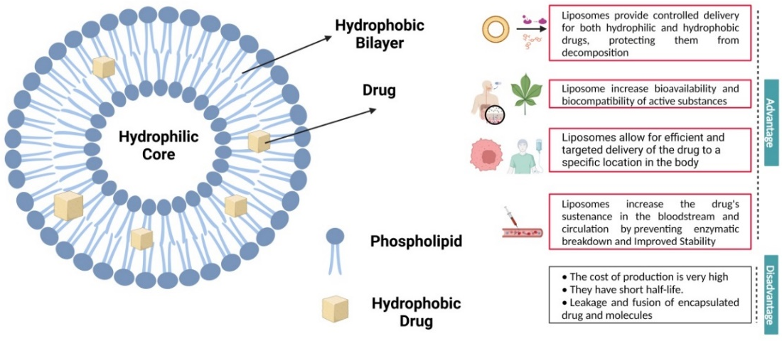
Figure 6: Liposomes

Nifedipine is a BCS Class II drug. The bioavailability of Nifedipine form proliposomes increased ten folds than the drug molecule itself upon oral administration by increasing the solubility by 24.8 folds. In addition to the enhanced bioavailability, the proliposomal formulation also increased the half-life of drug from 1.6 to 6.6 hours (Y. et al., 2020).

- Solid lipid nanoparticles (SLN)
These solid nano-sized particles have an average diameter ranging between 1 nm and 1000 nm. They are composed of a solid lipid matrix into which the therapeutic ingredient is generally incorporated. To avoid aggregation and stabilize the dispersion, several surfactants are utilized. The use of cationic lipids as matrix lipids in SLN has been reported as a novel transfection agent. The same cationic lipids utilized for producing liposomal transfection agents can also be employed to produce cationic SLN for gene transfer. SLNs have been produced and researched for delivery via parenteral, pulmonary, and cutaneous routes (Figure 7) (López et al., 2023).
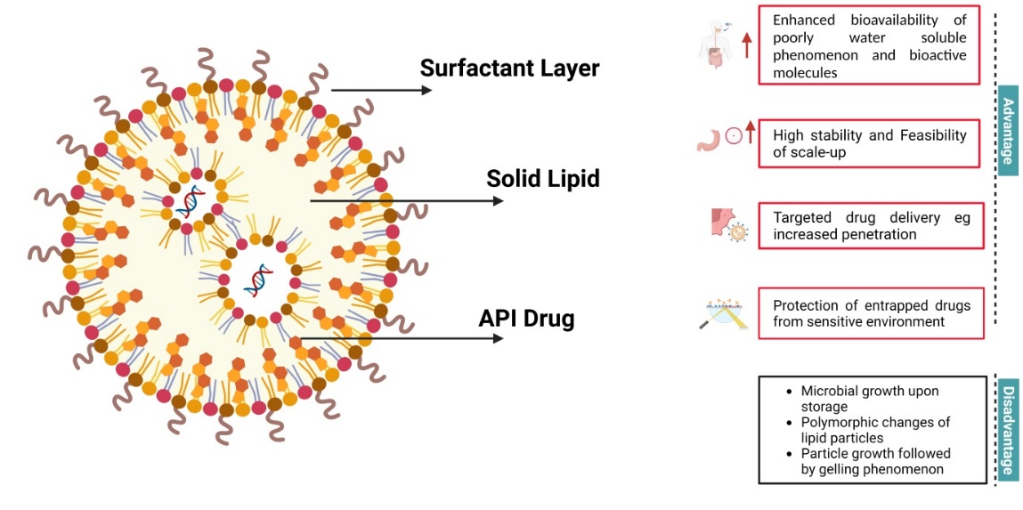
Figure 7: Solid Lipid Nanoparticle

Efavirenz is a highly lipophilic drug used for the treatment of human immunodeficiency virus. The drug has low water solubility. In an attempt to increase the solubility and hence the bioavailability of the drug, Efavirenz loaded SLN were formulated. The SLN demonstrated a 5.32-fold escalation in the peak plasma concentration and 10.98-fold rise in the bioavailability of the drug (Gaur et al., 2014)

- Dendrimers
Dendrimers, a subclass of polymers, are highly branching macro-molecules of specific shape and size (Figure 8). These are synthesized from monomers using either concurrent or contrasting step growth polymerization. The established structure, mono-dispersity of size, surface functionalization capacity, and stability makes them an interesting drug carrier. Dendrimers can be accessed by drug compounds via encapsulation or complexation (Santos et al., 2019).
Encapsulation of Cisplatin (antineoplastic), a BCS Class IV drug augmented the solubility of the drug. Similarly, Indomethacin (nonsteroidal anti-inflammatory drug), a class II drug also exhibited drastically enhanced water solubility through encapsulation in dendrimers (Chauhan et al., 2007)

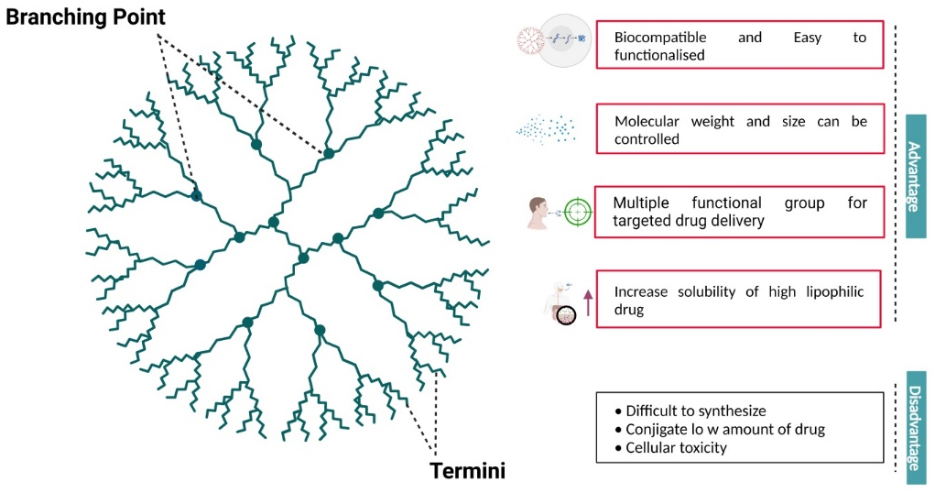
Figure 8: Dendrimer

- Carbon nanotubes
Carbon nanotubes have shown promising activities and their applications include the development of biological DNA and protein biosensors, ion channel blockers, bioseparators, and biocatalysts. This potential develops from their distinct surface or adjustable size-dependent features, as well as their anisotropy, which influences their electrical, photonic, mechanical, and chemical properties (Figure 9) (Liu et al., 2009).

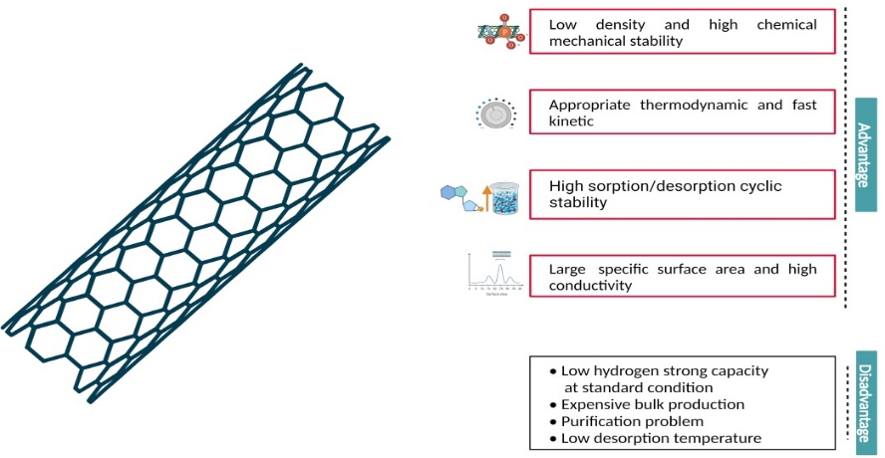
Figure 9: Carbon Nanotubes

Carbon nanotubes are hydrophilic in nature. They have been seen to enhance the dissolution profile of Griseofulvin (an antifungal agent) and Sulfamethoxazole (antibiotic). Both these drugs are BCS Class II drugs and have low solubility. The hydrophilic carbon nanotubes were incorporated in the drugs. The carbon nanotubes drastically reduced the time to reach 80% dissolution from 67 minutes to 10 minutes in Griseofulvin with the integration of just 5.1% carbon nanotube; and from 66 minutes to 18 minutes with the incorporation of just 4% carbon nanotube in Sulfamethoxazole. The improved dissolution rate was credited to the hydrophilic carbon nanotubes which aided as ducts for transporting water in close contact with drug crystals. (Chen and Mitra., 2019)

- Phytosomes
Phytosomes are one of the lipid based vasicular delivery systems which are used for encapsulation of drugs and phytoconstituents. The active ingredient of the phytosome is basically the parts of its membrane itself which makes it little differ from liposomes (Figure 10).

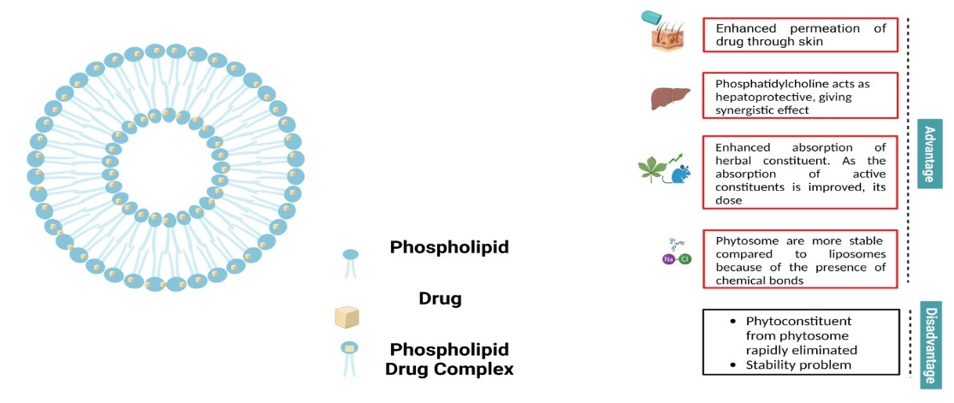
Figure 10: Phytosome
Phytosomes are prepared by complexing the drug molecules with phospholipids in the defined stoichiometric ratios under predefined conditions (Tripathy et al., 2013). The complex thus formed assists drug molecule to pass through outer membrane of GI cells and reach functional sites. This in return enhances the absorption of the drug and thereby enhancing their bioavailability in comparison to the original drug. (Kidd and Head, 2005; Gaikwad et al., 2023; Barani et al., 2021).

- Microspheres
Microspheres (Figure 11) are small, round shaped particles that are commonly made of decomposable and biocompatible polymers and range in size from 1 to 1000 μm and have therapeutics material and other bioactives inside their core. They have several benefits which include:
- Masking and shielding encapsulated pharmaceuticals from the severe conditions of the GI system
- Prolonged and regulated drug release
- Enhanced stability
- Increased bioavailability
- Targeted drug delivery (da Silva et al., 2023)

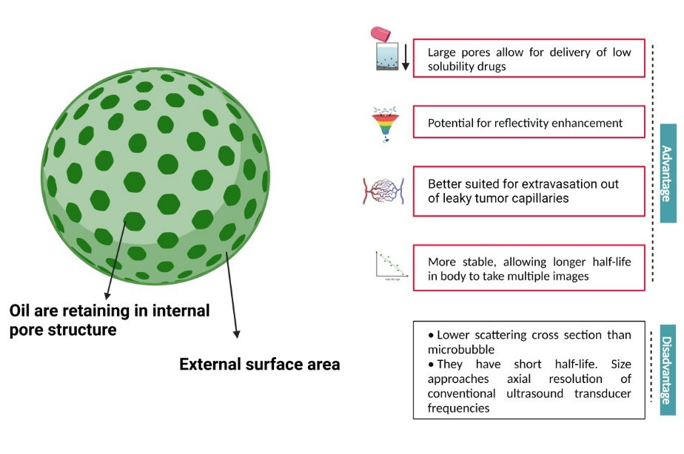
Figure 11: Mesoporus nanoparticle

- Micelles
Polymeric micelles are formed by self-assembly of block copolymers in an aqueous media, which spontaneously form a core-shell structure with a strong amphiphilic feature (Kulthe et al., 2012). Polymeric micelles have a hydrophobic core with a hydrophilic covering. Because most therapeutic therapies for cancer are hydrophobic, they can be encapsulated in the core. These copolymers may be infinitely changed to become more hydrophobic or hydrophilic, depending on the chemical characteristics of the medicine under investigation. This improves the stability and solubility of certain medicines in biological systems. Figure 12 illustrates the most common polymers utilized as a hydrophobic core (Guzmán et al., 2022).

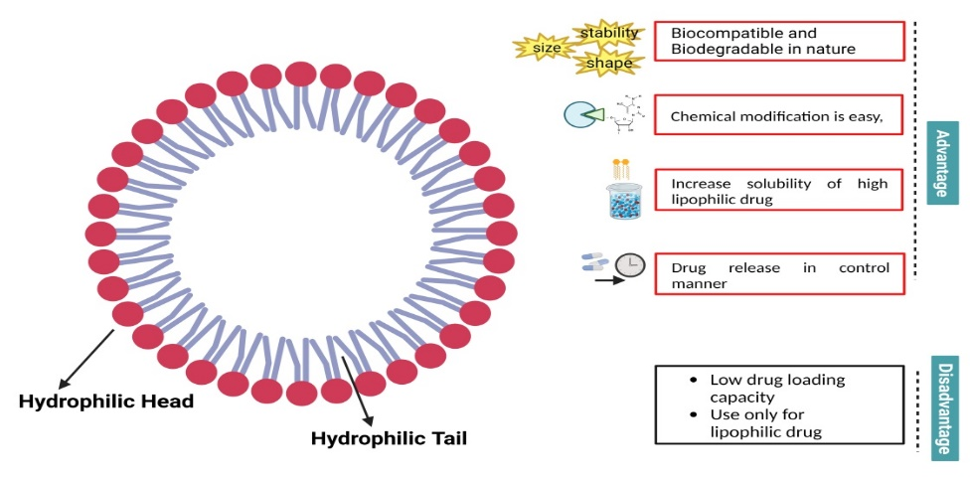
Figure 12: Micelles

- Polymeric nanoparticles
Polymeric nanoparticles (PNPs) are biodegradable polymer particles (Figure 9). PNPs have various advantages in drug administration, one of the most important is enhance the stability of any volatile medicinal entity and may be quickly and inexpensively synthesised in large numbers utilising number of processes. Additionally, polymeric nanoparticles with specific selectivity might be capable of delivering a larger quantity of therapeutic ingredient to a targeted site (Dristant et al., 2023)

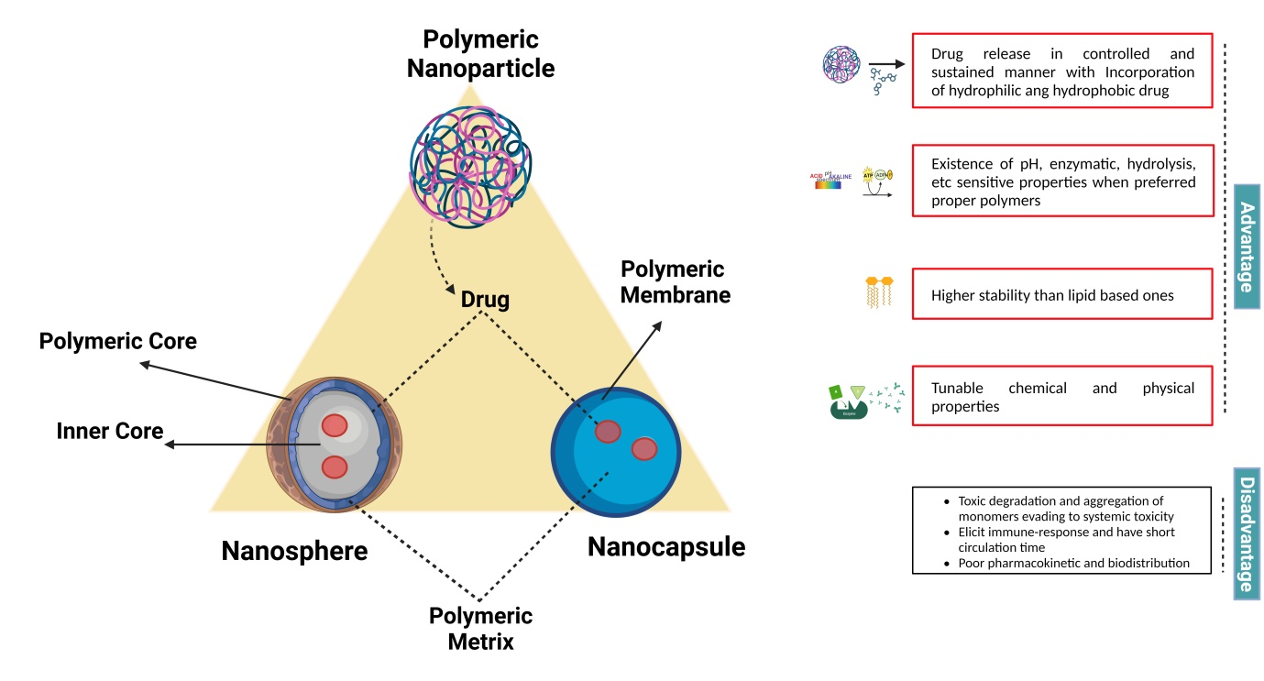
Figure 13: Polymeric Nanoparticle

- Hydrogels
Hydrogels are three-dimensional (3D) polymeric networks with a hydrophilic structure that allows massive amounts of water to be absorbed. Because of their increased life-time, better ability to absorb water, superior mechanical characteristics, and finely-tuned decomposition. Hydrogels composed of synthetic polymers are more preferred than made of naturally-derived polymers. Hydrogels can be chemically stable or quickly decomposable, depending on their structure.
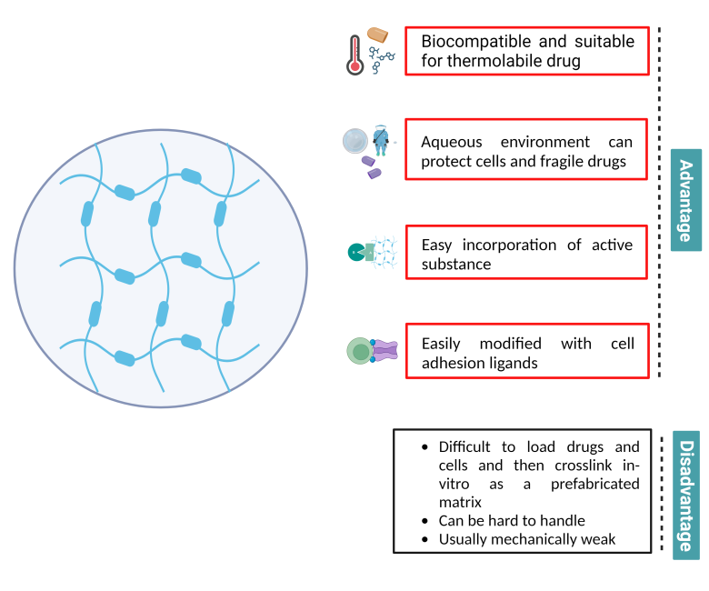
Figure 14: Hydrogel

Hydrogels are categorized as physical, which are kept together by reversible, non-covalent interactions, and chemical, which are bound together by non-reversible covalent bonds (Sayed et al., 2023). Their distinct qualities include consistent biocompatibility, customizable mechanical and degrading properties, sensitivity to diverse stimuli, and the ability to be readily conjugated with hydrophilic and hydrophobic medicinal molecules. (Onaciu et al., 2019)

- Gold Nanoparticle (GNP)
Simply putting, GNPs are very small particles made of gold that range from 1 nm to 100 nm in size. When dispersed in water, they are called colloidal gold. GNPs can be seen in different distinct forms like spherical, suboctahedral, octahedral, icosahedral multiple twined, tetrahedral, decahedral, multiple twined, irregular shape, nanotriangles, hexagonal platelets, nanorods, and nanoprisms , simultaneously (Chen et al., 2014). GNPs may interact with the epidermal barrier, increasing the delivery and penetration of high-molecular-weight active drugs. Gold nanoparticles are potential options for the optimization of skin immunisation and transdermal delivery system (Koushki et al., 2021)

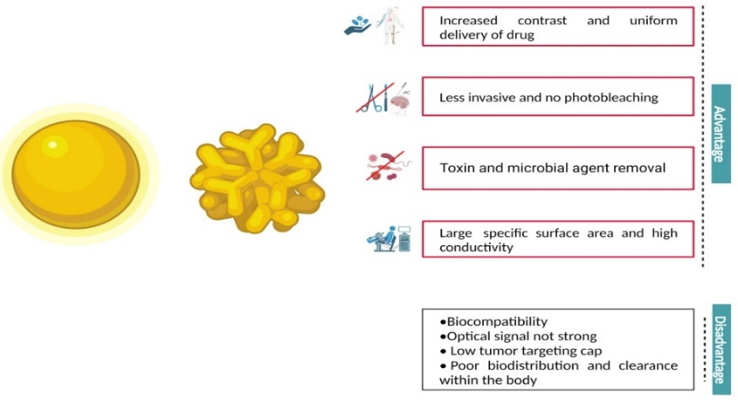
Figure 14: Gold Nanoparticle

- Silver Nanoparticle
Similar to GNPs, silver nanoparticles also range from 1 nm to 100 nm in size. As the name suggests, silver nanoparticles are composed of silver oxide in high percentage due to their high surface to bulk silver atom ratio. Depending on the application, nanoparticles of various shapes. Spherical silver nanoparticles are the most common, but thin sheets, diamond and octagonal are also very common (Mody et al., 2010). Owing to an astonishing wide surface area, they may interact with an immense quantity of ligands. Laboratory and animal studies are being conducted to examine the potential effectiveness, biosafety, and biodistribution of silver nanoparticles for human therapeutics (Xu et al., 2020).

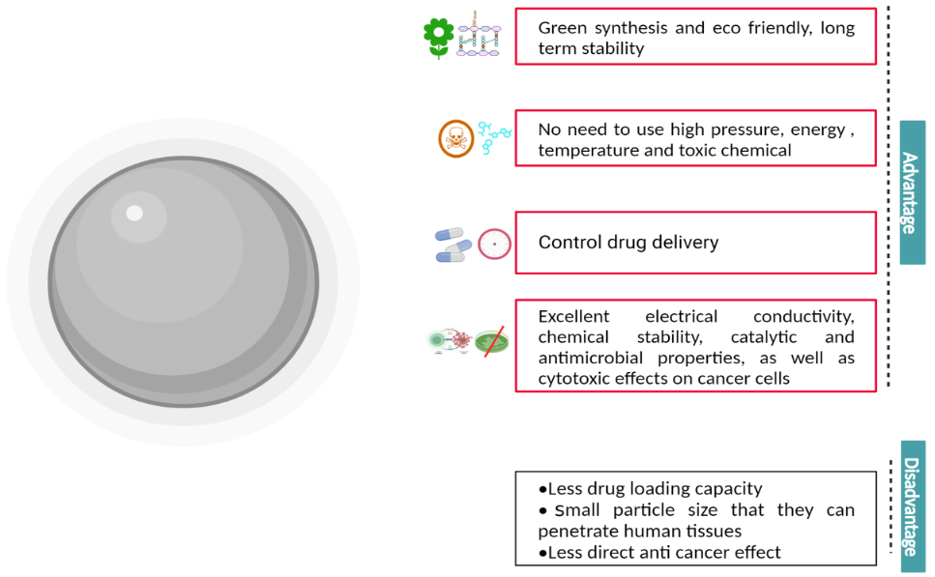
Figure 15: Silver Nanoparticle

Table 3: Features of Nanotechnology
Nanoparticles | Size | Structure | Features
Polymeric nanoparticles | 1 nm – 1000 nm | Polymeric material with the colloidal organic compounds | - Made by either natural or synthetic polymers  - Hydrophobic core with large adding capacity  - Hydrophilic shell for protection and customized targeting  - Can carry hydrophilic and hydrophobic molecules and macromolecules
Liposomes | 100 nm- 5 µm | Phospholipid bilayer surrounding an aqueous core | - Spherical polymeric vesicles  - Shell is made of lipids bilayer  - Ability to carry hydrophobic and hydrophilic molecules  - Easily manipulated during their synthesis process  - Long circulation time and good diffusion properties
Dendrimer | 5 nm – 10 nm | Branched polymer | - Tree-like nanoparticle, containing extensive branding and multivalent functional groups  - Can enclose different therapeutics inside its structure  - Can simultaneously contain imaging materials and targeting molecules  - By selecting a particular polymer, a controlled degradation of its branches can regulate the release of the therapeutic molecules
Micelles | 20 nm – 200 nm | Amphiphilic molecules in aqueous solution and self-assemble | - Spherical polymeric vesicles that can be functionalized for better targeting  - Shell is made of lipids or another amphiphilic material  - Hydrophobic interior and hydrophilic exterior
Mesopous | 2 nm – 50 nm | Synthesized by reacting tetra ethyl orthosilicate with a template made of micellar rods | - High specific surface, pores volume and unique pore size  - Thermodynamic stable and good biocompatible  - Great potential to disperse small metallic/ non-metallic material  - Also great potential as additive to improve the tri-biological, chemical and thermomechanical properties of polymeric material.
Solid Lipid Nanoparticle | 10 nm – 1000 nm | It made solid lipid, emulsifier and water/solvent | - Solid core contain both hydrophilic and hydrophobic ingredient  - It enhances drug delivery to target cell by passive mechanism  - They have spherical particles with a solid lipid matrix comprising of drug molecules and a surfactant layer in order to stabilize the solid lipid nanoparticles in an aqueous phase
Carbon Nanotube | 3 nm – 6 nm | It is made from enrolled cylindrical graphitic sheets wrapped up into a seamless cylinder | - Carbon nanotubes are allotropic form of carbons related to the fullerene family, used in diagnosis and cancer treatment  - High surface are but its needle shape allows for easily penetrate cell  - Penetrate tumor by enhanced permeability and retention  - Exceptional thermal properties Thermal ablation (cancer treatment) Good loading capacity
Hydrogel | 10 µm – 500 µm | Forming natural polymers include proteins such as collagen and gelatin and polysaccharides | - 3D network structures imbibe ample quantities of water  - Exist naturally as polymer networks such as collagen or gelatine, or can be made synthetically  - Encapsulate chemical systems which upon stimulation by external factors such as a change of pH may cause specific compounds such as glucose to be liberated to the environment
Phytosome | 50 nm – 100 µm | It standardized polyphenolic plant extract incorporated into phospholipids | - Synthesized from standardized extract of plants or phytoconstituents that are water-soluble mended into phospholipids  - Provides complexes that are compatible to lipid thus increasing the absorption and bioavailability of a drug.  - Phytovesicle technology produces a little cell, higher able to transfer from a hydrophilic setting to lipid-pleasant setting of enterocyte cell membrane and from there into the cellular, finally achieving the blood
Gold Nanoparticle | 1 nm- 150 nm | It is dielectric nucleus covered by a variable layer of gold are typically prepared by direct deposition of gold onto colloidal silica | - Self-assembled of metallic atoms such as gold.  - Can be modified through surface modifications) to achieve better targeting.  - Gold biologically have inert, low toxicity, and high biocompatibility. It also has surface plasmon resonance properties, so visible in the region of light spectrum.
Silver Nanoparticle | 1 nm- 100 nm | Synthesized by reduction of Silver(I) diammine cation with glucose, galactose, maltose, and lactose | - Large percentage of silver oxide due to their large surface ratio to bulk silver atoms.  - Co-ordination of a vast number of ligands is allowed by extremely large surface area.  - Cell death is triggered by silver nanoparticles of either mammalian cells or microbial cells, which gives the nanoparticles unique antibacterial and antifungal effect.

Table 4. Example of drugs solubility enhancement via different nanotechnology techniques
Nanotechnology Techniques | BCS Class | Method | Composition | Example of Drugs | Ref
Liposome | II | Extrusion method | Phospholipid, 1, 4–dioxane, 2, 2-diphenyl-1-picrylhydrazyl, 5,5′-dithiobis-2-nitrobenzoic acid and 3-(2-Pyridyl)-5,6-diphenyl-1,2,4-triazine-p,p'-disulfonic acid monosodium salt hydrate. | Apigenin | Telange et al., 2016/ Chaudhury et al., 2012
 | IV | Film hydration method | Soybean phosphatidylcholine Cholesterol:Tocopherol Polyethylene Glycol Succinate: Curcumin: Trimethyl chitosan | Curcumin | Lee et al., 2020
Solid Lipid Nanoparticle | II | Emulsification-evaporation followed by ultrasonification | Cetyl Alcohol/Spermaceti, Tween 20 or Poloxamer | Buspirone HCl | Varshosaz et al., 2010
 | IV | Solvent emulsification evaporation technique | Stearic acid, Tween-80 and Polyvinyl pyrrolidone | Famotidine | Shafique et al., 2017
Dendrimer | II | Shake flask method | Polyamidoamine dendrimers, Acetonitrile and o-phosphoric acid | Quercetin | Madaan et al., 2016
 | IV | Co-precipitation method | Polyamidoamine dendrimers,  ethylene diamine core, 2-(2-chloroethoxy) ethanol, Triethyl amine, methyl iodide, N, N- dimethyl formamide, and MTT (3-(4, 5-dimethylthiazol-2-yl)-2, 5-diphenyltetrazolium bromide) | Furosemide | Murugan et al., 2023
Carbon Nanotube | II | Quench cooling method | Hydroxypropylmethyl cellulose (E5, E15 and E50), povidone, microcrystalline cellulose, lactose monohydrate, sodium starch glycolate, colloidal silicon dioxide | Dipyridamole | Vora et al., 2016
 | IV | Spray Pyrolysis | H₂SO₄/HNO₃, ethylenediamine, benzene and ferrocene, Dimethyl sulphoxide | Amphotericin | Prajapati et al 2011
Micelles | II | Film hydration method | Cholesterol, lecithin, Oleic acid, carbomer 934, Poloxamer, Tween 80, and Span 20 | Deferoxamine mesylate | Salimi et al., 2019
 | IV | Co-solvent Evaporation method | Carboxymethyl chitosan, Docetaxel, 1-ethyl-3-(3-dimethylaminopropyl) carbodiimide hydrochloride, pyrene | Oleic acid | Kumar et al., 2020; Jena and Sangamwar et al., 2016
Phytosome | II | Solvent evaporation | Phosphatidylcholine, Methanol, Dichloromethane | Resveratrol | Kalita et al., 2015
 | IV | Solvent evaporation method | Lipoid S75, ovolecithin, Ethyl oleate, glycerol, n-octanol, ethanol, Tween-80, Methanol, isopropanol and potassium dihydrogen phosphate | Baicalin | Wu et al., 2014
Mesoporous | II | Solvent evaporation method | Aeroperl-300 , Aerosil 200, Syloid-244, Sylysia-350, Sylysia-770 w, Neucilin-US2, Fugicalin-SG, Tween 80, acetonitrile and methanol | Niclosamide | Pardhi et al., 2017
 | IV | Chemical methods | Acetonitrile, Cetyl Trimethylammonium Bromide, Ethanol, Hydrochloric Acid, Methanol, Sodium Dihydrogen Orthophosphate dihydrate, Sodium hydroxide, Tetraethyl Orthosilicate, Polaxamer, | CyclosporinA | Lodha et al 2012
Hydrogel | II | Phase Inversion Temperature Method | Palm kernel oil , coconut kernel oil, soybean oil, Ammonium acryloyldimethyltaurate, Tween 80 and sodium benzoate | Phenytoin | Lee et al., 2016
 | IV | Temperature-Sensitive Hydrogels | Acetone, Acetonitrile Cyclohexane, 95% methanol, 2- hydroxyl- propilmethacrylate, ethyleneglycole dimethacrylate, potassium acetate, N-isopropylacrylamide, 2,2’-azobis(2-methylpropionitrile), 99.5% aluminium chloride, 2,2-diphenyl-1-picrylhydrazyl, ellagic acid, potassium bromide | Ellagic Acid | Stojanović et al., 2018
Gold Nanoparticle | II | Green Synthesis | Tetrachloroauric acid trihydrate, pectin, tween 60 | Cabotegravir | Andre et al., 2023
 | IV | Seed-Growth Method | Ascorbic acid, cetyltrimethylammonium bromide, and NaBH₄ , | Folic Acid | Tsai et al., 2008
Silver Nanoparticle | II | Green Synthesis | Boric acid, Glacial acetic acid, Methanol, Silver nitrate and phosphoric acid | Miconazole | Magdy G et al., 2022
 | IV | Chemical Reduction Method | Trisodium citrate dehydrate, sodium borohydride and methotrexate | Methotrexate | Rozalen et al., 2020

Conclusion: In conclusion, nanotechnology-based solubility enhancement techniques have emerged as promising solutions to address the challenges associated with poorly soluble drugs. Through innovative approaches such as nanosuspensions, solid lipid nanoparticles, nanoemulsions, and cyclodextrin complexes, these techniques have shown significant potential in improving the aqueous solubility and bioavailability of various drugs. By utilizing nanoscale formulations, drug compounds can be encapsulated, stabilized, and delivered more efficiently, allowing for better drug dissolution and absorption in biological systems. Additionally, nanotechnology offers the advantage of targeted and controlled drug release, reducing potential side effects and optimizing therapeutic outcomes. Furthermore, the versatility of nanotechnology enables the encapsulation of both hydrophobic and hydrophilic drugs, providing a versatile platform for enhancing the solubility of a wide range of pharmaceutical compounds. However, it is essential to acknowledge that nanotechnology-based solubility enhancement techniques are still an evolving field, and further research is needed to explore their long-term safety, scalability, and cost-effectiveness. Additionally, regulatory considerations must be addressed to ensure the successful translation of these techniques into practical pharmaceutical applications. Despite these challenges, the advancements made in nanotechnology offer a promising avenue to revolutionize drug delivery and enhance the efficacy of various medications. As researchers, scientists, and pharmaceutical industries continue to invest in this area, we can look forward to witnessing the transformation of drug development and patient care through the realization of nanotechnology-based solubility enhancement techniques.

References:

- Andre M, Nair M, Raymond AD. HIV Latency and Nanomedicine Strategies for Anti-HIV Treatment and Eradication. Biomedicines. 2023 Feb 18;11(2):617.
- Bakatselou V, Oppenheim RC, Dressman JB. Solubilization and wetting effects of bile salts on the dissolution of steroids. Pharmaceutical research. 1991 Dec;8:1461-9.
- Barani M, Sangiovanni E, Angarano M, Rajizadeh MA, Mehrabani M, Piazza S, Gangadharappa HV, Pardakhty A, Mehrbani M, Dell’Agli M, Nematollahi MH. Phytosomes as innovative delivery systems for phytochemicals: A comprehensive review of literature. International journal of nanomedicine. 2021 Oct 15:6983-7022.
- Beg S, Swain S, Rizwan M, Irfanuddin M, Shobha Malini D. Bioavailability enhancement strategies: basics, formulation approaches and regulatory considerations. Current Drug Delivery. 2011 Nov 1;8(6):691-702.
- Betageri GV, Makarla KR. Enhancement of dissolution of glyburide by solid dispersion and lyophilization techniques. International journal of pharmaceutics. 1995 Dec 29;126(1-2):155-60.
- Bhalani DV, Nutan B, Kumar A, Singh Chandel AK. Bioavailability enhancement techniques for poorly aqueous soluble drugs and therapeutics. Biomedicines. 2022 Aug 23;10(9):2055.
- Bhise SB, Rajkumar M. Effect of HPMC on solubility and dissolution of carbamazepine form III in simulated gastrointestinal fluids. Asian Journal of Pharmaceutics (AJP). 2008;2(1).
- Bhusnure OG, Kazi P, Gholve S, Ansari MM, Kazi S. Solid Dispersion: An ever green method for solubility enhancement of poorly water soluble drugs. Int. J. Res. Pharm. Chem. 2014;4:906-18.
- Bi Y, Lv B, Li L, Lee RJ, Xie J, Qiu Z, Teng L. A liposomal formulation for improving solubility and oral bioavailability of nifedipine. Molecules. 2020 Jan 14;25(2):338.
- Blagden N, de Matas M, Gavan PT, York P. Crystal engineering of active pharmaceutical ingredients to improve solubility and dissolution rates. Advanced drug delivery reviews. 2007 Jul 30;59(7):617-30.
- Bodor N, Buchwald P. Theoretical insights into the formation, structure, and energetics of some cyclodextrin complexes. Journal of inclusion phenomena and macrocyclic chemistry. 2002 Dec;44:9-14.
- Chaudhury A, Das S, Lee RF, Tan KB, Ng WK, Tan RB, Chiu GN. Lyophilization of cholesterol-free PEGylated liposomes and its impact on drug loading by passive equilibration. International journal of pharmaceutics. 2012 Jul 1;430(1-2):167-75.
- Chauhan AS, Svenson S, Reyna L, Tomalia D. Solubility enhancement of poorly water soluble molecules using Dendrimers. Material Matters. 2007;2(1):24-6.
- Chen K, Mitra S. Incorporation of functionalized carbon nanotubes into hydrophobic drug crystals for enhancing aqueous dissolution. Colloids and Surfaces B: Biointerfaces. 2019 Jan 1;173:386-91.
- Chen T, Yang J, Chen L, Qian X, Zheng Q, Fu T, Qiao H, Li J, Di L. Use of ordered mesoporous silica-loaded phyto-phospholipid complex for BCS IV class plant drug to enhance oral bioavailability: a case report of tanshinone II A. RSC advances. 2016;6(116):115010-20.
- Chen X, Li QW, Wang XM. Gold nanostructures for bioimaging, drug delivery and therapeutics. InPrecious metals for biomedical applications 2014 Jan 1 (pp. 163-176). Woodhead Publishing.
- Chen X, Li QW, Wang XM. Gold nanostructures for bioimaging, drug delivery and therapeutics. InPrecious metals for biomedical applications 2014 Jan 1 (pp. 163-176). Woodhead Publishing.
- Dam P, Celik M, Ustun M, Saha S, Saha C, Kacar EA, Kugu S, Karagulle EN, Tasoglu S, Buyukserin F, Mondal R. Wound healing strategies based on nanoparticles incorporated in hydrogel wound patches. RSC advances. 2023;13(31):21345-64.
- Dissolution testing of immediate release solid oral dosage forms. U.S. Department of Health and Human Services, Food and Drug Administration, Center for Drug Evaluation and Research (CDER), 1997.
- Dristant U, Mukherjee K, Saha S, Maity D. An Overview of Polymeric Nanoparticles-Based Drug Delivery System in Cancer Treatment. Technology in Cancer Research & Treatment. 2023 Jan;22:15330338231152083.
- EMA I. M9 Guideline on Biopharmaceutics Classification System-based Biowaivers. CfMPfH Use (Ed.). 2020.
- Fonseca JD, Tenorio Clavijo JC, Alvarez N, Ellena J, Ayala AP. Novel solid solution of the antiretroviral drugs lamivudine and emtricitabine. Crystal Growth & Design. 2018 Apr 23;18(6):3441-8.
- Gaikwad SS, Morade YY, Kothule AM, Kshirsagar SJ, Laddha UD, Salunkhe KS. Overview of phytosomes in treating cancer: Advancement, challenges, and future outlook. Heliyon. 2023 May 24.
- Garud A, Singh D, Garud N. Solid lipid nanoparticles (SLN): method, characterization and applications. International Current Pharmaceutical Journal. 2012 Oct 3;1(11):384-93.
- Gaur PK, Mishra S, Bajpai M, Mishra A. Enhanced oral bioavailability of efavirenz by solid lipid nanoparticles: in vitro drug release and pharmacokinetics studies. BioMed research international. 2014 May 21;2014.
- Ghadi R, Dand N. BCS class IV drugs: Highly notorious candidates for formulation development. Journal of Controlled Release. 2017 Feb 28;248:71-95.
- Gupta S, Kesarla R, Omri A. Formulation strategies to improve the bioavailability of poorly absorbed drugs with special emphasis on self-emulsifying systems. International Scholarly Research Notices. 2013;2013.
- Guzmán Rodríguez A, Sablón Carrazana M, Rodríguez Tanty C, Malessy MJ, Fuentes G, Cruz LJ. Smart Polymeric Micelles for Anticancer Hydrophobic Drugs. Cancers. 2022 Dec 20;15(1):4.
- Haneef J, Chadha R, Gupta V, Mandal SK. Novel polymorph of ambrisentan: characterization and stability. Journal of pharmaceutical and biomedical analysis. 2018 May 10;153:102-9.
- Haneef J, Chadha R. Drug-drug multicomponent solid forms: cocrystal, coamorphous and eutectic of three poorly soluble antihypertensive drugs using mechanochemical approach. AAPS PharmSciTech. 2017 Aug;18:2279-90.
- Hussein Wais FM. Solubility and Dissolution Rate Enhancement of Ketoprofen by Nanoparticles. Indian Journal of Forensic Medicine & Toxicology. 2020 Oct 1;14(4).
- Ilić-Stojanović S, Nikolić V, Kundaković T, Savić I, Savić-Gajić I, Jocić E, Nikolić L. Thermosensitive hydrogels for modified release of ellagic acid obtained from Alchemilla vulgaris L. extract. International Journal of Polymeric Materials and Polymeric Biomaterials. 2018 Jun 13;67(9):553-63.
- Jadhav SM, Morey P, Karpe MM, Kadam V. Novel vesicular system: an overview. Journal of applied pharmaceutical science. 2012 Jan 30(Issue):193-202.
- Jagtap S, Magdum C, Jadge D, Jagtap R. Solubility enhancement technique: a review. Journal of pharmaceutical sciences and Research. 2018 Sep 1;10(9):2205-11.
- Jena SK, Sangamwar AT. Polymeric micelles of amphiphilic graft copolymer of α-tocopherol succinate-g-carboxymethyl chitosan for tamoxifen delivery: synthesis, characterization and in vivo pharmacokinetic study. Carbohydrate polymers. 2016 Oct 20;151:1162-74.
- Kalaiselvan R, Mohanta GP, Manna PK, Manavalan R. Studies on mechanism of enhanced dissolution of albendazole solid dispersions with crystalline carriers. Indian J Pharm Sci. 2006 Sep 1;68(5):599-607..
- Kale AR, Kakade S, Bhosale A. A Review on: Solubility Enhancement Techniques. Journal of Current Pharma Research. 2020;10(2):3630-47.
- Kalita B, Das MK. Resveratrol-phospholipid complexes (phytosomes) with improved physicochemical properties favorable for drug delivery via skin. World journal of pharmaceutical research. 2015 Feb 23;4(5):1497-517.
- Khadka P, Ro J, Kim H, Kim I, Kim JT, Kim H, Cho JM, Yun G, Lee J. Pharmaceutical particle technologies: An approach to improve drug solubility, dissolution and bioavailability. Asian journal of pharmaceutical sciences. 2014 Dec 1;9(6):304-16.
- Khan AD, Singh L. Various techniques of bioavailability enhancement: a review. Journal of Drug Delivery and Therapeutics. 2016 May 15;6(3):34-41.
- Khan KU, Minhas MU, Badshah SF, Suhail M, Ahmad A, Ijaz S. Overview of nanoparticulate strategies for solubility enhancement of poorly soluble drugs. Life Sciences. 2022 Feb 15;291:120301.
- Kocaman S. Synthesis and cationic dye biosorption properties of a novel low-cost adsorbent: coconut waste modified with acrylic and polyacrylic acids. International Journal of Phytoremediation. 2020 Apr 15;22(5):551-66.
- Koushki K, Keshavarz Shahbaz S, Keshavarz M, Bezsonov EE, Sathyapalan T, Sahebkar A. Gold nanoparticles: Multifaceted roles in the management of autoimmune disorders. Biomolecules. 2021 Aug 30;11(9):1289.
- Kulthe SS, Choudhari YM, Inamdar NN, Mourya V. Polymeric micelles: authoritative aspects for drug delivery. Designed Monomers and Polymers. 2012 Sep 1;15(5):465-521.
- Kumar R, Sirvi A, Kaur S, Samal SK, Roy S, Sangamwar AT. Polymeric micelles based on amphiphilic oleic acid modified carboxymethyl chitosan for oral drug delivery of bcs class iv compound: Intestinal permeability and pharmacokinetic evaluation. European Journal of Pharmaceutical Sciences. 2020 Oct 1;153:105466.
- Kumar SK, Sushma M, Raju PY. Dissolution enhancement of poorly soluble drugs by using complexation technique-a review. Journal of Pharmaceutical Sciences and Research. 2013 May 1;5(5):120.
- Lee MK. Liposomes for enhanced bioavailability of water-insoluble drugs: In vivo evidence and recent approaches. Pharmaceutics. 2020 Mar;12(3):264.
- Lee S, Teo CC, Tan WJ, Lim HY, Lim HH, Teo SY. Lipid microemulsion-based hydrogels for effective topical delivery of phenytoin. Int. J. Pharm. Pharm. Sci. 2016 Nov;8:240-6.
- Leleux J, Williams RO. Recent advancements in mechanical reduction methods: Particulate systems. Drug development and industrial pharmacy. 2014 Mar 1;40(3):289-300.
- Lenhardt T, Vergnault G, Grenier P, Scherer D, Langguth P. Evaluation of nanosuspensions for absorption enhancement of poorly soluble drugs: in vitro transport studies across intestinal epithelial monolayers. The aaps journal. 2008 Sep;10:435-8.
- Leuenberger H. Spray freeze-drying–the process of choice for low water soluble drugs?. Journal of Nanoparticle Research. 2002 Apr;4:111-9.
- Lipinski CA. Poor aqueous solubility—an industry wide problem in drug discovery. Am. Pharm. Rev. 2002 Nov;5(3):82-5.
- Liu C, Desai KG, Liu C. Solubility of valdecoxib in the presence of ethanol and sodium lauryl sulfate at (298.15, 303.15, and 308.15) K. Journal of Chemical & Engineering Data. 2004 Nov 11;49(6):1847-50.
- Liu Z, Tabakman S, Welsher K, Dai H. Carbon nanotubes in biology and medicine: in vitro and in vivo detection, imaging and drug delivery. Nano research. 2009 Feb;2:85-120.
- Liversidge GG, Cundy KC. Particle size reduction for improvement of oral bioavailability of hydrophobic drugs: I. Absolute oral bioavailability of nanocrystalline danazol in beagle dogs. International journal of pharmaceutics. 1995 Oct 17;125(1):91-7.
- Lodha A, Lodha M, Patel A, Chaudhuri J, Dalal J, Edwards M, Douroumis D. Synthesis of mesoporous silica nanoparticles and drug loading of poorly water soluble drug cyclosporin A. Journal of pharmacy & bioallied sciences. 2012 Mar;4(Suppl 1):S92.
- Loftsson T, Brewster ME. Pharmaceutical applications of cyclodextrins. 1. Drug solubilization and stabilization. Journal of pharmaceutical sciences. 1996 Oct;85(10):1017-25.
- Loftsson T, Magnúsdóttir A, Másson M, Sigurjónsdóttir JF. Self‐association and cyclodextrin solubilization of drugs. Journal of pharmaceutical sciences. 2002 Nov 1;91(11):2307-16.
- Loftsson T, Másson M, Brewster ME. Self-association of cyclodextrins and cyclodextrin complexes. Journal of pharmaceutical sciences. 2004 May 1;93(5):1091-9.
- Loftsson T, Matthı́asson K, Másson M. The effects of organic salts on the cyclodextrin solubilization of drugs. International journal of pharmaceutics. 2003 Aug 27;262(1-2):101-7.
- Loh ZH, Samanta AK, Heng PW. Overview of milling techniques for improving the solubility of poorly water-soluble drugs. Asian journal of pharmaceutical sciences. 2015 Jul 1;10(4):255-74.
- López KL, Ravasio A, González-Aramundiz JV, Zacconi FC. Solid Lipid Nanoparticles (SLN) and Nanostructured Lipid Carriers (NLC) Prepared by Microwave and Ultrasound-Assisted Synthesis: Promising Green Strategies for the Nanoworld. Pharmaceutics. 2023 Apr 25;15(5):1333.
- Madaan K, Lather V, Pandita D. Evaluation of polyamidoamine dendrimers as potential carriers for quercetin, a versatile flavonoid. Drug delivery. 2016 Jan 2;23(1):254-62.
- Magdy G, Aboelkassim E, El-Domany RA, Belal F. Green synthesis, characterization, and antimicrobial applications of silver nanoparticles as fluorescent nanoprobes for the spectrofluorimetric determination of ornidazole and miconazole. Scientific Reports. 2022 Dec 10;12(1):21395.
- McMorland GH, Douglas MJ, Jeffery WK, Ross PL, Axelson JE, Kim JH, Gambling DR, Robertson K. Effect of pH-adjustment of bupivacaine on onset and duration of epidural analgesia in parturients. Can Anaesth Soc J. 1986 Sep;33(5):537-41. doi: 10.1007/BF03014257. PMID: 3021299.
- Millard JW, Alvarez-Nunez FA, Yalkowsky SH. Solubilization by cosolvents: Establishing useful constants for the log–linear model. International Journal of Pharmaceutics. 2002 Oct 1;245(1-2):153-66.
- Mody VV, Siwale R, Singh A, Mody HR. Introduction to metallic nanoparticles. Journal of Pharmacy and bioallied sciences. 2010 Oct;2(4):282.
- Moyano JR, Arias-Blanco MJ, Gines JM, Giordano F. Solid-state characterization and dissolution characteristics of gliclazide-β-cyclodextrin inclusion complexes. International journal of pharmaceutics. 1997 Mar 28;148(2):211-7.
- Mumenthaler M, Leuenberger H. Atmospheric spray-freeze drying: a suitable alternative in freeze-drying technology. International Journal of Pharmaceutics. 1991 May 27;72(2):97-110.
- Murugan E, Yogaraj V. Development of a quaternary ammonium poly (amidoamine) dendrimer-based drug carrier for the solubility enhancement and sustained release of furosemide. Frontiers in Chemistry. 2023 Feb 17;11:1123775.
- Nokhodchi A, Talari R, Valizadeh H, Jalali MB. An investigation on the solid dispersions of chlordiazepoxide. International journal of biomedical science: IJBS. 2007 Sep;3(3):211.
- Nsairat H, Khater D, Sayed U, Odeh F, Al Bawab A, Alshaer W. Liposomes: Structure, composition, types, and clinical applications. Heliyon. 2022 May 1.
- Nutan B, Chandel AK, Biswas A, Kumar A, Yadav A, Maiti P, Jewrajka SK. Gold nanoparticle promoted formation and biological properties of injectable hydrogels. Biomacromolecules. 2020 Jul 23;21(9):3782-94.
- Nutan B, Kumar A, Jewrajka SK. Library of Derivatizable Multiblock Copolymers by Nucleophilic Substitution Polymerization and Targeting Specific Properties. Biomacromolecules. 2020 Nov 19;21(12):5029-43.
- Onaciu A, Munteanu RA, Moldovan AI, Moldovan CS, Berindan-Neagoe I. Hydrogels based drug delivery synthesis, characterization and administration. Pharmaceutics. 2019 Aug 23;11(9):432.
- Pardhi V, Chavan RB, Thipparaboina R, Thatikonda S, Naidu VG, Shastri NR. Preparation, characterization, and cytotoxicity studies of niclosamide loaded mesoporous drug delivery systems. International journal of pharmaceutics. 2017 Aug 7;528(1-2):202-14.
- Paroha S, Chandel AK, Dubey RD. Nanosystems for drug delivery of coenzyme Q10. Environmental chemistry letters. 2018 Mar;16:71-7.
- Patole T, Deshpande A. Co-crystallization-a technique for solubility enhancement. International journal of pharmaceutical sciences and research. 2014 Sep 1;5(9):3566.
- Prajapati VK, Awasthi K, Gautam S, Yadav TP, Rai M, Srivastava ON, Sundar S. Targeted killing of Leishmania donovani in vivo and in vitro with amphotericin B attached to functionalized carbon nanotubes. Journal of antimicrobial chemotherapy. 2011 Apr 1;66(4):874-9.
- Rajewski RA, Stella VJ. Pharmaceutical applications of cyclodextrins. 2. In vivo drug delivery. Journal of pharmaceutical sciences. 1996 Nov;85(11):1142-69.
- Rasenack N, Müller BW. Micron‐size drug particles: common and novel micronization techniques. Pharmaceutical development and technology. 2004 Jan 1;9(1):1-3.
- Rasool AA, Hussain AA, Dittert LW. Solubility enhancement of some water-insoluble drugs in the presence of nicotinamide and related compounds. Journal of pharmaceutical sciences. 1991 Apr 1;80(4):387-93.
- Ratnatilaka Na Bhuket P, El-Magboub A, Haworth IS, Rojsitthisak P. Enhancement of curcumin bioavailability via the prodrug approach: Challenges and prospects. European journal of drug metabolism and pharmacokinetics. 2017 Jun;42:341-53.
- Reddy A, Parthiban S, Vikneswari A, Senthilkumar G. A modern review on solid lipid nanoparticles as novel controlled drug delivery system. Int. J. Res. Pharm. Nano Sci. 2014;3(4):313-25.
- Richard C, Cassel S, Blanzat M. Vesicular systems for dermal and transdermal drug delivery. RSC advances. 2021;11(1):442-51.
- Ritika HS, Aggarwal G. Formulation tactics for the delivery of poorly soluble drugs. Int. J. PharmTech Res. 2012;4:914-23.
- Ritika HS, Aggarwal G. Formulation tactics for the delivery of poorly soluble drugs. Int. J. PharmTech Res. 2012;4:914-23.
- Rozalen M, Sánchez-Polo M, Fernández-Perales M, Widmann TJ, Rivera-Utrilla J. Synthesis of controlled-size silver nanoparticles for the administration of methotrexate drug and its activity in colon and lung cancer cells. RSC advances. 2020;10(18):10646-60.
- Salimi A, Zadeh BS, Kazemi M. Preparation and optimization of polymeric micelles as an oral drug delivery system for deferoxamine mesylate: In vitro and ex vivo studies. Research in pharmaceutical sciences. 2019 Aug;14(4):293.
- Santos A, Veiga F, Figueiras A. Dendrimers as pharmaceutical excipients: Synthesis, properties, toxicity and biomedical applications. Materials. 2019 Dec 21;13(1):65.
- Sareen S, Mathew G, Joseph L. Improvement in solubility of poor water-soluble drugs by solid dispersion. International journal of pharmaceutical investigation. 2012 Jan;2(1):12.
- Savjani KT, Gajjar AK, Savjani JK. Drug solubility: importance and enhancement techniques. International Scholarly Research Notices. 2012;2012.
- Severino P, Pinho SC, Souto EB, Santana MH. Polymorphism, crystallinity and hydrophilic–lipophilic balance of stearic acid and stearic acid–capric/caprylic triglyceride matrices for production of stable nanoparticles. Colloids and Surfaces B: Biointerfaces. 2011 Aug 1;86(1):125-30.
- Shafique M, Khan MA, Khan WS, Ahmad W, Khan S. Fabrication, characterization, and in vivo evaluation of famotidine loaded solid lipid nanoparticles for boosting oral bioavailability. Journal of Nanomaterials. 2017 Jan 1;2017.
- Song S, Wang C, Wang S, Siegel RA, Sun CC. Efficient development of sorafenib tablets with improved oral bioavailability enabled by coprecipitated amorphous solid dispersion. International journal of pharmaceutics. 2021 Dec 15;610:121216.
- Tay E, Nguyen TH, Ford L, Williams HD, Benameur H, Scammells PJ, Porter CJ. Ionic liquid forms of the antimalarial lumefantrine in combination with LFCS type IIIB lipid-based formulations preferentially increase lipid solubility, in vitro solubilization behavior and in vivo exposure. Pharmaceutics. 2019 Dec 22;12(1):17.
- Telange DR, Patil AT, Pethe AM, Fegade H, Anand S, Dave VS. Formulation and characterization of an apigenin-phospholipid phytosome (APLC) for improved solubility, in vivo bioavailability, and antioxidant potential. European Journal of Pharmaceutical Sciences. 2017 Oct 15;108:36-49.
- Thorat YS, Gonjari ID, Hosmani AH. Solubility enhancement techniques: a review on conventional and novel approaches. International journal of pharmaceutical sciences and research. 2011 Oct 1;2(10):2501.
- Tiwari G, Tiwari R, Sriwastawa B, Bhati L, Pandey S, Pandey P, Bannerjee SK. Drug delivery systems: An updated review. International journal of pharmaceutical investigation. 2012 Jan;2(1):2.
- Tsai SW, Liaw JW, Hsu FY, Chen YY, Lyu MJ, Yeh MH. Surface-modified gold nanoparticles with folic acid as optical probes for cellular imaging. Sensors. 2008 Oct;8(10):6660-73.
- Tsinontides SC, Rajniak P, Pham D, Hunke WA, Placek J, Reynolds SD. Freeze drying—principles and practice for successful scale-up to manufacturing. International journal of pharmaceutics. 2004 Aug 6;280(1-2):1-6.
- Varshosaz J, Tabbakhian M, Mohammadi MY. Formulation and optimization of solid lipid nanoparticles of buspirone HCl for enhancement of its oral bioavailability. Journal of liposome research. 2010 Dec 1;20(4):286-96.
- Vilhelmsen T, Eliasen H, Schæfer T. Effect of a melt agglomeration process on agglomerates containing solid dispersions. International journal of pharmaceutics. 2005 Oct 13;303(1-2):132-42.
- Vora C, Patadia R, Mittal K, Mashru R. Preparation and characterization of dipyridamole solid dispersions for stabilization of supersaturation: effect of precipitation inhibitors type and molecular weight. Pharmaceutical Development and Technology. 2016 Oct 2;21(7):847-55.
- Williams III RO, Johnston KP, Young TJ, Rogers TL, Barron MK, Yu Z, Hu J, inventors; University of Texas System, assignee. Process for production of nanoparticles and microparticles by spray freezing into liquid. United States patent US 6,862,890. 2005 Mar 8.
- Witika BA, Mweetwa LL, Tshiamo KO, Edler K, Matafwali SK, Ntemi PV, Chikukwa MT, Makoni PA. Vesicular drug delivery for the treatment of topical disorders: Current and future perspectives. Journal of Pharmacy and Pharmacology. 2021 Nov 1;73(11):1427-41.
- Wu H, Long X, Yuan F, Chen L, Pan S, Liu Y, Stowell Y, Li X. Combined use of phospholipid complexes and self-emulsifying microemulsions for improving the oral absorption of a BCS class IV compound, baicalin. Acta Pharmaceutica Sinica B. 2014 Jun 1;4(3):217-26.
- Xu L, Wang YY, Huang J, Chen CY, Wang ZX, Xie H. Silver nanoparticles: Synthesis, medical applications and biosafety. Theranostics. 2020;10(20):8996.

