**AURASTOP®**

**Giorgio Dalla Volta(1), Giuseppe Vargiu(2)**

**(1)Headache Center, U.O Neurologia, Istituto Clinico Città di Brescia, Brescia, Italy**

**(2) Medical-Scientific Dept. Aesculapius Farmaceutici, Brescia, Italy**

**Keywords: Tanacetum parthenium (feverfew), Griffonia simplicifolia, 5-hydroxytryptophan, magnesium pidolatum, migraine treatment and prevention, aura, clinical trial.**

Aurastop® is an original nutraceutical preparation, that combines Tanacetum parthenium 150 mg, Griffonia simplicifolia (an herbal supplement of 20 mg of 5-hydroxytryptophan) and magnesium pidolatum 185 mg, in order to enhance the synergistic effect of these three components in the treatment of migraine with or without aura.

Tanacetum parthenium ( nel mondo anglosassone commercializzato come farmaco con il nome di feverfew) is a member of the Asteracee family, long used empirically as an herbal remedy for migraine. The extract enriched in parthenolide significantly reduced nitroglycerin-induced Fos expression in the nucleus trigeminalis caudalis, and inhibits nitroglycerin-induced neuronal activation in specific brain nuclei, like dorsal root ganglia. [13]. It has been tested successfully years ago as a treatment to reduce migraine attacks frequency, aura duration and complexity [7]. Griffonia simplicifolia is a natural source of 5-hydroxytryptophan (5-HTP); 5-HTP could reduce the N-methyl-D-Aspartate (NMDA) receptors aberrant activity in trigeminal-vascular system, as well as in Cortical Spreading Depression (CSD) developing, principally through the activity of its precursor (kynurenic acid) acting as an endogenous NMDA receptor antagonist [2]. Finally, Magnesium is added to Aurastop® formulation because the deficiencies in this intracellular cation may play an important role in the pathogenesis of migraine headaches, promoting CSD through several mechanisms involving serotonin receptors, nitric oxide synthesis/release as well as NMDA receptors [12].

1. **Mechanisms of Action**

The antimigraine effect of Aurastop® is supposed to be due to the effects of its three compounds. Parthenolide is an antagonist of TRPA1 and an inhibitor of CGRP release, by desensitization and nociceptor defunctionalization. 5-HTP influences the effects of glutamate, a neuropeptide involved in migraine pathogenesis through its excitatory effect on first and second order neurons and its role in the activation of the trigeminovascular system.

Moreover, the post-synaptic glutamatergic receptor N-methyl-D-Aspartate (NMDA) is involved on the occurrence of both central sensitization and Cortical Spreading Depression, as demonstrated by its activation during migraine attacks [3;11]. NMDA receptors are activated by an increase of the synaptic levels of glutamate and inhibited by magnesium. Glutamate levels are regulated by kynurenine which metabolizes l-triptophan in kynurenic acid (KYNA) and quinolinic acid (QUINA). In particular, the NMDA receptor antagonist KYNA inhibits glutamatergic pathway by blocking glutamate release and neurotransmission in through its action on the binding site of glycin Glu N1. It has been shown that in migraineurs the kynuretic pathway is shifted towards the conversion of KYNA in antralinic acid (ANA). This observation is supported by the finding of elevated plasma levels of ANA in migraineurs. Low plasma levels of KYNA may be considered a reliable marker of NMDA receptor activation, while its cerebral levels can be increased by the assumption of its precursor 5-HTP [4].

If assumed as a drug, 5-HTP may, therefore, increase KYNA levels, inhibit peripheral NMDA receptors, and subsequently prevent the activation of the trigeminovascular system and the onset of Cortical Spreading Depression. In addition, TRPA1 and NMDA receptors, glutamate, and calcitonin-gene-related peptide (CGRP) are involved in the neurogenic inflammation process, which leads to the sensitization of trigeminal nucleus caudalis in the lower brainstem and upper cervical cord and, consequently, of all the structures implicated in the central transmission of nociceptive information. The molecules that could trigger a migraine attack act as agonist on TRP receptors, leading to a neurogenic inflammation, through the release of CGRP from perivascular nerve terminals. This pathogenetic process might be interrupted by parthenolide, that is a TRPA1 receptors inhibitor and a powerful inhibitor of nitric oxide (NO) synthase and, consequently, of NO production [13].

Intracellular magnesium, among its many actions, has a physiologic calcium-antagonist effect, resulting in a reduction of the toxic effects of calcium. On the contrary, suboptimal concentrations of this ion favor a free radical accumulation within the cell, which, in turn, may facilitate the onset of a migraine attack [20] [21]. Based on all the mechanisms described above, the combination of Aurastop® three components, Tanacetum parthenium, Griffonia simplicifolia (5-HTP), and magnesium has demonstrated to synergistically influence the biologic pathways involved in migraine pathogenesis, and, therefore, to have a therapeutic potential in migraine prevention and treatment. [5].

1. **Clinical studies**

The efficacy and tolerability of Aurastop have been studied in various clinical trials in migraine, with or without aura.

In a Multicentric Observational Study, Antonaci and Coll. enrolled subjects with a diagnosis of migraine with aura (ICHD-3 beta criteria). [1]. The primary endpoint of this open study was defined as a reduction > 50% of duration and disability of the aura phenomena. The secondary endpoint was the modification of the headache features after the aura (i.e., duration, intensity, assumption of usual analgesic-triptans, and efficacy of the pain relievers). Patients were instructed to keep a diary to record aura and headache characteristics. After reporting the characteristics of the first 3 episodes before treatment with Aurastop®, migraine headache diary of each patient was evaluated by the investigator (t1). Then, each patient received a blister with 6 tablets of Aurastop®, with the instruction to assume a tablet of Aurastop® at the beginning of the following 3 auras, recording aura characteristics on migraine headache diary, and a second tablet at the beginning of the pain (if needed). Patients were allowed to take the usual painkiller after 1 hour in case of persistent headache. After these 3 aura episodes, each patient and migraine headache diary data were further evaluated (t2). Two-hundred subjects with a diagnosis of migraine with aura (ICHD-3 beta criteria) completed the study (mean age 33 ± 1,5 years [range, 18 – 54], males, 83 [33.2%]). Aurastop® determined a significant reduction of the duration of aura (t1= 43.2 ± 19.3 minutes vs t2 = 18.2 ± 10.3 minutes, p < 0.01), as well as of the degree of disability (t1 = 5 [4-5] vs t2 = 2 [1-2], p < 0.01). A 4-5 degree of disability was observed in more than 90% of patients before treatment versus a 1-2 degree in more than 90% of patients after treatment. Furthermore, the characteristics of migraine aura were favorably modified by treatment with Aurastop®, with a reduction of its complexity (p > 0.01), with a reduction of somatosensory manifestations (111 18,5% before treatment vs 20 3,3% after treatment). After treatment with Aurastop®, it was also demonstrated a significant reduction of headache crises (p <0.01), of pain severity and duration (p < 0.01), of the number of analgesics assumed by each patient, while the level of efficacy of analgesics or triptans was shown to be increased.



***Fig. 1 Histograms of aura duration (left) and disability (right) pre- and post-treatment with Aurastop®.***

No major side effects or worsening of migraine characteristics were noted neither associated with the use of Aurastop®.

The main finding of the study is the reduction of about 96% of self-reported aura episodes in patients who shifted from a standard treatment approach to the regimen including Aurastop®. This reduction concerned not only the duration of the aura, but also the degree of disability related to this phenomenon. It is also important to point out that aura was no more followed by a headache phase in about 30% of patients.

Mainardi and Coll. carried out a clinical multicentric trial to verify the efficacy and safety of Aurastop® in the prophylactic treatment of episodic migraine without aura (MO), as defined by the International Classification of Headache Disorders 3 beta (ICHD 3 beta) [9]. Eighty patients suffering from MO for at least 6 months, with a monthly frequency of 3 to 8 attacks and 4 to12 headache days, were consecutively recruited in this open study and treated with Aurastop® twice daily per os for 3 months. All patients were carefully instructed on how to record MO attacks in their headache diary on a day-to-day basis. The reduction of headache days per month was assessed as the primary endpoint, while the secondary endpoints were reduction of the number of MO attacks, reduction of intensity of the pain, reduction of acute treatment drug intake, subjective change of pain intensity. At the end of the treatment with Aurastop®, study data showed a significant reduction of: number of headache days (from 9.1 ± 2.0 before treatment to 3.2 ± 1.8 post treatment, p < 0.001); number of attacks per month (from 6.0 ± 1.2 to 2.4 ± 1.1, p < 0.001); pain intensity (in a visual analogical scale [VAS]:from 7 ± 1.0 to 3.2 ± 0.7, p < 0.001); number of drug doses for acute treatment (triptans, simple analgesics or in combination) assumed by each subject per month (from 9.5 ± 1.8 to 2.2 ±1.1, p < 0.001).



***Fig. 2 Histogram showing the results of the primary and secondary endpoints, baseline vs. post-treatment with Aurastop®.***

No serious adverse events were observed.

A large amount of epidemiological data demonstrates that in the highest frequency headache categories, especially when associated with aura, there are significant relationships with increased disability, loss of productive time, and pain interference with normal activities daily. Despite the importance of this problem, no specific aura therapy is available and so far, only a few clinical trials have attempted to address this issue. In this context it was recently carried out by Dalla Volta and Coll. an observational clinical study, which enrolled patients presenting with an ICHD-3 beta diagnosis of migraine with aura (MWA) with a monthly crisis of migraine with aura ranging from 5 to 20, since at least 6 months. Eighteen patients (F: n = 10, M: n = 8, mean age: 28) were treated with Aurastop® twice a day for a period of 3 months. Diary cards were filled in during a 3-month period before the beginning of the survey and during the 3-month duration of the study. The reduction of MWA attacks per month was assessed as the primary endpoint; reduction in aura duration and disability and headache intensity were chosen as secondary endpoints. The results of the study show a statistically significant reduction of MWA attacks/month and more than 95% of the patients referred a reduction >50% of the frequency, 66.6% a reduction of more than 70%, and 16.6% a complete disappearance of the attacks after the first week of therapy.

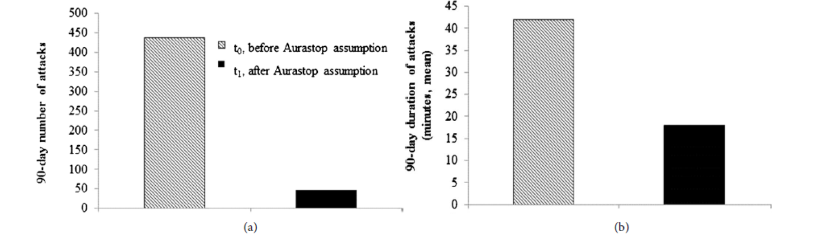

***Fig. 3 Variations in the number (a) and duration (b) of attacks, after taking Aurastop for 90 days (t0 vs t1).***

Moreover, an important reduction of the duration and disability of the aura phenomena was reported by more than 90% of the patients and in the 55% of the patients also a reduction of the intensity of the headache was noted. No side effects were reported. The efficacy of the treatment began to show during the first month of intake and was maintained during the following three months. These findings emphasize the potential effect of Aurastop® on the complex pathophysiological mechanisms of MWA. [6].

Only few of the clinical trials on migraine conducted thus far have focused on the possibility to modulate the phenomenon of aura. Furthermore, whether proper management of aura results in a better control of the headache phase has been poorly investigated. In a pilot clinical trial, the effects of Aurastop were compared with those of magnesium alone (2.25 grams/tablet, corresponding to 184 mg of Mg++) in the treatment of acute attacks of migraine with aura. 50 consecutive patients, with at least 3 episodes of aura per year were included in this open study. Participants kept track of the following 4 episodes of migraine with aura and were instructed to assume a tablet of Aurastop® at the beginning of the following 2 episodes of aura and a magnesium tablet alone at the occurrence of the third and fourth aura attacks. Forty-eight patients (96.0%) showed a >50% reduction in aura duration when treated with Aurastop vs. 7 patients (14.0%) treated with magnesium alone (*p* < 0*.*001); 48 patients (96.0%) had >50% reduction of aura-related disability when receiving Aurastop® compared with 5 patients (10.0%) treated with magnesium alone (*p* < 0*.*001); moreover, patients with nutraceutical did not need to take pain killers in 35% of aura attacks vs. 3% when assuming magnesium (*p* < 0*.*001).

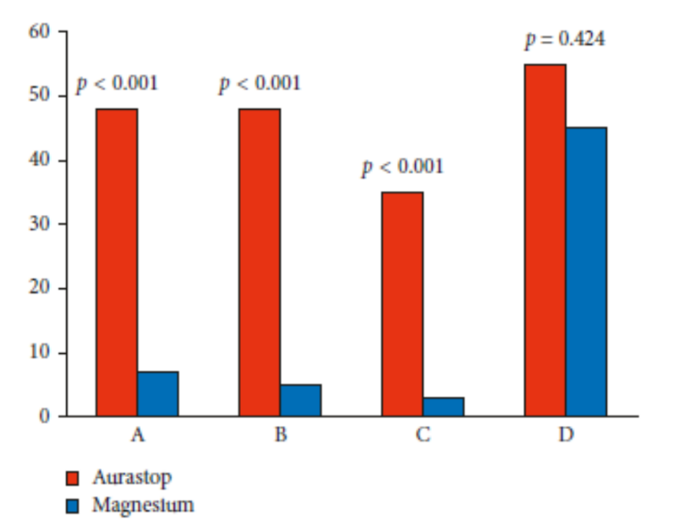

***Fig. 4 Histogram comparing the effects of Aurastop and magnesium: number of patients who had a >50% reduction in aura duration (A), aura-related disability (B), percentage of patients who did not need to take painkillers (C) and who experienced greater benefits from*** ***pain relievers (D).***

These results, in agreement with the other published clinical data illustrated above, strongly support the hypothesis that Aurastop might be effective in interfering with the phenomenon of aura and provide evidence that the clinical benefit attributable to this combination of molecules might be greater than that obtained with single compounds of proven effect on the biology of migraine. [6].

Headache is a common complaint among children that occurs in up to 75% of adolescents and 25% of young children; it is also the most common neurological disease observed in clinical practice. Migraine without aura and tension-type headache (TTH), both primary disorders, are the 2 most common types of headaches in children and adolescents. Pharmacological treatment is the first choice for migraine, but adverse effects and contraindications limit the use of drugs in children. A study was therefore carried out in children and adolescents with primary headaches without other comorbidities, administering Aurastop® in 42 children with ≥ three migraine attacks per month. 25 female (59.52%) and 17 male (40.48%) were included in the study, and the average age of children at the time of enrollment was 10.59 ± 3.18 years . The treatment period was 3 months (Aurastop® two sachets per day) following a 4-week baseline period without prophylactic treatment. Patients were assessed before treatment and at the end of the 3-month-treatment-phase for days with migraine, migraine pain, burden of disease (HIT-6) and subjective evaluation of efficacy. Migraine parameters and intake of sachets of Aurastop® were recorded daily in a diary by parents. The primary efficacy endpoint was determined by the number of days with migraine in 3 months and the Numerical Rating Scale (NRS), in addition to MIDAS score, which measures the headache-related disability. The secondary endpoint was determined by the HIT-6 score, which measures the impact of headaches on a patient’s life. Study results demonstrate that the active treatment was able to reduce the number of headache days in 3 months from 17.28 ± 14.62 days in the pretreatment phase to 4.5 ± 8.86 days after 3 months of treatment (pre- vs. post- treatment P < 0.05). The patients experienced reductions in the mean NRS (10-point scale); P < 0.05 for comparison of pretreatment (7.45 ± 1.74) vs. post-treatment (3.3 ± 2.26). A statistically significant reduction was also shown in the comparison of pre-treatment (46.48 ± 8.35) versus post-treatment (9.78 ± 18.16) mean MIDAS scores. No significant adverse effects, nor worsening of the patients’ clinical picture were recorded after the assumption of Aurastop®. All these observations, aimed at testing the synergistic effect of Aurastop® as a symptomatic treatment of migraine aura and related symptoms in childhood as well as the prophylaxis of headache attacks, showed that the nutraceutical can be used both as a prophylactic treatment at the dose of 1 teaspoon 2 times per day for 2-3 months, resulting in a significant reduction of headache frequency (the treatment can be repeated after a few months in case of need), and as an acute therapy when an attack occurs, in children above 4 years of age, at a dose of 1 Aurastop® pouch [8].

1. **Conclusions**

In conclusion, several studies have documented the efficacy and safety of the combination of Tanacetum parthenium, 5-hydroxy tryptophan and magnesium (Aurastop®) for migraine treatment and prevention; albeit obtained with the limitation of open design trials, the results suggest that Aurastop® is an effective approach for the treatment of migraine, with or without aura, even in pediatrics.

**References**

1. Antonaci F, Rebecchi V, Sances G, Merlo P, Giorgetti A, Di Palma F, Matta E, Dallocchio C, Tassorelli C, Pezzini A , Dalla Volta G. (2018) Aurastop© in the treatment of migraine aura. International Journal of Neurology and Brain Disorders 5.1 (2018): 11-14.
2. Chauvel, V., Vamos, E., Pardutz, A., Vecsei, L., Schoenen, J. and Multon, S. (2012) Effect of Systemic Kynurenine on Cortical Spreading Depression and Its Modulationby Sex Hormones in Rat. Experimental Neurology, 236, 207-214.
3. Csati, A., Edvinsson, L., Vecsei, L., Toldi, J., Fulop, F., Tajti, J. and Warfvinge, K. (2015) Kynurenic Acid Modulates Experimentally Induced Inflammation in the Trigeminal Ganglion. Journal of Headache and Pain, 16, 99.
4. Curto, M., Lionetto, L., Negro, A., Capi, M., Fazio, F., Giamberardino, M.A., et al . (2015) Altered Kynurenine Pathway Metabolites in Serum of Chronic Migraine Patients. The Journal of Headache and Pain, 17, 47.
5. Dalla Volta, G., Zavarise, P., Perego, L., and Pezzini, A. (2018). Efficacy of a Combination of Tanacetum parthenium, 5-Hydroxy Tryptophan and Magnesium (Aurastop) in the Prevention of High Frequency Migraine with Aura. Open Access Library Journal, 5(10), 1-8.
6. Dalla Volta, G. D., Zavarise, P., Perego, L., Savi, L., and Pezzini, A. (2019). Comparison of the effect of Tanacetum parthenium, 5-hydroxy tryptophan, and magnesium (Aurastop) versus magnesium alone on aura phenomenon and its evolution. Pain Research and Management.
7. Diener, H.C., Pfaffenrath, V., Schnitker, J., Friede, M. and Henneicke-von Zepelin, H.H. (2005) Efficacy and Safety of 6.25 mg t.i.d. Feverfew CO2-Extract (MIG-99) in Migraine Prevention—A Randomized, Double-Blind, Multicentre, Placebo-Controlled Study. Cephalalgia : An International Journal of Headache , 25, 1031-1041.
8. Ferrara, P. (2020). Tanacetum, Parthenium, Griffonia Simplicifolia and Magnesium as Symptomatic and Prophylactic Treatment for Headache in Paediatric Patients.(2020) Int J Neurol Brain Dis 7 (1): 17-23.
9. Mainardi, F., Merlo, P., Maggioni, F., Zanchin, G., and Dalla Volta, G. (2O18) Efficacy of a combination of tanacetum parthenium, 5-hydroxy tryptophan and magnesium (Aurastop) in episodic migraine prevention: a multicentric observational study. Open Access Library Journal, 5(8), 1-9.
10. Materazzi, S., Benemei, S., Fusi, C., et al . (2013) Parthenolide Inhibits Nociception and Neurogenic Vasodilatation in the Trigeminovascular System by Targeting the TRPA1 Channel. Pain , 154, 2750-2758.
11. Olah, G., Heredi, J., Menyhart, A., Czinege, Z., Nagy, D., Fuzik, J., Kocsis, K., Knapp, L., Krucso, E., Gellert, L., Kis, Z., Farkas, T., Fulop, F., Pardutz, A., Tajti, J., Vecsei, L. and Toldi, J. (2013) Unexpected Effects of Peripherally Administered Kynurenic Acid on Cortical Spreading Depression and Related Blood-Brain Barrier Permeability. Drug Design, Development and Therapy , 16, 981-987
12. Sun-Edelstein, C. and Mauskop, A. (2009) Role of Magnesium in the Pathogenesis and Treatment of Migraine. Expert Review of Neurotherapeutics , 9, 369-379.
13. Tassorelli, C., Greco, R., Morazzoni, P., Riva, A., Sandrini, G. and Nappi, G. (2005) Parthenolide Is the Component of Tanacetum parthenium That Inhibits Nitroglycerin-Induced Fos Activation: Studies in an Animal Model of Migraine. Cephalalgia : An International Journal of Headache , 25, 612-621.