UNDERWEIGHT
Miss.M Neeti Harshitha, Lecturer, capital degree and Pg college, Shapur nagar,chintal
MEANING:
Being underweight implies that you are below the healthy weight range the weight that science has revealed you need to be in order for your body to function normally. Falling outside of this range, whether overweight or underweight, can have major consequences for your health.

SIGNS AND SYMPTOMS :
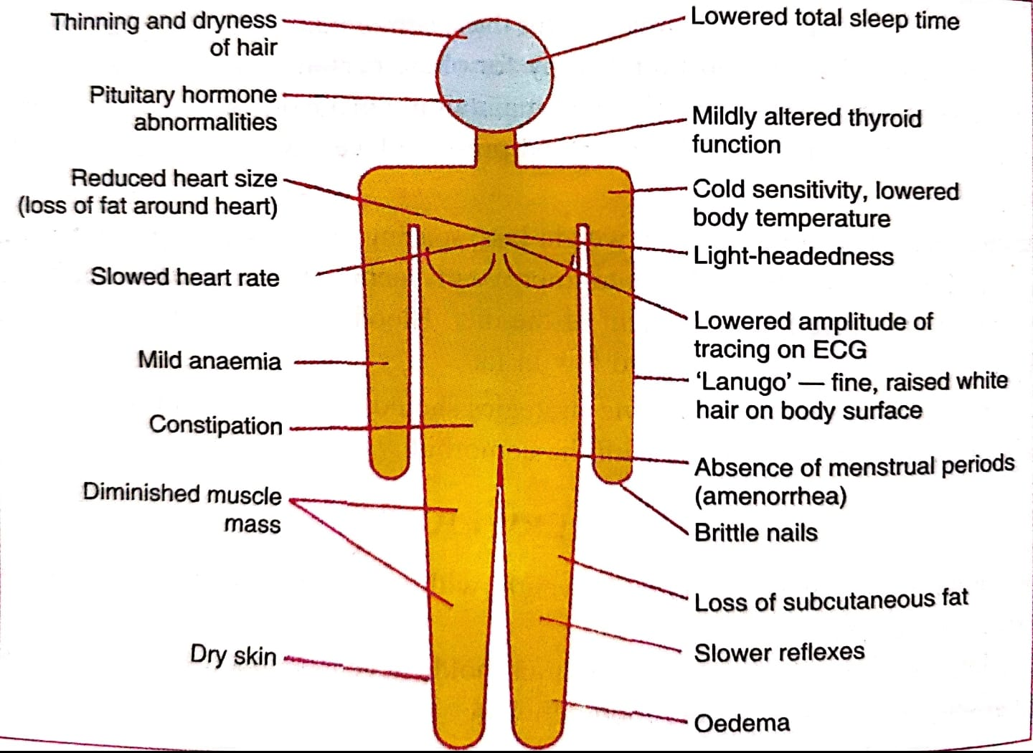
AETIOLOGY
Underweight has a number of reasons, including:
Starvation can result from famine,
A diet lacking in enough proteins, or
An effort to lose weight.
Fatty tissue is destroyed during famine, and the skeletal, cardiac, and small intestinal muscles atrophic, losing their ability to absorb nutrients.
Low blood pressure, pronounced emaciation, hair loss, and inelastic skin are the effects of this.
Since the feeding and unhealthy initially, glucose water, fruit juice, and skim milk powder may be administered as part of a progressive regimen.
Debilitating conditions including cancer, diabetes, malabsorption syndrome, and tb can also cause underweight. For them, infections are frequent. In these circumstances, tonics are ineffective since they only work to enhance hunger and not weight. Spending money on nutritious, high-calorie foods is prudent and required.
Eating extremely little food may be influenced by psychological variables (anorexia nervosa). Some mentally ill people refuse to eat, which causes drastic weight loss. Girls between the ages of 15 and 25 are most commonly affected by anorexia nervosa.
Those who are busy, agitated, nervous, and who never relax have underweight. As it becomes severe, psychological effectiveness as a whole is decreased, and their ability to focus, make decisions, and withstand disasters is very weak. Poor working efficiency results in lower production. He is not able to work nonstop for very long.
It happens under pathological circumstances including fevers, gastrointestinal problems, when the capacity for digestion and absorption is reduced, and in hyperthyroidism.
Being underweight could be an indication of a more severe underlying disease, in which case it is considered secondary. Unexplained weight loss might require an expert medical diagnosis.

Underweight is an important cause of other conditions in some circumstances. Those who are severely underweight may have decreased energy levels and a weakened immune system, leaving them more susceptible to sickness."
A deficiency in micro nutrients creates deficits in immune function and non-immune host defenses and should be classified as underlying causes of death if followed by infectious diseases; individuals are the ultimately linked causes," suggests Robert E. Black of the Johns Hopkins University Department of Health Sciences.
Category | Bmi (kg/m2)
Underweight (severe) | 16.0
Underweight (moderate) | 16.0- 16.9
Underweight (mild) | 17.0-18.4
Normal | 18.5-24.9

RESTRICTIONS OF UNDERWEIGHT
Individuals with a BMI of less than 18.5 have a lower vo, max, ability for prolonged strenuous labor, and productivity.
Pregnant mothers who are underweight run a higher chance of having underweight children.
When bmi values are below 17 in both men and women, progressively higher percentages of time are lost from work or spent unwell in bed.
The death rate increases gradually and curvilinearly in a group of males with bmis between 18.5 and less than 16.0.
Immunological deficiencies are more prevalent in males who have low bmis and concurrent
There are deficits in micronutrients. Children that are malnourished are smaller and lighter.
In females who are malnourished, the age of menarche is postponed by around one to two years.
EFFECT OF UNDERWEIGHT INFANTS
HOW IS A CHILD'S BMI DETERMINED?
Your physician will measure your child's height and weight when they are wearing no shoes or heavy clothing, and then calculate BMI using the following formula:
WHAT ARE BMI PERCENTILE GROUPS?
The labels underweight, healthy weight, overweight, and obese are used to characterize your child's BMI on the BMI curve. Remember that these terms do not characterize your child.
If the kid or adolescent falls into a high-risk category, such as being underweight, overweight, or obese, your physician may inquire further about their medical history. They may also conduct blood testing and other examinations to rule out any potential health issues.
What is the meaning of your child's BMI percentile?
BMI category percentile range
Underweight (less than the fifth percentile)
5th to 84th percentile of healthy weight
85th through 94th place for overweight
Obesity Levels Exceed the 95th Percentile
Paediatricians’ utilize both the BMI number and the percentile to determine which group a kid belongs to. The BMI percentile ranges and weight status categories are as follows:
Children should ideally fall between the 5th and 85th percentiles. Percentiles outside of this range can put children at risk of health concerns.
Children below the fifth percentile may have a nutritional deficit—either not obtaining enough calories or burning more calories than they are getting, or both. Similarly, children over the 85th percentile may have issues with how their bodies balance energy intake and production. This might be due to a number of causes, including diet, the way their bodies handle calories or other bodily processes, a lack of physical exercise, or a combination of these.
WHAT EXACTLY IS SLOW WEIGHT GAIN?
Delayed weight gain can occur at times which is known as "failure to thrive." it is not an illness in and of itself, However, it is the consequence of a range of medical, societal, and environmental concerns issues that keeps a child from getting the calories necessary for healthy development.
During the first 4 to 6 months of life, a baby's weight usually doubles and then triples. A six-pound infant, for example, would typically weigh roughly 12 pounds by 6 months of age and around 18 pounds by the age of one.
Modest weight growth isn't necessarily a cause for concern. Some newborns and youngsters are just smaller than the majority of their peers their age. Yet, between 1% and 10% of children are affected.
When does slow weight gain become an issue?
Weight growth is gradual is problematic when it impedes a child's healthy growth particularly during the first year of life when the brain is developing.

SLUGGISH WEIGHT INCREASE CAN BE A PROBLEM IF:

If the child does not regain his or her birth weight within 10 to 14 days of delivery,
- The kid gains less than an ounce every day until he or she is three months old.
- The infant should gain no more than 0.67 ounces each day between the ages of 3 and 6 months.
- A youngster of any age has been gradually developing and then stops.
- The possibility of delayed weight growth should always be reviewed with the child's doctor, it is less of a concern when:
- An infant wakes up on their own and wants to consume food 8 to 12 times per day.
- A baby increases at a steady pace.
- A baby has roughly the same number of dirty and wet diapers as the other babies.
HOW DO YOU MAKE SLOWER WEIGHT GAIN WORK FOR YOU?
Boston Children's Hospital's growth and nutrition program is a multidisciplinary curriculum comprising of physicians, nurses, nutritionists, social workers, behavioral experts, and speech therapists who will work collaboratively to identify the root cause and treatment for your child's slow weight gain. We work with parents, medical professionals, and other healthcare professionals to create a customized long-term treatment plan for each child and address the factors affecting their growth.
However, if your sprat grows taller, that should be your main concern rather than weight gain.

- WHAT IS THE IMPORTANCE OF SLOW WEIGHT GAIN?

- One of the most evident signs of delayed weight gain is that your child is substantially smaller than other children his or her age. Weight, height, and head size are a few examples.
- If the child is not getting enough calories, you may notice the following symptoms:
- Extreme sleepiness, frequent sobbing and fussiness, and inability to complete physical milestones including rolling upside down sitting standing, and moving at the exact same timeframe as other kids their age
WHICH FACTORS HELP TO PREVENT WEIGHT GAIN?
The slow increase in weight can be caused by a variety of causes, such as physical conditions or social or economic difficulties. Anything that limits a child's access to food or metabolism will negatively impact their growth. It frequently happens by a combination of variables.
HEALTH CAUSES:
Premature birth may render it difficult for your baby to receive nourishment until their breastfeeding and swallowing muscles fully develop.
• Having Down syndrome may additionally hinder an infant's capacity to take in and swallow.
• Metabolic conditions such as hypoglycaemia, galactosemia, and phenylketonuria are examples of metabolic diseases that can affect the body's ability to convert food into energy.
• A newborn with cystic fibrosis may have trouble absorbing calories.
• A food allergy or intolerance could restrict the foods the kid can consume without feeling sick.
• As a result of reflux in the stomach, an infant may vomit on frequent occasions.
• Anything that causes chronic diarrhea could strip the baby of vital vitamins and minerals.
CAUSES BOTH SOCIAL AND FINANCIAL:
Parents may not know how to properly mix formula or how frequently their newborn or toddler should consume it.
An infant may stop eating due to household stress caused by divorce, death, or another upheaval.
Poverty may make it difficult for parents to provide adequate meals for their children.
CHILDREN'S UNDERWEIGHT EFFECT
Throughout infancy and childhood, children increase weight and develop more rapid than at any other point in their life. Some children, however, struggle to put on weight at the anticipated pace, either because of presented genetic disorders, premature deliveries, or inadequate nutrition, which may happen for a variety of circumstances. An development a deficit weight loss, or failed growth are examples of terms used to refer to inadequate nutrition.
It is essential to recognise and address children who are not gaining weight on a regular schedule, since this could indicate malnutrition or a deeper medical issue that calls for treatment. Insufficient nutrition may end up in an immune system that is deficient, slower development, shorter height, or problems with learning.
Low weight growth refers to gaining weight more slowly than other children of the same age and gender. Weight "normal" ranges are calculated using the weights of thousands of children. The CDC and WHO publish standard growth charts for boys and girls that are appropriate for all races and ethnicities.
POOR WEIGHT GAIN CAUSES
Low weight gain is a sign of various possible causes, not a disease. Some of the causes of inadequate weight gain include:
Inadequate nutritional energy (measured in calories) or
Inadequate protein, fat, and carbohydrate balance
Inadequate nutrient absorption necessitates a larger-than-normal amount of nutritional energy (measured in calories).
POOR WEIGHT GAIN DIAGNOSIS
If the weight increase of a newborn or toddler slows or stops, it is vital to try to diagnose and address the underlying problem.
The first step is to do a complete medical history and physical examination on the kid.
Most children will not require blood or imaging tests, although testing may be recommended in certain instances.
The caregiver(s) should discuss any of the following conditions if the child has them:
Rationing, vomiting, or diarrhea (swallowing, regurgitating, and then re-swallowing food).
Avoids meals with certain textures (such as rough or crunchy), which might suggest a chewing/swallowing problem or a food aversion. Avoids specific foods or food groups (such as milk and wheat), which may suggest a food allergy or intolerance.
Frequently consumes low-calorie beverages such as low-fat milk or fruit juice. These beverages may make it difficult for the youngster to eat more calorie-dense solid meals.
EFFECT OF UNDERWEIGHT ON ADOLESCENCE
Undernutrition is a global health problem that mostly affects children and adolescents in low- and middle-income nations (lmics). Undernutrition is caused by inadequate macronutrient and micronutrient intakes and presents itself in four ways: wasting underweight, growth stunting, and nutritional deficiencies.
According to world bank research, india has the most undernourished children in the world, which has far-reaching implications for childhood and adolescent morbidity and mortality, as well as the national economy.
According to research being undertaken in eight indian megacities among women with a special focus on slum-non-slum, being underweight was much higher in slum inhabitants, while being overweight was significantly greater in non-slum regions.
Adolescents (13-19 years old) account for one-quarter of the global population. This era of life is significant since it is during this period that teenagers experience fast growth and development, necessitating larger nutritional requirements.
Additionally, during this time, health and dietary behaviors are formed, making teenagers more sensitive to health and nutrition difficulties than other age groups.
More importantly, adolescent girls require sufficient quantities of high-quality nutritive foods to meet the additional nutritional needs associated with
- Maturation, menstruation, and participation in various physical activities as well as to reduce health risks and break the intergenerational cycle of malnutrition.
Some major indicators of underweight teenage females have been missed by researchers in recent studies,
- Sociodemographic socioeconomic factors,
- Parental education, occupation,
- Eating habits and food insecurity.
Being underweight is well acknowledged to be one of the primary public health issues among adolescents, particularly school-aged children in south east asian nations, as it affects health, cognition, and scholastic success.
Furthermore, it is widely understood that the poor health and nutritional welfare of adolescent girls can have far-reaching effects in terms of an intergenerational cycle of malnutrition, productivity, and economic losses.
EFFECT OF UNDERWEIGHT ON PREGNANT WOMEN
Most pregnant women with a low bmi have a healthy pregnancy and infant, although there is an increased risk of:
- Premature labor and delivery,
- Miscarriage (when the baby is born before they are fully developed)
- Foetal growth restriction difficulties with your baby's development that may impair their heart, diaphragm, or stomach if your baby has a low birth weight.
The midwife may provide you with further particular advice and assistance based on the reason for your low bmi. This is so they can effectively help you, depending on the cause.
They will learn that there are several causes for having a low bmi, including:
- Being naturally slender but healthy
- Having a medical explanation for your weight loss, such as an overactive thyroid or a gastrointestinal condition, such as inflammatory bowel disease or celiac disease.
- An eating disorder prevents you from eating enough. A good balanced diet should include roughly 2,000 calories per day.
- Loss of appetite, maybe related to despair, anxiety, or stress over-exercising
EATING PROBLEMS
When pregnant women have an unhealthy relationship with food, they have an eating disorder. This has the potential to take over your life and make you physically and psychologically unwell. If they have an eating problem or have had one in the past, gaining weight may be mentally challenging for the woman.
They should be a designated expert, often a doctor or a midwife, to assist you during your pregnancy and after you give birth.
PSYCHOLOGICAL WELL-BEING
Depression or any other mental health problem can have an impact on your weight. During pregnancy or the first year following childbirth, up to one in every five women has mental health difficulties. Anxiety, sadness, and low mood are all frequent. Yet, help is available.
EXERCISE
It is still necessary to remain active throughout pregnancy, but you should not exceed the suggested amount of 30 minutes, 5 times per week.
Pregnant women should keep in mind that exercise does not have to be difficult in order to help them manage their weight and stay healthy throughout pregnancy. Swimming, strolling, yoga, or pilates are all softer activities that are mostly preferred.
INSUFFICIENT FUNDS
If you don't have enough money for meals, talk to your midwife or doctor. They may be able to put you in touch with organizations that can assist you.
There are other applications, that connect you to stores that offer food at reduced prices as it approaches its expiration date. The apps may contain some unhealthy food, but keep an eye out for vegetable and fruit packs from supermarkets, as well as other healthy alternatives.
EFFECT OF UNDERWEIGHT ON LACTATING MOTHERS
Because of the extra calories and nutrients needed for healthy while breastfeeding, mothers who are breastfeeding are at an increased risk of malnourished than the rest of the population.

Malnourished lactating mothers have been shown to have an influence on both the amount and quality of breast milk, as well as their children's nutritional and health condition.
According to several research, undernutrition among nursing mothers is a serious public health problem.
Several studies have indicated that a person's nutritional status is directly/immediately affected by the quality and quantity of food they consume, as well as their health condition/disease experience.

Three kinds of factors were chosen to explore their association with undernutrition: • Fundamental factors, underlying factors, and urgent factors. The results of a multivariable logistic regression study indicated that
EFFECT OF UNWEIGHT ON ADULT WOMEN AND ADULT MEN
Being underweight or not getting enough nourishment has several health hazards.
THESE DANGERS CONSIST OF:
Vitamin deficiency, anemia, or malnutrition
Osteoporosis caused by inadequate calcium and vitamin D intake
Reduced immune response higher risk of postoperative complications
Irregular menstrual cycles that affect reproductive problems growth and development problems, particularly in adolescents and teens
You may not be consuming enough nutritious foods containing essential nutrients to sustain your body if you are underweight. It could result in malnutrition. Malnutrition can have a range of long-term effects on your health, some of which may be apparent to you or people around you.
YOUR SIGNS MIGHT CONSIST OF:
Feeling depleted of vitality or fatigue
Being prone to disease or having difficulty fending it off
Having irregular or missing periods among women who also have problems with their teeth, dry skin, or hair.
REDUCED IMMUNOLOGICAL RESPONSE
The researchers acknowledged their difficulties in figuring out whether this is a result of being underweight or if the underlying reasons for being underweight are more to blame. For instance, malnutrition might result in weakened immunity and underweight individuals. To completely comprehend the relationship between weight and immunological function, more study is required.
INCREASED POTENTIAL FOR SURGICAL COMPLICATIONS
According to one study, those who have total knee replacement surgery when underweight had a higher risk of developing infections than people who are not underweight. Although they were unable to pinpoint the causes, they believe underweight individuals are unable to the same rate of wound healing as persons with a normal bmi. They discovered that the preoperative hemoglobin level was low in the underweight group. The results imply that being underweight may have an impact on your capacity to heal wounds, however, additional study is required.
THE IMPACT OF UNDERWEIGHT ON GERIATRIC WOMEN AND MEN
The WHO has chosen healthy aging as a priority for its work on aging between 2016 and 2030, and a policy framework has been designed to highlight the need for action in a variety of sectors. The objective of the program is to support older individuals in preserving and developing practical skills that promote well-being and enable them to take part in society.
Although there are significant individual variations in these changes, the biology of aging is understood to be the time-related decline of physiological functions that results in changes in the functional performance of various organ systems as well as decreased resilience to physical, cognitive, and mental stressors.
Age-related declines in adaptive and regenerative ability are linked to greater rates of morbidity. The occurrence of age-related illnesses in middle-aged people, on the other hand, has been perceived as a symptom of rapid aging. In order to maintain health and quality of life, one needs happiness as one ages, and a modulator of healthy aging, as defined by the WHO is maintaining optimal nutritional status and sufficient nutrient consumption.
Older people are particularly vulnerable to disease-related weight loss, loss of muscle mass and strength (i.e., sarcopenia), and ultimately, the frailty syndrome, all of which can significantly affect clinical outcomes and recovery from disease in general age is one of the main risk factors for the development of chronic disease. A typical critical early phenomenon in elderly people is weight loss, a hallmark of macronutrient shortage and/or catabolism. This starts off a catabolic cascade of unfavorable events that results in greater morbidity and death. Although there are many factors that contribute to weight loss as people age, some of them include disease processes including catabolic events, illness, or age-related anorexia (also known as "anorexia of aging") and consequent inadequate nutritional intake.
The damaging and far-reaching effects of starvation have been extensively discussed. Although disease-related malnutrition does not just affect older individuals, it is more common as people age and the effects seem to be more severe in older people due to their reduced ability for regeneration.
Malnutrition as a whole has been recognized as a significant burden on the health care system because of its negative effects on clinical outcomes, healing from illness, trauma, and surgery, and its association with increased morbidity and mortality in both acute and chronic diseases
RELATIONSHIP BETWEEN UNDERWEIGHT AND MALNUTRITION
As underweight reflects both low height for age and low weight for age, it serves as a clear sign of both chronic and acute malnutrition. Contrarily, it is believed that undernutrition, which is the study's major focus, is the primary cause of around half of all child mortality worldwide. Because of this, malnutrition is a significant problem for public health and development both internationally and in underdeveloped countries.
DIETARY MODIFICATIONS FOR AN UNDERWEIGHT PATIENT
Increase the number of calories in breast milk for babies by pumping it and adding a predetermined amount of formula powder or liquid concentrate. This combination is known as fortified human milk. For the infant's safety, this therapy should be carried out under the supervision of a healthcare expert or a nutritionist.
Infant formula calories can be increased by adding less water to an infant formula powder or liquid concentrate, or by employing a calorie supplement, such as maltodextrin or corn oil. As previously highlighted, the procedure should be conducted under the supervision of a medical professional or nutritionist for the safety of the baby.
FOOD TIPS
Feed your youngster first during mealtime. Youngsters that drink excessively may not consume as much food. (drinks are more filling and lower in calories.)
Fruit juices should not be given to children under the age of one year. After one year, reduce the amount of fruit juice to 4 ounces (120 milliliters) each day. Any sugary or fizzy drinks should be avoided. Breast milk, formula, or milk (for children over 1-year-old) are the best options.
Don't be concerned if your toddler insists on eating the same food every day. Most importantly, kids must consume adequate calories and protein.
Junk food is not a healthy way to gain weight. Junk foods frequently have a high fat or sugar content but little nutritional value.
TIMING OF MEALS
Children must eat on a regular basis, but not always. Provide something every two to three hours to allow for three meals and two to three snacks each day. Avoid snacking after an incomplete supper.
Schedules are simple for children to follow. If at all possible, try to serve meals and snacks at the same time every day.
Allow your child 1 hour before a meal to feel hungry by not offering them anything to eat or drink (other than water).
Keep mealtimes for your child short (15 minutes is generally adequate for a toddler).
EATING HABITS
Try to unwind.
Everyone should enjoy their meals.
Discover your child's behavior at times of hunger or fullness.
Find out what they enjoy eating.
You have a choice of foods.
FEEDING ZONE
Strive to eat as a family or group together. In this approach, people may set an example for healthy eating.
Minimize activities like watching tv that divert your child's attention from eating.
Ensure that the food is within your child's grasp. (Use a booster seat, high chair, or small table.)
DIETARY MANAGEMENT
A person who is underweight needs to have a positive energy balance. It is recommended that calorie intake exceed energy expenditure.
Foods high in energy are essential for weight growth.
A person who is underweight should have frequent meals. He needs to prioritize eating and give each meal the attention it deserves
They ought to have snacks in between their three main meals at the very least.
A person who is underweight should learn to eat more at each meal. One way to increase serving size is by drinking milk from a bigger glass. Supplements to the diet are an option.
Food must be enticing. You can experiment with different dishes and cuisine as well as your diet.
Eating may be done with friends, family, and in a variety of settings and environments. An individual may get hungrier after having a stroll before eating.
BOWELS AND EXERCISE
Frequent outdoor activity might increase hunger. Activity and high-calorie consumption help to build lean body mass rather than merely fat. A healthy appetite is dependent on emotional stability. Constipation can cause a decrease in appetite, so it's important to control it with enough water, exercise, and fruit. Avoid artificial beverages, soft drinks, alcohol, aerated drinks, excessive tea, and coffee as they suppress appetite. On November 26, we observe the anti-obesity day.
NUTRITION AND FOOD

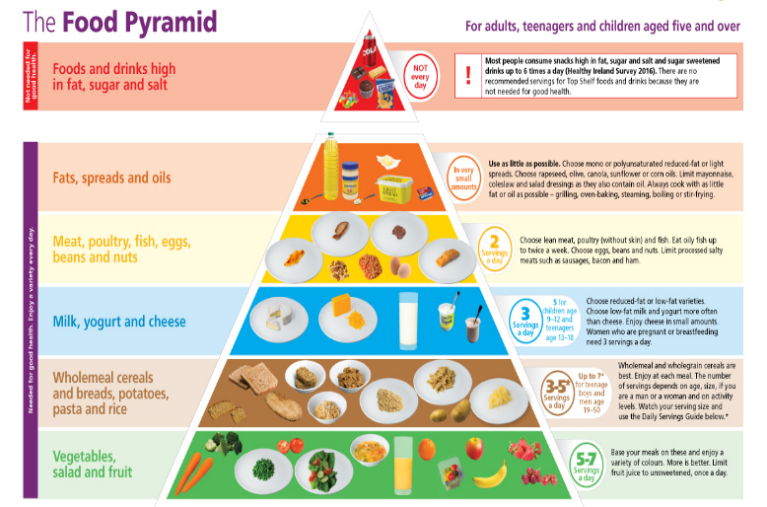

It is advised to consume enough of vitamins and eat a diet heavy in calories, protein, and fat.
But the first step is to identify and address the reason for undereating before beginning the diet. Following that, a balanced diet should be created depending on the needs. Fine, raised, lanugo hair on the body's surface. A lack of a menstrual cycle (amenorrhea) broken nails
Energy: The quantity of calories required varies depending on the activity. The overall number of calories ingested should be more than the quantity of energy required to gain weight. It is recommended that you take extra 500 kcal every day. Increases should be implemented progressively over one to two weeks to avoid gastrointestinal upset.
Proteins: for the purpose of creating tissue, more than 1.2 g of protein per kg is advised. The body fully utilizes high-quality protein, hence the best protein sources should be taken in large quantities at first. Subcutaneous fat loss, slower reactions, oedema
Fat: fat content, it is still important to have readily digested fats. Foods that are fried or greasy should be avoided since they might make you sick. A meal shouldn't start with fatty meals because they suppress appetite. Foods high in calories and fat, such as cream, butter, margarine, and oils, contribute to weight gain.
Carbohydrates: high-carbohydrate sources must be the foundation of the diet. Limit your intake of leafy vegetables and give potato and yam priority. The diet can be generously supplemented with non-vegetarian meals, dried fruits, candies, nuts, desserts, jam, jelly, cereals, and cereal goods, all of which are excellent sources of energy. There should be more meals served.
The nutritional content of the diet is improved by two small meals that include soups, juices, or sweets in between the main meals. Foods that are simple to digest should be offered. You can add foods like porridge, cutlets, sweets, potato chips, and high-protein beverages like milk, malted milk, and badam kheer. Thick soups are very healthy and readily digested foods.
Minerals and vitamins: A healthy diet removes the need for vitamin and mineral supplements
Fluids: in order to avoid reducing the amount of food consumed, fluids should only be consumed after a meal. Take in enough liquids to prevent constipation.

REFERENCES:
https://www.ncbi.nlm.nih.gov/pmc/articles/PMC7797319/#:~:text=adolescents%20from%20low,non%2Dslum%20areas
https://www.ncbi.nlm.nih.gov/pmc/articles/PMC7797319/#:~:text=Adolescents%20(10%E2%80%9319,16%2C17
https://www.tommys.org/pregnancy-information/im-pregnant/weight-management/underweight-during-pregnancy#:~:text=Lack%20of%20money,your%20visit%20today%3F
https://www.tommys.org/pregnancy-information/im-pregnant/weight-management/underweight-during-pregnancy#:~:text=Lack%20of%20money,your%20visit%20today%3F
https://en.wikipedia.org/wiki/Underweight#:~:text=A%20person%20may,accelerometry).%5B17%5Dhttps://onlinelibrary.wiley.com/doi/full/10.1002/hsr2.356#:~:text=Lactating%20mothers%20are%20at%20increased%20risk%20of%20being%20underweight%20because%20of%20the%20physiological%20changes%20that%20lead%20to%20disproportionately%20higher%20energy%20and%20nutrient%20requirements%20compared%20to%20their%20non%2Dpregnant%20and%20non%2Dlactating%20counterparts
https://www.healthychildren.org/English/health-issues/conditions/obesity/Pages/Body-Mass-Index-Formula.aspx#:~:text=Body%2DMass%20Index%20Formula,4%2C761%20%3D%2027.2%20(BMI%20Score)
https://www.healthline.com/health/underweight-health-risks#:~:text=There%20are%20certain,children%20and%20teenagers
https://www.ncbi.nlm.nih.gov/pmc/articles/PMC9528949/#:~:text=and%20underweight.%201-,Underweight,-is%20a%20direct
Dietetics by b Srilakshmi 7th and 8th series

