Robotics and Automation in Horticulture: A vision for Orchard Systems of the Future
Savreet Khehra
Farm Advisory Service Centre, Tarn Taran
Punjab Agricultural University, Ludhiana,
Punjab, India

ABSTRACT
Advances in horticulture are of great importance for the introduction of mechanical and robotic technologies in fruit tree production. The purpose of this chapter is to critically examine the opportunities and challenges in orchard management from the perspective of orchard robotics and automation from pre-harvest to post-harvest systems. Labour shortages and reliance on experienced growers are challenges in both developed and developing countries. In addition, the high reliance on scarce seasonal labour and rapidly rising labour costs have led to a growing interest in the use of robots and automatic machinery in orchards, which is critical to the quality of high-value fruit crops. The reason for failure of commercial utilization is high initial and maintenance costs. The newly introduced orchard architecture enables the robotic platform to successfully perform the desired robotic management.
Keywords
Automation, orchard management, post- harvest, pre-harvest, robotics
- INTRODUCTION
Agriculture in India is still in the continuation stage due to the constant practice of traditional farming methods. Due to population growth and future challenges, automation in horticulture seems to be the need of the moment (Smita, 2019). Automating horticultural production can solve the large-scale soil problems faced by orchards. Automation has not eliminated the need for human resources, but it has enabled key employees to work more efficiently and smarter, reducing the need for extra human resources during seasonal peaks. Robotics and automation procedures have unearthed many exercises in horticulture. The use of robotic or automated machines in orchard operations is primarily related with inadequate labour availability and rapidly increasing labour expenditures in tree fruit production. Both have diminished the general dependence on seasonal human labour keeping in mind improving yield of high-quality fruit. Apart from the uniformity of quality, the safety during production and postharvest phases is also the mandate of robotics and automation. The major robotic orchard management operations start after the establishment of the fruit trees. These include automated pruning, thinning, spraying, harvesting, sorting, grading etc. Specialty crop producers are starting to witness advances in production automation. Perhaps the most significant of these are vehicles capable of driving autonomously along rows of fruit and nursery trees while carrying a variety of sensors that increase management efficiency and implements.

II. APPLICATIONS OF ROBOTICS AND AUTOMATION IN ORCHARD MANAGEMENT

- Soil Health Analysis: The first and foremost need of horticultural crops is soil health which is estimated in terms of moisture and nutrients. These nutrient and moisture rich soils not only enhance yields (Sennar, 2019), but also improve fruit quality. For the detection and quantification of moisture and nutrients in soil, algorithms and sensors are used in artificial intelligence and machine learning systems. Moreover, for predictive analysis of recommended fertilizer and irrigation doses, robots can also be used to compute soil nutrients (Baruha, 2019). Crops such as cashews are exhausting and require large amounts of nutrients and machine learning and robotics (Kamilaris and Prenafeta-Boldú, 2018) could potentially resolve such problems in these crops. To determine the soil health, soil sampling is of great importance. Properly collecting soil samples is important step in any orchard for soil fertility management program. When fertility management is neglected in long term perspective, soil deterioration can builds up considerably resulting into a devastating problem. In general, soil sampling should reflect soil type and texture, drainage and slopes, cropping patterns, tillage, past fertilizer amendment programmes (Oliver, 2010). With the rapid increase in demand of soil sampling, the age old manual methods seems to be more time consuming and labour intensive. Or this option is robotic sampling; however often drilling is required particularly in areas with hard and uneven soil cover (Zhang et al., 2017). Allocation of soil sampling indicators on test locale has immense effect on result value. For soil fertility analysis, grid sampling is usually preferred method for sample collection (Ferguson and Hergert, 2000).Robotic research is mainly focused on mapping and sampling and is a research area with great potential impact in terms of precision agriculture (Bechar & Vigneault, 2017). It is clear that sampling model creation is a critical task so automating the process has obvious advantages. There is a huge need for complete soil sampling procedure automation so as to accomplish enhanced effectiveness and excellence (Krishna, 2016). A number of semi-automated commercial solutions are utilized, meaning the sample taking process is automated but the sampler is transported with ordinary vehicle (ATV or tractor) while human operator determines trajectory (Autoprobe, Falcon, Wintex, Magictec, Agriprobe etc.). In comparison with human operator and manual process, they are claimed roughly to double probing speed.
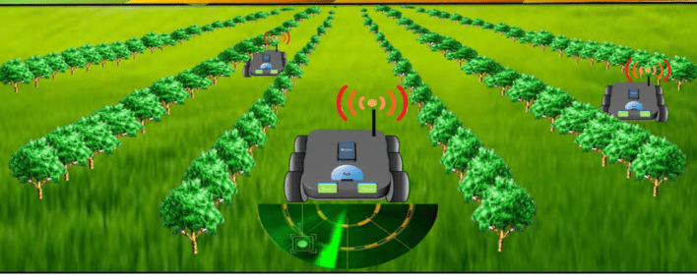

Figure 1: Automated soil sampling and health analysis

- Detection of disease: Horticultural crops are more vulnerable to pests and diseases than other crops. These pests and diseases decrease not only yield but also quality, leading to lower prices in the market (Singh et al. 2016). Due to inadequate awareness, farmers commonly spray all crops equally with pesticides and fungicides, increasing the cost of chemical use and waste. Machine learning can therefore build up algorithms that direct farmers to exactly where these chemicals are needed, further reducing input and disposal costs (Sennar, 2019). The nature of the disease can be identified by combining captured images with algorithms, thus better predicting how to battle it. This technology can be used in vineyards where diseased grape leaves can be detected. The recent advancements in artificial intelligence (AI) and machine learning have wide applications disease detection with sensors, drones, robots and intelligent monitoring systems. In recent years in horticultural crops, computer vision based phenotyping of plant stress, diagnostics and severity evaluation of plant diseases has gained momentum. For the early detection and prediction of plant diseases and host-pathogen interaction studies, networking sensors for biomarkers of disease like volatile organic compounds are being used. Thus for precise application of plant protection chemicals, unmanned aerial vehicles are employed for phenotyping orchards. In the remote locations especially where the laboratory diagnostics of diseases is difficult, smartphone based field diagnostics are gaining popularity across the world. AI in disease detection is still at its childhood. To enhance the accuracy and automation for remote diagnostics of plant diseases and precision plant protection, integration of AI and augmented reality is the need of an hour. It is evident that with the help of plant-robot bio-hybrids, the “self sufficient, disease free, perfect plant” concept will soon become reality.

- Tree pruning: For various horticultural and economic reasons, cutting off branches is done so as to maintain balance between vegetative and reproductive growth of the plant. This process id known as pruning which involves limiting of plant size, manipulation of the canopy to ensure good fruit quality, size, yield and fruit set, etc. for next season (Schupp et al., 2017). Pruning is a collective process with the results of one year's pruning impacting plant size and production in years to come as fruit trees are perennial in nature. Tree pruning is required every year and is very labour intensive for which human labour needs to be repalaced by machines due to seasonal deficit in terms of labour. The only solution is robotic pruning. However, robotic pruning as understood in the literature up to now consists of tree shape recognition, pruning protocol implementation, robotic navigation and branch cutting. In order to estimate an item's shape with high accuracy, well-established computer vision techniques frequently use qualities that make an object easy to identify, like corners and edges, stable or predictable imaging surroundings, or object smoothness. Based on this technique still cuts are performed while trees are leafless and objects are thin. Then finally, data is collected outdoor and stored. However, these properties breach many assumptions of established technology. For these reasons, many new methods have been developed to identify treetops. Last but not least, photographs may typically only be shot from one side of the tree at a time due to tree spacing and permanent trellis systems that restrict visual access to the canopy. Numerous groups around the world have created the recognition algorithms needed for robotic cutting, but processing time continues to be a significant constraint for real-time applications. Medeiros et al. (2017) reported that the data collection time for two trees was one hour. In Tabb and Medeiros (2017) system, the data collection time was 1.5 minutes per tree and the average transit time for small trees was 8.5 minutes using high performance computers. None of these research projects took any crossroad navigation for robots into account. Autonomous pruning will require further study and development in the future.

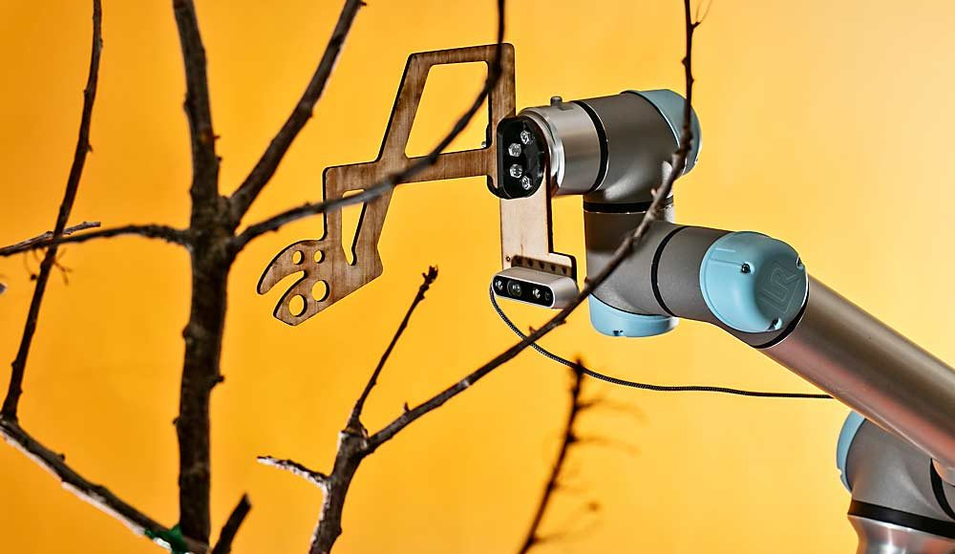

Figure 2: Robotic automated pruning

- Fruit thinning: Fruit trees generate a great deal more blossoms than are necessary for commercial cultivation, with optimal yields, fruit size, and fruit quality. By controlling the number of ripening fruits, flower thinning affects fruit size and quality. Additionally, thinning is required to account for some fruit kinds' propensity to spin during crop rotation. Crops are currently thinned either chemically or manually. As part of crop load management, growers, growers, and crop advisors use flower counts to schedule chemical thinning treatments. For apples, two models used to predict thinning splash require bloom as input (Yoder et al. 2013). The small size of the target flowers relative to the size of the canopy presents challenges for the introduction of robotic and automated solutions in this orchard operation. Robotic and automated thinning has so far focused on flower thinning. This included an introduction to the elements such as increased autonomy of bulk removal systems like filament tape by developing robotic thinning arms and end effects. It also detects colored flowers or multispectral images for dual purposes, as input for accurate estimation of flowers for thinning model and 3D estimation of treetops and flowers for robotic thinning. Research is also being done. Robotic flower removal systems require knowledge of canopy structure and flower location. In the framework of the robotic decimation system using the peach vertical V training system, efforts have been made to study the 3D reconstruction of tree crowns and flowers. Emery et al. (2010) developed a method to detect simplified crown peaches using structured light in a laboratory setting. In order to define peach tree locations and maps flower positions in a more realistic outdoor conditions, Nielsen et al. (2012 ) used special stereo reconstruction techniques combined with flash illumination and night operations.

- Spraying operations: One of the most crucial field operations is the spraying of pesticides to fruit crops in order to protect plants from numerous pests and diseases as well as to provide them with the nutrients and other elements they require, such as plant growth regulators. In order for the input to be administered successfully and produce the desired effect, accurate chemical application (also known as spraying the right amount at the right location at the right time, or the 3Rs) is essential. It is significant. The usage of chemicals has the potential to harm both the environment and human health. The following health and safety laws are thus applicable and ought to be taken into account. Therefore, precision spraying continues to be a crucial technology in the production of tree fruits. Robotic systems may be able to spray pesticides on orchards more precisely than ever thanks to fast improving processing power, sensor technology, and cutting-edge artificial intelligence methods like convolution neural networks (CNN) and deep learning. is displayed. 21-7 To attain the desired level of accuracy while spraying in orchards, both ground and aerial robots (such as spraying chemicals to specified places using UAS) can be used. Precision spraying is being researched for artificial (including mechanical) pollination of fruit crops in addition to pesticide treatments. To carefully and precisely distribute the proper amount of material to the target area within the canopy, a robotic spray system typically consists of a targeting system and a spray control system. The following subsections discuss recent advances in various components and aspects of robotic orchard application. The soil spray systems described so far do not have the ability to spray the input material specifically onto fruits or individual flowers. Several efforts are underway to develop robotic solutions for spraying tree canopies and specific parts of objects. Kang et al., 2012 evaluated a system aimed to apply herbicides to grape shoots growing at the base of the grape stem. The system included a camera that detected vine stems and shoots, and a series of nozzles that sprayed chemicals only on specific areas of the stem to control shoots insects. The system was tested on vines in Washington state and showed chemical savings of up to 92% compared to streak chemicals applied with a conventional sprayer. Berenstein et al. (2010) developed a machine vision-based automated system that precisely sprays hormones on fruits and insecticides on leaves without affecting non-targeted areas. A similar system was developed by Oberti et al. (2016) for the control of powdery mildew in grapes. It was observed that the tests in a greenhouse environment achieved 85% to 100% accuracy in detecting diseased areas, saving up to 35% in chemical consumption. To make these technologies reliable and extensively applicable to the target flower, fruit, and canopy areas where issues have been discovered, more research and development is required. Research and development efforts have been concentrated on robotic systems that can accurately administer the necessary amount of chemical to a target object or area of the crop canopy as well as sensor systems that can locate and identify the presence of certain pests and problems in the crop canopy.

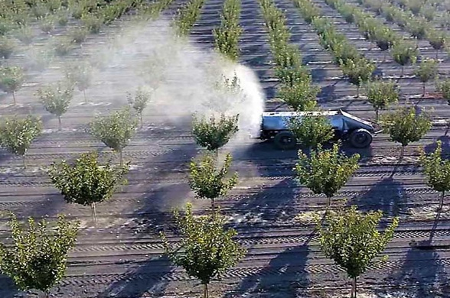

Figure 3: Autonomous spraying system for orchards

- Fruit harvesting: Fruit harvesting is a labor-intensive and time-sensitive process in fruit cultivation. Automated fruit harvesting is although still in its infancy, but many other orchard processes are already fully automated. Scientists and engineers have used apples (e.g. Rabatel et al. 1995), citrus fruits (e.g. Harrel et al., 1989), kiwis (e.g. Bazley, 2017) and cherries. Unfortunately, no commercial success has been achieved so far. With the latest developments in sensors, computers and artificial intelligence, robotic fruit picking appears to be a viable technology. Robotic orchard harvesting systems generally include a vision system to detect and locate the target crop, a steering system to reach the target crop and a harvesting table to detach the fruit from the branches. A targeted shake-and-catch system, an alternative method for automatic fruit harvesting is used in some countries. Bac et al. (2014), Gongal et al. (2015), Zhang et al. (2016) and Karkee et al. (2017) gave a more detailed work in fruit harvesting. Getting closer to the fruit is a critical step in robotic harvesting. The main concern is defining the optimal path to move the picking end effector to the target fruit and completely detach the fruit from the tree. Recently, deep learning has been successfully applied to solve various fruit recognition challenges (e.g., Zhang et al., 2017; Chen et al., 2017). The first step in robotic harvesting is to recognize the fruit and estimate its 3D position within the tree canopy so that the end effector can reach the target fruit and detach it from the tree. Extensive research has been done on fruit and obstacle detection using a variety of thresholding and classification techniques, such as Bayesian classifiers and neural networks, based on specific features such as color, shape, size, edges, and texture (Silwal et al., 2014 and Tab et al., 2006). Separating fruit from trees is the core of robotic tree fruit harvesting. A fruit picking end effector is typically used to apply the necessary force and movement to the fruit to detach it from the tree. Different types of end effector technology are used in fruit picking. One technique is to use a mechanical end effector with human-like hands and fingers to cut the fruit. You need a soft palm so as not to damage the fruit. Various designs are used in mechanical hands, including different numbers of fingers and actuators to manipulate the fingers (Davidson et al., 2016). Mechanical hands can also use soft robotic materials and pneumatic actuation (Shintake et al., 2018).

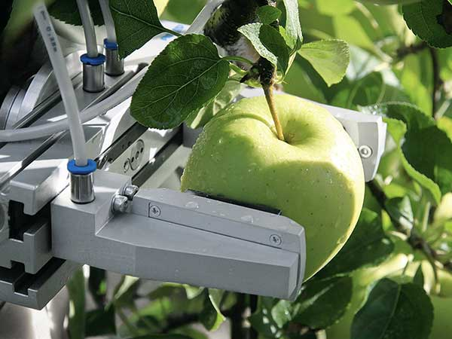

Figure 4. Robotic fruit harvesting in apple

- Sorting and grading of fruits: The actual processing of fresh horticultural produce and the reducing labour force have begun to force the development of robots that are capable of dealing with the variations inherent in the produce being sorted and graded. Without enough labour for sorting and grading procedures, a large amount of harvested crops get lost every year. Horticulture crops need new productive harvesting technologies (Sarig et. Al, 2000). The first and foremost important step for postharvest technologies include sorting and grading of harvested fruits. The time a produce is exposed to any adverse condition is generally directly proportional to the decrease of quality of any horticultural produce (Leblanc and Vigneault, 2008). Hence, timely transportation of fruits from orchards to the market is of utmost importance. Any delay will generates soon or later important effects on the final quality of the produce (Vigneault, 2004 and De Castro et al, 2005) at the marketing step, which may result in a significant loss of marketable value (Leblanc and Vigneault, 2008). In recent years, robot and automated machine vision based technology has become more potential and important in orchard management. The grading and sorting are considered as the most important step to achieve the high quality standards. Generally , the fruits quality depends upon parameter such as size, color, shape, and intensity, but color and size is the most important factor for grading and sorting of fruits. Color is very important in the sorting of fruits but due to the similarity of colors between some of the fruits, the size also help in solving problems. To maintain the quality of horticultural produce by applying prior knowledge, manufacturers supply a range of solutions based on control, automation and robotics. Although, sorting and grading of the fruit is one of the most important process, but this procedure is mostly carried out manually which is not efficient as it tends to human error. To speed up the process as well as maintain the consistency, uniformity and accuracy, a prototype computer vision based automatic grading and sorting system need to be developed. An automatic fruit quality inspection system helps in speed up the process improve accuracy and efficiency and reduce time. The grading process is carried out by capturing the fruit image using camera and this image is interpreted using image various processing techniques.The sorting process is done by sorting the fruits based on color and shape parameters. Then image processing is done, defected fruit is detected and size detection is based on binary image. Fruit Sorting is done based on color and grading is done based on size. An Automatic Fruit Grading System, which will save time, effort and provide better accuracy than the manual sorting. The techniques contains, the color detection and edge detection. Color Detection is used to identify the defected part with the threshold level while the edge detection is used for finding the boundaries of objects within images.

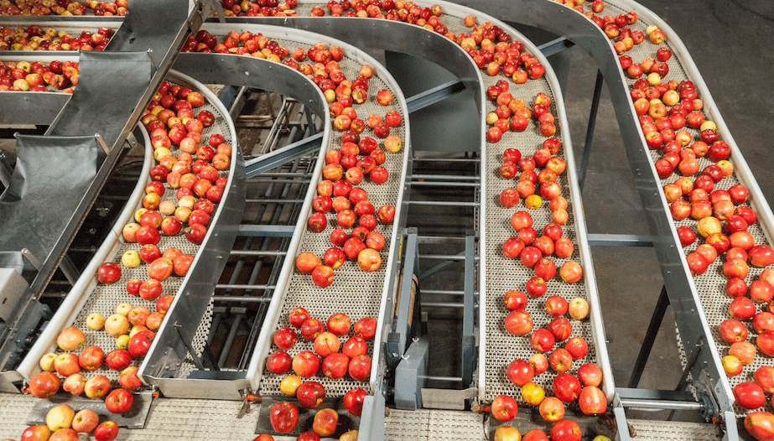

Figure 5 : Automated sorting and grading of fruits

III. CHALLENGES OF USING ROBOTICS AND AUTOMATION IN HORTICULTURE

The horticultural industry currently faces many challenges that affect crop yield and productivity. These variables prevent farmers from benefiting from the benefits of this industry, even though it is a highly profitable industry. Automation technologies such as artificial intelligence, big data analysis, digital image processing, and blockchain technology can solve such real-world problems that directly or indirectly improve the production and quality of agricultural products. These techniques can also be used to reduce the environmental damage caused by inappropriate use of synthetic chemicals in fruit and vegetable production. However, designers of robots for fields and orchards face a daunting task. Robots have to ‘see’ the paths between the produce and they need to ‘know’ which areas have already been harvested. They need eyes to see the trunk of a tree and to separately identify fruit, flowers and leaves. Their arms need to be able to pluck, prune, spray and pollinate. They have to be strong enough to handle rough terrain, sloping ground and mud. They must also be able to handle fragile fruits and berries which bruise easily. After avoiding all the people, poles, wires, stumps and rocks, robots need to be able to work near other robots without getting in their way. Their economic use poses a number of problems. Some horticultural tasks such as fruit picking last for only a few months of the year. It simply is not profitable to use a robot for such a short period. Robots may have to be multifunctional and be able to pick, count buds, prune, and pollinate to ensure a reasonable return on their cost.

REFERENCES

- T. Bazley, Robotic hands gently snatch kiwifruit future. 2017, pp. 21-18
- C. W. Bac, E. J. Van Henten, J. Hemming, and Y. Edan, Harvesting Robots for High-value Crops: State-of-the-art Review and Challenges Ahead. Journal of Field Robotics. 2014, https://doi.org/10.1002/rob.21525,
- A. Baruha, Artificial Intelligence in Indian Agriculture – An Industry and Startup Overview, 2019.emerj.rj.com/ai-sector-overviews/artificial-intelligence-in-indian-agriculture-an-industry-and-startup-overview.
- K. Sennar, AI in Agriculture – Present Applications and Impact. Available, 2019. https://emerj. com/ai-sector-overviews/ai-agriculture-present-applications-impact/
- A. Kamilaris, and F. X. Prenafeta-Boldú, F. X. Deep learning in agriculture: A survey. Computers and electronics in agriculture 2018,147:70-90.
- H. Medeiros, D. Kim, J. Sun, H. Seshadri, S. A. Akbar, N. M. Elfiky and J. Park, Modeling Dormant Fruit Trees for Agricultural Automation. Journal of Field Robotics. 2017, https://doi.org/10.1002/rob.21679
- K. G. Emery, D. M. Faubion, C. S. Walsh, and Y. Tao, Development of 3-D range imaging system to scan peach branches for selective robotic blossom thinning. In American Society of Agricultural and Biological Engineers Annual International Meeting 2010, ASABE 2010.
- M., Nielsen, D. C. Slaughter and C. Gliever, Vision-based 3D peach tree reconstruction for automated blossom thinning. IEEE Transactions on Industrial Informatics. 2012, https://doi.org/10.1109/TII.2011.2166780
- M. Karkee, R. J. Davidson and A. Silwal, Mechanical Harvest and In-field Handling of Tree Fruit Crops. Automation in Tree Fruit Production: Principles and Practice, 2017, pp. 179.
- F. Kang, H. Wang, F. J. Pierce, Q. Zhang, and S. Wang, Sucker detection of grapevines for targeted spray using optical sensors. Transactions of the ASABE, 2012, 55(5), 2007-2014
- R. Berenstein, O. Shahar, Ben, A. Shapiro and Y. Edan, Grape clusters and foliage detection algorithms for autonomous selective vineyard sprayer. Intelligent Service Robotics. 2010, https://doi.org/10.1007/s11370-010-0078-z
- R. Oberti, M. Marchi, P. Tirelli, A. Calcante, M. Iriti, E. Tona and H. Ulbrich, Selective spraying of grapevines for disease control using a modular agricultural robot. Biosystems Engineering. 2016, https://doi.org/10.1016/j.biosystemseng.2015.12.004
- G. Rabatel, A. Bourely, F. Sevila, and F. Juste, Robotic Harvesting of Citrus: State-Of-Art and Development of the French Spanish EUREKA Project,1995.
- R. C. Harrell, D. C. Slaughter and P. D. Adsit , A Fruit-Tacking System for Robotic Harvesting, Machine Vision and Applications, 1989, 2: pp.69-80.
- A. Gongal, S. Amatya, M. Karkee, Q. Zhang, and K. Lewis, Sensors and systems for fruit detection and localization: A review. Computers and Electronics in Agriculture. 2015, https://doi.org/10.1016/j.compag.2015.05.021
- A. Singh, B. Ganapathysubramanian and A.K. Singh, Machine learning for high-throughput stress phenotyping in plants. Trends Plant Sci 2016; 21(2):110–124.
- C. Smita, Smart Irrigation Techniques for Water Resource Management, in Smart Farming Technologies for Sustainable Agricultural Development, C. P. Ramesh, G. Xiao-Zhi, R. Linesh, S. Sugam, and V. Sonali, Eds. Hershey, PA, USA: IGI Global, 2019, pp 196-219.
- J. R. Schupp, H. E. Winzeler, T. M. Kon, R. P. Marini, T. A. Baugher, L. F. Kime, and M. A. Schupp, A Method for Quantifying Whole-tree Pruning Severity in Mature Tall Spindle Apple Plantings. HortScience, 2017, 52(9): pp 1233–1240.
- A. Tabb and H. Medeiros, A robotic vision system to measure tree traits. In IEEE/RSJ International Conference on Intelligent Robots and Systems. 2017. https://doi.org/10.1109/ IROS.2017.8206497
- K. S. Yoder, G. M. Peck, L. D. Combs, R. E. Byers, and A. H. Smith, Using a pollen tube growth model to improve apple bloom thinning for organic production. In Acta Horticulturae. 2013. https://doi.org/10.17660/ActaHortic.2013.1001.23
- Z. Zhang, P. H. Heinemann, J. Liu, T. A. Baugher and J. R. Schupp, The development of mechanical apple harvesting technology: A review. Transactions of the ASABE, 2016, 59(5): pp 1165–1180.
- J. Zhang, L. He, M. Karkee, Q. Zhang, X. Zhang and Z. Gao, Branch Detection with Apple Trees Trained in Fruiting Wall Architecture using Stereo Vision and Regions-Convolutional Neural Network (R-CNN). In 2017 ASABE Annual International Meeting (p. 1). American Society of Agricultural and Biological Engineers, 2017.
- S. W. Chen, S. S. Shivakumar, S. Dcunha, J. Das, E. Okon, C. Qu and V. Kumar, Counting Apples and Oranges With Deep Learning: A Data-Driven Approach. IEEE Robotics and Automation Letters, 2017, https://doi.org/10.1109/LRA.2017.2651944
- A. Silwal, A. Gongal and M. Karkee, Identification of red apples in field environment with over the row machine vision system. Agricultural Engineering International: CIGR Journal, 2014.
- A. Tabb, D. Peterson and J. Park, Segmentation of Apple fruit from Video via Background Modeling. ASABE paper No. 063060. St. Joseph, Mich.: ASABE. 2006
- J. R. Davidson, A. Silwal, C. J. Hohimer, M. Karkee, C. Mo, and Q. Zhang, Proof-of-concept of a robotic apple harvester. In IEEE International Conference on Intelligent Robots and Systems, 2016, https://doi.org/10.1109/IROS.2016.7759119
- J. Shintake, V. Cacucciolo, D. Floreano and H. Shea, Soft Robotic Grippers. Advanced Materials, 1707035, 2018.
- Y. Sarig, J.F. Thompson and G.K. Brown, Alternatives to Immigrant Labor? The Status of Fruit and Vegetable Harvest Mechanization in the United States. 2000:(http://www.cis.org/articles /2000/back1200.html). Avail able online 2010/07/29.
- D.I. Leblanc and C. Vigneault Predicting quality changes of fresh fruits and vegetables during postharvest handling and distribution. Stewart Postharvest Review 2008, 4 (4): pp 1.1–1.3.
- C. Vigneault, Y. Gariépy, D. Roussel and B. Goyette, The effect of precooling delay on the quality of stored sweet corn. International Journal of Food, Agriculture and Environment 2004,2(2): pp 71–73.
- L.R. De Castro, C, Vigneault, M.T. Charles and L.A.B .Cortez, Effect of cooling delay and cold-chain breakage on Santa Clara tomato. International Journal of Food, Agriculture and Environment 2005, 3 (1): pp 49–54.
- A. Bechar and C. Vigneault, Agricultural robots for field operations. Part 2: Operations and systems. Biosystems Engineering 2017, pp. 153, 110, 12
- K.R. Krishna, Push Button Agriculture: Robotics, Drones, Satellite-Guided Soil and Crop Management. Apple Academic Press, Oakville, 2016, pp.470
- M.A. Oliver, Geostatical Applications for Precision Agriculture. Springer, London, 2010, pp.331
- R.B. Ferguson and G.W. Hergert, EC00-154: Soil Sampling for Precision Agriculture. In: Precision Agriculture. University of Nebraska-Lincoln, 2000. pp. 1 4.
- T. Zhang, W. Zhang, K. Wang, S. Gao, L. Hou, J. Ji and X. Ding, Drilling, sampling, and sample-handling system for China's asteroid exploration mission. Acta Astronautica, 2017 pp 137, 192 204,

