Role of Functional Foods in Human Health: An Overview
Meenu Sirohi¹ and Shikha Singh²
¹Department of Home Science, Rani Bhagyawati Devi Mahila Mahavidyalaya, Bijnor UP, India
²Department of Home Science, Government Girls P.G. College, Gazipur, U.P, India
*Corresponding author email: meenusirohi22jan@gmail.com

Abstract
Food and health are directly related, and this has inspired several scientific studies to determine the impact of foods or food substances on particular bodily functions. Numerous studies have been conducted recently on functional characteristics that are directly related to the health advantages of diverse foods made from plants and animals. Certain food components play a vital role in the benefit of our health and wellness. These foods, also known as Functional Foods, help in reducing the risk of certain diseases and other conditions apart from providing fundamental nutrition. Functional food is a whole ingredient or a part of food that used as food for specific therapeutic purposes. Due to the presence of various types of physiologically active functional components it has various beneficial healthy functions in the body beyond nutrition. On the basis of functional components functional foods are divided into two categories: Conventional functional foods having natural or whole food ingredients and modified functional foods in which additional ingredients are added for specific health purposes. On the basis of sources functional foods are obtained from plant based sources such as fruits, vegetables, herbs, spices, nuts, beans, cereals, millets, algae, mushrooms etc., animal sources like sea foods, dairy products, fortified products etc, good microorganisms like L. casei or numerous Bifidobacter species which are called as probiotics, etc. The functional foods contain vitamins, minerals, dietary fiber, omega-3 fatty acids (ALA, EPA and DHA), antioxidants and phenolic compounds etc that play a functional role in the human body against various degenerative diseases such as cancer, cardiovascular diseases, diabetes mellitus ,etc.
Keywords: Antioxidants, degenerative diseases, functional foods, health, nutrition
1.1: Introduction
Foods contain a variety of dietary bioactive components with significant health advantages, providing a great opportunity to improve public health and wellbeing (Gul et al., 2018). Due to mounting evidence that a balanced diet can help lower the chance of developing a number of degenerative diseases, the relationship between nutrition and health has grown significantly in recent years Henson et al., 2008). Functional foods are those that, in addition to providing nutrients, may also have additional health advantages that could improve people's quality of life. They present a chance to lower the direct and indirect medical expenses linked to several common chronic conditions, such as diabetes, coronary heart disease, cancer, etc. Beyond providing appropriate nutrition, functional foods have positive effects on one or more target bodily processes that either enhance overall health and wellbeing or lower the risk of disease (Alzamora et al., 2005). A widespread belief in the health advantages of food has given rise to the interesting term "functional foods" (Milner, 2002). Bioactive ingredients are abundant in functional foods. According to Martirosyan and Singharaj (2016), "these components give a scientifically confirmed and recorded health benefit for the prevention, control, or treatment of chronic diseases when administered in dependable, non-toxic, and defined quantities. The concept of functional foods is improved by the addition of bioactive substances, which are biochemical molecules that improve health through physiological processes. Functional foods or bioactive components have a number of physiological benefits that are frequently linked to improved health, including improved physical performance, psychological activity, organ or system function, emotional stability, and the prevention or treatment of chronic or degenerative diseases (Lorencio & Alvarez, 2016).
1.2: Concept and definition of functional foods

A Japanese scholarly society first suggested the idea of functional foods. FOSHU, or "Foods for Specified Health Use," is the acronym for the law governing functional foods, which was initially adopted in the 1980s. Functional foods were first defined as being able to improve bodily functions and so aid in the prevention and treatment of disease (Shimizu, 2003). Various national and international organisations revealed about functional foods in various ways.
- International Life Sciences Institute (ILSI) revealed that functional food is a food that by virtue of the presence of physiologically active food components provide health benefits beyond basic nutrition” (Crowe and Francis, 2013).
- The European Food Safety Authority (EFSA) states that a functional food is one that "beneficially affects one or more target functions in the body, beyond adequate nutritional effects, in a way that is relevant to either an improved state of health and well-being and/or reduction of risk of disease." "A functional food must demonstrate their effects in amounts that can normally be expected to be consumed in the diet. It can be a natural food or a food to which a component has been added or removed by technological or biotechnological means" (Martirosyan and Singharaj, 2016).
- From a scientific standpoint, functional meals should primarily be focused on function enhancement or (longer-term) illness risk reduction for "healthy" individuals rather than disease therapy for "sick" individuals. According to Weststrate et al. (2002), the functional improvement may be connected to six different physiological processes: (1) growth, development, and differentiation; (2) substrate metabolism; (3) defence against reactive oxidative species; (4) the cardiovascular system; (5) gastrointestinal physiology and function; and (6) behavior and psychological processes.
- Any food or food ingredient that has positive impact on an individual’s health, physical performance or state of mind in addition to its nutritive value (Goldberg, 1994).
- According to Institute of Food Technologists (IFT) “Foods and food ingredients have health benefits in addition to basic nutrition. These products provide necessary nutrients in amounts that are often more than what is needed for regular operation, health, and production, as well as other pharmacologically active components that have a positive effect on health.” (MacAulay et al., 2005).
- According to Functional Food Centre (FFC) “Natural or processed foods containing known or unknown biologically active compounds that provide a scientifically supported and established health benefit for the prevention, management, or treatment of chronic diseases is prescribed, appropriate, and non-toxic amounts” (Martirosyan and Pisarski, 2017).
- The Food and Nutrition Board of the National Academy of Sciences defined functional foods as “any modified food or food ingredient that may provide a health benefit beyond the traditional nutrients it contains” (Committee on Opportunities in the Nutrition and Food Sciences, Food and Nutrition Board, Institute of Medicine, 1994).
- In a 1999 the American Dietetic Association defined functional foods as foods that are “whole, fortified, enriched, or enhanced,” but more importantly, states that such foods must be consumed as “part of a varied diet on a regular basis, at effective levels ” for consumers to reap their potential health benefits (American Dietetic Association, 1999).
1.3: Foods having functional components
Various types of health promoting substances which are also called as functional components are found in plant foods such as vitamins, minerals, phenolic compounds, phytosterols, carotenoids, phytoestrogens, dietary fibre, tocotrienols, organo-sulphur compounds, essential fatty acids, antioxidants and phytochemicals (Cartea, 2011). These secondary metabolites produce chemicals that are beneficial to the human body and are physiologically active. Functional foods made from plants, such as broccoli and other cruciferous vegetables, fruit, grapes, tomatoes, soybeans, oats, oranges, flaxseed, walnuts, garlic, wine, tea, whole grains, and millets, among others, have a purpose in the body that helps to promote health. The animal foods like fermented and non-fermented dairy products, freshwater fish etc contain essential fatty acids like polyunsaturated fatty acids (omega 3 and 6), various minerals having antioxidant properties like selenium etc (Abuajah, 2015).

Figure 1: Components of functional foods

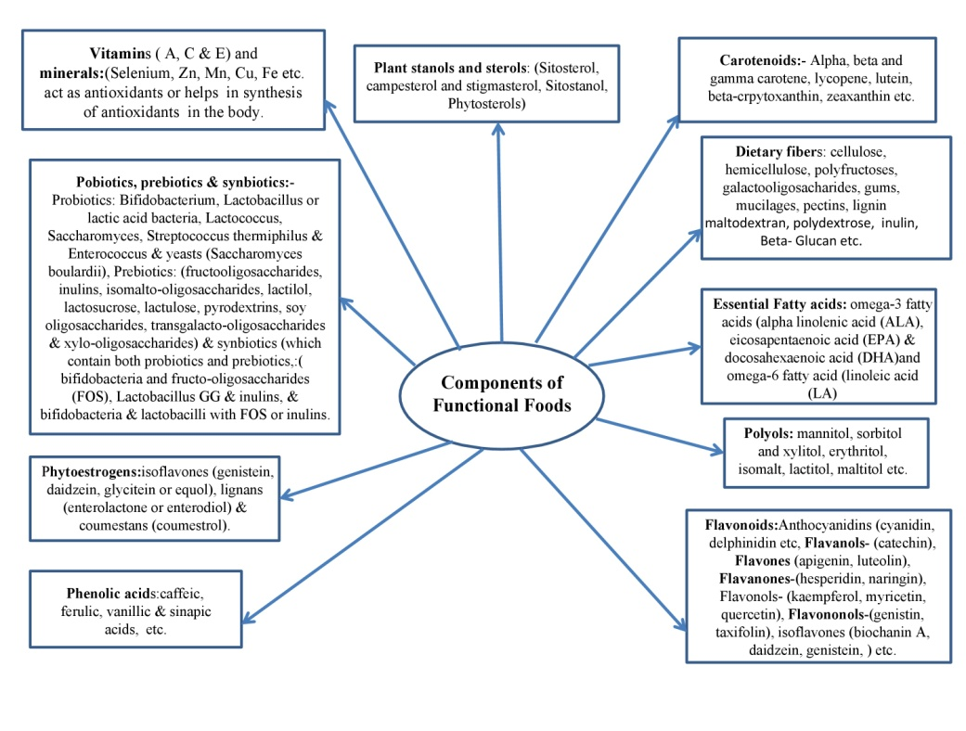
Source: Guine et al. (2011)

Table 1: List of foods and associated functional components
Component | Source | Physiological Role
α and β-carotene | Various types of colourful fruits and vegetables | Neutralize the cell-damaging free radicals
Lutein, Zeaxanthin etc. | Green vegetables (kale, spinach, broccoli, asparagus), corn, carrots | Lowering the likelihood of developing muscle degneration and maintaining eye health
Lycopene | Tomatoes, watermelon, red/pink grapefruit | Reduce the risk of development of prostate cancer
Anthocyanins-  Cyanidin, Pelargonidin, Delphinidin, Malvidin etc. | Fruits like berries, cherries, red grapes etc. | Control neurological and degenerative diseases because of antimicrobial and ant oxidative properties
Flavanols – such as catechins, epicatechins, epigallocatechin etc. | Tea, cocoa, chocolate, apples, grapes etc. | Controls diabetes, obesity, various cardiovascular diseases etc.
Flavones | Fruits and vegetables | Reduce the risk of cancer by neutralizing free radicals
Flavanones: (Hesperetin, Naringenin etc.) | Citrus fruits | Inhibit chronic diseases and neurodegenerative diseases like Alzheimer
Flavonols such as  Quercetin, Kaempferol, Isorhamnetin, Myricetin etc. | Found in onions, apples, tea, broccoli etc. | Neutralize free radicals that could harm cells and maintain the cellular antioxidant defences.
Tannins | Fruits, vegetables, seeds from legumes, grains from cereal, and nuts | Improve urinary tract health and lower the risk of heart disease
Quercetin | Red grapes, onions, cherries, and citrus fruits | Boost liver health and avoid obesity.
Phenolic acids (such as caffeine acid and ferulic acid) | Citrus fruits, some vegetables, whole grains, coffee, apples, pears, blueberries, pomegranates etc. | Lower risk of cardiovascular illness and strengthen neurons
Prebiotics-  Fructooligosaccharides, inulins, isomalto-oligosaccharides, lactilol, lactosucrose, lactulose, pyrodextrins, soy oligosaccharides, transgalacto-oligosaccharides & xylo-oligosaccharides, etc | Fortified foods and beverages, whole grains, millets, onions, some fruits, garlic, honey, and banana | Maintains intestinal health,  improves calcium  absorption, etc.
Bifidobacterium, Lactobacillus, Lactococcus, Saccharomyces, Streptococcus thermiphilus, Enterococcus, yeasts (Saccharomyces boulardii), and other particular types of helpful bacteria are examples of probiotics. | Found in fermented dairy  products like Yogurt and  other non dairy products also | Helpful in maintaining  digestive & immune health,  reduce colon cancer
Isoflavones (genistein, daidzein, glycitein, or equol), lignans (enterolactone or enterodiol), and coumestans (coumestrol) are all examples of phytoestrogens. | Soybeans and soy-based products,  flax, pumpkin, and rye seeds,  as well as triticales and other  seeds and nuts. | Maintain Bone Mineral Density, immune health, cardiovascular system, cognitive functions, supports health of menopausal women etc
Diallyl sulfide, Allyl methyl trisulfide, and dithiolthiones are thiols and sulfides. | Garlic, onions, cruciferous vegetables etc. | Enhance the elimination of harmful substances and aid in maintaining digestive, immunological, and cardiovascular health
Vitamins and minerals | Found in all food groups | Nutritional importance as well as antioxidant properties
Fatty acids: Monounsaturated fatty acids (MUFAs) | Canola oil, olive oil, and tree nuts | Reduce the chance of CHD
Polyunsaturated fatty acids (PUFAs) -Alpha linolenic acid (ALA) and EPA and DHA | Alpha linolenic acid found in walnuts, flaxseeds, flaxseed oil, mustard oil, rice bran oil, etc.  EPA and DHA found in sea foods | supports the maintenance of heart & eye health & cognitive function, maintain antioxidant defence system in body
Dietary Fibre (Soluble & Insoluble) | Peas, beans, apples, citrus fruits, psyllium seed husk, wheat bran, corn bran, fruit peel, etc. | Maintain gut health and lowering the risk of cancer and CHD
Source: Abdel-Aal, et al. (2013); Awika,( 2018); Baldi et al. (2020); Benvenutti et al, (2021); Buscemi., et al. (2018); Choi et al.(2011); Chen et al. (2020); Girard and Granato et al. (2018); Goni et al. (2006) ; Guine et al. (2011); Ilic et al. (2011); Karatas et al, (2017); Khoo et al. (2017); Kozlowska & Wegierek, (2017); ); Lange et al. (2014); Laparra and Sanz, (2010); Li. et al. (2014); Lutz et al. (2019); Montes-Avila et al. (2017); Oakley (2010); Oliveira et al. (2018); Oviasogie et al. (2009); Panche, et al, (2016); Shankar et al. (2015); Rodriguez et al. (2019); Sharma et al. (2019); Silva & Alcorn, (2019); Xia et al. (2020).
1.4: Functional food categories
On the basis of their vast array of health advantages, functional foods have been divided into two categories, conventional food and modified food. Functional foods, which are present in almost all food categories, must be designed with consumer demands in mind. Functional food groups include prebiotics, probiotics, symbiotic foods, isoflavones, phytosterols, anthocyanins, fat- and sugar-reduced foods, antioxidants, and foods with reduced levels of both. However, their distribution across consumer segments is not standardized, and product preferences vary (Siro et al., 2008). Among other food markets, functional foods have mostly been developed in the dairy, confectionery, soft drink, bakery, and baby-food businesses. Fortified foods are made with vitamins and minerals like vitamin C, vitamin E, folic acid, zinc, iron, and calcium. The focus then shifted to foods enriched with different micronutrients, such as soluble fiber, phytosterol, and omega-3 fatty acids, to promote wellness and ward against diseases like cancer (Bigliardi & Galati 2013).
Figure 2: Conventional food and modified food are forms of functional foods.

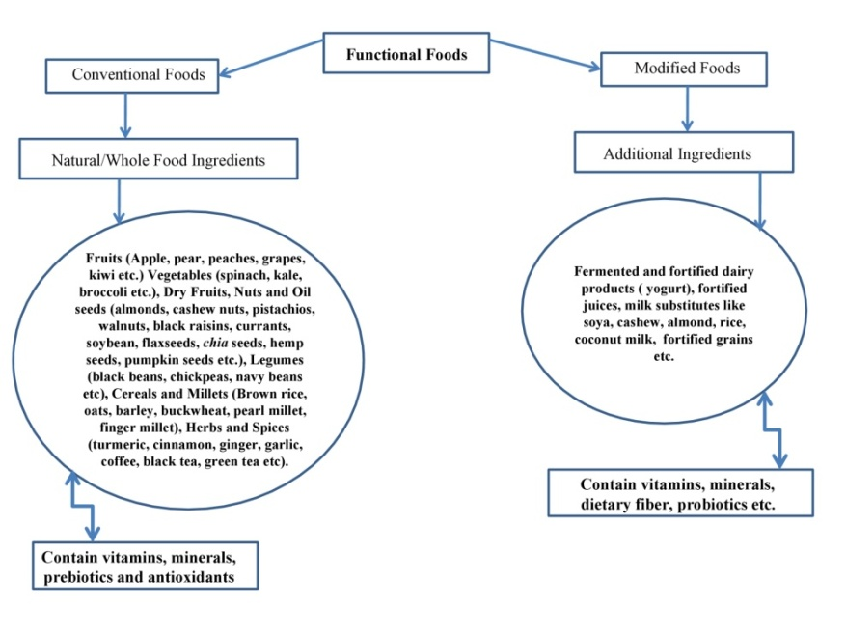
Source: Arshad et al. (2021)
1.5: Health benefits of functional foods
Some people have found it to be an interesting challenge to categorize which foods are considered to have health benefits and which are not, especially since a variety of factors, such as the quantity consumed, foods that are consumed with it, the length of exposure, physiological state, etc., can affect the body's overall response to a food. It is best to say at this time that all foods likely serve some purpose and that, depending on the situation, some may have immediate or long-term advantages.
Figure 3: Health Benefits of Functional Foods
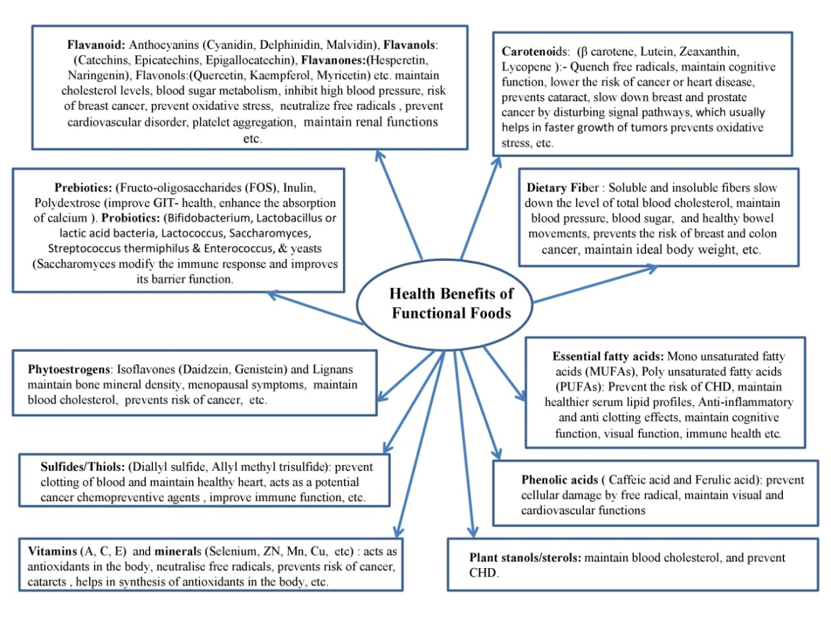Source: Jalgaonkar et al, (2019)
1.6: Classification of functional foods on the basis of origin and mechanism of action
Functional foods are categorized according to their origins, which include plant, animal, microbial, and other sources like algae and mushrooms. Aside from source of origin, the goal of functional foods is to control oxidative stress in the body to manage various degenerative diseases like cardiovascular diseases (CVDs), cancer, immune enhancement, gastrointestinal health, menopausal women's health, early aging, diabetes mellitus, stress, etc.
1.6.1: Plant-Derived Functional Foods
Functional foods which are obtained from plants are categorised into primary and secondary metabolites. Beta-glucans, omega-3 fatty acids, and plant proteins are examples of primary metabolites. Amino acids, soy protein isolate, and texturized vegetable protein are examples of plant proteins. Beta-glucans found in oats acts as functional foods by reducing the absorption of cholesterol. Flaxseed contains omega-3 fatty acids, which work as a functional food by lowering platelet aggregation. Phytoestrogens, antioxidants, vitamins, tocopherols, steroids, gamma-linolenic acid (GLA), and phase II enzyme inducers are examples of secondary metabolites. Soybeans and flaxseed contain phytoestrogens, which operate as functional foods by reducing the occurrence of post-menopausal cancers like breast cancer and managing menopausal symptoms including hot flushes, night sweats, and vaginal dryness (Arai et al., 2016). By squelching reactive oxygen species, antioxidants like anthocyanins serve as functional foods. Vitamins, such as vitamins C and E, which are abundant in fruits and vegetables, also act as quenchers of reactive oxygen species. Oilseeds contain vitamin E molecules called tocopherols, which also act as scavengers of reactive oxygen species. Additionally present in oilseeds, steroids compete with cholesterol for absorption and serve as functional meals. GLA is a fatty acid that contributes to the production of prostaglandins and controls inflammation (Hasler, 2002). Brassica vegetables contain phase II enzyme inducers that work as functional foods by glycosylating insoluble toxins to create soluble chemicals that are excreted. Foods containing phase II enzyme inducers also restrict the phase I enzyme detoxification system, which generates reactive oxygen species, when consumed.
1.6.2: Animal-Derived Functional Foods
Omega-3 and 6 fatty acids, conjugated linolenic acid (CLA), small peptides, whey and casein, glucosamine, and chondroitin sulfate are examples of animal-derived functional foods (Zoochemicals). Alpha-linolenic, docosahexaenoic (DHA), and eicosapentaenoic (EPA) fatty acids come under omega-3 fatty acids. Soy and canola oils, walnuts, and flaxseed are alpha-linolenic acid sources (4). Fatty seafood, particularly salmon, is the main source of EPA and DHA. Linolenic, gamma-linolenic, and arachidonic fatty acids are examples of omega-6 fatty acids (Hasler, 2001). Some vegetable oils, nuts, and whole grains are sources of these fatty acids (Arai, 2005). Omega-3 and omega-6 fatty acids boost immunity, control inflammation, and protect against neurological disorders, acting as functional nutrients. Although a fatty liver could form as a side consequence, CLA, a fatty acid found in milk, functions as a functional food by lowering cancer risks and adipose differentiation (Hassler, 2002). Small peptides perform similarly to whey and casein, milk proteins that operate as functional foods by being readily absorbed and digested and aid in the development of lean muscle mass (Arai et al., 2016).
1.6.3: Microbial Functional Foods
Probiotics, prebiotics, symbiotics, and synbiotics are examples of microbially generated functional foods. Probiotics are healthy, naturally occurring microorganisms that are found in the gut, such as L. casei or other Bifidobacter species (Hassler, 2002).
Prebiotics which assist probiotic bacteria to grow in the gut are known as dietary components. While synbiotics combine specific probiotics and prebiotics to benefit one another, synbiotics combine probiotics and prebiotics at random. In order to inhibit the growth of harmful bacteria, functional foods of microbial origin work by encouraging the growth of probiotic bacteria.
1.6.4: Miscellaneous Functional Foods
Some functional foods are made from various substances, including algae and mushrooms. Algae produce omega-3 fatty acids, which boost immune system, control inflammation, and fend off neurological illnesses. Mushrooms are a source of functional foods with antiviral, antibacterial, and anti-inflammatory activities.
Conclusion
In this way it can be concluded that functional foods obtained from natural sources or modified has a vital role in maintaining human health and wellness. On the basis of various studies it has been observed that functional foods have bioactive components which not only maintain human health but also reduce the risk of various degenerative diseases by suppressing/neutralising formation of free radicals and maintains oxidative stress under control due to antioxidant defence mechanism in the body. Some natural foods like plant based food including fruits, vegetable, nuts and oil seeds, herbs, cereals, millets and beans, seafood for example fish, and fermented and non-fermented dairy products are rich sources of various vitamins, minerals, probiotics, antioxidants, phenolic compound, phytochemicals, phytoestrogens, prebiotics, dietary fibre, monounsaturated and polyunsaturated fatty acids etc where as modified foods are fortified or enriched with various nutrients or non-nutrients having antioxidant properties. Numerous studies have showed that the functional substances present in these meals continue to play a distinct functional role in protecting human health from illnesses.
References
Abuajah, C.I., Ogbonna, A. C., & Osuji, C. M. (2015). Functional components and medicinal properties of food: a review. Journal of food science and technology, 52(5), 2522-2529.
Abdel-Aal, E. S. M., Akhtar, H., Zaheer, K., & Ali, R. (2013). Dietary sources of lutein and zeaxanthin carotenoids and their role in eye health. Nutrients, 5(4), 1169-1185.
Alzamora S M., Salvatori D, Tapia M S, Lopez-Malo A & Chanesc. (2005). Novel functional foods from vegetable matrices impregnated with biologically active compounds, Journal of Food Engineering, 67(1-2), 205-214.
American Dietetic Association. (1999) Position of the American Dietetic Association: functional foods. Journal of the American Dietetic Association, 99:1278–1285
Arai, S. (2005). Perspective functional food science. Journal of the Science of Food Agriculture, 85:1603–1605.
Arai, S., Vattem, D.A., & H. Kumagai, H. (2016). Functional Foods-History and Concepts. Functional foods, nutraceuticals and natural products. 1-18.
Arshad, M.S.; Khalid, W.; Ahmad, R.S.; Khan, K.M.; Ahmad, M.H.; Safdar, S.; Kousar, S.; Munir, H.; Shabbir, U.; Zafarullah, M.; Nadeem, M.; Zubia Asghar, Z. & Suleria H.A.R. (2021). Functional Foods and Human Health: An Overview, Functional Foods-Phytochemicals and Health Promoting Potential, pp-1-14 doi: http://dx.doi.org/10.5772/intechopen.99000.
Baldi A., Abramovic H., Poklar Ulrih N. and Daglia M. (2020) Tea Catechins. In: Xiao J., Sarker S., Asakawa Y. (eds) Handbook of Dietary Phytochemicals. Springer, Singapore.
Benvenutti, L.; Zielinski, A.A.F.; Ferreira, S.R.S. (2021). ‘Jaboticaba (Myrtaceae cauliflora) fruit and its byproducts: Alternative sources for new foods and functional components’. Trends in Food Science & Technology 112, 118-136.doi:10.1016/j.tifs.2021.03.044.
Bigliardi, B., & Galati, F. (2013). Innovation trends in the food industry: The case of functional foods. Trends in Food Science & Technology, 31(2), 118-129.
Buscemi, S., Corleo, D., Di Pace, F., Petroni, M. L., Satriano, A., & Marchesini, G. (2018). The effect of lutein on eye and extra-eye health. Nutrients, 10(9), 1321.
Caliskanturk Karatas, S.; Gunay, D.; Sayar, S. (2017). ‘In vitro evaluation of whole faba bean and its seed coat as a potential source of functional food components’, Food Chemistry 230, 182–188. doi: 10.1016/ j.foodchem.2017.03.037.
Cartea, M. E., Francisco, M., Soengas, P., & Velasco, P. (2011). Phenolic compounds in Brassica vegetables. Molecules, 16(1), 251-280.
Choi, S. H., Kim, D. H., & Kim, D. S. (2011). Comparison of ascorbic acid, lycopene\beta-carotene and alpha-carotene contents in processed tomato products, tomato cultivar and part. Culinary science and hospitality research, 17(4), 263-272.
Committee on Opportunities in the Nutrition and Food Sciences, (1994). Food and Nutrition Board, Institute of Medicine.
Chen, D., Ding,Y., Chen, G., Sun, Y., Zeng, X., Ye., H. (2020) Components identification and nutritional value exploration of tea (Camellia sinensis L.) flower extract: Evidence for functional food. Food Research International 132, 109100. doi: 10.1016/ j.foodres.2020.109100.
Crowe, K. M., & Francis, C. (2013). Position of the academy of nutrition and dietetics: functional foods. Journal of the Academy of Nutrition and Dietetics, 113(8), 1096-1103
De Silva, S. F., & Alcorn, J. (2019). Flaxseed lignans as important dietary polyphenols for cancer prevention and treatment: Chemistry, pharmacokinetics, and molecular targets. Pharmaceuticals, 12(2), 68.
Dutt, S., Manjul, A. S., Chauhan, M., Changan, S. S., Raigond, P., Singh, B., & Chakrabarti, S. K. (2019). Biotechnology for nutritional and associated processing quality improvement in potato. Nutritional Quality Improvement in Plants (pp. 429-483). Springer, Cham.
Girard, A.L. and Awika, J.M. (2018). ‘Sorghum polyphenols and other bioactive components as functional and health promoting food ingredients’. Journal of Cereal Science. pp.112–124. doi: 10.1016/j.jcs.2018.10.009.
Goldberg I. (1994). Functional Foods: Designer Foods, Pharmafoods, and Nutraceuticals. An Aspen Publication, Chapman and Hall, London, UK. pp. 3-4.
Goni, I., Serrano, J., & SauraCalixto, F. (2006). Bioaccessibility of β-carotene, lutein, and lycopene from fruits and vegetables. Journal of agricultural and food chemistry, 54(15), 5382-5387.
Granado-Lorencio, F., & Hernandez Alvarez, E. (2016). Functional foods and health effects: a nutritional biochemistry perspective. Current Medicinal Chemistry, 23(26), 2929-2957.
Granato, D.Santos., J.S., Escher., G. B., Ferreira., B.L. & Maggio., R.M. (2018). ‘Use of principal component analysis (PCA) and hierarchical cluster analysis (HCA) for multivariate association between bioactive compounds and functional properties in foods: A critical perspective’. Trends in Food Science and Technology. Elsevier, Ltd, pp.83–90. doi: 10.1016/j.tifs.2017.12.006.
Guine, R.; Lima, M.J.; Barroca, M.J. (2011) ‘Role and health benefits of different functional food components’. International Journal of Medical and Biological Frontiers ,17
Hasler, C. (2002). Funtional Foods: benefits, concerns and challenges-a position paper from the American Council on Science and Health. J Nutr. 132:3772–3781
Hasler, C. (2002). Funtional Foods: benefits, concerns and challenges-a position paper from the American Council on Science and Health. The Journal of Nutrition. 132:3772–3781.
Hasler, C.M. (2001). Functional Foods. In: Bowman, B.A., Russell, R.M., editors. Present Knowledge in Nutrition. Washington (DC): ILSI Press.
Henson S, Masakure O and Cranfield J, (2008). The propensity for consumers to offset health risks through the use of functional foods and nutraceuticals: The case of lycopene, Food Quality Prefer, 19(4), 395-406.
Ilic, D., Forbes, K. M., & Hassed, C. (2011). Lycopene for the prevention of prostate cancer. Cochrane database of systematic reviews, (11).
Jalgaonkar, K.; Mahawar, M.K.; Bibwe, B.; Nath, P. and Girjal, S. (2019). Nutraceuticals and Functional Foods, Trends & Prospects in Processing of Horticultural Crops. 231-250.
Kozlowska, A., & SzostakWegierek, D. (2017). Flavonoids-food sources, health benefits, and mechanisms involved. “Bioactive Molecules in Food”. Springer. Cham, 1-27.
Khoo, H. E., Azlan, A., Tang, S. T., & Lim, S. M. (2017). Anthocyanidins and anthocyanins: colored pigments as food, pharmaceutical ingredients, and the potential health benefits. Food & nutrition research, 61(1), 1361779.
Lange, M. (2014). ‘Determining Functional Properties and Sources of Recently Identified Bioactive Food Components: Oligosaccharides, Glycolipids, Glycoproteins, and Peptides’, in Encyclopedia of Agriculture and Food Systems. Elsevier, pp.441–461. doi: 10.1016/B978-0-444-52512-3.00067-X.
Laparra, J.M.; Sanz, Y. (2010). ‘Interactions of gut microbiota with functional food components and nutraceuticals’, Pharmacological Research. Academic Press, pp.219–225. doi: 10.1016/j.phrs.2009.11.001.
Li, S., Wang, Z., Ding, F., Sun, D., Ma, Z., Cheng, Y., & Xu, J. (2014). Content changes of bitter compounds in ‘Guoqing No. 1’Satsuma mandarin (Citrus unshiu Marc.) during fruit development of consecutive 3 seasons. Food chemistry, 145, 963-969.
Lutz, M., Fuentes, E., Avila, F., Alarcon, M., & Palomo, I. (2019). Roles of phenolic compounds in the reduction of risk factors of cardiovascular diseases. Molecules, 24(2), 366.
Mac Aulay, J., Petersen, B., & Shank, F. (2005). Functional foods: Opportunities and challenges. Institute of Food Technologists (IFT) Expert Report. Institute of Food Technologists.
Martirosyan, D. M., & Singharaj, B. (2016). Health claims and functional food: The future of functional foods under FDA and EFSA regulation. Functional Foods for Chronic Diseases; Food Science Publisher: Dallas, TX, USA, 410-424
Martirosyan, D., & Pisarski, K. (2017). Bioactive compounds: Their role in functional food and human health, classifications, and definitions. Bioactive Compounds and Cancer. Edited by Danik Martirosyan and Jin-Rong Zhou. San Diego: Food Science Publisher, 238-277.
Mezzomo, N., & Ferreira, S. R. (2016). Carotenoids functionality, sources, and processing by supercritical technology: a review. Journal of Chemistry.
Montes-Avila, J., Lopez-Angulo, G., & Delgado-Vargas, F. (2017). Tannins in fruits and vegetables: chemistry and biological functions. Fruitand Vegetable Phytochemicals, 221-268.
Oakley, G.P. (2010). ‘Global prevention of all folic acidpreventable spina bifida and anencephaly by 2010’. Community Genetics 5 (1), 70-77. doi: 10.1159/000064633.
Oliveira, A.; Amaro, A.L.; Pintado, M. (2018). ‘Impact of food matrix components on nutritional and functional properties of fruit-based products’. Current Opinion in Food Science.153-159.doi: 10.1016 / j.cofs.2018.04.002.
Oviasogie, P. O., Okoro, D., & Ndiokwere, C. L. (2009). Determinationof total phenolic amount of some edible fruits and vegetables. African journal of biotechnology, 8(12).
Panche, A. N., Diwan, A. D., & Chandra, S. R. (2016). Flavonoids: an overview. Journal of nutritional science, 5.
Rodriguez-Garcia, C., Sanchez Quesada, C., Toledo, E., Delgado Rodriguez, M., & Gaforio, J. J. (2019). Naturally lignan-rich foods: a dietary tool for health promotion. Molecules, 24(5), 917.
Shankar, G. M., Antony, J., & Anto, R. J. (2015). Quercetin and tryptanthrin: two broad spectrum anticancer agents for future chemotherapeutic interventions. In The enzymes (Vol. 37, pp. 43-72). Academic Press.
Sharma, K., Kumar, V., Kaur, J., Tanwar, B., Goyal, A., Sharma, R., & Kumar, A. (2019). Health effects, sources, utilization and safety of tannins: A critical review. Toxin Reviews, 1-13.
Shimizu, T. (2003). Health claims on functional foods: the Japanese regulations and an international comparison. Nutrition research reviews, 16(2), 241-252.
Siro, I., Kapolna, E., Kapolna, B., & Lugasi, A. (2008). Functional food. Product development, marketing, and consumer acceptance-A review. Appetite, 51(3), 456-467.
Xia, T., Zhang, B., Duan.,W.Zhang., J &Wang., M. (2020). ‘Nutrients and bioactive components from vinegar: A fermented and functional food’. Journal of Functional Foods. p.103681. doi: 10.1016/j.jff.2019.103681.
Weststrate J.A., Poppel GV, Verschuren PM. (2002).Functional foods, trends, and future. British Journal of Nutrition. 88: S233-S235.

