TOPIC: Use of artificial intelligence and machine learning for crop management
Author Name: Danish Gul¹ and Nuzhat Bint Nazir²
¹M.Tech Farm Machinery & Power Engineering, COAE&T, SKUAST KASHMIR
²Ph.D Soil and Water Conservation Engineering, COAE&T, SKUAST-KASHMIR
Introduction
Agriculture is one of the oldest and most significant economic sectors is agriculture. It is the source of food, fibre, and fuel for the world's population. Agriculture provides employment to a large number of people and contributes significantly to the global economy. However, the sector is facing several challenges such as climate change, soil degradation, water scarcity, and pest and disease outbreaks. These challenges have led to a decline in crop yields and increased food insecurity.
The use of technology has the potential to revolutionize the way we manage crops and address the challenges faced by the agriculture sector. One such technology is artificial intelligence (AI) and machine learning (ML). AI is the simulation of human intelligence processes by machines, computers which includes reasoning, learning and self-correction. ML is a subset of AI that involves the use of algorithms and statistical models to perform a specific task without being explicitly programmed. AI has begun to play a major role in day to day life, extending our ability and perceptions to modify the environment around us (Kundalia et al., 2020; Gandhi et al., 2020; Ahir et al., 2020). To determine various important parameters like weed detection, yield detection and crop quality and many other techniques, various hi-tech computer based systems are designed (Liakos et al., 2018).
AI and ML can be used in crop management to analyse large volumes of data and extract meaningful insights. This information can be used to optimize the use of resources such as water, fertilizers, and pesticides, reduce costs, and increase yields. In this chapter, we will explore the use of AI and ML in crop management. In nations like India, the agricultural industry contributes 18% of the country's GDP and employs 50% of the workforce. Rural development will be boosted by agricultural sector development, which will then lead to rural transformation and ultimately resulting in structural transformation (Mogili and Deepak, 2018; Shah et al., 2019).
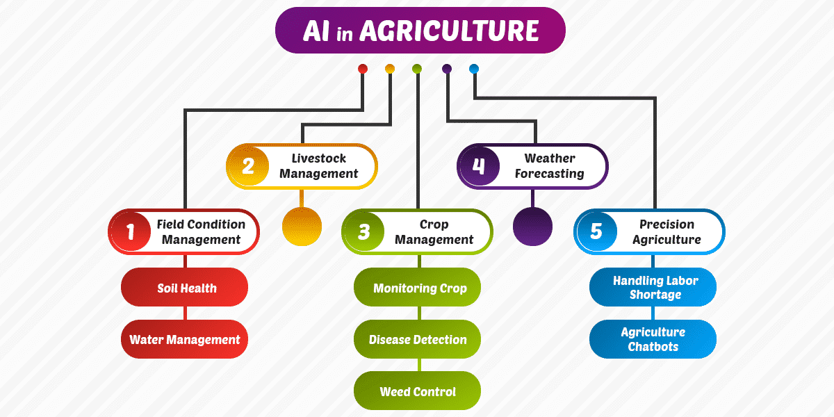
Figure 1: Artificial intelligence (AI) in agriculture.

Importance of Crop Management
Crop management is crucial for maintaining healthy crops and maximizing yields. Effective crop management involves a range of activities, including soil preparation, planting, irrigation, fertilization, pest and disease control, and harvest. Each of these activities requires careful planning, monitoring, and adjustment to ensure optimal crop growth and yield. The use of advanced technology, such as artificial intelligence and machine learning, can help farmers optimize their use of resources, reduce costs, and increase yields. By adopting effective crop management practices, farmers can not only ensure food security and economic sustainability, but also contribute to the global effort to address climate change and environmental degradation.

Predictive Analytics
One of the most significant advantages of AI and ML in crop management is the ability to use predictive analytics. AI algorithms can use historical weather data, soil information, and crop characteristics to predict future crop yields, disease outbreaks, and nutrient deficiencies. This information can help farmers make informed decisions about when to plant, how much water to use, and what fertilizers to apply. Predictive analytics can also help farmers identify areas of the field that may require additional attention and resources.
Weather Forecasting
Weather forecasting plays a critical role in crop management. Accurate predictions of temperature, rainfall, and other weather variables can help farmers make informed decisions about irrigation, fertilization, and other management practices. The use of artificial intelligence (AI) and machine learning (ML) can greatly improve the accuracy of weather forecasting and enable more precise crop management. AI and ML algorithms can be trained on large datasets of weather data to identify patterns and predict future conditions. These algorithms can take into account a range of variables, including temperature, humidity, wind speed, and precipitation, to provide more accurate and precise forecasts.
One of the primary advantages of using AI and ML for weather forecasting is the ability to provide real-time updates. This allows farmers to adjust their management practices in response to changing weather conditions, such as applying irrigation in advance of a drought or delaying planting in anticipation of heavy rainfall. Another advantage is the ability to provide more localized forecasts. Traditional weather forecasts may provide information for a broad region, but AI and ML algorithms can provide forecasts for specific fields or even individual plants. This can allow farmers to make more targeted management decisions, such as adjusting irrigation rates for areas of a field that are experiencing drought stress.
However, there are also some challenges and limitations to the use of AI and ML for weather forecasting in crop management. One of the primary challenges is the availability of data. While there are many sources of weather data, such as satellite imagery and weather stations, there may be gaps in coverage or inconsistencies in the data that can impact the accuracy of forecasts.
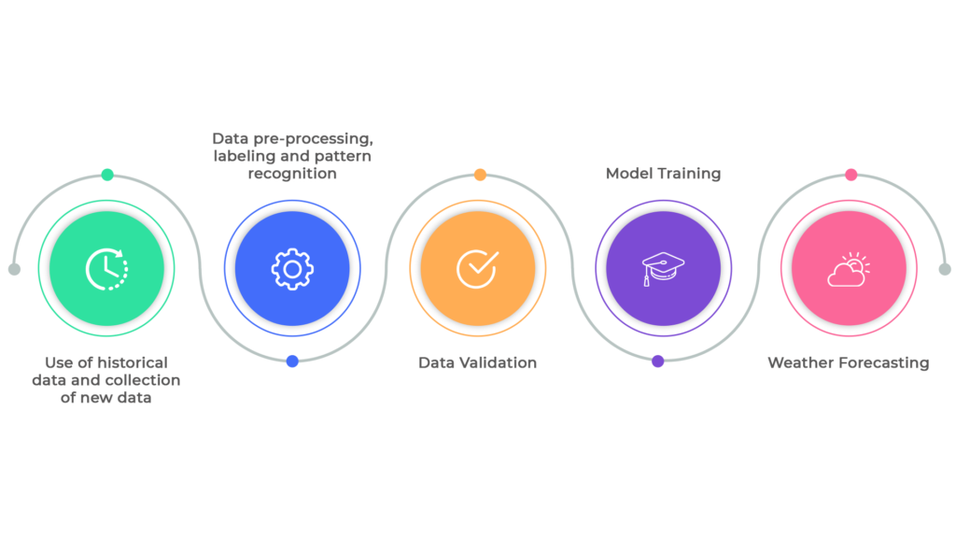
Figure 2: Weather forecasting by using AI and ML Algorithm.

Disease Outbreaks
Disease outbreaks can have a significant impact on crop yields. AI and ML algorithms can analyze historical data on disease outbreaks to predict the likelihood of future outbreaks. These algorithms can also analyze real-time data from sensors placed in the field to detect the early signs of disease outbreaks, allowing farmers to take corrective action before they become major issues.
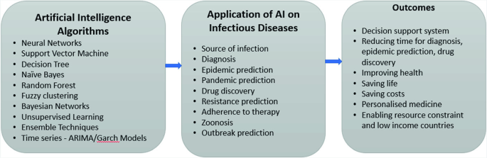
Figure 3: AI for infectious diseases.

Nutrient Deficiencies
Nutrient deficiencies can also impact crop growth and yield. AI and ML algorithms can analyze soil data to identify areas of the field that may be deficient in nutrients. This information can help farmers optimize their use of fertilizers and reduce the risk of nutrient runoff.
Precision Farming
Precision farming is an approach to crop management that utilizes advanced technologies such as artificial intelligence (AI) and machine learning (ML) to improve the efficiency and effectiveness of agricultural practices. Precision farming involves collecting and analyzing data on various aspects of crop production, such as soil moisture, plant health, and weather conditions, in order to make informed management decisions.
One of the primary advantages of precision farming is the ability to apply inputs, such as fertilizers and pesticides, more precisely and efficiently. By analyzing data on soil nutrient levels and crop growth patterns, AI and ML algorithms can recommend the optimal amount and timing of inputs to maximize yield while minimizing waste and environmental impact. Another advantage of precision farming is the ability to tailor management practices to the specific needs of each crop or field. By collecting and analyzing data on plant health and growth patterns, AI and ML algorithms can identify areas of a field that require more or less irrigation, fertilization, or other inputs. This allows farmers to adjust their management practices in real time to optimize crop health and yield.
Precision farming also has the potential to reduce labor costs and increase productivity. By automating tasks such as irrigation and fertilizer application, farmers can save time and resources while still achieving optimal yields.
Drones and Sensors
Drones and sensors are increasingly being used in conjunction with artificial intelligence (AI) and machine learning (ML) to improve crop management. Drones equipped with high-resolution cameras and sensors can capture detailed data on crop health, soil moisture, and other variables. This data can then be analyzed by algorithms to provide real-time insights and recommendations for farmers. One of the primary advantages of using drones and sensors for crop management is the ability to gather data at a much higher resolution than traditional methods. This allows for more accurate and precise management decisions. For example, drones can capture images of crops at a very high resolution, allowing algorithms to detect even minor variations in plant health or the presence of pests and diseases. Sensors can also provide real-time data on a range of variables, including temperature, humidity, and soil moisture. This data can be used to optimize irrigation and fertilizer application, reducing waste and improving yields. In coming years, the agricultural drone market is expected to grow over 38%. Due to increasing population levels and changing climate patterns, it is believed that the need for efficient agriculture is going to become more important. (Puri et al., 2017).
AI and ML algorithms can be used to analyze this data and provide recommendations for crop management. For example, algorithms can identify areas of a field that are experiencing stress or are at risk of pest infestation, allowing farmers to take targeted action. Algorithms can also be used to predict crop yields and optimize planting times based on weather and soil conditions. While the use of drones and sensors for crop management has many advantages, there are also some challenges and limitations. Data management is one of the primary challenges. Collecting and analyzing large amounts of data can be time-consuming and costly. In addition, there may be limitations to the types of data that can be collected in certain environments or regions, which can impact the accuracy of algorithms. Another challenge is the need for specialized expertise to develop and implement these systems. Farmers and other stakeholders may not have the technical skills or resources necessary to implement these technologies on their own, which could limit their adoption.
Overall, the use of drones and sensors in combination with AI and ML has the potential to revolutionize the way we manage crops. While there are challenges to overcome, continued research and development in this area could lead to more effective and sustainable crop management practices.
Crop Monitoring
Machine learning algorithms can analyze satellite imagery to detect changes in crop health, growth, and yield. This information can help farmers identify potential problems early on and take corrective action before they become major issues. Crop monitoring can also help farmers optimize their use of resources, reduce costs, and increase yields.
Pest Management
Pest management is a critical component of crop management, and the use of artificial intelligence (AI) and machine learning (ML) is an increasingly important tool in this area. Pest infestations can cause significant damage to crops and reduce yields, leading to economic losses for farmers and food shortages for consumers. Traditional pest management methods often rely on the use of chemical pesticides, which can have negative impacts on the environment and human health. AI and ML can provide an alternative approach to pest management, using data and algorithms to identify and respond to pest threats in real-time. One of the primary advantages of using AI and ML for pest management is the ability to detect pest infestations early. By analyzing data from sensors, drones, and other sources, algorithms can detect changes in plant health and identify potential pest threats before they become widespread. This early detection allows farmers to respond more quickly and effectively, reducing the need for costly and environmentally harmful pesticide applications.
Another advantage of using AI and ML for pest management is the ability to tailor treatments to specific pest species and environments. By analyzing data on pest populations and environmental conditions, algorithms can recommend targeted pest management strategies that are more effective and less harmful to non-target species. This precision approach can help reduce the overall use of pesticides and minimize the risk of unintended consequences. Despite these advantages, there are also some challenges and limitations to using AI and ML for pest management. One of the primary challenges is data quality. Accurate and reliable data is critical for effective pest management, but collecting and analyzing this data can be expensive and time-consuming. In addition, there may be limitations to the types of data that can be collected in certain environments or regions, which can impact the accuracy of algorithms. Another limitation is the need for specialized expertise to develop and implement AI and ML systems for pest management. Farmers and other stakeholders may not have the technical skills or resources necessary to implement these technologies on their own, which could limit their adoption.
Overall, the use of AI and ML for pest management has the potential to revolutionize the way we manage pests in agriculture. While there are challenges and limitations to overcome, continued research and development in this area could lead to more effective, sustainable, and environmentally friendly pest management practices.
Harvest Optimization
AI and ML can help farmers optimize the timing of their harvest by analyzing weather patterns, soil moisture levels, and other factors that affect crop growth and can help farmers to maximize their yields and reduce waste. Harvest optimization can also help farmers reduce labor costs and increase profits.
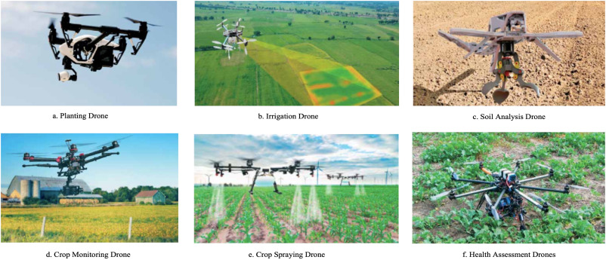
Figure 4. Types of agricultural drones (Unpaprom et al., 2018)
Challenges and Limitations
While the use of artificial intelligence and machine learning in crop management offers numerous benefits, there are also several challenges and limitations that must be considered. Availability and quality of data are the primary challenges. AI and ML algorithms rely on large amounts of data to generate accurate predictions and insights. However, in many regions, data is scarce, incomplete, or of poor quality. This can limit the effectiveness of AI and ML in crop management, as algorithms may be inaccurate or fail to identify key insights. Additionally, the cost of data collection and analysis can be a significant barrier, particularly for small-scale farmers who may lack the resources to invest in advanced technology.
Another challenge is the need for specialized expertise to develop and implement AI and ML systems. Developing algorithms and models requires specialized knowledge in fields such as data science, statistics, and computer programming. As such, many farmers may lack the necessary expertise to effectively develop and implement AI and ML systems. Additionally, there is a need for ongoing training and education to ensure that farmers and other stakeholders are able to effectively use these tools.
The cost of implementing AI and ML systems is another limitation. While the cost of technology is decreasing, implementing these systems can still be expensive. This may be a significant barrier for small-scale farmers who may lack the financial resources to invest in advanced technology. Additionally, the cost of maintenance and repair can be high, particularly in regions where access to technical support is limited.
Another challenge is the need for transparency and accountability in the use of AI and ML in crop management. There is a risk that these technologies could be used to exploit small-scale farmers or exacerbate existing inequalities. As such, there is a need for greater transparency and accountability in the use of these technologies to ensure that they are used ethically and in a way that benefits all members of value chain of agriculture.
Case Studies
There are several examples of how AI and ML are being used in crop management. One such example is the partnership between The Climate Corporation and John Deere. The two companies are working together to develop a platform that uses AI and ML to provide farmers with insights on planting, harvesting, and other aspects of crop management. Another example is the use of AI-powered sensors in vineyards to monitor water and nutrient levels and predict grape yields.
Future Directions
The use of artificial intelligence and machine learning in crop management is still in its early stages, and there are many exciting directions for future research and development. Here are some potential areas for future growth and innovation:

- Integration with Precision Agriculture: The integration of AI and ML with precision agriculture could revolutionize crop management. Precision agriculture relies on sensor technologies and other data sources to map soil properties, monitor plant growth, and detect pests and diseases. By integrating AI and ML with precision agriculture, farmers could receive real-time recommendations on optimal planting times, fertilizer applications, and pest and disease management.

- Improved Data Management: As mentioned earlier, data quality is critical for AI and ML to be effective in crop management. Future research could focus on improving data quality and management to ensure that algorithms have access to accurate and reliable information.

- Development of User-Friendly Interfaces: While AI and ML can provide powerful insights, the complexity of these technologies can be a barrier for farmers and other stakeholders. Future research could focus on developing user-friendly interfaces that make it easier for farmers to use these tools and access actionable insights.
- Integration with Crop Breeding: AI and ML could be used to accelerate crop breeding programs, allowing researchers to identify and develop new varieties more quickly. This could be particularly important in regions facing climate change or other environmental challenges.
- Expansion to New Crops and Regions: While AI and ML have been used primarily in staple crops such as maize, wheat, and rice, there is potential to expand these technologies to other crops and regions. Future research could explore how AI and ML could be used in specialty crops or in regions with unique agricultural challenges.
- Ethical Considerations: As the use of AI and ML in crop management expands, there will be a need to ensure that these technologies are used ethically and in a way that benefits all members of the agriculture value chain. Future research could focus on developing ethical guidelines and frameworks for the use of these technologies.
Overall, the future of AI and ML in crop management is exciting and full of potential. Continued research and development could lead to more efficient and sustainable agricultural practices, ultimately benefiting farmers, consumers, and the environment.
Conclusion
The use of artificial intelligence and machine learning in crop management is a rapidly growing field that offers a wide range of benefits to farmers and the agriculture sector as a whole. The implementation of these technologies has the potential to significantly improve crop yields, optimize the use of resources, and increase economic sustainability while contributing to the fight against climate change and environmental degradation.
One of the major benefits of using AI and ML in crop management is the ability to analyze vast amounts of data quickly and accurately. This can include weather patterns, soil quality, crop growth rates, and pest and disease infestations. By leveraging this data, farmers can make informed decisions about when to plant, fertilize, irrigate, and harvest crops. This, in turn, can increase efficiency, reduce waste, and minimize the use of expensive inputs such as fertilizers and pesticides.
Another significant benefit of using AI and ML in crop management is the ability to perform predictive analytics. By analysing historical data and identifying patterns, algorithms can predict future crop yields, identify areas of potential risk, and optimize crop management practices accordingly. This can help farmers plan for the future, mitigate risk, and maximize yields.
Precision farming is another area where AI and ML can be particularly useful. By utilizing sensors, drones, and other advanced technology, farmers can collect real-time data about their crops and make adjustments accordingly. For example, drones can be used to monitor crop growth rates, identify areas of drought stress, and deliver targeted irrigation. This level of precision can significantly increase efficiency and reduce waste.
However, the implementation of AI and ML in crop management is not without challenges, lack of data is one the main challenges. While there is a wealth of data available, it is often fragmented and not easily accessible. In addition, the cost of implementing these technologies can be prohibitive for small farmers, particularly in developing countries. There is also a need for greater collaboration between stakeholders to ensure that the technology is used ethically and in a way that benefits all members of the agriculture value chain.
Despite these challenges, the use of AI and ML in crop management has the potential to significantly improve the sustainability and efficiency of agriculture. This can not only benefit farmers, but also contribute to the global effort to address climate change and reduce the environmental impact of agriculture. By using technology to optimize the use of resources, reduce waste, and increase yields, we can work towards a more sustainable and food-secure future for all.
The implementation of AI and ML in crop management is a rapidly growing field that offers significant benefits to farmers and the agriculture sector as a whole. By leveraging data and advanced technology, farmers can optimize their use of resources, reduce waste, and maximize yields. While there are challenges to overcome, such as the lack of data and the cost of implementation, we can expect these technologies to play an increasingly important role in agriculture in the future. As we work towards a more sustainable and food-secure future, the use of AI and ML in crop management will be an important tool in our toolkit.
References:
- Ahir, K., Govani, K., Gajera, R., & Shah, M. (2020). Application on virtual reality for enhanced education learning, military training and sports. Augmented Human Research, 5, 1-9.
- Gandhi, M., Kamdar, J., & Shah, M. (2020). Preprocessing of non-symmetrical images for edge detection. Augmented Human Research, 5, 1-10.
- Kundalia, K., Patel, Y., & Shah, M. (2020). Multi-label movie genre detection from a movie poster using knowledge transfer learning. Augmented Human Research, 5, 1-9.
- Liakos, K. G., & PatriziaBusato, D. Simon Pearson, and DionysisBochtis.(2018).". Machine learning in agriculture: A review." Sensors, 18.
- Mogili, U. R., & Deepak, B. B. V. L. (2018). Review on application of drone systems in precision agriculture. Procedia computer science, 133, 502-509.
- Puri, V., Nayyar, A., & Raja, L. (2017). Agriculture drones: A modern breakthrough in precision agriculture. Journal of Statistics and Management Systems, 20(4), 507-518.
- Shah, G., Shah, A., & Shah, M. (2019). Panacea of challenges in real-world application of big data analytics in healthcare sector. Journal of Data, Information and Management, 1, 107-116.
- Unpaprom, Y., Ramaraj, R., & Dussadeeb, N. (2018). Modern Agriculture Drones The Development of Smart Farmers.

