Significance of Artificial Intelligence in Critical Care Medicine

Author- Dr Abhimanyu Bhatia, MD (Head and Consultant, Department of Critical Care Medicine, Saroj Hospital ,New Delhi)
Dr Pulkit Bansal, MBBS
Dr Aneesha Bhardwaj, MBBS
Dr Chinmaya Manchanda, MBBS

Introduction
Critical care refers to the medical treatment provided to individuals with life-threatening injuries who are admitted to an intensive care unit (ICU).It comprises of life-threatening injuries which range from diseases like sepsis, heart conditions, burns,traumaand various other problems.
Artificial intelligence (AI) refers to systems or machines that replicate intelligence to carry out tasks and possess the ability to enhance their performance iteratively through the data they gather. ¹.
In general, AI is referred to as the “field of science” as well as engineering and deals with thecomputational understanding of intelligence or intelligent behavior with the formation ofartefacts that impart such behaviors. (Alsheibani et.al. 2018); (Guan, 2019).¹

“AI is a multidisciplinary concept that incorporates principles and tools from various fields such as computing, mathematics, logic, and biology. It is employed to address the challenges of emulating and comprehending intelligence while executing cognitive tasks with minimal human intervention (Guan 2019). In healthcare, AI systems excel due to their sophisticated algorithms, enabling them to learn numerous features from vast healthcare datasets, facilitating problem-solving, and achieving results at a speed and scale unattainable for humans.¹
There are many potential applications in the intensive care unit (ICU)particularly, given the large amounts of data collected routinely.²With growing science and technology,there has been rapid advancement in timely diagnosis and treatmentsemployed in healthcare. Since AI has evolved, it can transform the face of medicine in a remarkable manner.

Types of A.I.
AI is a combination of various technologies which are integrated together and hence helps? the user to reach a calculated decision.
The various types of technologies available are detailed as follows:
- Machine Learning: neural networks and deep learning
Machine learning, a statistical method, stands out as one of the frequently employed forms of AI. In precision medicine, traditional machine learning finds extensive application. It proves advantageous in evaluating a patient's precise condition by considering their unique characteristics and medical history, subsequently estimating the appropriate treatment procedure.^{1,3,4}

- Natural Language Processing or NLP¹
NLP leverages unstructured healthcare data stored within electronic health record systems, with its primary role being the conversion of data into a format that is both usable and analyzable. Through NLP, patient records are thoroughly examined, and pertinent information, such as prescriptions, medication plans, and medical conditions, is extracted. AI is employed in the development of NLP algorithms to facilitate the assimilation and organization of clinical documents.
- Rule-based expert systems
These rules are established by various electronic health record (EHR) systems. The rule-based expert system engages data scientists in an effort to emulate human-like reasoning.^{1,4,5}

- Artificial Neural Networking
Artificial Neural Networks (ANN) refer to computational simulations inspired by the human brain. In ANN, AI advancements encompass voice recognition, image analysis, and robotics recognition. ANN primarily aims to replicate the functions of human brain neurons through the utilization of neural network algorithms and establishing correlations between datasets, akin to the human brain.^{1,5,6}

- Clinical Decision Support System (CDSS)
The primary objective of CDSS is to achieve precise disease diagnosis by leveraging past patient data, often through the use of web applications or integration with electronic health records (EHR) and computerized provider order data (CPOE) systems..^{1,5,7}

Advantages & Disadvantages of AI

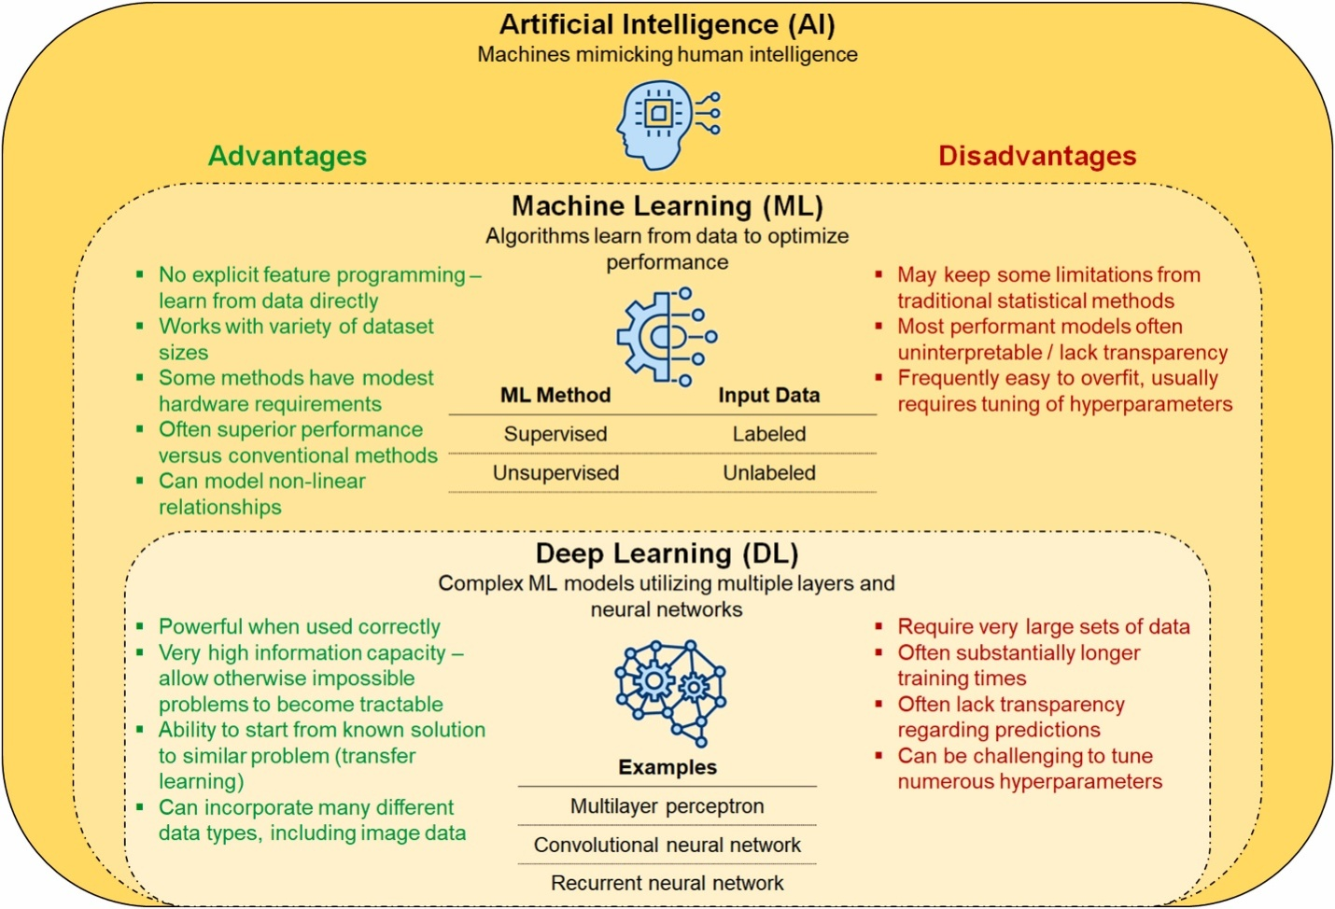

Jacob C. Jentzer, Anthony H. Kashou, Dennis H. Murphree, Clinical applications of artificial intelligence and machine learning in the modern cardiac intensive care unit, Intelligence-Based Medicine, Volume 7,2023,100089,ISSN 2666-5212.

AI Applications in Critical Care Medicine

AI has the potential to mitigate inter-clinician variability while providing additional advantages. AI's strength lies in identifying intricate relationships within extensive datasets, allowing it to efficiently and simultaneously analyze numerous variables to forecast specific outcomes, such as sepsis or mortality.

The contemporary ICU setting is abundant in data, creating a conducive environment for the advancement of more precise predictive models, enhanced decision support tools, and increased customization of patient care.⁹

While the implementation of machine learning in the ICU is still in its early stages, a number of studies have already been conducted, illustrating its use in the treatment of critically ill patients. Some of these studies have utilized extensive population datasets to forecast parameters like length of stay, ICU readmissions, mortality rates, and the likelihood of developing medical complications like sepsis and ARDS. Additionally, other investigations have focused on smaller datasets comprising clinical and physiological information to assist in the monitoring of patients receiving ventilatory support.¹⁰

Prediction of Length of Stay
Houthooft et al. deduced that for the prediction of patient mortality and extended stays, the most effective model is a support vector machine (SVM) with a GA,D of 65.9% (area under the curve (AUC) of 0.77) and GS,L of 73.2% (AUC of 0.82). Concerning the regression of length of stay (LOS), the most proficient model is support vector regression, achieving a mean absolute error of 1.79 days and a median absolute error of 1.22 days for patients who do not experience a prolonged stay. This leads to the conclusion that utilizing a classification grid based on the predicted patient mortality and extended stay enables a more precise modeling of patient length of stay. These comprehensive models provide valuable support for medical decisions in an ICU environment.¹¹

Yu-weilin et al. tackled the issue of predicting unplanned ICU readmissions by incorporating chart events, demographics, and ICD-9 embeddings features. Their machine learning approach for ICU readmission prediction demonstrates improved accuracy and sensitivity when compared to existing solutions. Moreover, the model's flexibility in having multiple operating points allows for the fine-tuning of its sensitivity and specificity to meet the specific clinical needs of various settings, such as prioritizing high sensitivity for critical care scenarios.¹²

A hidden Markov model framework, when applied to physiological measurements recorded within the initial 48 hours of ICU admission, also yielded a reasonably accurate prediction of the patient's ICU length of stay.¹³
Sepsis Prediction
The early prediction of sepsis can significantly reduce both ICU mortality rates and the length of stay. Desautels et al. conducted a study involving 22,853 ICU stays and found that at the time of onset, the AUCs (Area Under the Curve) for identifying sepsis using systemic inflammatory response syndrome (SIRS), Simplified Acute Physiology Score II (SAPS II), and sequential organ failure assessment (SOFA) were 0.609, 0.700, and 0.725, respectively.¹⁴

Nemati et al. employed a set of 65 features (variables) calculated on an hourly basis and fed them into the Artificial Intelligence Sepsis Expert algorithm to forecast the onset of sepsis within the next T hours, where T ranged from 4 to 12. The Artificial Intelligence Sepsis Expert was utilized to make predictions about the onset of sepsis within the next T hours and generate a list of the most influential contributing factors. Their findings indicated that the Artificial Intelligence Sepsis Expert can effectively predict the onset of sepsis in ICU patients 4-12 hours prior to clinical recognition.¹⁵

Kamaleswaran et al. employed artificial intelligence to create an innovative algorithm that utilizes physiomarkers for forecasting the emergence of severe sepsis in critically ill children. Their findings suggest that artificial intelligence can be effectively utilized to anticipate the onset of severe sepsis in critically ill children by leveraging physiomarkers. Furthermore, it has the potential to identify severe sepsis as early as 8 hours before a real-time electronic severe sepsis screening algorithm.^{16.}

Severity scoring and prediction of mortality

Making decisions regarding the admission of patients to the intensive care unit (ICU) and determining the appropriate length of stay can be challenging. Dybowski devised an artificial neural network (ANN), optimized it using genetic algorithms, and proceeded to train and evaluate its performance in a clinical context, specifically for cases of systemic inflammatory response syndrome and hemodynamic shock involving a dataset of 258 patients. They concluded that ANNs are well-suited for modeling complex clinical situations, likely due to their inherent flexibility in accommodating interactions among various clinical input factors. Furthermore, they highlighted the significance of employing another computational technique, genetic algorithms, to fine-tune the performance of ANNs. These methodologies have the potential to be implemented within individual ICU settings, generating outcome models that are sensitive to local medical practices. Analyzing such precise clinical outcome models may provide healthcare professionals with valuable insights into the aspects of their clinical approach that have the most impact on their patients' outcomes.¹⁷

Pirrachio and colleagues conducted research on the Super ICU Learner Algorithm (SICULA), an ensemble machine learning approach that incorporates multiple learning algorithms to enhance prediction accuracy. Their findings indicated that when compared to traditional severity scores, Super Learner demonstrates superior performance in predicting hospital mortality among patients in intensive care units.¹⁸

Mechanical Ventilation

Mechanical ventilation is the backbone of any critical care setup and even though modern high-end ventilators are extremely well-functioning and complicated, an autonomous ventilator is highly desirable.
Prasad et al worked on A Reinforcement Learning Approach to Weaning of Mechanical Ventilation in Intensive Care Units and concluded that AI algorithm used to advise when to wean, outperformed clinical practice in terms of number of re-intubations.¹⁹
Parreco conducted research involving the application of artificial intelligence to forecast the need for prolonged mechanical ventilation and tracheostomy placement. The study showcased the utilization of artificial intelligence via machine-learning classifiers to identify patients at an early stage who are at risk for requiring prolonged mechanical ventilation and tracheostomy. Implementing these identification methods could potentially enhance outcomes by enabling early intervention.²⁰

Chen and colleagues devised an algorithm designed to detect ineffective efforts by analyzing the maximum deflection of the expiratory segment of airway pressure and flow. Within their study's cohort of 24 patients, ineffective efforts were identified in 58% of cases. The analysis of 5899 breaths resulted in a sensitivity and specificity exceeding 90% for effectively detecting ineffective efforts.²¹
Rhem and Adams, in their respective studies, created a series of algorithms designed for the identification of two forms of asynchronies linked with dynamic hyperinflation, namely double triggering and flow asynchrony. Utilizing a learning database consisting of 5075 breaths collected from 16 patients, they devised logical operators rooted in bedside clinical guidelines to detect double triggering.^{22,23}

Patient Monitoring

AI and deep machine learning in conjugation with different sensors and devices is being used for better patient monitoring and better care nowadays in critical care setting.
Davoudi and colleagues investigated the application of wearable sensors, as well as light and sound sensors, in addition to a camera, for the purpose of gathering data about ICU patients and their surroundings. This data collection aimed to enhance the detection of delirium and facilitate real-time interventions to enhance sleep hygiene.²⁴
AI is capitalizing on the trend toward more detailed continuous data acquisition. As an instance, the use of deep learning to analyze continuous electrocardiogram data collected from ICU patients can identify ST changes.²⁵

Risk factors

The various risk factors with the use of AI in ICU is that it is prone to cyber-attacks, system bias and mismatch of data.
Cyber-attacks can hinder a machine’s effective use andmay even threaten the patient’s life as these attacks could range from a pacemaker malfunction to ventilator disruption.
System bias can creep in due to deep machine learning from physicians’ decisionswhich are biased towardscertain aspects of decision making.
Even the most proficient AI systems present a significant challenge referred to as a "mismatch." AI systems lack sufficient awareness of the underlying causes and may recommend a course of action that doesn't align with the patient's prior condition. This could potentially lead to significant harm to the patient.^{26,1}

Conclusion

In recent times, there has been significant advancement in the field of artificial intelligence (AI), marked by the emergence of deep neural networks, natural language processing, computer vision, and robotics.²⁶
Rapid advancement of AI from both private and public sector means that it is the fastest evolving technology which will be used for the next generation of healthcare technology. It can be a double-edged sword which in the right hands can prove to be a boon especially in the field of critical care where life altering decisions are taken in split seconds. AI can augment the quality of life as well as play a role in prolonging it.

REFERENCES

1.kaur, ekampreet, bans, akash, eze, U.O. and singh, jaskaran (2023). ARTIFICIAL INTELLIGENCE IN HEALTHCARE: A PROSPECTIVE APPROACH. Anveshan: Multidisciplinary Journal of Geeta University, 1(1).

2.Lovejoy, C.A., Buch, V. &Maruthappu, M. Artificial intelligence in the intensive care unit. Crit Care 23, 7 (2019).
3. Reddy, S., Fox, J., & Purohit, M. P. (2018). Artificial intelligence-enabled healthcaredelivery. Journal of the Royal Society of Medicine, 112(1),22-28.

4. Davenport, T., &Kalakota, R. (2019). The potential for artificial intelligence inhealthcare. Future Healthcare Journal, 6(2), 94-98.

5. Kourou, K., Exarchos, K. P., Papaloukas, C., Sakaloglou, P., Exarchos, T., & Fotiadis, D. I. (2021). Applied machine learning in cancer research: A systematic review for patient diagnosis,classification and prognosis. Computational and Structural Biotechnology Journal, 19, 5546-5555.
6.Alsheibani, S., Cheung, Y., &Messom, C. (2018). Artificial intelligence adoption: AIreadiness at firm-level. In M. Tanabu, & D. Senoo (Eds.), Proceedings of PACIS2018: Pacific Asia Conference in Information Systems (PACIS).
7. Amann, J., Blasimme, A., Vayena, E., Frey, D., & Madai, V. I. (2020). Explainability forartificial intelligence in healthcare: A multidisciplinary perspective. BMC MedicalInformatics and Decision Making, 20(1).

8.Jacob C. Jentzer, Anthony H. Kashou, Dennis H. Murphree,Clinical applications of artificial intelligence and machine learning in the modern cardiac intensive care unit,Intelligence-Based Medicine,Volume 7,2023,100089,ISSN 2666-5212,https://doi.org/10.1016/j.ibmed.2023.100089.(https://www.sciencedirect.com/science/article/pii/S2666521223000030)
9.Lovejoy et al. Critical Care (2019) 23:7https://doi.org/10.1186/s13054-018-2301-9
10.Gutierrez Critical Care (2020) 24:101https://doi.org/10.1186/s13054-020-2785-y
11.Houthooft R, Ruyssinck J, van der Herten J, et al. Predictive modelling of survival and length of stay in critically ill patients using sequential organ failure scores. ArtifIntell Med. 2015;63:191–207.
12.Lin YW, Zhou Y, Faghri F, Shaw MJ, Campbell RH. Analysis and prediction of unplanned intensive care unit readmission using recurrent neural networks with lon short term memory. PLoS One. 2019;14: e0218942.
13.Sotoodeh M, Ho JC. Improving length of stay prediction using a hidden Markov model. AMIA Jt Summits Transl Sci Proc. 2019;2019:425–34.
14.Desautels T, Calvert J, Hoffman J, Jay M, Kerem Y, Shieh L, et al. Prediction of Sepsis in the Intensive Care Unit With Minimal Electronic Health Record Data: A Machine Learning Approach. JMIR Med Inform. 2016;4:e28.
15.Nemati S, Holder A, Razmi F, Stanley MD, Clifford GD, Buchman TG. An Interpretable Machine Learning Model for Accurate Prediction of Sepsis in the ICU. Crit Care Med. 2018;46:547–53.
16.Kamaleswaran R, Akbilgic O, Hallman MA, West AN, Davis RL, Shah SH. Applying Artificial Intelligence to Identify Physiomarkers Predicting Severe Sepsis in the PICU. Pediatr Crit Care Med. 2018;19:e495–503.
17.Dybowski R, Gant V, Weller P, Chang R. Prediction of outcome in critically ill patients using artificial neural network synthesised by genetic algorithm. Lancet. 1996;347:1146–50.
18.Pirracchio R, Petersen ML, Carone M, Rigon MR, Chevret S, van der Laan MJ. Mortality prediction in intensive care units with the Super ICU Learner Algorithm (SICULA): a population-based study. Lancet Respir Med. 2015;3:42–52.
19.Prasad N, Cheng L-F, Chivers C, Draugelis M, Engelhardt BE. A Reinforcement Learning Approach to Weaning of Mechanical Ventilation in Intensive Care Units. ArXiv170406300 Cs. 2017 Apr 20; Available from: http://arxiv.org/abs/1704.06300.
20.Parreco J, Hidalgo A, Parks JJ, Kozol R, Rattan R. Using artificial intelligence to predict prolonged mechanical ventilation and tracheostomy placement. J Surg Res. 2018;228:179–87.
21.Chen CW, Lin WC, Hsu CH, Cheng KS, Lo CS. Detecting ineffective triggering in the expiratory phase in mechanically ventilated patients based on airway flow and pressure deflection: feasibility of using a computer algorithm. Crit Care Med. 2008;36:455–61.
22.Rehm GB, Han J, Kuhn B, et al. Creation of a robust and generalizable machine learning classifier for patient ventilator asynchrony. Methods Inf Med. 2018;57:208–19.
23.Adams JY, Lieng MK, Kuhn BT, et al. Development and validation of a multialgorithm analytic platform to detect off-target mechanical ventilation. Sci Rep. 2017;7:14980.
24.Davoudi A, Malhotra KR, Shickel B, Siegel S, Williams S, Ruppert M, et al. The Intelligent ICU Pilot Study: Using Artificial Intelligence Technology for Autonomous Patient Monitoring. ArXiv180410201 Cs Eess. 2018 Apr 25;
25.Afsar FA, Arif M, Yang J. Detection of ST segment deviation episodes in ECG using KLT with an ensemble neural classifier. Physiol Meas. 2008;29:747–60.
26. Reddy, S., Fox, J., & Purohit, M. P. (2018). Artificial intelligence-enabled healthcare delivery. Journal of the Royal Society of Medicine, 112(1), 22-28. https://doi.org/10.1177/0141076818815510.

