Agriculture Equipment and Smart Technologies
Chelpuri Ramulu¹, Saurabh Dubey¹, Dhiru Kumar Tiwari¹, Subhashisa Prharaj¹, M.L Meena¹, MS Kundu², Anupama Kumari^{2,} Reeta Devi Yadav^{1,} ARjun Naik⁴ and Anshu Gnagwar³
1* KVK Madhopur, West Champaran, , DRPCAU Bihar
2* Director Extension Education, DRPCAU Bihar
3* KVK Parsauni, East Champaran, , DRPCAU Bihar
4* Research Scholar, Dept of FMPE, IARI Delhi

- Introduction
The objective of farm mechanization is to increase the yield (Tiwari et al, 2012), save cost of operation, reduce the drudgery for farming operation and timeliness of operations. However, when you engage in intensive or large-scale farming, at the same cost of an activity, you realize this farm machinery may accomplish more. You greatly reduce the cost of production with the help of farm mechanization and also help in carrying out farming operations more rapidly and easier (Mehta et al, 2014). This means you can do more work within a specified space of time. We are aware that all crops are should sown in specific period, otherwise yield may affects negatively, honestly speaks most of the farmers could not sown timely because lack of labour. This issue can easily avoid by use farm mechanization by that farmer can get more yield. The inputs such as seeds, fertilizer and spray solution, etc, used in farming operations can reduce with the help of sowing machinery, fertilizer spreader and sprayers. The farm mechanization reduces drudgery as well as cost of operation by means of saving inputs and labour cost. Farm mechanization can also lead to lesser numbers of labour for farming operation( De klerk et al,1984). So the surplus manpower may be available for other economic activities. There are so many things to discus about benefits of farm mechanization for various agricultural crops.
We are already aware about that rice and wheat are the major crops grown in India. So due to this scenario in this chapter we are going to discuss about some important agricultural equipment and latest technologies which gives benefit to major crops grown farmers of India in terms of saving in cost of operation and time.
2.1. Latest Mechanization options for paddy and wheat
The farming operations involved in both paddy and wheat crops are land preparation, levelling, sowing, transplanting in case of paddy crop, intercultural operations, fertilizer and spraying, harvesting, threshing, straw management and loading etc. The most important, drudgery and costliest among all the operations rice cultivation are transplanting and harvesting. The latest machinery used for paddy crop and wheat crop are laser land leveller, paddy wheat seeder, inclined plate planter, happy seeder, brush cutter operated paddy weeder, self propelled spraying machinery, combine harvester, straw baler, fertilizer spreader, etc. The below mentioned important and cost saving machinery will be explained in this chapter.
2.2. Laser land levelling
Laser-controlled land levelling equipment grades fields to contour the land for different irrigation practices. Laser levelling can reduce water use by 20-30% and increase crop yields by 10-20%(Jat, M.L et al, 2006). Before starting the laser land levelling process, the field should be ploughed and a topographic survey be carried out. One of the measures to improve irrigation efficiency is zero-grade levelling for crop production. Zero-slope fields can be flushed or drained more quickly. Level fields allow for a more uniform flood depth, using less water and reducing pumping costs. Benefits from precision levelling of land extend for many years, although some minor land smoothing may be required from time to time due to field operations and weather conditions.
Laser-controlled precision land levelling helps to save irrigation water, increase cultivable area by 3 to 5% approximately, improve crop establishment, improve uniformity of crop maturity, increase water application efficiency up to 50% Increase crop yields (wheat 15%, and rice 61% and reduce weed problems and improve weed control efficiency(Bhatt and Sharma, 2009).
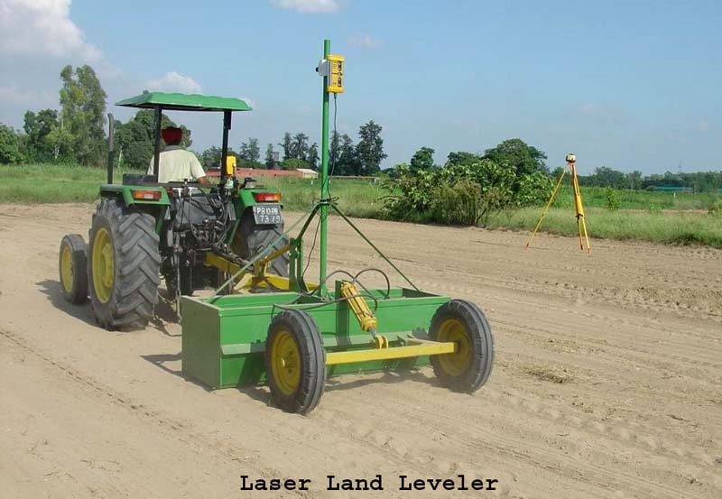
2.2.1 Components of laser land levelling system
The laser leveller involves the use of laser (transmitter), that emits a rapidly rotating beam parallel to the required field plane, which is picked up by a sensor (receiving unit) fitted to a tractor towards the scraper unit. The signal received is converted into cut and fill level adjustment and the corresponding changes in the scraper level are carried out automatically by a hydraulic control system. The scraper guidance is fully automatic; the elements of operator error are removed allowing consistently accurate land levelling. The set-up consists of two units. The Laser transmitter which is mounted on a high platform. It rapidly rotates, sending the laser light in a circle like a light house except that the light is a laser, so it remains in a very narrow beam. The mounting has an automatic leveller built into it, so when it’s set to all zeros, the laser’s circle of light is perfectly level. A laser-controlled land leveling system consists of the following five major components: (i) Drag bucket (ii) Laser transmitter (iii) Laser receiver (iv) Control box (v) Hydraulic system.
2.3. DSR Machinery
Direct sowing of rice is an ancient practice of rice cultivation in India, particularly in rain-fed areas, where farmers totally eliminate the seedling preparation in nursery and transplanting. The Direct Seeded Rice (DSR) cultivation is picking pace with the development of some improved varieties as well as on account of development of effective weedicides. At present, the farmers are slowly adopting the DSR (Direct Seeded Rice) technology and are broadcasting dry seeds of paddy in well-pulverized soil. The mixing of seed in soil upon broadcasting by tillage equipment result into dispersal of seed at variable depth in randomized pattern, accounting to poor germination of seed followed by poor crop establishment. There are some recommendations in DSR like land leveling and proper use of pre emergence herbicides and post emergence herbicides. Farmers can get profits from DSR If farmers follow above recommendations before going DSR.
2.3.1 Rice-Wheat Seeder
The Rice-Wheat Seeder equipment is capable of regulating the seed rate and put the seeds in soil at desired depth with proper maintenance of plant-to-plant distance ranging from 8-15 cm within the row. This character of machine helps the users to grow paddy in well defined row spaced at 20 cm and, thus, leaves the farmers with opportunities of using the mechanical weeding tools in between two consecutive rows for weeding. This machine can cover 1 acre/day of land with help of two farm labour. The cost of machine is ranging from Rs. 8000-9000. This type technology well suited for very small farmers who cannot afford high price of machine. By using this technology in paddy crop farmer can save around Rs. 6500-8000 for 1 acre DSR compared to conventional practice till the time of transplanting(RPCAU, ICAR website).
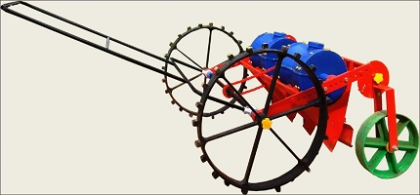

2.3.2 Inclined plate planter
Tractor mounted 9-row inclined plate planter is a multi-crop planter for planting of bold and small seeds which cannot be sown satisfactorily by conventional seed drills(Rajaiah et al,2020). Dry seeding of rice can be done by drilling the seed into a fine seedbed at a depth of 2-3 centimeters. The direct sown paddy saves about 25 percent irrigation water as it avoids puddling and enhanced irrigation intervals. There was a net saving of Rs. 15,000/ha in crop establishment due to direct sown paddy as against the conventional puddled transplanted rice. The Planter consists of a frame with tool bar, modular seed boxes; furrow openers and ground drive wheel system. Shoe type furrow openers ensure deeper seed placement in moist zone for sowing under dry land conditions. Drive to seed metering mechanism is transmitted from ground drive wheel through chain and sprockets. Seeds are filled in the first compartment of seed box. Flow of seeds to seed metering compartment is controlled through changing the angle of seed box, so as to keep the seed rate uniform. With Inclined plate planter sowing, the optimum seed rates for coarse grains 20-25 kg/ha and for hybrids 8-10 kg/ha. This machine can maintain proper spacing (20 cm) and reducing seed rate. For broadcasting a higher seed rate (25-30 kg/ha) is required. Seeding depth plays key role for good germination. Depth should not be kept more than 3 cm for desired level of crop stand. Placement of seeds below 3 cm adversely affects dynamics of seed emergence because of rapid drying of the upper layer soil moisture. This technique reduces labour needs, input requirements, investment and save time by timely sowing of rice and shorten crop duration by 7–10 days than transplanted rice. The cost of machine starts from Rs.80000 and cost of operation is about 1200 Rs/acre.
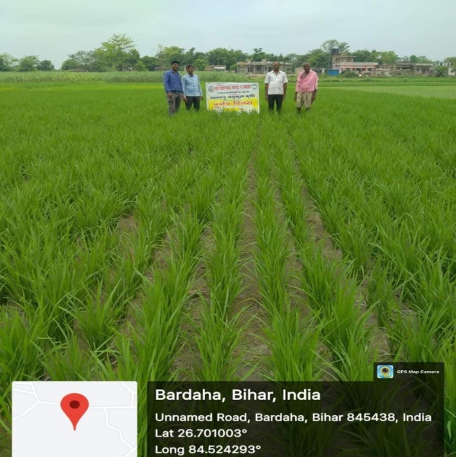
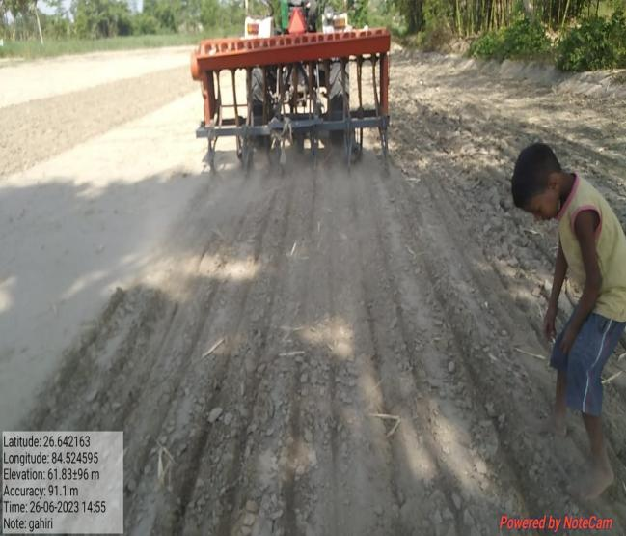
Inclined Plate Planter DSR technology Paddy crop
2.4 Happy seeder
A Happy Seeder is a no-till planter, towed behind a tractor, that sows the seeds directly into the soil in rows without any seedbed making(Sidhu et al, 2011). It is operated with the PTO of the tractor and is connected to it with three-point linkage. It consists of a straw managing chopper and a zero till drill that makes it possible to sow new crop in the residue of the previous crop. Flail type straight blades are mounted on the straw management rotor that chops the stubbles that comes in contact with the sowing tine. It deposits the residue of the previous crop over the sown field as mulch. Mainly, it is used to sow wheat after the paddy harvest in North India. After several investigation it is said observed that costs for sowing of wheat about 50-60% lower with happy seeder than with conventional sowing. The initial cost of machine is about 1.5 Lakh. The cost of opeartion of sowing of wheat by using happy seeder around 1200-1400 Rs/acre if a farmer hire happy seeder from nearby krishi vigyan kendras of north western states of India.
2.5 Self propelled sprayer
The sprayer consists of a light weight power unit and a spraying unit. The power unit has 3.75 kW diesel engine (AICRP, CIAE Bhopal,2004). It has two narrow rubber wheels which are powered from the engine through gears and chains. The ground clearance of the machine is 500 mm. A third wheel is also provided at the rear which acts as a support. The spray unit consists of a tank of 100 l capacity, roller type spray pump and a boom with 12 nozzles. The spraying boom has been mounted on the power unit through a canopy frame in such a way that spraying is done at the rear of the operator so that spray solution does not come on the operator. Provision has also been made in the mounting frame to adjust boom height from 600 mm to 1300 mm to suit different crops. The nozzle spacing is kept at 500 mm which can be adjusted to suit different types of nozzles and applications. A provision has also been made to adjust the track width from 900 mm to 1050 mm. Evolution of the machine The light weight boom sprayer on self propelled power unit was a felt need of wheat and vegetable growing farmers to complete the operation timely. The initial trials of sprayer upto 20 kg/cm2 pressure was carried out at Research farm which gave uniform and effective spraying. The sprayer covered a width of 7 m in a single pass. The fuel consumption varied from 0.5 - 0.6 l/h. For spraying in wheat crop at farmer’s fields, boom was adjusted at a height of about 600 mm from the ground. In order to make use of the same power source for spraying on paddy, a spray boom attachment was developed. The spray boom is attached to the sprayer through a long flexible pipe. The boom has 14 nozzles at a spacing of 500 mm. The boom was carried on the shoulders by two operators. The field capacity varied from 0.6 - 0.8 ha/h for spraying in paddy crop.
2.6 Straw chopper cum incorporator
The Straw chopper cum incorporator machine combined the adjustable frame, the incorporator, and the straw chopper. The straw chopper has inverted gamma-type blades, and processed paddy residues will be incorporated using an incorporator with L-type blades(Ramulu et al, 2023). This machine completes cutting, chopping, and incorporating straw in a single pass. Soil health would be improved by increasing the paddy residue decomposition rate and incorporating it into the soil. In a single operation, the machine harvests the stubbles left after combing, chopped into pieces, and spreads them on the ground. Using a single rotavator or disc harrow operation, the chopped and spread stubbles were easily buried in the soil and decayed after irrigation. Rice straw chopper-cum-spreader works satisfactorily in both loose and stand stubble conditions. This machine's primary purpose was to break up the straw and chaff from the combine's straw walker and sieve into smaller pieces before scattering them back over the harvested field.
3.0 Conclusions and recommendations
The conclusions drawn from this chapter is above mentioned machinery are cost saving, environment friendly and most useful machinery for farmers. We can recommended that farmers to use above cost saving machinery and also recommend to agriculture allied sectors to promote above discussed machinery for paddy and wheat cultivation.
References
- Bhatt R, Sharma M (2009) Laser leveller for precision land levelling for judicious use of water in Punjab,Extension Bulletin, Krishi Vigyan Kendra, Kapurthala, Punjab Agricultural University, Ludhiana.
- De Klerk, M. (1984). Seasons that will never return: the impact of farm mechanization on employment, incomes and population distribution in the Western Transvaal. Journal of Southern African Studies, 11(1), 84-105.
- https://icar.org.in/content/profitable-paddy-cultivation-through-direct-seeding-technology-rice-wheat-seeder-0
- Jat, M. L., et al. "Laser land leveling: A precursor technology for resource conservation." Rice-Wheat consortium technical bulletin series 7 (2006): 48.
- Mehta, C. R., Chandel, N. S., Senthilkumar, T., & Singh, K. K. (2014). Trends of agricultural mechanization in India. CSAM policy brief, 2(2), 1-13.
- Rajaiah, P., Mani, I., Parray, R. A., Lande, S. D., Kumar, A., & Vergese, C. (2020). Design and development of precision planter for paddy direct seeding. Journal of Agricultural Engineering, 57(4), 302-314.
- Ramulu, C., Pateriya, R.N., Naik, M.A. et al. A residue management machine for chopping paddy residues in combine harvested paddy field. Sci Rep 13, 5077 (2023). https://doi.org/10.1038/s41598-023-32148-9
- Self propelled light weight boom sprayer a success story(2004). All India Coordinated Research Project on FARM IMPLEMENTS AND MACHINERY Central Institute of Agricultural Engineering Nabi Bagh, Berasia Road, Bhopal - 462 038 (M.P.) India
- Sidhu, H. S., Singh, M., Singh, Y., Blackwell, J., Singh, V., & Gupta, N. (2011, September). Machinery development for crop residue management under direct drilling. In Resilient Food Systems for a Changing World: Proceedings of the 5th World Congress on Conservation Agriculture. Incorporating 3rd Farming Systems Design Conference (pp. 157-158).
- Tewari, V. K., Kumar, A. A., Kumar, S. P., & Nare, B. (2012). Farm mechanization status of West Bengal in India.

