Watershed Development- A Case Study on Harsule Village

Armaanjot Singh
Student, Punjab Agricultural University, Ludhiana, India – 141004.
Email: armaanjot-2002054@pau.edu

Introduction
A watershed is the area supplying water to a stream or river, ranging from small hectares to large expanses. It comprises the ridge line as the outermost boundary and the valley region where water from hilly areas collects. Drainage lines or streams carry water from the ridge line to the valley region, which serves as the outlet of the watershed.
India occupies about 2.4% of the world's geographical area, with a huge population and limited land resources leading to degradation of agricultural lands and conversion into wastelands. Restoring non-forested wastelands is essential to utilize the available land resources fully and prevent further degradation. Wasteland development aims to address the complex and multi-dimensional problems of degraded land and water management, while also developing human resources in watershed development and management.
The chosen site for the watershed development project is located near Harsule Village in Sinnartaluka of Nashik District. It is situated 13 km away from Sinnar town and 33 km from Nashik City, with latitude and longitude coordinates of approximately 19.822455 and 73.940904, respectively. During the summer season, water scarcity becomes an issue, and the water table declines. To tackle this problem, measures are required to recharge the groundwater sources using suitable techniques.

MATERIALS AND METHODOLOGY
A. Site selection:
The site for watershed development is chosen based on land parameters such as low soil fertility, undulating topography, land degradation, soil erosion, depleted water table, lack of land treatment structures, downstream impacts, inappropriate agricultural practices, deforestation, and high rainfall areas. Social criteria also play a role, including small marginal farmers, availability of labor, credit management skills, tribal status, people's response and interest, presence of people's institutions, poverty level, lack of alternative income sources, presence of bonded labor, and inability to meet consumption needs.

The selected site for the water shed development project is near Harsule Village in Sinnartaluka of Nashik District, located 13 km from Sinnar town and 33 km from Nashik City.

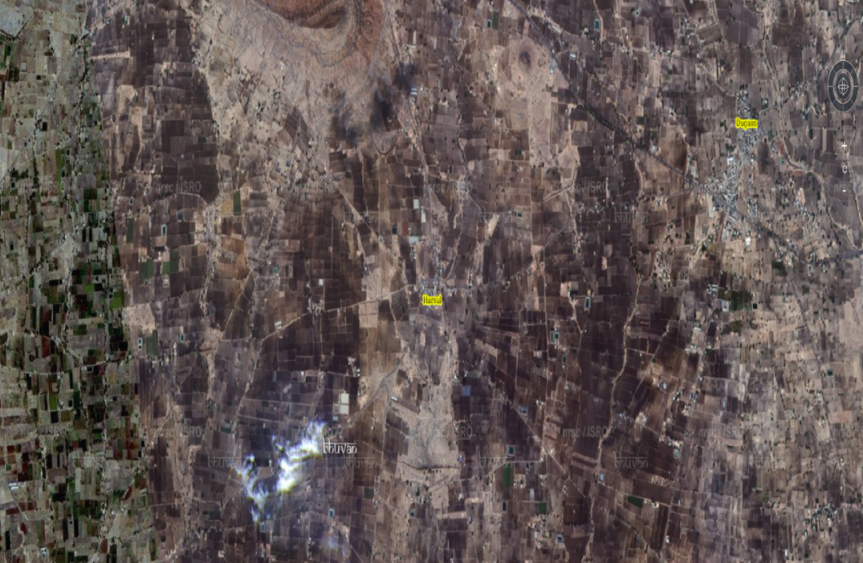
Img: Image from satellite of village Harsule
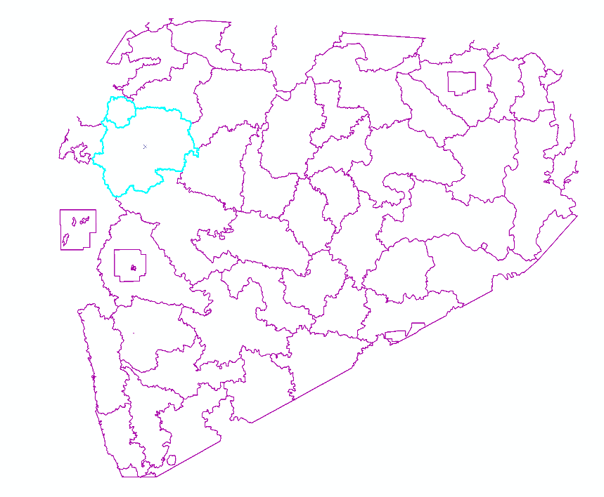
Img: GIS generated image of Nashik district

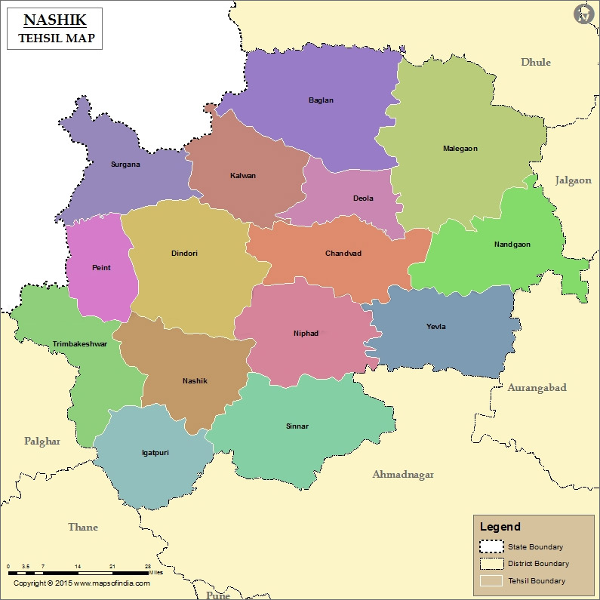
Img: Nashik Tehsil Map from www.mapsofindia.com
B. Various area treatments of watershed:
1) Bunding: Small earthen barriers are created in agricultural land with a slope of 1-6% to reduce runoff flow, prevent rill and gully formation, and retain water.
2) Continuous Contour trenches (CCT): Pits are dug along contour lines to retain water along slopes and prevent soil erosion.
3) Water Absorption Trench (WAT): Trenches are dug above farmlands to capture water runoff, allowing it to percolate into the ground to recharge groundwater and improve soil moisture.
4) Contour Stone Bunds (CSB): Stone bunds are placed along contour lines to slow down, filter, and spread out runoff water, increasing infiltration and reducing soil erosion.
5) Gully plug (GP): Gully plugs prevent soil erosion during rain and floods by acting as a soil trap. They are constructed using stone-based systems.
6) Loose Boulder Structure (LBS): Small barriers made of rocks, fiber rolls, gravel bags, sandbags, or reusable materials are placed across drainage ditches to reduce water velocity, allowing sediment to settle and reducing erosion.
7) Earthen Gully Plug (EGP): Earth plugs are constructed across gullies to retain water and facilitate percolation into the ground.
8) Gabion Structure: Gabion structures are built in nala areas where other water conservation works are not feasible. They help prevent soil erosion, and their location should be carefully selected to avoid soil blow on the banks.
These treatments help manage water flow, prevent erosion, and improve soil and water resources within the watershed area.

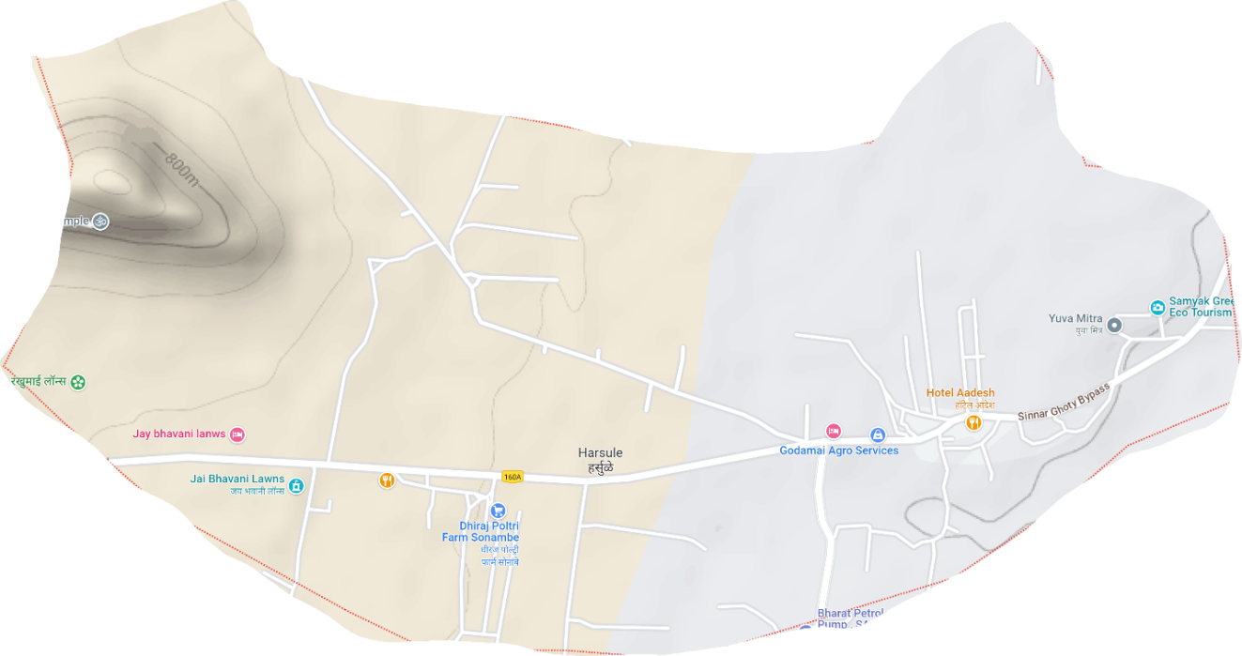
Img: Terrain Image of village Harsule

DATA COLLECTION AND ANALYSIS.
- Water Audit:A water audit is a comprehensive survey of available water in the village. In the case of Harsule, a remote drought-prone village in the rain shadow region of Maharashtra, the situation is grim, with depleted natural resources necessary for rural livelihoods. Drinking water is often not assured, forcing villagers to travel long distances to fetch water. Agriculture is severely affected due to water scarcity, leading to the need for water tankers, causing wastage of money and resources. Many villagers have abandoned their cultivable land due to the lack of water. To address this, a survey was conducted, collecting data on water availability for daily use, agriculture, livestock, and other purposes through the Grampanchayat as the information source.

Table 1: Demographic details
Sr. No | Population Classification |  | Workers in Village | Members involved
1 | Total Population | 782 | Farmers | 638
2 | Male | 408 | Farm Labours | 256
3 | Female | 374 | Labours | 28
4 | No. of Families | 152 | Businessmen | 25
5 | Schedule Caste | 24 | Trader | 5
6 | Schedule Tribe | 165 | Skilled Labour | 150
7 | Sex Ratio | 917 | Milk Business | 103
8 | Children | 104 | Other than Agriculture | 200

Table 2: Animals used for agriculture and other purpose:
Sr. No | Type of Animals | Number of Animals
1 | Hybrid Cows | 50
2 | Hybrid Ox | 20
3 | Cows | 50
4 | Buffalo | 15
5 | Goat | 50

Table 3: Geographic information
Sr. No | Classification of Area | Area(Hectare)
1 | Village Area | 970.14
2 | Area in Forest | 0.4
3 | Irrigated Area | 50
4 | Non-Irrigated Area | 50
5 | Cultivable Area | 30
6 | Actual Cultivable Area | 937.18
7 | Fertile Land | 52.54
8 | Irrigated Area | 322.1
9 | Per Capita Land | 0.37
10 | Area for each family | 1

Table 4: Present Land Use
Sr. No | Present Land Use | Area(hectare)
1 | Total Area | 970.14
2 | Cultivable Area | 291.04
3 | Wheat | 485.07
4 | Soybean | 679.1
5 | Groundnuts | 9.7
6 | Vegetables | 9.7

Table 5: Water required for different crops
Sr. No. | Crops | Need of Water(mm) | Area(hectare) | Total water required(m*3)
1 | Wheat | 500 | 485.07 | 2425.35
2 | Soybean | 550 | 679.1 | 3735.05
3 | Groundnut | 600 | 9.7 | 58.2
4 | Vegetables | 300 | 9.7 | 29.1
 |  |  | Total Water required | 6247.7
Table 6: Need of Water for Animals
Types of Animals | Water required(Gallon) | Water required(lit/year)[m*3] | No. of Animals | Total Required Water(m*3)
Human | 33.02 | 49.27 | 782 | 38533.05
Big Animals | 3-30 | 27.594 | 135 | 3725.19
Small Animals | 0.5-4 | 4.41 | 50 | 207
 |  |  | Total | 42465.24

Therefore, Total requirement of water is: (Water for Living Animals + Water for Crops) = 42465.24 + 6247.7 = 48712.94 m3 Extra water requirement in this village is: Therefore, extra volume of water is to be retained is: = 48712.94 48605.784 = 107.156 m3

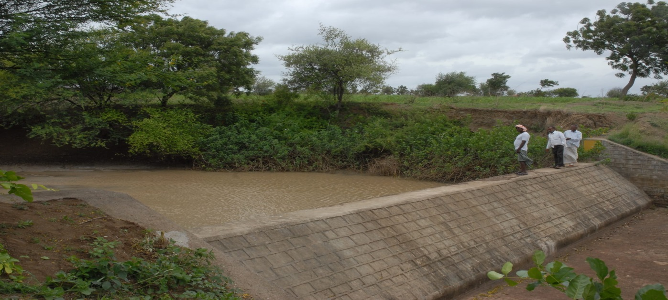
Fig: Nature Based integrated watershed management (side view)
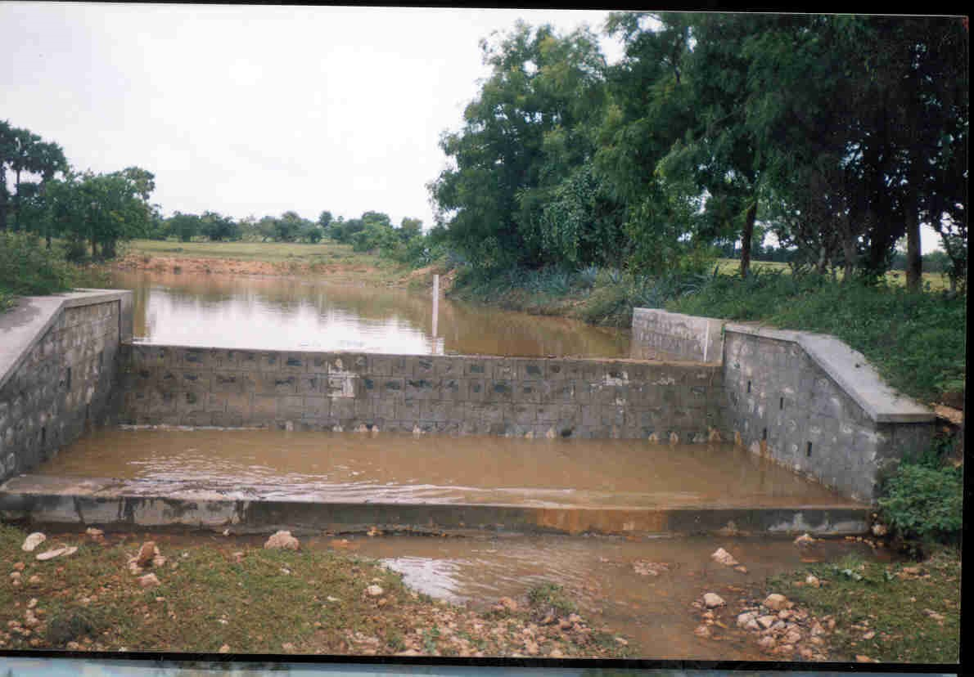
Fig: Nature Based integrated watershed management (front view)
B. General Survey:
The survey includes determining soil depth based on depth ranges and erosion percentage based on exposed rock. The slope of the land is calculated as 17.22% using RLs (Reduced Levels) at different points, which is essential for area treatment and structure design. Average rainfall is calculated using yearly rainfall data.
C. Land Capability Classification:
Land capability classification is vital for planning soil and water conservation programs. It involves systematically categorizing different types of land based on their properties and ability to sustain long-term productivity. Soil tests are conducted on-site to classify the soil into different texture classes.
D. Possible Treatments:
Based on the general survey and land capability classification, suitable treatments are determined, such as Seed Sowing, Farm Bunds, Pit excavation, Small Earthen Plugs, Continuous contour trenches (CCT), Horticulture, and Agroforestation. Among these, CCT is chosen because it can effectively retain water.
E. Design of CCT:
The design of CCT takes into account rainfall data, site and soil conditions, and the slope of the land. The length and number of CCTs are calculated using a method used by the Watershed Organization Trust in Ahmednagar, India. The proposed area treatment includes Plantation/Pit excavation/CCT, with a horizontal interval of 11.09 meters between two CCTs and a total length of 8246.53 meters. The cross-section of the CCT is 0.54 sq. meters (0.6x0.9), and the cross-section of the pit is 1 meter x 1 meter.
F. Water Management:
Water can be retained in Continuous Contour Trenches, water collection pits, and farm bunds among all proposed area treatments. The total water retained in CCT and pits is calculated to be 164.38 cubic meters (m3).

IV. RESULTS:
1) The water audit indicates that the total available water for the villagers' needs is 48,605.785 m3.2) The water requirement for the village is 48,712.94 m3.3) Villagers need an extra 107.156 m3 of water to fulfill their general needs.4) The identified area treatments include Seed Sowing, Farm Bunds, Pit excavation, Small Earthen Plugs, Continuous Contour Trenches (CCT), Horticulture, and Agro-forestation.5) The total water retained by providing these area treatments is 164.38 m3.6) Through watershed development, an additional 57.224 m3 of water is made available.

V. CONCLUSION:
Given Data
The chosen site for the watershed development project is located near Harsule Village in Sinnartaluka of Nashik District. It is situated 13 km away from Sinnar town and 33 km from Nashik City, with latitude and longitude coordinates of approximately 19.822455 and 73.940904, respectively. During the summer season, water scarcity becomes an issue, and the water table declines. To tackle this problem, measures are required to recharge the groundwater sources using suitable techniques.
What we learnt?
- The water audit indicates that the total available water for the villagers' needs is 48,605.785 m3
- The water requirement for the village is 48,712.94 m3.
- Villagers need an extra 107.156 m3 of water to fulfill their general needs.
- The identified area treatments include Seed Sowing, Farm Bunds, Pit excavation, Small Earthen Plugs, Continuous Contour Trenches (CCT), Horticulture, and Agro-forestation.
- The total water retained by providing these area treatments is 164.38 m3.
- Through watershed development, an additional 57.224 m3 of water is made available.
- Harsule village requires an extra 107.156 m3 of water, excluding their daily water availability. By implementing various area treatments, 57.224 m3 of water is retained, leading to a net availability of this much water for the villagers. This improved water availability can positively impact farming and enhance the productivity of the land by increasing groundwater levels.

What I want to add?
I observed that the given research paper lacks with the maps, soI added the maps by using the ArcGIS. I also saw the paper lacks as there are no images of watershed management, so I added images of integrated watershed management. I also observed that no information of storage area was provided, that information would be very resourceful in development of the watershed management by an individual. I could have thought of different ways of development where I could lead this watershed in improvement phase. I could have dealt with overall improvement in watershed and all land that is covered. Attention could have been paid to agriculture and forest management of the surrounding areas. Some other objectives could been reached with much effort in erosion control, prevention of soil, degradation and conservation of soil and water. I also observed that recharging of groundwater to provide regular water supply for consumption and for irrigation for the vegetation and forestry.

References
[1] Akhilesh Jitendra Jagtap1 Sanket Sunil Bhadane2 , has published paper on Watershed Development- A Case Study on Harsule Village (2020).
[2] MaruekCharnsungnern, SittichaiTantanasarit, has published paper on Environmental sustainability of highland agricultural land use patterns for Mae Raem and Mae Sa watersheds, Chiang Mai province. (27 April 2017).
[3] KeighobadJafarzadegan, VenkateshMerwade, has published paper on A DEM-based approach for largescale floodplain mapping in ungauged watersheds (2017)
[4] Scott Haag, Ali Shokoufandeh, has published paper on Development of a data model to facilitate rapid watershed delineation (15 June 2017).
[5] Timothy P. Sullivan, YongliGao, has published paper on Development of a new P3 (Probability, Protection, and Precipitation) method for vulnerability, hazard, and risk intensity index assessments in karst watersheds (2017).
[6] K. Ibrahim-Bathis, S.A. Ahmed, has published paper on Geospatial technology for delineating groundwater potential zones in Doddahalla watershed of Chitradurga district, India (17 June 2017).
[7] Maryam Adhami, SeyedHamidrezaSadeghi, has published paper on Sub-watershed prioritization based on sediment yield using game theory (16 Aug 2016)
[8] Timothy Nyerges, HrishikeshBallal, Carl Steinitz, Tess Canfieldd, Mary Roderick, John Ritzmana, WilawanThanatemaneerat, has published paper on Geodesign dynamics for sustainable urban watershed development (23 April 2016).
[9] Kaswanto and FitriyahNurulHidayatiUtami, has published paper on the disparity of watershed development between northern and southern region of Java Island (2015).
[10] Hsin-Fu Yeh, Youg-Sin Cheng, Hung-I. Lin, ChengHaw Lee, has published paper on Mapping groundwater

