IDEAL BODY SIZE OR IDEAL BODY WEIGHT
Miss . Tanveer Fathima, lecturer, capital degree and Pg college,shapurnagar,chintal
The term "ideal body weight" refers to the weight that is thought to be the healthiest for a certain person, taking height, gender, age, and the degree of muscle development into consideration.
*basically, optimal body weight is always determined by bmi.
Body mass index, or bmi, is a tool for evaluating weight that categorises people as normal weight, underweight, or overweight (obese level 1, obese level 2, or obese level 3). It represents the ratio of your weight in kilogrammes (kg) to your height in metres (m) squared. The bmi does not make a body fat or health diagnosis for a person, but it does screen for weight categories that may cause health issues.
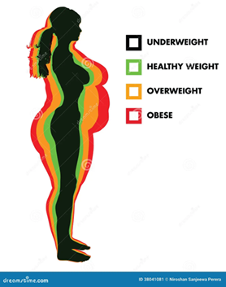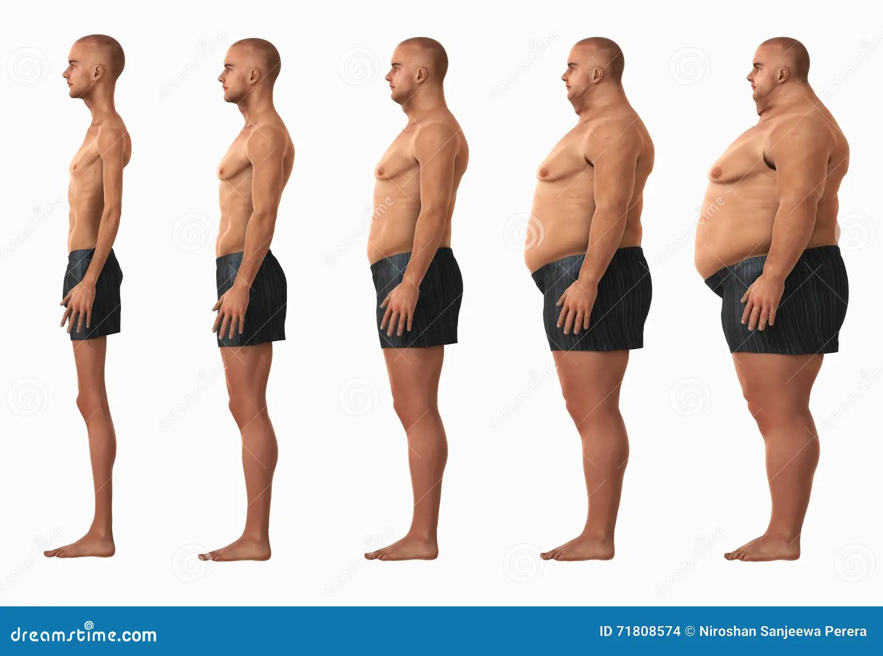

BMI = height in metres square / weight
BMI = w/ h(m)2
*Normal BMI values
in men: 20 - 25
In females 19 - 24
TABLE CLASSIFYING BMI
IN LINE WITH WHO
losing less than 18.5 pounds
normal range: 18.5 to 24.9
weight gain: 25 to 29.9
obese -1: 30- 34.5 obese -2: 35-39.9
obese – 3: more than 40

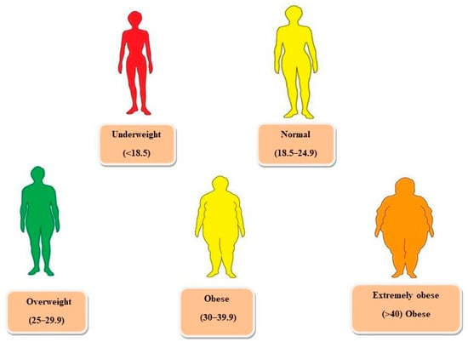

underweight people are those that weigh less than they should for their age and usually don't consume enough calories to keep their bodies running.
less than 18.5 bmi
A child who is underweight may be stunted, wasted, or both; it may also be undernourished (bodies are not absorbing enough vitamins and minerals from food). Based on bmi, this condition can be identified and treated through diet and prescription medications; both approaches can be used together.
The right amounts of all the key food kinds required for optimal growth and optimum health are consumed by people with adequate nutrition.
bmi: 18.5 to 24.9
* eating a balanced, nutritious diet is considered normal nutrition. Wealth and good health are components of a healthy physique.
●OBESITY
Obesity is the generalized buildup of extra bodily fat. A prevalent dietary condition is obesity. Higher-income groups in India and Western nations are the two regions where it is most prevalent. Obesity causes illness and early mortality due to the diseases and disabilities it causes.
Obese -1 is characterized as an abnormal buildup of extra fat that poses a health concern.
Obese-type 2 is characterized by abnormal or excessive fat buildup that poses a danger to health and has a BMI between 30 and 34.9.
Obese 2 BMI ranges from 35 to 39.9
Obese-3
It is described as an abnormal or excessive fat buildup that poses a health concern.
Obese 3 is a BMI greater than 40.
OBESITY
Large portions of the third world's inhabitants are now in various stages of developmental transition. On one end of the scale, there are populations that have not yet overcome their issues with undernourishment, while on the other, the issue of obesity is becoming worse. Although there are no official data on obesity in India, it is estimated that there are 1 lakh new instances of obesity each year, with 50% of those cases being severely obese.
The who has classified overweight and obesity as one of the most significant public health issues of our day due to the rising prevalence of these conditions and their negative health effects.
The cause of obesity is a positive energy balance. The number of calories consumed exceeds the amount of energy used. Obesity is a condition when there is a widespread buildup of extra adipose tissue in the body, exceeding the ideal weight by more than 20%. When the body weight is 10 to 20% over the primary norm for age, height, and sex, it is said to be overweight. Obesity is associated with debilitating illnesses and early mortality. Obesity is a long-lasting condition. Excess body weight is a barrier that causes dyspnea with even mild effort and puts a person at risk for illnesses including varicose veins, osteoarthritis of the weight-bearing joints, atherosclerosis, high blood pressure, and stroke.
AETIOLOGY
Obesity is a chronic multifactorial illness with many interconnected causes, including social, behavioural, psychological, metabolic, cellular, and molecular aspects.(genetic) body weight is determined by the desire and drive to eat, the satisfaction of the food chosen, the digestibility of the food consumed and its absorption in the body, the metabolism of nutrients and metabolic rate, the desire and capacity to exercise.
GENETIC VARIABLES
More than any other aspect, genetic inheritance most likely affects a person's likelihood of being overweight by 50 to 70 percent.within a species, variations in body fat and sexual behaviour are governed by genetics. Families have an 80% likelihood of having fat parents and a 50% chance of having obese parents. Obesity risk is significantly increased by a mutation in the human gene encoding the b3 receptor, which is found in adipose tissue and is involved in lipolysis and thermogenesis.
SEX AND AGE
As long as the person is in a state of positive energy balance, it can happen to either sex at any age.in all age categories, investigations at the indian nutrition foundation have indicated that more women than men are overweight. When compared to males, women have a larger chance of becoming obese due to hormonal predisposition.
EATING PATTERNS
Obesity may result from specific eating patterns.
Housewives frequently snack between meals, which may contribute to obesity.
Some people could eat more quickly, taking less time to chew their food, therefore they tend to eat more.
Neurotransmitters, or chemicals in the brain, send messages to various parts of the body and brain in response to external stimuli including temperature, taste, smell, and sight.in contrast to internal hunger signals, obese people respond to external urges to eat.instead of eating when they are hungry, they do it around mealtimes or when they are among delicious meals.
Those who work in kitchens or are housewives who enjoy preparing a range of dishes run the risk of being fat.
People who consume more high-fat, high-carb, and high-salt junk food or fried snacks run the risk of becoming obesity.
Certain cultural customs, such as the preparation and distribution of sweets during festive occasions, enhance calorie consumption.
Non-vegetarian diets with a high fat content and a lack of fruit and vegetable intake increase weight gain.
Those who enjoy eating processed, concentrated, and high-fat foods are more likely to become obese.
Some people may overeat as a coping tactic when they are sad or bored.
There is a wide variety of delicious, calorie-dense cuisine on the market. People are tempted to consume more by aggressive and sophisticated marketing in the media, supermarkets, and restaurants.
When eaten often, sugar-sweetened drinks may cause weight gain.
Employees whose biological clocks are thrown off by working multiple shifts may overeat.
There may be a connection between obesity and insufficient water intake.
People may overfeed at night as a result of a sleep issue.
This sort of high-carbohydrate diet consumption raises sincerely levels, interferes with leptin signalling, stimulates hunger, and promotes the accumulation of fat.
STRESS
Recent studies have shown that school children tend to take more fatty foods as their lives become more stressful chronic sleep deprivation and self-gratification may lead to excess calorie intake. Stress food is one of the many stimulants of endoften feel good neurotransmitter. May slightly enhance appetite.
HORMONE FACTOR
There is obesity in hypothyroidism. Hypothyroidism hypothyroidism obesity is frequent during poverty pregnancy menopause, hypothyroidism hypoglycemia, and cushing syndrome suggesting endocrine may be a cause in obesity.
TRAUMA
Due to hypothyroidism being damaged after a brain injury and its inability to control epitates on set id, obesity may result.
SUCCESS AND CIVILIZATION
Since they have the purchasing power and access to surplus food, people from higher social economic status in developing countries as well as in the ukus share and usa are more likely to be obese. In contrast, obesity is uncommon in preventive societies and among wild animals. However, civilization has brought a plentiful supply of enticing foods, concentrated foods, and a variety of foods to the market.
DRUGS
Some medications cause weight gain. Psychiatric medications such as antidepressants, steroid hormones, contraceptives, diabetic medications, and antioxidants might make someone gain weight.

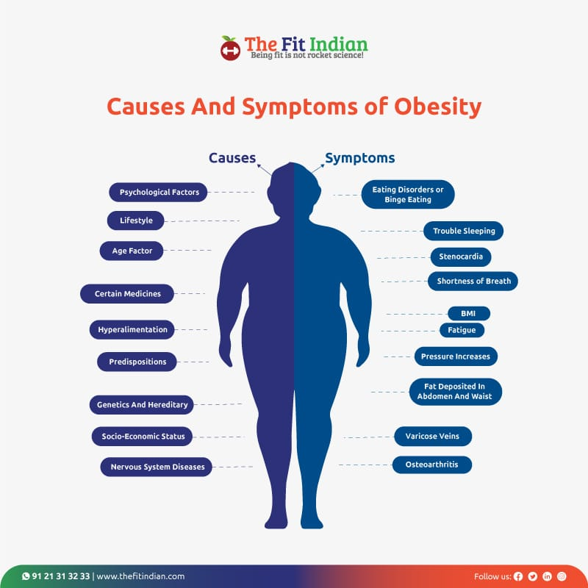

THEORIES
THEORY OF FAT CELLS
Early in infancy, the number of headsets is chosen to allow for the storage of fat; once produced, fat cells have a propensity to retain their fat content. Total number of fat cells was determined early in life, confirming the idea that juvenile crime in saturday city was brought on by obesity and that this number can actually decrease as a result of persistent weight loss. People with more fat cells than those with less fat cells struggle harder to maintain their weight. Medical issue risk has been demonstrated via studies. This relates to the size of fat cells present more than the number of fat cells are the person's weight and is isolated to the size of itself present more than the number of attentions.
INPUT-OUTPUT THEORY
Each individual has an optimal biological weight, or set point, that they should aim to maintain. Once this weight is reached, a variety of signals are released that affect the person's food intake.
IMPACT OF HORMONES
The obesity gene is expressed in fat cells, and it "acts as a hormone in the hypothyroidism promotes negative energy balance by suppressing appetite and increasing the energy expenditure" (lipton, protein). There is sufficient leftover production, but there is insensitivity or resistance of the ediposition to lifting, which plays a significant role in the long-term regulation of energy balance. People with genetic defects of lifting show signs of poor appetite control, constant hunger, and may eat more and gain weight in obesity.
When the fat stores in their divorce issue are enough, laptop levels are high, which sends signals to restrict feeding behaviour and limit fat intake. The laptop is regarded as a body weight regulatory hormone during starvation and weight loss as it binds to a specific receptor in the brain.
Laptops stimulate lipolicies and block sleepogenesis, which is one of the greatest methods to avoid cancer; any genetic abnormality in lipton or its receptor will result in obesity; and insulin and lifting her hormones, which function as medium- to long-term regulators of body weight.
By taking steps to reduce food intake and enhance energy expenditure, they are precisely balancing their energy intake and expenditure.
The effects of a limited deficiency are mimicked by the administration of a recommended laptop insulin. In addition to its effects in the central nervous system to inhibit food intake, acts in the periphery to ensure the efficiency.
People who do not produce laptop due to genetic deficiency or who have deficit defects in the left in receptor have dramatically deprived increased appetites and over eat to the point of becoming deficiency obese.
Insurance policies that cover the storage of incoming nutrients insurance and laptop are carried into the central nervous system, where they may interact with a variety of hypothyroidism neuropean diet known to regulate food intake and body weight.
Insulin also has an indirect function in the control of body weight through the activation of laptop. Reduced concentration has been seen after fasting or energy-restricted meals in the device. Insulin and laptop are secreted and circulate in the circulation at levels corresponding to body fat content secretion. Circulating levels are also controlled by the amount and kind of foods consumed.
It has been demonstrated that an increase in lifting during a prolonged energy-restricted diet is associated with an increase in hunger sensations and half-hunger, suggesting a role for low lifting levels to increase appetite during dieting in humans and, consequently, to the propensity for weight gain after beginning successful dieting, while an increase in insulin secretion has been proposed to protect against weight gain in humans. When a woman consumes high-fat meals, her insulin and left in concentrations decrease. Insulin stimulates left in production, which works centrally to lower energy intake and increase energy expenditure. This decrease in insulin and left in production while consuming high-fat diets may help to contribute to the effects of dietary fat that promote obesity.
OBESITY AND HORMONES
Insulin: the amount obesity increases insulin resistance because in india, 80% of obese people also have hypertension.
Effect of losing weight: enhanced elements of the glucose topic include enhanced insulin sensitivity.
TRADITOR HORMONES:
Obesity severity: although serum total and free thyroid hormones are typically normal, people who are fat may have less cellular receptors. On the long term, hypothyroidism has no impact on body weight.
Effects of losing weight: reduced fat freemas and a drop in the concentration of the 3 community 3 may be responsible for the formerly obese patient's lower resting metabolic rate.
HORMONES OF GROWTH
Obesity level: reduced baby adaptation.
Weight loss's effect: levels return to normal.
Obesity level is high; leptin resistance is prevalent.
Effect of losing weight: he can lower his plasma lifting levels, but they are still greater than those of non-obese people.
ASSESSMENT
A patient's visual infection can provide a subjective but generally accurate measure of their level of fat.
BODY MASS
An adult who weighs 10% more than the normal weight is overthink sorry overweight and 20% concerns obese, according to charts of average weights by height and age and tables of desired weights for height.
BODY WEIGHT AND THE SEVERITY OF OBESITY
Increased body weight compared to usual. Amount of obesity
25 mild
50 moderate
75 really severe
100 very severe
BODY MASS INDEX
A person's body mass index is used to determine whether or not they are overweight, underweight, or normal weight. Bm, also known as quite late index, is acknowledged as a more accurate measure of body fatness and health risk than body weight. Standard tables are not necessary for this index.
BMI is calculated as follows: 2(m) = weight/m
BMI CLASSIFICATION TABLE
according to WHO
underweight: less than 18.5
normal: 18.5 - 24.9
overweight.: 25 - 29.9
obese -1: 30- 34.5
obese -2: 35-39.9
obese -3: more than 40
When evaluating a sizable group, policymakers can use the BMI as a useful tool since it correlates with body fat composition, according to the national health organization. This metric has drawbacks since it cannot differentiate between obesity-related overweight and the muscular hyperthyroidism that occurs in athletes, and BMI gives no information regarding how body fat is distributed. The amount and distribution of body fat, as well as the percentage of muscle that is too fat, are not adequately measured by BMI. Bmi may be normal, but having more body fat and less muscle mass may result in insulin resistance and a higher risk of heart disease. Because they have a high body fat percentage, individuals with obese BMI may be in good health.
The most practical tool a practitioner has for assessing a patient's abdominal fat both before and after weight reduction treatment is waist circumference.
A high-risk waist measurement
Males: >40" (102 cm) and females: above 35 inches (88 cm).
Measurement of body fat: based on total body fat, an appropriate definition of overweight and obesity should be used. The top limit of body fat for defining obesity has been set at 25% for men and 30% for women. Absorb one of the most widely used methods of determining body composition is using tomatoes because it is a safe, convenient, and non-invasive method that can measure percent fat with great accuracy and correlates well with other methods. Another simple tool for determining body composition is a body fat analyzer, which compares the percentage of body fat to a reference value. Asian indians possess personality.
criteria for obesity in terms of the percentage body fat
Category males females
Normal 12-20% 20-30%
Borderline 21-25% 31-33%
Obesity >25% >33%
Insulin resistance is less likely to result from sub cutting as fat. Despite having extensive replacement fat and very little visional fat, smoke vessels never develop insulin resistance.
Index ponderal
The popular index is determined by the formula as being the height-to-weight cube root ratio.
pi = height (inches)/cube root of weight (IBS)
An index of less than 13 is associated with obesity.
Waist-to-hip ratio:
Obesity criteria based on the percentage of body fat
The pattern of the disease may be determined by the predominant location of fat in an obese individual, whether it is in the upper or lower body.
Waist-to-hip ratio is typically 0.7.
However, abdominal obesity does not necessarily correlate with being overweight or obese; according to European statistics, the ratio is higher than 1.0 in men and women.
THE BROKA’S INDEX
The Broka’s index formula is
Height (cm)-100=ideal weight (kg)
GRADES
Grade 1 obesity:
It is defined as having a body mass index greater than 25 but less than 29.9. These individuals have healthy lives, have life expectancies that are around average and may naturally lose weight.
Grade 2 obesity:
It occurs when the bmi is between 30 and 39.9 .despite appearing to be in good health, 9 patients need to be treated by doctors and dieticians because despite their increased weight and reduced capacity of the circulatory and respiratory systems due to masses of internal fat and fatty infiltration of muscle for mechanical and metabolic reasons, they have reduced tolerance to exercise, shortness of breath with exertion, and are excessively fatigued. Disorders of the gallbladder and liver hernias, varicose veins, and osteoarthritis the mortality rate is also rising.
Grade 3 obesity:
Patients with a body mass index of 40 or higher are in pitiful condition, have severe psychological problems, and are unable to engage in normal daily activities due to their enormous size and susceptibility to the diseases listed above as well as atherosclerosis and other conditions.

ANDROID OBESITY:
is defined as having a circumference more than 35 inches for women and 40 inches for males.
Adipose tissue and its effects
Hyperglycemia is never caused by increased abdominal adipose tissue, enhanced free fatty acid mobilization, or excess free fatty acid.
Muscle and effects
Exercise promotes slow twitch fibres, which are few and have a poor fibre oxidative capacity.
The muscles:
Decreased insulin sensitivity and glucose transport.
Insulin resistance reduced glucose tolerance, which led to diabetes mellitus in the context of glucose homeostasis. Obesity in a gnanoid
GYNAECOID OBESITY:
It refers to an accumulation of extra fat in the lower body, specifically the hips, buttocks, and thighs.
Effects of adipose tissue:
Expanded female gluten edipose tissues with normal free fatty acid seat turnover and minimal free fatty acid bubblization.
Strength and effects:
Strong oxidative capacity, few rapid twitch fibres, and a large number of low twitch fibres.
Normal insulin sensitivity and glucose transport in muscles.
Normal glucose tolerance in glucose homeostasis.

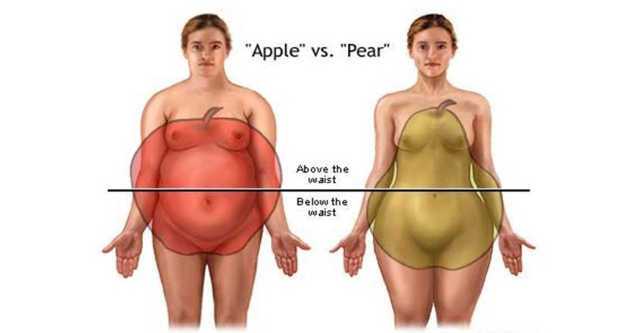

TREATMENT
The goal said the favourite law should be realistic on the ethical targets result in frustration and failure because obesity is a chronic disease that requires long-term treatment. Even a 5 to 10% loss of transformation weight may produce noticeable improvement in diabetes, sleep apnea, diabetes, and even diabetes.
In order to manage obesity, a Monday disciplinary strategy is applied.
A multidisciplinary approach to treating obesity
Registered dietician: access dietary habits and trends, formulate nutrition guidelines and put them into action.
The framework of the behavioral program highlighted behavior concerns impeding therapy, and the behavioral counselor consulted with the patient and family as necessary.
Coordinate the multidisciplinary team, doctor.
Diet therapy, exercise, stress management, medication, behavioral therapy, and weight reduction surgery are some methods of weight loss and weight control.
TYPES OF JUVENILE OBESITY:
Juvenile obesity is caused by hyperthyroidism and manifests itself most quickly in the first few years of life. The term "hyperplastic obesity" refers to the overproduction of fat cells that occurs as a result of excessive calorie intake in infancy and early childhood, which is then followed by hypothyroid enlargement of the fat cells. As a result, overweight children are more likely to grow up to be obese adults. Up to 80% of obese children will also grow up to be obese adults. The constant giving of a bottle is a way to deal with the productive hour.
Early introduction of high-calorie solid foods may lead to rapid weight gain and obesity studies suggest that a normal infant's infant autonomy in feeding may be advantageous in the appropriate regulation of weight during the first year of life. The incidence of childhood obesity is strongly correlated with family variables, including parental obesity and small family size.
The amount of time spent watching television, playing video games, and using the internet appears to be correlated with an increase in the incidence of childhood obesity. This correlation may be due to the sedentary nature of these activities as well as the subtle effects of food advertising that encourage the consumption of foods with low nutritional value, such as snack foods high in sugar, fat, and salt. Although obesity can become obvious at any age, it is most common in the first year of life, between the ages of 5 and 6, and throughout puberty. More and more fat youngsters, children, and teenagers are being diagnosed with sleep acne, glucose intolerance, and giggle problems.
ADULT-ONSET OBESITY:
In adult-onset obesity, hypertension obesity, the size of the person's allegedly enlarged distant edible person leads to further psychological psychological biochemical and atomic aberrations aberrations in the person's organs and organ systems. Patients with hypertropical cobbies have been reported to maintain weight loss better than hyperplastic patients after months.
GUIDELINES FOR MANAGING A DIET
Diets low in calories, high in protein, fibre, and all the vitamins and minerals – with the exception of salt – should be recommended for those who are obese.
Energy: in order to lose weight, a person's energy production must be lower than their energy intake. If i murder every one of these forward-movingly active workers, the optimal body weight for a sedentary worker at age 20 is around 20 kilograms per kilogram.
Protein: for tissue regeneration during the first particular dynamic activity, 0.821 g of protein per kg of body weight is advised.
Carbohydrates: high carbohydrate foods like potatoes and rice are restricted, and sugar, which provides empty calories, should be completely avoided because it increases insulin resistance, which causes the body to store excess carbohydrates as fat. The only way to lose weight is to decrease insulin by reducing carbohydrate intake. Avoid foods like bananas that are high in carbs. Consuming complex carbs is advised since they have a low classic index.
Fats: experiments have shown that people without weight problems can control their weight by unknowingly eating less food and fewer calories, but low-fat or no-fat diets should be given to reduce the energy value of foods rich in fat substances like nuts and seeds, which should be restricted, and skim milk should be consumed instead of whole milk. Trans fats and saturated fats are not preferred.
Vitamins: long-term fat restriction is likely to result in a limitation of the fat-soluble vitamins a and d, which need supplementation.
Minerals: research shows that a calcium-rich diet, especially one that mainly includes dairy sources, is highly effective at lowering weight since excess sodium predisposes to fluid retention. Calcium may suppress certain hormones, which subsequently increases the body's capacity to break down fat in cells and delay fat synthesis. Not only can calcium assist young women in maintain a healthy weight, but it may also reduce total levels of body fat.
Fluids: drink plenty of fluids as additional fluids are expelled by healthy kidneys, and drinking a glass of water before meals will help you eat less overall.
Fibre: the inclusion of high fibre foods in diets for obese people has numerous benefits. Low-calorie foods including green leafy vegetables, fruits, vegetables, salads, whole grain cereals, and pulses can be included in the diet. They have a low density of calories second foods, such as greens, offer a variety of vitamins and minerals that are hard to get from a restricted diet. They also aid in regulating bowel movements, lower blood cholesterol, encourage chewing and slow down the rate of consumption, and help with weight loss. Taking high fibre is thought to be less painful and expensive than receiving medical treatment for obesity.
GLUCOSE INDEX OR GLYCAEMIC INDEX
In addition to boosting satiety, low gi meals may also promote fat oxidation at the expense of carbohydrate oxidation.
Increased satiety and cholecystokinin secretion are brought on by mixed meals with low GI uterine receptors in the guest to install track estimates for a longer amount of time owing to a slower rate of digestion and absorption in the small intestine, resulting in extended feedback through signals like cholesterol instruction and glucose gone like peptide to the city center in the brain.
Except for calories, all other nutrients in the diet should be sufficient all five food categories should be included in the diet.
DIET RECOMMENDATIONS
The diet needs to include a range of whole grains. Brown rice or whole grains should be used in place of white rice. dietary oats should be consumed Included are millets like ragi, jawar, and bajra. Avoid refined grains such as polished rice and Maida.
Whole grains and other legumes should be a part of the diet. nutrient-rich grains include sprouted grains. Legumes have a low gi and make you feel full.
The diet should include skim milk. Prebiotics low in fat may be added.ice cream and buttercream ought to be avoided.use cheese in moderation. You may use paneer or low-fat cheese.
The diet should contain lots of colored fruits and vegetables. Every meal should include green leafy veggies. This will guarantee that the antioxidant needs on a low-calorie diet are met. salads sans oil ought to be consumed.
The diet needs to be high in fiber. salads are a good way to start a meal. The diet should contain unprocessed, raw, natural foods, sprouted grains, and whole grains. whole fruits are nutritious snacks.
Dietary intake of carbohydrates should be decreased because it is low in calories. It is important to use measured amounts of rice. Chapati consumption ought to be moderate.
Dietary intake of carbohydrates should be decreased because it is low in calories. It is important to use measured amounts of rice. Chapati consumption ought to be moderate.
The diet should have less fat. No trans and saturated fatty acids should be consumed. Avoiding fried meals is advisable. Avoid eating saturated fat-containing gravy meals. Avoiding junk food completely includes things like french fries and potato chips. Nuts and other naturally oil-rich foods should only be consumed in moderation.
The diet should contain less sugar. Avoiding sweets, cakes, and chocolate should be a top priority. Avoid consuming concentrated foods like condensed milk, honey, and sugar syrup.
One can drink as much water as they want. Avoid drinking carbonated or sweetened beverages. You can drink coffee, tea, and fruit juices without adding sugar. There should be limits on drinking. avoid eating items that are high in empty calories.
The way you cook has to be changed. Cooking should be done without adding any more fat through boiling, poaching, steaming, pressure cooking, and simmering.
Serving sizes can be lowered, and tiny plates and ladles can be used, in order to decrease the amount of food consumed.
Food should be taken on a regular basis in controlled portions meal should be missed. Avoid nibbling on fried foods in between meals.
Avoid eating when traveling.it is important to understand how to choose healthy foods when celebrating holidays and going to events. They might undergo a psychological transformation to celebrate holidays without placing a high value on eating. team games like cricket can be played after gatherings.
Fasting should be avoided since people tend to overeat afterward.in general, calorie-rich alternative foods during fasting times include potatoes, sago, and groundnuts. Those who eat only once each day typically eat concentrated meals.
Even low-calorie foods shouldn't be consumed in excess.

