Chemistry of Unsaturated All Thia and All Selena Donor Macrocycles: Some Noteworthy Results
Partha Pratim Das
P. G. Dept. of Ceimstry
Magadh University, Bodh-Gaya
Abstract:
Unsaturated thiacrown ethers with cis-conformation across the C=C bonds are more conformationally restricted than analogous saturated structures. As a result, they have a high preference for metals when utilised for the formation of metal complexes. In addition, unsaturated selenacrown ethers exhibit a variety of specificity towards metals due to changes in the conformity, diameters, as well as electronegativity. Besides these, role of directional forces are vital in host-guest chemistry. To create three-dimensional architectures containing voids, channels, helices, or networks, such forces are required. Additionally, directional factors are a fundamental prerequisite for the connection involving guests and hosts. Notably crucial ones in pure organic host-guest chemistry are H-bonds and π-π stacking. A wide range of chalcogen-containing molecules are stacked one on top of the other to form columnar or occasionally tubular stacks. They all have intimate chalcogen-chalcogen solid state interactions in general. In this chapter chemistry of all sulphur/selenium based unsaturated macrocycles have been discussed, mainly their synthesis, metal complex formation and structural details.

Introduction:
The host-guest chemistry of macrocyclic molecules has given rise to the establishment of the field of metal-ion recognition that constitutes one among the many significant coordination chemistry topics to have emerged in the previous several decades. A number of variables, including the size and ionic nature of the metal ion as well as the versatility or cavity dimensions of the macrocycle, have an impact on the chemical nature of metal-ion macrocyclic compounds as well as the shapes these assume in solid form and in a solution. During designing ligands that recognise certain metal ions, each of these aspects are to be put into consideration. Thiacrown ethers, sulfur-substituted crown ethers, experienced major advancements in science throughout the past few decades¹. Thiacrown ethers are recognised to bind to transition elements, while crown ethers tend to couple towards alkaline as well as alkaline earth metals². This is one of the key distinctions amongst the two types of ethers. On the contrary, compared to equivalent saturated frameworks, unsaturated thiacrown ethers having cis- orientation along the carbon-carbon double bonds appear to have been greater conformationally constrained. As a result, it is anticipated that the synthesis of metal compounds using unsaturated thiacrown ethers will exhibit strong selectivity towards metals. Not only thiacrown ether chemistry, scientists have shown immense interest towards selenacrown ethers too. Their chemistry is vastly reported³. However, because of variations in the conformity, dimensions, and electronegativity of the chalcogen atoms, unsaturated selenacrown ethers also display varied selectivity against metals. Many instances of pretty mild directional forces governing the architectures of aggregates in solid form may be found in supramolecular chemistry. These forces include, among others, H-bonding as well as π-π stacking, both of which are being exploited to create channel-like configurations. In the solid state, chalcogen centres in immediate proximity can exert directional forces. Most often close CH……S, C-H…….π-connections, and π-π stacking occurs hand in hand alongside short SS interconnections. Column-type frameworks are formed by cyclic alkynes, alkenes, as well as alkanes having chalcogen atoms. The intermolecular spacing that separate the chalcogen centres in such columns typically smaller than the total of the van der Waals radii, this is a typical construction motif produced by chalcogen atoms of surrounding stacks. In this chapter, the chemistry of several unsaturated all sulphur and all selenium macrocycles will be discussed in details.
Unsaturated all thia-donor macrocycles:
Kagimata et. al.⁴ reported the synthesis of L¹-L⁸ [Scheme 1]. Via the interaction of cis-1,2-dichloroethylene with Na₂S in CH₃CN, unsaturated thiacrown ethers 1,4-dithiin and L¹-L⁷ with 6-, 9-, 12-, 15-, 18-, 21-, 24-, and 27- members were produced. All of the sulphur atoms in L⁴–L⁷ route to the inside of the ring (endodentate), as per the crystalline arrangements of L³–L⁷ [Figure 1]. According to the figures, all the molecules have cavities. The cavities inside L³-L⁷ are, 1.76, 2.34, 3.48, 4.43, and 5.36 Å in size, respectively. The bigger unsaturated thiacrown ethers being oxidised more readily than the smaller systems, as well as unsaturated thiacrown ethers were oxidised more readily than equivalent saturated structures, according to the cyclic voltammograms of L³-L⁷. The colourless complex [Ag^{I}(L³)(CF₃COO)] [Figure 1] was produced via the interaction of L³ with CF₃COOAg in CH₃COCH₃ [Scheme 2]. Three of the five sulphur atoms are shown to be bound to Ag^{I} in the framework of the crystal.
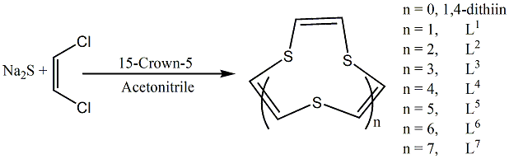
Scheme 1
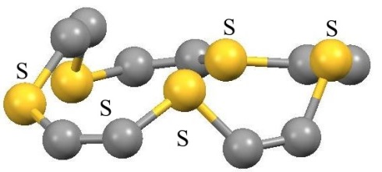 | 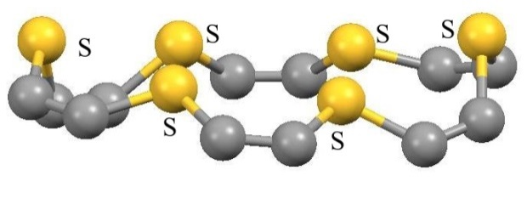
L³ | L⁴
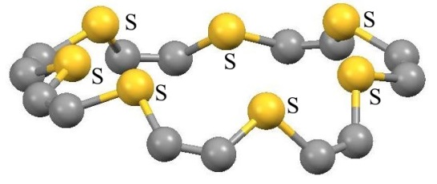 | 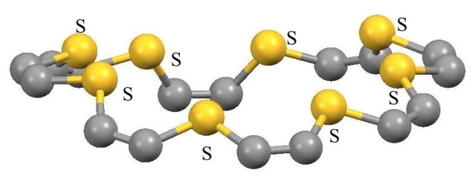
L⁵ | L⁶
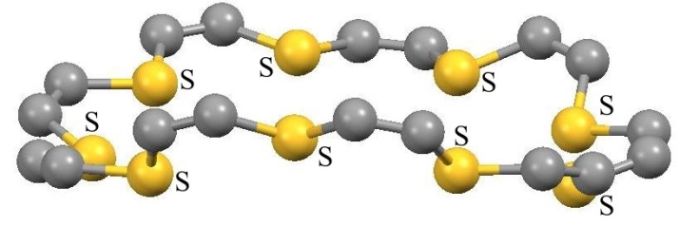 | 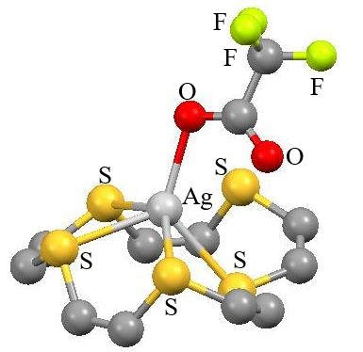
L⁷ | [Ag^{I}(L³)(CF₃COO)]
Figure 1
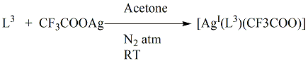
Scheme 2
New Ag^{I} compounds [Ag^{I}(L⁴)(CF₃COO)] and [Ag^{I}₂(L⁵)(CF₃COO)₂] were produced via the interactions of L⁴ and L⁵ with silver trifluoroacetate in CH₃COCH₃, respectively⁵. The Ag atom is shown to be located within the cavity of the L⁴ and to be surrounded in a distorted square pyramidal configuration in the crystal form of [Ag^{I}(L⁴)(CF₃COO)]. The [Ag^{I}₂(L⁵)(CF₃COO)₂] crystal form reveals that all of the sulphur atoms and all of the Ag atoms being roughly coplanar, whereas the two CF₃COO⁻ units are situated on either side of the plane. By analysing ¹H NMR, the composition of the association of L³, L⁴, and L⁵ using CF₃COOAg in solution was investigated. At 1:1 and 2:1 metal to macrocycle proportions, respectively, the titration graphs of L³ and L⁵ exhibit a clear inflection point, while the chart of L⁴ progressively varies at a range of 1:1 to 2:1. According to these findings, L³ and L⁵ exhibit inclusion selectivity for the quantity of Ag ions, while L⁴ exhibits minimal selectivity for the quantity of metals included. Unsaturated thiacrown ethers turn hard to oxidise by complexing with CF₃COOAg, and CF₃COOAg gets tough to reduce by complexing with unsaturated thiacrown ethers, according to a study comparing the oxidation and reduction potentials for the Ag^{I} compounds with those of free macrocycles and CF₃COOAg.
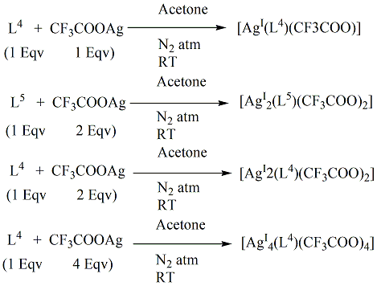
Scheme 3
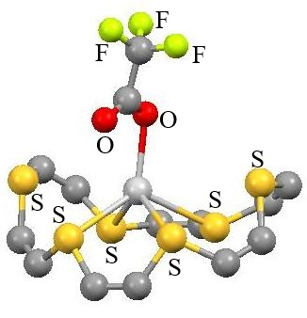 | 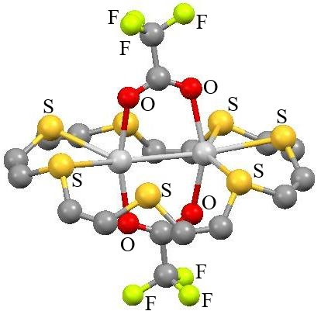 |  | 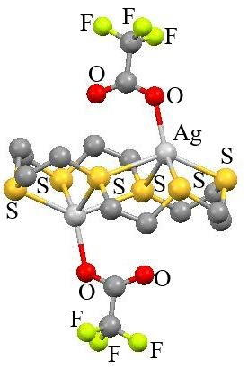
[Ag^{I}(L⁴)(CF₃COO)] | [Ag^{I}₂(L⁵)(CF₃COO)₂] | [Ag^{I}₄(L⁴)(CF₃COO)₄]
Figure 2
[Hg^{II}(L⁴)Cl₂] was produced by complexing L⁴ with one equivalent of HgCl₂ in CH₃COCH₃. Hg atom was found to be inside the macrocycle's cage and surrounded by an eight-coordinated hexagonal bipyramidal configuration according to the crystal framework of [Hg^{II}(L⁴)Cl₂]. The results of a ¹H NMR analysis of [Hg^{II}(L⁴)Cl₂] in CH₃COCH₃-d₆ showed that the interconversion of unbound L⁴ and pure compound occurred more slowly than the time scale of the NMR. According to the ¹H NMR titration study, L⁴ demonstrated inclusion selectivity regarding the quantity of Hg atoms⁶.
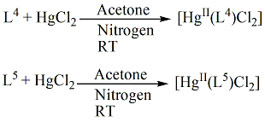
Scheme 4
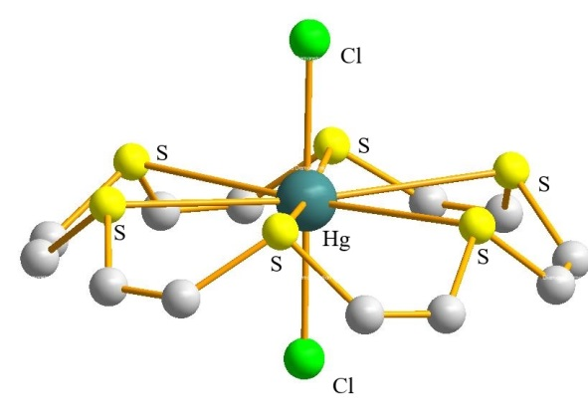  [Hg^{II}(L⁴)Cl₂] | 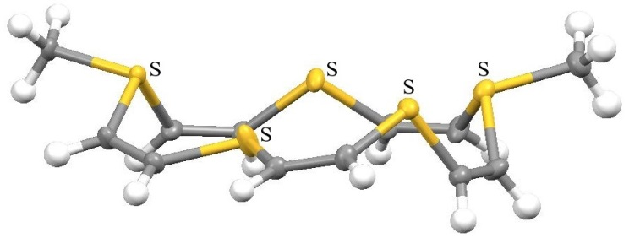  Dimethylated-L³
Figure 3
At room temperature, mono- and dimethylated compounds were produced when unsaturated thiacrown ether L³ and methyl trifluoromethanesulfonate (1 & 2 mmol) in CH₂Cl₂ interacted [Scheme 5]. X-Ray crystallographic study was used to ascertain the dimethylated product's structural architectures⁷ [Figure 3].
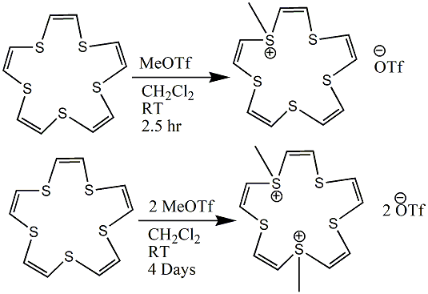
Scheme 5
Electron transfer mechanism causes the 15-, 18-, 21-, and 24-membered unsaturated thiacrown ethers (L3-L6) to create 1:1 combinations in solution containing the lanthanum metallofullerene La@C82. L5 possesses the most favourable ring diameter in terms of association with La@C82 among the aforementioned unsaturated thiacrown ethers. It is shown that the association efficiency towards La@C82 varies with the dimension of the thiacrown ethers as the host molecules, indicating the generation of inclusion compounds⁸.
Diisobutylaluminium Hydride (DIBAH) was used by researchers to precisely reduce the triple bonds of a number of cyclic diynes: 1,4,7,10-tetrathiacyclodeca-2,8-diyne (2-DiyneS₄-2), 1,4,8,11-tetrathiacyclotetradeca-2,9-diyne (3-DiyneS₄-3), 1,4,9,12-tetrathiacyclohexadeca-2,10-diyne (4-DiyneS₄-4), 1,4,10,13-tetrathiacyclooctadeca-2,11-diyne (5-DiyneS₄-5), 1,4,11,14-tetrathiacycloeicosa-2,12-diyne (6-DiyneS₄-6) and 1,4,8,11-tetrathiacycloheptadeca-2,9-diyne (6-DiyneS₄-3). It was possible to separate and characterise the consequent cyclic enynes as well as cyclic dienes. Most of them were characterized by X-Ray crystallography also [2-yne-eneS₄-2, 4-yne-eneS₄-4, 5-yne-eneS₄-5, 2-DieneS₄-2 to 6-DieneS₄-3]. Stair-like configurations were discovered for all molecular arrangements. The stiff structure units (S-CH=CH-S and/or (S-C≡C-S) and the zigzag orientations of the chains of hydrocarbons were the source of these molecular structures. Column-like features in the solid-state versions of 5-yne-eneS₄-5, 3-DieneS₄-3, 4-DieneS₄-4, and 5-DieneS₄-5 that were imposed on by close interactions between the sulphur centres of nearby rings were seen⁹.
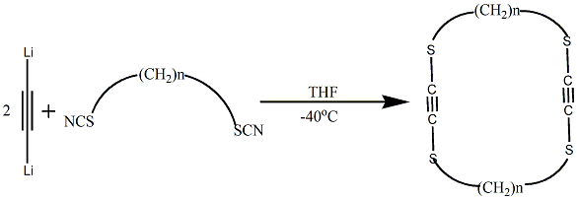
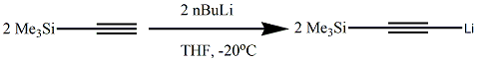
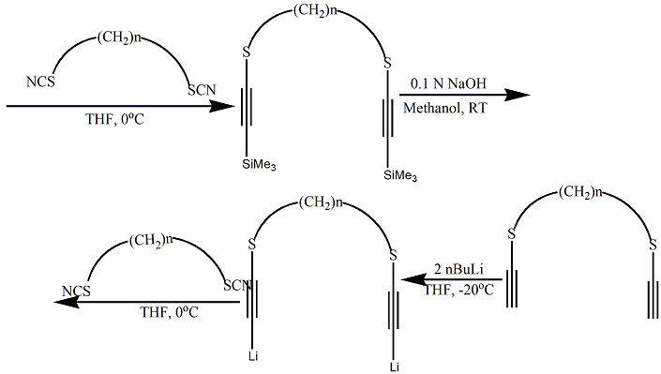
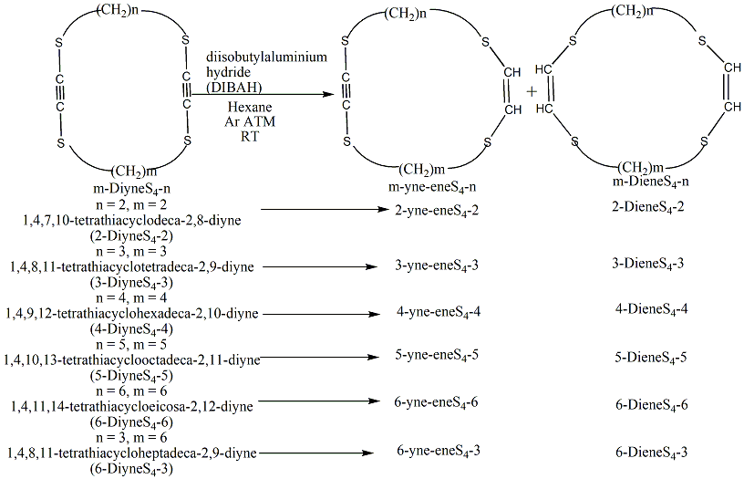
Scheme 6

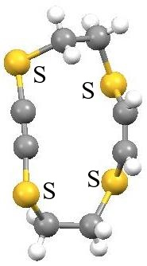  2-yne-eneS₄-2 |  | 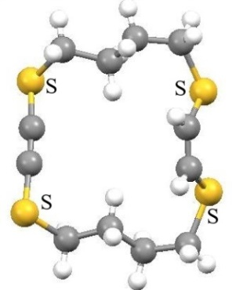  4-yne-eneS₄-4 |  | 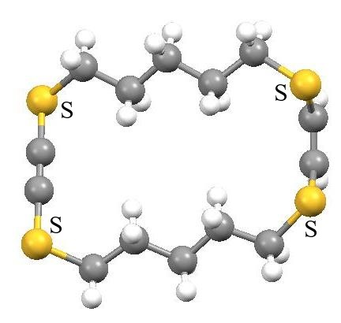  5-yne-eneS₄-5
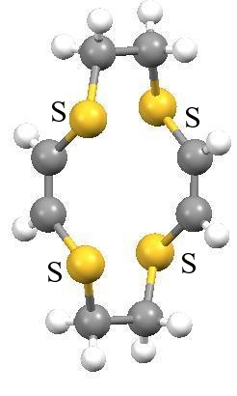  2-DieneS₄-2 |  | 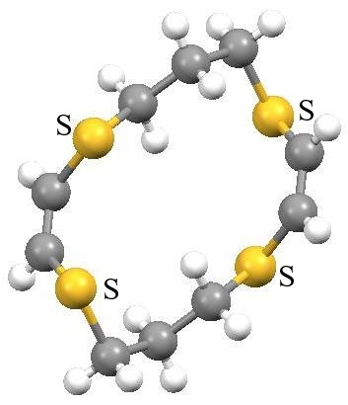  3-DieneS₄-3 |  | 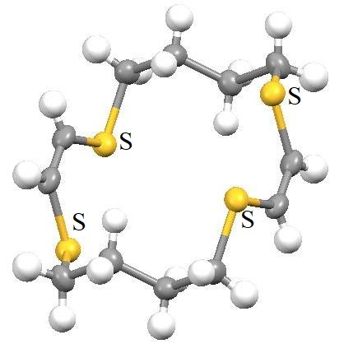  4-DieneS₄-4
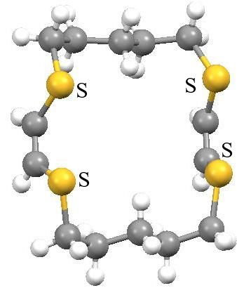  5-DieneS₄-5 |  | 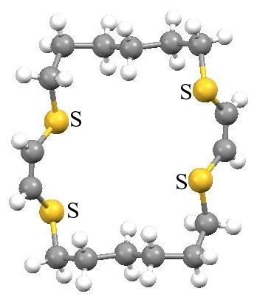  6-DieneS₄-6 |  |  | 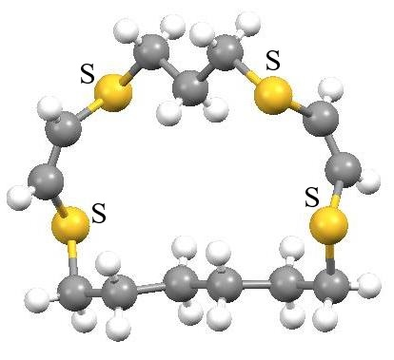  6-DieneS₄-3
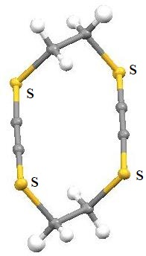  2-DiyneS₄-2 | 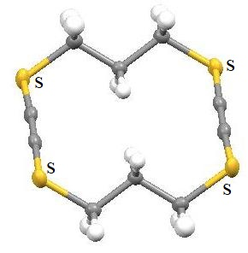  3-DiyneS₄-3 |  |  |  |  | 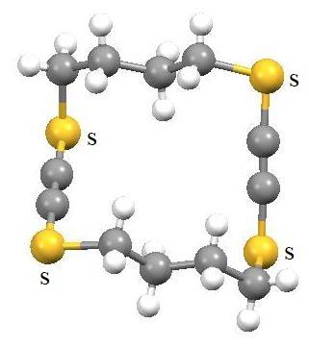  4-DiyneS₄-4
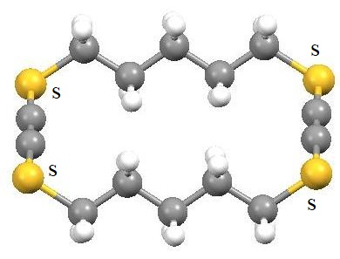  5-DiyneS₄-5 |  | 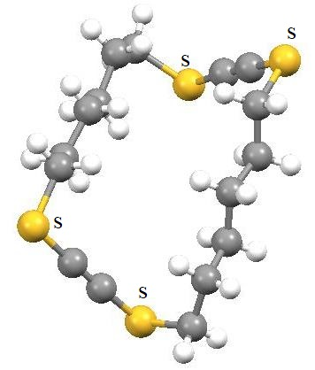  6-DiyneS₄-6 |  |  |  | 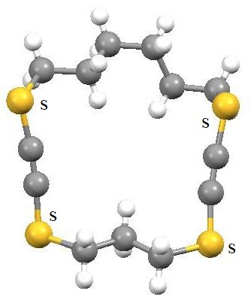  6-DiyneS₄-3
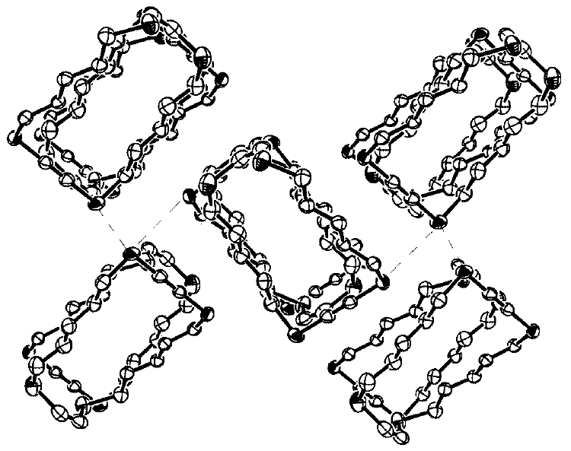 |  |  | 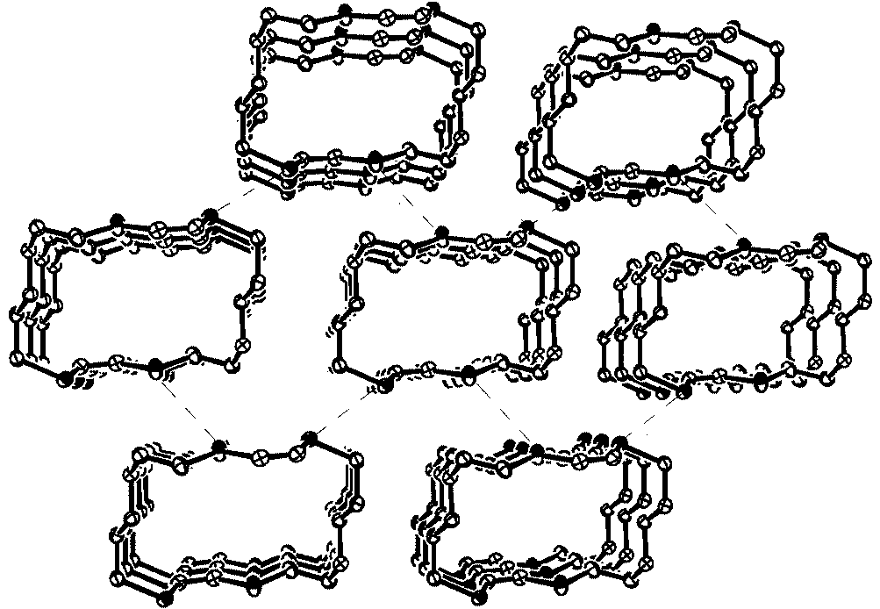
Columnar structure of 5-DieneS₄-5 |  |  | Columnar structure of 6-DieneS₄-6
Figure 4
Several similar types of Diyne-, tetrayne- and hexayne- systems will be discussed in details inside related sections for selenium later in this chapter.
Malononitrile, aryl aldehydes, and 1,2-ethanedithiol were all used in the multicomponent macroheterocyclization to generate 5,12-diamino-7,14-bis(aryl)-1,4,8,11-tetrathiacyclotetradeca-5,12-diene-6,13- dicarbonitriles in presence of catalytic quantity of Et₃N in EtOH [Scheme 7]. By using spectroscopic techniques, the geometry of the generated macroheterocycles was verified¹⁰.
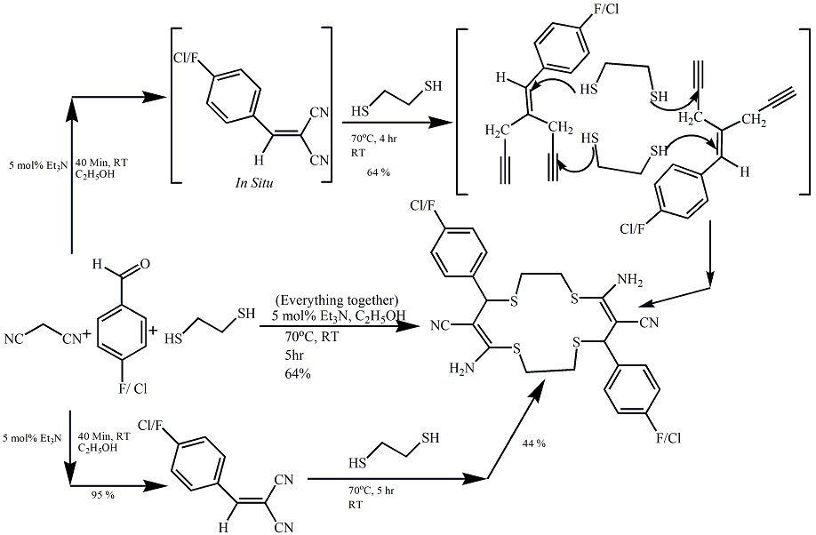
Scheme 7
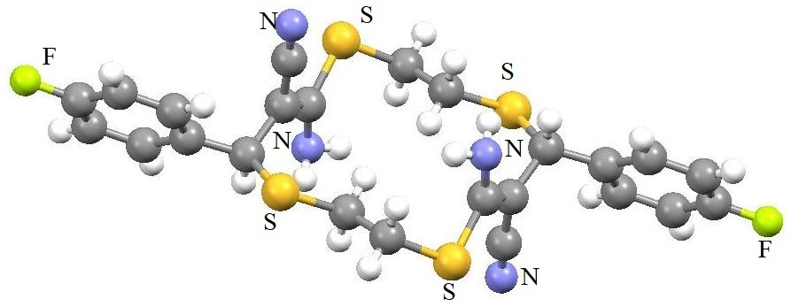
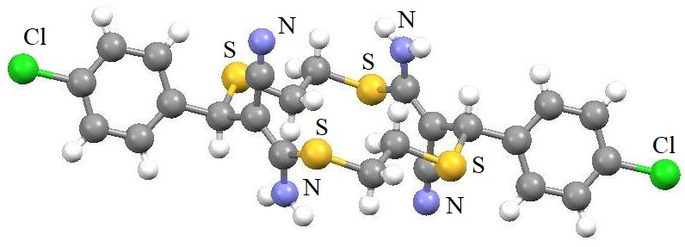
Figure 5
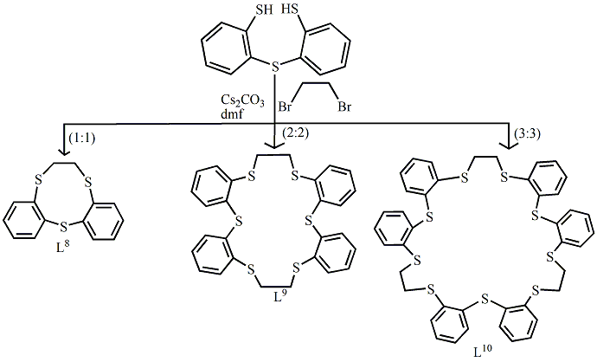
In the presence of Caesium Carbonate in N, N-dimethyl formamide, bis(o-mercaptophenyl) sulphide combined with 1,2-dibromoethane to produce the 9-membered-ring 1:1-condensed resultant compound (L⁸), the 18-membered ring 2:2 condensed item (L⁹), as well as the 27-membered ring 3:3 condensed final compound (L¹⁰), having yields of 42, 19, and 5%, respectively. The 10-membered ring 1:1 condense result (L¹¹) was the only discernible product in a 42% yield following the condensation of Bis(o-mercaptophenyl) sulphide with 1,3-dibromopropane. Two isomeric 1:1-condensation compounds with yields of 25% (L¹²) and 5% (L¹³), respectively, were produced by the reaction of Bis(o-mercaptophenyl) sulphide with cis-1,2-dichlorocthylene in refluxing Ethanol in the presence of EtONa, as well as the 2:2 condense compound (20%) (L¹⁴)¹¹.
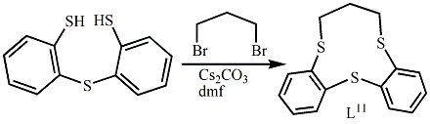
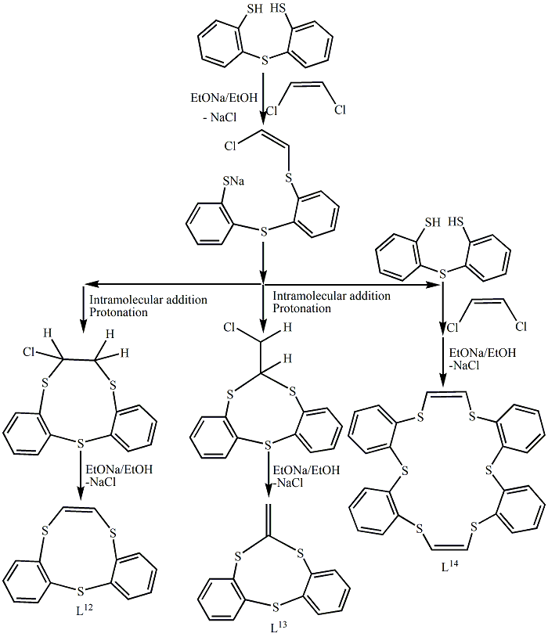
Scheme 8
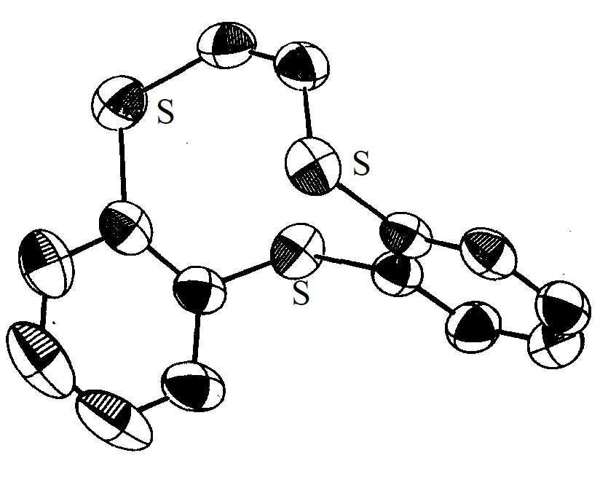  L¹² | 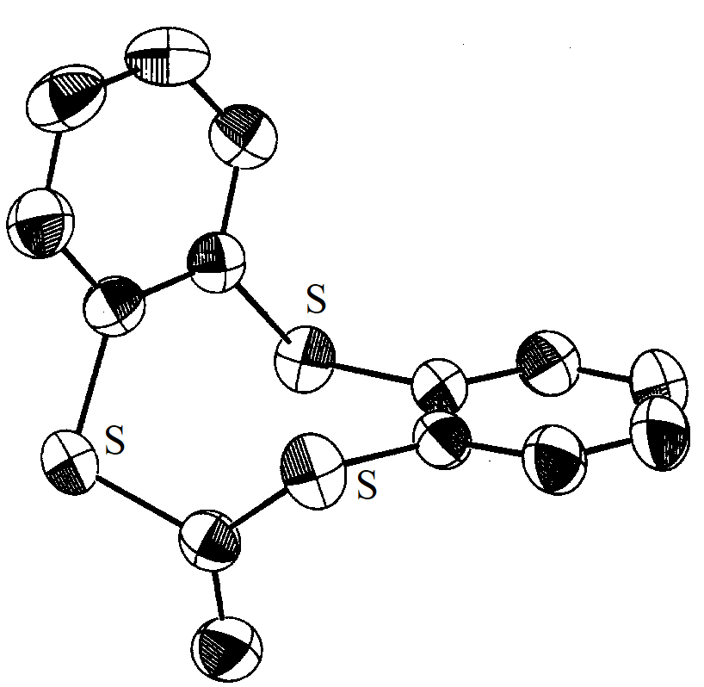  L¹³ | 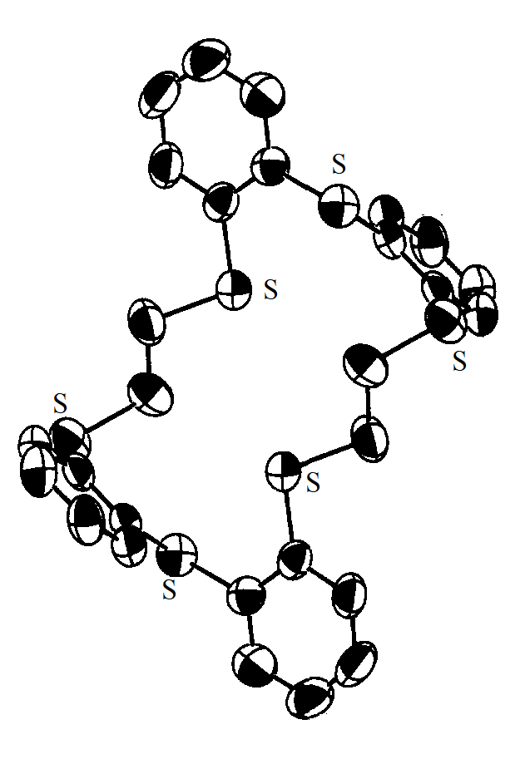  L¹⁴
Figure 6
Unsaturated all Selena-donor macrocycles:
In the beginning Kamigata et al.^{12,13} produced 1,4-diselenin and unsaturated selenacrown ethers L¹⁵–L¹⁹ [Scheme 9]. Because of the unfavourable conformation in the ring closing reaction, the 9- and 12-member unsaturated selelacrown ethers cannot be generated by the aforementioned procedure. The respective energy of the 9- and 12-member molecules are greater compared to that of the remaining selenacrown ethers, according to calculations of molecular orbitals¹³. The C=C bonds across each of the L¹⁵–L¹⁸ crystal frameworks have cis- conformations, and all of the Se atoms are pointed in the direction of the cavities. While the frameworks of the related unsaturated thiacrown ethers get rounder as the dimension increases⁴, the molecular frameworks of the rings get more elliptically narrow here. The larger unsaturated selenacrown ethers being more readily oxidised than the smnaller ones, according to the cyclic voltammograms. Because the C-Se bonds are weaker than those of the C-S bonds, unsaturated selenacrown ethers being thermally more unstable than their equivalent sulphur counterparts¹³. The following compounds were synthesized: [Ag(1,4-diselenin)(CF₃COO)], [Ag(1,4-diselenin)₂(CF₃COO)], [Ag(L¹⁵)(CF₃COO)], [Ag₅(L¹⁶)3(CF₃COO)₅], [Ag₇(L¹⁷)(CF₃COO)₅], [Ag(L¹⁸)(CF₃COO)], [Ag₂(L¹⁸)(CF₃COO)₂], [Ag₃(L¹⁸)₂(CF₃COO)₃], [Ag(L¹⁵)(NO₃)] and [Ag(L¹⁷)(BF₄)] [Scheme 10]. Crystal structure of [Ag(1,4-diselenin)₂(CF₃COO)], [Ag(L¹⁵)(CF₃COO)], [Ag(L¹⁵)NO₃] , [Ag₂(L¹⁸)(CF₃COO)₂] and [Ag₅(L¹⁶)₃(CF₃COO)₅] are shown in Figure 8. One Ag atom exists within the macrocycle cavity of [Ag(L¹⁵)(CF₃COO)]. This results in a deformed 5-coordinated square pyramidal configuration surrounding the Ag atom, linked by three Se atoms, one O atom that comes from the CF₃COO⁻ group, and another loosely bound Se atom. [Ag(L¹⁵)(NO₃)] shares structural similarities with [Ag(L¹⁵)(CF₃COO)]. Out of the three crown components in [Ag₅(L¹⁶)₃(CF₃COO)₅], one L¹⁶ has one Ag atom while the remaining two macrocycles contain two Ag atoms, respectively. In accordance with the arrangement of [Ag₂(L¹⁸)(CF₃COO)₂], one L¹⁸ unit's cavity contains two Ag atoms. Two of each CF₃COO⁻ group's O atoms coordinate with different Ag atoms. The two CF₃COO⁻ units are situated on different sides of the ring plane. Unsaturated selenacrown ether's in-solution Ag ion inclusion behaviour was studied. At low concentrations in solution, the unsaturated Se-ether predominantly produces 1:1 compounds.
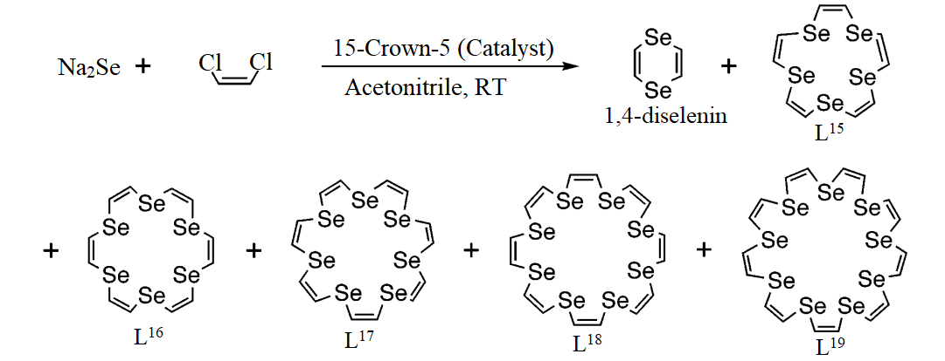
Scheme 9
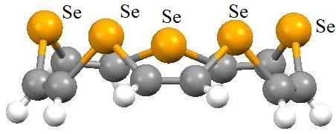  L¹⁵ | 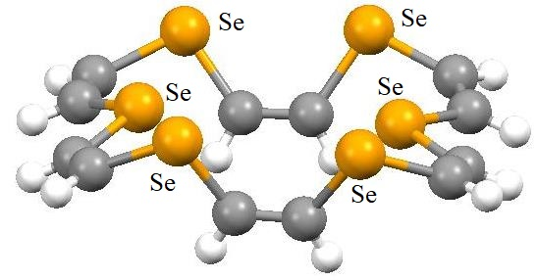  L¹⁶
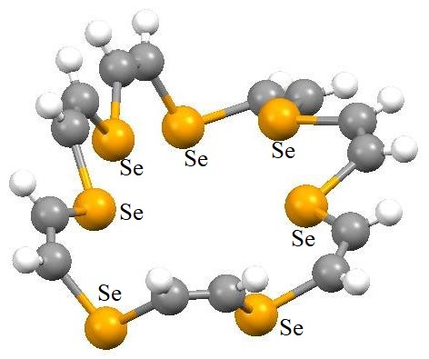  L¹⁷ | 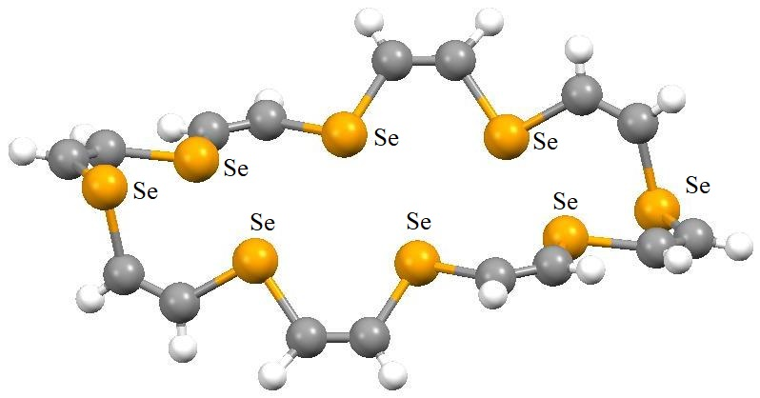  L¹⁸
Figure 7
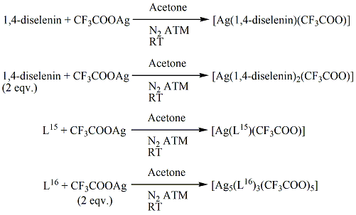
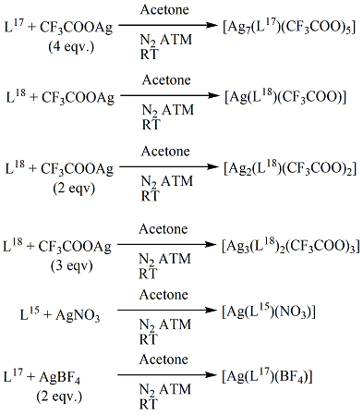
Scheme 10

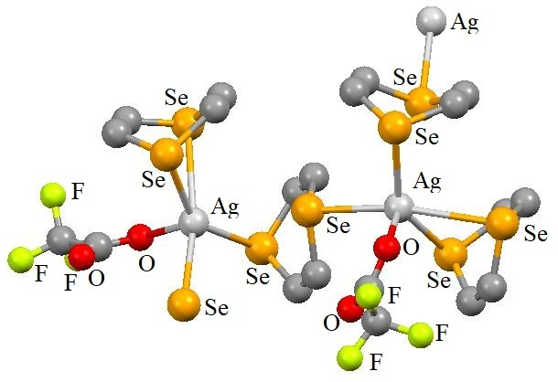 | 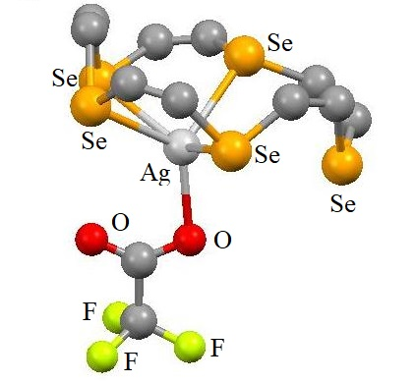
[Ag(1,4-diselenin)₂(CF₃COO)] | [Ag(L¹⁵)(CF₃COO)]
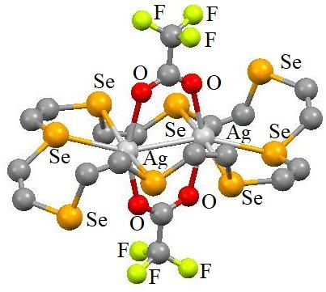 | 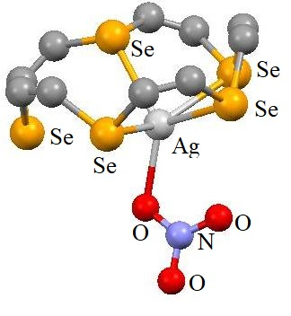
[Ag₂(L¹⁸)(CF₃COO)₂] | [Ag(L¹⁵)NO₃]
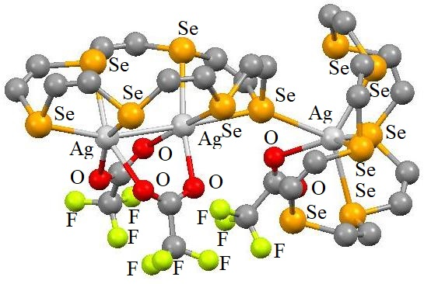
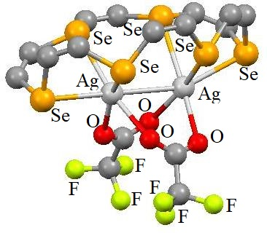
[Ag₅(L¹⁶)₃(CF₃COO)₅]
Figure 8
Sterically crowded compound Lithium 2,4,6- triisopropylphenylalkynylselenolate is produced when 2,4,6-triisopropylphenylethynyllithium reacts with grey selenium (Scheme 11). This compound is reactive in solution and proceeds self-addition to produce an unusually Se-rich macrocycle. Tetramethylethylenediamine and other coordinating chemicals appeared to significantly speed up the process. The macroheterocycle's architecture (Figure 10) revealed two outside six-membered rings connected to a centre 12-member ring. The only components of the rings' robust tricyclic backbone are quaternary alkenylidene and Se. This Se-enriched macrocycle has very little flexibility due to the positioning of the alkenylidene groups¹⁴.
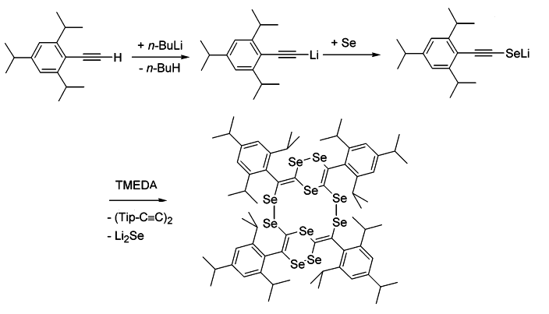

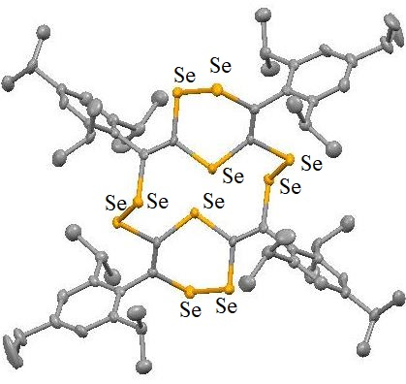
Scheme 11 Figure 10
The generation of cyclic diynes with the general composition m-DiyneX₂-n [X = S. Se] was described by Gleiter et al.¹⁵ The chains that separate two C≡C-Se units are denoted by the letters m and n. The bridges range in span from m = 4 to 8 and n = 2 to 6. For the majority of frameworks, structural studies using X-Ray diffraction show a chair-like shape in the solid phase. Weak X……X or weak C-H……π interactions are the origin of these formations. The synthetic route is shown in Scheme 12. Structural frameworks are shown in Figure 11. 5-DiyneS₂-2, 5-DiyneS₂-3, 7-DiyneS₂-5 and 5-DiyneSe₂-2 show columnar architectures. Gleiter et al.¹⁶ further reported that a stepwise process could be used for generating cyclic tetraselenadiynes. α,ω-Diselenocyanatoalkanes (m = 2–5) and the Li-salt of trimethylsilylacetylene were involved in key steps. The resultant bis-Li-salt of α,ω-diselenaalkadiynes (m = 2-5) were treated with α,ω-diselenocyanatoalkanes (n = 2-5) again which gave rise to cyclic tetraselenadiynes having methylene chains of lengths m and n between the Se-C≡C-Se groups [Scheme 13]. The yields are quite low. We observe that rings having m = n, have the largest yields (35–45%). Secondary processes which produced by-products with identical chain lengths, as illustrated in Schemes 14, constituted one cause of the reduced yields in instances of rings with variable lengths of the chain between the Se-C≡C-Se building blocks. In the solid state, the architectures of seven ring networks were studied [Figure 12]. Such studies show that the rigid Se-C≡C-Se components, which attempt to follow the torsion angles associated with CH₂-Se σ-bonds within 60°-90°, are what dictate the molecular architectures. Both the systems 5- DiyneSe₄-3 as well as 5- DiyneSe₄-5 exhibit columnar formations in crystalline state, which are likely attributed to strong interactions between Se atoms of nearby rings. Through combining the appropriate open chain dithia-α,ω-diynes, cyclic bis(1,3-butadiynes) with sulphur centres located in the α-position to the 1,3-butadiyne molecules were produced. In another method, Gleiter et al.¹⁷ used dilithium-1,3-butadiynide to interact with α,ω-dithiocyanatoalkanes or α,ω-diselenocyanatoalkanes to generate a four-component cyclization. The cyclic dimers or rimmers were both possible with this notion. In the solid state, the majority of the cyclic dimer and trimer of sulphur molecules assume chair-like shapes. For cyclic dimer of Sulfur when n = 5, cyclic trimer of Sulfur when n = 5, Cyclic dimer of Selenium when n = 4, and cyclic trimer of Selenium when n = 4, 5, all experienced tubular forms in their solid state having close proximity within the chalcogen centres of neighbouring stacking. Incorporation of the solvent molecules as guests was obtained upon recrystallization of the cyclic trimer of selenium when n = 5, using different nonpolar as well as polar environments. According to calculations, the solvent-accessible proportion varied from 19% (for n-hexane) to 25% (for mesitylene). Methylene chains’ flexibility and the readily adjustable torsional angles that connect the hard 1,3-butadiyne rods were what give these cycles their elasticity qualities.
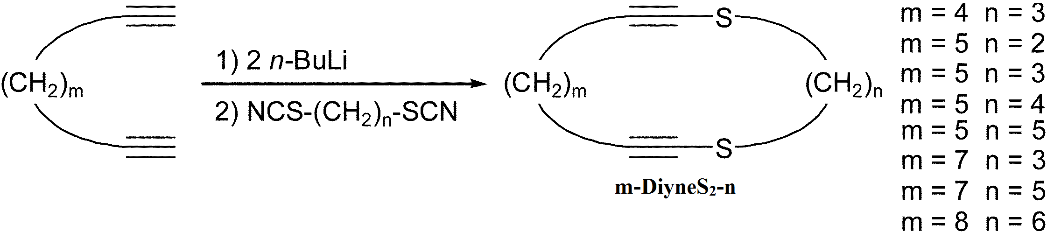
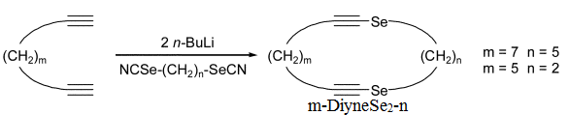
Scheme 12
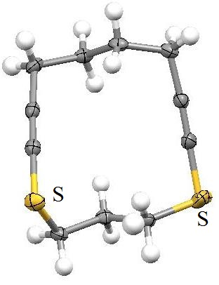  4-DiyneS₂-3 | 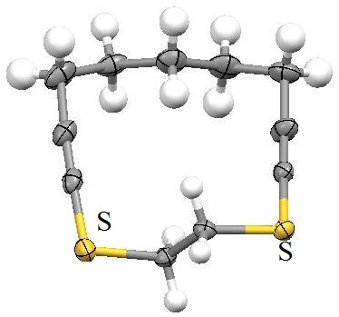  5-DiyneS₂-2 |  |  |  |  |  | 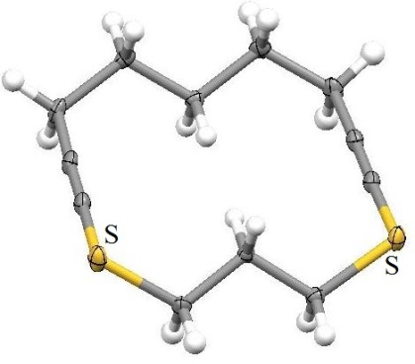  5-DiyneS₂-3
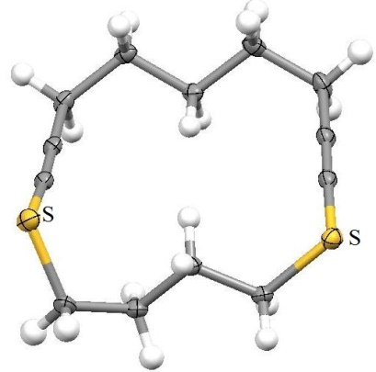  5-DiyneS₂-4 |  |  | 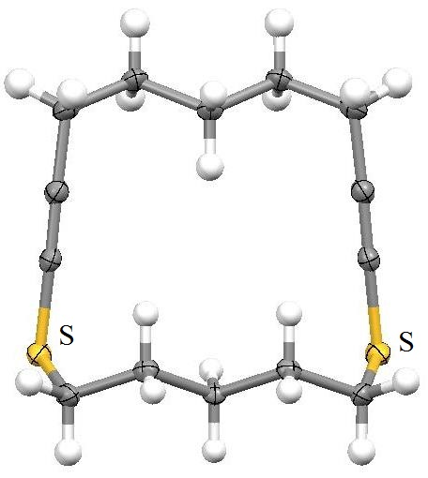  5-DiyneS₂-5 |  |  |  | 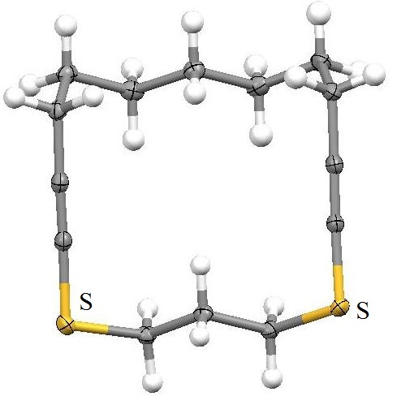  7-DiyneS₂-4
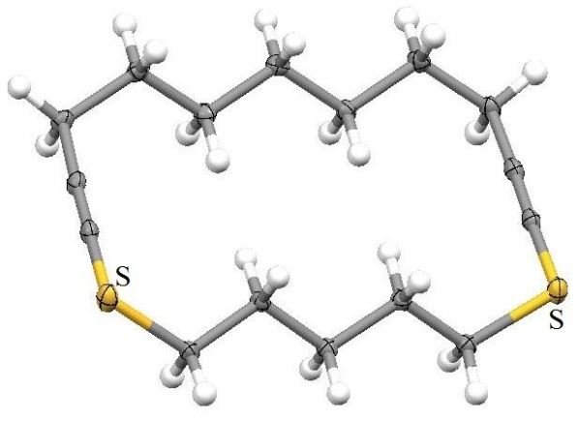  7-DiyneS₂-5 |  |  |  |  | 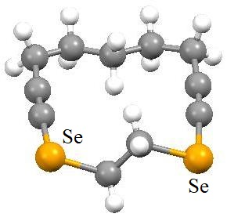  5-DiyneSe₂-2 |  |  |  |  | 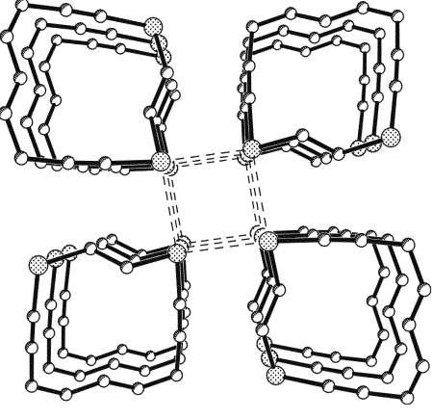  Tubular structure of 5-DiyneS₂-2 in the solid state
Figure 11
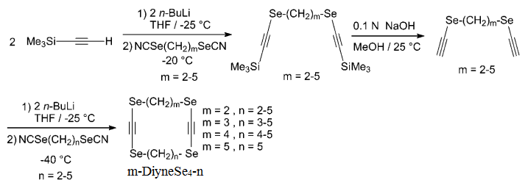
Scheme 13
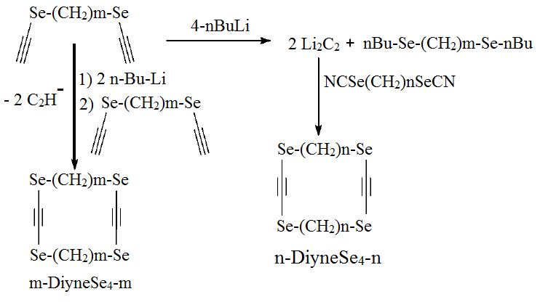
Scheme 14
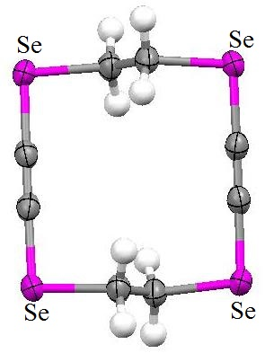  2-DiyneSe₄-2 |  | 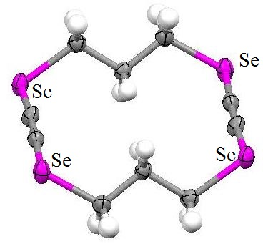  3-DiyneSe₄-3 |  |  |  |  |  |  | 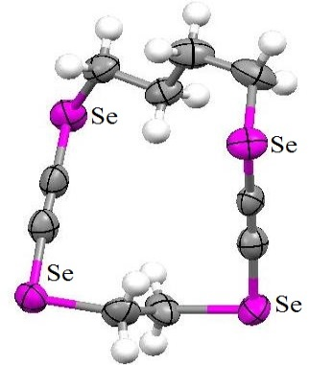  4-DiyneSe₄-2
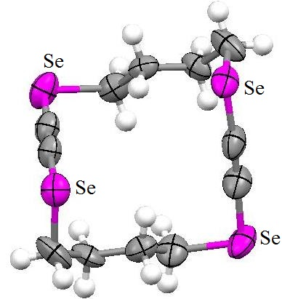  4-DiyneSe₄-4 |  | 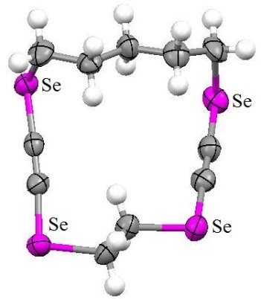  5-DiyneSe₄-2 |  |  |  | 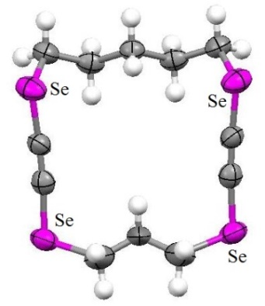  5-DiyneSe₄-3
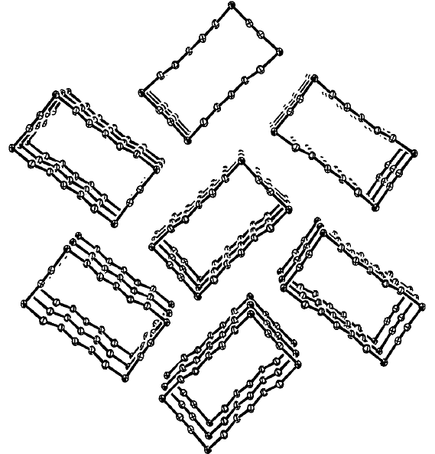
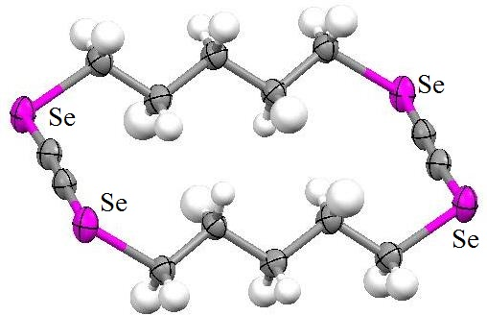

5-DiyneSe₄-5 and Columnar structures of 5-DiyneSe₄-5 in the solid state
Figure 12
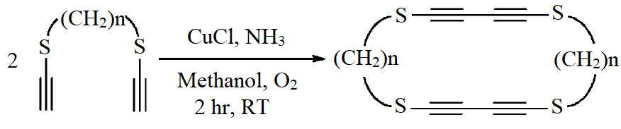
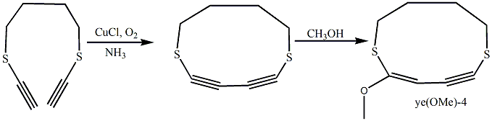
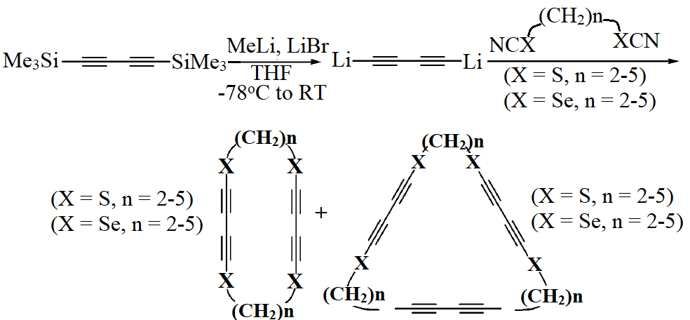
Scheme 15
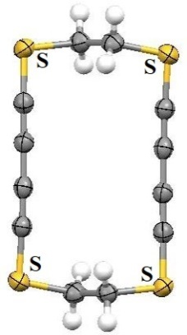 |  |  |  | 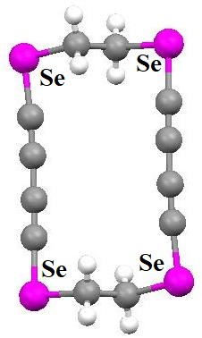 |  |  |  |  |  |  | 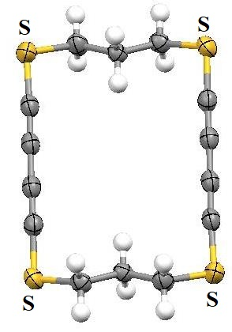
2-TetrayneS₄-2 |  |  |  | 2-TetrayneSe₄-2 |  |  |  |  |  |  | 3-TetrayneS₄-3
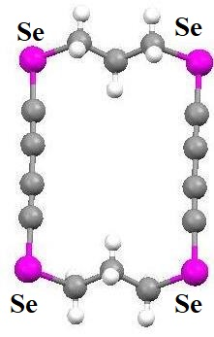 |  |  |  | 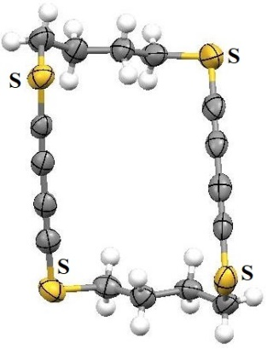 |  |  |  |  |  |  | 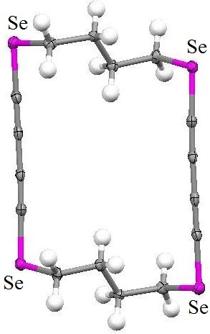
3-TetrayneSe₄-3 |  |  |  | 4-TetrayneS₄-4 |  |  |  |  |  |  | 4-TetrayneSe₄-4
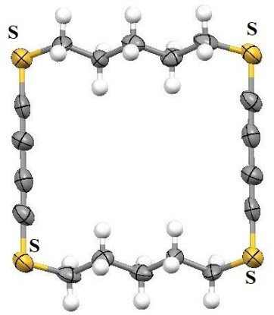 |  |  |  | 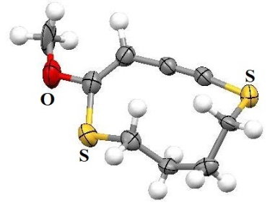 |  |  |  | 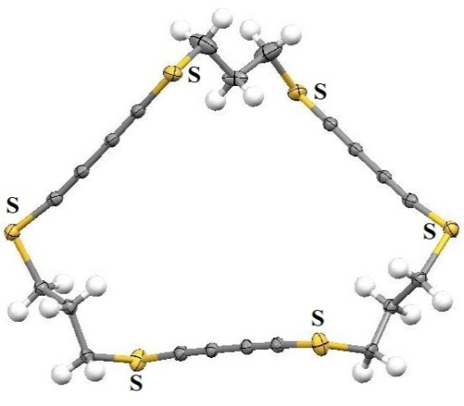
5-TetrayneS₄-5 |  |  |  | Yne-ene(OMe)S₂-4 |  |  |  | 3,3,3-HexayneS₆
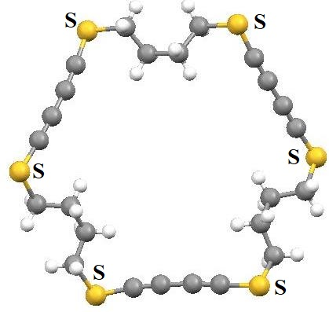 |  |  |  | 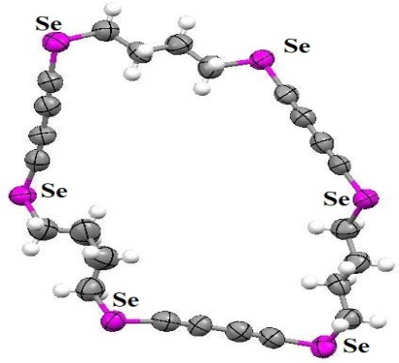 |  |  |  |  |  |  | 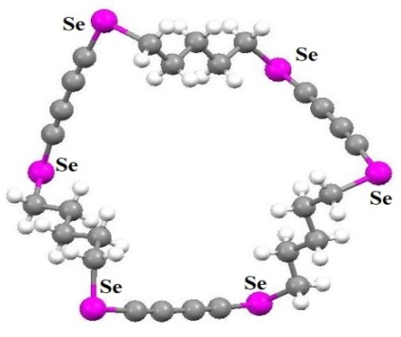
4,4,4-HexayneS₆ |  |  |  | 4,4,4-HexayneSe₆ |  |  |  |  |  |  | 5,5,5-HexayneSe₆
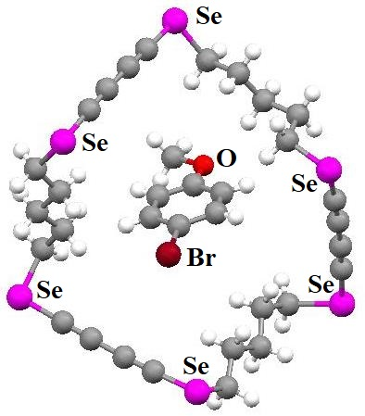 |  |  |  | 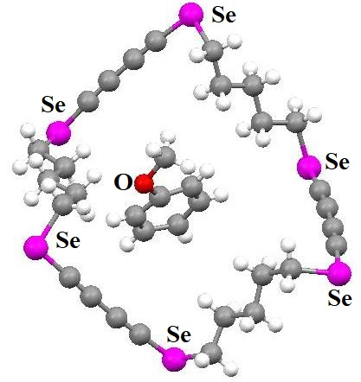 |  |  |  |  |  |  | 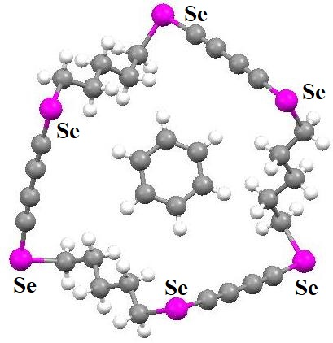
5,5,5-HexayneSe₆ with included 4-Bromo Anisole |  |  |  | 5,5,5-HexayneSe₆ with included Anisole |  |  |  |  |  |  | 5,5,5-HexayneSe₆ with included Benzene
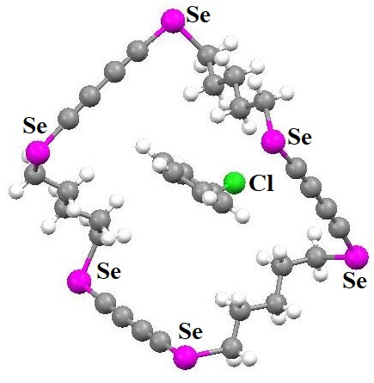 |  |  |  | 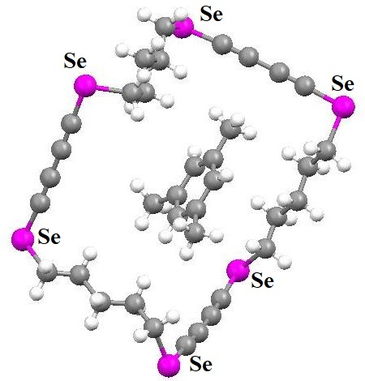 |  |  |  |  |  |  | 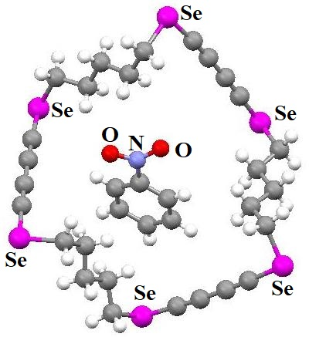
5,5,5-HexayneSe₆ with included Chlorobenzene |  |  |  | 5,5,5- HexayneSe₆ with included Mesitylene |  |  |  |  |  |  | 5,5,5-HexayneSe₆ with included Nitrobenzene
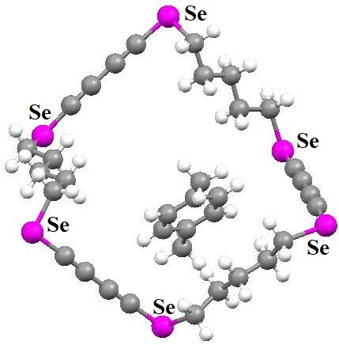 |  |  |  | 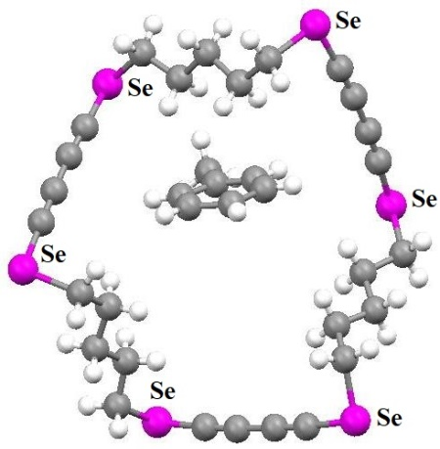 |  |  |  |  |  |  | 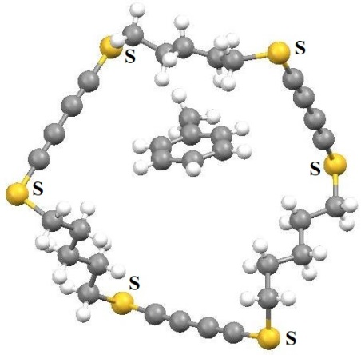
5,5,5-HexayneSe₆ with included p-Xylene |  |  |  | 5,5,5-HexayneSe₆ with included Toluene |  |  |  |  |  |  | 5,5,5-HexayneS₆ with included Toluene
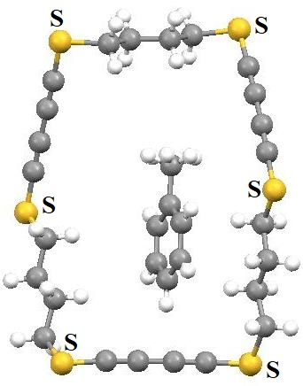 |  |  |  | 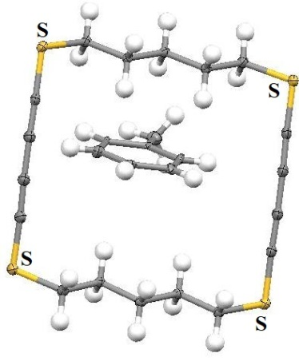 |  |  |  |  |  |  | 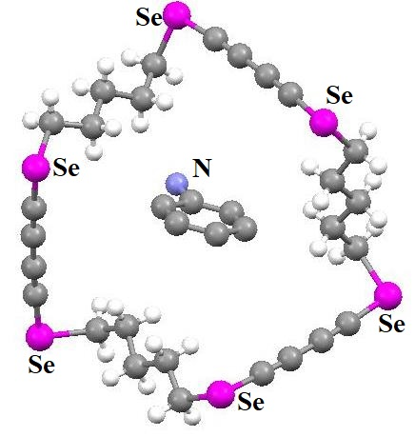
4,4,4-HexayneS₆ with included Toluene |  |  |  | 5-TetrayneS₄-5 with included toluene |  |  |  |  |  |  | 5,5,5-HexayneSe₆ with included Aniline
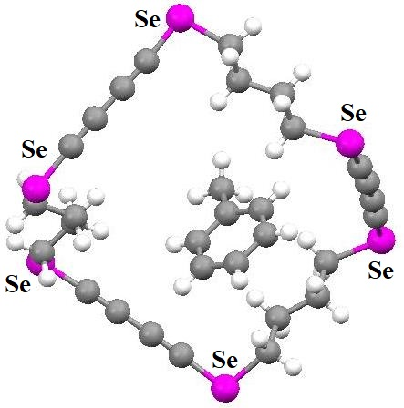 |  |  |  | 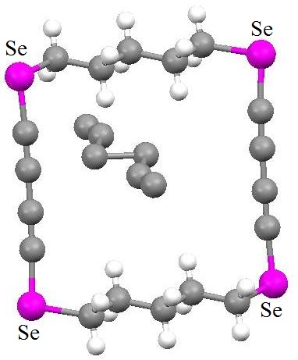 |  |  |  | 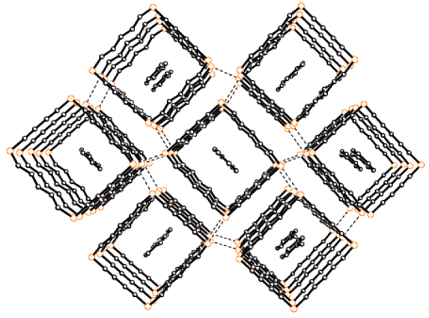
4,4,4-HexayneSe₆ with included Toluene |  |  |  | 5, 5, 5-HexayneSe₆ with included n-Hexane |  |  |  | Columnar structure of 5-TetrayneS₄-5 in the solid state with included toluene
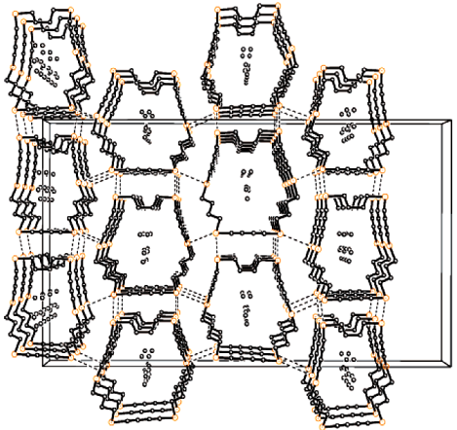 |  |  |  | 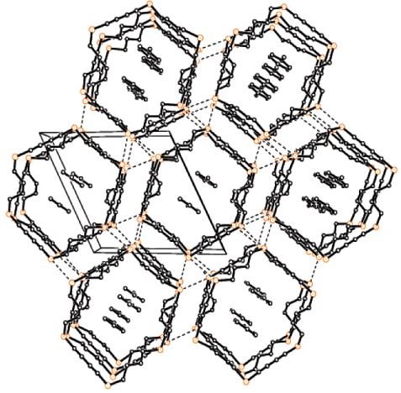 |  |  |  |  |  |  |  | 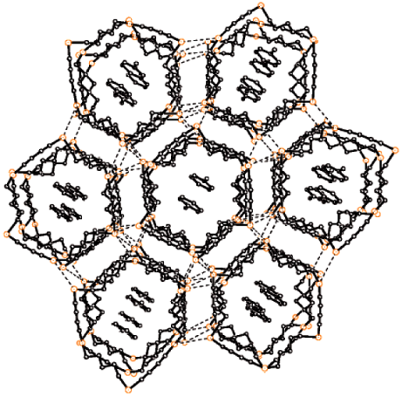
Columnar structure of 4,4,4-HexayneSe₆ in the solid state with included n-Hexane |  |  |  | Columnar structure of 4,4,4-HexayneSe₆ in the solid state with included Toluene |  |  |  |  |  |  |  | Columnar structure of 5,5,5-HexayneSe₆ in the solid state with included Toluene
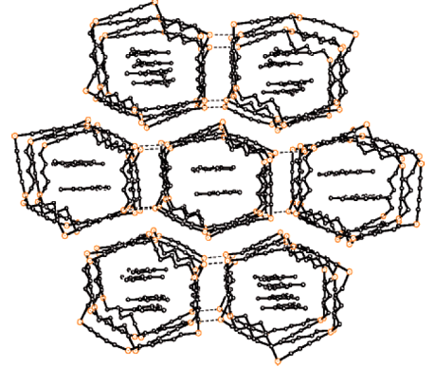
Columnar structure of 5,5,5-HexayneSe₆ in the solid state with included Mesitylene

Conclusion:
Over the years researchers have investigated rigorously on the chemistry of chalcogen macrocycles. In this chapter, chemistry of unsaturated all sulfer and all selenium based macrocycles have been discussed briefly, mainly focusing on their synthetic and metal complexation as well as structural details which generated column-like architectures easily due to secondary interactions.
Reference:
- S. Kim, L. F. Lindoy and S. S. Lee, “Recent developments in the thiamacrocyclic chemistry of the latter d-block elements”, Coord. Chem. Rev., Vol. 280, pp. 176-202, 2014.
- (a) R. M. Izatt, J. S. Bradshaw, S. A. Nielsen, J. D. Lamb and J. J. Christensen, “Thermodynamic and kinetic data for cation-macrocycle interaction” Chem. Rev. Vol. 85, pp. 271-339, 1985. (e) M. R. Izatt, K. Pawlak nd J. S. Bradshaw, “Thermodynamic and kinetic data for macrocycle interactions with cations and anions” Chem. Rev., Vol. 91, PP. 1721-2085, 1991.
- A. Panda, “Chemistry of selena macrocycles”, Coord. Chem. Rev., Vol. 253, pp. 1056-1098, 2009.
- T. Tsuchiya, T. Shimizu, and N. Kamigata, “Unsaturated Thiacrown Ethers: Synthesis, Physical Properties, and Formation of a Silver Complex”, J. Am. Chem. Soc. Vol. 123, pp. 11534-11538, 2001.
- T. Tsuchiya, T. Shimizu, K. Hirabayashi, and N. Kamigata, “Silver Complexes with Unsaturated Thiacrown Ethers: Inclusion Behavior of Conformationally Restricted Macrocycles” J. Org. Chem., Vol. 67, pp. 6632-6637, 2002.
- T. Tsuchiya, T. Shimizu, K. Hirabayashi, and N. Kamigata, “Formation and Structures of Mercury Complexes of 18-Membered Unsaturated and Saturated Thiacrown Ethers”, J. Org. Chem., Vol. 68, pp. 3480-3485, 2003.
- K. Hirabayashi, N. Sugano, M. Nakashizuka, T. Yaginuma, and T. Shimizu, “Polymethylation reactions of saturated and unsaturated thiacrown ethers”, Phosphorus Sulfur Silicon Relat. Elem., Vol. 194, pp. 753-755, 2019.
- T. Tsuchiya, H. Kurihara, K. Sato, T. Wakahara, T. Akasaka, T. Shimizu, N. Kamigata, N. Mizorogic and S. Nagase, “Supramolecular complexes of La@C82 with unsaturated thiacrown ethers”, Chem. Commun., Issue 34, pp. 3585–3587, 2006.
- (a) T. H. Staeb, R. Gleiter and F. Rominger, “Preparation and Structures of Cyclic Tetrathiadienes and Tetrathiaenynes”, Eur. J. Org. Chem., Issue 16, pp. 2815-2822, 2002. (b) D. B. Werz, T. H. Staeb, C. Benisch, B. J. Rausch, F. Rominger, and R. Gleiter, “Self-Organization of Chalcogen-Containing Cyclic Alkynes and Alkenes To Yield Columnar Structures”, Org. Lett., Vol. 4, pp. 339-342, 2002. (c) C. Benisch, S. Bethke, R. Gleiter, T. Oeser, H. Pritzkow, and F. Rominger, “Syntheses and Structural Properties of Cyclic Tetrathiadiynes”, Eur. J. Org. Chem,. Issue 13, pp. 2479-2488, 2000.
- N. S. Akhmadiev, E. S. Mescheryakova, V. R. Akhmetova and A. G. Ibragimov, “Metal-free multicomponent synthesis of novel macrocyclic tetrathiadienes with cyano and amino groups”, RSC Adv., Vol. 11, pp. 18768–18775, 2021.
- J. Nakayama, A. Kaneko, Y. Sugihara, and A. Ishii, “Synthesis of Sulfur-containing Large-membered Heterocycles (Crown Thioethers) with Bis(o-mercapto)phenyl Sulfide”, Tetrahedron, Vol. 55, pp. 10057-10066, 1999.
- T. Shimizu, M. Kawaguchi, T. Tsuchiya, K. Hirabayashi, and N. Kamigata, “Synthesis and Structures of 15- and 18-Membered Unsaturated Selenacrown Ethers and Their Complexation with Silver Trifluoroacetate”, Org. Lett., Vol. 5, pp. 1443-1445, 2003.
- T. Shimizu, M. Kawaguchi, T. Tsuchiya, K. Hirabayashi, and N. Kamigata, “Unsaturated Selenacrown Ethers: Synthesis, Structure, and Formation of Silver Complexes”, J. Org. Chem,. Vol. 70, pp. 5036-5044, 2005.
- R. Pietschnig, S. Scha1fer, and K. Merz, “Self-Addition of a Sterically Hindered Alkynylselenolate”, Org. Lett., Vol. 5, pp. 1867-1869, 2003.
- J. H. Schulte, D. B. Werz, F. Rominger and R. Gleiter, “Syntheses and solid state structures of cyclic diynes with two chalcogen centres – a competition between weak interactions”, Org. Biomol. Chem., Vol. 1, pp. 2788-2794, 2003.
- D. B. Werz, Rolf Gleiter and F. Rominger, “Cyclic Tetraselenadiynes: Rigid Cycles with Long-Range van der Waals Forces between Chalcogen Centers”, J. Org. Chem. Vol. 67, pp. 4290-4297, 2002.
- D. B. Werz, R. Gleiter and F. Rominger, “Cyclic Tetra- and Hexaynes Containing 1,4-Donor-Substituted Butadiyne Units: Synthesis and Supramolecular Organization”, J. Org. Chem., 69, 2945-2952, 2004.

