A Review of Medical and Ayurvedic Uses of Tulsi
*Suman Kumari, S K Jha, Ladly Rani, Rupa Verma
PG Biotechnology Department of Botany Ranchi University Ranchi, Jharkhand,834008
Corresponding author: simranbharti12k4@gmail.com
ABSTRACT
The Scientific name of Tulsi is Ocimum sanctum. It is a small fallow, braches, and full fill of medicinal herbs. Tulsi botanicals are not only Ayurvedic pharmaceuticals but also used in other medicines they have many good properties such as antibacterial, anticancer, antioxidant, immunoregulatory, etc. It is effective for reducing glucose levels in the blood. Therefore, it is useful for diabetic patients. All part of Tulsi is also used as medicine. “It is also called the queen of herbs” because it contains many nutrients and the leaf of Tulsi contains calcium, and magnesium ions in rich amounts. It also presents vitamins and proteins. The plants “tulsi” have great importance in “Indian culture”. It has been used in India since the old times to prevent colds, fever, coughs, skin diseases, and digestive problems. The height and length of the Tulsi plant is usually 20-50 cm. It is mostly cultivated in Hindu houses and temples for worship.
Keywords:- Tulsi, herbs, antioxidant, antifungal, pharmaceutical.

INTRODUCTION
In India, various plants are used for medicine. Since time immemorial plants have been used as
medicine which are practically indigestible, they are safe, effective, and easily available. According to the botanical survey of India, India houses more than 8,000 species of medicinal plants. Such plants have been used since ancient times in recruitment culture, of which Tulsi is one.
The name of Tulsi comes from Sanskrit it means “The Matchless One.” ⁽¹⁾ Tulsi is the one most holy plant,
healthy and conventional medicine. It is also known as Vishnu-Priya. It has various possessions of Tulasi or tulsi such as antibacterial, antioxidant, natural immunity booster, and antipyretic. ⁽²⁾ Tulsi are divided from the secondary metabolite components including flavonoids and tannins. ⁽³⁾⁽⁴⁾ It plays traditional and ayurvedic and is also used as a biofertilizer. tulsi is one of those great wonder plants, it is also used in the natural material of the cosmetic industry.⁽⁵⁾ Ocimum sanctum Linn is the scientific name of Tulsi.

CLASSIFICATION
Kingdom | Plantae
Division | Magnoliophyta
Class | Magnoliopsida
Order | Lamiales
Family | Lamiaceae
Genus | Ocimum
Species | Ocimum sanctum
Table 1: Classification of Ocimum sanctum (Tulsi)⁽⁶⁾

MORPHOLOGY
Ocimum sanctum (Tulsi) belongs to the Lamiaceae /Labiate family.
Height:-20-50cm
Leaves:-Green color (new leaf), pink (old leaf)
Leaf Length:- 2.5-5 cm long and 1.6-2.9 wide. ⁽⁵⁾
Flower:-Purple
Branch:-Subshrub
Seed :-Reddish black
Cultivation:-India (majorly)
Nutlets :- Pale brown

Type of tulsi⁽⁹⁾

Sri Ram Tulsi - green leaf
Krishna Tulsi - purple leaf
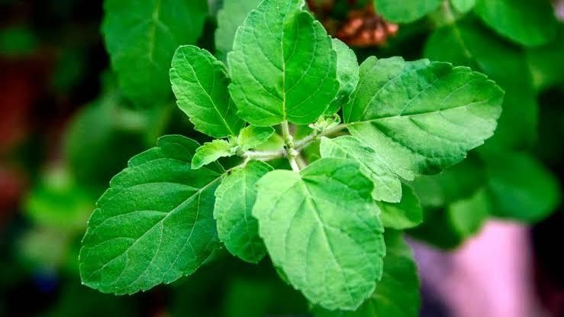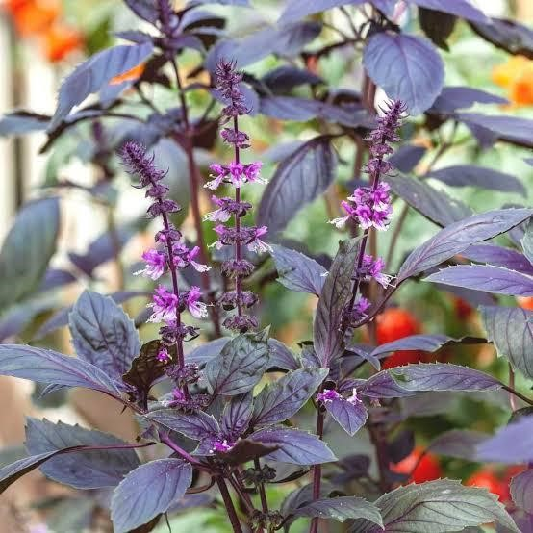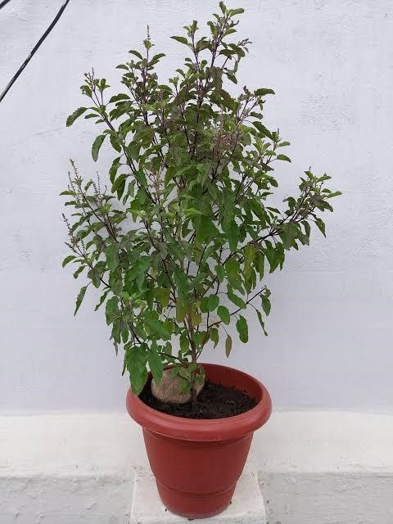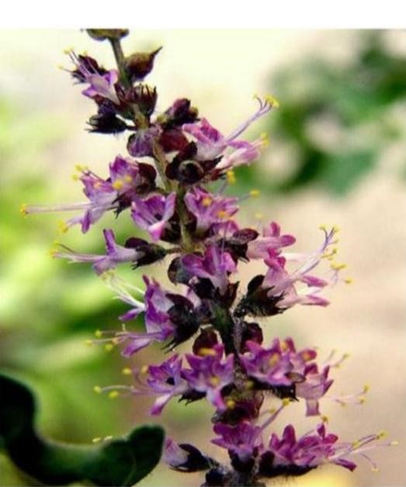
TULSI FLOWERS
DARK PINKISH LEAVES OF TULSI

GREEN LEAVES OF TULSI⁽⁸⁾

PLANT OF TULSI⁽⁷⁾

⁽⁸⁾

PLANT OF TULSI
⁽⁷⁾

T
ulsi
leaves and flowers

Table 2⁽¹⁰⁾⁽¹⁾: OTHER NAME OF TULSI IN DIFFERENT INDIAN LANGUAGE
S. no. | Language | State | Name
1. | Sanskrit | India | Tulsi, major
2. | Bengali | W. Bongal | Tulsi, kural
3. | Gujrati | Gujrat | Sabje, talsi
4. | Punjabi | Punjab | Tulsi
5. | Tamil | Tamil Nadu | Triuttizhai, Tiviragandam
6. | Manipuri | Manipur | Naoshek lei
7. | Odisya | Odisha | Karpura, dhalatulsi
8. | Kannada | Karnataka | Tulasia, karitulsi
9. | Marathi | Maharashtra | Sabja, Tulsa
10. | Nagpuri | Jharkhand | Tulsi

Table 3⁽¹⁰⁾⁽¹⁾: OTHER NAME OF TULSI IN INTERNATIONAL LANGUAGE
S. No. | Language | Region | Name
1. | Arabic | North Africa | Vasub, Dohsh
2. | Dutch | Netherlands | Baziel
3. | English | England | Sweetbasil
4. | French | France | Herbe royale
5. | Korean | Korea | Narukpul, yanggajuk
6. | Thai | Thailand | Horapa
7. | Khmer | Cambodia | Chetak, mareahproeu
8. | Chinese | China | Yu heungchoi
9. | Japanese | Japan | Kami-miboki, bajiru
10. | Italian | Italy | Basilico

PROPERTIES
The Ocimum sanctum test is the light or post-digestive effect.
Seeds are oily and slimy and have cold potency. It is known effective in fevers ⁽¹¹⁾.

CHEMICAL PROPERTIES
All medicinal properties of this plant for because of the essential oil and secondary metabolites that are present in its leaves and other parts of the tulsi plant. The major components of the tulsi plant such as Rosmerinic acid, Carnosic acid eugenol (57.82%)⁽¹²⁾, thymol (9.80%)⁽¹³⁾, vicenin, apigenin, methyl eugenol (20%), printing ( a form of flavonoids ) Beta–Caryophyllene (3.03%),p-Cymene(2.11%) and Cis beta Guaieno (1.06%)⁽¹⁴⁾ are present in large quantity and main components. Caryophyllene oxide (0.82%), germacrene D –Farnese (0.39%), and mycrene (0.34%) are in low amounts. The nutritional composition of tulsi has been investigated. ⁽¹⁵⁾ Mucilage polysaccharides and bets sitosterol and linoleic acid are obtained and they are present in the seed oil of this plant. (16)
Flavonoids:- They contain methoxy flavonoids and cirsimartin and orientin (that are components of glycosides) of the OG (Ocimum gratissimim\ Ocimum sanctum ) plants. ⁽¹⁷⁾

STUCTURE OF SOME COMPONENT⁽¹⁸⁾
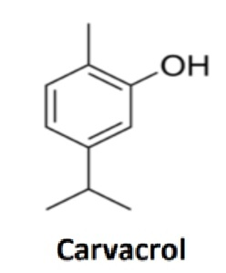
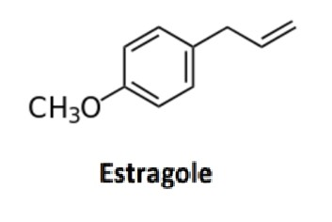
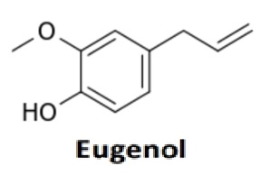
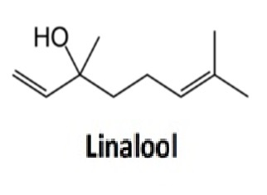
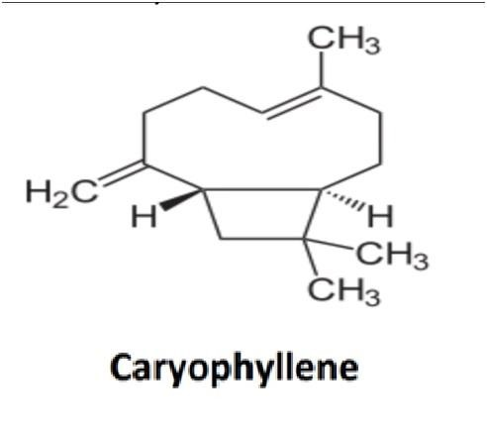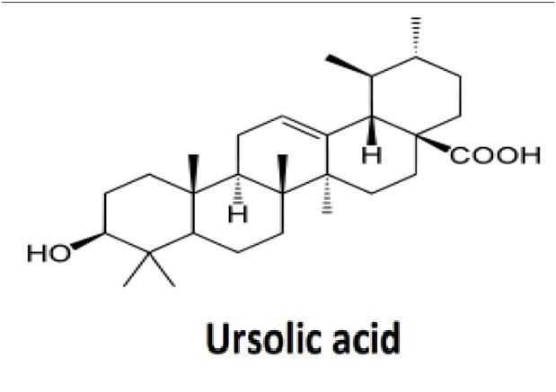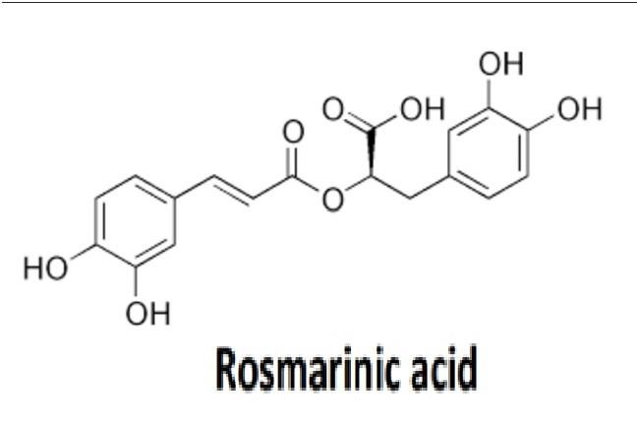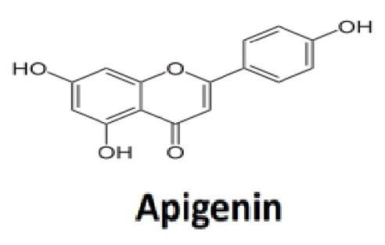

USES OF TULSI
Traditional Uses:- The plant of tulsi has much traditional importance in INDIA but apart from that it also has many medicinal benefits. That is why it is worshiped by all castes in Sanatan dharma⁽¹⁹⁾.
It is believed that Tulsi never gets contaminated, so it is used to purify the home and remove impurities and negative energy/ vibrations.
The Tulsi leaves are used in worship to make the charan-amrit and get blessings.
This charna-amrit is consumed by the devotees.
Also, it is still used for medical purposes in many villages of INDIA From very old times.
For example:- Even today in many homes Tulsi leaves are used to make tea. In a cough, cold, or viral infection, a tea or decoction of Tulsi leaves is drunk.

Industrial uses:- Tulsi is a very broad-spectrum antimicrobial activity, which includes activity against a range of human and animal pathogens, but suggests it can be used to make a hand sanitizer, mouthwash, and water cleaner as well as preservation of food and herbal raw materials⁽²⁰⁾.

PHARMACETICAL USES:- In the modern age various products of tulsi are easily available in the market, which are uses of ayurvedic medicines. This type of medicine is very useful has no side effects, and is used for the treatment of various diseases ⁽²¹⁾. People like it, because of its familiar characteristics and they are easily available in the market and our neighboring around⁽²²⁾.

PHARMACOLOGICAL ACTIVITY: -
Anticancer activity:- Various plants are used as a potential source of anticancer and antitumor properties in
Ayurveda. This type of plant has some special signification reduction in tumor cells. ⁽²³⁾

Antibacterial activity:- The plant of Tulsi has also antibacterial properties so it is used for the aqueous, alcoholic, chloroform, and oil extraction from leaves of the Tulsi plant.
The extract obtained from O. sanctum was observed to be effective against pathogens⁽²⁴⁾.

Antioxidant properties:- The chemical composition of Tulsi has Carvacrol and terpene, which is a powerful antioxidant⁽²⁵⁾.

MEDICINAL USES:-
Immunomodulatory:- Increase RBC, WBC, Hemoglobin, and antibody production without affecting other biochemical activities when tested in mice⁽²⁶⁾.
Memory enhancer:- It was reported that the inactive resident was used to access memory⁽²⁷⁾.
It has some immune modulators in the body that stabilize maintain and recover our immune system⁽²⁸⁾.
Eye disorder:- Juice of tulsi is a good home remedy for eye pain and night blindness, a condition often caused by a deficiency of vitamin A. Tulsi oil with honey also improves our eyesight. ⁽²⁹⁾⁽³⁰⁾ This juice uses two drops on your eyes every day at night.
Immuno-modulator:-Tulsi is a great immune booster that prevents external substances such as pathogens, allergies, viruses, etc.⁽³¹⁾

CONCLUSION
The plant Tulsi which is traditionally used in INDIA with some cultural values and also for some medicinal purposes, has multiple benefits Currently we can’t know all the facts and importance about this plant and we can’t identify all the chemical compounds present in this plant.
So that we have more useful medicinal benefits as well as some more uses in our life make our lives better and healthier. it can be used as a replacement for tea due to it having a beneficiary effect but tea has some harmful compounds like nicotine and some unknown compounds.

REFERENCES
- Renu Kadian , Milind Parle . Therapeutic potential & phytopharmacology of Tulsi.International Journal of Pharmacy and Life Sciences.2014
- H. A. Pawar ,K. J. Nandu and K. H. Khimasia. http://www.ijcpa.in PHARMACOGNOSTIC REVIEW ON OCIMUM SANCTUM LINN (TULSI) 2019.
- I. Gostin, E. Trutra, C. Padurariu. Composition and antibacterial activity of essential oil in three Ocimum species growing in Romania. 2013(Cross Ref)(Google Scholar)
- H..A. Dharsono, D.Dudi ,S.A. PutrI, Dikdip K.and M.H. Satari. Ocimum Species: A Review on Chemical Constituents and Antibacterial Activity2022.(Pubmud)(MEDLINE)
- A. Shival B.Aboli, M. Deepak and S. Aishwarya. GENERAL INTRODUCTION, CLASSIFICATION, MORPHOLOGY, PHYTOCONSTIUENTS, TRADITIONAL & MEDICINAL USES, PHARMACOLOGICAL ACTIVITY OF TULSI (OCIMUM SANCTUM)2020.
- P. Pattanayak, D. Das, S. K. Panda, P. Behera Ocimum sanctum Linn.A reservoir plant for therapeutic applications.2010
- PrakRatik. Tow to grow tulsi plant fast, 2019
- Medically reviewed by M. Hatanaka, L. D. 2020
- H. A. Pawar, H. K. Khimasia, J. K. Nandu PHARMA COUNOSTIC REVIEW ON O.S.L. (TULSI)
- S. Thakur, g. Chaudhary, Walia B and S. Choudhary https//www.ijrrjournal.com Tulsi-A review based on its ayurvedic and modern therapeutic uses May 2021
- Sai K. Gudi, P. Kumar and Bhavani Ramesh. T “Tulsi” – the wonder Herb (Pharmacological Activities of Ocimum Sanctum) Feb 2014
- Adams R.P. Identification of essential oil components by gas chormatogharphy\ mass spectroscopy 1995
- Anyiow, c Thomas. Ocimum gritissimum and blood coagulation. Journal of Research in Ethinomedan 1980
- Van DDH, KPDJA. Generalization of the retention index system including linear temperature programmed gas-liquid partition chromatography. Journal of Chromatography A.1963
- Vieira RF, RJ Grayer Paton, Simon JE Genetic diversity of Ocimum gratissimum L. BASED ON Volatile oil constituents, flavonoids and RAPD markers. Biochemical Systematic and Ecology 2001
- S. Monga Pradeep Dhanwal ,R.K. A. K. ,and V. Chhokar www. ThePharmajournal.com The Pharma Innovation 2017
- H. C. Bravo, L. A. Munoz A Review: basil seed Functional Ingredients with beneficial properties. 2017 SEEDS ARE OILY AND SLIMY
- Rahman S, M. Kamar Z Zaman, Jamal AM O.S.L. A review of phytochemical and pharmacological profile 2011.
- Muraleedharan G. Nair, M A Kelm, G M Strasburg Antioxidant cyclooxygenase inhibitory phenol component from Ocimum sanctum Linn. 2000
- M M cohen tulsi ocimum sanctum: A herb for all reasons. J Ayurveda integer med 2014 (Pubmed)
- CK Kokate, AP Purohit, SB Gokhale Pharmacognosy Nirali Prakashan 2005
- M, Sameen, F. Islam Influence of nanotechnology on herbal drugs; a review journal of advanced pharmaceutical technology & research 2012
- CV Nakamura , Ishida k, S Rozental Ueda-NakmuraT. In vitro activity of essentisal oil form Ocimum gratissimum . against four Candida species of research of microbiology.2004
- P. & S. Misra study of antibacterial activity of ocimum s. extract against gram+ and gram- bacteria A J FOOD TECH 2001
- Simoons, Frederick J. Plants of life, plants of death. Univ of Wisconsin Press. 1998.
- H. Joshi M Parl cholinergic basis of memory improving effect of Ocimum tenuiflorum Linn INDIAN JOURNAL OF PHARMACEUTICAL SCIENCES 2006
- V. V. giridharan v. mani T. dundapa Ocimum sanctum Linn leaf extracts inhibit acetylcholinesterase and improve cognition in rats with experimentally induced dementia. JOURNAL OF MEDICINAL FOOD 2011
- DR. S. K. Mishra a review paper on the Tulsi plant Ocimum sanctum Linn
- S Mondal, Sc Mahapatra Br Mirdha. Antimicrobial oils obtained from fresh and dried leaves of Ocimum sanctum Linn against enteric bacteria and yeast. 2007
- Sunita Varma chemical constituents and pharmacological action of Ocimum sanctum (INDIAN HOLY BASIL- TULSI)
- Sanjay Kumar Rao, Anshu Sharma and Deepak Jain A Review medicinal and traditional uses on Tulsi plant(Ocimum sanctum L.)2023

