5G TECHNOLOGY FOR HEALTHCARE: INCREASING THE EFFECTIVENESS OF HEALTHCARE
Divya Dwivedi¹

Abstract:
Health is a fundamental requirement. Despite significant efforts, there are still significant challenges in providing healthcare services to an aging population. Recent observations have raised concerns about rising healthcare costs, medical resource imbalances, inefficient healthcare system administration, and inconvenient medical experiences. However, cutting-edge technologies, such as the Internet of Things (IoT), big data, artificial intelligence, and 5G wireless transmission technology, are being developed to meet these challenges to improve the patient experience and healthcare service quality while lowering total healthcare costs.
Introduction:
- Why smart healthcare matters-
Through the use of networks and smart devices (such as smartphones, smartwatches, wireless smart glucometers, and wireless blood pressure monitors), smart healthcare offers medical services. A range of sources, including sensors and biological systems, are used by the smart gadgets to assess health data. In short, smart healthcare enables individuals from various backgrounds and spheres of society

- IoT: what is it?

There are various definitions of IoT; however, according to the IoT European Research Cluster (IECR) project definition, IoT is an evolving network architecture with the potential to self-configure based on open and standardized procedures for communication. Alternatively stated, IoT is a flexible, intricate, and dynamic network infrastructure that connects anybody, anything, whenever, anyplace, any type of service. The synthesis of sensors and sensor-based systems with device-to-device (D2D) connections is currently on the rise. IoT is taking center stage as devices are anticipated to make up a sizable component of this 5G network paradigm, which will usher in the era of 5G wireless systems (5G). However, technology is still advancing. While managing data from diverse sources is one of the problems of IoT in healthcare, the future of IoT applications in healthcare will depend on gaining insightful knowledge from obtained data.
Objectives for Smart Healthcare-
Objective-1 | Optimization of resources | Techniques for resource optimization are utilized to maximise network longevity while minimizing energy consumption. Numerous network problems can result from improper resource optimization.
Objective-2 | Enhancing QoS | A network's ability to provide quality of service (QoS) is described by manage high bandwidth and other network performance metrics including error rate, latency, and uptime.
Objective-3 | Reducing interference | The smart healthcare system can leverage the notion of frequency reuse to achieve optimal resource usage.
Objective-4 | Enhancing energy efficiency | The network's energy consumption has increased as a result of the density of access points. Therefore, network operators must reduce a network's energy usage to lower operational costs. However, the capacity of batteries keeps growing, which is insufficient to meet consumer expectations. The lifespan of the devices placed in the network must therefore be increased by the use of energy-efficient techniques.

5G's capabilities and instruments for medical procedures:
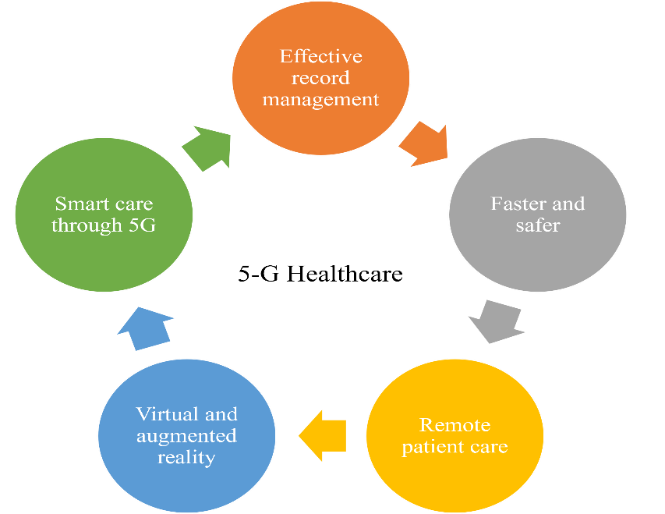
To allow high-quality patient services, advanced healthcare practices look for appropriate and connected network facilities. The various facets and key characteristics of 5G technology for medical practices are explored in Fig. 1. Wireless communications, quick and precise connective trends, virtual and augmented reality. Additional improvements in healthcare practises are made possible by 5G technology.

Fig- 5G's capabilities and instruments for medical procedures
Healthcare practitioners can now treat patients who are chronically ill in the present over the quickest network available thanks to 5G. Using trustworthy, always-on mobile individual situational response systems, patients with illnesses can keep their independence and enhance outcomes. As technology develops, added medical devices will be accessible capabilities and instruments for medical procedures to patients, enabling them to test and monitor their health from the convenience of their homes. This medical technology collects, calibrates, and verifies data from reliable sensors. A variety of medical and healthcare specialists can then receive this data for study.

Serviceable Pillars of 5G for Health care:
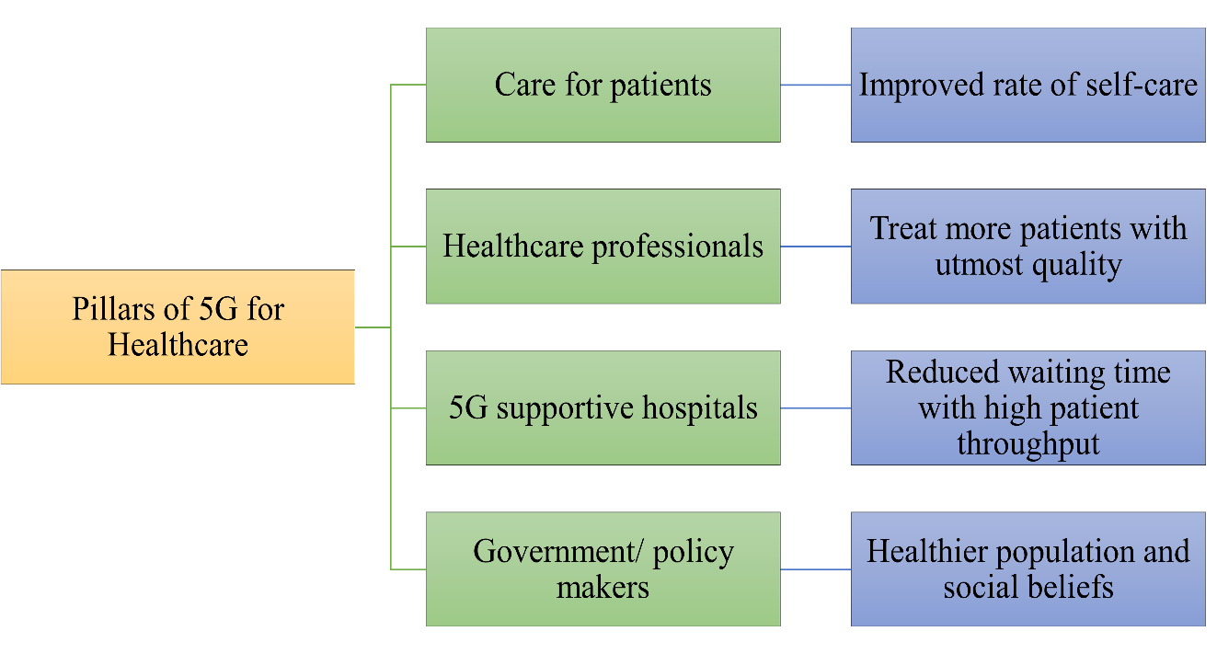
Existing Survey on Smart Healthcare:
For the IoT in Healthcare and the prediction of various sorts of diseases using various methodologies, several researchers have put forth several models. The work done in the same area is the emphasis of this section.

Barger et al. | A prototype of the same smart home facility is also being tested. It uses a sensor network to detect and monitor the patient's movements inside the home. Their main goal in their study is to determine whether their system can outsmart behavioral patterns, and they have talked about this in their work.
Chiuchisan et al. | provided a framework to stop patient hazards in intelligent ICUs. The suggested method alerts the patient's loved ones, the patient's doctors, and anybody else who needs to know about any discrepancies in the patient's health, bodily movements.
Gupta et al. | developed a model that uses a Raspberry Pi to measure and record ECG and other important patient health indicators. This model might be very useful for hospitals, patients, and patients' families.
Lopes et al. | To research and identify IoT solutions in the healthcare sector that can help disabled persons and their communities, an IoT framework has been developed. To explore the most recent IoT technology and its applications, which can be utilized primarily for the disabled, they chose two use cases.
Nagavelli and Rao | a unique statistical methodology known as the degree of disease probability threshold was established to forecast the severity of the illness from the patient's medical information. They have also updated an algorithm that is mostly required to calculate the hyperlink weight of websites to achieve their goal.
Sahoo et al. | examined the healthcare management system and the substantial amount of patient data produced by numerous reports. To forecast the patient's or subject's future health issues, they further assessed the health parameters. They employ the utilization of probability to accomplish the same using a cloud-based big data analytics platform.
Islam et al. | The author of this review concentrated on Internet of Things (IoT) technologies and the current architecture for healthcare networks and platforms that provide access to the IoT backbone and enable the receiving and transmission of medical data. The study also provides specific examples of how the IoT might help with pediatric, geriatric, and chronic disease supervision, as well as fitness management.
Baker et al. | In this review, the author introduced a fresh framework for a future smart healthcare system that may be applied to both specialized (e.g., monitoring of unique conditions) and general systems. In addition, the author provided an overview of recent developments in the field of the component of the models that were presented (i.e., wearables and non-intrusive sensors that monitor vital signs such as blood pressure and blood oxygen levels).
Mahmoud et al. | In this article, the author surveyed platforms for the Cloud of Things (CoT) and how to use it in applications for smart healthcare.

Schematic drawing illustrating applications of 5G technology in healthcare. VR, virtual reality.
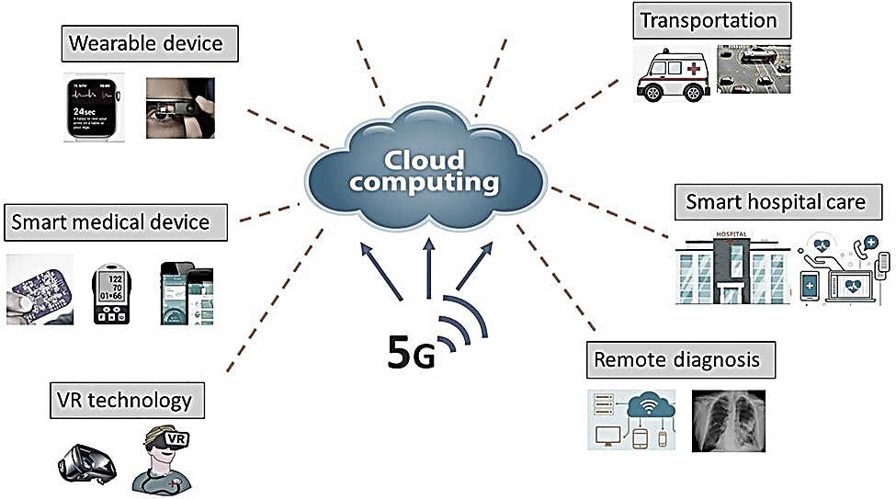
Challenges of 5G:
Availability | The 5G network will only considerably benefit urban areas, while coverage in rural areas may only last a few years.
Cost | Compared to other networks, building tower stations comes at a hefty price.
Weather | Rain can potentially affect 5G coverage, necessitating additional security.
Cellular devices | The battery life of a phone that has a 5G connection will be drastically reduced.
Cybersecurity | 5G-capable devices are also an easier target for cyber threads and data robbery due to the lack of encryption during connection.

APPLICATION OF 5G TECHNOLOGY FOR HEALTHCARE
5G technology has the potential to revolutionize the healthcare industry by increasing the effectiveness of healthcare in various ways. Here are some key applications of 5G technology in healthcare:
- Telemedicine and Remote Care: 5G's high-speed and low-latency capabilities enable real-time, high-definition video conferencing and data transmission. This facilitates seamless telemedicine consultations, remote monitoring of patients, and virtual care programs. Doctors can diagnose and treat patients in remote areas, reducing the need for physical visits and improving access to healthcare.

- Remote Surgery and Robotic Assisted Procedures: 5G's low latency is crucial in surgical procedures that require precise, real-time control. Surgeons can perform remote surgeries using robotic systems, which allows them to operate on patients from a distant location. This can be particularly beneficial for providing medical assistance in emergencies and offering specialized care from experts who are not physically present.

- Internet of Medical Things (IoMT): 5G technology enables a vast network of interconnected medical devices and wearables, collectively known as the Internet of Medical Things. These devices can continuously monitor patients' vital signs, transmit data in real time, and send alerts to healthcare providers in case of any anomalies. This proactive monitoring can lead to early detection of health issues and prompt interventions, reducing hospital admissions and healthcare costs.

- Enhanced Data Sharing and Collaboration: This seamless data sharing improves collaboration, allowing for quicker access to patient records, test results, and research findings. It can also support medical professionals in making more informed decisions and delivering personalized treatments.

- Augmented Reality (AR) and Virtual Reality (VR) in Medical Training: 5G's high bandwidth and low latency enable realistic and immersive AR/VR experiences. Medical students and healthcare professionals can use AR/VR for training, simulations, and surgical rehearsals. These technologies enhance learning and skill development, ensuring that healthcare providers are better prepared for complex procedures and situations.

- Personalized Medicine and Genomics: With 5G, it becomes easier to process vast amounts of genetic data quickly. This helps in advancing personalized medicine by tailoring treatments based on an individual's genetic profile.

- AI-Enabled Healthcare: 5G's capabilities complement the use of artificial intelligence in healthcare. AI algorithms can analyze large datasets. 5G's low latency ensures that AI-driven applications can deliver real-time insights to healthcare professionals.

- Mobile Health (m Health) Applications: 5G enhances the performance of mobile health applications, allowing patients to access healthcare resources, track their health conditions, and communicate with their healthcare providers more efficiently. This promotes patient engagement and proactive health management.
By incorporating 5G technology into various aspects of healthcare, the industry can experience significant advancements in efficiency, patient care, and outcomes. However, it's essential to address security and privacy concerns to ensure the safe and responsible adoption of these innovations.
Future Scope-
Future 5G technology will offer superior remote healthcare support while reducing patient exposure by doing away with in-person visits to doctors and medical facilities. Patients who are unable to physically visit their doctors will be able to do so by utilizing 5G-enabled telepresence devices that feel natural. Therefore, a wireless network can deliver essential healthcare treatments to individuals who are restricted or chronically unwell. The infrastructure of healthcare IT could be changed by 5G. A digital healthcare revolution will result from the increased viability of 5G technology. To remove any obstacles and prepare for a 5G future, healthcare organizations must evaluate their infrastructure and machinery. Patient empowerment and home healthcare could both undergo radical change as a result of this technology. Businesses will be able to track consumer behavior with the help of 5G networks, personalise marketing strategies, offer better services and deliveries, increase operational effectiveness, empower employees with readily accessible and seamlessly connected devices, and eventually use predictive analytics and better decision-making for a sustainable and lucrative future. Doctors and other medical professionals will be able to perform tasks that they previously couldn't do with the help of 5G technology. The success of 5G in healthcare will be largely dependent on AI and machine learning. The massively linked healthcare paradigm, wearables, imaging files, and electronic health records will all be sluicing large amounts of data over the network. Public safety personnel will be able to respond quicker and gain better situational awareness during emergencies because of 5G's improved command and administration of beyond-line-of-sight drones and other uncrewed vehicles.

Conclusion:
There are new choices for healthcare delivery thanks to 5G networks. Doctors will be able to monitor patients without costly inpatient care by integrating more medical equipment with IoT. The effectiveness of clinics and hospitals as well as patient monitoring and care at home can be improved by 5G. The creation of technology that assures secure and safe communications is required by wearable devices that transmit patient data through 5G networks.

Introduction-
5G-PPP White Paper on E-Health Vertical Sector, document 5G-PPP, Sep. 2015. [Online]. Available: https://5g-ppp.eu/wp-content/uploads/ 2014/02/5G-PPP-White-Paper-one-Health-Vertical-Sector.pdf
W. D. de Mattos and P. R. L. Gondim, ‘‘M-health solutions using 5G networks and M2M communications,’’ IT Prof., vol. 18, no. 3, pp. 24–29, 2016.
S. Kraijak and P. Tuwanut, ‘‘A survey on IoT architectures, protocols, applications, security, privacy, real-world implementation, and future trends,’’ in Proc. 11th Int. Conf. Wireless Commun., Netw. Mobile Comput. (WiCOM), Sep. 2015, pp. 1–6.
W. Ejaz, A. Anpalagan, M. A. Imran, M. Jo, M. Naeem, S. B. Qaisar, and W. Wang, ‘‘Internet of Things (IoT) in 5G wireless communications,’’ IEEE Access, vol. 4, pp. 10310–10314, 2016.
M. Elhoseny, G. Ramírez-González, O. M. Abu-Elnasr, S. A. Shawkat, N. Arunkumar, and A. Farouk, ‘‘Secure medical data transmission model for IoT-based healthcare systems,’’ IEEE Access, vol. 6, pp. 20596–20608, 2018.
Objectives-
M. A. Jan, S. R. U. Jan, M. Alam, A. Akhunzada, and I. U. Rahman, ‘‘A comprehensive analysis of congestion control protocols in wireless sensor networks,’’ Mobile Netw. Appl., vol. 23, no. 3, pp. 456–468, 2018.
T. Umer, M. H. Rehmani, A. E. Kamal, and L. Mihaylova, ‘‘Information and resource management systems for the Internet of Things: Energy management, communication protocols and future applications,’’ Future Gener. Comput. Syst., vol. 92, pp. 1021–1027, Mar. 2019.
Roy, T. Acharya, and S. DasBit, ‘‘Quality of service in delay tolerant networks: A survey,’’ Comput. Netw., vol. 130, pp. 121–133, Jan. 2018.
W. Mwashita and M. O. Odhiambo, ‘‘Interference management techniques for device-to-device communications,’’ in Predictive Intelligence Using Big Data and the Internet of Things. Hershey, PA, USA: IGI Global, 2019, pp. 219–245.
S. Samarakoon, M. Bennis, W. Saad, M. Debbah, and M. Latva-Aho, ‘‘Ultra dense small cell networks: Turning density into energy efficiency,’’ IEEE J. Sel. Areas Commun., vol. 34, no. 5, pp. 1267–1280, May 2016.
A. Ahad, ‘‘Comparison of energy efficient routing protocols in wireless sensor network,’’ Amer. J. Netw. Commun., vol. 6, no. 4, pp. 67–73, 2018.
Features and tools of 5G for healthcare practices-
Mamun MI, Rahman A, Khaleque MA, Mridha MF, Hamid MA. Healthcare monitoring system inside self-driving smart car in 5g cellular network. In: 2019 IEEE 17th International Conference on Industrial Informatics (INDIN). 1. IEEE; 2019, July:1515–1520.
Priya B, Malhotra J. 5GhNet: an intelligent QoE aware RAT selection framework for 5G-enabled healthcare network. J Ambient Intell Hum Comput. 2021:1–22.
Pundziene A, Heaton S, Teece DJ. 5G, dynamic capabilities and business models innovation in healthcare industry. In: 2019 IEEE International Symposium on Innovation and Entrepreneurship (TEMS-ISIE). IEEE; 2019, October:1–8.
Aldaej A, Tariq U. IoT in 5G aeon: an inevitable fortuity of next-generation healthcare. In: 2018 1st International Conference on Computer Applications & Information Security (ICCAIS). IEEE; 2018, April:1–4.
Lin K, Xia F, Wang W, Tian D, Song J. System design for big data application in emotion-aware healthcare. IEEE Access. 2016;4:6901–6909.
Zhong M, Yang Y, Yao H, Fu X, Dobre OA, Postolache O. 5G and IoT: towards a new era of communications and measurements. IEEE Instrum Meas Mag. 2019;22(6): 18–26.
Anwar S, Prasad R. Framework for future telemedicine planning and infrastructure using 5G technology. Wireless Pers Commun. 2018;100(1):193–208.
Gupta A, Hasija Y. Next generation 5G wireless technologies in healthcare. In: ICT with Intelligent Applications. Singapore: Springer; 2022:393–402.
Existing survey on smart healthcare-
T. S. Barger, D. E. Brown, and M. Alwan. Health status monitoring through analysis of behavioral patterns. IEEE Transactions on Systems, Man, and Cybernetics - Part A: Systems and Humans, 5(1):22–27, Jan 2005. ISSN 1083-4427.
I. Chiuchisan, H. N. Costin, and O. Geman. Adopting the internet of things technologies in health care systems. In 2014 International Conference and Exposition on Electrical and Power Engineering (EPE), pages 532– 535, Oct 2014.
M. S. D. Gupta, V. Patchava, and V. Menezes. Healthcare based on iot using raspberry pi. In 2015 International Conference on Green Computing and Internet of Things (ICGCIoT), pages 796–799, Oct 2015.

N. V. Lopes, F. Pinto, P. Furtado, and J. Silva. Iot architecture proposal for disabled people. In 2014 IEEE 10th International Conference on Wireless and Mobile Computing, Networking and Communications (WiMob), pages 152–158, Oct 2014.
R. Nagavelli and C. V. Guru Rao. Degree of disease possibility (ddp): A mining based statistical measuring approach for disease prediction in health care data min- ing. In International Conference on Recent Advances and Innovations in Engineering (ICsRAIE-2014), pages 1–6, May 2014.
P. K. Sahoo, S. K. Mohapatra, and S. L. Wu. Analyzing healthcare big data with prediction for future health condition. IEEE Access, 4:9786–9799, 2016. ISSN 2169-3536.
S. M. R. Islam, D. Kwak, M. H. Kabir, M. Hossain, and K.-S. Kwak, ‘‘The Internet of Things for health care: A comprehensive survey,’’ IEEE Access, vol. 3, pp. 678–708, 2015.
S. B. Baker, W. Xiang, and I. Atkinson, ‘‘Internet of Things for smart healthcare: Technologies, challenges, and opportunities,’’ IEEE Access, vol. 5, pp. 26521–26544, 2017.
M. M. E. Mahmoud, J. J. P. C. Rodrigues, S. H. Ahmed, S. C. Shah, J. F. Al-Muhtadi, V. V. Korotaev, and V. H. C. De Albuquerque, ‘‘Enabling technologies on cloud of things for smart healthcare,’’ IEEE Access, vol. 6, pp. 31950–31967, 2018.
Challenges of 5G:
Outlook Business Team. 5G Technology: What Are its Advantages and Disadvantages; 2023. https://www.outlookindia.com/business/5g-technology-what-are-its-advantages-and-disadvantages-news-214808.
Mehta R. Pros and Cons of 5G Technology; 2021. https://timesofindia.indiatime s.com/blogs/digital-mehta/pros-and-cons-of-5g-technology/.
Javaid M, Haleem A, Rab S, Singh RP, Suman R, Mohan S. Progressive schema of 5G for Industry 4.0: features, enablers, and services. Ind Robot: Int J Robot Res App. 2022;49(3):527–543.
Ali HM, Bomgni AB, Bukhari SAC, Hameed T, Liu J. Power-Aware fog supported IoT network for healthcare infrastructure using swarm intelligence-based algorithms. Mobile Network Appl. 2023:1–15.

Application of 5G TECHNOLOGY FOR HEALTHCARE
Georgiou, Konstantinos E., Evangelos Georgiou, and Richard M. Satava. "5G use in healthcare: the future is present." JSLS: Journal of the Society of Laparoscopic & Robotic Surgeons 25, no. 4 (2021).
Berlet, Maximilian, Thomas Vogel, Mohamed Gharba, Joseph Eichinger, Egon Schulz, Helmut Friess, Dirk Wilhelm, Daniel Ostler, and Michael Kranzfelder. "Emergency telemedicine mobile ultrasounds using a 5G-enabled application: Development and usability study." JMIR Formative Research 6, no. 5 (2022): e36824.
Seeliger, Barbara, Justin W. Collins, Francesco Porpiglia, and Jacques Marescaux. "The role of virtual reality, telesurgery, and teleproctoring in robotic surgery." In Robotic urologic surgery, pp. 61-77. Cham: Springer International Publishing, 2022.
Hasan, Mohammad Kamrul, Shayla Islam, Imran Memon, Ahmad F. Ismail, Salwani Abdullah, Anil K. Budati, and Nazmus S. Nafi. "A novel resource oriented DMA framework for internet of medical things devices in 5G network." IEEE Transactions on Industrial Informatics 18, no. 12 (2022): 8895-8904.
Li, Xiao, Wen Yi, Hung-Lin Chi, Xiangyu Wang, and Albert PC Chan. "A critical review of virtual and augmented reality (VR/AR) applications in construction safety." Automation in Construction 86 (2018): 150-162.
Lucivero, Federica, and Barbara Prainsack. "The lifestylisation of healthcare?‘Consumer genomics’ and mobile health as technologies for healthy lifestyle." Applied & translational genomics 4 (2015): 44-49.

