Cyclodextrin and their Imminent Applications: A Sophisticated Pharmaceutical Ingredient for Drug Delivery

Niku Ahmed
Department of Chemical Scienes
Tezpur University, Napaam, Tezpur, Assam 784028
nahmed@tezu.ernet.in

Dabasish Deka
Department of Chemical Scienes
Tezpur University, Napaam, Tezpur, Assam 784028
dabasish@tezu.ernet.in

ABSTRACT
Cyclodextrin signifies an important class of supramolecular chemistry. In this book chapter; fundamental ideas of structure, synthesis and application of this class of supramolecular chemistry is explored. Focus has been given to medicinal application like drug delivery and encapsulation with potential impact.

Keywords- Cyclodextrin, supramolecular, medicinal, drug delivery,

INTRODUCTION

Cyclodextrins are a family of cyclic oligosaccharides which are made up of a macrocyclic ring of glucose subunits connected by α-1,4 glycosidic bonds. They are mainly obtained from starch or starch derivatives through a enzymatic conversion. Cyclodextrins belongs to a family of caged shaped molecules and due to their unique structure with cavity, they can encapsulate other molecules [1].
Cyclodextrin was called "cellulosine" by A. Villiers in 1891. In between 1911 and 1935, Pringsheim in Germany did significant research in this area, demonstrating that cyclodextrins form stable aqueous complexes with many other class of chemicals. In between 1935 and 1950, cyclodextrin were investigated by structural results on the “Schardinger dextrins. In 1949, Cramer first introduced the concept of nomenclature to cyclodextrin-based compounds. In the last 50 years, cyclodextrins have attained ground in many industrial applications, mostly in the pharmaceutical formulation, chemical industries, environmental engineering and food sectors. In this chapter, we present an overview and applications of cyclodextrins [1,2].

STRUCTURE OF CYCLODEXTRIN
Chemically cyclodextrins are composed of five or more α-D-glucopyranoside units joined by α-1,4 glycosidic bonds. These glycosidic bonds form a cyclic structures and it consist of a lipophilic central cavity. The outer surface have a hydrophilic property. The primary hydroxyls can rotate and decrease the cyclodextrin diameter while secondary hydroxyl groups form strong hydrogen bonds and provide stiffness to cyclodextrin. Substitution of the hydrogen bond forming hydroxyl groups, by lipophilic methoxy functions, in general results in dramatic improvement in aqueous solubility properties. Due to this distinctive structure, cyclodextrin can encapsulate guest molecules leading to the formation of inclusion complexes. This encapsulation characteristic is very exclusive and significant, leading to application in different industries such as medicine or agro chemistry [2,3].
Figure 1: Anatomy of cyclodextrins

FAMILY OF CYCLODEXTRINS
Three important type of cyclodextrin family are α-cyclodextrin, β-cyclodextrin and γ-cyclodextrin. In addition to this, several minor cyclodextrin are also known like δ-cyclodextrin and ε-cyclodextrin. α, β, δ nomenclature are used to distinguishes the cyclodextrin with different ring size in a homologous series. (Table 1)
Table 1: Properties of different Cyclodextrins
Family | Number of glucose units | Ring size |  | Internal cavity (Å) |  | Water solubility at 25°C (g/L)
α | 6 |  | 30 |  | 5.0 | 145
β | 7 |  | 35 |  | 6.2 | 18.5
δ | 8 |  | 40 |  | 8.0 | 232

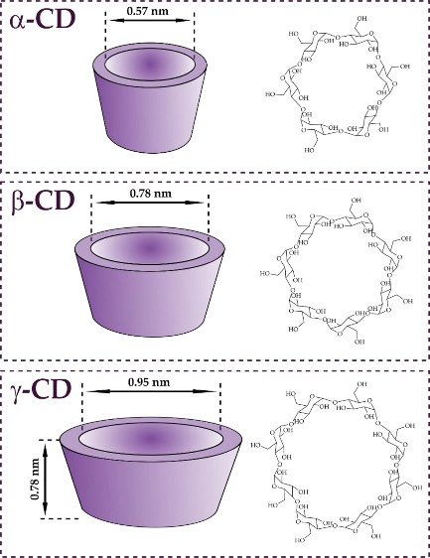
Figure 2: Dimensions of α-CD, β-CD and γ-CD, respectively. Original information provided by Crini (2014)
IV: PREPARATION AND CHERECTERIZATION
Photosynthetic plants produce starch and cellulose. Degradation process of starch with a variety of enzymes in aqueous solution results in dextrins. The degradation of dextrins by glucosyltransferase enzyme in absence of water results in cyclodextrins.
There are number of synthetic approach can be adopted to prepare cyclodextrins-guest complexes. Important approaches includes co-precipitation, kneading, super critical carbon dioxide, microwave irradiation and spray drying like technique. Scanning electron microscopy (SEM), Fourier-transform infrared spectroscopy (FT-IR), powder X-ray diffraction (PXRD) and thermogravimetric analysis (TGA) and differential scanning calorimetry (DSC) are few analytical techniques which are employed to characterize Guest-Cyclodextrin complex formation in solid phase. In solution phase, it is characterized by different analytical techniques such as UV-visible spectroscopy, nuclear magnetic resonance (NMR) spectroscopy, high-performance liquid chromatography (HPLC) and fluorescence spectroscopy [2].

V: APPLICATION IN SUPRAMOLECULAR CHEMISTRY

Overview
The cyclodextrin molecules have a unique structural feature with a hydrophobic cavity and a hydrophilic surface in which a guest molecule can be entrapped. A polar guest molecule interact with cyclodextrins in aqueous medium to form 1:1 molecular inclusion compounds. In general, the guest molecule is included within the cyclodextrins cavity [5].
Figure 3: Scheme of the formation of an inclusion complex between a cyclodextrin molecule and a guest
The key factor for formation of inclusion complex of the cyclodextrins involves the following important factors:
i. Steric flexibility and fitness
ii. Hydrophobic effects
iii. Van der Waals interactions
iv. Dipole-dipole interactions
v. Hydrogen bonding
vi. Electrostatic interactions
Cyclodextrins are well established and well-studied in the field of supramolecular chemistry. Applications of inclusion systems have gained considerable interest of cyclodextrin due availability in high purity, solubility, biocompatible nature and possibility of functionalization using different synthetic methods is also significant. Due to significant inclusion capability, α-CD and β-CD are employed in the design and construction of supramolecular structures. Different strategies are adopted to manipulate CDs in host-guest delivery systems. They are used in medicinal example in tablets, aqueous parenteral solutions, nasal sprays and eye drop solutions. In aqueous solutions cyclodextrins is evidenced to form inclusion complexes with many drug molecules by taking up a drug molecule, or lipophilic moiety of the molecule inside the central cavity available. In general, no covalent bonds are established to be formed or broken during the complex formation process and drug molecules in the complex are in very fast equilibrium with free molecules in the solution phase. Cyclodextrins and their derivatives have been used to synthesize novel nanomaterials of cyclodextrin-containing materials with versatile supramolecular topologies [1,3]. For pharmaceutical and medical applications, nanosubstances may be formulated as oral, parenteral, topical or inhalation dosage forms. Cyclodextrins and as well as their derivatives have also important real life applications in microencapsulation including aroma and fragrances, oils, analytical chemistry, organic chemistry, macromolecular chemistry, click chemistry, environmental chemistry, food chemistry and nanotechnology [4].
Cyclodextrins are potential candidate for various modern day purposes in daily life. Nowadays, it is hard to think of a world that does not have cyclodextrins. Unintentionally, today everyone routinely uses CDs in their daily lives food products as well as a significant amount of cosmetics, textiles and toiletries as invisible ingredients and numerous kinds of medical products. So the application of cyclodextrins contains area such as pharmaceuticals, food and flavors industry, agriculture industry, chemical industry, cosmetics and toiletries, textile and apparel industry. The extensive utilities of the cyclodextrins are due to the fascinating properties of them due to the presence of a cavity filled of methylene hydrogen and glucoside oxygen [6-7].

Application in Pharmaceutical

Comparatively low solubility of native cyclodextrins in common organic solvent as well as water makes them less beneficial in the pharmaceutical product. However there are some added advantage which make the cyclodextrin as active ingredient in pharmaceutical products. They are manufactured from the natural starch through a simple enzymatic transformation. Moreover any cytotoxic effect of cyclodextrin can be avoided by making proper derivatives. This motivates the scientist to synthesized different varieties of cyclodextrin which can be used to increase the bioavailability, solubility and stability of different drugs molecule by triggering formation of the ‟Inclusion complex” [8] (figure 5). Hydroxyalkylated-β-cyclodextrins derivatives are mostly used for improving the crystallization rates of inadequate water-soluble medicines and inhibiting polymorphic transitions during storage [9, 10].
Thiolated α-cyclodextrin are known to be the tiniest drug carrier [11]. Thiolation process of α-CD is showed in the figure 4. Cellular uptake experiment demonstrated that the thiolated α-CD can enter the HEK-293, Caco-2, and MC3T3 cells more simply compared to the native-CD. These thiolated α-CD carry the hydrophobic drug in its cavity and deliver to the target cells. The drug delivery of molecule can be explained in Figure 5.
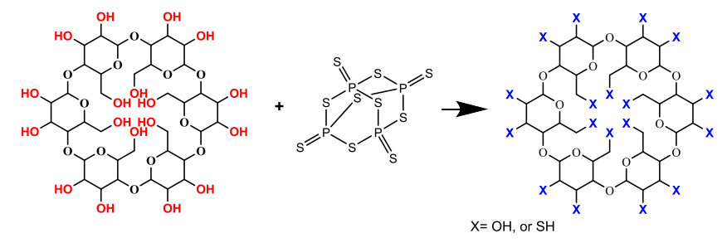
Figure 4: Schematic reaction for the synthesis thiolated α-cyclodextrines
Figure 5: The mechanism of formation of Inclusion compound with the drug molecule.
The drug delivery mechanism for the cyclodextrin is shown in the figure 6. CDs have no title role in the increasing permeability of drug across biological membrane. It only helps in the modification of the aqueous solubility of the drugs. The composition of the drug determine the rate of movement of the drugs across the membrane. [12].The main driving force for irreversible binding is simple dilution. Moreover, other well studied mechanism such as drug–protein binding, direct drug partition from the complex to competitive binding which also contribute to rapid drug release from the complexes [13,14]
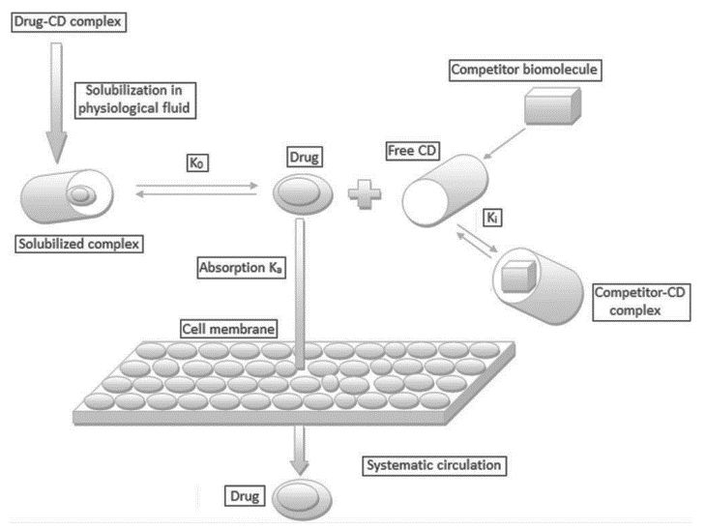
Figure 6: The mechanism and drug binding and releasing mode of cyclodextrin molecule
In recent times, the use of CD-containing polymers for drug release seems to have been seriously investigated. Some of them have reached upto clinical trial also. For example application of clycodextrin use in drug enablement are explained in short in the following-
(a)Piroxicam:
Piroxicam is a water insoluble non-steroidal anti-inflammatory drug (figure 7).For the purpose of increment in the solubility, piroxicam is treated with β−CD with molar ratio 1: 2.5 in aqueous ammonium hydroxide solution followed by spray drying to form white complex precipitate. [15]. Complex formation increases the aqueous solubility of the drug from about 0.02 mg/ml to about 0.15 mg/ml at pH 5 and 37°C temperature. Moreover, its increase the wettability, hence, the drug dissolution rate is also boosted [16].
Figure 7: Chemical structure of drug piroxicam.
(b)Ziprasidone:
Another low water soluble drug is Ziprasidone which used as an antipsychotic agent (figure 8) [17]. It has a solubility of 0.003 milligram per milliliter of solution. On the other hand the solubility of hydrochloride salt of ziprasidone is 0.08 mg/ml. Further, formation of mesylate salt increase the intrinsic solubility of the drug (Table 2). However, in case of this drug, it is impossible to increase the solubility through simple CD complexation. The complexation with negatively charged HPβ−CD and SBEβ−CD can provide alternate pathway to increase the solubility by formation of ion-pair. So, ziprasidone mesylate and SBEβ−CD are also used to formulate the drug as an aqueous solution for injection [18, 19].
Table 2: The solubility of ziprasidone solubility in pure water and aqueous solution containing 40% (w/v) HPβ−CD and 40% (w/v) SBEβ−CD
Salt | Solubility corresponding to weight of ziprasidone free base(mg/ml)
 | Pure Water | 40% (w/v) | 40% (w/v)
 |  | HPβ−CD | SBEβ−CD
Free base | 0.0003 | 0.26 | 0.35
Hydrochloride | 0.08 | 2.4 | 4.0
Aspartate | 0.17 | 1.3 | 9.3
Tartrate | 0.18 | 12.4 | 26
Esylate | 0.36 | 13.7 | 15
Mesylate | 1.0 | 17.3 | 44

Figure 8: Chemical structure of free drug Ziprasidone.
(c) Itraconazole:
Itraconazole is an widely used antifungal medication which offered as oral and solution for injection (figure 9). The solubility of the drug in water at room temperature is very less. It has a solubility of about 1 mg/ml at pH 7 and about 4 mg/ml in aqueous 0.1 N hydrochloric acid solution. Likewise the crystalline itraconazole has solubility of 3 mg/ml in aqueous 40% (w/v) solution. The interaction of the drug with the HPβ−CD enhance the solubility of the drug by transforming crystalline form into amorphous form [20,21]

Figure 9: Chemical structure of Itraconazole drug.

VI: CONCLUSION
Normal cyclodextrin and its derivatives have emerged as very essential ingredient for the formulation of drug in the pharmaceutical industry. The main attractive features of the cyclodextrines are host-guest type of interaction between the CDs and drug molecule. This makes the binding reversible and it is one of the key reason of cyclodextrines to be used for drug delivery. Apart from pharmaceutical filed, CDs are useful in other branches like food industry, textile industry etc [22]. This brands the CDs one of the most demandable and important requirement for mankind.

REFERENCES

- Szejtli, J., Introduction and general overview of cyclodextrin chemistry, Chemical reviews, 98(5), 1743-1754, 1998.
- Przybyla, M. A., Yilmaz, G., & Becer, C. R., Natural cyclodextrins and their derivatives for polymer synthesis. Polymer Chemistry, 11(48), 7582-7602, 2020.
- Gregório, C., Review: a history of cyclodextrins. Chem. Rev, 114(21), 10940-10975, 2014.
- Cid-Samamed, A., Rakmai, J., Mejuto, J. C., Simal-Gandara, J., & Astray, G., Cyclodextrins inclusion complex: Preparation methods, analytical techniques and food industry applications. Food Chemistry, 132467, 2022.
- Hu, Q. D., Tang, G. P., & Chu, P. K., Cyclodextrin-based host–guest supramolecular nanoparticles for delivery: from design to applications. Accounts of chemical research, 47(7), 2017-2025, 2014.
- Magnúsdóttir, A., Másson, M., & Loftsson, T., The conventional model of drug/cyclodextrin complex formation (salicylic acid/β-cyclodextrin inclusion complex), Journal of Inclusion Phenomena and Macrocyclic Chemistry, 44, 213-218, 2002.
- Higuchi, T., & Connors, K. A., Adv anal chem instrum. Phase-solubility techniques, 4, 117-212, 1965.
[9]. Uekama K. Design and evaluation of cyclodextrin-based drug formulation. Chem Pharm Bull, 52, 900–915, 2004.
[10] Brewster ME, Loftsson T. Cyclodextrins as pharmaceutical solubilizers. Adv Drug Deliv Rev, 59, 645–666, 2007.
[11] Kaplan, Ö., Truszkowska, M., Kali, G., Knoll, P., Massani, M.B., Braun, D.E. and Bernkop-Schnürch, A., Thiolated α-cyclodextrin: The likely smallest drug carrier providing enhanced cellular uptake and endosomal escape. Carbohydrate Polymers, p.121070, 2023.
[12] Rasheed A, Kumar A, Sravanthi V., Cyclodextrins as drug carrier molecule: a review. Sci Pharm 76:567–98, 2008.
[13] Stella VJ, He Q. Cyclodextrins. Tox Pathol, 36, 30–42, 2008.
[14] Amidon GL et al. A theoretical basis for a biopharmaceutic drug classification: the correlation of in vitro drug product dissolution and in vivo bioavailability. Pharm Res, 12, 413–420, 1995.
[15] Wenz G. An overview of host-guest chemistry and its application to nonsteroidal anti-inflammatory drugs. Clin Drug Invest,19 (Suppl.2), 21–25, 2000.
[16] Woodcock BG et al. Supermolecular inclusion of piroxicam xith -cyclodextrin: pharmacokinetic properties in man. Eur J Rheumatol Inflamm, 12, 12–28, 193l.
[17] McEwen J. Clinical pharmacology of piroxicam--cyclodextrin. Implications for innovative patient care. Clin Drug Invest, 19(Suppl. 2), 27–31, 2000.
[18] Kim Y et al. Inclusion complexes of arylheterocyclic salts.United States Patent No. 6,232,304 B1, May 15, 2001.
[19] Kim Y et al. Inclusion of ziprasidone mesylate with b-cyclodextrin sulfobutyl ether. J Pharm Sci, 87, 1560–1567, 1998.
[20] Moffat AC et al. Clarke’s Analysis of Drugs and Poisons. 3rd edn. London: Pharmaceutical Press, 2004.
[21] Uekama, K., Otagiri, M., Cyclodextrins in drug carrier systems. Crit. Rev. Ther. Drug Carrier Syst. 3 (1), 1–40, 1987.
[22] Crini, G., Fourmentin, S., Fenyvesi, É, Torri, G., Fourmentin, M., & Morin-Crini, N, Fundamentals and applications of cyclodextrins. In Cyclodextrin fundamentals, reactivity and analysis, Springer, Cham, pp. 1-55, 2018.

