"The Essential Importance of Tactile Experience in Universal Design"
¹Ms.Arushi Saxena, Bachelor of Interior Design, Amity School of Architecture and Planning Amity University Uttar Pradesh, Lucknow Campus and ^{*2}Dr. Deepti Pande Rana, Associate Professor Amity School of Architecture and Planning Amity University Uttar Pradesh, Lucknow Campus

Abstract
This research paper explores the synergy between tactile experience and Universal Design, investigating how integrating tactile elements enriches inclusivity, accessibility, and usability. Through a comprehensive literature review, it examines existing studies on Universal Design, tactile perception, and touch's role in design. The paper introduces theoretical frameworks to support the crucial link between tactile experience and inclusivity. It delves into the physiological and psychological aspects of tactile perception, highlighting how tactile cues shape spatial understanding and interactions. Real-world cases underscore successful tactile integration in Universal Design, showcasing benefits and challenges. Advantages of tactile experiences, from improved communication to enhanced engagement, are explored, along with potential obstacles and practical considerations. The paper offers design guidelines and recommendations, underscoring the significance of tactile elements in achieving Universal Design objectives. It concludes by discussing future research potential and the impact of advancing tactile design for more universally accessible and engaging spaces. In essence, this paper underscores the profound influence of tactile experience on fostering inclusivity and accessibility.

Keywords: Tactile, Inclusivity, Guidelines, Accessibility

Introduction
Universal design is a design philosophy focused on creating products, environments, and systems that are inherently accessible, usable, and inclusive for people of all abilities and characteristics. Rooted in the principle of equitable access, universal design seeks to eliminate barriers and ensure that everyone, regardless of age, mobility, sensory, or cognitive differences, can engage fully and independently in various activities. By incorporating features that cater to a wide range of users from the outset, universal design goes beyond accommodating disabilities and aims to enhance usability for everyone. This approach values flexibility, simplicity, clear communication, and ergonomic considerations, aiming to create seamless experiences that don't require separate adaptations or modifications. Whether in architecture, technology, transportation, or communication, the concept of universal design fosters an inclusive and empathetic society, where diversity is celebrated and barriers are minimized, ultimately enriching the lives of all individuals.

Role of Tactile Experience in the Design Process and its impact on Universal Design
Tactile experience is crucial in the design process, adding a dimension of sensory engagement that enhances the overall quality and effectiveness of the final product or environment. Tactile feedback provides valuable information about textures, surfaces, and materials, aiding in the comprehension of an object's function and usability. Tactile sensations evoke emotions, contributing to a deeper and more memorable user experience. In fields such as product design, architecture, and user interface development, taking tactile aspects into account ensures a well-rounded approach that appeals to both function and human sensibilities.

The impact of tactile experiences in universal design is profound, as it responds to the diverse needs of individuals with different sensory abilities, contributing to truly harmonious products and environments. Incorporating tactile elements into the universal design improves accessibility for people with visual impairments or cognitive differences, providing them with another means of interaction and understanding. Tactile cues, such as raised surfaces, braille signage, or textured interfaces, provide important information that allows users to navigate and engage independently.

Tactile experience necessary for creating Universal Design
In the universal design arena, incorporating tactile experiences emerges as an indispensable element to promote inclusive products and environments. Tactile involvement transcends the limits of visual and auditory senses, extending tactile accessibility to individuals of varying abilities, including those with visual or cognitive impairments. This multi-sensory dimension not only enriches the user experience, but also plays a central role in providing different individuals the means to interact, navigate, and understand their environment spontaneously. Tactile cues, such as textured surfaces, raised labels, and tactile lanes, provide tangible reference points that allow for seamless orientation and interaction. In addition, the tactile domain establishes a shared language of understanding, facilitating communication and empathy among individuals from all walks of life. In this context, the research attempts to elucidate the deeper meaning of tactile experiences in universal design, emphasizing its ability to bridge accessibility gaps, build inclusivity, and transcend model boundaries. shapes of conventional designs.

Universal Design
The concept of Universal Design has its origins in the field of architecture, with the term "universal design" coined by architect Ronald Mace. This concept revolves around creating products and built environments that are aesthetically pleasing and usable by a wide range of individuals, regardless of their age, abilities, or status. Universal Design is also referred to as inclusive design, design for all, or life span design. It seeks to develop environments and products that can be used without requiring adaptation, catering to the needs of diverse users. According to the Centre for Universal Design (1997), it is about designing in a way that accommodates the broadest spectrum of users.

Universal Design is characterized by its aim to make life easier, healthier, and more inclusive for everyone. It not only benefits individuals with functional limitations but also enriches society at large by fostering self-reliance and social engagement. The Disability Act (2005) defines Universal Design as creating environments that can be accessed, understood, and used independently and naturally by individuals of all ages, sizes, and abilities. This extends to electronic systems as well, ensuring usability for all.

The goals of Universal Design, as outlined by Steinfeld and Maisel (2012), encompass a holistic approach:
1. Body Fit: Designing to accommodate a wide range of body sizes and abilities.
2. Comfort: Ensuring that demands placed on users align with desirable levels of body function.
3. Awareness: Making critical information easily perceivable for use.
4. Understanding: Creating intuitive, clear, and unambiguous methods of operation and use.
5. Wellness: Contributing to health promotion, disease prevention, and injury avoidance.
6. Social Integration: Treating all user groups with dignity and respect.
7. Personalization: Incorporating opportunities for user choice and individual expression.
8. Cultural Appropriateness: Respecting and reinforcing cultural values and the broader context of any design project.
These principles collectively form the foundation of Universal Design, aiming to make environments and products accessible, intuitive, and accommodating to diverse users, thereby enhancing societal inclusivity and promoting user well-being.

In 1997, the Center for Universal Design developed seven core principles that underpin the concept of universal design and are particularly applicable to products and the environment. Although originally devised without direct focus on education, these principles have gained traction among educational researchers and practitioners as a framework for incorporating universal design into the context of education. These principles provide a comprehensive guideline for ensuring inclusivity and accessibility.

7 PRINCIPLES OF UNIVERSAL DESIGN

5. Tolerance for Error
- Minimize hazards and negative outcomes stemming from inadvertent act.
- Provide fail-safe features.

6. Low Physical Effort
- Allow user to maintain a neutral body position.
- Minimize repetitive actions and sustained physical effort.

7. Size and Space for Approach and Use
- Provide a clear line of sight to important elements for any seated or standing user,
- Make reach to all components comfortable for any seated or standing user.
- Accommodate variations in hand and grip size.
- Provide adequate space for the use of assistive devices or personal assistance.
1. Equitable Use
- Designing products and environments that are not only functional but also appealing and marketable to individuals with diverse abilities.

2. Flexibility in Use
- Accommodating a broad array of individual preferences and capabilities

3. Simple & Intuitive Use
- Use of the design is easy to understand.
- Any undue complexity is removed.

4. Perceptible Information
- Effective communication of vital information to users, regardless of ambient conditions and sensory abilities.
- Provide contrast between essential information and its surroundings.

Tactile Perception
Tactile sensing plays a crucial role in both natural organisms and technological advancements, offering unique insights into the world around us. Spiders, for instance, rely heavily on their sensitive touch to decipher their surroundings, extracting detailed information from vibrations that inform them about potential threats or prey. This reliance on tactile cues is often more pronounced in organisms lacking advanced visual or auditory capabilities. However, despite its significance, tactile sensing has received comparatively less attention in research when compared to other senses.

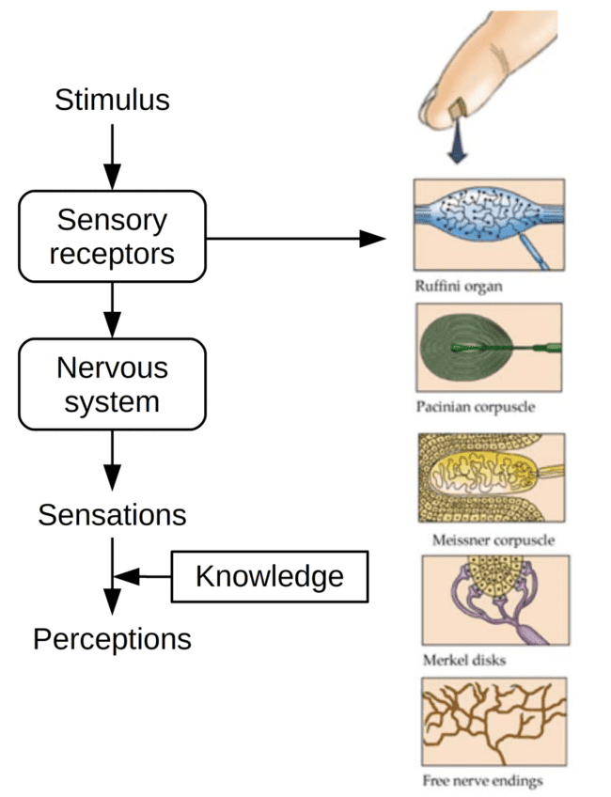

Fig. The human tactile perception process. Inspired from De Boissieu (2010) and De Rossi and Scilingo (2006).

Relationship between Touch and Design
A mechanoreceptor is a type of sensory receptor that reacts specifically to mechanical pressure or deformation stimuli. An illustration of this concept is observed in the periodontal ligament, where mechanoreceptors enable the relaxation of the jaw muscles in response to the act of biting down on solid objects. The mediation of this reflex is attributed to the mesencephalic nucleus.

Fig. Human sense of touch
In the skin, there are four main types in glabrous (hairless) skin:
- Ruffini endings.
- Meissner’s corpuscles.
- Pacinian corpuscles.
- Merkel’s discs.
There are also mechanoreceptors in hairy skin. The hair cells in the cochlea are the most sensitive mechanoreceptors, transducing air pressure waves into nerve signals sent to the brain.
Ruffini Ending | The Ruffini ending, also known as the Ruffini corpuscle or bulbous corpuscle, is a type of slowly adapting mechanoreceptor that is thought to be found only in human glabrous dermis and subcutaneous tissue.
Meissner’s corpuscles | Meissner's corpuscles, also known as tactile corpuscles, are essential for detecting gentle tactile stimuli. Notably, they have the most sensitivity, as measured by the lowest threshold, while perceiving vibrations with frequencies less than 50 hertz. These receptors respond to stimuli very quickly.
Pacinian corpuscles | Pacinian corpuscles, also known as lamellar corpuscles, detect vibrations and pressure and contribute to the perception of these tactile sensations. Their ability to detect vibrations may aid in the identification of surface textures, distinguishing between characteristics such as roughness and smoothness.
Merkel nerve | Merkel nerve endings, which are found in vertebrate skin and mucosa, act as mechanoreceptors, sending tactile information to the central nervous system. These receptors specifically transmit information about pressure and texture.

The essence of tactile experience design lies in the thoughtful orchestration of sensory engagements that resonate with users both physically and emotionally. To accomplish this, numerous essential aspects interplay harmoniously to generate a user-centric outcome that is both meaningful and effective. At the core of this methodology is a thorough contemplation of various design elements. Initially, the selection of materials and textures carries substantial weight. Designers must meticulously choose materials that evoke intended tactile sensations – whether it's the warmth of wood, the smoothness of glass, or the softness of fabric. The sensory reactions triggered by these materials significantly contribute to the user's encounter. To achieve a seamless outcome, prototyping and testing are essential. Through the creation of prototypes reflecting the tactile design, designers amass invaluable insights from user feedback. This iterative process refines the design, aligning it more closely with user expectations and requisites. In essence, the design of tactile experiences embodies a harmonious fusion of materials, ergonomics, feedback mechanisms, accessibility, emotional resonance, and functionality. By adeptly weaving these elements together, designers compose a rich and immersive journey that captivates users, intensifies their interactions, and enriches their overall encounter. The design of tactile experiences should consider various aspects to ensure a meaningful and effective user-centred outcome:
The significance of tactile experience in user-centered design
The significance of tactile encounters within user-centred design is profound. These haptic interactions establish a direct and intimate link connecting users with products, interfaces, or surroundings. By involving the sense of touch, designers have the ability to fashion comprehensive and immersive engagements that deeply resonate with users. Tactile experiences significantly amplify user engagement and contentment. When users can tangibly interact with a product or interface, it introduces an added layer of authenticity and realism to their interactions. This sensory immersion captures their focus, prolongs their involvement, and nurtures a more potent emotional attachment to their interactions. Furthermore, tactile feedback imparts valuable insights and cues to users. It aids in comprehending the functionality and responsiveness of a product. Whether through the clicking of a button, the smoothness of a surface, or the vibration of a device in response to touch, users immediately gain affirmation of their actions, thereby heightening their sense of control and confidence. Tactile experiences also occupy a pivotal role in fostering accessibility and inclusivity. They cater to a wide spectrum of users, including those with visual impairments who heavily rely on touch for environmental awareness. By integrating tactile elements, designers can create designs that are more universally usable, placing inclusivity at the forefront. Within user-centred design, tactile interactions present an unparalleled avenue for conveying information. They can guide users across interfaces, facilitate navigation within environments, and even express emotions. For instance, a smartphone's distinct vibration patterns can indicate various notification types, all without necessitating visual attention. In essence, tactile experiences imbue user-centred design with added layers of depth, engagement, and inclusiveness. By recognizing the import of touch, designers can fabricate products and interfaces that are not only more instinctive, immersive, and user-friendly but also finely attuned to the diverse preferences and requisites of users.
Tactile elements contribution to enhancing accessibility, usability, and inclusivity in various environments.
- Accessibility: Accessibility stands as a vital principle aiming to eliminate unjust barriers and ensure an equitable user experience for individuals facing disabilities. Particularly in the realm of web accessibility, the objective is to grant individuals with disabilities the same level of entry, understanding, navigation, and interaction with digital tools and websites as those without disabilities. This encompasses various impairments, including visual, auditory, cognitive, and motor challenges.
- Usability: Usability involves the creation of products that are efficient, effective, and fulfilling for users. This also encompasses the field of user experience design, where the goal is to ensure a smooth and satisfying interaction between user and products. This entails considering factors like user-friendliness, the ease of learning, and the overall enjoyment of using the product.
- Inclusivity: inclusion revolves around embracing diversity and actively involving everyone to the maximum extent possible. It’s also known as universal design or design for all in certain regions. It encompasses a wide spectrum of issues, including:
- Ensuring accessibility for individuals with disabilities.
- Providing access to and ensuring the quality of hardware, software, and Internet connectivity.
- Promoting computer literacy and skills.
- Addressing economic disparities.
- Focusing on education opportunities.
- Bridging gaps influenced by geographic locations.
- Valuing cultural differences.
- Considering all age groups, from the elderly to the youth.
- Acknowledging linguistic diversity.

In essence, inclusion is about creating an environment where all individuals are valued, involved, and empowered, regardless of their diverse characteristics and circumstances.[3]

Human-centred design
Theories within human-centred design encompass diverse strategies that prioritize understanding and catering to user needs, preferences, and behaviours during the design process. Some prominent human-centred design theories include:
- User-centred Design (UCD)
- Activity-centred Design
- Emotion-centred Design
- Contextual Design
- Participatory Design
- Universal Design
- Design Thinking
- User Experience (UX) Design

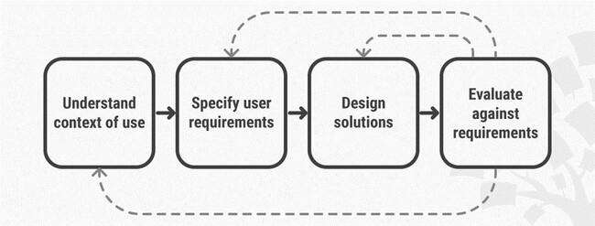
Fig. Importance of Human-Centred Design

Tactile Communication
Tactile communication pertains to the exchange of information, emotions, or messages through the sense of touch. It involves utilizing physical contact, pressure, texture, and other tactile sensations to convey significance or express sentiments. Tactile communication occurs both deliberately and unintentionally, manifesting in diverse situations and interactions. In both humans and animals, tactile communication holds a notable role in social exchanges, establishing connections, and expressing emotions. Instances of tactile communication encompass handshakes, embraces, gentle taps, and handholding, all of which can signify greetings, solace, affection, or encouragement. Tactile cues also hold crucial importance for infants, aiding them in forming bonds with caregivers and acquiring knowledge about their surroundings. In certain cases, tactile communication can function as the primary mode of interaction, especially for individuals with visual or hearing impairments. For instance, individuals without sight may utilize Braille for reading and tactile communication, while interpreters of sign language employ tactile signing to convey spoken language to those who are both deaf and blind. In essence, tactile communication serves as a fundamental mechanism for relaying information, emotions, and interpersonal connections across various human interactions and even among different species.

Tactile Perception and Universal Design

Physiology and psychology of tactile perception.
Physiology: The physiology of tactile perception refers to the biological mechanisms involved in the ability to sense and interpret information through touch. This process involves the activation of sensory receptors in the skin, the transmission of nerve impulses, and cortical processing in the brain. The somatosensory cortex is responsible for processing tactile information and giving rise to tactile perception, including the ability to discriminate between different types of touch, localize tactile stimuli, and perceive texture and pain. Overall, the physiology of tactile perception is a complex interplay between sensory receptors, nerve fibres, and cortical processing that allows us to perceive and respond to our environment through touch.
Psychology: The psychology of tactile perception examines how the brain interprets and responds to touch sensations. Mechanoreceptors transmit signals from the skin to the brain, allowing individuals to perceive texture, pressure, and temperature. Tactile perception involves not only physical sensations but also emotional and cognitive aspects. Touch experiences trigger memories, emotions, and influence decision-making. Attention and memory play roles in prioritizing and recalling tactile sensations. Overall, understanding the psychology of tactile perception provides insights into human behaviour and interactions with the environment, relevant to fields like design and psychology.Tactile encounters have a substantial influence on how individuals perceive their surroundings and engage with objects. The act of touch allows people to gather insights into textures, shapes, temperatures, and weights, enriching their grasp of both items and spaces. Tactile feedback assists in distinguishing various materials and surfaces, aiding in decision-making and navigation. This is particularly significant for those with visual impairments, as tactile cues contribute to spatial awareness and secure movement. Interactions take on deeper meaning as touch forges emotional bonds and evokes memories. Tactile experiences offer a multi-sensory outlook, supplementing visual cues and augmenting the overall comprehension of the environment and object interactions.

Case study where Tactile elements have been successfully integrated into universal design.

Universal Design and Visual Impairment: Tactile Products for Heritage Access by Jaume Gual, Marina Puyuelo and Joaquim Lloveras carried out a case study in Barcelona on assistive resources applied to an itinerary of possible interest to visually impaired.

- Mobility Maps. These present information such as streets, buildings, obstacles, stairs, urban lifts, telephones, etc.
- Topological Maps. These present the itinerary to the blind and they have a high level of simplification and exclude external details.
- Orientation Maps. These contain less detailed information than Mobility maps, for example, transportation networks, shopping centres, recreational areas, etc.
- General Reference Maps, such as political maps or physical maps of a country.
- Thematic Maps. These present specific information such as population, climate, etc.

The synergy between tactile encounters and spatial perception reinforces the importance of considering tactile aspects during the design process. This understanding reinforces the idea that tactile experiences are not mere embellishments but integral components that significantly contribute to the success of Universal Design objectives.
The research sheds light on the pivotal role of tactile experience in crafting Universal Design. Tactile elements serve as powerful mediators that connect users to their environments on a deeper level, transcending physical limitations and fostering inclusivity. As designers, architects, and planners, recognizing and harnessing the potential of tactile encounters allows us to create spaces that are universally appreciated, functional, and emotionally enriching. By acknowledging the crucial role of tactile experience in Universal Design, we can pave the way for environments that accommodate everyone, embodying the essence of inclusivity and accessibility. Conventional production methods involve using plastic thermoforming and microencapsulated paper. However, the emergence of advanced 3D printing techniques presents new potential in production. Research suggests that incorporating three-dimensional structures can enhance comprehension of products by the visually impaired. To create user-friendly tactile-graphic devices, it's crucial to consider that tactile perception is less sharp than visual perception. Therefore, these devices need to convey synthesized information for easy comprehension through touch. By including corresponding visual information tailored to specific needs, such devices can extend their benefits to a broader user base, including the elderly and partially sighted, aligning with Inclusive Design principles.. However, existing design guidelines mainly focus on traditional relief map production methods, which have limitations in replicating volumetric forms and effectively presenting certain map data. Advanced rapid prototyping techniques like stereolithography, selective laser sintering, and 3D printing overcome these limitations, enabling more complex and informative tactile devices for the visually impaired.
Incorporating tactile elements in design

Tactile elements in public spaces have gained prominence for their potential to enhance inclusivity and engagement. The case study explores the integration of tactile features in a park to cater to a wide range of visitors, including those with visual impairments and neurodiverse conditions. The study sheds light on the benefits of tactile design in creating sensory-rich environments that foster interaction and accessibility.

The case study centres on a park revitalization project that aimed to reimagine the park as a universally accessible space. Tactile design elements were introduced, including textured pathways, interactive sculptures, and braille signage. A mixed-methods approach was adopted, combining on-site observations, user surveys, and qualitative interviews to assess the impact of these tactile features on visitors' experiences.

Fig. Texture pathways Fig. Interactive sculptures

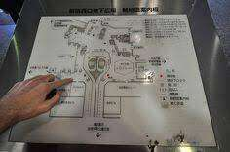
Fig. Braille Signage

The integration of tactile elements in the park yielded several positive outcomes. Foremost, the design enhancements catered to individuals with visual impairments, offering them an avenue for independent exploration and engagement. The tactile pathways and sculptures provided sensory cues that facilitated navigation and interaction, empowering these individuals to engage with the park environment in new ways.

Beyond their practical benefits, the tactile elements also drew interest from visitors of all abilities. Families with children, individuals seeking sensory experiences, and curious park-goers were equally intrigued by the tactile features. This not only enriched the overall park experience but also fostered a sense of inclusivity and community. Conversations and interactions among visitors became more spontaneous and collaborative, contributing to a vibrant and connected park atmosphere.

Moreover, the tactile elements contributed to the park's aesthetics and cultural significance. The interactive sculptures served as focal points, inviting visitors to engage physically and intellectually with the art installations. The braille signage and textured pathways also contributed to a multi-sensory interpretation of the park's narrative, amplifying its cultural and historical context.

The case study illustrates the transformative influence of integrating tactile elements in public spaces. By enhancing accessibility and involving diverse visitor groups, tactile design features contribute to a more inclusive and enriching environment. This study not only underscores the practical benefits of tactile elements but also highlights their role in fostering interactions, community engagement, and a deeper connection to the environment. As public spaces continue to evolve, the integration of tactile design elements remains a powerful tool for creating spaces that resonate with all visitors.

Positive impact of tactile experiences

Tactile experiences have a positive impact on diverse user groups, enhancing engagement and accessibility. For individuals with visual impairments, tactile cues offer essential information and orientation. Children benefit from tactile learning, fostering cognitive development. When children touch and manipulate objects, they engage multiple senses simultaneously. This multisensory engagement strengthens neural connections in the brain, supporting the development of cognitive skills such as problem-solving, spatial awareness, and language comprehension. Tactile experiences also contribute to refining fine and gross motor skills, as children manipulate objects of varying shapes, sizes, and textures.

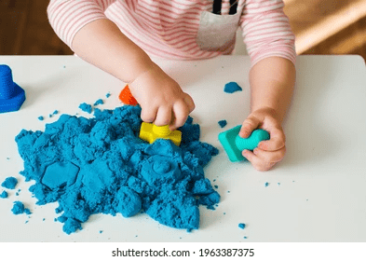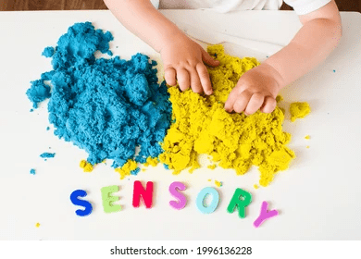

Fig. Tactile Perception in Children

Tactile feedback enhances spatial orientation, communication, and engagement for all users.

Spatial Orientation
Tactile feedback aids individuals in understanding their surroundings and spatial relationships. For those with visual impairments, tactile cues like textured surfaces, handrails, and braille signage provide vital information about pathways, obstacles, and landmarks. These cues enable safe and independent navigation by offering tangible guidance and promoting a comprehensive mental map of the environment. However, tactile feedback is not limited to the visually impaired; even sighted individuals benefit from tactile cues in unfamiliar settings, as they reinforce their visual understanding of space and enhance their overall awareness.

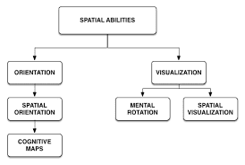
Fig. Spatial Orientation

Spatial Communication
Tactile feedback serves as a non-verbal communication channel that transcends language barriers. Through touch, individuals can convey emotions, intentions, and information. For instance, a reassuring pat on the back, a firm handshake, or a gentle touch can convey empathy, friendship, or comfort. In the context of individuals with hearing impairments, sign language and tactile signing leverage touch to communicate complex ideas and concepts. This tactile language bridges communication gaps, fostering meaningful interactions and mutual understanding.

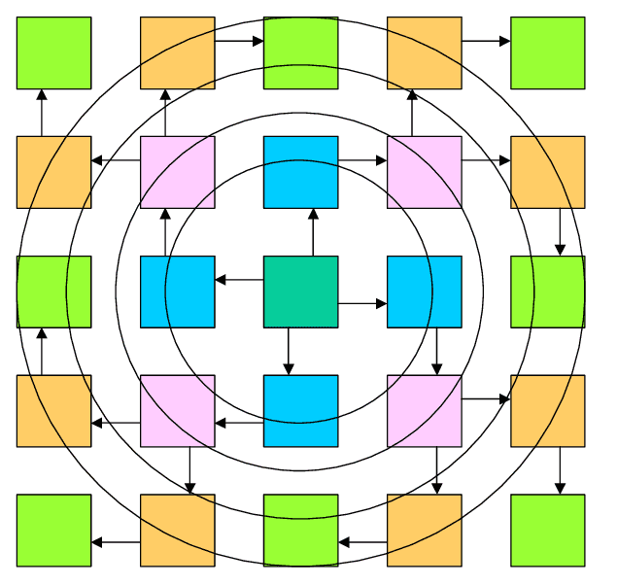
Fig. Spatial Communication

Spatial Engagement
Tactile sensations engage our senses, creating a deeper level of connection and involvement. In interactive settings, such as museums, exhibitions, and educational programs, tactile elements provide a multisensory experience that captivates users of all abilities. Tactile exploration stimulates curiosity and encourages active participation. For instance, tactile models and objects in a museum allow visitors to engage directly with artifacts, enhancing comprehension and retention of information. Children, in particular, benefit from tactile engagement, as they naturally explore and learn through hands-on experiences.

Potential challenges and limitations of integrating tactile experiences into Universal Design.

Incorporating touch experiences into Universal Design has many advantages, but it also brings some difficulties and restrictions that need attention. While tactile features make things more inclusive and engaging, dealing with these issues is important for a good design.

Practical considerations: Materials, Maintenance, and Cultural Differences.

The selection of appropriate materials for tactile elements is a fundamental consideration in design, bearing significant implications for the effectiveness and inclusivity of tactile experiences. These materials hold the key to crafting tactile elements that are not only safe and durable but also capable of conveying meaningful information through touch. A critical aspect lies in the textures and sensations that these materials offer, which enable users to discern and interpret their surroundings. Moreover, the diversity of textures, including roughness, smoothness, softness, and hardness, enriches tactile encounters by providing a range of sensory inputs.
Maintaining tactile features within the realm of design carries significant importance, particularly as these elements often inhabit bustling, high-traffic areas. Their resilience against wear and tear is paramount, necessitating materials that can endure the rigors of frequent usage while retaining their functional integrity. Moreover, the exposure of tactile elements to varying environmental elements, encompassing weather fluctuations and constant touching, necessitates materials that can withstand such pressures without succumbing to deterioration.
Tactile design is profoundly influenced by cultural diversity, shaping how tactile experiences are perceived and interacted with across different societies. Cultural nuances intricately intertwine with tactile perceptions, affecting preferences for touch, acceptable materials, and sensory comfort. Designers must navigate the complex landscape, considering cultural attitudes towards touch and tactile materials to create designs that are inclusive and culturally sensitive. By fostering an environment where tactile features are universally understood and embraced, designers can effectively bridge cultural gaps and enhance the accessibility and relevance of tactile experiences for diverse user groups.

Importance of tactile experience in achieving Universal Design goals.

The significance of tactile encounters in attaining the objectives of Universal Design is paramount and multifaceted. The primary objective of Universal Design is to establish environments, products, and experiences that are accessible and functional for all individuals, irrespective of their abilities or attributes. Tactile experiences play a pivotal role in achieving these goals by enhancing inclusivity, communication, and engagement.

Tactile interactions are pivotal for fostering inclusiveness. The integration of tactile components empowers individuals with visual impairments to navigate and interpret their surroundings with greater efficacy. Elements such as textured pathways, braille signage, and tactile graphics offer crucial cues that enable visually impaired individuals to independently explore and interact within their environment. Tactile elements serve as a non-verbal means of conveying information, emotions, and intentions. Individuals with hearing impairments or those reliant on sign language often utilize touch to communicate intricate concepts. By incorporating tactile components, Universal Design embraces various communication methods, enabling individuals to connect, share, and comprehend beyond conventional verbal and auditory modes. Tactile experiences cultivate deeper levels of engagement. Human beings innately learn through touch, making it an essential facet of exploration and comprehension, particularly for young learners. The integration of tactile components into educational spaces, museums, and public domains enhances the learning process, creating a more immersive and lasting encounter. Tactile participation sparks curiosity, prompting active involvement and heightening the overall experience for all users.

However, it is imperative to recognize that actualizing tactile experiences also introduces challenges. The selection of suitable materials, ensuring consistent maintenance, and accommodating cultural distinctions necessitate meticulous consideration. By addressing these hurdles, designers can harness the potency of tactile experiences to effectively accomplish the aspirations of Universal Design.

Conclusion
In conclusion, this research delves into the intricate interplay between tactile experience and the domain of Universal Design, casting a spotlight on its undeniable significance in shaping inclusive environments. The journey through this exploration has underscored the integral role tactile encounters play in realizing the core tenets of Universal Design – accessibility, usability, and inclusivity.

The discussion on tactile perception has further fortified the notion that touch is not merely a sensory experience; it is a conduit through which individuals understand and interact with their surroundings. Case studies and real-world examples have demonstrated how tactile cues, carefully woven into Universal Design, offer unparalleled benefits, enhancing the lives of individuals with visual impairments and other disabilities. The positive impact resonates across diverse user groups, enriching experiences for children, the elderly, and individuals seeking immersive engagement.

In closing, this research tells us that touch is key to Universal Design. It's like a bridge that helps us build places where everyone can fit in. The stories and studies explored show us that adding touch to designs brings big benefits, especially for those who might find things hard due to their vision or other reasons.

References

- Dr. Santhosh Areekkuzhiyil. Universal Design for learning
- J Dargahi, S Najarian Human tactile perception as a standard for artificial tactile sensing J Dargahi, S Najarian
- Accessibility, Usability, and Inclusion | W3C Web Accessibility Initiative (WAI)
- Amelia Lewis. In Search of a Unified Theory of Sensory Perception
- Catia Prandi, Barbara Rita Barricelli, Silvia Mirri and Daniela Fogli. Accessible wayfinding and navigation: a systematic mapping study
- Institute for Human-Centred Design. (n.d.). What is Universal Design? Retrieved from https://humancentereddesign.org/what-is-ud
- Preiser, W. F., & Ostroff, E. (Eds.). (2001). Universal Design Handbook. McGraw-Hill.
- Gibson, J. J. (1986). The Ecological Approach to Visual Perception. Psychology Press.
- Heller, M. A., & Mohan, V. (Eds.). (2019). Haptic Experience in the Writings of Georges Bataille, Maurice Blanchot and Michel Serres. Springer.
- Sánchez, J., & Cubillo, J. (2018). Tactile and Haptic Interaction Design: A User-Centered Approach to Designing Touch and Tactile Interfaces. Springer.
- Dong, H., & Saramäki, T. (2016). Tactile Display in Virtual Reality Applications: Taxonomy, Opportunities, and Challenges. In Virtual Reality (pp. 185-209). InTech.

