A STUDY OF SURGICAL MANAGEMENT OF PROXIMAL HUMERUS FRACTURES

Aditi M Sengupta^{1*}
Kallol K. Haldar²
Punit Sureka³

^{1*}International Member of American College of Physicians(MACP), Principal Medical Officer, CK Birla Hospitals, Kolkata, Harvard Medical School, Department of Continuing Medical Education, Post Graduate
Association Member.

² HOD Department of Physiotherapy, CK Birla Hospitals, Kolkata

³ Founder and CEO, Cikitsa International and President of Rotary Club of Central Gardens.

Address of the Corresponding Author:
7/2 Diamond Harbour Road, Kolkata-700027

Email: sengupta2aditi@gmail.com

Phone number: +91-9674131369

]

INTRODUCTION

Proximal humeral fractures are the second most common upper-extremity fracture and the third most common fracture after hip fractures and distal radial fractures, in patients who are older than sixty-five years of age. They account for about 5% of all injuries to appendicular skeleton ^{1.}
Although the overwhelming majority of proximal humeral fractures are either non-displaced or minimally displaced and can be treated with sling immobilization and physical therapy ^{2,} approximately 20% of displaced proximal humeral fractures may benefit from operative treatment ^{3.}
Many surgical techniques have been described, but no single approach is considered to be the standard of care.⁴
Over the last 3 decades, various modalities of fixations have evolved for the proximal humerus fractures (transosseous suturing, percutaneous pinning, tension band wiring, plating, rush nailing, arthroplasty). The proximal humerus locking system plate has been developed to improve screw fixation in osteoporotic bone and to minimize soft tissue dissection.
The type of fixation used depends on the patient's age, activity and bone quality, the fracture type and the surgeons technical ability. If the fracture reduction is achieved by manipulation but cannot be maintained, percutaneous K- wire fixation is performed. Recent advances in fracture fixation technologies have led to the development of fixed-angle locked plates that maintain angular stability under load.
The treatment is more controversial for articular fractures which carry a high risk of the humeral head necrosis. In Neer's clasification, these are two part , three-part and four-part fracture and those with dislocation of head of humerus. A review of published result suggests that there is no universally accepted form of treatment. Conservative management may be associated with non-union, malunion and avascular necrosis resulting in painful dysfunction.
Proximal humeral fracture whether caused by trauma or related to osteoporosis, requires carefully planned individual treatment. The choice of technique and devices depends on quality of bone, soft tissue, age and reliability of patients. However the goal of proximal humerus fracture fixation should be stable reduction, allowing early motion of fracture.
This study is conducted to analyze fractures of the proximal humerus that were treated either with the proximal humerus internal locking system (PHILOS) locking plate or percutaneous K wire and documents their clinical and functional outcome.

AIMS AND OBJECTIVES

To do a prospective study and compare the outcomes of surgical management of proximal humerus fractures.

LITERATURE REVIEW
In 460 BC ⁵ the first documentation of treatment of a proximal humeral fracture was published by Hippocrates, who described a method of weight traction to aid bone healing. The final result is unknown.
In 1884 the first surgical treatment of a fracture dislocation of the proximal humerus reported in the literature was performed by LaMotte in Belgium and Lane in Great Britain.⁶ The humeral head was removed and the patient was ready for dismissal 13 days later when he had an attack of diarrhoea from which he died 1 week later.
In 1896 Kocher⁷ developed an anatomical classification in an attempt to improve diagnosis and treatment but this simplified scheme was not thorough enough and lacked consistency.
In 1907 Keen⁷ performed first open reduction and internal fixation of an acute fracture of the greater tuberosity but he credited Barden aver with having developed concept in 1886 and Muller with having done first repair of an old fracture in 1898.
In 1912 Albee⁷ and in 1923 Austin proposed immobilization by casts and splints.
In 1932 Roberts SM⁷ reported that elaborate apparatus and prolonged immobilization were not beneficial, as simpler forms of fixation and early motion.
In 1934 Codmen⁷ made a significant contribution when he divided proximal humeral fracture into four basic parts.
In 1934 Howard and Eloesser⁷ developed a complex theoretical shoulder model that simulated muscle forces and demonstrated that abduction splint was not beneficial for reduction and control of muscle forces.
In 1937 Meyerding⁷ suggested the use of open reduction and early mobilization to improve alignment and avoid malunions that would limit motion. Suture material, wire and screw were types of early fixation.
In 1955 Rush⁷ described his method of intramedullary nailing for displaced proximal humeral fractures, which became quite popular
In 1963 Maclauglin⁷ found that fractures of greater tuberosity that healed with more than 1cm of displacement resulted in permanent disability, while those with 1/2cm of displacement or less did well. He reported that patient who had ½ to 1cm displacement of fragment often had prolonged convalescence, with some having permanent pain and disability and 20% needing reconstructive procedure.
In Early 1970s the association for study of internal fixation (ASIF) group popularized osteosynthesis (AO) by plates and screws for the displaced fractures.
In 1970 Dr. Charles S. Neer II has made an outstanding contribution to proximal humerus fractures. He published two articles.^{8,9} The first article deals with classification and evaluation and second with treatment of fracture with three part and four part displacement. The study was made of anatomy of 300 displaced proximal humerus fractures and fracture dislocations, selected at random from those treated by closed reduction under anaesthesia or surgery at the New York, Orthopaedic Hospital–Columbia – Presbyterian medical center between 1953 and 1967.The age of patients ranged from 22 years to 89 years and average age was 55.6 years. Treatment consisted of closed reduction, under anaesthesia in 162(54%). Open reduction in 75(25%), with removal of humeral head on five occasions and prosthetic replacement in 63(21%) patients. After considering this group of patients he suggested that displacement of less than 1.0cm (or) angulations less than 45° between fragments did not alter the anatomy to such an extent that final clinical result would be jeopardized. Thus the new classification system evolved.
In 2nd article, the more complex fractures were considered. One hundred and seventeen patients with three-part or four part displacement were treated with closed reduction 77(65.8%), open reduction 43 (36.7%) or a proximal humeral prosthesis(43) and were followed for minimum of one year. In closed reduction only 3 had satisfactory result, 19 three parts fracture treated with open reduction had satisfactory result and 13 four part fracture with open reduction had satisfactory result. 7% of three parts and 75% four part treated with open reduction developed osteonecrosis of head.
In 1983 Pavolonian et al,¹⁰ reported 23 of 31 patients (74%) with good to excellent results by the Neer criteria following open reduction and fixation with plate and lag screw. Half of the patients included in the study were younger patient and half of the patients were with two part and the good results in this study were attributed to these factors.
In 1985 Siebler G., et al,¹¹ has reported on late results of 65 proximal humerus fractures, operated upon between 1970 and 1980. Fracture classified as Neer two part (28), three part (15), and four part (21) and fracture of articular surface. In 34 cases T-plate, 23 cases screws and K-wires, 3 cases primary head replacement have been done. The functional result were excellent in (38%) patients, good in (22%) patients, fair in (15%) patients, poor in (25%) patients. The better results obtained in younger patients, isolated shoulder injuries and patient with 2 or 3 part fractures.
In 1986 Kristiansen¹² has reported 9(45%) satisfactory and 11(55%) unsatisfactory results for 20 patients with two–part, three-part, and four-part fracture treated with AO Buttress plate. In this study 4 cases developed infection, and in five cases impingement of plate were present and in two cases loosening of plate were present. They concluded that buttress plate offers satisfactory reduction and good stability at high risk of complications and hence the indications should be carefully considered in elderly and operation should be performed by experienced orthopaedic surgeon.
In 1986 Mourdian¹³ developed an intramedullary device with screw fixation for head and tuberosities. However, the incidence of avascular necrosis (AVN) was high and follow up was short. He used nail for 6-two part, 10-three part and 7-four part acute fractures. According to Neer functional score patient with two part fracture had 86.5 score, 3-part fracture had 80, and four part had 80 score. All patients healed without infection, 4 (19%) patients had avascular necrosis (AVN), 5 (23%) had impingement.
In 1990 Moda SK, Chadha NS, et al,¹⁴ treated 25 patients with plate and screws. This is a very important series from India on proximal humerus fractures. It Illustrates the reasonable degree of effectiveness of rigid internal fixation for younger patients with proximal humerus fracture. They used AO" T" plate in 15 patients, blade plate in 10 patients. Excellent or satisfactory result achieved in 21 of 25 patients (84%) including all 6 patients with two part, 4 of 5 with three-part, 9 of 11 with fracture dislocation and 2 of 3 with split fracture head of humerus. There were 4(11.4%) un-satisfactory result which were associated with rotator cuff damage. They concluded that AO" T" plate or blade plate is best.
In 1993 Szyszkowitz et al,¹⁵ study during a ten year period [1978- 1988) treated 193 patients with proximal humerus fractures by internal osteosynthesis. 97 patient had adequate documentation 77 (80%) were available for review. Fractures were graded by AO/AISF classification (44 group A, 32 group B 21 and group C). In 70% patients T-plate/cloverleaf plate/ small condylar plate fixation was performed and in remaining patients K-wire or screw or encirclage wire used. 52% patients had excellent and good result, 15% had fair result and 33% had poor result. 61% of poor result occurred in 4 part fracture and only 22% excellent result occurred in 4 part fracture.
In 1994 Robinson CM, Christie T,¹⁶ reviewed 45 patients who have undergone two operative technique (AO plating and IM rush pins). Good functional results were obtained using the former technique in which 7 (87%) out of 8 patients mainly sustained fracture following high energy trauma and were above 50 years and 12(85%) out of 14 patients who had low energy trauma and with osteoporotic bone treated with buttress plate had unsatisfactory result, but rush pin produced more reliable results in this group. Hence they recommended rush pin for low energy trauma and osteoporotic bones in elderly and plate for younger patients.
In 1995 Zyto K, et al¹⁷ their study of shoulder function after displaced fractures of proximal humerus, concluded that – it is difficult to consistently achieve success in patients with four-part fractures or fracture dislocations. However many of those with three-part fracture can be successfully treated. In their study out of thirty eight patients, 26 with 3-part, 12 with four part were followed for 3 to 3½ year, 28(74%) patients were treated conservatively, 7(18%) underwent open reduction and internal fixation, 3(8%) had hemiarthoplasty. According to Neer score 4 patients with three part and 7 with four part were classified as failure, that is total 28% of failure were present.
In 1996 Koval KJ, et al,¹⁸ conducted a bio-mechanical cadaver study to compare the stability and ultimate strength of ten standard fixation techniques used for the treatment of surgical neck fracture of proximal humerus. They concluded that the T-plate and screws provided significantly stronger fixation (P<0.005) in fresh frozen specimens than all other methods. The nails/tension band construct was the second strongest fixation technique (P<0.01).
In 1999 Hessman M, et al,¹⁹ concluded that functional results after plate osteosynthesis of unstable and displaced proximal humerus fractures occurring in elderly patients are good to excellent in 70% of patients when surgery is performed according to the no-touch technique. This study included 99 patients with three, four, and two part fractures for which open reduction and internal fixation done with Buttress plate using deltopectoral approach and they found the incidence of avascular necrosis of humeral head and non union are rare with this technique.
In 2000 Hintermann B, et al,²⁰ studied 42 patients (34 three part, 8 four part), fractures treated using blade plate by deltopectoral approach. On final review (after average of 3.4 years), they found 13 patients with excellent result, 17 patients with good result, fair in seven and poor in 1 patient. They concluded that rigid fixation of displaced fractures of proximal humerus with a blade plate in elderly patient provides sufficient primary stability to allow early functional treatment.
In 2002 A J Wijgman et al,²¹ assessed the intermediate and long-term results for sixty patients with a three or four-part fracture of the proximal part of the humerus who had undergone open reduction and internal fixation with circlage wires or a T plate. The Constant score and a visual analog score for pain were calculated, and radiographs of the proximal part of the humerus were evaluated. After an average of ten years of follow-up, fifty-two patients (87%) had a good or excellent result on the basis of the Constant score whereas eight patients (13%) had a poor result. Fifty-one patients (85%) were satisfied with the result at the time of most recent examination. Twenty-two patients (37%) had development of avascular necrosis of the humeral head, and seventeen (77%) of these twenty-two patients had a good or excellent Constant score. They concluded open reduction and internal fixation with circlage wires or a T-plate yields good functional results in most patients. This option should be considered even for patients with fracture-dislocation patterns that are associated with a high risk for avascular necrosis of the humeral head, as this complication did not preclude a good result.
In 2004 Jan Magnus Bjorkenheim et al,²² retrospectively reviewed complication and functional outcome after minimum follow up of 1 year in 72 patients treated with locking compression plate, two fractures failed to unite, three patients developed avascular necrosis of humeral head and two implant failures. They concluded locking compression plate appears to be safe and recommended in patients with poor bone quality.
In 2004 Gerber C., et al,²³ treated 34 articular fractures of the proximal humerus with good bone quality in 33 patients by open reduction and internal fixation with various modalities (Plate screw/ percutaneous pinning/osteosuture). They achieved anatomical or near anatomical reduction in 30 patients. 32 patients obtained mean constant score of 78 points. They concluded that operative treatment of complex fractures of proximal humerus gives good result if anatomical or near anatomical reduction is achieved in a patient with good bone quality.
In 2005 C.P.Charalambous et al²⁴ treated 25 patients with proximal locking compression plate of which 20 went to union with mean neck shaft angle of 127.2°.Five cases required revision surgery for non union or implant failure. Of 25 implants, four had screw protrusion into gleno humeral joint, four had screw loosening and backing out, and one plate broke without further trauma. They concluded proximal locking compression plate as effective system for fracture stabilization and bony union.
In 2007 Reto Babst et al,²⁵ patients treated with locking compression plate. According to AO classification 16 fractures were type A, 21 type B, 17 type C fractures. The mean constant score was 70 points and reached 87.3% in relation to the contralateral healthy side. Observed complication in 16 patients including two partial and two complete avascular necrosis,6 primary screw perforation, five secondary screw perforation due to impaction of fracture,1 distal partial plate and screw pull out and one secondary loss of reduction. They concluded in young patients plate has best potential.
In 2007 Ash wood N et al,²⁶ studied 32 patients with acutely displaced three-or four-part proximal fractures of the humerus were treated by open reduction and internal fixation using the proximal humeral internal locking system plate. There were 23 women and 9 men with a mean age of 59.9 years. Data were collected prospectively and the outcomes were assessed using the Constant score. The mean follow-up was for 11 months (3 to 24). In 31 patients (97%) the fracture united clinically and radio logically at a mean of 10 weeks (8 to 24). The mean Constant score at final review was 66.5 (30 to 92). There was no significant difference in outcome when comparing patients aged more than 60 years (18 patients) with those aged less than 60 years (14 patients) (t-test, p = 0.8443). There was one case each of nonunion, malunion and a broken screw in the elderly population. Hence concluded plate provides an alternative method of fixation for fractures of the proximal humerus. It provides a stable fixation in young patients with good-quality bone sufficient to permit early mobilization. Failure of the screws to maintain fixation in the elderly remains a problem.
In 2007 Ramchander Siwach et al,²⁷ prospectively assessed the functional outcome and complications in 25 patients of proximal humerus fracture with 10 osteoporosis treated with locking compression plate. Mean constant score was 80 points. According to constant score, 28% excellent outcome, 64%good functional outcome, 8% had moderate outcome. Varus malalignment and subacromial impingement were observed in 8% patients. Loosening of implant and loss of reduction were observed in 4%,superficial infection in 4%. They concluded locking compression plate is an advantageous implant in proximal humerus fracture due to angular stability particularly in osteoporotic bone and comminuted fracture.
In 2008 Rizwan Shahid et al,²⁸ prospectively reviewed 50 patients with proximal humerus fracture treated with proximal humerus locking compression plate from sep 2002 to sep 2006. Of which 11 patients had two part, eleven had three part, and eighteen had four part fracture. Radiological union was achieved within 8 weeks in 40/41 fracture. They concluded locking compression plate as a reliable implant. Increase in number of parts of fracture did not affect final outcome.
In 2008 Kenneth A. Egol et al,²⁹ studied early complications in Proximal Humerus fractures treated with Locked Plates. Fifty-one consecutive patients treated with a proximal humerus locking plate. A retrospective analysis was undertaken for a consecutive series of proximal humerus fractures treated with a locking plate between February 2003 and January 2006 at our institution. Fracture union was identified in 18 male and 33 female patients with an average age of 61. All were treated with a similar protocol of open reduction internal fixation with the PHILOS plate followed by early range of shoulder motion. Fifty-one patients were available for minimum 6-month follow-up (mean, 16 months; range, 6 to 45 months). Radiographically, 92% of the cases united at 3 months after surgery, and 2 fractures had signs of osteonecrosis at latest follow-up. Eight patients (16%) had screws that penetrated the humeral head early implant failure occurred in 2 patients; one was revised to a longer plate, and one underwent resection arthroplasty. There was one acute postoperative infection. The major complication reported in this study was screw penetration, suggesting that exceptional vigilance must be taken in estimating the appropriate number and length of screws used to prevent articular penetration. Hence concluded although the device provides exceptional fixation stability, its indication must be scrutinized for each individual patient, taking the extent of trauma/fracture and age into consideration and carefully weighing it against other forms of treatment.
In 2009 Felix Brunner et al.³⁰ Multicenter study in 8 trauma units (levels I, II, and III) with recruitment between September 12, 2002 and January 9, 2005. One hundred fifty-seven patients treated with Open reduction and internal fixation with a PHILOS plate. One-year follow-up rate was 84%. The incidence of experiencing any implant-related complication was 9% and 35% for non implant related complications. Primary screw perforation was the most frequent problem (14%) followed by secondary screw perforation (8%) and avascular necrosis (8%).
After 1 year, a mean Constant score of 72 points (87% of the contra lateral noninjured side), a mean Neer’s score of 76 points, and mean Disabilities of the Arm, Shoulder, and Hand score of 16 points were achieved. Concluded that Fixation with PHILOS plates preserves achieved reduction, and a good functional outcome can be expected. However, complication incidence proportions are high, particularly due to primary and secondary screw perforations into the glenohumeral joint, with an overall complication rate of 35%. More accurate length measurement and shorter screw selection should prevent primary screw perforation. Awareness of obtaining anatomic reduction of the tubercles and restoring the medial support should reduce the incidence of secondary screw perforations, even in osteopenic bone.
In 2009 AA Martinez et al,³¹ retrospectively reviewed 58 patients who underwent locking compression plate fixation for proximal humerus fracture between september 2004 to march 2006. All fractures healed satisfactorily, except in 1 patient with a valgus 4-part fracture who had malunion. Functional outcome was excellent in 13 patients, good in 36, moderate in 8 and poor in 1 patient. They concluded that proximal humerus locking compression plate is appropriate treatment for proximal humerus fracture.
In 2009 MA Fazal et al,³² retrospectively reviewed 27 patients who underwent locking compression plate fixation for proximal humerus fracture between June, 2003 to June, 2006. All fracture were classified as 2 part (n=13), 3 part (n=12), 4 part (n=2). All fractures united except one 3-part fracture in 78yrs aged women in whom there was a collapse and screw penetration. Mean constant shoulder score was 70. 11 patients had score exceeding 75, 13 were scored between 50 and 75, and 3 were below 50.They concluded PHILOS plate fixation provided stable fixation, minimal metal work problem and enabled early range of motion exercises to achieve acceptable functional results.
In 2010 Sameer Aggarwal et al,³³ Over two and a half years, treated 56 patients with an acute proximal humerus fracture with locking plate osteosynthesis. 47 of these patients who completed a minimum follow up of 1 year were evaluated using Constant score calculation. The average follow up period was around 21.5 months. Outcomes were excellent in 17%, good in 38.5%, moderate in 34% while poor in 10.5%. The Constant score was poorer for AO-OTA type 3 fractures as compared to other types. The scores were also inferior for older patients (> 65 years old). Complications included screw perforation of head, AVN, subacromial impingement, loss of fixation, axillary nerve palsy and infection. A varus malalignment was found to be a strong predictor of loss of fixation. They concluded locking plate osteosynthesis leads to satisfactory functional outcomes in all the patients. Results are better than non locking plates in osteoporotic fractures of the elderly.
In 2011 Georg Osterhoff, Ossendorf et al,³⁴ studied patients with proximal humerus fracture who underwent angular stable plate fixation between 2007 to 2009. Follow up was possible in 60 patients. Patients with calcar screw were assigned to group c+, patients without calcar screw to group c-. Humeral head necrosis occurred in 6 patients in (c+, 15.4%) and 3 in (c-, 14.3%). Cut out of the proximal screw were observed in 3(c+, 7.7%) and 1 (c-, 4.8%) cases. In each group 1 patient showed delayed union. There was significant loss of reduction in group c- compared to c+. He concluded the placement of calcar screw in angular stable plate fixation of proximal humerus fracture is associated with less secondary loss of reduction.
In 2012 Adithya C Pawaskar, Kee-Won lee et al,³⁵ studied 25 patients who underwent surgery for proximal humerus fracture with locking plate between 2008 and 2010. Measurement of neck shaft angle was done at immediate post op, 3 month post op and final follow up (8 to 17 months). He found mean loss in neck shaft angle in the first 3 month was 3.8° as compared to 1.3° in the p period between 3 months and final follow up. This was statistically significant (p=0.002). He concluded proximal humerus locking plate maintains reliable radiographic results even in elderly population with proximal humerus fracture.

ANATOMY
Sushruth in 6th BC correctly described the two shoulder bones. At the same time western world thought of acromion as seperate bone. In the same era Atroya fully described the bones of humans.
Hippocrates in 5th BC was probably the first physician whose idea regarding shoulder anatomy perpetuated.
Humerus is the largest, most proximal bone of the upper extremity.
The proximal humerus is uniquely adapted to allow for the large range of motion of the shoulder which is ball and socket type of joint. The bony anatomy of proximal humerus is divided into following parts.³⁶
1) The Head
2) The Anatomical neck
3) The Greater tuberosity
4) The Lesser tuberosity
5) The Surgical neck
6) Inter tubercular sulcus
7) Proximal shaft
It is important to differentiate between the anatomical neck ( which is junction of head and tuberosities) from surgical neck (which is at the area below the greater and lesser tuberosities), the boundaries of later are variable without a distinct line.
The Head:
The head forms about one-third of a sphere and is much larger than the glenoid cavity.³⁶ It is directed medially, backwards and upwards. Diameter of curvature is about 46mm (ranging from 37 mm to 57 mm) ⁵
Humeral articulation is retroverted, averages about 20 degrees (ranging from 10 degree of anteversion to 60 degree of retroversion.⁵ The inclination of humeral head relative to the shaft averages 130 degree.⁵
The Anatomical Neck:
The line separating the articular portion of head from the rest of the proximal humerus is the anatomical neck. It affords attachment to the articular capsule of the shoulder joint and is perforated by numerous vascular foramina.^{5,36}
The Greater tuberosity:
It is an elevation that forms the lateral aspect of the proximal humerus. Its posterior aspect is marked by three impressions, which give attachment to
1) Supra spinatus
2) Infra spinatus
3) Teres minor
The greater tuberosity does not protrude above humeral head.
The Lesser tuberosity:
It is an elevation on the anterior aspect of the proximal humerus. It is directed medial ward and forward. It gives attachment to the insertion of subscapularis.
The Surgical neck:
The constriction between the tuberosities and shaft of humerus is the surgical neck.
The Intertubercular sulcus (Bicipital groove):
It separates the lesser tubercle immediately from the anterior part of the greater tubercle. Its contents are:
1) Long head of biceps
2) Branch of the anterior humeral circumflex artery
Its upper part is covered with a thin layer of cartilage, lined by a prolongation of synovial membrane of the shoulder joint. Its lower portion gives attachment to the insertion of latissimus dorsi. ^{36,37}

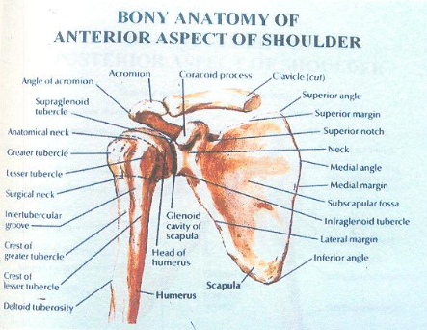
FIG 1A : ANTERIOR ASPECT OF SHOULDER

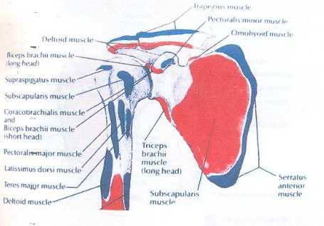
FIG 1B: ANTERIOR MUSCLE ATTACHEMENTS OF THE SHOULDER
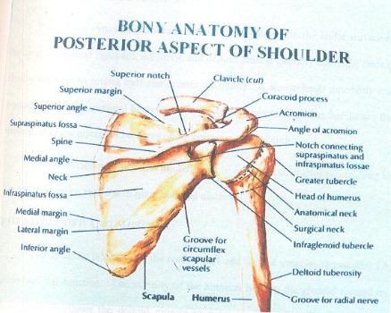
FIG 2A : POSTERIOR ASPECT OF SHOULDER

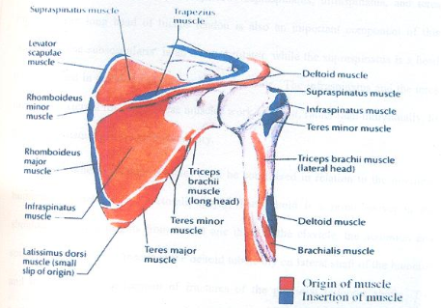
FIG 2B: POSTERIOR MUSCLE ATTACHEMENTS OF SHOULDER
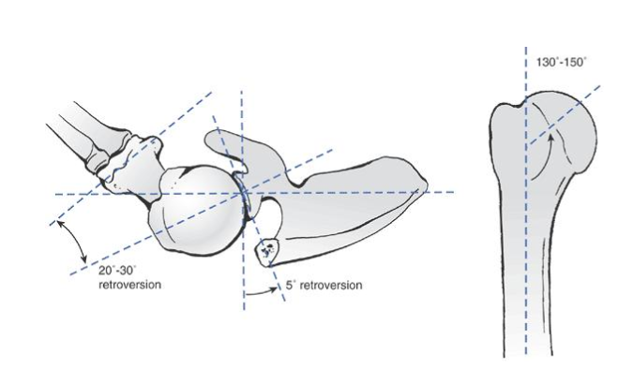
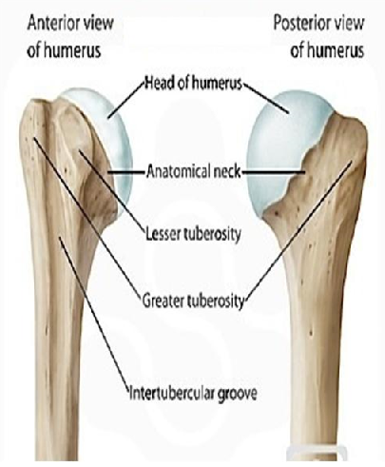
FIG 3 : ANATOMY OF PROXIMAL HUMERUS
Rotator cuff:
- The tendons attached to the greater and lesser tuberosity form the rotator cuff. They are:
1) Supra spinatus
2) Infra spinatus
3) Teres minor
4) Subscapularis
The orientation of the rotator cuff attachment to the humerus is important to understand the displacement of tuberosities in proximal humerus fractures.

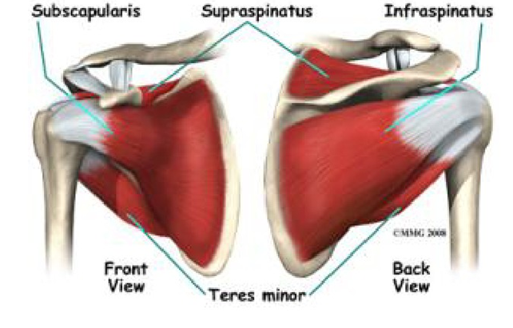 FIG 4: ROTATOR CUFF MUSCLES

VASCULAR ANATOMY OF PROXIMAL HUMERUS
The major arterial supply of proximal humerus is from axillary artery and its lateral branches the anterior and posterior humeral circumflex arteries. The anterior humeral circumflex artery a branch of axillary artery arises at the inferior border of subscapularis tendon. It is the main arterial supply to the humeral head; The anterolateral branch eventually enters the head to form the arcuate artery which supplies all the anterior part and a small posterior part of the head. This branch continues laterally around the shaft to anastomose with the posterior humeral circumflex artery.
The posterior humeral circumflex artery goes posteriorly with the axillary nerve through the quadrilateral space.^{2, 3,38}

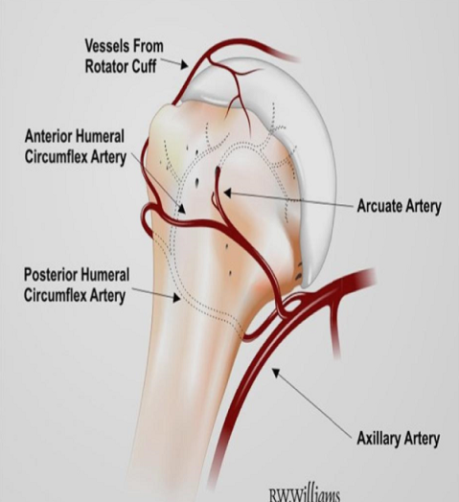
FIG 5 : VASCULAR ANATOMY OF PROXIMAL HUMERUS

NERVE SUPPLY
The shoulder’s innervations are derived from the brachial plexus (C5-T1) with contributions from C3&C4 cervical nerves. Axillary nerve a branch of the posterior cord enters the quadrilateral space it sends articular branches to the glenohumeral capsule. It also sends branches along the anterior humeral circumflex artery to the bicipital groove. Additional branches to the capsule may come off the nerve where it enters the quadrilateral space. As the nerve traverses the quadrilateral space, it wraps around the proximal humerus while lying on the deep surface of the deltoid muscle. It ramifies into three major branches that supply motor innervations to the teres minor and the overlying deltoid muscle. The lateral brachial cutaneous nerves represent the sensory branches that penetrate the deltoid muscle to provide sensation to the overlying skin. The articular branches to the shoulder joint come primarily from axillary, suprascapular and the lateralanterior thoracic nerves.^{2, 3, 38} Branches also come from the posterior cord and from the sympathetic ganglion
BIOMECHANICS
Most of the fractures are the result of an indirect force such as a fall on outstretched arm rather than direct blow to shoulder.³⁹ The muscular pull of adjacent tendon attachments on humeral fracture fragments determines the pattern of displacement.
- Greater tuberosity fragment→ Posterosuperiorly (by supraspinatus and infraspinatus)
- Lesser tuberosity fragment → Medially (by Subscapularis)
- Shaft → Anteriorly and Medially (by Pectoralis major)
In 3 part fractures, if the lesser tuberosity remains attached to the head, the articular surface faces posteriorly. On the other hand if the greater tuberosity remains attached to the head, the articular surface faces anteriorly.
In general, two specific groups of patient can be identified based on bone quality. In group I, the patient is young, with either minimally displaced fractures or more comminution. These individuals are generally better suited to rigid fixation due to good quality bone. In group II patients the bone is more osteoporotic due to advanced age and decreased bone density. They are most often displaced than impacted, and for this reason reduction and stable fixation can be a challenge due to the poor bone quality.^{3,5}

MECHANISM OF INJURY
Most fractures of proximal humerus occur through osteoporotic bones in older patients. High energy trauma may result in such fractures at any age. Most common mechanism is a simple fall on the arm. Strong muscular contraction is the proposed mechanism for greater tuberosity fractures. This is seen in cases of electric shock or seizure. Once the fragments separate muscle forces contribute to their displacement. The shaft is generally drawn anteriorly and medially by the pectoralis major. Greater tuberosity may be pulled posteriorly by infraspinatous and superiorly by supraspinatus. The subscapularis tends to retract medially an isolated lesser tuberosity fracture or to rotate internally a head segment to which only the lesser tuberosity remains attached.
CLINICAL FEATURES: ^{7,40}
Most of proximal humerus fractures occur as a result of fall usually in elderly with osteoporotic bones. In young patients, it results from high energy trauma.
On examination there may be extensive ecchymosis and swelling seen but lacerations and open fractures are rare. There may be anterior bulge below the corocoid in cases of anterior dislocation. There may be posterior bulge and anterior sulcus seen in case of posterior dislocation.
On palpation there will be tenderness around the shoulder and movements may be associated with crepitations. Sensation on lateral aspect of shoulder will give the information about integrity of axillary nerve.

CLASSIFICATION
Historically, there have been a lot of attempts to classify the fractures of the proximal humerus. The first known attempt was made in 1896 by Kocher, ⁴¹ who based his classification on the level of the fracture. The two most widely used classifications today are the AO/OTA classsification⁴² and the Neer classification^{.8}
The AO/OTA classification⁴² is based on the complexity of the fracture, and for the proximal humerus it is also based on the vascular anatomy. The fractures are divided into 3 different categories: Group A, extra-articular, unifocal fracture, with an intact vascular supply; Group B, partially extra-articular, bifocal, with possible vascular compromise; and Group C, articular, with a high likelihood of vascular compromise.
Neer’s classification scheme is the most widely used in proximal humerus fractures. For descriptive purpose, it is classified according to:
Number of fragments
Displacement of fragments
The criteria for displacement are 45 degree angulation or more than 1cm displacement between the fracture parts.^{2,8,9}

FIG 6A: NEER'S CLASSIFICATION
- 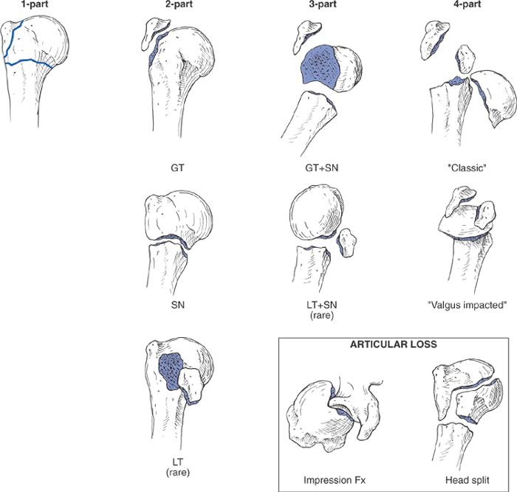

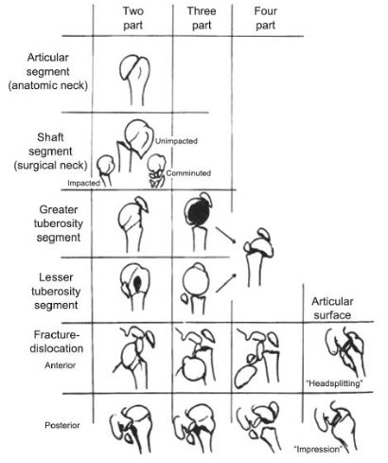
FIG 6B: NEER'S CLASSIFICATION

INVESTIGATION
Adequate radiographic evaluation is essential for accurate fracture classification and
treatment decision. Following views of X-ray will be more useful.
1) True Anteroposterior(AP) view of shoulder
2) Axillary view (or) Velpeau axillary view.
3) Lateral Y view of the scapula
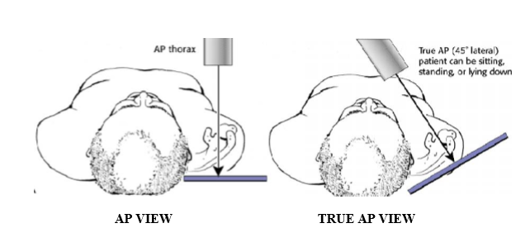
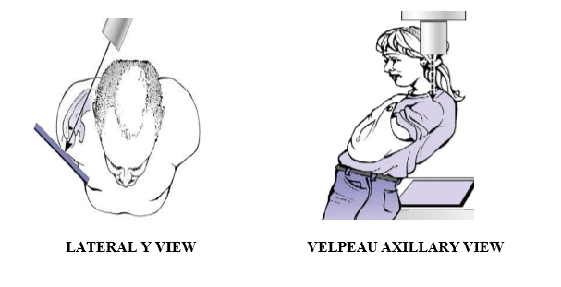
FIG 7 : RADIOGRAPHS PROXIMAL HUMERUS FRACTURE

PRINCIPLES OF MANAGEMENT
There are number of factors which play a dynamic role in determining the type of management and in turn influencing the prognosis .They include
1) Number of fractured fragments
2) Displacement of tuberosities
3) Presence of posteromedial spike inarticular fragment.
4) Degree of osteoporosis
5) Extent of soft tissue injuries
6) Associated neurovascular injuries
7) Presence of multiple trauma
8) Magnitude of joint involvements
9) Degree of comminution
Increased number of fragments and dislocation of the articular segment lead to high chance of avascular necrosis (AVN) head of humerus. The presence of posteromedial spike in the articular fragment reduces the chance of avascular necrosis (AVN). Degree of osteoporosis and the extent of soft tissue injury will decide the implant to be used.^{43,44}
So the objectives of treatment of proximal humerus fractures in adults are
1) To obtain and maintain the satisfactory reduction
2) To treat the associated injuries
3) To regain the functional range of movements of shoulder joint
METHODS OF TREATMENT
There are varieties of options for treating an adult with a fracture proximal
humerus.
A) Conservative management
B) Surgical management ^{2,44}
1. Closed reduction and K-wire/ cancellous screw fixation
2. Transosseous suturing
3. Tension band wiring
4. ORIF with plate and screws
a. Locking compression plate
b. Conventional AO plate
c. Blade plate
5. Proximal humerus nail
6. Replacement surgery
CONSERVATIVE MANAGEMENT
Conservative management may be preferred for
1) Elderly patients with co-morbid illness
2) One part fracture
3) Impacted fractures
Fracture is immobilized by a sling or 'U' slab for 2-3 weeks. Passive motion is
allowed after 2 weeks in one part fractures and impacted fractures. It can be delayed upto 6-10 weeks in displaced four part fractures.The reduction manevour involves holding one hand anteriorly on the fracture site and then forceful flexion of the arm combined with adduction to disimpact the posterior impaction and to relax the pectoralis major muscle. The proximal shaft next to the fracture site is there by manipulated posteriorly and laterally.^{2,5}
SURGICALMANAGEMENT
Better understanding of the fracture configuration and knowledge of the implant profile, with minimal soft tissue handling technique and preoperative antibiotics have made surgical fixation safe and practical. The goals of operative treatment includes
a) Proper anatomical alignment (restoration of tuberosity anatomy)
b) Stable fixation
c) Early functional rehabilitation of upper limb
Indications forsurgery:⁹
1) Displacement of a fracturefragment by 1cm
2) Angulation between fracture fragments more than 45 degree
3) Displacement of greater tuberosity more than 5mm
Preoperative planning:
Proper preoperative planning should be performed, including standard history taking, examination of the patient with a possible shoulder injury, including neurovascular assessment, and full radiological examination. The axillary view is particularly important to assess head splitting fractures, visualize posterior displacement of the greater tuberosity and to assess the relationship between the articular surfaces.3D reconstructive computerized tomography may be needed in some cases to visualize the fracture configurations.
Trans Osseous Suture fixation: ² It can be done in two part surgical neck fractures and 3 part proximal humerus fractures. Four or five number sized nonabsorbable sutures are passed through supraspinatus tendon, and drill holes are created in the humerus to secure anatomic reduction of the greater tuberosity fragments. Part et al reputed 78% excellent results in patients with proximal humerus fractures .
PercutaneousPinning: ^{2,45} It avoids further damage to the soft tissue envelope and blood supply to the humeral head. It is not a good choice for patients with mental problems or substance abuse problem. The procedure is technically challenging. Loss of fixation and pintract infectionsare common complications.

Proximal Humerus Nailing:^{2,40,44} It provides more stable fixation than percutaeneous pinning, although less than locking plate fixation. Newer nail designs with polyaxial screws have more stability than earlier designs. Advantage includes preservation of the soft tissues and the theoretical biomechanical properties of intramedullary nails. Insertion of an intramedullary nail into the proximal humerus violates the rotator cuff, causing postoperative shoulder pain.
ReplacementSurgery:^{2,46}
Indications for the replacement surgery in proximal humerus fractures
1) Fracture in Anatomical neck
2) Head splitting fractures involving more than 40% of the articular surface
3) Four part fracture with complete dislocation of articular surface.
4) Non reconstractable tuberosity fractures.
Available options are:
a) Shoulder Hemiarthroplasty
b) Total Replacement Arthroplasty
ORIF with Plate Osteosynthesis:^{4,5,37}
Various plates are used for the proximal humerus fracture fixation.
i) Conventional cloverleaf plate
ii) AO ‘T ’plate
iii) Angled blade plate
iv)Locking compression plate
Advantage of plate fixation:
1. Stable fixation of the fracture site with anatomical restoration of the tuberosity.
2. Early mobilization of the shoulder joint.
3. Reduced hardware complications.
4. Because of the anatomical restoration of the tuberosities, future revision arthroplasty will be technically easy and functional output will be good.
IMPLANT:
PROXIMAL HUMERUS LOCKING COMPRESSION PLATE:
Proximal humerus locking plate is anatomical and shaped to accommodate the junction of the humeral head and the shaft. In the area of the humeral head the plate has, in addition to the holes for the locking head screws, small holes in order to fix the rotator cuff with sutures or circlage wires^{.49}
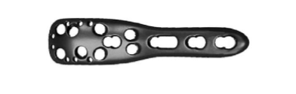
FIG 8: PROXIMAL HUMERUS LOCKING COMPRESSION PLATE
The screw holes of the plates in the area of the humeral head have been designed exclusively for the insertion of locking head screws for safer fragment fixation. The plates sit very firmly in the bone due to the (converging/diverging) screw orientation and the locked screw anchorage.
In the shaft area different plate fixation techniques are possible due to the combination holes provided by the LCP, permitting insertion of different types of screw. Conventional small fragment screws can also be introduced, on the one hand as compression screws.
Loss of reduction over time could be prevented by the placement of one or two screws running tangentially to the medial curvature of the humeral surgical neck, commonly referred as calcar screws. Loss of fracture reduction was linked to the presence or absence of medial support.
The function of screws in internal fixator is more like to that of external fixator pins.
1. The basic principle of the internal fixator is its angular stability, where as stability of conventional plate osteosynthesis relies on friction caused by compression between the bone and the plate. In contrast the principle of fixation of angular stable devices is screw locking. Compression between bone and plate is avoided, thereby biological integrity of periosteum is maintained.
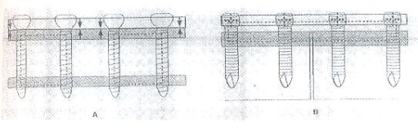
FIG 9A: ANGULAR STABILITY BY LOCKING SCREW
2. Friction transfers load tangentially between the implant surface and bone in DCP, while in LCP the screws with threaded head acts as a peg connecting the splint to bone.
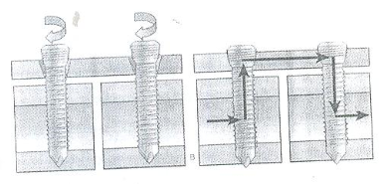
FIG 9B: FRICTION TRANSFER IN LCP
3. Precise contouring of the fixator is not necessary.
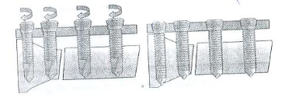
FIG 9C: PRECISE COUNTERING NOT NECESSARY IN LCP
4. Locking of the screws in the LCP and the very close proximity of the plate to the bone allows for the use of monocortical screws .Damage to the intramedullary blood vessels by the application of conventional bicortical screws is eliminated by the use of monocortical screws.
FIXATION PRINCIPLES
Locked Plating Using Locking Screws
• Screws lock to the plate, forming a fixed-angle construct.
• Bone healing is achieved indirectly by callus formation when using locking screws exclusively.
• Maintenance of primary reduction Once the locking screws engage the plate, no further tightening is possible. Therefore, the implant locks the bone segments in their relative positions regardless of degree of reduction. Stability under load by locking the screws to the plate, the axial force is transmitted over the length of the plate. The risk of a secondary loss of the intraoperative reduction is reduced.
COMPLICATIONS
Most common complications after surgical treatment of fractures of the proximal humerus are
- Stiffness
- Persistent pain
- Post operative infection
- Osteonecrosis.
- Late rupture of rotator cuff
- Instability
- Mal union
- Implant loosening
- Non union
- Neuro vascular injury.
Instability: True gleno humeral instability is unusual after fractures. Transient inferior subluxation is common after both non operative and operative treatment. Instability should not be ignored because if the head is left subluxed long enough, permanent capsular stretch may occasionally result.
Stiffness: The fixation must be stable enough to obtain anatomical reduction allow immediate passive movement so that adhesive scaring is limited and recovery of function is allowed. A proper surgical technique to avoid scarring also prevents stiffness.
Persistent pain has many causes including non union, musculotendinous damage, instability, capsulitis, osteonecrosis, migration of Implant, neuro-vascular damage and low grade infection. All these must be considered and appropriate diagnostic procedures performed.
Post operative infection is one of the most important avoidable complication signs and symptoms of infection may be minor and loss of glenohumeral joint space, accompanied by persistent pain and discomforts are the first indications before any other radiological or biological evidence.
Implant loosening is due to poor bone stock in elderly patients with osteopenia or osteoporosis.
Non union of fractures of the proximal humerus is uncommon but when it occurs it is disabling and should be dealt surgically.
Osteonecrosis cannot be avoided but a meticulous surgical technique should strive to pressure the blood supply of all fragments.
Tearing of the lateral part of the rotator cuff may occur with a hemi-arthroplasty when the sub-acromial space narrows progressively.

MATERIALS AND METHODS
SOURCE OF DATA
Chalmeda anand rao institute of medical sciences.
PERIOD OF STUDY
November 2012 to September 2014

METHOD OF COLLECTION OF DATA
The study purpose to include patients with proximal humerus fractures admitted and examined according to protocol, associated injuries noted. Clinical and radiological evaluation done. Fractures classified using Neer's classification. Routine investigations carried out to get fitness for surgery.
Patients underwent Open reduction and internal fixation with PHILOS locking plate or Percutaneous K-wire fixation under general anaesthesia/ brachial block.
Post operative physiotherapy followed according to protocol, to evaluate the functional outcome. Patients will be followed up at 6 weekly interval until fracture union and at once at 1 yr after the surgery
A minimum of 30 cases studied, cases are selected randomly for both PHILOS and percutaneous k wire fixation, each 15 cases.
INCLUSION CRITERIA
1. Patients of age above 18 yrs.
2. Two part, three part and four part fracture of proximal humerus
EXCLUSION CRITERIA
1. Children and adolescent patients less than 18yrs
2. Pathological fractures
3. Patients with compound fractures
On admission of the patient a careful history was elicited from the patients and/or attendants of injury and the severity of trauma. The patients were then assessed clinically to evaluate their general condition and the local injury.
The general condition of the patient and the vital signs were recorded. The local examination of injured shoulder was done for swelling, deformity, loss of function and altered attitude. Any nerve injury was also looked for and noted. Axillary nerve assesed by looking for anaesthetic patch over lateral aspect of shoulder.
Radiograph of proximal humerus i.e., antero-posterior view and axillary view taken and fractures were classified according to Neer's classification. Next the limb was immobilized in U slab and arm-pouch. The patient was taken for surgery after routine investigation and after obtaining physician fitness towards surgery. The investigations are as follows. Hb%, RBS, blood urea, serum creatinine, HIV, HBsAg and ECG.
The consent for surgery was also taken from the patient and attendants after explaining the procedure and possible complications.
OPERATIVE TECHNIQUE
General anaesthesia/ Brachial block was used in all patients.
PATIENT POSITION AND DRAPING:
Patients placed in supine position on operating table with a sand bag under the spine and medial border of scapula to push the affected side forward while allowing the arm to fall back ward. Drape the arm free, because it will have to be moved during the approach.
OPEN REDUCTION AND INTERNAL FIXATION WITH PHILOS:
SURGICAL APPROACH:
The commonly used approaches are
1) Delto pectoral approach^{2.47,48}
2) Trans deltoid split approach.^{2,48}
1. Delto-pectoral approach
Incision started just above the coracoid process, which is palpated in deepest point in the clavicular concavity distally towards acromioclavicular joint. An 8 to 10 cm incision started from just above corocoid process advanced following the line of deltopectoral groove. The internervous plane is between the deltoid muscle which is supplied by axillary nerve and pectoralis major muscle, which is supplied by the medial and lateral pectoral nerves. Retract pectoralis major medially and deltoid laterally, splitting the two muscle apart. The vein is retracted either medially or laterally. The short head of biceps and the corocobrachialis must be displaced medially before access can be gained to anterior aspect of shoulder joint.
Beneath the tendons lie the transversly running fibers of subscapularis muscle. Apply external rotation to the arm to stretch the subscapularis, bringing the muscle belly into wound and making its superior and inferior borders easier to define. Pass a blunt instrument between the capsule and the subscapularis, then divide the subscapularis . Incise the capsule longitudinally to enter the joint where the selected repair must be performed.
PROCEDURE:
All patients received a prophylactic dose of 1 gm cefuroxime axetil intravenously preoperatively . The operation was done in supine position with small sand bag under shoulder, under general anesthesia. Through delto-pectroal approach, the fracture was exposed and reduced with minimal soft tissue dissection. Briefly, the anatomical relationship between humeral head and greater tuberosity was reduced and fixed temporarily with K- wires. In case if obvious rotation or displacement of the humeral head, a joystick technique was used. Then the shaft fragment was reduced by abduction, traction and rotation of the arm. Reduction was checked under image intensifier. Definitive fixation with locking plate was done with plate positioned lateral to bicipital groove sparing tendon of long head of biceps and 1 cm distal to greater trochanter. The screws were chosen according to preoperative planning, and all the four head screws were supposed to be inserted to the head fragment.
The inferior screws supporting the humeral head were considered critical . Proximal locking screws were inserted to hold the humeral head, which are multidirectional screws with the tips of the screws staying 5-10 mm away from the articular surface. All proximal locking screws were placed in a unicortical fashion through an external guide and confirmed to be within the humeral head with intraoperative fluoroscopy . AP (internal and external rotation) views and axillary views 90 degrees to each other were used to visualize screw placement. The distal shaft screws were placed bicortically A minimum of there bicortical screws were used. Fluoroscopic images were taken to confirm satisfactory fracture reduction, plate positioning and proper length of screws in the humeral head. In case of severe comminution or instability, the rotator cuff, the greater tuberosity , and the lesser tuberosity were fastened to the plate using non-absorbable sutures. Range of motion of shoulder was checked on the table for impingement. Wound was closed under negative suction. Which was removed after 48 hours.
Postoperative management:
- All patients are immobilized in arm pouch with cuff and collar sling.
- Appropriate antibiotics and analgesics were used.
- Immediate post operative radiographs were taken to determine the bone alignment and maintenance of reduction.
- Sutures removed by 10th day
- Passive range of motion and pendulum excises are begun immediately depending on pain.(around three to four weeks).

PERCUTANEOUS K-WIRE FIXATION:
PROCEDURE:
- Placement of percutaneous pin for fracture fixation includes two k wires passed through lateral aspect of shaft just above the deltoid insertion. One pin is passed through anterior cortex if required
- K-wire are inserted from greater tuberosity to the medial humeral shaft to add stability to the overall construct.
Postoperative management:
- All patients are immobilized in arm pouch with cuff and collar sling.
- Appropriate antibiotics and analgesics were used.
- Immediate post operative radiographs were taken to determine the bone alignment and maintainance of reduction.
- Passive range of motion and pendulum exercises are begun immediately depending on pain from third week.
- K-wires are removed at about 6-8 weeks.
Follow up:
All patents were followed every week in first month and every 2-3 weeks for 6months.
- The active range of motion were started at 1-2 weeks. postoperatively, depending on stability of osteosynthesis and bone quality.
- The sling is discontinued by 8-12 weeks depending upon fracture stability.
- Further follow ups were at 8 weeks and 12 weeks and 24 weeks.
- The patients were examined clinically and radiologically. Assessed for range of motion and bony union and complication.
- The patient with shoulder stiffness given physiotherapy for 1 week to 15 days on outpatient basis.
Functional results:
The final result were evaluated using Constant-Murley score.
This system base on 100 point score composed of a number of individual parameters. The subjective parameters assess the degree of pain the patient experiences and the ability to perform normal tasks of daily living as they apply to him or her in both activity and position related terms. Both of these assessments are subjective and are carried out independently prior to objective testing of active motion range and shoulder power
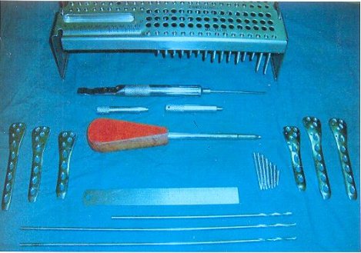
FIG 10 : INSTRUMENTS

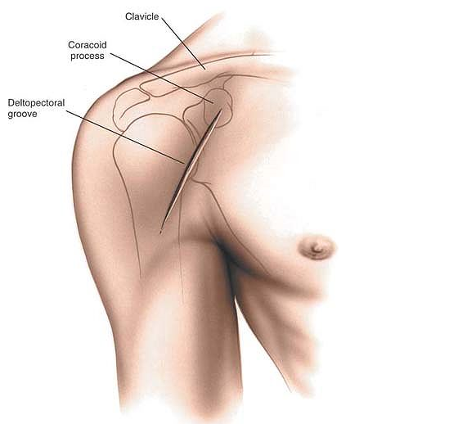

FIG 11A : SKIN INCISION
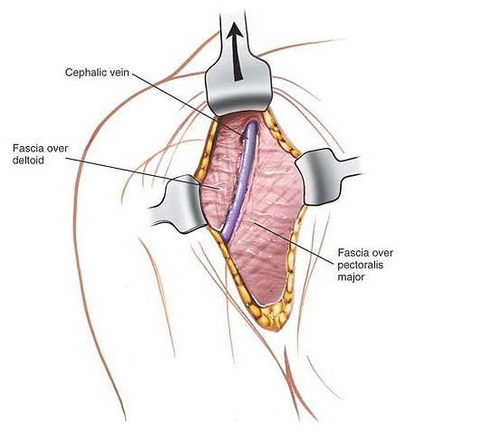
FIG 11B : CEPHALIC VEIN EXPOSED
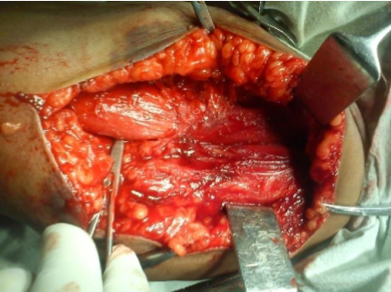
FIG 12A : INTERNERVOUS PLANE BETWEEN DELTOID AND PECTORALIS MAJOR

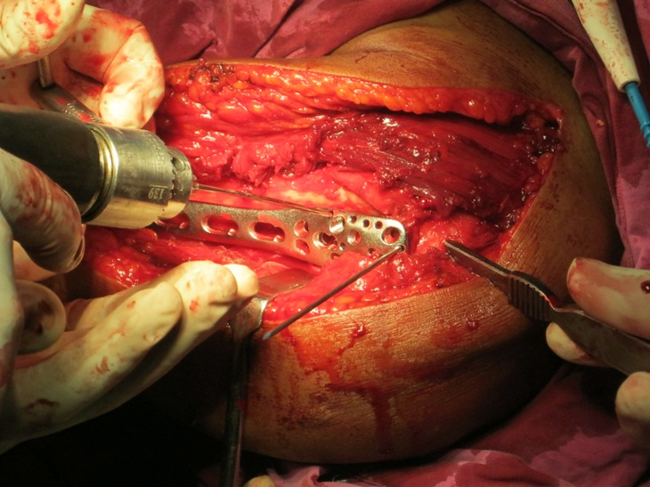
FIG 12B : PLATE PLACEMENT
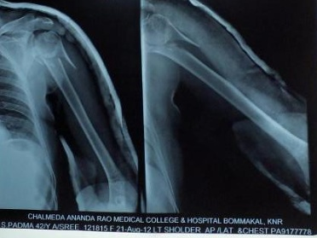
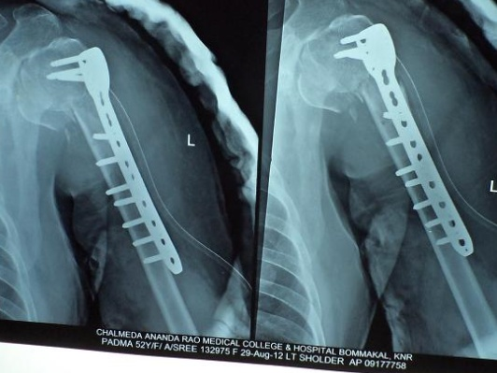
Pre op X ray Post op X ray

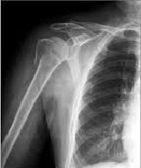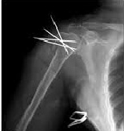

Pre op X ray Post op X ray

RESULTS

Thirty patients with closed displaced proximal humerus fracture were treated by open reduction with Locking Compression plate and percutaneous pinning with K- wire fixation. The following observations were made from the data collected during the study.

TABLE - 1 : AGE DISTRIBUTION

Age group(in years) | No. of patients | Percentage
19-30 | 5 | 16.66%
31-40 | 4 | 13.33%
41-50 | 9 | 30%
>50 | 12 | 40%
Total | 30 | 100%

In our study most of the patients 40% belong to the age group of >50yrs. 30% patients belong to the age group 41-50. The average age of the patient was 47.93 years.

GRAPH - 1 : AGE DISTRIBUTION

TABLE - 2 : SEX DISTRIBUTION

Sex | No of patients | Percentage
Male | 16 | 53.3
Female | 14 | 46.6

Sex distribution was comparable between males and females corresponding to 53.33% and 46.6% respectively. Male: Female sex ratio is 1.14:1.

GRAPH - 2 : SEX DISTRIBUTION

TABLE - 3 : SIDE DISTRIBUTION

Side Affected | No of patients | Percentage
Right | 16 | 53.3%
Left | 14 | 46.6%

Most of the patients were affected on the right humerus corresponding to 53.33% and on left side in 46.6% patients. p>0.05

GRAPH - 3 : SIDE DISTRIBUTION

TABLE - 4 : MODE OF INJURY

Nature of trauma | No. of patients | Percentage
Fall | 17 | 56.6%
Road traffic accident | 13 | 43.3%

56.66% of our patients had suffered a domestic fall and 43.3% were involved in motor vehicle accidents.

GRAPH - 4 : MODE OF INJURY

TABLE - 5 : ASSOCIATION BETWEEN TYPE OF FRACTURE AND MODE OF INJURY

TYPE OF FRACTURE | MODE OF INJURY
 | FALL |  | RTA
TWO PART | 8 | 6
THREE PART | 6 | 5
FOUR PART | 3 | 2
Total | 17 | 13

Fall resulted in three part fracture in 6 patients; Road Traffic Accident resulted in two part fracture in 7 cases. The association of type of fracture and mode of injury is insignificant.

GRAPH - 5 : ASSOCIATION BETWEEN TYPE OF FRACTURE AND MODE OF INJURY

TABLE - 6 : ASSOCIATION OF AGE TO MODE OF INJURY

AGE | No. of patients | MODE OF INJURY
 |  | FALL | RTA
19-30yrs | 5 | NIL | 05
31-40yrs | 4 | 01 | 03
41-50yrs | 9 | 04 | 05
>50yrs | 12 | 12 | NIL
Total | 30 | 17 | 13

In our study , in the age group >50yrs the commonest mode of injury is by fall (domestic). In the age group 19-30yrs the commonest mode of injury is by RTA. There is significant association of mode of injury and age. p<0.05 which shows significant association.

GRAPH - 6 : ASSOCIATION OF AGE TO MODE OF INJURY

TABLE - 7 : FRACTURE PATTERN

FRACTURE PATTERN | PHILOS | PERCUTANEOUS | TOTAL
2 PART (SURGICAL NECK) | 4 | 10 | 14
3 PART (SURGICAL NECK+ GREATER TUBEROSITY/ LESSER TUBEROSITY) | 7 | 4 | 11
4 PART | 4 | 1 | 5

In our study we had 46.66% of patients with 2 part fracture and 36.66% of patients had 3 part fractures. 16.66% of patients had 4 part fracture. 71.4% patients with two part fractures were treated using closed reduction and k- wire fixation. 63% of patients with three part fractures are treated with open reduction and internal fixation with PHILOS plating. 80% of patients with four part fractures are treated with open reduction and internal fixation with PHILOS plating.

GRAPH - 7 : FRACTURE PATTERN

TABLE - 8 : COMPLICATIONS

COMPLICATION | PHILOS plating | PERCUTANEOUS K wire | TOTAL
Impingement | 2 | 0 | 2
Varus Malunion | 1 | 2 | 3
Pin tract infection | 0 | 3 | 3
NIL | 12 | 10 | 22

The patients treated with open reduction and internal fixation with PHILOS plating, Impingement of the implant with restriction of movements was present in 2 cases and Varus malunion is seen in 1 patient.
In patients treated with percutaneous pinning the complications noted are pin tract infection in 3 of patient and varus malunion in 2 patients.

GRAPH - 8 : COMPLICATIONS

TABLE -9 : COMPARISION BETWEEN MEANS OF CONSTANT MURLEY'S SCORE OF TWO GROUPS
Procedure | No. of Patients | Mean of constant Murley's score
PHILOS | 15 | 68.13%
Percutaneous | 15 | 71.9%

The mean constant Murley score for patients treated with open reduction and internal fixation with PHILOS plating is 68.13% compared to Percutaneous pinning which is 71.9%. p>0.05, which refers that comparision between two groups is insignificant.

GRAPH - 9 : COMPARISION BETWEEN MEANS OF CONSTANT MURLEY'S SCORE OF TWO GROUPS

TABLE - 10 : RELATION BETWEEN RESULTS TO FIXATION METHOD

TYPE OF FIXATION | RESULTS
 | EXCELLENT | GOOD | FAIR | POOR
PHILOS Plating | 2 | 3 | 7 | 3
Percutaneous Pinning | 4 | 2 | 6 | 3
Total | 6 | 5 | 13 | 6

In the present study 33.34% patients treated with open reduction and internal fixation with PHILOS plating had good to excellent results, 46.6% of patients had fair results and the remaining 20% had poor results.
40% of patients treated with closed reduction and K wire fixation had good to excellent results, 40% of patients had fair results and remaining 20% had poor results.

TABLE - 10 : RELATION BETWEEN RESULTS TO FIXATION METHOD

STATISTICAL ANALYSIS:
Chi-Square Test:
The chi-Square test procedure tabulates a variable into categories and computs a chi-square statistic. This goodness –of-fit test compares the observed and expected frequencies in each category to test either that all categories contain the same proportion of value or that each category contains a user-specified proportion of values.
Crosstabs :
The Crosstabs procedure forms two-way and multiway tables and provides a variety of tests and measures of association for two-way tables. The structure of the table and whether categories are ordered determine what test or measure to use. Contingency coefficient analysis was employed in the present study.
Independent – samples T Test :
The independent – samples T test procedure compares means for two groups of cases. Ideally, for this test, the subjects should be randomly assigned to two groups. So that any difference in response is due to the treatment (or lack of treatment) and not to other factors.

CASE :1
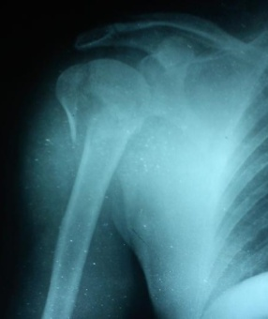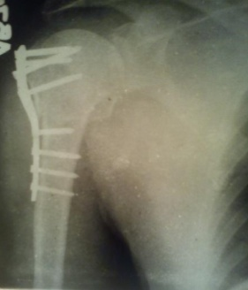
Pre op X ray Post op X ray

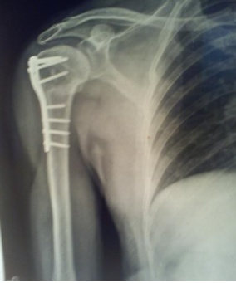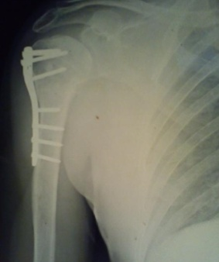
6 weeks follow up 6 months follow u
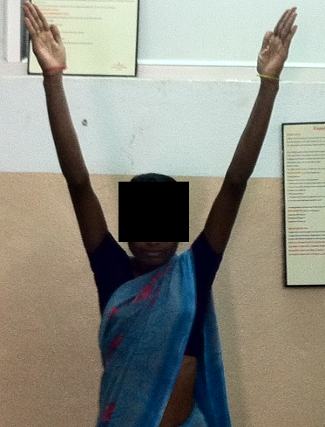
Abduction Internal rotation

CASE : 2
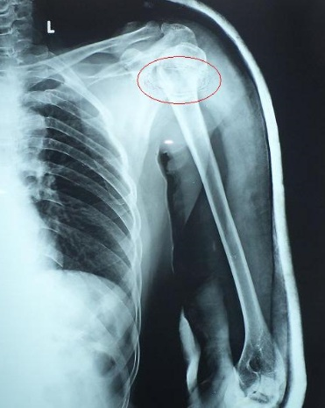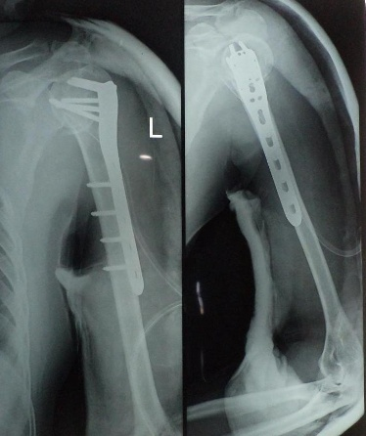
pre op x ray post op x ray

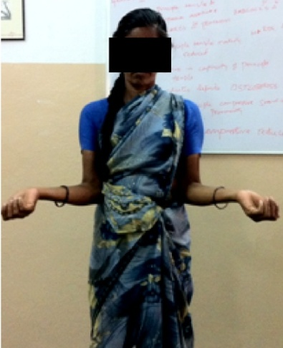
External rotation Abduction
Internal rotation

CASE : 3
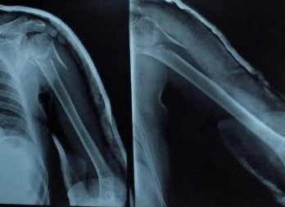 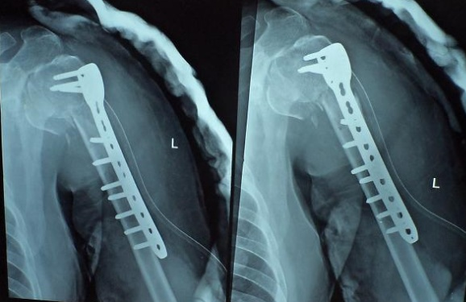
Pre op X ray Post op X ray

Internal rotation External rotation

CASE : 4
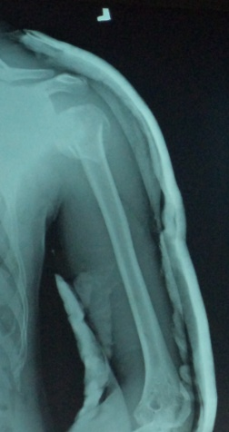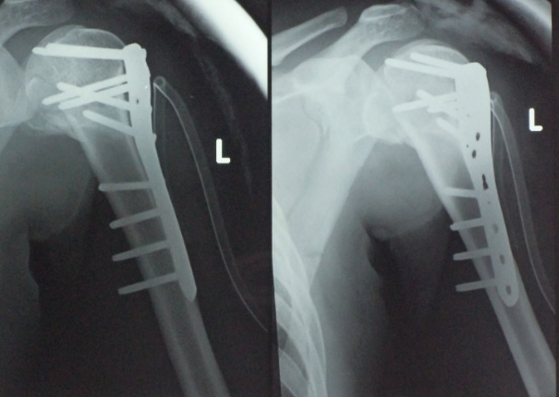
Pre op X ray Post op X ray

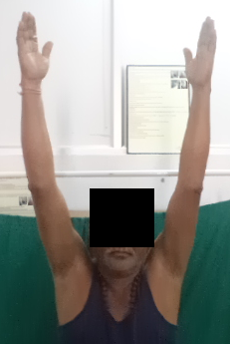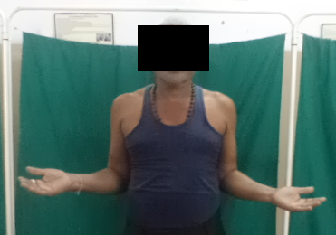
Abduction External rotation
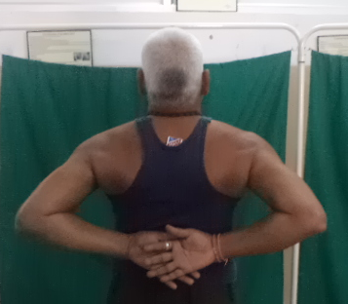
Internal Rotation

CASE : 5
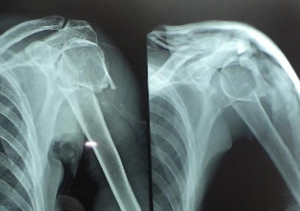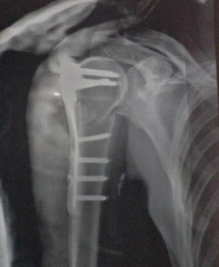
Pre op X ray Post op X ray

External rotation Internal rotation

CASE 6
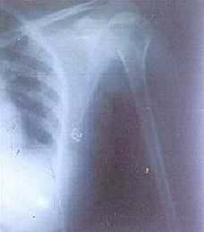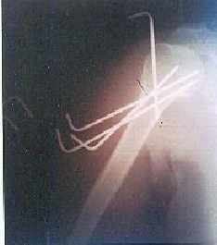
Pre op X ray Post op X ray
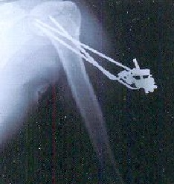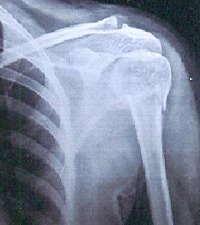
At 4 weeks follow up After K wire removal
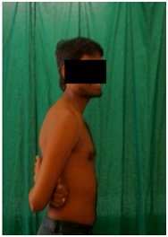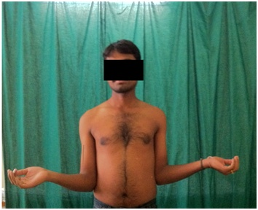
Internal Rotation External Rotation

CASE : 7
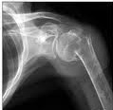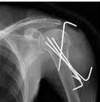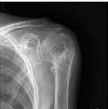
Pre op X ray Post op X ray After K wire removal

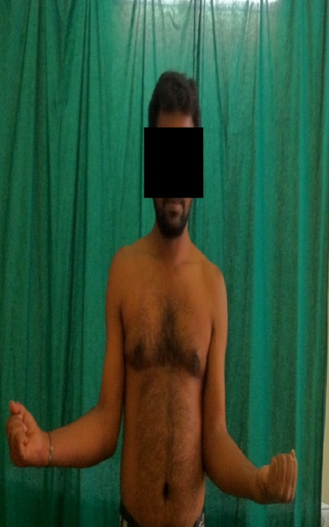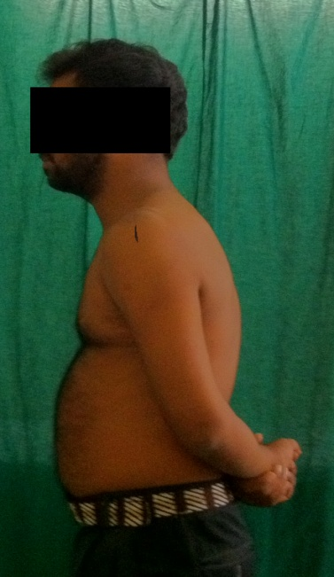
External Rotation Internal Rotation

CASE 8
Pre op X ray Post op X ray

Internal Rotation External Rotation Abduction

DISCUSSION
The operative treatment of proximal humeral fractures is a therapeutic challenge for orthopaedic surgeons. Most of the proximal humerus fracture which are un-displaced can be treated conservatively. Even if the injury is thoroughly analyzed and the literature is understood, treatment of displaced fracture or fracture dislocation is difficult.
The result is related to restoration of anatomical alignment, and if the fracture is treated conservatively, a functional deficit will certainly develop and may be associated with pain. The external support is difficult to apply effectively because fracture site is adjacent to trunk.
Many studies have shown that the displaced fracture of the proximal humerus have a poor functional prognosis when left untreated because of severe displacement of fragments.¹⁻⁵
Numerous investigators have described the various surgical treatments for displaced proximal humerus fracture. There is no consensus on optimal treatment of displaced proximal humerus fractures which account for about 20% of fractures. In some studies, the objective functional results of conservative treatment have been unsatisfactory. The fractures are defined by variety of classification systems. The difficulty in accurately classifying the fracture creates problems in reporting outcome and also none of the system gives clear prognosis and direction of treatment.
AGE INCIDENCE: The average age incidence in present series of 30 patients analyzed, was 47.93 years, which was consistent with the age incidence in studies done by Kenneth A. Egol et al,²⁹ (61 years) and the average age incidence in C. Gerber et al,²³ study was 44.9 years. In present series 12 (40%) out of 30 Patients were age group of > 50 years and 9 (30%)patients in 41-50 age group. Majority of the patient in our group are elderly in our study
AUTHOR | PERCENTAGE
Kenneth A. Egol et al²⁹ | 61
GerberCet al²³ | 44.9
Ronald.P Jacob et al | 49.5
Wijgman et al | 48
PRESENT STUDY | 47.93

In present study the association between age and mode of injury shows that the common mode of injury in the age group 50yrs is by fall (domestic). The common mode of injury in the age group between 19-30yrs is road traffic accidents.
SEX INCIDENCE
Further as compared with other studies, present study showed a higher incidence of fractures in men than in women. The gender ration was 1.14:1.this higher ration can be explained by a higher involvement of male in day to day activities in compare to female.
STUDY | MALE:FEMALE | RATIO(M:F)
KENNETH A. EGOL et al²⁹ | 18:33 | 0.5:1
ASH WOOD N et al²⁶ | 9:23 | 0.4:1
PRESENT STUDY | 16:14 | 1.14:1

MODE OF INJURY:
Motor vehicle accidents constitute a major cause of musculosketetal trauma worldwide. In our country too, it happens to be very common and is reflected in present study, the second most common cause after the domestic fall.
Rose SH et al, in their study of proximal humerus fracture, have reported 80% of cases the mode of injury was minor fall in a patients aged above 40 years and especially in osteoporotic females⁴.
Herbert Resch et al in their study 27 patients with three part and four part fracture,24 patients had history of high energy trauma.³²
Fall resulted in three part fractures in 6 cases, road traffic accident resulted in two part fractures in 6 cases and three part fracture in 5 cases and four part fractures in 2 cases.
SIDE AFEECTED:
In our present study fracture occurred on right side in 16 patients and on left side in 14 patients .C. Gerber reported ,in their series of 34 fractures 16 were on left side and 18 were on right side.²³
PERIOD BETWEEN INJURY AND TIME OF SURGERY:
The average interval between fracture and surgery was 3.63 days in our study
Average interval between fracture and surgery was 3.2 days in Gerber C.et al
Study.²³

Fracture pattern and various method of treatment used by different Study series
Author | Year | No.of cases | TWO PART | THREE PART | FOUR PART | AVERAGE AGE | METHOD
Moda SK ¹⁴ | 1990 | 25 | 6 | 5 | 11 | 62 | OR+ IF with T-plate+15. Blade plae=10
Gerber C ²³ | 2004 | 34 | 2 | 15 | 16 | 60 | CR+PP=3  OR+PLATES=8  OR+SCREW=5  OR+IF SUTURE=13
Ramchander  Siwach²⁷ | 2008 | 25 | 12 | 13 | - | 62 | OR+IF philos  Locking plate
Felix Brunner ³⁰ | 2009 | 157 | 49 | 70 | 38 | 65 | OR+IF Philos  Locking plate
Present study | 2013 | 30 | 14 | 11 | 5 | 48 | OR + IF Philos Locking plate=15 CR+IF K-Wire fixation=15

- OR: Open Reduction, IF: Internal fixation,
- CR-Closed reduction, AO- Arbeitsgemeinschaft fur osteosynthesfragen
- PP=Percutaneous pinning
TYPE OF FRACTURE
The study of type of fracture in present series revealed, 14 (46.66%) were two part fractures, 11 (36.66%) were three part fractures, 05 (16.66%) was four part fracture. In studies done by Rizwan Shahid et al,²⁸ in a series of 50 patients studied 11 (22%) were two part fractures, 21 (42%) were three part fractures and 18 (36%) were four part fractures. In another study by MA Fazal et al,³² 0f 27 cases 13 (48%) were two part fractures, 12 (44.5%) were three part fractures and 2 (7.5%) were four part fractures indicating that the incidence of type of fracture is nearly consistent with the studies in literature.
STUDY | 2PART # | 3 PART # | 4 PART#
RIZWAN SHAHID et al²⁸ | 11(22%) | 21(42%) | 18(36%)
MA FAZAL et al ³² | 13(48%) | 12(45.5%) | 02(7.5%)
PRESENT STUDY | 14 (46.66%) | 11 (36.66%) | 05 (16.66%)

COMPLICATIONS :
Secondary displacement and malunion occurred in three cases at surgical neck. It usually involves to anterior angulation and varus deformity, decreasing neck shaft angle <120⁰. It was probably due to communition of underlying osteoporotic bone which may go impaction at the fracture site after reduction leading to varus malunion.
Two patients in PHILOs group had plate impingement and limitation of abduction, its hardware related complication, improper plate positioning may have lead to impingement.
Three patients had pin track infection in percutaneous K- Wire fixation series which are treated with appropriate antibiotics and it didn’t result in any loosening of k-wire. Pin track infection is the commonly encountered complication in percutaneous pinning.
- Both complications in PHILOS group i.e. varus malunion and impingement lead to poor results.
- In percutaneous group pin track infection is commonest complication where 66% of patients had fair to excellent result and the remaining 33% had poor results.

TABLE- Comparison of complications in other study group on surgical
Management of proximal humerus fracture with our study
COMPLICATIONS | RAMCHANDER SIWACH²⁷ | RICHARD J HAWKINS | PRESENT STUDY
Post op Infection | 01 | 00 | 03
Plate impingement | 01 | 02 | 02
Mal union | 01 | 0O | 03
Non union | 02 | 00 | 00
AVN | 02 | 02 | 00

The incidence of avascular necrosis ranges from 8% to 35% in different studies. we had no case of avascular necrosis.
RESULTS:
The final results are graded according to constant Murley’s scoring criteria. In the present study in both the groups most of the cases had fair results.
In PERCUTANEOUS GROUP 40% of patients had good to excellent results, 40% had fair result and 20% had poor result.
In PHILOS Plating GROUP 33.34% of patients had good to excellent result, 46.6% patients had fair results and 20% had poor results.
The association of age and results in this study is insignificant.
In present study two part fractures had better result compared to three and four part fractures

TABLE 18-COMPARISION OF RESULTS IN STUDIES TREATED
WITH PHILOS plating

STUDY | CONSTANT MURLEY  SCORE
Gerber.,et al.⁹ | 78
Monnot et al.¹⁹ | 66.5
Felix Brunner et al.³⁸ | 72
Present study | 68.13
In Present study the mean constant score of PHILOS group is 68.13 points
Table19.COMPARISION OF RESULTS IN STUDIES TREATED
PERCUTANEOUS K-WIRE FIXATION
STUDY | CONSTANT MURLEY SCORES
Jay D. keener MD et al.⁵² | 73.9
Bruner.Aetal.⁵³ | 73.6
Present study | 71.9

In Present study the mean constant score of percutancous group is 71.9 points,

CONCLUSION
The present study was done to compare and assess functional out come and complications following surgical management of proximal humerus fracture by Percutaneous K- wire fixation and open reduction and internal fixation with PHILOS.
Proximal humerus fracture is common in elderly aged with commonest mode of injury being trivial fall. Rigid fixation with locking plates is preferred procedure for :
- Two-part surgical neck fractures with displacement, fractures with comminution, and irreducible fractures
- Three-part proximal humeral fractures in elderly patients with osteopenic, plate fixation is the preferred procedure.
- Four-part proximal humeral fractures.
The most common complication in open reduction and plate fixation is plate impingement, leading to limitation of abduction.
Closed reduction and percutaneous pinning have advantage in retaining the vascularity of the humeral head.
- It can be used for Un-displaced two, three or four part fracture of the proximal humerus without communition, in the younger age groups.
- Elderly who are unfit for major surgery.
Complication faced are pin track infections and loss of reduction.
In both these groups of percutaneous pinning and plate fixation, comparatively minor differences were detected with regard to functional outcome.

SUMMARY
Thirty patients with displaced two part, three part and four part proximal humerus fractures were treated surgically by Proximal Humerus Interlocking System (PHILOS) plating and Percutaneous K wire fixation between November 2012 to September 2014.
In present study we had
46.66% of patients with 2 part fracture
36.66% of patients had 3 part fractures
16.66% of patients had 4 part fracture.
Association between age group and mode of injury is significant. In elderly people common cause of mode of injury is trivial fall. In young patients its road traffic accidents.
In PHILOS plating group
- 63% of patients with three part fractures , 80% of patients with four part fractures are treated.
- 33.34% patients had good to excellent results. 20%patients had poor results and remaining 46.6% had fair results.
- Complications in PHILOS group include varus malunion (one case) and plate impingement (two cases).
- Both complications encountered in PHILOS group lead to poor results.
- The mean constant Murley' s score is 68.13
In Percutaneous K wire group
- 71.4% patients with two part fractures were treated.
- 40% patients had good to excellent results 20% poor results,and remaining 40% had fair results.
- In percutneous pinning group varus malunion was seen in two cases and pin tract infections in three cases.
- The mean constant Murley' s score is 71.9.
The results of surgical treatment of proximal humerus fractures in both the groups (percutaneous pinning and PHILOS plating) are satisfactory with good functional outcome.

REFERENCES
- Court Brown CM,Caesar B. Epidemiology of adult fractures: A review Injury 2006;37:691-697.
- Terry Canale’s Campbell’s Operative Orthopaedics, Vol-3: 9th edition, 1998 Mosby Publishers, USA Pg 2286-2296.
- Steven .H.Rose Joseph Melton Bernard.F.Morrey et al Epidemiological features of humeral fractures Clin. Orthop-1982:168:24-30.
- RL Sahu : Philos Locking plates in proximal humerus fractures literature review..The Internet Journal of Health. 2010 Volume 11
- Bigliani LU, Flatow EL, Pollock RG. Fractures of the proximal humerus In: Rockwood CA, Green DP, Bucholz RW, Heckman JD, eds. Fractures In adults. Philadelphia, etc: Lippincott-Raven, 1996: 1055-107.
- Buchanan JJ. IV. Fracture through the anatomical neck of the humerus with dislocation of the head. Ann Surg 1908; 47:659-71.
- Lous U., Bigiliani, Chapter 9 The shoulder, Vol-1 ed. Charles Rockwood, Frederick A. Fractures of proximal humerus. In Rockwood CA, Matsen. Philadelphia: W.B. Saunders, 1990: p278-334.
- Neer CS. Displaced proximal humeral fracture: Part 1: Classification and evaluation. J Bone Joint Surg (Am) 1970; 52-A: 1077-89.
- Neer CS. “Displaced proximal humeral fractures. Par t II. Treatment of three part and four part displacement”. J Bone Joint Surg , 1970; 52A : 1090-11.
- Paavolainen P, Bjorkenheim JM, Slatis P, and Paukku P. “Operative treatment of severe proximal humeral fractures”. Acta Orthop Scand, 1983; 54: 374-379.
- Siebler G, Kuner EH , “Late results following the surgical treatment of proximal humerus fractures in adults”. Unfall chirurgie 1985; 11(3): 119-127.
- Kristiansen B and Christensen SW : Plate fixation of proximal humeral fractures, Acta Orthop Scand, 1986; 57: 320-323.
- Mourdian WH., “Displaced proximal humeral fractures. Seven years experience with a modified zickel supracondyalr device”. Clin Orthop 1986; 212: 209-218.
- Moda SK, Chadha NS, Sangwan SS, Khurana DK, Dahiya AS, SiwachRC. “Open reduction and fixation of proximal humeral fr actures and fracture dislocations”. J Bone Joint Surg 1990; 72-B: 1050-1 052.
- Szyszkowitz R, Seggl W, Schleifer P, Cundy PJ. Proximal humeral fractures : management techniques and expected results. Clin Orthop, 1993; 293: 13-25.
- Robinson CM, Christie T. Two part proximal humeral fracture: A review of operative treatment using two techniques. Injury, 1993; 24(2): 123-125.
- Zyto K, Wallace WA, Frostick SP, Preston BJ. Outcome after hemiarthroplasty for three and four part fracture of the proximal humerus. J Shoulder Elbow Surg, 1998; 7: 85-9.
- Koval KJ, Blair B, Takie R, Kummer FT, Zuckerman D. “Surgical neck fractures of proximal humerus; a laboratory evaluation of ten frixation techniques”. J Trauma 1996; 40(S): 778-783.
- Hessmann M, Gehling H, Gotzenl, “Plate fixation of proximal humerus fracture with indirect reduction; surgical technique and results using the shoulder score.”. Injury 1999; 30: 453-462.
- Hintermann B, Trouillier HH, Schufer D. “Rigid internal fixation of fractures of the proximal humerus in older patients”. J Bone Joint Surg (Br), 2000 Nov; 82(8): 1107-1112.
- Wijgman A.J, Roolker W,Patt T W et al , open reduction and internal fixation of three and four part fractures of proximal humerus. Scientific Article November 01, 2002.
- Jan-Magnus Björkenheim, Jarkko Pajarinen et al, “ Internal fixation of proximal humeral fractures with a locking compression plate” Acta Orthop Scand 2004; 75 (6): 741–745.
- Gerber C, Worner CM, Vienne P. “Interal fixation of complex fractures of the proximal humerus”. J Bone Joint Surg (Br), 2004 Aug; 86(60:P 848- 855.
- C.P.Charalambous ,I.siddiqe,et al”Proximal humerus internal locking for the treatment of proximal humerus fracture” Archieve of orthopaedic and trauma surgery(2007)127:205-210.
- Reto Babst,Flexi Brunner” Plating in proximal humerus fractures” European Journal of trauma and emergency surgery 2007:33,345-56.
- Moonot P, Ashwood N, Hamlet M., Early results for treatment of three- and four- part fractures of the proximal humerus using the PHILOS plate system , J Bone Joint Surg Br. 2007 Sep;89(9):1206-9.
- Ramchander Siwach Roop Singh Rajesh Kumar Rohilla et al Internal fixation of proximal humerus fracture by locking proximal humerus plate in elderly osteoporotic J Orthopaedic Trauma (2008) 9:149–153.
- Rizwan Shahid et al, “proximal humerus fracture treated with locking compression plate” Acta Orthop. Belg., 2008, 74, 60 2-608.
- Kenneth A.egol, Crispin Cong, Michael Walsh et al, Early complication of proximal humerus fractures treated with locked plates, J ortho trauma 2008; 22:159-164.
- Felix Brunner, Christoph Sommer, Christian Bahrs et al Open Reduction and Internal Fixation of Proximal Humerus Fractures Using a Proximal Humeral Locked Plate: A Prospective Multicenter Analysis, J Ortho Trauma 2009;23:163–172.
- AA Martinez et al. “proximal humerus locking plate for proximal humerus fracture –retrospective study” journal of orthopaedic surgery2009;17(1):10-4.
- MA Fazal,FS Haddad “PHILOS plate fixation for displaced proximal humeral fractures” journal of orthopaedic surgery2009;2009 17(1)15-8.
- Sameer Aggarwal et al “Displaced proximal humeral fractures: an Indian experience with locking plate”. Journal of Orthopaedic surgery and research2010,5:60.
- Georg Osterhoff,Christian Ossendorf et al. “The calcar screw in angular stable plate fixation of proximal humerus fractures-a case study”. Journal of orthopedic surgery and research 2011,6:50.
- Adithya C Pawaskar, Kee-Won Lee. “locking plate for proximal humerus fracture in the elderly population:serial change in neck shaft angle” clinic ortho surg.2012 september:4(3)209-215.
- Gray's Anatomy, 40th Edition, Susan Standring.
- Esser, 1994. Esser RD: Open reduction and internal fixation of three- and four- part fractures of the proximal humerus. Clin Orthop Relat Res 994;299:244.
- Hawkins RJ, Kiefer Gin: Internal fixation for proximal humeral Fractures Clin. Orthop-1987:223:77-85.
- Lorenzo FT. Osteosynthesis with Blount staples in fracture of the proximal end of the humerus: a preliminary report. J Bone Joint Surg Am 1955;37:45 – 48.
- Lind T, Kronerk, Jensen J. The epidemiology of fractures of proximal humerus. Arch Orthop Trauma Surg, 1989; 108: 285.
- Kocher T. Beitrage zur Kenntnis einiger praktisch wichtige Frakturenformen. Basel: Karl Sallman Verlag; 1896.
- Marsh JL, Slongo TF, Agel J, Broderick JS, Creevey W, DeCoster TA et al. Fracture and Dislocation Classification Compendium - 2007: Orthopaedic Trauma Association Classification, Database and Outcomes Committee. J Orthop Trauma 2007; 21:S1-133.
- .Palvanen M, Kannus P, Parkkari J, et al: The injury mechanisms of osteoporotic upper extremity fractures among older adults: A controlled study of 287 consecutive patients and their 108 controls. Osteoporos Int 2000; 1:822-831.
- Chapman JR, Henley MB, Agel J, et al. Randomized prospective study of humeral shaft fracture fixation: intramedullary nails versus plates. J Orthop Trauma. 2000; 14:162-166.
- Jaberg H, Warner JJ, Jakob RP. Percutaneous stabilization of unstable fractures of the humerus. J Bone Joint Surg [Am] 1992;74-A:508-15.
- Movin T, Sjoden GO, Ahrengart L. Poor function after shoulder replacement in fracture patients: a retrospective evaluation of 29 patients followed for 2-12 years. Acta Orthop Scand 1998;69:392-6).
- Stanley Hoppenfield Piet deBoer; Surgical exposures in Orthopaedics The anatomic approach 3rd Ed Lippincott William Wilkins.
- P.Hoffmeyer: The operative management of displaced fractures of the proximal humerus JBJS (Br) 2002 May Vol 84-B No 4 Pg 469-80.
- Evan L. Flatow. Fracture of the proxiaml humerus. Chapter-25, In: Text book of Rockwood and Green’s fractures in adults. Vol.1, New York: Lippincott Willimas & Wilkins, 2001: p.997-1035.

ANNEXURE -1
CONSENT FORM
Patient’s name:
Address:
I.P. No.
The details of the study have been provided to me in writing and explained to me in my own language. I confirm that I have understood the above study and had the opportunity to ask questions. I understand that my participation in the study is voluntary and that I am free to withdraw at any time, without giving any reason, without the medical care that will normally be provided by the hospital being affected. I agree not to restrict the use of any data or results that arise from this study provided such a use is only for scientific purpose(s). I fully consent to participate in the above study.
Signature of the Patient: _____________________
Date: _____________

Signature of the witness: ________________________
Date: _____________
(Note: Consent form should be appropriately worded for adults and children (less than 18 years)
e.g. If the Patient is less than 18 years of age, instead of ‘my participation’, ‘my child’s/ward’s participation’ needs to be replaced.)

Place:
Date: Signature

ANNEXURE 2

CLINICAL PROFORMA

I Introduction
Name –
Age –
Sex – Male/ Female
Occupation –
Address –
I.P. No-
Date of Injury –
Date of admission –
Date of Surgery –
Date of Discharge –
II History
Mode of injury – (tick appropriate one)
Road traffic accident/Domestic injury/Industrial injury/Miscellaneous (specify)
Duration from injury to surgery - ___________ days
Mode of treatment till reference – (tick appropriate one)
Nil/Collar and cuff/U-slab
III Local Examination
Inspection
Side of injury-right/left
Overlying skin-
Simple-
Compound- type
Palpation- (tick appropriate one)
Tenderness – Yes/No
Crepitus– Yes/No
Abnormal mobility– Yes/No
Neurological deficit– Yes/No
If yes, specify nerve-
Vascular deficit– Yes/No
IV Systemic Examination
PR
BP
RR
Temperature
CVS/RS/CNS/PA
Associated injuries-
V Clinical Diagnosis
VI Investigation
Hb %
Blood urea
Random blood sugar
Blood group
Urine routine
Radiology
Site of Fracture
Type of fracture –
VII Management
1.Immediate management – IV fluids
2.Blood transfusion
3Analgesic/sedation
4.Method of immobilization/ Splintage &Duration
5.Surgical management
Data of surgery
Anaesthesia
Position
Approach
Operation findings
Implants used
a.PHILOS
b.K wires
Duration of surgery
External immobilization
6.Post-operative management
Position of limb
Compression bandage
External immobilization
Antibiotics
Wound healing – primary/ secondary
VIII Follow up Data
Clinical union
Radiological union
Constant Murley's score
Result: Excellent/good/fair/poor

ANNEXURE 3

CONSTANT MURLEY 'S SHOULDER SCORE
1. Pain
Severe -0
Moderate -5
Mild -10
None -15
2. Activity Level ( check all that apply)
Unaffected Sleep 2
Full Recreation/ Sport 4
Full Work 4
3. Strength of abduction ( in pounds)
0 -13-15
1-3 -15-18
4-6 -19-21
7-9 -22-24
10-12 -25
4. Arm Positioning
Up to Waist 2
Up to Xiphoid 4
Up to Neck 6
Up to Top of Head 8
Above Head 10
RANGE OF MOTION
5. Forward Flexion
31-60 degrees 2
61-90 degrees 4
91-120 degrees 6
121-150 degrees 8
151-180 degress 10
6. Lateral Flexion
31-60 degrees 2
61-90 degrees 4
91-120 degrees 6
121-150 degrees 8
151-180 degress 10
7. External Rotation
Hand behind head, Elbow forward 2
Hand behind head, Elboe back 2
Hand to top of head, Elbow forward 2
Hand to top of head, Elbow back 2
Full Elevation 2
8. Internal Rotation
Lateral Thigh 2
Buttock 4
Lumbosacral Junction 6
Waist (L3) 8
T12 Vertebrae 10
Interscapular (T7) 12

The Constant Shoulder Score iscalculated on case to case basis.

KEYS TO MASTER CHART

RTA - Road Traffic Accident
M - Male
F - Female
R - Right
L - Left
MOI - Mode of Injury
AI - Associated injury

ANNEXURE 4
MASTER CHART

No |  | IP no |  | Age  (in yrs) |  |  | Sex |  | Side |  | Type of fracture |  | AI |  |  | Mode  Of  Injury |  |  | Injury surgery (interval) | Complications | Functional outcome | Score
PHILOS GROUP
1 | 9369938 |  |  |  | 68 |  | M | R |  | 2 part |  |  | - |  | Fall |  |  | 2days |  | Impingement | Fair | 70
2 | 9414050 |  |  |  | 38 |  | M | L |  | 2 part |  |  |  |  | Fall |  |  | 2 days |  | - | Excellent | 91
3 | 8930242 |  |  |  | 36 |  | F | R |  | 3 part |  |  | Both bone forearm # |  | RTA |  |  | 2 days |  |  | Good | 85
4 | 9433729 |  |  |  | 64 |  | F | R |  | 3 part |  |  | - |  | Fall |  |  | 4 days |  | - | Ecellent | 90
5 | 9439917 |  |  |  | 42 |  | M | R |  | 4 part |  |  |  |  | RTA |  |  | 3 day |  |  | Good | 81
6 | 9439901 |  |  |  | 50 |  | F | L |  | 3 part |  |  |  |  | Fall |  |  | 5 days |  | - | Fair | 65
7 | 9439988 |  |  |  | 66 |  | M | R |  | 2 part |  |  |  |  | Fall |  |  | 10 days |  |  | Fair | 70
8 | 9290359 |  |  |  | 54 |  | F | R |  | 4 part |  |  |  |  | Fall |  |  | 2 days |  |  | Fair | 68
9 | 9440034 |  |  |  | 60 |  | F | L |  | 3 part |  |  |  |  | Fall |  |  | 3 days |  |  | Fair | 61
10 | 9059304 |  |  |  | 45 |  | M |  |  | 3part |  |  | - |  | RTA |  |  | 3 days |  | - | Good | 82
11 | 9434059 |  |  |  | 22 |  | M | R |  | 2 part |  |  | Clavicle fracture |  | RTA |  |  | 10 days |  |  | Fair | 58
12 | 9493227 |  |  |  | 62 |  | F | R |  | 4 part |  |  |  |  | Fall |  |  | 10 days |  |  | Poor | 40
13 | 9163924 |  |  |  | 70 |  | M | L |  | 4 part |  |  |  |  | Fall |  |  | 2 days |  | Varus malunion | Poor | 48
14 | 9459016 |  |  |  | 50 |  | F | L |  | 3 part |  |  | - |  | Fall |  |  | 3 days |  | Impingement | Poor | 50
15 | 9094812 |  |  |  | 56 |  | F | R |  | 3 part |  |  |  |  | Fall |  |  | 2 days |  | - | Fair | 63
PERCUTANEOUS GROUOP
16 |  |  | 9461182 |  |  | 26 | F | L |  | 4 part |  |  |  | RTA |  |  | 2 day |  |  | Pin tract infection | Fair | 64
17 |  |  | 9492824 |  |  | 35 | M | R |  | 2 part |  |  |  | Fall |  |  | 5 days |  |  | - | Fair | 65
18 |  |  | 9069407 |  |  | 19 | M | L |  | 2 part |  | - |  | RTA |  |  | 2day |  |  | - | Fair | 70
19 |  |  | 9507728 |  |  | 70 | M | L |  | 2 part |  | - |  | Fall |  |  | 4 days |  |  | Pin tract infection | Poor | 44
20 |  |  | 9418863 |  |  | 20 | M | R |  | 3 part |  |  |  | RTA |  |  | 1 day |  |  | - | Excellent | 93
21 |  |  | 9188623 |  |  | 50 | M | L |  | 2 part |  | - |  | Fall |  |  | 3 days |  |  |  | Excellent | 90
22 |  |  | 9517763 |  |  | 50 | F | L |  | 2 part |  |  |  | RTA |  |  | 3 days |  |  | Varus malunion | Poor | 48
23 |  |  | 9077029 |  |  | 63 | M | R |  | 3 part |  | - |  | Fall |  |  | 10 days |  |  | - | Fair | 70
24 |  |  | 9216954 |  |  | 41 | F | R |  | 3 part |  |  |  | RTA |  |  | 2 day |  |  | - | Excellent | 91
25 |  |  | 9517907 |  |  | 22 | M | L |  | 2 part |  |  |  | RTA |  |  | 1 day |  |  |  | Excellent | 93
26 |  |  | 9067020 |  |  | 37 | F | L |  | 2 part |  |  |  | RTA |  |  | 2 days |  |  | Pin tract infection | Fair | 70
27 |  |  | 9238345 |  |  | 41 | M | L |  | 2 part |  |  |  | RTA |  |  | 2 days |  |  | Varus malunion | Fair | 68
28 |  |  | 9440988 |  |  | 70 | F | R |  | 2 part |  |  |  | Fall |  |  | 4 day |  |  |  | Poor | 43
29 |  |  | 9323408 |  |  | 61 | M | L |  | 2 part |  |  |  | Fall |  |  | 3 days |  |  |  | Good | 80
30 |  |  | 9162836 |  |  | 50 | F | R |  | 3 part |  |  |  | RTA |  |  | 2 days |  |  |  | Good | 75

ACKNOWLEDGEMENT:
CMRI Hospital, Kolkata Thesis archives, Department of Orthopedics, CMRI Hospital, Department of Physiology, University of Calcutta, Rotary Club of Central Gardens, Calcutta.
Special acknowledgement to Dr. Barabara Bonk (Doctor Ecclesias), Dr. Maria Ruah(Doctor Ecclesias), Dr. Ratnamala Ray( Chairperson of the Ashok group).
ETHICAL GUIDELINES
The article is based on interdepartmental collaborative study and approved by the Internal administrative committee of the CMRI Hospital and the Rotary Foundation.

CONFLICTS OF INTEREST
The author hereby declares no conflict of interest.
FUNDING
Sarosij Ray Research Support Fund

