Micro Finance Interventions: Women Empowerment and Poverty Reduction in Rayagada District, Odisha
Dr. Rinki Mishra
Assistant Professor, Faculty of Management Studies, Parul University
Rinki.mishra0924@gmail.com

Abstract
Microfinance initiative for urban and rural women's empowerment. Women's standing has transformed as a result of the microfinance initiative's provision of economic and social decision-making freedom. Microfinance made it easier for the underprivileged and disadvantaged groups to get access to official financial institutions' resources and greatly encouraged the development of skill-based livelihoods. Microfinance made it easier for the underprivileged and disadvantaged groups to obtain financial assistance from official financial institutions and considerably aided in the development of sources of income via the improvement of participation and skills. The study considers Both primary and secondary data are taken in the investigation. 140 SHG members from 8 blocks in the Rayagada area make up the whole sample for this study. In order to I Analyze the expansion and functioning of the microfinance programme in the Rayagada district of Odisha. To assess how well the Self-Help Group (SHG) programme is addressing the many facets of empowerment in rural communities. (iii)To make recommendations for potential actions to ensure the viability of microloans and to increase chances for empowerment among rural women in the research region.
Keywords: WSHG, microfinance, empowerment.
INTRODUCTION
The two parts of finance are microcredit and microfinance. The distinction between microfinance and microcredit is made based on the service areas they cover, i.e., microfinance primarily refers to the provision of financial services such as savings, loans, insurance, remittances, and other services while microcredit includes fundamental services like savings and loans. It is a modest loan facility given to a person with little income in order to encourage them to start their own business and become independent. The superset, microfinance, is capable of little funding or financing activities. But a part of microfinance is microcredit.
There are other ways to supply microfinance services, but the SHG-based approach has gained popularity for its affordability, dependability, and efficiency. Microfinance has existed for as long as our communities have. It has been noted that it exists in every civilization or nation, but under several names and primarily in the informal sector.Numerous savings clubs and burial societies can be found all over the world. Saving and credit organizations that have been in operation for centuries include "Susas" in Ghana, "Chitfund" in India, "Tandas" in Mexico, "Arisan" in Indonesia, and "Cheetu" in Sri Lanka. Because of his study effort in 1979, when Bangladesh was severely impacted by hunger, Prof. Mohammed Yunus is widely regarded as the inventor of the microcredit system. 42 impoverished ladies received a little loan from him totaling $27. The women's repayment of all debts obtained from moneylenders makes Yunus and Bangladesh Gramin Bank's trip straightforward. (Rajpal,2014).
Self-help groups (SHGs) SHG programmes were launched in India in 1991–1992, thanks to the National Bank for Agriculture and Rural Development (NABARD). With the aid of MYRADA and a pilot survey of 500 SHGs, NABARD began to widely promote SHGs. The Reserve Bank of India (RBI) subsequently permitted SHGs to open their savings accounts in banks so that they could save money as a deposit in the institution and utilize banking services. This was done in 1993. The use of financial services is the main catalyst for the SHG movement.An SHG is defined as "a small, economically homogeneous and affinity group of rural poor who voluntarily form to save and mutually agree to contribute common fund to be lent to its members as per group decision for their socio-economic development" by National Bank for Agriculture and Rural Development [NABARD], the apex banking body in India. Self-Help Groups are a small, homogenous group of low-income individuals. The group's minimum and maximum memberships are 10 and 20, respectively.
The SHGs' participants have a same economic background and community. Additionally, SHGs in the same geographic region encourage members to make modest savings. They can reduce their daily, weekly, biweekly, and monthly costs. This little saving creates a shared fund under the SHG moniker. A saving account can be used to save this money at a bank. The fundamental goal of SHG is to empower group members via group dynamics and self-employment to become autonomous and self-sufficient.

LIETRATURE REVIEW
According to P. Muralis (2018), the creation of Self-Help Groups (SHGs), particularly among women, is one of the effective methods for empowering women and encouraging rural entrepreneurship. This approach has produced observable results not just in India but also throughout the entire world. The success of Grameen Bank, ICICI Bank's SHGs, Shakthi Ammas at HLL, Cemex, Amul, the US and international success of Avon, Mary Kay, and Tupperware are just a few instances of how women are at the center of development and the forerunners of social reform. Microfinance has become widely accepted in global development discussions as an efficient strategy for reducing poverty and empowering women. According to this report, there is a severe lack of credit available to the poor for both production and consumption. According to this study, credit is necessary not only for food but also for housing, education, and health. Additionally, essential for existence are these needs (Zeller, 2000). The accessibility of microfinance is essential to the effectiveness of SHGs as a development instrument.
In their study, ArtyMud liar and Miss AyeshaMathura (2019) examined the relationship between economic empowerment and women's decision-making capacity, self-confidence, improved status, and increased involvement in domestic tasks. A forum for addressing the exploitation, issues, and difficulties faced by rural poor women who are largely invisible in society is provided through SHG-based cooperatives. They also discovered widespread acceptance of the microfinance programme for women's economic empowerment. They looked at the link between microloans and women's empowerment as well as the difficulties in doing so.
Microfinance institutions-SHG
- Microfinance institutions (MFIs) have requested that the Center provide immunizations for self-help group workers and staff first priority.
- MFI is a company that provides low-income people with financial services.
- Microloans, micro savings, and micro insurance are some of these services.
- MFIs are financial institutions that offer modest loans to borrowers without access to banking services.
- The term "small loans" has different meanings in different nations. All loans in India that are less Rs. 1 lakh can be categorized as microloans.
- Although the so-called interest rates are typically lower than those imposed by conventional banks, some opponents of this idea claim that microfinance institutions use the money of the poor to their advantage.
- Over the past several decades, the microfinance industry has expanded quickly, and at this time, it serves 102 million accounts (including banks and small finance banks) of India's poor people.
Joint Liability Group:
- This informal club, often made up of 4–10 people, looks for loans with mutual guarantees.
- The majority of the time, loans are used for agricultural purposes or related activities.
Self Help Group:
- These small company owners, who come from comparable socioeconomic origins, band together for a brief period of time and establish a shared fund for their operating expenses. These organizations fall under the category of non-profits.
- The SHG linkage programme of the National Bank for Agriculture and Rural Development (NABARD) is remarkable in this regard since it allows numerous Self Help Groups to borrow money from banks provided they can demonstrate a history of prompt repayments.
Grameen Model Bank:
It was invented in Bangladesh in the 1970s by Nobel Laureate Prof. Muhammad Yunus.
It served as inspiration for India's Regional Rural Banks (RRBs). The complete growth of the rural economy is the main goal of this system.
Rural Cooperatives:
- They were founded in India upon the country's independence.
- This method, however, had intricate monitoring protocols and primarily benefited creditworthy borrowers in rural India. As a result, this method did not achieve the initial level of success.
- They give consumers modest loans without any kind of collateral and simple financing.
- It increases the amount of money accessible to the poorer sectors of the economy, increasing their income and employment.
- It assists the impoverished and marginalized segment of the society by making them aware of the financial tools available for their assistance and also aids in building a culture of saving. Serving the under-financed section, such as women, the jobless, and those with disabilities.
- Families that get microloans are more likely to give their kids better and ongoing education.
Methodology and Sample Selection
The methodology selected for data collection is divided into following stages:
Research Design
The study universe, sampling frame, sample size calculation, chosen research region, and sampling procedure used for the study were all included in this section. 3.2. Examine the cosmos The study's focus group was the District Rural Development Authority's Women SHGs in Rayagada District, Odisha (DRDA).
Geographical stratification and selection were done for districts. The Rayagada district was divided into 20 blocks in accordance with the district categorization. Four blocks out of the 20 were selected depending on the number of communities in each block.
Sources of Data
150 respondents were chosen from each block in the Rayagada District out of 20 SHGs. Using a survey approach and an interview schedule, the primary data was gathered. The SHG members in the chosen sample were given the interview schedule by the researcher, and their comments regarding themselves were recorded. The minutes of SHG meetings, the attendance register, the group accounts register, other pertinent papers, and the annual reports of the Block Development Office (BDO) and linked financial institutions served as sources for secondary data.
Results interpretation and data analysis are included in this part. An overview of analysis, descriptive statistics, inferential statistics, and the interpretation of the findings of the data analysis are all included. This chapter analyses the degree of women's empowerment at various levels and looks at how respondents' living conditions changed after joining the SHG. There are three sections in this segment. o The socioeconomic circumstances of the respondents are portrayed in Section I. O The structure and operation of SHG are described in Section II. o The empowerment of women through SHG is examined in Section III at various levels, including the economic, social, psychological, political, and health aspects.
Women's Empowerment via SHG for many developing nations, including India, the goal of empowering women has been long-stated. Women gradually develop their sense of self-worth and confidence. Rural women are less powerful and don't have a voice outside of the home. They are denied their fundamental rights and excluded from society's mainstream. SHG is a tool for rural women's empowerment. SHG gives women a chance to integrate into society on a regular basis.When a woman joins a SHG, she first learns how to speak up in front of the group, learns how to budget, and develops financial stability. The economic stability boosts women's self-esteem. This section focuses on how women are empowered economically after joining the SHG, how they use their loan money, how they save and spend it, how they use support networks, how they participate in training programmes and social activities, how their roles in the family are changing, how their children are developing academically, and other topics.
Table 1.1 Women Social- empowerment
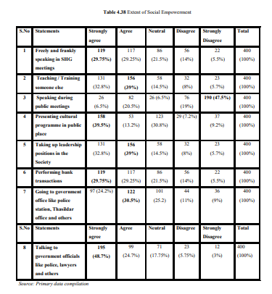
It was quite clear that 50% of the respondents agreed that SHGs allowed them the ability to interact with government representatives, including police, attorneys, village administration officers, revenue inspectors, and tahsildars, whom they would otherwise be scared to approach. Nearly 60% of them said that participating in SHG helped them get the confidence to talk openly and honestly in front of large crowds and the knowledge necessary to conduct financial transactions.
More than three-quarters of the respondents agreed that SHG had given them the skills and self-assurance to assume leadership roles and train others in doing so; however, almost one-fourth of them claimed they were unable to speak in front of large crowds or plan any social programmes or events for the benefit of society. The idea of social empowerment through SHGs was shared by all the women, but there are still certain societal limitations that must be taken into account. The comments clearly demonstrated a high level of social empowerment when taken as a whole.
Table 1.2. Increasing health awareness after joining in SHG.
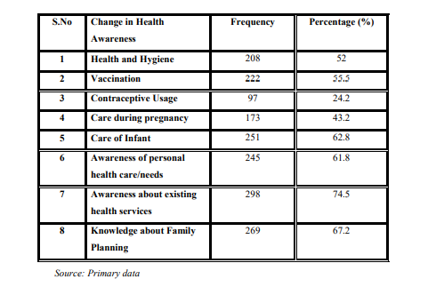
reported that 52% of the study's participants agreed that SHG had increased their awareness of health and cleanliness, as well as their understanding of various immunizations. 55.5% for themselves and their kids. 74.5% of respondents said they were more knowledgeable about available medical treatments and precautions to take throughout their pregnancy. After having a kid, understanding of family planning increased by 67.2 percent, and after joining the SHG, members knew how to care for their own health. Only 24.2% of the respondents believed that discussing the use of contraceptives and awareness around it in a group setting was acceptable because it was forbidden to do so in everyday conversation.
1.3. Cross tabulation analysis
(Time of association with SHG and effect on living standard of respondents)
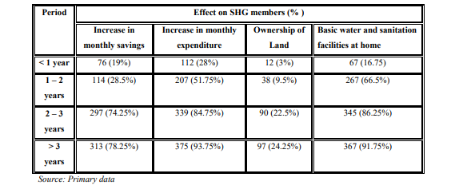
depicts the period during which women were associated with SHGs and the effect this had on their level of living. The impact may be observed in the growth in monthly savings, expenditure, ownership of land, and growth in basic facilities as the members' time with the SHG has expanded. It is very obvious that once women join SHGs and begin to save there, they develop a savings habit that lasts year after year, increases their savings, and is reflected in their spending patterns. The influence may be observed in the supply of basic amenities at home and in the ownership of property. As savings rise, expenditures expand as well. The women claim that restroom facilities have even been created.
1.4. Chi- Square analysis
(Impact of SHG on the living conditions of the respondents)
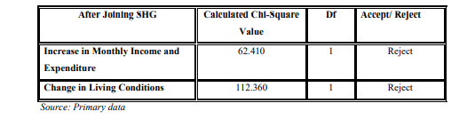
Chi Square analysis was used to analyses the effect of SHG on respondents' living conditions and validate the null hypothesis. The results show that after joining the group, members' monthly income and expenses significantly increased, which had an impact on the SHG members' living conditions. Table 4.44 illustratively demonstrates that the null hypothesis is rejected and that the SHG members' living conditions significantly improved. After joining the SHG, the members' living situations have been significantly impacted by the rise in monthly revenue and expenses.
Impact of SHG on the Extent of Empowerment Hypothesis 2: H02: Loan acquired through SHG has no influence on the economic empowerment of women in SHG. 4.4.5. Effect on Economic Empowerment
Table 1.5. Loan acquired through SHG and its effect on economic empowerment
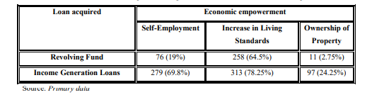
Table 1.6. Economic empowerment of women in SHG
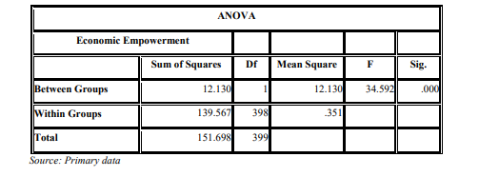
Regarding changes in respondents' living situations after joining SHG and increases in economic factors such monthly income and expenditure, the null hypothesis is rejected. When one-way ANOVA is used, the estimated result exceeds the table value, indicating a substantial change in economic empowerment following SHG membership.
Findings of the Study:
The findings of the study support the researcher's recommendations, which may be useful in bolstering SHGs and making strategic choices about upcoming Poverty Alleviation Programmes in the District and State.
1. Microfinance institutions and nongovernmental organizations should dispel the myth that by joining a SHG, members will be eligible for a loan or credit for their personal use. Instead, it offers the chance for the person to start their own business or find self-employment.
2. In order to advertise their products, SHGs should generate business prospects and marketplaces across all industries.
3. SHGs should inspire older women and widows to participate in all programmes and offer them the self-assurance to launch a company, which will give them the self-assurance to lead an independent life.
4. It is crucial to literate the group's illiterate members as soon as possible. so that those participants may contribute to SHG operations more effectively.
5. To reduce loan defaulters, SHGs should be regularly evaluated and monitored by a variety of organizations, including the government, banks, and NGOs.
6. More training programmes on generating money and working for oneself should be offered. This would make it possible for SHG members to get finance, leave their low-paying jobs, and increase their income.
7. In order for SHGs to operate efficiently, the Odisha government should provide the SHGs with a location and area where they may do so without interference.
8. The media may persuade individuals to join SHGs. The benefits of SHGs should be highlighted in the media in order to increase participation in SHGs.
9. There should be more women from reserved castes participating. Additionally, it becomes necessary to give them more formal positions. More women from other categories need to have official jobs, and particular measures need to be done to make that happen.
10. BDOs and NGOs should be in charge of keeping an eye on how SHGs are operating in their area. If any group was found to be inactive, appropriate training should be provided whenever necessary, and the group should be encouraged to engage fully.
11. SHGs should be established to give rural women a sustainable means of subsistence, and each village should develop into an institution with sustainable governance, which will promote the empowerment of women generally.
Suggestions
1. The fact that 85% of the study population was under 35 years old demonstrated the potential for active engagement in the group.
2. The requirement for SHG participation in raising awareness of various issues was closely tied to the educational background. It was clear that 65.2% of the respondents had completed all of their SHGs and had studied from sixth to tenth grade.
3. It was discovered that SC made up 74.5% of the respondents. People from the scheduled caste were given the chance to improve their social standing through SHG.
4. Of the responders in the categories, 74% were married. More members were between the ages of 25 and 35, as could be observed from the age distribution. This demonstrated the group's diversity in terms of age, religion, and community.
5. Despite the fact that SHGs were created to promote self-employment, the members lacked much initiative in generating an income for their families and was content with their regular jobs and the help provided by SHGs in times of need thanks to their savings.
6. When the members' earnings were examined, it was discovered that 94% of them made less than Rs. 10,000 per month, and those who made more than that amount were linked to further family businesses.
7. It was noteworthy that just 25.8% of the respondents owned their homes, which is a crucial component of empowerment and a feature that conveys social status.
8. Vehicle ownership (69.2%), which was aided by SHG involvement, was yet another indicator of the improvement in women's living conditions and economic empowerment.
9. The members have recognized the necessity for the building of hygienic latrines, and the government has also offered a loan for it.

Conclusion
Not every issue in society connected to poverty can be resolved through microfinance. On the other hand, giving rural communities access to microcredit and microfinance support will improve their economic circumstances and so provide them social influence. Many poverty-eradication programmes were conducted as part of the Integrated Rural Development Programmes, but Swarna Jayanthi Swarozgar Yojana was the one that really got all the rural women out of their homes. The SHGs were established as part of this plan. This programme from the State and Central governments has being conducted in the Rayagada district by the "District Rural Development Agency (DRDA)".
Similar to DRDA, a group of 12 to 15 women were assembled and made into a group where women save on a regular basis. The BDO officer and gramme seva selected the beneficiaries based on the beneficiaries' below-poverty-line status. To sustain and develop credit flow inside the organization, a revolving loan is given out, and the repayment status is tracked. This encourages the ladies to support one another during times of need. The rural poor are released from the control of the lenders during this phase.
When this level was achieved, the women received training in a variety of income-generating activities as well as financial assistance in the form of revenue production loans to launch their business. This would give rural women more economic power. In addition, it promotes their social empowerment to play a part in family decision-making, community welfare, and social engagement. Every week, even women join together to discuss group issues, document transactions, learn how to keep records, improve their financial literacy, and generally raise their awareness levels.
The Rayagada Block, Katpadi Block, Gudiyattam Block, and K.V.Kuppam Block in the Rayagada district served as the sample research sites. Women were not given much influence in any of the blocks prior to the foundation of SHG, and the majority of them were housewives. They were forced to leave their houses as a result of this campaign, and they were required to take part in various ways. Women said that the same bank that had previously requested security and other documentation from them before allowing them to introduce a SHG member now willingly offers them loans with a subsidy to start businesses without requiring any security. Through this organization, the women have developed self-confidence as well as self-trust and reciprocal relationships, which have improved the social capital of the nation.
References:
- Abhaskumar Jha (2004), “Lending to the Poor: Designs for Credit”, Economic and Political Weekly 25, 8- 9.
- Ackerly, B. (1995), Testing the tools of Development: Credit programmes loan involvement and Women’s Empowerment, World Development, 26(3), 56-68.
- Amita Rani and Pawan Kumar Dhiman (2012): Dimensions and Apprehensions of Self-Help Groups: An Analysis. International Journal of Economics and Business Modeling 3, 172-176.
- Bharad N.D., Kalsariya B.M., Karkar B.R. and Popat M.N. (2007) “Self Help Group, an accelerate of Sustainable Production in Agricultural Entrepreneurship”, Kalpaz Publication. Chandra (2000), “Women and Empowerment”, Indian Journal of Public Administration, 42(3) 12-16.
- Chiranjeevulu T. (2003) Empowering Women through Self-Help Groups- Experiences in Experiment.
- Dhanalakshmi, U and Rajini, K (2013): A Review of Literature: Women Empowerment Through Self-Help Groups (SHGs). International Journal of Research in Commerce and Management 10, 29-35.
- Gautam Vir (2008) “Status of Women in Rural India and their role in rural development”, Abhijeet Publications.
- Gunasekaran. S, (2009) Human Rights Approach in Poverty Alleviation Programmes in Odisha, Journal of Rural Development 28, 491 – 501.
- Karkar (1995), “Empowering Women through Self Help Groups – Experiences in Experiment”, Kurukshetra.
- Karmakar K.G. (1999), “Rural Credit and Self Help Groups: Micro Finance Needs and Concepts in India”, Sage Publications, 207-316.
- Mayoux L. (2005), Women’s Empowerment through Sustainable Micro-finance: Rethinking ‘Best Practice’.
- Mofidul Islam & Jayanta Krishna Sarmah, (2014) Impact of Self Help Groups in
- Nayar K.R. and Kyobutungi C. (2005), Community participation in health: A qualitative study of women’s self-help groups in Kerala state, India. Journal of Health and Development 1, 91-101.
- Rajasekhar.D, (2002) “Economic Programmes and Poverty Reduction: NGO Experiences
- form Odisha”, Economic and Political Weekly 37(29), 3063-3068.
- Sathya Sundaram I. (2011), “Women Empowerment; Rhetoric and Reality” Sothern Economist, 50(9) 56-57.
- Shylendra, H S. (1998), ‘Promoting Women’s Self Help Groups: Lessons from an Action Research Project of Institute of Rural Management Anand’.
- Shylendra, H.S. and Kishore Bhirdikar, (2005) “‘Good Governance’ And Poverty Alleviation Programmes: A Critical Analysis of Swarnjayanti Gram Swarozgar Yojana (SGSY) International Journal of Rural Management 1(2), 203-221.
- Syed Hashemi, Sidney Schuler, and Ann Riley (1996), "Rural Credit Programs and Women's Empowerment in Bangladesh," World Development 24, 635-653.
- Tanmoyee Banerjee, (2009), Economic Impact of Self-Help Groups - A Case Study, Journal of Rural Development 28, 451 – 467.
- Tripathy, KK and Jain, Sudhir K (2011): Income Impact of Micro-Enterprise Finance: An Empirical Study on Government Initiatives in Rural India. International Journal of Rural Management 7, 5-26.
- Yadappanavar A.V. (2008) Credit Support to Women Entrepreneurs under SGSY, Gyan Publishing House

