Analytical Study of Internet Advertising and Marketing at Paragon Shoes
(With reference to Raipur and Durg district)
Ravindra Baghel
Research Scholar
MATS School of Business Studies
MATS University, Raipur (C.G.)

Abstract
This study was conducted to determine how different online marketing tools used in various industries such as Word of Mouth (WOM), online chat and email advertising affect brand perception and consumer purchasing decisions. The goal is to study the effects of different online marketing tools and techniques, WOM, online chat and email, on brand perception and consumer purchase decisions. There are many factors that influence consumer purchase decisions and the development of specific brand perceptions, but the most important factors that play an important role in changing consumer brand perceptions and purchase decisions are WOM and behavior. it has three variables. The results show that Karachi residents who are active on the Internet prefer WOM over the other two variables, namely online chat and email advertising. Various companies use online WOM marketing strategies to attract potential customers and influence their purchase decisions and brand perception. In Raipur and Durg, there are no common factors influencing consumer purchase decisions and brand perception development. WOM is consumer driven and is one of the cheapest online marketing methods used by many companies and proven to be effective.
Keywords: Marketing, advertising, strategy, business growth rate, analysis
Introduction
Nowadays, traditional marketing is disappearing with the penetration of online marketing which has spread to many different industries including social media, blogs, chat forums and general problem solving forums. The pace of information sharing has never been faster than it is today, and online marketing plays a role in facilitating this explosion of new, changing information. Online marketing allows consumers to sell products that they believe are worth buying, along with detailed discussions about the features, quality, durability, design and functionality of various products across industries.
Marketing managers are increasingly using online marketing for a variety of reasons including; removal of geographical limitation, easy accessibility, consolidation of large volume of information into a compact online site, high margin for customization and intensity of reach of potential and actual consumers at their fingertips. Online marketing can influence consumer purchasing decisions and change brand perceptions of various products from various industries. The purpose of this research is to study the various tools and techniques that marketers can use to influence consumers' purchase decisions and brand perceptions by using consumers as their marketing asset. Advertising is always present, although people may not be aware of it. In today's world, advertising uses every possible medium to spread its message. It does this through television, print (newspapers, magazines, magazines, etc.), radio, print, internet, direct sales, billboards, mailers, contests, sponsorships, posters, clothing, events, colors, sounds, visuals, and even people. (recommendation). .Marketing is the process of controlling marketing aspects, setting company goals, organizing step-by-step plans, making business decisions and implementing them in order to achieve maximum turnover by meeting consumer requirements. International marketing is the application of marketing principles by industries in one or more countries. ... Simply put, international marketing is the trading of goods and services between different countries.
Studio background
The following is an overview of major research papers on this topic that are relevant to this study: Maheshwari, Seth & Gupta (2016) in their paper "An Empirical Approach to Consumer Buying Behavior in the Indian Automobile Sector" concluded that advertising effectiveness is positively influenced by happening Consumer buying behavior.
John, Swinder & Muthaly (2011) in their research paper "Effects of Advertising Expenditure on Brand Loyalty in Services" found that advertising expenditure affects customer's perceived product quality, customer loyalty and satisfaction level.
Kumar and Raju (2013) in their paper “Role of Advertising in Consumer Decision Making” found that advertisements are capable of changing a consumer's mind about a particular product.
Advertising has always been known as one of the main factors influencing the consumer's decision-making process. In this paper, we have attempted to test different sets of variables from these previous studies and analyze how they influence consumer purchase intention. Online advertising is a newly emerging form of advertising that has grown with the rapid development of the Internet and has gradually become one of the most important advertising media. Berthona, Pitt and Watson (1996) refer to the Internet as a virtual place where consumers interact with various advertisers. The Internet enables advertisers to maintain and improve relationships with consumers around the world and "presents a significant new opportunity for businesses to communicate with new and existing markets in a highly integrated manner." According to Smith and Chaffey (2005), online advertising is “the use of online promotional techniques such as search engines, banner advertising, direct mail, and links to other websites or services on a company's website to acquire new customers and provide services. existing customers."
Methodology
This article presents an analysis of online advertising and marketing for Paragon footwear products. We evaluate transaction accuracy and business growth percentage. We used three different types of datasets in the experiments, Bag of Words and Twenty Newsgroups datasets. The Internet offers companies the opportunity to sell goods and services to more consumers than ever before. Reaching these customers and developing their loyalty by offering quality, convenience, price competitiveness and the right products and services starts with a solid e-marketing plan. Effective marketing programs and strategies that set goals and deliver measurable impact are the tools for success in the new economy. Different methods are used in online advertising and marketing and electronic payment service providers over the Internet. These methods are service providers: Accuracy formulas help detect errors in the measurement of values. If the measured value is equal to the true value, then it is said to be highly accurate and with less errors. Accuracy and error rate are inversely proportional. High accuracy means low error rate and high error rate means low accuracy. The accuracy formula gives the accuracy as a percentage value, and the sum of the accuracy and the error rate equals 100 percent. The electronic payment accuracy indicator of a cloud computing service provider is an accuracy value defined by:
Where alpha α can be the computational, network or storage unit of the service and Ti α is where alpha is the service time T for user i
Business growth percentage
Online marketing and advertising business development uses cloud computing as a computing model rather than technology. Sustainable growth rate.
available evening and target income range
D is the amount of dividend payout.
L is the total debt to equity ratio.
T is the ratio of total assets to sales.
The right job
In this study, a comparative study was conducted on marketing and promotion in Paragon Footwear Company through the Internet for Raipur and Durg district of Chhattisgarh. We measure the accuracy of departments and districts and the percentage of transactions and businesses. Usually we win two districts namely Raipur and Durg. We will select five districts for each section. We have Raipur and Durg districts. In our experiments, we used two different datasets, the Bag of Words dataset and the Twenty Newsgroup dataset.
In this study, we have two datasets, Bag of Words dataset, test results and case reports for performance evaluation. Usually we calculate transaction accuracy and business growth percentage; we mostly get Raipur and Durg district of Chhattisgarh.
Experience and results
In this section, we have used five districts of Raipur and Gariaband district for experimental results. With social networks Facebook, Blogger, Twitter, YouTube, Paragon, Amazon and other websites, we show the percentage of accuracy of reviews and transactions and the percentage of business growth. This chart shows the percentage accuracy of online marketing and social media advertising.
Table 5.1 District Raipur Accuracy Advertisement Percentage

Social Network and Website | Accuracy of Transaction %
Facebook | 85
YouTube | 90
Blogger | 78
Tweeter | 75
Amazon | 87
Snapdeal | 82
Mantra | 80
paragon | 79
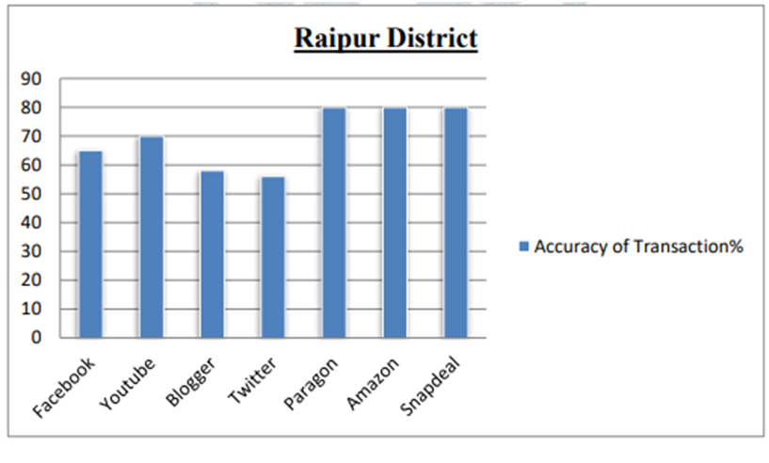
Figure 5.1 District Raipur Accuracy Percentages
This data describes Raipur district with % accuracy with social networks Facebook, Blogger, Twitter, YouTube, Web and Amazon. This table shows the accuracy. Facebook, Blogger and Twitter social media advertising percentage is shown for Raipur district.
The percentage of online advertising on social networks Facebook, blogger, twitter, web, youtube is given for Durg district.
Table 5.2 Durg District Accuracy Advertisement Percentage
Social Network and Website | Accuracy of Transaction %
Facebook | 90
YouTube | 88
Blogger | 76
Tweeter | 78
Amazon | 80
Snapdeal | 81
Mantra | 80
paragon | 78

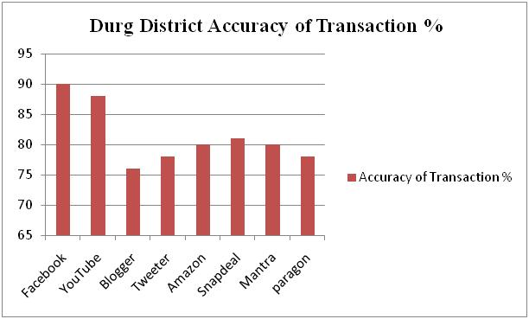
Figure 5.2 Durg District Accuracy Percentages

This figure describes the accuracy % of Durg district with social media, books, bloggers, twitter, YouTube, web and more, this table shows the accuracy.
Conclusion
In this research paper, e-payment focuses on the study of Footwear Company's marketing and advertising and improving the accuracy and security of district CG, we used different types of Bag of Words datasets in the experiments. Experimental results show that our proposed new approach to electronic payments works better. The work presented here focuses on the design of the framework and algorithm of electronic payments. The work can be extended by e-payment of Paragon footwear products.
In this paper, we proposed an analysis of online marketing and advertising or e-payments for Paragon footwear products in CG. This approach is based on the analysis of e-payments. An Analysis of Electronic Payments Based on Paragon Footwear in C.G. We takes the districts of Raipur and Durg in Chhattisgarh. Generally we calculate transaction accuracy and business growth percentage for two divisions Raipur and Durg. The results of this approach are above average. In this section, we used two districts Raipur and Durg for experimental results and performance evaluation. Find it Raipur District is more effective online marketing and advertising for Paragon brand shoes.
Reference
- Alexandras Pappas；Panagiotis Panagiotopoulos. Information Technology Risk Management in Electronic Commerce: Classical and Catastrophic Approaches to Risk. International Journal of Applied Systemic Studies. 2009 Vol.2 (No.3)
- Allen, C., Pierce, T., (1999) The TLS Protocol Version 1.0, RFC2246, http://www.ietf.org/rfc/rfc2246.tx45
- A.V. Sutagunder, S.S. Manavi, Selvin and M.N. Birje, "Agent-Based Location Aware Services in Wireless Mobile Networks", in Proceedings of the Third Advanced International Conference on Telecommunications, IEEE, 2007, pp. 20–25
- B. Aboba, D. Simon, P. Eronen, Extensible Authentication Protocol Key Management Framework, IETF RFC 5247, August 2008.
- B. Aboba, L. Blunk, J. Walbrecht, J. Carlson, H. Levkovetz, Extensible Authentication Protocol (EAP), June 20048 RFC3748.
- Bhawani Prasad G.V. and d.Veena (2011), “NPA Reduction Strategy for Commercial Banks in India”, International Journal of Management and Business Studies, Vol.1; P. no. 47-53
- Bordelion Etienne and Graham Christopher (2010) “The Impact of Liquidity on Bank Profitability” Bank of Canada Working Paper 2010-38, pp. 1-22
- Boschkoska, Marie. "Banking Sector Profitability in the Republic of Macedonia", International Journal of Economics and Finance, 2013.
- Goyal Vishal, Pandey USA. and Batra Sanjay (2012) “Mobile Banking in India: Practices, Challenges and Security Issues”, International Journal of Advanced Trends in Computer Science and Engineering, Volume 1; P. no. 56-66
- Ibrahim M (2011), “Operational Performance An Analysis of Indian Scheduled Commercial Banks” International Journal of Business and Management, Vol 6; P. no. 120-128

